[Egyptian Informatics Journal 20 (2019) 33–44](https://doi.org/10.1016/j.eij.2018.07.001)

Contents lists available at [ScienceDirect](http://www.sciencedirect.com/science/journal/11108665)

Egyptian Informatics Journal

journal homepage: [www.sciencedirect.com](http://www.sciencedirect.com/)

[](http://crossmark.crossref.org/dialog/?doi=10.1016/j.eij.2018.07.001&domain=pdf)Multi-agent based context aware information gathering for agriculture using Wireless Multimedia Sensor Networks

K.N. Bhanu a,⇑, T. Bhaskara Reddy b, M. Hanumanthappa c

a *Research Scholar, Dept. of Computer Science & Applications, Rayalaseema University, A.P., India*

b *Dept. of Computer Science & Technology, Sri Krishnadevaraya University, A.P., India*

c *Dept. of Computer Science & Applications, Bangalore University, Bangalore, India*

a r t i c l e i n f o

*Article history:*

Received 4 June 2017

Revised 5 April 2018

Accepted 2 July 2018

Available online 13 July 2018

*Keywords:*

Wireless multimedia sensor networks Context-aware computing

Agent technology

Content-based image retrieval

a b s t r a c t

Wireless multimedia sensor networks (WMSN) can be used in a wide range of applications such as mon- itoring agriculture, infrastructures, military operations, disaster management and so on. Energy conser- vation is a major concern in WMSN applications. This paper proposes a multi-agent based context-aware information gathering using WMSN for monitoring agriculture. Three kinds of contexts are considered in this paper such as detecting an emergency, temporal and computational contexts for detection of dis- eased plants, weeds, fire and interpret the soil fertility based on the soil parameters. This work considers contexts driven by a sensor node. Whenever the context is detected the information will be sent to the sink node. The proposed scheme works as follows: Every sensor senses the information and updates the node knowledge base. Based on the sensed information node interprets the context such as disease affected plants, soil fertility, fire, and growth of weeds. The sensor nodes begin to transmit the stored information to the cluster heads with the help of Path Finding Agent (PFA). Cluster heads aggregate the information received by the sensor nodes in the field before sending this information with the help of Querry Agent (QA) to the sink node. At the sink node all the information will be sent to the end-user, but in case of the fire detection, the immediate action will be taken by the sink node itself to turn on the sprinklers. Once the sensor finishes the assigned task (sensing, communicating) then automatically it goes into sleep mode. To detect plant disease and weeds, content-based image retrieval is used to com- pare with the healthy or useful plant images respectively. For performance analysis, the proposed scheme is simulated using NS2. Some of the performance parameters considered in this work are context detec- tion time, delay, fusion time and energy consumption.

© 2019 Production and hosting by Elsevier B.V. on behalf of Faculty of Computers and Information, Cairo

University. This is an open access article under the CC BY-NC-ND license ([http://creativecommons.org/](http://creativecommons.org/licenses/by-nc-nd/4.0/)

[licenses/by-nc-nd/4.0/](http://creativecommons.org/licenses/by-nc-nd/4.0/)).

1. Introduction

Wireless Sensor Networks (WSN) comprises of tiny sensor nodes that have sensing, computation, and wireless communica- tion capabilities. A tiny sensor node communicates within a short distance and collaboratively works to fulfill the application specific

* Corresponding author.

*E-mail address:* [bhanu.kn@gmail.com](mailto:bhanu.kn@gmail.com) (K.N. Bhanu).

Peer review under responsibility of Faculty of Computers and Information, Cairo University.

**Production and hosting by Elsevier**

objectives of WSN. In [1], the author has emphasized on demand for re-consideration of computational capabilities in traditional WSN. The sensor nodes may be equipped with multi-resolution cameras which collects a huge amount of multimedia data apart from the basic sensor nodes which collect scalar data. Wireless multimedia sensor network (WMSN) is a network of multimedia- enabled sensor nodes that are capable of sensing, computing and communicating multimedia data. WMSN demands sophisticated hardware that processes the multimedia data and reduces the amount of energy required for the communication as discussed by the author in [2](#_bookmark26),[3]. Most of the WMSN have a lot of redundant data, hence these redundant data can be processed and aggregated in an efficient manner, which in-turn reduces the energy consump- tion and prolong the lifetime of the battery. In order to conserve the network lifetime of the WMSN, context-aware computing along with software agent technology is proposed in this work.

<https://doi.org/10.1016/j.eij.2018.07.001>

1110-8665/© 2019 Production and hosting by Elsevier B.V. on behalf of Faculty of Computers and Information, Cairo University. This is an open access article under the CC BY-NC-ND license (<http://creativecommons.org/licenses/by-nc-nd/4.0/>).

A system is context-aware if it uses context to provide relevant information and service to the user. Context-based information gathering for WMSN needs to have proper information and mea- sure of the context what we are using to represent the system. Context-aware computing helps to retrieve the relevant informa- tion from the environment, which in turn can conserve the net- work lifetime of WMSN as discussed in [4].

Software agents can be employed for information gathering to prolong the network lifetime as given in [5]. Agents can be static or mobile. Static agents reside at a particular location and perform the task by collecting the sensed information and storing in the node database. Further, it provides information to the mobile agents. Mobile agents perform the task by moving throughout the network environment thereby collecting the data from each sensor node and providing it to the sink node as given in [26–29]. The modern technologies such as wireless multimedia sensor networks along with context-aware decision-making capabilities are important to change the agricultural practices for better pro- ductivity. The wire-free nature of WMSN is suitable for monitoring the agricultural needs. Context-aware sensor network helps in con- serving energy utilization in the network thereby enabling smart decision in productive agriculture monitoring. The sensor nodes are deployed randomly throughout the field. The sensor node col- lects various information such as soil moisture, leaf wetness, soil pH, temperature, atmospheric pressure etc. Based on these values

the sink node provides the solution.

The motivation for carrying out the proposed work is, in coun- tries like India, agriculture is a major occupation and acts as a back- bone for the nation’s economy. Two main drawbacks can be observed with respect to agriculture, which is water management and low productivity. WMSN helps in providing the solution for problems in agriculture such as monitoring of crops for disaster detection, soil fertility, plant disease and weeds detection. As agri- culture is a rich domain for context awareness, agriculture scenario is considered for the proposed work. This article concentrates on improving the low productivity issue by considering WMSN for agricultural context.

The proposed agent-based context-aware information gather- ing using WMSN in monitoring agriculture addresses the following issues: (i) to detect the disease affected plants in the irrigated land;

(ii) to recognize the growth of unwanted plants within the crop;

(iii) to check the fertility of the soil periodically; (iv) to detect fire disaster in the field; (v) to prolong the network lifetime in wireless multimedia sensor networks.

* 1. *Related works*

Some of the related works on context-aware agriculture using wireless sensor networks are as follows: Agriculture is a very important aspect of human society. Use of a proper method for irri- gation is important in the field of agriculture. The article [6] focuses on, detection of plant diseases which includes three major parts: image segmentation, feature extraction and classification. Image segmentation part extracts the regions affected by the dis- ease for an input image. Feature extraction part converts the seg- mentation results into feature extract vectors. Classification part decides whether the plant in the input image is sick based on com- paring the feature information of the input image. The work pre- sented in [7] has discussed periodic maintenance of drip irrigation. Zigbee is one of the good technologies for controlling irrigation over large agricultural sector areas for growing crops. This proves to be a real-time feedback control system which mon- itors and controls all the activities of drip irrigation system effi- ciently. Article [8], explains about a pyramid context-aware model. A context-aware sensor grid is implemented to add preci- sion for decision making and control process in agriculture. As

described in [10,11], the scalar WSN is used to detect the fertility of the soil. An alarm system is used in emergency situations and conditions when the plant is in danger. When critical conditions threat a plant, the alarm system is enabled. In [12], the author explains about Coupling of a camera with the scalar WSN node enables to meet most of the requirement of environmental data collection and event detection. The low-cost charged coupled device (CCD) camera is used to detect the disease infected plants. In [9], the author has described the architecture of context-aware sensor grid system. Context-aware sensor grid is a combination of three promising technological domains that are context-aware computing, grid computing, and sensor networks. The sensed information is communicated from the sensor nodes to the sink node using agent technology. Agents are the autonomous pro- grams located in an environment, which perform dedicated tasks either by itself or by interacting with other agents in the environ- ment as explained in [13]. Software agents are of two types: static agents and mobile agents. Mobile agent systems perform tasks by roaming in an environment and interacting with other mobile agents as well as the nodes in an environment. Mobile agents also aggregate the data from all sensor nodes and help in routing the aggregated data to sink node as mentioned in [14]. The work pro- posed in [15], explains the context-aware image fusion using the multi-agent system for wireless military sensor networks using wavelet-based transformation for image fusion. A WSN system is proposed in [16], for use in precision agriculture applications, where real-time data of climatic and other environmental proper- ties are sensed and control decision are taken based on it to modify them using Zigbee protocol. As irrigation method depends on the weather conditions, soil structure and variety of crop cultures, a greenhouse technology enabled with wireless sensor networks for automatic environment monitoring is proposed in [17] for pre- cision agriculture. In [18], the authors have tried to explore how sensors and sensor networks have been utilized in crop production process from a user perspective. The work in [20] explains the con- cepts of auto color correlogram and it also deals with the perfor- mance of the content based image retrieval (CBIR) system using color features. The techniques used for color feature extraction are explained as HSV histogram, color correlogram and color moments in [21]. Texture feature extraction is achieved by Gabor wavelet filter as given in [22]. A combination of local, global and k-mean using wavelet transforms for content-based image retrie- val is explained in [23]. Similarity measurement can be done with the help of Manhattan distance as explained in [24]. Precision farming using wireless sensor network technology to improve agri- culture in Egypt is discussed in [25].

Context-aware wireless irrigation system (CAWIS) is proposed in [19], where a context-aware system is proposed using wireless sensor networks to minimize the wastage of water in irrigation process. CAWIS is used for comparing the proposed work, agent- based context-aware agriculture (ACAA) using WMSN.

Some of the drawbacks of existing precision agriculture tech- niques using wireless sensor networks are that most of the works consider only real-time scalar data to improve the agriculture pro- cess. The performance of WSN with respect to energy conservation of the sensor nodes and prolonging the network lifetime of WSN is not considered in most of the existing works. Also a very few liter- ature exists for energy conservation in sensing, processing and transmission of multimedia data in WMSN.

* 1. *Our contributions*

The proposed scheme considers contexts driven by a sensor node. Whenever the context is detected the information will be sent to the sink node. Our contributions for the proposed scheme is as follows: (1) Modeling the event detected area of WMSN using

context aware computing for agriculture scenario. (2) Usage of sta-

# Cd(i)= 0;

*Pi* < *Pith*

# (1)

tic and mobile agents for information gathering and detection of context based on soil fertility, fire, diseased plants and weeds. (3) Improvement in performance parameters such as context detec- tion time, fusion time, energy consumption, cluster head selection time etc. when compared to the existing systems.

The rest of the paper is organized as follows: Section 2 presents a context-aware model for agriculture. Section 3 explains the content-based image retrieval for plant disease and weed detec- tion. Section 4 describes the agent technology. Section 5 presents the simulation model and performance parameters. Section 6 dis- cusses the results and Section 7 gives the conclusion of the work.

1. Context aware model for agriculture

Context is any information that can be used to characterize the situation of an entity. This section consists of the mathematical model required for simulation.

* 1. *Network environment*

The network environment shown in Fig. 1 consists of sensor nodes and a sink node. Sensor nodes are randomly distributed in the field. The sensor node senses the data and updates the knowledge base. Sensor node comprises of an agent platform with static and mobile agents, camera and other sensory devices such as soil pH, moisture, temperature and smoke detection. A sensor node is said to form a cluster around it based on the communication range. A sensor node has different sensory devices connected to it. Once the information is sensed by the sensor node, it compares the information with a threshold value; if it is not in the threshold range, a message is sent to sink node via cluster head using the multi-hop technique.

* 1. *Context detection model*

Let ‘Cd’ be the context detection based on soil fertility/ fire detection/ growth of weeds/ diseased plants considered in this scheme.

1; *Otherwise*

where i = 1,2,3, ,n

‘Pith’ be the threshold of the context detected where ‘P1th’ be the threshold of the soil fertility context, ‘P2th’ be the fire detection context, ‘P3th’ be the growth of weeds context and ‘P4th’ be the dis- eased plant context.

* + 1. *Soil fertility*

The fertility of the soil can be measured as a combination of sev- eral parameters like soil moisture, the salinity of soil (soil electric conductivity), soil PH, soil temperature and so on as given in [30]. The threshold values of soil parameters like soil PH and soil electric conductivity can vary based on the geographic region of agricultural land and the type of crop cultivated in that land. In this work, only soil moisture and soil temperature parameters for Indian soil are considered for simulation along with their respec- tive threshold values as given in Table 1. The threshold values

are relative to the geographic area of agricultural land.

* + 1. *Fire detection*

The occurrence of fire can be detected as a combination of sev- eral parameters like temperature, smoke, humidity, light intensity, carbon monoxide in smoke and atmospheric pressure as given in [31]. The various threshold values for detection of fire are as given in Table 2. The atmospheric pressure varies with the region of the agricultural land situated from sea level. Temperature, smoke and carbon monoxide are three parameters that help detection of fire with high probability. Hence these three parameters along with

Table 1

Soil Fertility Parameters.

|  |  |  |
| --- | --- | --- |
| Soil Fertility Parameters | Sensor (manufacturer) | Threshold |
| Soil Moisture (%) | EC-5 (Decagon) | 80% |
| Soil Temperature (°C) | THERM200 (vegetronix) | 42 °C |
| Soil PH | EC-250 (Stevens water) | 6.5 |
| Soil Electric Conductivity (mS/m) | WET-2 (Dynamax) | 25 mS/m |

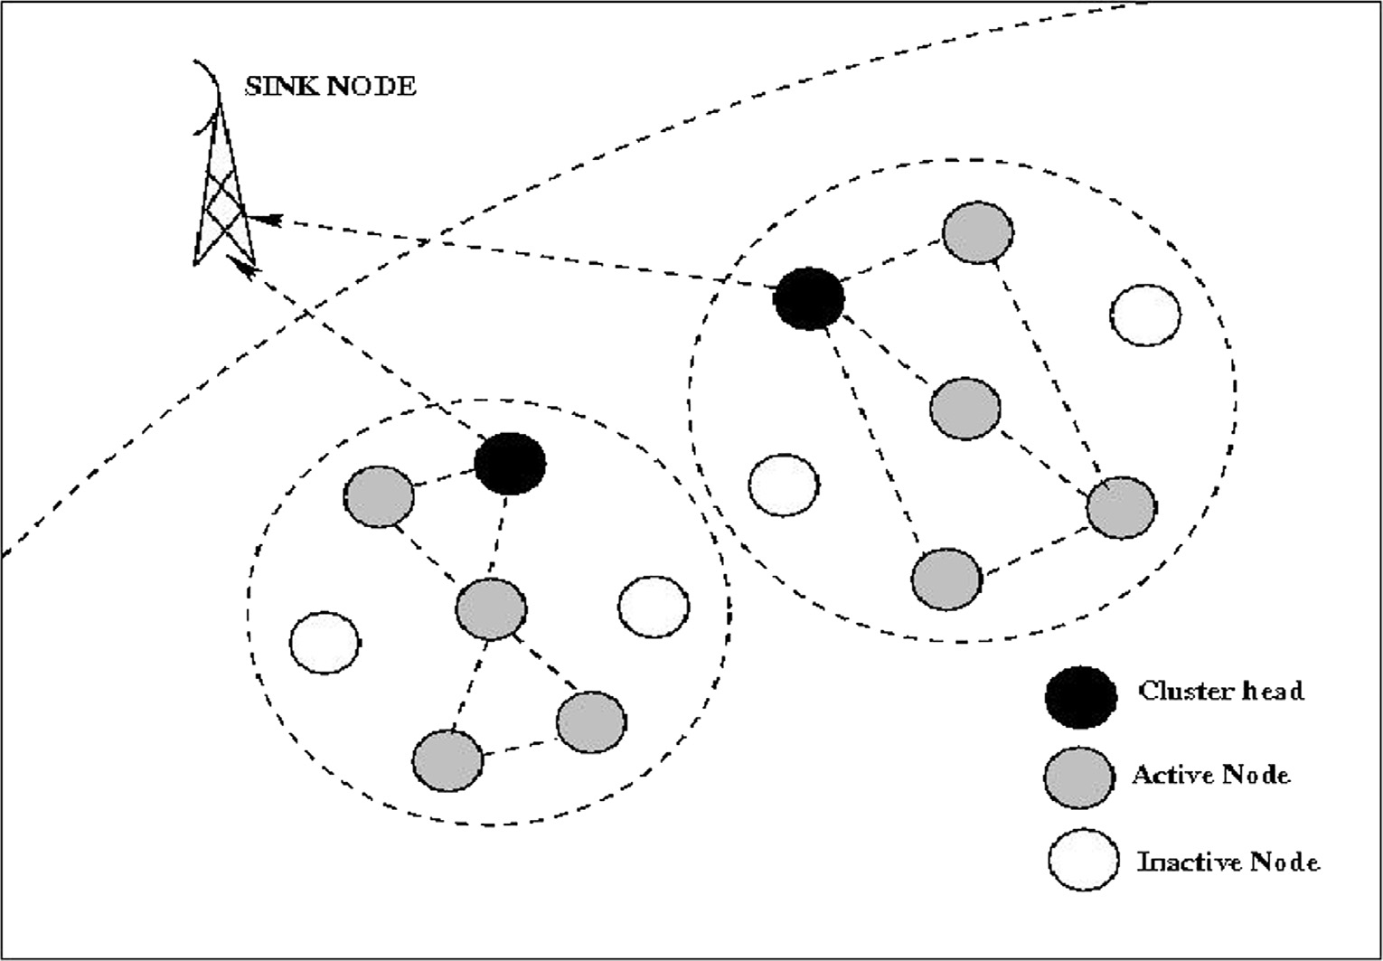

Fig. 1. Network Environment.

Table 2

Fire Detection Parameters.

Fire Detection Parameters Sensor (manufacturer) Threshold Humidity (%) STDS75 (STM) 50%

tion, especially in describing the content of images. In this work, DWT is applied on a set of texture images that is extracted from approximation and detail coefficients of DWT decomposition. The image is decomposed into four sub-bands and critically sub-

Temperature (°C) HIH-4000-001 (Honeywell)

70 °C

sampled by applying DWT. These sub bands which are labelled as low high (LH1), high low (HL1), high high (HH1) represents the fin-

Light Intensity (Lux) BH1750FVI (DLI) 700 Lux

Carbon Monoxide (ppm) GGS-200T (UST) 50 ppm

est scale wavelet region (Detailed images), while the sub-band low

low (LL1) corresponds to coarse level coefficient (Approximation

Atmospheric Pressure (mbar)

MS5540B (Interseema) 500 mbar

image). To obtain next level of decomposition, the sub-band LL1

Smoke (OD/m) EC01000 (Honeywell) 0.025 ± 0.005 OD/m

their respective threshold values are considered for simulation in this work.

* + 1. *Growth of weeds*

Identification of weeds using digital images is discussed in [32]. In the proposed system, some of the useful plant images are stored in the database. If the captured image exceeds the threshold of the stored image then the weeds are detected. The threshold consid- ered in this work is 85 percent.

* + 1. *Disease detection*

Some of the diseased plant images are stored in the database. If the captured image exceeds the threshold of the stored image then the diseased plants are detected. The threshold considered in this work is 88 percent.

1. Content-Based image retrieval for plant disease and weed detection

alone is further decomposed and critically sampled which results

in two-level wavelet decomposition.

Once the feature extraction is done, those values will be stored in the form of a feature vector. Similarly, features of the captured image will be extracted. Then similarity comparison is done between the captured image and database images. Manhattan dis- tance is considered for similarity matching. Indexing is used to quickly locate data without searching every row in a database table. Then the images are sorted in ascending order according to the similarity distance with the captured image. Then the images with minimum distance are retrieved. The proposed CBIR system uses the statistical metrics precision-recall to validate the retrieval accuracy. Fig. 2 shows the steps involved in CBIR.

*3.2. Proposed Algorithm Nomenclature:*

n: Number of images in database, s: Stored images in database,

c: Captured images by sensor nodes, L: Length of database, dv: Dis- tance Vector, p: Precision, r: Recall, fc: Feature Vector of captured image, fs: Feature vector of stored images, md: Manhattan Dis- tance, fv: Feature Vector

The process of retrieving a set of images from a database storing

images by matching similarity is called Image retrieval. The visual contents of the image such as color, shape or features is considered for similarity matching between the images stored in the database and the query image, then such kind of image retrieval is called as content-based image retrieval (CBIR). In the proposed work, to detect plant disease and weeds, CBIR is considered. Useful and healthy plant images are stored in the node knowledge base of the sensor node. The camera-enabled sensor nodes are turned on to sense the agricultural field periodically. The captured image is checked for the similarity of the images stored in the node knowl- edge base. If the images captured are similar, then the captured image is dropped else the captured image is stored and related message is sent to the sink node.

* 1. *Proposed CBIR system*

The CBIR system considered for the proposed work has the visual contents of the images in the database that are extracted and described by multi-dimensional feature vectors which are stored in the database related to the relative image. For feature extraction in the proposed system, color and texture features are considered. For color feature extraction color moments, HSV (Hue*,* Saturation, Value) histogram and auto color correlogram are used. A color moment is a method of image indexing, where the image can be interpreted as mean, standard deviation, skewness, and kur- tosis. In this scheme, only mean and standard deviation color moments are considered. HSV histogram provides perception rep- resentation according to human visual features. HSV histogram ignores spatial organization of pixels in images, auto correlogram is considered as it describes the correlation of the image color as the function of their spatial distance. For texture feature extraction discrete wavelet transform (DWT) is used. In CBIR, texture feature plays a very important role in computer vision and pattern recogni-

Algorithm 1: Plant disease and Weed detection using Content-based image retrieval

1: Begin

2: if n – 0 then

3:for i in 1: L loop 4:fsi:= feature_vector (si) 5:end for

6:while (s)

7:fc:= feature_vector (c) 8:for i in 1: L loop 9:Compute md of fc with fsi

10:Perform indexing by sorting 11:Retrieve si having least dv 12:Compute p and r values 13:if fc = fsi then

14:drop c 15:else

16:update Node Knowledge Base with c 17:end if

18:end for 19:end while 20: else

21:image database does not exist 22: end if

23: End

24: Begin feature_vector

25: Input image

26: Compute color histogram of the image

27: Compute correlogram and color moments value 28: Compute RGB image to HSV image

29: Compute wavelet coefficients of the image 30: Output fv

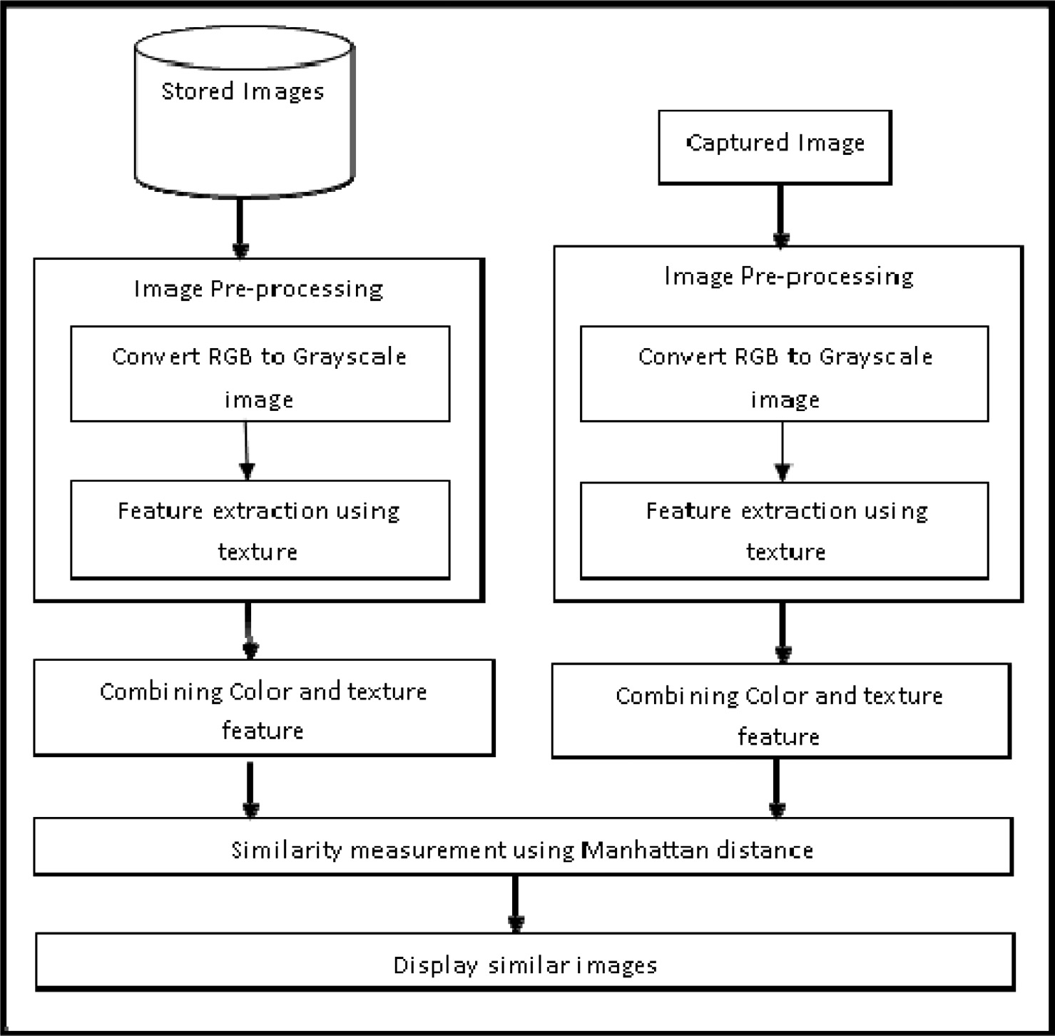

Fig. 2. Flow Diagram of CBIR.

1. Agent technology

WMSN comprises of static sensor nodes and sink nodes (also called as end nodes that require information). A sensor node is said to form a cluster around it based on the communication range. Each cluster will have cluster head node. Sensor nodes are geo- graphically distributed and collect the information at the time of context detection. Every sensor node of WMSN has predetermined value. Once the information is sensed by the sensor node, it com- pares the information with predetermined value, if it is out of range, a message is sent to its cluster head saying that it is an active node. Sink node is the node, which requires the information from different sensor nodes. Routes to get the information from each of the nodes or a set of nodes are available with sink node, which is supplied by the nearest cluster head node. Each node in WMSN comprises of an agent platform and the proposed agent informa- tion transformation model. There are two kinds of agencies pro- posed in this work, they are sensor node agencies and sink node agencies.

* 1. *Sensor node agencies*

The sensor node agency consists of agents such as sensor man- ager agent, sensor knowledge base and pathfinding agent as shown in Fig. 3.

* + 1. *Sensor manager agent (SMA)*

It is a static agent that resides in all the sensor nodes of WMSN. It creates pathfinding agent (PFA) and node knowledge base (NKB)

and is responsible for synchronizing the actions of the agents within themselves and outside agents too. SMA updates the NKB with sensed information, capture time and signal strength. It com- pares the sensed value with threshold values residing in NKB and interprets the context. If the context is detected then it computes arbitrary midpoint between the source and destination node and intermediate nodes around the reference axis between the source and the destination node. It also computes hop distance factor. In sleep mode, SMA does not transmit any information to sink. It monitors the battery life; if the battery is exhausting, it sends the information about the status of the battery to the sink node. It sends information of the node such as node id, location informa- tion, context, and signal strength information to the sink node, if and only if it has a signal strength above the predefined threshold set by the sink.

* + 1. *Node knowledge base (NKB)*

This knowledge base is read and updated by the SMA. NKB com- prises of node id, active mode/sleep mode, sensing time, threshold values, input values, bandwidth required to transmit, signal strength and location of the node as shown in Table 3.

* + 1. *Path Finding agent (PFA)*

It is a mobile agent which resides in all sensor nodes. If the con- text is detected then SMA generates PFA and its clone for route dis- covery. PFA carry information of each node such as node id, residual energy, hop count, bandwidth and hop distance. Then this collected information is sent to the cluster head.

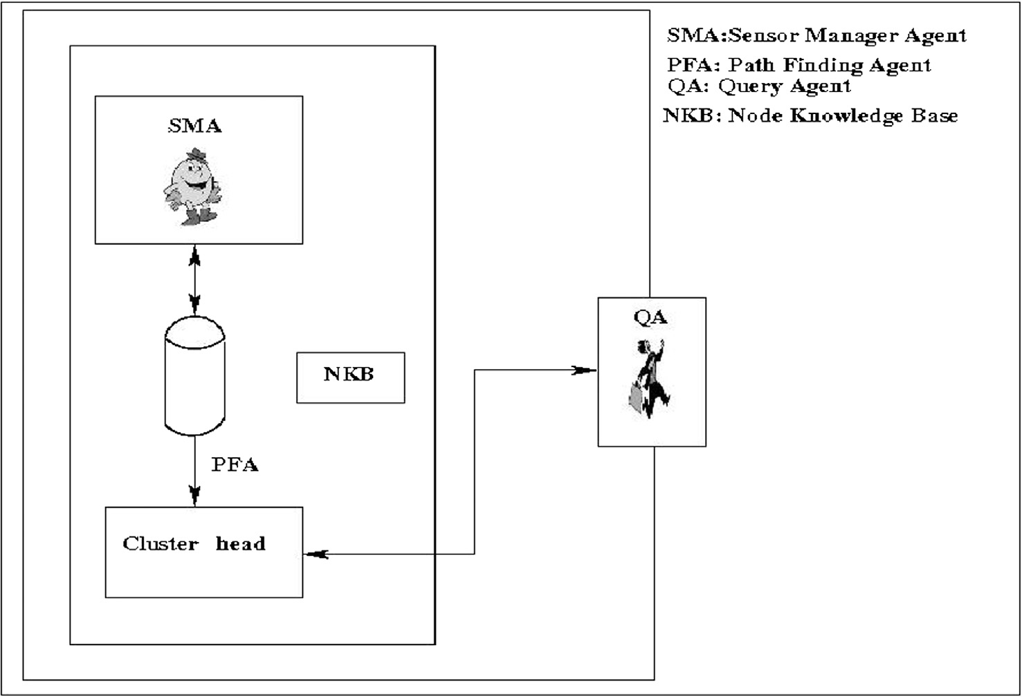

Fig. 3. Sensor Node Agency.

Table 3

Sample data of Node Knowledge Base.

|  |  |  |  |  |  |  |  |  |  |
| --- | --- | --- | --- | --- | --- | --- | --- | --- | --- |
| Node ID | Location | Status | Battery in volts | Signal strength in  % | Power in milliwatts | Stored images | Captured images | The bandwidth required for Tx in% | Context |
| 4 | (3,7) | Active | 7.9 | 75 | 14.0 | st1.jpg st2.jpg st3.jpg st4.jpg | ct.jpg | 15 | 12:15 PM  Disease detected |
|  |  |  |  |  |  | st5.jpg |  |  |  |

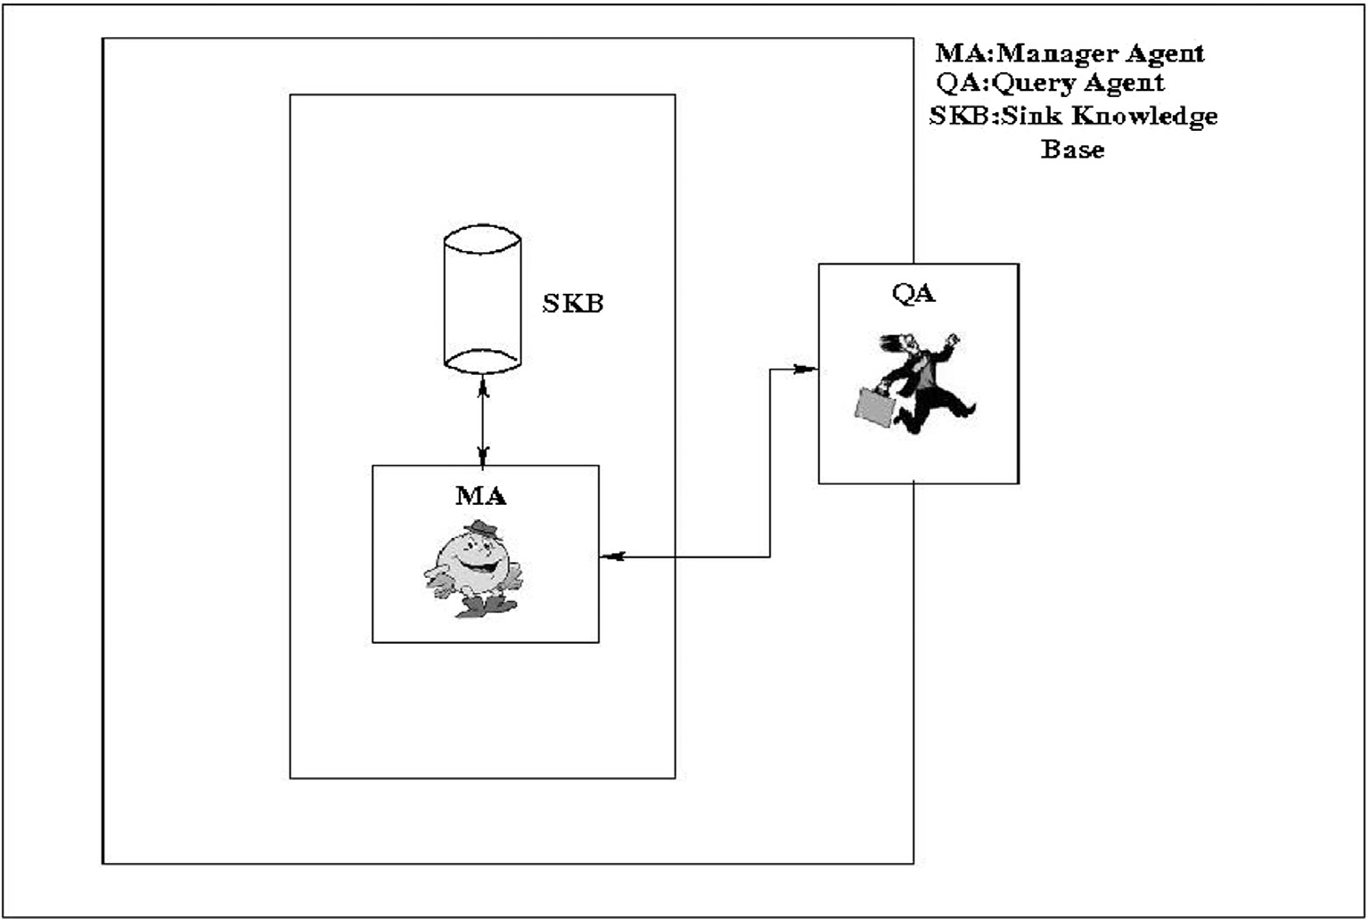

Fig. 4. Sink Node Agency.

* 1. *Sink node agency*

The sink node agency consists of agents such as manager agent, sensor knowledge base and query agent as shown in Fig. 4.

* + 1. *Manager agent (MA)*

This agent resides in the sink node of WMSN and is a static agent. It creates query agent (QA) and sink knowledge base (SKB) and is responsible for synchronizing the actions of the agents within themselves and outside agents. It monitors and updates the SKB when context occurs. MA checks for active sensor node’s locations information from the SKB and generates the optimum routes. When the context is detected, the information is given to the user by monitoring the network either by alert alarm or by updating in the user database.

* + 1. *Sink knowledge base (SKB)*

It is the knowledge base that can be read and updated by MA. It stores the information about the node id, context information, time of sensing, signal strength, the bandwidth required to transmit the image of each active node, available network bandwidth, and loca- tions of the active nodes as shown in Table 4.

* + 1. *Query agent (QA)*

Whenever the query is sent from sink node, the information from all the sensor nodes has to be sent. The sensor nodes are divided into clusters. All the sensor nodes in the cluster send the sensed information to its cluster head. The information from all the cluster heads is fused and sent to sink node. The process of fusion takes place from the farthest cluster. The farthest cluster is decided based on the Euclidian distance.

* 1. *Agent Interactions*

Sensor nodes are geographically distributed throughout the field and collect the information at the time of context detec- tion. LEACH protocol [23], is used for cluster head selection. Once the cluster head is selected, it advertises the same to all the sensor nodes. Then the sensor nodes decide to which cluster it belongs depending on the signal strength. Agent Interaction sequences of the proposed scheme are presented in Fig. 5.

1. Senor node agent interaction information can be explained as given below:

Table 4

Sample Data of Sink Knowledge Base.

|  |  |  |  |  |  |  |  |
| --- | --- | --- | --- | --- | --- | --- | --- |
| Node ID | Location | Status | Battery in volts | Signal Strength in% | Power in milliwatts | Bandwidth required for Tx in% | Context |
| 3 | 06,09 | Active | 8.3 | 79 | 3.1 | 13 | 10:00 AM |
| 4 | 03,13 | Inactive | – | 0 | – | – | Fertile soil  – |
| 6 | 05,07 | Inactive | – | 0 | – | – | – |
| 8 | 10,04 | Active | 7.9 | 83 | 4.5 | 10 | 11:20 AM |
| 9 | 05,15 | Active | 7.5 | 75 | 8.5 | 15 | Disease detected  12:15 PM |
| 10 | 12,01 | Inactive | – | 0 | – | – | Fire not detected  – |
| 12 | 02,08 | Active | 8.0 | 80 | 7.0 | 18 | 2:00 PM  Non-fertile soil |

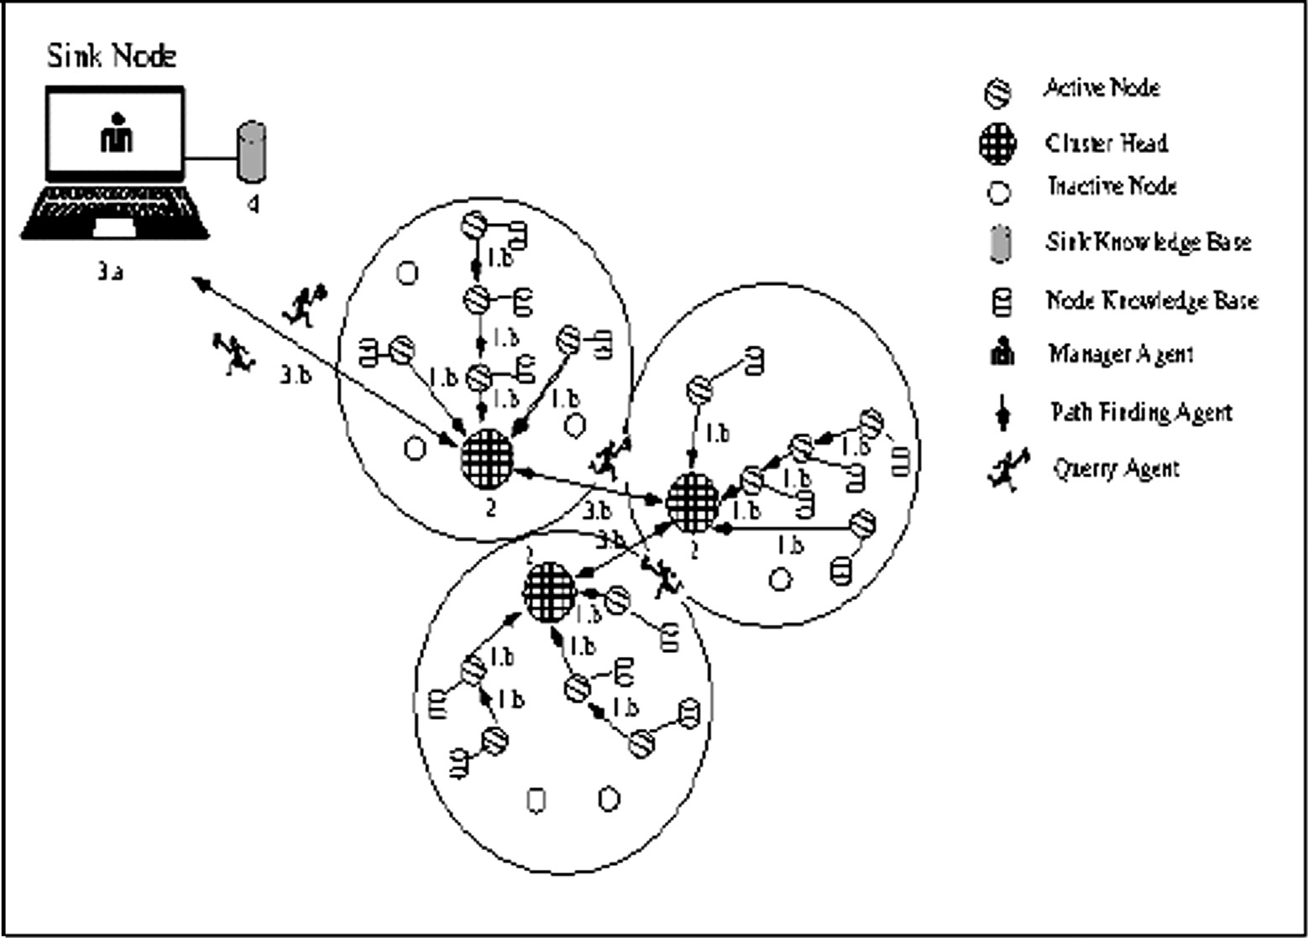

Fig. 5. Agent Interactions.

* 1. Sensor node senses the information and updates it in the NKB whenever the context is detected.
  2. SMA sends the status as active to its cluster heads.

1. SMA generates PFA and its clone for route discovery and sends the sensed information to the cluster head. All the infor- mation from all the sensor nodes is stored in the cluster head.
2. Sink node agent interaction information can be explained as given below:
   1. The MA generates the QA and provides the routing information.
   2. The QA reaches the farthest cluster head and collects the information. The farthest cluster is decided based on Euclidian distance. The QA reaches next nearest cluster and collects the information from cluster head. Likewise, QA collects and fuses the information from all sensor nodes and reaches the sink node.
3. Then MA of sink node updates SKB and provides the information of all the sensor nodes to the user. If required, MA takes necessary action by turning on/off the sprinkler or motor.
   1. *Proposed algorithms*

Nomenclature:

n: number of nodes, i: sensed information of sensor nodes, ith: threshold values, nactive: active node, ninactive: inactive node, SMA: Sensor Manager Agent, PFA: Path Finding Agent, MA: Sink node Manager Agent, QA: Querry Agent, CH: Cluster Head

Algorithm 2: Agent Interactions

1: Begin

2: for i in 1: n loop 3:SMA checks for nactive 4:if n = nactive then

6:if i ≥ ith then 5:SMA updates NKB with i

7:SMA generates PFA and sends it to respective CH

8:MA generates QA which aggregates and collects i from every CH

9:else 10:drop i 11:end if 12:else

13:n = ninactive 14:end if

15: end for

16: End

*Nomenclature:*

i: Information from various sensor nodes, ith: Threshold val- ues, i1th: Healthy plant images stored in database, i2th: Images of useful plants stored in database, i3th: Soil moisture, i3thmax: Maximum threshold of soil moisture which is 100%, i4th: Soil temperature, i5th: Temperature of the field, i6th: Carbon monoxide level, i1, i2: Camera Sensors, i3, i4: Soil fertility sen- sors (soil moisture and soil temperature respectively), i5, i6: Fire detection sensors (Temperature and Carbon Monoxide respectively)

Algorithm 3: Context Detection

1: Begin

2: While (i)

3: if i = i1 then goto Disease_detection 4:else if i = i2 then goto Growth_weeds 5:else if i = i3 or i = i4 then goto Soil_fertility

6:else if i = i5 or i = i6 then goto Fire_detection 7:else goto End

8:end if

9: end while

10: End

11: Begin Disease_detection 12: if i1 = i1th then

13: drop i1

14: else

15: update NKB

16: end if

17: End Disease_detection 18: Begin Growth _weeds 19: if i2 = i2th then

20: drop i2

21: else

22: update NKB

23: end if

24: End Growth_weeds

26: while (i3 ≤ i3thmax) 25: Begin Soil_fertility

27: if i3 < i3th and i4 ≥ i4th then

28: update the NKB

29: MA turns on the motor 30: else if i3 < i3th then

31: MA turns on the motor 32: else

33: drop i3, i4 34: end if

35: end while

36: End Soil_fertility

37: Begin Fire_detection

38: if i6 ≥ i6th and i7 ≥ i7th then

39: update the NKB

40:MA triggers the alarm and turns on the sprinkler 41: else

42:drop i6, i7 43: end if

44: End Fire_detection

1. Simulation model and performance parameter

The simulation of the proposed model is done using the NS2 platform. We discuss a generalized simulation model, simulation procedure and some of the performance parameters.

* 1. *Simulation model*

In the simulation model, we consider ‘‘N” number of nodes in the area of length ‘‘L” and breadth ‘‘B”. A network consists of N sta- tic nodes that are randomly placed within a given area. We find

Table 5

|  |  |  |
| --- | --- | --- |
| Simulation Inputs. |  | |
| Parameter | Notation | Value |
| Length | L | 5000 m |
| Breadth | B | 5000 m |
| Number of nodes | N | 1–80 |
| Transmission range | Rx | 300 m–500 m |
| Varying Image Sizes | px | 32 × 32, 64 × 64, 128 × 128, 256 × 256 |
|  |  | (8, 12, 16, 24) bits/pixel |
| Bandwidth | Bw | 4 Mbps |

some static and mobile agents between sensor nodes and sink node.

The transmission of packets is assumed to occur in discrete time. A node receives all packets heading to it during receiving interval unless the sender node is in a non-active state. For simplic- ity, we have considered the channel to be error free. Table 5 shows the various simulation inputs considered.

* 1. *Simulation procedure*

Simulation procedure involves following steps:

1. Generate sensor network environment.
2. Sensor node sends the context information to sink node.
3. Apply the proposed scheme.
4. Compute performance parameters of the system.
   1. *Performance parameters*

Some of the performances considered to evaluate the proposed scheme are as follows:

* Delay: It is the time taken to send the sensed information from the sensor node to the sink node. It is expressed in terms of

milliseconds.

* Cluster head selection time: It is the time taken to form the clusters and select the cluster head based on the energy. It is

expressed in terms of milliseconds.

* Context detection time: It is the time required to sense the information and detect the context. It is expressed in terms of

milliseconds.

* Energy consumption: It is the total energy required to transmit the data from sensor nodes to the sink node. It is expressed in

terms of millijoules.

* Fusion time: It is the time taken to fuse the information from all the sensor nodes and transmit to the sink node. It is

expressed in terms of milliseconds.

* Correlation: It is the mutual connection between two sensor nodes. For multimedia data, correlation can also be considered

as similarity measurement between two frames.

1. Results

This section consists of various simulation results of this work such as cluster head selection time, delay, context detection time, energy consumption, fusion time and so on.

* 1. *Delay based on communication range and number of nodes deployed*

As the number of nodes increases, there is a gradual increase in the delay of each sensor nodes. As the communication range and the number of nodes increases, there is a gradual increase in the delay as shown in Fig. 6.

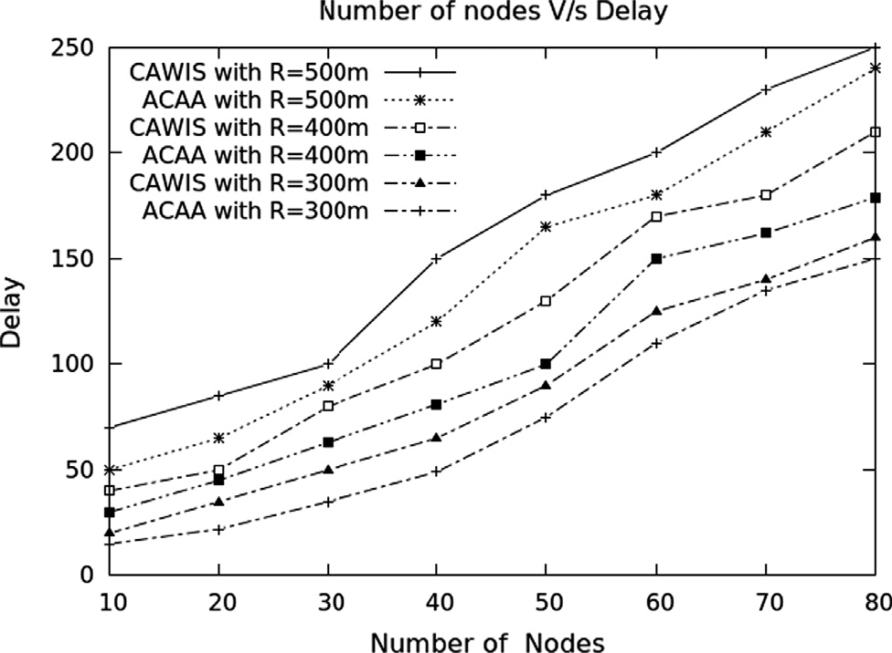

Fig. 6. Number of Transmitting Nodes vs. Delay in milliseconds.

* 1. *Cluster head selection time based on the communication range*

As the number of nodes increases, the time taken to form clus- ters is more, as shown in Fig. 7. Hence the time taken to select the cluster head is also more. As the communication range increases the number of sensor nodes increases hence the time taken to select cluster head is more.

* 1. *Context detection time based on the communication range*

As the number of sensor node increases, the time taken for con- text detection also increases. From the Fig. 8, it can be understood that, as the communication range increases the time taken for con- text detection will be more.

* 1. *Energy consumption based on communication range and number of nodes*

As the number of sensor nodes increases, the energy required to transmit the information from sensor nodes to sink node will be more. Hence the energy consumption will be more as the number of nodes is involved in the communication. As the communication range increases the distance between sensor nodes and sink node increases hence the energy consumption is more. Fig. 9 shows the energy consumption for different transmission ranges.

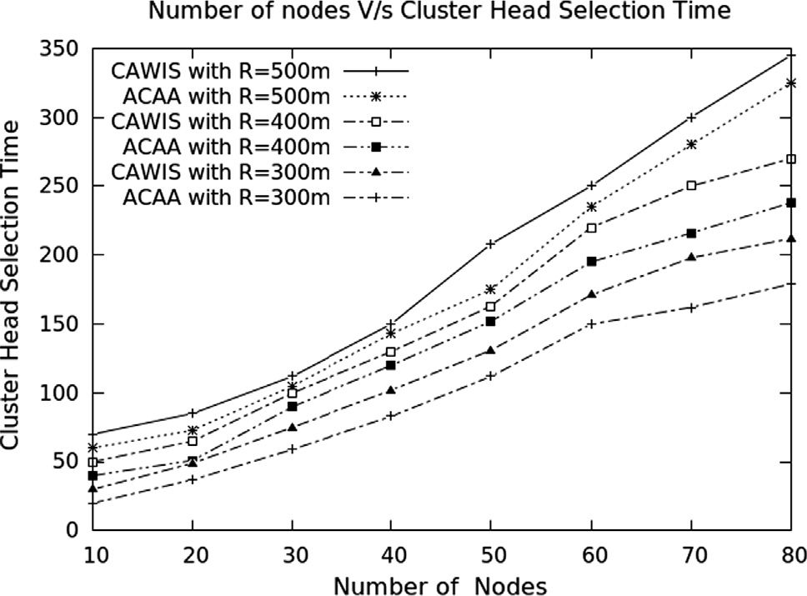

Fig. 7. Number of Transmitting Nodes vs. Cluster Head Selection Time in milliseconds.

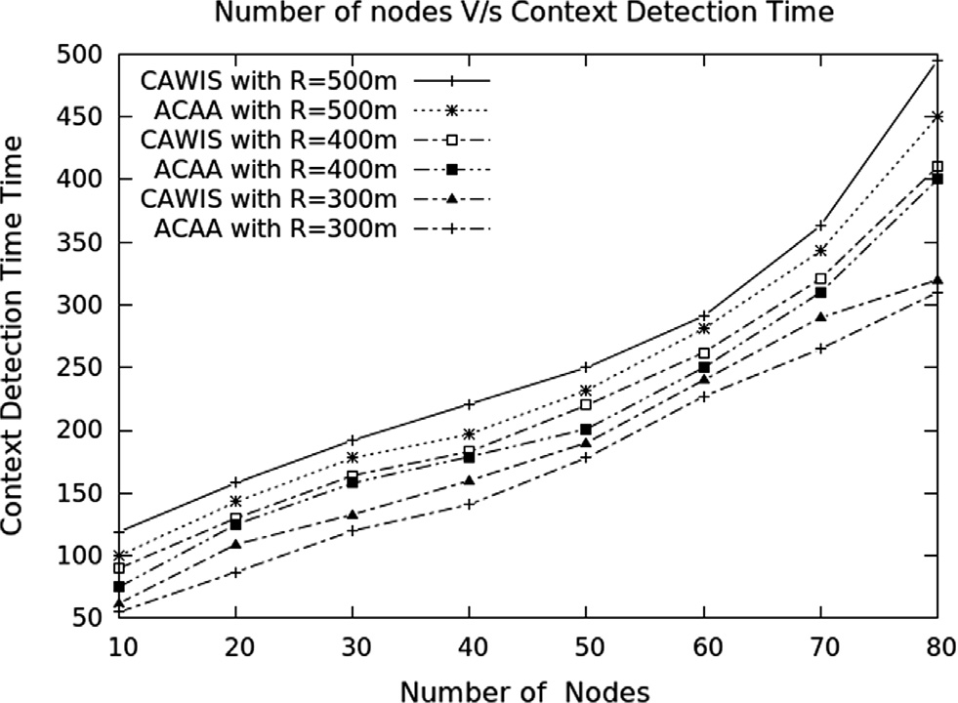 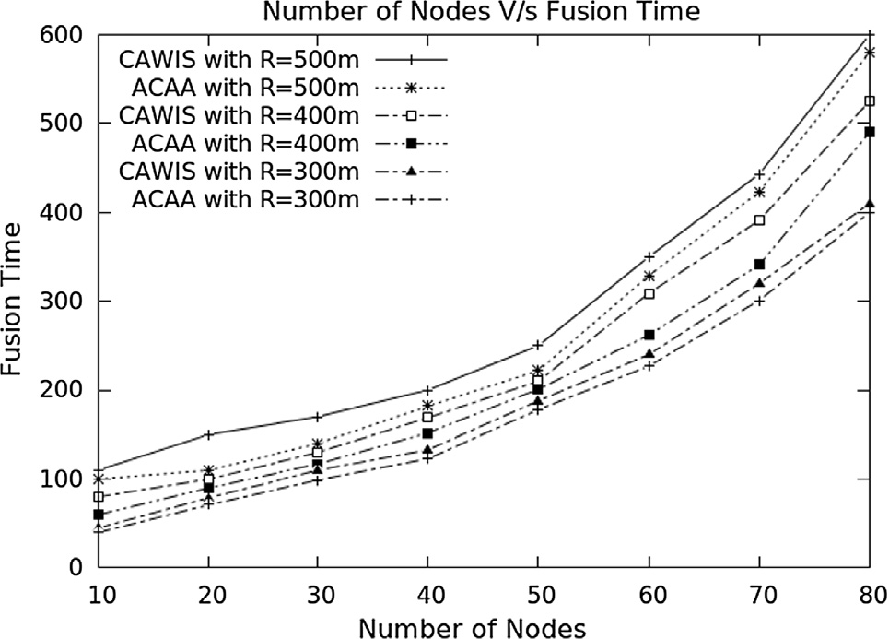

Fig. 8. Number of Transmitting Nodes vs. Context Detection Time in milliseconds.

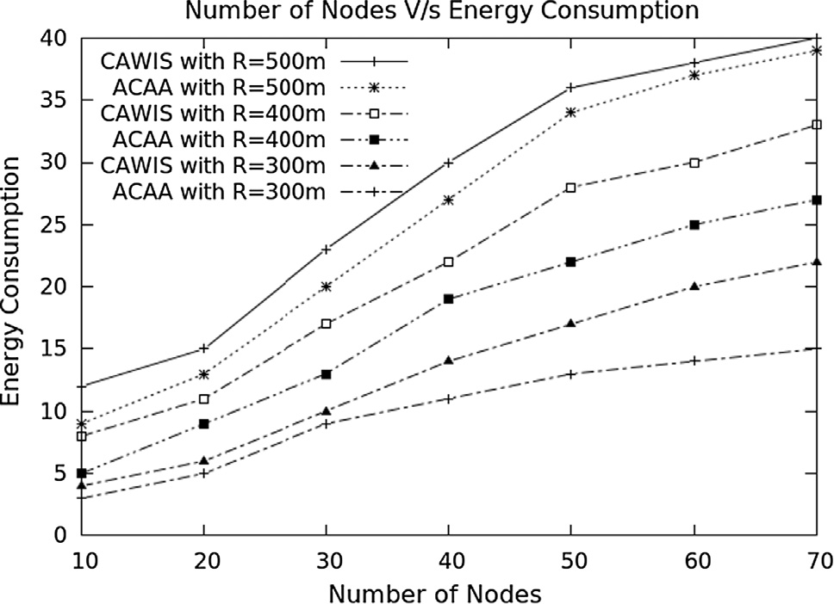

Fig. 9. Number of Transmitting Nodes vs. Energy Consumption in millijoules.

* 1. *Fusion time based on communication range and number of nodes*

As the number of nodes increases the information sensed in each sensor nodes will be more. All the sensed information after comparing has to be fused and sent to sink node. Also as the com- munication range increases the time required for fusion will be more. Fig. 10 shows the time taken for fusion of information based on communication range and number of nodes.

* 1. *Correlation based on sensing range and number of nodes*

Correlation is the mutual connection between two sensor nodes. As the number of nodes increases the correlation between nodes also increases. In Fig. 11, the communication range is consid- ered to be 300 m. As the sensing range and the number of nodes deployed in the communication range increases, the correlation among nodes increases.

* 1. *Context detection time based on context*

As the number of nodes increases the time required for context detection will be more. Context such as fertility of the soil and fire detection require less time when compared to disease detection and weeds detection. Images are transmitted for disease and weeds detection, hence the time required for disease detection and weeds detection will be more as shown in Fig. 12.

Fig. 10. Number of Transmitting Nodes vs. Fusion Time in milliseconds.

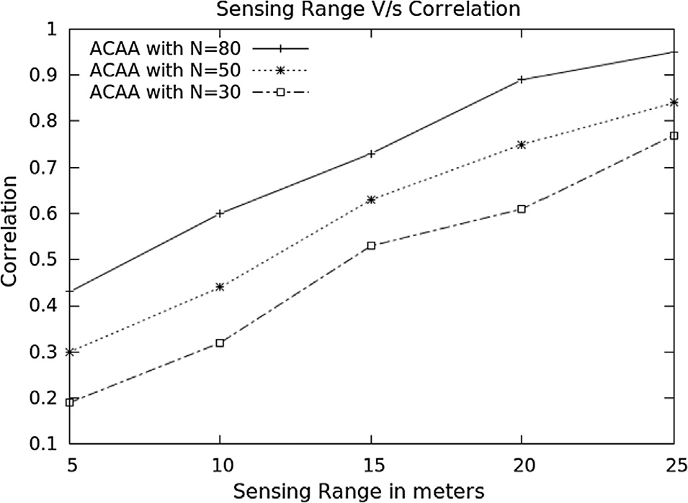

Fig. 11. Sensing Range vs. Correlation.

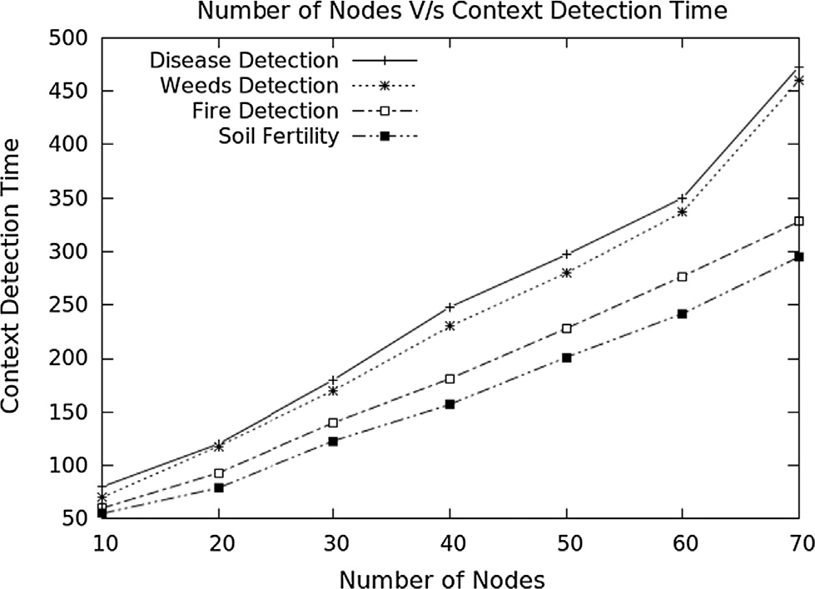

Fig. 12. Number of Transmitting Nodes vs. Context Detection Time in milliseconds.

* 1. *Energy consumption based on context*

As the number of nodes increases the energy required for con- text detection will be more. Context such as fertility of the soil and fire detection require less energy compared to disease detection and weeds detection as represented in Fig. 13. As images are trans-

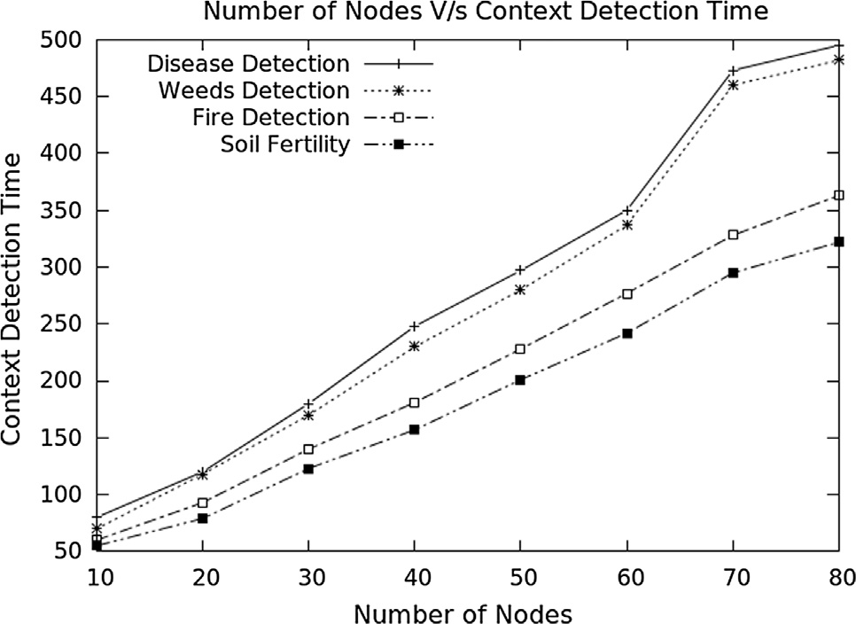

Fig. 13. Number of Transmitting Nodes vs. Context Aware Energy Consumption in millijoules.

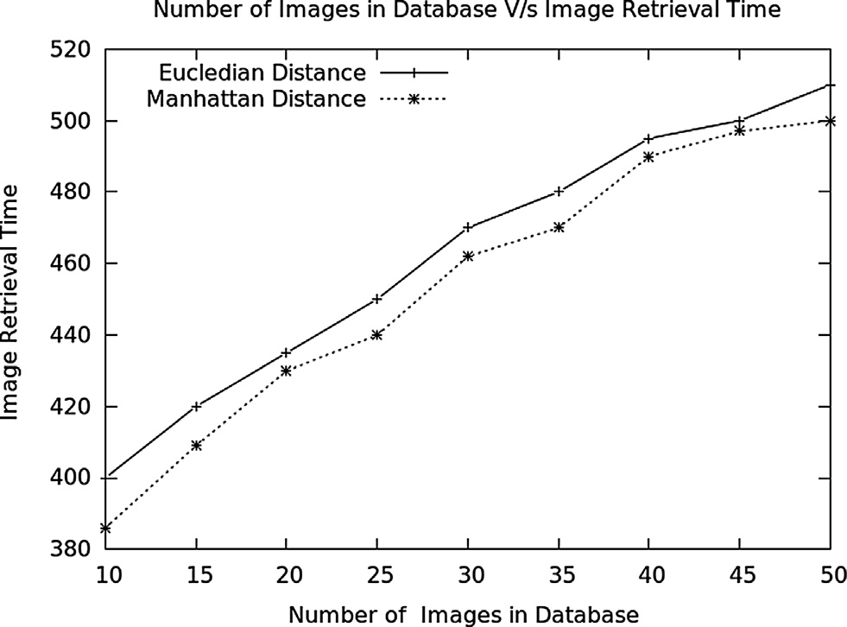

Fig. 14. Number of Images in Database vs. Image Retrieval Time in milli seconds.

mitted for disease and weeds detection, the energy consumed for disease detection and weeds detection is more.

* 1. *Image retrieval time in CBIR*

The image retrieval time for similarity measurement using Manhattan distance and Euclidean distance is plotted in Fig. 14. According to the results, Manhattan distance has better retrieval time and hence it is considered in the proposed work. As the num- ber of images in database increases, the image retrieval time also increases gradually.

1. Conclusion

A multi-agent based context-aware information gathering for monitoring agriculture using WMSN is proposed in this article. The sensor node senses the data and updates the knowledge base. Sensor node comprises of an agent platform with static and mobile agents, camera and other sensory devices such as soil pH, moisture, temperature, smoke, etc. The sensor node forms a cluster on its own based on the communication range. Once the information is sensed by the sensor node, it compares the information with the threshold value; if it is not in range, a message is sent to sink node via cluster head using the multi-hop technique. Information from

different active nodes is fused and sent to the sink node using mobile agents. The end user can access the reliable information at the sink node whenever required. As compared to CAWIS, the proposed agent-based context-aware system for agriculture (ACAA) to gather information using WMSN, performed better in terms of context detection time, delay, fusion time and energy con- sumption. The work can be extended by considering video sensors for intrusion detection along with the other sensing parameters considered in this work. For bigger crop fields the work can be extended by incorporating multiple sink nodes to perform better.

References

1. [Akyildiz Ian F, Weilian Su, Sankarasubramaniam Yogesh, Cayirci Erdal. A](http://refhub.elsevier.com/S1110-8665(17)30185-8/h0005) [Survey on Sensor Networks Georgia Institute of Technology. J Comput](http://refhub.elsevier.com/S1110-8665(17)30185-8/h0005) [Networks 2002;38](http://refhub.elsevier.com/S1110-8665(17)30185-8/h0005).
2. Islam T. Almalkawi, Manel Guerrero Zapata, Jamal N. Al-Karakiand, Julian Morillo-Pozo. Wireless Multimedia Sensor Networks: Current Trends and Future Directions. Sensors 2010;10,6662–6717; doi:https://doi.org//10.3390/ s100706662.
3. [Davis Thomas, Pang Qing, Skelton Gordon W, Meghanathan Natarajan. On the](http://refhub.elsevier.com/S1110-8665(17)30185-8/h0015) [Design and Implementation of Wireless Multimedia Sensor Networks. Int J](http://refhub.elsevier.com/S1110-8665(17)30185-8/h0015) [Next-Generation Networks (IJNGN) 2010;2(3)](http://refhub.elsevier.com/S1110-8665(17)30185-8/h0015).
4. Charith Perera, Arkady Zaslavsky, Peter Christen. Dimitrios Georgakopoulos, ‘‘Context Aware Computing for The Internet of Things: A Survey”. IEEE Commun Surveys Tutorials 16(1), DOI: https://doi.org//10.1109/ SURV.2013.042313.00197.
5. [Dagdeviren Orhan, Korkmaz Ilker, Tekbacak Fatih, Erciyes Kayhan. A Survey of](http://refhub.elsevier.com/S1110-8665(17)30185-8/h0025) [Agent Technologies for Wireless Sensor Networks. IETE Technical Rev 2011;28](http://refhub.elsevier.com/S1110-8665(17)30185-8/h0025) [(2)](http://refhub.elsevier.com/S1110-8665(17)30185-8/h0025).
6. K. Dang, H. Sun, C. Jean-Pierre, J. Garcia-Vidal, J.M. Barcelo-Ordinas, H.L. Shi, K.

M. Hou. Wireless Multimedia Sensor Network for plant disease detections”. @https://hal.archives-ouvertes.fr/docs/.

1. [Awati JS, Patil VS. Automatic Irrigation Control by using wireless sensor](http://refhub.elsevier.com/S1110-8665(17)30185-8/h0035) [networks. J Exclusive Manage Sci Jun 2012;1:332–7](http://refhub.elsevier.com/S1110-8665(17)30185-8/h0035).
2. Jayant P. Pawar, Dr. Prashant V. Ingole, Aparna R. Kadam. Context-Aware Wireless Sensor Grid Implementation for Agriculture. IJECET 2013;4.
3. Aqeel-ur-Rehman, Zubair A. Shaikh. Towards Design of Context-Aware Sensor Grid Framework for Agriculture. World Academy of Science, Engineering and Technology, Vol 2, Feb 2008.
4. Siuli Roy, Somprakash Bandyopadhyay. A Test-bed on Real-time Monitoring of Agricultural Parameters using Wireless Sensor Networks for Precision Agriculture.@https://facultylive.iimcal.ac.in/.
5. N. Sakthipriya. An Effective Method for Crop Monitoring Using Wireless Sensor Network. Middle-East J Scientific Res 20 2014;9.
6. Hong Ling Shi, Kun Mean Hou, Xunxing Diao, Liu Xing, Jian-Jin Li, Christophe de Vaulx. A Wireless Multimedia Sensor Network Platform for Environmental Event Detection Dedicated to Precision [Agriculture.@edss.isima.fr/.](mailto:Agriculture.@edss.isima.fr)
7. Jyotitewari, Swatiarya, Premnarayansingh. Approach of Intelligent Software Agents in Future Development. 2013;3.
8. Edison Pignaton de Freitas§, Tales Heimfarth, Ivayr Farah Netto, Alex Guimarães Cardoso de Sá, Carlos Eduardo Pereira, Armando Morado Ferreira, FlávioRech Wagner, Tony Larsson. Enhanced Wireless Sensor Network Setup Strategy Supported by Intelligent Software Agents. IEEE 2010.
9. Ashok V. Sutagundar, S.S. Manvi. Context Aware Multisensor Image Fusion for Military Sensor Networks using Multi-Agent system. International Journal of Ad hoc, Sensor & Ubiquitous Computing (IJASUC) 2011;2.
10. Manjesh Keshtgari, Amene Deljoo. A Wireless Sensor Network Solution for Precision Agriculture Based on Zigbee Technology. Wireless Sensor Network, 2012, 4, 25–30, Scientific Research. @doi: https://doi.org//10.4236/wsn-

2012.41004.

1. [Chaudhary DD, Nayse SP, Waghmare LM. Application of Wireless Sensor](http://refhub.elsevier.com/S1110-8665(17)30185-8/h0085) [Networks for Greenhouse Parameter Control in Precision Agriculture. Int J](http://refhub.elsevier.com/S1110-8665(17)30185-8/h0085) [Wireless Mobile Networks February 2011;3(N0):1](http://refhub.elsevier.com/S1110-8665(17)30185-8/h0085).
2. Thessler Shipra, Kooistra Lammer, Teye Frederick, Huitu Hanna, Bregt Anold K. Geosensors to Support Crop Production”: Current Applications and User Requirements. Sensors 2011;11:6656–84. doi: [https://doi.org/10.3390/](https://doi.org/10.3390/s110706656) [s110706656](https://doi.org/10.3390/s110706656).
3. Divya P, Sonkiya Surbhi, Das Preeti, Manjusha VV, Ramesh Maneesha V. CAWIS: Context Aware Wireless Irrigation System. IEEE Digital Library 2014. doi: <https://doi.org/10.1109/I4CT.2014.6914195>.
4. K. Nirmala, Dr. A. Subramani. Content-Based Image Retrieval System Using Auto Color Correlogram. J Comput Appl 2013;4(4).
5. Hari Hara Pavan Kumar Bhuravarjula, V.N.S. Vijaya Kumar. A Novel Image Retrieval Method Using Color Moments. Int J Electr Comput Sci Eng 2012;1(4).
6. S. Mangijao Singh, K. Hemachandran. Content Based Image Retrieval Using Color Moment and Gabor Texture Feature. Int J Comput Sci Issues 2012;9(1).
7. [Ekta Gupta and Rajendra Singh Kushwah. Combination of local, global and k-](http://refhub.elsevier.com/S1110-8665(17)30185-8/h0115) [mean using wavelet transforms for content based image retrieval. Int J Signal](http://refhub.elsevier.com/S1110-8665(17)30185-8/h0115) [Processing Image Processing Pattern Recognition 2015;8(6):253–66](http://refhub.elsevier.com/S1110-8665(17)30185-8/h0115).
8. Kondekar V.H., Kolkure V.S., Kore S.N. Image retrieval techniques based on image features: a state of art approach for CBIR. Int J Comput Sci Information Security 2010;7(1).
9. [Abd El-Kader Sherine M, Mohammad El-Basioni Basma M. Precision farming](http://refhub.elsevier.com/S1110-8665(17)30185-8/h0125) [solution in Egypt using the wireless sensor network technology. Egyptian](http://refhub.elsevier.com/S1110-8665(17)30185-8/h0125) [Informatics J 2013;14:221–33](http://refhub.elsevier.com/S1110-8665(17)30185-8/h0125).
10. [Sutagundar AV, Manvi SS. Location-aware event driven multipath routing in](http://refhub.elsevier.com/S1110-8665(17)30185-8/h0130) [Wireless Sensor Networks: agent-based approach. Egyptian Informatics J](http://refhub.elsevier.com/S1110-8665(17)30185-8/h0130) [2013;14:55–65](http://refhub.elsevier.com/S1110-8665(17)30185-8/h0130).
11. Heinzelman W, Chandrakasan A, Balakrishnan H. Energy-efficient communication protocol for wireless sensor networks. In: Proceedings of the Hawaii international conference system sciences; 2000.
12. A.V. Sutagundar, S.S, Manvi. Wheel based Event-Triggered Data Aggregation and Routing in Wireless Sensor Network: Multi-agent based Approach. Springer J Wireless Personal Commun March 2012.
13. A.V. Sutagundar, S.S, Manvi. Fish Bone Structure based Data Aggregation and Routing in Wireless Sensor Network: Multi-agent based Approach. Springer J Telecommun Syst, February 2012.
14. Swati Narsing Nandagawali, Parameters of Soil Fertility (As a Part of Project on Soil Parameters Monitoring With Automatic Irrigation System), Int J Electrical Electronics Res ISSN 2348–6988 (online), Vol 4, Issue 4, pp: (219–222), Month: October - December 2015, Available at: [www.researchpublish.com.](http://www.researchpublish.com/)
15. Andrey Somov. Wildfire safety with wireless sensor networks. ICST Trans Ambient Syst, October- December 2011, Volume 11, Issues 10–12, Available at: [www.icst.org](http://www.icst.org/)
16. Martin Weis, Roland Gerhards. Identification of weeds from digital images. Agricultural Field Trials 2007 - biometrische-gesellschaft.de.