Available online at [www.sciencedirect.com](http://www.sciencedirect.com/)

[Electronic Notes in Theoretical Computer Science 343 (2019) 3–17](https://doi.org/10.1016/j.entcs.2019.04.007)

[www.elsevier.com/locate/entcs](http://www.elsevier.com/locate/entcs)

Multi-model Short-term Prediction Schema for mHealth Empowering Asthma

Self-management

Otilia Kocsisa Aris Lalosa*,*b, Gerasimos Arvanitisa Konstantinos Moustakas a*,*1*,*2

a *Department of Electrical and Computer Engineering University of Patras*

*Patras, Greece*

b *Industrial Systems Institute ATHENA Research and Innovation Center*

*Platani-Patras, 26504, Greece*

**Abstract**

Ambient intelligence and machine learning techniques are widely proposed by various eHealth and mHealth applications for home-care and self-management of various chronic health conditions. Their adoption for self-management of asthma, a multifactorial chronic disease, requires evaluation and validation in a real-life setups along with optimization at patient level to personalize predictions with respect to asthma control status and exacerbation risk. The current work proposes a novel short-term prediction approach for asthma control status, considering training of multiple classification models for each monitored parameters along with necessary pre-processing methods to enhance robustness and efficiency. The machine learning algo- rithms considered in this study are the Support Vector Machines, the Random Forests, AdaBoost and Bayesian Network. The Random Forests and Support Vector Machines classifiers demonstrated overall superior performance for the case studies (models) considered.

*Keywords:* asthma control, personalized self-management, short-term prediction, machine learning algorithms, decision support system, mHealth.

# Introduction

The currently large amounts of data being automatically collected in various ap- plication domains, including health, requires also automatic processing means to extract meaningful high level information for health risk assessment. Artificial Intel- ligence (AI) and Machine Learning (ML) techniques are widely used to pre-process

1 This work has been partially supported by the myAirCoach project (GA no.643607), EU H2020.Self- management of health and disease: citizen engagement and mHealth.

2 Email: [okocsis@bok.gr,](mailto:okocsis@bok.gr) [aris.lalos@ece.upatras.gr,](mailto:aris.lalos@ece.upatras.gr) [arvanitis@ece.upatras.gr,](mailto:arvanitis@ece.upatras.gr) [moustakas@ece.upatras.gr](mailto:moustakas@ece.upatras.gr)

<https://doi.org/10.1016/j.entcs.2019.04.007> 1571-0661/© 2019 Published by Elsevier B.V.

This is an open access article under the CC BY-NC-ND license (<http://creativecommons.org/licenses/by-nc-nd/4.0/>).

the data (e.g. optimize collection and transmission, de-noise and complete data), extract features and identify patterns in order to predict future behaviours and po- tential problems, thus allowing for decision support and preventive actions. In the health domain, the usage of mobile, wearable, pervasive and smart sensing tech- nologies have boosted the implementation of eHealth and mHealth applications for home-care and self-management of various chronic health conditions (e.g. diabetes, cardiac diseases) [1] [2] [3], including asthma and other respiratory diseases [4], [5]. At global level, an increasing trend in the percentage of older population is observed (we live longer) [6], which is accompanied by an increased need for home-care health services and pro-active support and prevention (predict a potential problem early to avoid associated health complications, need of hospitalization and increased health- care costs) [2], [3], [4]. Taking into account the increased prevalence of chronic diseases among the older adults and the long-term monitoring requirements, the proposed solutions must have the capability to: (i) cope with missing data (e.g. a sensor may fail to gather data or the user may forget to fill in a questionnaire) ,

(ii) efficiently transmit and store dense measurements (e.g. continuous monitoring

of activity), (iii) process and interpret heterogeneous datasets, and (iv) personal- ize risk assessment, predictions and feedback to specific conditions and individual patients [7].

Asthma is a multifactorial, chronic inflammatory disease of the airways (breath- ing tubes), which has a high prevalence worldwide, and without adequate healthcare management can lead to death, especially for the older adults. Recent efforts have been oriented towards establishing guidelines and monitoring strategies to assess asthma severity and control, and have highlighted the importance of identification of future risk of deterioration in the management of asthma [8]. Various instru- ments are in place to identify and measure asthma symptoms and severity, along with well established therapies and self-management protocols [9], [10]. However, it appears that due to the heterogeneity and complexity of the disease, new holistic and personalized management approaches are needed [7] to increase efficiency of interventions. Furthermore, a large number of patients do not fully adhere to the self-management programme and their disease management is poor [11], thus re- quiring specific knowledge and understanding on what triggers their asthma attack and how to avoid these triggers in the daily management of the disease, while being supported and guided to respond quickly to worsening of their asthma in order to maintain a good quality of life and avoid hospitalization.

More specifically, previous works were focused on monitoring and assessing asthma control through a limited set of parameters, most of the times consider- ing the Asthma Control Diary (ACD) or the Asthma Quality of Life Questionnaire (AQLQ) [12] [13], along with the Forced Expiratory Volume in the first second (FEV1) and/or the exhaled nitric oxide (FeNO) [14] [15]. Recently, an increasing number of mHealth applications are exploiting the advances of Information and Communication Technology (ICT) to deliver highly customizable, low-cost and eas- ily accessible self-management interventions to asthma patients [5], [16], [17], [18]. Older studies indicated that there is no clear conclusion with respect to the effec-

tiveness of mobile apps for the delivery of asthma self-management programs [16], which is however changing in the last years [19], [20], and both patients and health- care professionals are strongly supporting the mHealth interventions for asthma self-management [20] [21]. Furthermore, big data analytics using machine learning (ML) methods enable implementation of useful early predictors of risk of developing exacerbations [22], [23], [24], [25]. However, most of the proposed classification or regression prediction approaches only consider monitoring of one parameter (e.g. ACD or FEV1), focus on identifying who is at risk of developing an exacerbation and not when, and do not consider short-term personalized prediction of asthma control status to allow for personalized patient guidance in order to reduce the exacerbation risk.

myAirCoach project developed an asthma monitoring platform using personal- ized mHealth to help patients manage their asthma condition and increase their awareness of their clinical state, as well as the adherence and effectiveness of the medical treatment [26]. The integrated sensors monitor several physiological, be- havioural and environmental factors [27], which are further processed and aggre- gated to provide clinicians early indications of increasing symptoms or exacerbations and provide tools for clinical decision support [32].

The work presented in this paper focuses on the design aspects and first pro- totype implementation of the personalized Decision Support System (DSS) of the myAirCoach platform. More specifically, this work proposes a novel multi-model approach for the short-term prediction of asthma control status, which provides flexibility with respect to the set of collected clinical parameters for the implemen- tation of the rule-based decision support and allows for personalized guidance of the patients for optimal self-management of their asthma condition. The remaining sections of this paper are organized as follows: the Methods section provides an overview of the myAirCoach DSS, along with details on the short-term prediction approach proposed, including the machine learning algorithms used to train the models, the dataset and experimental setup and the annotation and pre-processing steps; the Results section presents the results of the ACD-based short-term predic- tion and the multi-parameter personalized short-term prediction results; and the last section discusses the limitations of the current study and future work, and presents the conclusion of the current study.

# Methods

Asthma is characterized by acute episodic deterioration (exacerbations) against a background of chronic persistent inflammation and/or structural changes that may be associated with persistent symptoms and reduced lung function. Currently there is no single outcome measure to assess asthma control, and its assessment should include components relevant to both asthma treatment and reduction of future risk of exacerbations. The detailed study protocol of the 1-year observational study for the use of myAirCoach home-monitoring and mHealth system to predict dete- rioration in asthma and the occurrence of asthma exacerbations clearly defines all

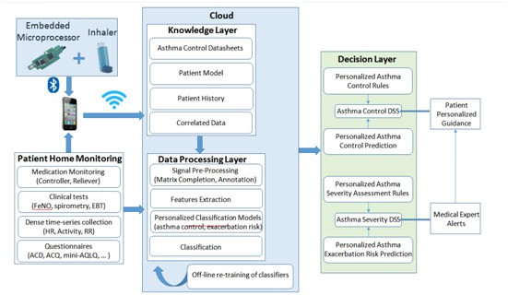

Fig. 1. Architecture design of the DSS.

procedures and measurements [27]. Increasing the daily control of asthma through well-targeted self-management and personalized interventions has the potential to decrease the risk of developing exacerbations [12], [28], [29]. Thus, in the design of the DSS implemented in myAirCoach platform one of the major importance aspects is to optimize and personalize the short-term prediction of asthma control taking into account the established home monitoring procedures and measurements.

* 1. *Personalized Decision Support System*

Patient support and guidance through web-based self-management tools has demon- strated encouraging results with respect to improvement of asthma-related quality of life and asthma control both on the short- and long-term, and it is currently preferred by the patients [5], [21], [30], [31] as compared to frequent visits to the health care centers. Although recently the number of mobile applications available on the market is increasing fast, most of them do not provide adequate tools for asthma self-management and none of them propose comprehensive guidance [18]. Furthermore, they do not integrate real-time heterogeneous data collection along with personalized prediction capabilities (e.g. selection of best available model for the specific patient).

The high-level architecture of the myAirCoach platform differentiates between:

(i) the Wireless Body Area Network (WBAN) including all sensing devices for home monitoring of the patient; (ii) the application layer, including both the mobile apps and server services for processing, prediction and visualization; and (iii) the knowl- edge layer for data storage [32]. The DSS, presented in Fig. 1, is one of the platform services running on the server side, which processes the data collected by the sensor

network in order to extract important high level information (e.g. warnings, alerts) both for patients and medical doctors. Machine learning algorithms are employed to train personalized classification models for two prediction tasks: short-term predic- tion of asthma control level and long-term prediction of exacerbation risks. For each type of prediction, the rule-based decision support modules are generating daily and real-time personalized patient advices and notifications, which are communicated to the patient mobile application and alerts for the medical personnel directed to the dedicated information visualization module.

The large amount of data collected and used by the myAirCoach system for the personalized guidance of the patient with respect to their optimal care self- management for asthma control and avoidance of exacerbations, imposes two major requirements on the design of the decision support system: automation of tasks and real-time processing. These are supported by a series of pre-processing algorithms, which are exploiting the heterogeneous knowledge layer along with the real-time home monitoring of patient physiology and environmental conditions, and include: annotation of control status and exacerbation events, identification of best predict- ing parameters per patient, completion of missing data and periodic retraining of personalized prediction models. As the focus of this work is the short-term pre- diction of asthma control, further details are provided in the following sections on the pre-processing tasks, the data set used to train the models and the experi- mental setup required for the implementation and testing of this component of the myAirCoach DSS.

* 1. *Asthma Control Status Annotation*

The ACD is one of the most recommended numerical asthma control tools, being considered as sensitive to change in symptom control and widely used by patients for self-monitoring of their asthma condition [9]. The ACD questionnaire is used to calculate a daily score from 0-6, where a score of 0.0-0.75 is classified as well-

controlled asthma (green), 0.75-1.5 is a grey zone (yellow), and *>* 1*.*5 as poorly

controlled asthma (red) [27]. The control status established through the use of the

ACD score is considered as ground through, as it provides a daily assessment of multiple symptoms along with medication usage.

When ACD data is not available in a consistent way for the long-term monitoring of asthma, other parameters can be monitored in order to similarly establish the asthma control status, including: asthma medication usage, including both the preventer (or controller) and the reliever inhalers; spirometry related measurements, such as the FEV1; and FeNO measurement. More specifically, in our study, the

controller daily usage is classified as: 0 (the patient forgot his medication) or *>* 8

(too much use) red; 1 (most controllers are required twice a day) or 7-8 (a bit too

much) yellow; and 2-6 (normal range green. The reliever usage is classified as green when not used, 1-2 times/day is yellow, and *>* 3 is red.

In Phase I of the myAirCoach quantification campaign [27], FEV1 is monitored twice daily through home-spirometry. Two different approaches for the calculation of FEV1 deviation were explored in a preliminary study [33]. The patient specific

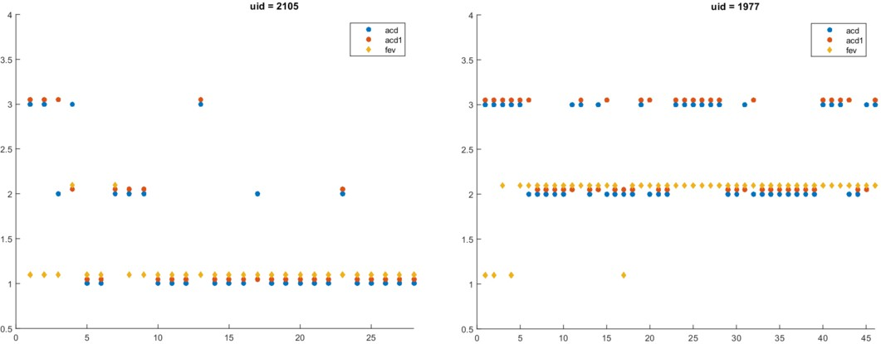

Fig. 2. Asthma control status automatic annotation derived by using the standard ACD-based status (acd), the modified ACD-based status (acd1) and the patient specific deviation of FEV1 (fev).

deviation of FEV1, calculated as percentage of the actual value of the personal best FEV1 measure, demonstrated slightly better prediction power and correlation to the ACD-based status, thus it has been adopted for the implementation of the myAirCoach prediction tasks. The personal best is identified as the best score of

FEV1 of each patient and a percentage of *>* 80 percent is classified as green (well- controlled), 60-80 percent is yellow and *<* 60 percent is red. FeNO is monitored daily at home, in the morning and evening, in a 10s exhalation manoeuvre, using a

device which provides audiovisual guidance and alerting when incorrectly used. A value *<* 25 ppb is classified as green, 25-50 is yellow and *>* 50 is red.

In addition to the standardized approach to establish the ACD-based asthma control status, an additional annotation approach is explored. The two main factors leading us to this approach are: (i) a deviation in score larger than 0.50 between two consecutive days is considered clinically significant, and (ii) for some patients (e.g. uncontrolled asthma) the baseline is not usually in the green status, but in the yellow zone. Thus, the proposed modified ACD-based annotation rule considers that the current day status changes only if the ACD average score deviates with more than 0.5 compared to the previous day, while the thresholds between status intervals are kept the same as in the standard approach.

The modified ACD-based status has the role of an outliers remover and it makes the transition between different status more smooth. Fig. 2 shows some examples of noticeable differences in asthma control status as derived by using the two ACD- based approaches (acd - standard ACD-based status, acd1 - modified ACD-based status) and the patient specific deviation of FEV1 (fev), for tow patients.

* 1. *Machine Learning Algorithms*

Pattern classification in machine learning focuses in recognition of patterns and regularities in data using learning algorithms, in order to divide entities into a finite number of classes. The learning algorithms, or classifiers, are trained using a training dataset (known class for each entity) in order to build a classification model

that best fits to the data. The resulted model must be able to fit to the training data optimally, but also to predict entities with unknown classes.

For the purpose of this study, we have selected 4 classification algorithms, namely: Support Vector Machines (SVM), Random Forests, AdaBoost and Bayesian Network. The first three classifiers have been tested on many databases from var- ious application domains and have proven overall superior performance [33]. Fur- thermore, these algorithms were also considered in our preliminary study [34]. In addition, the Bayesian Network classifier is also considered in the current work, as it has recently demonstrated good performance in the specific application domain, in the prediction task of asthma exacerbations [35].

Support Vector Machines (SVM) is a well-known kernel method for supervised learning, widely used in bioinformatics, and known to perform very well especially for the binary (2-class) problem even with the linear implementation. Kernels are employed for the non-linear classification, improving the accuracy for classification of high-dimensional entities. Gaussian and higher degree polynomial kernels are employed for a more flexible decision boundary, with the risk of overfitting.

Random Forests is a bagging (bootstrap aggregating) algorithm, used to per- form both regression and classification tasks. A large number of individual classifiers (usually between 500 and 1000) are built at training time, which are small classifica- tion trees, and are applied to different bootstrap samples of the training dataset. For the estimation of classification performance the out-of-bag (OOB) error is used. For each bootstrap sample used to build a tree, there are samples left behind, which are not included in the training set. The OOB performance is estimated as the average performance of individual models on their left out samples.

AdaBoost is a widely used classification boosting algorithm, which creates a highly accurate prediction rule (or strong learner) by combining many week and inaccurate rules (weak learners). The weak learners are slightly correlated with true classification while the strong learner is arbitrarily well-correlated with the true classification. Similarly to Random Forests, the AdaBoost weak learners are simple classification trees. Usually between 500 and 1000 weak classifiers are combined iteratively, and at each iteration the weights of misclassified entities are boosted (increased) and a score is assigned to each classifier. The linear combination of the classifiers from each stage builds the final classifier.

Bayesian Network classifier is based on a probabilistic directed acyclic graph, sta- tistically modeling a set of attributes (properties of an entity) and their conditional dependencies. Each node represents an attribute and has associated a probability function, and the conditional probability of an instance of a certain node is given by the relative frequencies of the associated attributes in the training data. The net- work structure is usually automatically learned from the training data by searching through the space of potential networks.

* 1. *Dataset*

The dataset used for the short term prediction of asthma control was collected dur- ing the implementation of Phase I of the myAirCoach observational study [27], and

consists of daily assessment of asthma control through various tools (e.g. ACD, spirometry) for a total of 76 patients. During this phase, a total of 1471 ACD questionnaires were filled online by the patients, the usage of reliever and controller was reported 1472 times, a total of 998 FeNO measurements were performed, and 3221 spirometry measurements were recorded. Being a dataset collected in real life conditions, from actual asthma patients who are self-monitoring their condition, this initial dataset is characterized by many consistency issues: failure to fill-in the ACD questionnaire on a daily basis, filling in the questionnaire twice and perform- ing only one spirometry measurement, performing FeNo measurement, but not the spirometry, failure to report on medicine usage on a daily basis, etc.

Taking into account the heterogeneity of the initial data set, and the aim to build personalized classification models considering an optimized multi-parametric approach, the dataset was cleaned by removing incomplete records (e.g. missing entries for one of the monitored parameters) and by removing patients that did not have a sufficiently long period (e.g. at least 3 days) of consecutive complete records. Finally, 786 unique registers from 55 patients satisfied the requirements, which are used for the creation of the dataset of this study. Each register represents a full set of daily measurements of all investigated parameters, such that it can be considered that it provides a complete description of patients asthma condition.

* 1. *Experimental Setup*

The statistical analysis in this study was accomplished using R language as an entire environmental tool which contains implemented functions and a variety of classifiers, including SVM, Random Forests, AdaBoost and Bayesian Network. In order to evaluate the classification results of each used classifier, due to the rather small size of the data set, we utilized 10-fold cross validation, as a more robust approach for predictive accuracy estimation. Reported overall classification accuracy is defined as the percent of samples that were classified correctly when the trained model is applied back to the data used to train it. The process to reach the training of the various classification models used by the multi-model schema for personalized prediction of asthma control status is presented in the following.

In a first study the four different classifiers were extensively tested with respect to their prediction capability using only the ACD measurements. More specifically, the ACD scores of previous days as used as features (input variables) and the current day control status, determined from the assessment of current day ACD score, as annotation variable. Both, the standard and the modified methods were considered for the annotation of the control status based on the ACD score. The 3 previous ACD scores used as input are collected (reported by the patient) in a window of

(a) 3 days - consistent day-to-day data collection, (b) 5 days training data set is expanded to include also data characterized by moderate inconsistency; and (c) 7 days training data set is expanded to include also data characterized by high level of inconsistency. In Fig.3 the automatic annotation process and the training of models is shown.

Preliminary tests demonstrated that using more than 3 ACD scores collected in

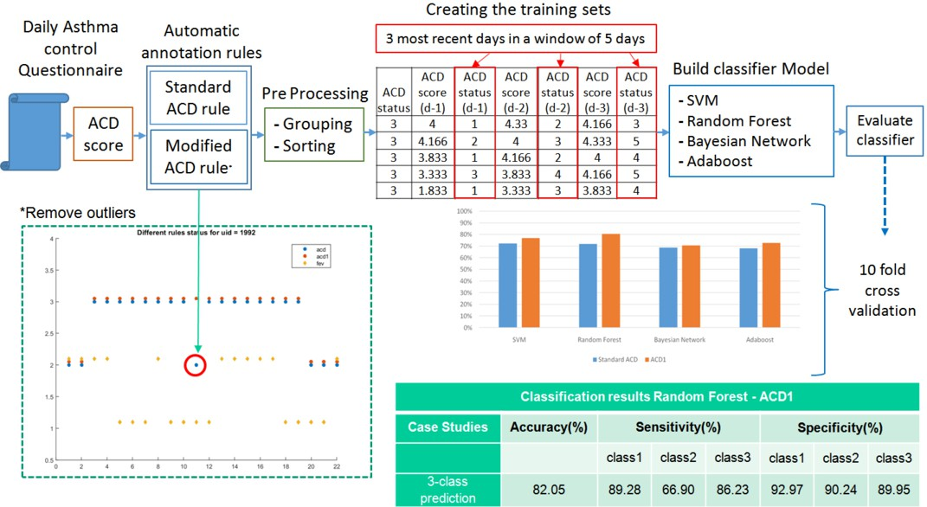

Fig. 3. Schematic representation of the ACD-based classification models training process.

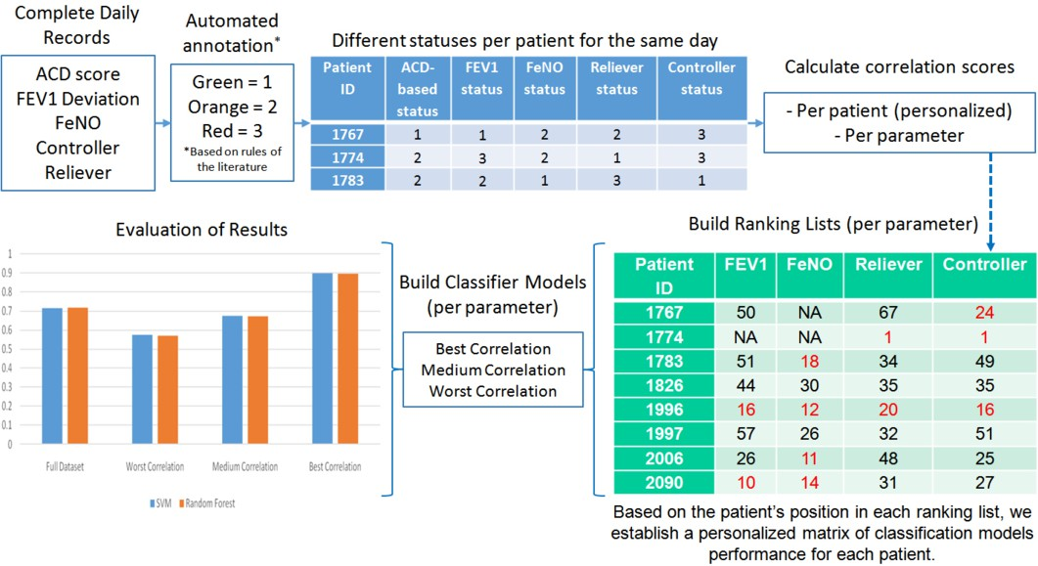

Fig. 4. Schematic representation of the ranking lists generation.

a time frame of up to 10 days did not significantly improve the accuracy, although additional statistical features extracted from the data were used. As a result, the 3 cases (3-days window, 5-days window and 7-days window) are considered to build the ACD-based generic classification models (all patient records are used). In the next step (see Fig.4), for the currently available dataset, patient ranking lists are automatically generated for each monitored parameter, indicating the correlation degree between the asthma control status established using the specific parameter and the ACD-based control status. At runtime, the patient ranking lists are updated after each retraining of the generic classification models. This step is followed by

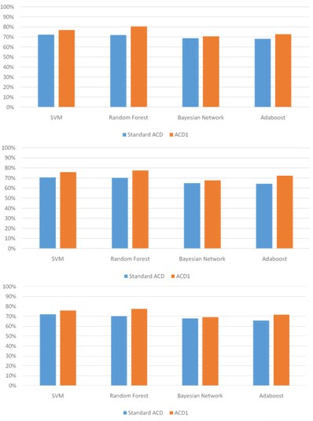

Fig. 5. Accuracy of short-term prediction of asthma control using previous days ACD scores (up - 3-day window, middle - 5-day window, bottom - 7-day window).

training a different classification model for each 1/3 of the patients in the ranking lists.

It was observed that for the top 1/3 patients in each ranking list the specific pa- rameter has prediction power significantly higher than that of the approach based on ACD alone. Based on the position of each patient in each ranking list, for each pa- tient we establish a personalized matrix of classification models performance, which is further exploited by the rule-based intervention module of the DSS to generate personalized patient guidance instructions or alerts for the medical personnel. As a result, at runtime the DSS will use a different matrix of classification models per patient for each short-term prediction task (as indicated in Fig.4), depending on the completeness of the incoming data and on the position of the patient in each ranking list.

# Results

The potential of the considered machine learning algorithms with respect to ACD- based short-term prediction of asthma control has been tested for a total of six cases,

by considering three different input scenarios and two potential output variables. The input variables used as features for the trained models are three ACD scores reported by the patient in previous days, being collected in a window of (a) 3 days,

(b) 5 days, and (c) 7 days. The two potential output variables are: (1) the standard ACD class, derived from the ACD score by applying the usual annotation rule; and

(2) the modified ACD class (ACD1), derived from the ACD score by applying the modified annotation rule which considers that there is a change in status if there is a deviation of more than 0.5 as compared to previous day. The comparative results with respect to the achieved overall accuracy for these six cases are presented in Fig.5.

Best accuracy, of 80.41 percent, is demonstrated by the Random Forests algo- rithm in the case of consistent data collection (ACD reported daily during previous 3 days) and using the modified ACD annotation rule (ACD1) to establish the output asthma control classes. Overall, SVM and Random Forests algorithms demonstrate superior performance in all cases when compared to the AdaBoost and the Bayesian Network algorithms for the ACD-based short-term prediction task. With respect to the data collection window, the accuracy of all algorithms is slightly decreased when the training data includes also samples of inconsistent data collection.

The addition of other collected data (e.g. FEV1) as features to the ACD scores collected in a 3-day window does not improve significantly the accuracy of the short-term prediction models, but there is a significant increase in accuracy for the partition of the data set characterized by the best correlation between FEV1-based and ACD-based asthma control status (see Fig.6). Although in the case of full dataset, the two considered algorithms, SVM and Random Forests, show better accuracy when using the modified ACD rule to establish the output classes (ACD1 case), there is no significant difference between the accuracy of the algorithms in the case of best correlated partition of the dataset. When considering FEV1 alone, it is observed that it has a very good short-term predictive power for the best correlated dataset when using as input the FEV1 measurements collected during previous days (3-day window).

With respect to other monitored parameters, similarly, the prediction models were constructed using both the full dataset and the rank-based partitions datasets, using the best performing algorithms, SVM and Random Forests. The current day measurement of the specific parameter (e.g. FeNO, Controller, Reliever) was used as input variable, while the standard ACD asthma control status of that day was used as annotation variable. As shown in Fig.7, the prediction accuracy for the best correlated partition of the dataset always outperforms the accuracy of the full dataset for all parameters, and in many cases performs better than the ACD-based prediction models.

# Discussion and Conclusion

AI tools and mHealth interventions have the potential to positively impact on pa- tient self-management of chronic conditions, and the uptake of such interventions

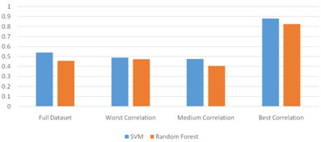

Fig. 6. Prediction accuracy using previous days FEV1 values (3-day window) as input variables and standard ACD as annotation variable.

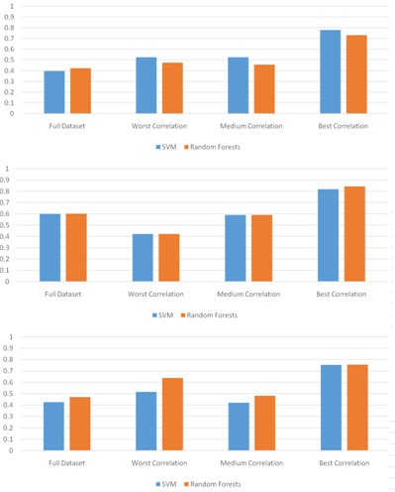

Fig. 7. Prediction accuracy using current day FeNO (top), Reliever (middle) and Controller (bottom) measurements.

can be improved if they are adequately integrated into healthcare systems (e.g. as part of a service) and they implement features to facilitate action (e.g. decision support followed by task support) [36]. More specifically, with respect to mHealth intervention for asthma, older studies indicated that there is no clear conclusion with respect to the effectiveness of mobile apps for the delivery of asthma self- management programs [16]. However the technological advances and the increasing acceptance and usage of technology by older people have changed the trend, and in the last years both patients and healthcare professionals are strongly support- ing the mHealth interventions for asthma self-management [19] [20]. The current work extensively investigated the potential of several machine learning algorithms, SVM, Random Forests, AdaBoost and Bayesian Network, with respect to their ac- curacy in the short-term prediction of asthma control status. Being part of the decision support system, the short-term prediction of asthma control status must work optimally in various conditions (inconsistent time series, not all parameters monitored for a certain patient, etc.) and allow for personalized patient guidance. Taking into account the results of the prediction tasks based on single and multiple parameters, as well as the performance of models trained on the rank-based parti- tions, a multi-model approach is adopted for the implementation of the short-term prediction component. This multi-model approach allows for personalization of the prediction, as each prediction task will result in a personalized prediction matrix, including details on the type of prediction, which are the best predicting models for the specific patient, and detailed prediction results for each model, including the rank-based models accuracy. Among the tested algorithms, the SVM and the Random Forests demonstrated overall best performance. However this result is not conclusive with respect to the adoption of a specific algorithm, as the data collec- tion campaign is not completed, and all algorithms will be further tested on a larger dataset.

# References

1. Andrea, B., Allison,L.G., Jonathan, W.M., Eiman, J., Agustn, C., Adolfo, R., “The impact of mobile health interventions on chronic disease outcomes in developing countries: a systematic review”, Telemedicine and e-Health, **20(1)**, 2014, 75–82.
2. Fatehi, F., Gray, L.C., Russell, A.W., “Mobile Health (mHealth) for Diabetes Care: Opportunities and Challenges”, Diabetes Technology and Therapeutics, 19(1), 2017.
3. Dale,L.P., Whittaker, R., Eyles, H., Mhurchu, C.N., Ball, K., Smith, N., Maddison, R., “Cardiovascular Disease Self-Management: Pilot Testing of an mHealth Healthy Eating Program”, J. Pers. Med., **4(1)**, 2014, pp.88-101.
4. Kocsis, O., Vasilopoulou, M., Tsopanoglou, A., Papaioannou, A., Vogiatzis, I., “Telemonitoring System for home rehabilitation of patients with COPD”, 5th IEEE International Conference on E-Health and Bioengineering (EHB 2015), Iasi, Romania, November 19-21, 2015.
5. Al-Dowaihi, D., Al-Ajlan, M., Al-Zahrani, N., Al-Quawayfili, N., Al-Jwiser, N., Kanjo, E., “mBreath: asthma monitoring system on the go”, International Conference on Computer Medical Applications (ICCMA), 2013.
6. United Nations, Department of Economic and Social Affairs, Population Division. World Population Ageing Report, 2015.
7. Chung, K.F., Personalised medicine in asthma: time for action, European Respiratory Review, **26**, 2017. DOI: 10.1183/16000617.0064-2017.
8. Reddel, H.K., Taylor, D.R., Bateman, E.D., Boulet, L.-P., Boushey, H.A., Busse, W.W., et all. “ An official American Thoracic Society/European Respiratory Society statement: asthma control and exacerbations: standardizing endpoints for clinical asthma trials and clinical practice”, Am J Respir Crit Care Med, **180**, 2009; pp. 59-99.
9. Krishnan, J.A., Lemanske, R.F., Canino, G.J., Elward, K.S., Kattan, M., et all. “ Asthma outcomes: symptoms”, Journal of Allergy and Clinical Immunology, **129(3)**, 2012, pp.S124-135.
10. Cloutier, M.M., Schatz, M., Castro, M., Clark, N., Kelly, H.W., Mangione-Smith, R., et all. “ Asthma outcomes: composite scores of asthma control”, Journal of Allergy and Clinical Immunology, **129(3)**, 2012, pp.S24-33.
11. Kaya, Z., Erkan, F., Ozkan, M., Ozkan, S., Kocaman, N., Aslantas, B., et al. Self-management plans for asthma control and predictors of patient compliance, Journal of Asthma, **46(3)**, 2009, pp. 270275.
12. Bateman, E.D., Reddel, H.K., Eriksson, G., Peterson, S., Ostlund, O., Sears, M.R., Jenkins, C., Humbert, M., Buhl, R., Harrison, T.W., Quirce, S., OByrne, P.M., Overall asthma control: the relationship between current control and future risk, J Allergy Clin. Immunol., **125(3)**, 2010, pp.600- 608.DOI: 10.1016/j.jaci.2009.11.033.
13. Meltzer, E.O., Busse, W.W., Wenzel, S.E., Belozeroff, V., Weng, H.H., Feng, J.Y., Chon, Y., Chiou, C.F., Globe, D., Lin, S.L., “Use of the asthma control questionnaire to predict future risk of asthma exacerbation”, J Allergy Clin. Immunol., **127(1)**, 2011, pp.167-172. DOI: 10.1016/j.jaci.2010.08.042.
14. J.F. Donohue, N. Jain, “Exhaled nitric oxide to predict corticosteroid responsiveness and reduce asthma exacerbation rates”, Respiratory Medicine, **107**, 2013, pp.943-952.
15. Sousa,J.C. de, Pina, A., Cruz, A.M., Quelhas, A., Almada-Lobo, F., Cabrita, J., Oliveira, P., Yaphe, J., Asthma control, quality of life, and the role of patient enablement: a cross-sectional observational study, Prim. Care Respir. J, **22(2)**, 2013, pp.181-187.
16. Marcano Belisario, J.S., Huckvale, K., Greenfield, G., Car, J., Gunn, L.H., Smartphone and tablet self management apps for asthma (review), Cochrane Database of Systematic Reviews, **11**, 2013.
17. Ryan, D., Price, D., Musgrave, S.D., Malhotra, S., Lee, A.J., Ayansina, D., Sheikh, A., Tarassenko, L., Pagliari, C., Pinnock, H., Clinical and cost effectiveness of mobile phone supported self monitoring of asthma: multicentre randomized controlled trial, BMJ, **344:e**, 2012. DOI: 10.1136/bmj.e1756.
18. Do, Q., Tran, S., Robinson, K., Big data and mHealth drive asthma self-management, In proceedings of the International Conference on Computational Science and Computational Intelligence (CSCI), 2015. DOI: 10.1109/CSCI.2015.129.
19. Bonini, M., Usmani, O.S., Novel methods for device and adherence monitoring in asthma, Current Opinion in Pulmonary Medicine, **24(1)**, 2018, pp.63-69. DOI: 10.1097/MCP.0000000000000439.
20. Bousquet, J., Chavannes, N.H., Guldemond, N., et al. “Realising the potential of mHealth to improve asthma and allergy care: how to shape the future”, Eur Respir J, **49**, 2017. DOI: 10.1183/13993003.00447-2017.
21. Simpson, A.J., Honkoop, P.J., Kennington, E., Snoeck-Stroband, J.B., Smith, I., East, J., Coleman, C., Caress, A., Chung, K.F., Sont, J.K., Usmani, O., Fowler, S.J., Perspectives of patients and healthcare professionals on mHealth for asthma self-management, European Respiratory Journal, **49**, 2017.
22. Chatzimichail, E., Paraskakis, E., Sitzimi, M., Rigas, A., An intelligent system approach for asthma prediction in symptomatic preschool children, Computational and Mathematical Methods in Medicine, 2013. DOI: 10.1155/2013/240182.
23. Spathis, D., Vlamos, P., Diagnosing asthma and chronic obstructive pulmonary disease with machine learning, Health Informatics Journal, 2017. DOI: 10.1177/1460458217723169.
24. Price, D., Wilson, A.M., Chisholm, A., et al., Predicting frequent asthma exacerbations using blood eosinophil count and other patient data routinely available in clinical practice, J. Asthma Allergy, **9**, 2016.
25. Sanchez-Morillo, D., Fernandez-Granero, M.A., Leon-Jimenez, A., “Use of predictive algorithms in- home monitoring of chronic obstructive pulmonary disease and asthma: a systematic review”, Chron. Respir. Dis., **13**, 2016, pp.264283.
26. myAirCoach EU research project [(www.myaircoach.eu).](http://www.myaircoach.eu/)
27. Honkoop, P.J., Simpson, A., Bonini, M., Snoeck-Stroband, J.B., Meah, S., Chung, K.F., Usmani, O.S., Fowler, S., Sont, J.K., ”MyAirCoach: the use of home-monitoring and mHealth systems to predict deterioration in asthma control and the occurrence of asthma exacerbations; study protocol of an observational study”, British Medical Journal Open, **7(1)**, 2017.
28. Price, D., Fletcher, M., van der Molen, T., Asthma control and management in 8000 European patients: the recognize asthma and link to symptoms and experience (REALISE) survey, Primary Care Respiratory Medcine, 2014.
29. Brisk, R., Heaney, L.G., Asthma control and exacerbations: two different sides of the same coin, Current Opinion in Pulmonary Medicine, **22(1)**, 2016.
30. van Gaalan, J.L., Beerthuizen, T., van der Meer, V., et al., Long-term outcomes of internet-based self- management support in adults with asthma: randomized controlled trial, J Med Internet Res., **15(9)**, 2013.
31. Araujo, L., Jacinto, T., Moreira, A., Castel-Branco, M.G., Delgado, L., Costa-Pereira, A., Fonseca, J., Clinical efficacy of web-based versus standard asthma self-management, J Investig Allergol Clin Immunol, **22(1)**, 2012, pp.28-34.
32. Votis, K., Lalos, A.S., Moustakas, K., Tzovaras, D., ”Analysis, modelling and sensing of both physiological and environmental factors for the customized and predictive self-management of asthma”, In proceedings of the 6th Panhellenic Conference of Biomedical Technology, Athens, Greece, 2015.
33. M. Fernandez-Delgado, E. Cernadas, S. Barro, D. Amorim, Do we need hundreds of classifiers to solve reald world classification problems?, Journal of Machine Learning Research, **15**, 2014, pp.3133-3181.
34. O. Kocsis, G. Arvanitis, A. Lalos, K. Moustakas, et al., Assessing machine learning algorithms for self-management of asthma, In Proceedings of the 6th IEEE International Conference on E-Health and Bioengineering (EHB 2017), Sinaia, Romania, June 22-24, 2017. DOI: 10.1109/EHB.2017.7995488.
35. J. Finkelstein, I.C. Jeong, Machine learning approaches to personalize early prediction of asthma exacerbations, Ann. N.Y. Acad. Sci., 2016, pp.153-165. DOI: 10.1111/nyas.13218.
36. Laranjo, L., Lau, A., Oldenburg, B., Gabarron, E., ONeill, A., Chan, S., Coiera, E., ”mHealth technologies for chronic disease prevention and management: an Evidence Check review brokered by the Sax Institute [(www.saxinstitute.org.au)](http://www.saxinstitute.org.au/) for Healthdirect Australia, 2015.