[Egyptian Informatics Journal 21 (2020) 67–71](https://doi.org/10.1016/j.eij.2019.10.004)

Contents lists available at [ScienceDirect](http://www.sciencedirect.com/science/journal/11108665)

Egyptian Informatics Journal

journal homepage: [www.sciencedirect.com](http://www.sciencedirect.com/)

[](http://crossmark.crossref.org/dialog/?doi=10.1016/j.eij.2019.10.004&domain=pdf)NOMA based CR for QAM-64 and QAM-256

Arun Kumar ⇑, Mohit Kumar Sharma, Kanchan Sengar, Suraj Kumar

*Dept. of Electronics and Communication, JECRC University, Jaipur 303905, India*

# a r t i c l e i n f o

*Article history:*

Received 11 August 2019

Revised 12 October 2019

Accepted 21 October 2019

Available online 28 October 2019

*Keywords:*

Matched filter Cognitive radio (Cr) NOMA-OFDM

# a b s t r a c t

Non-Orthogonal multiple access (NOMA) and Cognitive radio (Cr) are seen as one of the most promising techniques, which improves the utilization of the spectrum in 5G. The expanding number of wireless applications like new gadgets, IOT brought about developing a block in the ISM groups. The FCC requested to permit unlicensed clients to work in the void area without obstruction to an authorized guest. Cr gives an answer for an extra range prerequisite issue for productive spectrum usage. The foremost condition for permitting CRs to utilize spectrum is not causing obstruction to licensed users. Spectrum sensing permit secondary users (Su) to separately recognize the idle portions of the spectrum, and thus evade obstruc- tion to licensed users. In existing spectrum sensing techniques, SU can only utilize the unused spectrum when PU is not present. Therefore, spectrum exploitation of the conventional system is very low. In recent times NOMA has been projected to utilize the spectrum in an efficient manner. The proposed work permits the SU to utilize a spectrum of PU, both at its absence. Spectrum sensing in NOMA is not explored so far. Hence, in this paper, NOMA based matched filter detection is designed for QAM-64 and QAM-256. Matlab simulation is applied to study the operation of the proposed detection technique in NOMA in respect of several parameters like bit error rate (BER) Vs signal to noise ratio (SNR), the probability of detection (Pd), and probability of false alarm (Pfa).

© 2019 Production and hosting by Elsevier B.V. on behalf of Faculty of Computers and Information, Cairo

University. This is an open access article under the CC BY-NC-ND license ([http://creativecommons.org/](http://creativecommons.org/licenses/by-nc-nd/4.0/)

[licenses/by-nc-nd/4.0/](http://creativecommons.org/licenses/by-nc-nd/4.0/)).

1. Introduction:

Remote Communication is the most stunning developing seg- ment of the correspondence business. In a definite sense, it has caught the entire market and individual’s consideration. The sur- veys indicated that cell framework is continually building up everywhere throughout the year and directly there are close to two billion portable clients everywhere throughout the world. With the purpose of certainty, cell mobiles have built up into a sig- nificant business gadget and part of regular day to day existence for everyday citizens [1]. Spectrum is considered as one of the most significant requirements in designing a 5G communication with more dependable quality of service (Qos). It is important to avoid

* Corresponding author at: Dept. of Electronics and Communication, JECRC University, Jaipur 303905, India

*E-mail address:* [arun.kumar1986@live.com](mailto:arun.kumar1986@live.com) (A. Kumar).

Peer review under responsibility of Faculty of Computers and Information, Cairo University.

**Production and hosting by Elsevier**

the wastage of the spectrum. Hence it takes a strict regulation across the world. The Federal Communication Commission (FCC) regulates the commercial and costumer spectrum. The limitation of the spectrum is one of the major concerned for the regulariza- tion of 5G communications [2]. In the recent surveys, it is researched that more than 75% of spectrum is wasted. Hence, it is really important to use the wasted spectrum. The assigned spec- trum is not utilized 24/7 by the license owner known as primary users (PUs) which results in the wastage of the spectrum. One of the solutions to enhance the spectrum utilization is to allocate the spectrum to the unlicensed users (secondary users/Sus) when PUs are found to be idle. At the same time, the spectrum should be reapportioned to the PUs, when they desire to apply it without bearing on the performance of SUs. It means SUs should access the spectrum both in the presence and absence of PUs. To do so, it is important to identify the idle spectrum. Spectrum sensing is a pro- cedure of intermittently sensing a particular spectrum band, indenting to identify the free spectrum. Several spectrum sensing techniques were proposed for OFDM system but so far, spectrum sensing in NOMA is an open field of research [3,4]. NOMA is expected to take on an important function as a transmission schemes and spectrum saver. NOMA based on OFDM used a cyclic prefix (CP), which results in 11% waste of bandwidth, while NOMA

<https://doi.org/10.1016/j.eij.2019.10.004>

1110-8665/© 2019 Production and hosting by Elsevier B.V. on behalf of Faculty of Computers and Information, Cairo University. This is an open access article under the CC BY-NC-ND license (<http://creativecommons.org/licenses/by-nc-nd/4.0/>).

implemented with super coding (SC) and successive interference cancellation (SIC) with filters at the transceiver of NOMA efficiently utilize the spectrum with no loss. It allows several users to multi- plex on the identical channel, to access the spectrum simultane- ously in the power domain. Therefore, SUs can utilize the spectrum bot at the presence and absence of PUs which increase the throughput of the system [5]. In this work, we combine NOMA into matched filter detection technique to acquire a smarter spec- trum allocation. To the best of my knowledge NOMA based CR is not implemented so far. Further, Several parameters like Pd, Pfa, BER Vs SNR and PSD are discussed to analyse the performance of the proposed system.

1. Literature review

Recently, several studies on NOMA with spectrum sensing tech- niques have indicated a hope to fulfil the spectrum demand of var- ious applications in 5G. Rollout of 5G mobile communications is becoming worldwide. Arun and Nandha [6] proposed a Cyclosta- tionary spectrum sensing for OFDM system. It is discovered that the execution of the proposed detection of OFDM with CP is more serious than the OFDM without CP. Requirement of prior informa- tion of the primary user considered as unitary of the major draw- backs of the proposed technique. The authors [7] implemented an energy detection spectrum sensing for OFDM system. The simula- tion result reveals that the OFDM system with CP enhanced the throughput and detection performance, whereas, OFDM without CP perform better for pfa. The matched filter spectrum sensing for OFDM was designed by Arun and Nandha. It is noted that the proposed technique to enhance the spectrum performance and sensing capabilities at low SNR [8]. In this study, energy spectrum

nominal 5G and IoT communication rates. The results are analyzed to assess the performance of the proposed systems from different perspectives. In this work [17] Matched filter spectrum detectior is designed and evaluated. the PD) and PFA at several SNR values are studeied. It is observed that the proposed technique efficiently detect the unsed spectrum. The simulation results shows a improve detection at 25 dB SNR.

1. Proposed methodology

The comparison between proposed spectrum sensing technique for NOMA and traditional sensing techniques are shown in Table 1. MATLAB 2013b simulation tool is used to carry out the present work. A basicarrangementofmatched filter is indicated in Fig. 1. It is a linear filter which offers extreme SNR with a given transmitted signal. It demands for the precise synchronization and the prevail- ing information of licensed users signals such as spectrum, power, modulating type, frequency and waveform. The decision is pre- dicted whether the received signal is greater or equal to threshold signal, can be recognized if we spread the signal over a filter, which will stress the beneficial signal and reduce the distortion at the equivalent time. This will convey an extreme deviation among

the signal and the distortion [14].

The filter input c(t) consists of a pulse signal a(t) corrupted by additive channel noise b(t);is given below:

## c(t) = a(t) + b(t); 0 ≤ t ≤ T (4)

Table.1

Comparison between traditional and proposed sensing technique [18].

sensing technique is integrated with NOMA. The proposed tech- nique allows the SUs to use the sub-channels, bothin the presence and absence of PUs. The requirement of high SNR for an efficient detection was considered one of the major drawbacks of the pro- posed technique [9]. In this work [10], the performance of the Cr is improved by designing the cooperative sensing and energy har- vesting system. The proposed design is implemented by utilizing the Greedy algorithm and sensing joint optimization technique. Simulation result reveals that the performance of the proposed design is better than the existing system. The authors of this work

[11] presented a cooperative spectrum modal based on DS func- tion. The sensing performance of the proposed system is enhanced by analyzing the power, waveform and spectrum of the licensed users. In this work [12] joint optimization technique based on lagrange decomposition is presented. The main objective of the work is to improve the spectrum shortage, to provide better.

quality of service to 5G, IoT (Internet of Things). The results indicate the improvement of the BER, throughput and detection performance of the system. The present work proposed a CR sens- ing scheme to utilized the idle spectrum Cognitive Radios [13]. The simulation results indicate that the proposed system is less prone to distortion but it need high SNR for detections. In this work [14] Matched filter is designed for CR. The simulation result reveals that that it improves the detection and the spectrum loss is minimized. Further the requirement of SNR is also minimized. In this work

1. Spectrum Sensing No Techniques
   1. Conventional Energy detection
   2. Conventional Cyclostationary detection
   3. Conventional matched filter detection

Remarks

1. Simple and easy to implement.
2. Interference between PUs & SUs.
3. SUs can use spectrum only in the absence of Pus.
4. High SNR requirement.
5. Sensing time low.
6. Low robust detectors.
7. Loss of spectrum.
8. 8. No Prior information is required
9. Complex design.
10. Interference between PUs & SUs.
11. SUs can use spectrum only in the absence of PUs.
12. Low SNR is required.
13. Sensing time is more.
14. Medium robust detectors
15. Loss of spectrum
16. 8. No Prior information is required.
17. Design is complex.
18. Interference between PUs & SUs.
19. 3 SUs can use spectrum only in the absence of Pus
20. Low SNR is required.
21. Sensing time is better than Cyclostationary detection but poor than energy detection.
22. Medium robust detectors
23. Loss of spectrum
24. 8. No Prior information is required

[15],Cooperative Cr for several users is implemented by utilizing the Cyclostationary technique. The simulation results are analysed with 0.01 Pfa and 0.9 Pd and it is onserved that the proposed tech- nique enhanced the detection for multiple users at the cost of high omputational complexity. In this work [16] joint optimization technique modelled on the Lagrange dual optimization is designed to achieve the resolution to the optimization tribulations in the 5G communication system. An energy efficient system is projected to reduce the average power of the IoT while maintaining the

Proposed Work 1. Simple design and low complexity.

1. No interference between Pus and SUs.
2. The idle spectrum of PUs can be utilized by SUs, in absence and presence of PUs.
3. Low SNR is required for detection.
4. Sensing time is less.
5. High robust detectors
6. Efficiently utilize the spectrum with no loss.
7. 7. No Prior information is required.

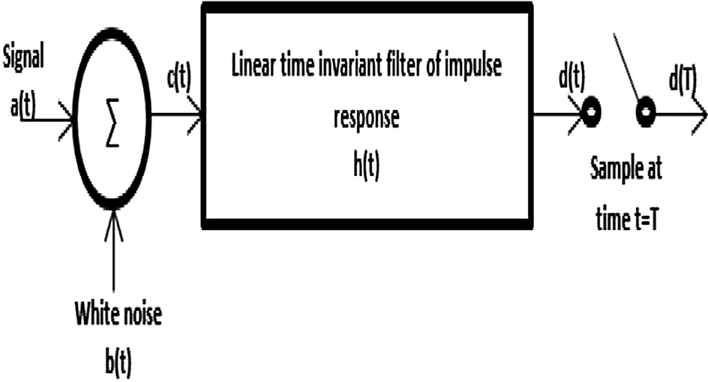

Fig. 1. Matched Filter [14].

where T is an arbitrary observation internal. The pulse signal*a*(*t*) may represent a symbol 1 or 0. The b(t) is a sample function of a white noise process of zero mean and power spectral density No.

2

The objective of the receiver is to detect the pulse signal a(t) in an optimum manner; given the received signal d(t).An NOMA based matched filter spectrum sensing is assumed. The power spectrum

density (PSD) of the nth subcarrier can be written as:

## SinpfTs 2

Fig. 2. NOMA based matched filter spectrum sensing technique.

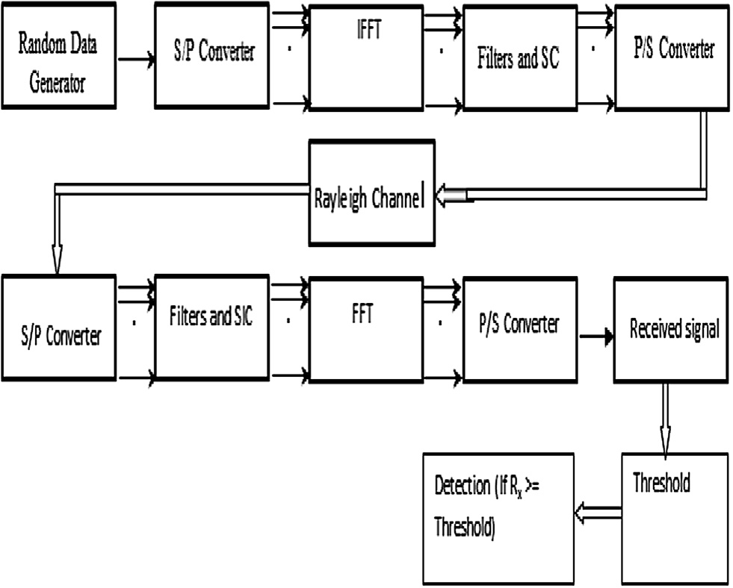From Eq. (3), we can say that NOMA based CR system has more capacity than the conventional OFDM. The block diagram of the

Un(f) = PnTs

pfTs

(1)

proposed methodology is indicated in Fig. 2. A random parallel symbol is generated in a sequential way. IFFT is used to analyse

where Pnis the transmit power emitted by the nth subcarrier, U*i* is the PSD of nth subcarrier and Ts represents the symbol duration. NOMA based matched filter spectrum sensing can be expressed as

## Un(f) = |Hn(f)|2 (2)

where |*Hn*(*f* )|is the frequency response of the prototype filter with co- efficient h[n] with *n* = 0; ...; *W* — 1; where *W* = *KN* and K is the length of each poly phase filters. The frequency response is given by:

—1

the signal in time domain and SC allow several users to access the sub-channel after that transmitted through a Rayleigh channel. At the receiver,the time domain signal is decoded by SIC and FFT convert the signal from time to frequency domain. Finally, the threshold is calculated and assumption is defined: if the energy of the received symbol is more than the threshold value there will be identification else no detection is considered.

## H f h

## W

w

2 X2

+

## h W

## r cos 2pfr

—

1. Results and discussion

## 3

| n( )| =

2 i=1 2

( ) ( )

The results are thoroughly analysed by using a mathematical

The phase angle is represented by the following equation [8]:

*Ph*(*u*) = h*s*(*u*); *s*(*u*); ·· · ; *s*(*u*) i; (4)

0 1 *L*—1

where u = 1, 2 .. .U,*s*(*u*) = *exp* *j*H(*u*) ; *j* = 0; 1; ··· ; *L* — 1;and H(*u*) is the random phase angle. The NOMA symbol is indicated by:

*j* 0 *j*0

## yk = [yk;0; yk;1; ··· ; yk;L—1] (5)

The phase angle is multiplied with NOMA symbols indicated by:

*y*(*v*) = *p*(*u*)*yk (6)

*k*

The NOMA signals (*y*(*u*)(*t*)) is determined by the following equation:

model of NOMA based matched filter spectrum sensing technique and simulated in MATLAB. In his work, we have calculated the threshold value at the receiving end of NOMA system. A hypothesis is considered that, if the received signal is greater or equal than the threshold value, than the detection is considered else no detection is assumed. The constant threshold value is considered to examine the performance of matched filter detection because variable threshold degrades the performance of spectrum sensing tech- niques. The power spectrum density (PSD) of NOMA with overlap- ping factors (K = 1, 2, 3 and 4) and roll off factor of PHYDAS filter

a = 0.25 is shown in Fig. 3. The PSD indicates the distribution of

power signal over a certain range of frequencies without the out of band radiation and increase of power spectrum. To analyse the importance of threshold on the detection of matched filter, QAM-

*y*(*u*)(*t*) =

L—1 k—1

l=0 k' =0 L—1

X X

+ X d(u)h(t — kT))ej2pltejHk;l (7)

(umin )

k' ;l

x

## h(t —

k T j2plt jHk' l

## 2

'

))e T e ;

64, QAM-256 transmission schemes with number of sub-carries 64 and 256 and number of samples 1024 is fixed. Fig. 4 and Table 2 indicates the Pd as a function of SNR. The Pd is analysed and sim-

ulated for different SNR values ranging from —10 dB to 20 dB. The

l=0

k;l 2 T

Pd is 100% at 4 dB, 6 dB for QAM-64 and QAM-256. Hence, it is con- cluded that the Pd of QAM-64 is better than the QAM-256. Pfa

where y(umin) preceded signal. The NOMA symbols are splited into V

'

k ;l

sub-blocks represented by:

*Y*(*t*) = {*YV*;*l*(*t*); *l* = 0; 1; ·· · ; *L* — 1} (8)

*k*

Finally, the received NOMA signal is represented by:

K—1

X j

*Y*' (*t*) = x(umin )e Hk;l h(t — k® ) (9)

means misrepresenting noise as a desired detected signal. The probability of signal detection is supreme for maximum value of Pfa. The Pd for different values of Pfa is indicated in Fig. 5 and Table 3. In the present simulation, SNR = 10 dB fixed to analyse the performance of the matched filter detection scheme for NOMA. From the figure, it is observed that the Pd of NOMA-QAM-64 is minimum as compared to QAM-256. Hence, QAM-64 performs

better than the QAM-256 for NOMA system. The BER Vs SNR

k=0

k' ;l 0

performance of NOMA system for QAM-64 and QAM-256 is shown

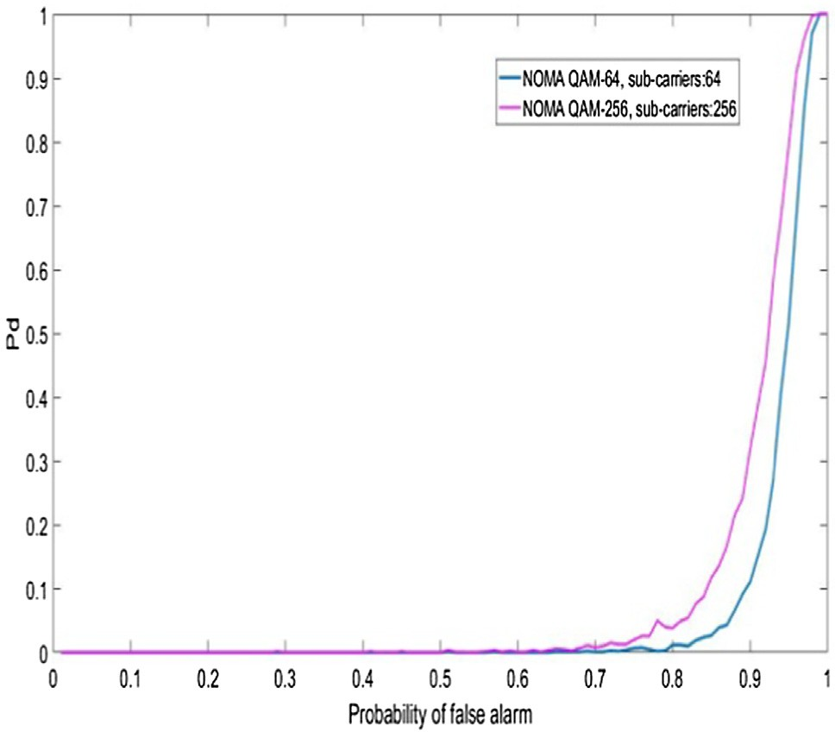

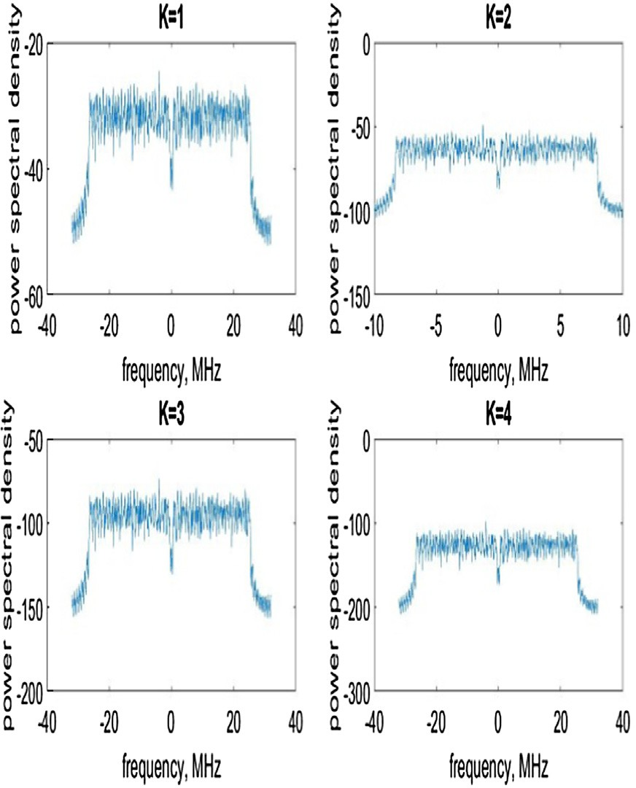Fig. 3. PSD of NOMA for K = 1, 2, 3 and 4.

Fig. 5. Pd Vs Pfa.

Table 3

Pd vs Pfa for OFDM with Matched Filter detection.

|  |  |  |  |  |  |  |  |  |  |  |
| --- | --- | --- | --- | --- | --- | --- | --- | --- | --- | --- |
| Pfa/Pd | 0.1 | 0.2 | 0.3 | 0.4 | 0.5 | 0.6 | 0.7 | 0.8 | 0.9 | 1 |
| NOMA | 0 | 0 | 0 | 0 | 0 | 0 | 0 | 0.2128 | 1 | 1 |

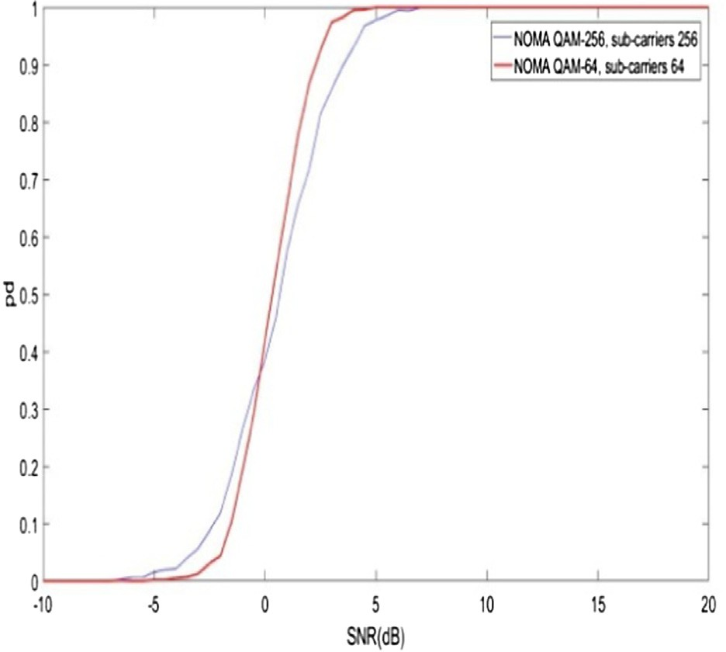

Fig. 4. Pd Vs SNR.

QAM-256 NOMA

QAM-64

0 0 0 0 0 0 0 0 0.257 1

10—5 is achieved at 5.8 dB, 9.6 dB for QAM-64 and QAM-256. It is in Fig. 6 and Table 4. The BER increases with increase of SNR. BER of observed that, the effect of inter symbol interference is minimum

for former system as compared to latter system. Hence, it is con- cluded that, the BER performance of QAM-64 is better than the QAM-256 for NOMAA system.

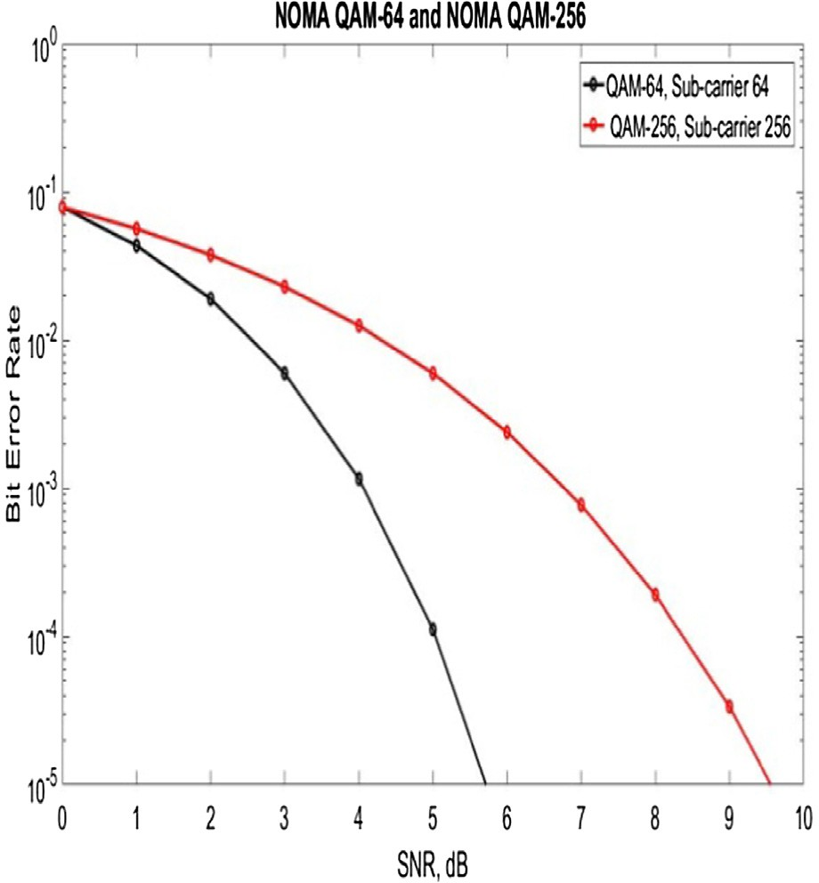Fig. 6. BER Vs SNR.

Table 2

Pd vs SNR for OFDM with Matched Filter Detection.

|  |  |  |  |  |  |  |  |  |  |  |  |  |  |  |  |
| --- | --- | --- | --- | --- | --- | --- | --- | --- | --- | --- | --- | --- | --- | --- | --- |
| SNR (dB)/Pd | —7 | —6 | —5 | —4 | —3 | —2 | —1 | 0 | 1 | 2 | 3 | 4 | 5 | 6 | 7 |
| NOMA QAM-256 (dB) | 0 | 0.0009 | 0.166 | 0.218 | 0.687 | 0.968 | 1 | 1 | 1 | 1 | 1 | 1 | 1 | 1 | 1 |
| NOMA QAM-64 (dB) | 0 | 0 | 0.016 | 0.173 | 0.629 | 0.959 | 1 | 1 | 1 | 1 | 1 | 1 | 1 | 1 | 1 |

Table 4

BER Vs SNR.

|  |  |  |  |  |  |
| --- | --- | --- | --- | --- | --- |
| BER (dB) | 10—1 | 10—2 | 10—3 | 10—4 | 10—5 |
| SNR (dB) values of NOMA QAM-256 | 0 | 4.2 | 7 | 8.2 | 9.6 |
| SNR (dB) values of NOMA QAM-64 | 0 | 2 | 4 | 4.9 | 5.5 |

1. Conclusion

To the best of my knowledge integration of Matched filter spec- trum sensing technique into NOMA for QAM-64 and QAM-256 has not been studied in the literature. The main objective of the pro- posed work is to design a NOMA based Cr: to use the spectrum in an efficient manner, enhance the spectral performance and qual- ity of service. It is observed that the proposed technique enhances the performance of Pd, BER and reduces the Pfa. PSD of the pro- posed system is also described for different overlapping factor. The simulation results reveal that the sensing time of the proposed technique is less and detection is achieved at minimum SNR for a static threshold value.

References

1. [Mitola J. Cognitive radio for flexible mobile multimedia communications.](http://refhub.elsevier.com/S1110-8665(19)30199-9/h0005) [Mobile Netw Appl 2001;6:435–41](http://refhub.elsevier.com/S1110-8665(19)30199-9/h0005).
2. [Ancans Guntis, Bobrovs Vjaceslavs, Ancans Arnis, Kalibatiene Diana. Spectrum](http://refhub.elsevier.com/S1110-8665(19)30199-9/h0010) [considerations for 5G mobile communication systems. Procedia Comput Sci](http://refhub.elsevier.com/S1110-8665(19)30199-9/h0010) [2017;104:509–16](http://refhub.elsevier.com/S1110-8665(19)30199-9/h0010).
3. [Liu Xin, He Dongyue, Jia Min. 5G-based wideband cognitive radio system](http://refhub.elsevier.com/S1110-8665(19)30199-9/h0015) [design with cooperative spectrum sensing. Phys Commun 2017;25(Part](http://refhub.elsevier.com/S1110-8665(19)30199-9/h0015) [2):539–45](http://refhub.elsevier.com/S1110-8665(19)30199-9/h0015).
4. [Kumar Arun, Gupta Manisha. A review on activities of fifth generation mobile](http://refhub.elsevier.com/S1110-8665(19)30199-9/h0020) [communication system. Alexandria Eng J 2018;57(2):1125–35](http://refhub.elsevier.com/S1110-8665(19)30199-9/h0020).
5. [Song Z, Wang X, Liu Y, Zhang Z. Joint Spectrum resource allocation in NOMA-](http://refhub.elsevier.com/S1110-8665(19)30199-9/h0025) [based cognitive radio network With SWIPT. IEEE Access 2019;7:89594–603](http://refhub.elsevier.com/S1110-8665(19)30199-9/h0025).
6. [Kumar Arun, NandhaKumar P. OFDM system with cyclostationary feature](http://refhub.elsevier.com/S1110-8665(19)30199-9/h0030) [detection spectrum sensing. ICT Express 2019;5(1):21–5](http://refhub.elsevier.com/S1110-8665(19)30199-9/h0030).
7. Zhenguo Shi1, Des McLernon. MounirGhogho and Zhilu Wu1, ‘‘Improved spectrum sensing for OFDM cognitive radio in the presence of timing offset”. EURASIP J Wireless Commun Network 2014. doi: [https://doi.org/10.1186/](https://doi.org/10.1186/1687-1499-2014-224) [1687-1499-2014-224](https://doi.org/10.1186/1687-1499-2014-224).
8. [Kumar Arun, NandhaKumar P. Matched Fliter detection sensing in cognitive](http://refhub.elsevier.com/S1110-8665(19)30199-9/h0040) [radio. Electron World 2017;123(1973):34–7](http://refhub.elsevier.com/S1110-8665(19)30199-9/h0040).
9. [Liu X, Wang Y, Liu S, Meng J. Spectrum resource optimization for NOMA-based](http://refhub.elsevier.com/S1110-8665(19)30199-9/h0045) [cognitive radio in 5G communications. IEEE Access 2018;6:24904–11](http://refhub.elsevier.com/S1110-8665(19)30199-9/h0045).
10. Liu X, Li F, Na Z. Optimal resource allocation in simultaneous cooperative spectrum sensing and energy harvesting for multichannel cognitive radio. IEEE Access 2017;5:3801–12. doi: <https://doi.org/10.1109/ACCESS.2017.2677976>.
11. Liu X, Jia M, Na Z, Lu W, Li F. Multi-modal cooperative spectrum sensing based on dempster-shafer fusion in 5G-based cognitive radio. IEEE Access 2018;6:199–208. doi: <https://doi.org/10.1109/ACCESS.2017.2761910>.
12. Liu X, Jia M, Zhang X, Lu W. A novel multichannel internet of things based on dynamic spectrum sharing in 5G communication. IEEE Internet Things J 2019;6(4):5962–70. doi: <https://doi.org/10.1109/JIOT.2018.2847731>.
13. Mehdawi, Meftah & Riley, Nick & Ammar, Mahmood & Fanan, Anwar & Zolfaghari, Mahsa. Experimental detection using cyclostationary feature detectors for Cognitive Radios. 2014. 272-275. 10.1109/TELFOR.2014.7034403.
14. [Salahdine F, Ghazi H, Kaabouch N, Fihri W. ‘Matched filter detection with](http://refhub.elsevier.com/S1110-8665(19)30199-9/h0070) [dynamic threshold for cognitive radio network’, Wireless Networks and](http://refhub.elsevier.com/S1110-8665(19)30199-9/h0070) [Mobile Communications (WINCOM). IEEE 2015;1(1):1–6](http://refhub.elsevier.com/S1110-8665(19)30199-9/h0070).
15. [Srinu S, Sabat S. Co-operative wide band sensing based on cyclostationary](http://refhub.elsevier.com/S1110-8665(19)30199-9/h0075) [features with multiple malicious user elimination. Int J Electron Commun,](http://refhub.elsevier.com/S1110-8665(19)30199-9/h0075) [Elsevier 2013;68(7):702–9](http://refhub.elsevier.com/S1110-8665(19)30199-9/h0075).
16. Liu, X., Zhang, X. Rate and Energy Efficiency Improvements for 5G-Based IoT With Simultaneous Transfer. IEEE Internet Things J, 6, 4, pp. 5971–5980.
17. [Dannana S, Chapa BP, Rao GS. Spectrum Sensing Using Matched Filter](http://refhub.elsevier.com/S1110-8665(19)30199-9/h0085) [Detection. In: Bhateja V, Coello Coello C, Satapathy S, Pattnaik P, editors.](http://refhub.elsevier.com/S1110-8665(19)30199-9/h0085) [Intelligent Engineering Informatics. Advances in Intelligent Systems and](http://refhub.elsevier.com/S1110-8665(19)30199-9/h0085) [Computing. Singapore: Springer; 2018](http://refhub.elsevier.com/S1110-8665(19)30199-9/h0085).
18. Zeng Y, Liang YC, Hoang AT, et al. A review on spectrum sensing for cognitive radio: challenges and solutions 381465. EURASIP J Adv Signal Process 2010;2010. doi: <https://doi.org/10.1155/2010/381465>.