[](http://crossmark.crossref.org/dialog/?doi=10.1016/j.ejbas.2015.06.002&domain=pdf) HOSTE D BY

Available online at [www.sciencedirect.com](http://www.sciencedirect.com/science/journal/2314808X)

**ScienceDirect**

journal homepage: [http://ees.elsevier.com/ejbas/default.asp](http://http//ees.elsevier.com/ejbas/default.asp)

**Full Length Article**

**New traceability strategies based on a biological Bar Code by PCR-DGGE using bacterial and yeast communities for determining farming type of peach**



***Ahmed El Shobaky*** ***a******,******b******,******\*******, Jean-Christophe Meile*** ***b******, Didier Montet*** ***b***

a *Botany Department, Faculty of Science, Mansoura University, 60 El Gohoureya Street, El Mansoura, El* *Dakahylea 35516, Egypt*

b *Cirad, UMR 95 Qualisud, TA B-95/16, 73, rue Jean-François Breton, Montpellier cedex 5 34398, France*

A R T I C L E I N F O A B S T R A C T

*Article history:*

Received 5 April 2015

Received in revised form 15 June 2015

Accepted 17 June 2015

Available online 29 June 2015

*Keywords:*

Peaches

Biological bar-code PCR-DGGE

Bacterial and yeasts communities Farming type

**Introduction:** EU Regulations continue to be strict in order to allow the highest degree of insurance in foodstuffs’ safety and quality. The traceability and labeling of imported prod- ucts in EU still remain a valuable issue (EU-Regulation 178/2002). One of the most important concerns of the customers is the product traceability, which is defined as the ability to screen the whole history or geographical origin or farming type of any food by certified method- ologies. In this regard, we proposed to study the link between microbial ecology and farming type of foodstuffs via a unique molecular analytical technique which is followed by an image analysis.

**Purpose:** A unique molecular analytical tool using 16S rDNA and 26S rDNA profiles gener- ated by “PCR-DGGE” was used to detect the variation in bacterial and yeast communities respectively of peaches from Jordan (control fruit, organic farming and conventional farming). **Results:** When the 16S and 26S rDNA profiles were analyzed using image and multivariate analysis, certain microbiota were detected on peach fruits originating from Jordan. The re- sulted band profiles of bacteria and yeasts from different farming types were specific and could be used as a bar-code to discriminate the fruits’ farming type.

**Significance of the paper:** This method could be considered as a new traceability tech- nique which provides fruits with a unique biological bar-code and permits the possibility to control the farming type of foodstuffs.

© 2015 Mansoura University. Production and hosting by Elsevier B.V. This is an open access article under the CC BY-NC-ND license (<http://creativecommons.org/licenses/by->

nc-nd/4.0/).

* *Corresponding author*. Tel.: +20 1000858724.

*E-mail address:* [dshobaky84@yahoo.com](mailto:dshobaky84@yahoo.com) (A. El Shobaky). <http://dx.doi.org/10.1016/j.ejbas.2015.06.002>

2314-808X/© 2015 Mansoura University. Production and hosting by Elsevier B.V. This is an open access article under the CC BY-NC-ND license ([http://creativecommons.org/licenses/by-nc-nd/4.0/).](http://creativecommons.org/licenses/by-nc-nd/4.0/))

# Introduction

Food safety is considered nowadays as a critical issue for the imported food to EU. EU regulation imposed the traceability to all imported kinds of food. Over a long period of time, food in- dustry had very simple traceability systems, but after increasing implementation of current Good Manufacturing Practice (GMP), the traceability systems have become important in the pro- duction chain.Traceability can be defined as the ability to retrieve the history or geographical origin of an article or its relevant components or an activity through a registered method for stan- dardization (ISO, 2007). Installing these documentary systems in developing countries like sub-Saharan Africa is facing a lot of difficulties that is why new traceability strategies have been developed. In order to follow the farming types of peach fruit products during processing, we proposed to identify and vali- date some linked and important biological markers that come from the original habitat of these fruits.

The peach (*Prunus persica*) is defined as a deciduous tree that is native to Northwest China, in the region that present between the north slopes and Tarim Basin of the mountains of Kunlun Shan, where it was first cultivated [1]. It has an edible juicy fruit that is called a peach. The name of the species *P. persica* is linked to its spread cultivation in Persia. It also belongs to the genus Prunus that includes the cherry and plum in the family Ro- saceae. Finally, the peach is classified with the almond in the subgenus Amygdalus that is distinguished from the other sub- genera by the corrugated shell of seed.

The most common analytical methods, which allow en- suring the determination of farming type, used bar-code, stable isotope, spectroscopy, etc. [2]. It seems difficult to use the genomic markers of the fruit to ensure the traceability of peaches. However, skin of fresh fruits is contaminated and not sterile, so it may carry microorganisms or any of their DNA frag- ments. The occurrence of various microorganisms depends on the fruits’ external environment (spoilage, insects, soil ecology, diseases etc.), but also microorganisms introduced by human activities [3].

The idea was to develop a “biological bar code” that is based upon analysis of the DNA of micro flora present on the prod- ucts [4]. This technique is based upon the postulation that fruits’ microbial communities are specific for a certain farming type. The main motive of this paper was to perform PCR-DGGE,

a method to analyze in a specific unique step all the bacteria and yeasts that present on the fruit in order to create an ana- lytical technique that allows the linkage of bacterial and yeast communities to the farming type and avoid any individual analysis of each microbial strain. To the best of our knowl- edge, “this paper describing a molecular method of microbial ecology”, the PCR-DGGE that allows the certification of peach fruits using 16S rDNA and 26S rDNA fingerprinting of bacte- ria and yeasts, is one of the first techniques that link microbial ecology to fruit processing. Only Hamdouche et al. [5] de- scribed a similar method on cocoa during fermentation.

The most specific advantage of this technique is that it allows analysis for both non-cultivable and cultivable, anaero- bic and aerobic bacteria and also provides a rapid analytical methodology to observe any changes in the community struc- ture in response to different environmental factors [6].

# Materials and methods

## *Sampling of fruits*

Mature peach fruits were harvested and collected from two dif- ferent farming types in Jordan, which are organic and treated fruits from conventional farming. The control of fruits was pro- duced from organic farming while, the treated fruits were produced by conventional farming.

The collection of these fruits was done to preserve their initial micro flora. They were directly collected from the tree using gloves and kept in sterile bags on Oct. 2012. The col- lected samples were stored in a refrigerator then transferred via plane to Cirad Montpellier (France). The bacterial and yeast DNA were extracted from the fresh fruits. The farming types of the samples were defined as well as the harvest date.

## *Extraction of DNA from bacteria and yeast*

This technique was carried out according to the protocol de- scribed by El Sheikha et al. [7].

## *PCR-DGGE analysis*

The specific amplification of the 16S rDNA was carried out via PCR using universal primers for the bacterial domain de- scribed by Muyzer et al. [8]. Gc338f (5’CGCCCGCCGCGCGCGG CGGGCGGGGCGGGGGCACGGGGGGACTCCTACGGGAGGCAGCAG,

Sigma Company, France) and 518r (5’ATTACCGCGGCTGCTGG, Sigma Company). The amplification of the V3 variable region

of the 16S rDNA of peaches’ bacterial communities was real- ized using GC clamp that consists of 40 nucleotides. The addition of clamp to forward primer 5’ of 338f was to ensure that DNA fragment will remain partially double stranded [9]. Each PCR mixture is composed of about 100 ng of DNA tem- plate, the primers (0.2 µM), the dNTPs (200 µM), 5 µL MgCl2 (1.5 mM) of 10X of taq buffer MgCl2 free (Promega Company, France) and 5 units of the Tag polymerase enzyme (Promega Company). The initial denaturation was done at 95 °C for 1 min and ten touchdown cycles of denaturation at 95 °C for 1 min, followed by annealing at 65 °C for 1 min and finally exten- sion at 72 °C for about 3 min followed by twenty cycles of 94 °C for 1 min, 55 °C for 1 min and 72 °C for 3 min.

Also, the amplification of D1/D2 region of the 26S rRNA gene was carried out via eukaryotic universal primers “NL1GC (5’- CGC CCG CCG CGC GCG GCG GGC GGG GCG GGG GCC ATA TCA

ATA AGC GGA GGA AAA G-3’”, Sigma Company) and the reverse primer “LS2 (5’-ATT CCC AAA CAA CTC GAC TC-3’”, Sigma

Company) amplifying a 250 base pair fragment [7,10]. A 30 bp GC-clamp (Sigma Company) was added to NL1. The PCR was

done in a final volume of 50 µL containing 0.2 µM of each

primers, dNTPs (200 µM), MgCl2 (1.5 mM), 5 µL of reaction Taq buffer MgCl2 free (10×) (Promega Company), 1.25 Unit of Taq DNA polymerase (Promega Company) and 2 µL of the ex- tracted DNA {≈30 ng}. The PCR was run for about thirty cycles with annealing temperature at 52 °C for 2 min, extension at

72 °C for 2 min, and denaturation at 95 °C for 60 s [7].

About 5 µL of the PCR products for bacteria and yeasts were analyzed initially using conventional electrophoresis 2% (w/v)

agarose gel with TAE 1 × buffer, stained with ethidium bromide and quantified by a standard of DNA mass ladder 100 bp (Promega Company).

The PCR products were analyzed using DGGE via a Dcode™ universal mutation detection system (Bio-Rad Laboratories, USA) using the procedure first described by Muyzer et al. [8] and modi- fied by El Sheikha et al. [7]. Samples were loaded into 8% (w/v)

polyacrylamide gels (acrylamide/N,N’-methylene bisacrylamide,

37.5/1, Promega Company) in 1 × TAE buffer (40 mM Tris–HCl, pH 7.4, 20 mM sodium acetate, 1.0 mM Na2-EDTA).

All electrophoresis experiments were done at 60 °C using a denaturing gradient ranging from 30% to 60% (100% corre- sponded to 7 M urea and 40% [v/v] formamide, Promega Company). The gels were electrophoresed at twenty volts for ten minutes and then at eighty volts for twelve hours. After electrophoresis, the gels were stained with ethidium bromide for 30 min and then rinsed for ten minutes in distilled water and then photographed on a UV trans illuminator using the Gel Smart 7.3 system (Clara Vision, Les Ulis).

## *Statistical and image analysis*

All of the gel images’ Individual lanes were straightened and aligned via Image Quant TL – software, v.2003. This software allowed identifying the relative positions of bands.

The generated banding pattern in the analysis of DGGE is considered as a complete photo of all of the dominant bacte- ria and yeast in the populations. Any individual distinct band refers to a unique “sequence type” [11]. This was ensured by Kowalchuk et al. [12], who demonstrated that co-migrating bands were generally linked to an identical sequence. The PCR- DGGE fingerprints were scored manually via the presence and absence of co-migrating bands, regardless of intensity. Pair wise community similarities were quantified via the Dice similar- ity coefficient (*S*D) [13].

*S*D  2*N*c*N*a  *N*b

where, Na refers to the band number recorded in A sample, Nb refers to the band number in B sample, and Nc refers to the band numbers that are common into both samples. The Similarity index was expressed ranging from 0 (complete dis- similarity) to 100 (perfect similarity). Valuable differences of bacteria and yeast communities of peach fruits from two farming types were determined via the factorial correspondence

analysis (FCA) using the first two variances which described most of the variation in the whole data set.

## *DNA bands sequence analysis and microbial* identification

The DGGE gel DNA bands were selected and excised carefully from the gel by means of sterile cutter. The gel pieces were soaked into TE buffer (100 mL) overnight (4 °C). Each band Eluted DNA was purified using Wizard PCR Preps kit DNA Purification system (Promega Company), and then the DNA purified was am- plified again via the same PCR conditions as mentioned above by using primers (without GC-clamp). The PCR amplicons were sequenced via GATC Biotech (Germany). The analysis of DNA base sequences were performed via comparison with the da- tabases of GenBank of NCBI. Then, searches in GenBank via BLAST program were done in order to detect the closest re- corded relative of partial 16S and 26S rDNA sequences [14].

# Results

## *Fruits sampling*

Mature peach fruits were collected in Jordan from two farming types which are organic farming and conventional farming (Fig. 1).

## *Extraction of bacterial and yeast DNA from Jordan* peach fruits from two farming types and confirmation of PCR amplification of DNA extracted

The extraction of DNA of the bacterial and yeast communi- ties that are present on peach fruits was verified on agarose gel {0.8% (w/v)} and achieved very good patterns.

The amplification efficiency of the fractions was performed via electrophoresis of the PCR products (amplicons) on agarose gel {2% (w/v)} at 100 V for 30 min in TEA buffer. All resulted bands were clearly observed and had a molecular size of 250 base pairs (yeast) and 236 base pairs (bacteria) (Figs. 2 and 3). The band in- tensity of the PCR products (amplicons) was very important and confirmed that the amplification of bacterial and yeast DNA was done very well and by this way we can continue to make analy- sis of all of these amplicons via DGGE method.

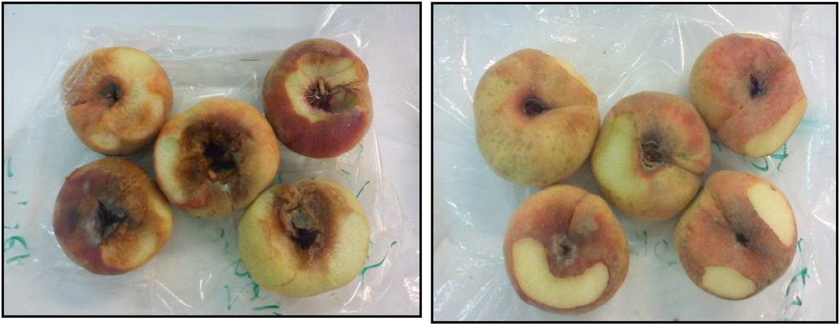

**Fig. 1 – Mature peach fruits were collected in Jordan from two farming types (on the left side: control fruit from organic farming and on the right side: treated fruits from conventional farming, both were collected in Jordan).**

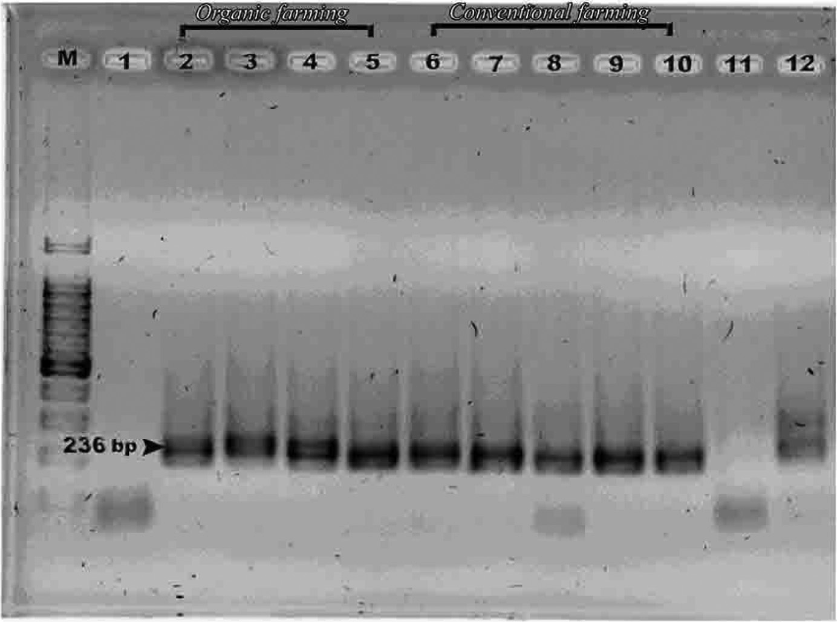

**Fig. 2 – Amplicons of bacterial communities after PCR using Gc 338f and 518r primers (236 bp). Lanes 2–5 are c2, c3, c4, c5 for organic farming while lanes 6–10 are f1–5 for conventional farming. Lane 12: +ve control *Escherichia coli* Lane 11: –ve** **control.**

## *Bacterial and yeast DNA. DGGE pattern from Jordan* peach fruits via different farming types

The observed and obtained bands from DGGE gels had good and enough intensities that enable us to analyze bacteria and yeast DNA samples extracted from Jordan peach fruits (Fig. 4), so, the whole DNA quantity that was deposited in the

DGGE gel was enough to use bacteria and yeast DNA as potent markers in order to detect Jordan peach fruits’ farming type. Each of the vertical lines refers to a fruit farming type and each of the spots refers to a bacterial or yeast species. The replica of PCR-DGGE patterns of Jordan peach fruits for each farming type was the same for each type and indicated presence of 4 to 11 bands for each peach fruit farming type.

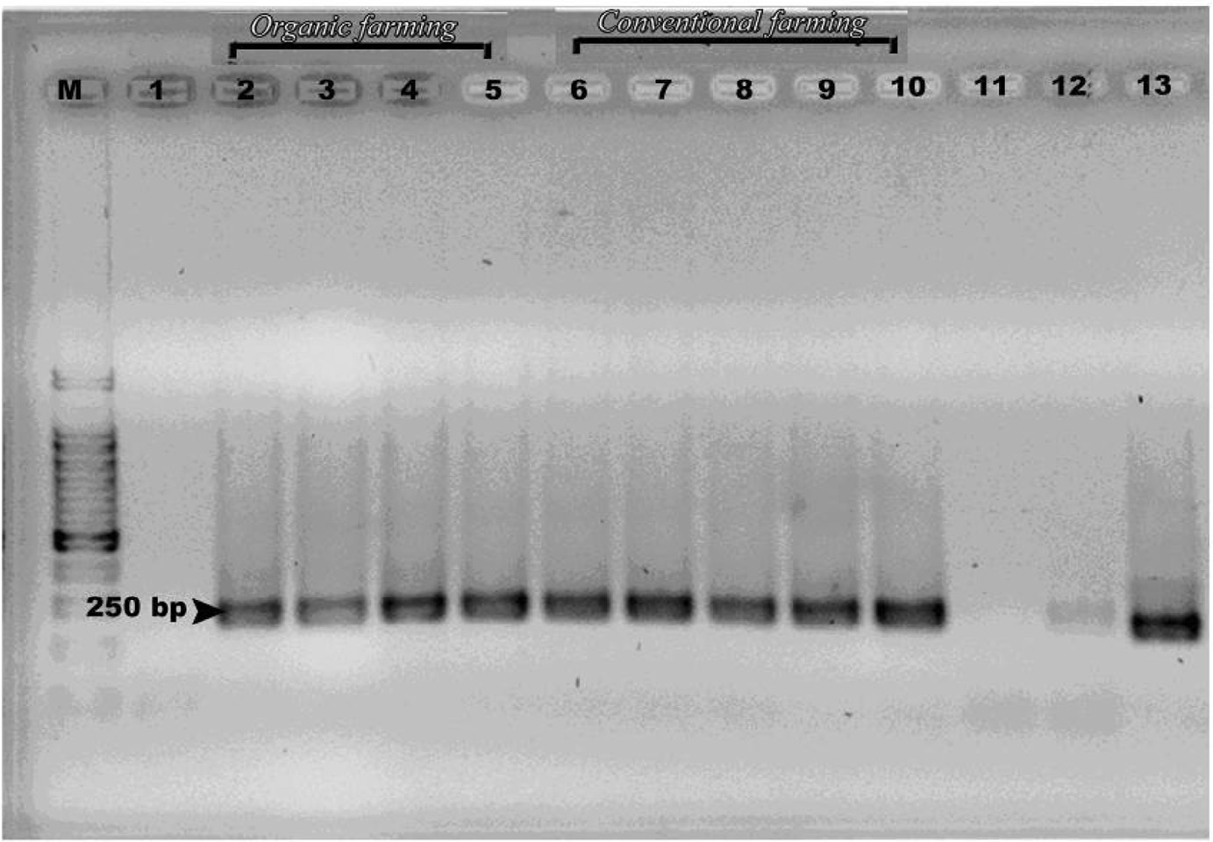

**Fig. 3 – Amplicons of yeast communities after PCR using NL1 GC and LS2 primers (250 bp). Lanes 2–5 are c2, c3, c4, c5 for organic farming type while lanes 6–10 are f1–5 for conventional farming. Lane 13: +ve control *Candida apicola* Lane 11: –ve control.**

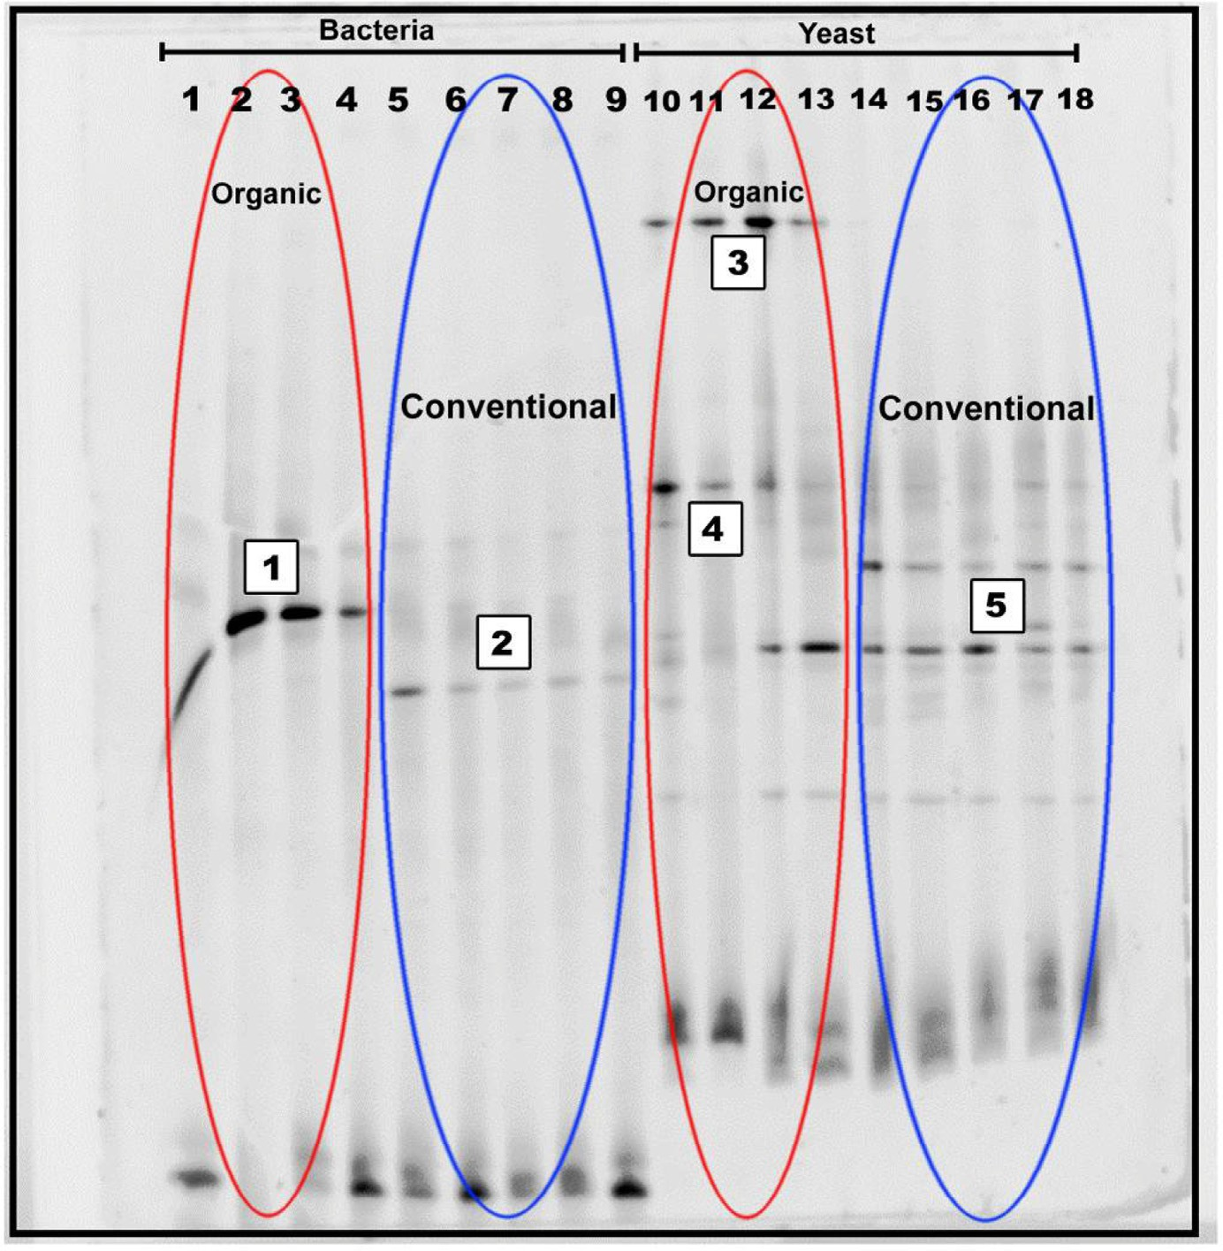

**Fig. 4 – PCR-DGGE profiles of 16S and 26S rDNA of peach fruits collected in Jordan from two different farming types (organic and conventional) from Jordan Lanes 1–4 are c2, c3, c4, c5 for organic farming type while lanes 5–9 are f1–5 for Conventional farming = bacteria. Lanes 10–13 are c2, c3, c4, c5 for organic farming type while lanes 14–18 are f1–5 for Conventional farming = yeast.**

Furthermore, the Factorial Correspondence Analysis (FCA) was confirmed to be a potential statistical analysis tool for compar- ing the bacterial and yeast communities similarity of Jordan peach fruit samples according to farming types during the har- vested season (Fig. 5). Finally, we can see clearly that the two different farming types were represented by two different groups.

## *Identification of dominant bacteria and yeasts on* peach fruits from two different farming types via sequencing

The characterization of the bacterial and yeast population con- taminated Jordan peach fruits were performed using molecular analysis via PCR DGGE and sequencing. By this way the domi- nant micro flora that was present in the samples can be detected and identified via sequencing of the gel interesting bands.

To our information, there is no knowledge on the bacte- rial and yeasts populations from these two different Jordan peach farming types that were obtained via cultural methods. Excised bands from DGGE gel of peach fruits extracted yeast and bacterial DNA were sequenced to identify bacterial and yeasts strains that present on the samples. Each band sequence refers to “a unique sequence” which is enough for identification

via comparison in between the obtained sequences and BLAST standard references based upon the phylogenetic relations of the 236 and 250 base pairs of partial 16S rDNA and 26S rDNA sequences of hyper variable regions (Table 1).

## *Microbial diversity of the excised DGGE bands*

In order to describe changes in the bacterial and yeast popu- lations that were present on farmed Jordan peach fruits from the two farming types, a molecular approach including PCR-DGGE and sequencing was performed. It reveals micro- bial diversity between the two farming types.

### *Identification of bacteria from their DNA*

Sequence analyses of two bands, shown in Fig. 4, permitted to identify *Leuconostoc pseudomesenteroides* as the dominating bacteria in the organic peaches. This strain is traditionally found in association with plant matter, fruits etc. and could cause food spoilage [15], which may appear in many diverse forms, all being consequences of the accumulative effects of spoil- age compounds. Thus, the spoilage potential of *leuconostoc* is not solely dependent on their growth, but also on their metabolic activities. The spoilage metabolites produced reflect

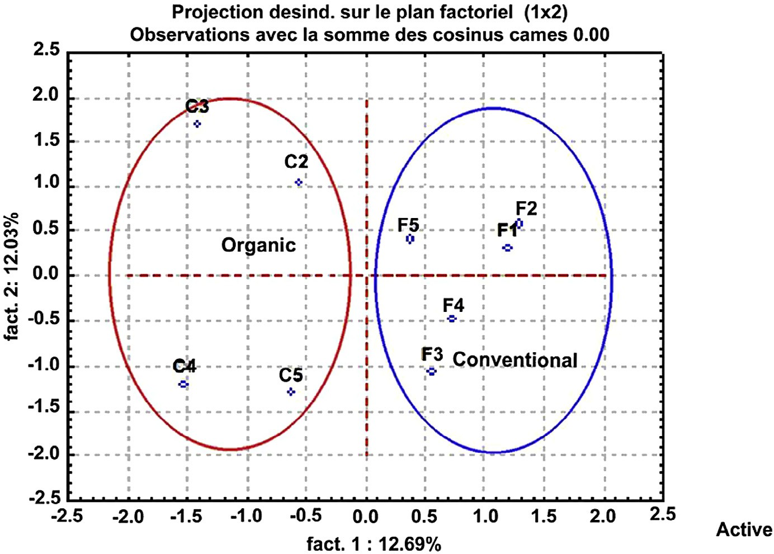

**Fig. 5 – Factorial variance analysis of 26S rDNA profiles of peach fruits from two different farming types, organic and conventional.**

the physiological activities of the cell and hence vary depend- ing on the conditions of the food system, involving oxygen tension, pH and carbon sources available.

The second band was identified as *Lactobacillus coryniformis* which is regarded as the main bacteria in conventional farming type of peach. This strain is one of the most important lactic acid bacteria. Lactic bacterial cluster name is due to the ability of bacteria to convert lactose into lactic acid. The production ability of lactic acid makes its media acidic that in turn in- hibits growth of some other harmful or pathogenic bacteria and fungi and favors good plant growth and development [16]. Furthermore, these bacteria may have some potent therapeu- tic properties (anti-inflammatory, anti-cancer activities etc.).

### *Identification of yeasts from their DNA*

The three band sequence analyses that were included in the indicated bands on “Fig. 4”, ensured that two of them were iden- tified as *Pichia kluyveri* and *Pichia fermentans* that have been reported to be part of the yeast micro flora in the organic farming type of peach. This genus of yeasts belongs to the family Saccharomycetaceae and most of these strains are usually found in decaying plants and fruit juices. The anamorphs of some *Pichia* species are *Candida* species. Some

*Pichia* species have recently been clinically proven to be patho- gens, well known as opportunistic pathogens in fruits [17].

Finally, *Tremella flava (TF)* was detected as the predomi- nant yeast in the conventional farming type of peach at the end of the trail. This strain is a genus of fungi of the family Tremellaceae and this species has anti-inflammation and anti- infection applicability [18]. So, many researchers suggested that TF might be a novel, natural alternative for use as anti- inflammation and an anti-infection agent, so it is valuable for fruits in this farming case.

# Discussion

Several scientists already used the PCR-DGGE technique in order to analyze the bacterial and yeast populations in fruits and their products [7,19–21]. However, we think that our paper is one of the few publications that introduced the bacterial and yeast populations analysis in peach fruits to differentiate different farming types by PCR-DGGE.

In our study, we proved that the DGGE pattern of the bac- terial and yeast populations DNA isolated from Jordan peach fruits were strictly linked to the treatments applied to the fruits.

|  |  |  |  |
| --- | --- | --- | --- |
| **Table 1 – Sequencing results of the bands cut from the DGGE gel.** | | | |
| Band (s) | Closest relative | % Similarity with the reference strain | Source |
| 1 (organic farming, bacteria) | *Leuconostoc pseudomesenteroides* | 99% | JX866706.1 |
| 2 (conventional farming, bacteria) | *Lactobacillus coryniformis* | 98% | JX914660.1 |
| 3 (organic farming, yeast) | *Pichia kluyveri* | 99% | JX103190 |
| 4 (organic farming, yeast) | *Pichia fermentans* | 99% | JX848637 |
| 5 (conventional farming, yeast) | *Tremella flava* | 89% | AF042238 |

Analysis of peach fruits originated from two different farming types that showed some significant differences in the migra- tion profiles on DGGE gel. However, the replica for each farming mode gave similar DGGE profiles through the research.

The differences in microbial environment resulted from dif- ferences in the band profiles that are greatly influenced by the farming types. The processing system types applied could also influence the microbial populations of peach fruits. Some common bacteria and yeast bands were observed in the DGGE gel in all of the peach fruit samples.

We saw also that there was a complete statistical linkage between the bacterial and yeast populations and the farming mode, if we compared by FCA for DGGE profile for different farming modes of fruits. We can conclude that there were suf- ficient environmental differences between the two different farming types where the Jordan peach fruits were harvested to have a major effect on the bacterial and yeast ecology. Based upon this, we could make a statistical relationship between the farming mode and the bacterial yeast populations.

Finally, analysis of peach fruit bacterial yeast populations via PCR-DGGE could be applied to discriminate different farming types. This global technique is very quick (i.e. <24 h) com-

pared with all of the other classical and traditional microbial

techniques used and avoids the biochemical analysis of mi- crobes. In addition the molecular sizes of the bands permit the identification of strain via sequencing facility. By this way this technique can be suggested as a quick analytical traceability tool for fruits and could be considered as a supplier of “a unique molecular biological bar code” for each farming mode.

# Acknowledgments

The authors thank Cirad, UMR 95 Qualisud, Montpellier, France and Egyptian Ministry of Higher Education for financial support of this scientific research work.

R E F E R E N C E S

1. [Faust M, Timon BL. Origin and dissemination of peach.](http://refhub.elsevier.com/S2314-808X(15)00041-X/sr0010) [Hortic Rev 2010;331.](http://refhub.elsevier.com/S2314-808X(15)00041-X/sr0010)
2. [Peres B, Barlet N, Loiseau G, Montet D. Review of the current](http://refhub.elsevier.com/S2314-808X(15)00041-X/sr0015) [methods of analytical traceability allowing determination of](http://refhub.elsevier.com/S2314-808X(15)00041-X/sr0015) [the origin of foodstuffs. Food Control 2007;18:228–35.](http://refhub.elsevier.com/S2314-808X(15)00041-X/sr0015)
3. [Sodeko OO, Izuagbe YS, Ukhun ME. Effect of different](http://refhub.elsevier.com/S2314-808X(15)00041-X/sr0020) [preservative treatment on the microbial population of](http://refhub.elsevier.com/S2314-808X(15)00041-X/sr0020) [Nigerian orange juice. Microbios 1987;51:133–43.](http://refhub.elsevier.com/S2314-808X(15)00041-X/sr0020)
4. [Montet D, Leesing R, Gemrot F, Loiseau G. Development of](http://refhub.elsevier.com/S2314-808X(15)00041-X/sr0025) [an efficient method for bacterial diversity analysis:](http://refhub.elsevier.com/S2314-808X(15)00041-X/sr0025) [Denaturing Gradient Gel Electrophoresis (DGGE). In: Seminar](http://refhub.elsevier.com/S2314-808X(15)00041-X/sr0025) [on food safety and international trade, Bangkok, Thailand;](http://refhub.elsevier.com/S2314-808X(15)00041-X/sr0025) [2004.](http://refhub.elsevier.com/S2314-808X(15)00041-X/sr0025)
5. [Hamdouche Y, Guehi T, Durand N, Kedjebo KBD, Montet D,](http://refhub.elsevier.com/S2314-808X(15)00041-X/sr0030) [Meile J-C. Dynamics of microbial ecology during cocoa](http://refhub.elsevier.com/S2314-808X(15)00041-X/sr0030) [fermentation and drying: towards the identification of](http://refhub.elsevier.com/S2314-808X(15)00041-X/sr0030) [molecular markers. Food Control 2015;48:117–22.](http://refhub.elsevier.com/S2314-808X(15)00041-X/sr0030)
6. [Yang CH, Crowley DE, Menge JA. 16S rDNA fingerprinting of](http://refhub.elsevier.com/S2314-808X(15)00041-X/sr0035) [rhizosphere bacterial communities associated with healthy](http://refhub.elsevier.com/S2314-808X(15)00041-X/sr0035) [and Phytophthora infected avocado roots. FEMS Microbiol](http://refhub.elsevier.com/S2314-808X(15)00041-X/sr0035) [Ecol 2001;35:129–36.](http://refhub.elsevier.com/S2314-808X(15)00041-X/sr0035)
7. [El Sheikha AF, Condur A, Métayer I, Le Nguyen DD, Loiseau](http://refhub.elsevier.com/S2314-808X(15)00041-X/sr0040) [G, Montet D. Determination of fruit origin by using 26S rDNA](http://refhub.elsevier.com/S2314-808X(15)00041-X/sr0040) [fingerprinting of yeast communities by PCR-DGGE:](http://refhub.elsevier.com/S2314-808X(15)00041-X/sr0040) [preliminary application to Physalis fruits from Egypt. Yeast](http://refhub.elsevier.com/S2314-808X(15)00041-X/sr0040) [2009;26(10):567–73.](http://refhub.elsevier.com/S2314-808X(15)00041-X/sr0040)
8. [Muyzer G, De Waal EC, Uitterlinden AG. Profiling of complex](http://refhub.elsevier.com/S2314-808X(15)00041-X/sr0045) [microbial populations by denaturing gradient gel](http://refhub.elsevier.com/S2314-808X(15)00041-X/sr0045) [electrophoresis analysis of polymerase chain reaction-](http://refhub.elsevier.com/S2314-808X(15)00041-X/sr0045) [amplified genes coding for 16S rRNA. Appl Environ Microbiol](http://refhub.elsevier.com/S2314-808X(15)00041-X/sr0045) [1993;59:695–700.](http://refhub.elsevier.com/S2314-808X(15)00041-X/sr0045)
9. [Sheffield VC, Beck JS, Stone EM, Myers RM. Attachment of](http://refhub.elsevier.com/S2314-808X(15)00041-X/sr0050) [40bp G+C rich sequence (GC-clamp) to genomic DNA](http://refhub.elsevier.com/S2314-808X(15)00041-X/sr0050) [fragments by polymerase chain reaction results in improved](http://refhub.elsevier.com/S2314-808X(15)00041-X/sr0050)

[detection of singlebase changes. Proc Natl Acad Sci USA](http://refhub.elsevier.com/S2314-808X(15)00041-X/sr0050) [1989;86:232–6.](http://refhub.elsevier.com/S2314-808X(15)00041-X/sr0050)

1. [Cocolin L, Bisson LF, Mills DA. Direct profiling of the yeast](http://refhub.elsevier.com/S2314-808X(15)00041-X/sr0055) [dynamics in wine fermentations. FEMS Microbiol Lett](http://refhub.elsevier.com/S2314-808X(15)00041-X/sr0055) [2000;189:81–8.](http://refhub.elsevier.com/S2314-808X(15)00041-X/sr0055)
2. [Muyzer G, Teske A, Wirsen CO, Jannasch HW. Phylogenetic](http://refhub.elsevier.com/S2314-808X(15)00041-X/sr0060) [relationships of Thiomicrospira species and their](http://refhub.elsevier.com/S2314-808X(15)00041-X/sr0060) [identification in deep-sea hydrothermal vent sample by](http://refhub.elsevier.com/S2314-808X(15)00041-X/sr0060) [denaturing gradient gel electrophoresis of 16S rDNA](http://refhub.elsevier.com/S2314-808X(15)00041-X/sr0060) [fragment. Arch Microbiol 1995;164:165–72.](http://refhub.elsevier.com/S2314-808X(15)00041-X/sr0060)
3. [Kowalchuk GA, Stephen JR, De Boer W, Prosser JI, Embley](http://refhub.elsevier.com/S2314-808X(15)00041-X/sr0065) [TM, Woldendorp JW. Analysis of ammonia-oxidizing](http://refhub.elsevier.com/S2314-808X(15)00041-X/sr0065) [bacteria of the beta subdivision of the class Proteobacteria](http://refhub.elsevier.com/S2314-808X(15)00041-X/sr0065) [in coastal sand dunes by denaturing gradient gel](http://refhub.elsevier.com/S2314-808X(15)00041-X/sr0065) [electrophoresis and sequencing of PCR amplified 16S](http://refhub.elsevier.com/S2314-808X(15)00041-X/sr0065) [ribosomal DNA fragments. Appl Environ Microbiol](http://refhub.elsevier.com/S2314-808X(15)00041-X/sr0065) [1997;63:1489–97.](http://refhub.elsevier.com/S2314-808X(15)00041-X/sr0065)
4. [Heyndrickx M, Vauterin L, Vandamme P, Kersters K, De Vos](http://refhub.elsevier.com/S2314-808X(15)00041-X/sr0070)

[P. Applicability of combined amplified ribosomal DNA](http://refhub.elsevier.com/S2314-808X(15)00041-X/sr0070) [restriction analysis (ARDRA) patterns in bacterial phylogeny](http://refhub.elsevier.com/S2314-808X(15)00041-X/sr0070) [and taxonomy. J Microbiol Methods 1996;26:247–59.](http://refhub.elsevier.com/S2314-808X(15)00041-X/sr0070)

1. [Altschul SF, Madden TL, Schaffer AA, Zhang J, Zhang Z,](http://refhub.elsevier.com/S2314-808X(15)00041-X/sr0075) [Miller W, et al. Gapped BLAST: a new generation of protein](http://refhub.elsevier.com/S2314-808X(15)00041-X/sr0075) [database search programs. Nucleic Acids Res 1997;25:3389–](http://refhub.elsevier.com/S2314-808X(15)00041-X/sr0075) [402.](http://refhub.elsevier.com/S2314-808X(15)00041-X/sr0075)
2. [Hamasaki Y, Ayaki M, Fuchu H, Sugiyama M, Morita H.](http://refhub.elsevier.com/S2314-808X(15)00041-X/sr0080) [Behavior of psychrotrophic lactic acid bacteria isolated from](http://refhub.elsevier.com/S2314-808X(15)00041-X/sr0080) [spoiling cooked meat products. Appl Environ Microbiol](http://refhub.elsevier.com/S2314-808X(15)00041-X/sr0080) [2003;69:3668–71.](http://refhub.elsevier.com/S2314-808X(15)00041-X/sr0080)
3. [Batish VK, Roy U, Lal R, Grover S. Antifungal attributes of](http://refhub.elsevier.com/S2314-808X(15)00041-X/sr0085) [lactic acid bacteria. Crit Rev Biotechnol 1997;17:209–25.](http://refhub.elsevier.com/S2314-808X(15)00041-X/sr0085)
4. [Mamakos PS. Outlines the production method of Birch](http://refhub.elsevier.com/S2314-808X(15)00041-X/sr0090) [derived Xylitol. Birch-Xylitol Manufacturing Report; 2009.](http://refhub.elsevier.com/S2314-808X(15)00041-X/sr0090)
5. [Chen T-I, Sheih I-C, Joann Jeng H-Y, Fang TJ. Anti-](http://refhub.elsevier.com/S2314-808X(15)00041-X/sr9010) [inflammation and anti-infection applicability of *Tremella*](http://refhub.elsevier.com/S2314-808X(15)00041-X/sr9010)[*flava* Chen fermented soymilk (TFS) in a BALB/c mice model.](http://refhub.elsevier.com/S2314-808X(15)00041-X/sr9010) [Int Proc Chem Biol Environ 2014;77:6–10.](http://refhub.elsevier.com/S2314-808X(15)00041-X/sr9010)
6. [Prakitchaiwattanaa CJ, Fleet GH, Hearda GM. Application and](http://refhub.elsevier.com/S2314-808X(15)00041-X/sr0095) [evaluation of denaturing gradient gel electrophoresis to](http://refhub.elsevier.com/S2314-808X(15)00041-X/sr0095) [analyze the yeast ecology of wine grapes. FEMS Yeast Res](http://refhub.elsevier.com/S2314-808X(15)00041-X/sr0095) [2007;4:865–77.](http://refhub.elsevier.com/S2314-808X(15)00041-X/sr0095)
7. [(a) El Sheikha AF, Métayer I, Montet D. A biological bar-code](http://refhub.elsevier.com/S2314-808X(15)00041-X/sr0100) [for determining the geographical origin of fruit by using 28S](http://refhub.elsevier.com/S2314-808X(15)00041-X/sr0100) [rDNA fingerprinting of fungi communities by PCR-DGGE: an](http://refhub.elsevier.com/S2314-808X(15)00041-X/sr0100) [application to Physalis fruits from Egypt. Food Biotechnol](http://refhub.elsevier.com/S2314-808X(15)00041-X/sr0100) [2011;25(2):115–29.](http://refhub.elsevier.com/S2314-808X(15)00041-X/sr0100) [(b), El Sheikha AF, Montet D.](http://refhub.elsevier.com/S2314-808X(15)00041-X/sr0105) [Determination of fruit origin by using 28S rDNA](http://refhub.elsevier.com/S2314-808X(15)00041-X/sr0105) [fingerprinting of fungal communities by PCR-DGGE: an](http://refhub.elsevier.com/S2314-808X(15)00041-X/sr0105) [application to Physalis fruits from Egypt, Uganda and](http://refhub.elsevier.com/S2314-808X(15)00041-X/sr0105) [Colombia. Fruits,2011; 66(2):79–90.](http://refhub.elsevier.com/S2314-808X(15)00041-X/sr0105)
8. [El Sheikha AF, Durand N, Sareter S, Okullo JB, Montet D.](http://refhub.elsevier.com/S2314-808X(15)00041-X/sr0110) [Study of the microbial discrimination of fruits by PCR-DGGE:](http://refhub.elsevier.com/S2314-808X(15)00041-X/sr0110) [application to the determination of the geographical origin](http://refhub.elsevier.com/S2314-808X(15)00041-X/sr0110) [of Physalis fruits from Colombia, Egypt, Uganda and](http://refhub.elsevier.com/S2314-808X(15)00041-X/sr0110) [Madagascar. Food Control 2012;24:1–2, 57–63.](http://refhub.elsevier.com/S2314-808X(15)00041-X/sr0110)