

[Egyptian Informatics Journal (2016) 17, 217](http://dx.doi.org/10.1016/j.eij.2015.09.004)–[225](http://dx.doi.org/10.1016/j.eij.2015.09.004)

Cairo University

Egyptian Informatics Journal

[www.elsevier.com/locate/eij](http://www.elsevier.com/locate/eij) [www.sciencedirect.com](http://www.sciencedirect.com/science/journal/11108665)

Optimal sink placement in backbone assisted wireless sensor networks



I. Snigdh a,*, D. Gosain a, N. Gupta b

a *Department of Computer Science and Engineering, Birla Institute of Technology, Ranchi, India*

b *Department of Electronics and Communication Engineering, Birla Institute of Technology, Ranchi, India*

Received 16 April 2015; revised 11 September 2015; accepted 15 September 2015

Available online 24 December 2015

Abstract This article proposes a scheme for selecting the best site for sink placement in WSN applications employing backbone assisted communications. By placing the sink at a specific posi- tion, energy scavenging and delay constraints can effectively be controlled. In contrast to the con- ventional scheme for base station placement at the geographical centre or random placement at the end of the region of interest, the proposed scheme places the base station at either the graph theo- retical centre or centroid of the backbone connecting nodes in the region of interest. This strategy shows a considerable reduction in the total number of hops that each packet needs to travel to reach the sink. The proposed scheme is applied on all the families of graphs prevalent in backbone assisted sensor networks to confirm the performance consistency and improvement in network parameters of the communication backbone measured in terms of delay, the carried load and the total energy consumption, eventually affected by the average number of hops for the message to reach the sink.

© 2016 Production and hosting by Elsevier B.V. on behalf of Faculty of Computers and Information,

KEYWORDS

Wireless sensor networks; Tree topology;

Sink placement; Energy;

Delay

Cairo University. This is an open access article under the CC BY-NC-ND license [(http://creativecommons.](http://creativecommons/)

org/licenses/by-nc-nd/4.0/).

1. Introduction

Wireless Sensor Network (WSN) is all pervasive in world. From home automation system to critical boiler monitoring, and from X-Box to military surveillance, they are ubiquitous. Recently, considerable amounts of research efforts have

* Corresponding author.

E-mail address: [itusnigdh@bitmesra.ac.in](mailto:itusnigdh@bitmesra.ac.in) (I. Snigdh).

Peer review under responsibility of Faculty of Computers and Information, Cairo University.

**Production and hosting by Elsevier**

enabled the actual implementation and placement of sensor networks tailored to the unique requirements of certain sensing and monitoring applications as mentioned by [1].

Every WSN is constrained by low data rates, energy reser- vations, and usually a many to one communication pattern. Analysing the performance of such networks has been done with the help of Steiner trees [2], shortest path trees [3] or greedy heuristic [4] based trees. These topologies have been put to numerous routing protocols, and data aggregation methods to optimize energy, load, response time or simply net- work longevity. The choice of a tree based backbone for our research is attributed and influenced by the literary works available for performance optimality. Protocols such as HTECRP [5] claim to manage congestion and perform fairness

<http://dx.doi.org/10.1016/j.eij.2015.09.004>

1110-8665 © 2016 Production and hosting by Elsevier B.V. on behalf of Faculty of Computers and Information, Cairo University. This is an open access article under the CC BY-NC-ND license [(http://creativecommons.org/licenses/by-nc-nd/4.0/).](http://creativecommons.org/licenses/by-nc-nd/4.0/))

218 I. Snigdh et al.

on the network by assigning privileges to the traffic. ViTAMin

[6] offers a hierarchical backbone tree algorithm for energy efficiency and sufficient network lifetime. While Localized area spanning tree (LAST) protocols for wireless short range sensor networks optimize the energy cost and the interference imposed by the structure [7,8], a BFS based tree rooted at the base station offers shortest path traversal for each data message which utilizes the sensor resources efficiently by employing a local repairing approach for the crashing nodes thereby increasing the lifetime [6] similar to CTP [9,10]. More- over, tree based strategies reduce the burden of retransmissions and hence can be used for congestion management [5]. Thus, it can be believed that a tree structure is popular in wireless sen- sor network structure, for most applications having one sink and too many sender nodes which justify our choice for further analysis. However, these researches focus on measuring the communication flows either for one or for multiple static or mobile sinks without emphasizing whether the placement of a sink too plays a role in determining the aforementioned net- work statistics such as delay, load and energy consumption. While tree based networks have been considered, the place- ment of sink has been done either at the root or at the source [11]. Also, source based trees and sink based tree construction algorithms have been analysed and used to optimize conges- tion in WSNs [12].

In addition to congestion control mechanisms, energy effi- ciency in communication also depends upon the sink place- ment strategy. Energy consumption can be estimated for WSNs, comparatively for static and mobile sinks. However, literatures [13] consider the energy consumption on the basis of mobility path and duty cycling of the nodes. The energy consumption of the nodes primarily depends on the communi- cation distance. One way to reduce the communication dis- tance is to deploy multiple static sinks and to program each sensor to route data to the closest sink [14]. Since the nodes near the sink forward and process more data, they tend to deplete early. The solution to this problem is to partition the region of interest into sub-fields with static sinks [15]. How- ever, the main problem in adopting multiple sinks is to decide where to deploy them in the monitored region, so that, the data relaying load is balanced among all the nodes. The other situation is deploying mobile sinks in addition to static sinks. In case of mobile sinks, the random sink movements do not guarantee that data have been collected from all the nodes [16]. Therefore, there is a need of multiple mobile sinks to improve data collection in an efficient way.

Sink location strategies include deterministic as well as ran- dom deployments. The placement of sinks has been chosen to be at the end points of the region of interest (ROI) or the edges of a ROI as in [17,18]. Researchers evaluate the network per- formance when the sink is placed at the midpoint of the edges of the ROI, the centre of the ROI or even at the centres of clus- ters in case of portioned ROIs. The load on the sink can be decreased by adapting the high energy nodes around the sink as the base stations. However, there is no focus on the delay. On the contrary, delay has been observed by using GA based approaches but without considering energy optimization [18]. Our article considers both energy conservation and reduction in delay by appropriate sink placements in the network already connected.

Experimental results show that the optimal sink placement can increase the node degree and greatly reduce the average

hop counts, leading to a longer lifespan [19,20]. Experimental evaluation confirms that topology aware algorithms give remarkable lifetime improvement as compared to geo-aware algorithms and naive centre placement strategy [17,21,22]. While there are local search techniques [23] that aim to maxi- mize the worst case delay and extend lifetime of a WSN, in practical scenarios, there may be obstacles or wireless range constraints that may not make the sink placements feasible.

Our article, therefore addresses the problem of converge- cast communication for a tree based topology. We try to pre- sent a strategy that, while a tree based backbone is incorporated as the steady backbone for convergecast commu- nications, the choice of the node would be the most appropri- ate to serve the purpose of the sink. We argue that the performance of the tree based communication is better if the sink is placed at the centroid or the graph theoretic centre of the tree.

We further divulge from comparing or proposing any best suited tree construction algorithm in terms of optimality. We further assume that the network employs a tree based back- bone for carrying out the necessary data dissemination. These algorithms are employed at a separate computer and the sink relocation is performed either manually or by mobile sinks or robots. Our main aim is to isolate the minimum energy con- suming node (MECN) that validates good performance in terms of the studied network parameters. We propose algo- rithms to identify the nodes appropriate to serve as the sink in a backbone assisted network on the basis of eccentricity and node degrees of the graphs.

The proposed strategy ensures that, irrespective of the backbone generation strategy employed for typical WSN applications, the optimal sink position falls at either the tree theoretic ‘centre’ or the ‘centroid’ of the graph. As the number of hop counts is basically determined by a routing scheme which decides the best route from a source to a destination, the proposed work focuses on identifying the node that would optimize the network parameters under the frequently adopted routing protocols for networks. Hence, our analysis is based on experimental results of default routing protocols for all families of trees to confirm our observations.

1. Preliminaries

Definition 1 (*Geographic Centre (GC) of Topology*). Assum-

ing ‘*N*’ sensors placed in a field and represented as (*xi*, *yi*) coordinates in two dimensional plane, the ‘GC(*X*, *Y*)’ of any

topology is calculated as GC(*X*, *Y*) = P*xi*/*n*, P*yi*/*n*.

Definition 2 (*Tree Theoretic Centre (TTC) of Topology*). In order to define ‘TTC’ we first define distance in a tree ‘*T*(*V*, *E*)’, as the distance ‘*dT*(*Vi*, *Vj*)’ between nodes ‘*Vi*’ and ‘*Vj*’ which is the minimum path length between them. In general, a centre is a vertex (or a minimum set of vertices) which min- imizes some function involving the distance between an arbi- trary vertex and the vertex in the centre.

* For *f*(*x*) = P*dT*(*x*, *V*), *V* 2 *V*(*T*) where ‘*V*(*T*)’ is set of all vertices in tree *T*; any vertex ‘*x*’ which minimizes *f*(*x*) is

as min–max problem min{max *dT*(*x*, *V*), *V* 2 *V*(*T*)}. known as the ‘centre’. Alternatively, Centre can be viewed

Optimal sink placement 219

* Eccentricity of vertex ‘*x*’ is defined as distance from ‘*x*’ to *dT*(*x*, *V*), for *V* 2 *V*(*T*). Therefore, the vertex with minimum the vertex farthest from ‘*x*’ in ‘*V*(*T*)’. Thus, *E*(*x*) = max eccentricity is the ‘centre’ or ‘TTC’.

Lemma 1. *Eccentricity of a vertex in a tree can be computed in linear time*.

Proof. Let *Tx*, denote the subtree rooted at vertex ‘*x*’ 2 *V*(*T*), which is the subgraph induced on vertex ‘*x*’ and all its descen-

dants. Let *children*(*x*) denote the set of children of ‘*x*’. The eccentricity of the root of a tree can be computed by the fol- lowing recurrence relation:

*dTx*(*x*, *V*(*Tx*)) = max{*dTs*(*s*, *V*(*Ts*)) + *w*(*x*, *s*)}, 6*s* 2 *chil- dren*(*x*) and

*w*(*x*, *s*) ) weight of edge between node ‘*x*’ and its child ‘*s*’.

Using the recursive algorithm Eccentricity (*Tx*), eccentricity

can be computed in linear time since each vertex is traversed once. h

Algorithm: Eccentricity (*Tx*)

Input: A tree *Tx* = (*V*, *E*) rooted at *x*. Output: The eccentricity of *node x* in *Tx*. Step 1: if *x* is a leaf then return 0;

Step 2: for each child *s* of *x* do compute Eccentricity (*Ts*) recursively;

Step 3: return max{Eccentricity(*s*)+ *w*(*x*, *s*)}, 6*s* 2 *children*(*x*)

Using Lemma 1 and Eccentricity algorithm we find the centre of any tree in polynomial time.

Theorem 1. *A tree can be either unicentric or bicentric*.

Fact 1. *A tree has two or more leaf nodes* [24].

Fact 2. *The maximum distance dT(x, V) from x to any vertex in tree T, occurs when the vertex is leaf/pendant vertex* [24].

Proof. Deletion of all the leaf nodes results in a graph that is still a tree. Careful observation reveals that the removal of all leaf nodes from tree uniformly reduces the eccentric- ities of the remaining vertices by one (Fact 1). So all ver- tices that were centres originally, still remain centres. Continuing this process leaves us with either one vertex which eventually is a centre or an edge whose end points are centres. h

Definition 3 (*Tree Theoretic Centroid (TTCD)*). In a tree ‘*T* (*V*, *E*)’, the number of subtrees of any vertex ‘*v*’ is equal to its degree and sum of branches (in a subtree) corresponds to the weight of the subtree at ‘*v*’. The weight of the heaviest subtree of vertex ‘*v*’ is designated as weight of ver- tex ‘*v*’ and the minimum weighted vertex is designated as Centroid of tree ‘*T*’.

Lemma 2. *Weight of a vertex can be computed in linear time*.

Algorithm: Weight (*Tx*)

Initialize Main_Root = *T*X

Input: A tree *Tx* = (*V*, *E*) rooted at *x*. Output: The weight of *node x* in *Tx*. Step 1: if *x* is a leaf then return 0;

Step 2: for each child *s* of *x* do compute Weight (*Ts*) recursively; Step 3: if (*T*S = Main_Root)

Return max{Weight(*s*)+ *w*(*x*, *s*)}, 6*s* 2 *children*(*x*)

else

return sum{Weight(*s*)+ *w*(*x*, *s*)}, 6*s* 2 *children*(*x*)

Theorem 2. *Every tree has a centroid consisting of either one vertex or two adjacent vertices*.

Proof. Similar to proof of Theorem 1, by recursive iteration it can be proved that any tree is either unicentroidal or bicen- troidal [24]. Hence, we can find centroid of a tree in polyno- mial time. h

1. System model

We consider a tree *T*(*V*, *E*) which is an ordered pair (*V*, *E*), where *V* = Vertex Set (consisting of *|V|* vertices) and *E* = Edge Set (consisting of *|E|* edges). The distance between two vertices *Vi* and *Vj* of any given tree is represented as ‘*dT*(*Vi*, *Vj*)’ and it denotes the shortest path length between the two vertices. The degree ‘*d*(*v*)’ of a vertex ‘*v*’ is defined as number of edges incident to it. A node which has degree one is called as leaf/pendant vertex.

It is known that the number of hop counts is basically determined by a routing scheme which decides the best route from a source to a destination. Also, most routing protocols choose the shortest route which has the smallest number of hop counts. With the increase in number of hops the total time to reach the destination increases. Hence, the performance is measured in terms of delay, the carried load and the total energy consumption which is eventually affected by the aver- age number of hops for message to reach the sink. We there- fore address these performance parameters to evaluate our sink placement scheme.

The parameters considered for our observations consider two versions of trees: one that follows a linear arrangement, while the other focuses on the more realistic non-linear arrangement of the nodes. The carried load computations for these strategies can be computed as under Section 4.

1. Carried load calculations

The carried load on the sink is implicative of the total number of data packets received. In contrast, the total load on the nodes is indicative of the total number of packets generated and forwarded for a successful message delivery at the sink. This arrangement of the source to sink communications can

220 I. Snigdh et al.

pictorially be represented as either a linear or nonlinear topol- ogy with different sink placements. Table 1 denotes the graph- ical representation of the notation used to diagrammatically illustrate the different strategies considered for further analysis.



Table 1 Notations used in diagrams.

Colour Representation

TTCT (Tree theoretic centroid) TTC (Tree theoretic centre) TTC and TTCT coincide

* 1. *Linear tree topology strategies*

The established tree based topology is classified over three families referred to as case 1, case 2 and case 3 subsequently and is compared to the communication backbone performance with respect to sink at geographical centre or at the end of the region of interest. The placement of sink at different positions in the ROI has been analysed as separate cases.

*Strategy 1:* The placement of sink at one end of the WSN has been considered as sinks are generally seen at one end of the network which is easily accessible for either data col- lection or battery replenishment purposes as shown in

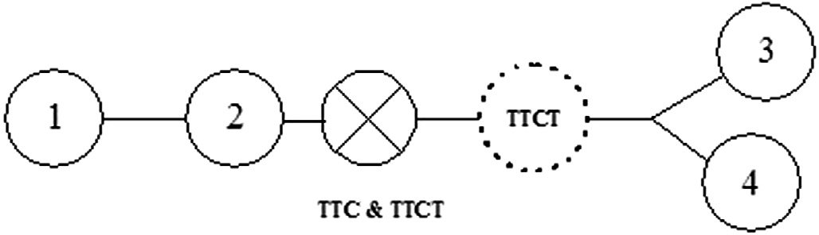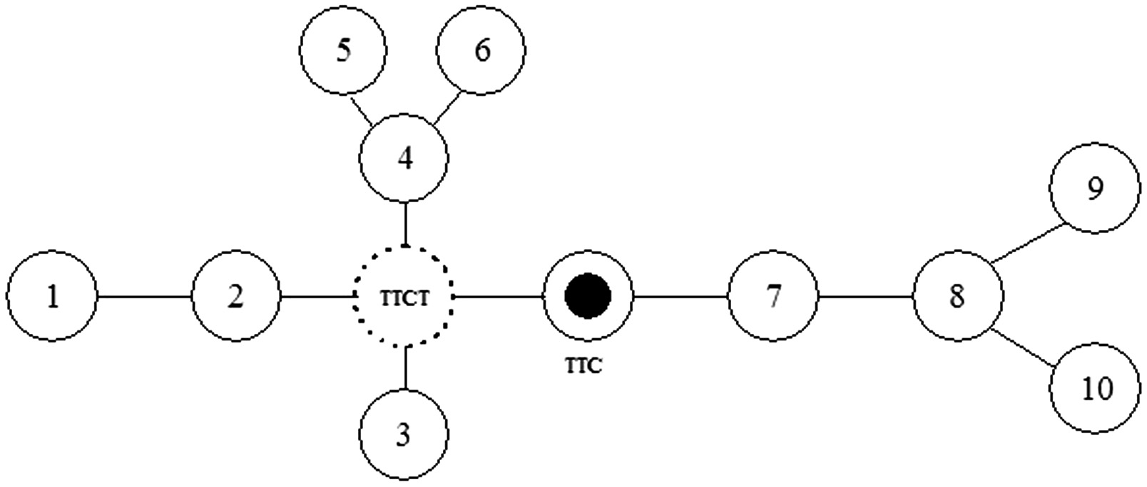

Figure 1 Linear arrangement of sensors with sink at one end.

Figure 2 Linear arrangement of sensors with sink at middle.

Figure 3 Arrangement of sensors in linear tree topology.

Figure 4a Nonlinear tree topology: TTC and TTCT at different locations.

Figure 4b Nonlinear tree topology: TTC and TTCT at different locations; one additional TTCT at different locations.

Optimal sink placement 221

total carried load can be calculated as 2 * [1 + 2 + 3 +

·· ·(*N* — 1)/2].

*CL* = (*N*2 — 1)/4 (2)

*Strategy 4:* Finally placing the sink at the proposed loca-

tion; the tree theoretic centre (TTC) and centroid (TTCT) as illustrated in Fig. 3. Fig. 3 depicts eight sensors in tree topology which are connected linearly with a maximum of ‘one’ edge between them. Sensors (at positions 4 and 5) can act as sinks. Total carried load can be calculated as

*CL* = *N*2/4 (3)

Figure 4c Nonlinear tree topology: TTC and TTCT at same location.

* 1. *Nonlinear tree topology strategies*

Figs. 4a–4d depict one representative tree of each scenario in nonlinear tree topology. Fig. 4c is the ideal case where the cen- tre and the centroid coincide and hence our results do not include the trivial proposition.

* 1. *Algorithms used*

Figure 4d Nonlinear tree topology: TTC and TTCT at same position; additional TTC at different positions.

Algorithm: Combined (*Tx*)

Initialize Main_Root = *T*X

Input: A tree *Tx* = (*V*, *E*) rooted at *x*.

Output: The weight and eccentricity of *node x* in *Tx*. 1: if *x* is a leaf then

Send 0 to parent;

2: for each child *s* of *x* do

Compute Combined (*Ts*) recursively;

3: Weights = sum{Combined(*s*)+ *w*(*x*, *s*)}, 6*s* ∈ *children*(*x*) Eccentricitys = max{Combined (*s*) + *w*(*x*, *s*)}, 6*s* ∈ *children*(*x*) If (*T*S = Main_Root)

Weights = max{Combined(*s*)+ *w*(*x*, *s*)}, 6*s* ∈ *children*(*x*) Send Weights and Eccentricity*s* to parent node

Algorithm: Sink_Establishment (*Tx*)

1. For each non-leaf node *x* of Tree *T*
2. Let *x* be the root
3. Call Combined(*Tx*)
4. Broadcast Weightx and Eccentricityx to all other non-leaf nodes with its NbrID
5. Centre[ID] = ID of min(Eccentricitys) 6*z* ∈ *non-leafnode*(*T*)
6. Centroid[ID] = ID of min(Weightz) 6*z* ∈ *non-leafnode*(*T*)
7. SinkID = Intersection(Centre, Centroid)

Fig. 1. Fig. 1 depicts a linear arrangement comprising of seven sensors in which the last sensor (at position 7) acts as the sink. For message communication commencing at Node 1 causes it to generate the first data packet and for- ward it. Node 2 generates its own packet and forwards two packets (its own and the additional of node 1’s that it received). Similarly, node 3 will generate its own and for- wards three packets (its own and two from previous nodes). Hence, iteratively the total carried load can be calculated as

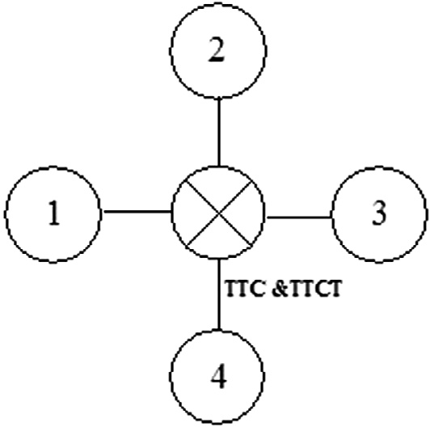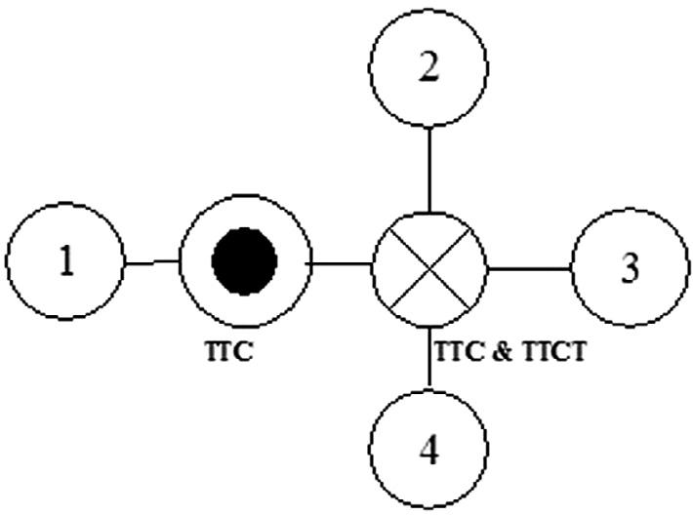

*CL* = 1 + 2 + 3 + 4 + 5 + 6 + ·· ·*N* — 1 (where *N* is

total number of sensors).

*CL* = *N* * (*N* — 1)/2 (1)

*Strategy 2:* Placing the sink at some random location in

topology is avoided as it is not a desired strategy where results are unpredictable, arbitrary and uncontrolled. Hence, we do not include it for analysis.

*Strategy 3:* The sink is sited at the centre of the linear topologies considered as given in Fig. 2. Fig. 2 depicts a similar linear arrangement of seven sensors in which middle sensor (at position 4) can act as a sink. Node 1 generates the first packet and forwards it to node 2 which forwards two packets (its own and node 1’s received data). This process continues for node 3 similar to case 1. However, Node 7 will forward one, 6 will forward two and 5 will forward three packets to sink. The packet forwarding and aggregation is depicted by the unidirectional arrows. The

1. Results

It is assumed that packets are sent to sink via multi-hop com- munication for energy efficiency in most WSNs. The interme- diate sensors act as routers and experience a high packet flow from other sensors and routers. Henceforth, the carried load per node increases and for nodes near the base station or the sink and eventually the packet delivery is delayed considerably. Optimal sink placement results in combating such scenarios. Our aim is to determine the best sited sink among the deployed nodes that conform to tree structured topologies for the rea- sons best known.

222 I. Snigdh et al.

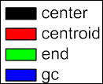

The parameters that have been put to investigation are car- ried load, average end to end delay and total energy consump- tion for the key routing protocols namely Ad hoc On Demand Vector based (AODV), Dynamic Source Routing (DSR), Fish- eye, Optimised Link state routing (OLSR) protocols [17] depicted by the figures pertaining to the considered cases. To estimate the considered parameters nodes are deployed ran- domly and individual node statistics are collected over differ- ent number of iterations using QualNet simulator 6.0 [25]. QualNet provides a comprehensive environment for employing different protocols, creating and animating network scenarios, and analysing their performance. The nodes are initially deployed randomly and are then arranged in the manner that they topographically resemble the families mentioned. The nodes once arranged approximately to the pattern similar to the figures depicted in Figs. 4a, 4b and 4d are subject to the dif- ferent routing protocols used in wireless networks. The statis- tics are collected for 50 topologies for each type of family illustrated and averaged for each one of the three classes; specifically belonging to the nonlinear tree topologies. The conclusions based on the average values of the 50 topologies were considered.

Assumptions.

* The nodes are location aware and a preconstructed tree based communication backbone exists among them.
* The average end to end delay is dependent on the number of hops undertaken for the message to finally reach the sink.
* The energy consumed is the sum of the total energy spent in communicating and receiving. The energy spent during the

idle and sleep period is negligible.

* The simulation parameters are given in Table 2.

The first case considers a graph with ‘one’ Tree Theoretic

Centre and ‘one’ Tree Theoretic Centroid at two different node locations. The second case analyses a graph with ‘one’ Tree Theoretic Centre and ‘two’ Tree Theoretic Centroid where cen- tre overlaps one centroid while the third case observes a graph with ‘two’ Tree Theoretic Centres and ‘one’ Tree Theoretic Centroid where one of the centre overlaps centroid.

Fig. 5(a), (b) and (c) depict the average hop counts for each protocol. We confirm that the number of hop counts is significantly less in our proposed sites (centre and centroid) for all the protocols considered as compared to the average hop count in case we place the sink at the end or at the

Table 2 Simulation parameter.

Parameters Values

Radio type 802.11b

Routing protocols AODV, DSR, FISHEYE, OLSR

Network size (ROI) 1500 × 1500

Node type Mica motes

Battery model Residual life estimator

Path loss model Two Ray

Sensing range 10 m

(a)





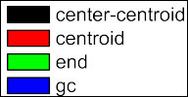

(b)



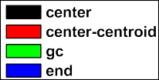

(c)

Figure 5 Average hop counts for each protocol (a) Case 1 (b) Case 2 (c) Case 3.

Optimal sink placement 223

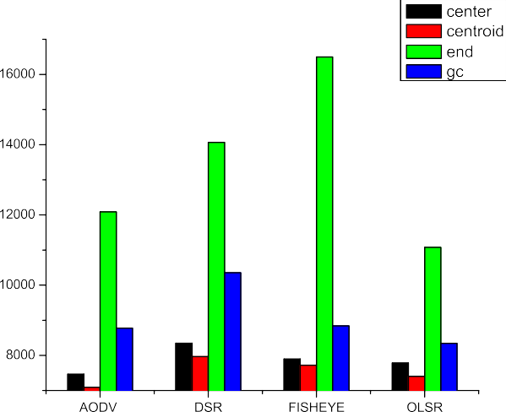

(a)

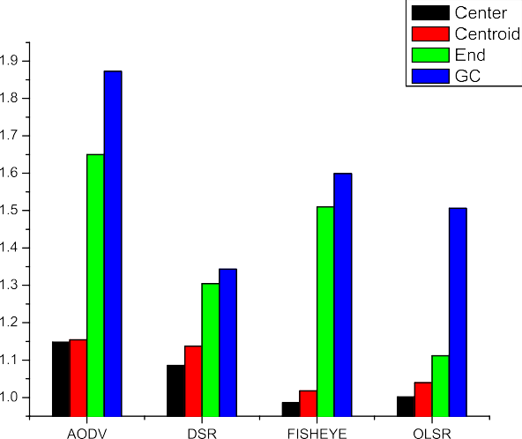(a)



(b)

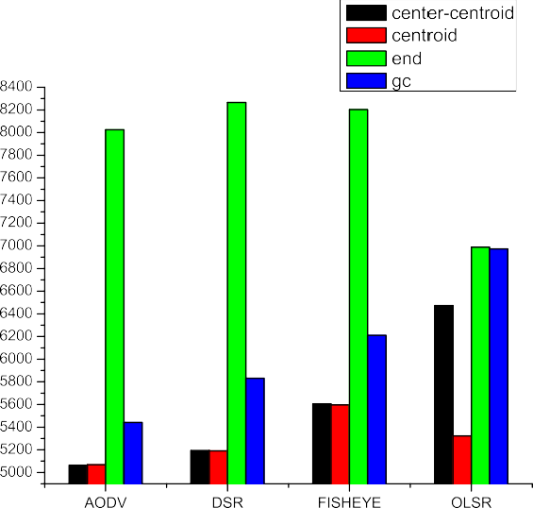





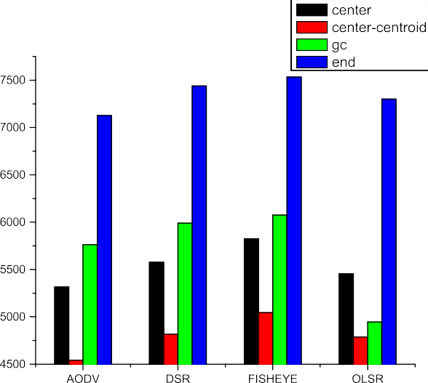

(c)

Figure 6 Total carried load for each protocol (a) Case 1 (b) Case 2 (c) Case 3.



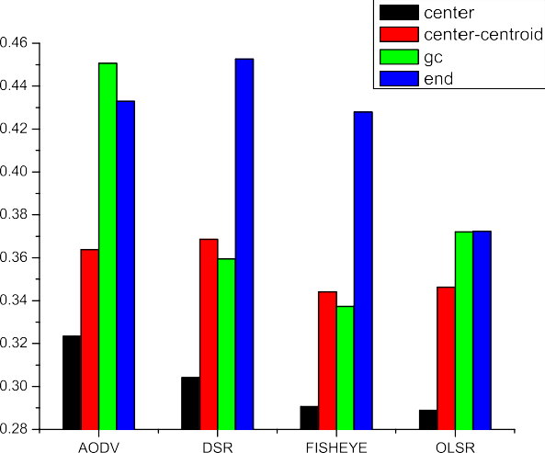(b)

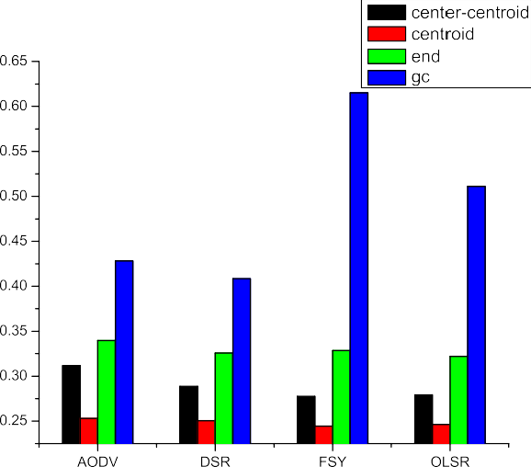





(c)





Figure 7 Average end to end delay for protocols (a) Case 1 (b) Case 2 (c) Case 3.

224 I. Snigdh et al.

(a)

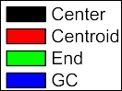



(b)

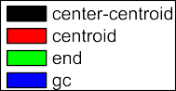



(c)

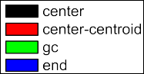



Figure 8 Total energy consumed under each protocol (a) Case 1

(b) Case 2 (c) Case 3.

geographical centre. As the number of hop counts is less, the carried load per node, as well as the end to end delay is largely reduced. This explanation is supplemented by graphical results in Fig. 6(a), (b) and (c) which depict the carried load per node and Fig. 7(a), (b) and (c) which depict the end to end delay respectively. In addition, if the nodes receive and transmit les- ser number of packets routed to them, the average energy con- sumption of the network as a whole is also quite less as depicted in Fig. 8(a), (b) and (c). The different topology sce- narios generate almost similar results which induce us to con- sider their average values for the sake of avoiding redundancies in the graphs. We observe consistent results for all the three cases considered where the adoption of best suited placement of the sink falls either at the centre or at the centroid of the graph. Thus our findings obliterate the requirements to place a sink centrally or at the end of the region of interest.

1. Conclusion

Typical WSN scenarios assume the message routed towards the sink that usually is the root of the tree. This strategy suffers from the problem of hot spots ending into communication dis- ruption due to single node failure closest to the sink. Adopting a graph based topology offers us the choice of variable routes and sink placement which usually turns out to be the geo- graphical centre or the end of the region under observation. The argument biasing this structure is based on achieving max- imal coverage under one sink. However, our article confirms that graph centroid placement of the sink node is better in terms of network delay and energy consumption rather than having a sink rooted tree for a communication backbone. Also, our results show that the message forwarding to the sink (in terms of the hop count) is the least for either the graph the- oretic centre or centroid. This ensures minimum delay and les- ser energy consumption per node and hence a longer lifetime. Our results are limited due to the simulation environment con- straints for small number of nodes. This work may be extended by incorporating a wider network with dense deployment. The poor performance of the Fisheye protocol motivates us to analyse our proposed work for incorporating mobility in future.

References

1. [Akyildiz IF, Su W, Sankarasubramaniam Y, Cayirci E. Wireless](http://refhub.elsevier.com/S1110-8665(15)00062-6/h0005) [sensor networks: a survey. Comput Netw 2002;38(4):393–422](http://refhub.elsevier.com/S1110-8665(15)00062-6/h0005).
2. [Prabh KS, Abdelzaher TF. Energy-conserving data cache](http://refhub.elsevier.com/S1110-8665(15)00062-6/h0010) [placement in sensor networks. ACM Trans Sens Netw (TOSN)](http://refhub.elsevier.com/S1110-8665(15)00062-6/h0010) [2005;1(2):178–203](http://refhub.elsevier.com/S1110-8665(15)00062-6/h0010).
3. Wang ZM, Basagni S, Melachrinoudis E, Petrioli C, Exploiting sink mobility for maximizing sensor networks lifetime. In: 38th annual Hawaii international conference on system sciences. IEEE HICSS; 2005.
4. [Incel OD, Ghosh A, Krishnamachari B. Scheduling algorithms for](http://refhub.elsevier.com/S1110-8665(15)00062-6/h0020) [tree-based data collection in wireless sensor networks. In: Theo-](http://refhub.elsevier.com/S1110-8665(15)00062-6/h0020) [retical aspects of distributed computing in sensor networks.](http://refhub.elsevier.com/S1110-8665(15)00062-6/h0020) [Berlin, Heidelberg: Springer; 2011. p. 407–45](http://refhub.elsevier.com/S1110-8665(15)00062-6/h0020).
5. Messina D, Ortolani M, Lo Re G, A network protocol to enhance robustness in tree-based WSNs using data aggregation. In: IEEE international conference on mobile adhoc and sensor systems, MASS; 2007. p. 1–4.

Optimal sink placement 225

1. Wang J, Hyong KJ. ViTAMin: a virtual backbone tree algorithm for minimal energy consumption in wireless sensor network routing. In: IEEE international conference on information networking (ICOIN); 2012. p. 144–9.
2. Johansson T, Osipov E, Motyckova L. Interference aware construction of multi and convergecast trees in wireless sensor networks. In: Next generation teletraffic and wired/wireless advanced networking, Lecture notes in computer science, vol. 5174; 2008. p. 72–87.
3. Chakraborty S, Nandi S, Karmakar S. A tree-based local repairing approach for increasing lifetime of query driven WSN. In: IEEE international conference on computational science and engineering (CSE); 2011.
4. [Patel D, Chawla B, Parekh C. Energy aware and link quality](http://refhub.elsevier.com/S1110-8665(15)00062-6/h0045) [based routing in wireless sensor networks under TinyOS-2.x. Int J](http://refhub.elsevier.com/S1110-8665(15)00062-6/h0045) [Mod Eng Res 2013;3(3):1357–65](http://refhub.elsevier.com/S1110-8665(15)00062-6/h0045).
5. Colesanti U, Santini S. The collection tree protocol for the castalia wireless sensor networks simulator. Technical Report Nr. 729, Department of Computer Science ETH Zurich; 2011.
6. Krishnamachari B, Deborah E, Wicker S. The impact of data aggregation in wireless sensor networks. In: 22nd IEEE international conference on distributed computing systems; 2002. p. 575–8.
7. Intanagonwiwat C, Estrin D, Govindan R, Heidemann J. Impact of network density on data aggregation in wireless sensor networks. In: 22nd IEEE international conference on distributed computing systems; 2002. p. 457–8.
8. [Lee E, Park S, Yu F, Kim S. Communication model and protocol](http://refhub.elsevier.com/S1110-8665(15)00062-6/h0065) [based on multiple static sinks for supporting mobile users in](http://refhub.elsevier.com/S1110-8665(15)00062-6/h0065) [wireless sensor networks. IEEE Trans Consum Electron](http://refhub.elsevier.com/S1110-8665(15)00062-6/h0065) [2011;56:1652–60](http://refhub.elsevier.com/S1110-8665(15)00062-6/h0065).
9. [Lee E, Park S, Lee J, Oh S, Kim S. Novel service protocol for](http://refhub.elsevier.com/S1110-8665(15)00062-6/h0070) [supporting remote and mobile users in wireless sensor networks](http://refhub.elsevier.com/S1110-8665(15)00062-6/h0070) [with multiple static sinks. Wireless Netw 2011;17:861–75](http://refhub.elsevier.com/S1110-8665(15)00062-6/h0070).
10. Chatzigiannakis I, Kinalis A, Nikoletseas S. Sink mobility protocols for data collection in wireless sensor networks. In: Proceedings of the international workshop on mobility manage- ment and wireless access, MobiWac ‘06; 2006. p. 52–9.
11. Vincze Z, Vida R, Vidacs A. Deploying multiple sinks in multi- hop wireless sensor networks. In: IEEE international conference on pervasive services; 2007. p. 55–63.
12. [Khan MI, Gansterer WN, Haring G. Static vs. mobile sink: the](http://refhub.elsevier.com/S1110-8665(15)00062-6/h0085) [influence of basic parameters on energy efficiency in wireless](http://refhub.elsevier.com/S1110-8665(15)00062-6/h0085) [sensor networks. Comput Commun 2013;36:965–78](http://refhub.elsevier.com/S1110-8665(15)00062-6/h0085).
13. [Kosar R, Ersoy C. Sink placement on a 3D terrain for border](http://refhub.elsevier.com/S1110-8665(15)00062-6/h0090) [surveillance in wireless sensor networks. Eng Appl Artif Intell](http://refhub.elsevier.com/S1110-8665(15)00062-6/h0090) [2012;25:82–9](http://refhub.elsevier.com/S1110-8665(15)00062-6/h0090).
14. [Younis M, Akkaya K. Strategies and techniques for node](http://refhub.elsevier.com/S1110-8665(15)00062-6/h0095) [placement in wireless sensor networks: a survey. Ad Hoc Netw](http://refhub.elsevier.com/S1110-8665(15)00062-6/h0095) [2008;6(4):621–55](http://refhub.elsevier.com/S1110-8665(15)00062-6/h0095).
15. [Krishnamachari B, Estrin D, Wicker S. Modelling data-centric](http://refhub.elsevier.com/S1110-8665(15)00062-6/h0100) [routing in wireless sensor networks. IEEE Infocomm 2002;2:](http://refhub.elsevier.com/S1110-8665(15)00062-6/h0100) [39–44](http://refhub.elsevier.com/S1110-8665(15)00062-6/h0100).
16. [Tang J, Hao B, Sen A. Relay node placement in large scale](http://refhub.elsevier.com/S1110-8665(15)00062-6/h0105) [wireless sensor networks. Comput Commun 2006;29(4):490–501](http://refhub.elsevier.com/S1110-8665(15)00062-6/h0105).
17. [Kim H, Seok Y, Choi N, Choi Y, Kwon T. Optimal multi-sink](http://refhub.elsevier.com/S1110-8665(15)00062-6/h0110) [positioning and energy-efficient routing in wireless sensor](http://refhub.elsevier.com/S1110-8665(15)00062-6/h0110) [networks. In: Information networking. Convergence in](http://refhub.elsevier.com/S1110-8665(15)00062-6/h0110) [broadband and mobile networking. Berlin, Heidelberg: Springer;](http://refhub.elsevier.com/S1110-8665(15)00062-6/h0110) [2006. p. 264–74](http://refhub.elsevier.com/S1110-8665(15)00062-6/h0110).
18. [Kim J, Lin X, Shroff NB, Sinha P. Minimizing delay and](http://refhub.elsevier.com/S1110-8665(15)00062-6/h0115) [maximizing lifetime for wireless sensor networks with anycast.](http://refhub.elsevier.com/S1110-8665(15)00062-6/h0115) [IEEE/ACM Trans Netw (TON) 2007;18(2):515–28](http://refhub.elsevier.com/S1110-8665(15)00062-6/h0115).
19. [Bondy JA, Murty USR. In: Graph theory. Graduate texts in](http://refhub.elsevier.com/S1110-8665(15)00062-6/h0120) [mathematics, vol. 244. New York: Springer; 2008](http://refhub.elsevier.com/S1110-8665(15)00062-6/h0120).
20. Qualnet Simulator 6.0. http:// web.scalable-networks.com.