[Egyptian Informatics Journal 18 (2017) 133–139](http://dx.doi.org/10.1016/j.eij.2016.11.003)

Contents lists available at [ScienceDirect](http://www.sciencedirect.com/science/journal/11108665)

Egyptian Informatics Journal

journal homepage: [www.sciencedirect.com](http://www.sciencedirect.com/)

Full length article

Performance analysis and implementation of proposed mechanism for detection and prevention of security attacks in routing protocols of vehicular ad-hoc network (VANET)



Parul Tyagi a,⇑, Deepak Dembla b

a *Dept of ECE, JECRC University, Jaipur 303905, India*

b *Dept of Computer Science, JECRC University, Jaipur 303905, India*

# a r t i c l e i n f o

*Article history:*

Received 23 December 2015

Revised 23 August 2016

Accepted 7 November 2016

Available online 18 November 2016

*Keywords:*

Routing protocol

Mobile ad hoc network (MANET) Vehicular ad hoc network (VANET) Black Hole Attack

Malicious node Throughput

# a b s t r a c t

Next-generation communication networks have become widely popular as *ad-hoc* networks, broadly cat- egorized as the mobile nodes based on mobile *ad-hoc* networks (MANET) and the vehicular nodes based vehicular ad-hoc networks (VANET). VANET is aimed at maintaining safety to vehicle drivers by begin autonomous communication with the nearby vehicles. Each vehicle in the ad-hoc network performs as an intelligent mobile node characterized by high mobility and formation of dynamic networks. The ad- hoc networks are decentralized dynamic networks that need efficient and secure communication requirements due to the vehicles being persistently in motion. These networks are more susceptible to various attacks like Warm Hole attacks, denial of service attacks and Black Hole Attacks. The paper is a novel attempt to examine and investigate the security features of the routing protocols in VANET, appli- cability of AODV (Ad hoc On Demand) protocol to detect and tackle a particular category of network attacks, known as the Black Hole Attacks. A new algorithm is proposed to enhance the security mecha- nism of AODV protocol and to introduce a mechanism to detect Black Hole Attacks and to prevent the network from such attacks in which source node stores all route replies in a look up table. This table stores the sequences of all route reply, arranged in ascending order using PUSH and POP operations. The priority is calculated based on sequence number and discard the RREP having presumably very high destination sequence number. The result show that proposed algorithm for detection and prevention of Black Hole Attack increases security in Intelligent Transportation System (ITS) and reduces the effect of malicious node in the VANET. NCTUNs simulator is used in this research work.

© 2016 Production and hosting by Elsevier B.V. on behalf of Faculty of Computers and Information, Cairo

University. This is an open access article under the CC BY-NC-ND license ([http://creativecommons.org/](http://creativecommons.org/licenses/by-nc-nd/4.0/)

[licenses/by-nc-nd/4.0/](http://creativecommons.org/licenses/by-nc-nd/4.0/)).

1. Introduction

Vehicle to vehicle communication (V2V) and Intelligent Trans- portation Systems (ITS) have emerged as a reliable solution to a number of inconveniences faced by drivers and commuters on the road. Vehicular communication (VC) architecture utilizes a

* Corresponding author.

*E-mail addresses:* [parultyagi.ece@jecrc.ac.in](mailto:parultyagi.ece@jecrc.ac.in), [tyagi.parul82@gmail.com](mailto:tyagi.parul82@gmail.com) (P. Tyagi), [deepak.dembla@jecrcu.edu.in](mailto:deepak.dembla@jecrcu.edu.in) (D. Dembla).

Peer review under responsibility of Faculty of Computers and Information, Cairo University.

**Production and hosting by Elsevier**

specific wireless communication frequency band known as the dedicated short-range communication (DSRC) band that enables wireless coverage to provide the wireless access in vehicular envi- ronments (WAVE). WAVE allows vehicles within specified vicinity to interact with the road side infrastructure (V2I communication) and also with other neighboring vehicles (V2V communication). These vehicles have lack of centralized controlling authority and form a distributed network, characterized by dynamic movement and self organization of nodes, leading to vehicular ad-hoc net- works (VANET). Whereas the nodes in MANET cannot recharge their battery power, provisions exist for VANET nodes to recharge themselves at frequent intervals [1]. A pictorial display of a typical V2V and V2I communication scenario is shown in Fig. 1.

Two types of such units that provide V2V and V2I communica- tions are the On Board Unit (OBU) inside the vehicles and the Road Side Unit (RSU) installed along the travel zones. Increasing number

<http://dx.doi.org/10.1016/j.eij.2016.11.003>

1110-8665/© 2016 Production and hosting by Elsevier B.V. on behalf of Faculty of Computers and Information, Cairo University. This is an open access article under the CC BY-NC-ND license (<http://creativecommons.org/licenses/by-nc-nd/4.0/>).

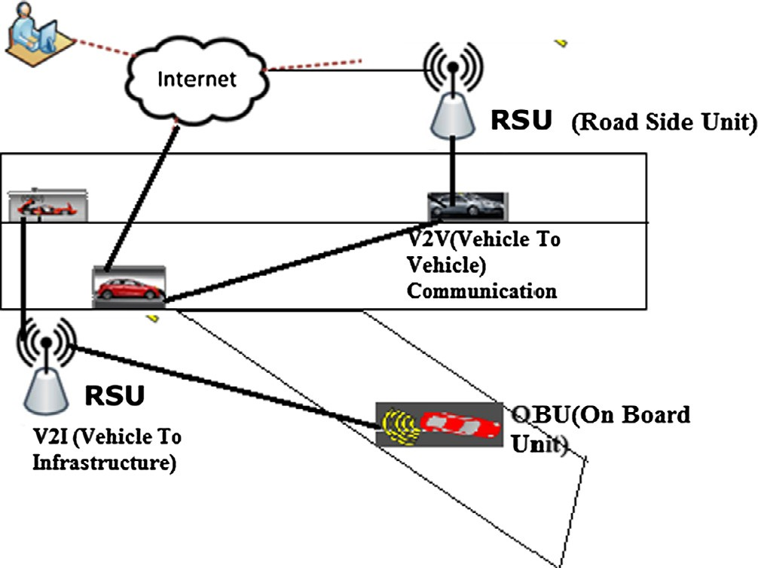

Figure 1. Vehicular ad hoc networks.

of car-manufacturers employ the VANET framework to incorporate more and more comfort and security applications of VANET. Due to high mobility of nodes, executing efficient data transmission in VANET needs appropriate communication protocol. VANET nodes traverse a fixed number of internet gateways at high speed to forward data and then get disconnected from the network as they fall out of the wireless coverage range. Link reliability model is used to compute and predict the optimum probability of future status (formation and disruption of links among nodes) in wireless link [2].

VANET is susceptible to a number of attacks and malicious intrusions, and designing stronger routing protocols would con- tribute towards making the networks less prone to attacks. This paper presents an insight into the working and performance char- acteristics of two commonly used VANET protocols: DSR [3] and AODV [4]. The original version and implementation of the AODV protocol was centered on efficient routing of data packets, but had little consideration for security aspects and we have designed a algorithm to enhance the security mechanism of AODV protocol and to introduce a mechanism to detect Black Hole Attacks and to prevent the network from such attacks in which source node stores all route replies in a look up table. This table stores the sequences of all route reply, arranged in ascending order using PUSH and POP operations. The priority is calculated based on sequence number and discard the RREP having presumably very high destination sequence number.

1. Related work

Significant amount of research has analyzed the security aspects of routing protocols used in VANET described as follows:

Yi et al. [7] investigated Security-Aware Ad hoc Routing (SAR) protocol using trust values and relationships. The work yielded some results having varying percentages of message packets trans- mitted by unauthorized and malicious nodes, indicating flaws in the security aspects of ad-hoc network communication.

Sanzgiri et al. [8] introduced Authenticated Routing protocol for ad hoc Networks (ARAN). ARAN was viewed as a mechanism to resolve the security issues based on cryptographic public-key cer- tificates. ARAN is as efficient as AODV in maintaining and discover- ing the route but ARAN uses larger packets which results overall higher routing overhead.

Hu et al. [9] proposed Secure Efficient Ad hoc Distance Vector Routing Protocol (SEAD), which was based on hash chain

sequences to authenticate hop counts between nodes. The sequence numbers also enhanced the security features in Distance Sequence Distance Vector (DSDV) protocol. SEAD outperforms than DSDV in terms packet delivery ratio but it increase more overhead in network due to increase in number of routing advertisement.

Ariadne Perrig [10] proposed a algorithm based on Dynamic Source Routing (DSR) that shared the secret key between two nodes. Although these distributed and independent developments have provided an insight into analysis of network security features, still there is a lack of a standard protocol that characterizes secure VANET and could act as a benchmark against which further proto- cols could be designed.

Shurman et al. [11] proposed a novel mechanism where the source node was appended with computational capabilities to ver- ify the authenticity of the node initiating the RREP messages. The node could now detect so many possible paths to the destination and compute the safest route to the destination. The method, though novel, resulted in routing delays extending from a few nanoseconds to several orders of magnitude. He studied only one node attack to be in the route but not considered group attack.

Dokurer et al. [12] resolved group attack problem with a solu- tion to ignore the first route, in order to counter the Black Hole Attack under the assumption that the first RREP message might be from a malicious node. Though widely agreed upon, this method ignored the possibility of the second RREP message being received from a malicious node. Thus, the method was susceptible to Black Hole Attacks, lacking a mechanism to identify and delete attacker node from the network.

Raj and Swadas [13] suggested an enhanced model to detect Black Hole Attacks, where the source continuously monitors the RREP destination sequence number and compares it with a period- ically updated threshold. A value higher than the threshold is sus- pected to have arrived from malicious node. The neighboring nodes are informed of the presence of the malicious node through an ALARM packet. The method again increased the routing overhead. DPRAODV increases PDR with minimum increase in Average-End- to-end Delay and normalized Routing Overhead.

Kurosawa et al. [14] proposed an anomaly detection scheme using dynamic training method in which the training data is reno- vated at regular time intervals and analyzes Black Hole Attack in the network which is one of the main attacks in ad hoc networks. In Black Hole Attack a malicious node impersonates a destination node by sending forged RREP to a source node that initiates route discovery, and consequently deprives data traffic from the source node.

Mistry et al. [15] proposed an algorithm to verify the authentic- ity of RREP destination sequence number by heuristically analyzing the predefined waiting period. A high sequence number marked the sender as malicious node. The node suffered from latency time in case there was no attack from any node; still the monitoring proofs had to be carried out, in order to decrease the redundant threshold and hence the routing overhead.

As observed from the above discussion, most of the methods and algorithms brought some novelty to the attack detection scheme, but also suffered from routing overhead issues on inter- mediate and source node. Here, we propose a new algorithm with the following objectives of minimizing the routing overhead, decreasing the latency time and designing a routing protocol for efficient processing.

1. Security aspects and issues in routing protocol in VANET

Ad-hoc routing protocols usually work based on either route discovery or route maintenance. A source node without routing information needs to establish a route towards the destination.

When the node changes, certain link on the activated path may break, then the route maintenance process will be initiated. Ad- hoc On-Demand Distance Vector (AODV) [5,6] routing protocol is the most widely adopted topology based routing protocol used in VANET. A source node looking for a route to the desti- nation node openly broadcasts a route request (RREQ) message to the neighboring nodes and awaits route reply (RREP) message from any of the nodes which has detected a path to the destina- tion. The AODV protocol suffers from a major drawback that the source node is unaware of which node receives the transmitted request packet and sends a reply. Because ad-hoc networks are absence of a fixed framework, there is no fixed line of infras- tructure, therefore AODV is vulnerable and susceptible to the attacks.

The vehicular ad hoc network suffers from all-weather attacks, which can come from any node that is in the radio range of any node in the network. The attacks mainly include passive eaves- dropping and leakage of secret information, Gray Hole, Black Hole, Worm Hole, and denial of service. The focus of this research paper is to detect and prevent Black Hole Attack.

In Black Hole Attack, the source node broadcasts route request (RREQ) to the nearby nodes in search for the shortest possible route to the destination. The intermediate nodes that receive the RREQ message transmit to the neighboring nodes till they find a route to the destination. Meanwhile, one of the intermediate nodes may be a malicious node and it transmits a false route reply (RREP) message to the source node. The source node transmits all the mes- sage packets to this malicious node, thus never transmitting them to the intended receiver. In the meantime, the source also rejects other RREP messages that contain a genuine path to the destination.

Black Hole Attack in VANET is diagrammatically explained in Fig. 2. Source node A broadcasts an RREQ message to discover a route for sending packets to destination node F. Node A broadcasts RREQ to its neighboring nodes B, M and C. However, malicious node M sends an RREP message immediately without even having a route to destination node F.

After receiving a false RREP, source node selects the route received from the malicious node and also ignores any forthcoming RREP messages from genuine nodes. By repeating this process, an intruder node can successfully capture other routes as well as mes- sage packets in the network by forcing most of the network traffic to flow through itself. If a malicious node intercepts the transmit- ted RREQ message and sends a fake RREP message, there is no inherent mechanism in AODV to detect whether the received RREQ is from a genuine node or from a malicious node.

This research focuses on Black Hole Attack, where the legiti- mate data packets are absorbed by a malicious node, thus causing the information to be lost. The malicious node can occur due to an intentionally node misbehaving or due to a damaged or corrupted node interface. A Black Hole Attack comes across as denial of ser-

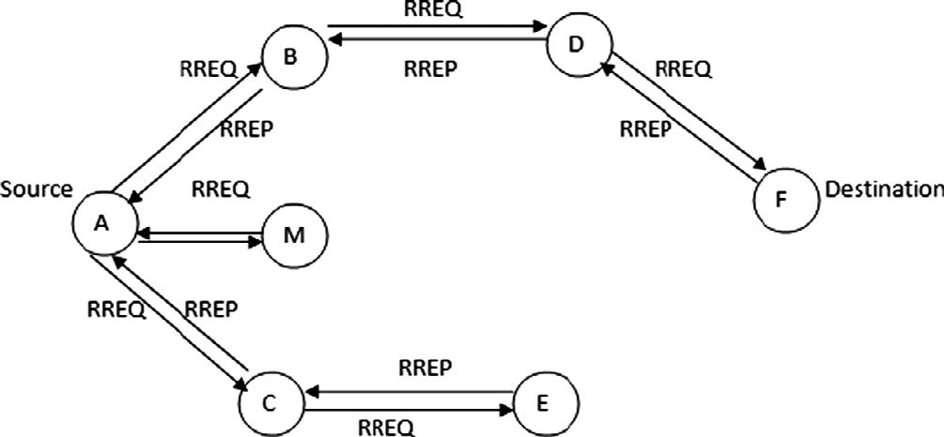

Figure 2. Black Hole Attack in VANET.

vice, with a malicious node falsely claiming to possess route infor- mation to the destination.

1. Proposed solution to detect and prevent Black Hole Attack

To prevent Black Hole Attack, the following mechanism is pro- posed and explained in Fig. 3. The source node uses additional information known as pseudo reply packet (PRREP). The source node stores the information about all the incoming packets in a look-up table designated as RREP_T. This table stores the PRREP sequences, arranged in ascending order using PUSH and POP oper- ations. Any abnormality in the table sequences is considered to be a PRREP sequence received from a malicious node and is discarded by the source. Furthermore, the table is periodically updated, with all the PRREP sequences stores for a set duration defined by STR_dur. A header H_node attached to each message received from different nodes, assigns a priority to the PRREP message and is con- sidered in that order by the source node. The priority is calculated based on the sequence number, and the shortest sequence number is given the highest priority. Node having abnormal sequence num- ber is considered as a malicious node and source broadcast this message in network.

*Proposed Algorithm*

*Pseudo Reply Packet (PRREP) { t0 = get (current time value) t1 = t0 + STR_Dur*

*while (CURRENT_TIME <= t1) {*

*Store P.Dest_Seq_No and P.NODE_ID In RREP_Tab table*

*}*

*while (RREP_Tab is not empty) {*

*if (Dest_Seq_No >>>= Src_Seq_No) {*

*Mali_Node=Node_Id*

*discard entry from M_ table*

*}*

*}*

*select Packet q for Node_Id having highest value of Dest_Seq_No ReceiveReply(Packet q)*

*}*

1. Experiment setup for implementation of proposed algorithm

The various network traffic scenarios are simulated in an envi- ronment without Black Hole Attack and a new algorithm is pro- posed to detect and prevent the Black Hole Attack in AODV and DSR routing protocol in VANET using NCTUns (*National Chiao Tung University Network Simulator*) [16,17] is used for simulation of VANET routing protocols, that serves both as an open end network simulator as well as an emulator. Embedded with GUI environ- ment, NCTUns requires, Fedora to be operated. NCTUns provides many advantages over other network simulators.

The freeway mobility model is adopted to simulate vehicle movements on a highway. This model can simulate a bidirectional multi-lane highway that gets the highway route from an input map. The proposed algorithm is implemented and tested on NCTUns and the results are compared with AODV, DSR and B- AODV (AODV with Black Hole Attack) using various simulation parameters.

Testing scenario conditions of VANET in NCTUns:

1. A vehicular ad-hoc network is considered for study.



Start

Do you have

destination

Are You

Destination

STR-

DUR < 1

RREP-

Wait Time

>1

Check for Abnormal

Sequence

Store all RREP in new RREP-T

Wait for more time

Sending RREP message

Compare all RREP in RREP-T

RREQ message Directional

Are You

Destination

Flooding RREQ

Sending Data

Establish main route

Finish

Discard RREP from that

Node is malicious

Source is declared a malicious and broadcast to all

Destination sends a PRREP

1. The Lane Width for vehicles is taken as 30 m.

Figure 3. Flow chart of proposed algorithm.

* 1. *Performance metrics*

1. The initial average distance between two nodes is supposed to be 500 m.
2. Average simulation time is supposed to be 100 s.
3. The RTS threshold is set at 3000 bytes.

The simulated nodes are based on PHY/MAC networks. The vehicular network scenario is implemented using the Car Agent application. The simulation environment consists of 18 nodes on 4-lane road spread over an area of 1200 m.

The average speed 50 m/s with maximum deceleration 1–20 m per Second Square in each scenario. Table 1 shows the physical layer and channel model specification of simulation environment.

Various performance measurement and analysis metrics exist that evaluate the protocol efficiency and performance in different traffic scenario in VANET environment. This work focuses on throughput, packet loss and collision rate parameters to investi- gate the performance of VANET routing protocols [18].

* 1. Packet loss

Packet loss is obtained by subtracting the number of packets received at Access Point from the total number of packets transmitted.

## Packets losts = X Packets transmited — X Packets received Packet loss ratio = (Packets losts * 100)

RPackets transmitted

Table 1

Simulation environment parameters.

Parameter Setting

Frequency (MHz) 24

Fading var 10

RiceanK 10

Tx antenna height (m) 1.5

System loss 1.0

Trans power (dbm) 3.0

Average building height (m) 10

Street width (m) 30

Average building distance (m) 80

Path loss exponent 2.0

Shadowing standard deviation 4.0

Close in distance (m) 1.0

Rx antenna height (m) 1.5

* 1. Throughput

It is defined as the time average of the number of bits that can be transmitted by each node to its destination is called the per- node throughput. The sum of per-node throughput over all the nodes in a network is called the throughput of the network. The throughput is obtained by dividing the total number of packets received by the total time taken for simulation

## Throughput = (received packets * packet size)

simulation time

Throughput of the network is inversely proportional to the average delay between source and destination. Throughput of the network can also be estimated as follows:

## Throughput (Th)= ETT · (n + 1)· L

nR

where R is transmission range, n is number of neighbors in the direction of destination node and ETT (Expected Transmission Time) is used to maximize the throughput of the path by measuring the link capacities and would increase the overall performance of the network. ETT is defined as

## ETT = S L(1 — p)

where S is the size of a packet and L is the bandwidth of the link and p is the probability to deliver a packet successfully.

* 1. Collision

A significant number of packets collide with the neighboring packets due to limited availability of communication bandwidth or congestion. This metric is defined as the ratio of the unsuccess- ful transmissions from the vehicle to the total number of sent packets over CCH.

## Unsucessfull TransmissionCR Collision Rate Total number of sent packet

( )= P

* 1. *Different traffic scenarios used*

The first VANET scenario depicts a highway area, and is repre- sented using a simple single-hop scenario. Two cases under consid- eration for this study are the highway scenario and a city scenario. The simulation is carried out for different number of nodes (vehi- cles) travelling at variable speeds. These scenarios can be easily designed NCTUns-5 ‘‘draw topology” feature. The Car Agent mobil- ity model allows nodes to follow roads just as in a real-time envi- ronment and additionally enables them to be aware of neighboring vehicles, traffic signals and varying traffic light status.

Highway scenario:

Fig. 4 illustrates the highway scenario with 10 cars with speed 90 km/h through NCTUns simulator and Table 2 describes the input parameters variation pattern and distribution pattern for highway scenario.

City scenario:

Fig. 5 illustrates the scenario with 20 cars with speed 60 km/h through NCTUns simulator and Table 3 depicts input parameters for city scenario.

* 1. *Result analysis*

A number of simulations were carried out in order to compared the performance of various protocols. The following results com- pared the performance characteristics of DSR and AODV in a simu- lated environment which is free of Black Hole Attacks. The practical networks contain a significant number of malicious nodes, and their effects need to be countered. The experiments were con- ducted without taking into consideration Black Hole Attacks and with Black Hole Attack in network. The results are exhibited in fol- lowing figures.

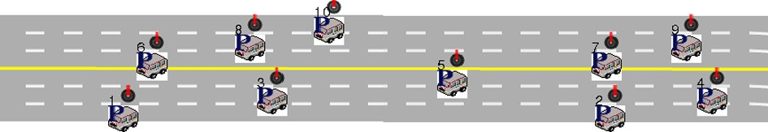

Figure 4. Highway scenario with 10 nodes with 60–90 km/h speed drawn using NCTUns -5.0.

Table 2

Input parameters for highway scenario.

Parameter Setting Total number of nodes 10

Max. node speed 60 km/h, 90 km/h

Packet type UDP

Simulation time 100 s

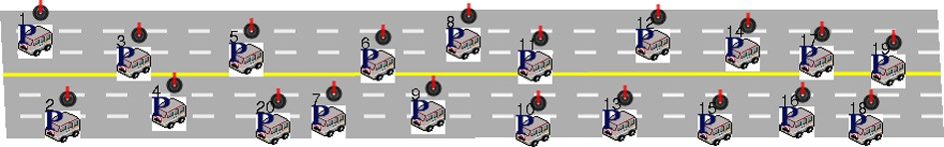

Figure 5. City scenario with 20 nodes with 20–60 km/h speed had drawn using NCTUns-5.

Table 3

Input parameters for city scenario.

Parameter Setting Total number of nodes 20

No. of radio obstacles 4

Attenuation provided 20 dBm

Max. node speed 20 km/h, 40 km/h

Packet type UDP

Simulation time 100

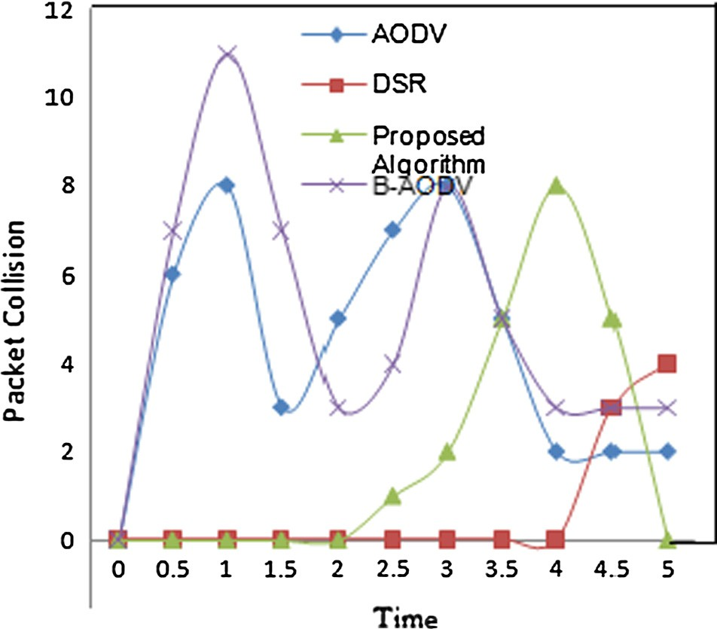

Figure 6. Packet collision rate vs. time (s) plot of highway scenario (vehicle density 10).

City scenario:

The graphs in Figs. 6, 7, 9 and 10 shows the AODV and DSR pro- tocol suffer from increased call drop rates and collision rates as the node density increases. Finally, the results in Figs. 8 and 11 empha- size that the throughput is better for proposed algorithm as the number of packet drop is higher as compared to AODV, DSR and B-AODV (AODV with Black Hole Attack). The protocols are ana- lyzed and compared with respect to throughput, call drop and packet collision. The proposed algorithm shows somewhat better performance for all the three parameters in comparison to DSR, AODV protocol. Now we implement to enhance the security mech- anism of AODV. The results are summarized in Table 4.

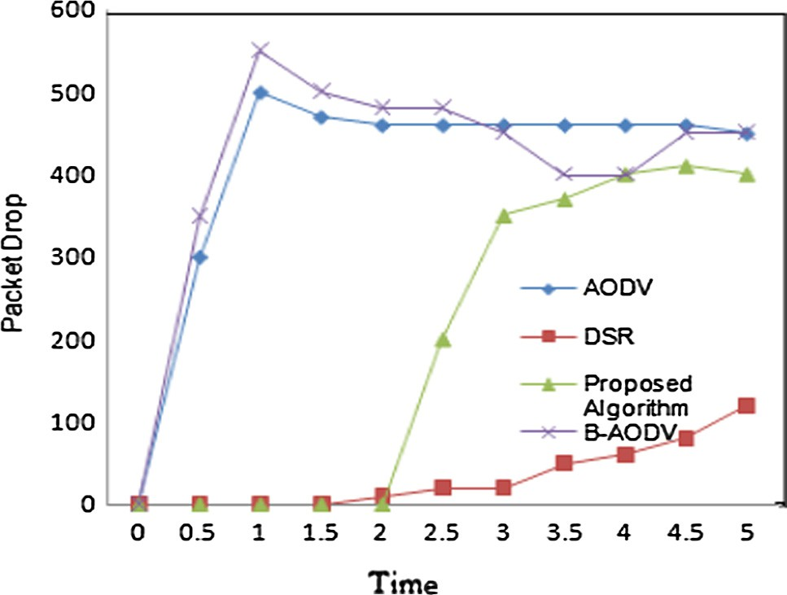 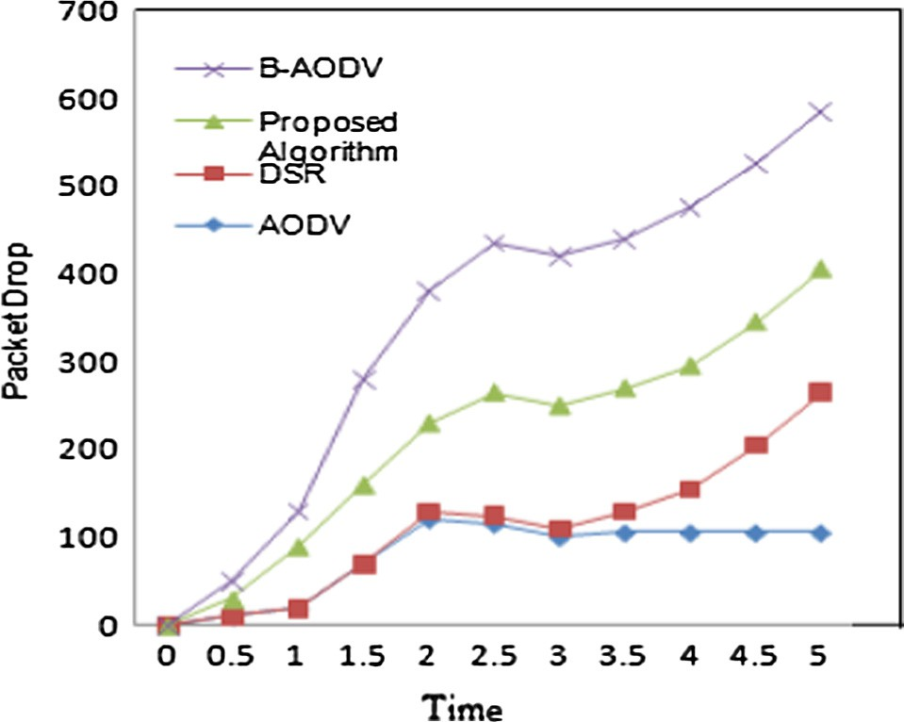

Figure 7. Packet drop vs. time (s) plot of highway scenario (vehicle density 10).

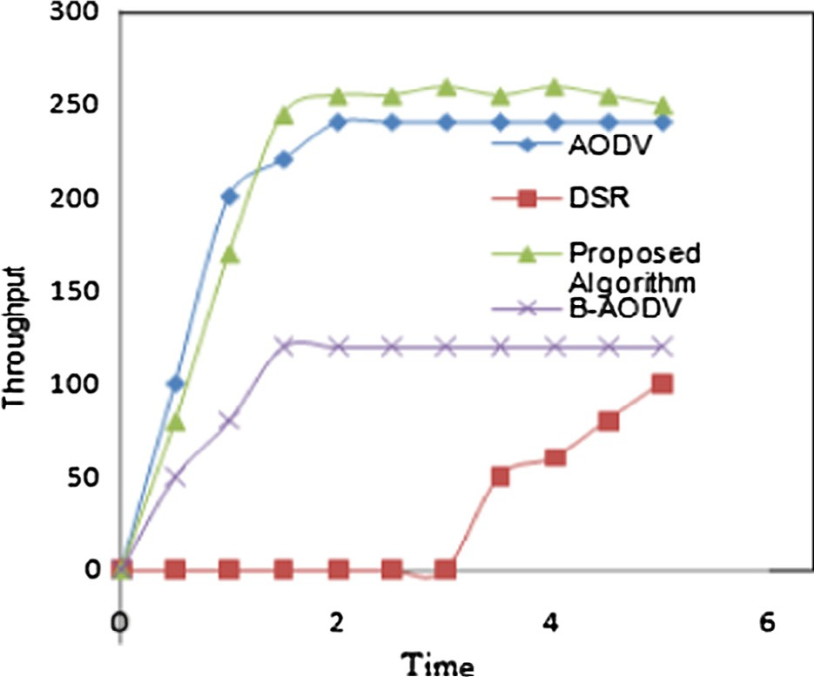

Figure 8. Throughput in kb/s vs. time in sec plot of highway scenario (car density 10).

Figure 10. Packet drop vs. time in sec plot of city scenario.

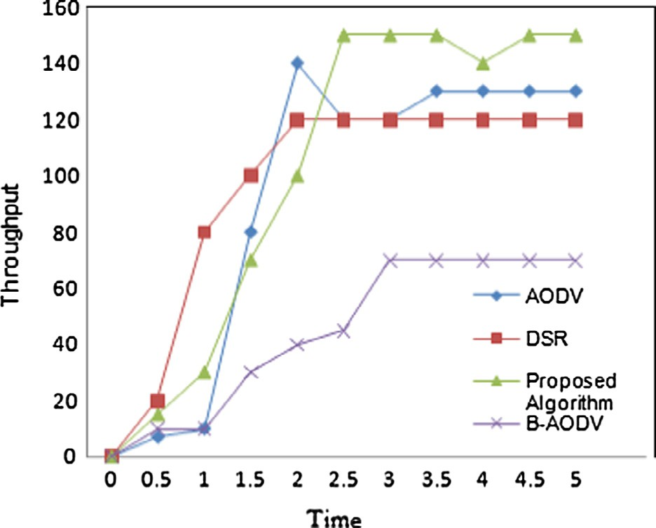

Figure 11. Throughput in kb/s vs. time in sec plot of city scenario.

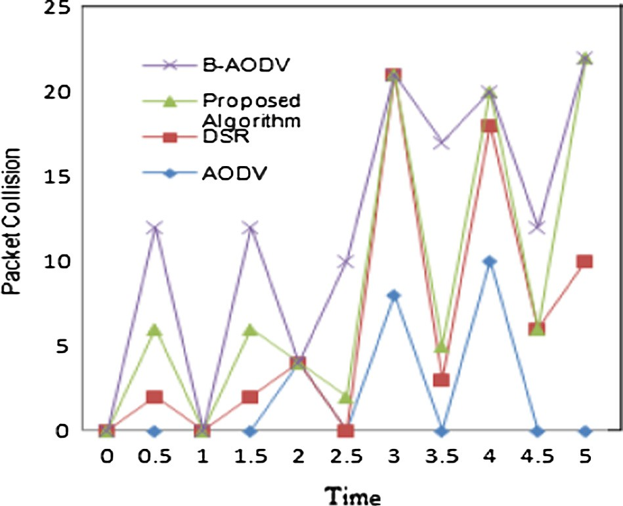

Figure 9. Packet collision rate vs. time in sec plot of city scenario.

Table 5 gives comparative study of various algorithms, with proposed algorithm with low overhead and it is efficient for single and cooperative attacks. The solution does not add any control message to existing AODV neither it needs to even regenerate any control messages. So, there are minimum chances of rise in Normalized Routing Overhead i.e. in the ratio of number of control packets to data transmissions in a simulation.

1. Conclusion and future work

Routing protocols in VANET are more susceptible to attacks. Hence, there is a requirement for a novel supervisory algorithm. A new algorithm is proposed and implemented for VANET routing scenarios to take evasive action against the Black Hole Attack. This paper discusses the performance of DSR and AODV routing proto- cols for city and highway scenarios, for VANET and proposed a novel algorithm to examine the security features of the routing protocols in VANET, applicability of AODV (Ad hoc On Demand) protocol to detect and tackle a particular category of network attacks, known as the Black Hole Attacks. As VANET architectures are characterized by frequent topology changes, a precise descrip- tion, control and monitoring of the timing of routing update is very important. The NCTUns simulation for these two protocols reveals

|  |  |  |  |  |  |
| --- | --- | --- | --- | --- | --- |
| Table 4  Simulation highway and city | scenario. |  | | | |
|  |  | Basic AODV | DSR | B-AODV | Proposed algorithm |
| Packet collisions | Scenario 1 (highway scenario) | 8 | 4 | 11 | 7 |
|  | Scenario 2 (city scenario) | 10 | 22 | 22 | 22 |
| Packets dropped | Scenario 1 (highway scenario) | 500 | 100 | 550 | 410 |
|  | Scenario 2 (city scenario) | 100 | 230 | 550 | 400 |
| Throughput (KB/s) | Scenario 1 (highway scenario) | 230 | 100 | 120 | 255 |
|  | Scenario 2 (city scenario) | 140 | 120 | 70 | 150 |

Table 5

Comparative analysis on algorithm performance.

|  |  |  |  |  |
| --- | --- | --- | --- | --- |
| Techniques | Overhead | Black Hole Attack | Cooperative Black Hole | Collision rate |
| Sanzgiri et al. [8] introduced Authenticated Routing protocol for ad hoc Networks (ARAN). It is based on | High | Yes | No | High |

cryptographic public-key certificates

Shurman et al. [11] proposed a novel mechanism which reduces overhead but group attack was not considered

Dokurer et al. [12] resolved group attack problem with a solution to ignore the first route reply but, this method was susceptible to Black Hole Attacks

In the proposed algorithm, overhead has been reduced and security of network for single and group attack is also been improved

Low Yes No Low

– Yes Yes High

Low Yes Yes Low

that proposed algorithm is much better than AODV, DSR and B- AODV in comparison, with reference to parameters such as throughput, call drop and collision rate. Proposed algorithm adapts faster to dynamic network conditions with the help of various con- trol messages.

The future aim would be to make the network completely immune to Black Hole Attacks using AODV routing protocol.

References

1. [Chlamtac, Conti M, Liu J. Mobile ad hoc networking: imperatives and](http://refhub.elsevier.com/S1110-8665(16)30050-0/h0005) [challenges. Ad Hoc Networks; 2003. p. 13–64](http://refhub.elsevier.com/S1110-8665(16)30050-0/h0005).
2. [Zeadally Sherali et al. Vehicular ad hoc networks (vanets): status, results, and](http://refhub.elsevier.com/S1110-8665(16)30050-0/h0010) [challenges. Telecommun Syst 2012;50(4):217–41](http://refhub.elsevier.com/S1110-8665(16)30050-0/h0010).
3. [Paul B et al. VANET routing protocols: pros and cons. Int J Comput Appl](http://refhub.elsevier.com/S1110-8665(16)30050-0/h0015) [2011;20(3):28–34. April](http://refhub.elsevier.com/S1110-8665(16)30050-0/h0015).
4. Perkin Charles E. Ad hoc on demand distance vector (AODV) routing. Internet draft, draft-ietf-manetaodv-02.txt, November 1988.
5. [Dembla Dr Deepak, Tyagi Ms Parul. A taxonomy of security attacks and issues](http://refhub.elsevier.com/S1110-8665(16)30050-0/h0025) [in vehicular ad-hoc networks (VANETs). Int J Comput Appl 2014;91(7):22–7](http://refhub.elsevier.com/S1110-8665(16)30050-0/h0025) [[Published by Foundation of Computer Science, New York, USA]](http://refhub.elsevier.com/S1110-8665(16)30050-0/h0025).
6. [Hong X, Xu K, Gerla M. Scalable routing protocols for mobile ad hoc networks.](http://refhub.elsevier.com/S1110-8665(16)30050-0/h0030) [Kluwer Wireless Networks 2002;16:11](http://refhub.elsevier.com/S1110-8665(16)30050-0/h0030).
7. [Yi S, Naldurg P, Kravets R. Security-aware ad hoc routing for wireless networks.](http://refhub.elsevier.com/S1110-8665(16)30050-0/h0035) [In: Proc. 2nd ACM symp. mobile Ad Hoc networking and computing](http://refhub.elsevier.com/S1110-8665(16)30050-0/h0035) [(Mobihoc‟01), Long Beach, CA, October. 2001. p. 299–302](http://refhub.elsevier.com/S1110-8665(16)30050-0/h0035).
8. [Sanzgiri Kimaya, Dahill B. A secure routing protocol for Ad hoc networks. In:](http://refhub.elsevier.com/S1110-8665(16)30050-0/h0040) [10th IEEE international conference on network protocols (ICNP‟ 02). 2002. p.](http://refhub.elsevier.com/S1110-8665(16)30050-0/h0040) [78–87. Nov](http://refhub.elsevier.com/S1110-8665(16)30050-0/h0040).
9. [Hu YC, Johnson DB, Perrig A. SEAD: secure efficient distance vector routing for](http://refhub.elsevier.com/S1110-8665(16)30050-0/h0045) [mobile wireless Ad Hoc networks. Ad Hoc Networks J 2003;1:175–92](http://refhub.elsevier.com/S1110-8665(16)30050-0/h0045).
10. [Yih-Chun, Perrig Adrian, Johnson David B. Ariadne: a secure on- demand](http://refhub.elsevier.com/S1110-8665(16)30050-0/h0050) [routing protocol for AdHoc networks. In: MobiCom’02 proceedings of the 8th](http://refhub.elsevier.com/S1110-8665(16)30050-0/h0050) [annual international conference on mobile computing and networking. 2002.](http://refhub.elsevier.com/S1110-8665(16)30050-0/h0050)

[p. 12–23](http://refhub.elsevier.com/S1110-8665(16)30050-0/h0050).

1. [Shurman MA, Yoo SM, Park S. Black hole attack in mobile Ad Hoc networks. In:](http://refhub.elsevier.com/S1110-8665(16)30050-0/h0055) [ACM Southeast Regional Conference. 2004. p. 96–7](http://refhub.elsevier.com/S1110-8665(16)30050-0/h0055).
2. [Dokurer Semih, Erten YM, Acar Can Erkin. Performance analysis of ad-hoc](http://refhub.elsevier.com/S1110-8665(16)30050-0/h0060) [networks under black hole attacks. In: Southeast con. proceedings. IEEE; 2007.](http://refhub.elsevier.com/S1110-8665(16)30050-0/h0060)

[p. 148–53](http://refhub.elsevier.com/S1110-8665(16)30050-0/h0060).

1. [Raj Payal N, Swadas Prashant B. DPRAODV: a dynamic learning system against](http://refhub.elsevier.com/S1110-8665(16)30050-0/h0065) [black hole Attack in AODV based manet. Int J Comput Sci Issues 2009;2:54–9](http://refhub.elsevier.com/S1110-8665(16)30050-0/h0065).
2. [Kurosawa Satoshi et al. Detecting black hole attack on AODV-based mobile Ad](http://refhub.elsevier.com/S1110-8665(16)30050-0/h0070) [Hoc networks by dynamic learning method. Int J Network Security 2007;5](http://refhub.elsevier.com/S1110-8665(16)30050-0/h0070) [(3):338–46. Nov](http://refhub.elsevier.com/S1110-8665(16)30050-0/h0070).
3. [Mistry NH, Jinwala DC, Zaveri MA. MOSAODV: solution to secure AODV against](http://refhub.elsevier.com/S1110-8665(16)30050-0/h0075) [black hole attack. (IJCNS) Int J Comput Network Security 2009;1(3). December](http://refhub.elsevier.com/S1110-8665(16)30050-0/h0075).
4. [Wang Shie-Yuan, Lin Chih-Che. NCTUns 5.0: a network simulator for IEEE](http://refhub.elsevier.com/S1110-8665(16)30050-0/h0080) [802.11(p) and 1609 wireless vehicular network researches. In: Vehicular](http://refhub.elsevier.com/S1110-8665(16)30050-0/h0080) [technology conference, VTC 2008-Fall. IEEE 68th. 2008. p. 1–2. Sept](http://refhub.elsevier.com/S1110-8665(16)30050-0/h0080).
5. [Dembla Dr Deepak, Tyagi Ms Parul. Performance analysis and quality-of-](http://refhub.elsevier.com/S1110-8665(16)30050-0/h0085) [service monitoring of protected and unprotected TCP networks using NCTUns](http://refhub.elsevier.com/S1110-8665(16)30050-0/h0085) [simulator. In: Proc. IEEE CSNT 2015, April-4–6, 2015. Gwalior: Organized by-](http://refhub.elsevier.com/S1110-8665(16)30050-0/h0085) [Machine Intelligence Research Labs, IEEE Madhya Pradesh Subsection; 2015](http://refhub.elsevier.com/S1110-8665(16)30050-0/h0085).
6. [Elboukhari Mohamed, Azizi Abdelmalek. Impact analysis of black hole attacks](http://refhub.elsevier.com/S1110-8665(16)30050-0/h0090) [on mobile Ad Hoc networks performance. Int J Grid Comput Appl (IJGCA)](http://refhub.elsevier.com/S1110-8665(16)30050-0/h0090) [2015;6(1). June](http://refhub.elsevier.com/S1110-8665(16)30050-0/h0090).