

[Egyptian Informatics Journal (2011) 12, 139](http://dx.doi.org/10.1016/j.eij.2011.06.002)–[149](http://dx.doi.org/10.1016/j.eij.2011.06.002)

Cairo University

Egyptian Informatics Journal

[www.elsevier.com/locate/eij](http://www.elsevier.com/locate/eij) [www.sciencedirect.com](http://www.sciencedirect.com/science/journal/11108665)

ORIGINAL ARTICLE

Performance analysis of a handoff scheme for two-tier cellular CDMA networks

Ahmed Hamad a, Ehab Morsy b, Sameh Adel c,*

a *Faculty of Computers and Informatics, British University, Egypt*

b *Mathematics Department, Faculty of Science, Suez Canal University, Egypt*

c *Computer Science Department, Suez Institute of Management Information Systems, Egypt*

Received 13 December 2010; accepted 6 June 2011

Available online 23 July 2011

Abstract A two-tier model is used in cellular networks to improve the Quality of Service (QoS), namely to reduce the blocking probability of new calls and the forced termination probability of ongoing calls. One tier, the microcells, is used for slow or stationary users, and the other, the mac- rocell, is used for high speed users. In Code-Division Multiple-Access (CDMA) cellular systems, soft handoffs are supported, which provides ways for further QoS improvement. In this paper, we introduce such a way; namely, a channel borrowing scheme used in conjunction with a First- In-First-Out (FIFO) queue in the macrocell tier. A multidimensional Markov chain to model the resulting system is established, and an iterative technique to find the steady-state probability distri- bution is utilized. This distribution is then used to find the performance measures of interest: new call blocking probability, and forced termination probability.

© 2011 Faculty of Computers and Information, Cairo University.

KEYWORDS

Cellular networks; CDMA;

Two-tier; Handoff; Markov chains;

Channel-borrowing; Queueing system

Production and hosting by Elsevier B.V. All rights reserved.

1. Introduction

* Corresponding author.

E-mail address: [Samehake@yahoo.com](mailto:Samehake@yahoo.com) (S. Adel).

1110-8665 © 2011 Faculty of Computers and Information, Cairo University. Production and hosting by Elsevier B.V. All rights reserved.

Peer review under responsibility of Faculty of Computers and Information, Cairo University.

doi:[10.1016/j.eij.2011.06.002](http://dx.doi.org/10.1016/j.eij.2011.06.002)

Production and hosting by Elsevier

Handoff is the mechanism of transferring an ongoing call from the current cell to the neighbor cell as the Mobile Station (MS) moves through the coverage area of the cellular network. There are two important performance indices used in designing cellular communication systems. The first index is the blocking probability of a new call, which is the probability that a new call is denied due to the unavailability of free channels. The second index is the forced termination probability of handoff call, which is the probability that an ongoing call is ended abruptly while a handoff attempt is being made, again due to the unavailability of free channels. Typically, customers prefer having their new calls denied to having their ongoing ones ended. Suppose that the speed of MSs in a given cell



Microcell

Macrocell

Figure 1 Two-tier cellular network.

***E-group of cell B***

***F-group of cell A***

***cell A***

***cell B***

***E-group of cell A***

***F-group of cell B***

can be estimated. Then calls emanating from them can be clas- sified into three types: high speed, low speed, and stationary [1]. Usually, call is considered high speed if the MS moves at 36 km/h or higher, low speed if the motion is lower than 36 km/h and greater than 0 km/h, and stationary if the MS does not move [2].

For highly populated areas, cells with smaller sizes are pref- erable to those of larger sizes, due to the frequency reuse advantage of smaller cells [3]. However, this causes more forced terminations for high speed calls. Therefore, two-tier [2,4] cellular networks are used as a feasible solution.

A two-tier cellular network consists of a tier of cells with smaller size called microcells overlaid by a tier of cells with lar- ger size called macrocells, with each macrocell covering *N* microcells, as shown in Fig. 1. In two-tier cellular networks, high speed calls are assigned to macrocells, whereas stationary and low speed calls are assigned to microcells.

Handoff between cells in a two-tier cellular network occurs in three cases. The first case is when a call moves from a micro- cell to a macrocell (overflow), whether the macrocell is cover- ing the microcell or a neighbor macrocell. The second case occurs when a call moves from a microcell to a microcell, whether in the same macrocell or not. The third case occurs when a call moves from a macrocell to a macrocell.

Stationary and low speed calls can be overflowed from a microcell to a macrocell in two cases:

1. When a call cannot find a free channel in a microcell.
2. When a call becomes high speed.

A two-tier cellular network can reduce the forced termina- tion probability by two methods. The first method, called guard channels [10], is to reserve channels in the cell, either macrocell or microcell, exclusively for handoff calls, and the remaining channels are shared among new calls and handoff calls. The second method, queueing handoff calls [11], places in a queue requests for handoff calls that find no free channels in the destination cell.

There are two types of handoff: hard, used in Frequency- Division Multiple-Access (FDMA) and Time-Division Multi- ple-Access (TDMA) systems, and soft, used in code-division multiple-access (CDMA) systems [2]. In hard handoff the con- nection to the current cell is broken, then a connection to the new cell is made. This is known as break-before-make [5], where a MS is connected to only one Base Station (BS) at any given time. In soft handoff, which is the subject of this paper, where all cells use the same frequency [6], it is possible to make a connection to the new BS before the connection to

Figure 2 E-group and F-group in the overlapping zone between two cells.

the current BS is broken. This is known as make-before-break. That is, a MS call can be connected to two or more BSs at a time. For simplicity, we assume that each MS making a hand- off call can connect to at most two BSs. It should be noted that a CDMA cell, either microcell or macrocell, is divided into two regions, Handoff Region (HR), and Non-Handoff Region (NHR). In a HR of a two-tier cellular CDMA network, one BS, which has a higher receiving power than another BS, is se- lected to demodulate the received signal. The selected BS is called the controlling BS, and the other BS is called the non- controlling BS.

Stationary calls in a HR are divided into two groups: *E*-*group* and *F*-*group* . Let *Pr*,*A* be the received power at BS *A* of a signal transmitted by a stationary MS call in handoff with cell *A* and *B*. Also, let *Pr*,*B* be the received power at BS *B* of a signal transmitted by the MS call (Fig. 2). Then the *E*-*group* and the *F-group* can be defined as follows:

1. If *Pr*,*A* > *Pr*,*B*, that is, if BS is the controlling BS of the call, the call is in the *E*-*group* of cell *A* and the *F-group* of cell *B*.
2. If *Pr*,*A* < *Pr*,*B*, that is, if BS *B* is the controlling BS of the call, the call is in the *F-group* of cell *A* and the *E*-*group* of cell *B*.

In this paper, a handoff scheme based on the mobility of calls in a two-tier cellular CDMA network is proposed. This scheme is called a channel-borrowing handoff scheme. In this scheme, if there is a handoff call incoming to a cell with no free channels, a channel is borrowed from a call in the *F-group* of that cell, which corresponds to channel-borrowing from a call in the *E*-*group* of the current cell, and the channel is borrowed from the noncontrolling BS. If there are no channels in the *F- group* of the destination cell, the incoming handoff call is placed into a queue.

The rest of this paper is organized as follows: Section 2 de- scribes the related works previously published in the literature. In Section 3, the system model is described. Section 4 analyzes the proposed model using Markov chain and compute perfor- mance measures of interest, and numerical results and analysis

are presented in Section 5. Finally, in Section 6 we conclude the work and propose a future work.

2. Related works

1. The arrival process of stationary new calls in a microcell is assumed to be Poisson with rate k(1). The arrival rate k(1)  k(1) of stationary new calls in the HR (NHR) of a

microcell is given by

*sn*

*sn*;1

*sn*;2

Much research work has focused on the handoff problem in

*sn*;1

*sn*

*sn*;2

*sn*

CDMA cellular networks. In [10], guard channels for handoff

k(1)

= *a* · k(1); k(1)

= (1 — *a*)· k(1). (3)

calls to reduce the forced termination probability. In [11],

queues are used to achieve the same purpose. However, these

The arrival rate of stationary new calls at the *E*-*group*

k(1) (*F*-*group* k(1)) of a microcell and participating in a

*e f*

two methods, while they reduce the forced termination prob-

ability, increase the new call blocking probability. This trade- off is inevitable in single tier systems. In [12], a combined guard channels/queueing approach is proposed. But then again, a single-tier system is assumed, and hence users’ mobil- ity difference is not taken into account. In [13], a model is proposed for a two-tier cellular network is proposed whereby high and low speed calls are taken into account. In this mod- el a first-in-first-out (FIFO) queue is used in one of the tiers to reduce the new call blocking probability and the forced

termination probability. However, the assumed system uses

soft handoff process can be calculated as follows:

2

1 *p*(1)

1) (1) — *bn*

k(1) = k( = k · ; (4)

*e f sn*;1 2

where *p*(1) is the blocking probability of a new call in a microcell. The arrival rate of stationary new calls in a microcell and not participating in the soft handoff pro- cess k(1) can be calculated as follows:

*m*

*bn*

1 — *p*(1) *p*(1)

k(1) = k(1) · 1 — *p*(1)

+ k(1) ·

*bn*

*bn*

. (5)

*m*

*sn*;2

*bn*

*sn*;1

2

in one of the tiers are considered also in [3,14,15] to take care of high and low speed calls, but in using TDMA. In [2], a two-tier cellular CDMA network with soft handoff queueing is developed. However, the forced termination probability in this model can be further reduced by applying such a tech- nique as channel-borrowing, and the present work does just

FDMA not CDMA. Two tier systems with a FIFO queue

was proposed in [9].

that. It should be noted that the channel borrowing technique

1. The voice call holding time *Tl*(*Th*) for a low (high) speed call is assumed to be exponentially distributed with mean 1.
2. The cell dwell time *T* (1) for a low speed calls in a micro-

l

*dl*

cell is assumed to be exponentially distributed with mean

*dl*

l( )

l( )

1 . The mean cell dwell time 1

1

for low speed

l(1)

1

*dl*;1

1

*dl*;2

1. Model description

calls in the HR (NHR) of a microcell can be calculated

[2] as

We consider a two-tier cellular network composed of micro- cells and macrocells covering the service area. The cell dwell

1

1 =

l( )

*dl*;1

16log10 *a*

;

l(1)

*dl*

1

1 =

l( )

*dl*;2

2log10 (1—*a*)

l(1)

*dl*

. (6)

time is defined as the time a MS spends in a cell before it is

handed off to another cell. The mean cell dwell time  1 can

l

*d*

be calculated [2] as

1. The transition rate of low speed calls from HR to NHR in a microcell l(1) is given by

l(1) = b · l(1) ; (7)

*hnl*

1 p*R*

*hnl*

*dl*;1

l = 2*n* ; (1)

*d*

where *R* is the radius of the cell, and is the speed of the MS. The voice call holding time is defined as the total time of the call.

where b is the moving back (i.e., a call moves from HR to NHR) probability.

1. The departure rate of low speed calls from HR of the microcell l(1) is given by

*dl*;1*s*

To simplify notation, all parameters related to microcell

*ln*

1

*dl*;1*s*

l( )

= (1 — b)· l(1) . (8)

and macrocell use superscripts 1 and 2, respectively, and all parameters related to HR and NHR use subscripts 1 and 2,

*dl*;1

respectively.

*ln*;1

1. The arrival process of overflow low speed new calls in a macrocell is assumed to be Poisson with rate k*o* . The

We introduce the assumptions used in our system model as

arrival rate k*o*

*o*

*ln*;2

of overflow low speed new calls

follows:

*o o*

*o*

in the HR (NHR) of a macrocell is given by

1. The arrival process of low speed new calls in a microcell

k

k = *b* · k ; k

= (1 — *b*)· k ; (9)

is assumed to be Poisson with rate k(1). The arrival rate

*o*

*ln*;1

*ln ln*;2 *ln*

1

k( )

*ln*;1

k(1)

*ln*

of low speed new calls in the HR (NHR) of a

where *b*(1 *b*) is the probability that a new call arrives at

the HR (NHR) of a macrocell.

—

1. The arrival process of overflow low speed handoff

microcell is given by

*ln*;2

calls in a macrocell is assumed to be Poisson with

k(1) = *a* · k(1); k(1) = (1 — *a*)· k(1); (2) *o*

*ln*;1

*ln*

*ln*;2

*ln*

*o* *o*

rate k*lh*. The arrival rate k*lh*;1 k*lh*;2

of overflow low

where *a*(1 *a*) is the probability that a new call arrives at HR (NHR) of a microcell.

—

*o o*

*o*

*o*

speed handoff calls in the HR (NHR) of a macrocell is given by

1. The arrival process of low speed handoff calls in a

k = *b* · k ; k

= (1 — *b*)· k . (10)

microcell is assumed to be Poisson with rate k(1).

*lh*

*lh*;1

*lh lh*;2 *lh*

1. The arrival process of overflow stationary new calls in a 18. The departure rate of low speed calls from HR of the

*dl*,1*s*

macrocell is assumed to be Poisson with rate k*o* . The

*sn*

k

macrocell l(2)

is given by

arrival rate k*o*

*sn*,1

*o sn*,2

of overflow stationary new calls

2

*dl*,1*s*

l( )

= (1 — b)· l(2) . (19)

in the HR (NHR) of a macrocell is given by

*dl*,1

* 1. The departure rate of high speed calls from HR of the

*o o o o*

macrocell l(2)

is given by

k*sn*,1 = *b* · k*sn* , k*sn*,2 = (1 — *b*)· k*sn*. (11)

The arrival rate of overflow stationary new calls at the *E*-

2

*dh*,1*s*

l( )

*dh*,1*s*

= (1 — b)· l(2) . (20)

*dh*,1

*group* k*o* (*F-group* k*o*) of a macrocell and participating in

* 1. The time line is divided into slots, each equal to the

*e f*

the soft handoff process is given by

1 — *p*(2) 2

transmission time of one packet. Nonnegative integers

*k* = 0, 1,.. . are assigned to the individual slot bound- aries. Slot *k* + 1 indicates the time interval [*k*, *k* + 1).

k*o* = k*o* = k*o* ·

*bn*

, (12)

* 1. The total number of channels in a microcell (macrocell)

*e f sn*,1 2

is *C*

micro

(*C*macro

), and the queue size of the macrocell is

where *P*(2) is the blocking probability of new call in a macrocell. The arrival rate of overflow stationary new calls in a macrocell and not participating in the soft handoff process is given by

*bn*

*Q* = *ql* + *qh*,where *ql* is the queue size for low speed calls and *qh* is the queue size for high speed calls, and there is no queue in a microcell.

1 — *p*(2) · *p*(2)

*o*

k*o* = k*o*

· 1 — *p*(2)

+ k

·

*bn*

*bn*

. (13)

*m*

*sn*,2

*bn*

*sn*,1

2

1. Model analysis
2. The arrival process of high speed new calls in a macro- cell is assumed to be Poisson with rate k(2). The arrival rate k(2) k(2) of high speed new calls in the HR

*hn*

In this section, we analyze the performance of the microcell

*hn*,1

*hn*,2

and the macrocell in a two-tier CDMA cellular network oper- ating under the assumptions in Section 3. We will use for the analysis a Markov chain model. We will use extensively in

the analysis the indicator function d(*x*) defined as follows:

(NHR) of a macrocell is given by

k*hn*,1 = *b* · k*ln* , k*hn*,2 = (1 — *b*)· k*ln* . (14)

(2)

(2)

(2)

(2)

1. The arrival process of low speed handoff calls in a mac- rocell is assumed to be Poisson with rate k(2).

*lh*

1. The arrival process of high speed handoff calls in a mac- rocell is assumed to be Poisson with rate k(2).

1 *x* is true,

0 *x* is false.

* 1. *Analysis of the microcell*

d(*x*)

(21)

According to our assumptions, we define some random vari-

*hh*

(2) ables (RVs) which are all assumed non-negative integers. Let

1. The cell dwell time *T dl* for low speed calls in a macrocell

*P*

*lnh*

*lh*

is assumed to be exponentially distributed with mean 1 .

*dl*

*k* and *Pk* be two RVs denoting the number of low speed

1

l(2)

calls in HR and NHR of a microcell, respectively, in slot *k*.

Let *Pk* and *Pk* be two RVs denoting the number of stationary

for low speed calls in

*sE*

*sF*

2

l( )

The mean cell dwell time 1

*dl*,1

2

*dl*,2

l( )

calls participating in the soft handoff process in *E*-*group* and

*F*-*group* of a microcell, respectively, in slot *k*. Let *Pk* be a

the HR (NHR) of a macrocell can be calculated [2] as

*s*

RV denoting the number of stationary calls not participating

1 16log10 *b*

l(2) = l(2) ,

*dl*,1

*dl*

1 2log10 (1—*b*)

l(2) = l(2)

*dl*,2

*dl*

. (15)

in the soft handoff process of a microcell in slot *k*. Clearly,

*Pk* + *Pk* + *P* + *P* + *P* 6 *C* , Let the state of a micro-

*k*

*k*

*k*

= ( )

*lh*

*lnh*

*sE*

*sF*

*s*

micro

1. The cell dwell time *T* (2) for high speed calls in a macro- cell is assumed to be exponentially distributed with mean

*dh*

1 . The mean cell dwell time 1

1

for high speed

2

*dh*,1

2

*dh*,2

cell be defined by the vector →*s i*, *j*, *e*, *f*, *m* . Then, the joint

probability of the RV elements of the state vector →*s* is

*p k* = Pr *Pk* = *i*, *Pk* = *j*, *P* = *e*, *P* = *f*, *Pk* — *m* .

*k*

*k*

*s*

*lh*

*lnh*

*sE*

*sF*

*s*

l(2)

l( )

l( )

calls in the HR (NHR) of a macrocell can be calculated

*dh*

[2] as

Let *M* denote the number of channels in use in the cell while in

state →*s*. Thus, *M* = *i* + *j* + *e* + *f* + *m* and *M* 6 *C*micro . Let

*p*1,*k* be the probability that a microcell is in the borrowing state

*c*

1

2

l( )

*dh*,1

16log10 *b*

= l(2) ,

*dh*

1

2

l( )

*dh*,2

2log10 (1—*b*)

= l(2)

*dh*

. (16)

in slot *k*, and is calculated as follows:

*p*1,*k* = X *p k*

*s*

(22)

1. The transition rate of low speed calls from HR to NHR in a macrocell l(2) is given by

*hnl*

l(2) = b · l(2) . (17)

*c*

*c*1

where

*C*1 = {→*s*|*M* = *C*micro, *f* > 0}.

*hnl*

*dl*,1

Referring to Fig. 3, which is the transition diagram of the

1. The transition rate of high speed calls from HR to NHR

in a macrocell l(2) is given by

microcell containing *C*micro channels, it can be seen that

*hnh*

1,*k* 1,*k*

l(2) = b · l(2) . (18)

*hnh*

*dh*,1

(5/6)k*lh* · *pc* is the rate at which a channel is borrowed from

an *E*-*group* of the current cell (which is at the same time the

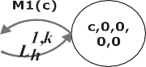

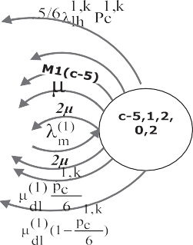

Figure 3 Transition diagram of the microcell containing C channels.

*F-group* of the destination cell). This is because the destination cell is in the borrowing state and a there are 5 other cells, be-

sides the current cell, exporting handoff calls to the destination

The corresponding state transition rates are

*L*1,*k* = k(1) + k1,*k*,

*h ln*,1 *lh*

(1)

cell. Now, *j* · l*dl*,2 · *c*

*p*1,*k*

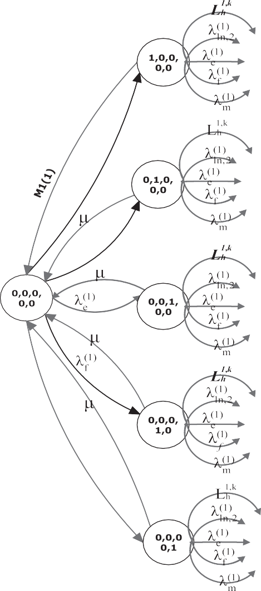

6

*M*1(*i*)= *i* · l + l(1) .

from an *E*-*group* of the current cell. This is because the desti-

*s*

is the rate at which a channel is borrowed

*dl*,1*s*

nation cell is in the borrowing state, and the calls are moved

The balance equation for the joint probability of the RV ele- ments of the state vector *s*¯ of the current cell *p k*+1 in slot

from NHR of the current cell to HR of the same cell. Also, *k* + 1 can be written as follows:

*j* · l(1) · 1 — *p*1,*k* is the rate at which a channel is borrowed *k* + 1 *A*

*c*

*dl*,2 6

*p* = , (24)

from one of the 5 other *F-groups* of the destination cell. This is because the destination cell is in the borrowing state, and

*s B*

where

the calls are moved from the NHR of the current cell to the

HR of the same cell. Let *S* represent the set of all feasible states

*A* = d(*M*–*C*micro)· [*M*1(*i* + 1)· *pk*

*k*

*i*+1,*j*,*e*,*f*,*m*

+ (*j* + 1)· l · *pi*,*j*+1,*e*,*f*,*m*

*k*

*k*

of the current cell. Then, the arrival rate k1,*k* of low speed handoff calls in a microcell in slot *k* can be calculated [2] as

*lh*

+ (*e* + 1)· l · *pi*,*j*,*e*+1,*f*,*m* + (*f* + 1)· l · *pi*,*j*,*e*,*f*+1,*m*

+ (*m* + 1)· l · *pi*,*j*,*e*,*f*,*m*+1]

*k*

1,*k k*

X !

!

1. *k*

*k*

k1,*k* =

*j* · l(1) · *p*

*s*

*lh dl*,2

*S*

l(1)

l(1) + l

*dl*,2

·

*dl*,2

+ k(1) · 1 — *p*(1)

*ln*,1

*bn bn*

· *p*(1).

+ d(*i*–0)· *Lh* · *pi*—1,*j*,*e*,*f*,*m* + d(*j*–0)· k*ln*,2 · *pi*,*j*—1,*e*,*f*,*m*

+ d(*e*–0)· k*e* · *pi*,*j*,*e*—1,*f*,*m* + d(*f*–0)· k*f* · *pi*,*j*,*e*,*f*—1,*m*

(1)

*k*

(1)

*k*

+ d(*m*–0)· k( · *p*

1) *k*

(23)

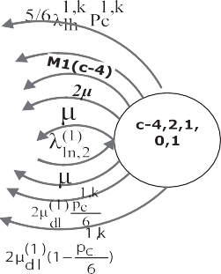

*m i*,*j*,*e*,*f*,*m*—1

+ d(*M* = *C*micro, *m*–0)· (5/6)k · *p* · *p*

1,*k* 1,*k k*

1. *Traffic overflow rate*: The rate of overflow of low speed new

*lh c*

*i*,*j*,*e*+1,*f*,*m*—1

calls k*o* can be found to be

+ d(*M* = *C*

micro

, *i*–0, *m*–0)· (*j* + 1)· l(1)

*ln*

2

k*o* = *N* · k(1) · *p*(1)

+ k(1) · *p*(1)

· 6 · *pi*—1,*j*+1,*e*+1,*f*,*m*—1

*dl*,2

*p*1,*k*

*c*

*k*

, *j*–0)· l(1) · 1 — *c*

*p*1,*k*

, *j*–0)· (*i* + 1)· l(1) · *pk*

*ln*

*ln*,1

*bn*

*ln*,2

*bn*

. (28)

The rate of overflow of stationary new calls k*o* can be

*sn*

*k*

· *p*

found to be

micro

+ d(*M* = *C*

*dl*,2

6 *i*—1,*j*+1,*e*,*f*,*m*

k*o* = *N* · k(1) · *p*(1) 2 + k(1) · *p*(1) . (29)

*sn*

*sn*,1

*bn*

*sn*,2

*bn*

and

+ d(*M* = *C*

micro

*hnl*

*i*+1,*j*—1,*e*,*f*,*m*

The rate of overflow of low speed handoff calls k*o* can be

*lh*

*B* = d(*M*–*C*

)· [*L*1,*k* + k(1) + k(1) + k(1) + k(1)]

found to be

micro *h*

*ln*,2 *e f m*

k*o* = *N* · k(1) · *p*(1). (30)

+ d(*i*–0)· *M*1(*i*)+ d(*j*–0)· *j* · l + d(*e*–0)· *e* · l

+ d(*f*–0)· *f* · l + d(*m*–0)· *m* · l

*lh lh fh*

1,*k* 1,*k*

* 1. *Analysis of the macrocell*

+ d(*M* = *C*micro, *e*–0)· (5/6)k*lh* · *pc*

(1)

*p*1,*k k k*

+ d(*M* = *C*micro, *j*–0, *e*–0)· *j* · l*dl*,2 6

·

*c*

We define some RVs. Let *Xlh* and *Xlnh* be two RVs denoting the

number of low speed calls in HR and NHR of a macrocell,

*hh*

*hnh*

(2)

*p*1,*k*

respectively, in slot *k*. Let *Xk*

and *Xk*

be two RVs denoting

+ d(*M* = *C*micro, *j*–0)· *j* · l*dl*,2 · 1 — 6

*c*

*sE*

*sF*

(1)

the number of high speed calls in HR and NHR of a macrocell, respectively, in slot *k*. Let *Xk* and *Xk* be two RVs denoting the

+ d(*M* = *C*micro, *i*–0)· *i* · l*hnl* .

At steady state, the sequence *p k*}∞

*s*

*k*=1

converges to a common

number of stationary calls participating in the soft handoff process in *E*-*group* and *F-group* of a macrocell, respectively,

distribution *ps*. The following algorithm shows how this distri- bution can be found iteratively.

¯

*s*

calls not participating in the soft handoff process of a macro-

*lhw*

in slot *k*. Let *Xk* be a RV denoting the number of stationary

Algorithm to find state distribution of a microcell without

cell in slot *k*. Let *Xk*

be a RV denoting the number of low

handoff queueing:

speed handoff calls waiting in the macrocell queue in slot *k*.

Let *Xk*

*hhw*

be a RV denoting the number of high speed handoff

*Step 1*: *k* = 0 and set a suitable tolerance, *tol*.

calls waiting in the macrocell queue in slot *k*. Clearly,

*Step 2*: Input *a*, *R*, m, b, k(1), and k(1).

*sn*

*ln*

*hnh*

*sE*

*sF*

*s*

*lhw*

*Xk* + *Xk* + *X* + *X*

+ *X* + *X*

+ *X* 6 *C*macro and *X* +

*Step 3*: Arbitrarily, initialize *p k*.

*k*

*k*

*k*

*k k*

*s*

*k*

*hhw*

*k*

*X*

*lh*

*lnh*

*hh*

6 *Q*. Let the state of a macrocell be defined by the vector

*Step 4*: Using Eqs. (1)–(8) and (21)–(23) in Eq. (24), plus the normalization condition to compute *p k*+*s* 1.

→*v i*, *j*, *k*, *l*, *e*, *f*, *m*, *ql* , *qh* . Then, the joint probability of the RV

elements of the state vector →*v* is

= ( )

*Step 5*: If *p k*+*s* 1 — *p k* > *tol*, then set *p k* = *p k*+*s* 1, and go to *k*

*s*

*s*

*p*

*k k k k k k*

=Pr *Xlh* = *i*, *Xlnh* = *jXhh* = *k*, *Xhnh* = *l*, *XsE* = *e*, *XsF* = *f*,

step 4.

*Step 6*: Output the value *p*¯*s* = *p k*+*s* 1 (convergence reached).

Once *ps*¯ is obtained, then we can find our measures as follows:

1. *New call blocking probability for low speed call*: A low speed

*v*

*Xk* = *m*, *Xk* = *q* , *X* = *q* .

*k*

*s*

*lhw*

*l*

*hhw*

*h*

Let *M*(→*v*) denote the number of channels in use in state →*v*. Thus, *M* →*v i j k l e f m* and *M* →*v* 6 *C*macro, and *ql* + *qh* 6 *Q*. Let *p*2,*k* be the probability that a macrocell is in the borrowing state in slot *k*, and is calculated as follows:

*c*

( )= + + + + + + ( )

*p* = X

new call is blocked if *M* = *C*micro. Thus, the new call block- ing probability in a microcell is

2,*k c*

*c*2

*k p v* ,

(31)

*p*(1) = X

*b*

*ps*¯. (25)

where

*M*=*Cmicro*

On the other hand, since a new call arriving at the HR of the current cell can attempt to obtain a free channel from both the current and destination cells, then the new call blocking probability in a microcell *p*(1) can be calculated as follows:

*bn*

*p*(1) = *a* · *p*(1) 2 + (1 — *a*)· *p*(1). (26)

*C*2 = {→*v*|*M*(→*v*)= *C*macro, *f* > 0}.

By considering Fig. 4, which is the transition diagram of the macrocell containing *C*macro channels and queue size

*Q* = *ql* + *qh*. Let represent the set of all feasible states. The ar- rival rate k2,*k* of low speed handoff calls in a macrocell in slot can be calculated [2] as

*lh*

! !

*bn b b*

2. *Forced termination probability for low speed call*: A low

k2,*k* = X *j* · l(2) · *p k* — 1

l(2)

· + k

*dl*,2

*o*

*lh*

*dl*,2

*v*

l(2) + l

*ln*,1

speed handoff call is forcefully terminated if *M* = *C*micro

and *f* = 0 to the unavailability of free channels and the full-

*V*

*dl*,2

1. (2) *o* (2) (2)

· 1 — *pbn*

· *pbn* + k*lh*,1 · 1 — *pfh*

· *pfh* , (32)

ness of the handoff queue. This probability is as follows:

*fh* =

where *p*(2) is the forced termination probability of the macro-

*p*(1)

X *ps*¯.

*M*=*C*micro,*f*=0

*fh*

27 2,*k*

(

)

cell. The arrival rate k*hh* of high speed handoff calls in a mac- rocell in slot *k* can be calculated [2] as

Performance analysis of a handoff scheme for two-tier cellular CDMA networks 145

Figure 4 Transition diagram of themacrocell containing C channels and queue size Q.

X *k* — 1!

l( )

k2,*k*

*l* · l(2)

· *p*

·

*dh*,2

*hh* =

*V*

*gh*,2

*v*

2

*dh*,2

l(2) !

*hn*,1

where

· 1 — *p*(2) · *p*(2). (33)

k(2)

+

*bn*

*bn*

+(*j* + 1)· l· *p*

The corresponding state transition rates are

)· h ( + )·

*k*

+ l

*C* = d(*M*(→*v*)–*C*

macro

*M*1 *i* 1 *pk*

*i*+1,*j*,*k*,*l*,*e*,*f*,*m*,*ql* ,*qh*

*i*,*j*+1,*k*,*l*,*e*,*f*,*m*,*ql* ,*qh*

*k*

*k*

+ *M*2(*k* + 1)· *pi*,*j*,*k*+1,*l*,*e*,*f*,*m*,*ql* ,*qh* + (*l* + 1)· l*pi*,*j*,*k*,*l*+1,*e*,*f*,*m*,*ql* ,*qh*

*k k*

+(*e* + 1)· l· *pi*,*j*,*k*,*l*,*e*+1,*f*,*m*,*ql* ,*qh* + (*f* + 1)· l· *pi*,*j*,*k*,*l*,*e*,*f*+1,*m*,*ql* ,*qh*

+(*m* + 1)· l· *pi*,*j*,*k*,*l*,*e*,*f*,*m*+1,*ql* ,*qh*

+ d(*i*–0)· *Lh* · *pi*—1,*j*,*k*,*l*,*e*,*f*,*m*,*ql* ,*qh*

*L*2,*k* = k*o* + k + k ,

*o*

2,*k*

*h*

*ln*,1

*lh*,1

*lh*

*k* i 2,*k k*

*L*(2) = k*o* + k ,

*o*

(2)

*k*

*k*

2,*k*

*nh*

2,*k*

*ln*,2

(2)

*lh*,2

2,*k*

+ d(*j*–0)· *Lnh*

* *pi*,*j*—1,*k*,*l*,*e*,*f*,*m*,*ql* ,*qh*

+ d(*k*–0)· *Hh*

* *pi*,*j*,*k*—1,*l*,*e*,*f*,*m*,*ql* ,*qh*

*Hh* = k*hn*,1 + k*hh* ,

*o k*

*M*1(*i*)= *i* · l + l(2)

+ d(*l*–0)· k(2) · *pk*

+ d(*e*–0)· k *p*

*hn*,2 *i*,*j*,*k*,*l*—1,*e*,*f*,*m*,*ql* ,*qh*

*o k*

+ d(*f*–0)· k · *p*

+ d(*m*–0)· k · *p*

*e i*,*j*,*k*,*l*,*e*—1,*f*,*m*,*ql* ,*qh*

*dl*,1*s*

*o k*

+ d(*M*(→*v*)= *C*macro, *m*–0)· (5/6)ÿk2,*k* + k2,*k* · *p*2,*k* · *pk*

*dl*,1*s*

,

*f*

*i*,*j*,*k*,*l*,*e*,*f*—1,*m*,*ql* ,*qh*

*m*

*i*,*j*,*k*,*l*,*e*,*f*,*m*—1,*ql* ,*qh*

*M*2(*k*)= *k* · l + l(2)

,

, *q* –0)· k2,*k* · *pk*

*lh*

*hh*

*c*

*i*,*j*,*k*,*l*,*e*+1,*f*,*m*—1,*ql* ,*qh*

macro *l*

+ d(*M*(→*v*)= *C*

*M*3(*i*, *q* )= *i* · l + l(2)

+ *q* · l + l(2)

+ d(*M*(→*v*)= *C*

, *q* –0)· k2,*k* · *pk*

macro

*h*

*hh*

*lh i*,*j*,*k*,*l*,*e*,*f*,*m*—1,*ql* —1,*qh*

*l*

*dl*,1*s*

*l*

*dl*,1

,

*M*4(*k*, *q* )= *h* · l + l(2) + *q* · l + l(2) .

*h*

*dh*,1*s*

*h*

*dh*,1

(2)

*i*,*j*,*k*,*l*,*e*,*f*,*m*—1,*ql* ,*qh* —1

+ d(*M*(→*v*)= *C*macro, *i*–0, *m*–0)· (*j* + 1)· l

*dl*,2

*p*2,*k k*

The balance equation for the joint probability of the RV ele-

·

*c*

6

· *p*

(2)

*p*2,*k* *k*

ments of the state vector →*v* of the current cell *p k*+1 in slot

*v*

+ d(*M*(→*v*)= *C*macro, *i*–0)· (*j* + 1)· l

*dl*,2

· 1 — 6

*p*2,*k*

*c*

*i*—1,*j*+1,*k*,*l*,*e*+1,*f*,*m*—1,*ql* ,*qh*

· *pi*,*j*,*k*—1,*l*+1,*e*+1,*f*,*m*—1,*ql* ,*qh*

*k* + 1 can be written as follows:

+ d(*M*(→*v*)= *C*

, *k*–0, *m*–0)· (*l* + 1)· l(2) · *c* · *pk*

*k* + 1 *C*

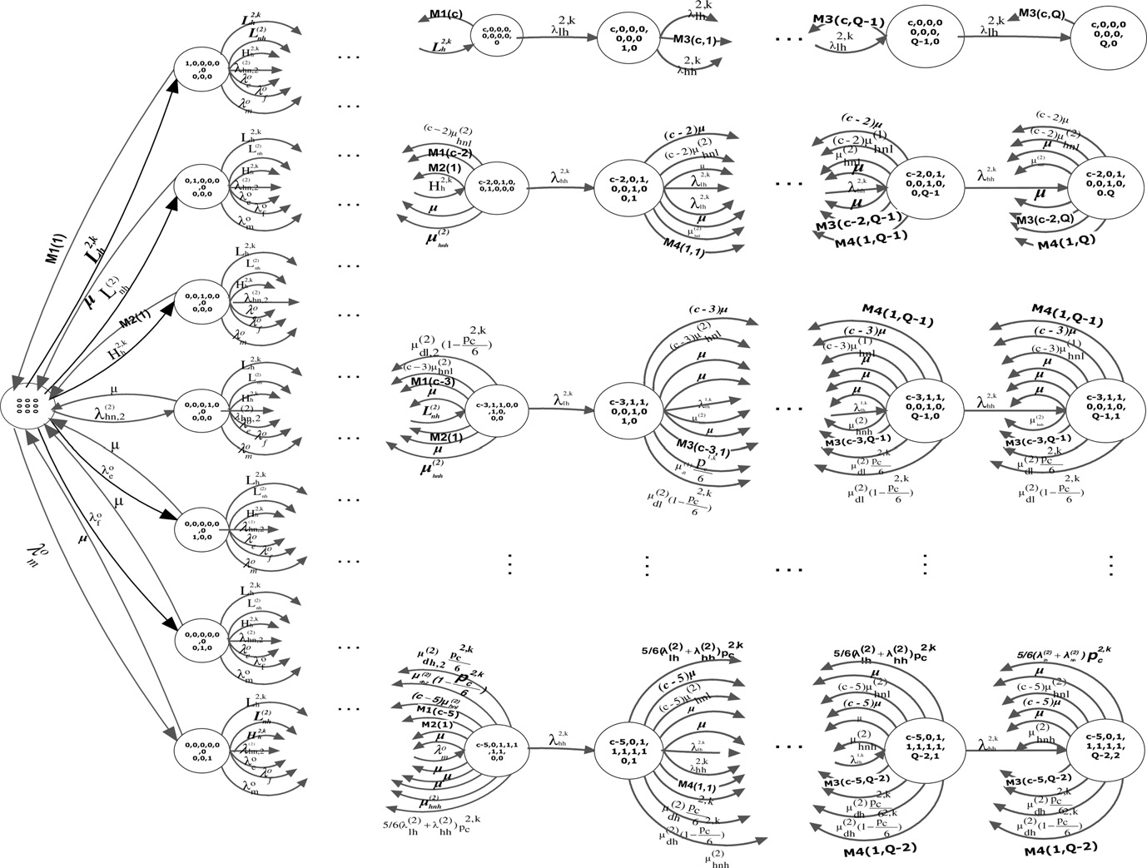

*p*

=

, (34)

*v*

*D*

macro

(2)

*dh*,2

+ d(*M*(→*v*)= *C*macro, *k*–0)· (*l* + 1)· l*dh*,2

· 1 — 6

6

*p*2,*k*

*c*

*i*,*j*,*k*—1,*l*+1,*e*+1,*f*,*m*—1,*ql* ,*qh*

*k*

· *pi*,*j*,*k*—1,*l*+1,*e*,*f*,*m*,*ql* ,*qh*

+ d(*M*(→*v*)= *C*

, *j*–0)· (*i* + 1)· l(2) · *pk*

and destination cells, thus, the new call blocking proba-

macro

*hnl i*+1,*j*—1,*k*,*l*,*e*,*f*,*m*,*ql* ,*qh*

(2)

+ d(*M*(→*v*)= *C*

, *l*–0)· (*k* + 1)· l(2) · *pk*

bility in a macrocell *pbn* can be calculated as follows:

+ d(*M*(→*v*)= *C*

macro

macro

*hnh*

, *i*–0)· (*j* + 1)· l· *pk*

*i*—1,*j*+1,*k*,*l*,*e*,0,*m*,*ql* +1,*qh*

*i*,*j*,*k*+1,*l*—1,*e*,*f*,*m*,*ql* ,*qh*

(2)

(2) 2

(2)

*f A*

+ (1 — *b*)· *pb* . (36)

d *M* →*v C* , *i*–0 *e* 1 l *pk*

+ ( ( )= macro )· ( + )· ·

*i*—1,*j*,*k*,*l*,*e*+1,0,*m*,*ql* +1,*qh*

d *M* →*v C* , *i*–0 *m* 1 l *pk*

+ ( ( )= macro )· ( + )· ·

*i*—1,*j*,*k*,*l*,*e*,0,*m*+1,*ql* +1,*qh*

1. *Forced termination probability for high speed call*: Two probabilities are defined. The first, is the probability *p*(2)

+ d(*M*(→*v*)= *C*

macro

, *k*–0 *l* 1 l *pk*

*i*,*j*,*k*—1,*l*+1,*e*,0,*m*,*ql* ,*qh* +1

)· ( + )· ·

*pbn* = *b* · *pb*

,

that a handoff call is forcefully terminated due to the

d *M* →*v C* , *k*–0 *e* 1 l *pk*

+ ( ( )= macro )· ( + )· ·

*i*,*j*,*k*—1,*l*,*e*+1,0,*m*+1,*ql* ,*qh* +1

d *M* →*v C* , *k*–0 *m* 1 l *pk*

+ ( ( )= macro )· ( + )· ·

*i*,*j*,*k*—1,*l*,*e*,0,*m*+1,*ql* ,*qh* +1

unavailability of free channels and the fullness of the hand- off queue. This probability is as follows:

+ *M*3(*i*, *q* + 1)· *p*

*k*

*k*

*l*

*i*,*j*,*k*,*l*,*e*,0,*m*,*ql* +1,*qh*

*h*

*i*,*j*,*k*,*l*,*e*,0,*m*,*ql* ,*qh* +1

*f*,*A*

*M*(→*v*)=*C*macro ,*ql* +*qh* =*Q*

+ *M*4(*i*, *q* + 1)· *p*

*p*(2) = X

*p*→*v*. (37)

and

2,*k* (2) 2,*k* (2) *o o o*

*D* = d(*M*(→*v*)–*C* )· *L* + *L* + *H* + k + k + k + k ]

macro

*h*

*nh*

*h*

*hn*,2

*e*

*f*

*m*

The second probability, is the probability *p*(2) *p*(2) that

+ d(*i*–0)· *M*1(*i*)+ d(*j*–0)· *j* · l+ d(*k*–0)· *M*2(*k*)+ d(*l*–0)· *l* · l

*lf*,*B*

*hf*,*B*

+ d(*e*–0)· *e* · l+ d(*f*–0)· *f* · l+ d(*m*–0)· *m* · l

ÿ

+ d(*M*(→*v*)= *C*macro, *e*–0)·(5/6) k2,*k* + k2,*k* · *p*2,*k*

*lh*

*hh*

*c*

+ d(*M*(→*v*)= *C*macro, *q* –*Q* )· k + d(*M*(→*v*)= *C*macro, *q* –*Q* )· k

2,*k* 2,*k*

a low (high) speed handoff call is forcefully terminated due to the expiration of queueing time of the call before it can obtain a free channel from the destination cell.

Thus, we can write the second probability as in [2]

*l l lh*

*p*2,*k*

*dl*,2

*h h lh*

+ d(*M*(→*v*)= *C*

macro

, *j*–0, *e*–0)· *j* · l(2) · *c*

P (2)

+ d(*M*(→*v*)= *C*macro, *j*–0)· *j* · l

2

( )

(2)

*dl*,2

*p*2,*k*

1 — *c*

6

*plf*,*B* =

*l h*

2,*k lh*

k

*f*,*A*

(*M*(→)=*C*macro,16*q* +*q* 6*Q*) *ql* · l*dl*,1 · (1 — b)· *p*→

1 — *p*(2)

6

, (38)

(2)

*c*

*p*2,*k*

P *q* · l(2)

* (1 — b)· *p*→

+ d(*M*(→*v*)= *C*macro, *l*–0, *e*–0)· *l* · l

*p*

, *l*–0)· *l* · l(2)

2,*k*

1 — *c*

*dh*,2 · 6

2

*hf*,*B*

*p*( )

= . (39)

k

1 — *p*(2)

(*M*(→)=*C*macro,16*ql* +*qh* 6*Q*) *h dh*,1

2,*k*

*hh*

*f*,*A*

macro

*dh*,2

(2)

6

(2)

Thus, the forced termination probability for low (high) speed

+ d(*M*(→*v*)= *C*macro, *i* = 0)· *i* · l*hnl* + d(*M*(→*v*)= *C*macro, *k*–0)· *k* · l*hnh* .

+ d(*M*(→*v*)= *C*

+ d(*M*(→*v*)= *C*macro)· *M*3(*i*, *ql* )+ d(*M*(→*v*)= *C*macro)· *M*3(*k*, *qh* )

*flh*

*fhh*

handoff call *p*(2) *p*(2) in a macrocell can be written as follows:

+ d(*M*(→*v*)= *C*macro, *j*–0, *ql* –0)· *j* · l+ d(*M*(→*v*)= *C*macro, *e*–0, *ql* –0)· *e* · l

*p*(2) = *p*(2) + *p*(2) , (40)

+ d(*M*(→*v*)= *C*macro, *m*–0, *ql* –0)· *m* · l+ d(*M*(→*v*)= *C*macro, *l*–0, *qh* –0)· *l* · l

*flh*

*f*,*A*

*lf*,*B*

+ d(*M*(→*v*)= *C*macro, *e*–0, *q* –0)· *e* · l+ d(*M*(→*v*)= *C*macro, *e*–0, *q* –0)· *m* · l.

*h*

*h*

*fhh*

*f*,*A*

*hf*,*B*

*p*(2) = *p*(2) + *p*(2) . (41)

At steady state, the sequence *pk*∞ } converges to a common

*vk*=1

After calculating the new call blocking probability and the

distribution *pv*. The following algorithm shows how this distri- bution can be found iteratively.

→

Algorithm to find state distribution of a macrocell with handoff queueing:

The results obtained from the iterative algorithm for micro- cell are provided to the iterative algorithm for macrocell with- out any handoff queueing.

forced termination probability in a macrocell, we find the

new call blocking probability, and the forced termination probability for the overall system for the two types of calls. Thus, the new call blocking probability for high speed call is *p*(2), which is given by (36). The forced termination probability for high speed call is *p*(2) , which is given by (41). However, the new call blocking probability for low speed call *pbn*_*l* is given by

*bn*

*fhh*

the following equation, using (36) for *p*(2), and (26) for *p*(1)

*bn bn*

*Step 1*: Set *k* = 0 and set a suitable tolerance, *tol*.

*p* = *p*(2) · *p*(1). (42)

*Step 2*: Input *a*, *b*, *R*, m, b, l, k*o* , k*o* , k*o*

and k*o* .

*bn l*

*bn bn*

*ln sn lh hn*

*Step 3*: Arbitrarily initialize *p k*.

*v*

*Step 4*: Using Eqs. (1), (9)–(21) and (31)–(33) in Eq. (34), plus the normalization condition to compute *p k*+1.

The forced termination probability for low speed call *pfh*_*l* is given by the following equation, using (40) for *p*(2), and (27) for *p*(1)

*v*

*Step 5*: If *p k*+*v* 1 — *p k* > *tol*, then set *p k* = *p k*+*v* 1, and go to

*v*

*v*

step 4.

*flh fh*

2) (1)

*p* = *p*( · *p* . (43)

*fh l*

*fh*

*fh*

*Step 6*: Output the value *p*→*v* = *p k*+*v* 1 (convergence reached).

Once *p*→*v* is obtained, thus, we can find our measures as follows:

1. *New call blocking probability for high speed call*: A high speed new call is blocked if *M* →*v C*macro. Thus, the new call blocking probability in a macrocell is given by

( )=

(2) X

*pb* =

*p*→*v*. (35)

1. Numerical results

In this section, we calculate, plot, and discuss the performance measures of interest: new call blocking probability and forced termination probability. We assume that every macrocell covers *N* = 7 microcells. We also assume that the low and high speeds of the mobile user are 3.6 and 36 km/h, respectively. Also, we assume *C*macro = 4, *C*ﬃﬃﬃ macro = 5, *Q* = 3, 1 = 180 s,

*R*macro

= 300 m, *R*

= 300,7 m, *a* = *b* = 0.3,

l

b

= 0.37,

*M*(→*v*)=*C*macro

On the other hand, since the new call arriving at HR can attempt to obtain a free channel from both the current

macro

and choose the tolerance *tol* to be 10—8. We will validate our results by comparing with the results of model C in Shun [2] which is similar to our model, except for channel

Performance analysis of a handoff scheme for two-tier cellular CDMA networks 147

Figure 5 New calls blocking probability of low speed users for different arrival rates of low speed new calls.

borrowing––the main feature of the present work. Thus in the graphs of this section we will plot always two curves: one for

Shun Model C and one for our work, in order to show the im- pact of using channel borrowing on the system performance.

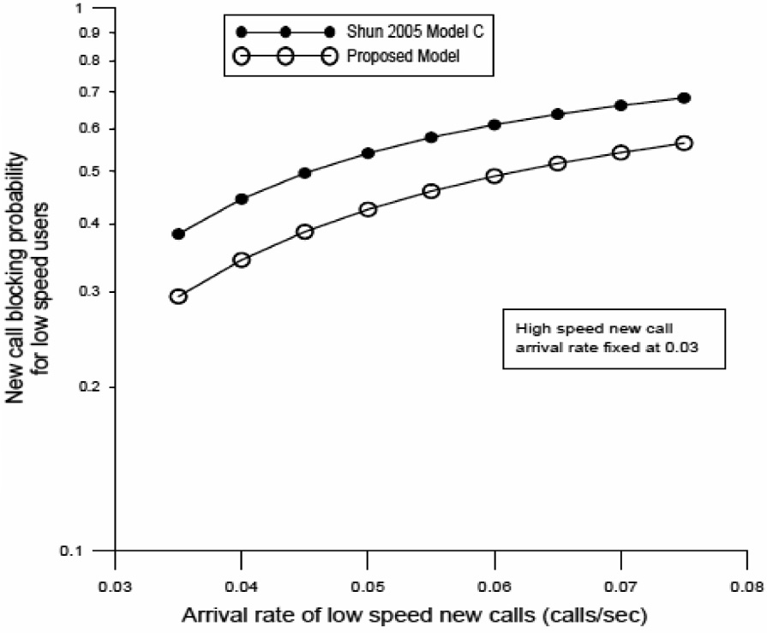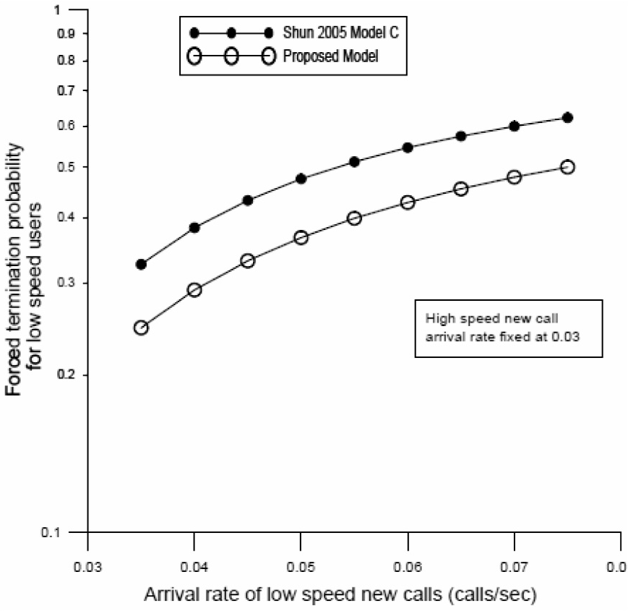

Figure 6 Forced termination probability for low speed users for different arrival rates of low speed new calls.

148 A. Hamad et al.

Figure 7 New call blocking probability for high speed users for different arrival rates of high speed new calls.

The performance measures of low speed calls are shown in Figs. 5 and 6, respectively, with the high speed new call arrival rate fixed at 0.03. Fig. 5 shows that the new call blocking prob- ability for low speed call of the proposed model is lower than

that of the Shun model C by an average of 12%. This improve- ment is due the channel-borrowing handoff scheme serves more moving handoff calls by borrowing channels from sta- tionary calls to serve moving handoff calls.

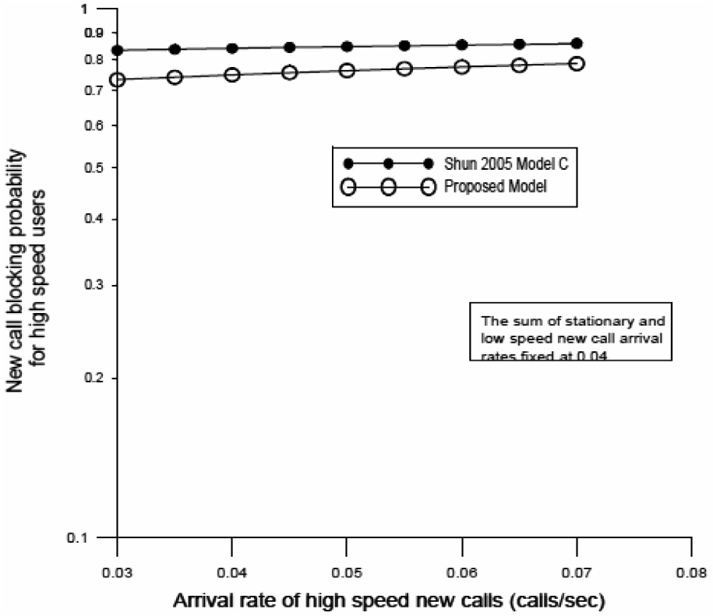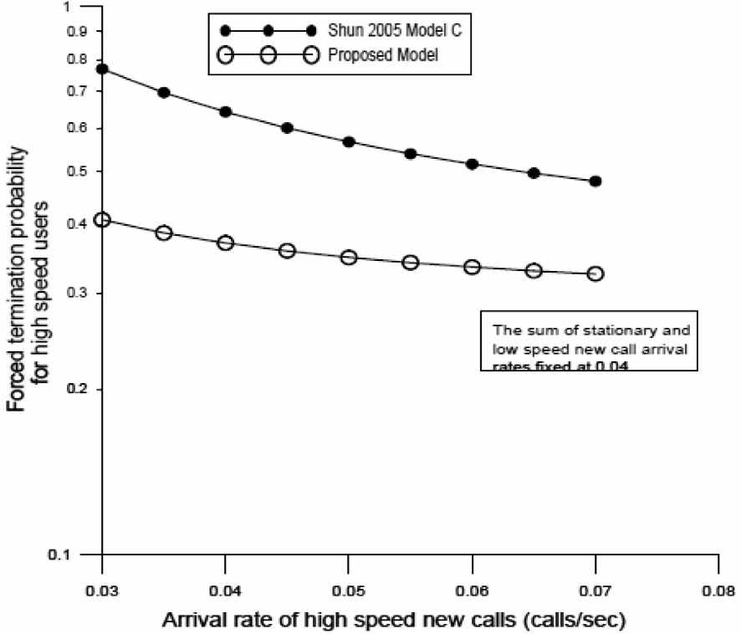

Figure 8 Forced termination probability for high speed users for different arrival rates of high speed new calls.

Performance analysis of a handoff scheme for two-tier cellular CDMA networks 149

Fig. 6 shows the forced termination probability *pfh*_*l* of low speed calls vs. new high speed call arrival rate, in both the pro- posed model and model C in Shun [2]. It can be seen that the forced termination probability in the proposed model is lower than that of the Shun model C by an average of 0.1%. This improvement is admittedly insignificant. The performance measures of high speed calls are shown in Figs. 7 and 8, respec- tively, with the sum of stationary and low speed new call arri- val rates fixed at 0.04. The improvement due to the channel borrowing scheme of the proposed models is made clear by plotting the same measure for both the proposed model and that of Shun model C.

Fig. 7 shows that the new call blocking probability *p*(2) of

*bn*

high speed calls in the proposed model lower than that in the Shun model C by an average of 9%. Similarly, Fig. 8 shows that the forced termination probability *p*(2) of high speed calls in the proposed model is lower than that in the Shun model C by an average of 26%. The improvement may not seem signif- icant, but in view of the fact that call blocking and forced ter- mination are highly undesired by mobile users, any amount of improvement is badly sought.

*fh*

We can see that the improvement in performance due to the channel borrowing scheme is more in the case of high speed calls that low speed calls. This can be attributed to the fact that low speed calls make less handoffs than high speed calls and thus benefit less from the channel borrowing scheme introduced in the proposed model. Recall that low speed calls can operate both in macrocells and microcells. In the former case, they understandably need to handoff less often because they reach the border of the cell slowly. In the latter case, they reach the border of the cell quickly, but then they can be overflowed to a macrocell, avoiding many future handoffs.

1. Conclusions and future work

In this paper, we consider CDMA cellular networks of two tiers, where users with different mobility behaviors are assigned to the proper tier. Namely, high speed users are always assigned to the higher tier (macrocells), even if the speed decreases during the call to the low level. By contrast, low speed users are initially assigned to the lower tier (micro- cells), but if during their movement they reach the edge of the current (micro)cell and fail to get handed over to the neigh- bor (micro)cell, they then are assigned to the current higher tier (macrocell). For such networks a channel borrowing handoff scheme aiming at improving the quality of service without deteriorating the throughput of the system is proposed. To analyze the performance of the scheme, The system is modeled as a Markov chain, and utilize an iterative method to find the steady-state probability distribution. For validation and com- parison purposes, numerical results have been obtained for both an example system using our scheme and an identical sys- tem not using the scheme. The results show that the scheme re- duces the blocking probability of low speed calls by an average of 12%, and of high speed call by an average of 9%. On the other hand, the results shown that the scheme reduces the forced termination probability of low speed calls by an average of 0.1%, and of high speed calls by an average of 26%.

A two-tier CDMA cellular networks, utilizing the channel- borrowing handoff scheme without any queue in both micro-

cell and macrocell is currently under investigation. Also, a two-tier CDMA cellular networks can be presented, utilizing the channel-borrowing handoff scheme with a FIFO queue in both macrocell and microcell.

References

1. Chung Y, Lee D, Cho D, Shin B. Macrocell/microcell selection schemes based on a new velocity estimation in multitier cellular system. IEEE Trans Vehicular Technol 2002;51(5):893–903.
2. Chung S, Li M. Performance evaluation of hierarchical cellular CDMA networks with soft handoff queueing. IEEE Trans Vehicular Technol 2005;54(2):652–72.
3. Maheshwari K, Kumar A. Performance analysis of microcelliza- tion for supporting two mobility classes in cellular wireless networks. IEEE Trans Vehicular Technol 2000;49(2):321–33.
4. Salih T, Fidanboylu K. Performance analysis and modeling of two-tier cellular networks with queuing handoff calls. IEEE Int Symp Comput Commun 2003;1:143–8.
5. Hamdaoui B, Ramanathan P. A network-layer soft handoff approach for mobile wireless IP-based systems. IEEE J Select Area Commun 2004;22(4):630–42.
6. Kishore S, Kumar A, Schwartz S, Greenstein LJ, Poor HV. Uplink throughput in a single-macrocell/single-microcell CDMA system with application to data access points. IEEE Trans Wireless Commun 2005;4(4):1302–6.
7. Lee D, Cho D. Performance analysis of channel-borrowing handoff scheme based on user mobility in CDMA cellular systems. IEEE Trans Vehicular Technol 2000;49(6):2276–85.
8. Ekici E, Ersoy C. Multi-tier cellular network dimensioning. Wireless Networks 2001;7:401–11.
9. Tekinay S, Jabbari B. A measurement-based prioritization scheme for handovers mobile cellular networks. IEEE J Select Area Commun 1992;10(8):1343–50.
10. Su S, Chen J, Huang J. Performance analysis of soft handoff in CDMA cellular networks. IEEE J Select Area Commun 1996;14:1762–9.
11. Fitzpatrick P, Lee C, Warfield B. Teletraffic performance of mobile radio networks with hierarchical cells and overflow. IEEE J Select Area Commun 1997;15(8):1549–57.
12. Salih T, Fidanboylu K. A comparison of the performance of two- tier cellular networks based on queueing handoff calls. Int J Signal Process 2004;1(4):343–7.
13. Salih T, Fidanboylu K. Modeling and analysis of queuing handoff calls in single and two-tier cellular networks. Comput Commun 2006;29:3580–90.

Further reading

1. Narrainen RP, Takawira F. Performance analysis of soft handoff in CDMA cellular networks. IEEE Trans Vehicular Technol 2001;50(6):1507–17.
2. Chung Y, Cho D. Performance evaluation of soft handoff for multimedia services in intelligent transportation systems based on CDMA. IEEE Trans Intell Transport Syst 2003;4(4):189–97.
3. Kim D, Lee D, Kim H, Whang K. Capacity analysis of macro/ microcellular CDMA with power ratio control and tilted antenna. IEEE Trans Vehicular Technol 2000;49:34–42.
4. Lin W, Wu J. Mobility management in all-IP two-tier cellular networks. Comput Commun 2007;30:3442–6.
5. Park J, Han S. Load balancing for video streaming services in hierarchical wireless networks. Comput Commun 2008;52:259–74.
6. Wu Z, Kuang Y, Zhao N, Zhao Y. A hybrid CDMA multiuser detector with ant colony optimization and code filtering system. Informat Technol 2010;9:818–24.