HOSTE D BY

Available online at [www.sciencedirect.com](http://www.sciencedirect.com/science/journal/2314808X)

ScienceDirect

journal homepage: <http://ees.elsevier.com/ejbas/default.asp>

[e g ypti an j o ur nal o f b a sic and a pp l i e d sci en c e s 2 ( 201 5 ) 2 5](http://dx.doi.org/10.1016/j.ejbas.2014.12.002) e[31](http://dx.doi.org/10.1016/j.ejbas.2014.12.002)



Full length article

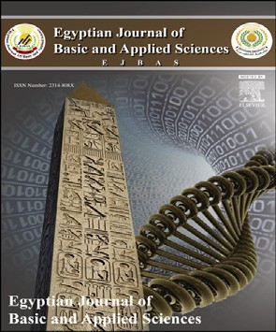Pharmacognostic evaluation of Achyranthes coynei: Leaf



*Gireesh M. Ankad* *a**, Sandeep R. Pai* *a**, Vinayak Upadhya* *a**,*\**,*

*Pramod J. Hurkadale* *b**, Harsha V. Hegde* *a*

a *Regional Medical Research Centre, Indian Council of Medical Research, Nehru Nagar, Belgaum 590 010, Karnataka,*

*India*

b *College of Pharmacy, KLE University, Nehru Nagar, Belgaum 590 010, Karnataka, India*

## a r t i c l e i n f o

*Article history:*

Received 22 October 2014 Received in revised form 2 December 2014

Accepted 6 December 2014

Available online 19 December 2014

*Keywords:* Amaranthaceae *Achyranthes coynei* Endemic Pharmacognosy Physicochemisty HPTLC

## a b s t r a c t

*Achyranthes coynei* Sant., (Amaranthaceae) is a rare, medicinal shrub, endemic to India. The plant especially, leaves are used in treatment of various disorders by folk healers. It has been scientifically evaluated for its antimicrobial and antioxidant properties. Pharmacog- nostic studies have not been carried out so far in this plant. So, the present study was undertaken to evaluate pharmacognostic characters of leaf of *A. coynei*. The studies were carried out in terms of morphological, microscopic characters and physicochemical pa- rameters using standard methods. Leaf size (15e23 × 7e10 cm) and petiole nature (pink above and green beneath) were the distinguishing morphological character observed in the present study. Transverse section of leaf and petiole showed presence of long, multi- cellular, warty trichomes with pointed apex and short, glandular trichomes with blunt

apex on thick walled epidermis; conjoint, collateral closed, endarch vascular bundles; rosette crystals of calcium oxalate in ground tissue. Ash and extractive values, micro and macro elements and nutritive factors were estimated. Leaf powder showed fluorescence under the influence of different solvents. Preliminary phytochemical screening showed the presence of alkaloids, saponins and triterpenoids. High Performance Thin Layer Chroma- torgraphic (HPTLC) analysis yielded eight bands in leaf extract. The study forms the first report on pharamcognostic characters for *A. coynei*, which could be useful for identification and authentication of the plant.

Copyright 2014, Mansoura University. Production and hosting by Elsevier B.V. This is an open access article under the CC BY-NC-ND license ([http://creativecommons.org/licenses/](http://creativecommons.org/licenses/by-nc-nd/3.„0/)

[by-nc-nd/3.0/](http://creativecommons.org/licenses/by-nc-nd/3.„0/)).

# Introduction

Plants are used as medicine to maintain human health from ages [1]. Plants are also major natural sources of medicinal

compounds in current pharmacopoeias [2]. Indian Materia Medica includes about 2000 drugs of natural origin and most of them are derived from different traditional system and folklore practices [3]. However, there are large numbers of

* *Corresponding author*. Tel.: +91 831 2475477; fax: +91 831 2475479. E-mail address: [sirsivinayak@yahoo.com](mailto:sirsivinayak@yahoo.com) (V. Upadhya).

Peer review under responsibility of Mansoura University. <http://dx.doi.org/10.1016/j.ejbas.2014.12.002>

2314-808X/Copyright 2014, Mansoura University. Production and hosting by Elsevier B.V. This is an open access article under the CC BY- NC-ND license ([http://creativecommons.org/licenses/by-nc-nd/3.0/](http://creativecommons.org/licenses/by-nc-nd/3.„0/)).

26 [e gypti an j o ur nal o f b a sic and a pp l i ed sci e n c e s 2 ( 201 5 ) 2 5](http://dx.doi.org/10.1016/j.ejbas.2014.12.002) e[31](http://dx.doi.org/10.1016/j.ejbas.2014.12.002)

|  |  |  |  |  |  |  |
| --- | --- | --- | --- | --- | --- | --- |
| Table 1 e Histochemical tests. | | | | | | |
| Section treated with Reagents | Tests for | Observations  Leaf Petiole | | Leaf | Result | Petiole |
| Conc. sulphuric acid | Cellulose | Green | Green | Present |  | Present |
| Ruthenium red solution | Mucilage | ea | ea | Absent |  | Absent |
| Phlorogucinol + conc. HCL | Lignin | Magenta | Magenta | Present |  | Present |
| Iodine | Starch | Blue | Blue | Present |  | Present |
| Ferric chloride solution (10%) | Tannin | ea | ea | Absent |  | Absent |
| Conc. HCl | Calcium oxalate crystals | Dissolved | Dissolved | Present |  | Present |
| a No results observed. | | | | | | |

plants, which have not been mentioned in these reports, in spite of their usage in the traditional and folk medicinal systems.

*Achyranthes coynei* Santapau (Amaranthaceae) is one such plant, which is a profusely branching perennial shrub growing up to a height of 2.0e4.5 m. The plant is endemic to India and reported from Maharashtra and Karnataka states [4]. The plant was categorized as rare in Red data book of Indian plants [5]. This plant is locally known as *Kempu Uttarani* (Kannada) and *Lal Agada* (Marathi) and used to treat various ailments by folk healers, most of the times, similar to that of *Achyranthes aspera* [4]. Leaves are reported to have antibacterial [6] and antioxidant [7] activities.

According to Hegde et al., every plant shows unique nature in terms of its botany, chemistry and therapeutic potency and it is essential to study pharmacognostic characters of a me- dicinal plant, not only for its proper identification, but also to understand its structure and biology [8]. The available litera- ture revealed that, no such studies have been carried out for *A. coynei*. Hence in the present investigation, the leaves of *A. coynei* was studied for its pharmacognostic characteristics.

# Materials and methods

### *Collection of plant material*

Leaves of *A. coynei* along with petiole were collected from Madhanbhavi, Belgaum district, Karnataka. The plant spec- imen was authenticated and herbarium was deposited at Regional Medical Research Centre, (ICMR), Belgaum, Karna- taka, India for future reference (Voucher number: RMRC 784).

### *Chemicals, reagents and solvents*

All chemicals, reagents and solvents used during the experi- mentation were of analytical grade.

### *Macroscopic and microscopic analysis*

Key morphological features of the leaf were observed during macroscopic analysis using dissecting microscope (Labomed, India). Transverse section (TS) of the leaf and petiole were taken using LEICA CM (1850) cryostat. For this, fresh plant material was mounted on the specimen disk covered with

tissue freezing medium (Jung). The specimen disks were kept for freezing at —18 ± 2 ◦C for about 30 min. Frozen plant

materials were used for sectioning at a thickness of 20 ± 2 microns. Histochemial and powder studies were carried out by using reagents and stains like iodine, concentrated sul- phuric acid, concentrated hydrochloric acid, ferric chloride, Sudan III, ruthenium red and phloroglucinol with Conc. HCl

(1:1) [9]. Similarly, organoleptic characters like colour, odour and taste were determined for the leaf powder [9].

* + 1. *Quantitative microscopy* The quantitative examinations such as vein islet number, vein termination number, palisade ratio and stomatal index were studied using standard methods [9].

### *Microphotography*

Microphotographs of the sections and powder microscopy were taken using microscope (Olympus BX 41) at different magnifications (4×, 10× and 40×) with inbuilt analogue cam- era (ProgRess C3-JENOPTIK). Computer images were captured

using software ProgRes® CapturePro 2.1.1-JENOPTIK laser op- tical system.

### *Preparation of extracts and preliminary* phytochemical analysis

The powdered material was serially extracted by continuous shaking method using petroleum ether, chloroform, methanol and water. Leaf powder (5 g) was extracted with 20 mL of respective solvent on a shaker at room temperature at 120 ± 10 rpm for overnight. The same was filtered and evap- orated to dryness. The extracts were stored at 4 ◦C for further use. These extracts were subjected for preliminary phyto- chemical screening as per standard pharmacognostic methods [7].

### *Physico-chemical and nutritive content analysis*

Physico-chemical parameters of the powdered drug such as total ash, water-soluble ash and acid-insoluble ash were determined [9]. Soluble extractive values were determined as per standard procedure. The moisture content was detected by loss on drying method [9]. Determination of macro ele- ments (phosphorus, potassium, sulphur, calcium, sodium and magnesium) and microelements (zinc, iron, manganese, and copper) were estimated using atomic absorption techniques [10,11]. Nitrogen content in the leaf powder was estimated by Kjeldahl method [10,11]. Nutritive contents *viz*. percent starch, total carbohydrates, reducing and non-reducing sugars were

[e g ypti an j o ur nal o f b a sic and a pp l i e d sci en c e s 2 ( 201 5 ) 2 5](http://dx.doi.org/10.1016/j.ejbas.2014.12.002) e[31](http://dx.doi.org/10.1016/j.ejbas.2014.12.002) 27

also estimated [11,12]. Protein was calculated using the formula:

|  |  |  |  |
| --- | --- | --- | --- |
| Table 3 e Fluorescence analysis. | | | |
| Treatment | Visible light | UV light at 254 nm | UV light at 365 nm |
| P  P + water  P + methanol P + con. H2SO4  P + con. HCL P + 1 N NaOH  P + acetic acid P + nitric acid P + formic acid | Green Dark green Florescent green  Blackish green  Bottle green Dark green Reddish green Brick red  Reddish green | Black Green Black  Green  Black Black Green Black  Green | Green Bluish green  Biscuit brown  Florescent green Black  Parrot green Brick red Brown  Dark green |
| P e Powder. | | | |

% Proteins = % Nitrogen × 6.125[8].

### *Fluorescence analysis*

Different reagents were used to check the fluorescence ac- tivity [12]. In fluorescence analysis 0.1 g of leaf powder was mixed with 1.5 ml of respective reagent (Table 3). The mixture was kept for a minute and the same was observed under visible light, short ultra-violet light (254 nm) and long ultra- violet light (365 nm).

### *High performance thin layer chromatography*

Extraction method given by Tandon [13], was employed for HPTLC analysis. A CAMAG High performance thin layer chromatography (HPTLC) system was used for detection and separation. Analysis was performed on a pre-coated TLC silica gel G60 F254 plates. Standards and sample bands (6 mm) were applied using CAMAG Automated TLC Sampler (ATS-4) equipped with 25-ml syringe operated with settings: band length 6 mm, application rate 150 ml/s, distance from the bottom of the plate (*Y*) 5 mm, distance from edge of plate (*X*) 5 mm, distance between bands were auto set (10 mm). The plates were developed to a distance of 75 mm with chloro- form: methanol (9:1, v/v) as mobile phase in a CAMAG twin trough glass chamber previously saturated with the mobile phase at room temperature for 20 min. After the run plates were dried in air current using drier and developed using

|  |  |
| --- | --- |
| Table 2 e Physicochemical parameters and nutritive content. | |
| Ash value (% w/w) |  |
| Total ash | 12.7 |
| Acid insoluble ash | 1.31 |
| Water soluble ash | 6.03 |
| Moisture | 10.23 |
| Soluble extractive values (% w/w) |  |
| Ethanol | 9.61 |
| Water | 15.24 |
| Macro elements (%) |  |
| Nitrogen | 2.82 |
| Potassium | 0.192 |
| Phosphur | 1.976 |
| Sulphur | 0.332 |
| Calcium | 2.64 |
| Magnesium | 1.02 |
| Sodium | 0.367 |
| Micro elements ppm |  |
| Iron | 6113.13 |
| Zinc | 33.39 |
| Copper | 37.97 |
| Manganese | 171.18 |
| Nutritive contents (%) |  |
| Reducing sugars | 11.94 |
| Non reducing sugars | 1.68 |
| Total carbohydrates | 13.62 |
| Starch | 25.89 |
| Protein | 17.272 |

anisaldehydeesulphuric acid reagent followed by heating for 5 min at 110 ± 2 ◦C. Visualization of various coloured bands on plate in white light was recorded using CAMAG TLC visualizer. In the present study, *R*f value, band colour, intensity of colour and colour codes were used to identify and differentiate the

visualized bands. The colour codes were given using Adobe Photoshop 7 software.

### *Data analysis*

Cell dimensions were represented as RDS (radius for circle), DST (Length of line) and Maj (Length of large half axis for el- lipse) in microscopy as defined in ProgRes® CapturePro 2.1.1- JENOPTIK, software. Standard deviation was calculated as mean of three replicates using Microsoft Excel (2007).

# Results

### *Morphological description*

*A. coynei* is a profusely branching perennial shrub growing up to a height of 2e4.5 m (Fig. 1a). The plants were seen on the sides of small streams and canal bunds of the agricultural land. Leaves were simple, opposite, deciduous, showing dimorphic nature. The lower leaves were larger in size

(15e23 × 7e10 cm) and the upper leaves gradually decreases in

size. Leaves were elliptic to lanceolate, acute or acuminate; sub-glabrous above, pubescent beneath especially on the midrib, primary nerves and margins. Leaf margins were entire; petiole 1e3.5 cm long, channelled, pink above, green beneath (Fig. 1b).

### *Anatomical description and powder microscopy*

Transverse section of leaf and petiole were taken for the anatomical study. The sections stained with Phlor- oglucinol:Concentrated HCl (1:1) have been shown in Fig. 1.

### *Leaf*

Fig. 2a, shows the transverse section of leaf passing through midrib and lateral lamina. Transverse section shows single layered, thick walled epidermal cells (size:

28 [e gypti an j o ur nal o f b a sic and a pp l i ed sci e n c e s 2 ( 201 5 ) 2 5](http://dx.doi.org/10.1016/j.ejbas.2014.12.002) e[31](http://dx.doi.org/10.1016/j.ejbas.2014.12.002)

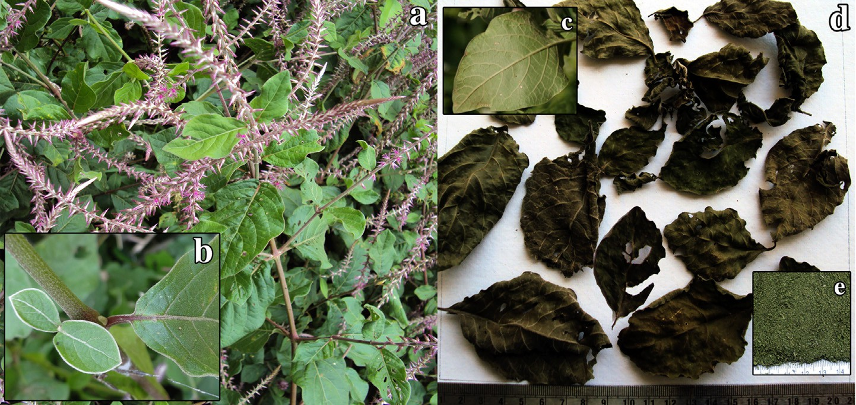

Fig. 1 e a: A. coynei habit; b: petiole; c: ventral view of leaf; d: dried leaves; e: leaf powder.

238.17e14.33 sq mm) covered by cuticle (thickness of DST: 5.557e1.621 mm). The epidermal cells were rectangular in shape with convex nature on upper and lower margins. The cells of the upper epidermis were larger in size than the lower epidermis. Long, multi-cellular warty trichomes (DST: 348.6e476.2 mm) with pointed apex were present on the epidermis. Few short, irregularly bent glandular tri- chomes (DST: 20.59e73.2 mm) with blunt apex were seen in the midrib region of the epidermal layer. Transverse sec- tion shows 4e6 rows of collenchyma bellow the upper epidermis and 2e3 layers after lower epidermis in the midrib region. The cells of collenchyma were thick walled; oval in shape, showing tiny air spaces followed by broad parenchymatous ground tissues. The cells of the ground tissue were round/oval/polygonal in nature with intercel- lular spaces. Conjoint, collateral closed, 5e9 vascular bun- dles were present in ground tissue. The vascular bundles were endarch, enclosed by sclerenchymatous sheath; phloem consists of companion cells and sieve tubes; xylem consists of spiral annular thickened vessels, tracheids, fi- bres and xylem parenchyma. Rosette crystals of calcium oxalate were observed in ground tissue and palisade cells of midrib and lamina (RDS: 22.69e10.21 mm). Laminar TS of the leaf shows 2e3 layers of palisade cells underneath the upper epidermis and 2e4 layer of spongy parenchyma below lower epidermis.

The peels of epidermis were analysed to observe the sto- mata and its nature. Both lower (Fig. 2c) and upper epidermis (Fig. 2d) show stomata (Maj: 7.241e11.37 mm) and were of similar nature. Two guard cells of stomata were surrounded by three to four wavy walled epidermal cells falling in both anisocytic and anomocytic category.

### *Petiole*

Crescent shaped petiole was observed in TS (Fig. 2b), showing a layer of thick walled epidermis with trichomes as mentioned in the leaf. Thick walled, 4e5 layers of collenchymas were

present beneath the epidermal layer. Various sized paren- chymatous cells forms' the ground tissue with rosette crystals of calcium oxalates (RDS: 30.48e17.3 mm). An arc of vascular

bundles was present at the centre of the petiole and the nature is similar to that of leaf.

### *Powder microscopy*

Powder of the leaf along with petiole showed fragmented pitted and spiral vessels (Fig. 2e, j), trichomes attached to the epidermal cells (Fig. 2g, h, m), palisade and spongy paren- chyma cells (Fig. 2f, i), calcium oxalate crystals (Fig. 2f, k), collenchyma cells (Fig. 2l), thick walled epidermal cells and stomata (Fig. 2l, m).

### *Leaf constant*

Leaf venation was reticulate with 8 ± 4 pairs of alternate lateral veins (Fig. 1c). Vein islet number is 12 ± 6 and vein termination number is 15 ± 5.5. The stomatal index for lower

epidermis is 23.63% and for upper epidermis 20.69% (Fig. 2c, d) and palisade ratio varies from 1:7 to 1:13.

### *Histochemical analysis*

Leaf and petiole sections were treated with different reagents to know various cell components. The results are presented in Table 1. Both leaf and petiole showed the presence of calcium oxalate crystals soluble in Conc. HCl with lignin and cellulose.

### *Organoleptic characters*

Dried leaves (Fig. 1d) and leaf powder has green colour (Fig. 1e) without any specific odour and taste.

### *Physicochemical parameters*

The physiochemical characters such as total ash, acid soluble ash, moisture content, and extractive values in ethanol and water of dried leaf powder were calculated in terms of air dried sample. The results were presented in Table 2. Total ash plays an important role in evaluation of purity of drugs and for

*A. coynei* leaf powder it was 12.7% w/w. Quantitative estima- tion of extractive values was represented as percent yield. Soluble extractive percent yield for leaves was higher in water (15.24% w/w) than in ethanol (9.61% w/w). The results showed greater extractive values on water extract followed by ethanol indicating the concentration of secondary metabolites. Macro elements (nitrogen, potassium, phosphor, sulphur, calcium, magnesium, sodium), microelements (iron, zinc, copper,

[e g ypti an j o ur nal o f b a sic and a pp l i e d sci en c e s 2 ( 201 5 ) 2 5](http://dx.doi.org/10.1016/j.ejbas.2014.12.002) e[31](http://dx.doi.org/10.1016/j.ejbas.2014.12.002) 29

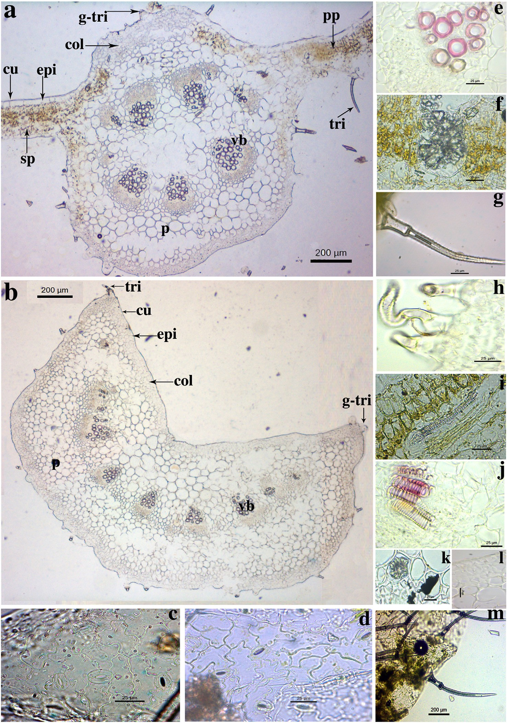

Fig. 2 e a: TS of leaf; b: TS of petiole; c: lower epidermis; d: upper epidermis; e: vascular bundles; f: calcium oxalate crystal; g: long, multi-cellular warty trichome; h: glandular trichome with blunt apex; i: palisade and spongy parenchyma cells; j: xylem vessels; k: calcium oxalate crystals; l: collenchyma cells; m: epidermis with trichoms; col: collenchyma cells; cu: cuticle; epi: epidermis; g-tri: glandular trichomes with blunt apex; p: parenchyma; pp: palisade parenchyma; tri: long, multi- cellular warty trichome; vb: vascular bundle; sp: spongy parenchyma.

manganese) were estimated for the leaves and were repre- sented as percent and parts per million (ppm) respectively (Table 2). Among micro elements iron (6113.13 ppm) content was high in *A. coynei* leaves. The results indicate considerable content of moisture, fat and fibre in leaf. Nutritive contents like reducing and non-reducing sugars, carbohydrates, starch and protein were also estimated in the present study (Table 2).

### *Fluorescence analysis*

Fluorescence analysis of leaf powder was carried out after treating with several solvents. Fluorescence was observed at 254 and 365 nm comparing its change of colour in visible light. The observations are presented in Table 3 showing the vari- ation in colour.

30 [e gypti an j o ur nal o f b a sic and a pp l i ed sci e n c e s 2 ( 201 5 ) 2 5](http://dx.doi.org/10.1016/j.ejbas.2014.12.002) e[31](http://dx.doi.org/10.1016/j.ejbas.2014.12.002)

|  |  |  |  |  |  |  |
| --- | --- | --- | --- | --- | --- | --- |
| Table 4 e Preliminary phytochemical analysis. | | | | | | |
| Test for | Aqueous | Methanol | Leaf  Ethyl acetate | extracts  Chloroform | Benzene | Petroleum ether |
| Steroids | +a | +a | +a | +a | +a | +a |
| Triterpenoids | +a | +a | +a | +a | eb | eb |
| Saponins | +a | +a | +a | eb | eb | +a |
| Flavonides | +a | +a | eb | eb | eb | eb |
| Alkaloids | +a | +a | eb | +a | eb | +a |
| Tannins | eb | eb | eb | eb | eb | eb |
| Glycosides | +a | +a | +a | +a | eb | +a |
| a Present.  b Absent. | | | | | | |

### *Phytochemical analysis*

Respective extracts were subjected to preliminary phyto- chemical screening and the results (Table 4) validated the presence of triterpenoids, alkaloids, glycosides, steroids, and saponins in leaves.

### *HPTLC analysis*

Fast screening of the triterpenoids were studied using appli- cability of thin layer chromatography (TLC). A better separa- tion with chloroform: methanol (9:1 v/v) was observed as determined by Tandon [13]. The results for the TLC run were captured on the visualizer and the photograph of the chro- matographic plate is presented as Fig. 3. In all, 8 bands were identified after spraying of anisaldehydeesulphuric acid re- agent (Fig. 3). Colour of band, intensity of colour and *R*f values for all the 8 bands were recorded (Table 5).

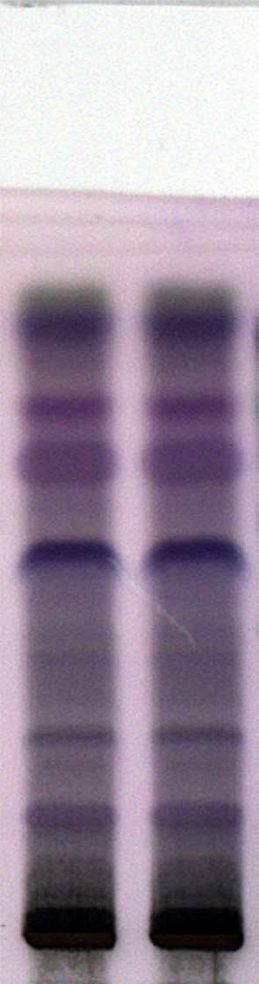

Fig. 3 e HPTLC plate image.

# Discussion

In codified traditional medicine (like Ayurveda, Homeopathy, Sidhha) *A. aspera* is a well known drug and used to cure various disorders [13,14]. *A. coynei* and *A. aspera* belongs to the same family and genus [4]. Pai et al., reported that *A. coynei* is used by the local community for similar purposes to that of *A. aspera* because of the similarities in their morphological characters [4]. Pharmacognostical and physicochemical studies, being reliable and inexpensive, play an important role in quality control issues of the crude drug samples [15]. The macro and micro characters observed in the leaves of *A. coynei* serve as basis for the identification of right sample of the plant. Morphologically *A. coynei* was differentiated through its perennial shrubby nature and rosy-purplish coloured flowers on the inflorescence from *Achyranthes apera* [4]. The petiole of

*A. coynei* is pink above and green beneath, whereas in *A. aspera*

petiole was pale green. The bigger size of leaves and typical petiole colour in *A. coynei* can be used to differentiate it from *A. aspera*. It is reported that *A. aspera* have 4e5 vascular bundles in leaf and petiole [13,14] whereas more number of vascular bundles were observed in *A. coynei*. This may be because of the larger size of leaves in *A. coynei*. However, the TS and powder study reveals similarities in *A. coynei* and *A. aspera* in terms of rosette shaped calcium oxalate crystals; long, multi cellular, warty, pointed apex and short, blunt glandular trichomes; anisocytic and anomocytic types of stomata.

Total ash, acid insoluble ash and water soluble ash param- eters indicate the presence of inorganic and silica components in the sample studied [8]. The ash content of *A. coynei* lies within the range of *A. aspera* as reported in Ayurvedic

|  |
| --- |
| Table 5 e HPTLC analysis of A. coynei leaf extract. |
| *R*f Values Band colour and intensitya Colour codeb |
| 0.17 Purple2 #68566C  0.28 Dark purple2 #62576A  0.38 Light blue3 #736676  0.42 Light pink3 #766B7C  0.53 Blue1 #382C5A  0.65 Indigo1 #6F5271  0.72 Violet1 #65456D  0.83 Dark blue1 #493A56 |
| a 1: High intensity; 2: medium intensity; 3: low intensity.  b Codes as per Adobe Photoshop 7. |

[e g ypti an j o ur nal o f b a sic and a pp l i e d sci en c e s 2 ( 201 5 ) 2 5](http://dx.doi.org/10.1016/j.ejbas.2014.12.002) e[31](http://dx.doi.org/10.1016/j.ejbas.2014.12.002) 31

pharmacopeia [14]. The results of the water and ethanol extractive studies reveal the presence of secondary metabolite in the powder sample [8] and Upadhya et al. reported consid- erable amount of total phenolic content in the leaves of *A. coynei*, which was further reported to be responsible for *in vitro* antioxidant activities [7]. Leaf powder display the florescence activity due to the presence of diverse chemical entities under the influence of ultraviolet light and different reagents.

The results of HPTLC analysis for triterpenoids from *A. coynei* leaf extract were in accordance with the reports of Ton- don, wherein they have differentiated the TLC profile on the basis of *R*f values. The band with *R*f value 0.57 was attributed as oleanolic acid for *A. aspera* [13]. In the present study, similar observations for *R*f value of 0.53 with intense blue colour band was recorded. This indicated the presence of oleanolic acid, as also reported by Upadhya et al., using HPLC method [16].

# Conclusion

The phytochemical studies reported in the present study need further scientific investigation to ascertain its identity up to compound level. Study on various biological activities similar to that of *A. aspera* are needed to substantiate the usage of *A. coynei* by folk healers. Pharmacognostic characters studied will be helpful in quantitative and qualitative standardization of *A. coynei*. However, detailed differential studies using molecular and chemical markers are required for *A. coynei* and *Achyranthes apsera*, for their authentication especially in their drug form.

# Acknowledgement

Authors are grateful to the Director-in-Charge, Regional Medical Research Centre, (ICMR) Belgaum for the facilities and ANCHROM, Mumbai for providing HPTLC facility. Authors are also thankful to Mr. Bhoopal Talawar, lab attendant for his help in processing plant material. VU is indebted to Indian Council of Medical Research, New Delhi for Senior Research Fellowship during the study.

## referen c es

1. [Upadhya V, Hegde HV, Bhat S, Hurkadale PJ, Kholkute SD,](http://refhub.elsevier.com/S2314-808X(14)00057-8/sref1) [Hegde GR. Ethno medicinal plants used to treat bone fracture](http://refhub.elsevier.com/S2314-808X(14)00057-8/sref1)

[from North-Central Western Ghats of India. J](http://refhub.elsevier.com/S2314-808X(14)00057-8/sref1) [Ethnopharmacol 2012;142:557](http://refhub.elsevier.com/S2314-808X(14)00057-8/sref1)e[62](http://refhub.elsevier.com/S2314-808X(14)00057-8/sref1).

1. [Kingston DG. Modern natural products drug discovery and its](http://refhub.elsevier.com/S2314-808X(14)00057-8/sref2) [relevance to biodiversity conservation. J Nat Prod](http://refhub.elsevier.com/S2314-808X(14)00057-8/sref2) [2011;74:496](http://refhub.elsevier.com/S2314-808X(14)00057-8/sref2)e[511](http://refhub.elsevier.com/S2314-808X(14)00057-8/sref2).
2. [Narayana DBA, Katayar CK, Brindavanam NB. Original](http://refhub.elsevier.com/S2314-808X(14)00057-8/sref3) [system: search, research or research. IDMA Bull](http://refhub.elsevier.com/S2314-808X(14)00057-8/sref3) [1998;29:413](http://refhub.elsevier.com/S2314-808X(14)00057-8/sref3)e[6](http://refhub.elsevier.com/S2314-808X(14)00057-8/sref3).
3. [Pai SR, Upadhya V, Hegde HV, Kholkute SD. *Achyranthes*](http://refhub.elsevier.com/S2314-808X(14)00057-8/sref4)[*coynei* Santapau (Amranthaceae)](http://refhub.elsevier.com/S2314-808X(14)00057-8/sref4) e [an addition of endemic](http://refhub.elsevier.com/S2314-808X(14)00057-8/sref4) [taxon to Flora of Karnataka, India. J Threat Taxa](http://refhub.elsevier.com/S2314-808X(14)00057-8/sref4) [2011;3:1875](http://refhub.elsevier.com/S2314-808X(14)00057-8/sref4)e[9](http://refhub.elsevier.com/S2314-808X(14)00057-8/sref4).
4. [Sharma BD, Kulkarni BG. *Achyranthes coynei* Santapau,](http://refhub.elsevier.com/S2314-808X(14)00057-8/sref5) [Amaranthaceae. In: Nayar MP, Sastry ARK, editors. Red data](http://refhub.elsevier.com/S2314-808X(14)00057-8/sref5) [book of Indian plants, vol. 2. Calcutta: Botanical Survey of](http://refhub.elsevier.com/S2314-808X(14)00057-8/sref5) [India; 1987. p. 8](http://refhub.elsevier.com/S2314-808X(14)00057-8/sref5)e[9](http://refhub.elsevier.com/S2314-808X(14)00057-8/sref5).
5. [Ankad G, Upadhya V, Pai SR, Hegde HV, Roy S. In vitro](http://refhub.elsevier.com/S2314-808X(14)00057-8/sref6) [antimicrobial activity of *Achyranthes coynei* Sant. Asian Pac J](http://refhub.elsevier.com/S2314-808X(14)00057-8/sref6) [Trop Dis 2013;3:930](http://refhub.elsevier.com/S2314-808X(14)00057-8/sref6)e[5](http://refhub.elsevier.com/S2314-808X(14)00057-8/sref6).
6. [Upadhya V, Pai SR, Ankad G, Hurkadale PJ, Hegde HV.](http://refhub.elsevier.com/S2314-808X(14)00057-8/sref7) [Phenolic contents and antioxidant properties from aerial](http://refhub.elsevier.com/S2314-808X(14)00057-8/sref7) [parts of *Achyranthes coynei* Sant. Indian J Pharm Sci](http://refhub.elsevier.com/S2314-808X(14)00057-8/sref7) [2013;75:483](http://refhub.elsevier.com/S2314-808X(14)00057-8/sref7)e[6](http://refhub.elsevier.com/S2314-808X(14)00057-8/sref7).
7. [Hegde SV, Hegde GR, Mulgund GS, Upadhya V.](http://refhub.elsevier.com/S2314-808X(14)00057-8/sref8) [Pharmacognostic evaluation of leaf and fruit of *Capsicum*](http://refhub.elsevier.com/S2314-808X(14)00057-8/sref8)[*frutescens* (Solanaceae). Pharmacogn J 2014;6:14](http://refhub.elsevier.com/S2314-808X(14)00057-8/sref8)e[22](http://refhub.elsevier.com/S2314-808X(14)00057-8/sref8).
8. [Khandelwal KR. Practical pharmacognosy. 10th ed. Pune:](http://refhub.elsevier.com/S2314-808X(14)00057-8/sref9) [Nirali Publication; 2003](http://refhub.elsevier.com/S2314-808X(14)00057-8/sref9).
9. [Thimmaiah SK. Standard methods of biochemical analysis.](http://refhub.elsevier.com/S2314-808X(14)00057-8/sref10) [1st ed. Calcutta: Kalyani Publisher; 1999](http://refhub.elsevier.com/S2314-808X(14)00057-8/sref10).
10. [Chopra SL, Kanwar JS. Analytical agricultural chemistry. 1st](http://refhub.elsevier.com/S2314-808X(14)00057-8/sref11) [ed. Calcutta: Kalyani Publishers; 1991](http://refhub.elsevier.com/S2314-808X(14)00057-8/sref11).
11. [Kokoshi CJ, Kokoshi RJ, Salma FJ. Fluorescence of powdered](http://refhub.elsevier.com/S2314-808X(14)00057-8/sref12) [vegetable drugs under ultraviolet radiation. J Pharm Sci](http://refhub.elsevier.com/S2314-808X(14)00057-8/sref12) [1958;47:715](http://refhub.elsevier.com/S2314-808X(14)00057-8/sref12)e[7](http://refhub.elsevier.com/S2314-808X(14)00057-8/sref12).
12. [Tandon N, editor. Quality standards of Indian medicinal](http://refhub.elsevier.com/S2314-808X(14)00057-8/sref13) [plants, vol. 9. New Delhi: Indian Council of Medical Research;](http://refhub.elsevier.com/S2314-808X(14)00057-8/sref13) [2011](http://refhub.elsevier.com/S2314-808X(14)00057-8/sref13).
13. [Anonymous. The ayurveda pharmacopeia of India part 2, vol.](http://refhub.elsevier.com/S2314-808X(14)00057-8/sref14)

[2. New Delhi: Department of AYUSH Ministry of Health and](http://refhub.elsevier.com/S2314-808X(14)00057-8/sref14) [Family Welfare; 2007. p. 7](http://refhub.elsevier.com/S2314-808X(14)00057-8/sref14)e[9](http://refhub.elsevier.com/S2314-808X(14)00057-8/sref14).

1. [Bigoniya P, Singh CS, Srivastava B. Pharmacognostical and](http://refhub.elsevier.com/S2314-808X(14)00057-8/sref15) [physico-chemical standardization of *Syzigium cumini* and](http://refhub.elsevier.com/S2314-808X(14)00057-8/sref15) [*Azadirachta indica* seed. Asian Pac J Trop Biomed](http://refhub.elsevier.com/S2314-808X(14)00057-8/sref15) [2012:S290](http://refhub.elsevier.com/S2314-808X(14)00057-8/sref15)e[5](http://refhub.elsevier.com/S2314-808X(14)00057-8/sref15).
2. [Upadhya V, Ankad GM, Pai SR, Hegde HV, Kholkute SD.](http://refhub.elsevier.com/S2314-808X(14)00057-8/sref16) [Accumulation and trends in distribution of three](http://refhub.elsevier.com/S2314-808X(14)00057-8/sref16) [triterpenoids in various parts of *Achyranthes coynei*](http://refhub.elsevier.com/S2314-808X(14)00057-8/sref16)[determined using RP-UFLC analysis. Pharma Mag](http://refhub.elsevier.com/S2314-808X(14)00057-8/sref16) [2014;10:398](http://refhub.elsevier.com/S2314-808X(14)00057-8/sref16)e[401](http://refhub.elsevier.com/S2314-808X(14)00057-8/sref16).