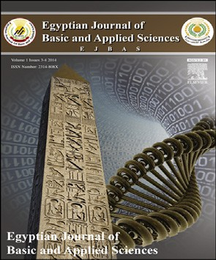 HOSTE D BY

Available online at [www.sciencedirect.com](http://www.sciencedirect.com/science/journal/2314808X)

**ScienceDirect**

journal homepage: [http://ees.elsevier.com/ejbas/default.asp](http://http//ees.elsevier.com/ejbas/default.asp)

**Full Length Article**

**Phytotoxicity of three *Plantago* species on germination and seedling growth of hairy beggarticks (*Bidens pilosa* L.)**



***Ahmed M. Abd El-Gawad*** ***\*******, Ibrahim A. Mashaly, Mohamed E. Abu Ziada, Maha R. Deweeb***

*Botany Department, Faculty of Science, Mansoura University, Mansoura 35516, Egypt*

A R T I C L E I N F O A B S T R A C T

*Article history:*

Received 25 April 2015

Received in revised form 29 June 2015

Accepted 12 July 2015

Available online 29 July 2015

*Keywords:*

Allelopathy

Bioactive compounds

*Bidens pilosa Plantago* spp Weeds

*Plantago* genus has a wide geographical distribution all over the world. It has been widely used in folk medicine for various purposes, where it is used as anti-inflammatory, antimi- crobial and antitumor agent. In this research, total phenols, tannins, saponins, flavonoids and alkaloids were determined in *Plantago lagopus*, *Plantago major* and *Plantago squarrosa*. Furthermore, concentrations of 2.5, 5, 7.5 and 10 mg ml−1 of both alcoholic and aqueous ex-

tracts were prepared to study their phytotoxic effect on the germination and seedling growth

of the noxious weed *Bidens pilosa*. *P. major* expressed the highest values of total phenolics, tannins and flavonoids. However, *P. lagopus* has the highest content of alkaloids. The ger- mination of *B. pilosa* was completely inhibited under treatment of *P. lagopus* and *P. major* methanolic extracts at 7.5 mg ml−1 and 10 mg ml−1, respectively. However, the allelopathic effect of *P. lagopus* aqueous extract showed a complete inhibition of *B. pilosa* germination followed by *P. major*. The germination inhibition of *B. pilosa* increased with the increase in the extracts concentration. In addition, both radicle and plumule were strongly inhibited under the same treatment. Our results showed a potent allelopathic effect on *B. pilosa* that could be valorized in managing this noxious weed as an ecofriendly bio-control method. However, other studies are needed for the identification, characterization of the respon- sible allelochemicals and for the demonstration of their modes of action.

Production and hosting by Elsevier B.V. on behalf of Mansoura University. This is an open access article under the CC BY-NC-ND license (<http://creativecommons.org/licenses/by->

nc-nd/4.0/).

# Introduction

Due to the high food requirement of the ever-growing popu- lation of the world and the oriented productivity of agriculture,

the introduction of synthetic herbicides to control noxious weeds was a favorable way below the threshold limit to reduce the yield loss. Besides improving the crop production, a preda- tory impact on the environment quality and on human health was generated and increased the number of herbicide resistant

* *Corresponding author.* Tel.: +20 1003438980.

*E-mail address:* [dgawad84@mans.edu.eg](mailto:dgawad84@mans.edu.eg); [dgawad84@yahoo.com](mailto:dgawad84@yahoo.com) (A.M. Abd El-Gawad). <http://dx.doi.org/10.1016/j.ejbas.2015.07.003>

2314-808X/Production and hosting by Elsevier B.V. on behalf of Mansoura University. This is an open access article under the CC BY- NC-ND license ([http://creativecommons.org/licenses/by-nc-nd/4.0/).](http://creativecommons.org/licenses/by-nc-nd/4.0/))

weeds [1,2]. The weed science society of America defines a weed as any plant that is objectionable or interferes with the ac- tivities and welfare of humans [3]. Weed species might vary in their response to the phytotoxicity, it has received atten- tion in numerous publications [4,5]. Weed management research should find out some natural ways of minimizing the depen- dency on synthetic herbicides which is still in need of an effective and affordable technological solution. Allelopathy rep- resented aproper solution for this problem.

Allelopathy represents a natural phenomenon of a plant emancipation of inhibitory substances that interfere with other plants sharing the same environment. Allelopathy is well- defined as both the plant’s inhibitory and stimulatory effects upon the other plant including microorganisms [6]. A simpler meaning of allelopathy is that it is the inhibitory effect of one plant on another due to the release of chemical substances. This meaning is compatible with the famous phrase of Paracelsus “All things are poison and are not poison; only the dose makes a thing not a poison” [7]. Allelochemicals (inhibi- tors) are defined as plant secondary metabolites that are released into the environment through volatilization, root exu- dation, leaching from plants or plant residues, and decay of residues. Also, they can be present in various parts of a plant, ranging from the root to stem or seeds [8]. Although we cannot discard the use of synthetic herbicides completely at the present situation, their use can be reduced up to a certain extent by utilizing allelopathic potentiality as an alternative weed man- agement strategy for crop production as well as environmental profits [2].

*Bidens pilosa L.* (Asteraceae) is a noxious annual weed native to tropical America. In Africa *B. pilosa* is recorded in many coun- tries and it is likely to occur in all countries. This genus contains about 280 species worldwide and it is widespread in both field crops and wild areas because of its fast growth, strong inva- sive nature and its easy adaptation [9]. The enormous genus *Plantago* of family Plantaginaceae comprises 483 perennial and annual species distributed throughout the world. They have wide ecological amplitude. They are weeds of both arable lands and grasslands [10,11]. The highly diverse genus *Plantago* has been used as traditional medicinal plant for centuries. It was reported to have biological activities including anti- inflammatory, analgesic, anti-tumoral, anti-spasmodic, hepatoprotective, antiviral, antibacterial, antifungal and anti- ulcerogenic [12,13]. The aim of the present study was to evaluate the allelopathic potential of *Plantago lagopus*, *Plantago major* and *Plantago squarrosa* extracts on the germination and early seed- ling growth of the noxious weed *B. pilosa*.

## *Phytochemical analysis*

Total phenolics, tannins, alkaloids, flavonoids and saponins of

*P. lagopus*, *P. major* and *P. squarrosa* samples were determined spectrophotometrically [14–17].

## *Allelopathic bioassay*

### *Weed seed source*

The seeds of *B. pilosa* were collected from the orchards habitat in El-Sharkia Governorate in Egypt, sterilized by 0.3% sodium hypochlorite, rinsed by distilled water, dried on the filter paper in the laboratory at room temperature for 7 days and packed in a paper bag until use [18,19].

### *Preparation of plant extract*

For bioassay tests, aqueous and methanolic stock extracts (10% w/v) were diluted with distilled water to obtain concentra- tions of 7.5%, 5% and 2.5% (v/v) test extracts. All osmotic concentrations of bioassay solutions were less than 0.1 Mpa and hence not considered a factor affecting germination. The solutions were filtered through double layers of muslin cloth followed by a Whatman No.1 filter paper, the pH values were adjusted to 7 and these were kept in the refrigerator at 4 °C until further use [20].

### *Germination bioassay*

Two layers of Whatman No. 1 filter paper were placed in 90 mm diameter glass Petri dishes. In each dish, 25 seeds were placed and 10 ml of each plant extract were added in concentra- tions of 10, 7.5, 5 and 2.5% (v/v). In case of methanolic extract, seeds were placed after alcohol evaporation and then 10 ml of distilled water were added. A check treatment was as- signed with distilled water and left at room temperature. Starting from the first day of the experiment, germinated seeds were counted and removed daily. A seed with 2 mm of radicle was considered germinated. Experiment designed was ran- domized complete block with three replicates and the experiment was repeated twice. The inhibition percentage was calculated.

### *Seedling growth bioassay*

The seeds of *B. pilosa* were germinated on filter paper in the dark at room temperature for 2 days. Twenty five germinated seeds were transferred to Petri dishes lined with two layers of Whatman No. 1 filter paper and 10 ml of different extracts were added in concentrations of 10, 7.5, 5 and 2.5% (v/v). In addi-

tion a check treatment was assigned with distilled water and

# Materials and methods

## *Preparation of plant materials*

*P. lagopus*, *P. major* and *P. squarrosa* aerial parts were har- vested at a vegetative stage. The plant tissues were clipped 1 cm above the soil, washed with distilled water and left to dry in room temperature (25 °C) in a shaded place for several days until completely dried. The dried samples were ground to pass a 1 mm screen, packed in a polyethylene bag and stored in a refrigerator until use.

left at room temperature. Experiment designed was random- ized complete block with three replicates and the experiment was repeated twice. The shoot and root lengths of seedlings were measured on the tenth day and growth inhibition for radicle and plumule lengths was calculated.

## *Statistical analysis*

All values of phytochemistry and allelopathy experiments are the mean of three replicates ± standard error. Data were sub- jected to ANOVA and the mean values were separated based

on Duncan’s test at 0.05 probability level using COSTAT 6.3 program.

of *B. pilosa* four days after treatment is illustrated in Fig. 1. The obtained data revealed that there was a slight significant varia- tion between the three studied *Plantago* species (*P* ≤ 0.05);

however the degree of inhibition was significantly increased

# Results

## *Phytochemical constituents of the studied* Plantago

***species***

The phytochemical constituents of the aerial parts of *P. lagopus*,

*P. major* and *P. squarrosa* are presented in Table 1. *P. major* at- tained the highest significant values of phenolics, tannins and flavonoids compared to *P. lagopus* and *P. squarrosa*. However,

*P. lagopus* exhibited the highest values of flavonoids and sa- ponins. Tannins, alkaloids and saponins did not show significant variation between *P. lagopus* and *P. major* (*P* ≤ 0.05).

## *Allelopathic effect of various* Plantago *extracts on*

**B. pilosa *germination***

The allelopathic effect of the aqueous and methanolic ex- tracts of *P. lagopus*, *P. major* and *P. squarrosa* on the germination

in a concentration-dependent manner.

The aqueous extracts of *P. major*, *P. lagopus* and *P. squarrosa* at 10 mg ml−1 inhibited the germination of *B. pilosa* by about 72.41%, 62.96% and 62.96%, respectively. On the other hand, the lowest concentration (2.5 mg ml−1) of *P. lagopus*, *P. major* and

*P. squarrosa* extracts showed the lowest inhibition percentage of germination (10.34%, 7.41% and 3.70%, respectively). The IC50 values (the concentration of a substance that is required for 50% inhibition of a specific biological or biochemical func-

tion) of the germination of *B. pilosa* were 7.50 mg ml−1,

7.88 mg ml−1 and 7.91 mg ml−1, respectively for *P. squarrosa*,

*P. major* and *P. lagopus* extracts (Fig. 1).

On the other hand, *P. lagopus* methanolic extract showed a complete inhibition of germination at 7.5 mg ml−1, while *P. major* extract showed a complete inhibition of germination at 10 mg ml−1. *P. squarrosa* extract showed the highest inhibition percentage (85.19%) at 10 mg ml−1. At the lowest concentra- tion (2.5 mg ml−1), *P. lagopus*, *P. major* and *P. squarrosa* extracts

**Inhibition (%)**

**IC50 (mg ml-1)**

|  |  |  |  |  |  |
| --- | --- | --- | --- | --- | --- |
| **Table 1 – The composition of the active secondary chemical constituents (mg/g dry weight) of the three studied *Plantago***  **species.** | | | | | |
| Plant species | Phenolics | Tannins | Alkaloids | Flavonoids | Saponins |
| *Plantago lagopus* | 50.3b ± 1.32 | 20.3a ± 0.53 | 12.5a ± 0.26 | 10.0c ± 0.28 | 10.8a ± 0.33 |
| *Plantago major* | 123.9a ± 3.26 | 21.3a ± 0.56 | 12.0a ± 0.42 | 16.0a ± 0.27 | 10.4a ± 0.32 |
| *Plantago squarrosa* | 40.8c ± 1.07 | 16.7b ± 0.44 | 10.0b ± 0.36 | 13.0b ± 0.18 | 6.8b ± 0.26 |
| LSD0.05 | 6.54 | 1.58 | 0.94 | 1.07 | 0.77 |
| Different letters in each column indicate values with significant variation (*P* ≤ 0.05). | | | | | |

#### Fig. 1 – The inhibitory effect and IC50 of both aqueous and methanolic *Plantago* extracts on the germination percentage (mean value) with the error bars of *Bidens pilosa* four days after treatment. Different letters indicate values with significant variation (*P* ≤ 0.05).

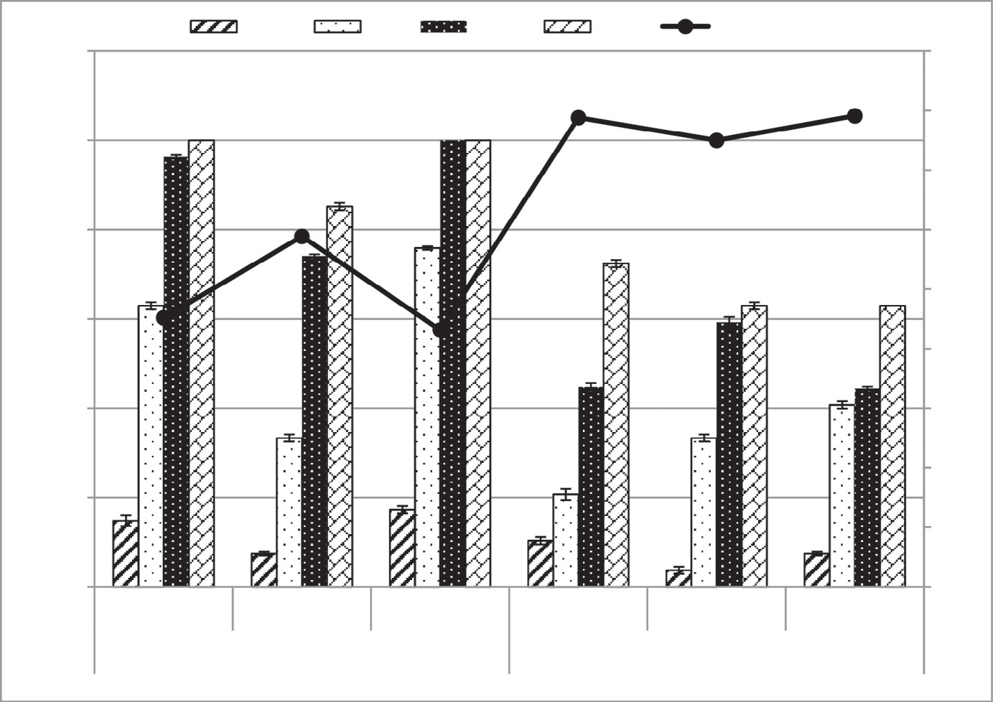

120

2.5

5

7.5

10

IC50 (mg/ml)

LSD0.05 (Methanolic) = 16.85 LSD0.05 (Aqueous) = 22.51

100

a

a

a a

ab

80

bc

bc

a

9

8

7

6

c

ab

ab

ab

5

60

bc

bc

4

40

bc

d

c

3

cd

20

e

de

2

e

d

d

d

1

0

***P. major P. Squarrosa P. lagopus P. major***

***P. Squarrosa***

***Aqueous Extract***

***P. lagopus***

0

***Methanolic Extract***

**Fig. 2 – The allelopathic effect and IC50 of both aqueous and methanolic *Plantago* extracts on the radicle growth inhibition percentage (mean value) with the error bars of *Bidens pilosa* ten days after treatment. Different letters indicate values with significant variation (*P*** ≤ **0.05).**

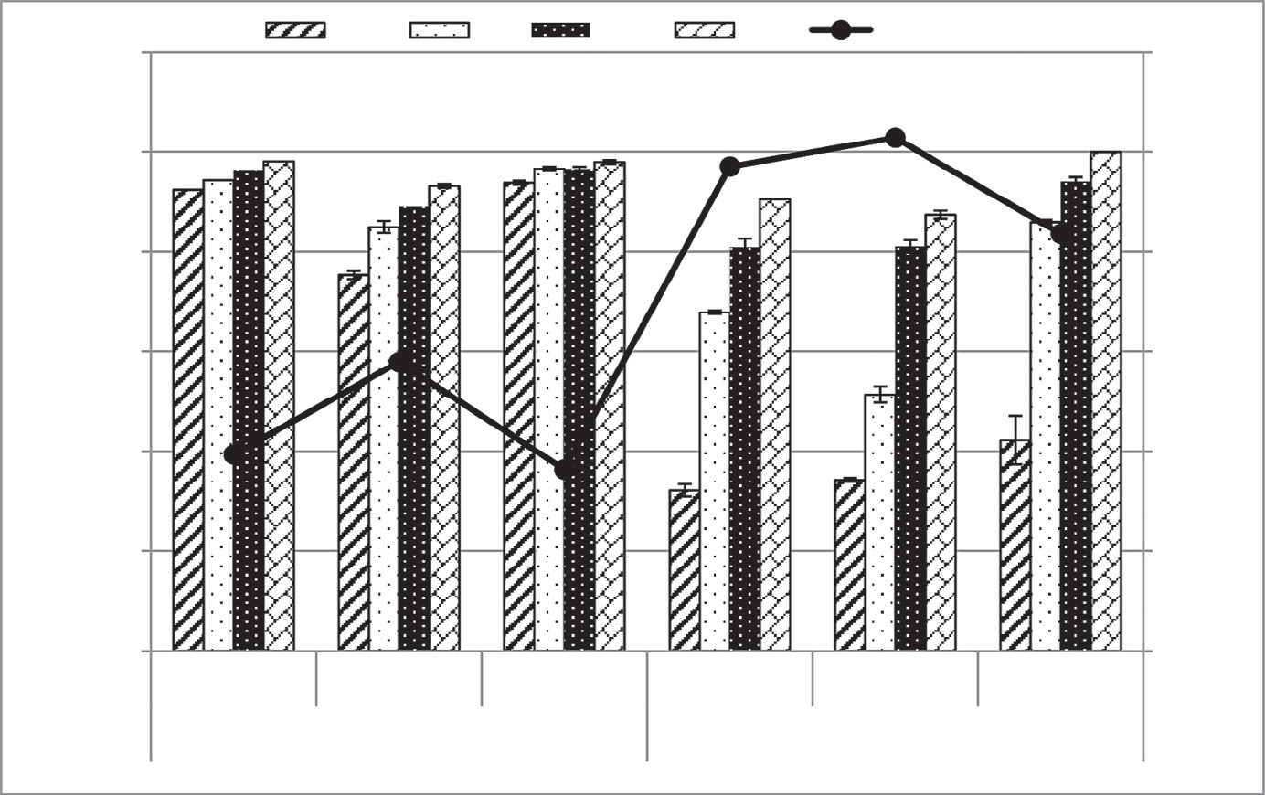

120

2.5

5

7.5

10

IC50 (mg/ml)

6

LSD0.05 (Methanolic) = 6.41

LSD0.05 (Aqueous) = 18.92

100

ab

ab ab a

ab ab a a

c bc

ab

ab

ab a

5

ab

bc

ab

ab

80

d

bc

4

60

cd

de

3

40

de

e

2

20

1

0

***P. major P. squarosa P. lagopus***

***P. major***

0

***Methanolic extract***

***P. squarosa P. lagopus***

***Aqueous extract***

showed the lowest inhibition percentage of germination ex- pressed 17.24%, 14.81% and 7.41%, respectively. The IC50 values of the germination of *B. pilosa* were 4.32 mg ml−1, 4.52 mg ml−1 and 5.89 mg ml−1, respectively for *P. lagopus*, *P. major* and

**Inhibition (%)**

**IC50 (mg ml-1)**

*P. squarrosa* (Fig. 1).

## *Allelopathic effect of various* Plantago *extracts on*

**B. pilosa *radicle growth***

The allelopathic effect of both aqueous and methanolic ex- tracts on *B. pilosa* radicle growth after ten days of treatment revealed that there was not any significant variation between the three studied *Plantago* species (*P* ≤ 0.05). However, the degree of inhibition significantly increased in a dose-dependent manner (Fig. 2).

The aqueous extract of *P. lagopus* expressed a complete in- hibition of radicle growth of *B. pilosa* at 10 mg ml−1. However,

*P. major* and *P. squarrosa* extracts showed 90.48% and 87.39%,

respectively. At 2.5 mg ml−1, *P. lagopus*, *P. major* and *P. squarrosa* extracts showed the lowest inhibition percentage of radicle growth 42.22%, 32.14% and 34.23%, respectively. The IC50 values

for *P. lagopus*, *P. major* and *P. squarrosa* extracts on the radicle development of *B. pilosa* were 4.18 mg ml−1, 4.85 mg ml−1 and

5.14 mg ml−1, respectively (Fig. 2).

On the other side, the methanolic extracts from *P. major*,

*P. lagopus*, and *P. squarrosa* at 10 mg ml−1 inhibited the radicle growth of *B. pilosa* by 98.10%, 97.93%, and 93.15%, respec- tively. At the lowest concentration (2.5 mg ml−1), *P. lagopus*,

*P. major* and *P. squarrosa* extracts showed the lowest inhibi-

tion percentage of radicle growth (93.79%, 92.38% and 75.34%, respectively). The IC50 values of *P. lagopus*, *P. major* and *P. squarrosa* extracts on *B. pilosa* were 1.82 mg ml−1, 1.97 mg ml−1 and

2.89 mg ml−1, respectively (Fig. 2).

## *Allelopathic effect of various* Plantago *extracts on*

**B. pilosa *plumule growth***

The phytotoxic effect of both methanolic and aqueous ex- tracts from the studied *Plantago* species on *B. pilosa* plumule growth revealed slight significant variation between the three studied *Plantago* species. Nevertheless, there was a highly sig- nificant variation (*P* ≤ 0.05) between the different concentrations (Fig. 3).

The aqueous extracts from *P. lagopus*, *P. major* and *P. squarrosa*

showed the highest inhibition percentage of *B. pilosa* plumule growth (88.44%, 69.62% and 49.37%, respectively) at 10 mg ml−1. However, at 2.5 mg ml−1, *P. lagopus*, *P. major* and *P. squarrosa* ex- tracts inhibited the plumule growth by 11.56%, 18.35% and 18.36%, respectively. The IC50 values of the plumule develop- ment of *B. pilosa* were 5.18 mg ml−1, 7.71 mg ml−1 and

10.43 mg ml−1, respectively for *P. lagopus*, *P. major* and *P. squarrosa*

extracts (Fig. 3).

However, the methanolic extracts of *P. lagopus* and *P. major* completely inhibited *B. pilosa* plumule growth at 7.5 mg ml−1 and 10 mg ml−1, respectively. However, *P. squarrosa* extract ex- pressed 93.75% at 10 mg ml−1. On the other hand, the lowest concentration (2.5 mg ml−1) of *P. major*, *P. squarrosa* and *P. lagopus* extracts inhibited the plumule growth by 60.95%, 33.09% and

22.92%, respectively. The IC50 values for *P. major*, *P. lagopus* and

*P. squarrosa* extracts were 2.11 mg ml−1, 4.80 mg ml−1 and

4.81 mg ml−1, respectively (Fig. 3).

# Discussion

Medicinal plants are used as old as human civilization and con- tinuous efforts of scientists around the world are being made

#### Fig. 3 – The allelopathic effect and IC50 of both aqueous and methanolic *Plantago* extracts on the plumule growth inhibition percentage (mean value) with the error bars of *Bidens pilosa* ten days after treatment. Different letters indicate values with significant variation (*P* ≤ 0.05).

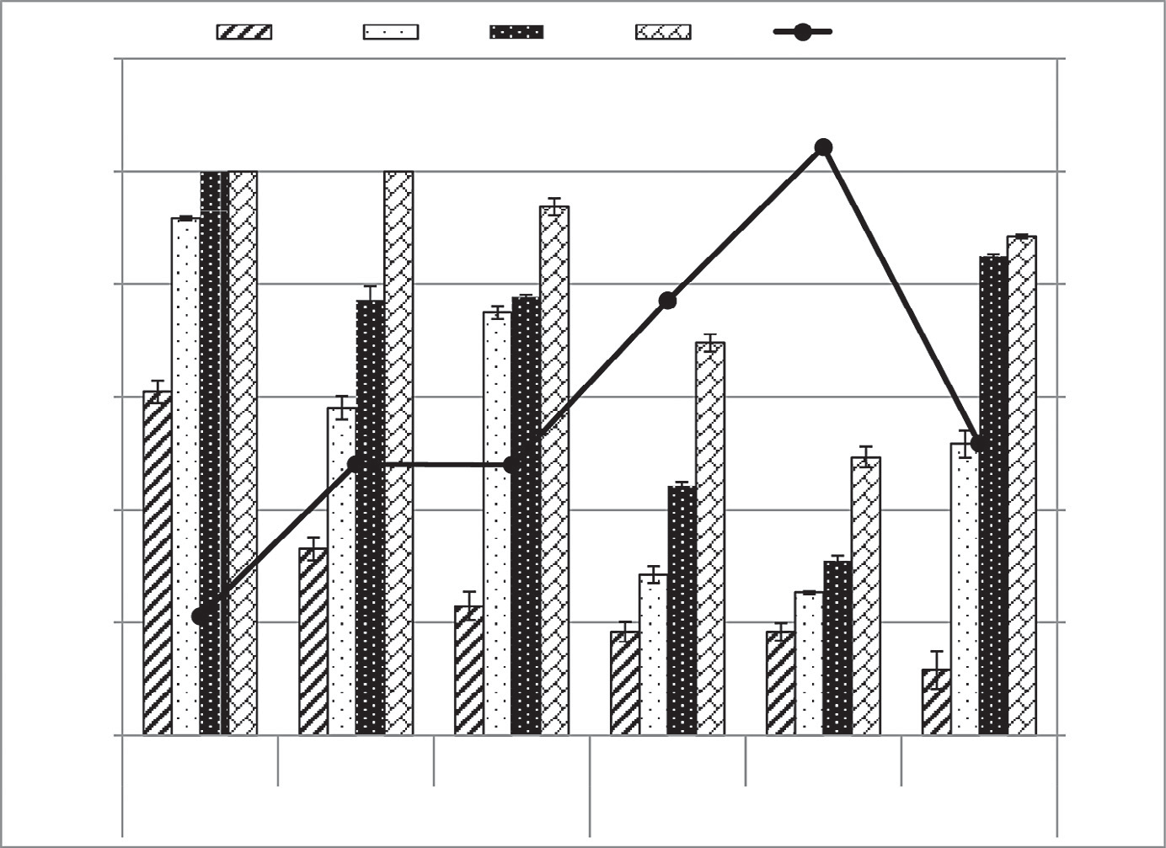

120

**2.5**

**5**

**7.5**

**10**

**IC50 (mg/ml)**

12

LSD0.05 (Methanolic) = 9.02

LSD0.05 (Aqueous) = 11.07

a

a a

a

100

a

10

a a

b

80

b b

b

8

c

c

60

c

c

c

6

40

d

d

d

d

4

f

de

20

ef

f

2

0

***P. major P. squarosa P. lagopus P. major***

***P. squarosa***

***Aqueous extract***

***P. lagopus***

0

***Methanolic extract***

to isolate and characterize novel bioactive compounds from these plants. The present investigation revealed that, *P. major* is rich in phenolics, tannins and flavonoids compared to that reported by Kobeasy et al. [21]. However, the phenolics of

**Inhibition (%)**

**IC50 (mg ml-1)**

*P. lagopus* was lower than reported in Turkish ecotype [12]; this could be corroborated to the variation in the habitat, climate and/or genetic pool [22,23]. On the other hand, it attained the highest content of flavonoids and saponins compared to *P. major* and *P. squarrosa*.

The allelopathic assay of the present study showed that the germination of *B. pilosa* was completely inhibited under treat-

ment of *P. lagopus* and *P. major* methanolic extracts at 7.5 mg ml−1 and 10 mg ml−1, respectively. In addition, the aqueous ex- tracts of *P. major*, *P. lagopus* and *P. squarrosa* at 10 mg ml−1 inhibited the germination of *B. pilosa* by about 72.41%, 62.96%

and 62.96%, respectively. Moreover the germination inhibi- tion of *B. pilosa* increased with the increase in the extracts concentration [5,24–26]. Many plant species showed inhibi- tory effects on *B. pilosa* germination such as *Cajanus cajan*, maize roots and rice husks [27], *Lantana camara* [28] and *Ipomoea cairica* [29]. In addition, many identified allelochemicals had inhibi- tory effects on *B. pilosa* germination such as eugenol [30] and parthenin [1].

The present results showed that the three studied *Plantago* species showed higher inhibition percentage on *B. pilosa* ger- mination than that attained by maize roots, rice husks and

*C. cajan* at 10 mg ml−1 [27]. Additionally, they are more effec- tive against *B. pilosa* germination compared to that of *I. cairica*

[29]; however the concentration used in the present study was lower than the *I. cairica* extract. The allelochemicals inhibited germination perhaps by affecting the cell division and elonga- tion process that are very important at this stage or by interfering with oxidative enzymes [31] involved in the mobilization of

nutrients necessary for germination [6,24] or by increasing ion leakage by altering membrane permeability [32].

*P. lagopus* aqueous extract showed a complete inhibition of

*B. pilosa* radicle growth at 10 mg ml−1; moreover, *P. major* and

*P. squarrosa* showed the maximum inhibitory effect of *B. pilosa* radicle growth at the same concentration. The same observa- tion was reported for plumule growth, although *B. pilosa* radicle is more sensitive to the *Plantago* extracts than the plumule which could be attributed to the direct contact of radicle to the allelochemicals [24]. Additionally, the inhibition of *B. pilosa* seed- ling growth was concentration-dependent. This is similar to the effect of eugenol and parthenin on *B. pilosa* seedling growth [1,30].

The reduction in the seedling growth of *B. pilosa* in this study may be attributed to reduction in cell division of the seed- lings, altering the ultrastructure of the cells [33]. The reduction of protein and nucleic acids, as well as the alteration of the ion uptake, water balance, phytohormone balance, photosyn- thesis, respiration and inactivate several enzymes in *B. pilosa* seedling growth [24,26,34].

The methanolic extract of *P. major*, *P. lagopus*, and *P. squarrosa* inhibited the radicle growth of *B. pilosa* by 98.10%, 97.93%, and 93.15%, respectively at 10 mg ml−1. On the other hand, *P. lagopus*

and *P. major* extracts showed a complete inhibition of *B. pilosa*

plumule growth at 7.5 mg ml−1 and 10 mg ml−1, respectively. The radicle growth of *B. pilosa* was more sensitive than plumule under treatment of the methanolic extracts of the three studied *Plantago* species. This observation is comparable to other studies [35]. Previous studies have indicated that weed species might vary in their response tolerance to phytotoxicity [4,5].

The allelopathic effect of the studied *Plantago* species could be attributed to several bioactive compounds that act in a syn- ergistic manner or to compounds which regulate one another

such as flavonoid, phenolic acids, saponin, alkaloids and tannins. *Plantago* species was reported to contain several bioactive secondary metabolites such as vanillic acid, iridoid glycoside (aucubin), caffeic acid derivatives, chlorogenic acid, ferulic acid, *p*-coumaric acid and triterpenes (oleanolic acid, ursolic acid) [36–38]. Many of these compounds were re- ported as allelochemicals [24,39].

According to the IC50 values, the methanolic extracts of the three *Plantago* species were more phytotoxic on the germina- tion of *B. pilosa* than the aqueous extract. Moreover, the allelopathic effects of the methanolic extracts on the growth of both radicle and plumule were higher than aqueous ex- tracts. This could be attributed to the degree of solubility of the allelochemicals in the studied *Plantago* species [40]. Metha- nol has the ability to extract a wide variety of active components compared to water.

# Conclusion

The germination of *B. pilosa* was completely inhibited under treatment of *P. lagopus* and *P. major* methanolic extracts at

7.5 mg ml−1 and 10 mg ml−1, respectively. Moreover, both radicle and plumule were strongly inhibited under the same treat- ment. This could be attributed to the high content of bioactive

constituents. Therefore, these two species could be possible can- didates to be used in managing this noxious weed in an ecofriendly bio-control method. Moreover, further studies are needed to identify and characterize the proper allelochemicals and demonstrate their modes of action.

R E F E R E N C E S

1. [Batish DR, Singh H, Kohli R, Saxena D, Kaur S. Allelopathic](http://refhub.elsevier.com/S2314-808X(15)00045-7/sr0010) [effects of parthenin against two weedy species, *Avena fatua*](http://refhub.elsevier.com/S2314-808X(15)00045-7/sr0010)[and *Bidens pilosa*. Environ Exp Bot 2002;47:149–55.](http://refhub.elsevier.com/S2314-808X(15)00045-7/sr0010)
2. [Bhadoria PBS. Allelopathy: a natural way towards weed](http://refhub.elsevier.com/S2314-808X(15)00045-7/sr0015) [management. Am J Exp Agric 2011;1:7–20.](http://refhub.elsevier.com/S2314-808X(15)00045-7/sr0015)
3. [Booth BD, Murphy SD, Swanton CJ. Weed ecology in natural](http://refhub.elsevier.com/S2314-808X(15)00045-7/sr0020) [and agricultural systems. Oxford, USA: CABI Publishing;](http://refhub.elsevier.com/S2314-808X(15)00045-7/sr0020) [2003.](http://refhub.elsevier.com/S2314-808X(15)00045-7/sr0020)
4. [Batish DR, Setia N, Singh H, Kohli R. Phytotoxicity of lemon-](http://refhub.elsevier.com/S2314-808X(15)00045-7/sr0025) [scented eucalypt oil and its potential use as a bioherbicide.](http://refhub.elsevier.com/S2314-808X(15)00045-7/sr0025) [Crop Protect 2004;23:1209–14.](http://refhub.elsevier.com/S2314-808X(15)00045-7/sr0025)
5. [Gomaa NH, AbdElgawad HR. Phytotoxic effects of *Echinochloa*](http://refhub.elsevier.com/S2314-808X(15)00045-7/sr0030)[*colona* (L.) Link. (Poaceae) extracts on the germination and](http://refhub.elsevier.com/S2314-808X(15)00045-7/sr0030) [seedling growth of weeds. Span J Agric Res 2012;10:492–501.](http://refhub.elsevier.com/S2314-808X(15)00045-7/sr0030)
6. [Rice EL. Allelopathy. Orlando, FL: Academic Press; 1984.](http://refhub.elsevier.com/S2314-808X(15)00045-7/sr0035)
7. [Willis RJ. The history of allelopathy. Netherlands: Springer;](http://refhub.elsevier.com/S2314-808X(15)00045-7/sr0040) [2007.](http://refhub.elsevier.com/S2314-808X(15)00045-7/sr0040)
8. [Aasifa G. Allelopathic effect of aqueous extracts of different](http://refhub.elsevier.com/S2314-808X(15)00045-7/sr0045) [part of *Eclipta alba* (L.) Hassk. on some crop and weed plants.](http://refhub.elsevier.com/S2314-808X(15)00045-7/sr0045) [J Agric Extens Rural Dev 2014;6:55–60.](http://refhub.elsevier.com/S2314-808X(15)00045-7/sr0045)
9. [Khanh TD, Cong LC, Xuan TD, Uezato Y, Deba F, Toyama T,](http://refhub.elsevier.com/S2314-808X(15)00045-7/sr0050) [et al. Allelopathic plants: 20 hairy beggarticks (*Bidens pilosa*](http://refhub.elsevier.com/S2314-808X(15)00045-7/sr0050)[L.). Allelopathy J 2009;24:243–59.](http://refhub.elsevier.com/S2314-808X(15)00045-7/sr0050)
10. [Mohsenzadeh S, Nazeri V, Mirtadzadini SM. Chromosome](http://refhub.elsevier.com/S2314-808X(15)00045-7/sr0055) [numbers of fifteen species of *Plantago* L. (Plantaginaceae)](http://refhub.elsevier.com/S2314-808X(15)00045-7/sr0055) [from Iran. Iran J Bot 2008;14:47–53.](http://refhub.elsevier.com/S2314-808X(15)00045-7/sr0055)
11. [Ghdifan A, Ibrahim G, Basheer A. Survey of insect species](http://refhub.elsevier.com/S2314-808X(15)00045-7/sr0060) [associated with the perennial weed, *Plantago* spp. in](http://refhub.elsevier.com/S2314-808X(15)00045-7/sr0060) [Damascus region, Syria. Egypt J Biol Pest Control 2011;21:89–](http://refhub.elsevier.com/S2314-808X(15)00045-7/sr0060) [96.](http://refhub.elsevier.com/S2314-808X(15)00045-7/sr0060)
12. [Harput US, Genc Y, Saracoglu I. Cytotoxic and antioxidative](http://refhub.elsevier.com/S2314-808X(15)00045-7/sr0065) [activities of *Plantago lagopus* L. and characterization of its](http://refhub.elsevier.com/S2314-808X(15)00045-7/sr0065) [bioactive compounds. Food Chem Toxicol 2012;50:1554–9.](http://refhub.elsevier.com/S2314-808X(15)00045-7/sr0065)
13. [Abd Razik BM, Hasan HA, Murtadha MK. The study of](http://refhub.elsevier.com/S2314-808X(15)00045-7/sr0070) [antibacterial activity of *Plantago major* and *Ceratonia siliqua*.](http://refhub.elsevier.com/S2314-808X(15)00045-7/sr0070) [Iraqi Postgrad Med J 2012;11:130–5.](http://refhub.elsevier.com/S2314-808X(15)00045-7/sr0070)
14. [Bohm B, Kocipai-Abyazan R. Flavonoid and condensed](http://refhub.elsevier.com/S2314-808X(15)00045-7/sr0075) [tannins from leaves of *Vaccinum raticulation* and *Vaccinum*](http://refhub.elsevier.com/S2314-808X(15)00045-7/sr0075)[*calcyimium*. Pac Sci 1994;48:458–63.](http://refhub.elsevier.com/S2314-808X(15)00045-7/sr0075)
15. [Obdoni B, Ochuko P. Phytochemical studies and comparative](http://refhub.elsevier.com/S2314-808X(15)00045-7/sr0080) [efficacy of the crude extracts of some homostatic plants in](http://refhub.elsevier.com/S2314-808X(15)00045-7/sr0080) [Edo and Delta States of Nigeria. Glob J Pure Appl Sci](http://refhub.elsevier.com/S2314-808X(15)00045-7/sr0080) [2001;8:203–8.](http://refhub.elsevier.com/S2314-808X(15)00045-7/sr0080)
16. [Sadasivam S, Manickam A. Biochemical methods. 2nd ed.](http://refhub.elsevier.com/S2314-808X(15)00045-7/sr0085) [New Delhi, India: New Age International Limited; 2008.](http://refhub.elsevier.com/S2314-808X(15)00045-7/sr0085)
17. [Van Burden T, Robinson W. Formation of complexes](http://refhub.elsevier.com/S2314-808X(15)00045-7/sr0090) [between protein and tannin acid. J Agric Food Chem](http://refhub.elsevier.com/S2314-808X(15)00045-7/sr0090) [1969;17:772–7.](http://refhub.elsevier.com/S2314-808X(15)00045-7/sr0090)
18. [Sampietro DA, Catalan CAN, Vattuone MA. Isolation,](http://refhub.elsevier.com/S2314-808X(15)00045-7/sr0095) [identification and characterization of allelochemicals](http://refhub.elsevier.com/S2314-808X(15)00045-7/sr0095) [natural products. Enfield, NH, USA: Science Publishers; 2009.](http://refhub.elsevier.com/S2314-808X(15)00045-7/sr0095)
19. [Uremis I, Arslan M, Uludag A. Allelopathic effects of some](http://refhub.elsevier.com/S2314-808X(15)00045-7/sr0100) [*Brassica* species on germination and growth of cutleaf](http://refhub.elsevier.com/S2314-808X(15)00045-7/sr0100) [ground cherry (*Physalis angulata* L.). J Biol Sci 2005;5:661–5.](http://refhub.elsevier.com/S2314-808X(15)00045-7/sr0100)
20. [Rice EL. Allelopathic effect of *Andropogon virginicus* and its](http://refhub.elsevier.com/S2314-808X(15)00045-7/sr0105) [persistence in old field. Am J Bot 1972;59:752–5.](http://refhub.elsevier.com/S2314-808X(15)00045-7/sr0105)
21. [Kobeasy MI, Abdel-Fatah M, Abd El-Salam SM, Mohamed](http://refhub.elsevier.com/S2314-808X(15)00045-7/sr0110) [ZM. Biochemical studies on *Plantago major* L. Int J Biodivers](http://refhub.elsevier.com/S2314-808X(15)00045-7/sr0110) [Conserv 2011;3:83–91.](http://refhub.elsevier.com/S2314-808X(15)00045-7/sr0110)
22. [Devkota A, Dall’Acqua S, Jha PK, Innocenti G. Variation in](http://refhub.elsevier.com/S2314-808X(15)00045-7/sr0115) [the active constituent contents in *Centella asiatica* grown in](http://refhub.elsevier.com/S2314-808X(15)00045-7/sr0115) [different habitats in Nepal. Bot Orientalis J Plant Sci](http://refhub.elsevier.com/S2314-808X(15)00045-7/sr0115) [2010;7:43–7.](http://refhub.elsevier.com/S2314-808X(15)00045-7/sr0115)
23. [Cirak C, Radusiene J, Ivanauskas L, Jakstas V, Çamas¸ N.](http://refhub.elsevier.com/S2314-808X(15)00045-7/sr0120) [Changes in the content of bioactive substances among](http://refhub.elsevier.com/S2314-808X(15)00045-7/sr0120) [*Hypericum montbretii* populations from Turkey. Rev Bras](http://refhub.elsevier.com/S2314-808X(15)00045-7/sr0120) [Farmacogn 2014;24:20–4.](http://refhub.elsevier.com/S2314-808X(15)00045-7/sr0120)
24. [El-Shora HM, Abd El-Gawad AM. Evaluation of allelopathic](http://refhub.elsevier.com/S2314-808X(15)00045-7/sr0125) [potential of *Rumex dentatus* root extract and allelochemicals](http://refhub.elsevier.com/S2314-808X(15)00045-7/sr0125) [on *Cicer arietinum*. J Stress Physiol Biochem 2014;10:167–80.](http://refhub.elsevier.com/S2314-808X(15)00045-7/sr0125)
25. [El Ayeb A, Jannet HB, Harzallah-Skhiri F. Effects of *Acacia*](http://refhub.elsevier.com/S2314-808X(15)00045-7/sr0130)[*cyanophylla* Lindl. extracts on seed germination and seedling](http://refhub.elsevier.com/S2314-808X(15)00045-7/sr0130) [growth of four crop and weed plants. Turk J Biol 2013;37:305–](http://refhub.elsevier.com/S2314-808X(15)00045-7/sr0130) [14.](http://refhub.elsevier.com/S2314-808X(15)00045-7/sr0130)
26. [El-Shora HM, Abd El-Gawad AM. Physiological and](http://refhub.elsevier.com/S2314-808X(15)00045-7/sr0135) [biochemical responses of *Cucurbita pepo* L. mediated by](http://refhub.elsevier.com/S2314-808X(15)00045-7/sr0135) [*Portulaca oleracea* L. allelopathy. Fresen Environ Bull](http://refhub.elsevier.com/S2314-808X(15)00045-7/sr0135) [2015;24:386–93.](http://refhub.elsevier.com/S2314-808X(15)00045-7/sr0135)
27. [Ayeni MJ, Kayode J. Allelopathic effects of extracts from](http://refhub.elsevier.com/S2314-808X(15)00045-7/sr0140) [maize roots and rice husks’ residues on the germination](http://refhub.elsevier.com/S2314-808X(15)00045-7/sr0140) [and growth of *Bidens pilosa* L. J Agric Sci 2013;5:146–52.](http://refhub.elsevier.com/S2314-808X(15)00045-7/sr0140)
28. [Kwembeya A, Rugare J, Mabasa S. Allelopathic effects of](http://refhub.elsevier.com/S2314-808X(15)00045-7/sr0145) [*Lantana* (*Lantana camara*) on blackjack (*Bidens pilosa*) and](http://refhub.elsevier.com/S2314-808X(15)00045-7/sr0145) [pearl millet (*Pennisetum glaucum*). Asian J Agric Rural Dev](http://refhub.elsevier.com/S2314-808X(15)00045-7/sr0145) [2013;3:543–53.](http://refhub.elsevier.com/S2314-808X(15)00045-7/sr0145)
29. [Takao LK, Ribeiro JPN, Lima MIS. Allelopathic effects of](http://refhub.elsevier.com/S2314-808X(15)00045-7/sr0150) [*Ipomoea cairica* (L.) sweet on crop weeds. Acta Bot Bras](http://refhub.elsevier.com/S2314-808X(15)00045-7/sr0150) [2011;25:858–64.](http://refhub.elsevier.com/S2314-808X(15)00045-7/sr0150)
30. [Vaid S, Batish D, Singh H, Kohli R. Phytotoxic effect of](http://refhub.elsevier.com/S2314-808X(15)00045-7/sr0155) [eugenol towards two weedy species. Bioscan 2010;5:339–](http://refhub.elsevier.com/S2314-808X(15)00045-7/sr0155) [41.](http://refhub.elsevier.com/S2314-808X(15)00045-7/sr0155)
31. [Pourmorad F, Hosseinimehr SJ, Shahabimajd N. Antioxidant](http://refhub.elsevier.com/S2314-808X(15)00045-7/sr0160) [activity, phenol and flavonoid contents of some selected](http://refhub.elsevier.com/S2314-808X(15)00045-7/sr0160) [Iranian medicinal plants. Afr J Biotech 2006;5:1142–5.](http://refhub.elsevier.com/S2314-808X(15)00045-7/sr0160)
32. [Yu JQ, Matsui Y. Effects of root exudates of cucumber](http://refhub.elsevier.com/S2314-808X(15)00045-7/sr0165) [(*Cucumis sativus*) and allelochemicals on ion uptake](http://refhub.elsevier.com/S2314-808X(15)00045-7/sr0165) [by cucumber seedlings. J Chem Ecol 1997;23:817–](http://refhub.elsevier.com/S2314-808X(15)00045-7/sr0165)

[27.](http://refhub.elsevier.com/S2314-808X(15)00045-7/sr0165)

1. [Li Z, Wang Q, Ruan X, Pan C, Jiang D. Phenolics and plant](http://refhub.elsevier.com/S2314-808X(15)00045-7/sr0170) [allelopathy. Molecules 2010;15:8933–52.](http://refhub.elsevier.com/S2314-808X(15)00045-7/sr0170)
2. [Fahmy GM, Al-Sawaf NA, Turki H, Ali HI. Allelopathic](http://refhub.elsevier.com/S2314-808X(15)00045-7/sr0175) [potential of *Pluchea dioscoridis* (L.) DC. J Appl Sci Res](http://refhub.elsevier.com/S2314-808X(15)00045-7/sr0175) [2012;8:3129–42.](http://refhub.elsevier.com/S2314-808X(15)00045-7/sr0175)
3. [Netsere A, Mendesil E. Allelopathic effects of *Parthenium*](http://refhub.elsevier.com/S2314-808X(15)00045-7/sr0180)[*hysterophorus* L. aqueous extracts on soybean (*Glycine max* L.)](http://refhub.elsevier.com/S2314-808X(15)00045-7/sr0180) [and haricot bean (*Phaseolus vulgaris* L.) seed germination,](http://refhub.elsevier.com/S2314-808X(15)00045-7/sr0180) [shoot and root growth and dry matter production. J Appl Bot](http://refhub.elsevier.com/S2314-808X(15)00045-7/sr0180) [Food Qual 2012;84:219–22.](http://refhub.elsevier.com/S2314-808X(15)00045-7/sr0180)
4. [Chiang LC, Chiang W, Chang MY, Ng LT, Lin CC. Antiviral](http://refhub.elsevier.com/S2314-808X(15)00045-7/sr0185) [activity of *Plantago major* extracts and related compounds in](http://refhub.elsevier.com/S2314-808X(15)00045-7/sr0185) [vitro. Antiviral Res 2002;55:53–62.](http://refhub.elsevier.com/S2314-808X(15)00045-7/sr0185)
5. [Long C, Moulis C, Stanislas E, Fouraste I. L’aucuboside et le](http://refhub.elsevier.com/S2314-808X(15)00045-7/sr0190) [catalpol dans les feuilles de *Plantago lanceolata* L., *Plantago*](http://refhub.elsevier.com/S2314-808X(15)00045-7/sr0190)[*major* L. et *Plantago media* L. J Pharm Belg 1995;50:484–8.](http://refhub.elsevier.com/S2314-808X(15)00045-7/sr0190)
6. [Samuelsen AB. The traditional uses, chemical constituents](http://refhub.elsevier.com/S2314-808X(15)00045-7/sr0195) [and biological activities of *Plantago major* L. A review. J](http://refhub.elsevier.com/S2314-808X(15)00045-7/sr0195) [Ethnopharmacol 2000;71:1–21.](http://refhub.elsevier.com/S2314-808X(15)00045-7/sr0195)
7. [Cheema ZA, Farooq M, Wahid A. Allelopathy: current trends](http://refhub.elsevier.com/S2314-808X(15)00045-7/sr0200) [and future applications. Verlag: Springer; 2013.](http://refhub.elsevier.com/S2314-808X(15)00045-7/sr0200)
8. [Choyal R, Sharma SK. Evaluation of allelopathic effects of](http://refhub.elsevier.com/S2314-808X(15)00045-7/sr0205) [*Lantana camara* (Linn) on regeneration of *Pogonatum aloides* in](http://refhub.elsevier.com/S2314-808X(15)00045-7/sr0205) [culture media. Asian J Plant Sci Res 2011;1:41–8.](http://refhub.elsevier.com/S2314-808X(15)00045-7/sr0205)