HOSTE D BY

Available online at [www.sciencedirect.com](http://www.sciencedirect.com/science/journal/2314808X)

ScienceDirect

journal homepage: <http://ees.elsevier.com/ejbas/default.asp>

[e gypti an j o ur nal o f b a sic and a p p l i ed sci e n c e s 2 ( 201 5 ) 120](http://dx.doi.org/10.1016/j.ejbas.2015.03.003) e[131](http://dx.doi.org/10.1016/j.ejbas.2015.03.003)



Polyphenon-60 ameliorates metabolic risk factors, oxidative stress, and proinflammatory cytokines and modulates apoptotic proteins to protect the heart against streptozotocin-induced apoptosis

*Mohamed A. El-Missiry* *a**,*\**, Maher A. Amer* *a**, Azza I. Othman* *a**,*



*Yaseen khashman* *b*

a *Zoology Department, Faculty of Science, Mansoura University, Mansoura, Egypt*

b *Microbiology, Faculty of Science, Al-Mustansiriya University, Baghdad, Iraq*

## a r t i c l e i n f o

*Article history:*

Received 3 March 2015 Received in revised form 29 March 2015

Accepted 31 March 2015

Available online 18 April 2015

*Keywords:* Green tea Catechins

Cardiomyopathy Lipids Streptozotocin Heart

## a b s t r a c t

The role of green tea polyphenon-60 (PP-60) in decreasing metabolic risk factors, oxidative stress, and inflammation and in the amelioration of cardiac apoptosis in experimentally induced diabetes was investigated. After the induction of diabetes in male rats by strep- tozotocin (STZ; 50 mg/kg, i.p.), PP-60 (100 mg/kg) was orally administered for two weeks. The treatment of the diabetic rats with PP-60 ameliorated hyperglycemia and HbA1c, increased insulin secretion, improved the HOMA-IR level and lipid profile and increased the levels of IL-1b, IL-6, and TNF-a. PP-60 also blunted the increase in the level of MDA and H2O2 and the decreases in the levels of GSH, SOD, and CAT in the heart of STZ-treated rats

and improved heart function. PP-60 decreased the apoptosis of cardiomyocytes; enhanced Bcl-2 expression; blocked the increases in p53, Bax, caspases 9, 8 and 3; and ameliorated DNA damage in the heart. Our data suggests that PP-60 decreased apoptosis by blocking DNA damage via the action of caspases and the suppression of pro-inflammatory cyto- kines. The pleiotropic effects of PP-60, including its anti-hyperglycemic effect, hypolipi- demic influence, attenuation of oxidative stress reduction of circulating pro-inflammation cytokines and anti-apoptotic action through modulation of its related regulated proteins, contribute to and accompany the beneficial effects of treatment with PP-60 on diabetic heart dysfunction.

Copyright 2015, Mansoura University. Production and hosting by Elsevier B.V. This is an open access article under the CC BY-NC-ND license ([http://creativecommons.org/licenses/](http://creativecommons.org/licenses/by-nc-nd/4.„0/)

[by-nc-nd/4.0/](http://creativecommons.org/licenses/by-nc-nd/4.„0/)).

# Introduction

Diabetes mellitus is one of the most common endocrine metabolic disorders and is associated with marked morbidity

and mortality due to cardiac complications [1,2]. The patho- physiology underlying diabetes-induced cardiac damage is complex and is induced by several factors, including elevated oxidative stress, high proinflammatory cytokines and dysli- pidemia as the main risk factors [3]. It was recently reported

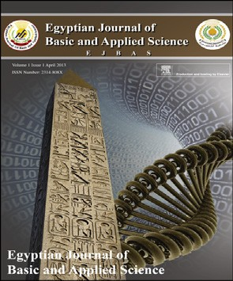

* *Corresponding author*.

E-mail address: [maelmissiry@yahoo.com](mailto:maelmissiry@yahoo.com) (M.A. El-Missiry).

Peer review under responsibility of Mansoura University. <http://dx.doi.org/10.1016/j.ejbas.2015.03.003>

2314-808X/Copyright 2015, Mansoura University. Production and hosting by Elsevier B.V. This is an open access article under the CC BY- NC-ND license ([http://creativecommons.org/licenses/by-nc-nd/4.0/](http://creativecommons.org/licenses/by-nc-nd/4.„0/)).

[e g ypti an j o ur nal o f b a sic and a pp l i e d sci en c e s 2 ( 201 5 ) 120](http://dx.doi.org/10.1016/j.ejbas.2015.03.003) e[131](http://dx.doi.org/10.1016/j.ejbas.2015.03.003) 121

that short-term diabetes induces cardiac antioxidant deple- tion, increases the oxidative stress levels, and results in car- diac apoptosis as early as three weeks after diabetic induction in rats [4]. A similar finding was reported after the adminis- tration of streptozotocin (STZ) for four days [5].

In diabetes, the dysregulation of programmed cell death is a significant factor of cardiomyopathy. In human and animal models of diabetes, cardiac pathology is associated with excessive apoptosis [5,6] that progressively leads to histo- pathological features and eventually to heart disease [7,8]. Overwhelming evidence indicates that cardiomyocyte apoptosis in diabetes is associated with cytopathological fea- tures [9,10], which is likely a direct result of hyperglycemia- triggered caspase 3 activation [3,11]. There are two pathways known to produce cardiac apoptosis, namely the mitochon- drial and the death receptor-mediated pathways, and both are influenced by cellular antioxidants [5]. Caspases 8 and 9 are initiator caspases for the extrinsic and intrinsic pathways, respectively, and caspase 3 is activated by both pathways and initiates apoptosis. The early event of myocyte apoptosis is characterized by nuclear damage, which is often undetectable morphologically, but DNA damage can be identified by several techniques, including the comet assay. The initial phase of the apoptotic process is followed by nuclear fragmentation and later by cytoplasmic alterations [12,13]. In diabetes, oxidative stress is the key element in all of mechanisms underlying cardiomyopathy and apoptosis, both of which are associated with hyperglycemia and hyperlipidemia [3].

Beyond the beverage use of tea, naturally derived catechins

have been recognized to have numerous health benefits. However, the molecular mechanisms through which these molecules mediate their effects remain largely unknown [14,15]. Green tea is obtained from the fresh leaves of the *Camellia sinensis* plant and is processed to prevent oxidation of the polyphenolic constituents [16]. Experimental and clinical studies have confirmed the efficacy of phytochemicals in the modulation of oxidative stress-induced cardiovascular dis- eases associated with diabetes [17,18]. Catechins are flavanols that constitute the majority of soluble solids of green tea.

EGCG [(—)-epigallocatechin-3-gallate] is the main catechin [19]

and ECG [(—)-epicatechin-3-gallate] is the second most concentrated catechin component of green tea. Other major catechins found in green tea include (—)-epicatechin (EC) and (—)-epigallocatechin (EGC) [20]. Catechins afford an antioxi- dant effect by inducing antioxidant enzymes, inhibiting pro-

oxidant enzymes and scavenging free radicals [16]. The po- tential mechanisms underlying the antioxidant effects of tea as effective scavengers of physiologically relevant reactive oxygen and nitrogen species were reviewed previously. The aromatic phenol rings present in these molecules cause them to behave as antioxidants by reducing free radicals and chelating metals in the body [21].

Catechins of green tea, particularly EGCG, have antioxidant activity [22], antidiabetic activity and antiobesity [23] as well as anti-inflammatory activities [24,25], and can modulate apoptotic processes in the liver [26]. EGCG binds to low- density lipoproteins (LDL) and protects them from glycation and oxidation under high-glucose medium, which mimics diabetes. Oxidized LDL and soluble vascular cell adhesion molecule-1 are markedly decreased after 30 days of green tea

ingestion [27]. Oral treatment with green tea polyphenol offers cardioprotection against ischemia-reperfusion injury in an isolated rat heart model [28]. Plyphenol-60 (PP-60) has a ther- apeutic effect on acne by suppressing inflammation, specif- ically by inhibiting IL-8 secretion [29].

The beneficial effects of green tea are related to catechins, particularly EGCG [30]. However, no previous study has investigated the efficacy of polyphenon-60, which contains pure catechins, mainly EGCG, in diabetes-induced cardiomy- opathy in rats. In addition, the mechanisms involved in its beneficial effects are not fully understood. Therefore, the present study was designed to evaluate the cardio- ameliorative effects of polyphenon-60 in STZ-induced early cardiac injury in rats and attempts to understand the mech- anism underlying the therapeutic effects of this compound with reference to biochemical and molecular markers.

# Materials and methods

### *Chemicals*

Green tea polyphenol (polyphenon-60) and streptozotocin (STZ) were purchased from Sigma (Sigma, St. Louis, MO, USA).

### *Experimental design and animal groups*

Male Wistar rats weighing approximately 250e300 g were obtained from the Laboratory Animal Maintenance Unit, Faculty of Science, Mansoura University and acclimatized to the laboratory conditions for two weeks. They were main-

tained at 25 ± 2 ◦C and a 12-h light/12-h dark cycle. The rats

were given standard commercial rat chow and water *ad libi- tum*. All of the experiments were conducted in accordance with protocols approved by the local ethical committee for *in vivo* animal experiments. The animals were divided into four groups of eight rats each. The first group served as a control. The second group received an oral dosage of polyphenon-60 (100 mg/kg body wt) every other day for a period of two weeks. The third group received a single i.p. injection of STZ (40 mg/kg body wt). The diabetic state of the rats was confirmed by determination of the blood glucose level after two days of STZ injection. The fourth group received STZ followed by green tea polyphenon-60 at the same doses as the second and third groups.

After two weeks of treatments, overnight fasted rats were

anaesthetized with sodium pentobarbital (50 mg/kg i.p.), and their blood was collected by cardiac puncture. The sera were separated by centrifugation (500× g) for 5 min for biochemical determinations. The heart samples were homogenized in 10 volumes of 50 mM sodium phosphate buffer (pH 7.4) at 4 ◦C for

30 s. The homogenate was centrifuged (1000× g) for 5 min in a refrigerated centrifuge. The resulting supernatant was used for the biochemical determinations.

### *Biochemical analysis*

The blood glucose, insulin and HbA1c levels were estimated using kits supplied by Spinreact (St. Esteve d'en Bas Girona, Spain), Abcam (Cambridge, MA, USA) and BioSystems

122 [e gypti an j o ur nal o f b a sic and a p p l i ed sci e n c e s 2 ( 201 5 ) 120](http://dx.doi.org/10.1016/j.ejbas.2015.03.003) e[131](http://dx.doi.org/10.1016/j.ejbas.2015.03.003)

(Barcelona, Spain), respectively. The profile of the serum lipids, including total lipids, triglyceride, total cholesterol, high-density lipoprotein (HDL), low-density lipoprotein (LDL), very low-density lipoproteins (VLDL), was assayed following the kit's instructions (Spinreact, St. Esteve d'en Bas Girona,

Spain). The heart function was estimated by determining the

creatine kinase (CK-MB) and lactic dehydrogenase (LDH) ac- tivities using kits purchased from Elitech (Puteaux, France). The lipid peroxidation was estimated by measuring the amount of malondialdehyde (MDA). The hydrogen peroxide (H2O2) concentrations were determined following the kit's instructions (Dokki-Giza, Egypt). The antioxidant levels were

estimated by determining superoxide dismutase (SOD) activ- ity, catalase (CAT) activity, and glutathione (GSH) content using kits supplied by Biodiagnostic (Dokki-Giza, Egypt). The pro-inflammatory markers interleukin 6 (IL-6), interleukin 1 beta (IL-1b) and tumor necrosis factor alpha (TNF-a) were estimated according to kits purchased from R&D Systems (NE Minneapolis, MN, USA) and EBioscience (San Diego, CA, USA). The protein concentrations were determined as previously described [31].

### *Molecular analysis*

Heart samples were prepared for flow cytometry as previously described [32]. The cells obtained were suspended in PBS with BSA, divided into aliquots collected in round-bottom tubes (Becton Dickinson) and stored at 4 ◦C for flow cytometric an- alyses. The flow cytometric analyses were performed on a FACSCalibur™ cytometer (BD Biosciences, San Jose, CA, USA) using the CellQuest Pro software (Becton Dickinson) for data acquisition and analysis [33].

### *Flow cytometric analysis of apoptosis with Annexin* Ve*FITC/PI staining*

Apoptosis in the heart samples was probed using fluorescein isothiocyanate-conjugated annexin V/PI with the ApoAlert kit from Clontech (Palo Alto, CA, USA) according to the manu- facturer's instructions. The flow cytometric analyses were performed on a FACSCalibur™ cytometer (BD Biosciences, San Jose, CA, USA) using the CellQuest Pro software (Becton Dickinson) for data acquisition and analysis [33].

### *Flow cytometric analysis of Bcl-2 and Bax*

Heart samples were prepared with PBS/BSA buffer and then incubated with anti-Bcl-2 [100/D5] antibody (ab692) or anti- Bax [6A7] antibody (ab5714) for 15 min at room temperature. The cells were then resuspended in 0.5% paraformaldehyde in PBS/BSA and analyzed by flow cytometry.

### *Flow cytometric analysis of P53*

The cell suspensions were prepared with a PBS/BSA buffer, incubated with antibody (mouse anti-P53 “aa20-25” FITC, Clone: DO-1), mixed well and incubated for 30 min at room temperature. The cells were washed with PBA/BSA and centrifuged at 400× g for 5 min, and the supernatant was discarded. The cells were then resuspended in 0.5%

paraformaldehyde in PBS/BSA and analyzed using a flow cy- tometer [34].

### *Flow cytometric analysis of CD95*

The cell suspensions were prepared with a PBS/BSA buffer, incubated with antibody (monoclonal anti-Fas (CD95/Apo-1) antibody), mixed well and incubated for 30 min at room

temperature. The cells were washed with BD Perm/Wash (BD Bioscience) and centrifuged at 400× g for 5 min, and the su- pernatant was discarded. The cells were then resuspended in BD Perm/Wash and analyzed by flow cytometry.

### *Flow cytometric analysis of caspases 3, 8 and 9*

The cell suspensions were prepared with a PBS/BSA buffer, incubated with antibody FITC rabbit anti-active caspase-3 antibody (CPP32; Yama; Apopain, BD Bioscience); anti- caspase-8 (E6) antibody (Abcam); or rabbit monoclonal anti- caspase 9 (E23) antibody (ab32539), mixed well and incu- bated for 30 min at room temperature. The cells were washed with BD Perm/Wash (BD Bioscience) and centrifuged at 400× g

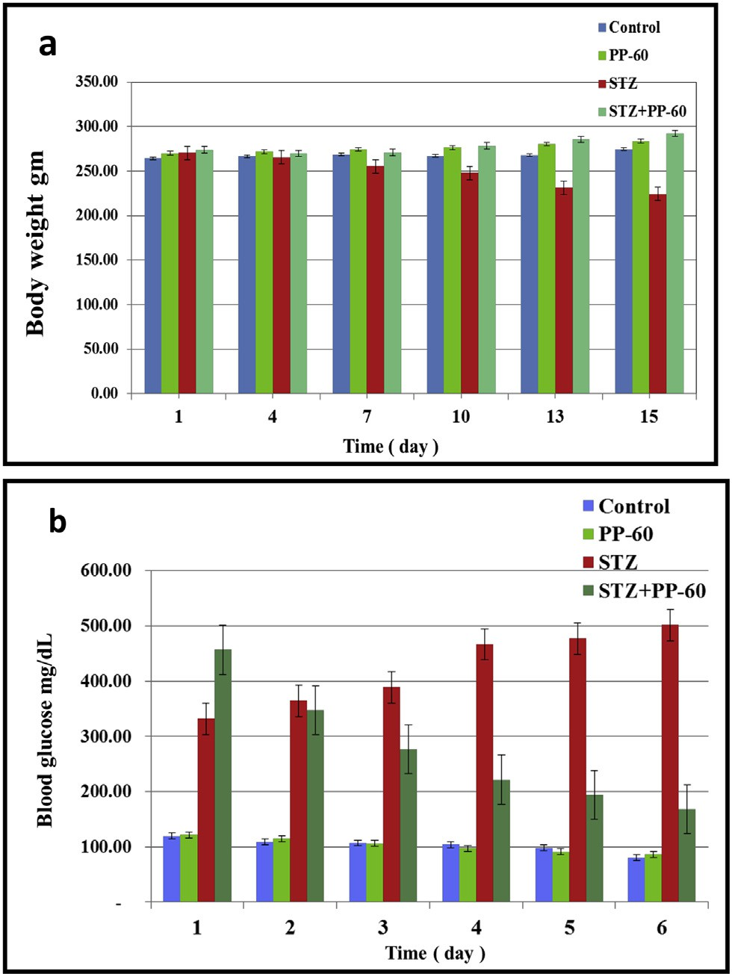

Fig. 1 e Effect of polyphenon-60 on blood glucose and body weight in the different animal groups during the experimental period. The values are expressed as the means ± S.D. (n ¼ 6). a&d Significant at P < 0.05, b&e Significant at P < 0.01, c&f Significant at P < 0.001. a, b & c indicate comparisons with respect to the control group. d, e & f indicate comparisons with respect to the diabetic

group.

[e g ypti an j o ur nal o f b a sic and a pp l i e d sci en c e s 2 ( 201 5 ) 120](http://dx.doi.org/10.1016/j.ejbas.2015.03.003) e[131](http://dx.doi.org/10.1016/j.ejbas.2015.03.003) 123

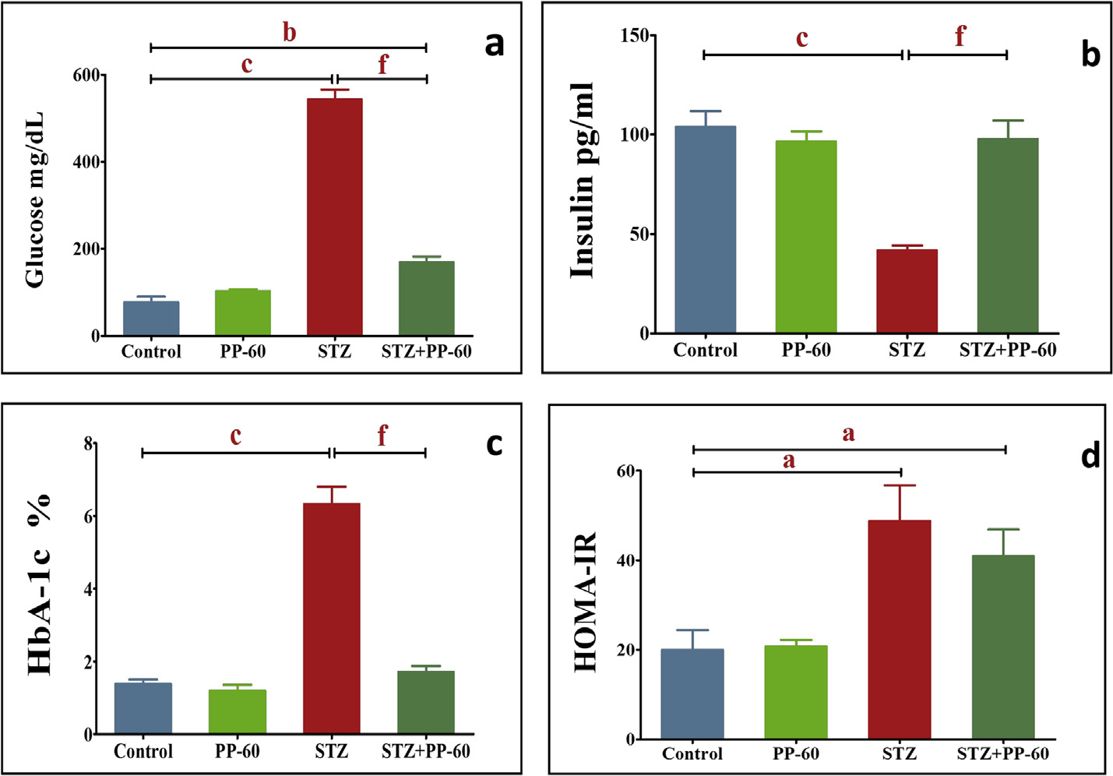

Fig. 2 e Effect of polyphenon-60 on the serum levels of glucose (mg/dl), insulin (pg/ml), blood HbA1c percentage and HOMA-

IR percentage of the experimental groups at the end of the experimental period. The values are expressed as the means ± S.D. (n ¼ 6). a&d Significant at P < 0.05, b&e Significant at P < 0.01, c&f Significant at P < 0.001. a, b & c indicate comparisons with respect to the control group. d, e & f indicate comparisons with respect to the diabetic group.

for 5 min, and the supernatant was discarded. The cells were then resuspended in BD Perm/Wash and analyzed by flow cytometry.

### *Single-cell gel electrophoresis (comet assay)*

The DNA damage in the heart samples was assessed using the single-cell gel electrophoresis (comet assay) method, a well- validated technique developed for measuring DNA strand breaks in individual cells, as described previously [35,36]. The quantification of the DNA from the obtained images was performed with the CASP software, which allows the direct determination of the percentage of DNA in the tail.

### *Statistical analysis*

The data are presented as the means ± S.D. The statistical analyses were performed by one-way ANOVA followed by

Students NewmaneKeuls post-hoc test. Statistical signifi- cance was considered as P < 0.05.

# Results

The effect of polyphenon-60 on blood glucose and body weight in the different animal groups was studied during the exper- imental period. The body weight of the diabetic rats was gradually decreased during the experimental period compared with that of the control group. The treatment of the diabetic rats with PP-60 (100 mg/kg) resulted in a marked amelioration along the experimental period compared with the diabetic group (Fig. 1a). The blood glucose of the diabetic rats was significantly increased during the experimental period compared with that of the control group. The treat- ment of the diabetic rats with PP-60 resulted in a marked amelioration along the experimental period compared with

|  |  |  |  |  |
| --- | --- | --- | --- | --- |
| Table 1 e Effect of polyphenon-60 on the serum lipid profile (total lipids (TL), cholesterol (Ch), triglycerides (TG), high- density lipoprotein (HDL), low-density lipoprotein (LDL), and very-low-density lipoprotein (VLDL)) expressed as mg/dl in the different animal groups. | | | | |
|  | Control | PP-60 | STZ | STZ + PP-60 |
| Total Lipid | 438 ± 5.3 | 371 ± 20.5 a | 1055 ± 26.4 c | 575 ± 12.8 c, f |
| Cholesterol | 81.54 ± 6.2 | 80.19 ± 2.618 | 145.6 ± 6.1 c | 95.96 ± 3.1 f |
| Triglyceride | 58.12 ± 6.8 | 46.21 ± 5.6 | 146.8 ± 18.8 b | 75.18 ± 7.7 e |
| LDL | 28.49 ± 5.017 | 29.06 ± 1.609 | 94.70 ± 8.8 c | 39.02 ± 5.1 f |
| HDL | 41.44 ± 2.5 | 41.92 ± 2.2 | 23.72 ± 1.50 c | 40.90 ± 1.5 f |
| VLDL | 11.61 ± 1.3 | 9.21 ± 1.1 | 27.70 ± 3.35 b | 15.04 ± 1.5 e |
| The values are expressed as the means ± S.D. (n = 6). a&d Significant at P < 0.05, b&e Significant at P < 0.01, c&f Significant at P < 0.001. a, b & c indicate comparisons with respect to the control group. d, e & f indicate comparisons with respect to the diabetic group. | | | | |

124 [e gypti an j o ur nal o f b a sic and a p p l i ed sci e n c e s 2 ( 201 5 ) 120](http://dx.doi.org/10.1016/j.ejbas.2015.03.003) e[131](http://dx.doi.org/10.1016/j.ejbas.2015.03.003)

the diabetic group (Fig. 1b), but the level was significantly lower than that of the control group.

STZ treatment produced a significant elevation in the serum glucose and HbA1c levels two weeks after injection (Fig. 2a and b). These diabetic rats had significantly higher HOMA-IR levels and secreted significantly less insulin than the control group (Fig. 2c and d). The oral treatment of the diabetic rats with PP-60 showed a significant effect on the serum glucose and HbA1c levels and presented significantly higher insulin and HOMA-IR values compared with that of the diabetic rats.

Compared with the control group, the lipid profile, including the levels of total lipids, triglycerides, total choles- terol, low-density lipoprotein and very-low lipoprotein, was significantly higher, whereas the level of high-density lipo- protein was significantly lower in the diabetic rats (Table 1). The treatment of the diabetic rats with PP-60 caused marked amelioration of the lipid fractions toward the control levels compared with the diabetic group (Table 1).

The diabetic rats showed significantly higher activities of CK-MB and LDH in the serum compared with the control values. The oral treatment with PP-60 after diabetic induction normalized the increase in the activities of these enzymes and demonstrated insignificant changes compared with those of the control group (Fig. 3).

A significant increase in lipid peroxidation was demon- strated in the heart of the diabetic rats, as indicated by the increase in the MDA and H2O2 concentrations after STZ treatment (Table 2). A marked control of lipid peroxidation and generation of H2O2 in the heart against the diabetic- induced increase in the MDA level and generation of H2O2 by the oral administration of PP-60 after STZ treatment was demonstrated. The cardiac content of GSH and activities of SOD and CAT significantly decreased after diabetic induc- tion by STZ. This effect was significantly prevented in the heart by the oral administration of PP-60 into the diabetic rats.

The degree of apoptosis in the heart was assessed through

flow cytometric analysis with Annexin V-FITC staining (Fig. 4). The data demonstrate that the percentage of apoptotic cells was significantly higher in the heart of the diabetic rats compared with the controls (Fig. 4a). Treatment with PP-60 significantly minimized the number of apoptotic cells compared with the diabetic rats. In addition, DC95 was significantly increased in the heart of diabetic rats compared with the controls (Fig. 4b). The effects of PP-60 and diabetes on specific apoptotic proteins were assessed. The flow cytometric analysis demonstrated that the anti-apoptotic protein Bcl-2 was significantly decreased and that the apoptotic protein Bax was increased in the heart of diabetic rats and that treatment with PP-60 markedly normalized the changes in the expression of these proteins (Fig. 4c and d). The expression of caspases 9, 8 and 3 was strongly detected in the heart of the diabetic rats, and the treatment with PP-60 significantly inhibited the diabetes-induced activation of these apoptotic proteins (Fig. 5aec).

The diabetic rats had significantly higher levels of IL-1b, IL-

6, and TNF-a compared with the control values. The oral treatment with PP-60 after diabetic induction normalized the increase in the levels of these cytokines in the serum and

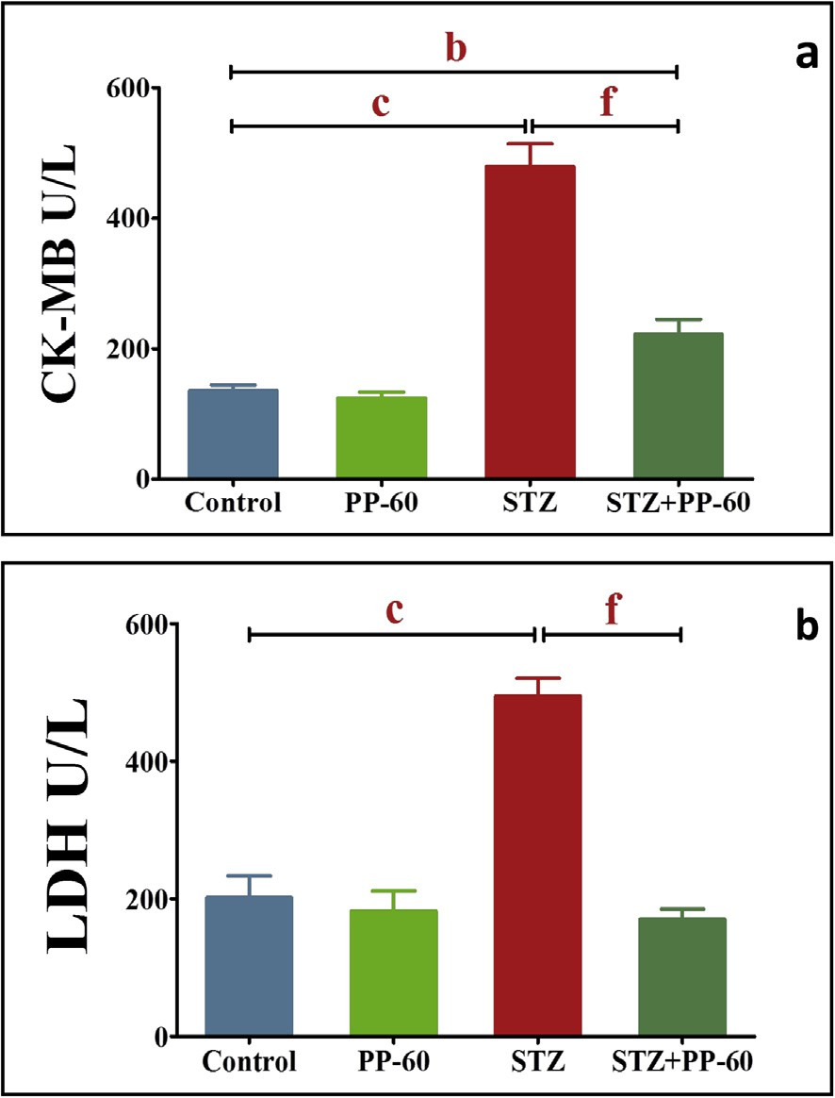

Fig. 3 e Effect of polyphenon-60 on the activities of serum CK-MB and LDH expressed as U/ml in the different animal groups. The values are expressed as the means ± S.D. (n ¼ 6). a&d Significant at P < 0.05, b&e Significant at P < 0.01, c&f Significant at P < 0.001. a, b & c indicate comparisons

with respect to the control group. d, e & f indicate comparisons with respect to the diabetic group.

displayed insignificant changes compared with those of the control (Fig. 6aec).

The rats in both the control and PP-60-treated groups had lower levels of both the percentage of p53 and tail DNA in the hearts compared with the diabetic rats, with the latter appearing to be more severe than the former (Fig. 7a), sug- gesting oxidative DNA damage in the diabetic rats. The treatment of diabetic rats with PP-60 significantly ameliorated both the percentage of tail DNA and p53 in the heart compared with the diabetic rats (Fig. 7b).

# Discussion

There is increasing evidence of a protective effect of green tea catechins against cardiac disease. The present results demonstrate the mechanism underlying the antiapoptotic action of green tea PP-60 synchronized with amelioration of metabolic risk factors and oxidative stress as well as the modulation of proinflammatory cytokines in STZ-diabetic rats.

The results demonstrated a significant improvement in the levels of serum glucose and HbA1c accompanied with a marked amelioration of insulin release and HOMA-IR in the diabetic rats treated with PP-60. Previous studies have shown

[e g ypti an j o ur nal o f b a sic and a pp l i e d sci en c e s 2 ( 201 5 ) 120](http://dx.doi.org/10.1016/j.ejbas.2015.03.003) e[131](http://dx.doi.org/10.1016/j.ejbas.2015.03.003) 125

that green tea catechins inhibit intestinal glucose uptake by the sodium-dependent glucose transporter SGLT1 [37], acti- vates glucose uptake, and mimics insulin in that it decreases the expression of genes that control gluconeogenesis [38]. Moreover, EGCG increases the tyrosine phosphorylation of the insulin receptor and insulin receptor substrate [39]. Further- more, the administration of 100 mg/kg PP-60 markedly improved the body weight loss in the diabetic rats in com- parison with the diabetic group. This is likely due to the

|  |  |  |  |  |  |
| --- | --- | --- | --- | --- | --- |
| Table 2 e Effect of polyphenon-60 on the levels of the lipid peroxidation product MDA (nmol/mg protein), hydrogen peroxide (H2O2), glutathione (GSH; mg/g protein) superoxide dismutase (SOD; U/mg protein) and catalase (CAT; U/mg protein) in the heart in the different animal groups. | | | | | |
|  | Control | PP-60 |  | STZ | STZ + PP-60 |
| MDA | 6.43 ± 0.65 | 6.9 ± 0.57 | 14.87 | ± 0.79 c | 5.8 ± 0.18 f |
| H2O2 | 0.48 ± 0.03 | 0.45 ± 0.01 | 1.15 | ± 0.08 c | 0.54 ± 0.02 f |
| SOD | 58.88 ± 3.484 | 67.63 ± 2.489 | 40.44 | ± 2.434 b | 59.92 f ± 1.790 |
| CAT | 1.045 ± 0.04602 | 1.917 ± 0.1726 b | 0.4657 | ± 0.08651 c | 1.139 ± 0.1385 e |
| GSH | 88.6 ± 1.83 | 95.26 ± 3.99 | 29.83 | ± 4.70 c | 119.4 ± 30.36 d |
| The values are expressed as the means ± S.D. (n = 6). a&d Significant at P < 0.05, b&e Significant at P < 0.01, c&f Significant at P < 0.001. a, b & c indicate comparisons with respect to the control group. d, e & f indicate comparisons with respect to the diabetic group. | | | | | |

protective effect of green tea catechins in decreasing gluco- neogenesis and regulating muscle loss [40].

The present study showed that green tea PP-60 may in- crease the heart antiglycating activity produced by diabetes, as previously observed in aortic tissue [41], and this finding was supported by a decrease in HB-A1c in the PP-60-treated diabetic rats (Fig. 2). This finding is supported by the present

findings that PP-60 ameliorates the elevation of IL-1b, IL-6, and TNF-a in the sera of diabetic rates treated with PP-60. It has

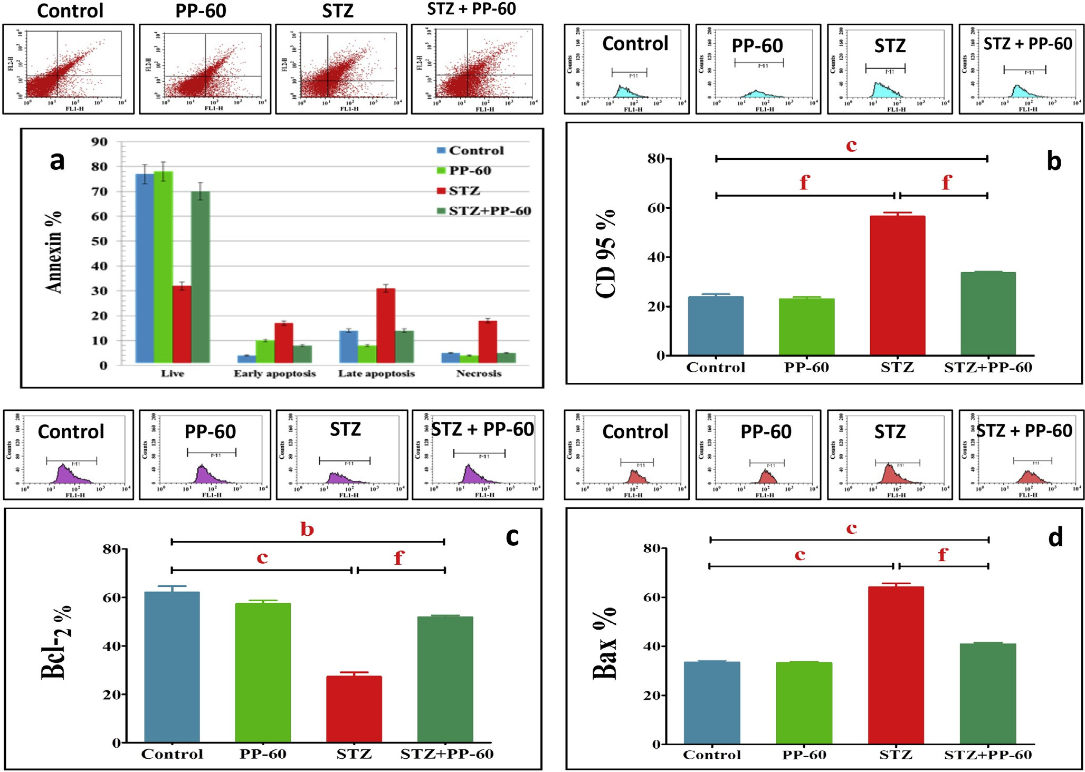

Fig. 4 e Effect of polyphenon-60 on the percentage of apoptosis, DC-95, Bcl-2 and Bax in the different animal groups. Flow cytometry data showing examples of data generated by FACS on top of each histogram. The values are expressed as the means ± S.D. (n ¼ 6). a&d Significant at P < 0.05, b&e Significant at P < 0.01, c&f Significant at P < 0.001. a, b & c indicate

comparisons with respect to the control group. d, e & f indicate comparisons with respect to the diabetic group.

126 [e gypti an j o ur nal o f b a sic and a p p l i ed sci e n c e s 2 ( 201 5 ) 120](http://dx.doi.org/10.1016/j.ejbas.2015.03.003) e[131](http://dx.doi.org/10.1016/j.ejbas.2015.03.003)

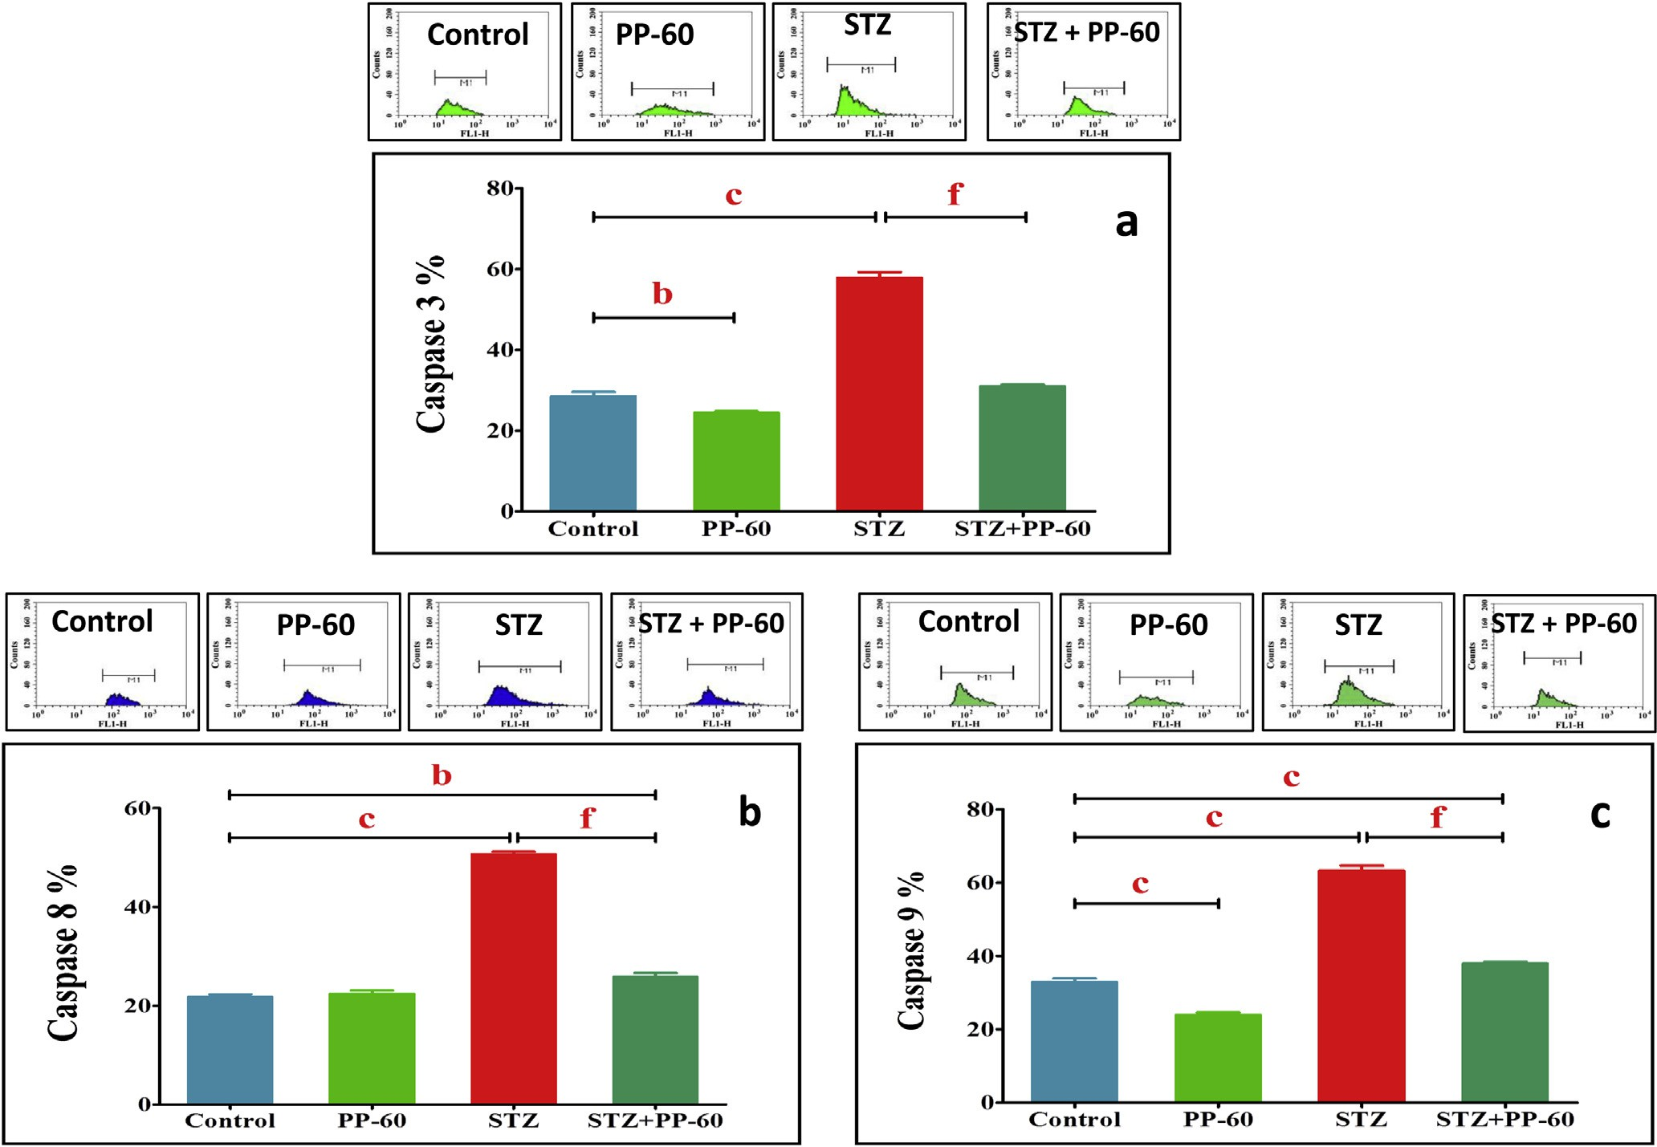

Fig. 5 e Effect of polyphenon-60 on the percentage of caspases 3, 8 and 9 in the different animal groups. Flow cytometry data showing examples of data generated by FACS at the side of each histogram. The values are expressed as the means ± S.D. (n ¼ 6). a&d Significant at P < 0.05, b&e Significant at P < 0.01, c&f Significant at P < 0.001. a, b & c indicate comparisons with respect to the control group. d, e & f indicate comparisons with respect to the diabetic group.

been suggested that the presence of the gallate group at po- sition 3 plays an essential role in the protection against pro- tein oxidation and glycation [42].

In line with these findings, PP-60 significantly reduced HOMA-IR in STZ-diabetic rats (Fig. 2), supporting the finding that green tea catechin improves the insulin resistance of diabetic rats. Similarly, the HOMA-IR index has been found to increase when dogs become obese and decreases after green tea treatment [43]. It is possible that green tea increases GLUT4 translocation in muscle cells [43]. EGCG also inhibits dexamethasone-induced insulin resistance through the AMPK and PI3K/Akt pathways [44]. This finding implies that PP-60 may protect against insulin sensitivity and improves glucose homeostasis. Previous studies have also shown that EGCG may increase insulin activity [45,46]. Thus, supple- mentation with PP-60 ameliorates risk factors, improves glucose homeostasis and may be beneficial to diabetes for preventing possible early cardiac events.

Hyperglycemia is not the only major factor affecting

cardiac complications. Dyslipidemia has been reported to be particularly important for the development of cardiomyop- athy [6,47]. Therefore, improvement of the lipid profile in serum is a feasible health strategy that considers the

therapeutic potential of EGCG on cardiovascular disease. Both experimental and clinical studies have suggested that EGCG may have such an effect [46,48]. The administration of PP-60 to the diabetic rats significantly lowered the serum levels of total cholesterol, triglycerides, and low-density and very-low-density lipoproteins and resulted in a significantly higher serum level of high-density lipoprotein compared with the diabetic rats. Previous studies have shown that catechin extracted from green tea improves the serum lipid profile in rats fed an atherogenic diet [49] and injected with STZ [50] and in obese patients with metabolic syndrome [51]. A recent study showed that the tea polyphenol EGCG actually binds to lipoprotein particles and facilitates the LDL antioxidant and anti-glycation activities in a high glucose environment. Lowering the levels of serum lipid risk factors through dietary polyphenol treatment appears to be the main scheme for decreasing the threat of cardiac disease and related complications [52,53]. These results indicate that EGCG is the major component of polyphrnol-60 that has a beneficial effect for protecting against risk of cardiac disease by improving the lipid levels. Thus, EGCG is a pri- mary agent in LDL-lowering therapy for the reduction of cardiac risk.

[e g ypti an j o ur nal o f b a sic and a pp l i e d sci en c e s 2 ( 201 5 ) 120](http://dx.doi.org/10.1016/j.ejbas.2015.03.003) e[131](http://dx.doi.org/10.1016/j.ejbas.2015.03.003) 127

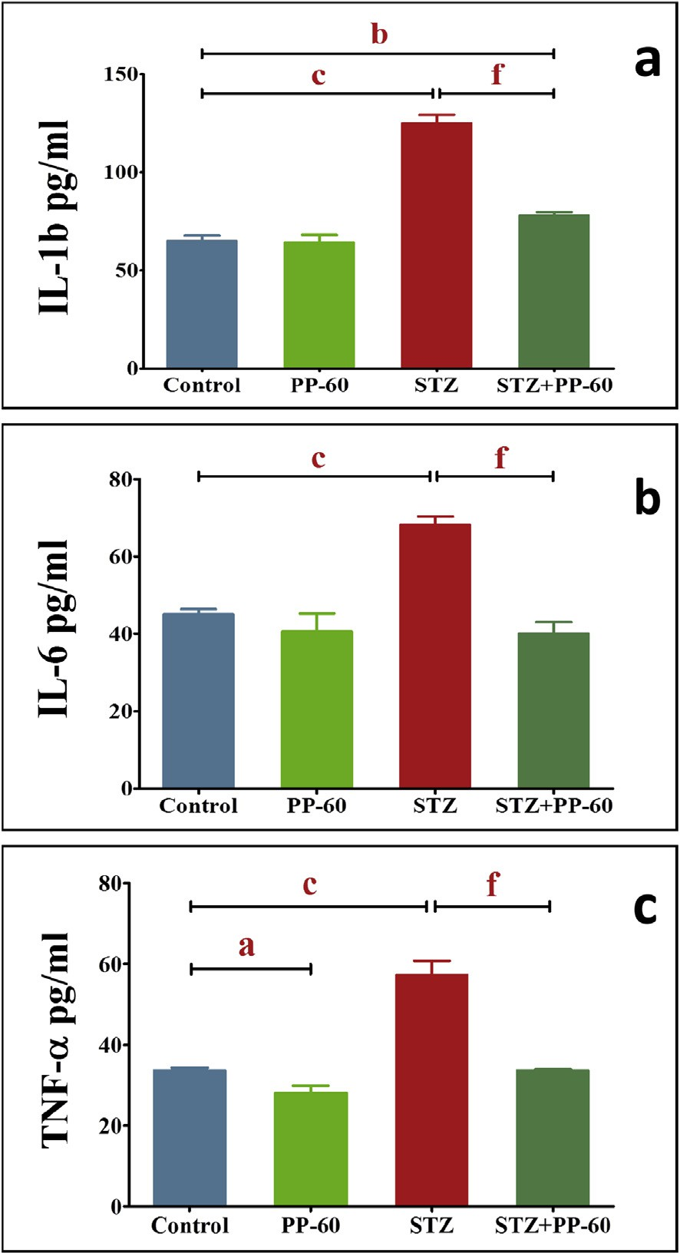

Fig. 6 e Effect of polyphenon-60 on the serum IL-1b, IL-6, and TNF-a levels expressed as pg/ml in the different animal groups. The values are expressed as the

means ± S.D. (n ¼ 6), a&d Significant at P < 0.05, b&e Significant at P < 0.01, c&f Significant at P < 0.001. a, b & c indicate comparisons with respect to the control group. d, e

& f indicate comparisons with respect to the diabetic group.

lipid hydroperoxides, 4-hydroxynonenal and malondialde- hyde, in the liver, serum and brain [55]. These results confirm the ability of PP-60 to attenuate oxidative stress in the heart. Marked increased in the serum CK-MB and LDH activities were demonstrated in the diabetic group, suggesting the incidence of significant injury in the membrane of car- diomyocytes, likely due to lipid peroxidation, and the leaking of the functional marker enzymes into the blood. After PP-60 treatment, the diabetic rats presented significant reductions in the elevated activities of CK-MB and LDH, demonstrating the efficiency of green tea catechin for the protection of car- diomyocyte integrity. This finding agrees with the ability of

EGCG to significantly decrease reactive oxygen species (ROS) and cytosolic Ca2+ and to prevent alterations in the protein expression of the adherens molecules b-catenin and N-cad-

herin and the gap junction protein connexin 43 in cardiac cells [56]. Green tea significantly reduces the serum biomarker levels, increases the antioxidants levels in cardiac tissue and restores electrocardiographic changes compared with the isoproterenol-only-treated group [57] as well as reduces cyclophosphamide-induced myocardial toxicity [58]. These data clearly show that PP-60 is effective against cardiac stress.

The upregulation of the pro-inflammatory cytokine TNF-a,

which increases after increases in ROS and oxidative stress, has emerged as a significant contributor to myocardial heart failure [59,60]. The effect of hyperglycemia-induced oxidative stress on inflammation has been documented by numerous

studies [61,62]. A previous study found that the levels of IL-6, TNF-a and IL-18 were increased significantly in patients with impaired glucose tolerance [63,64]. Therefore, it has been hy- pothesized that polyphenols can modulate cellular signaling processes during inflammation due to their antioxidant properties. It has been reported that green tea extract reduces the serum levels of TNF-alpha, insulin, and free fatty acid and decreases the mRNA expression level of TNF-alpha, inter- leukin (IL)-6, IL-1b, and IL-18 in the liver of obese mice [65] and

prevents cardiac fibrosis by attenuating TNF-a [66]. TNF-a is

critical for the induction of the inflammatory response. Experimentally induced diabetes mellitus is characterized by intramyocardial inflammation, including increased TNF-a expression and myocardial fibrosis [67]. Hyperglycemia can produce ROS, which in turn triggers TNF-a gene expression, and treatment with the ROS scavenger N-acetylcysteine

significantly reduces the hyperglycemia-induced TNF-a [68].

Our experimental results are consistent with those of previous

Concomitant with the disturbed metabolic risk factors, increased events of oxidative stress were found in the heart of the diabetic rats. Treatment with PP-60 evidently prevented the diabetes-induced decrease in SOD and CAT activities and MDA formation, which culminated into a marked ameliora- tion of oxidative stress in the heart tissue. Oxidative stress leads to the accumulation of the lipid peroxidation product MDA in the heart and causes impaired cell function. Mounting evidence strongly indicates the potency of the free-radical- scavenging abilities of catechins due to the presence of the C-ring gallate group. Galloylated catechins, including PP-60, are strong antioxidants due to their higher phospholipid/ water partition coefficients and hence have the protective properties of the membrane phospholipids [54]. Green tea extract can decrease lipid peroxidation markers, including

studies, which have revealed that the circulating IL-1b, IL-6, and TNF-a levels are elevated in STZ-induced diabetic rats [67], and agree with the results of a study that showed that EGCG reduces the expression of IL-6 and TNFa in the heat of an I/R injury model by decreasing NFkB [69]. We further observed

that PP-60 suppresses the elevated level of these cytokines. In conjunction with the hypoglycemic and antioxidant activities of tea catechins, the results imply that PP-60 may reduce pro- inflammatory cytokines by modulating the glucose levels and oxidative stress in the heart of diabetic rats.

To investigate the mechanism underlying the action of PP- 60 on cardiac apoptosis in diabetes, we determined the levels of apoptosis and related regulatory proteins in the heart of STZ-induced diabetic rats before and after PP-60 treatment. In the diabetic group, the numbers of both apoptotic and necrotic

128 [e gypti an j o ur nal o f b a sic and a p p l i ed sci e n c e s 2 ( 201 5 ) 120](http://dx.doi.org/10.1016/j.ejbas.2015.03.003) e[131](http://dx.doi.org/10.1016/j.ejbas.2015.03.003)

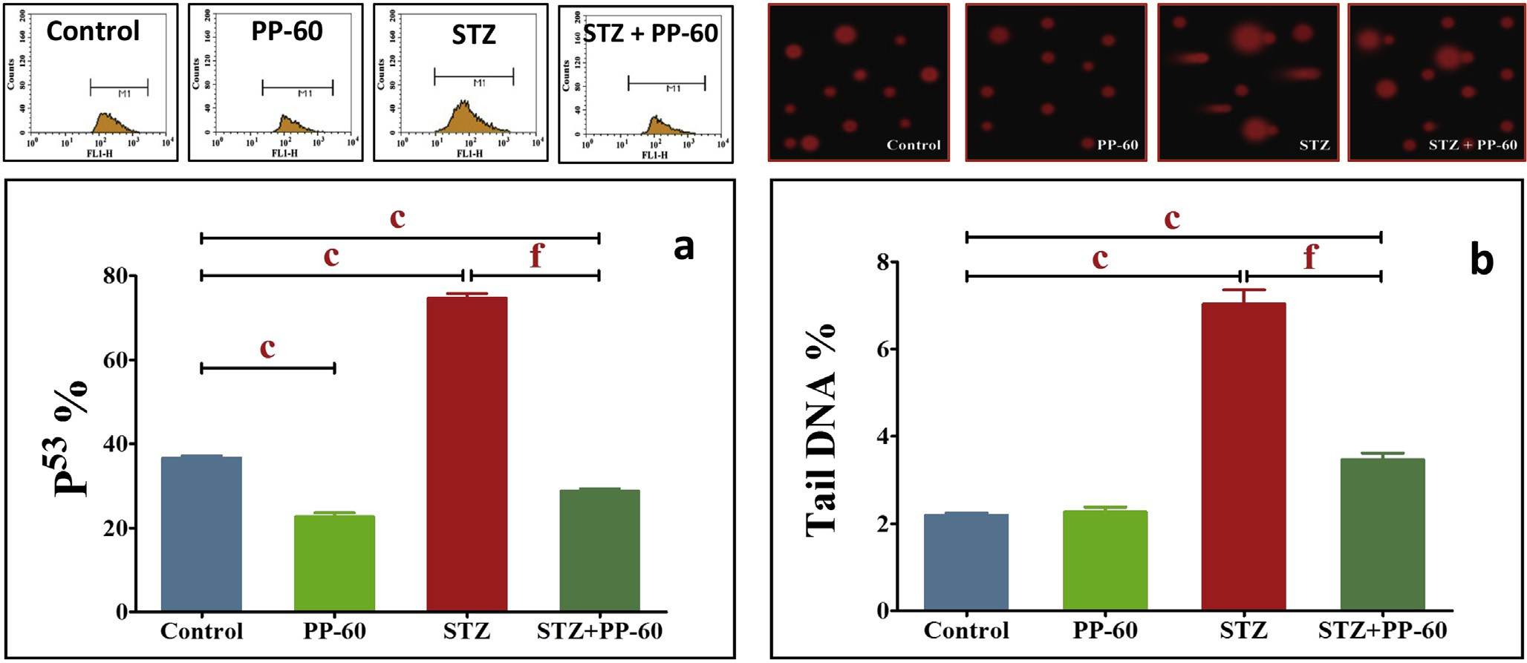

Fig. 7 e Effect of polyphenon-60 on the percentage of P53 assessed by flow cytometer (a) and % DNA in the tail assessed by comet assay (b). Flow cytometry data showing examples of data generated by FACS on top of the histogram. The values are

expressed as the means ± S.D. (n ¼ 6), a&d Significant at P < 0.05, b&e Significant at P < 0.01, c&f Significant at P < 0.001. a, b & c indicate comparisons with respect to the control group. d, e & f indicate comparisons with respect to the diabetic group.

cells were increased significantly compared with the control group, whereas PP-60 markedly reduced the numbers of these cells. In addition, PP-60 normalized the levels of CD95, cas- pases 8, 9, and 3 and Bax in the same group. These results indicate a marked modulation of both extrinsic and intrinsic apoptotic pathways in the heart of PP-60-treated diabetic rats and provide evidence that EGCG has the ability to modulate apoptotic pathways in diabetes. EGCG protects against sub- sequent apoptosis following I/R injury in cardiac surgery by regulating the Bcl-2/Bax ratio and blocking the cleavage of caspase 3 [28]. Similarly, EGCG increases the expression levels of Bcl-2, Mn-superoxide dismutase, and catalase, decreases the levels of Bax and increases the ratio of Bcl-2/Bax in iso- lated rat hearts [70]. In addition, EGCG modulates apoptosis by preventing the expression of the proapoptotic genes Bax, Bad and Mdm2 while inducing the anti-apoptotic genes Bcl-2, Bcl- w and Bcl-xL in SH-SY5Y cells [71]. These results show that EGCG, which is the most abundant antioxidant catechin in PP- 60, exerts a protective effect on cardiac injury by acting as an antioxidant and anti-apoptotic agent.

The present results further show that the mechanism may

be related to the inhibitory effects of PP-60 on p53 induction and DNA damage. A previous study demonstrated that p53 plays an important role in cardiomyocyte apoptosis in cardiac hypertrophy because the upregulation of the p53 and its dependent genes is important in the modulation of myocyte apoptosis in heart failure [71]. The present results demon- strated obvious DNA damage with a markedly high fraction of tail DNA and typical comet-like nuclei, which are indicative of increased DNA damage in the hearts of diabetic rats. Thus, apoptosis results in nuclear fragmentation via the action of caspases as well as pro-inflammatory cytokine release.

The oral treatment of diabetic rats with PP-60 inhibits the increase in the comet parameter compared with diabetic rats.

The mechanism of protection may be attributed to the effec- tive antioxidant and scavenging free radical potential of catechin. These data confirm recent reports that EGCG markedly protects against DNA damage and oxidative stress in different cells and tissues, including human leucocytes [72], human mucosa cell cultures [73] and liver cells [74]. PP-60 treatment effectively upregulates Bcl-2, downregulates p53 and protects against DNA damage. Hyperglycemia activates p53 and p53-regulated genes leading to myocyte cell death [13]. It has been reported that p53 can act to regulate the intracellular redox state and induces apoptosis by a pathway dependent on ROS production [71,75]. In contrast, Bcl-2 exerts anti-apoptotic and anti-necrotic effects through its antioxi- dant influence on intracellular ROS [6,76]. Bcl-2 may decrease lipid peroxidation by enhancing cell resistance to ROS and preventing ROS production [71]. Therefore, we propose that the anti-apoptotic effect of PP-60 by decreasing p53 induction and the decrease in Bcl-2 may be related, at least in part, to its antioxidant impact. It appears that PP-60 decreases apoptosis by blocking DNA damage via the action of caspases and pro- inflammatory cytokine suppression.

# Conclusions

The modulation of pro-inflammatory and pro-apoptotic pathways by green tea catechins in the diabetic heart may be an additional pathophysiological mechanism that prevents further consequences of the diabetic heart and beneficially prevents progression of the complication. It appears that the pleiotropic effects of polyphenon-60, including its anti- hyperglycemic effect, its influence of hypolipidemia, its attenuation of the oxidative stress reduction induced by circulating pro-inflammation cytokines and its anti-apoptotic

[e g ypti an j o ur nal o f b a sic and a pp l i e d sci en c e s 2 ( 201 5 ) 120](http://dx.doi.org/10.1016/j.ejbas.2015.03.003) e[131](http://dx.doi.org/10.1016/j.ejbas.2015.03.003) 129

action through the modulation of its related regulated pro- teins, contribute to and accompany the beneficial effects of treatment with PP-60 on diabetic heart dysfunction.

# Acknowledgments

The facilities provided by Faculty of Science, Mansoura Uni- versity, Egypt, are greatly acknowledged and appreciated.

## referen c es

1. [Forbes JM, Cooper ME. Mechanisms of diabetic](http://refhub.elsevier.com/S2314-808X(15)00019-6/sref1) [complications. Physiol Rev 2013;93(1):137](http://refhub.elsevier.com/S2314-808X(15)00019-6/sref1)e[88](http://refhub.elsevier.com/S2314-808X(15)00019-6/sref1).
2. [Bos M, Agyemang C. Prevalence and complications of](http://refhub.elsevier.com/S2314-808X(15)00019-6/sref2) [diabetes mellitus in Northern Africa, a systematic review.](http://refhub.elsevier.com/S2314-808X(15)00019-6/sref2) [BMC Public Health 2013;13:387](http://refhub.elsevier.com/S2314-808X(15)00019-6/sref2).
3. [Huynh K, Bernardo BC, McMullen JR, Ritchie RH. Diabetic](http://refhub.elsevier.com/S2314-808X(15)00019-6/sref3) [cardiomyopathy: mechanisms and new treatment strategies](http://refhub.elsevier.com/S2314-808X(15)00019-6/sref3) [targeting antioxidant signaling pathways. Pharmacol Ther](http://refhub.elsevier.com/S2314-808X(15)00019-6/sref3) [2014;142(3):375](http://refhub.elsevier.com/S2314-808X(15)00019-6/sref3)e[415](http://refhub.elsevier.com/S2314-808X(15)00019-6/sref3).
4. [El-Missiry MA, Othman AI, Al-Abdan MA, El-Sayed AA.](http://refhub.elsevier.com/S2314-808X(15)00019-6/sref4) [Melatonin ameliorates oxidative stress, modulates death](http://refhub.elsevier.com/S2314-808X(15)00019-6/sref4) [receptor pathway proteins, and protects the rat cerebrum](http://refhub.elsevier.com/S2314-808X(15)00019-6/sref4) [against bisphenol-A-induced apoptosis. J Neurol Sci](http://refhub.elsevier.com/S2314-808X(15)00019-6/sref4) [2014;347(1](http://refhub.elsevier.com/S2314-808X(15)00019-6/sref4)e[2):251](http://refhub.elsevier.com/S2314-808X(15)00019-6/sref4)e[6](http://refhub.elsevier.com/S2314-808X(15)00019-6/sref4).
5. [Ghosh S, Qi D, An D, Pulinilkunnil T, Abrahan A, Kuo KH,](http://refhub.elsevier.com/S2314-808X(15)00019-6/sref5) [et al. Cardiomyocyte apoptosis induced by short-term](http://refhub.elsevier.com/S2314-808X(15)00019-6/sref5)

[diabetes requires mitochondrial GSH depletion. Am J Physiol](http://refhub.elsevier.com/S2314-808X(15)00019-6/sref5) [Heart Circ Physiol 2005;289(2):H768](http://refhub.elsevier.com/S2314-808X(15)00019-6/sref5)e[76](http://refhub.elsevier.com/S2314-808X(15)00019-6/sref5).

1. [Amin AH, El-Missiry MA, Othman AI. Melatonin ameliorates](http://refhub.elsevier.com/S2314-808X(15)00019-6/sref6) [metabolic risk factors, modulates apoptotic proteins, and](http://refhub.elsevier.com/S2314-808X(15)00019-6/sref6) [protects the rat heart against diabetes-induced apoptosis.](http://refhub.elsevier.com/S2314-808X(15)00019-6/sref6) [Eur J Pharmacol 2014;747C:166](http://refhub.elsevier.com/S2314-808X(15)00019-6/sref6)e[73](http://refhub.elsevier.com/S2314-808X(15)00019-6/sref6).
2. [Ghosh S, Ting S, Lau H, Pulinilkunnil T, An D, Qi D, et al.](http://refhub.elsevier.com/S2314-808X(15)00019-6/sref7) [Increased efflux of glutathione conjugate in acutely diabetic](http://refhub.elsevier.com/S2314-808X(15)00019-6/sref7) [cardiomyocytes. Can J Physiol Pharmacol 2004;82(10):879](http://refhub.elsevier.com/S2314-808X(15)00019-6/sref7)e[87](http://refhub.elsevier.com/S2314-808X(15)00019-6/sref7).
3. [Ghosh S, Pulinilkunnil T, Yuen G, Kewalramani G, An D, Qi D,](http://refhub.elsevier.com/S2314-808X(15)00019-6/sref8) [et al. Brief episode of STZ-induced hyperglycemia produces](http://refhub.elsevier.com/S2314-808X(15)00019-6/sref8) [cardiac abnormalities in rats fed a diet rich in n-6 PUFA. Am J](http://refhub.elsevier.com/S2314-808X(15)00019-6/sref8) [Physiol Heart Circ Physiol 2004;287(6):H2518](http://refhub.elsevier.com/S2314-808X(15)00019-6/sref8)e[27](http://refhub.elsevier.com/S2314-808X(15)00019-6/sref8).
4. [Huynh K, Kiriazis H, Du XJ, Love JE, Gray SP, Jandeleit-](http://refhub.elsevier.com/S2314-808X(15)00019-6/sref9) [Dahm KA, et al. Targeting the upregulation of reactive](http://refhub.elsevier.com/S2314-808X(15)00019-6/sref9) [oxygen species subsequent to hyperglycemia prevents type 1](http://refhub.elsevier.com/S2314-808X(15)00019-6/sref9) [diabetic cardiomyopathy in mice. Free Radic Biol Med](http://refhub.elsevier.com/S2314-808X(15)00019-6/sref9) [2013;60:307](http://refhub.elsevier.com/S2314-808X(15)00019-6/sref9)e[17](http://refhub.elsevier.com/S2314-808X(15)00019-6/sref9).
5. [Yoon YS, Uchida S, Masuo O, Cejna M, Park JS, Gwon HC,](http://refhub.elsevier.com/S2314-808X(15)00019-6/sref10) [et al. Progressive attenuation of myocardial vascular](http://refhub.elsevier.com/S2314-808X(15)00019-6/sref10) [endothelial growth factor expression is a seminal event in](http://refhub.elsevier.com/S2314-808X(15)00019-6/sref10) [diabetic cardiomyopathy: restoration of microvascular](http://refhub.elsevier.com/S2314-808X(15)00019-6/sref10) [homeostasis and recovery of cardiac function in diabetic](http://refhub.elsevier.com/S2314-808X(15)00019-6/sref10) [cardiomyopathy after replenishment of local vascular](http://refhub.elsevier.com/S2314-808X(15)00019-6/sref10) [endothelial growth factor. Circulation 2005;111(16):2073](http://refhub.elsevier.com/S2314-808X(15)00019-6/sref10)e[85](http://refhub.elsevier.com/S2314-808X(15)00019-6/sref10).
6. [Cai L, Li W, Wang G, Guo L, Jiang Y, Kang YJ. Hyperglycemia-](http://refhub.elsevier.com/S2314-808X(15)00019-6/sref11) [induced apoptosis in mouse myocardium: mitochondrial](http://refhub.elsevier.com/S2314-808X(15)00019-6/sref11) [cytochrome C-mediated caspase-3 activation pathway.](http://refhub.elsevier.com/S2314-808X(15)00019-6/sref11) [Diabetes 2002;51:1938](http://refhub.elsevier.com/S2314-808X(15)00019-6/sref11)e[48](http://refhub.elsevier.com/S2314-808X(15)00019-6/sref11).
7. [Darzynkiewicz Z, Juan G, Li X, Gorczyca W, Murakami T,](http://refhub.elsevier.com/S2314-808X(15)00019-6/sref12) [Traganos F. Cytometry in cell necrobiology: analysis of](http://refhub.elsevier.com/S2314-808X(15)00019-6/sref12) [apoptosis and accidental cell death (necrosis). Cytometry](http://refhub.elsevier.com/S2314-808X(15)00019-6/sref12) [1997;27(1):1](http://refhub.elsevier.com/S2314-808X(15)00019-6/sref12)e[20](http://refhub.elsevier.com/S2314-808X(15)00019-6/sref12).
8. [Fiordaliso F, Leri A, Cesselli D, Limana F, Safai B, Nadal-](http://refhub.elsevier.com/S2314-808X(15)00019-6/sref13) [Ginard B, et al. Hyperglycemia activates p53 and p53-](http://refhub.elsevier.com/S2314-808X(15)00019-6/sref13) [regulated genes leading to myocyte cell death. Diabetes](http://refhub.elsevier.com/S2314-808X(15)00019-6/sref13) [2001;50(10):2363](http://refhub.elsevier.com/S2314-808X(15)00019-6/sref13)e[75](http://refhub.elsevier.com/S2314-808X(15)00019-6/sref13).
9. [Katz A, Efros M, Kaminetsky J, Herrlinger K, Chirouzes D,](http://refhub.elsevier.com/S2314-808X(15)00019-6/sref14) [Ceddia M. A green and black tea extract benefits urological](http://refhub.elsevier.com/S2314-808X(15)00019-6/sref14) [health in men with lower urinary tract symptoms. Ther Adv](http://refhub.elsevier.com/S2314-808X(15)00019-6/sref14) [Urol 2014;6(3):89](http://refhub.elsevier.com/S2314-808X(15)00019-6/sref14)e[96](http://refhub.elsevier.com/S2314-808X(15)00019-6/sref14).
10. [Gaur S, Agnihotri R. Green tea: a novel functional food for the](http://refhub.elsevier.com/S2314-808X(15)00019-6/sref15) [oral health of older adults. Geriatr Gerontol Int](http://refhub.elsevier.com/S2314-808X(15)00019-6/sref15) [2014;14(2):238](http://refhub.elsevier.com/S2314-808X(15)00019-6/sref15)e[50](http://refhub.elsevier.com/S2314-808X(15)00019-6/sref15).
11. [Bhardwaj P, Khanna D. Green tea catechins: defensive role in](http://refhub.elsevier.com/S2314-808X(15)00019-6/sref16) [cardiovascular disorders. Chin J Nat Med 2013;11:345](http://refhub.elsevier.com/S2314-808X(15)00019-6/sref16)e[53](http://refhub.elsevier.com/S2314-808X(15)00019-6/sref16).
12. [Singal A, Kaur S, Tirkey N, Chopra K. Green tea extract and](http://refhub.elsevier.com/S2314-808X(15)00019-6/sref17) [catechin ameliorate chronic fatigue-induced oxidative stress](http://refhub.elsevier.com/S2314-808X(15)00019-6/sref17) [in mice. J Med Food 2005;8(1):47](http://refhub.elsevier.com/S2314-808X(15)00019-6/sref17)e[52](http://refhub.elsevier.com/S2314-808X(15)00019-6/sref17).
13. [El-Mowafy AM, Al-Gayyar MM, Salem HA, El-Mesery ME,](http://refhub.elsevier.com/S2314-808X(15)00019-6/sref18) [Darweish MM. Novel chemotherapeutic and renal protective](http://refhub.elsevier.com/S2314-808X(15)00019-6/sref18) [effects for the green tea (EGCG): role of oxidative stress and](http://refhub.elsevier.com/S2314-808X(15)00019-6/sref18) [inflammatory-cytokine signaling. Phytomedicine](http://refhub.elsevier.com/S2314-808X(15)00019-6/sref18) [2010;17:1067](http://refhub.elsevier.com/S2314-808X(15)00019-6/sref18)e[75](http://refhub.elsevier.com/S2314-808X(15)00019-6/sref18).
14. [Khan N, Afaq F, Saleem M, Ahmad N, Mukhtar H. Targeting](http://refhub.elsevier.com/S2314-808X(15)00019-6/sref19) [multiple signaling pathways by green tea polyphenol](http://refhub.elsevier.com/S2314-808X(15)00019-6/sref19)

[(-)-epigallocatechin-3-gallate. Cancer Res 2006;66:2500](http://refhub.elsevier.com/S2314-808X(15)00019-6/sref19)e[5](http://refhub.elsevier.com/S2314-808X(15)00019-6/sref19).

1. [Valcic S, Timmermann BN, Alberts DS, Wachter GA,](http://refhub.elsevier.com/S2314-808X(15)00019-6/sref20) [Krutzsch M, Wymer J, et al. Inhibitory effect of six green tea](http://refhub.elsevier.com/S2314-808X(15)00019-6/sref20) [catechins and caffeine on the growth of four selected human](http://refhub.elsevier.com/S2314-808X(15)00019-6/sref20) [tumor cell lines. Anticancer Drugs 1996;7(4):461](http://refhub.elsevier.com/S2314-808X(15)00019-6/sref20)e[8](http://refhub.elsevier.com/S2314-808X(15)00019-6/sref20).
2. [Frei B, Higdon JV. Antioxidant activity of tea polyphenols](http://refhub.elsevier.com/S2314-808X(15)00019-6/sref21) [in vivo: evidence from animal studies. J Nutr](http://refhub.elsevier.com/S2314-808X(15)00019-6/sref21) [2003;133(10):3275S](http://refhub.elsevier.com/S2314-808X(15)00019-6/sref21)e[84S](http://refhub.elsevier.com/S2314-808X(15)00019-6/sref21).
3. [Singh BN, Shankar S, Srivastava RK. Green tea catechin,](http://refhub.elsevier.com/S2314-808X(15)00019-6/sref22) [epigallocatechin-3-gallate (EGCG): mechanisms, perspectives](http://refhub.elsevier.com/S2314-808X(15)00019-6/sref22) [and clinical applications. Biochem Pharmacol](http://refhub.elsevier.com/S2314-808X(15)00019-6/sref22) [2011;82(12):1807](http://refhub.elsevier.com/S2314-808X(15)00019-6/sref22)e[21](http://refhub.elsevier.com/S2314-808X(15)00019-6/sref22).
4. [Rains TM, Agarwal S, Maki KC. Antiobesity effects of green tea](http://refhub.elsevier.com/S2314-808X(15)00019-6/sref23) [catechins: amechanisticreview. J NutrBiochem2011;22(1):1](http://refhub.elsevier.com/S2314-808X(15)00019-6/sref23)e[7](http://refhub.elsevier.com/S2314-808X(15)00019-6/sref23).
5. [Singh R, Akhtar N, Haqqi TM. Green tea polyphenol](http://refhub.elsevier.com/S2314-808X(15)00019-6/sref24) [epigallocatechin-3-gallate: inflammation and arthritis. Life](http://refhub.elsevier.com/S2314-808X(15)00019-6/sref24) [Sci 2010;86(25](http://refhub.elsevier.com/S2314-808X(15)00019-6/sref24)e[26):907](http://refhub.elsevier.com/S2314-808X(15)00019-6/sref24)e[18](http://refhub.elsevier.com/S2314-808X(15)00019-6/sref24).
6. [Riegsecker S, Wiczynski D, Kaplan MJ, Ahmed S. Potential](http://refhub.elsevier.com/S2314-808X(15)00019-6/sref25) [benefits of green tea polyphenol EGCG in the prevention and](http://refhub.elsevier.com/S2314-808X(15)00019-6/sref25) [treatment of vascular inflammation in rheumatoid arthritis.](http://refhub.elsevier.com/S2314-808X(15)00019-6/sref25) [Life Sci 2013;93(8):307](http://refhub.elsevier.com/S2314-808X(15)00019-6/sref25)e[12](http://refhub.elsevier.com/S2314-808X(15)00019-6/sref25).
7. [El-Beshbishy HA, Tork OM, El-Bab MF, Autifi MA. Antioxidant](http://refhub.elsevier.com/S2314-808X(15)00019-6/sref26) [and antiapoptotic effects of green tea polyphenols against](http://refhub.elsevier.com/S2314-808X(15)00019-6/sref26) [azathioprine-induced liver injury in rats. Pathophysiology](http://refhub.elsevier.com/S2314-808X(15)00019-6/sref26) [2011;18(2):125](http://refhub.elsevier.com/S2314-808X(15)00019-6/sref26)e[35](http://refhub.elsevier.com/S2314-808X(15)00019-6/sref26).
8. [Sung H, Min WK, Lee W, Chun S, Park H, Lee YW, et al. The](http://refhub.elsevier.com/S2314-808X(15)00019-6/sref27) [effects of green tea ingestion over four weeks on](http://refhub.elsevier.com/S2314-808X(15)00019-6/sref27) [atherosclerotic markers. Ann Clin Biochem 2005;42(4):292](http://refhub.elsevier.com/S2314-808X(15)00019-6/sref27)e[7](http://refhub.elsevier.com/S2314-808X(15)00019-6/sref27).
9. [Yanagi S, Matsumura K, Marui A, Morishima M, Hyon SH,](http://refhub.elsevier.com/S2314-808X(15)00019-6/sref28) [Ikeda T, et al. Oral pretreatment with a green tea polyphenol](http://refhub.elsevier.com/S2314-808X(15)00019-6/sref28) [for cardioprotection against ischemia-reperfusion injury in](http://refhub.elsevier.com/S2314-808X(15)00019-6/sref28) [an isolated rat heart model. J Thorac Cardiovasc Surg](http://refhub.elsevier.com/S2314-808X(15)00019-6/sref28) [2011;141(2):511](http://refhub.elsevier.com/S2314-808X(15)00019-6/sref28)e[7](http://refhub.elsevier.com/S2314-808X(15)00019-6/sref28).
10. [Jung MK, Ha S, Son JA, Song JH, Houh Y, Cho E, et al.](http://refhub.elsevier.com/S2314-808X(15)00019-6/sref29) [Polyphenon-60 displays a therapeutic effect on acne by](http://refhub.elsevier.com/S2314-808X(15)00019-6/sref29) [suppression of TLR2 and IL-8 expression via down-regulating](http://refhub.elsevier.com/S2314-808X(15)00019-6/sref29) [the ERK1/2 pathway. Arch Dermatol Res 2012;304(8):655](http://refhub.elsevier.com/S2314-808X(15)00019-6/sref29)e[63](http://refhub.elsevier.com/S2314-808X(15)00019-6/sref29).
11. [Lambert JD, Elias RJ. The antioxidant and pro-oxidant](http://refhub.elsevier.com/S2314-808X(15)00019-6/sref30) [activities of green tea polyphenols: a role in cancer](http://refhub.elsevier.com/S2314-808X(15)00019-6/sref30) [prevention. Arch Biochem Biophys 2010;501(1):65](http://refhub.elsevier.com/S2314-808X(15)00019-6/sref30)e[72](http://refhub.elsevier.com/S2314-808X(15)00019-6/sref30).
12. [Lowry OH, Rosebrough NJ, Farr AL, Randall RJ. Protein](http://refhub.elsevier.com/S2314-808X(15)00019-6/sref31) [measurement with the Folin phenol reagent. J Biol Chem](http://refhub.elsevier.com/S2314-808X(15)00019-6/sref31) [1951;193(1):265](http://refhub.elsevier.com/S2314-808X(15)00019-6/sref31)e[75](http://refhub.elsevier.com/S2314-808X(15)00019-6/sref31).
13. [Gong J, Qian L, Kong X, Yang R, Zhou L, Sheng Y, et al.](http://refhub.elsevier.com/S2314-808X(15)00019-6/sref32) [Cardiomyocyte apoptosis in the right auricle of patients with](http://refhub.elsevier.com/S2314-808X(15)00019-6/sref32) [ostium secundum atrial septal defect diseases. Life Sci](http://refhub.elsevier.com/S2314-808X(15)00019-6/sref32) [2007;80(12):1143](http://refhub.elsevier.com/S2314-808X(15)00019-6/sref32)e[51](http://refhub.elsevier.com/S2314-808X(15)00019-6/sref32).
14. [Juan WS, Lin HW, Chen YH, Chen HY, Hung YC, Tai SH, et al.](http://refhub.elsevier.com/S2314-808X(15)00019-6/sref33) [Optimal Percoll concentration facilitates flow cytometric](http://refhub.elsevier.com/S2314-808X(15)00019-6/sref33)

130 [e gypti an j o ur nal o f b a sic and a p p l i ed sci e n c e s 2 ( 201 5 ) 120](http://dx.doi.org/10.1016/j.ejbas.2015.03.003) e[131](http://dx.doi.org/10.1016/j.ejbas.2015.03.003)

[analysis for annexin V/propidium iodine-stained ischemic](http://refhub.elsevier.com/S2314-808X(15)00019-6/sref33) [brain tissues. Cytom Part A 2012;81:400](http://refhub.elsevier.com/S2314-808X(15)00019-6/sref33)e[8](http://refhub.elsevier.com/S2314-808X(15)00019-6/sref33).

1. [Bonsing BA, Corver WE, Gorsira MC, van Vliet M, Oud PS,](http://refhub.elsevier.com/S2314-808X(15)00019-6/sref34) [Cornelisse CJ, et al. Specificity of seven monoclonal](http://refhub.elsevier.com/S2314-808X(15)00019-6/sref34) [antibodies against p53 evaluated with Western blotting,](http://refhub.elsevier.com/S2314-808X(15)00019-6/sref34) [immunohistochemistry, confocal laser scanning](http://refhub.elsevier.com/S2314-808X(15)00019-6/sref34) [microscopy, and flow cytometry. Cytometry 1997;28:11](http://refhub.elsevier.com/S2314-808X(15)00019-6/sref34)e[24](http://refhub.elsevier.com/S2314-808X(15)00019-6/sref34).
2. [Singh NP, McCoy MT, Tice RR, Schneider EL. A simple](http://refhub.elsevier.com/S2314-808X(15)00019-6/sref35) [technique for quantitation of low levels of DNA damage in](http://refhub.elsevier.com/S2314-808X(15)00019-6/sref35) [individual cells. Exp Cell Res 1988;175(1):184](http://refhub.elsevier.com/S2314-808X(15)00019-6/sref35)e[91](http://refhub.elsevier.com/S2314-808X(15)00019-6/sref35).
3. [Tice RR, Andrews PW, Singh NP. The single cell gel assay: a](http://refhub.elsevier.com/S2314-808X(15)00019-6/sref36) [sensitive technique for evaluating intercellular differences in](http://refhub.elsevier.com/S2314-808X(15)00019-6/sref36) [DNA damage and repair. Basic Life Sci 1990;53:291](http://refhub.elsevier.com/S2314-808X(15)00019-6/sref36)e[301](http://refhub.elsevier.com/S2314-808X(15)00019-6/sref36).
4. [Kobayashi Y, Suzuki M, Satsu H, Arai S, Hara Y, Suzuki K,](http://refhub.elsevier.com/S2314-808X(15)00019-6/sref37) [et al. Green tea polyphenols inhibit the sodium-dependent](http://refhub.elsevier.com/S2314-808X(15)00019-6/sref37) [glucose transporter of intestinal epithelial cells by a](http://refhub.elsevier.com/S2314-808X(15)00019-6/sref37) [competitive mechanism. J Agric Food Chem](http://refhub.elsevier.com/S2314-808X(15)00019-6/sref37) [2000;48(11):5618](http://refhub.elsevier.com/S2314-808X(15)00019-6/sref37)e[23](http://refhub.elsevier.com/S2314-808X(15)00019-6/sref37).
5. [Waltner-Law ME, Wang XL, Law BK, Hall RK, Nawano M,](http://refhub.elsevier.com/S2314-808X(15)00019-6/sref38) [Granner DK. Epigallocatechin gallate, a constituent of green](http://refhub.elsevier.com/S2314-808X(15)00019-6/sref38) [tea, represses hepatic glucose production. J Biol Chem](http://refhub.elsevier.com/S2314-808X(15)00019-6/sref38) [2002;277(38):34933](http://refhub.elsevier.com/S2314-808X(15)00019-6/sref38)e[40](http://refhub.elsevier.com/S2314-808X(15)00019-6/sref38).
6. [Ashida H, Furuyashiki T, Nagayasu H, Bessho H,](http://refhub.elsevier.com/S2314-808X(15)00019-6/sref39) [Sakakibara H, Hashimoto T, et al. Anti-obesity actions of](http://refhub.elsevier.com/S2314-808X(15)00019-6/sref39) [green tea: possible involvements in modulation of the](http://refhub.elsevier.com/S2314-808X(15)00019-6/sref39)

[glucose uptake system and suppression of the adipogenesis-](http://refhub.elsevier.com/S2314-808X(15)00019-6/sref39) [related transcription factors. Biofactors 2004;22:135](http://refhub.elsevier.com/S2314-808X(15)00019-6/sref39)e[40](http://refhub.elsevier.com/S2314-808X(15)00019-6/sref39).

1. [Shirwaikar A, Rajendran K, Dinesh Kumar C, Bodla R.](http://refhub.elsevier.com/S2314-808X(15)00019-6/sref40) [Antidiabetic activity of aqueous leaf extract of Annona](http://refhub.elsevier.com/S2314-808X(15)00019-6/sref40) [squamosa in streptozotocin-nicotinamide type 2 diabetic](http://refhub.elsevier.com/S2314-808X(15)00019-6/sref40) [rats. J Ethnopharmacol 2004;91(1):171](http://refhub.elsevier.com/S2314-808X(15)00019-6/sref40)e[5](http://refhub.elsevier.com/S2314-808X(15)00019-6/sref40).
2. [Babu PV, Sabitha KE, Shyamaladevi CS. Therapeutic effect of](http://refhub.elsevier.com/S2314-808X(15)00019-6/sref41) [green tea extract on advanced glycation and cross-linking of](http://refhub.elsevier.com/S2314-808X(15)00019-6/sref41) [collagen in the aorta of streptozotocin diabetic rats. Clin Exp](http://refhub.elsevier.com/S2314-808X(15)00019-6/sref41) [Pharmacol Physiol 2006;33:351](http://refhub.elsevier.com/S2314-808X(15)00019-6/sref41)e[7](http://refhub.elsevier.com/S2314-808X(15)00019-6/sref41).
3. [Nakagawa T, Yokozawa T, Terasawa K, Shu S, Juneja LR.](http://refhub.elsevier.com/S2314-808X(15)00019-6/sref42) [Protective activity of green tea against free radical- and](http://refhub.elsevier.com/S2314-808X(15)00019-6/sref42) [glucose-mediated protein damage. J Agric Food Chem](http://refhub.elsevier.com/S2314-808X(15)00019-6/sref42) [2002;50(8):2418](http://refhub.elsevier.com/S2314-808X(15)00019-6/sref42)e[22](http://refhub.elsevier.com/S2314-808X(15)00019-6/sref42).
4. [Serisier S, Leray V, Poudroux W, Magot T, Ouguerram K,](http://refhub.elsevier.com/S2314-808X(15)00019-6/sref43) [Nguyen P. Effects of green tea on insulin sensitivity, lipid](http://refhub.elsevier.com/S2314-808X(15)00019-6/sref43) [profile and expression of PPARalpha and PPARgamma and](http://refhub.elsevier.com/S2314-808X(15)00019-6/sref43) [their target genes in obese dogs. Br J Nutr 2008;99(6):1208](http://refhub.elsevier.com/S2314-808X(15)00019-6/sref43)e[16](http://refhub.elsevier.com/S2314-808X(15)00019-6/sref43).
5. [Zhang ZF, Li Q, Liang J, Dai XQ, Ding Y, Wang JB, et al.](http://refhub.elsevier.com/S2314-808X(15)00019-6/sref44) [Epigallocatechin-3-O-gallate (EGCG) protects the insulin](http://refhub.elsevier.com/S2314-808X(15)00019-6/sref44) [sensitivity in rat L6 muscle cells exposed to dexamethasone](http://refhub.elsevier.com/S2314-808X(15)00019-6/sref44) [condition. Phytomedicine 2010;17(1):14](http://refhub.elsevier.com/S2314-808X(15)00019-6/sref44)e[8](http://refhub.elsevier.com/S2314-808X(15)00019-6/sref44).
6. [Moon HS, Lee HG, Choi YJ, Kim TG, Cho CS. Proposed](http://refhub.elsevier.com/S2314-808X(15)00019-6/sref45) [mechanisms of (-)-epigallocatechin-3-gallate for anti-](http://refhub.elsevier.com/S2314-808X(15)00019-6/sref45) [obesity. Chem Biol Interact 2007;167(2):85](http://refhub.elsevier.com/S2314-808X(15)00019-6/sref45)e[98](http://refhub.elsevier.com/S2314-808X(15)00019-6/sref45).
7. [Wu LY, Juan CC, Ho LT, Hsu YP, Hwang LS. Effect of green tea](http://refhub.elsevier.com/S2314-808X(15)00019-6/sref46) [supplementation on insulin sensitivity in Sprague-Dawley](http://refhub.elsevier.com/S2314-808X(15)00019-6/sref46) [rats. J Agric Food Chem 2004;52(3):643](http://refhub.elsevier.com/S2314-808X(15)00019-6/sref46)e[8](http://refhub.elsevier.com/S2314-808X(15)00019-6/sref46).
8. [Poss J, Custodis F, Werner C, Weingartner O, Bohm M,](http://refhub.elsevier.com/S2314-808X(15)00019-6/sref47) [Laufs U. Cardiovascular disease and dyslipidemia: beyond](http://refhub.elsevier.com/S2314-808X(15)00019-6/sref47) [LDL. Curr Pharm Des 2011;17(9):861](http://refhub.elsevier.com/S2314-808X(15)00019-6/sref47)e[70](http://refhub.elsevier.com/S2314-808X(15)00019-6/sref47).
9. [Babu PV, Sabitha KE, Shyamaladevi CS. Green tea impedes](http://refhub.elsevier.com/S2314-808X(15)00019-6/sref48) [dyslipidemia, lipid peroxidation, protein glycation and](http://refhub.elsevier.com/S2314-808X(15)00019-6/sref48) ameliorates Ca[2](http://refhub.elsevier.com/S2314-808X(15)00019-6/sref48)+ -ATPase and Na+/K+ [-ATPase activity in the](http://refhub.elsevier.com/S2314-808X(15)00019-6/sref48) [heart of streptozotocin-diabetic rats. Chem Biol Interact](http://refhub.elsevier.com/S2314-808X(15)00019-6/sref48)

[2006;162:157](http://refhub.elsevier.com/S2314-808X(15)00019-6/sref48)e[64](http://refhub.elsevier.com/S2314-808X(15)00019-6/sref48).

1. [Ramesh E, Elanchezhian R, Sakthivel M, Jayakumar T, Senthil](http://refhub.elsevier.com/S2314-808X(15)00019-6/sref49) [Kumar RS, Geraldine P, et al. Epigallocatechin gallate](http://refhub.elsevier.com/S2314-808X(15)00019-6/sref49) [improves serum lipid profile and erythrocyte and cardiac](http://refhub.elsevier.com/S2314-808X(15)00019-6/sref49) [tissue antioxidant parameters in Wistar rats fed an](http://refhub.elsevier.com/S2314-808X(15)00019-6/sref49) [atherogenic diet. Fundam Clin Pharmacol 2008;22(3):275](http://refhub.elsevier.com/S2314-808X(15)00019-6/sref49)e[84](http://refhub.elsevier.com/S2314-808X(15)00019-6/sref49).
2. [Roghani M, Baluchnejadmojarad T. Hypoglycemic and](http://refhub.elsevier.com/S2314-808X(15)00019-6/sref50) [hypolipidemic effect and antioxidant activity of chronic](http://refhub.elsevier.com/S2314-808X(15)00019-6/sref50)

[epigallocatechin-gallate in streptozotocin-diabetic rats.](http://refhub.elsevier.com/S2314-808X(15)00019-6/sref50) [Pathophysiology 2010;17(1):55](http://refhub.elsevier.com/S2314-808X(15)00019-6/sref50)e[9](http://refhub.elsevier.com/S2314-808X(15)00019-6/sref50).

1. [Basu A, Sanchez K, Leyva MJ, Wu M, Betts NM, Aston CE,](http://refhub.elsevier.com/S2314-808X(15)00019-6/sref51)

[et al. Green tea supplementation affects body weight, lipids,](http://refhub.elsevier.com/S2314-808X(15)00019-6/sref51) [and lipid peroxidation in obese subjects with metabolic](http://refhub.elsevier.com/S2314-808X(15)00019-6/sref51) [syndrome. J Am Coll Nutr 2010;29:31](http://refhub.elsevier.com/S2314-808X(15)00019-6/sref51)e[40](http://refhub.elsevier.com/S2314-808X(15)00019-6/sref51).

1. [El-Missiry MA, El Gindy AM. Amelioration of alloxan induced](http://refhub.elsevier.com/S2314-808X(15)00019-6/sref52) [diabetes mellitus and oxidative stress in rats by oil of Eruca](http://refhub.elsevier.com/S2314-808X(15)00019-6/sref52) [sativa seeds. Ann Nutr Metab 2000;44(3):97](http://refhub.elsevier.com/S2314-808X(15)00019-6/sref52)e[100](http://refhub.elsevier.com/S2314-808X(15)00019-6/sref52).
2. [El-Missiry MA, Othman AI, Amer MA. L-Arginine ameliorates](http://refhub.elsevier.com/S2314-808X(15)00019-6/sref53) [oxidative stress in alloxan-induced experimental diabetes](http://refhub.elsevier.com/S2314-808X(15)00019-6/sref53) [mellitus. J Appl Toxicol 2004;24(2):93](http://refhub.elsevier.com/S2314-808X(15)00019-6/sref53)e[7](http://refhub.elsevier.com/S2314-808X(15)00019-6/sref53).
3. [Caturla N, Vera-Samper E, Villalain J, Mateo CR, Micol V. The](http://refhub.elsevier.com/S2314-808X(15)00019-6/sref54) [relationship between the antioxidant and the antibacterial](http://refhub.elsevier.com/S2314-808X(15)00019-6/sref54) [properties of galloylated catechins and the structure of](http://refhub.elsevier.com/S2314-808X(15)00019-6/sref54) [phospholipid model membranes. Free Radic Biol Med](http://refhub.elsevier.com/S2314-808X(15)00019-6/sref54) [2003;34:648](http://refhub.elsevier.com/S2314-808X(15)00019-6/sref54)e[62](http://refhub.elsevier.com/S2314-808X(15)00019-6/sref54).
4. [Sutherland BA, Rahman RM, Appleton I. Mechanisms of](http://refhub.elsevier.com/S2314-808X(15)00019-6/sref55) [action of green tea catechins, with a focus on ischemia-](http://refhub.elsevier.com/S2314-808X(15)00019-6/sref55) [induced neurodegeneration. J Nutr Biochem](http://refhub.elsevier.com/S2314-808X(15)00019-6/sref55) [2006;17(5):291](http://refhub.elsevier.com/S2314-808X(15)00019-6/sref55)e[306](http://refhub.elsevier.com/S2314-808X(15)00019-6/sref55).
5. [Hsieh SR, Hsu CS, Lu CH, Chen WC, Chiu CH, Liou YM.](http://refhub.elsevier.com/S2314-808X(15)00019-6/sref56) [Epigallocatechin-3-gallate-mediated cardioprotection by](http://refhub.elsevier.com/S2314-808X(15)00019-6/sref56) [Akt/GSK-3beta/caveolin signalling in H9c2 rat](http://refhub.elsevier.com/S2314-808X(15)00019-6/sref56) [cardiomyoblasts. J Biomed Sci 2013;20:86](http://refhub.elsevier.com/S2314-808X(15)00019-6/sref56).
6. [Chakraborty M, Kamath JV. Pharmacodynamic interaction of](http://refhub.elsevier.com/S2314-808X(15)00019-6/sref57) [green tea extract with hydrochlorothiazide against](http://refhub.elsevier.com/S2314-808X(15)00019-6/sref57) [ischemia-reperfusion injury-induced myocardial infarction. J](http://refhub.elsevier.com/S2314-808X(15)00019-6/sref57) [Adv Pharm Technol Res 2014;5(3):134](http://refhub.elsevier.com/S2314-808X(15)00019-6/sref57)e[9](http://refhub.elsevier.com/S2314-808X(15)00019-6/sref57).
7. [Chakraborty M, Kamath JV, Bhattacharjee A.](http://refhub.elsevier.com/S2314-808X(15)00019-6/sref58) [Pharmacodynamic interaction of green tea extract with](http://refhub.elsevier.com/S2314-808X(15)00019-6/sref58) [hydrochlorothiazide against cyclophosphamide-induced](http://refhub.elsevier.com/S2314-808X(15)00019-6/sref58) [myocardial damage. Toxicol Int 2014;21(2):196](http://refhub.elsevier.com/S2314-808X(15)00019-6/sref58)e[202](http://refhub.elsevier.com/S2314-808X(15)00019-6/sref58).
8. [Rahman I, Biswas SK, Kirkham PA. Regulation of](http://refhub.elsevier.com/S2314-808X(15)00019-6/sref59) [inflammation and redox signaling by dietary polyphenols.](http://refhub.elsevier.com/S2314-808X(15)00019-6/sref59) [Biochem Pharmacol 2006;72(11):1439](http://refhub.elsevier.com/S2314-808X(15)00019-6/sref59)e[52](http://refhub.elsevier.com/S2314-808X(15)00019-6/sref59).
9. [Rahman I, Adcock IM. Oxidative stress and redox regulation](http://refhub.elsevier.com/S2314-808X(15)00019-6/sref60) [of lung inflammation in COPD. Eur Respir J 2006;28(1):219](http://refhub.elsevier.com/S2314-808X(15)00019-6/sref60)e[42](http://refhub.elsevier.com/S2314-808X(15)00019-6/sref60).
10. [Ceriello A, Testa R. Antioxidant anti-inflammatory treatment](http://refhub.elsevier.com/S2314-808X(15)00019-6/sref61) [in type 2 diabetes. Diabetes Care 2009;32(Suppl. 2):S232](http://refhub.elsevier.com/S2314-808X(15)00019-6/sref61)e[6](http://refhub.elsevier.com/S2314-808X(15)00019-6/sref61).
11. [Piarulli F, Sartore G, Ceriello A, Ragazzi E, Reitano R,](http://refhub.elsevier.com/S2314-808X(15)00019-6/sref62) [Nollino L, et al. Relationship between glyco-oxidation,](http://refhub.elsevier.com/S2314-808X(15)00019-6/sref62) [antioxidant status and microalbuminuria in type 2 diabetic](http://refhub.elsevier.com/S2314-808X(15)00019-6/sref62) [patients. Diabetologia 2009;52(7):1419](http://refhub.elsevier.com/S2314-808X(15)00019-6/sref62)e[25](http://refhub.elsevier.com/S2314-808X(15)00019-6/sref62).
12. [Khurana S, Venkataraman K, Hollingsworth A, Piche M,](http://refhub.elsevier.com/S2314-808X(15)00019-6/sref63)

[Tai TC. Polyphenols: benefits to the cardiovascular system in](http://refhub.elsevier.com/S2314-808X(15)00019-6/sref63) [health and in aging. Nutrients 2013;5(10):3779](http://refhub.elsevier.com/S2314-808X(15)00019-6/sref63)e[827](http://refhub.elsevier.com/S2314-808X(15)00019-6/sref63).

1. [Khurana S, Piche M, Hollingsworth A, Venkataraman K,](http://refhub.elsevier.com/S2314-808X(15)00019-6/sref64) [Tai TC. Oxidative stress and cardiovascular health:](http://refhub.elsevier.com/S2314-808X(15)00019-6/sref64) [therapeutic potential of polyphenols. Can J Physiol](http://refhub.elsevier.com/S2314-808X(15)00019-6/sref64) [Pharmacol 2013;91(3):198](http://refhub.elsevier.com/S2314-808X(15)00019-6/sref64)e[212](http://refhub.elsevier.com/S2314-808X(15)00019-6/sref64).
2. [Shimizu M, Sakai H, Shirakami Y, Yasuda Y, Kubota M,](http://refhub.elsevier.com/S2314-808X(15)00019-6/sref65) [Terakura D, et al. Preventive effects of (-)-epigallocatechin](http://refhub.elsevier.com/S2314-808X(15)00019-6/sref65) [gallate on diethylnitrosamine-induced liver tumorigenesis in](http://refhub.elsevier.com/S2314-808X(15)00019-6/sref65) [obese and diabetic C57BL/KsJ-db/db Mice. Cancer Prev Res](http://refhub.elsevier.com/S2314-808X(15)00019-6/sref65) [2011;4(3):396](http://refhub.elsevier.com/S2314-808X(15)00019-6/sref65)e[403](http://refhub.elsevier.com/S2314-808X(15)00019-6/sref65).
3. [Cherng SH, Huang CY, Kuo WW, Lai SE, Tseng CY, Lin YM,](http://refhub.elsevier.com/S2314-808X(15)00019-6/sref66) [et al. GABA tea prevents cardiac fibrosis by attenuating](http://refhub.elsevier.com/S2314-808X(15)00019-6/sref66) [TNF-alpha and Fas/FasL-mediated apoptosis in](http://refhub.elsevier.com/S2314-808X(15)00019-6/sref66) [streptozotocin-induced diabetic rats. Food Chem Toxicol](http://refhub.elsevier.com/S2314-808X(15)00019-6/sref66) [2014;65:90](http://refhub.elsevier.com/S2314-808X(15)00019-6/sref66)e[6](http://refhub.elsevier.com/S2314-808X(15)00019-6/sref66).
4. [Westermann D, Van Linthout S, Dhayat S, Dhayat N,](http://refhub.elsevier.com/S2314-808X(15)00019-6/sref67) [Schmidt A, Noutsias M, et al. Tumor necrosis factor-alpha](http://refhub.elsevier.com/S2314-808X(15)00019-6/sref67) [antagonism protects from myocardial inflammation and](http://refhub.elsevier.com/S2314-808X(15)00019-6/sref67) [fibrosis in experimental diabetic cardiomyopathy. Basic Res](http://refhub.elsevier.com/S2314-808X(15)00019-6/sref67) [Cardiol 2007;102(6):500](http://refhub.elsevier.com/S2314-808X(15)00019-6/sref67)e[7](http://refhub.elsevier.com/S2314-808X(15)00019-6/sref67).
5. [Quan Y, Jiang CT, Xue B, Zhu SG, Wang X. High glucose](http://refhub.elsevier.com/S2314-808X(15)00019-6/sref68) [stimulates TNFalpha and MCP-1 expression in rat microglia](http://refhub.elsevier.com/S2314-808X(15)00019-6/sref68)

[e g ypti an j o ur nal o f b a sic and a pp l i e d sci en c e s 2 ( 201 5 ) 120](http://dx.doi.org/10.1016/j.ejbas.2015.03.003) e[131](http://dx.doi.org/10.1016/j.ejbas.2015.03.003) 131

[via ROS and NF-kappaB pathways. Acta Pharmacol Sin](http://refhub.elsevier.com/S2314-808X(15)00019-6/sref68) [2011;32(2):188](http://refhub.elsevier.com/S2314-808X(15)00019-6/sref68)e[93](http://refhub.elsevier.com/S2314-808X(15)00019-6/sref68).

1. [Aneja R, Hake PW, Burroughs TJ, Denenberg AG, Wong HR,](http://refhub.elsevier.com/S2314-808X(15)00019-6/sref69) [Zingarelli B. Epigallocatechin, a green tea polyphenol,](http://refhub.elsevier.com/S2314-808X(15)00019-6/sref69) [attenuates myocardial ischemia reperfusion injury in rats.](http://refhub.elsevier.com/S2314-808X(15)00019-6/sref69) [Mol Med 2004;10:55](http://refhub.elsevier.com/S2314-808X(15)00019-6/sref69)e[62](http://refhub.elsevier.com/S2314-808X(15)00019-6/sref69).
2. [Piao CS, Kim DS, Ha KC, Kim HR, Chae HJ, Chae SW. The](http://refhub.elsevier.com/S2314-808X(15)00019-6/sref70) [protective effect of epigallocatechin-3 gallate on ischemia/](http://refhub.elsevier.com/S2314-808X(15)00019-6/sref70) [reperfusion injury in isolated rat hearts: an ex vivo approach.](http://refhub.elsevier.com/S2314-808X(15)00019-6/sref70) [Korean J Physiol Pharmacol 2011;15(5):259](http://refhub.elsevier.com/S2314-808X(15)00019-6/sref70)e[66](http://refhub.elsevier.com/S2314-808X(15)00019-6/sref70).
3. [Sheng R, Gu ZL, Xie ML, Zhou WX, Guo CY. EGCG inhibits](http://refhub.elsevier.com/S2314-808X(15)00019-6/sref71) [cardiomyocyte apoptosis in pressure overload-induced](http://refhub.elsevier.com/S2314-808X(15)00019-6/sref71) [cardiac hypertrophy and protects cardiomyocytes from](http://refhub.elsevier.com/S2314-808X(15)00019-6/sref71) [oxidative stress in rats. Acta Pharmacol Sin](http://refhub.elsevier.com/S2314-808X(15)00019-6/sref71) [2007;28(2):191](http://refhub.elsevier.com/S2314-808X(15)00019-6/sref71)e[201](http://refhub.elsevier.com/S2314-808X(15)00019-6/sref71).
4. [Pandir D. Protective effect of (-)-epigallocatechin-3-gallate on](http://refhub.elsevier.com/S2314-808X(15)00019-6/sref72) [capsaicin-induced DNA damage and oxidative stress in](http://refhub.elsevier.com/S2314-808X(15)00019-6/sref72)

[human erythrocyes and leucocytes in vitro. Cytotechnology](http://refhub.elsevier.com/S2314-808X(15)00019-6/sref72) [2014;67(2):367](http://refhub.elsevier.com/S2314-808X(15)00019-6/sref72)e[77](http://refhub.elsevier.com/S2314-808X(15)00019-6/sref72).

1. [Baumeister P, Reiter M, Zieger S, Matthias C, Harreus U. DNA-](http://refhub.elsevier.com/S2314-808X(15)00019-6/sref73) [protective potential of polyphenols in human mucosa cell](http://refhub.elsevier.com/S2314-808X(15)00019-6/sref73) [cultures. HNO 2008;56:795](http://refhub.elsevier.com/S2314-808X(15)00019-6/sref73)e[8](http://refhub.elsevier.com/S2314-808X(15)00019-6/sref73).
2. [Yen GC, Ju JW, Wu CH. Modulation of tea and tea](http://refhub.elsevier.com/S2314-808X(15)00019-6/sref74) [polyphenols on benzo(a)pyrene-induced DNA damage in](http://refhub.elsevier.com/S2314-808X(15)00019-6/sref74) [Chang liver cells. Free Radic Res 2004;38(2):193](http://refhub.elsevier.com/S2314-808X(15)00019-6/sref74)e[200](http://refhub.elsevier.com/S2314-808X(15)00019-6/sref74).
3. [Cesselli D, Jakoniuk I, Barlucchi L, Beltrami AP, Hintze TH,](http://refhub.elsevier.com/S2314-808X(15)00019-6/sref75) [Nadal-Ginard B, et al. Oxidative stress-mediated cardiac cell](http://refhub.elsevier.com/S2314-808X(15)00019-6/sref75) [death is a major determinant of ventricular dysfunction and](http://refhub.elsevier.com/S2314-808X(15)00019-6/sref75) [failure in dog dilated cardiomyopathy. Circ Res](http://refhub.elsevier.com/S2314-808X(15)00019-6/sref75) [2001;89(3):279](http://refhub.elsevier.com/S2314-808X(15)00019-6/sref75)e[86](http://refhub.elsevier.com/S2314-808X(15)00019-6/sref75).
4. [Kowaltowski AJ, Fiskum G. Redox mechanisms of](http://refhub.elsevier.com/S2314-808X(15)00019-6/sref76) [cytoprotection by Bcl-2. Antioxid Redox Signal](http://refhub.elsevier.com/S2314-808X(15)00019-6/sref76) [2005;7(3](http://refhub.elsevier.com/S2314-808X(15)00019-6/sref76)e[4):508](http://refhub.elsevier.com/S2314-808X(15)00019-6/sref76)e[14](http://refhub.elsevier.com/S2314-808X(15)00019-6/sref76).