

Electronic Notes in Theoretical Computer Science

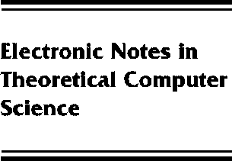[www.elsevier.com/locate/entcs](http://www.elsevier.com/locate/entcs)

Powersets, Fixed Points, and Lambda Calculus

Dana S. Scott

**Abstract**

The Knaster-Tarski Fixed-Point Theorem applies to monotone self-maps of a powerset, giving the existence of minimal and maximal fixed points. An analogy in Category Theory gives — for certain categories and certain functors — the existence of initial algebras and final coalgebras. For some interesting kinds of functors, this categorical construction can be reduced back to powersets and monotone functions. Applications include the construction of some new lambda-calculus models based on initial algebras and final coalgebras.

1571-0661 *⃝*c Elsevier Ltd Open access under [CC BY-NC-ND license.](http://creativecommons.org/licenses/by-nc-nd/3.0/)

10.1016/S1571-0661(05)80065-9