

[Egyptian Informatics Journal (2013) 14, 221–233](http://dx.doi.org/10.1016/j.eij.2013.06.004)

Cairo University

Egyptian Informatics Journal

[www.elsevier.com/locate/eij](http://www.elsevier.com/locate/eij) [www.sciencedirect.com](http://www.sciencedirect.com/science/journal/11108665)

ORIGINAL ARTICLE

Precision farming solution in Egypt using the wireless sensor network technology

Sherine M. Abd El-kader, Basma M. Mohammad El-Basioni *

*Electronics Research Institute, Computers and Systems Dept., Cairo, Egypt*

Received 13 December 2012; revised 18 June 2013; accepted 26 June 2013

Available online 22 July 2013

Abstract This paper gives an overview of the wireless sensor network, studies its application in precision farming, and its importance for improving the agriculture in Egypt. An example for using wireless sensor network in cultivating the potato crop in Egypt is given, and it is shown that the cost of the system with respect to the yearly benefit from exporting potato crop after recovering the loss from its export preventing (this loss is estimated to be 2 billion pounds which is the value of the potato export to Russia annually), after the expected consequence of increasing the yield size and quality, after the expected savings in the resources used in cultivation such as the fertilizer and irrigation water, and after recovering the monetary loss results from the harms caused by exces- sive use of pesticides, is acceptable, and it can be said that this cost can be recovered in one year. It is concluded that the APTEEN protocol is the most suitable routing strategy to precision farming and its network lifetime can reach 6.5 month which is a period more than the maximum value of the potato crop lifetime that estimated to be 120 day, but it is greater than the yearly cultivation period of potato in Egypt which reaches 6 month.

© 2013 Production and hosting by Elsevier B.V. on behalf of Faculty of Computers and Information,

KEYWORDS

Wireless sensor networks; Energy aware routing proto- cols;

Precision farming

Cairo University.

1. Introduction

* Correspoding author. Address: Computers and Systems Depart- ment, Electronics Research Institute, 33 El-Tahrir St., El-Dokki, Giza 12622, Egypt. Tel.: +20 10 303 557 3; fax: +20 23 335 163 1.

E-mail addresses: [bbasioni@yahoo.com](mailto:bbasioni@yahoo.com), [bbasioni@eri.sci.eg](mailto:bbasioni@eri.sci.eg) (B.M. Mohammad El-Basioni).

Peer review under responsibility of Faculty of Computers and Information, Cairo University.

**Production and hosting by Elsevier**

While it is known that, Egypt originally an agricultural coun- try, its people since the era of the Pharaohs are proud of land and agriculture, Egypt bears since a not close era from many problems concerning agriculture and crises facing a lot of important crops production size and quality causing shortcom- ings in their export size and also the self-satisfaction from them, threatening to aggravate the specter of abandoning and letting the agricultural lands searching for other sources of income give more money, such as tourism and construction businesses.

The agriculture in Egypt needs more concern for farms and farmers, more advanced research in available recent

1110-8665 © 2013 Production and hosting by Elsevier B.V. on behalf of Faculty of Computers and Information, Cairo University. <http://dx.doi.org/10.1016/j.eij.2013.06.004>

agricultural technologies, more automation, and more testing and applying of new methods of study, analysis, and mecha- nization. So, this paper studies the application of Precision Farming (PF), which is emerged as a management practice with the potential to increase profits by utilizing more precise information about agricultural resources through sensing and communication technology, in Egypt generally and takes the potato crop as a specific example for investigating a pos- sible PF solution using Wireless Sensor Network (WSN) technology.

The rest of this paper is organized as follows: Section 2 de- fines the WSN and PF, Section 3 gives some PF real implemen- tation examples, Section 4, talks about PF in Egypt, Section 5, gives an overview of the egyptian potato crop, Section 6, illus- trates the egyptian potato crop cultivation, Section 7, formu- lates a WSN precision farming solution for the egyptian potato crop cultivation, and finally Section 8, represents the conclusion and future work.

1. Precision farming and wireless sensor network overview

Precision farming is the ability to handle variations in produc- tivity within a field and maximize financial return, reduce waste and minimize impact of the environment using auto- mated data collection, documentation and utilization of such information for strategic farm management decisions through sensing and communication technology.

Several technologies were used in the PF such as Remote Sensing (RS) [1,2], Global Positioning System (GPS) [3], and Geographic Information System (GIS) [4]. The most impor- tant step in PF is the generation of maps of the soil with its characteristics. These included grid soil sampling, yield moni- toring, and crop scouting. RS coupled with GPS coordinates produced accurate maps and models of the agricultural fields. The sampling was typically through electronic sensors such as soil probes and remote optical scanners from satellites. The collection of such data in the form of electronic computer dat- abases gave birth to the GIS. Statistical analyses were then conducted on the data, and the variability of agricultural land with respect to its properties was charted. These technologies apart from being non-real time involved the use of expensive technologies like satellite sensing and were labor intensive where the maps charting the agricultural fields were mostly manually done [5].

The Wireless sensor network is composed of a large number of sensor nodes consist of sensing, processing, transmission, mobilizer, position finding system, and power units (some of these components are optional like the mobilizer and position finding system), Fig. 1, demonstrates the components of the sensor node.

These nodes are densely deployed either inside the phenom- enon or very close to it. The position of sensor nodes does not need to be engineered or predetermined. Sensor nodes coordi- nate among themselves to produce high-quality information about the physical environment. Each of these scattered sensor nodes has the capability to collect and route data [7–9] either to other sensors or back to an external base station(s), as shown in Fig. 2. A base station may be capable of connecting the sensor network to an existing communications infrastruc- ture or to the Internet where a user can have access to the re- ported data [10].

As a result of its features and abilities, WSN has several applications [11–14] and several advantages over traditional data collection schemes such as:

* Real-time data can be accessed from the remote site and analyzed and a real-time reaction taken upon it.
* Closed loop control ability (automation).
* Larger coverage area and high temporal and spatial resolution.
* Improved accuracy.
* Phenomena can be observed unobtrusively.
* Negative weather conditions do not affect a researcher’s work.
* Sensor nodes are small in size and weight and require no wiring which means that they are easy to install in most locations and applications.
* Usable for monitoring environments as contrasting as out- breaks of fire as well as glacier and also in rugged terrain, harsh, and inaccessible places.
* It is possible to have many users viewing the data simulta- neously, and also manipulating it.
* Adaptability for different scenarios and sensor nodes can be re-tasked in the field (reconfiguration).
* Fewer personnel are required to perform data collection from remote sites.
* Relatively inexpensive, it has been suggested that the total system cost (for both materials and installation labor) can be reduced by over 80% by using commercially available WSNs [15] over using a wired solution.
* Easy and brief deployment in the desired environment.
* Simple to use.
* Friendly GUI.
* Extremely versatile.
* Low maintenance.

WSNs are increasingly considered by the scientific commu- nity as the future of environmental monitoring: providing at a low cost the possibility to gather and process all sorts of data with a space and time resolution unimaginable before, these networks are viewed as a critical element of the revolution of ubiquitous computing [16].

So using WSN in PF applications will revolutionize the data collection in agricultural field, support the sought highly automated agriculture system which requires intensive sensing of environmental conditions at the ground level and rapid communication of the raw data to a local or remote server where the availability of computational and storage power, the identification of pests in the crops, drought or increased moisture, the decision making, and the control of farm equip- ment is done in real time (automated actuation devices like sprinklers, foggers, valve-controlled irrigation system, etc, can be used to control irrigation, fertilization and pest control in order to offset the adverse conditions forming Wireless Sen- sor and Actuator Network (WSAN)).

WSN has advantages in the PF applications over RS as sta- ted in literature:

* Brought down the cost of deployment and running of a fea- sible PF framework.
* The sensing and communication can now be done on a real- time basis leading to better response times.

Figure 1 The components of a sensor node [6].

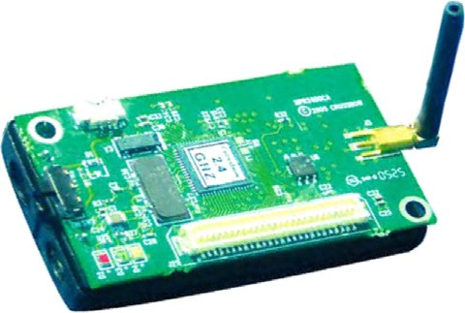

From environment

Sensing Unit number n

Sensing Unit number 1

Locomotive Unit (Optional)

Power Unit

Processing Unit

Communication Unit

Location Finding System (Optional)

To/From other nodes

Antenna

Transceiver

Memory

MCU

ADC

Sensor

ADC

Sensor

* Suitability for distributed data collecting and monitoring in tough environments.

Batteries

DC-DC

* Capable to control an economical way of climate, irrigation and nutrient supply to produce the best crop condition, increase the production efficiency while decreasing cost and provide the real-time information.
* Gives better spatial and temporal variability than satellites.
* Permits collection of other soil and plant data different than satellite collects, as temperature, moisture, pH, and soil electrical conductivity.
* Ability to form a highly automated agriculture system.
* Gives better resolution.
* Ability to observe for long periods of time crop state.
* Analytical information storage in order to create a case record of the field crop.
* Friendly Graphical User Interface (GUI) with the monitor- ing system.
* Potential to make exact evaluation of new crop methods and techniques.
* Potential for large area surveillance with high sampling densities.

1. Precision farming real implementations

Lofar Agro [17] is a project deals with fighting a fungal dis- ease called phytophtora in a potato field; the development

and associated attack of the crop depends strongly on the climatological conditions within the field; temperature, rela- tive humidity, luminosity, air pressure, precipitation, wind strength and direction, and the height of the groundwater ta- ble are the environmental parameters sensed in this project; the WSN data and statistics are sent to a field gateway then to the Lofar gateway (a simple PC for data logging) via WiFi connection, then through a wired connection they sent to the Internet to Lofar server and a couple of other servers under XML format. AGRO-SENSE [5] introduces a wireless mesh network comprises of sensors placed at different locations in a crop field where the intended characteristics of the soil or atmosphere (soil pH, soil moisture, electrical conductivity, soil temperature) need to be captured, the actuation is done based on the readings supplied by the sensors, upon exceeding a threshold, the system will generate automated alert mes- sages on the console, upon which appropriate action can be taken.

In [18], a preliminary design on the development of WSN for paddy rice cropping monitoring application in Malaysia is introduced, standard measurement parameters sensors such as ambient air temperature and humidity, soil pH and mois- ture are integrated in all nodes, there are two directions the data will go, which is first linked to server data based system to be recorded and revealed on Internet web page and real-time alert system using SMS system via GSM modem to person in charge cell phone. In [19], a WSN based on

Zigbee [20] and Internet is proposed for monitoring a field-environment factors in an automatic manner and dy- namic transmitting the measured data to the farmer or researchers; the main part of the network acquiring unit mainly includes the sensors of temperature and moisture in air and soil, CO2, and illumination.

1. Precision farming in Egypt

Devising a PF solution for the Egyptian agriculture entails per- forming some of anterior essential important steps. As well as the design of the system requires a comprehensive study and analysis of the technology used in building the system which is the WSN, it requires studying the conditions of the agricul- ture in Egypt generally and its challenges. Also, the application and evaluation of the system require the selection of a specific crop selected from the main crops in Egypt according to its importance and effect on the national income, and according to whether there are problems weaken its production and lead to other problems such as lack of self-sufficiency of it, its loss after harvesting, financial loss for farmers, and ban of its ex- port which causes a big monetary loss for the country. The se- lected crop should be studied in details and analyzed considering all the agricultural processes it passes by from till- age, cultivation, irrigation, harvesting, and storage and what this covers from methods and tools, what are its past, current, and expectable problems and the proposed methods (if any) to overcome them.

The Egyptian economy has relied heavily on the agricul- tural sector for food, feed, fiber, and other products. It pro- vides livelihood for about 55% and employs 30% of the labor force, contributes approximately 17% of the (Gross Domestic Product) GDP and 20% of all foreign exchange earnings. The recorded share from animal protein is about 21 g/day in 1997 and is planned to rise to 24 g per capita by 2017, while the minimum recommended share by Food and Agriculture Organization (FAO) is about 30 g/day/person [21]. Egypt has vast areas of poor rangeland due to the lack of sustainable management, estimated at more than 10 million

ha [22], and also it has no effective rainfall except in a narrow band along the northern coast. Consequently, Egypt has only one main source of water supply, the Nile. The availability of a reliable water supply from the High Dam in Aswan is gov- erned by the water-sharing treaty with the countries of the Nile Basin under which 55.5 billion m3 per annum is allocated to Egypt. Total available water resources are estimated at

73.8 billion m3 annually. Total of water use is about 62.6 bil- lion m3. Agriculture’s share of the water budget is about 81% and increased to 85% in 2006 [23]. According to Sustain- able Agricultural Development Strategy Toward 2030 [21], per capita fresh water is expected to decline from 711.0 m3 in 2008 to 550 m3 in 2030. Recorded share from cultivable land was about 504 m2 per inhabitant in 2006 [22]. An increase in water availability and efficiency could result from proper manage- ment of water through more effective on-farm water manage- ment practices, changes in cropping patterns toward less water consuming crops.

Generally, the problems facing agricultural production in Egypt and the achievement of food security can be summa- rized as follows: first, problems related to climatic factors which are signs of a danger because the decrease or the altitude of temperature affects the feddan productivity as a result for its effect on the activity of the plant’s enzymes, second, problems related to terrestrial factors which represented by the soil and its physical and chemical properties that directly affect the pro- ductivity per feddan, third, problems related to human factors which indoors may cause climate change and include irrespon- sible behaviors, such as the unlimited thermal emission caused by the industry, and the nonuse of agricultural counseling well and ignorance of the farmer of the best ways to deal with the crop and the modern methods in agriculture, the forth and last type of problems is related to the diseases and pests which may devour the complete crop.

Although the genetic engineering and biotechnology play an important role in dealing with these problems, more inno- vative solutions using modern technologies is very important also it is logical and necessary to catch up with the developed countries. To efficiently manage Egypt’s complex agricultural

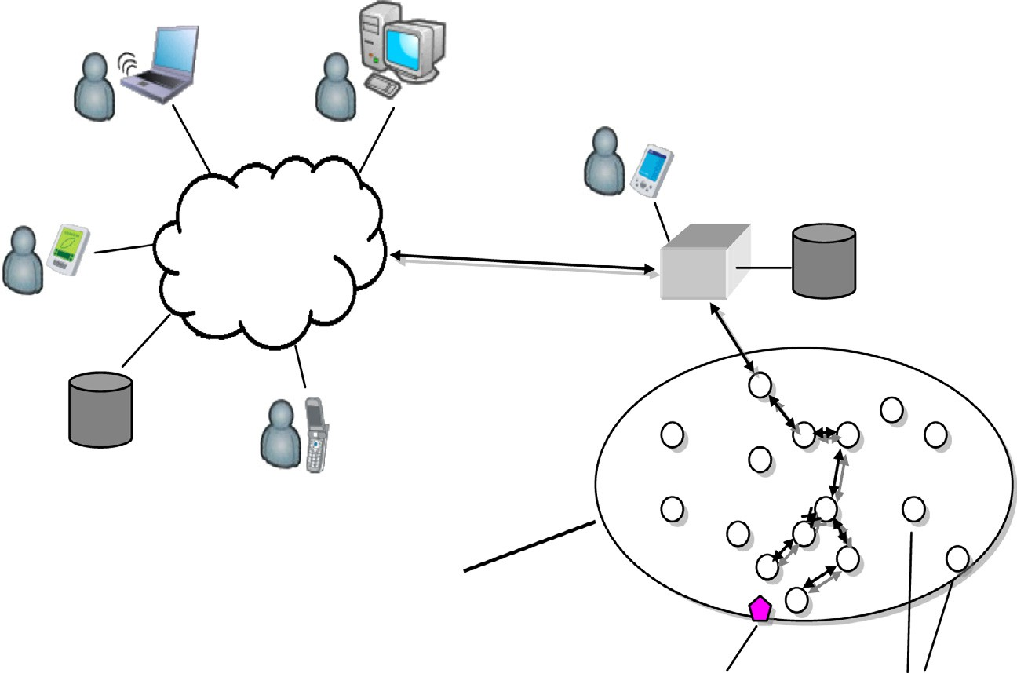

Remote users

Local user

Sink Storage

Internet

Storage

Sensor field

Target node Sensor nodes

Figure 2 Sensor nodes scattered in a sensor field [6].

production system and vast irrigation and drainage networks the acquisition of accurate and timely crop data is essential using a complete PF solution using WSN technology. From this study and analysis, it will be specified what of these prob- lems are related to the selected crop and upon that the concep- tualization and determination of how to improve this crop using WSN will be put.

1. Potato crop PF in Egypt

Potatoes were first introduced outside the Andes region four centuries ago, and have become an integral part of much of the world’s cuisine. It is the world’s fourth-largest food crop, following rice, wheat and maize. In Egypt, the crop was introduced on a small scale during the nineteenth century. It is nowadays the second most important vegetable crop after tomato, where about 20% of total area devoted for vegetable production is cultivated with potato, and Egypt is one of the largest producers and exporters of potatoes in Africa [24].

Egyptian potato exports fluctuate from one season to an- other. In year 2010, Egyptian companies managed to export 289 thousand Tonnes, while in 2011, the exported quantity rose to 461 thousand Tonnes. The main export destinations in 2011 were Russia, EU countries, and countries in the Gulf region [24].

This crop is economically important to Egypt and any dis- turbance in its production affects severely its local and more importantly export impact, perhaps the greatest example of this is the big existing problem of the Russia’s decision to ban the Egyptian potato exports due to its infection with brown rot, this problem causes a loss estimated at 2 billion pounds which is the value of the potato export to Russia annually.

From the important position which the potato crop occu- pies among all vegetable crops in Egypt, from the sensitivity of the national income to its production, and based on the big problem currently faces its export, it deserved to be the first choice to study and design a precision farming solution for improving its production size and quality and facing the prob- lems that harms its production and export using the wireless sensor network emerging technology. The following section talks about the potato crop cultivation in Egypt and how WSN can be used to improve it.

1. Egyptian potato crop cultivation conditions and methods

In order to figure out what are the problems face the potato production that the WSN can solves them and to know the information required for specifying how the WSN solution will be established, the following subsections will address some of the important characteristics [24] of the potato crop.

* 1. *Soil type*

Potatoes prefer well aerated, loamy soil with good drainage. Soil Salinity, water logging, and high levels of calcium-carbon- ate are undesirable for potato cultivation as they negatively af- fect productivity and starch content. The WSN can be used to test the suitability of the agricultural land to the crop cultiva- tion, ensuring its freeness from diseases and harmful fungi, and

for performing nutrient availability analysis in order to devel- op an appropriate fertilization scheme, so the knowledge of the required soil type determines sensing modalities should be used.

* 1. *Planting period*

Potatoes are cultivated continuously in Egypt starting from August. Plantings from mid-August to mid-October (main plantation) are harvested from December to mid-February; this represents about 55% of annual production, and it is des- tined mainly for exporting. Plantings from late-October to mid-November account for 10% or less of annual production and are harvested in February, and this crop is grown mainly for export. December till mid-February plantings are har- vested in May/June, and most of this crop (roughly 35% of an- nual production) is sold on the local market or kept as seed for autumn planting.

The cultivation period and seasons are very important to be known to determine the lifetime required form the network and the possibility to need a manual maintenance of the net- work, what will be its expected magnitude and repetition times.

* 1. *Seed cutting and storage*

Cutting of seed tubers is common although not recommended practice for some varieties. Farmers who cut their seed should take measures such as applying seed treatment (which is any- how important) in order to prevent infection of planting mate- rial and to control early pests and diseases. The cut-away seeds need special conditions until they are planted, temperature 15–

20 °C, Relative Humidity (RH) greater than 90%, and good ventilation. The WSN needs these special conditions to main-

tain them for the cut-away seeds.

* 1. *Harvesting methods*

Most potato crops grown for export are mechanized or semi- mechanized; the remainder often involves hand labor. Here, the application of the WSN in the agricultural land may spec- ify a certain method of harvesting.

* 1. *Post-harvest*

Storage at temperature 2–3 °C and RH 85–90% for 45– 120 days is required for the harvested potato crop. Also,

WSN can play an important role in improving the potato crop storage by maintaining the essential storage conditions as they described later and along the required period.

* 1. *Crop phases*

It could be said that the period of the potato plant life in Egypt can be divided into four broad stages: two of them were men- tioned before, the land test phase and the storage phase, the two others namely:

*Stage 1* – Stage of the field and before the advent of plants rights of the earth’s surface.

*Stage 2*– Stage of the field and after the emergence of plants above ground.

226 S.M. Abd El-kader, B.M. Mohammad El-Basioni

Figure 3 Sensor nodes hardware and deployment.

These stages are characterized with certain characteristics and dynamic processes, and also during both of these stages, the growth of some parts of the crop are more than other parts, and accordingly, each requires certain treatment and adjustments of different parameters and conditions such as, soil water balance, solar radiation, minimum and maximum relative humidity, minimum and maximum temperature, wind speed, and rainfall. The study of these characteristics, treat- ments, and adjustments is essential for determining the sensing parameters needed during the crop lifetime for crop modeling, specifying the network protocols and different protocols set- tings, designing the user application, and determining the suit- able node deployment, for example, the length of the crop foliage affects the wireless signal propagation which indoors affects the transmission ranges of sensor nodes and accord- ingly their positions and distances.

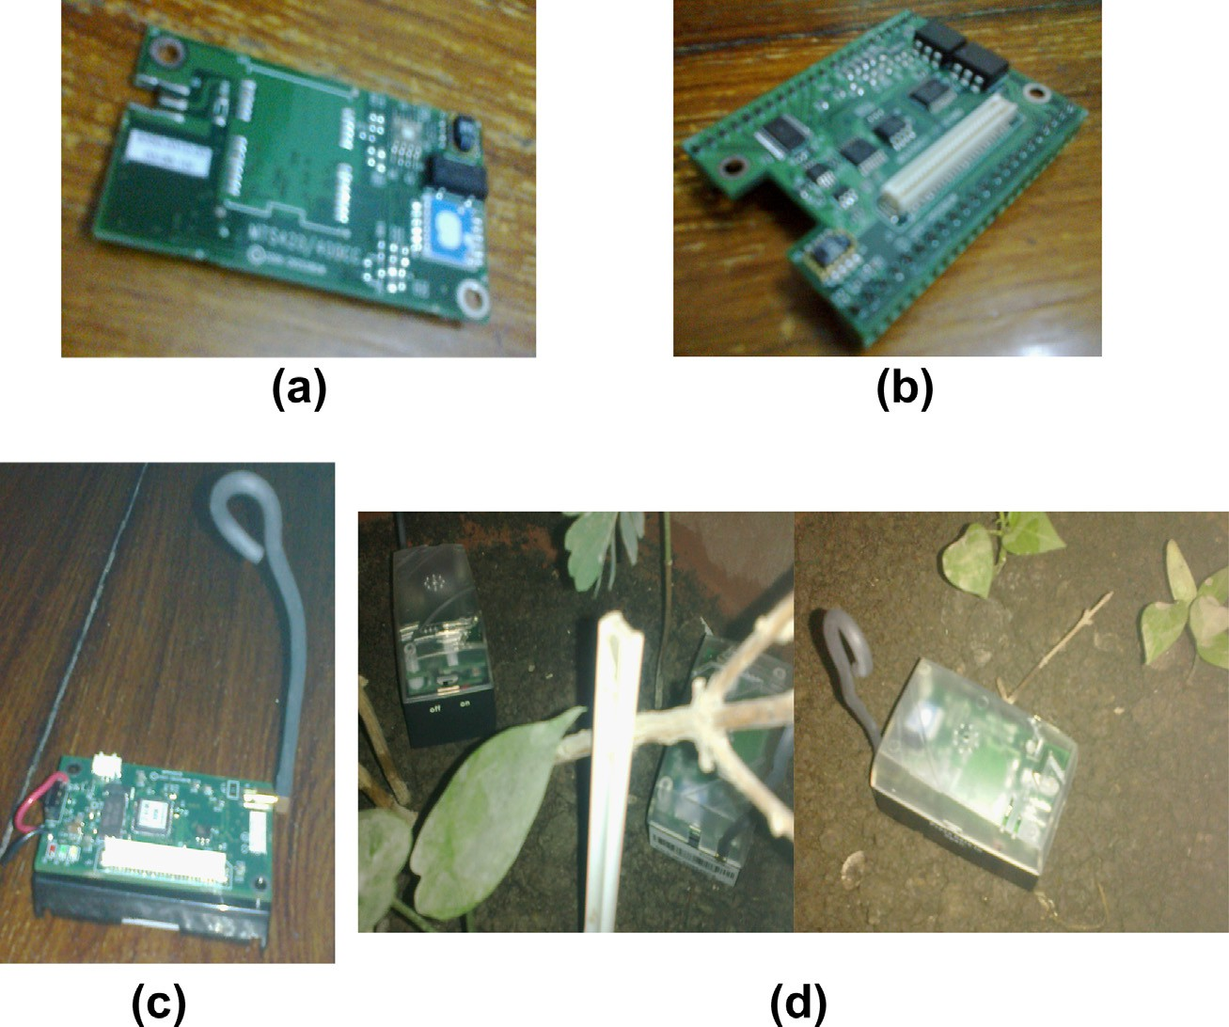

Potato crop modeling can be used as a decision tool for farmers to do irrigation scheduling and fertilization scheduling and other plating practices scheduling which helps to improve potato crop and save of resources such as irrigation water and fertilizers, and this modeling can be efficiently and easily done by deploying the sensor nodes in the crop field which sense the required parameters and send it to the user on real time where he can analyze this data, draw a complete accurate picture of the field characteristics, and take the suitable decision in the suitable time.

By this also, we can overcome the key barrier to the improvement of potato in Egypt which is the reduction in yield and tuber quality caused mainly by potato pests and pathogens where during its seasonal plantations (Summer, Nili and Fall), potato plants are subjected to numerous pathogens and insect pests which cause considerable loss in Egyptian quantitative and qualitative potato yield. Such pathogenic and insect

problems include the fungal pathogens (and their diseases): *Alternaria solani* (early blight) and *Phytophthora infestans* (late blight); bacterial pathogens: *Ralstonia* solanacearum/ *Pseudomonas* (brown rot or bacterial wilt), *Erwinia carotovora* subsp. atroseptica (black leg and rot Erwinia), *Clavibacter michiganense* subsp. sepedonicum (ring rot) and *Streptomyces scabies* (common scob); nematode diseases especially those caused by *Meloidogyne incognita*; virus diseases: mottle or latent virus (Marmor dubium var. annulus), mild mosaic (Marmor solani) and insect such as *Gryllotalpa gryllotalpa*, *Agrotis ipselon*, Pentodon lispinosus, *Bemisia tabaci* and Liromyza begoniae [25]. Preventing the conditions under which these pathogens and insect pests appear or the early detection of them can be done efficiently by WSN.

The talk about the detailed description of all of these phases elongates, so it is out of the scope of this paper.

1. The proposed solution

This section describes the network example used in deriving the proposed solution including node deployment, nodes’ number determination, and routing protocol. The network monitors the crop during the two stages of the field before and after the emergence of plants above ground, Stages 1 and 2.

* 1. *The proposed sensing modalities and node hardware*

Sensor nodes will contain sensors for temperature, humidity, light intensity, soil pH, and soil moisture. These sensing modalities exists in market in variations of hardware, for example, one sensor board such as MTS400 contains sensors

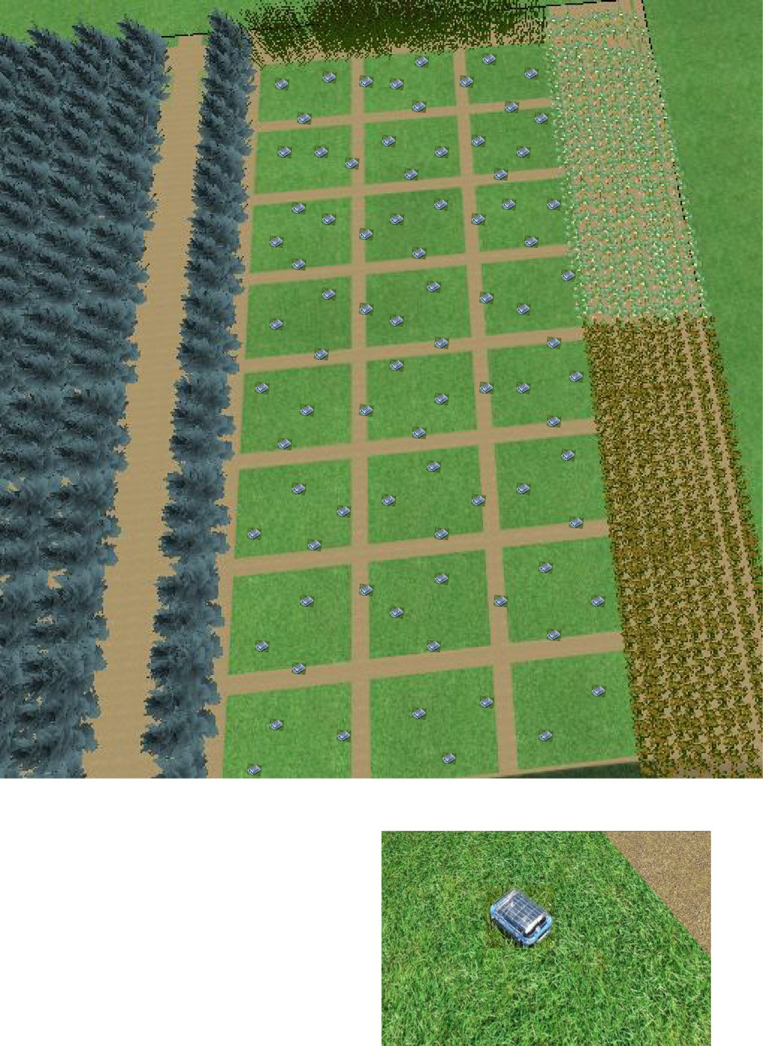

39.7 m

13.2 m

13.2 m

105.8 m

Sensor node

Figure 4 A sample of one feddan for potato field.

for temperature, relative humidity, light intensity, and also barometric pressure (this board is pictured in Fig. 3a), also dif- ferent types of sensors can be attached to different data acqui- sition boards such as MDA300 (pictured in Fig. 3b) which can attach a soil moisture sensor in addition to the onboard tem- perature and humidity sensors. These sensors and data acqui- sition boards are compatible with the processor/radio platforms MICA2 and MICAz (pictured in Fig. 3c). Attaching the processor/radio platform to the sensors or the data acqui- sition board forms the sensor node that will be deployed in the field after covered by a suitable housing. Fig. 3d represents a picture of a sensor node in its final form after it had been de- ployed in the field.

* 1. *The proposed node deployment*

The common method for planting potato in Egypt entails the division of the field into tubs with large area each of them rep- resents 1–2 carat for irrigation frapping. This division will be

used to distribute sensor nodes uniformly, and it will be used for nodes localization.

Assuming that the field will be divided into tubs each of one carat area. Each carat will contain two nodes distributed on it with approximate separation of six meter and a node put on every one of its edges (near the edge) shared with another carat.

The non-identification of a strict specific location for nodes simplifies its deployment. This number and positions of nodes in each feddan are suitable for fault tolerance and also for cov- erage and connectivity which is also achieved by selecting a separation between nodes equals approximately 6 meter as this separation represents a suitable distance according to the find- ings of [26] where it is concluded upon an extensive set of mea- surements taken in a potato field, where the foliage has an important effect on the propagation of radio waves, that the distance between nodes for precision-agriculture applications should be at most 10 m when the micro-climate must be sensed during the whole growing season.

228 S.M. Abd El-kader, B.M. Mohammad El-Basioni

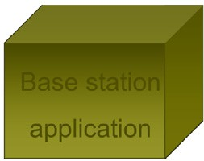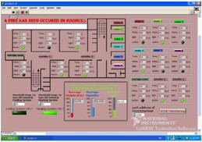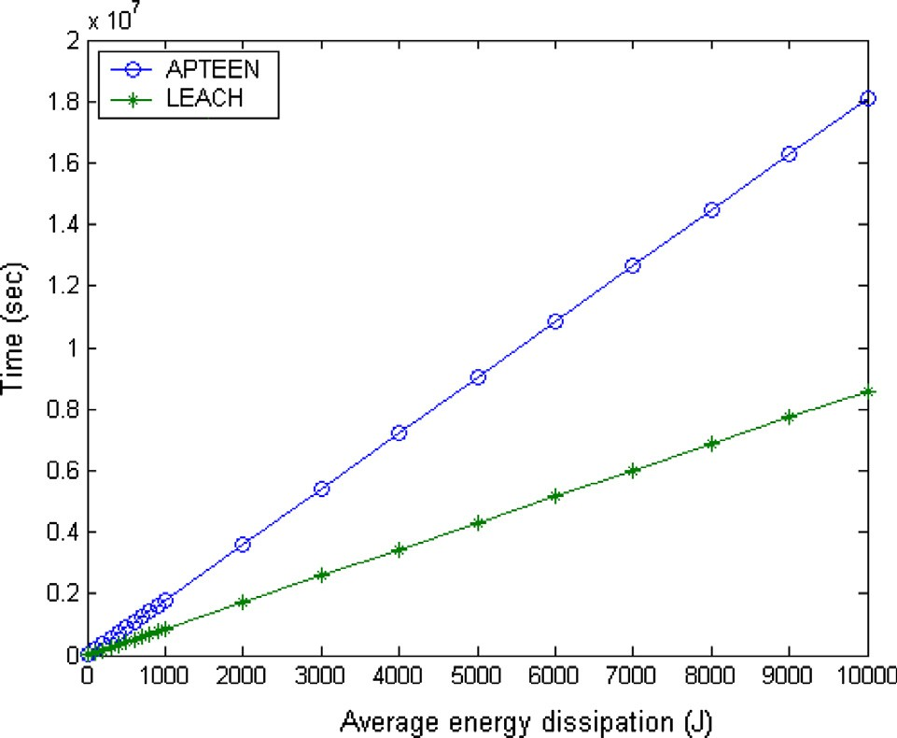

Custom user application

Application

**Base station application**

Network

MICA2 radio stack

MAC

Physical

Sensor node reference model

Figure 6 Time versus avg. energy consumption.

Management and Control plane

avoidance schemes. The network layer incorporates the rout- ing protocol, which will be selected from the existing routing

Figure 5 Architecture of the proposed solution.

* 1. *Determining the number of sensor nodes*

To calculate the number of sensor nodes required for a given crop field according to the proposed scheme for node deploy- ment descried in the previous section, Eq. (1) can be used to approximate it:

protocols for WSN with characteristics suitable to the PF application. The application layer involves the commands to read the sensed values with a specific rate and request from the lower layers to send it also with a specific rate or on special events. The overall architecture of the proposed solution formed by having a number of scattered sensor nodes with the previously stated architecture communicate wirelessly to a base station connected to the local or remote user application which receives the network data and appropriately process it.

*N* = *N* × 2 + [(*f* — 1)+ ((*N* — *f* )× 1 × 1)+ ((*N*

*s*

*c*

*w*

*c*

*w*

*f*

*w*

*c*

*7.5. Proposing the most suitable routing protocol*

— *f* )× 1 — 1 × 2)] (1)

*w*

*fw*

where *Ns* is the number of sensor nodes, *Nc* is the number of

carats, and *fw* is the field width in carats.

Fig. 4 represents a sample of land equals one feddan, and this feddan is divided into 24 one carat tubs. The sensor nodes are distributed on the land sample according to the used node deployment, so, from Eq. (1), it could be concluded that each feddan will require about 85 node.

* 1. *The architecture of the proposed solution*

The architecture of the proposed solution starts from describ- ing the sensor node architecture. The sensor node hardware architecture has been described in Section 7.1; therefore, this section will talk about the software architecture of the sensor node. The reference model of the sensor node is depicted in Fig. 5; the physical layer is implemented by the radio stack of the ChipCon model CC1000 single-chip Radio Frequency used in the transceiver MICA2 mote. The software stack of the node will consist of the MAC layer, the network layer, the application layer, and other management services, and the node will be driven by the TinyOS which is the operating system supported by MICA2. The MAC layer is also imple- mented in the CC1000 Stack where it provides transmit and receive data movement using CSMA/CA based contention

From the technical point of view, most of the scalable hierar-

chical routing protocols [27–30] assume a WSN collecting data

periodically from its environment or responding to a particular query. So, there is a need for networks responding immediately to the changes in the sensed attributes. WSNs should also pro- vide the end user with an ability to dynamically monitor and control the trade-off between energy efficiency, accuracy, and response times. The PF and some other applications need a comprehensive, easy-to-use querying system, so that reliable and accurate answers can be obtained with minimal delays. As all of these features can be provided by the Periodic Thresh- old-sensitive Energy-Efficient sensor Network (APTEEN) [27] routing strategy, it could be concluded that it is the most suit- able routing idea for PF.

APTEEN is a hierarchical cluster-based routing protocol in which the nodes are grouped into clusters; each cluster has member nodes and one head node responsible for receiving, aggregating, and transmitting the data of its cluster members. In APTEEN, the cluster-heads broadcast the following parameters:

* + - *Attributes (A)*: is a set of physical parameters about which the user is interested in obtaining information.
    - *Thresholds*: consist of the Hard Threshold (*HT*) which trig- gers transmission and the Soft Threshold (*ST*) which trig-

gers subsequent transmissions.

* *Schedule*: is a Time Division Multiple Access (TDMA) sche- dule that assigns a slot to each node for transmission.
* *Count time (TC)*: is the maximum time period between two successive reports sent by a node.

The main features of the APTEEN routing strategy that fits to PF applications are as follows:

1. It combines both proactive and reactive policies. By send- ing periodic data, it provides a complete picture of the net- work to the user, like a proactive scheme. It also senses data continuously and responds immediately to drastic changes, thereby making it responsive to time critical situations, like a reactive network.
2. Energy saving by using TDMA schedule for transmission which enables nodes to sleep and prevents collisions among cluster members.
3. Energy saving as the node senses the environment continu- ously and only transmits if hard threshold condition met.
4. Energy consumption can be controlled by changing the count time as well as the threshold values.
5. Centralized nature of the protocol makes the base station forms an optimal clustering and able to appoint a fixed number of nodes as cluster heads versus a percentage may not be satisfied sometimes.
6. Supports a query handling mechanism.
7. Small response delay, because the base station can be placed near the network deployment area, the structure of the network can be limited to one-level clustering which involves only two hops to reach the sink, this can compen- sate the delay resulted due to using the TDMA schedule. In addition, the PF is one of the applications that tolerate rea- sonable delay.
   1. *The performance of the proposed solution*

The performance of the proposed solution concerns the oper- ational cost of the system and the network characteristics. The operational cost will be addressed in Section 7.8. The network characteristics include the connectivity, the delay, the lifetime,

coverage, fault tolerance, scalability, reliability, and the com- munication cost.

The full coverage of the field is achieved by exploiting the field division method in uniformly distributing sensor nodes to guarantee that each division covered by a suitable and equal number of nodes. The connectivity among sensors is guaran- teed by deploying nodes with separation less than 10 m to mit- igate the effect of foliage on the propagation of radio waves, while the fault tolerance and reliability are achieved by deploy- ing redundant nodes in each field division.

The scalability to large fields is achievable by using a clus- ter-based hierarchical network architecture implemented by the APTEEN strategy. With respect to the performance of AP- TEEN network in terms of lifetime and energy dissipation, it is better than the two popular hierarchical routing protocols Low-Energy Adaptive Clustering Hierarchy (LEACH) [31] and Low-Energy Adaptive Clustering Hierarchy-Centralized (LEACH-C) [32]. The last node dies lifetime of APTEEN is approximately greater than that of LEACH by on average 79% and greater than that of LEACH-C by on average 112%. From the average energy dissipation curve in APTEEN pa- per, by putting time in the vertical axis and energy in the hor- izontal axis and fitting the last behavior taken by the APTEEN

and LEACH curves to the linear equations:

*TA* = 1807.7 × *EA* — 2519.8 (2)

Start

Determine suitable clusters construction and send it to nodes

Wait clusters to be formed

Wait the

*cluster period*

Send queries to CHs if required

Receive sensors data

Send the initial query to CHs

Re-cluster the network

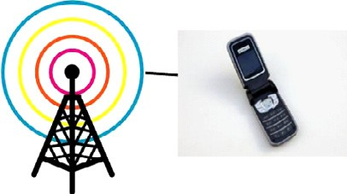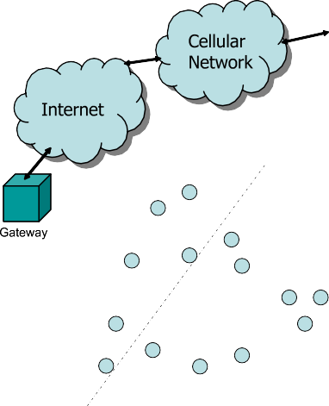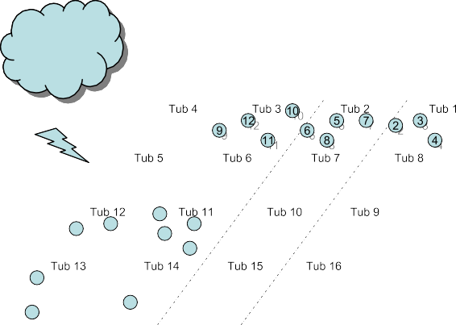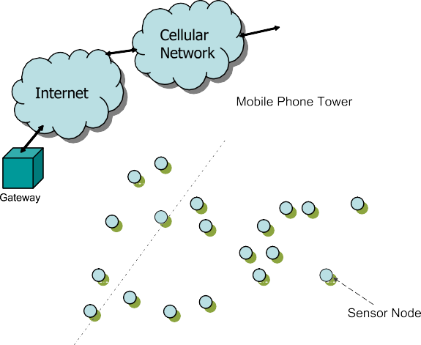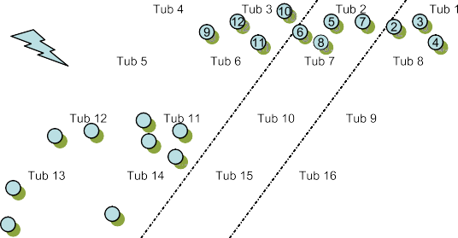

Figure 7 The WSN for the potatoes field. Figure 8 Base station procedures.

*TL* = 858.6 × *EL* — 1150.9 (3) The main limitation of the APTEEN scheme is the additional

|  |  |  |  |  |  |
| --- | --- | --- | --- | --- | --- |
| Table 1 Parameters’ values of the APTEEN protocol for potato crop precision farming. | | | | | |
| Attributes | Thresholds |  | Morning (M)/night (N) | Period of crop life | *TC* |
|  | *HT* | *ST* |  |  |  |
| Temperature | >25 °C  <15 °C  >18 °C  <15 °C  >40 °C  <10 °C  <23 °C and >20 °C | 3 °C  3 °C  3 °C  3 °C  3 °C  3 °C – | M M N | Stage 1 (about 6 weeks) Stage 2  Stages 1 and 2 | Multiple of the TDMA schedule length |
| Light intensity | <800 fc | 10 fc | N and M | Stages 1 and 2 | 0.5 day |
|  | >100 fc and <150 fc | – |  |  |  |
| Relative humidity | >85% | 5% | N and M | Stages 1 and 2 | Multiple of the TDMA |
|  |  |  |  |  | schedule length |
| pH value | <5 | – | N and M | Stages 1 and 2 | 2 week |
|  | >6 | – |  |  |  |
| Soil moisture | – | – | N or M | Stages 1 and 2 | 2 week |
|  |  |  |  |  |  |

where *TA* and *EA* are respectively the time in seconds and the average energy dissipation in joule for APTEEN, and *TL* and *EL* are respectively the time in seconds is the average energy dissipation in joule for LEACH.

From Eq. (2), it can be deduced that, in APTEEN network the first node dies lifetime due to energy exhaustion for sensor nodes powered by AA Alkaline batteries which has energy storage 9360 J is about 6.5 month, which is a time period much greater than the lifetime of the potato crop (4 months) in Egypt, but it is greater than the whole period of its cultivation yearly. In the same time, from Eq. (3), it can be found that the lifetime that may be reached by LEACH is about 3 month, which is smaller than the lifetime reached by APTEEN and the more important that it is not adequate for the Egyptian po- tato crop lifetime. Fig. 6, shows the time duration expected for consuming a certain amount of node’s energy for APTEEN and LEACH.

The communication cost of the system which depends on the communication distances between sensors and their corre- sponding cluster head, the number of cluster heads, the num- ber of member nodes, and the selection of the cluster heads is controllable by the base station as the network is centralized. By introducing to APTEEN the concept of urgent data or high priority data the node can send its urgent data in its time slot to avoid collision or using CSMA/CA if its slot is far, and its cluster head does not wait to collect the other nodes data, rather it proceeds to send it directly to the base station, so the delay of urgent data is reduced. The end-to-end delay of

non-urgent data is computed from:

*E* — *to* — *E delay* = *Tnode*—CH + *Tlastnode*—CH + *T*CH—BS (4)

where *Tnode-*CH one-hop delay from node to its cluster head,

*Tlastnode-*CH delay from the packet transmission completion up to the time the cluster head receives the packet of the last node in the schedule, *T*CH_BS, one-hop delay from cluster head to base station.

One — hop delay = Transmission delay

+ Propagation delay (5)

complexity required to implement the threshold functions, the

count time, and the query handling at the nodes. However, for the PF applications, this is a reasonable tradeoff and intro- duces additional flexibility, versatility and energy savings.

* 1. *A possible scenario for the proposed solution*

The user application will simulate the field and its tubs and give each tub a specific number recursively as shown in Fig. 7, and then determines the required number of nodes according to the used Eq. (1) and simulates their distribution on the field according to the proposed node deployment meth- od in Section 7.2. From this simulation the user determines the number of nodes required for each tub, and then discerns the group of nodes that will be deployed in each tub by program- ming them with their tub number. Each node in the group will have an ID different than its group members and the members of others groups, the tub number will be marked on the hous- ing of each node and also the node ID.

These tubs numbers and the corresponding nodes’ IDs for each tub will be recorded in the application. The workers are tasked to deploy the nodes according to the tub number marked on them binding to the used deployment method, tub 1 nodes put in tub 1 and so on, giving them where is to start to count tubs and how to proceed the count. After deployment, the base station determines the nodes’ clustering and sends this clustering information to the nodes, and after the clusters are formed, it sends the initial queries to the net- work according to Table 1. Then the nodes start to sense the medium and send the required periodic information to their cluster heads, and the cluster heads send it toward the base sta- tion where it is processed, stored on a database, plotted in graphs, and fire alarms upon some conditions.

In one day morning, the nodes in tubs 5, 6, 11, and 12 sensed the temperature equal 30 °C, they reported this to the base station and the application informs the farmer that it is

better to make a cactarium on this place to decrease the tem- perature to the suitable values. In another period, two nodes in tub 15 reported that the temperature is about 25 °C and

the pH value is greater than 6 (about 6.5), the application also



Start

Receive clustering info.

Wait for the initial query

Wait my cluster head message

no

If

I am a cluster head

yes

Receive the cluster head message

Wait for members data

Learn my slot time and command the application layer with the message primitives

Wait a frame time, aggregate received data

no

yes

If urgent

no

the time

Is

Morning

yes Determine the morning HT and

ST

no

Determine the night HT and ST

yes

If

this attribute is sent before

If

the value of the sensed attribute satisfies HT condition

no

yes

If

the ST condition is satisfied

If

this attribute is just sent

no

no

no

yes

yes

If

a Tc

is passed

Sense temperature, light intensity, relative humidity, pH value, and Soil moisture

Receive members data

Send the query and the schedule for cluster members

Receive the initial query

Locate my dedicated slot and send the values to the cluster head

send to the base station

Figure 9 Sensor node procedures.

found in the database that the soil moisture is high, then, it in- formed the farmer to go immediately to this place because these are the conditions suitable for the brown rot existence

and informed him what is the amount of bounds of sulfur he should apply per 100 square feet to lower soil pH to 5.5 according to the recorded soil type. The farmer in this case

may find parts of the crop are already infected by the rot, then he can quickly take the suitable reaction to prevent its spread as it spreads in about 36–48 h and may corrupt the whole field especially when the RH is equal or greater than 85%.

The data collected from the network above is stored at the local user, it may also forwarded to a remote Internet or cellu- lar user as shown in Fig. 7, for example, to allow agricultural engineers follow farmers activities and guide them, and also to model the crop for improving current and future agricultural activities.

The procedures taken by the base station and the nodes are illustrated in the flowcharts in Figs. 8 and 9.

* 1. *The expected outcome*

It should be noted that the market for wireless sensors has a steady increase over the past decade. In 2004, 500,000 wireless sensor networks have been sold, and this number increased to 10 million in 2006. In terms of dollars, shipments of wireless products increase three times from 2003 to 2006. Fig. 10, dem-

2.5

2

**The Market Value of WSN (billion $)**

1.5

1

0.5

0

**Year**

Figure 11 The market of WSN.

onstrates the number of wireless sensors that have been sold from 2002 up to 2008, and then it predicts the increase in these numbers in 2009 and 2010.

According to IDTechEx research in the new report ‘‘Wire- less Sensor Networks 2011–2021’’, the Market Value of Wire- less Sensor Network reaches approximately 280 US$ million in 2010 and 400 US$ million in 2011 and it will grow rapidly to

$1.75 billion in 2019 and $2 billion in 2021 as shown in Fig. 11. Researchers at Intel expect that the number of transistors on a chip roughly doubles every two years, resulting in more features, increased performance, decreased cost per transistor and volume production, so, nodes could drop in price to less

than $5 each over the next several years.

The cultivated land with potato on Egypt currently reaches about 160,000 feddan yearly. Assuming as just mentioned that the cost of one sensor node would approximately be $5, then we need approximately 408 million Egyptian pound for equip- ping potato yearly cultivated land with sensor nodes, by add- ing the cost of base stations, the total cost may be 417 million and 600,000 Egyptian pound.

This cost with respect to the yearly benefit from exporting potato crop after recovering the loss from its export prevent- ing, after the expected consequence of increasing the yield size and quality, after the expected savings in the resources used in cultivation such as the fertilizer and irrigation water, and after recovering the monetary loss results from the harms caused by

600

500

400

**No. of sold wireless sensors (Millions)**

300

200

100

0

2002 2003 2004 2005 2006 2007 2008 2009 2010

**Year**

Figure 10 The number of sold wireless sensors.

excessive use of pesticides, is acceptable; it can be said that this

cost can be recovered in one year, with the knowledge that the Russia’s decision to ban the Egyptian potato exports causes a losses estimated at 2 billion pounds which is the value of the potato export to Russia annually.

1. Conclusion and future work

This paper shows the importance of using the wireless sensor network in precision farming field. Also this paper sheds the light on the agriculture in Egypt and how the automation of the agriculture using wireless sensor network will help to solve a lot of Egyptian agricultural problems and improve the crops. An example of the most important crops is selected, which is the potato crop, to study the usage of wireless sensor network for precision farming in Egypt.

The wireless sensor network can be used to test the land to assess its suitability to potato planting and ensure that it is free from diseases and harmful fungi for old used lands and for rec- lamation of new lands, improve the storage of potato seed tu- bers and crop, model the potato crop to be used as a decision tool for farmers to do irrigation scheduling and fertilization scheduling and other plating practices scheduling which helps to improve potato crop and save of resources, and prevent or early detect harmful diseases.

The main corners of the potato crop wireless sensor net- work system are proposed including the sensing parameters and node hardware, the node deployment and number deter- mination, and the most suitable routing strategy. It is shown that the cost of the system with respect to the yearly benefit from exporting potato crop after recovering the loss from its export preventing due to the brown rot (this loss is estimated to be 2 billion pounds which is the value of the potato export to Russia annually), after the expected consequence of increas- ing the yield size and quality, and after recovering the mone- tary loss results from the harms caused by excessive use of pesticides, is acceptable and it can be said that this cost can be recovered in one year. It is concluded that the APTEEN protocol is the most suitable routing strategy to precision farming and its network lifetime can reach 6.5 month which is a period more than suitable to potato crop lifetime period in Egypt.

As a future work, it is planned to enhance the APTEEN strategy to be more suitable to different scenarios of the potato crop monitoring, study the application of wireless sensor net- work in the crop storage and land test phases, and finally apply the system in reality.

References

1. [Weng Q. Advances in environmental remote sensing: sensors,](http://refhub.elsevier.com/S1110-8665(13)00025-X/h0005) [algorithms, and applications (remote sensing applications series).](http://refhub.elsevier.com/S1110-8665(13)00025-X/h0005) [CRC Press Taylor & Francis Group; 2011](http://refhub.elsevier.com/S1110-8665(13)00025-X/h0005).
2. Committee on the earth system science for decisions about human welfare: contributions of remote sensing, contributions of land remote sensing for decisions about food security and human health, workshop report. Washington: National Academies Press, 2007.
3. [Xu G. GPS: theory, algorithms and applications. 2nd ed. Berlin](http://refhub.elsevier.com/S1110-8665(13)00025-X/h0010) [Heidelberg: Springer-Verlag; 2007](http://refhub.elsevier.com/S1110-8665(13)00025-X/h0010).
4. [Pierce FJ, Clay D. GIS applications in agriculture. CRC Press](http://refhub.elsevier.com/S1110-8665(13)00025-X/h0015) [Taylor & Francis Group; 2007](http://refhub.elsevier.com/S1110-8665(13)00025-X/h0015).
5. Anurag D, Roy S, Bandyopadhyay S. AGRO-SENSE: precision agriculture using sensor-based wireless mesh networks. In: Pro- ceedings of ITU (international telecommunications union) con- ference on next generation networks, Geneva, Switzerland; 2008.

p. 383–8. <http://dx.doi.org/10.1109/KINGN.2008.4542291>.

1. Mohammad El-Basioni BM, Abd El-kader SM, Eissa HS, Zahra

MM. Performance evaluation of an energy-aware routing proto- col for wireless sensor networks. M.S. thesis. Dept. Electrical Eng., Faculty of Engineering, Al-Azhar University; 2011.

1. [Aziz AA, Sekercioglu YA, Fitzpatrick P, Ivanovich M. A survey](http://refhub.elsevier.com/S1110-8665(13)00025-X/h0020) [on distributed topology control techniques for extending the](http://refhub.elsevier.com/S1110-8665(13)00025-X/h0020) [lifetime of battery powered wireless sensor networks. IEEE](http://refhub.elsevier.com/S1110-8665(13)00025-X/h0020) [Commun Survey Tutorial 2012;15(1):121–44](http://refhub.elsevier.com/S1110-8665(13)00025-X/h0020).
2. [Mohammad El-Basioni BM, Abd El-kader SM, Eissa HS.](http://refhub.elsevier.com/S1110-8665(13)00025-X/h0025) [Designing a local path repair algorithm for directed diffusion](http://refhub.elsevier.com/S1110-8665(13)00025-X/h0025) [protocol. Egypt Inform J 2012;13(3):155–69](http://refhub.elsevier.com/S1110-8665(13)00025-X/h0025).
3. Jagadeeswara Reddy M, Suman Prakash P, Chenna Reddy P. Homogeneous and heterogeneous energy schemes for hierarchical cluster based routing protocols in WSN: a survey. in: Proceedings of the 3rd international conference on trends in information, telecommunication and computing lecture notes in electrical engineering, vol. 150; 2013. p. 591–5.
4. [Ilyas M, Mahgoub I. Handbook of sensor networks: compact](http://refhub.elsevier.com/S1110-8665(13)00025-X/h0030) [wireless and wired sensing systems. CRC Press LLC; 2005](http://refhub.elsevier.com/S1110-8665(13)00025-X/h0030).
5. [Mohammad El-Basioni BM, Abd El-kader SM, Fakhreldin MA.](http://refhub.elsevier.com/S1110-8665(13)00025-X/h0035) [Smart home design using wireless sensor network and biometric](http://refhub.elsevier.com/S1110-8665(13)00025-X/h0035) [technologies. Int J Appl Innov Eng Manage 2013;2(3):413–29](http://refhub.elsevier.com/S1110-8665(13)00025-X/h0035).
6. El Barachi M, Alfandi O. The design and implementation of a wireless healthcare application for WSN-enabled IMS environ- ments. In: Proceedings of IEEE consumer communications and networking conference (CCNC); 2013. p. 892–7. [http://dx.doi.org/](http://dx.doi.org/10.1109/CCNC.2013.6488580) [10.1109/CCNC.2013.6488580](http://dx.doi.org/10.1109/CCNC.2013.6488580).
7. Jaafar K, Watfa MK. Sensor networks in future smart rotating buildings. In: Proceedings of IEEE consumer communications and networking conference (CCNC); 2013. p. 962–7. [http://](http://dx.doi.org/10.1109/CCNC.2013.6488590001) [dx.doi.org/10.1109/CCNC.2013.6488590001](http://dx.doi.org/10.1109/CCNC.2013.6488590001).
8. Mikhaylov K, Tervonen J, Heikkila J, Kansakoski J. Wireless sensor networks in industrial environment: real-life evaluation results. In: Proceedings of 2nd IEEE baltic congress on future

internet communications (BCFIC); 2012. p. 1–7. [http://](http://dx.doi.org/10.1109/BCFIC.2012.6217971) [dx.doi.org/10.1109/BCFIC.2012.6217971](http://dx.doi.org/10.1109/BCFIC.2012.6217971).

1. Merrett G. Wireless sensor networks for process monitoring. Lecturer in intelligent sensing and pervasive systems at the university of southampton; 2011.
2. Panchard J, Hubaux J-P. Wireless sensor networks for marginal farming in India. PhD. thesis, Lausanne: EPFL; 2008. [http://](http://dx.doi.org/10.5075/epfl-thesis-4172) [dx.doi.org/10.5075/epfl-thesis-4172](http://dx.doi.org/10.5075/epfl-thesis-4172).
3. Baggio A. Wireless sensor networks in precision agriculture.

<<http://www.lofar.org/p/Agriculture.htm>> [accessed 2013].

1. [Akyildiz IF. Wireless sensor networks (series in communications](http://refhub.elsevier.com/S1110-8665(13)00025-X/h0040) [and networking. John Wiley & Sons Ltd.; 2010](http://refhub.elsevier.com/S1110-8665(13)00025-X/h0040).
2. Lin J-S, Chang Y-Y, Liu C-Z, Pan K-W. Wireless sensor networks and their applications to the healthcare and precision agriculture. In: Tarannum Suraiya, editor. Wireless sensor networks. InTech. ISBN: 978-953-307-325-5; 2011. <[http://www.intechopen.com/](http://www.intechopen.com/articles/show/title/wireless-sensor-networks-and-their-applications-to-the-healthcare-and-precision-agriculture) [articles/show/title/wireless-sensor-networks-and-their-applications-](http://www.intechopen.com/articles/show/title/wireless-sensor-networks-and-their-applications-to-the-healthcare-and-precision-agriculture) [to-the-healthcare-and-precision-agriculture](http://www.intechopen.com/articles/show/title/wireless-sensor-networks-and-their-applications-to-the-healthcare-and-precision-agriculture)>.
3. Zigbee Alliance. <<http://www.zigbee.org/>> [accessed 2013].
4. Rice Facts & Figures. <[https://www.integratedbreeding.net/rice-](https://www.integratedbreeding.net/rice-facts-figures) [facts-figures](https://www.integratedbreeding.net/rice-facts-figures)> [accessed 2013].
5. Running on rice residue, IRRI, Annual Report; 2011.
6. Meyer W. Improving rice production in Asia partnership results; 2008. <[http://www.deza.admin.ch/ressources/resource_en_169135.](http://www.deza.admin.ch/ressources/resource_en_169135.pdf) [pdf](http://www.deza.admin.ch/ressources/resource_en_169135.pdf)>.
7. Bayer CropScience Egypt. <[http://www.egypt.crop-](http://www.egypt.cropScience.bayer.com/en/Crops/Potato.aspx) [Science.bayer.com/en/Crops/Potato.aspx](http://www.egypt.cropScience.bayer.com/en/Crops/Potato.aspx)> [last updated 03.05.12].
8. [Kabeil SS, Lashin SM, El-Masry MH, El-Saadani MA, Abd-](http://refhub.elsevier.com/S1110-8665(13)00025-X/h0045) [Elgawad MM, Aboul-Einean AM. Potato brown rot disease in](http://refhub.elsevier.com/S1110-8665(13)00025-X/h0045) [Egypt: current status and prospects. American–Eurasian J Agric](http://refhub.elsevier.com/S1110-8665(13)00025-X/h0045) [Environ Sci 2008;4(1):44–54](http://refhub.elsevier.com/S1110-8665(13)00025-X/h0045).
9. Thelen J, Goense D, Langendoen K. Radio wave propagation in potato fields. In: 1st Workshop on wireless network measurements (co-located with WiOpt 2005). Riva del Garda, Italy; 2005.
10. Manjeshwar A, Agrawal DP. APTEEN: a hybrid protocol for efficient routing and comprehensive information retrieval in wireless sensor networks. In: The 2nd international workshop on parallel and distributed computing issues in wireless networks and mobile computing, Ft. Lauderdale, FL; 2002.
11. [Mohammad El-Basioni BM, Abd El-kader SM, Eissa HS, Zahra](http://refhub.elsevier.com/S1110-8665(13)00025-X/h0050)

[MM. An optimized energy-aware routing protocol for wireless](http://refhub.elsevier.com/S1110-8665(13)00025-X/h0050) [sensor network. Egypt Inform J 2011;12(2):61–72](http://refhub.elsevier.com/S1110-8665(13)00025-X/h0050).

1. [Mohammad El-Basioni BM, Abd El-kader SM, Eissa HS.](http://refhub.elsevier.com/S1110-8665(13)00025-X/h0055) [Improving LLEAP performance by determining sufficient number](http://refhub.elsevier.com/S1110-8665(13)00025-X/h0055) [of uniformly distributed sensor nodes. CiiT Int J Wire Commun](http://refhub.elsevier.com/S1110-8665(13)00025-X/h0055) [2012;4(13):777–89](http://refhub.elsevier.com/S1110-8665(13)00025-X/h0055).
2. Hady AA, Abd El-kader SM, Eissa HS. Intelligent sleeping mechanism for wireless sensor networks. Egypt Inform J 2013;14(2):109–15. <[http://www.sciencedirect.com/science/article](http://www.sciencedirect.com/science/article/pii/S1110866513000182)

[/pii/S1110866513000182](http://www.sciencedirect.com/science/article/pii/S1110866513000182)> [ISSN 1110-8665].

1. Heinzelman W, Chandrakasan A, Balakrishnan H. Energy- efficient communication protocol for wireless sensor networks. In: Proceedings of the Hawaii international conference system sciences; 2000.
2. Heinzelman W, Chandrakasan A, Balakrishnan H. Energy- efficient communication protocols for wireless microsensor net- works. In: Proceedings of Hawaiian international conference on, systems science; 2000.