

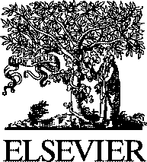Electronic Notes in Theoretical Computer Science

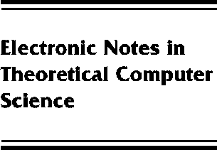[www.elsevier.com/locate/entcs](http://www.elsevier.com/locate/entcs)

Preface

**Volume 59, Issue 1**

Nick Benton and Andrew Kennedy

**Abstract**

This volume contains the proceedings of BABEL’01, the First International Workshop on Multi- Language Infrastructure and Interoperability. Recent years have seen a resurgence of interest in multi-language tools and intermediate languages, and in interoperability between programs and components written in different programming languages. Shared infrastructure such as code generators, analysis tools and garbage collectors can greatly ease the task of producing a high- quality implementation of a new programming language, whilst being able to interoperate easily with code written in existing languages is essential for such an implementation to be useful in practice. The BABEL workshop brought together researchers and developers working on multi- language integration.

BABEL was sponsored by ACM SIGPLAN and took place on September 8th, 2001 as part of PLI’01, the Colloquium on Principles, Logics, and Implementations of High-Level Programming Languages.

The programme committee selected 10 papers from 22 submissions. Each paper was reviewed by three or more committee members or their subreferees.

The members of the BABEL’01 programme committee were:

1571-0661 *⃝*c Elsevier B.V. Open access under [CC BY-NC-ND license](http://creativecommons.org/licenses/by-nc-nd/3.0/).

10.1016/S1571-0661(05)80448-7