[Egyptian Journal of Basic and Applied Sciences 5 (2018) 191–196](https://doi.org/10.1016/j.ejbas.2018.06.001)

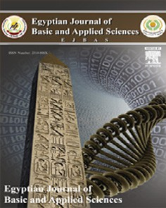

Contents lists available at [ScienceDirect](http://www.sciencedirect.com/science/journal/2314808X)

Egyptian Journal of Basic and Applied Sciences

journal homepage: [www.elsevier.com/locate/ejbas](http://www.elsevier.com/locate/ejbas)

[](http://crossmark.crossref.org/dialog/?doi=10.1016/j.ejbas.2018.06.001&domain=pdf)Protective effect of Spirulina against cyclophosphamide-induced urotoxicity in mice

Fatma M. Eltantawy a,⇑, Mohamed A. Ali Sobh a,b, Ahmed M. EL-Waseef c, Rehab-Allah A. Ibrahim d,

Mohamed A.A. Saad b,e

a *Urology and Nephrology Center, Mansoura University, Mansoura 35511, Egypt*

b *Medical and Experimental Research Center, Faculty of Medicine, Mansoura University, Mansoura 35511, Egypt*

c *Department of Chemistry/Biochemistry, Faculty of Science, Mansoura University, Mansoura 35511, Egypt*

d *Department of Pathology, Faculty of Medicine, Mansoura University, Mansoura 35511, Egypt*

e *Department of Pharmacology, Faculty of Medicine, Mansoura University, Mansoura 35511, Egypt*

# a r t i c l e i n f o

*Article history:*

Received 15 March 2018

Received in revised form 10 June 2018 Accepted 13 June 2018

Available online 27 June 2018

*Keywords:* Cyclophosphamide Spirulina Hemorrhagic cystitis Malondialdehyde Glutathione

Mice

# a b s t r a c t

Cyclophosphamide (CP) is an anti-neoplastic drug, which is widely used for treating cancer and non- malignant tumors. One of the major side effects of CP is hemorrhagic cystitis. Spirulina (*Arthrospira platensis*; Sp) is a blue-green algae with the ability to attenuate oxidative stress, which may be utilized for alleviating side effects of chemotherapeutic drugs in the clinic. The aim of the present study was to evaluate the ability of *Sp*, to protect mice from cyclophosphamide-induced urotoxicity and hemorrhagic cystitis due to its antioxidant properties. Adult female mice were orally administered Sp (600 g/kg body weight/day) over nine days as well as a single dose of CP (40 mg/kg body weight) intraperitoneally either four days previously (CP + Sp group) or four days after the start of Sp intake (Sp + CP group); two further groups were treated with either Sp or CP only, respectively. The results showed that CP induced hemor- rhagic cystitis in mice, with levels of malondialdehyde (MAD) significantly increased and those of glutathione (GSH) decreased compared with the control group (*P* < 0.05), while the opposite effects were observed in the mice who received Sp only (*P* < 0.05). Furthermore, in the CP + Sp group, MAD and GSH levels were improved compared with those in the CP only group, and in the Sp + CP group, the effects of CP were reversed. In addition, histomorphological alterations of the urinary bladder were significantly lower than those in the CP group. In conclusion, pre-treatment with Sp protected mice from CP-induced urotoxicity, probably via its anti-oxidant and anti-apoptotic properties.

© 2018 Mansoura University. Production and hosting by Elsevier B.V. This is an open access article under

the CC BY-NC-ND license (<http://creativecommons.org/licenses/by-nc-nd/4.0/>).

Introduction

CyclophoSphamide (CP) has been used in the treatment of cer- tain types of cancer (lymphoma, leukemia and multiple myeloma) and non-malignant diseases such as rheumatoid arthritis [1]. How- ever, CP has numerous adverse effects, a major one being hemor- rhagic cystitis (HC), which arises from acute inflammation of the urinary bladder [2,3]. Acrolein, a metabolic product of CP, rapidly reacts at numerous cellular sites and depletes cellular antioxidants [4]. It can also react with certain protein residues and nucleophilic sites of the DNA [5].

In addition, CP has been identified as an initiator of lipid perox- idation [6]. Acrolein, the metabolic product of CP, is a reactive and relatively electrophilic compound, and its high toxicity is

* Corresponding author at: Urology and Nephrology Center, Faculty of Medicine, Mansoura University, El Gomhouria St., Mansoura 35511, Egypt.

*E-mail address:* [fatma_201014@yahoo.com](mailto:fatma_201014@yahoo.com) (F.M. Eltantawy).

associated with its ability to rapidly enter the uroepithelium due to its chemical nature as an un-saturated aldehyde as well as to increase the production of reactive oxygen Species (ROS) in the

bladder epithelium [7]. Numerous studies have used anti- oxidants, including a-tocopherol, b-carotene and melatonin [8,9], as protective agents against CP-induced bladder damage with the elimination of the urotoxicity of CP improving the tolerability of

the drug [1].

Spirulina (Sp; *ArthroSpira platensis*) is a photosynthetic cyanobacterium that possesses biological activity and is widely cultivated for the production of nutritional supplements [10]. Sp has also gained increasing attention from medical scientists as a nutraceutical and source of potential pharmaceuticals. Indeed, numerous active components of Sp, including phycocyanins, tocopherols, b-carotenes and phenolic compounds exhibit antioxi- dant properties [11]. Sp is rich in fatty acids (linoleic acid, F-linolenic acid and palmitic acid), essential amino acids, selenium (Se) and vitamins A–E [12].

<https://doi.org/10.1016/j.ejbas.2018.06.001>

2314-808X/© 2018 Mansoura University. Production and hosting by Elsevier B.V.

This is an open access article under the CC BY-NC-ND license (<http://creativecommons.org/licenses/by-nc-nd/4.0/>).

Malondialdehyde (MDA) is formed as a product of free oxygen radicals during oxidative degeneration of lipids [13] and serves as an indicator of oxidative stress [14]. Studies have shown that ROS have an important role in CP-induced HC [3,2].

Biological systems possess numerous biomolecular agents to protect themselves from damage through free radicals. Glu- tathione (GSH) is the most abundant intracellular thiol-based anti-oxidant and has an important role in the cellular defense cas- cade against oxidative injury [15]. GSH, a cofactor for glutathione peroxidase, catalyzes the reduction of hydrogen peroxide to oxy- gen and water, thereby limiting the formation of hydroxyl radicals, which are highly toxic ROS [16].

The activities of enzyme as antioxidant are dependent on cer- tain metalloenzymes, which in turn require trace elements, micro-nutrients present at very low concentrations (lg/dl) in bodily fluids, to function effectively [17]. Zinc (Zn) and selenium

(Se) are examples of trace elements that we include them in our study.

The aim of the present study was to demonstrate, biochemically as well as histopathologically, the toxic effects of CP on the bladder and to assess the capacity of Sp extract to alleviate this side effect.

Materials and methods

*Animals*

A total of 50 female BALB/C mice (age, 6 weeks; weight, 25–30 g) were obtained from the Animal Resources Unit of the Medical Experimental Research Center (MERC), Faculty of Medicine, Man- soura University (Mansoura, Egypt). The mice were kept under a 12-h light/dark cycle in clean plastic cages with free access to food (standard mouse pellet diet) and water *ad libitum*. The humidity was kept at 55 ± 10% and the temperature was controlled at

23 ± 1 °C.

All experiments using animals were performed according to the protocol approved by the Intuitional Animal Care and Use Commit- tee at Mansoura University.

*Drugs and agents*

CP (Endoxa) was purchased from Baxter Oncology Chemical Co. (Egypt) and dissolved in 0.9% NaCl solution to prepare a stock solu- tion, which was intraperitoneally (i.p.) injected into the mice. Sp was provided as a fine dark blue-green powder by the Botany Department Faculty of Science Zagazig University (Zagazig, Egypt) and was dissolved in sterile distilled water to prepare a stock solu- tion which was orally administered to mice using intragastric gavage.

*Experimental design*

Mice were allocated to five groups (10 mice in each) as follows:

All mice were sacrificed at the end of the 9 days. Blood samples of mice from each group were collected by cardiac puncture on the day of termination. Whole blood was withdrawn from each mouse, 2 ml of which were mixed with ethylenediaminetetraacetic acid for complete blood count using automatic hematology analyzer (Sysmex Corp., Kobe, Japan), and the remaining blood was left to stand in a plain tube for preparation of serum from clotted blood by centrifugation at 2000 rpm for 5 min. Serum was divided into

two aliquots and immediately frozen at —70 °C for later assess-

ment of MDA and GSH by ELISA (Calbiotech, Spring Valley, CA, USA; R&D Systems, Minneapolis, MN, USA) and Zn and Se were estimated using atomic absorption Spectroscopy [18].

*Histological analysis*

Following fixing in 10% formalin and embedding in paraffin, tis- sues were cut into 5-lm sections, mounted on slides and stained with hematoxylin-eosin (H-E) to visualize the general structure of the urinary bladder. The severity of bladder damage was

assessed depending on the following phenomena: Edema, hemor- rhage, desquamation of epithelial cells and destruction of smooth muscle cells.

*Statistical analysis*

Differences within groups were analyzed by one-way analysis of variance with SPSS software (version 10; SPSS Inc., Chicago, IL, USA). P < 0.05 was considered to indicate a statistically significant difference. Mean ± standard deviation values were calculated for each group to determine the significance of inter-group differences.

Results

*Sp inhibits CP-induced oxidative stress in mice*

At the end of the experiment (day 9), the serum MDA levels in the CP group were significantly higher than those in the control group, while those in the Sp group were significantly lower than those in the CP group (P < 0.05). Furthermore, serum GSH levels in the Sp group were significantly elevated, while those in the CP group were significantly reduced compared with those in the con- trol group (P < 0.05) (Table 1).

*Sp attenuates Cp-induced reduction of Zn and Se levels in mice*

Administration of CP alone caused a significant drop in the serum levels of Zn and Se of the mice (P < 0.05). By contrast, treat- ment with Sp alone significantly elevated the serum levels of Zn and Se (Table 1). Ingestion of Sp (600 mg/kg) after CP significantly improved the lowered levels of Zn and Se compared with those in the CP group; however, they remained below their correSponding control levels. Administration of Sp prior to CP caused further

|  |  |  |
| --- | --- | --- |
| Group 1 | The negative control (C) group | animals received one i.p. injection of 0.5 ml saline. |
| Group 2 | The positive control (CP) group | mice received an i.p. injection of CP dissolved in 0.5 ml saline at a dose of 40 mg/kg body |
|  |  | weight. |
| Group 3 | Sp group | mice received an oral dose of Sp of 600 mg/kg body weight in 0.5 ml water for nine |
|  |  | successive days. |
| Group 4 | treatment group (CP + Sp) | mice were treated as in the CP group, and from day four after CP injection, mice were |
|  |  | administered Sp at a dose of 600 mg/kg body weight. |
| Group 5 | prophylactic group (Sp + CP) | mice were treated as in the Sp group for 9 days and were given one i.p. injection of CP |
|  |  | (40 mg/kg body weight) on day four after the first dose of Sp. |

Table 1

Serum MDA, GSH, Se and Zn levels in the experimental groups at day 9.

|  |  |  |  |  |
| --- | --- | --- | --- | --- |
| Group | GSH (mg/dl) | MDA (nM/ml) | Se (mg/ml) | Zn (mg/ml) |
| Control | 4.65 ± 0.12 | 0.68 ± 0.02 | 0.15 ± 0.007 | 1.46 ± 0.07 |
| CP | 2.25 ± 0.06a | 4.51 ± 0.12a | 0.11 ± 0.005a | 1.13 ± 0.023a |
| Sp | 8.62 ± 0.08b | 0.42 ± 0.04b | 0.22 ± 0.007b | 1.64 ± 0.1b |
| CP + Sp group | 3.75 ± 0.21 | 2.14 ± 0.20b | 0.13 ± 0.006b | 1.0 ± 0.07b |
| Sp + CP group | 5.85 ± 0.18b | 0.54 ± 0.04b | 0.145 ± 0.01b | 1.3 ± 0.06b |

a *P* < 0.05 vs. control group.

b *P* < 0.05, compared with CP group. Groups: Control, i.p. injection of saline on day 1; CP, CP (40 mg/kg, i.p.) on day 1; Sp, Sp (600 mg/kg, p.o.) for 9 days; CP + Sp, CP (40 mg/ kg, i.p.) on day 1 and Sp (600 mg/kg/day, p.o.) from days 4–9; Sp + Cp, Sp (600 mg/kg/day, p.o.) from days 1–9 and CP (40 mg/kg, i.p.) on day 4. Values are expressed as the mean ± standard deviation (n = 10). MDA, malondialdehyde; GSH, glutathione; Zn, Zinc; Se, selenium; Sp, Spirulina; CP, cyclophoSphamide; i.p., intraperitoneal; p.o., per os.

elevations in serum Zn and Se levels, while they were still slightly below their correSponding control levels (Table 1).

*Sp reduces or prevents CP-induced reduction of hematological parameters in mice*

Laboratory analysis of the blood of the mice on day 9 revealed that the red blood cell count (RBCs), hemoglobin (Hb) concentra- tion, platelet count and white blood cell count (WBCs) in CP- treated mice were all significantly reduced in comparison with those in the control mice (P < 0.05) (Table 2). Oral administration of Sp at 600 mg/kg in mice previously injected with CP significantly improved the platelet count and WBCs as well as the Hb concentra- tion, while the RBC count was not significantly affected. Further- more, if Sp was administered prior to CP, the improvement in the four hematological parameters was more significant and their levels nearly approached the control levels.

However, four hematological parameters did not significantly affect by administration of Sp only when compared with those in the control mice (Table 2).

*Sp prevents CP-induced damage to bladder tissues of mice*

Histopathological analysis revealed that the damage to the uri- nary bladder in the CP group was highest among all groups. Of note, in the SP + CP group, the damage was reduced compared with that in the CP group. In the control and Sp groups, the structure of the bladder tissues was normal. The normal urinary bladder wall was composed of the urothelium formed by firmly stuffed transi- tional cells showing the superficial umbrella cells with minimal intercellular Space. The basement membrane which separates the epithelium from the underlying lamina propria was intact. The mucosa was thrown into folds and there was no exudate in the lumen (Fig. 1A and B).

Table 2

Hematological parameters in each experimental group.

Group RBCs (106/ll) Hb (g/dl) Platelets (103/ll) WBCs (103/ll) Control 9.90 ± 0.21 14.91 ± 0.32 1012 ± 56 8.90 ± 0.60

CP 8.10 ± 0.46a 9.30 ± 0.31a 493 ± 52.3a 4.30 ± 0.53a

Sp 10.0 ± 0.20b 15.60 ± 0.35b 1007 ± 42b 9.20 ± 0.51b CP + Sp 8.30 ± 0.40b 10.91 ± 0.61b 591 ± 50.41b 6.50 ± 0.24b Sp + CP 9.2 ± 0.41b 12.9 ± 0.70b 794 ± 52.3b 7.31 ± 0.37b

a *P* < 0.001 vs. control group.

b P < 0.001 vs. CP group. Groups: Control, i.p injection of saline on day 1; CP, CP (40 mg/kg, i.p.) on day 1; Sp, Sp (600 mg/kg, p.o.) for 9 days; CP + Sp, CP (40 mg/kg, i.p.) on day 1 and Sp (600 mg/kg/day, p.o.) from days 4–9; Sp + Cp, Sp (600 mg/kg/day, p.o.) from days 1–9 and CP (40 mg/kg, i.p.) on day 4. Values are expressed as the mean ± standard deviation (n = 10). RBCs, red blood cells; WBC, total white blood cell count, Hb, hemoglobin; Sp, Spirulina; CP, cyclophoSphamide; i.p., intraperitoneal; p.o., per os.

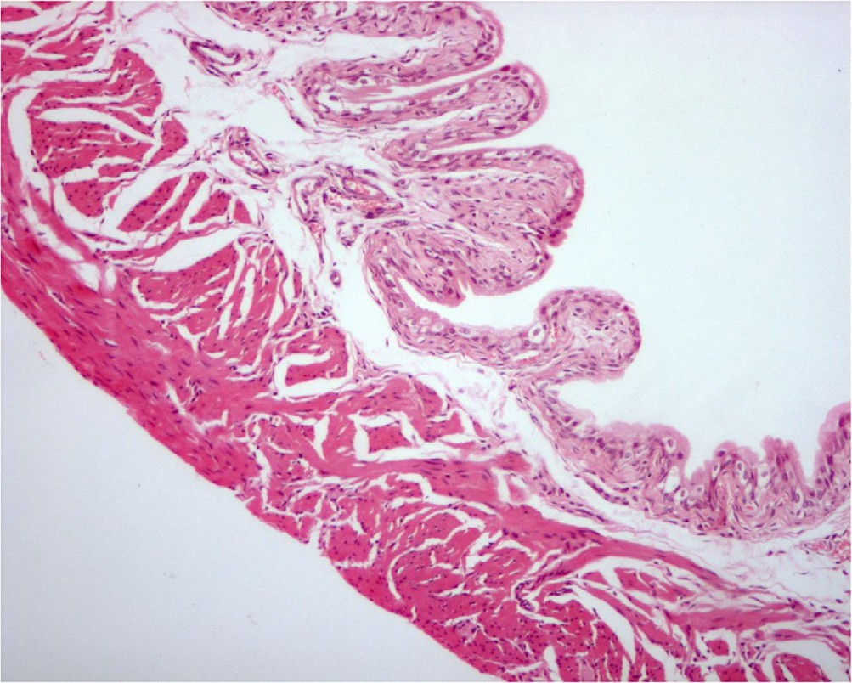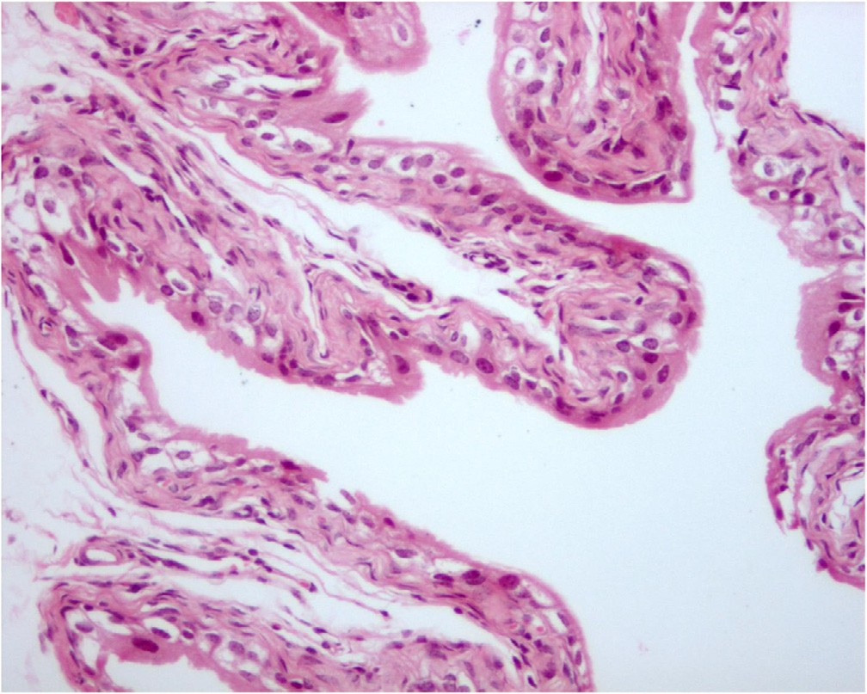

Fig. 1a. A urinary bladder in a mice received only saline showing normal structure (Hx&Ex100).

Fig. 1b. A urinary bladder from a mice received Spirulina only showing normal mucosa of the urinary bladder (Hx&Ex200).

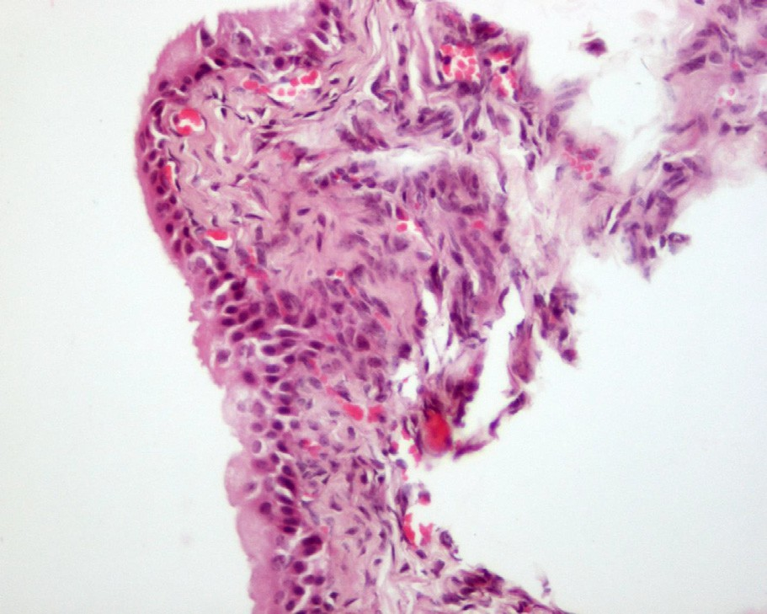 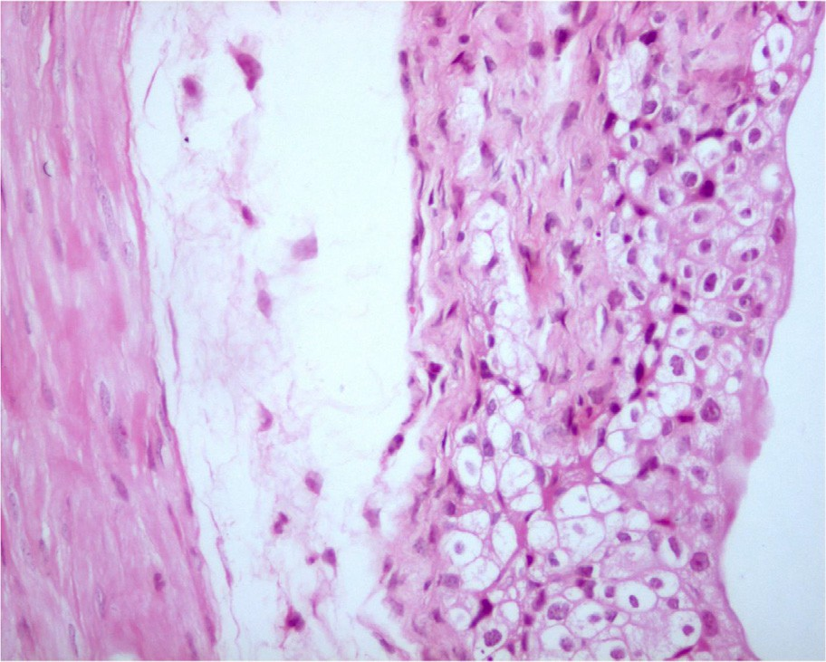

Fig. 2a. A urinary bladder from a mice received only cyclophoSphamide showing interstitial haemorrhage (Hx&Ex200).

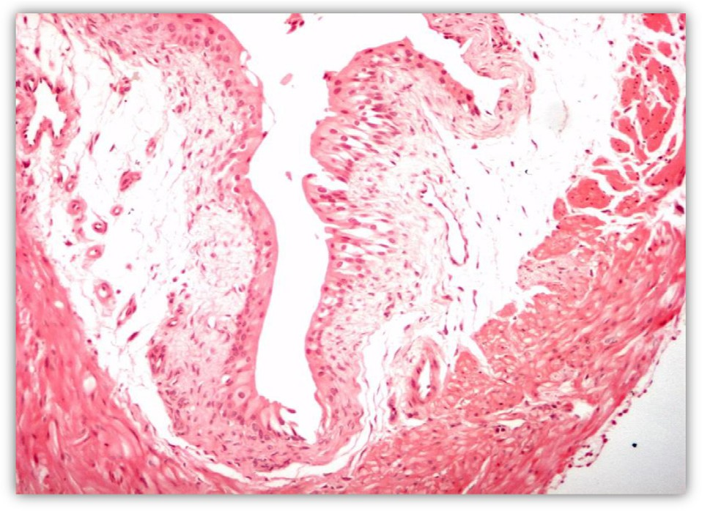

Fig. 2b. A urinary bladder from a mice received only cyclophoSphamide showing marked edema and epithelial desquamation (Hx&Ex200).

By contrast, the bladder wall in CP-treated animals showed sev- ere damage with desquamation of the surface epithelium. Marked edema in the lamina propria and cloudy swelling of the epithelial cells were observed, as well as inflammation in the mucosal and the sub-urothelial connective tissues of the urinary bladder, lead- ing to vascular damage and subsequent bleeding followed by for- mation of granulation tissue (Fig. 2A–D).

In the group administered SP after CP injection, the bladder walls in most mice showed was normal (Fig. 3A); however, certain mice showed partially desquamated epithelium (Fig. 3B). Others showed enlarged hyperchromatic nuclei of the transitional cells and hyperplasia of the basal cells, which indicates attempts of repair (Fig. 3C and D).

In the Sp pre-treatment group, the urinary bladder showed a normal structure without any histopathological changes (Fig. 4).

Discussion

CP belongs to a class of alkylating agents known as nitrogen mustard derivatives. It is a common immunosuppressive and chemotherapeutic agent used for the treatment of certain autoim- mune diseases and a wide range of neoplasms, also in combination with other drugs [19]. In patients receiving CP for the treatment of solid tumors, leukemia or lymphomas or for conditioning prior to bone marrow or stem cell tranSplantation, side effects are well known.

Fig. 2c. A urinary bladder from a mice received only cyclophoSphamide showing marked edema and cloudy swelling of the epithelial cells (Hx&Ex200).

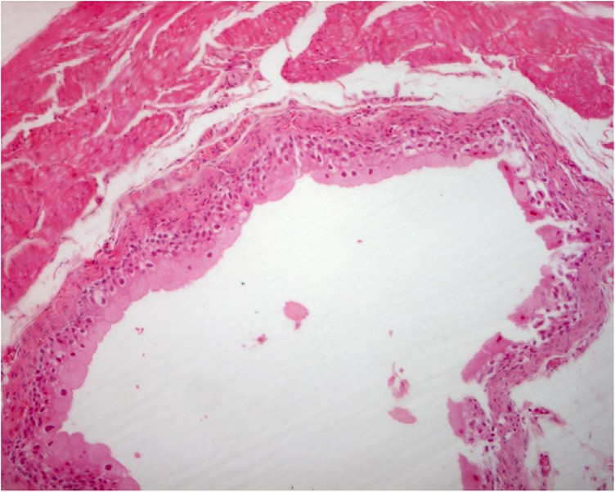

Fig. 3a. A urinary bladder in a mice received cyclophoSpamide followed by Spirulina showing normal structure (Hx&Ex200).

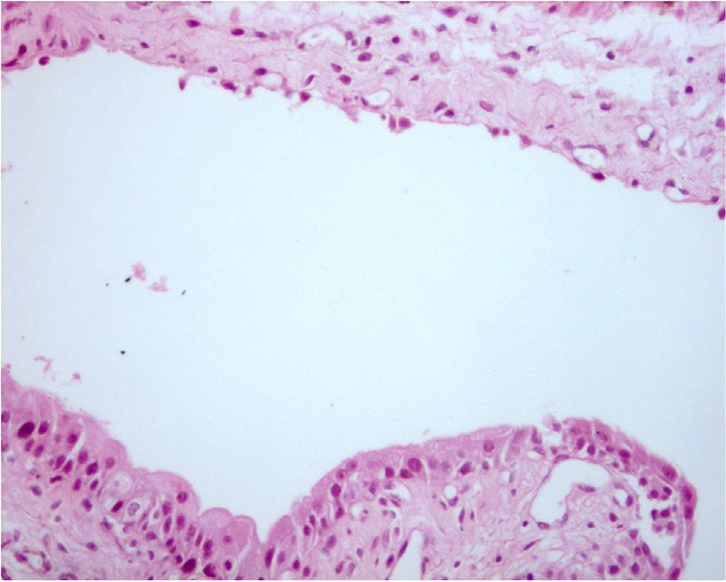

Fig. 3b. A urinary bladder in a mice received cyclophoSpamide followed by Spirulina showing desquamated epithelial cells.

CP is one of the most damaging alkylating agents that can cause oxidative stress due to the over-production of ROS [19,20,7]. It affects the DNA of replicating and rapidly multiplying cells partic- ularly in the gonads and pituitary, which results in miscoding, crosslinking and DNA breakage by transferring alkyl groups to the guanine components of DNA [21]. A potential approach to interfere with CP-induced toxicity is to lower the induced oxida- tive stress.

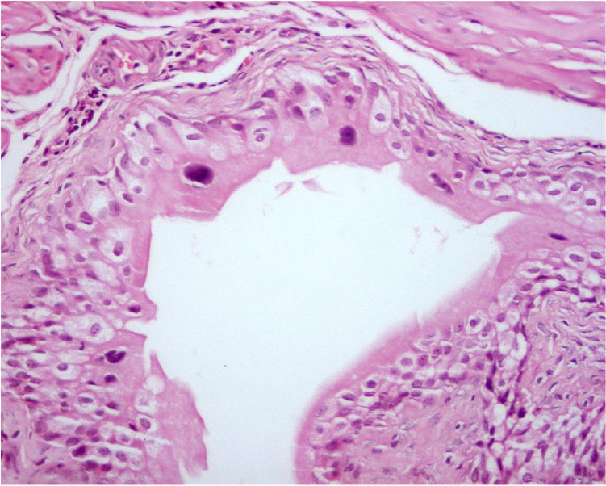

Fig. 3c. A urinary bladder in a mice received cyclophoSphamid followed by Spirulina showing epithelial cells with large hyperchromatic nuclei which suggest attempt for healing (H&Ex200).

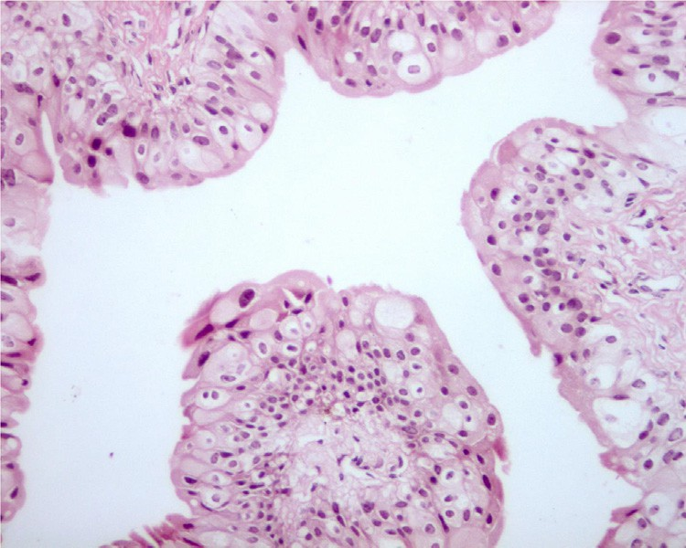

Fig. 3d. A urinary bladder in a mice received cyclophoSphamid followed by Spirulina showing epithelial cells with large hyperchromatic nuclei which suggest attempt for healing (H&Ex200).

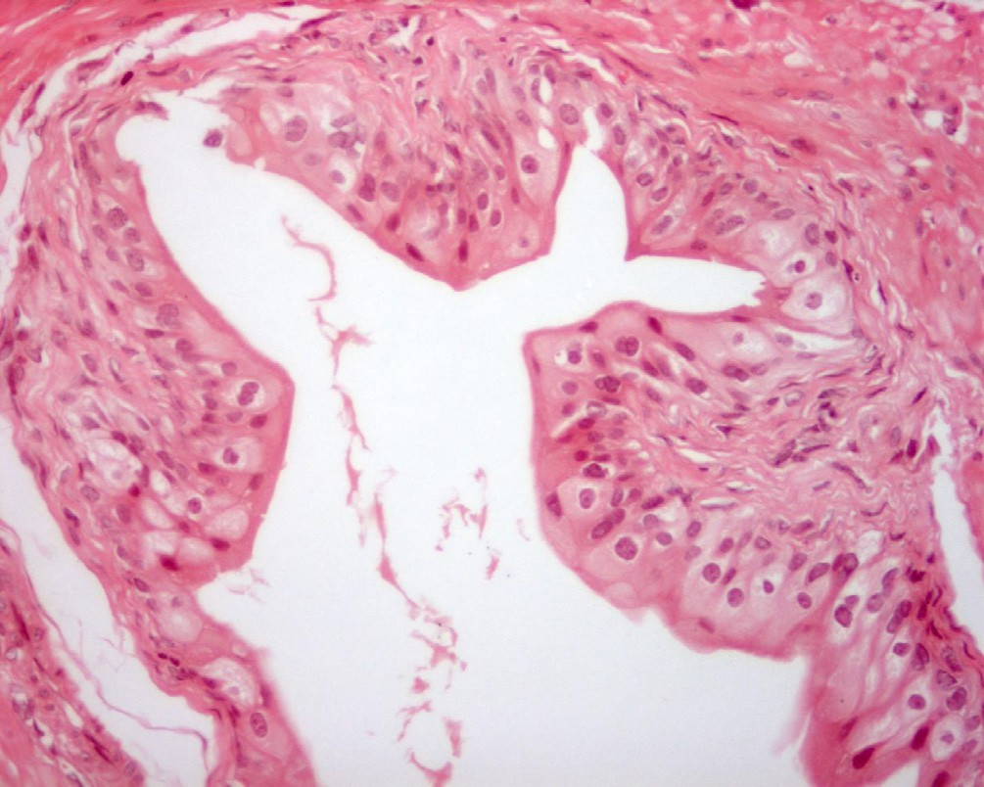

Fig. 4. A urinary bladder from a mice received Spirulina before cyclophoSphamide showing normal structure without histopathological changes (Hx&Ex200).

Acrolein is a metabolic product of CP and its effects on tubular and urinary bladder epithelium are the first manifestation of CP- induced toxicity in addition to the excessive generation of free oxy- gen radicals through the principal alkylating metabolite of CP,

intracellular phoSphoramide mustard [22–24]. The tolerance of CP can be improved by eliminating its side effects to achieve a more proficient treatment for patients requiring CP treatment.

Sp is one of the most widely used herbal medicines for the treatment of various diseases. The pharmacological properties of Sp have been reported to include anti-inflammatory, anti-cancer, anti-diabetic, anti-microbial, anti-histaminic, anti-infertility and hypotensive effects [25]. Clinical trials have shown that Sp can serve as a supplementary cure for numerous diseases as well as improving immunological function; Sp has also been used in health foods, animal feed and for biochemical products since the 1980s [26].

MDA is an end-product of lipid peroxidation, which is a free radical-mediated process. It may be used as an indicator of oxida- tive stress and increases in the body after administration of CP. MDA resulting from increased lipid peroxidation in aberrantly pro- liferating cells is known to be secreted into the circulating blood, leading to increased MDA levels in cancer patients. In line with these results, the present study showed that MDA levels were increased and that HC and bladder toxicity were induced by CP administration in mice. Sp has multiple active component, includ- ing superoxide dismutase, vitamin E, carotene, chlorophyll, B- complex vitamins and numerous minerals, these components may be accountable for the tissue protective properties of Sp [26]. In addition, C-phycocyanin, a protein-bound pigment found in Sp, prevents renal injury by inhibiting oxalate-mediated lipid peroxidation [27]. Furthermore, it inhibits apoptotic death of pan- creatic cells by enhancing the GSH and SOD peroxidase enzymes to prevent the overproduction of ROS [28].

The present study revealed that after CP treatment, MDA, an indicator of oxidative stress, was markedly increased in urinary bladders mice, suggesting that it caused oxidative damage to the proteins and lipids in this organ. In the Sp + CP group, MDA levels were significantly lower than those in the CP group but were not significantly different from those in the control group (P > 0.05). It was therefore indicated that pre-treatment with Sp prevented CP-induced elevation of MDA.

Increases in the levels of anti-oxidant enzyme GSH in mice trea- ted with Sp indicated it is protective effects by enhancing the cells’ anti-oxidant capacity. While GSH was significantly reduced follow- ing CP treatment, GSH levels in the CP + Sp group were compara- tively higher and those in the Sp + CP group were even higher (P < 0.05). Therefore, Sp was indicated to be a potent inhibitor of CP-induced lipid peroxide formation.

The protective effects of Sp against CP-induced acute urotoxic- ity in mice are associated with its anti-oxidant properties. More- over, the protective effects of Sp may be due to a decrease in oxidative stress via reduction of the accumulation of protein- acrolein adducts. This can be explained by the free radical scaveng- ing properties of the Sp. CP-induced histopathological changes in the urinary bladder were observed to be prevented by pre- treatment with Sp [29].

Zn and Se have a vital role in numerous physiological processes, including the function of the immune system, and the develop- ment and healing of inflammatory tissue lesions. Se has been shown to have a positive effect on the outcome of cancer and infec- tious diseases [30], whereas a deficiency of Zn may negatively affect the immune system and cell growth. In the present study, Sp ingestion increased the concentration of Zn and Se in the blood of mice compared with that in CP-treated mice, indicating that supplementation with Se and Zn contained in Sp may have a role in alleviating CP-associated toxicity.

The present study revealed that RBCs, Hb, WBCs and platelets were significantly decreased in mice receiving CP. These findings were in agreement with those of other studies, which reported that CP induces leukopenia in mice [31]. The anemia found in

CP-treated mice may be of the type caused by chronic disease; however, other causes include autoimmune hemolytic anemia, iron deficiency anemia, anemia of chronic renal failure and CP- associated myelotoxicity. Thrombocytopenia occurs in CP-treated mice and it is part of a broader hematological disturbance. In the present study, all of these disturbances of hematological parame- ters were alleviated by Sp treatment, since Hb, RBCs, WBCs and platelet count were increased compared to those in CP-treated mice. These findings are in good agreement with the result of a previous study, which reported that Sp supplementation in drink- ing water for 30 days induced significant increases of RBCs and Hb in rats [32]. It was also found that disturbances of hematological parameters were attenuated to a greater extent if Sp was given prior to CP rather than thereafter, which indicates that Sp may have a marked effect on the process of erythropoiesis. However, Sp treatment alone did not significantly affect any of these hema- tological parameters compared to those in the control group.

These findings suggested that Sp may also protect against toxi- city induced by other chemotherapeutic agents whose mecha- nisms of action are similar to that of CP. Finally, chronic CP-associated urotoxicity may be alleviated by Sp. The combina- tion of CP with a potent anti-oxidant may be appropriate to reduce its urotoxicity, which was supported by the results of the present study on the treatment of CP-induced mice with Sp.

The positive effects of Spirulina in allergic rhinitis are based on adequate evidence but larger trials are required. It is believed that the anticancer effects of Spirulina are perhaps derived from b- carotene, a known antioxidant; however, the link between b- carotene level and carcinogenesis cannot be established as the etiology of carcinoma is frequently multifactorial [33,34]. There are some positive studies on the cholesterol-lowering effects of Spirulina but larger studies are required before any definitive con- clusions can be made. Finally, there are no high-level evidence tri- als on the role played by Spirulina in chronic fatigue and in antiviral applications. At the moment, what the literature suggests is that Spirulina is a safe food supplement without significant side- effects but its role as a drug remains to be seen.

CP treatment is associated with an increased risk of HC and bladder cancer, while the effectiveness of Sp in preventing cystitis is largely based on its anti-oxidant properties. In the present study, the anti-oxidants GSH, Zn and Se were significantly reduced in CP- treated but elevated in Sp-treated mice; however, CP caused an elevation of MDA levels as well as severe damage to the urinary bladder. The present study showed that Sp protected from CP- induced urotoxicity and hemorrhagic cystitis, probably due to its anti-oxidant and anti-apoptotic properties. Thus, Sp can be recom- mended as a food supplement to alleviate the side effects of numerous drugs and to stimulate the immune system of drugs users.

Acknowledgements

The authors would like to thank all of the staff of the MERC of Mansoura University.

References

1. [Dollery C. CyclophoSphamide. In: Dollery C, editor. Therapeutic](http://refhub.elsevier.com/S2314-808X(18)30139-8/h0005) [drugs. Edinburg: Churchill Livingstone; 1999. p. 349–53](http://refhub.elsevier.com/S2314-808X(18)30139-8/h0005).
2. [Wong TM, Yeo W, Chan LW, Mok TS. Hemorrhagic pyelitis, ureteritis, and](http://refhub.elsevier.com/S2314-808X(18)30139-8/h0010) [cystitis secondary to cyclophoSphamide: case report and review of literature.](http://refhub.elsevier.com/S2314-808X(18)30139-8/h0010) [GynecolOncol 2000;76:223–5](http://refhub.elsevier.com/S2314-808X(18)30139-8/h0010).
3. [Walker RD, Sommerkamp H. Hemorrhagic cystitis after high dose](http://refhub.elsevier.com/S2314-808X(18)30139-8/h0015) [chemotherapy. An interdisciplinary problem. Urologie A 1998;37:516–21](http://refhub.elsevier.com/S2314-808X(18)30139-8/h0015).
4. [Ozcan A, Korkmaz A, Oter S, Coskun O. A: contribution of flavonoid](http://refhub.elsevier.com/S2314-808X(18)30139-8/h0020) [antioxidants to the preventive effect of mesna in cyclophoSphamide-induced](http://refhub.elsevier.com/S2314-808X(18)30139-8/h0020) [cystitis in rats. Arch Toxicol 2005;79:461–5](http://refhub.elsevier.com/S2314-808X(18)30139-8/h0020).
5. [Souliotis VL, Dimopoulos MA, S fikakis PP. Gene Specific formation and repair](http://refhub.elsevier.com/S2314-808X(18)30139-8/h0025) [of DNA monoadducts and interstrand cross-links after therapeutic exposure to](http://refhub.elsevier.com/S2314-808X(18)30139-8/h0025) [nitrogen mustards. Clin Cancer Res 2003;9:4465–74](http://refhub.elsevier.com/S2314-808X(18)30139-8/h0025).
6. [Adams JD, Klaidman LK. Acrolein-induced oxygen radical formation. Free Radic](http://refhub.elsevier.com/S2314-808X(18)30139-8/h0030) [Biol Med 1993;15(2):187–93. PMID: 8397144](http://refhub.elsevier.com/S2314-808X(18)30139-8/h0030).
7. [Alenzi FQ, El-Bolkiny YS, Salem ML. Protective effects of Nigella sativa oil and](http://refhub.elsevier.com/S2314-808X(18)30139-8/h0035) [thymoquinone against toxicity induced by the anticancer drug](http://refhub.elsevier.com/S2314-808X(18)30139-8/h0035) [cyclophoSphamide. Br J Biomed Sci 2010;67(1):20–8](http://refhub.elsevier.com/S2314-808X(18)30139-8/h0035).
8. [Sener G, Sehirli O, Yegen BC, Cetinel S, Gedik N, Sakarcan A. Melatonin](http://refhub.elsevier.com/S2314-808X(18)30139-8/h0040) [attenuates ifosfamide-induced Fanconi syndrome in rats. J. Pineal ResAug](http://refhub.elsevier.com/S2314-808X(18)30139-8/h0040) [2004;37(1):17–25. PMID: 15230864](http://refhub.elsevier.com/S2314-808X(18)30139-8/h0040).
9. [Topal T, Oztas Y, Korkmaz A, Sadir S, Oter S, Coskun O. Melatonin ameliorates](http://refhub.elsevier.com/S2314-808X(18)30139-8/h0045) [bladder damage induced by cyclophoSphamide in rats. J Pineal Res 2000;38](http://refhub.elsevier.com/S2314-808X(18)30139-8/h0045)

[(4):272–7. PMID: 15813904](http://refhub.elsevier.com/S2314-808X(18)30139-8/h0045).

1. [Mc Carty MF. Clinical potential of Spirulina as a source of phycocyanobilin. J](http://refhub.elsevier.com/S2314-808X(18)30139-8/h0050) [Med Food 2007;10(4):566–70](http://refhub.elsevier.com/S2314-808X(18)30139-8/h0050).
2. [Heyland DK, Dhaliwal R, Suchner U, Berger MM. Antioxidant nutrients: a](http://refhub.elsevier.com/S2314-808X(18)30139-8/h0055) [systematic review of trace elements and vitamins in the critically ill patient.](http://refhub.elsevier.com/S2314-808X(18)30139-8/h0055) [Intens Care Med 2005;31(3):327–37](http://refhub.elsevier.com/S2314-808X(18)30139-8/h0055).
3. [Dartsch PC. Antioxidant potential of selected Spirulina platensis preparations.](http://refhub.elsevier.com/S2314-808X(18)30139-8/h0060) [Phytother Res 2008;22(5):627–33](http://refhub.elsevier.com/S2314-808X(18)30139-8/h0060).
4. [Neilsen F, Mikkelsen BB, Neilsen JB, Andersen HR, Grandjean P. Plasma](http://refhub.elsevier.com/S2314-808X(18)30139-8/h0065) [malondialdehyde as biomarker for oxidative stress: reference interval and](http://refhub.elsevier.com/S2314-808X(18)30139-8/h0065) [effects of life-style factors. Clin Chemist 1997;47:1209–14](http://refhub.elsevier.com/S2314-808X(18)30139-8/h0065).
5. [Valenzuela A. The biological significance of malondialdehyde determination in](http://refhub.elsevier.com/S2314-808X(18)30139-8/h0070) [the assessment of tissue oxidative stress. Life Sci 1990;48:301–9](http://refhub.elsevier.com/S2314-808X(18)30139-8/h0070).
6. [Jafari M, Salehi M, Ahmadi S, Asgari A, Abasnezhad M, Hajigholamali M. The](http://refhub.elsevier.com/S2314-808X(18)30139-8/h0075) [role of oxidative stress in diazinon-induced tissues tox-icity in Wistar and](http://refhub.elsevier.com/S2314-808X(18)30139-8/h0075) [Norway rats. Toxicol Mech Methods 2012;22:638–47](http://refhub.elsevier.com/S2314-808X(18)30139-8/h0075).
7. [Hsu CH, Chi BC, Liu MY, Li JH, Chen C, J and Chen RY. PhoSphine-induced](http://refhub.elsevier.com/S2314-808X(18)30139-8/h0080) [oxidative damage in rats: role of glutathione. Toxicology 2002;179:1–8](http://refhub.elsevier.com/S2314-808X(18)30139-8/h0080).
8. [Uboh FE, Akpanabiatu MI, Alozie Y. Comparative effects of vitamins A and E on](http://refhub.elsevier.com/S2314-808X(18)30139-8/h0085) [gasoline vapour induced haematotoxicity and weight loss in male rats. Int J](http://refhub.elsevier.com/S2314-808X(18)30139-8/h0085) [Pharmacol 2009;5(3):215–21](http://refhub.elsevier.com/S2314-808X(18)30139-8/h0085).
9. [Mortada WI, Hassanien MM, EL-Asmy AA. Speciation of platinum in blood,](http://refhub.elsevier.com/S2314-808X(18)30139-8/h0090) [plasma and urine by micelle-mediated extraction and graphite furnace atomic](http://refhub.elsevier.com/S2314-808X(18)30139-8/h0090) [absorption Spectrometry. Trace Elem Medb Biol 2013;27:267–72](http://refhub.elsevier.com/S2314-808X(18)30139-8/h0090).
10. Pryor JL, Hughes C, Foster W, Hales BF, Robaire B. Critical windows of exposure for children’s health. Environ. Health PerSp 2000;108(3):491–503.
11. [Mitchell DC, Niu SL, Litman BJ. Enhancement of G protein-coupled signaling by](http://refhub.elsevier.com/S2314-808X(18)30139-8/h0100) [DHA phoSpholipids. Lipids 2003;38:437–43](http://refhub.elsevier.com/S2314-808X(18)30139-8/h0100).
12. [Becker K, Schoneich J. Expression of genetic damage induced by alkylating](http://refhub.elsevier.com/S2314-808X(18)30139-8/h0105) [agents in germ cells of female mice. Mutat Res 1982;92(1–2):447–64](http://refhub.elsevier.com/S2314-808X(18)30139-8/h0105).
13. [Abraham P, Rabi S, Selvakumar D. Protective effect of aminoguanidine against](http://refhub.elsevier.com/S2314-808X(18)30139-8/h0110) [oxidative stress and bladder injury in cyclophoSphamide-induced](http://refhub.elsevier.com/S2314-808X(18)30139-8/h0110) [hemorrhagic cystitis in rat. Cell Biochem Funct 2009;27:56–62](http://refhub.elsevier.com/S2314-808X(18)30139-8/h0110).
14. [Sadir S, Deveci S, Korkmaz A. Alpha tocopherol, beta carotene, and melatonin](http://refhub.elsevier.com/S2314-808X(18)30139-8/h0115) [administration protects cyclophoSphamide induced oxidative damage to](http://refhub.elsevier.com/S2314-808X(18)30139-8/h0115) [bladder tissue in rats. Cell Biochem Funct 2007;25:521–52](http://refhub.elsevier.com/S2314-808X(18)30139-8/h0115).
15. [Asiri YA. Probucol attenuates cyclophoSphamide-induced oxidative apoptosis,](http://refhub.elsevier.com/S2314-808X(18)30139-8/h0120) [p53 and Bax signal expression in rat cardiac tissues. Oxid Med Cell Longev](http://refhub.elsevier.com/S2314-808X(18)30139-8/h0120) [2010;3:308–16](http://refhub.elsevier.com/S2314-808X(18)30139-8/h0120).
16. [Zhi-gang Z, Zhi-li L, Xue-xian L. Study on the isolation, purification and](http://refhub.elsevier.com/S2314-808X(18)30139-8/h0125) [antioxidation properties of polysaccharides from Spirulina maxima. Acta](http://refhub.elsevier.com/S2314-808X(18)30139-8/h0125) [BotanicaSinica 1997;39:77–81](http://refhub.elsevier.com/S2314-808X(18)30139-8/h0125).
17. Becker EW. Microalgae. In: Nutrition. Cambridge: Cambridge University; 1988.

p. 196–249.

1. Schwerdt G, Gordjani N, Benesic A. Chloroacetaldehydeandacrolein-induced death of human proximal tubule cells. PediatrNephrol 2006;21(1):60–7.
2. [Muthuraman P, Senthilkumar R, Srikumar K. Alterations in betaislets of](http://refhub.elsevier.com/S2314-808X(18)30139-8/h0140) [langerhans in alloxan-induced diabetic rats by marine Spirulina platensis. J](http://refhub.elsevier.com/S2314-808X(18)30139-8/h0140) [Enzyme Inhib Med Chem 2009;24(6):1253–6](http://refhub.elsevier.com/S2314-808X(18)30139-8/h0140).
3. [Gey KF. Vitamins E plus C and interacting conutrients required for optimal](http://refhub.elsevier.com/S2314-808X(18)30139-8/h0145) [health. A critical and constructive review of epidemiology and](http://refhub.elsevier.com/S2314-808X(18)30139-8/h0145) [supplementation data regarding cardiovascular disease and cancer.](http://refhub.elsevier.com/S2314-808X(18)30139-8/h0145) [Biofactors Biofactors 1998;7:113–74](http://refhub.elsevier.com/S2314-808X(18)30139-8/h0145).
4. [Rayman MP. Selenium in cancer prevention: a review of the evidence and](http://refhub.elsevier.com/S2314-808X(18)30139-8/h0150) [mechanism of action. ProcNutrSoc 2005;64:527–42](http://refhub.elsevier.com/S2314-808X(18)30139-8/h0150).
5. [Huang GC, Wu LS, Chen LG, Yang LL, Wang CC. Immuno-enhancement effects](http://refhub.elsevier.com/S2314-808X(18)30139-8/h0160) [of Huang Qi Liu Yi Tang in amurine model of cyclophoSphamide-induced](http://refhub.elsevier.com/S2314-808X(18)30139-8/h0160) [leucopenia. J Ethnopharmacol 2007;109:229–35](http://refhub.elsevier.com/S2314-808X(18)30139-8/h0160).
6. [Simsek N, Karadeniz A, Kalkan Y, Keles ON, Unal B. Spirulinaplatensis feeding](http://refhub.elsevier.com/S2314-808X(18)30139-8/h0165) [inhibited the anemia and leucopeniainduced Lead and cadmium in rats. J](http://refhub.elsevier.com/S2314-808X(18)30139-8/h0165) [Hazar Mat 2010;164:1304–9](http://refhub.elsevier.com/S2314-808X(18)30139-8/h0165).
7. [Malila N, Virtamo J, Virtanen M, Pietinen P, Albanes D, Teppo L. Dietary and](http://refhub.elsevier.com/S2314-808X(18)30139-8/h0170) [serum alpha-tocopherol, beta-carotene and retinol, and risk for colorectal](http://refhub.elsevier.com/S2314-808X(18)30139-8/h0170) [cancer in male smokers. Eur J Clin Nutrition 2002;56:615–21](http://refhub.elsevier.com/S2314-808X(18)30139-8/h0170).
8. [Liede K, Hietanen J, Saxen L, Haukka J, Timonen T, Hayrinen-Immonen R, et al.](http://refhub.elsevier.com/S2314-808X(18)30139-8/h0175) [Long-term supplementation with alpha-tocopherol and beta-carotene and](http://refhub.elsevier.com/S2314-808X(18)30139-8/h0175) [prevalence of oral mucosal lesions in smokers. Oral Diseases 1998;4:78–83](http://refhub.elsevier.com/S2314-808X(18)30139-8/h0175).