[Egyptian Informatics Journal 23 (2022) 65–72](https://doi.org/10.1016/j.eij.2021.06.001)

Contents lists available at [ScienceDirect](http://www.sciencedirect.com/science/journal/11108665)

Egyptian Informatics Journal

journal homepage: [www.sciencedirect.com](http://www.sciencedirect.com/)

[](http://crossmark.crossref.org/dialog/?doi=10.1016/j.eij.2021.06.001&domain=pdf)RFID-based location based services framework for alerting on black spots for accident prevention

Wilson Ogutu Ochieng ⇑, Kipruto Wilson Cheruiyot, George Okeyo

*Jomo Kenyatta University of Agriculture and Technology, Kenya*

# a r t i c l e i n f o

*Article history:*

Received 7 December 2020

Revised 21 May 2021

Accepted 9 June 2021

Available online 22 June 2021

*Keywords:* Transportation M-RFID

GPS LBS

Black spot Exposure Likelihood Impact

# a b s t r a c t

The need of developing systems that address traffic matters such as traffic control and accidents has led to the development of a number of techniques, methods and tools to address road usability issues. Many automated models have been proposed and applied in different scenarios such as road oddities. Despite of the advantages of these models the major problem of road accidents continue to pose problem glob- ally. This has created the need to come up with more user-effective approaches to address road accidents. Main objective of this research therefore is to identify and address the gap in Location Based Services (LBS). A model that combines RFID and GPS technology to provide Location Based Services via audio alerts to drivers as they approach black spots is presented. The model provides location based services to dri- vers as they approach black spots causing them to adjust their driving accordingly (i.e. speeding, overtak- ing). Since LBS technologies have different limitations, most researchers have focused on addressing accuracy limitation by proposing hybrid technologies. Accuracy requirement varies depending on appli- cation area. The analysis of the different technologies revealed that in vehicle transportation medium accuracy is effective. This research focused on availability aspect which is a key requirement in LBS. To achieve this a model made up of RFID & GPS is formulated. Higher availability of significant alerts at black spots is registered through simulation as compared to alerts when the technologies are applied sepa- rately. Black spot accidents are therefore managed due to safer driving around black spots. This can lead to reduction in exposure to accidents, likelihood of occurrence and impact in the event of an incident. Usability metrics is used to determine effectiveness of the model.

© 2022 THE AUTHORS. Published by Elsevier B.V. on behalf of Faculty of Computers and Information,

Cairo University. This is an open access article under the CC BY-NC-ND license ([http://creativecommons.](http://creativecommons.org/licenses/by-nc-nd/4.0/)

[org/licenses/by-nc-nd/4.0/](http://creativecommons.org/licenses/by-nc-nd/4.0/)).

1. Introduction

According to Chowdhury, [1] between 3000 and 13 000 Ken- yans lose their lives in road traffic crashes every year. Global status report on road safety by WHO [2] highlighted road traffic deaths at

1.35 million and that it is the leading killer of people aged 5– 29 years. The estimated mean annual fatality rate from road traffic accidents (RTAs) in Kenya stands at 50 deaths per 10 000 registered

* Corresponding author.

*E-mail addresses:* [pewilsonho@gmail.com](mailto:pewilsonho@gmail.com) (W.O. Ochieng), [wilchery68@jkuat.ac.](mailto:wilchery68@jkuat.ac.ke) [ke](mailto:wilchery68@jkuat.ac.ke) (K. Wilson Cheruiyot), [gokeyo@jkuat.ac.ke](mailto:gokeyo@jkuat.ac.ke) (G. Okeyo).

Peer review under responsibility of Faculty of Computers and Information, Cairo University.

**Production and hosting by Elsevier**

vehicles Ogendi et al.[3]. Manyara, [4] reports that in 2011 the WHO estimated that Kenya lost US$4 billion annually due to road traffic fatalities, Given that the GDP in 2012 was $37.23 billion, that means the loss was approximately 11% of the GDP. Mureithi, [5] reports that between January and August 2017, according to Rift Valley regional traffic enforcement records, at least 450 lives had been lost in 664 road crashes in that region and a further 813 peo- ple injured. According to Nyamori, [6] NTSA puts an estimate at 3,000 deaths, with an estimated economic loss of Ksh. 300 billion attached to it annually (5.6 per cent of the country’s GDP). Kelley, [7]. reported that the World Health Organization’s new global sur- vey of road safety reported that 13,463 Kenyans died in 2017 in crashes on the country’s roads — a toll more than four times higher than the government’s figure of 2,965 deaths. Kelley, [7] also reported that Dr. Nhan Tran the WHO’s leading expert on road safety, explained that ‘‘the reported number (2,965) comes from the National Transport and Safety Authority, and the definition that is used is ‘died at the scene of crash’.” ‘‘We know that many

<https://doi.org/10.1016/j.eij.2021.06.001>

1110-8665/© 2022 THE AUTHORS. Published by Elsevier B.V. on behalf of Faculty of Computers and Information, Cairo University. This is an open access article under the CC BY-NC-ND license (<http://creativecommons.org/licenses/by-nc-nd/4.0/>).

more deaths occur after the crash, in the hospital and sometimes many months after the crash,” Dr. Tran added. The statistics on road accidents is an evidence that much needs to be done to man- age the risk of road accidents. The researcher in effort to address this menace presents a model of safety through location based services.

1. Related work

Huang and Gao [8] stated that Location-Based Services (LBS) are mobile applications that provide users with information depending on their location. According to Mohammadi et al. [9] Pull or Push LBS can be used depending on information to be communicated with user.

This section has focused on wireless location based technolo- gies and some of its applications on road transport. Some of the wireless location based technologies are: GPS, RFID, WIFI, and hybrid technologies such as A-GPS, Wi-Fi-GPS.

* 1. *Location based technologies*

According to Yassin et al. [10] the most used technology for out- door LBS is GPS which uses localization techniques such as global system for mobile communications to perform time, angle or power measurements to estimate user position. Ahlawat et al.

1. stated that GPS works in all climates, day and night, and around the world at no cost. Ahlawat et al. [11] and Raper et al.
2. identified hindrances to GPS performance such as trees, build- ings, and climatic conditions e.g. geomagnetic rainstorms. Also when using a battery functioned device for GPS, there could be a battery letdown and you may need some outside power supply which is not always conceivable. Hybrid positioning techniques are proposed to satisfy the need for positioning accuracy hence user satisfaction. For instance, Assisted-GPS uses information from the mobile network to improve positioning accuracy in GPS Yassin and Rachid [13]. However Shek [14] analyzed the features of GPS and A-GPS and observed that the accuracy of GPS is not that differ- ent from that of A-GPS. Another major technology applied in LBS is RFID. RFID is a non-contact and two-way communication technol- ogy which can bring about the automatic ID and data exchange to people and equipment. RFID has a fairly perfect communication protocol with the intimate anti-collision mechanism so that it can identify multiple fast-moving targets concurrently as observed by Ahlawat et al. [11]. According to Ahlawat et al. [11]and Krausz et al. [15] RFID technology does not require tags to be in line of sight with the receiver to be read and tags can store a lot of statis- tics, can follow commands, the read/write capability can determine position. However Gaukler and Seifert [16] noted that there could be some natural limitations to the use of RFID. According to the laws of physics metals and liquids can block the radio waves, inter- ference issues between readers may exist that prevent tags from being read or RFID can be defective. Other technologies exist and have specific application areas. Hybrid technologies have been used to overcome limitations on non-hybrid wireless technologies. A lot of literature has been done on this and is available online.

From the technologies analyzed much has been done to address accuracy needs in location positioning services. However Raper et al. [12] observed that availability of a geo-positioning capability is a vital performance parameter for LBS and perhaps more than positioning accuracy and Lekakos et al. [17]observed that in out- door vehicle transport medium accuracy is adequate. Hence the need to address availability of relevant information to drivers par- ticularly as they interact with black spots.

* 1. *Approaches in transport management*

In Nejati [18] a system that can record traffic violations and dis- patch them to police central server in real time using RFID and M- RFID was presented. The design was based on no overtaking and speed limit traffic signs while Mohammed Ahmed [19] designed a system for collision avoidance by using RFID. The system has a collision warning capabilities hence minimizing accidents, like car crushing, hit and run by forcing the car to stop before the acci- dent or giving a buzz to the people to avoid the accident. In Alpana et al. [20] RFID technology has been integrated with Software- Defined Networking (SDN) developing a solution architecture for locating, tracking and informing the authority in the right time when accidents are detected. SDN enabled them to achieve visual sharing which would be useful in case of getting accident claims. Benjamin et al. [21] developed an in-vehicle decision support sys- tem (DSS) as a native Android Application for drivers to provide contextual warnings on up-coming historically hazardous loca- tions in form of visual based warnings. The system however couldn’t confirm an immediate effect of warnings on driver behav- ior and its accuracy is dependent on effectiveness of GSM. Muba- shir and Chowdhury [22] developed system that alerts and controls the speed of a vehicle using smart brakes and notifies indi- viduals using GPS when an accident occurs while Vaibhav et al.

[23] have developed system to prevent accidents by alerting the driver using LED light which glows when vehicle approaches a curve by using ultrasonic sensor and in case of accident an alert message is transmitted via GSM and GPS modules.

1. Methodology
   1. *Problem statement*

The rate of fatal road accidents in Kenya and globally has remained high and the effects to the community and to the econ- omy is unbearable hence the need to address the situation. A num- ber of wireless technologies have therefore been used to address road transport matters such as traffic light, recognition of road signs and so on. Technologies available for use have merits and demerits. Researches on location based service have been focused on addressing accuracy requirements which is dependent on appli- cation area. On road transport high availability is core as compared to high accuracy. Hence the need to address availability parameter in location based services in order to achieve safety objective and reduction of fatal road accidents.

* 1. *Research objective.*

To formulate a framework for accident prevention through alerts using location based technology (GPS/RFID) and evaluate the effectiveness of the framework.

* 1. *Major causes of fatal road accidents*

Analysis of causes for Road Traffic Accidents by Maloney [24] and also analysis by NTSA [25] shows that mostly road accidents occur due to one or more of the following factors: losing control, over speeding, overtaking, untraced causes as shown in Fig. 3.1.

* 1. *Requirements*

This research to achieve its objective will require these tech- nologies: RFID, GPS and LBS (Push technology) approach. OR logic

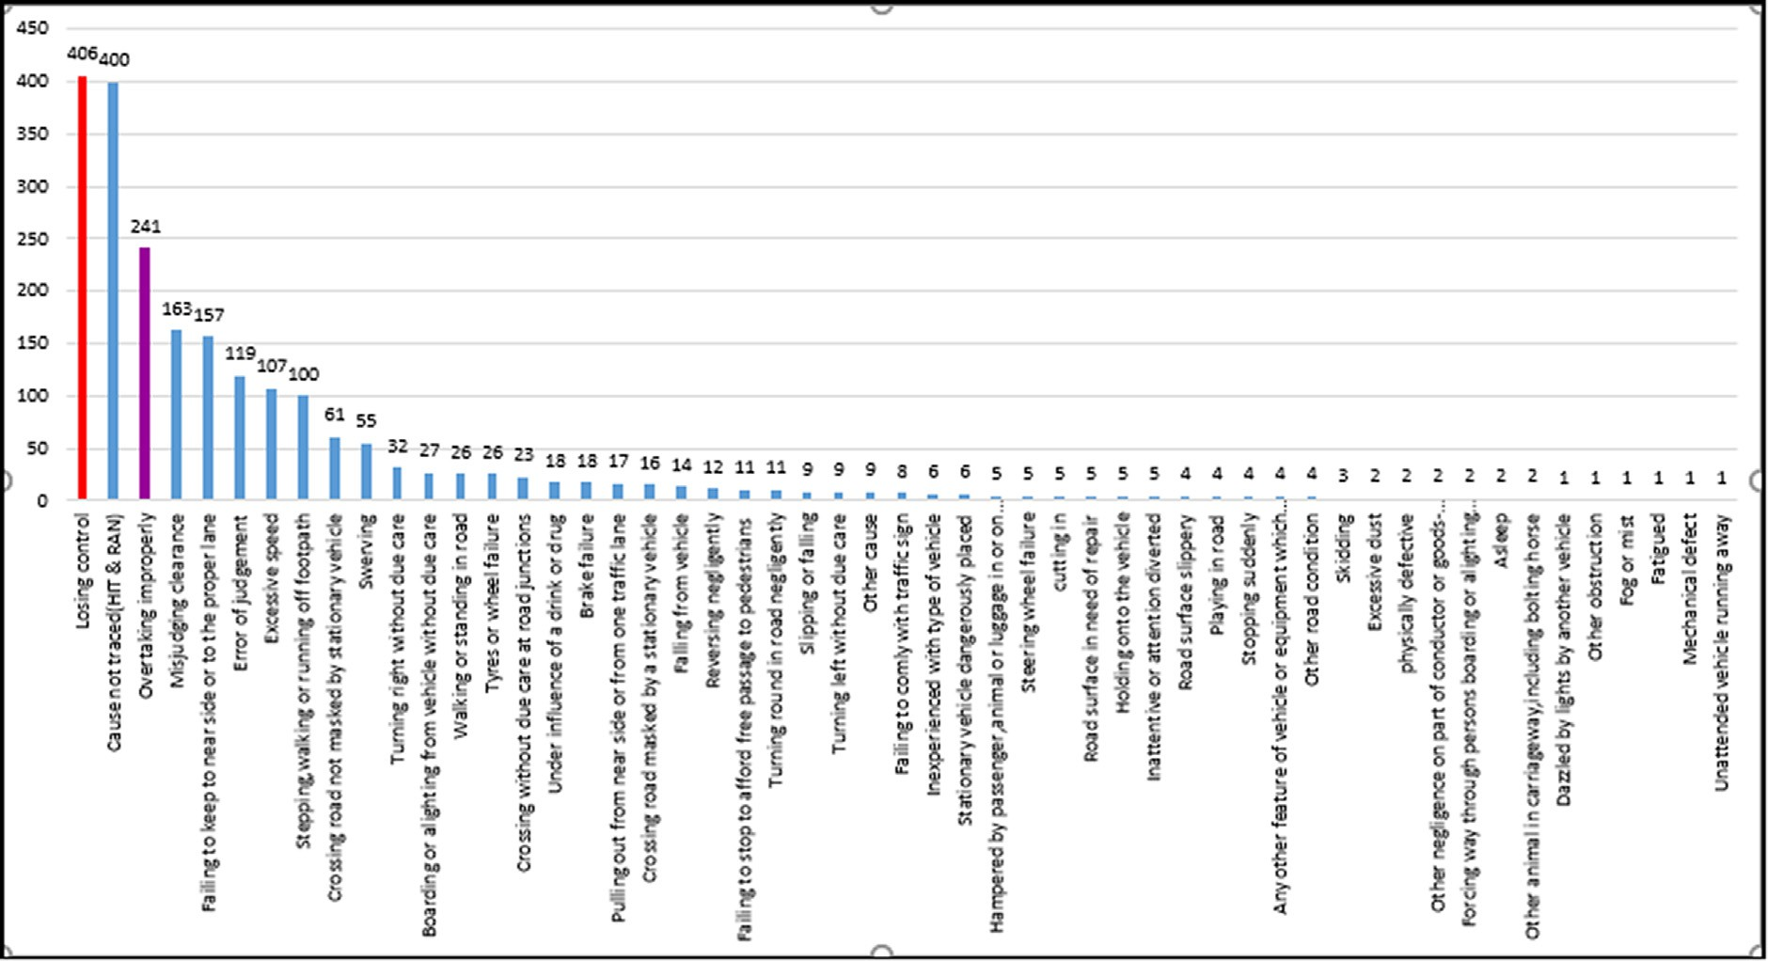

Fig. 3.1. Causes of Crashes on Kenyan roads. Source: NTSA [25].

gate is also proposed in development of the model while Matlab software is used for simulation.

* 1. *Data encoding*

Małecki and Kopaczyk [26] proves that the fewer the tags the better the performance and the lower the implementation cost. Nejati, [18]stated and used two tags in achieving his goal of no overtaking and two for speed limit. He noted that each sign need start and end tags. To accomplish this objectives line tracking and speed sensors are used.

* 1. *Black spot and violation phases*

Blackspot Phase

As vehicles approach black spot an audio alert is communicated to the driver (black spot information, the nature of the black spot area and speed limit) as shown in Fig. 3.2 below. The driver is expected to respond accordingly by driving safely and avoid any human errors. Audio alerts is used because according to Spence

& Ho [30], Spence & Ho [31], and Sivak [32], visual modality is widely used in available products but drivers often suffer from visual overload while driving which might then be overlooked or ignored hence the need for audio delivery of information to drivers.

Violation Phase

This phase as shown in Fig. 3.2 below focuses on over-speeding and over-taking violations which are majorly caused by human factor and they pose high risk at blackspots. Violation by the driver would lead to a warning being generated and then the violation is recorded in the event of disregarding the warning. The violation component has been done by Nejati, [18]using line tracking and speed sensors.

* 1. *The deriving models for the proposed Design.*

From Fig. 3.3 we realize that RFID tag stores road sign data which is read by RFID reader to the in-vehicle signal processing, monitoring and display system. The system then conveys the rep- resented message (here: STOP) to drivers through on-board display system or in-vehicle audio system

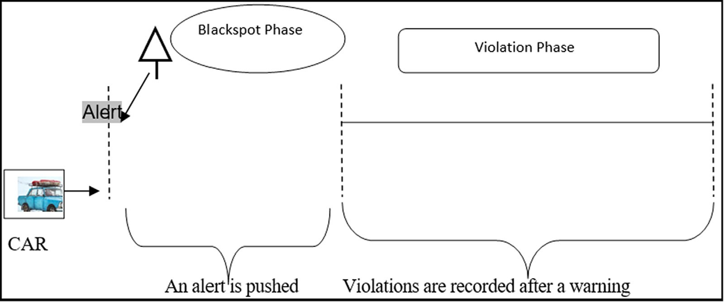

Fig. 3.2. Black spot alerting and violation phases.

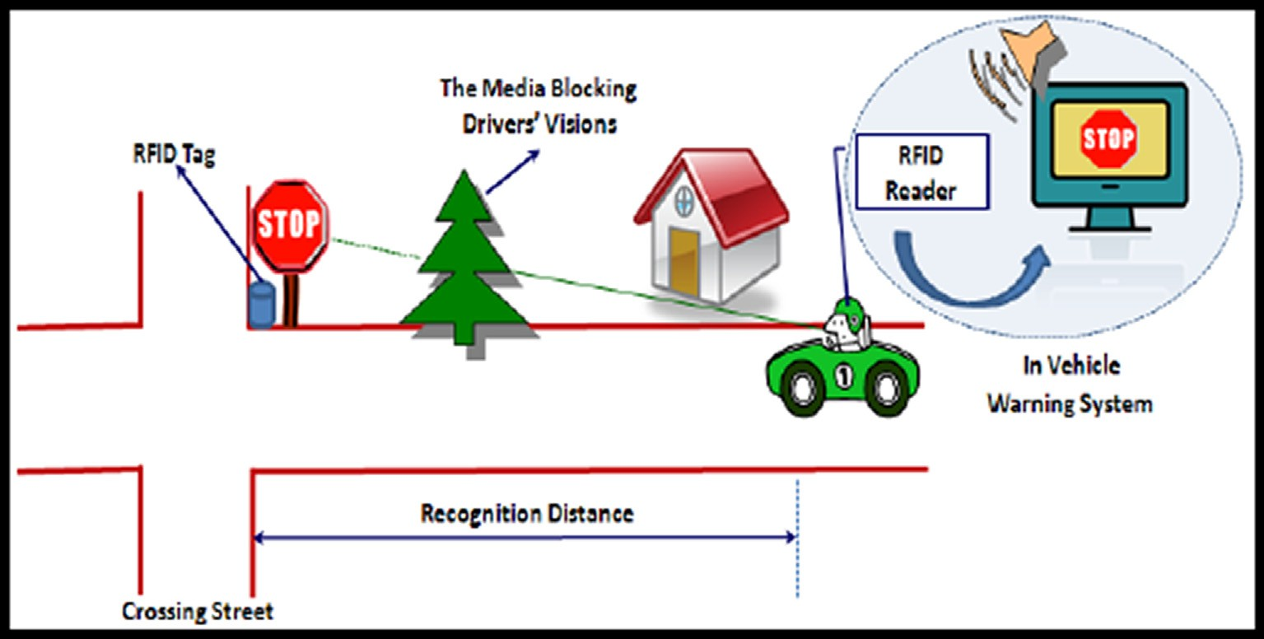

Fig. 3.3. The illustration of a RFID based smart guide signing system. Qiao et al. [33].

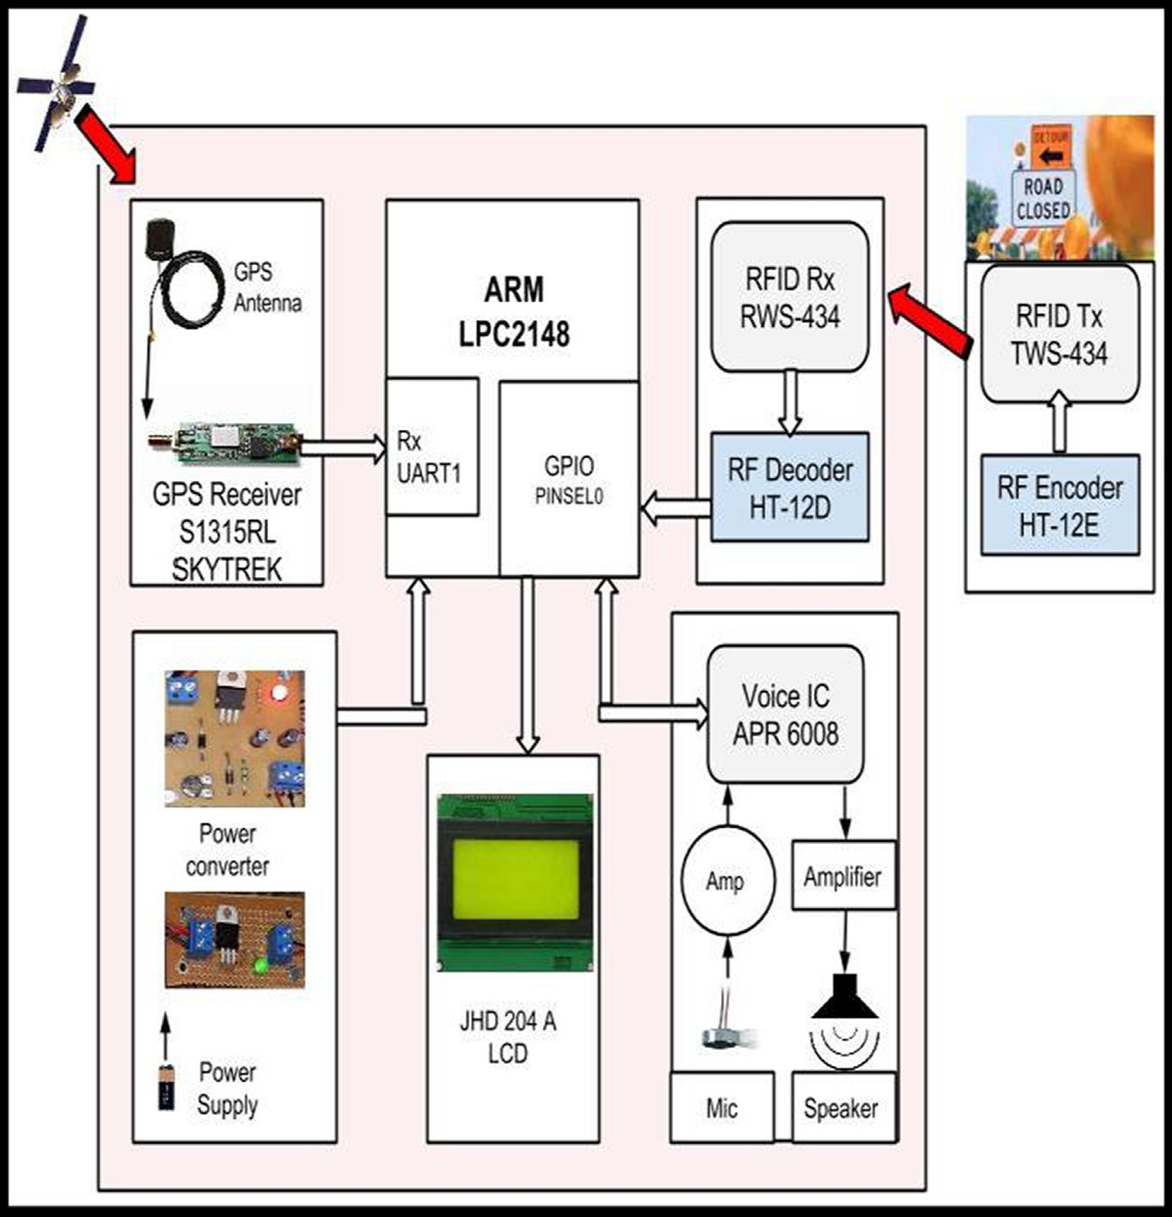

Fig. 3.4. Block diagram of in-vehicle road sign delivery system. Rajale et al. [27]

Rajale et al.[27] have used the model on Fig. 3.4 to replace static road signs which appear too late for an action to be taken. GPS is used as the main technology and RFID in special specific cases like inside the tunnels, road under construction or some repairing work.

* 1. *Proposed black spot alert model*

The concept of using RFID tags to store road sign data by Qiao et al. [33] and the application of GPS for the same by Rajale et al.

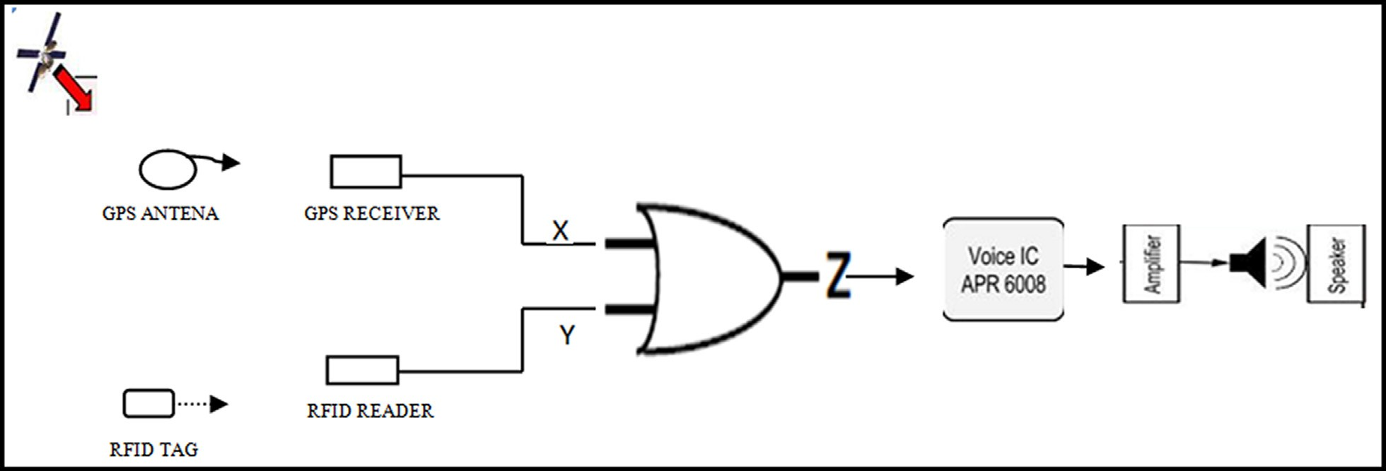

Fig. 3.5. The proposed RFID/GPS black spot in-vehicle audio alert model.

[27] have been considered in building the model. The other key component used is the OR Logic gate. The RFID-GPS model incorpo- rates the OR Logic component in delivering non-static LBS informa- tion to drivers through the on-board in-vehicle audio system as illustrated in Fig. 3.5 below. The model works by using two wire- less sources of alerts. The alert signals pushed by the two sources as a vehicle approaches a blackspot are transmitted to the in- vehicle signal processing unit via the OR Logic component. The on-board in-vehicle audio system then conveys the relevant infor- mation to drivers in time as they drive towards a blackspot. Table 3.1 shows the input and expected OR logic gate outputs. This means that in the event that one signal source fails, the other source can still generate LBS information needed by motorists.

* 1. *Implementation*

Simulation is done to simulate the designed model using Mat- lab whereby a number of scenarios are simulated. Rift valley region is selected for this research since the main highway linking Nairobi to Western region and Uganda passes through Rift valley and the region most often records fatal accidents. According to Kenya Police website (2019) there are a total of 78 black spots in Kenya of which 12 are from Rift Valley region but statistics from other sources such as Standard Digital Newspaper in 2015, indicates that there are around 160 black spots while NTSA new mapping exer- cise revealed 273 black spots in Kenya as reported by Standard Dig- ital Newspaper in 2018. Due to this conflicting statistics in the country a dataset of 15 blackspots was selected for the study.

* 1. *Testing*
     1. *Model Simulation Scenarios*
        1. *Scenario A.* In scenario A, input from one signal source is used (RFID or GPS) and a car is set to move from point 1 to point 15 (blackspots). As the car moves along an alert signal is generated, transmitted to the car as an output and recorded as a successful transmission. In the event that no signal is transmitted it’s recorded as an error.

Table 3.1

OR Logic Gate Signal Outputs.

|  |  |  |
| --- | --- | --- |
| RFID | GPS | LBS Output |
| 0 | 0 | 0 |
| 1 | 0 | 1 |
| 0 | 1 | 1 |
| 1 | 1 | 1 |

* + - 1. *Scenario B.* In scenario B, input from the two signal sources are used and a car is set to move from point 1 to point 15 (blackspots). As the car moves along an alert signal is generated, transmitted to the car as an output and recorded as a successful transmission. In the event that no signal is transmitted it’s recorded as an error.

1. Results and discussion
   1. *Simulation design findings*

Two scenarios were tested with an aim of determining the effectiveness of the proposed model through simulation. In both scenarios a total of 15 black spots are considered and one vehicle moves across the 15 black spots. During the movement the vehicle receives an alert as it draws towards a black spot enabling the dri- ver to lower driving speed and avoid any form of recklessness that could result to accidents. In some cases the vehicle fails to get an alert. This is attributed to factors that affect performance of either RFID or GPS.

* + 1. *Simulation results*

The results for both the scenarios were captured as has been displayed in Figs. 4.1 and 4.2 below. Fig. 4.1 represents the scenario when the model is using one source of signal as input to generate and transmit location based alerts. The output shows 9 successful alert transmissions out of the 15 locations. Fig. 4.3 represents sim- ulation the scenario when the model is using both the two wireless technologies as source of input to generate and transmit location based alerts. The output shows 14 successful alert transmissions out of the 15 locations

* 1. *Usability metrics for effectiveness*

According to Sauro, [28] one of the ways of calculating usability is by determining effectiveness of a system. Effectiveness of a sys- tem is therefore dependent on its successful performance given a number of tasks. Failure to successfully perform certain tasks con- stitutes error rate which affects the level of effectiveness. This can therefore be done by determining task completion rate. I.e. per- centage of tasks completed successfully against total number of tasks.

* + 1. *Scenario A*

The vehicle received 9 alerts out of the expected 15 from the 15 black spots. Hence effectiveness and error rate can be calculated as follows:

## Effectiveness 9/15 * 100 = 60% Percentage error(6/15) × 100% = 40%

* + 1. *Scenario B*

The vehicle received 14 alerts out of the expected 15 from the 15 black spots. Hence effectiveness and error rate can be calculated as follows:

## Effectiveness = (14/15) * 100 = 93.3%

Percentage error = 1/15 × 100% = 6.7%

*H*

Table 4.1

Percentage effectiveness and error rate of the model.

|  |  |  |
| --- | --- | --- |
| Scenarip | %error | Effectiveness |
| A | 40 | 60 |
| B | 6.7 | 93.3 |

between Human factor, LBS and accidents can be presented as shown in Table 4.2 below:

* + 1. *Human factor and other causes of accidents*

Considering the statistics on causes of road accidents by NTSA in 2017 the causes of road accidents due to human factor were extracted as shown in Table 4.3. From the data it is realized that out of the 2628 total death statistics human factor accounted for

Table 4.2

Relation between Human errors, LBS and Accidents.

Factor LBS Accidents

From the two cases as shown in Table 4.1 below we observed

Human *L* / 1

H / A

that when using the proposed model to generate alerts, there is reduced error rate of non-transmission of signal as compared to scenario where only one of the technologies is in use and this con- tributes to the effectiveness and reliability needed in LBS.

* 1. *Relation between effectiveness of location based services and road accidents*

|  |  |  |
| --- | --- | --- |
|  | Cause | Total |
| Zhang et al. [29] noted that road traffic systems are composed of | Losing control | 406 |
| humans, vehicles and roads as well as driving contexts (e.g., traffic | Hit and run (Cause not traced) | 400 |
| volume, weather condition, and time of day). According NTSA [25]  human factors are major causes of fatal road accidents. | Overtaking improperly Misjudging clearance | 241  163 |

LBS – *L* / 1

Where: H – Human errors. L – LBS. A – Accidents.

Table 4.3

*A*

Total number of deaths per human error in Kenya in 2016. Source: NTSA (2017).

* + 1. *Human factor, location based services and accidents*

From the data presented in Table 4.3 it’s observed that human factor is key cause of accidents compared to other causes such as road and vehicle factors. Since location based services alerts are meant to keep motorists informed about dangerous road sections so that they be more observant the relation

Not keeping proper lane 157

Judgment error 119

Swerving 55

Turning right without due care 32

Turning left without due care 9

Inattentive 5

Asleep 2

Total : 1,589

Out of: 2628

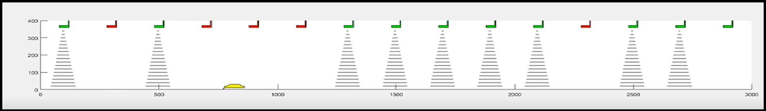

Fig. 4.1. Transmission output from a single source (RFID or GPS) model.

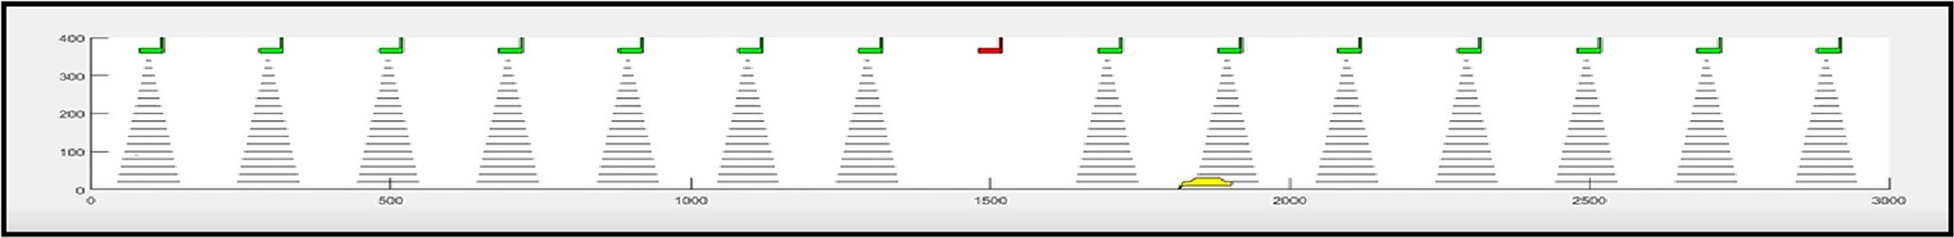

1. Completion Rate
2. Number of Errors

Fig. 4.2. Transmission output from the proposed RFID-GPS model.



Fig. 4.3. Usability Metrics. Sauro, [28]

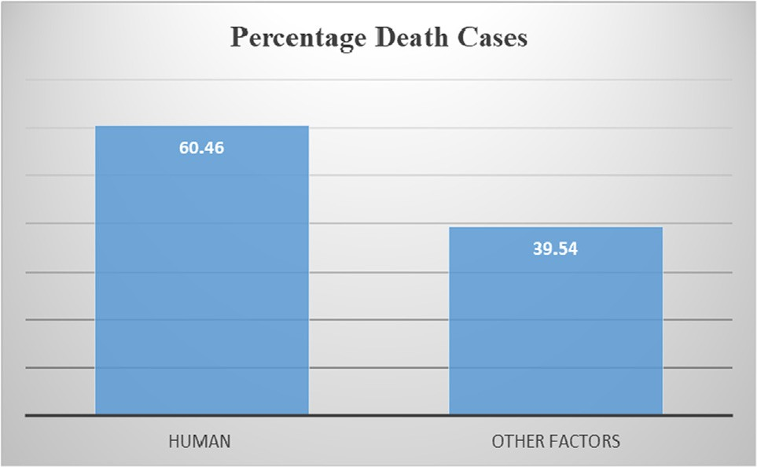

Fig. 4.4. Comparison of human factor against road and vehicle factors on death statistics.

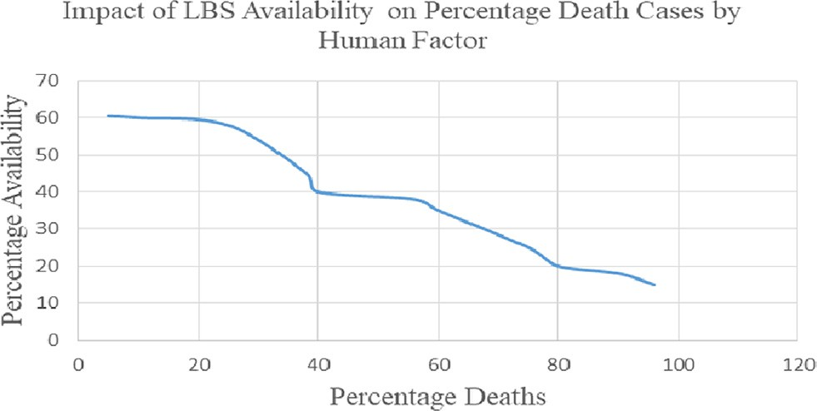

Fig. 4.5. Impact of LBS availability on death statistics by human factor.

1589 which translates to 60.46%. Vehicle and road factors accounted for 39.54% as can be seen in Fig. 4.4 below

* + 1. *Availability of alerts and the impact on fatal accidents*

We observed that human factor is the major cause of accidents and that LBS can keep motorists informed and reduce human fac- tors that lead to road accidents. We also noted that during limited or absence of LBS the human factor accounted for 60.46% cases of death. This means that management of human factor on the road by providing effective location based services could result in low death rate as shown in Fig. 4.5 below.

* + 1. *Location based services: Availability versus accuracy*

Even though much efforts has been done, Raper et al. [12] observed that availability of a geo-positioning capability is a vital performance parameter for LBS, and perhaps more than position- ing accuracy. In vehicle transport medium accuracy is required in outdoor environments observed Lekakos et al. [17]. The proposed framework achieves the availability need by integrating two the technologies. The two technologies tend to overcome the weak- nesses of each other hence registering high percentage of signal availability and hence reliability as compared to using one technology.

* + 1. *Human factor impact on road accidents*

We observed that human factor caused around 60.46% of deaths as observed in Fig. 4.4. The remaining percentage could be caused by other factors such as road condition, vehicle mechanical faults or if there could be any other factor yet to be captured in literature.

* 1. *Impact of the alert framework on road accidents*

The relationship between human factors, LBS and accidents showed that location based service alerts can positively impact human actions towards safe driving as a driver approaches a black spot. Resultant effect would be avoidance of road accidents. Effec- tiveness of the alerting system becomes very significant in that once drivers anticipate alerts they may tend to rely on the service most. To achieve safety effective LBS becomes handy. The frame- work demonstrates its effectiveness by registering higher percent- age availability of alerts (93%) as compared to 60% availability when one location based services technology is used. Fig. 4.5 shows that addressing human factor could change road accident trends.

* + 1. *Impact of the alert framework on the violation phase*

Effectiveness of the framework will also cause motorists not to unintentionally become victims of the violation phase and be charged by the legal systems every time.

* 1. *Discussion of the results*

From data analysis we observed that human/driver error was a major cause of fatal road accidents as compared to road and vehicle factors. Therefore addressing the human element can lead to major decrease in likelihood of fatal road accident incidences and resul- tant impacts. To address human element location based services was proposed. Audio alerts through the in-vehicle sound system was used to inform drivers on black spots and the need to observe safe driving culture such as avoiding over speeding, overtaking. Audio model was selected since perceived ease-of-use and per- ceived usefulness determines acceptance of any given technology. From past literature it was noted that on road transport med- ium accuracy was adequate to serve location based purposes and that availability of LBS could be more vital. From the result it was observed that availability of LBS had a direct impact on the human element. Unavailability of the LBS when needed in a critical environment such as a black spot is therefore a high risk. An effec- tive system therefore would be that which is capable of providing

LBS information when needed most

The proposed framework utilized the capabilities of both GPS and RFID in location based service to achieve effectiveness by reg- istering low alert error rate which is very key on critical road loca- tions. Application of GPS or RFID alone in LBS had high error rate due to limitations like line of sight for GPS and interferences or faultiness in the case of RFID. High error rate is an indicator of inef- fectiveness in providing LBS for critical purposes. The in-vehicle sound system audio alerts was preferred as compared to visual signs that needs interpretation resulting to visual overload and high resource demands as observed by Spence and Ho (2008), Spence and Ho (2009), Sivak (1996).

1. Conclusion

The main objective of the research was to design a framework for preventing road accidents at black spots. The design and simu- lation of the whole concept attests that high availability of alerts is very key for the effectiveness of location based services on black spots. It was observed through analysis of death statistics that human factor is the main cause of road accident related deaths. Since LBS is aimed at providing relevant information to motorists with an objective of sound decision making it was observed that the information pushed to drivers could cause them to act appro- priately hence prevent human errors that account for most fatal

accidents. The conclusion therefore is that awareness based pre- ventive measures that assist drivers on the road can effectively reduce human factor based road accidents.

Future Work

LBS is aimed at providing relevant information to drivers as they approach the black spots so that they can act appropriately to avoid accidents. To motivate and influence drivers’ response towards LBS alerts there is need to develop a model that can collect data about compliant vehicles and drivers. Insurance companies should then have rewarding framework.

Declaration of Competing Interest

The authors declare that they have no known competing finan- cial interests or personal relationships that could have appeared to influence the work reported in this paper.

Acknowledgment

My acknowledgement goes to the School of Computing and Informatics, Jomo Kenyatta University of Agriculture and Technol- ogy for the support. I sincerely appreciate the tireless efforts and very rich guidance I obtained from my supervisors Dr. Okeyo and Prof. Cheruiyot and all staff. In all this thanks to God.

References

1. Chowdhury S. WHO (2013). Road safety in Kenya [http://www.who.int/](http://www.who.int/violence_injury_prevention/road_traffic/countrywork/ken/en/) [violence_injury_prevention/road_traffic/countrywork/ken/en/](http://www.who.int/violence_injury_prevention/road_traffic/countrywork/ken/en/)
2. WHO (2018). Global status report on road safety [https://www.who.int/](https://www.who.int/violence_injury_prevention/road_safety_status/2018/en/) [violence_injury_prevention/road_safety_status/2018/en/](https://www.who.int/violence_injury_prevention/road_safety_status/2018/en/)
3. [Ogendi J, Odero W, Mitullah W, Khayesi M. Pattern of Pedestrian Injuries in the](http://refhub.elsevier.com/S1110-8665(21)00042-6/h0015) [City of Nairobi: Implications for Urban Safety Planning. Journal of Urban](http://refhub.elsevier.com/S1110-8665(21)00042-6/h0015) [Health: Bulletin of the New York Academy of Medicine 2013;90:5](http://refhub.elsevier.com/S1110-8665(21)00042-6/h0015).
4. Manyara G. Charles (2013). Combating Road Traffic Accidents in Kenya: a challenge for an emerging economy. [http://kessa.org/yahoo_site_admin/](http://kessa.org/yahoo_site_admin/assets/docs/17_Manyara_KESSA_Proceedings_2013.25183342.pdf) [assets/docs/17_Manyara_KESSA_Proceedings_2013.25183342.pdf](http://kessa.org/yahoo_site_admin/assets/docs/17_Manyara_KESSA_Proceedings_2013.25183342.pdf)
5. Mureithi R. (2017 September). 450 killed in road crashes in Rift Valley: Report

- Daily Nation [https://mobile.nation.co.ke/news/1950946-4093024-format-](https://mobile.nation.co.ke/news/1950946-4093024-format-xhtml-ch08bmz/index.html) [xhtml-ch08bmz/index.html](https://mobile.nation.co.ke/news/1950946-4093024-format-xhtml-ch08bmz/index.html)

1. Nyamori M. (2016, 12th December). NTSA: Accidents claim eight lives on Kenyan roads daily and cost Sh300b annually. [https://www.standardmedia.co.](https://www.standardmedia.co.ke/article/2000226569/ntsa-accidents-claim-eight-lives-daily-and-cost-sh300b-annually) [ke/article/2000226569/ntsa-accidents-claim-eight-lives-daily-and-cost-](https://www.standardmedia.co.ke/article/2000226569/ntsa-accidents-claim-eight-lives-daily-and-cost-sh300b-annually) [sh300b-annually](https://www.standardmedia.co.ke/article/2000226569/ntsa-accidents-claim-eight-lives-daily-and-cost-sh300b-annually)
2. Kelley K. J. (2018). WHO: Kenya road deaths four times higher than NTSA reported. [https://www.nation.co.ke/news/Kenya-road-deaths-grossly-](https://www.nation.co.ke/news/Kenya-road-deaths-grossly-underreported--WHO/1056-4893792-ve7d07z/index.html) [underreported–WHO/1056-4893792-ve7d07z/index.html](https://www.nation.co.ke/news/Kenya-road-deaths-grossly-underreported--WHO/1056-4893792-ve7d07z/index.html)
3. Huang H. and Gao S. (2018). Location-Based Services. The Geographic Information Science & Technology Body of Knowledge
4. Mohammadi M, Molaei E, and Naserasadi A. (2011, June). A Survey on Location based Services and Positioning Techniques: International Journal of Computer Applications (0975 – 8887) Volume 24– No.5
5. Yassin M., Rachid E., and Roukoz M. (2016). A Survey of Positioning Techniques and Location Based Services in Wireless Networks.
6. Ahlawat P., Kataria S., and Singh P. (2015, November). Survey Paper on Wireless Underground Positioning System, International Journal of Computer Applications (0975 – 8887) Volume 130 – No.1.
7. Raper J, Gartner G, Karimi H, Rizos C. A critical evaluation of location based services and their potential. Journal of Location Based Services 2007;1

(1):5–45. doi: https://doi.org/10.1080/17489720701584069. doi: 10.1080/ 17489720701584069.

1. Yassin M., and Rachid E. (2015 February). A Survey of Positioning Techniques and Location Based Services in Wireless Networks. IEEE 2015 Int. Conf. Signal Processing, Informatics, Communication and Energy Systems, Kozhikode, India.
2. Shek S., (2010 February). Next-Generation Location-Based Services for Mobile Devices. [sshek2@csc.com](mailto:sshek2@csc.com)
3. Krausz N., Lovas T., Barsi A. (2017 February), Radio Frequency Identification in Supporting Traffic Safety
4. [Gaukler GM, Seifert RW. Applications of RFID in Supply Chains. Trends in](http://refhub.elsevier.com/S1110-8665(21)00042-6/h0080) [Supply Chain Design and Management: Technologies and](http://refhub.elsevier.com/S1110-8665(21)00042-6/h0080) [Methodologies. London Ltd: Springer-Verlag; 2007](http://refhub.elsevier.com/S1110-8665(21)00042-6/h0080).
5. Lekakos G., Zeimpekis V., and Giaglis G. M. (2003). A Taxonomy of Indoor and Outdoor Positioning Techniques for Mobile Location Services. Athens University of Economics and Business, Department of Management Science & Technology
6. Nejati O. (2013, Jun 7) Smart Recording Of Traffic Violation System. [http://](http://www.slideshare.net/nanonsrc/smart-recording-of-traffic-violations-via-m-rfid) [www.slideshare.net/nanonsrc/smart-recording-of-traffic-violations-via-m-](http://www.slideshare.net/nanonsrc/smart-recording-of-traffic-violations-via-m-rfid) [rfid](http://www.slideshare.net/nanonsrc/smart-recording-of-traffic-violations-via-m-rfid)
7. Mohammed S. Ahmed (2019), Application of RFID Systems to Collision Avoidance
8. [Alpana G, Divya P, Litty R, Surya R, Shini R. Accident Tracking and Visual](http://refhub.elsevier.com/S1110-8665(21)00042-6/h0100) [Sharing Using RFID and SDN”.](http://refhub.elsevier.com/S1110-8665(21)00042-6/h0100) [International Journal of Computer Engineering](http://refhub.elsevier.com/S1110-8665(21)00042-6/h0100) [In Research Trends 2013;3(10):544–9](http://refhub.elsevier.com/S1110-8665(21)00042-6/h0100).
9. Benjamin R., Bernhard G., Philipp E., Andre D., Felix W. (2017) Preventing traffic accidents with in-vehicle decision support systems – The impact of accident hotspot warnings on driver behaviour
10. Mubashir M. and Chowdhury S. (2019). An IoT Based Car Accident Prevention and Detection System with Smart Brake
11. Vaibhav Y., Akshay T., Govind D., Rishikesh B., Mohan K. (2020) Smart Road Safety and Vehicle Accident Prevention System for Mountain Roads
12. Maloney J. (2013, November). ―Is technology the key to Safer roads  , SAP Bussiness Innovations.
13. Causes of Crashes on Kenyan roads. (2017). <https://www.ntsa.go.ke/>.
14. [Małecki K, Kopaczyk K. RFID-Based Traffic Signs Recognition System. Berlin](http://refhub.elsevier.com/S1110-8665(21)00042-6/h0120) [Heidelberg: Springer-Verlag; 2013](http://refhub.elsevier.com/S1110-8665(21)00042-6/h0120).
15. Rajale H, Khachane A, Atul O. (2014) Design of a Road Sign Informing System Based on GPS and RFID
16. Sauro, J. (2011). Essential Usability Metrics.
17. [Zhang J, Kim W, Fujiwara A. ICT-Based Traffic Safety Measures and Drivers’](http://refhub.elsevier.com/S1110-8665(21)00042-6/h0135) [Responses. Berlin Heidelberg: Springer-Verlag; 2013](http://refhub.elsevier.com/S1110-8665(21)00042-6/h0135).
18. Spence C., Ho C. (2008). ‘‘Tactile and multisensory spatial warning signals for drivers,” IEEE Trans. Haptics, vol. 1, no. 2, pp. 121–129.
19. Spence C., Ho C. (2009). ‘‘Crossmodal information processing in driving,” Hum. factors Vis. Cogn. Perform. Driv., pp. 187–200.
20. Sivak M. (1996). ‘‘The Information That Drivers Use: Is It Indeed 90 Percent Visual?,” Perception, vol. 25, pp. 1081–1089.
21. Qiao F., Yu L., Fatholahzadeh R., Yuan X. (2012, April). Smart Guide Signing System Using RFID as an Intelligent Sensor. 2012. Proceedings of the 13th ASCE Aerospace Division Conference on Engineering, Construction, and Operations in Challenging Environments and the 5th NASA/ASCE Workshop on Granular Materials in Space Exploration. ISBN: 978-0-7844-1219-0.