

[Egyptian Informatics Journal (2013) 14, 205–209](http://dx.doi.org/10.1016/j.eij.2013.07.001)

Cairo University

Egyptian Informatics Journal

[www.elsevier.com/locate/eij](http://www.elsevier.com/locate/eij) [www.sciencedirect.com](http://www.sciencedirect.com/science/journal/11108665)

ORIGINAL ARTICLE

Rational trigonometric cubic spline to conserve convexity of 2D data

Farheen Ibraheem a,*, Maria Hussain b, Malik Zawwar Hussain c

a *National University of Computer and Emerging Sciences, Lahore, Pakistan*

b *Lahore College for Women University, Lahore, Pakistan*

c *Department of Mathematics, University of the Punjab, Lahore, Pakistan*

Received 25 March 2013; revised 12 June 2013; accepted 7 July 2013

Available online 5 August 2013

Abstract Researchers in different fields of study are always in dire need of spline interpolating function that conserve intrinsic trend of the data. In this paper, a rational trigonometric cubic spline with four free parameters has been used to retain convexity of 2D data. For this purpose, con- straints on two of free parameters *bi* and *ci* in the description of the rational trigonometric function are derived while the remaining two *ai* and *di* are set free. Numerical examples demonstrate that resulting curves using the technique of the underlying paper are *C*1.

© 2013 Production and hosting by Elsevier B.V. on behalf of Faculty of Computers and Information,

KEYWORDS

Rational trigonometric cubic function;

Free parameters; Convex data; Data visualization

Cairo University.

1. Introduction

Representation of data in the form of congenial curves and surfaces is of great importance in many areas of scientific re- search such as computer graphics and data visualization. This visual display of data provides prompt cognition and insight into data. Shape preservation and smoothness are the most desirable features required by a researcher in the field of data

* Corresponding author. Tel.: +92 42 99231444.

E-mail addresses: [farheen.butt@gmail.com](mailto:farheen.butt@gmail.com) (F. Ibraheem), [mariahus-](mailto:mariahussain_1@yahoo.com) [sain_1@yahoo.com](mailto:mariahussain_1@yahoo.com) (M. Hussain), [malikzawwar.math@pu.edu.pk](mailto:malikzawwar.math@pu.edu.pk) (M.Z. Hussain).

Peer review under responsibility of Faculty of Computers and Information, Cairo University.

**Production and hosting by Elsevier**

visualization. Spline interpolating function demonstrates the incredible result in this regard.

Properties that quantify shape of data are positivity, mono- tonocity, and convexity. Plenty of spline functions exist which can produce a smooth curve but inept to preserve the inherent shape of the given data. The motivation of this paper is to pre- serve the intrinsic attribute of data that is convexity.

Convexity pervades everyday life. Whether it is manufac- turing of lenses, modeling of cars, analysis of indifference curves, nonlinear programming and approximation of func- tions, convexity stays the part and parcel of all. Loss of con- vexity is irreconcilable in all such practical problems.

Over the years, many milestones have been achieved in the field of shape preservation when data under consideration ex- hibit convex trend. Various schemes have been developed to reach the epitome of abstraction. Brodlie and Butt [1] pre- served the convex shape of data by establishing a piecewise cu- bic function. Their scheme suffered the detriment of insertion of the additional knots in an interval where convexity is lost.

1110-8665 © 2013 Production and hosting by Elsevier B.V. on behalf of Faculty of Computers and Information, Cairo University. <http://dx.doi.org/10.1016/j.eij.2013.07.001>

206 F. Ibraheem et al.

Convexity preserving properties of rational Bezier and non-uni- form rational B-spline were studied geometrically by Carnicer [2]. Explicit representation of rational cubic function with one free parameter was developed by Delbourgo and Gregory [3] to retain convexity. Passcow and Roulier [4] formed a spline interpolant by constructing an auxiliary set of points and using convexity preserving properties of Bernstein polynomials. Schumaker [5] preserved the convexity by piecewise quadratic polynomial which was economical but again an extra knot had to be inserted. A rational cubic function with two shape parameters was introduced by Sarfraz and Hussain [6] to retain convexity. Sarfraz et al. [7] developed rational cubic functions with four parameters. In [7], the authors derived the shape pre-

serving constraints on two parameters and two parameters are

3. Convex rational trigonometric cubic spline

In this section, problem of preserving convexity of 2D is ad- dresses. For this purpose, constraints on free parameters in the description of rational trigonometric cubic function (1) are developed. Let the convex data set defined over the interval [*a*, *b*] be {(*xi*, *fi*), *i* = 0,1, 2,..., *n*}. The necessary condition for the convexity of data is

*d*1 < *D*1 < ... *Di*—1 < *di* < *Di* ... < *Dn*—1 < *dn*.

The rational trigonometric cubic function (1) is convex if and only if *S*2(*x*) > 0, where

*i*

2  *p* 8 2 7

*S* (*x*)= {*A* sin *h*(1 — sin *h*) + *A* cos *h*(1 — sin *h*)

*i* 2*h* (*q* (*h*))2 0 1

left free for the user to refine the shape of the curves. *i i*

+ *A*2 sin2 *h*(1 — sin *h*)7 + *A*3 sin *h* cos2 *h*(1 — sin *h*)6

The algorithm presented in this paper is a noteworthy addi-

2 5

tion to already existing schemes and is a leap forward in many

+ *A*4 sin *h* cos *h*(1 — sin *h*) (1 — cos *h*)

+ *A*5 sin2 *h* cos *h*(1 — sin *h*)6 + *A*6 sin *h* cos2 *h*(1 — sin *h*)6

ways. The use of trigonometric function strengthens a designer 2 6

to frame conics accurately. It does not require insertion of ex- tra knots to conserve the intrinsic trend of the data. Four free parameters have been used in the specification of the rational trigonometric cubic spline. Constraints on two of free param- eters are derived to envision convex data. The remaining two free parameters give enough freedom to the user for the refine- ment of convex shape of data according to the requirement.

The remainder of the paper is organized as follows. Sec- tion 2 is a review of the rational trigonometric cubic function

[8] to be used for convexity. Section 3 deals with the develop- ment of convexity conserving constraints. In Section 4, numer- ical examples have been demonstrated. Section 5 summarizes the contributions and concludes the paper.

2. Rational trigonometric cubic function

Let {(*x* , *f* ), *i* = 0, 1, 2, ..., *n*} be the given set of data points de-

+ *A*7 sin *h*(1 — sin *h*) (1 — cos *h*)

+ *A*8 cos *h*(1 — sin *h*)6 (1 — cos *h*)2

+ *A*9 sin3 *h* cos *h*(1 — sin *h*)5

+ *A*10 sin2 *h* cos2 *h*(1 — sin *h*)4 (1 — cos *h*)

+ *A*11 sin3 *h*(1 — sin *h*)5 (1 — cos *h*)

+ *A*12 sin2 *h* cos *h*(1 — sin *h*)4 (1 — cos *h*)2

+ *A*13 sin *h* cos *h*(1 — sin *h*)5 (1 — cos *h*)2

+ *A*14 cos3 *h*(1 — sin *h*)4 (1 — cos *h*)2

+ *A*15 cos3 *h* sin *h*(1 — sin *h*)3 (1 — cos *h*)2

+ *A*16 cos *h* sin2 *h*(1 — sin *h*)3 (1 — cos *h*)3

+ *A*17 cos2 *h*(1 — sin *h*)3 (1 — cos *h*)4

+ *A*18 cos2 *h* sin *h*(1 — sin *h*)3 (1 — cos *h*)3

+ *A*19 sin2 *h*(1 — sin *h*)3 (1 — cos *h*)4

+ *A*20 cos2 *h*(1 — sin *h*)4 (1 — cos *h*)3

+ *A*21 sin *h*(1 — sin *h*)5 (1 — cos *h*)3

+ *A*22 sin2 *h*(1 — sin *h*)4 (1 — cos *h*)3

+ *A*23 cos *h*(1 — sin *h*)3 (1 — cos *h*)5

+ *A*24 sin3 *h*(1 — sin *h*)6 + *A*25 sin2 *h* cos2 *h*(1 — sin *h*)5

*i i*

fined over the interval [*a*, *b*] where *a* = *x*0 < *x*1 < *x*2

< ·· · < *xn* = *b*. A piecewise rational trigonometric cubic function is defined over each subinterval *I* = [*x* , *x* ] as

+ *A*26 sin4 *h* cos *h*(1 — sin *h*)4

+ *A*27 sin3 *h*(1 — cos *h*)4 (1 — sin *h*)2

+ *A*28 sin *h* cos *h*(1 — cos *h*)5 (1 — sin *h*)2

*i i i*+1

+ *A*29 sin3 *h* cos *h*(1 — cos *h*)3 (1 — sin *h*)2

*S* (*x*)= *pi* (*h*) ; (1)

*i*

+ *A*30 sin3 *h* cos *h*(1 — cos *h*)2 (1 — sin *h*)3

*qi* (*h*)

+ *A*31 sin4 *h*(1 — cos *h*)(1 — sin *h*)4

3 2*hiaidi* 2

*pi*(*h*)= *aifi*(1 — sin *h*)

+ *bifi* +

*p*

sin *h*(1 — sin *h*)

+ *A*32 sin3 *h* cos2 *h*(1 — cos *h*)(1 — sin *h*)3

+ *A*33 sin *h* cos2 *h*(1 — cos *h*)4 (1 — sin *h*)2

+ *A*

34

sin2 *h* cos3 *h*(1 — cos *h*)2(1 — sin *h*)2

2*h d d*

+ *cifi*+1

—

*i*

*i i*+1

*p*

cos *h*(1 — cos *h*)2

+ *A*35 sin3 *h*(1 — cos *h*)3 (1 — sin *h*)3

+ *A*

36

sin2 *h* cos2 *h*(1 — cos *h*)3(1 — sin *h*)2

+ *difi*+1(1 — cos *h*)3;

*q* (*h*)= *a* (1 — sin *h*)3 + *b* sin *h*(1 — sin *h*)2 + *c* cos *h*(1 — cos *h*)2

+ *A*37 sin2 *h* cos *h*(1 — cos *h*)6 + *A*38 cos2 *h*(1 — cos *h*)7

+ *A*39 sin2 *h* cos2 *h*(1 — cos *h*)4 (1 — sin *h*)

+ *A*40 cos3 *h*(1 — cos *h*)3 (1 — sin *h*)3

+ *A*41 sin2 *h* cos2 *h*(1 — cos *h*)2 (1 — sin *h*)3

*i i i* *i*

3

+ *A*42 sin *h* cos3 *h*(1 — cos *h*)3 (1 — sin *h*)2

+ *di*(1 — cos *h*) ;

where

*h* = *p x* — *xi* ; *h* = *x*

2

*hi*

*i*

*i*+1

— *x* ; *i* = 0; 1; 2; .. . ; *n* — 1.

*i*

+ *A*43 sin3 *h* cos2 *h*(1 — cos *h*)2 (1 — sin *h*)2

+ *A*44 cos3 *h*(1 — cos *h*)6 + *A*45 cos4 *h*(1 — cos *h*)4 (1 — sin *h*)

+ *A*46 cos3 *h*(1 — cos *h*)5 (1 — sin *h*)

+ *A*47 cos4 *h* sin *h*(1 — cos *h*)4 + *A*48 sin2 *h* cos *h*(1 — cos *h*)5 (1 — sin *h*)

+ *A*

49

sin *h* cos3 *h*(1 — cos *h*)5 + *A*

50

sin2 *h*(1 — cos *h*)3(1 — sin *h*)4

+ *A*51 cos *h*(1 — cos *h*)8 + *A*52 sin2 *h*(1 — cos *h*)7

The rational trigonometric cubic function (1) satisfies the fol-

3 5 6 2

lowing properties:

*S*(*xi*)= *fi*; *S*(*xi*+1

)= *f*

*i*+1

; *S*(1)(*xi*)= *di* ; *S*(1)(*xi*+1

)= *di*+1.

+ *A*53 sin *h*(1 — cos *h*) (1 — sin *h*) + *A*54 sin *h*(1 — cos *h*) (1 — sin *h*)

+ *A*55 sin *h* cos2 *h*(1 — cos *h*)3 (1 — sin *h*)3 + *A*56 cos2 *h*(1 — cos *h*)6 (1 — sin *h*)

+ *A*57 sin2 *h*(1 — cos *h*)6 (1 — sin *h*)+ *A*58 sin *h* cos2 *h*(1 — cos *h*)6

+ *A*59 sin2 *h* cos2 *h*(1 — sin *h*)5 + *A*60 sin2 *h* cos2 *h*(1 — cos *h*)3 (1 — sin *h*)2

*di* and *di*+1 are derivatives at the end points of the interval

*I* = [*x* , *x* ], *a* , *b* , *c* and *d* are the free parameters.

+ *A*61 sin3 *h* cos2 *h*(1 — cos *h*)(1 — sin *h*)3 + *A*62 sin2 *h* cos3 *h*(1 — cos *h*)3 (1 — sin *h*)

+ *A*63 sin2 *h* cos2 *h*(1 — cos *h*)4 (1 — sin *h*)} (2)

*i i i*+1 *i i i* *i*

Rational trigonometric cubic spline to conserve convexity of 2D data 207

with

*A*0 = —*aid*; *A*1 = *aid* + *aia* — 2*bid*; *A*2 = —*aia* — *bid*; *A*3

= 2*aia* — 2*bia* — *bid*; *A*4 = 3*aik* + 2*ail* + 3*aib* — *bik* — 4*cid*; *A*5 = *aik*

= *A*6; *A*7 = 2*aig* — *aik*; *A*8 = *gai*; *A*9 = *ail* + *bik*; *A*10

= 4*ail* + 2*aie* + *bik* + 2*bib* — 4*cia*; *A*11 = 2*aih* — *ail* + 2*big* — *bik*; *A*12

= *ai*(4*h* — 2*e* + 3*f* + 6*a*)+ *bi* (3*c* — 2*b* + *g*)— 6*dia* + *cia*; *A*13

= *ai*(2*h* + 3*g* — 2*b* + 3*c*)— *big* — 6*did* + *cid*; *A*14

= *ai*(4*b* + *e*)— 2*bib* + *ci* (*a* — 5*d*); *A*15 = 5*aie* + *bi* (2*b* — *e*)+ 4*cia*; *A*16

= 4*aii* + *ci* (*k* — 2*g*)— 5*dik*; *A*17 = *aii* + *cig* + *dik*; *A*18

= 5*aif* + *bi* (2*c* — *f*); *A*19 = *ai*(5*j* — *i*)— *di*(*k* + 4*g*)+ 2*cig*; *A*20

= *ai*(4*c* + *f*)— 2*bic* + *di*(*a* — 5*d*); *A*21 = —*aic*; *A*22 = —*aif* — *bic*; *A*23

= *aij* + *dig*; *A*24 = —*bia*; *A*25 = —4*bia*; *A*26 = *bil*; *A*27

= *bi* (—*i* + 5*j*)— *di*(4*h* + *l*)+ 2*cih*; *A*28

= 6*aij* — *bij* + *di*(2*h* — 3*g* — 2*b* — 3*c*)+ *cic*; *A*29

= 4*bii* + *ci* (*l* — 2*h*)— 5*dil*; *A*30 = *bi* (2*h* — 2*e* + 3*f*); *A*31 = *bi* (2*h* — *l*); *A*32

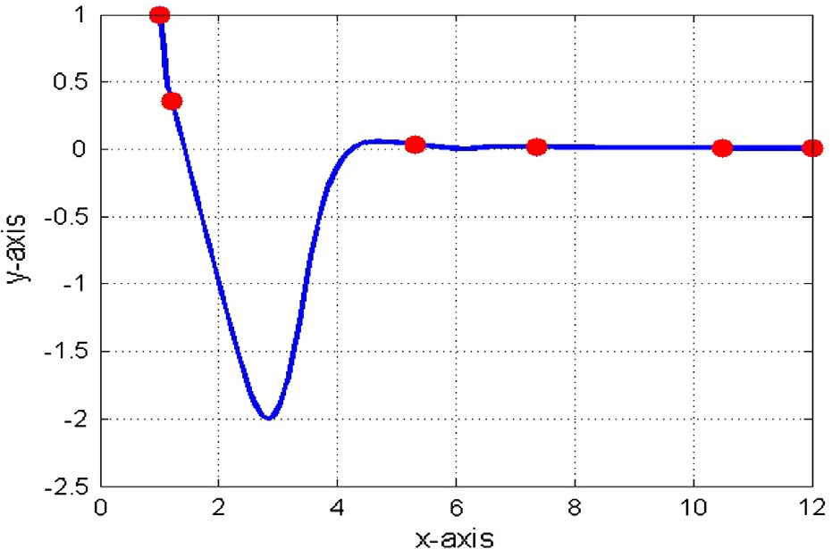

= 2*b* (*e* — *l*); *A*33 = 6*aii* — *b i* + *c* (2*h* — 3*g* — *c*)+ *di*(2*l* — 4*b* — 3*k*); *A*34

|  |  |  |  |  |  |
| --- | --- | --- | --- | --- | --- |
| Table 1 A convex data set. | | | | | |
| *x* | 1 | 1.2 5.3 | 7.36 | 10.5 | 12 |
| *y* | 1 | 0.36 0.035 | 0.018 | 0.008 | 0.0069 |
|  |  |  |  |  |  |

Table 2

*x y*

A convex data set.

—1.6

0.81

—1.71

0.29

—5.3 —7.36 —7.8

0.30 0.016 0.018

Table 3 A convex data set.

*i i* *i*

= 3*bie*; *A*35 = —*bif*; *A*36 = —*bif*; *A*37 = *ci* (3*i* + *j*)— 2*dii*; *A*38

= *cij* + *dii*; *A*39 = 4*bii* + *ci* (*j* — 2*h*)+ 2*di*(*e* — *l*); *A*40 = *cik*; *A*41

= —3*cik*; *A*42 = *ci* (6*b* + 2*l* — 3*k*); *A*43 = —3*cil*; *A*44 = *cii*; *A*45

= *ci* (*e* — 2*b*); *A*46 = *ci* (*f* — 2*c*)+ *di*(*e* — 2*b*); *A*47 = —*cie*; *A*48

= 4*bij* — *cif* — *di*(2*e* + 3*f* + 2*h*); *A*49 = —*cif* — *die*; *A*50 = —*dia*; *A*51

= —*dij*; *A*52 = 2*cij* — *di*(*i* + *j*); *A*53 = —*did*; *A*54 = —*dic*; *A*55

= —4*dia*; *A*56 = *di*(*f* — 2*c*); *A*57 = —*dif* = *A*58; *A*59 = 4*bia*; *A*60

= 4*bif*; *A*61 = 4*bil*; *A*62 = 4*cie*; *A*63 = 3*die*;

and

*a* = —*bi F*0 + *aiF*1; *b* = *ci* (*F*1 — 3*F*0)+ *F*2(3*ai* — *bi* ); *c*

= *di*(*F*1 — 3*F*0)+ *F*3(3*ai* — *bi* ); *d* = —*bi F*0 + *aiF*1; *e*

= 2*bi F*2 — 2*ci F*1; *f* = 2*bi F*3 — 2*diF*1; *g*

= *ai*(3*F*3 — *F*2)— *F*0(3*di* — *ci* ); *h*

= *bi* (3*F*3 — *F*2)— *F*1(3*di* — *ci* ); *i* = *ci F*3 — *diF*2; *j*

= *ci F*3 — *diF*2; *k* = 2*aiF*2 — 2*ciF*0; *l* = 2*bi F*2 — 2*ci F*1;

where

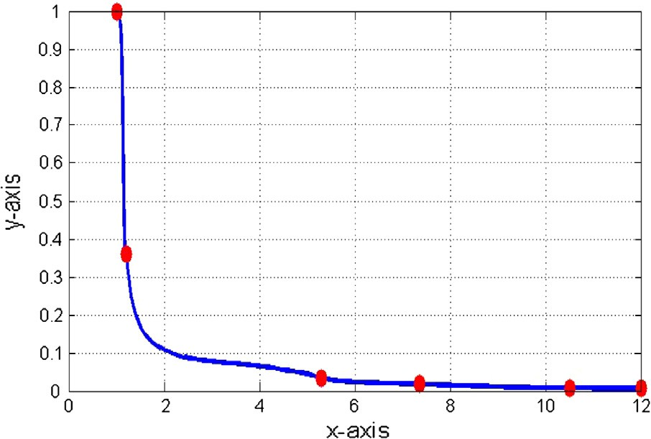

*F*0 = *aifi*;

*x* 0.1 6 10 28

*y* 4 0.1 15 25

Figure 1 *C*1 rational trigonometric cubic function with *ai* = 0.5,

*bi* = 1.0, *ci* = 0.5, *di* = 1.0.

*F* = *b f* + 2*aihidi* ;

1 *i i*

*F*2 = *cifi*+1

*p*

— 2*hididi*+1 ;

*p*

*F*3 = *difi*+1.

Now, *S*2(*x*) > 0 if *Ai*, *i* = 0, 1, 2, ..., 63 are all positive as the denominator in (2) is strictly a positive quantity. *Ai*, *i* = 0, 1, 2, ..., 63 are all positive if the free parameters satisfy the following conditions

*i*

*c* > 2*hidi*+1*di* ; *c* > 2*di*+1*di* ; *c* > 2*di*+1*di* ;

*i pfi*+1

*i p*D*i*

*i p*(D*i* — 3*di*D*i*)

*c* > 6*di*+1*di* ;

*i* 3*di*D*i*

*b* > 2*aidi* ; *b* > *ai*(2*di* + 3*p*D*i*) ; *b* > 2*aiuidi* ;

*i p*D*i* *i*

D*ip*

*i pui* D*i* — 2*didi*+1

*b* > 6*aiui*(*didi*+1 + *uidi* + 5*pdi*D*i*) ;

*i pui* D*i* — 2*didi*+1

Figure 2 *C*1

convex rational trigonometric cubic function with

where *ui* = max{0; *ci*}; *ai* and *di* are positive real numbers.

*ai* = 2.1, *di* = 0.3.

208 F. Ibraheem et al.

Figure 3 *C*1 rational trigonometric cubic function with *ai* = 0.5,

*bi* = 1.0, *ci* = 0.5, *di* = 1.0.

Figure 6 *C*1 convex rational trigonometric cubic function with

*ai* = 1.5, *di* = 1.0.

|  |  |  |  |  |  |  |
| --- | --- | --- | --- | --- | --- | --- |
| Table 4 Numerical results corresponding to Fig. 2. | | | | | | |
| *i* | 1 | 2 | 3 | 4 | 5 | 6 |
| *di* | —3.3452 | —1.6396 | —0.0438 | —0.0057 | —0.002 | 0.001 |
| *bi* | 78.7019 | 30.691 | 8.2637 | 3.1249 | 3.816 | – |
| *ci* | 10.09 | 1.2543 | 1.5234 | 1.3748 | 0.2 | – |
|  |  |  |  |  |  |  |

Figure 4 *C*1 convex rational trigonometric cubic function with

|  |  |  |  |  |  |
| --- | --- | --- | --- | --- | --- |
| Table 5 Numerical results corresponding to Fig. 4. | | | | | |
|  | 1 | 2 | 3 | 4 | 5 |
| *di* | 4.8657 | 2.3998 | 0.0396 | 0.0011 | —0.0065 |
| *bi* | 284.9378 | 81.0980 | 17.7179 | 63.8082 | – |
| *ci* 21.5843 1.2445 0.5162 2.9486 – | | | | | |

*ai* = 3.5, *di* = 0.3.

|  |  |  |  |  |  |  |  |  |
| --- | --- | --- | --- | --- | --- | --- | --- | --- |
| Table 6 Numerical results corresponding to Fig. 6. | | | | | | | | |
| 1 2 | | | | 3 | 4 | 5 | 6 | |
|  | *di* | —5.3290e9 | —1.7764e9 | 0 | 0 | 1.7764e9 | 5.3290e9 |  |
|  | *bi* | 6.885e19 | 0 | 0 | 0 | 6.885e19 | – |  |
|  | *ci* | 0.3965e20 | 0 | 0 | 0 | 1.1896e20 | – |  |
|  |  |  |  |  |  |  |  |  |

*c* > 2*hidi*+1 *di* ; *c* > 2*di*+1 *di* ; *c* > 2*di*+1*di* ; *c* > 6*di*+1*di* ;

*i*

and

*pfi*+1 *i*

*p*D*i*

*i p*(D*i* — 3*di*D*i*) *i*

3*di*D*i*

*b* > 2*aidi* ; *b* > *ai*(2*di* + 3*p*D*i*) ; *b* > 2*aiuidi* ;

*i p*D*i* *i*

D*ip*

*i pui*D*i* — 2*didi*+1

*b* > 6*aiui*(*didi*+1 + *uidi* + 5*pdi*D*i*) ;

Figure 5 *C*1 rational trigonometric cubic function with *ai* = 0.6, *i*

*pu* D — 2*d d*

*i i i i*+1

*bi* = 1.5, *ci* = 1.0, *di* = 1.5.

The above discussion can be put together as:

1

where *ui* = max{0; *ci* }; *ai* and *di* are positive real numbers.

The above constraints can be rearranged as

*c* = + max 0; 2*hidi*+1 *di* ; 2*di*+1 *di* ; 2*di*+1 *di* ; 6*di*+1 *di* ; ; > 0;

*i*

*i*

*pf*

*p*D

*p*(D — 3*d* D ) 3*d* D

*i*

*i*+1

*i*

*i*

*i i*

*i i*

*i*

function (1) preserves the convexity if in each subinterval

Theorem 1. The C

piecewise trigonometric rational cubic

*b* = *w* + max 0; 2*aidi* ; *ai* (2*di* + 3*p*D*i* ); 2*aiuidi* ; 6*aiui* (*didi*+1 + *uidi* + 5*pdi* D*i* ) ; *w* > 0;

Ii = [xi, xi+1], the parameters *bi* and *ci* satisfy the following

*i*

*i*

*i i i i*

*i i*+1

*i i i i*+1

sufficient conditions

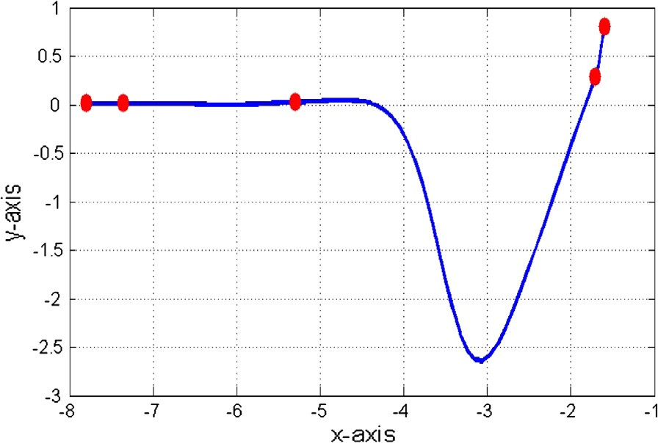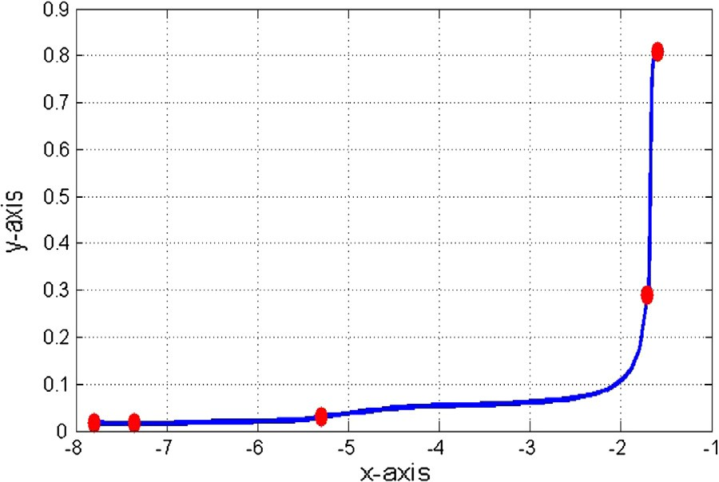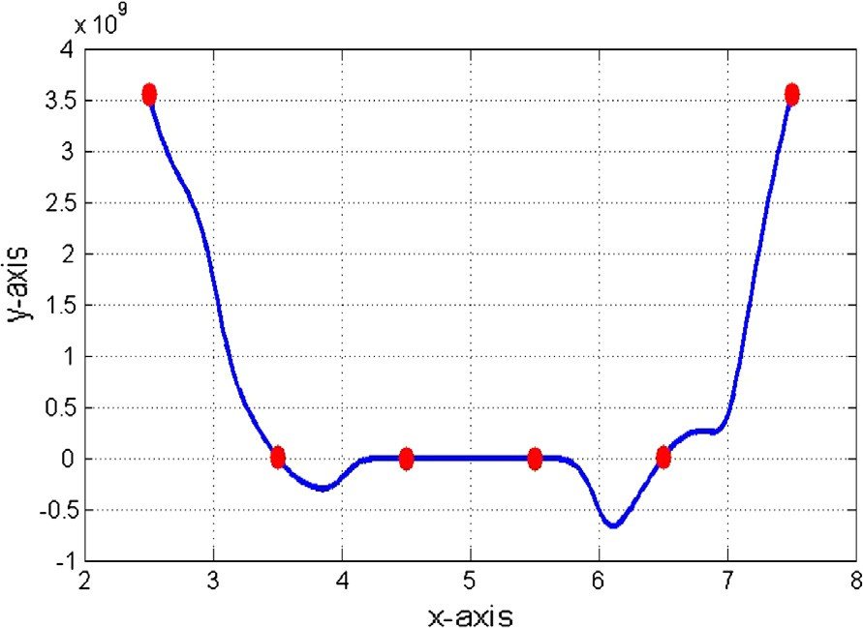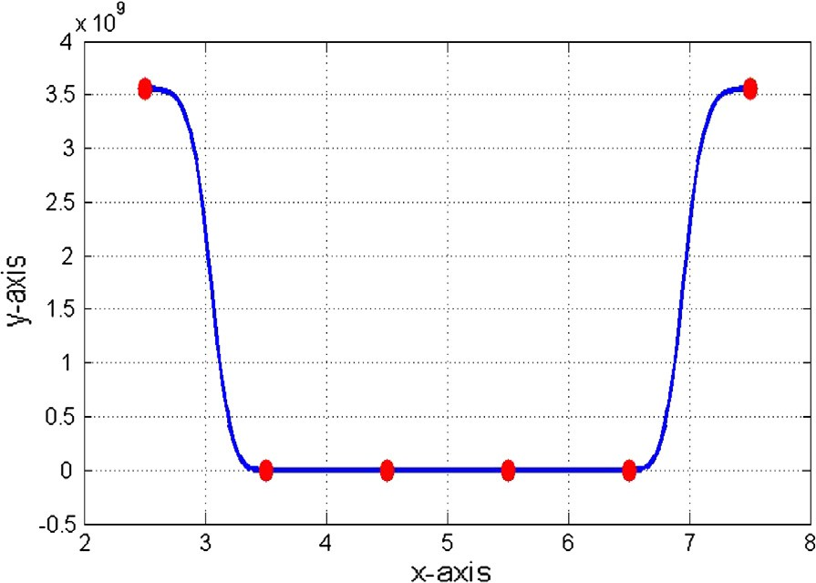

*p*D

D *p*

*pu* D — 2*d d*

*pu* D — 2*d d*

*where ui* = max{0; *ci*}; *ai and di are positive real numbers.*

Rational trigonometric cubic spline to conserve convexity of 2D data 209

Algorithm 1.

Step 1. Take a convex data set {(*xi*, *fi*): *i* = 0,1, 2,.. . , *n*}.

Step 2. Estimate the derivatives *d*0*s* at the knots *x*0*s* (if the data are

*i*

*i*

given without derivatives at the knots *x*0*s*) with the Arithmetic

*i*

Mean method.

Step 3. Compute the values of parameters *b*0*s* and *c*0*s* using

*i*

*i*

Theorem 1.

Step 4. Substitute the values *d*0*s* at knots *x*0*s*; *b*0*s* and *c*0*s*; *ai* and *di*

*i*

*i* *i*

*i*

(positive real numbers) in rational trigonometric cubic function (1)

to interpolate and visualize the convex pattern of data.

1. Numerical examples and analysis

This section demonstrates the scheme for convex data devel- oped in Section 3.

The *C*1 rational trigonometric cubic function (1) is first used to visualize the convex data sets taken in Tables 1–3, respec- tively. Arbitrary values are assigned to free parameters *ai*, *bi*, *ci* and *di* and resulting curves are shown in Figs. 1, 3 and 5 respectively. It is evident from Figs. 1, 3 and 5 that rational trig- onometric cubic function does not preserve the shape of data for arbitrary values of free parameters. The convex curves for the same data sets are produced in Figs. 2, 4, and 6 , respectively, by the convexity preserving rational trigonometric scheme developed Section 3. The corresponding outputs of the deriva- tive and shape parameters, for the convexity conserving curves in Figs. 2, 4, and 6 are given in Tables 4–6, respectively.

1. Conclusion

The problem of retaining convex trend of 2D data is dealt in this paper. A *C*1 rational trigonometric cubic spline with four

free parameters has been utilized for this purpose. Constraints on two of free parameters *bi* and *ci* are derived while the remaining two *ai* and *di* are set free. Though literature is inun- dated with shape preserving schemes but use of rational trigo- nometric cubic functions makes the underlying algorithm distinguished and unparalleled. Due to the orthogonality of sine and cosine function, much smoother results are obtained as compared to algebraic spline. Derivative of the trigonomet- ric spline is much lower than that of algebraic spline. Insertion of extra knots to conserve the shape of data is not required. Its applicable for both equally and unequally spaced data. No additional information about derivatives is needed as they are estimated by arithmetic mean method. The process of con- structing convex surface is under process.

References

1. [Brodlie KW, Butt S. Preserving convexity using piecewise cubic](http://refhub.elsevier.com/S1110-8665(13)00026-1/h0005) [interpolation. Comput Graph 1991;15(1):15–23](http://refhub.elsevier.com/S1110-8665(13)00026-1/h0005).
2. [Carnicer JM, Garcia-Esnaola M, Pena JM. Convexity of rational](http://refhub.elsevier.com/S1110-8665(13)00026-1/h0010) [curves and total positivity. J Comput Appl Math](http://refhub.elsevier.com/S1110-8665(13)00026-1/h0010) [1996;71(2):365–82](http://refhub.elsevier.com/S1110-8665(13)00026-1/h0010).
3. [Delbourgo R, Gregory JA. Shape preserving piecewise rational](http://refhub.elsevier.com/S1110-8665(13)00026-1/h0015) [interpolation. SIAM J Sci Statist Comput 1985;6(4):967–76](http://refhub.elsevier.com/S1110-8665(13)00026-1/h0015).
4. [Passow E, Roulier JA. Monotone and convex spline interpolation.](http://refhub.elsevier.com/S1110-8665(13)00026-1/h0020) [SIAM J Numer Anal 1977;14(5):904–9](http://refhub.elsevier.com/S1110-8665(13)00026-1/h0020).
5. [Schumaker LL. On shape preserving quadratic spline interpolation.](http://refhub.elsevier.com/S1110-8665(13)00026-1/h0025) [SIAM J Numer Anal 1983;20(4):854–64](http://refhub.elsevier.com/S1110-8665(13)00026-1/h0025).
6. [Sarfraz M, Hussain MZ. Data visualization using rational spline](http://refhub.elsevier.com/S1110-8665(13)00026-1/h0030) [interpolation. J Comput Appl Math 2006;189(1-2):513–25](http://refhub.elsevier.com/S1110-8665(13)00026-1/h0030).
7. [Sarfraz M, Hussain MZ, Hussain M. Shape preserving curve](http://refhub.elsevier.com/S1110-8665(13)00026-1/h0035) [interpolation. Int J Comput Math 2012;89(1):35–53](http://refhub.elsevier.com/S1110-8665(13)00026-1/h0035).
8. Ibraheem F, Hussain M, Hussain MZ, Bhatti AA. Positive data visualization using trigonometric function. J Appl Math 2012;2012. <http://dx.doi.org/10.1155/2012/247120>.