Journal Pre-proofs

Article

Replacing Traditional Plastics with Biodegradable Plastics: Impact on Carbon Emissions

Guanyi Chen, Jianyuan Li, Yunan Sun, Zhi Wang, Gary A. Leeke, Christian Moretti, Zhanjun Cheng, Yuan Wang, Ning Li, Lan Mu, Jinyu Li, Junyu Tao, Beibei Yan, Li'an Hou

PII: S2095-8099(23)00462-9

DOI: <https://doi.org/10.1016/j.eng.2023.10.002>

Reference: ENG 1397

To appear in: *Engineering*

Received Date: 18 February 2023

Revised Date: 1 June 2023

Accepted Date: 19 October 2023

Please cite this article as: G. Chen, J. Li, Y. Sun, Z. Wang, G.A. Leeke, C. Moretti, Z. Cheng, Y. Wang, N. Li, L. Mu, J. Li, J. Tao, B. Yan, L. Hou, Replacing Traditional Plastics with Biodegradable Plastics: Impact on Carbon Emissions, *Engineering* (2023), doi: <https://doi.org/10.1016/j.eng.2023.10.002>

This is a PDF file of an article that has undergone enhancements after acceptance, such as the addition of a cover page and metadata, and formatting for readability, but it is not yet the definitive version of record. This version will undergo additional copyediting, typesetting and review before it is published in its final form, but we are providing this version to give early visibility of the article. Please note that, during the production process, errors may be discovered which could affect the content, and all legal disclaimers that apply to the journal pertain.

© 2023 THE AUTHORS. Published by Elsevier LTD on behalf of Chinese Academy of Engineering and Higher Education Press Limited Company

Research

Biomass Energy Environment—Article

**Replacing Traditional Plastics with Biodegradable Plastics: Impact on Carbon Emissions**

# Guanyi Chen a,b,c, Jianyuan Li a, Yunan Sun a,d,*, Zhi Wang b, Gary A. Leeke e, Christian Moretti f, Zhanjun Cheng b,d, Yuan Wang b, Ning Li b,d, Lan Mu a, Jinyu Li a,

Junyu Tao a, Beibei Yan b,d, Li'an Hou b,g,*

a *Interdisciplinary Innovation Lab for Environment and Energy, School of Mechanical Engineering & School of Biotechnology and Food Science, Tianjin University of Commerce, Tianjin 300134, China*

b *School of Environmental Science and Engineering, Tianjin University, Tianjin 300350, China*

c *School of Ecology and Environment, Tibet University, Lhasa 850012, China*

d *Tianjin Key Lab of Biomass, Wastes Utilization, Tianjin Engineering Research Center for Organic Wastes Safe Disposal and Energy Utilization, Tianjin 300072, China*

e *School of Chemical Engineering, University of Birmingham, Birmingham B15 2TT, UK*

f *Department of Environmental Systems Science, ETH Zürich, Zürich CH-8092, Switzerland*

g *Unit 96911 of the Armed Forces, Beijing 100011, China*

* Corresponding authors.

E-mail addresses: [sunyunan@tjcu.edu.cn](mailto:sunyunan@tjcu.edu.cn) (Y. Sun), [houla@cae.cn](mailto:houla@cae.cn) (L. Hou).

ARTICLE INFO

Article history:

Received 18 February 2023

Revised 1 June 2023

Accepted 19 October 2023 Available online

Keywords:

Carbon emissions Biodegradable plastics Different disposal scenarios Daily life consumption

Environmental and economic discussion

**ABSTRACT**

In recent years, a great deal of attention has been focused on the environmental impact of plastics, including the carbon emissions related to plastics, which has promoted the application of biodegradable plastics. Countries worldwide have shown high interest in replacing traditional plastics with biodegradable plastics. However, no systematic comparison has been conducted on the carbon emissions of biodegradable versus traditional plastic products. This study evaluates the carbon emissions of traditional and biodegradable plastic products (BPPs) over four stages and briefly discusses environmental and economic perspectives. Four scenarios—namely, the traditional method, chemical recycling, industrial composting, and anaerobic digestion—are considered for the disposal of waste biodegradable plastic product (WBBPs). The analysis takes China as a case study. The results show that the carbon emissions of 1000 traditional plastic products (plastic bags, lunch boxes, cups, etc.) were 52.09–150.36 carbon emissions equivalent of per kg (kg CO2eq), with the stage of plastic production contributing 50.71%–50.77%. In comparison, 1000 similar BPPs topped out at 21.06–56.86 kg CO2eq, approximately 13.53%–62.19% lower than traditional plastic products. The difference was mainly at the stages of plastic production and waste disposal, and the BPPs showed significant carbon reduction potential at the raw material acquisition stage. Waste disposal plays an important role in environmental impact, and composting and anaerobic digestion are considered to be preferable disposal methods for WBBPs. However, the high cost of biodegradable plastics is a challenge for their widespread use. This study has important reference significance for the sustainable development of the biodegradable plastics industry.

## Introduction

Greenhouse gas (GHG) emissions from human activities have resulted in serious global warming [1]. Over the past 70 years, global plastics production has shown a sustained increase from 1.5 × 106 metric tons (Mt) in the 1950s to 359.0 × 106 Mt in 2018 [2]. According to statistics, the production of plastic products in China reached about 7.84 × 107 Mt in 2020 [3,4]. The production, use, and disposal of plastic products such as plastic bags, meal boxes, and cups comprise a significant source of GHG emissions [5–8]. To cope with these environmental problems, Circular of the State Council banning certain types of plastic (such as super-thin plastic bags) were implemented in 2008 in China and further strengthened in 2020; since then, restricting and banning the use of traditional plastics have become an important step in promoting sustainable and circular economic development [9]. In addition, China has promised to follow a low-carbon road toward greener and high-quality development [10,11]. Against this background, China’s annual apparent consumption of biodegradable plastics reached more than 150 kilotons in 2020, as the nation begins to transition from demonstration to large-scale industrialization [3,4].

Polylactic acid (PLA) is a biodegradable material that is widely used because of its favorable biodegradability and its advantageous biomass raw materials [12–14]. There are several major advantages in using biodegradable materials for biodegradable plastic products (BPPs): ① reducing the use of fossil resources and the release of fossil CO2 emissions by using biomass as a feedstock; ② providing climate change mitigation benefits by temporarily storing biogenic carbon in biodegradable materials for a period of time; and ③ offering innovative disposal strategies such as composting or anaerobic digestion [15,16]. Furthermore, biodegradable materials are suitable for mechanical and chemical recycling if a dedicated infrastructure is in place [17,18]. In recent years, biodegradable materials have been widely applied in various fields. Their application in daily life accounts for about 80% of total consumption. Among their applications, biodegradable plastic bags, meal boxes, and cups account for 38.34%, 38.82%, and 4.07% of all BPPs, respectively [19,20].

Biodegradable materials such as PLA are widely used as an alternative to traditional plastic materials such as polyethylene (PE) and polypropylene (PP), which are commonly used as the materials for plastic meal boxes and cups [21,22]. In addition, polybutylene adipate terephthalate (PBAT), which is a biodegradable material produced from petroleum-based raw materials, is commonly mixed with PLA for the production of plastic bags, due to its better flexibility and lower cost.

With the rapid development of biodegradable materials, the recovery of resources or energy from

used/wasted biodegradable plastics has attracted attention worldwide [23,24], providing new development ideas and opportunities for biodegradable materials such as PLA [25,26]. Therefore, various studies have been performed to assess or discuss the environmental impacts of biodegradable plastics using life-cycle assessment (LCA) [27,28]. The LCA evaluations suggest that the use of biodegradable material for BPPs has overall environmental advantages over traditional plastic products [28–30]. In summary, most of these studies have focused on assessing the various environmental impacts and energy consumption of different plastics. However, the global climate impact due to GHGs, especially carbon emissions, has aroused great concern around the world [1]. At present, no studies have focused on systematically comparing the carbon footprints of traditional plastic products with those of BPPs.

To broaden current knowledge and provide a more holistic perspective on the use of biodegradable plastics, this study systematically investigates the resulting impact on carbon emissions when traditional plastic products are replaced with BPPs. To do so, we examine: ① the carbon emissions of traditional plastic products versus those of BPPs, from raw materials acquisition to waste disposal; ② the differences in carbon emissions at every stage; ③ the environmental and economic benefits of the different plastic products.

## Materials and methods

In this study, the system boundaries were determined by reference to International Organization for Standardization (ISO) 14040 and ISO 14044 [31,32].

* 1. *Definition of the goal and scope*

In this study, 62.75%–79.25% PBAT with 20.75%–37.25% PLA was selected and defined as PBAT-LA [33]. Based on a market survey, PE and PP materials were chosen as samples for traditional plastic products, and PBAT-LA and PLA materials were chosen for BPPs (the market survey is provided in Tables S1 and S2 in Appendix A).

This study focuses on the carbon emissions of plastic products throughout their whole life cycle, with a comparison of different materials. The calculations and analyses focus on plastics in China. The differences in the carbon emissions from traditional plastic products and BPPs during their transport and use stages are minor [29,34–36]. Thus, this study did not compare emissions during these stages. The system boundary of this study includes four stages, as shown in Fig. 1: raw materials acquisition (T1), plastic production (T2), product manufacturing (T3), and waste disposal (T4). (Fig. S1 in Appendix A for details.)

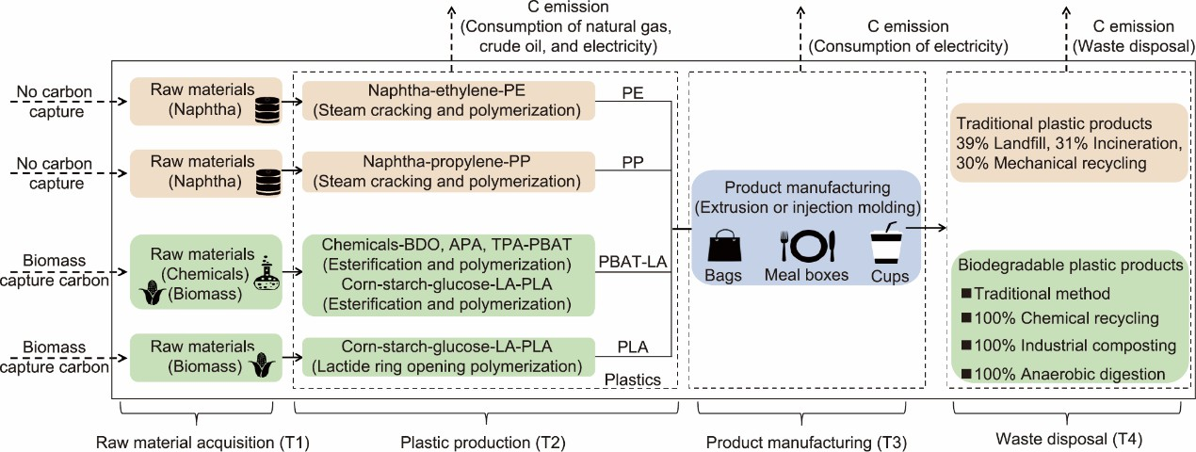

**Fig. 1.** The system boundary. BDO: 1,4-butanediol; APA: adipic acid; TPA: terephthalic acid; LA: lactic acid.

* 1. *Functional unit (FU)*

The FU was defined as 1000 single-use bags, meal boxes, or cups used in daily life. Dimensions of 260.00 × 420.00 × 0.04, a volume of 1000 mL, and a volume of 500 mL were respectively chosen as samples for the single-use bags, meal boxes, and cups. Section S1 in Appendix A for further

details.

The weights of the single-use bags were calculated according to their size and material density [37,38]. Each single-use bag with the dimensions 260.00 × 420.00 × 0.04 weighs 8.04 g if made from PE or 10.83 g if made from PBAT-LA. Based on the market survey, the weight of a 1000-mL meal box is 25–31 g if made from PP or 27–34 g if made from PLA, and the respective weights of a 500-mL cup are 8–11 and 10–14 g. However, to avoid the differences in weight observed in the market, which may not be caused by the material properties but rather by the limitations of the processing equipment and techniques, we used a theoretical approach to estimate the weights of plastic meal boxes and cups made from different materials. Ashby [39,40] has proposed the material index (MI) to indicate the stiffness of a material as a function of the Young’s modulus *E* and the density *ρ* of that material (Eq. (1)).

1

*E* 3

MIstiffness *= ρ*

(1)

Then, the material substitution factor (MSF) represents the ratio between the minimum masses

needed by two materials to satisfy the same requirement (e.g., the same stiffness performance). The MSF is defined as the ratio between the MI of the reference material (MIref) and that of the new material (MIA) (Eq. (2)) [36]. The comparative analysis of weight for a novel material by defining the MSF is given as follows.

MIref

MSFstiffness = MIA

(2)

First, the 1000-mL PLA meal box and 500-mL PLA cup were assumed to be 27 and 10 g,

respectively, which was within the scope of the weights of the products observed in the market (27– 34 and 10–14 g, respectively). Applying the concept of the MSF, the theoretical weights of the PP meal box and cups were calculated to be 23.17 and 8.58 g, respectively. The data used to calculate the MSFs, MIs, and weights of the PP meal box and cups for the same FU are shown in Table S3 in Appendix A.

* 1. *Life-cycle inventory analysis*

The life-cycle inventories of different plastic products, from raw materials acquisition to waste disposal, are described in this section (Section S2 in Appendix A for more details). The relevant parameters are provided in

Table **1**[29,36,38,41–60].

**Table 1**

The relevant parameters of different plastic products.

|  |  |  |  |  |  |  |
| --- | --- | --- | --- | --- | --- | --- |
| Stage | Relevant parameter | PE | PP | PBAT-LA | PLA | References |
|  | Carbon content | 85.60%– | 77.60%– | 58.56%– | 50.00%– | [36,38,52,58– |
| T1 |  | 93.02% | 85.62% | 58.62% | 50.20% | 60] |

— — [42]

|  |  |  |
| --- | --- | --- |
| CO2 emission factor (t·t−1) | 2.250 (1.575– | 2.250 (1.575– |
|  | 2.925) | 2.925) |
| Geographical adjustment factor | 130% (120%– | 130% (120%– |
|  | 140%) | 140%) |
| CH4 emission factor (kg·t−1) | 3.30 (2.97–  3.63) | 3.30 (2.97–  3.63) |

T2

— —

— —

Carbon emissions of per kg (kg

|  |  |  |  |  |  |
| --- | --- | --- | --- | --- | --- |
| CO2eq) |  | | | | |
| The electricity consumption (kWh·kg−1) | 1.03–2.00 | 1.41–2.00 | 1.23–2.00 | 1.23–2.00 | [29,36,38,41] |
| Emission factors of plastics for incineration* | 3.14 | 3.14 | 1.62 | 1.47 | [48] |

— — 2.95–3.22 1.30–2.19 [43–47]

T3 T4

Chemical recovery rate — — — 60%–80% [49,50] Industrial composting rate — —

|  |  |  |
| --- | --- | --- |
| 20.0%– | 70%–82% | [51–53] |
| 81.1% |  |  |
| 57.1% | 57.1% | [53] |
| 70%–80% | 70%–80% | [54–57] |

Proportion of CO2 released in — —

industrial composting

Anaerobic digestion ratio — —

Proportion of CO2 in biogas — — 20%–40% 20%–40% [54–57]

*These were calculated via stoichiometry; detailed data are provided in Table S4 in Appendix A.

* + 1. *Raw materials acquisition (T1)*

The raw material for the PE and PP is mostly naphtha obtained from the secondary distillation of crude oil, where the latter was formed through the deposition of organic matter over thousands of years [61,62]. Thus, it was considered that no carbon capture occurred for traditional plastics at the T1 stage [63,64]. In contrast, CO2 is absorbed by the plants that will later be used to make PLA at the T1 stage [65]. The biological carbon content of PLA is shown in

Table **1**[29,36,38,41–60]. The calculation method was adjusted according to the biomaterial storage method, as shown in Eq. (3) in Fig. 2 [34,42,43,48–50,54–56,66,67].

* + 1. *Plastic production (T2)*

At present, ethylene and propylene are usually produced via the steam cracking of fossil fuel in a tubular furnace [68]. CO2 and CH4 emissions during ethylene and propylene production are calculated in Eqs. (4) and (5) in Fig. 2 [34,42,43,48–50,54–56,66,67]. For the polymerization of the monomer, the electricity consumption of PE and PP is assumed to be 0.37 kWh·kg−1 [29].

PLA is commonly produced via the lactide ring-opening polymerization method, which consumes natural gas and electricity [28,30,69]. The carbon emissions for 1.00 kg of PLA are found to be 1.30–2.19 carbon emissions equivalent of per kg (kg CO2eq) [43,45,47,61]. In addition, 0.41 kg of 1,4-butanediol (BDO), 0.37 kg of adipic acid (APA), and 0.33 kg of terephthalic acid (TPA) are required for the production of 1.00 kg of PBAT [44,45]. The carbon emissions of 1.00 kg of PBAT-LA are found to be 2.95–3.22 kg CO2eq [43–45,61].

* + 1. *Product manufacturing (T3)*

The melting point of PP is as high as 189 ℃, while that of PE is only 85–110 ℃. Therefore, the electricity consumption of thermoforming per kilogram of PE and PP is 1.03–2.00 and 1.41–2.00 kWh, respectively [36,38]. PLA and PBAT have similar melting points; thus, the electricity consumption of PBAT-LA and PLA is 1.23–2.00 kWh [36,41]. The carbon emissions of electricity consumption are calculated in Eq. (15) in Fig. 2 [34,42,43,48–50,54–56,66,67].

* + 1. *Waste disposal (T4)*

The traditional method currently used in China for the disposal of plastics—that is, 39% landfill, 31% incineration, and 30% mechanical recycling—was set as the waste disposal option for the traditional plastic products in this study [18]. Four scenarios were set for the disposal of waste biodegradable plastic products (WBPPs): the traditional method (S1); 100% chemical recycling (S2); 100% industrial composting (S3); and 100% anaerobic digestion (S4).

The carbon emissions generated by the landfill disposal of traditional plastic products are evaluated in the form of CO2 in this study [70]. PLA and PBAT can be completely degraded to produce water and CO2 [36,71]. For the WBPPs disposed of in a landfill, the calculation of the carbon emissions is shown in Eq. (6) in Fig. 2 [34,42,43,48–50,54–56,66,67]. For the incinerated WBPPs, the carbon emissions were calculated using stoichiometry, as shown in Eq. (7) in Fig. 2 [34,42,43,48–50,54–56,66,67]. For the WBPPs disposed of via mechanical recycling, it was considered that there were no carbon emissions for all plastic products.

The carbon emissions of the WBPPs in the scenarios S2, S3, and S4 were calculated as follows (Table S5 in Appendix A for relevant parameters). The calculation method for chemical recycling is shown in Eq. (8) in Fig. 2 [34,42,43,48–50,54–56,66,67]. Based on the requirement for a 30-day maximum operation time in industrial composting in China [20], the calculation method for industrial composting was adjusted, as shown in Eq. (9) in Fig. 2 [34,42,43,48–50,54–56,66,67]. Eq. (10) in Fig. 2 [34,42,43,48–50,54–56,66,67] was used to calculate the escaped carbon emissions, and the carbon emissions without composting were calculated using Eq. (11) in Fig. 2[34,42,43,48–

50,54–56,66,67]. The product of anaerobic digestion is biogas (mainly CH4 and CO2), where 60%– 80% of the CH4 is reused as energy. Based on the requirement for a 40-day maximum operation time for anaerobic digestion in China [20,67], the specific calculation method is presented in Eqs.

(12)–(14) in Fig. 2 [34,42,43,48–50,54–56,66,67].

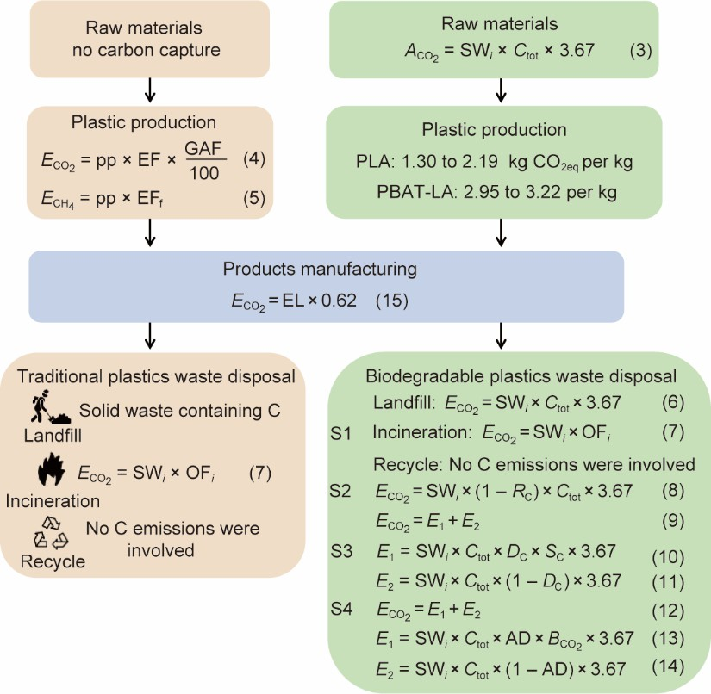

**Fig. 2.** Summary of the relevant equations used in the calculations. In regard to the four scenarios, traditional method (S1), 100% chemical recycling (S2), 100% industrial composting (S3), and 100% anaerobic digestion (S4), the T4 stage of the BPPs takes place using the S1, S2, S3, or S4 [34,42,43,48–50,54–56,66,67]. *A*CO2: absorption of CO2, kg; *C*tot: biological carbon content, %; *E*CO2: emissions of CO2, kg; pp: yields of ethylene, kg; EF: CO2 emission

factor of steam cracking, kg CO2·kg−1; GAF: geographical adjustment factor for ethylene production via steam

cracking, %; EFf: CH4 emission factor of naphtha steam cracking, kg CH4·t−1; SW*i*: weight of plastic products, kg; *i*: the type of plastic product waste; OF*i*: emission factors of plastic products for incineration disposal, tCO2·t−1 plastic; *R*C: chemical recycling rate, %; *D*C: industrial composting rate, %; *S*C: proportion of CO2 released in industrial

composting, %;

AD: anaerobic digestion ratio, %; *B*CO2: proportion of CO2 in biogas, %; EL: electricity

consumption, kWh; 3.67: conversion factor from C to CO2.

* 1. *The computing method*

All the equations in this study have been adjusted according to the 2019 Intergovernmental Panel on Climate Change (IPCC) report [42] and relevant studies based on emission factors and mass balance methods, as shown in Fig. 2 [34,42,43,48–50,54–56,66,67]. The bases of definition for the equations are shown in Section S3 in Appendix A.

## Results and discussion

* 1. *Carbon emissions from the life-cycle of traditional plastic products*

The carbon emissions related to traditional plastic products, from raw materials acquisition to waste disposal, are shown in Fig. 3.

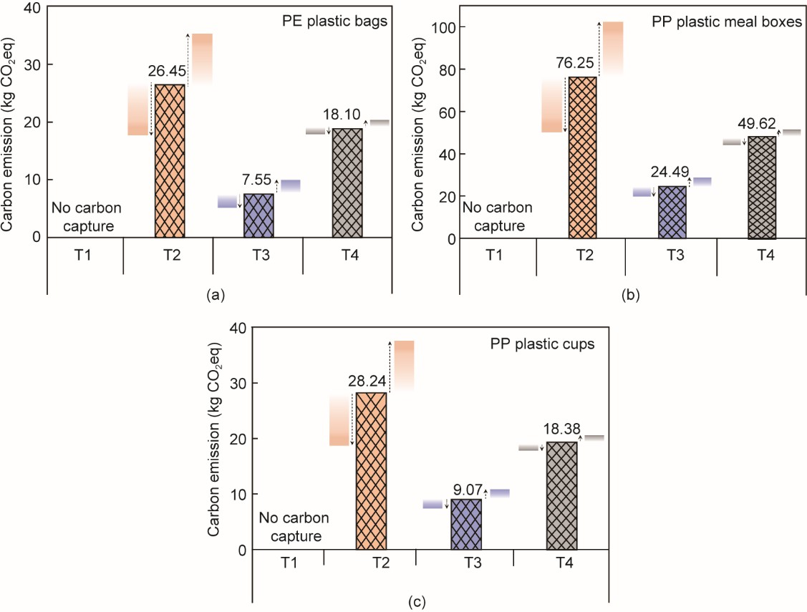

**Fig. 3.** Carbon emissions of traditional plastic products across the whole life cycle. (a)–(c) Carbon emissions of (a) 1000 single-use PE plastic bags; (b) 1000 single-use PP plastic meal boxes; (c) 1000 single-use PP plastic cups.

Crude oil was formed through the deposition of organic matter over many thousands of years [61,62]. Thus, regarding the negative carbon emissions of traditional plastics at the stage of raw materials acquisition (T1), it was considered that no carbon capture occurred.

The carbon emissions of PE plastic bags at the plastic production (T2) stage accounted for 50.77% of the total, and those of PP plastic meal boxes or cups accounted for 50.71%, making this stage one of the main sources of emissions. This is because traditional plastic products consume a large amount of GHG-intensive fossil-derived resources (e.g., naphtha) at this stage, resulting in a large amount of CO2 emissions and releasing the GHG methane as well, which has a higher global warming potential [72,73]. Based on the electricity consumption, there were relatively fewer carbon emissions at the product manufacturing (T3) stage, accounting for 14.49%–16.29% of the total. The carbon emissions of the PP plastic products at this stage were slightly higher than those of the PE plastic products, due to the difference in melting points, which affected the electricity consumption. The carbon emissions at the waste disposal (T4) stage were calculated based on traditional disposal methods. The results showed that the carbon emissions of 1000 single-use PE plastic bags, PP plastic meal boxes, and PP plastic cups at this stage were 18.10, 49.62, and 18.38 kg CO2eq, respectively, making this stage the second highest source of carbon emissions from traditional plastic products. Traditional plastic products directly contribute to carbon emissions during disposal in the incineration scenario, which is the main source of emissions at the T4 stage. Moreover, the traditional combination methods included 30% mechanical recycling, whereas single-use plastic products might not be able to achieve this percentage. Therefore, it is likely that the carbon emissions from traditional plastic products at the T4 stage are higher than those presented in Fig. 3. In addition, traditional plastic products are decomposed (by landfilling) over a period ranging from decades to hundreds of years [74]. The greenhouse effect from the landfill disposal of traditional

plastic products might be even worse than predicted in this study.

Therefore, eco-friendly production techniques and waste disposal methods should be considered in order to potentially reduce the carbon emissions from traditional plastic products.

* 1. *Carbon emissions from the life-cycle of BPPs*

The carbon emissions of PBAT-LA and PLA plastic products, from raw material acquisition to waste disposal, are shown in Fig. 4. The carbon emissions for 1.00 kg of PBAT-LA plastic products

are about 3.41–4.43 kg CO2eq, which is slightly higher than the emissions for 1.00 kg of PLA plastic products (1.37–2.15 kg CO2eq).

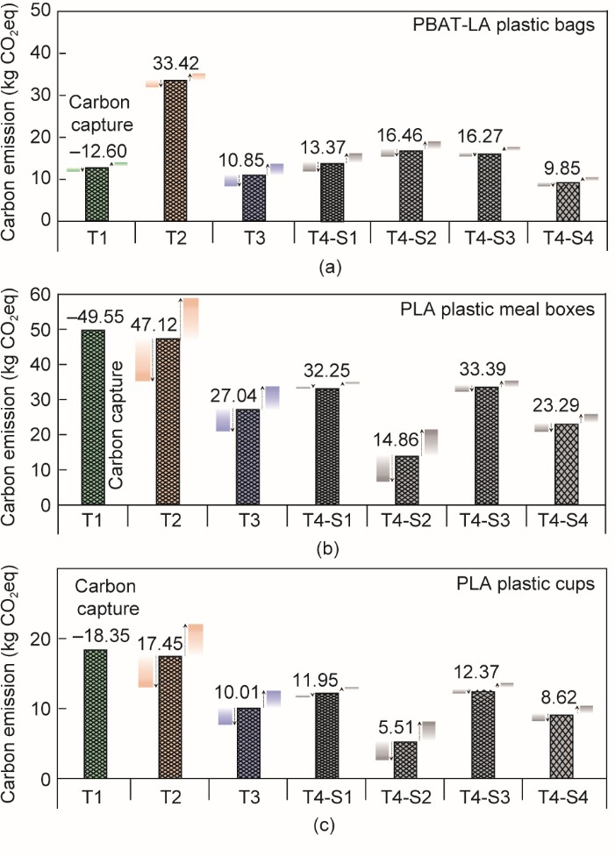

**Fig. 4.** Carbon emissions of BPPs in the whole life cycle. (a)–(c) Carbon emissions of (a) 1000 single-use PBAT- LA plastic bags; (b) 1000 single-use PLA plastic meal boxes; (c) 1000 single-use PLA plastic cups. Here, the labels T4-S1, T4-S2, T4-S3, and T4-S4 indicate that the T4 stage takes place using S1, S2, S3, or S4.

At the T1 stage, the CO2 absorption of 1.00 kg of PBAT-LA and PLA plastic products was 1.16 and 1.84 kg CO2eq, respectively, because the raw material of PLA is derived from biomass. It was verified that BPPs hold the potential for carbon neutrality, especially PLA [75]. The reason for the difference between PBAT-LA and PLA plastic products at this stage is that the raw materials of PBAT are petroleum-based products, such as nitric acid and cyclohexane, through which no carbon capture occurs [45].

Similar to traditional plastic products, the main carbon emissions source from the BPPs was the T2 stage. The results showed that the carbon emissions of PBAT-LA and PLA plastic products accounted for 55.20%–61.76% and 43.81%–52.93% of the total, respectively. These emissions mainly came from the energy inputs for monomer production and polymerization, such as natural gas, electricity, and steam. The carbon emissions of 1.00 kg of PBAT-LA plastic products (3.09 kg CO2eq) were significantly higher than those of 1.00 kg of PLA (1.75 kg CO2eq), due to the relatively complex production process of PBAT. At the product manufacturing (T3) stage, the carbon emissions of the PBAT-LA and PLA plastic products accounted for 17.86%–20.05% and 25.14%– 30.37% of the total carbon emissions (TC), respectively. The carbon emissions of the PBAT-LA plastic products were lower than those of PLA, mainly because the total mass of 1000 single-use PBAT-LA plastic bags was lower, resulting in relatively lower power consumption.

As shown in Fig. 4, four different scenarios were set for the disposal of WBPPs. In S1, the carbon emissions of the PBAT-LA plastic bags and of PLA meal boxes and cups at the T4 stage were 13.37, 32.25, and 11.95 kg CO2eq, respectively. These values might be due to the large amounts of GHGs caused by the landfill and incineration of WBPPs, which are released directly into the environment. When the other three waste disposal scenarios at the T4 stage were considered, the results indicated that the WBPPs held potential for carbon emission reduction in a particular scenario. For example,

the carbon emissions of WBPPs in S4 were 26.35%–27.80% lower than those in S1. The carbon emissions of industrial composting (S3) were relatively high, which should be due to two factors:

① The composting of WBBPs mainly produces carbon fertilizer and CO2; ② industrial composting generates uncontrolled CO2 escape emissions [76]. In chemical recycling (S2), the carbon emissions for 1.00 kg of PBAT-LA and PLA plastic products were only 1.52 and 0.55 kg CO2eq, respectively. The higher carbon emissions of the PBAT-LA plastic products in the S2 scenario were mainly due to the difficulty of the chemical recycling of composite plastics. Although the PLA plastic products had lower carbon emissions in the S2 scenario, the uncertainty of the recovery rate and the secondary contamination of chemical agents are the major challenges presented by chemical recycling [77]. In anaerobic digestion (S4), the carbon emissions of 1.00 kg of PBAT-LA and PLA plastic products were only 0.91 and 0.86 kg CO2eq, respectively. In comparison with the other scenarios, anaerobic digestion can be considered the preferable technology for disposing of these WBPPs due to the biodegradability of BPPs. Furthermore, there is a much greater margin for improvement in the digestibility of WBPPs toward achieving lower carbon emissions. However, other PBAT plastic products might not achieve the same digestibility as single-use PBAT-LA plastic bags [78]. In addition, the CH4 in biogas produced by anaerobic digestion could be used to replace some traditional energy sources, thereby further reducing the carbon emissions of traditional energy sources. Currently, most WBPPs in China cannot be well distinguished from waste traditional plastic products, making it difficult to achieve these disposal advantages; moreover, the long operation cycle of biomass treatment facilities cannot satisfy existing degradation standards [20,79].

In conclusion, the carbon emissions of BPPs could be reduced by decreasing the energy

consumption in their production or by promoting waste disposal methods involving resource or energy recovery, such as anaerobic digestion.

* 1. *Comparison between carbon emissions from biodegradable and traditional plastic products*

Fig. 5 shows a comparison of the carbon emissions for the PBAT-LA, PLA, PE, and PP plastic products used in daily life. The net carbon emissions of different plastic products from T1 to T4 are denoted by TC. The results show that the TC of the BPPs is 7.60%–73.75% lower than that of the traditional plastic products. Among them, the TC of PLA plastic products is 61.43%–73.75% lower than that of PP plastics products, showing a greater advantage in carbon emission reduction. (Tables S6 and S7 in Appendix A for detailed data.)

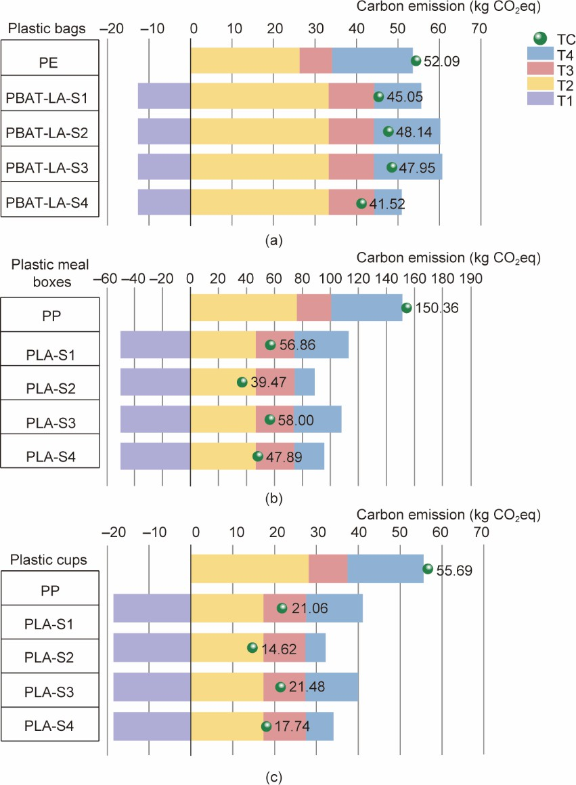

**Fig. 5.** Comparison of life-cycle carbon emissions from traditional plastic products and BPPs. (a) 1000 single-use PE and PBAT-LA plastic bags; (b) 1000 single-use PP and PLA plastic meal boxes; (c) 1000 single-use PP and PLA plastic cups. The labels PBAT/PLA-S1, PBAT/PLA-S2, PBAT/PLA-S3, and PBAT/PLA-S4 indicate that the T4 stage uses S1, S2, S3, or S4.

At the T1 stage, the raw material of the BPPs had absorption of CO2, which was one of the reasons why the TC of the BPPs is lower than that of the traditional plastic products. The negative carbon emissions in stage T1 are a significant advantage of the utilization of BPPs, especially plastics made from biomass such as PLA.

As shown in Fig. 5, the difference in the carbon emissions of traditional plastic products versus BPPs was obvious at the T2 stage. The carbon emissions of 1000 PLA plastic products were lower by about 10.79–29.13 kg CO2eq in comparison with those of the traditional plastic products. Thus, replacing traditional plastic products with PLA plastic products holds potential for carbon emissions reduction at the T2 stage. The difference between the PLA and traditional plastic products was mainly attributed to the use of fossil-derived resources to manufacture the traditional plastic products [72,73]. In comparison, the carbon emissions of 1000 PBAT-LA plastic products were

6.79 kg CO2eq higher than those of PE products, which may be due to the petroleum-based raw materials and cumbersome production process of PBAT. Compared with the established PE and PP plastic production techniques, those of biodegradable plastics are under development [80,81]. For example, Nature Works is attempting to reduce the consumption of natural gas, electricity, water, and other resources for PLA plastic production [43]. Therefore, PBAT-LA and PLA plastic products might achieve lower carbon emissions than those presented in this study. In addition, as the four plastic products were all thermoformed, the carbon emissions were not significantly different at the T3 stage.

At the T4 stage, the waste flows and carbon emissions of traditional plastic products and BPPs were compared. As shown in Fig. 6(a), The BPPs at the T4 stage showed a clear difference from

the traditional plastic products, mainly due to the lower carbon content. As shown in Fig. 5, the TC of the WBPPs that were disposed of according to S1 was 65.00%–73.88% of that of the disposal of traditional plastic products in the same scenario, and did not show a clear advantage. However, the greenhouse effect of traditional plastic products in landfills is worse and continues for centuries [70]. The landfill and incineration of WBPPs not only had a non-negligible greenhouse effect but also contributed to the destruction of the ozone layer. The analysis found that the WBPPs had better carbon emission advantages in a particular scenario. As shown in Fig. 6(b), the waste flows of PLA plastic products in S2 showed that there was lactic acid (LA) recovery, and the proportion of CO2 decreased by about 17.60% compared with S1. The carbon emissions of WBPPs at the T4 stage in S2 were 29.95%–90.95% of those of traditional plastic products. Among them, the potential for carbon reduction through the use of PBAT-LA plastic products was not obvious, due to the difficulty in the chemical recycling of composite plastics. The difficulty of chemical recycling also includes the use of toxic solvents and a complex recycling process. Fig. 6(c) shows that 11.10% and 16.30% of PBAT-LA and PLA plastic products, respectively, were recycled through fertilizer in industrial composting. In the anaerobic digestion scenario, S4 (as shown in Fig. 6(d)), the proportion of CO2 emissions decreased by 8.90%–9.10% compared with S1, and the process generated biogas energy products. As shown in Fig. 5, the carbon emissions of WBPPs at the T4 stage in S3 and S4 were 67.29%–89.91% and 46.93%–54.41%, respectively, of those of traditional plastic products. These results indicate that the potential for carbon emission reduction from the disposal of WBPPs in S3

is not as good as that in S4, which should be viewed from the following two aspects: ① industrial composting generates uncontrolled CO2 escape emissions; and ② the anaerobic digestion of WBPPs is faster and releases much less CO2 than composting.

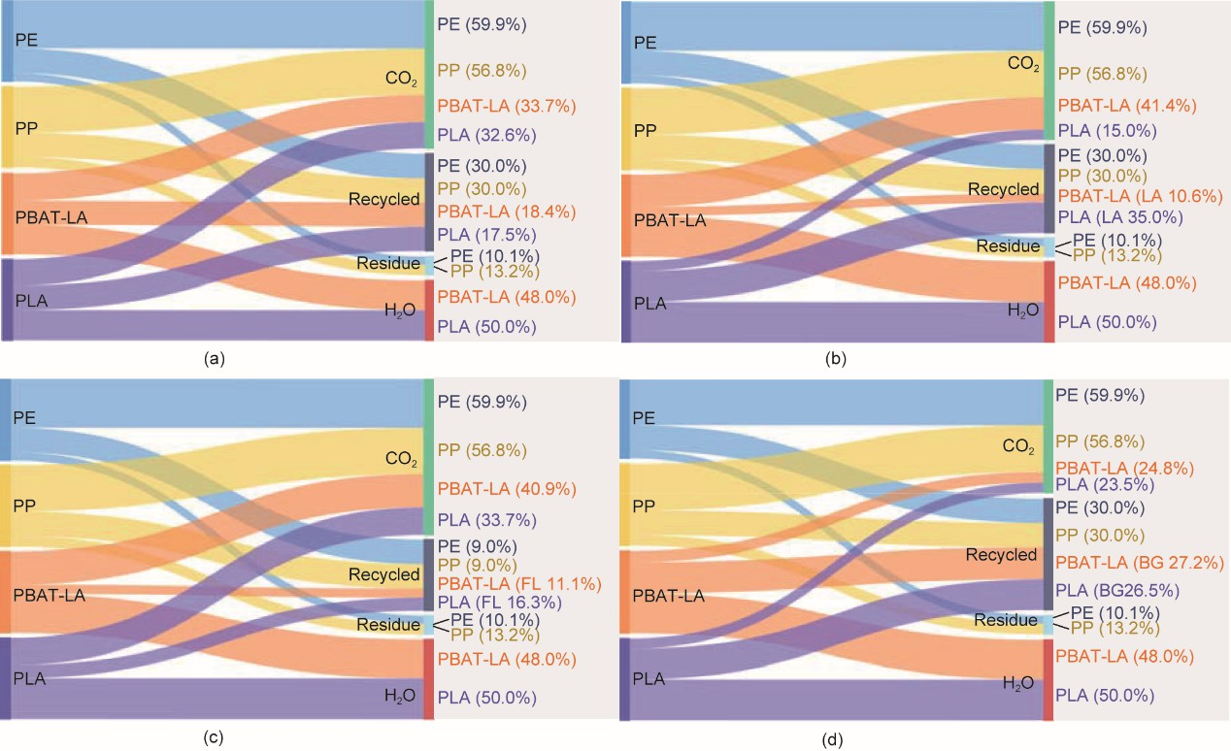

**Fig. 6.** The waste flows of different waste traditional plastic products and WBPPs. (a)–(d) The disposal of WBPP in

(a) S1; (b) S2; (c) S3; (d) S4. Reference flow: per 1 kg of plastic products; FL: fertilizer; BG: biogas.

The carbon emissions of products such as plastic bags, meal boxes, and cups were compared from the perspective of replacing traditional plastic products with BPPs (as shown in **Error! Reference source not found.**). The results indicate that replacing PE plastic bags with PBAT-LA and replacing PP plastic meal boxes and cups with PLA may reduce carbon emissions by 4.23 × 107, 1.10 × 108, and 1.14 × 106 kg CO2eq per year in the optimal scenario. From the perspective of the product’s carbon footprint, BPPs have the potential to reduce carbon emissions, especially the use of separate PLA plastic products.

**Table 2**

Annual consumption and carbon reduction of different plastic products.

Plastic products Annual

consumption (t)

Traditional→Biodegradabl

e

Carbon reduction (kg CO2eq·year−1)

S1 S2 S3 S4

Plastic bags

Plastic meal boxes

Plastic cups

4.00 × 106 PE→PBAT-LA 2.82 × 107 1.58 × 107 1.66 × 107 4.23 × 107

1.07 × 106 PP→PLA 1.00 × 108 1.19 × 108 0.99 × 108 1.10 × 108

3.00 × 104 PP→PLA 1.04 × 106 1.23 × 106 1.03 × 106 1.14 × 106

Therefore, the use of BPPs holds the potential for carbon emission reduction compared with traditional plastic products; however, it must be considered that this study is a carbon emission assessment based on the current situation of plastic products used in daily life. The wide application of BPPs might require a comprehensive assessment of other environmental impacts, economic benefits, and feasibility.

* 1. *Environmental and economic discussion*
     1. *Environmental discussion*

In addition to emitting GHGs, the production and waste disposal of traditional plastic products cause serious environmental pollution, such as the generation of hazardous wastes, the destruction of oceans and soils, and the emission of air pollutants (volatile organic carbon, carbon monoxide, etc.) [82,83]. More specifically, traditional plastic products rely on oil feedstock, so their manufacturing depletes fossil-fuel resources. Previous LCAs of biodegradable plastics have shown significant reductions in the depletion of nonrenewable resources when biodegradable plastics replace traditional plastics, ranging between 7% and 70% depending on the polymer, plastic item, and form of waste management [84,85]. Furthermore, the generation of waste plastic products is contaminating the oceans and soils due to the low global recycling rate of traditional plastic products. This issue could be mitigated by biodegradable plastics, which are intended to degrade faster in the natural environment [85].

However, the production and waste management of BPPs can also cause environmental risks (Table S8 in Appendix A for a detailed description of the BPP environmental impact) [83,86,87]. Regarding raw materials, PLA is produced from renewable resources such as corn and sugarcane, which require land for 2.0–2.5 t of biomass per ton of PLA. The stage of biomass cultivation contributes to eutrophication and agricultural land use [88]. Furthermore, converting biomass into sugars and then polymers requires a significant energy consumption [43]. Although PBAT is a degradable plastic material, its petroleum-based raw materials can deplete fossil-fuel resources, similar to traditional plastics in the production process [20,89]. The manufacturing of PBAT-LA requires a high energy consumption because of the complex production process for PBAT [45]. Thus, the current production process of PBAT also has an environmental impact in terms of air pollution, acidification, greenhouse effect, and among others [20,36]. In addition, the polyesters and additives (i.e., compatibilizers and others) added to PLA have a major environmental impact that is often neglected in their LCAs [89]. From the perspective of environmental impact, components such as compatibilizers should be minimized. Nevertheless, energy consumption is expected to have much more margin for improvement in the case of biodegradable plastics compared with well- established traditional plastics.

The inappropriate disposal of WBPPs may result in worse environmental impacts than the disposal of waste traditional plastic products in certain cases. For example, the WBPPs in landfills may produce landfill gas relatively quickly, causing climate change impacts and ozone depletion [29,36]. Potentially hazardous emissions such as particulate matter, dioxins, and furans during the incineration of WBPPs are a major environmental pollution [23,36]. While recycling is possible for WBPPs, its success is limited by the lack of dedicated infrastructure, since WBPPs exhibit deterioration in their physical properties during the mechanical recycling process and thus cannot be recycled together with traditional plastics. Chemical recycling is possible as an alternative, but it generally requires the use of toxic solvents to degrade the polymers into monomers [23,90]. The

biodegradability of biodegradable materials makes it possible to adopt end-of-life strategies for WBPPs such as composting and anaerobic digestion to prevent direct leakage into the environment. Composting and anaerobic digestion are considered to be preferable end-of-life disposal methods for WBPPs, along with fertilizer or CH4 energy recovery in biogas. However, these methods present the challenges of a long operating cycle and inefficient recovery of WBPPs [91].

In conclusion, the environmental impact of WBPPs varies greatly according to the different disposal scenarios, and it is essential to choose appropriate waste management strategies in order to reduce their environmental impact.

* + 1. *Economic discussion*

Many factors affect the cost of plastic products, including the raw material, equipment, research and development, and energy needs. When comparing the costs of BPPs with those of traditional plastic products, the difference mainly comes from the variance in the cost of materials. In China, the production method used for BPPs (taking PLA and PBAT as examples) is shown in Fig. S1.

The production of PBAT includes the production of BDO, APA, and TPA, as well as polymerization [45]. In recent years, the high and greatly fluctuating price of BDO has increased the uncertainty of PBAT production cost [20]. The production technology for PLA that is commonly adopted in China is lactide ring-opening polymerization, whose core is the synthesis and purification of lactide [92]. Of the compared plastics, PLA has the highest cost, which was analyzed based on the following aspects: ① Corn, which is the raw material used to make PLA in China, has a large consumption and relatively high cost; ② the purification process of lactide is complex and difficult,

presenting technical barriers to the production of lactide, with only a few domestic companies

possessing this capacity in China; and ③ at present, the production capacity of PLA is relatively low, with unsatisfied demand in China, resulting in a relatively high import dependence [20]. The high costs of production have become a major technology bottleneck in the large-scale development of China’s biodegradable plastics industry. According to domestic market research, the prices of PBAT-LA and PLA are respectively around 21 772 and 25 500 RMB·t−1 (based on the USD/RMB exchange rate on June 31, 2023, where 1 USD = 7.11 RMB)—nearly 2.63–2.70 and 3.08–3.16 times greater that of traditional plastics (A detailed price market survey is shown in Table S9 in Appendix A). As shown in

Table **3**, the cost of 1000 plastic bags, meal boxes, and cups made from biodegradable plastics was approximately 169.35, 501.66, and 185.80 RMB, respectively—higher than those made from traditional plastics, with an annual cost approximately 163%–216% higher. Therefore, developing more economical production technologies is an important direction for the sustainable application and promotion of BPPs in China.

**Table 3**

Comparison of costs of biodegradable and traditional plastic products.

|  |  |  |  |
| --- | --- | --- | --- |
| Products Price of plastic | Weight of 1000 plastic | Price of plastic products | Annual cost of plastic |
| (RMB·kg−1) | products (kg) | (RMB·1000−1) | products (RMB) |
| 8.28 | 8.04 | 66.51 | 3.31 × 1010 |
| PE bags  21.77 | 10.83 | 235.85 | 8.71 × 1010 |
| PBAT-LA  bags  8.06 | 23.17 | 186.84 | 8.63 × 109 |
| PP meal boxes  25.50 | 27.00 | 688.50 | 2.73 × 1010 |
| PLA meal boxes  8.06 | 8.58 | 69.20 | 2.42 × 108 |
| PP cups  25.50 | 10.00 | 255.00 | 7.65 × 108 |

PLA cups

## Conclusions

This study calculated and discussed the life-cycle carbon emissions of traditional plastic products and BPPs commonly used in daily life in China. The results showed that the carbon emissions of 1000 single-use traditional plastic products (PE and PP plastic products) were 52.09–150.36 kg CO2eq, with the T2 stage contributing 50.71%–50.77%. The emissions from 1000 single-use BPPs (PBAT-LA and PLA plastic products) topped out at 21.06–56.86 kg CO2eq, which is 13.53%–62.19% lower than those of traditional plastic products. Furthermore, disposal via anaerobic digestion had the optimal performance at stage T4, with the lowest TC of the BPPs being 17.74–41.66 kg CO2eq. The most significant differences were at the T2 and T4 stages, although the T1 stage exhibited the unique advantage of the use of biomass raw material, which yields negative carbon emissions.

It was determined that 1.03 × 106–1.10 × 108 kg CO2eq of carbon emissions per year would be reduced in China if BPPs were used instead of traditional plastic products (e.g., plastic bags, meal boxes, or straws). In terms of environmental impacts, composting and anaerobic digestion are considered to be the preferable end-of-life disposal methods for WBPPs, with fertilizer or CH4 energy recovery in biogas. Conversely, the high production costs of BPPs have limited their development. The development of more economical production technologies and waste disposal methods to recover resources or energy may contribute to the promotion and sustainable application of BPPs. This study has important reference significance for the sustainable development of the biodegradable plastics industry.

## Acknowledgments

This research was supported by the National Natural Science Foundation of China (52100157, 52176197, and 52100156) and the National Key Research and Develop Program of China (2022YFD1601100).

## Compliance with ethics guidelines

Guanyi Chen, Jianyuan Li, Yunan Sun, Zhi Wang, Gary A. Leeke, Christian Moretti, Zhanjun Cheng, Yuan Wang, Ning Li, Lan Mu, Jinyu Li, Junyu Tao, Beibei Yan, and Li’an Hou declare that they have no conflict of interest or financial conflicts to disclose.

## Appendix A. Supplementary data

Supplementary data to this article can be found online at

## References

1. Li Z. Research on Scenario Prediction of Carbon Emissions in China, the United States and India in Chinese [dissertation]. Beijing: North China Electric Power University; 2021. Chinese.
2. Okoffo ED, Donner E, McGrath SP, Tscharke BJ. Plastics in biosolids from 1950 to 2016: a function of global plastic production and consumption. Water Res 2021;201:117367.
3. China Plastics Industry Yearbook. [Composite film product]. Report. Beijing: China Plastics Processing Industry Association; 2021. Chinese.
4. China Plastics Industry Yearbook. [National Development and Reform Commission Opinions of the Ministry of Ecology and Environment on further strengthening plastic pollution control: policies and regulations]. Report. Beijing: China Plastics Processing Industry Association; 2021. Chinese.
5. Di J, Reck BK, Miatto A, Graedel TE. United States plastics: large flows, short lifetimes, and negligible recycling. Resour Conserv Recycling 2021;167:105440.
6. Bauer F, Fontenit G. Plastic dinosaurs—digging deep into the accelerating carbon lock-in of plastics. Energy Policy 2021;156:112418.
7. Geyer R, Jambeck JR, Law KL. Production, use, and fate of all plastics ever made. Sci Adv 2017;3(7):1700782.
8. Simon N, Raubenheimer K, Urho N. A binding global agreement to address the life cycle of plastics to eliminate plastic pollution, a holistic approach is needed. Science 2021;373(6550):43–7.
9. Wang B, Li Y. Plastic bag usage and the policies: a case study of China. Waste Manag 2021;126:163–9.
10. Sun L, Cui H, Ge Q. Will China achieve its 2060 carbon neutral commitment from the provincial perspective? Adv Clim Chang Res 2022;13(2):169–78.
11. Zhao X, Ma X, Chen B, Shang Y, Song M. Challenges toward carbon neutrality in China: strategies and countermeasures. Resour Conserv Recycl 2022;176:105959.
12. Moshood TD, Nawanir G, Mahmud F, Mohamad F. Biodegradable plastic applications towards sustainability: a recent innovations in the green product. Cleaner Eng Technol 2022;6:100404.
13. Rosenboom JG, Langer R, Traverso G. Bioplastics for a circular economy. Nat Rev Mater 2022;7(2):117–37.
14. Viera JSC, Marques MRC, Nazareth MC, Jimenez PC, Sanz-Lázaro C, Castro ÍB. Are biodegradable plastics an environmental rip off? J Hazard Mater 2021;416:125957.
15. Zhu J, Wang C. Biodegradable plastics: green hope or greenwashing? Mar Pollut Bull 2020;161(B):11774.
16. Stegmann P, Daioglou V, Londo M, van Vuuren DP, Junginger M. Plastic futures and their CO2 emissions. Nature 2022;612:272–6.
17. Gisia SD, Gadaletaa G, Gorrasi G. The role of (bio)degradability on the management of petrochemical and bio-based plastic waste. J Environ Manage 2022;310(16):114769.
18. Chu S, Zhang B, Zhao X, Soo HS. Photocatalytic conversion of plastic waste: from photodegradation to photosynthesis. Adv Energy Mater 2022;12(22):23.
19. Narancic T, Cerrone F, Beagan N, O’Connor KE. Recent advances in bioplastics: application and biodegradation. Polymers 2020;12(4):920.
20. Environmental impact assessment of degradable plastics and policy support research project. Report. Beijing: Tsinghua University; China Petroleum and Chemical Corporation; 2022. Chinese.
21. Balla E, Daniilidis V, Karlioti G, Kalamas T, Stefanidou M, Bikiaris ND, et al. Poly(lactic Acid): a versatile biobased polymer for the future with multifunctional properties—from monomer synthesis, polymerization techniques and molecular weight increase to PLA applications. Polym (Basel) 2021;13(11):1822.
22. Rodrigues MO, Abrantes N, Gonçalves FJM, Nogueira H, Marques JC, Gonçalves AMM. Impacts of plastic products used in daily life on the environment and human health: what is known? Environ Toxicol Pharmacol 2019;72:103239.
23. Abraham A, Park H, Choi O. Anaerobic co-digestion of bioplastics as a sustainable mode of waste management with improved energy production—a review. Bioresour Technol 2021;322:124537.
24. Bátori V, Åkesson D, Zamani A. Anaerobic degradation of bioplastics: a review. Waste Manag 2018;80:406–13.
25. Nazareth MC, Marques MRC, Pinheiro LM, Castro ÍB. Key issues for bio-based, biodegradable and compostable plastics governance. J Environ Manage 2022;322:116074.
26. Viera JSC, Marques MRC, Nazareth MC, Jimenez PC, Castro ÍB. On replacing single-use plastic with so-called biodegradable ones: the case with straws. Environ Sci Policy 2020;106:177–81.
27. Vidal R, Martínez P, Mulet E. Environmental assessment of biodegradable multilayer film derived from carbohydrate polymers. J Polym Environ 2007;15(3):159–68.
28. Zhao M, Yang Z, Zhao J, Wang Y. Life cycle assessment of biodegradable polylactic acid (PLA) plastic packaging products—taking Tianjin, China as a case study. J Resour Ecol 2022;13(3):428–41.
29. Benavides PT, Lee U, Zarè-Mehrjerdi O. Life cycle greenhouse gas emissions and energy use of polylactic acid, bio- derived polyethylene, and fossil-derived polyethylene, J Cleaner Prod 2020;277:124010.
30. Papong S, Malakul P, Trungkavashirakun R. Comparative assessment of the environmental profile of PLA and PET drinking water bottles from a life cycle perspective. J Clean Prod 2014;65:539–50.
31. ISO 527–2:2012: Plastics: determination of tensile properties—part 2: test conditions for moulding and extrusion plastics. International standard. Switzerland: International Organization for Standardization; 2017.
32. ISO/TR 14049:2012. Environmental management—life cycle assessment—illustrative examples on how to apply ISO 14044 to goal and scope definition and inventory analysis. Switzerland: International Organization for Standardization; 2012.
33. Li Z, Sang K, inventors. An antibacterial high-strength biodegradable plastic bag and a preparation method. China patent CN202110062753.5. 2022 Mar 29. Chinese.
34. Leejarkpai T, Mungcharoen T, Suwanmanee U. Comparative assessment of global warming impact and eco-efficiency of PS (polystyrene), PET (polyethylene terephthalate) and PLA (polylactic acid) boxes. J Cleaner Prod 2016;125:95–107.
35. Abbate E, Rovelli D, Andreotti M, Brondi C, Ballarino A. Plastic packaging substitution in industry: variability of LCA due to manufacturing countries. Procedia CIRP 2022;105:392–7.
36. Moretti C, Hamelin L, Jakobsen LG, Junginger MH, Steingrimsdottir MM, Høibye L, et al. Cradle-to-grave life cycle assessment of single-use cups made from PLA, PP and PET. Resour Conserv Recycl 2021;169:105508.
37. Harst Ed, Potting J. A critical comparison of ten disposable cup LCAs. Environ Impact Assess Rev 2013;43:86–96.
38. Choi B, Yoo S, Park S. Carbon footprint of packaging films made from LDPE, PLA, and PLA/PBAT blends in South Korea. Sustainability 2018;10(7):2369.
39. Sapuan SM. A knowledge-based system for materials selection in mechanical engineering design. Mater Des 2001;22(8):687–95
40. Ashby MF. Materials Selection in Mechanical Design. 3rd ed. Switzerland: MRS Bulletin; 2005.
41. Suwanmanee U, Chaiwutthinan VVP. Life cycle assessment of single use thermoform boxes made from polystyrene (PS), polylactic acid, (PLA), and PLA/starch: cradle to consumer gate. Int J Life Cycle Assess 2013;18(2):401–17.
42. Intergovernmental Panel on Climate Change. 2019 Refinement to the 2006 IPCC guidelines for national greenhouse gas inventories. Report. IPCC; 2019.
43. Vink ETH, Davies S. Life cycle inventory and impact assessment data for 2014 ingeo™ polylactide production. Ind Biotechnol 2015;11(3):167–80.
44. Schrijvers DL, Leroux F, Verney V, Patel MK. Ex-ante life cycle assessment of polymer nanocomposites using organo- modified layered double hydroxides for potential application in agricultural films. Green Chem 2014;16(12):4969–84.
45. Saibuatronga W, Cheroenneta N, Suwanmanee U. Life cycle assessment focusing on the waste management of conventional and bio-based garbage bags. J Cleaner Prod 2017;158:319–34.
46. Sun XZ, Minowa T, Yamaguchi K, Genchi Y. Evaluation of energy consumption and greenhouse gas emissions from poly(phenyllactic acid) production using sweet sorghum. J Cleaner Prod 2015;87:208–15.
47. Vink ETH, Davies S, Kolstad JJ. Original research: the eco-profile for current Ingeo® polylactide production. Ind Biotechnol 2010;6(4):212–24.
48. de Oliveira CCN, Zotin MZ, Rochedo PRR, Szklo A. Achieving negative emissions in plastics life cycles through the conversion of biomass feedstock. Biofuels Bioprod Biorefin 2021;15(2):430–53.
49. Maga D, Hiebel M, Thonemann N. Life cycle assessment of recycling options for polylactic acid. Resour Conserv Recycling 2019;149:86–96.
50. Payne J, Jones MD. The chemical recycling of polyesters for a circular plastics economy: challenges and emerging opportunities. ChemsusChem 2021;14(19):4041–70.
51. Mistry AN, Kachenchart B, Pinyakong O, Assavalapsakul W, Luepromchai E. Bioaugmentation with a defined bacterial consortium: a key to degrade high molecular weight polylactic acid during traditional composting. Bioresour Technol 2023;367:128237.
52. Hermann BG, Debeer L, Wilde BD. To compost or not to compost: carbon and energy footprints of biodegradable materials’ waste treatment. Polym Degrad Stab 2011;96(6):1159–71.
53. Pradhan M, Reddy M, Diebel W, Erickson L, Misra M, Mohanty A. Comparative compostability and biodegradation studies of various components of green composites and their blends in simulated aerobic composting bioreactor. Int J Plast Technol 2010;14(1):45–50.
54. Peng Z, Wang Z, Shu Y, Lv F, Zhang H, Shao L, et al. Fate of a biobased polymer via high-solid anaerobic co-digestion with food waste and following aerobic treatment: insights on changes of polymer physicochemical properties and the role of microbial and fungal communities. Bioresour Technol 2022;343:126079.
55. Narancic T, Verstichel S. Chaganti SR, Morales-Gamez L, Kenny ST, Wilde BD, et al. Biodegradable plastic blends create new possibilities for end-of-life management of plastics but they are not a panacea for plastic pollution. Environ Sci Technol 2018;52(18): 10441-52.
56. Li Y, Park SY, Zhu J. Solid-state anaerobic digestion for methane production from organic waste. Renew Sustain Energy Rev 2011;15 (1):821–6.
57. Abraham A, Park H, Choi O, Sang BI. Anaerobic co-digestion of bioplastics as a sustainable mode of waste management with improved energy production—a review. Bioresour Technol 2021;322:124537.
58. Götze R, Pivnenko K, Boldrin A, Scheutz C, Astrup TF. Physico–chemical characterization of material fractions in residual and source-segregated household waste in Denmark. Waste Manag 2016;54:13–26.
59. Zhou C, Fang W, Xu W, Cao A, Wang R. Characteristics and the recovery potential of plastic wastes obtained from landfill mining. J Cleaner Prod 2014;80:80–6.
60. Saeaung K, Phusunti N, Phetwarotai W, Assabumrungrat S, Cheirsilp B. Catalytic pyrolysis of petroleum-based and biodegradable plastic waste to obtain high-value chemicals. Waste Manag 2021;127:101–11.
61. Sun XZ, Minowa T, Yamaguchi K, Genchi Y. Evaluation of energy consumption and greenhouse gas emissions from poly(phenyllactic acid) production using sweet sorghum. J Cleaner Prod 2015;87:208–15.
62. Young B, Hawkins TR, Chiquelin C, Sun P, Gracida-Alvarez UR, Elgowainy A. Environmental life cycle assessment of olefins and by-product hydrogen from steam cracking of natural gas liquids, naphtha, and gas oil. J Cleaner Prod 2022;359:131884.
63. Chu J, Zhou Y, Cai Y, Wang X. Life-cycle greenhouse gas emissions and the associated carbon-peak strategies for PS, PVC, and ABS plastics in China. Resour Conserv Recycling 2022;182:106295.
64. An J, Wu F, Wang D, You J. Estimated material metabolism and life cycle greenhouse gas emission of major plastics in China: a commercial sector-scale perspective. Resour Conserv Recycling 2022;180:106161.
65. Zhang JF, Li X, He Y, Xie YF. Physiological mechanism on drought tolerance enhanced by exogenous glu-cose in C4-*pepc* rice. Acta Agron Sin 2018;44(1):82–94.
66. Fu Y, Wu G, Bian X, Zeng J, Weng Y. Biodegradation behavior of poly(butylene adipate-co-terephthalate) (PBAT), poly(lactic acid) (PLA), and their blend in freshwater with sediment. Molecules 2020;25(17):3946.
67. Cazaudehore G, Guyoneaud R, Evon P, Martin-Closas L, Pelacho AM, Raynaud C, et al. Can anaerobic digestion be a suitable end-of-life scenario for biodegradable plastics? A critical review of the current situation, hurdles, and challenges. Biotechnol Adv 2022;56:107916.
68. Zhao Y. Environmental Impact Analysis of Ethylene Production Based on Life Cycle Method [dissertation]. Dalian: Dalian University of Technology; 2021. Chinese.
69. Castro-Aguirrea E, Iñiguez-Francoa F, Samsudin H, Fang X, Auras R. Poly(lactic acid)—mass production, processing, industrial applications, and end of life. Adv Drug Delivery Rev 2016;107:333–66.
70. Macleod M, Arp HPH, Tekman MB. The global threat from plastic pollution. Science 2021;373(6550):61–5.
71. An XH, Liu P, Meng Q, Su CG, Zhao S. Research on life cycle environmental property of biomass biodegradable packaging material. Appl Mech Mater 2014;3558:670–1.
72. Kleine RDD, Keoleian GA, Miller SA. Impact of updated material production data in the GREET life cycle model. Journal of Industrial Ecology 2014;18(3):356–65.
73. Wang M. GREET: greenhouse gases, regulated emissions, and energy use in technologies. Report. Lemont: Argonne National Laboratory; 2019.
74. Ballerstedt H, Tiso T, Wierckx N, Wei R, Averous L, Bornscheuer, et al. MIXed plastics biodegradation and UPcycling using microbial communities: EU Horizon 2020 project MIX-UP started January 2020. Environ Sci Eur 2021;33(1):99..
75. Narayan R. Carbon footprint of bioplastics using biocarbon content analysis and life-cycle assessment, Mrs Bulletin 2011;36(9):716–21.
76. Peng L, Ma R, Jiang S. Co-composting of kitchen waste with agriculture and forestry residues and characteristics of compost with different particle size: an industrial scale case study. Waste Manag 2022;149:313–22.
77. Mazhandu ZS, Muzenda E, Mamvura TA, Belaid M, Nhubu T. Integrated and consolidated review of plastic waste management and bio-based biodegradable plastics: challenges and opportunities. Sustainability 2020;12(20):8360.
78. Vardar S, Demirel B, Onay TT. Degradability of bioplastics in anaerobic digestion systems and their effects on biogas production: a review. Rev Environ Sci Biotechnol 2022;21(1):205–23.
79. Vella K. Biodegradability of plastics in the open environment. Report. Berlin: European Union; 2020.
80. Nofarab M, Sacligilb D, Carreau PJ. Poly (lactic acid) blends: processing, properties and applications. International Journal of Biological Macromolecules 2019;125:307–60.
81. Hottle TA, Bilec MM, Landis AE. Sustainability assessments of bio-based polymers. Polym Degrad Stabil 2013;98(9):1898–907.
82. Zhang Y, Wen Z. Mapping the environmental impacts and policy effectiveness of takeaway food industry in China. Sci Total Environ 2022;808:152023.
83. Kubowicz S, Booth AM. Biodegradability of plastics: challenges and misconceptions. Environ Sci Technol

2017;51(21):12058–60.



1. Gursel IV, Moretti C, Hamelin L, Jakobsen LG, Steingrimsdottir MM, Junginger M, et al. Comparative cradle-to- grave life cycle assessment of bio-based and petrochemical PET bottles. Sci Total Environ 2021;793:148642.
2. COWI A/S; Utrecht University. Environmental impact assessments of innovative bio-based product. Report. Brussels: European Commission; 2019.
3. Anshassi M, Smallwood T, Townsend TG. Life cycle GHG emissions of MSW landfilling versus Incineration: Expected outcomes based on US landfill gas collection regulations. Waste Manag 2022;142:44–54.
4. Rai P, Mehrotra S, Priya S, Gnansounou E, Sharma SK. Recent advances in the sustainable design and applications of biodegradable polymers. Bioresour Technol 2021;325:124739.
5. Saibuatrong W, Cheroennet N, Suwanmanee U. Life cycle assessment focusing on the waste management of conventional and bio-based garbage bags, J Cleaner Prod 2017;158:319–34.
6. Broeren MLM, Kuling L, Worrell E, Shen L. Environmental impact assessment of six starch plastics focusing on wastewater-derived starch and additives. Resour Conserv Recycling 2017;127:246–55.
7. Ragaert K, Delva L, Geem KV, Mechanical and chemical recycling of solid plastic waste. Waste Manage 2017;69:24– 58.
8. Abraham A, Park H, Choi O, Sang BI. Anaerobic co-digestion of bioplastics as a sustainable mode of waste management with improved energy production—a review, Bioresour Technol 2021;322:124537.
9. Nazareth M, Marques MRC, Leite MCA, Castro ÍB. Commercial plastics claiming biodegradable status: is this also accurate for marine environments? J Hazard Mater 2019;366:714–22.

**Declaration of interests**

# ☒ The authors declare that they have no known competing financial interests or personal relationships that could have appeared to influence the work reported in this paper.

* + The authors declare the following financial interests/personal relationships which may be considered as potential competing interests: