[Egyptian Informatics Journal 23 (2022) 55–64](https://doi.org/10.1016/j.eij.2021.05.005)

Contents lists available at [ScienceDirect](http://www.sciencedirect.com/science/journal/11108665)

Egyptian Informatics Journal

journal homepage: [www.sciencedirect.com](http://www.sciencedirect.com/)

Full length article

[](http://crossmark.crossref.org/dialog/?doi=10.1016/j.eij.2021.05.005&domain=pdf)Retrieval of behavior trees using map-and-reduce technique

Safia Abbas a,b, Rania Hodhod c,⇑, Mohamed El-Sheikh d

a *Computer Sciences Department, College of Computer and Information Sciences, Princess Nourah bint Abdulrahman University, Saudi Arabia*

b *Computer Science Department, Faculty of Computer and Information Sciences, Ain Shams University, Egypt*

c *TSYS School of Computer Science, Columbus State University, USA*

d *Basic Science Department, Cairo University, Egypt*

a r t i c l e i n f o

*Article history:*

Received 22 December 2020

Revised 19 March 2021

Accepted 26 May 2021

Available online 11 June 2021

*Keywords:* Information retrieval Behavior trees Cognitive scripts Map-and-reduce Pharaoh

a b s t r a c t

There has been an increased interest in the creation of AI social agents who possess complex behaviors that allow them to perform social interactions. Behavior trees provide a plan model execution that has been widely used to build complex behaviors for AI social agents. Behavior trees can be represented in the form of a memory structure known as cognitive scripts, which would allow them to evolve through further development over multiple exposure to repeated enactment of a particular behavior or similar ones. Behavior trees that share the same context will then be able to learn from each other resulting in new behavior trees with richer experience. The main challenge appears in the expensive cost of retriev- ing contextually similar behavior trees (scripts) from a repertoire of scripts to allow for that learning pro- cess to occur. This paper introduces a novel application of map-and-reduce technique to retrieve cognitive with low computational time and memory allocation. The paper focuses on the design of a cor- pus of cognitive scripts, as a knowledge engineering key challenge, and the application of map-and- reduce with semantic information to retrieve contextually similar cognitive scripts. The results are com- pared to other techniques used to retrieve cognitive scripts in the literature, such as Pharaoh which uses the least common parent (LCP) technique in its core. The results show that the map-and-reduce technique can be successfully used to retrieve cognitive scripts with high retrieval accuracy of 92.6%, in addition to being cost effective.

© 2022 THE AUTHORS. Published by Elsevier B.V. on behalf of Faculty of Computers and Information,

Cairo University. This is an open access article under the CC BY-NC-ND license ([http://creativecommons.](http://creativecommons.org/licenses/by-nc-nd/4.0/)

[org/licenses/by-nc-nd/4.0/](http://creativecommons.org/licenses/by-nc-nd/4.0/)).

1. Introduction

Creating social intelligent agents (SIAs) that can behave in a human-like manner has been of interest to AI researchers. SIAs have played various roles in different domains including non- player characters (NPCs) in game environments [1], IoT assistive agents [2], narrative intelligence [3], and autonomous virtual agents or robots [4,5]. Representing and modeling complex AI behaviors for social agents has been classified as a cumbersome task for specialized researchers across multiple domains. Hence,

* Corresponding author.

*E-mail addresses:* [samahmoud@pnu.edu.sa](mailto:samahmoud@pnu.edu.sa) (S. Abbas), [hodhod_rania@columbus-](mailto:hodhod_rania@columbusstate.edu) [state.edu](mailto:hodhod_rania@columbusstate.edu) (R. Hodhod), [mohamedelsheikh@cu.edu.eg](mailto:mohamedelsheikh@cu.edu.eg) (M. El-Sheikh).

Peer review under responsibility of Faculty of Computers and Information, Cairo University.

**Production and hosting by Elsevier**

different attempts have been done to model social behaviors including manually designed scripts, finite state machines (FSMs), machine learning techniques, and behavior trees (BTs) [6,7,8,9]. All these techniques depend on the targets and goals of the agents to model social behaviors [10,11,12]. Among these modeling tech- niques, BTs have been in the forefront and the most effective struc- tured model [6] to capture and store the required information about the surrounding environment [13,2]. This can be attributed to the nature the social behaviors’ structure which has the form of a series of events linked with preceding and succeeding ones, in addition to its flexibility to handle the internal relations between the connected events.

Many researches have been devoted to improve and develop the learning process in behavior trees using machine learning and graph theory [14] to either learn from observations [9] or learn from experience [8]. The main assumption in these works is the presence of the BTs of interest; there was no need to search for a similar BT. However, this is not usually the case as there might be situations where the SIAs need to look for similar BTs to learn from them to handle the current situation. Representing BTs as

<https://doi.org/10.1016/j.eij.2021.05.005>

1110-8665/© 2022 THE AUTHORS. Published by Elsevier B.V. on behalf of Faculty of Computers and Information, Cairo University. This is an open access article under the CC BY-NC-ND license (<http://creativecommons.org/licenses/by-nc-nd/4.0/>).

cognitive scripts can allow for that learning process to occur by SIAs. Cognitive scripts allow for the change and further develop- ment over multiple exposure to repeated enactment of a particular behavior or similar ones. Retrieval of cognitive scripts has always been challenging because of the context and dependency of events [15,16]; some events can only occur if other events occurred prior to them, this is defined by the prerequisite relation. Moreover, defining the context of an event is another challenge since an event occurring in the beginning of a script might have a different mean- ing from when it occurred at the end of a script [17].

This paper introduces a new retrieval method for BTs repre- sented in the form of cognitive scripts. The implemented method uses the map-and-reduce technique to retrieve contextually simi- lar scripts to a current script (target) from a corpus of scripts. Con- textual information of scripts can be captured via different relations, such as pre-requisite, is-a, and part-of relations provided by ConceptNet, a giant semantic network hosted on the cloud [18]. Pharaoh [17] was also implemented to compare its performance to the map-and-reduce technique in terms of run time. The rest of the paper is organized as follows: Section 2 presents the related work. Section 3 shows the building blocks, development, and the imple- mentation of the corpus of cognitive scripts. Section 4 illustrates the map-and-reduce retrieval method followed by a practical example. Section 5 discusses the experimental results. Finally, Sec- tion 6 provides concluding remarks and future work.

1. Related work

Recently, information retrieval prominence from semantic, unstructured heterogeneous data that is delivered by multiple sources of electronic media has attracted many researchers, espe- cially in the AI domain [19], and has been considered as one of the key challenges when developing assistive technologies [2,12]. Despite many researchers have been devoted to address the pre- diction problem from BTs using machine learning techniques like behavioral decision tree, rule-based machine learning, classifica- tion technique, and reinforcement learning behavior, they all focused on easy and small-sized BTs that allows for limited and fixed pre-determined future actions for a specific application or game scene. None of these research works has considered methods to allow learning between BTs, independent from a particular domain or tree size, by retrieving and using similar BTs to predict new unforeseen actions without any limitation to a particular scene/application or the existence of pre-canned expected actions [20,21,22]. Accordingly, new existing works have shifted the focus to the use of sensors to capture user behaviors and modeling them using BTs, in addition to working out ways to optimize and refine these BTs to allow for more logical trees for future learning goals. To the extent of our knowledge, no work has been done in the area of retrieving contextually similar BTs with the goal of allowing the evolvement of a BT of interest. The representation of BTs as cogni- tive scripts facilitates this retrieval process and allows for cross- learning to take place between the BTs.

Few works have been done to retrieve the most relevant cogni- tive scripts to a target script, most of which rely on exact matching between events that occur in the same levels in both the retrieved and target scripts [19,23,24]. This can be seen as a limitation as it might cause missing other scripts that can be similar enough but do not hold these two requirements. [17] presented Pharaoh, a contextually retrieval algorithm that relies on the least common parent (LCP) technique to find/define a common perquisite event for two events in two scripts; LCP helps define the context of scripts. Pharaoh retrieves the most similar cognitive scripts to a target script and organize them based on their relevance. The main

drawback of Pharaoh is the high retrieval time, especially when it comes to large multi-branched scripts [17,21].

Recently, map-and-reduce technique has been prospered as one of the multiple techniques that have been developed and imple- mented to cope with the immense growth of multifarious types of data and excavate the pertinent information for further use in classification [25], scheduling [26,27], time and storage optimiza- tion [28,29], and clustering [30,31,32]. Despite the immense use of map-and-reduce technique in big data and information retrieval [13,14], it has not been considered as a way to look for and retrieve cognitive scripts from a corpus of cognitive scripts.

This paper presents a novel application of the map-and-reduce technique to retrieve similar cognitive scripts to a target script. The paper compares the performance of map-and-reduce with seman- tic knowledge to Pharaoh’s performance. Map-and-reduce has pro- vided higher accuracy rate over Pharaoh and very short retrieval time. The following section presents the structure of the corpus of cognitive scripts.

1. Corpus of cognitive scripts

The corpus of cognitive scripts consists of semi-structured NoSQL data in the form of JSON files and structured data in the form of relational tables - both the files and tables are managed by the database engine. In this section, the cognitive scripts’ pre- liminaries, the semi-structured files and the internal relational tables are presented in detail, whereas the retrieval of scripts from the corpus is described later in Section 4.

* 1. *Cognitive scripts preliminaries*

Cognitive scripts are defined as hypothetical mental structures that describe everyday knowledge to reflect the understanding of events [33]. Cognitive scripts provide a representation of behav- ioral tasks in the form of connected events linked with preceding and succeeding ones [17]. In this paper, cognitive scripts are repre- sented in predicate form where each node has an id and represents an event that is comprised of a verb, a subject and an object as fol- lows: *verb (subject, object)*. Fig. 1 shows a sample cognitive script for attending a concert represented as a tree of nodes and edges where the nodes signify the events in predicate form and the con- nected edges show the temporal precedence of the events. Fig. 1 also shows how branches can occur in a cognitive script; node 303 can have a subsequent event node 307 or node 309. Table 1 provides a snippet of the structured table stored in the database with the predicate form of the tree nodes.

* 1. *Semi-Structured files*

This work represents BTs as cognitive scripts. The relation between the events in a cognitive script is retrieved from Con- ceptNet [18] and are then stored in JSON files. Fig. 2 shows the rela- tion between the event ‘sleep’ being a prerequisite to the event ‘dream’, this contextual information is added to the edge connect- ing these two events in the following form: start node is ‘‘dream”, relation is ‘‘HasPrerequisite”, and end node is ‘‘sleep”. The most sig- nificant fields are:

@id: unique field shows a short string of the start and end nodes, and the relation between them.

@type: represents the type, either an edge or a node.

weight: shows the edge strength in this assertion. If it is 1, the two words are identical.

end: shows the URL of the second argument of the assertion.

Table 1

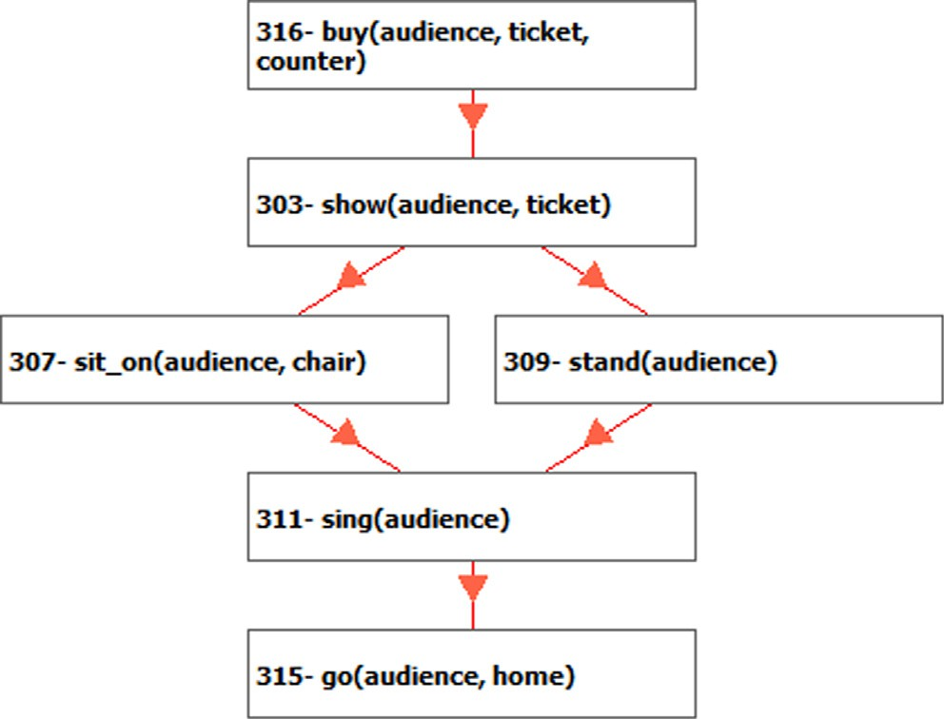Fig. 1. Cognitive script for attending a concert [17]

dataset: represents the language of the ConceptNet, English language in our case.

surfaceText: a sentence expresses the meaning of an edge start: shows the URL of the first argument of the assertion. rel: shows the relation type of the assertion, Fig. 3 shows exam-

ple of the relations.

The JSON files are stored locally as contextual information asso- ciated with the scripts. This helps to lessen the retrieval time when checking this information during the retrieval process. Moreover, the corpus has general contextual information for 2000 common words in the English language that were chosen from to [www.](http://www/) talkenglish.com website and are stored in the form of txt files. In order to reduce the error cost and increase the agility of the script retrieval process, the corpus is designed to be scalable; new con- textual information can be retrieved and stored automatically when the system receives new scripts that contain new words.

When a new script is received, the database engine crawls Con- ceptNet to find information about the new words in this script. For example, Fig. 4 shows a snapshot of the txt file for the new event ‘‘sleep”. Each line in the txt file is a contextual piece of information for the term ‘‘sleep”. For example, ‘close eyes’ is a pre-req to ‘sleep’ and ‘dream’ is a subsequent event. The ‘‘none” field means that the concept can be a noun, verb, or the concept consists of more than one word as in ‘‘get_in_bed”. This information is then stored in the

Attending a concert script represented in predicate form. Parent node Child node

|  |  |  |  |
| --- | --- | --- | --- |
| IID | Form | IID | Form |
| 307 | sit_on(audience, chair) | 311 | sing(audience) |
| 309 | stand(audience) | 311 | sing(audience) |
| 303 | show(audience, ticket) | 307 | sit_on(audience, chair) |
| 303 | show(audience, ticket) | 309 | stand(audience) |
| 316 | buy(audience, ticket, counter) | 303 | show(audience, ticket) |
| 311 | sing(audience) | 315 | go(audience, home) |

internal database and is used to define the relations between dif- ferent events when needed. The crawling algorithm is described in Fig. 5.

* 1. *Internal relational database*

The internal database consists of multiple structured relational tables as shown in Fig. 6. It contains contextual information about the nodes (events) and the connecting edges in the cognitive script,

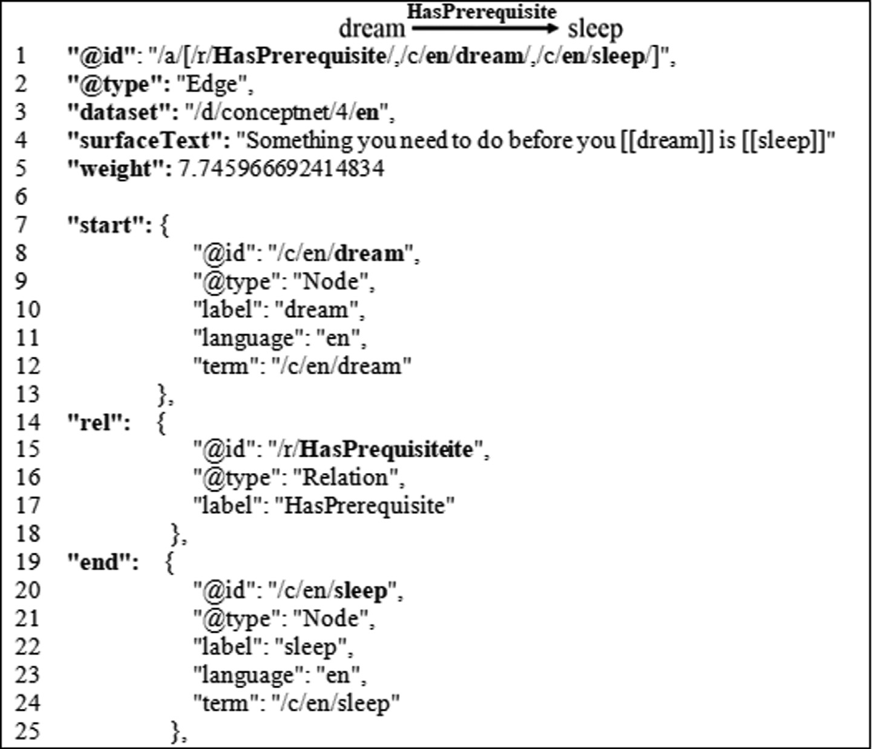

Fig. 2. Prerequisite relations for ‘‘dream” word.

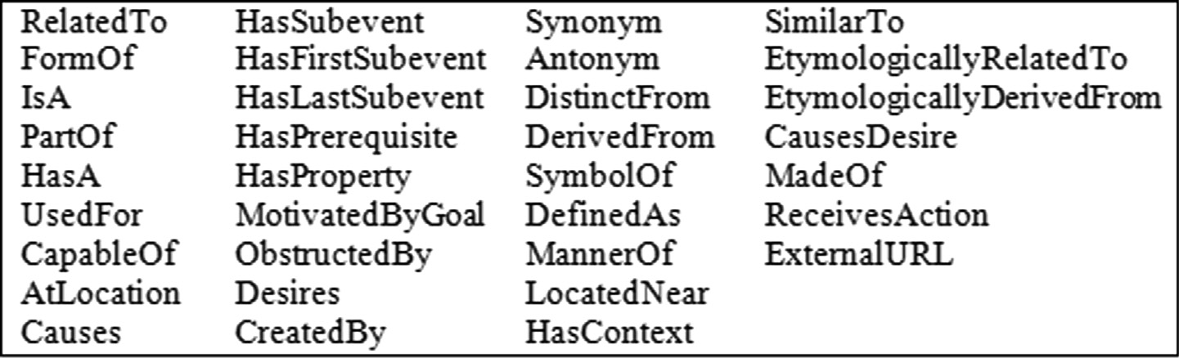

Fig. 3. Types of relations used in ConceptNet knowledge base.

bed, RelatedTo, sleep, 12.5373, [bed] is related to [sleep], none, none

sleep, HasSubevent, dream, 9.797959, Something that might happen when you [sleep] is [you dream], none, none sleep, HasPrerequisite, close_eyes, 8.717798, If you want to [sleep] then you should [close your eyes], none, none dream, RelatedTo, sleep, 8.134126, [dream] is related to [sleep], none, none

dream, HasPrerequisite, sleep, 7.745967, Something you need to do before you [dream] is [sleep], none, none rest, RelatedTo, sleep, 7.246241, [rest] is related to [sleep], none, none

sleep, HasPrerequisite, get_in_bed, 6.324555, Something you need to do before you [sleep] is [get in bed], none, none

going_to_bed, Causes, sleep, 6, Sometimes [going to bed] causes [sleep], none, none gathering_energy_for_tomorrow, HasSubevent, sleep, 6, Something you might do while [gathering energy for tomorrow] is [sleep], none, none

resting, HasSubevent, sleep, 6, Something you might do while [resting] is [sleep], none, none sleep, MotivatedByGoal, rest, 6, You would [sleep] because you want to [rest], none, none sleep, RelatedTo, rest, 5.688233, [sleep] is related to [rest], none, none

sleep, HasPrerequisite, go_to_bed, 5.656854, If you want to [sleep] then you should [go to bed], none, none dream, HasSubevent, sleep, 5.656854, One of the things you do when you [dream] is [sleep], none, none having_rest, Causes, sleep, 5.291502, Sometimes [having a rest] causes [sleep], none, none

being_tired, CausesDesire, sleep, 5.291502, [Being tired] would make you want to [sleep], none, none sleep, RelatedTo, bed, 5.039444, [sleep] is related to [bed], none, none

snore, HasPrerequisite, sleep, 4.89898, Something you need to do before you [snore] is [sleep], none, none snoring, HasPrerequisite, sleep, 4.89898, [snoring] requires [sleep], none, none

sleep, RelatedTo, night, 4.720593, [sleep] is related to [night], none, none

Fig. 4. The output txt file for the term ‘‘sleep”.

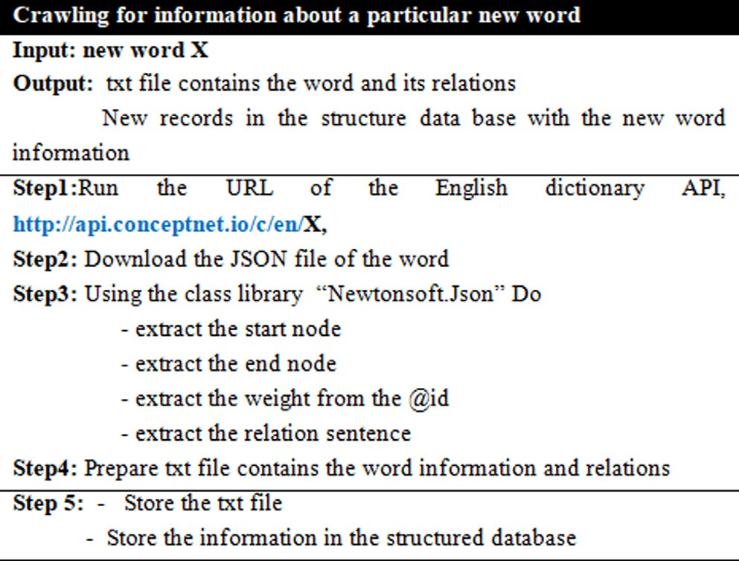

Fig. 5. Crawling Algorithm.

in addition to information about the words (e.g. the word type, synonyms, prerequisite verbs, events of each script and its possible sequences). The main purpose of the relational database is to improve the retrieval time of a script’s information using SQL queries. Fig. 7 shows the main tables in the database.

As seen in Fig. 7, the following tables exist in the internal database:

* ScriptsNames: contains the name of each script and its ID.
* Scripts: retains the detail of each script and stores the IDs of edges connecting events, such that each cognitive script is pre-

sented as a tree of events connected by edges. The details of these events are found in Events table.

* Terms: dictionary of all cognitive scripts.
* Events: contains the verbs, subjects, objects, and the predicate form of the events.
* all_edges: represents the information retrieved from the Con- ceptNet knowledge base.

For clarification, the Terms table is searched first using an SQL query then the output of the query is linked to the all_edges table to retrieve the corresponding information for the term in hand. If a term is not found, the system automatically crawls ConceptNet to find information about this term, download and save this informa- tion in the internal database for future searches.

1. MAP-and-REDUCE TECHNIQUE

Map-and-reduce is a programming model and an associated implementation for processing big datasets in parallel to reduce the processing time. The use of the map-and-reduce technique for web query retrieval has been discussed in many works

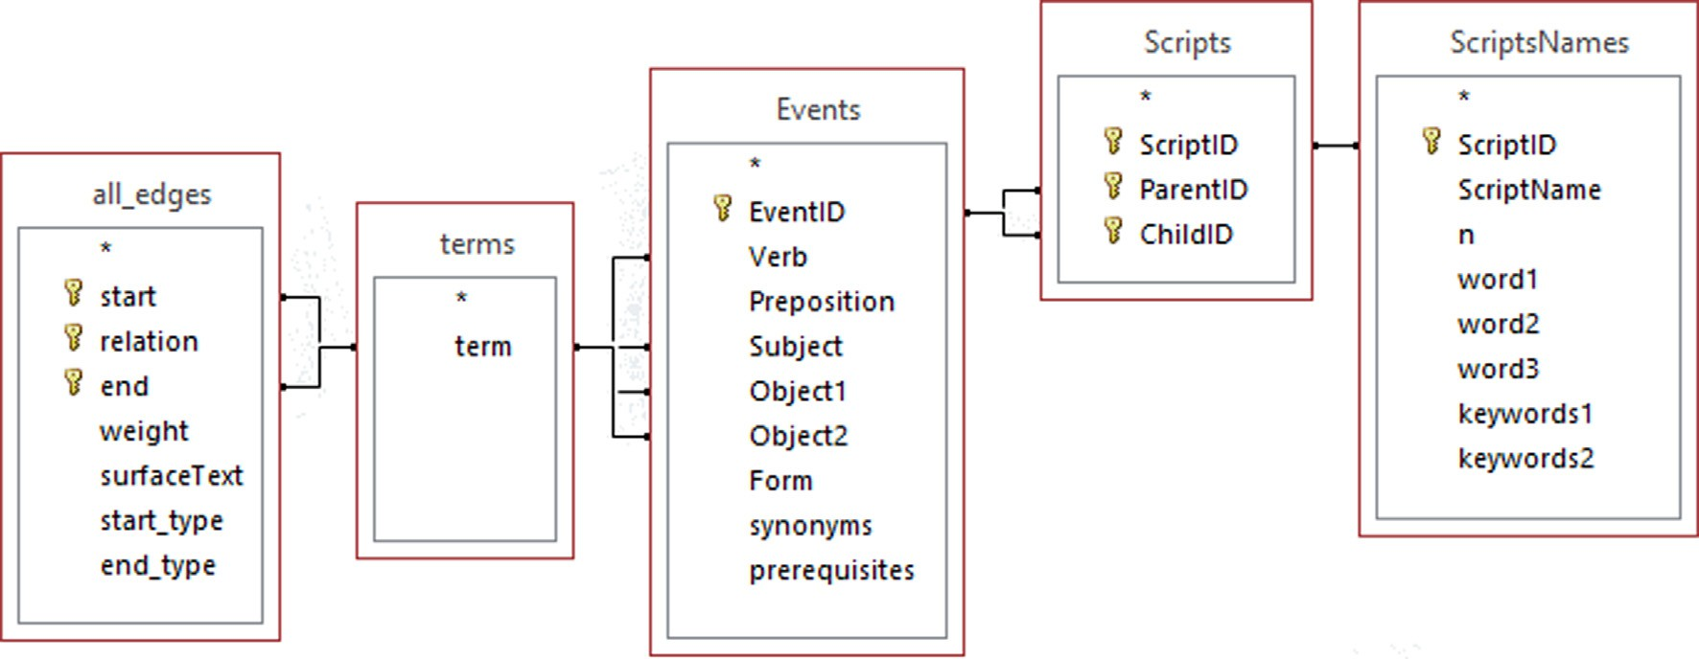

Fig. 6. Structured tables in the internal database.

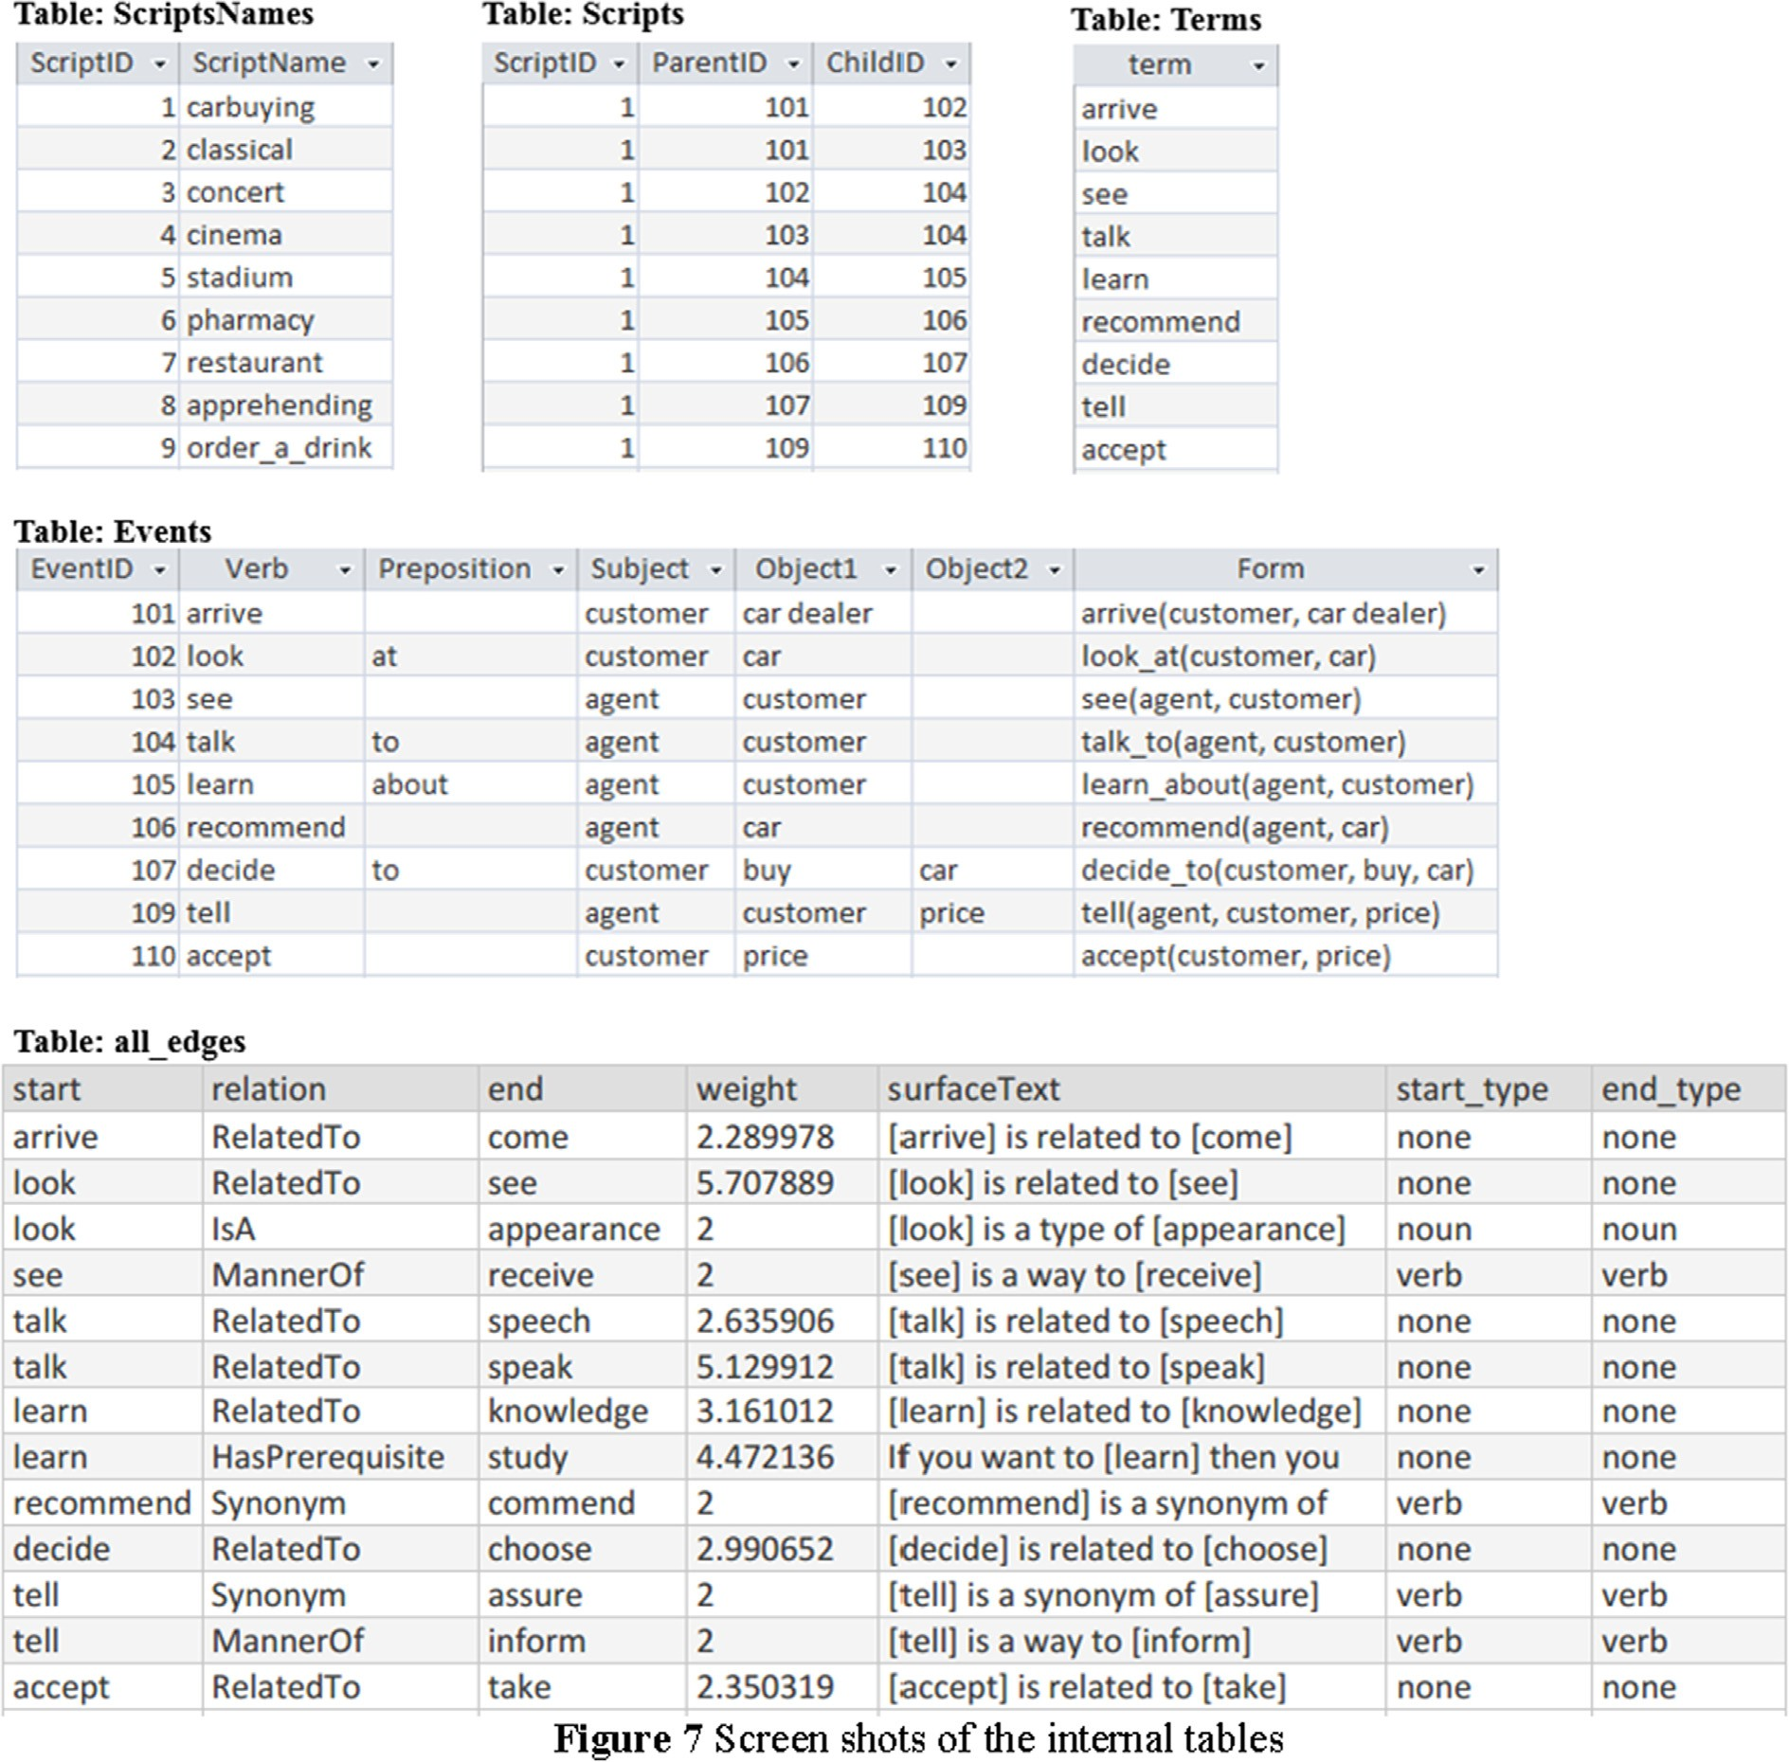

Fig. 7. Screen shots of the internal tables.

[31,34,35] as a mean to provide fast and accurate retrieval. This work provides a new application for map-and-reduce in knowl- edge retrieval that is the retrieval of cognitive scripts.

The retrieval process of cognitive scripts using map-and-reduce technique is shown in Fig. 8. The process unfolds as follows: the target script is analyzed, tokenized, and transformed into the pred- icate form (all scripts in the corpus are already tokenized and are represented in the predicate form). A bag-of-words for each script is created to be later used by the map-and-reduce technique in the retrieval process. The retrieval algorithm is presented in Fig. 9.

* 1. *Illustrative example*

Suppose that the user entered the ‘‘concert” script shown in Fig. 10, the map-and-reduce technique is applied as follows:

* + - Step 1: base script S=”concert”, the bag of words of S is B(S)={buy, ticket, online, print, show, enter, stadium, snacks,

seating area, sit_on, chair, stand, listen_to, song, sing, dance, stop,

performing, go_to, backroom, go, home, counter, take, warm_up, say, welcome, start}

* + - Step 2: assume the first script in the corpus is the ‘‘cinema” script which is presented Fig. 11;

T1 = cinema script, then

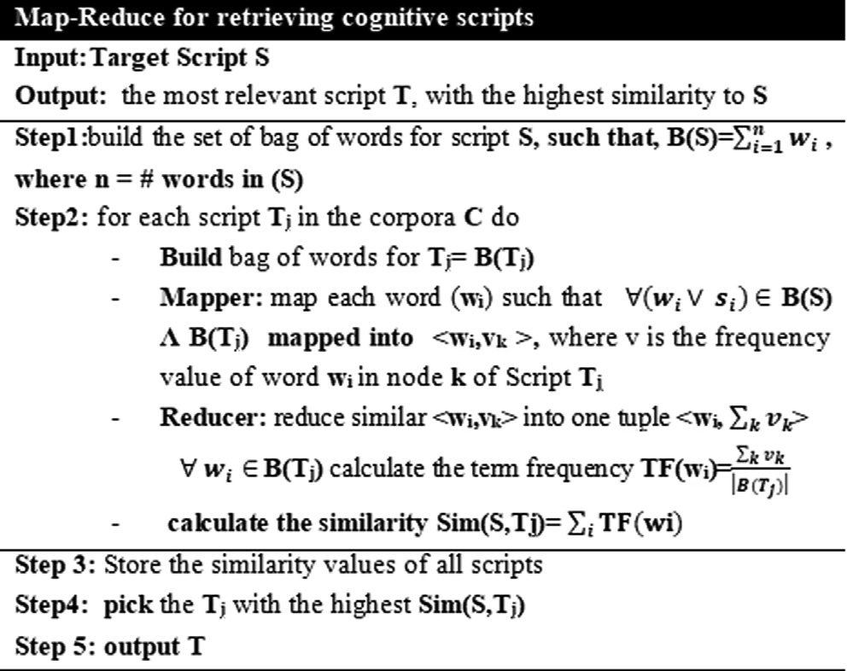

Fig. 9. Map-and-Reduce Retrieving Technique.

* B(T1) = {buy, ticket, enter, theater, buy, popcorn, enter, audito- rium, sit_down, watch, movie, be, scared, end, stand_up, go, home, turn_off, show, start}
* Mapper will map the common words of B(S) and B(T1) into < key, value > form as:

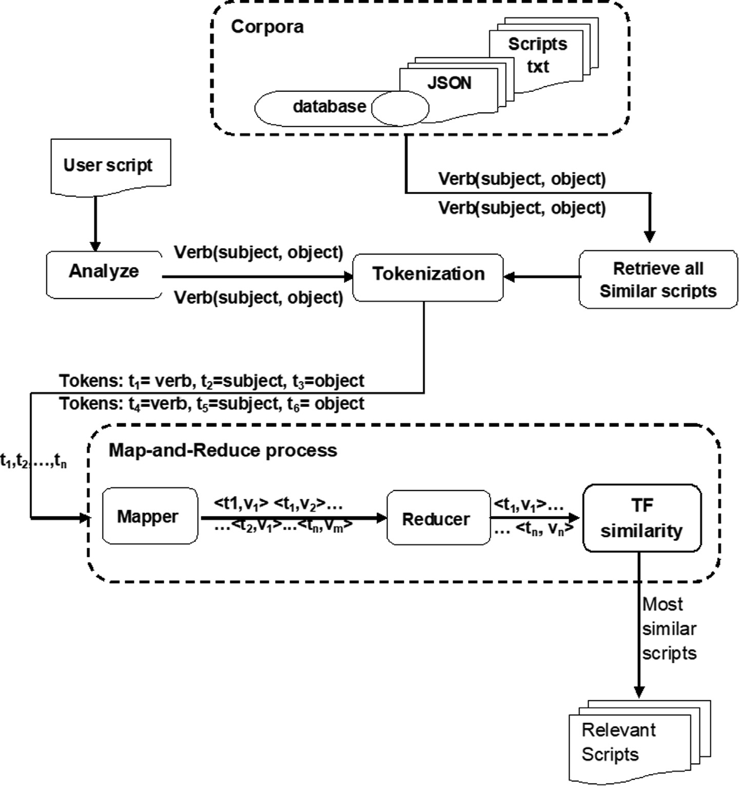

Fig. 8. The retrieval process.

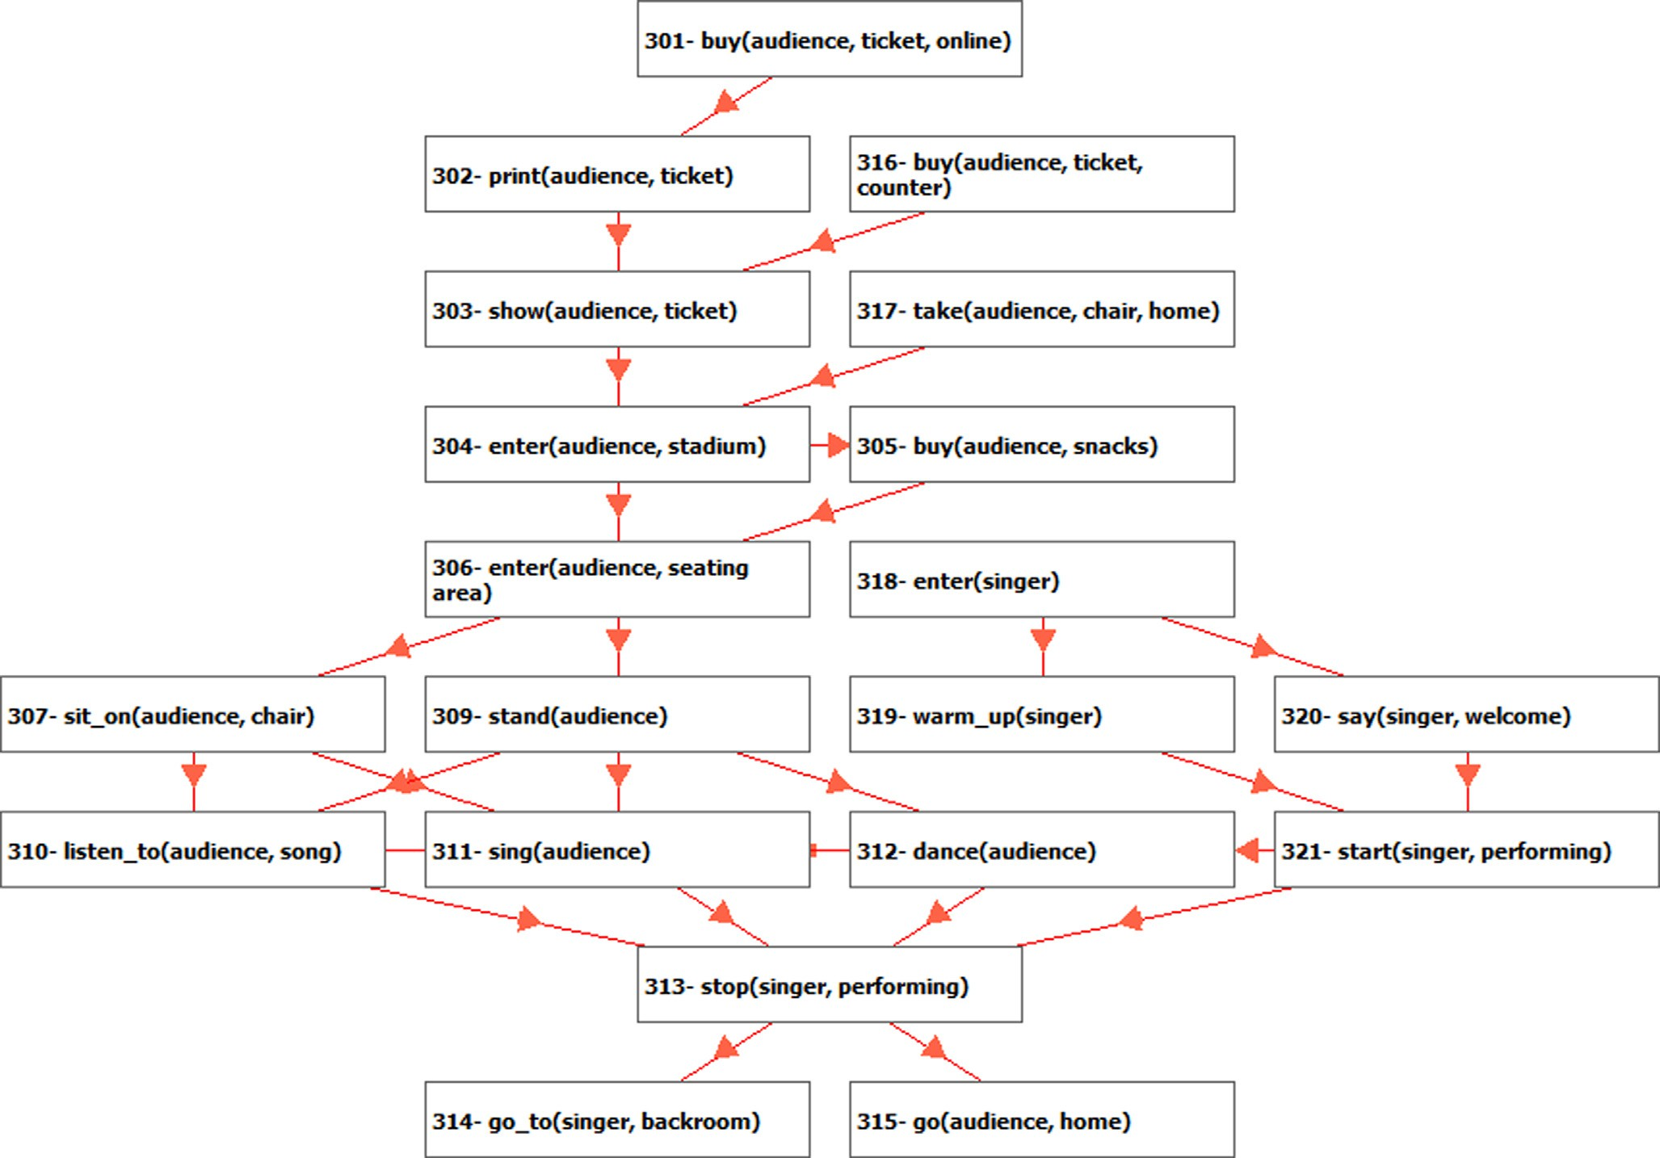

Fig. 10. Concert Script.

< buy,1 > node 401| <buy,1 > node 403| <ticket,1 > node 401|

<show,1 > node 412| <enter,1 > node 402| <enter,1 > node 404|

<go,1 > node 410| <home,1 > node 410| <start,1 > node 413.

- Reducer does the following:

Sort and reduce the number of pairs as follows:

<buy,2> <ticket,1> <show,1> <enter,2> <go,1> <home,1>

<start,1 > calculate the TF for each word

* 1. *Accuracy measurements*

This section presents the results from retrieving cognitive scripts by the map-and-reduce technique on the same multi- branched scripts using C#2020 programming language. Table 3a shows the results from the human participants [17]. It is worth mentioning that all the retrieved scripts are valid scripts, but some are more similar than others, that is why order was not considered in evaluating the results [17]. For the purpose of this study, a null

script has been added to the corpus to indicate the absence of a rel-

word buy ticket show enter go home start Total

TF 0.1 0.05 0.05 0.1 0.05 0.05 0.05 0.45

evant script.

Table 4 shows the results from Pharaoh [17] and our results

from the application of the map-and-reduce technique. In order

to compare the performance of both techniques, the retrieved scripts are compared to the human results in Table 3 and a confu-

* calculate the similarity

Sim(S,T1)= P1TF(w1)

Sim (S, T1) = 0.45

1. Experimental results and analysis

For the purpose of this study, we adopted the same corpus used in [17] and added a null script for clarity of results. The database has 131 nodes and more than 262 words, Table 2 shows the scripts’ names and the number of nodes in each script. All scripts were pre- processed and stored in a semi-structured data form as explained earlier in Section 2. The results obtained by the map-and-reduce in this work is compared to the results obtained by Pharaoh in [17]. The following subsections present the accuracy and time per- formance of the retrieval process for both techniques.

sion matrix is built.

As seen in Table 5, the map-and reduce technique provided higher accuracy, precision, recall, and specificity over Pharaoh. The harmonic mean (F1) shows the precedence of the map- and-reduce technique over Pharaoh. This shows that the map- and-reduce technique with ConceptNet can be effectively used for contextual retrieval of similar cognitive scripts to a query script.

* 1. *Time performance measurements*

For the purpose of this comparative study, we implemented Pharaoh [17] so that we can compare its cost to map-and-reduce using the same hardware, operating system, and programming lan- guage. This subsection focuses on comparing the retrieval time for Pharaoh and map-and-reduce with and without threads. As shown

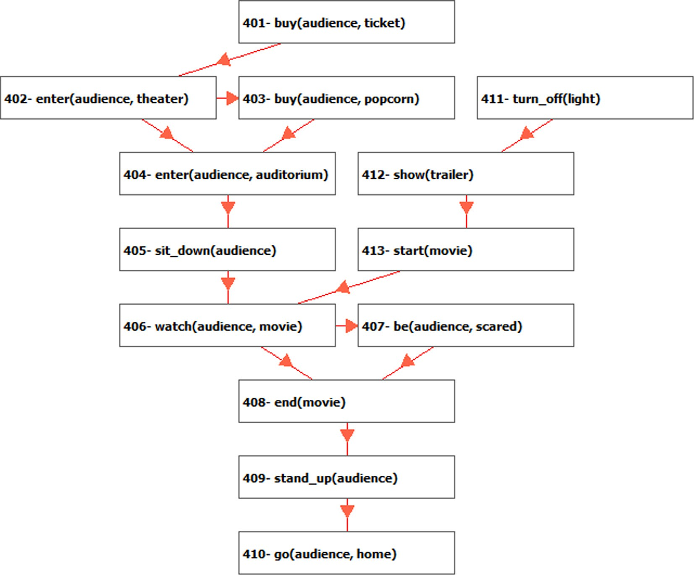

Fig. 11. Cinema Script.

Table 2

The stored scripts for evaluation.

Table 3

Retrieved scripts based on human participants.

|  |  |  |  |  |  |  |  |
| --- | --- | --- | --- | --- | --- | --- | --- |
| IID | Name | #nodes |  | Query Script | Human Participants | Selected scripts |  |
| Scr1 | Apprehending | 7 |  | apprehending | null script | null script | null script |
| Scr2 | Car_buying | 16 |  | car_buying | pharmacy | order_a_drink | null script |
| Scr3 | Cinema | 13 |  | Cinema | stadium | concert | classical |
| Scr4 | Classical | 17 |  | classical | concert | cinema | stadium |
| Scr5 | Concert | 20 |  | concert | classical | Cinema | stadium |
| Scr6 | Order_a_drink | 10 |  | order_a_drink | restaurant | pharmacy | car_buying |
| Scr7 | Pharmacy | 12 |  | pharmacy | order_a_drink | restaurant | car-buying |
| Scr8 | Restaurant | 21 |  | restaurant | order_a_drink | pharmacy | car_buying |
| Scr9 | Stadium | 15 |  | stadium | cinema | concert | classical |
| Scr10 | Null Script | 0 |  |  |  |  |  |

Table 4

Retrieved scripts based on Map-Reduce & Pharaoh.

|  |  |  |  |  |  |  |
| --- | --- | --- | --- | --- | --- | --- |
| Query Script apprehending | map-and-ReduceTechnique null | Null | Null | Pharaoh null | Null | Null |
| car_buying | Order_a_drink | Cinema | Stadium | Pharmacy | Null | Null |
| Cinema | Stadium | Classical | Concert | Stadium | Concert | Classical |
| Classical | Concert | Cinema | Stadium | Concert | Cinema | Stadium |
| Concert | Classical | Stadium | Cinema | Classical | Cinema | Stadium |
| Order_a_drink | Restaurant | Pharmacy | Stadium | Stadium | Concert | Cinema |
| Pharmacy | Restaurant | Order_a_drink | car_buying | Restaurant | car_buying | Null |
| Restaurant | Order_a_drink | Pharmacy | car_buying | Pharmacy | Null | Null |
| Stadium | Cinema | Concert | Classical | Cinema | Concert | Classical |

in Table 6, Pharaoh suffers from high retrieval time which makes it an expensive algorithm to use, especially with large size scripts and large corpora. On the other hand, the map-and-reduce technique has shown low retrieval time which makes it a cost-effective algorithm to use with large corpora of scripts. For

example, Table 6 shows that the retrieval time for similar scripts to the target ‘apprehending script’ using Pharaoh took more than three seconds, while took less than 1 s using map-and-reduce.

For further investigation, we implemented both techniques using threads to see how much threads would expedite the retrieval pro-

|  |  |  |  |  |  |  |  |
| --- | --- | --- | --- | --- | --- | --- | --- |
| Table 5  Confusion matrix for the most 3 similar | scripts retrieving process. |  | | | | | |
|  |  | Predict (Map-and-Reduce) |  |  | Predict (Pharaoh) |  |  |
|  |  | True | False |  | True | False |  |
| Actual (Expert opinion) | TTrue FFalse | TP(24)  FP(3)  Map-and-Reduce | FN(3)  TN(51)  Pharaoh |  | TP(20)  FP(7) | FN(7)  TN(47) |  |
| Accuracy | *TP*+*TN*  *TP* | 92.6% | 82.7% | | | | |

*precision*+*recall*

|  |  |  |  |  |
| --- | --- | --- | --- | --- |
| Precision | | +*TN*+*FP*+*FN*  *TP*  *TP*+*FP* | 89% | 74% |
| Recall (Sensitivity) | | *TP*  *TP*+*FN* | 89% | 74% |
| F1 | | 2* *Precision*\**recall* | 89% | 74% |
| Specificity | | *TN*  *TN*+*FP* | 94% | 87% |
|  | |  |  | - |
| Table 6 | |  |  | BTs and appropriate retrieval process of similar BTs are keys to |
| Retrieval time for cognitive scripts using non-thread programming. allow for that learning process to occur.  Cognitive Scripts Pharaoh(ms) Map-and-Reduce(ms) Cognitive scripts can be used to represent BTs and allow for | | | | |
| Apprehending Car_buying | 3101  3206 | 630  725 | | them to evolve through the allocation and retrieval of similar ones  that SIAs can learn from. Retrieval of contextually similar cognitive |
| Cinema | 3156 | 677 | | scripts poses the challenge of not only finding the right script but |

also retrieving this script in a reasonable time, especially when a large-size scripts and/or large corpuses are considered. This paper

|  |  |  |
| --- | --- | --- |
| Classical | 3153 | 757 |
| Concert | 3140 | 739 |
| Order_a_drink | 3075 | 660 |

|  |  |  |  |
| --- | --- | --- | --- |
| Pharmacy | 3239 | 700 | examined a novel representation of BTs as cognitive scripts and the |
| Restaurant | 3045 | 697 | use of the map-and-reduce technique to retrieve contextually sim- |
| Stadium | 3167 | 667 | ilar cognitive script in a very short time as a first step in the learn- |

*Average Time* 3142 694

Table 7

Retrieval time for cognitive scripts using threads.

Cognitive Scripts Pharaoh(ms) Map/Reduce(ms)

ing process that can occur between BTs. The results were compared to those obtained from applying Pharaoh, which is to the extent of our knowledge, the only algorithm used in the past to contextually retrieve cognitive scripts.

A two-proportion z-test was performed to determine if the pro- portion of accuracy was significantly greater for the map-and-

|  |  |  |  |
| --- | --- | --- | --- |
| Apprehending Car_buying | 1724  1790 | 350  311 | reduce method over Pharaoh using R. The results indicate that the  proportion of accuracy for map-and-reduce is significantly greater |
| Cinema | 1673 | 336 | than the proportion of accuracy for Pharaoh with p-value = 0.05 |
| Classical | 1801 | 291 | and p-value = 0.13 for both techniques, respectively. Other results |

show that the map-and-reduce technique overrules existing algo- rithms like Pharaoh in terms of accuracy, specificity, and sensitivity,

|  |  |  |
| --- | --- | --- |
| Concert | 1905 | 374 |
| Order_a_drink | 1650 | 272 |
| Pharmacy | 1633 | 261 |

|  |  |  |  |
| --- | --- | --- | --- |
| Restaurant | 1660 | 298 | in addition to be computationally cheap as it reduces the computing |
| Stadium | 1715 | 338 | time by 80% of the actual time taken by Pharaoh. |

*Average Time* 1728 315

cess. Table 7 shows how using threads cuts the time taken by the both techniques to almost half the actual time reported in Table 6.

The results from Table 6 and Table 7 are promising as they show the ability of the map-and-reduce technique to successfully retrieve similar cognitive scripts to a query script in a very short time, espe- cially with using threads as it took just 10% of the original time Phar- aoh took. This indicates how map-and-reduce can be used effectively with large scripts and/or large corpora. These results open new arena for SIAs to find similar BTs and learn from them to enrich their experiences and allow for more complex behaviors.

1. Conclusion

Behavioral trees (BTs) have been widely used to represent com- plex behaviors of social intelligent agents (SIAs). Many works have focused on the use of BTs with restricted set of actions to allow for socially accepted behavior by SIAs or the prediction of future behavior in a particular domain or scene. However, there was no much consideration for possible learning that can occur between similar domains, which might allow for the enrichment of these BTs and for new behaviors to emerge rather than relying on a pre-canned set of actions. Choosing the right representation for

The results of this work show that the representation of behav- ior trees as cognitive scripts can aid in the contextual retrieval of similar BTs, which SIAs can use to learn from and enrich their cur- rent experiences. Future work will focus on the implementation of a learning process between BTs represented as cognitive scripts, the development of an evaluation model for newly generated BTs, and the application of behavior prediction techniques on the retrieved cognitive script(s) to aid in predicting future behaviors in similar domains.

Declaration of Competing Interest

The authors declare that they have no known competing finan- cial interests or personal relationships that could have appeared to influence the work reported in this paper.

Acknowledgement

This research was funded by the Deanship of Scientific Research at Princess Nourah bint Abdulrahman University through the Fast- track Research Funding Program.

References

1. Flórez-Puga, G., Gomez-Martin, M., Diaz-Agudo, B., & Gonzalez-Calero, P., ‘‘Dynamic expansion of behaviour trees. In Proceedings of Artificial

Intelligence and Interactive Digital Entertainment Conference”, AAAI Press, pp. 36-41, October 2008.

1. Francillette, Y., Bouchard, B., Bouchard, K., & Gaboury, S, ‘‘Modeling, learning, and simulating human activities of daily living with behavior trees”, In Knowledge and Information Systems, pp.1-32, 2020.
2. Li, B., Lee-Urban, S., Appling, D. S., & Riedl, M. O., ‘‘Crowdsourcing narrative intelligence”, Advances in Cognitive systems, Vol. 2, No. 1, 2012.
3. [Tîrna˘uca˘ C, Montaña JL, Ontañón S, González AJ, Pardo LM. Behavioral](http://refhub.elsevier.com/S1110-8665(21)00040-2/h0020) [modeling based on probabilistic finite automata: An empirical study. Sensors](http://refhub.elsevier.com/S1110-8665(21)00040-2/h0020) [May 2012;16(7):958](http://refhub.elsevier.com/S1110-8665(21)00040-2/h0020).
4. [Nicolau M, Perez-Liebana D, O’Neill M, Brabazon A. Evolutionary behavior tree](http://refhub.elsevier.com/S1110-8665(21)00040-2/h0025) [approaches for navigating platform games. IEEE Trans Comput Intell AI Games](http://refhub.elsevier.com/S1110-8665(21)00040-2/h0025) [2017;9(3):227–38](http://refhub.elsevier.com/S1110-8665(21)00040-2/h0025).
5. Toubman, A., Poppinga, G., Roessingh, J. J., Hou, M., Luotsinen, L., Løvlid, R. A., ... & Turcanık, M. (2015, November). Modeling cgf behavior with machine learning techniques: Requirements and future directions. In Proceedings of the 2015 Interservice/Industry Training, Simulation, and Education Conference (pp. 2637-2647).
6. Diller, D. E., Ferguson, W., Leung, A. M., Benyo, B., & Foley, D., ‘‘Behavior modeling in commercial games. In Proceedings of the 2004 Conference on Behavior Representation in Modeling and Simulation (BRIMS)”, pp. 17-20, May 2004.
7. [Kamrani F, Luotsinen LJ,](http://refhub.elsevier.com/S1110-8665(21)00040-2/h0040) Lø[vlid RA. In: Learning objective agent behavior using](http://refhub.elsevier.com/S1110-8665(21)00040-2/h0040) [a data-driven modeling approach. IEEE; October 2016. p. 002175–81](http://refhub.elsevier.com/S1110-8665(21)00040-2/h0040).
8. [Luotsinen LJ, Kamrani F, Hammar P, Jändel M,](http://refhub.elsevier.com/S1110-8665(21)00040-2/h0045) Løvlid [RA. In: Evolved creative](http://refhub.elsevier.com/S1110-8665(21)00040-2/h0045) [intelligence for computer generated forces. IEEE; October 2016. p. 3063–70](http://refhub.elsevier.com/S1110-8665(21)00040-2/h0045).
9. [Chaari T, Ejigu D, Laforest F, Scuturici VM. A comprehensive approach to model](http://refhub.elsevier.com/S1110-8665(21)00040-2/h0050) [and use context for adapting applications in pervasive environments. J Syst](http://refhub.elsevier.com/S1110-8665(21)00040-2/h0050) [Softw 2007;80(12):1973–92](http://refhub.elsevier.com/S1110-8665(21)00040-2/h0050).
10. [Bouchard K, Ajroud A, Bouchard B, Bouzouane A. In: SIMACT: a 3D open source](http://refhub.elsevier.com/S1110-8665(21)00040-2/h0055) [smart home simulator for activity recognition. Berlin, Heidelberg: Springer;](http://refhub.elsevier.com/S1110-8665(21)00040-2/h0055) [2010. p. 524–33](http://refhub.elsevier.com/S1110-8665(21)00040-2/h0055).
11. Bouchard, B., Gaboury, S., Bouchard, K., & Francillette, Y. , ‘‘Modeling human activities using behaviour trees in smart homes”, In Proceedings of the 11th PErvasive Technologies Related to Assistive Environments Conference, pp. 67- 74, june 2018.
12. Dey, R., & Child, C., ‘‘Ql-bt: Enhancing behaviour tree design and implementation with q-learning”, In 2013 IEEE Conference on Computational Intelligence in Games (CIG) (pp. 1-8). IEEE, August 2013.
13. [Zhang Q, Yao J, Yin Q, Zha Y. Learning behavior trees for autonomous agents](http://refhub.elsevier.com/S1110-8665(21)00040-2/h0070) [with hybrid constraints evolution. Applied Sciences 2018;8(7):1077](http://refhub.elsevier.com/S1110-8665(21)00040-2/h0070).
14. [Bazire M, Brézillon P. In: Understanding context before using it. Berlin,](http://refhub.elsevier.com/S1110-8665(21)00040-2/h0075) [Heidelberg, July: Springer; 2005. p. 29–40](http://refhub.elsevier.com/S1110-8665(21)00040-2/h0075).
15. Hodhod, R., & Magerko, B.,” Pharaoh: Conceptual blending of cognitive scripts for computationally creative agents”, In the Twenty-Seventh International Flairs Conference., May 2014.
16. Hodhod, R., Magerko, B., & Gawish, M., ‘‘Pharaoh: Context-based structural retrieval of cognitive scripts”, International Journal of Information Retrieval Research (IJIRR), Vol. 2, No.3, pp. 58-71, 2012.
17. Speer, R., & Havasi, C., ‘‘Representing General Relational Knowledge in ConceptNet 5”, In LREC, pp. 3679-3686, May 2012.
18. Tamine-Lechani, L., Boughanem, M., & Daoud, M.,” Evaluation of contextual information retrieval effectiveness: overview of issues and research”, Knowledge and Information Systems, Vol. 24, No.1, pp. 1-34, 2010.
19. Yanchang Fu, Long Qin and Quanjun Yin. A Reinforcement Learning Behavior Tree Framework for Game AI, in the proceeding of the 2nd International Conference on Economics, Social Science, Arts, Education and Management Engineering (ESSAEME 2016), pp. 573—579, 2016.
20. [Sarker IH, Colman A, Han J, Khan AI, Abushark YB, Salah K. Behavdt: a](http://refhub.elsevier.com/S1110-8665(21)00040-2/h0105) [behavioral decision tree learning to build user-centric context-aware](http://refhub.elsevier.com/S1110-8665(21)00040-2/h0105) [predictive model. Mobile Networks and Applications 2020;25(3):1151–61](http://refhub.elsevier.com/S1110-8665(21)00040-2/h0105).
21. [Sarker IH. A machine learning based robust prediction model for real-life](http://refhub.elsevier.com/S1110-8665(21)00040-2/h0110) [mobile phone data. Internet of Things 2019;5:180–93](http://refhub.elsevier.com/S1110-8665(21)00040-2/h0110).
22. Tseng, E., & Braginsky, D. (2018). ‘‘Providing context relevant search for a user based on location and social information”, U.S. Patent No. 9,978,022.

Washington, DC: U.S. Patent and Trademark Office

1. [ELMougi AM, Omar YM, Hodhod R. An Evaluation Model for Auto-generated](http://refhub.elsevier.com/S1110-8665(21)00040-2/h0120) [Cognitive Scripts. International Journal of Advanced Computer Science and](http://refhub.elsevier.com/S1110-8665(21)00040-2/h0120) [Applications (IJACSA) 2019;10(8):333–40](http://refhub.elsevier.com/S1110-8665(21)00040-2/h0120).
2. Deligiannis, P., Loidl, H. W., & Kouidi, E., ‘‘Improving the diagnosis of mild hypertrophic cardiomyopathy with mapreduce”, In Proceedings of third international workshop on MapReduce and its Applications Date, pp. 41-48, June 2012.
3. [Savage N. Better medicine through machine learning. Commun ACM 2012;55](http://refhub.elsevier.com/S1110-8665(21)00040-2/h0130) [(1):17–9](http://refhub.elsevier.com/S1110-8665(21)00040-2/h0130).
4. Mantha, P. K., Luckow, A., & Jha, S.,” Pilot-MapReduce: an extensible and flexible MapReduce implementation for distributed data”, In Proceedings of

third international workshop on MapReduce and its Applications Date, pp. 17- 24, June, 2012.

1. [Geery D. Reducing the storage burden via data deduplication. Computer](http://refhub.elsevier.com/S1110-8665(21)00040-2/h0140) [2008;41(12):15–7](http://refhub.elsevier.com/S1110-8665(21)00040-2/h0140).
2. [Sethi P, Kumar P. Leveraging hadoop framework to develop duplication](http://refhub.elsevier.com/S1110-8665(21)00040-2/h0145) [detector and analysis using Mapreduce, Hive and Pig. In: In 2014 Seventh](http://refhub.elsevier.com/S1110-8665(21)00040-2/h0145) [International Conference on Contemporary Computing (IC3). p. 454–60](http://refhub.elsevier.com/S1110-8665(21)00040-2/h0145).
3. [Ye K, Jiang X, He Y, Li X, Yan H, Huang P. Hadoop: A scalable Hadoop virtual](http://refhub.elsevier.com/S1110-8665(21)00040-2/h0150) [cluster platform for MapReduce-based parallel machine learning with](http://refhub.elsevier.com/S1110-8665(21)00040-2/h0150) [performance consideration. In: In 2012 IEEE International Conference on](http://refhub.elsevier.com/S1110-8665(21)00040-2/h0150) [Cluster Computing Workshops. p. 152–60](http://refhub.elsevier.com/S1110-8665(21)00040-2/h0150).
4. Liao, J., Zhao, Y., & Long, S., ‘‘MRPrePost—A parallel algorithm adapted for mining big data”, In 2014 IEEE Workshop on Electronics, Computer and Applications, pp. 564-568, IEEE, May 2014.
5. Assunçao, J., Fernandes, P., Lopes, L., & Normey, S, ‘‘Distributed Stochastic Aware Random Forests–Efficient Data Mining for Big Data”, In 2013 IEEE International Congress on Big Data, pp. 425-426, June 2013.
6. Hanson, K., ‘‘Cognitive script theory. Encyclopedia of Children”, Adolescents, and the Media, pp. 186-188, 2007.
7. Chawda, B., Gupta, H., Negi, S., Faruquie, T. A., Subramaniam, L. V., & Mohania,

M. K., ‘‘Processing Interval Joins on Map-Reduce”, In EDBT, pp. 463-474, 2018.

1. [Hashem IAT, Anuar NB, Gani A, Yaqoob I, Xia F, Khan SU. MapReduce: Review](http://refhub.elsevier.com/S1110-8665(21)00040-2/h0175) [and open challenges. Scientometrics 2016;109(1):389–422](http://refhub.elsevier.com/S1110-8665(21)00040-2/h0175).

FIRST AUTHOR Safia Abbas is an associate professor in the Department of Computer Science, Faculty of Com- puter and Information Sciences, Princess Nourah Bint Abdulrahman University, KSA since 2019 and University of Ain Shams, Cairo, Egypt during 2016-2018. During 2006-2011, she received her Ph.D. from the Graduate School of Science and Technology, Niigata University, Japan. A strong theme of her work is in swarm opti- mizers, security in cloud, and medical diagnosis using machine learning and data mining.

SECOND AUTHOR Rania Hodhod is an associate pro- fessor and assistant chair at the TSYS School of Com- puter Science, Columbus State University (CSU) in USA. She has a Ph.D. in Computer Science from University of York, UK. She has an extensive background in artificial intelligence, machine learning, intelligent systems, and serious games as well as 70+ peer- reviewed publications in these areas. She is the holder of CSU International Educator of the Year in 2020, CSU Research Scholarship Award in 2019, and CSU Teaching and Learning Scholarship Award in 2017. She was a University System of Georgia Chancellor’s Learning Scholar from 2018-2020.

THIRD AUTHOR Mohamed Abd el-Salam El-Sheikh is an Assistant Professor and Assistant Chair at Basic Sci- ence Department, Cairo University, Egypt. He has a Ph.

D. in Computer Science from Cairo University, Egypt. He holds a Master’s degree in Computer Science from Hel- wan University, Egypt and a Bachelor’s degree in Physics and Computer Science.