[Expert Systems with Applications: X 3 (2019) 100015](https://doi.org/10.1016/j.eswax.2019.100015)

 

Contents lists available at [ScienceDirect](http://www.ScienceDirect.com/)

Expert Systems with Applications: X

journal homepage: [www.elsevier.com/locate/eswax](http://www.elsevier.com/locate/eswax)

Robust machine layout design under dynamic environment: Dynamic customer demand and machine maintenance

Srisatja Vitayasak a, Pupong Pongcharoenb,∗, Christian Hicks c,d

a *Centre of Operations Research and Industrial Applications (CORIA), Department of Industrial Engineering, Faculty of Engineering, Naresuan University,*

*Phitsanulok 65000, Thailand*

b *Department of Industrial Engineering, Faculty of Engineering, Naresuan University, Phitsanulok 65000, Thailand*

c *Newcastle University Business School, University of Newcastle upon Tyne, NE1 7RU, UK*

d *Department of Management Studies, Indian Institute of Technology, New Delhi, Delhi, 110016, India*

a r t i c l e i n f o a b s t r a c t

*Article history:*

Received 7 April 2019

Revised 3 August 2019

Accepted 3 August 2019

Available online 4 August 2019

*Keywords:*

Machine layout Robust design

Preventive and corrective maintenance Dynamic demand

Genetic Algorithm

The layout of manufacturing facilities has a large impact on manufacturing performance. The layout de- sign process produces a block plan that shows the relative positioning of resources that can be devel- oped into a detailed layout drawing. The total material handling distance is commonly used for mea- suring material flow. Manufacturing systems are subject to external and internal uncertainties includ- ing demand and machine breakdowns. Uncertainty and the rerouting of material flows have an impact on the material handling distance. No previous research has integrated robust machine layout design through multiple periods of dynamic demand with machine maintenance planning. This paper presents a robust machine layout design tool that minimises the material flow distance using a Genetic Algorithm (GA), taking into account demand uncertainty and machine maintenance. Experiments were conducted using eleven benchmark datasets that considered three scenarios: preventive maintenance (PM), correc- tive maintenance (CM) and both PM and CM. The results were analysed statistically. The effect of several maintenance scenarios including the ratio of the number of machines with period-based PM (PPM) to the number with production quantity-based PM (QPM), the percentage of machines with CM (%CM), and a combination of PMM/QPM ratios and %CM on material flow distance were examined. The results show that designing robust layouts considering maintenance resulted in shorter material flow distances. The distance was decreased by 30.91%, 9.8%, and 20.7% for the PM, CM, and both PM/CM scenarios, respec- tively. The PPM/QPM ratios, %CM, and a combination of PPM/QPM and %CM had significantly resulted in the material flow distance on almost all datasets.

© 2019 The Authors. Published by Elsevier Ltd. This is an open access article under the CC BY-NC-ND license. (<http://creativecommons.org/licenses/by-nc-nd/4.0/>)

# Introduction

The costs related to material handling are typically 20%−50% of total manufacturing operating expenses. Effective layouts can re- duce material handling costs by at least 10–30% (Tompkins, White, Bozer & Tanchoco, 2010). The total distance travelled by materials is a commonly used proxy for measuring the eﬃciency of layouts (Drira, Pierreval & Hajri-Gabouj, 2007).

Changes to the manufacturing environment may be caused by internal or external factors which disrupt the eﬃcient flow of

∗ Corresponding author.

*E-mail addresses:* [srisatjav@nu.ac.th](mailto:srisatjav@nu.ac.th) (S. Vitayasak), [pupongp@nu.ac.th](mailto:pupongp@nu.ac.th) (P. Pongcharoen), [Chris.hicks@ncl.ac.uk](mailto:Chris.hicks@ncl.ac.uk) (C. Hicks).

materials (Kulturel-Konak, 2007). External uncertainties include: variations in customer demand and product mix; changes to prod- uct design; shorter product life cycles; the discontinuation of prod- ucts; or the introduction of new products (Sahin & Turkbey, 2009). Internal disturbances, such as machine breakdowns, reduce the number of available machines which can cause queuing that leads to uneven workload, longer flow-time, lower productivity and higher production costs. When flow is disrupted, downstream re- sources may be starved of work-in-process which can reduce util- isation. Maintenance activities may be planned or corrective ‘fix it when it breaks’ (Waeyenbergh & Pintelon, 2009). Both types of maintenance reduce the number of machines available, which can disrupt flow. With preventative maintenance production plans can take into account downtime, whereas corrective maintenance oc- curs randomly and needs to be addressed through control actions.

<https://doi.org/10.1016/j.eswax.2019.100015>

2590-1885/© 2019 The Authors. Published by Elsevier Ltd. This is an open access article under the CC BY-NC-ND license. (<http://creativecommons.org/licenses/by-nc-nd/4.0/>)

2 *S. Vitayasak, P. Pongcharoen and C. Hicks / Expert Systems with Applications: X 3 (2019) 100015*

To maintain production performance, alternative routings may be adopted to avoid interruption, but the flow distances may increase. There is a substantial literature on the facilities layout problem and there have been several comprehensive reviews. Kusiak and Heragu (1987) surveyed formulations of the FLP and algorithms for solving deterministic problems. Meller and Gau (1996) reviewed methodologies, objectives, algorithms, and extensions that consid- ered a time element (dynamic layout), uncertainty (stochastic lay- out) or multiple evaluation criteria (multi-criteria, robust or flexi- ble layout). Dynamic layout problems take into account changes in material handling flow over multiple periods. Robust layouts aim to accommodate changes without the need for expensive reorgani- sation, whereas the re-layout approach produces a series of layouts for the various periods (Kulturel-Konak, 2007). Balakrishnan and Cheng (1998) presented an early review of the dynamic facil- ities layout literature, which categorised research according to: equal/unequal size departments; deterministic/stochastic mate- rial flow; and the algorithms adopted. Drira et al. (2007) sur- veyed the literature on facilities layout problems using a frame- work that included: the type of manufacturing system; facil- ity shapes; layout configuration; material handling system; lay- out formulation; constraints; and optimisation methods. Kulturel- Konak (2007) reviewed research relating to dynamic and stochastic facility layout problems. Hosseini-Nasab, Fereidouni, Fatemi Ghomi and Fakhrzad (2018) reviewed 250 FLP-related papers published during the period 1987–2016 and applied a hierarchical classifi- cation based upon: layout evolution (static/dynamic); workshop characteristics (shape and dimensions, flow movement, type of manufacturing system and materials handling approach); problem formulation (objective function, problem representation, modelling approach, type of data, constraints); and resolution approaches (multi-objective, multi-attribute, single objective). However, the lit- erature has not considered the integration of the FLP with machine maintenance, which is the research gap that is addressed by this

paper.

The objectives of this paper are to: (i) review the literature on facilities layout design, uncertainties in production and main- tenance policies; (ii) outline the Genetic Algorithm-based Layout Design (GALD) tool that was developed to solve robust machine layout design problems for systems that are subject to demand un- certainties and maintenance; (iii) describe the experimental design that was used to test the robust design approach with corrective, preventative and combined maintenance regimes; and (iv) inves- tigate how the number of unavailable machines in each mainte- nance scenario affects the material flow distance.

Section 2 critically reviews appropriate literature. Section 3 out- lines the development of the Genetic Algorithm tool for solving facilities layout problems, which is integrated with maintenance planning. The experimental results are presented in Section 4. Section 5 provides a discussion and highlights the conclusions of the work and identifies opportunities for future research.

# Literature review

Drira et al. (2007) and Kulturel-Konak (2007) published com- prehensive reviews of the facilities layout problem literature. A systematic review was undertaken using the ISI Web of Science database covering the period 2007 to May 2018 to identify the cur- rent status of the literature and research gaps. The initial searches used the keywords “layout design” and “facility layout” and found 308 papers. The definition of the facilities layout problem and its categorisation are presented in Section 2.1. The 308 papers were carefully screened to identify those relevant to dynamic layout de- sign. The problem characteristics and the solution approach of the selected papers are shown in Section 2.2.

* 1. *Facilities layout problem*

Azadivar and Wang (2000, p.4369) defined the facilities layout problem (FLP) as “the determination of the relative locations for, and the allocation of, the available space among a number of work- stations”. Singh and Sharma (2006, p.425) stated that “the output of the FLP is a block layout that specifies the relative location of each department. The detailed layout of a department can also be obtained later by specifying aisle structure and input/output point locations which may include flow line and machine layout prob- lems”.

The FLP may be considered to be a static plant layout prob- lem (SPLP), which produces an optimal layout that suits the cur- rent state of business (Rosenblatt, 1986). However, when there are changes over time, it is important to design facilities that can quickly and effectively adapt (Yin & Khoo, 2011). The dynamic plant layout problem (DPLP) involves the design of facility layouts based on a multi-period planning horizon. During this horizon, the material handling flows between pairs of departments in the layout may change (Balakrishnan & Cheng, 2009). It is necessary to determine an appropriate layout for each period, during which it is assumed that the flow data remains constant (Drira et al., 2007). The DPLP may be either a deterministic or stochastic prob- lem. The decision on whether to change the layout should take into account the costs associated with material flow and the re- arrangement of the layout (Rosenblatt, 1986). There are two alter- native approaches to solving the DPLP: the agile approach which assumes low rearrangement costs and relocates machines from time-to-time; and the robust approach that assumes high reloca- tion costs and aims to minimise total material handling costs in all periods using a single layout (Pillai, Hunagunda & Krishnan, 2011). Kouvelis, Kurawarwala and Gutiérrez (1992), p.287) defined a ro- bust layout as “one that is ‘good’ (or close to optimal) for a wide variety of demand scenarios even though it may not be optimal under any specific demand scenario”. A robust layout design pro- cedure attempts to minimise the total expected material handling costs over a specific planning horizon (Yang & Brett, 1998), so there is no rearrangement cost. To maintain the shortest material flow distance, the layout can be periodically redesigned. However, this has an impact on production time and costs due to facility move- ment and interrupted production. It may also require specialised labour and equipment, especially for large-size or heavy facilities (McKendall, Shang & Kuppusamy, 2006).

The DPLPs have been formulated as mathematical models.

Balakrishnan (1992) presented the formulation for department layouts during the planning horizon with budget constraints and assumed equal-sized facilities. This model was adapted by Balakrishnan and Cheng (1998), McKendall et al. (2006), Reza- zadeh, Ghazanfari, Saidi-Mehrabad and Sadjadi (2009), Sahin and Turkbey (2009), and Ulutas and Islier (2009). The flexible machine layout with dynamic environments was formulated as a quadratic assignment problem, in which unequal-size machines and ma- chine position constraints (vertical or horizontal) were considered (Yang & Brett, 1998). Dunker, Radons and Westkamper (2005) and McKendall and Hakobyan (2010) considered the dynamic facility layout problem with unequal-area departments using a mixed- integer linear programming formulation. Baykasoglu, Dereli and Sabuncu (2006) studied the budget-constrained dynamic layout problem. Kia et al. (2012) used a mixed-integer non-linear pro- gramming model to design a dynamic cellular manufacturing sys- tem layout.

Facility layout design (FLD) problems are complex and non- deterministic polynomial time hard (NP-hard) problems (Pourvaziri & Naderi, 2014), which means the amount of computational time required to find a solution increases exponentially with prob- lem size. Eﬃcient metaheuristics have therefore been widely

*S. Vitayasak, P. Pongcharoen and C. Hicks / Expert Systems with Applications: X 3 (2019) 100015* 3

used for solving FLPs, including: Genetic Algorithms; Simu- lated Annealing; Tabu Search; Ant Colony Optimisation; Parti- cle Swarm Optimisation; and Biogeography-Based Optimisation (Sooncharoen, Vitayasak & Pongcharoen, 2015). Genetic Algo- rithms have been a popular approach to solving facility layout design problems. Kia, Khaksar-Haghani, Javadian and Tavakkoli- Moghaddam (2014) found that GA can find near-optimal so- lutions in much less computational time than CPLEX software for almost all problems. Lenin, Siva Kumar, Islam and Ravin- dran (2013) demonstrated the effectiveness of GA for solving a single-row layout design problem. The results obtained from GA were more favourable than other approaches. Dapa, Loreungthup, Vitayasak and Pongcharoen (2013) reported that GA outperformed the Bat Algorithm and Shuffied Frog Leaping Algorithm in a multiple-row layout design. Vitayasak and Pongcharoen (2016) in- vestigated the affects of breakdown maintenance and provided a cost-based decision framework for re-layout investment.

* 1. *Facilities layout design with uncertainties*

Table 1 presents 74 of 308 FLP articles which considered uncer- tainties due to external and/or internal variabilities. There were 55 papers that only considered variability in customer demand. De- mand profiles may be represented by material flow matrices, prob- ability distributions, or empirical data. Internal factors include the number of machines, set up time, facility size, routing flexibility, machine maintenance, processing time, waiting time, human fac- tors, and machine reliability.

There were only 10 papers that considered only inter- nal variabilities: Azadeh, Moghaddam, Nazari and Sheikhal- ishahi (2016) that used a fuzzy multivariate approach to opti- mise the FLP with ambiguous data; Azimi and Soofi (2017) which applied Artificial Neural Networks and a hybrid non-dominated Genetic Algorithm to optimise layout and material handling; Chae and Regan (2016) that considered heterogeneous area con- straints; Chang, Wu and Wu (2013) who considered cell forma- tion, layout and intercellular sequences with flexible routings; Dong, Wu and Hou (2009) which considered the adding/removal of machines during each period; Khaksar-Haghani, Kia, Mahdavi and Kazemi (2013) that applied Genetic Algorithms for optimising multi-floor layouts with alternative process routings and flexible configurations; Li, Tan and Li (2018) who used an Artificial Bee Colony algorithm for optimising layout taking into account hu- man factors; Neghabi, Eshghi and Salmani (2014) which adopted an adaptive algorithm for generating robust facility layouts without predetermining the length and width of departments; Salmani, Es- hghi and Neghabi (2015) that used Mixed Integer Linear Program- ming and considered dynamic and uncertain values for the dimen- sions of departments; and Wang, Shin and Moon (2016) which considered layout design with unreliable machines. Only 9 papers studied both external and internal variabilities in FLP. There has been no previous research that has considered layout problems with dynamic demand and machine maintenance. This is the re- search gap considered by this research.

* 1. *Machine breakdown*

Machine breakdown has been one of the most studied dis- ruptions in flexible job shop scheduling (Nouiri et al., 2017). The machine failure rate has been represented by the Poisson distri- bution (Schemeleva, Delorme, Dolgui & Grimaud, 2012) or gen- erated randomly (Nodem, Kenne & Gharbi, 2011). Machine life- time is commonly modelled using the Weibull distribution (Fitouhi & Nourelfath, 2012). The mean-time-to-failure has been repre- sented by the normal distribution or the exponential distribution (Schemeleva et al., 2012). Corrective maintenance has also been

considered in the context of robust scheduling for a flexible job- shop scheduling problem (Xiong, Xing & Chen, 2013). In terms of production scheduling, machine breakdown is stochastic, whereas preventative maintenance is planned (Sbihi & Varnier, 2008).

* 1. *Preventive maintenance policies*

Machines are subject to deterioration with usage and age. There is a substantial literature on maintenance that was reviewed by Garg and Deshmuth (2006). Preventive maintenance (PM) com- prises “a series of tasks performed at a frequency dictated by the passage of time, the amount of production or machine condition” (Garg & Deshmukh, 2006, p.214). PM refers to “all actions per- formed in an attempt to retain a resource in a specified condi- tion by providing systematic inspection, detection, and prevention of incipient failures” (Wang, 2002, p.470). Under a periodic policy, a unit is preventatively maintained at fixed time intervals and re- paired if there are intervening failures, this is called fixed period maintenance or time-based maintenance (Safari & Sadjadi, 2011). Fig. 1 illustrates customer demand (D) changes over time period

(P). PM policies can be periodic or based upon production quan- tities. In Fig. 1a, periodic-based PM (PPM) is scheduled every two periods. In Fig. 1b, the maintenance operations are performed ac- cording to a predefined production quantity (Q), known as pro- duction quantity-based PM (QPM), which is scheduled in periods 3 and 5. This policy is growing in popularity in industrial environ- ments because these policies can decrease the cost of maintenance activities, which may be the largest part of an operational budget (Safari & Sadjadi, 2011).

* 1. *Routing flexibility*

Flexibility was defined as “the ability to effectively respond to change” (Buzacott & Mandelbaum, 1985, p.405). Flexibility helps address internal disturbances arising from machine breakdowns, variable task times, queuing delays, rejects and rework (Sethi & Sethi, 1990). There are eleven different types of flexibility: machine, material handling, operation, process, product, routing, volume, expansion, program and market. The flexibility to use al- ternative machines or routings helps mitigate problems with ma- terial flow that can arise when a particular machine becomes unavailable. Byrne and Chutima (1997) considered alternative ma- chines to be those that could perform the same operations; whilst alternative routings could perform the same sequence of opera- tions. A system with alternative production routes (flexible routes) can maintain high productivity when some machines have broken down or are under maintenance (Chang, 2007). Routing flexibility has been recognised as a fundamental characteristic of a manufac- turing system’s overall flexibility, as it enhances a system’s ability to produce a given set of part types or part families without in- terruption. When routings are altered, material flow time and dis- tances are likely to change.

# Genetic algorithm for solving layout design problem

The Genetic Algorithm (GA) is a population-based, nature- inspired algorithm (Goldberg, 1989; Holland, 1962). A set of can- didate solutions is generated as an initial set of solutions, which then undergoes an evolutionary search process. GAs use probabilis- tic transition rules to guide a highly exploitative search and also performs a multiple directional search by maintaining a population of potential solutions. In each iteration (generation) of the search process the crossover operator helps the GA move towards a local optimum (Hicks, 2006), whereas the mutation operator tends to move the search to a new neighbourhood which leads to increased diversity (Hicks, 2006; Islier, 1998).

**Table 1**

4

*S. Vitayasak, P. Pongcharoen and C. Hicks / Expert Systems with Applications: X 3 (2019) 100015*

Problem characteristics based on demand profiles, dynamic conditions, layout configurations, and optimisation methods.

|  |  |  |  |  |  |  |  |  |  |  |  |  |  |  |  |  |  |  |
| --- | --- | --- | --- | --- | --- | --- | --- | --- | --- | --- | --- | --- | --- | --- | --- | --- | --- | --- |
| Authors | External factors |  |  |  |  | Internal factors |  |  |  |  |  |  |  |  |  |  |  | Approaches |
|  | Flow matrix | Distribution function | Empirical data | Not explained |  | Number of machines | Set up time | Facility size | Routing flexibility | Machine mainte- nance | Processing time | Waiting time | Human factors | Machine reliability | Ambiguous data | Robust layout design | Re-layout design |  |
| Abedzadeh, Mazi- | **/** |  |  |  |  |  |  |  |  |  |  |  |  |  |  |  | **/** | GAMS software, |
| nani, |  |  |  |  |  |  |  |  |  |  |  |  |  |  |  |  |  | PVNS algorithm |
| Moradinasab and |  |  |  |  |  |  |  |  |  |  |  |  |  |  |  |  |  |  |
| Roghanian (2013) |  |  |  |  |  |  |  |  |  |  |  |  |  |  |  |  |  |  |
| Altuntas and |  | **/** |  |  |  |  |  |  |  |  |  |  |  |  |  | **/** |  | Rule-based data |
| Selim (2012) |  |  |  |  |  |  |  |  |  |  |  |  |  |  |  |  |  | mining |
| Asl, Wong and |  |  |  | **/** |  |  |  |  |  |  |  |  |  |  |  | **/** |  | Covariance matrix |
| Tiwari (2016) |  |  |  |  |  |  |  |  |  |  |  |  |  |  |  |  |  | adaptation |
|  |  |  |  |  |  |  |  |  |  |  |  |  |  |  |  |  |  | evolution |
| Asl and | **/** |  |  |  |  |  |  |  |  |  |  |  |  |  |  |  | **/** | Modified Particle |
| Wong (2017) |  |  |  |  |  |  |  |  |  |  |  |  |  |  |  |  |  | Swarm Optimisation |
| Ayodeji, Adeyeri and |  | **/** |  |  |  |  |  |  |  |  |  |  |  |  |  |  | **/** | Dynamic |
| Ogunsua (2017) |  |  |  |  |  |  |  |  |  |  |  |  |  |  |  |  |  | Programming |
| Azadeh, Mote- |  | **/** |  |  |  |  |  | **/** |  |  |  |  |  |  |  | **/** |  | Data Envelopment |
| vali Haghighi and |  |  |  |  |  |  |  |  |  |  |  |  |  |  |  |  |  | Analysis Algorithm |
| Asadzadeh (2014) |  |  |  |  |  |  |  |  |  |  |  |  |  |  |  |  |  |  |
| Azadeh et al. (2016) |  |  |  |  |  |  |  |  |  |  |  |  |  |  | **/** | **/** |  | Fuzzy multivariate |
|  |  |  |  |  |  |  |  |  |  |  |  |  |  |  |  |  |  | approach |
|  | **/** |  |  |  |  |  |  |  |  |  |  |  |  |  |  |  | **/** | Quadratic |
| Azevedo, Crispim and |  |  |  |  |  |  |  |  |  |  |  |  |  |  |  |  |  | programming |
| Pinho de |  |  |  |  |  |  |  |  |  |  |  |  |  |  |  |  |  |  |
| Sousa (2017) |  |  |  |  |  |  |  |  |  |  |  |  |  |  |  |  |  |  |
| Azimi, Saberi and |  | **/** |  |  |  |  |  |  |  |  |  |  |  |  |  |  | **/** | Hybrid Particle |
| Studies (2013) |  |  |  |  |  |  |  |  |  |  |  |  |  |  |  |  |  | Swarm Optimisation |
| Azimi and |  |  |  |  |  |  |  |  |  | **/** | **/** | **/** |  |  |  | **/** |  | Artificial Neural |
| Soofi (2017) |  |  |  |  |  |  |  |  |  |  |  |  |  |  |  |  |  | Network hybrid GA |
| Balakrishnan and |  | **/** |  |  |  |  |  |  |  |  |  |  |  |  |  |  | **/** | Heuristic and |
| Cheng (2009) |  |  |  |  |  |  |  |  |  |  |  |  |  |  |  |  |  | Dynamic |
|  |  |  |  |  |  |  |  |  |  |  |  |  |  |  |  |  |  | Programming |
|  |  | **/** |  |  |  |  |  |  |  |  |  |  |  |  |  |  | **/** | Tabu Search |
| Bozorgi, Abedzadeh and |  |  |  |  |  |  |  |  |  |  |  |  |  |  |  |  |  |  |
| Zeinali (2015) |  |  |  |  |  |  |  |  |  |  |  |  |  |  |  |  |  |  |
| Chang et al. (2013) |  |  |  |  |  |  |  |  | **/** |  |  |  |  |  |  | **/** |  | Tabu Search |
| Chae and |  |  |  |  |  |  |  | **/** |  |  |  |  |  |  |  | **/** |  | Linear Programming |
| Regan (2016) |  |  |  |  |  |  |  |  |  |  |  |  |  |  |  |  |  |  |
| Chan and |  | **/** |  |  |  |  |  |  |  |  |  |  |  |  |  | **/** |  | Monte Carlo |
| Malmborg (2010) |  |  |  |  |  |  |  |  |  |  |  |  |  |  |  |  |  | simulation |
| Chen (2013) |  | **/** |  |  |  |  |  |  |  |  |  |  |  |  |  |  | **/** | Hybrid Ant Colony |
|  |  |  |  |  |  |  |  |  |  |  |  |  |  |  |  |  |  | Optimisation |
| Chen and Lo (2014) | **/** |  |  |  |  |  |  |  |  |  |  |  |  |  |  | **/** |  | Ant Colony |
|  |  |  |  |  |  |  |  |  |  |  |  |  |  |  |  |  |  | Optimisation |
| Cheng Ying, Ab- |  |  |  | **/** |  |  |  |  |  |  |  |  |  |  |  | **/** |  | Simulation, Analytic |
| Samat and |  |  |  |  |  |  |  |  |  |  |  |  |  |  |  |  |  | Hierarchy Process |
| Kamaruddin (2016) |  |  |  |  |  |  |  |  |  |  |  |  |  |  |  |  |  |  |
| Dong et al. (2009) |  |  |  |  |  | **/** |  |  |  |  |  |  |  |  |  |  | **/** | Modified Simulated |
|  |  |  |  |  |  |  |  |  |  |  |  |  |  |  |  |  |  | Annealing |
| Drira, Pierreval and |  | **/** |  |  |  |  |  |  |  |  |  |  |  |  |  | **/** | **/** | Fuzzy Evolutionary |
| Hajri-Gabouj (2013) |  |  |  |  |  |  |  |  |  |  |  |  |  |  |  |  |  | Algorithm |
| Emami, S. and | **/** |  |  |  |  |  |  |  |  |  |  |  |  |  |  |  | **/** | GA, Differential |
| Nookabadi (2013) |  |  |  |  |  |  |  |  |  |  |  |  |  |  |  |  |  | Evolution, and SA |
| Fazlelahi, Pournader, |  |  |  | **/** |  |  |  |  |  |  |  |  |  |  |  | **/** |  | Permutation-based |
| Gharakhani and |  |  |  |  |  |  |  |  |  |  |  |  |  |  |  |  |  | GA |
| Sadjadi (2016) |  |  |  |  |  |  |  |  |  |  |  |  |  |  |  |  |  |  |
| Ghosh, Doloi and |  | **/** |  |  |  |  |  |  |  |  |  |  |  |  |  | **/** |  | GA and SA |
| Dan (2016) |  |  |  |  |  |  |  |  |  |  |  |  |  |  |  |  |  |  |
| Guan, Dai, Qiu and | **/** |  |  |  |  |  |  |  |  |  |  |  |  |  |  |  | **/** | Revised |
| Li (2012) |  |  |  |  |  |  |  |  |  |  |  |  |  |  |  |  |  | electromagnetism- |
|  |  |  |  |  |  |  |  |  |  |  |  |  |  |  |  |  |  | like |
|  |  |  |  |  |  |  |  |  |  |  |  |  |  |  |  |  |  | mechanism |
| Hanafy and |  |  |  | **/** |  |  |  |  |  |  |  |  |  |  |  |  | **/** | Phylogenetic |
| ElMaraghy (2015) |  |  |  |  |  |  |  |  |  |  |  |  |  |  |  |  |  | networks |

(*continued on next page*)

*S. Vitayasak, P. Pongcharoen and C. Hicks / Expert Systems with Applications: X 3 (2019) 100015*

5

|  |  |  |  |  |  |  |  |  |  |  |  |  |  |  |  |  |  |  |
| --- | --- | --- | --- | --- | --- | --- | --- | --- | --- | --- | --- | --- | --- | --- | --- | --- | --- | --- |
| **Table 1** (*continued*) |  |  |  |  |  |  |  |  |  |  |  |  |  |  |  |  |  |  |
| Authors | External factors |  |  |  |  | Internal factors |  |  |  |  |  |  |  |  |  |  |  | Approaches |
|  | Flow |  | Empirical | Not |  | Number | Set up | Facility | Routing | Machine |  | Waiting | Human | Machine |  | Robust | Re-layout |  |
|  | matrix | Distribution | data | explained |  | of | time | size | flexibility | mainte- | Processing | time | factors | reliability | Ambiguous | layout | design |  |
|  |  | function |  |  |  | machines |  |  |  | nance | time |  |  |  | data | design |  |  |
| Hosseini and |  |  |  | **/** |  |  |  |  |  |  |  |  |  |  |  |  | **/** | Multi-objective |
| Seifbarghy (2016) |  |  |  |  |  |  |  |  |  |  |  |  |  |  |  |  |  | water flow like |
|  |  |  |  |  |  |  |  |  |  |  |  |  |  |  |  |  |  | algorithm |
|  | **/** |  |  |  |  |  |  |  |  |  |  |  |  |  |  |  | **/** | Neighborhood |
| Hosseini, Khaled and |  |  |  |  |  |  |  |  |  |  |  |  |  |  |  |  |  | Search and SA |
| Vadlamani (2014) |  |  |  |  |  |  |  |  |  |  |  |  |  |  |  |  |  |  |
| Hosseini-Nasab and |  |  |  | **/** |  |  |  |  |  |  |  |  |  |  |  |  | **/** | Hybrid Particle |
| Emami (2013) |  |  |  |  |  |  |  |  |  |  |  |  |  |  |  |  |  | Swarm Optimisation |
| Jithavech and |  | **/** |  |  |  |  |  |  |  |  |  |  |  |  |  | **/** |  | Simulation, Genetic |
| Krishnan (2010) |  |  |  |  |  |  |  |  |  |  |  |  |  |  |  |  |  | Algorithm |
| Kaveh, Dalfard and |  |  |  | **/** |  |  |  |  |  |  |  |  |  |  |  |  | **/** | GA and fuzzy |
| Amiri (2014) |  |  |  |  |  |  |  |  |  |  |  |  |  |  |  |  |  | Simulation |
|  |  |  |  |  |  |  |  |  |  |  |  |  |  |  |  |  |  | Algorithm |
| Khaksar- |  |  |  |  |  |  |  |  | **/** |  |  |  |  |  |  | **/** |  | Improved GA |
| Haghani et al. (2013) |  |  |  |  |  |  |  |  |  |  |  |  |  |  |  |  |  |  |
| Kheirkhah and |  | **/** |  |  |  |  |  |  |  |  |  |  |  |  |  |  | **/** | Competition |
| Bidgoli (2016) |  |  |  |  |  |  |  |  |  |  |  |  |  |  |  |  |  | algorithm and SA |
| Kheirkhah, Na- |  | **/** |  |  |  |  |  |  |  |  |  |  |  |  |  |  | **/** | PSO and |
| vidi and Messi |  |  |  |  |  |  |  |  |  |  |  |  |  |  |  |  |  | Co-evolutionary |
| Bidgoli (2015) |  |  |  |  |  |  |  |  |  |  |  |  |  |  |  |  |  | Algorithms |
| Kia et al. (2012) |  |  | **/** |  |  | **/** |  |  | **/** |  |  |  |  |  |  |  | **/** | Simulated |
|  |  |  |  |  |  |  |  |  |  |  |  |  |  |  |  |  |  | Annealing |
| Kia, Javadian, |  |  |  | **/** |  | **/** |  |  | **/** |  |  |  |  |  |  |  | **/** | Simulated |
| Paydar and Saidi- |  |  |  |  |  |  |  |  |  |  |  |  |  |  |  |  |  | Annealing |
| Mehrabad (2013) |  |  |  |  |  |  |  |  |  |  |  |  |  |  |  |  |  |  |
| Kia et al. (2014) |  |  | **/** |  |  |  | **/** |  |  |  |  |  |  |  |  |  | **/** | Genetic Algorithm |
| Kia, Shirazi, |  |  |  | **/** |  |  | **/** |  |  |  |  |  |  |  |  |  | **/** | Simulated |
| Javadian and |  |  |  |  |  |  |  |  |  |  |  |  |  |  |  |  |  | Annealing |
| Tavakkoli- |  |  |  |  |  |  |  |  |  |  |  |  |  |  |  |  |  |  |
| Moghaddam (2015) |  |  |  |  |  |  |  |  |  |  |  |  |  |  |  |  |  |  |
| Kovács and | **/** |  |  |  |  |  |  |  |  |  |  |  |  |  |  |  | **/** | Kanban principle |
| Kot (2017) |  |  |  |  |  |  |  |  |  |  |  |  |  |  |  |  |  |  |
|  |  | **/** |  |  |  |  |  |  |  |  |  |  |  |  |  |  | **/** | Genetic Algorithm |
| Krishnan, Jithavech and |  |  |  |  |  |  |  |  |  |  |  |  |  |  |  |  |  |  |
| Liao (2009) |  |  |  |  |  |  |  |  |  |  |  |  |  |  |  |  |  |  |
| Kulturel-Konak and |  |  |  | **/** |  |  |  | **/** |  |  |  |  |  |  |  | **/** |  | Hybrid SA |
| Konak (2015) |  |  |  |  |  |  |  |  |  |  |  |  |  |  |  |  |  |  |
| Kumar and |  |  |  | **/** |  |  |  |  |  |  |  |  |  |  |  |  | **/** | Score-based |
| Singh (2017) |  |  |  |  |  |  |  |  |  |  |  |  |  |  |  |  |  | two-phase heuristic |
|  |  |  |  |  |  |  |  |  |  |  |  |  |  |  |  |  |  | approach |
| Li et al. (2018) |  |  |  |  |  |  |  |  |  |  | **/** |  |  |  |  |  | **/** | Artificial Bee Colony |
|  |  |  |  |  |  |  |  |  |  |  |  |  |  |  |  |  |  | algorithm |
| Liu, Wang, He and | **/** |  |  |  |  |  |  |  |  |  |  |  |  |  |  |  | **/** | Combination of |
| Xue (2017) |  |  |  |  |  |  |  |  |  |  |  |  |  |  |  |  |  | algorithm and |
|  |  |  |  |  |  |  |  |  |  |  |  |  |  |  |  |  |  | heuristics |
| Manoochehri and |  |  |  | **/** |  |  |  |  |  |  |  |  |  |  |  |  | **/** | Simulation |
| Mohammadja- |  |  |  |  |  |  |  |  |  |  |  |  |  |  |  |  |  | technique |
| fari (2017) |  |  |  |  |  |  |  |  |  |  |  |  |  |  |  |  |  |  |
|  |  |  |  | **/** |  |  |  |  |  |  |  |  |  |  |  |  | **/** | Genetic Algorithm |
| Mazinani, Abedzadeh and |  |  |  |  |  |  |  |  |  |  |  |  |  |  |  |  |  |  |
| Mohebali (2013) |  |  |  |  |  |  |  |  |  |  |  |  |  |  |  |  |  |  |
| McKendall and | **/** |  |  |  |  |  |  |  |  |  |  |  |  |  |  |  | **/** | Tabu Search / |
| Hakobyan (2010) |  |  |  |  |  |  |  |  |  |  |  |  |  |  |  |  |  | Boundary Search |
|  |  |  |  |  |  |  |  |  |  |  |  |  |  |  |  |  |  | Heuristic |
| Mohammadi and |  | **/** |  |  |  | **/** |  |  | **/** |  |  |  |  |  |  | **/** |  | Genetic Algorithm |
| Forghani (2014) |  |  |  |  |  |  |  |  |  |  |  |  |  |  |  |  |  |  |
| Moslemipour and |  | **/** |  |  |  |  |  |  |  |  |  |  |  |  |  |  | **/** | Simulated |
| Lee (2012) |  |  |  |  |  |  |  |  |  |  |  |  |  |  |  |  |  | Annealing |
|  |  | **/** |  |  |  | **/** |  | **/** |  |  |  |  |  |  |  | **/** |  | Dynamic |
| Moslemipour, Lee and |  |  |  |  |  |  |  |  |  |  |  |  |  |  |  |  |  | Programming / |
| Loong (2017) |  |  |  |  |  |  |  |  |  |  |  |  |  |  |  |  |  | Simulated |
|  |  |  |  |  |  |  |  |  |  |  |  |  |  |  |  |  |  | Annealing |

(*continued on next page*)

|  |  |  |  |  |  |  |  |  |  |  |  |  |  |  |  |  |  |
| --- | --- | --- | --- | --- | --- | --- | --- | --- | --- | --- | --- | --- | --- | --- | --- | --- | --- |
| **Table 1** (*continued*) |  | | | | | | | | | | | | | | | | |
| Authors External factors |  |  |  |  | Internal factors |  |  |  |  |  |  |  |  |  |  |  | Approaches |
| Flow |  | Empirical | Not |  | Number | Set up | Facility | Routing | Machine |  | Waiting | Human | Machine |  | Robust | Re-layout |  |
| matrix | Distribution | data | explained |  | of | time | size | flexibility | mainte- | Processing | time | factors | reliability | Ambiguous | layout | design |  |
|  | function |  |  |  | machines |  |  |  | nance | time |  |  |  | data | design |  |  |
| **/** |  |  |  |  |  |  |  |  |  |  |  |  |  |  |  | **/** | Symbiotic |
| Nageshwaraniyer, Khilwani, |  |  |  |  |  |  |  |  |  |  |  |  |  |  |  |  | Algorithm and |
| Tiwari, Shankar and |  |  |  |  |  |  |  |  |  |  |  |  |  |  |  |  | Clonal Algorithm |
| Ben-Arieh (2013) |  |  |  |  |  |  |  |  |  |  |  |  |  |  |  |  |  |
|  |  |  |  |  |  |  | **/** |  |  |  |  |  |  |  | **/** |  | Adaptive algorithm |
| Neghabi et al. (2014) |  |  |  |  |  |  |  |  |  |  |  |  |  |  |  |  |  |
| Nematian (2014) | **/** |  |  |  |  |  |  |  |  |  |  |  |  |  | **/** |  | A modified Branch |
|  |  |  |  |  |  |  |  |  |  |  |  |  |  |  |  |  | and Bound method |
| Pillai et al. (2011) | **/** |  |  |  |  |  |  |  |  |  |  |  |  |  | **/** | **/** | Simulated |
|  |  |  |  |  |  |  |  |  |  |  |  |  |  |  |  |  | Annealing |
| Pourvaziri and | **/** |  |  |  |  |  |  |  |  |  |  |  |  |  |  | **/** | GA and SA |
| Nederi (2014) |  |  |  |  |  |  |  |  |  |  |  |  |  |  |  |  |  |
| Pourvaziri and | **/** |  |  |  |  |  |  |  |  |  |  |  |  |  |  | **/** | Cloud-based |
| Pierreval (2017) |  |  |  |  |  |  |  |  |  |  |  |  |  |  |  |  | multi-objective SA |
| Rabbani, Farrokhi- |  |  | **/** |  |  |  |  |  |  |  |  |  |  |  |  | **/** | SA, PSO, and Hybrid |
| Asl, Rafiei and |  |  |  |  |  |  |  |  |  |  |  |  |  |  |  |  | PSO |
| Khaleghi (2017) |  |  |  |  |  |  |  |  |  |  |  |  |  |  |  |  |  |
| **/** |  |  |  |  |  |  |  |  |  |  |  |  |  |  |  | **/** | Improved Particle |
| Rezazadeh et al. (2009) |  |  |  |  |  |  |  |  |  |  |  |  |  |  |  |  | Swarm Optimisation |
| Sahin and | **/** |  |  |  |  |  |  |  |  |  |  |  |  |  |  | **/** | Simulated |
| Turkbey (2009) |  |  |  |  |  |  |  |  |  |  |  |  |  |  |  |  | Annealing (SA) and |
|  |  |  |  |  |  |  |  |  |  |  |  |  |  |  |  |  | Tabu Search |
| Salmani et al. (2015) |  |  |  |  |  |  | **/** |  |  |  |  |  |  |  | **/** |  | Mixed integer linear |
|  |  |  |  |  |  |  |  |  |  |  |  |  |  |  |  |  | programming |
|  | **/** |  |  |  |  |  |  |  |  |  |  |  |  |  |  | **/** | Fuzzy Tabu |
| Samarghandi, Taabayan and |  |  |  |  |  |  |  |  |  |  |  |  |  |  |  |  | Algorithm |
| Behroozi (2013) |  |  |  |  |  |  |  |  |  |  |  |  |  |  |  |  |  |
| Shafigh, Defer- |  | **/** |  |  | **/** |  |  | **/** |  |  |  |  |  |  |  | **/** | Simulated |
| sha and |  |  |  |  |  |  |  |  |  |  |  |  |  |  |  |  | Annealing (SA) |
| Moussa (2017) |  |  |  |  |  |  |  |  |  |  |  |  |  |  |  |  |  |
| Tavakkoli- | **/** |  |  |  |  |  |  |  |  |  |  |  |  |  | **/** |  | Branch-and-Bound |
| Moghaddam, Java- |  |  |  |  |  |  |  |  |  |  |  |  |  |  |  |  | approach |
| dian, Javadi and |  |  |  |  |  |  |  |  |  |  |  |  |  |  |  |  |  |
| Safaei (2007) |  |  |  |  |  |  |  |  |  |  |  |  |  |  |  |  |  |
| Tayal and | **/** |  |  |  |  |  |  |  |  |  |  |  |  |  |  | **/** | Integrated Firefly |
| Singh (2017) |  |  |  |  |  |  |  |  |  |  |  |  |  |  |  |  | and SA-based |
|  |  |  |  |  |  |  |  |  |  |  |  |  |  |  |  |  | approach |
| Tayal, Gunasekaran, | **/** |  |  |  |  |  |  |  |  |  |  |  |  |  |  | **/** | SA, Chaotic SA, |
| Singh, Dubey and |  |  |  |  |  |  |  |  |  |  |  |  |  |  |  |  | Hybrid SA and |
| Papadopou- |  |  |  |  |  |  |  |  |  |  |  |  |  |  |  |  | MADM method |
| los (2017) |  |  |  |  |  |  |  |  |  |  |  |  |  |  |  |  |  |
| Turanog˘lu and | **/** |  |  |  |  |  |  |  |  |  |  |  |  |  |  | **/** | Hybrid Bacterial |
| Akkaya (2018) |  |  |  |  |  |  |  |  |  |  |  |  |  |  |  |  | Foraging |
|  |  |  |  |  |  |  |  |  |  |  |  |  |  |  |  |  | Optimisation |
| Ulutas and |  | **/** |  |  |  |  |  |  |  |  |  |  |  |  |  | **/** | Clonal Selection |
| Islier (2015) |  |  |  |  |  |  |  |  |  |  |  |  |  |  |  |  | based algorithm |
| Ulutas and | **/** |  |  |  |  |  |  |  |  |  |  |  |  |  |  | **/** | Clonal Selection |
| Islier (2009) |  |  |  |  |  |  |  |  |  |  |  |  |  |  |  |  | Algorithm |
| Vitayasak and | **/** | **/** |  |  |  |  |  |  |  |  |  |  |  |  | **/** |  | Teaching-Learning- |
| Pongcharoen (2018) |  |  |  |  |  |  |  |  |  |  |  |  |  |  |  |  | Based |
|  |  |  |  |  |  |  |  |  |  |  |  |  |  |  |  |  | Optimisation |
|  | **/** |  |  |  |  |  |  |  |  |  |  |  |  |  | **/** |  | Backtracking Search |
| Vitayasak, Pongcharoen and |  |  |  |  |  |  |  |  |  |  |  |  |  |  |  |  | Algorithm and GA |
| Hicks (2017) |  |  |  |  |  |  |  |  |  |  |  |  |  |  |  |  |  |
| Wang, Yang and |  | **/** |  |  |  |  |  |  |  |  |  |  |  |  | **/** |  | Mixed Integer |
| Chang (2017) |  |  |  |  |  |  |  |  |  |  |  |  |  |  |  |  | Programming |
| Wang et al. (2016) |  |  |  |  |  |  |  |  |  |  |  |  | **/** |  | **/** |  | Queueing Theory |
| Xiao, Xie, **/** |  |  |  |  |  |  |  |  |  |  |  |  |  |  |  | **/** | Problem Evolution |
| Kulturel-Konak and |  |  |  |  |  |  |  |  |  |  |  |  |  |  |  |  | Algorithm |
| Konak (2017) |  |  |  |  |  |  |  |  |  |  |  |  |  |  |  |  |  |
| Zhao and |  |  | **/** |  |  |  |  |  |  |  |  |  |  |  | **/** |  | Simulated |
| Wallace (2014) |  |  |  |  |  |  |  |  |  |  |  |  |  |  |  |  | Annealing |
| Zhao and |  |  | **/** |  |  |  |  |  |  |  |  |  |  |  | **/** |  | Myopic approach |
| Wallace (2016) |  |  |  |  |  |  |  |  |  |  |  |  |  |  |  |  |  |
| This work | **/** | **/** |  |  |  |  |  | **/** | **/** |  |  |  |  |  | **/** |  | Genetic Algorithm |

6

*S. Vitayasak, P. Pongcharoen and C. Hicks / Expert Systems with Applications: X 3 (2019) 100015*

*S. Vitayasak, P. Pongcharoen and C. Hicks / Expert Systems with Applications: X 3 (2019) 100015* 7

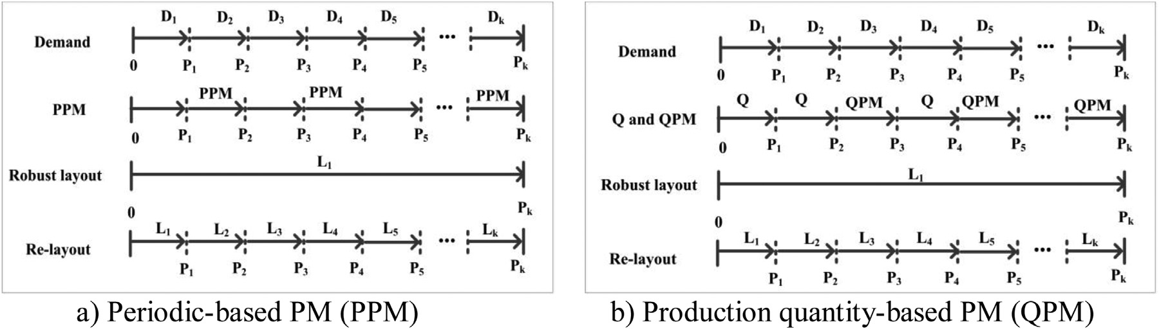

**Fig. 1.** Relationship between layout design approaches and type of preventive maintenance.

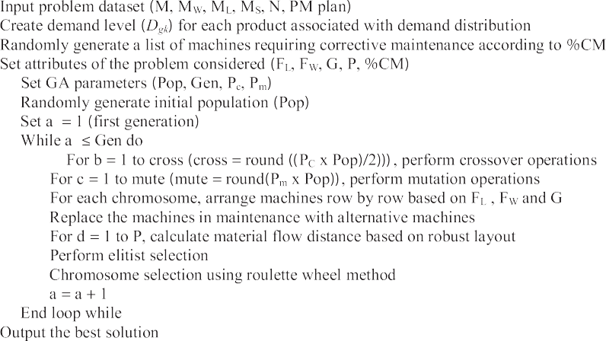

**Fig. 2.** Pseudo code of GA for robust FLD.



**Fig. 3.** Chromosome representation (gene represents a machine number).

In this work, a GA was adopted for solving the facilities layout design (FLD) problem. The GA-based layout design tool includes both robust and re-layout design approaches for dealing with un- certainties that arise from dynamic customer demand and machine maintenance (based on three scenarios: only preventive mainte- nance, only corrective maintenance, and both preventive and cor- rective maintenance).

The GA pseudo-code for the proposed robust Facility Layout De- sign (FLD) problem shown in Fig. 2 has the following steps:

1. problem encoding - chromosomes are produced that com- prise a list of genes (each representing a machine number); the number of genes in each chromosome is equal to the number of machines to be arranged (see Fig. 3);
2. load the input data - the number of machines (M), the di- mensions of machines (width: MW x length: ML), the num- ber of products (N), the machine sequences (MS) and the preventative maintenance (PM) plan for each machine;
3. specify the Genetic Algorithm parameters: the population size (Pop), the number of generations (Gen), the probabil- ity of crossover (Pc), the probability of mutation (Pm), floor length (FL), floor width (FW), the gap between machines (G), the number of periods (P) and the percentage of machines that require corrective maintenance (%CM) per period. All parameters can be identified via the user interface window of the program as shown in Fig. 4;
4. create the demand levels for each product in each period (*Dgk* );
5. randomly generate a list of machines that require CM ac-

cording to the %CM;

1. randomly generate initial chromosomes according to popu- lation size (*Pop*);
2. apply crossover and mutation operators to generate new offspring considering Pc and Pm. The two-point centre crossover operator (illustrated in Fig. 5a) and two-operations random swap mutation operator (see Fig. 5b) were applied in this work.
3. arrange the machines sequentially row-by-row, from left to right, starting at the first row and taking into account FL with a gap (G) between adjacent machines. The machine width is parallel to the x-axis. The machine length is par- allel to the y-axis. Fig. 6 illustrates the placement of the ma- chines relating to the genes in the child chromosome shown in Fig. 5b).

When there is not enough space for placing the next machine at the end of the row, it is placed in the next row. If floor width (FW) is insuﬃcient, the program will report the extra space required for placing all of the machines. Vehicles moving between rows move from the left or the right side of the row and then up or down to the destination row. The flow distance was evaluated for the short- est route. For example, there are two routes from machine 4 to machine 11; route A would be selected as it is shorter.

1. replace the machines in maintenance with alternative ma- chines;

Once a machine becomes. unavailable, for example being under maintenance, an alternative machine with same type

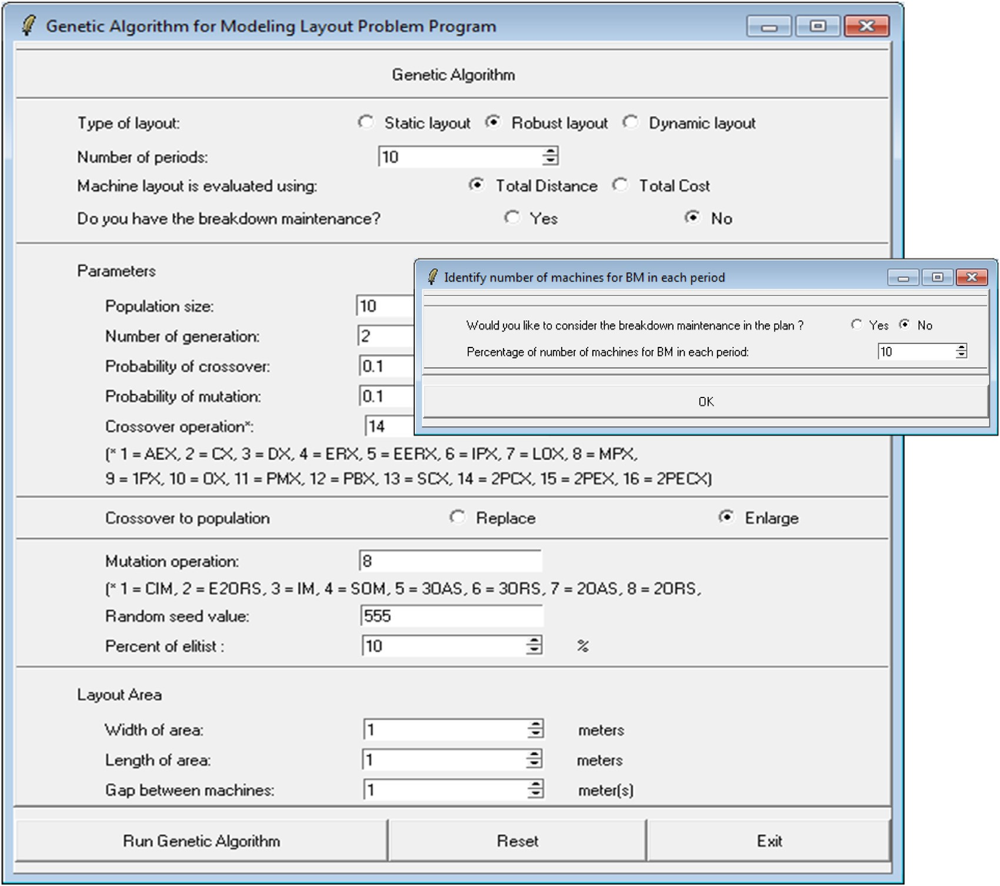

**Fig. 4.** User interface window of the program.

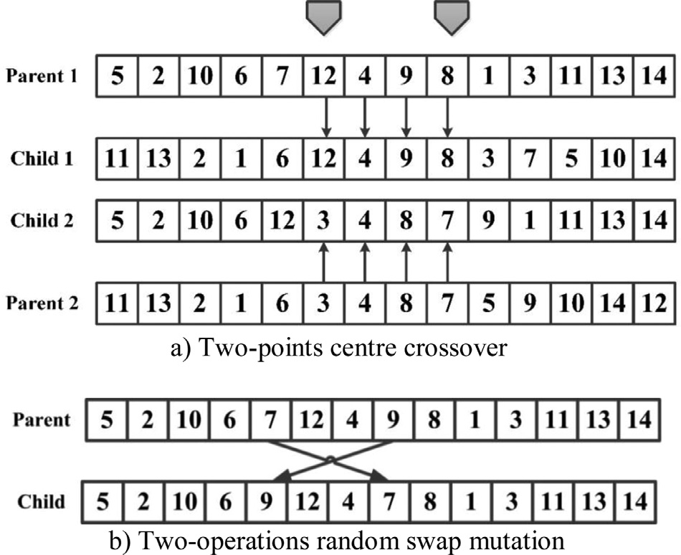

**Fig. 5.** Mechanism of genetic operators (Murata & Ishibuchi, 1994).

is MFD1. If machine 3 is unavailable, machine 11 can be used an alternative, leading to the sequence 1-2-11. The distance for this route is MFD2. When machine 3 is available again the sequence returns to 1-2-3. If the lower-classed machine can only perform some of the operations required, a second alternative machine may be required to cover the remaining operations performed on the unavailable machine. Fig. 7 provides an example. If machine 8 and machine 9 (8-9) are alternative machines for the unavailable machine 3, the new machine sequence is 1-2-8-9.

1. calculate the fitness value (material flow distance) for chro- mosome (a) in each period (d) by applying the fitness func- tion. The fitness function (*Z*) for the eﬃciency of robust lay- out design minimises total material flow distance (MFD) as defined by Eq. (1). In case of machine maintenance, Eq. (1) is still valid for determining the total material flow distance (MFD∗) but the added star symbol “∗” differentiates the maintenance case with alternative machines from the case without maintenance or alternative machines (MFD).

*M M N P*

will be prioritised first. Otherwise, a set of pre-defined al- ternative machines types (e.g. lower-classed machines) will be selected to cover all of the operations for the unavailable machine. The processing route is changed to reflect the alternative machine(s). For example, Fig. 7 assumes the ma- chine sequence 1-2-3. The total material handling distance

*Minimise Z* = Σ Σ Σ Σ *dijgk fijgk Dgk ,* (1)

*i*=1 *j*=1 *g*=1 k=1

*M* is the number of machines, *i* and *j* are machine indexes (*i* and *j* **=** *1, 2, 3, …, M)* (*i* /= *j*). *N* is the number of product types, *g* is a product index (*g* = 1, 2, 3, …, *N*) and *P* is the number of time periods, *k* is a time period index *(k* = *1, 2, 3,*

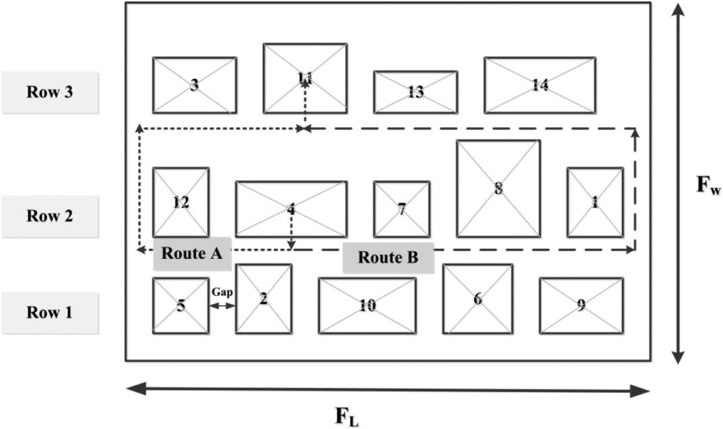

**Fig. 6.** Example of multiple-row machine layout design (Vitayasak & Pongcharoen, 2015).

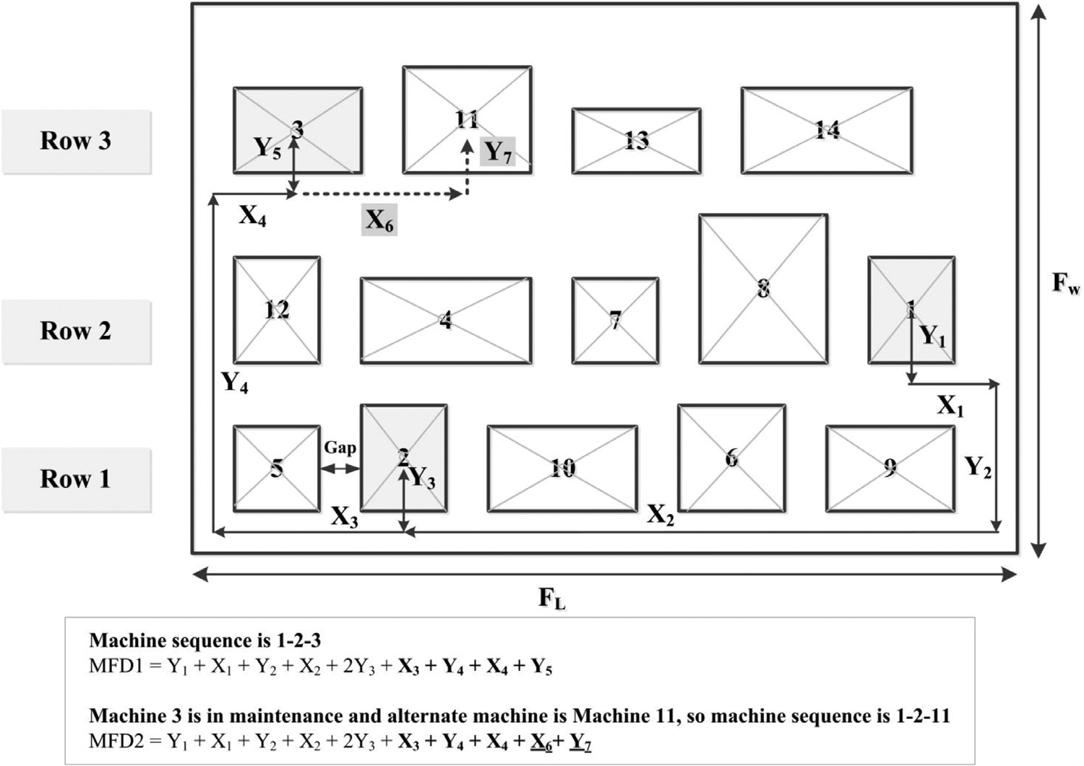

**Fig. 7.** Example of changes in the processing route and material flow distance.

*…, P). dijgk* is the material flow distance for product *g* from machine *i* to *j* in period *k, fijgk* is the frequency of material flow for product *g* from machine *i* to *j* in period *k*, and *Dgk* is the customer demand for product *g* in period *k.*

The following assumptions were made to simplify and for- mulate the problem: 1) material handling between machines is operated via pick-up and drop-off points (P/D points) lo- cated at the machines’ centroids; 2) the material flow dis- tance between P/D points was measured from the front of machines; 3) the machines were arranged in multiple rows;

4) each machine had either one alternative machine or a group of alternative machines; 5) in case of a random break- down, an available alternative machine is used during the time period; 6) automated guided vehicles move on rectilin- ear lines along the perimeter of the shop floor; 7) the gap between machines is constant; 8) preventive maintenance

plans are periodic (PPM) or based upon production quanti- ties (QPM); and 9)for the QPM, the maintenance operations are performed when the summation of customer demand equals the predefined production quantity.

1. select elite chromosomes according to percentage of sorted chromosomes (%Elite) in Eq. (2) using the elitist selection mechanism. The chromosomes are sorted according to the material flow distance (MFD). The best chromosome has the shortest MFD;

Elite chromosome = %Elite x Population size*(*Pop*)* (2)

The elitist selection mechanism (Fig. 8) reproduces the best%Elite chromosomes in the next generation, which is used in step xii). A value of 10% was used.

1. choose chromosomes by using roulette wheel selection - the probability of selecting an individual is proportional to its

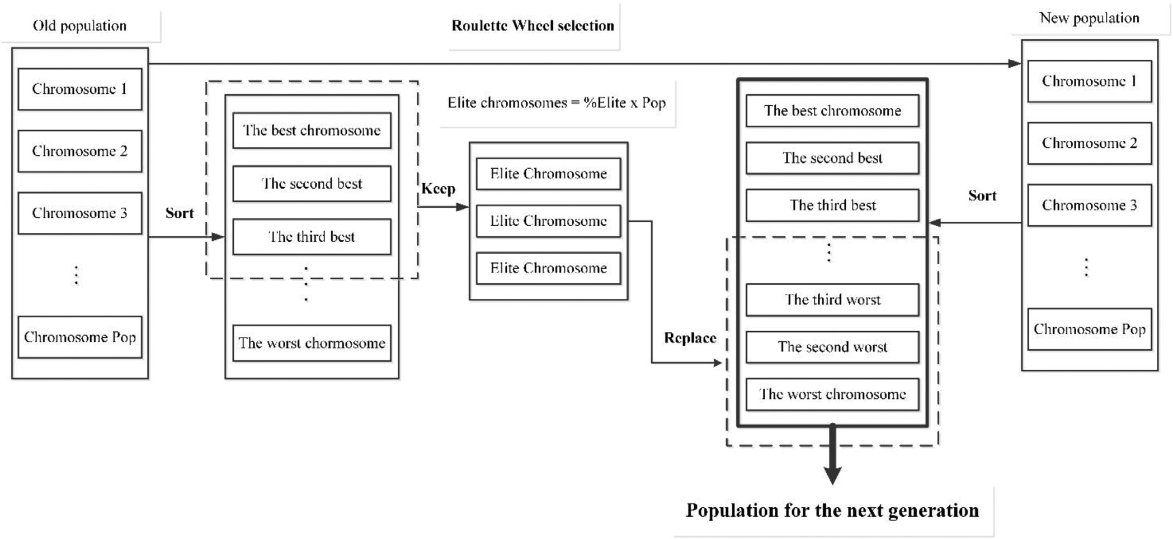

**Fig. 8.** Mechanism for Elitist selection and Roulette wheel selection.

relative fitness. The roulette wheel is ‘spun’ repeatedly to produce a new population of the same size as the initial population. Then, the chromosomes in the new population are sorted in accordance with their fitness. The least fit chro- mosomes are replaced with elite chromosomes;

1. the GA process is terminated after the specified number of generations and the best-so-far solution is reported and shown as a graphic.

The selection of GA parameters (population size, num- ber of generations and the probabilities of crossover and mutation) has a large impact on their performance (Pongcharoen, Chainate & Samranpun, 2007). The appropri- ate settings of the GA parameters for the machine layout problems were considered by Vitayasak (2011), in which an analysis of variance (ANOVA) suggested that the probability of crossover (*Pc*) and mutation (*Pm*) should be set at 0.9 and

**Table 2**

Datasets.

Datasets Number of machines (M) Number of products (N) 10M5N 10 5

10M10N 10 10

20M10N 20 10

20M20N 20 20

20M40N 20 40

30M15N 30 15

30M30N 30 30

40M20N 40 20

40M40N 40 40

|  |  |  |
| --- | --- | --- |
| 50M25N | 50 | 25 |
| 50M40N | 50 | 40 |

**Table 3**

Summary of product demand distributions and machine sequences for 10M5N.

0.5, respectively, with 50 chromosomes and 50 generations.

The genetic operators adopted in this work were Two-point Centre Crossover (2PCX) and Two Operation Random Swap (2ORS) (Vitayasak & Pongcharoen, 2011). The GA based lay- out design tool was developed and coded in a modular style using the Tool Command Language and Tool Kit (Tcl/Tk) pro- gramming language (Ousterhout, 2010).

|  |  |  |
| --- | --- | --- |
| Product | Product demand distribution | Machine sequence |
| 1 | Uniform (100, 200) | 2-1-6-5-8-9-3-4 |
| 2 | Uniform (50, 100) | 10-8-7-5-9-6-1 |
| 3 | Normal (180, 50) | 9-2-7-4 |
| 4 | Normal (300, 120) | 8-10-5-9-6 |
| 5 | Exponential (1/200) | 2-4-8-10-7 |

# Experimental design and analysis

The computational experiments were conducted using eleven datasets (Vitayasak & Pongcharoen, 2018), which had different numbers of non-identical machines, with various product types as shown in Table 2. Each type of product had different demand pro- files and machine sequences, as shown in Table 3. Demand profiles can be uploaded into the program using either empirical data or by selecting a probability distribution (exponential, normal distri- bution, or uniform). The user can select the number of time peri- ods. In the computational experiments ten time-periods were con- sidered. The layout design approach was based on ‘robust design’, without machine relocation. The experiments were conducted on a personal computer with an Intel Core i5 2.8 GHz CPU and 4 GB DDR3 RAM.

To investigate the effect of number of unavailable machines on material flow distance, the following three maintenance scenarios were considered: Scenario I: only preventive maintenance (PM); Scenario II: only corrective maintenance (CM); and Scenario III: both PM and CM.

For scenario I, the ratio of the number of machines with period-based PM to the number with production quantity-based PM (PPM/QPM) in each period was studied at three levels, 20/80, 50/50, and 80/20. For scenario II, the percentage of machines with corrective maintenance (%CM) was also considered at three levels, 10%, 20% and 30%. For scenario III, two levels of PMM/QPM ra- tio (20/80 and 80/20) and two levels of %CM (10% and 30%) were studied. During periods of maintenance alternative machines were used, which required changes to the routings.

Each experiment was replicated thirty times using different random seeds with a full factorial design. There were eleven

**Table 4**

Comparison of MFD and MFD∗ for scenario I: PM.

Dataset Value MFD based on PPM/QPM (metre) MFD∗ based on PPM/QPM (metre)

|  |  |  |  |  |  |  |  |  |  |
| --- | --- | --- | --- | --- | --- | --- | --- | --- | --- |
|  | | 20/80 | 50/50 | 80/20 |  | 20/80 | 50/50 | 80/20 |  |
| 10M5N | Mean | 732,542.5 | 682,908.9 | 671,328.9 |  | **691,865.7** | **668,652.3** | **665,583.0** |  |
|  | SD | 24,647.6 | 20,695.9 | 20,238.0 |  | 4119.6 | 11,341.9 | 13,758.9 |  |
|  | Min | 713,598.0 | 664,472.9 | 654,634.8 |  | 689,136.2 | 661,275.3 | 654,634.8 |  |
|  | Max | 832,939.7 | 736,192.5 | 722,275.7 |  | 705,477.0 | 702,680.3 | 700,175.2 |  |
| 10M10N | Mean | 1,976,667.4 | 1,892,978.1 | 1,859,314.2 |  | **1,365,585.7** | **1,555,505.8** | **1,713,101.3** |  |
|  | SD | 49,187.6 | 16,297.4 | 20,541.5 |  | 30,343.5 | 18,713.4 | 14,422.8 |  |
|  | Min | 1,861,464.9 | 1,873,784.0 | 1,810,030.5 |  | 1,332,408.9 | 1,539,135.7 | 1,700,812.0 |  |
|  | Max | 2,016,763.9 | 1,932,690.0 | 1,881,312.6 |  | 1,455,138.8 | 1,635,094.6 | 1,742,679.4 |  |
| 20M10N | Mean | 4,001,771.7 | 3,940,840.1 | 3,729,899.9 |  | **3,592,326.6** | **3,634,375.6** | **3,614,821.5** |  |
|  | SD | 78,242.4 | 79,494.8 | 68,393.4 |  | 73,249.1 | 43,154.5 | 44,409.6 |  |
|  | Min | 3,829,033.9 | 3,821,550.9 | 3,599,206.3 |  | 3,465,857.2 | 3,539,722.1 | 3,539,102.4 |  |
|  | Max | 4,101,750.6 | 4,085,982.0 | 3,842,643.8 |  | 3,766,232.0 | 3,722,638.0 | 3,727,000.0 |  |
| 20M20N | Mean | 11,513,726.3 | 10,783,205.5 | 10,843,729.9 |  | **9,977,229.7** | **10,189,105.8** | **10,627,060.1** |  |
|  | SD | 299,771.8 | 298,390.9 | 240,696.3 |  | 244,037.1 | 121,587.8 | 115,279.7 |  |
|  | Min | 11,071,694.1 | 10,333,942.9 | 10,463,019.1 |  | 9,597,502.4 | 9,989,522.6 | 10,432,751.3 |  |
|  | Max | 12,130,858.2 | 11,517,033.3 | 11,454,630.8 |  | 10,524,709.4 | 10,486,443.6 | 10,862,024.5 |  |
| 20M40N | Mean | 21,401,460.7 | 19,986,017.0 | 20,544,511.3 |  | **18,412,155.3** | **18,938,010.2** | **19,970,511.5** |  |
|  | SD | 512,797.8 | 578,927.0 | 323,605.9 |  | 391,668.2 | 230,848.5 | 232,269.3 |  |
|  | Min | 20,603,137.2 | 18,731,438.0 | 19,999,276.1 |  | 17,817,505.4 | 18,475,407.8 | 19,590,558.5 |  |
|  | Max | 22,339,703.9 | 21,082,385.4 | 21,104,899.6 |  | 19,093,318.0 | 19,437,762.3 | 20,595,303.8 |  |
| 30M15N | Mean | 8,789,956.5 | 8,551,413.8 | 8,643,304.4 |  | **7,956,149.15** | **8,440,682.20** | **8,483,438.64** |  |
|  | SD | 163,832.5 | 191,461.6 | 173,280.2 |  | 194,371.04 | 131,806.11 | 87,145.06 |  |
|  | Min | 8,515,022.2 | 8,255,329.1 | 8,206,987.7 |  | 7,466,729.75 | 8,179,130.67 | 8,328,513.24 |  |
|  | Max | 9,175,074.3 | 8,926,977.0 | 8,949,400.7 |  | 8,438,340.21 | 8,715,695.05 | 8,701,946.22 |  |
| 30M30N | Mean | 19,301,863.60 | 18,487,734.83 | 18,690,797.41 |  | **17,204,962.04** | **17,396,236.45** | **18,214,404.94** |  |
|  | SD | 435,923.13 | 516,278.59 | 380,761.66 |  | 402,715.31 | 353,777.78 | 263,081.10 |  |
|  | Min | 18,372,318.53 | 17,551,378.72 | 17,995,914.35 |  | 16,445,449.33 | 16,716,437.07 | 17,375,926.59 |  |
|  | Max | 20,179,254.75 | 19,818,815.62 | 19,456,224.74 |  | 18,125,773.31 | 18,031,117.12 | 18,725,122.02 |  |
| 40M20N | Mean | 18,858,370.7 | 17,337,722.43 | 17,809,046.9 |  | **17,318,043.57** | **17,225,214.19** | **17,255,004.23** |  |
|  | SD | 511,956.3 | 447,197.64 | 488,921.8 |  | 296,621.80 | 365,120.69 | 378,466.45 |  |
|  | Min | 17,894,054.6 | 16,480,907.34 | 16,853,058.9 |  | 16,508,074.48 | 16,539,613.57 | 16,600,313.04 |  |
|  | Max | 20,246,679.0 | 18,345,406.56 | 18,957,250.8 |  | 17,975,588.85 | 17,916,696.26 | 18,277,513.32 |  |
| 40M40N | Mean | 32,803,402.4 | **30,982,086.8** | 31,641,802.8 |  | **31,298,488.0** | 31,035,390.7 | **31,345,619.6** |  |
|  | SD | 801,659.0 | 722,317.8 | 650,073.4 |  | 726,381.7 | 711,805.7 | 620,078.0 |  |
|  | Min | 30,977,346.9 | 29,219,342.9 | 30,194,195.0 |  | 30,232,613.4 | 29,534,475.2 | 30,301,396.8 |  |
|  | Max | 34,205,187.1 | 32,381,014.5 | 32,864,760.4 |  | 32,875,952.8 | 32,327,958.4 | 32,969,441.4 |  |
| 50M25N | Mean | 30,416,821.5 | 28,333,573.0 | 29,107,471.2 |  | **29,229,012.2** | **28,160,455.8** | **28,469,378.4** |  |
|  | SD | 760,184.5 | 633,765.3 | 650,899.3 |  | 594,235.6 | 493,595.3 | 595,960.7 |  |
|  | Min | 28,813,572.1 | 26,841,331.4 | 27,568,289.9 |  | 28,053,520.0 | 27,109,933.9 | 27,433,665.5 |  |
|  | Max | 31,820,838.4 | 29,787,280.8 | 30,314,566.6 |  | 30,417,033.0 | 29,194,486.7 | 29,549,430.7 |  |
| 50M40N | Mean | 43,031,913.11 | 40,691,396.66 | 41,268,975.91 |  | **40,460,200.71** | **39,490,367.57** | **40,344,555.51** |  |
|  | SD | 952,627.77 | 918,014.12 | 879,344.63 |  | 972,265.88 | 592,128.02 | 751,780.72 |  |
|  | Min | 40,965,451.37 | 38,282,898.46 | 39,139,888.29 |  | 39,055,623.37 | 38,466,880.56 | 38,826,428.61 |  |
|  | Max | 45,404,975.41 | 42,428,452.96 | 43,581,746.30 |  | 44,343,340.20 | 40,718,144.44 | 42,392,739.34 |  |

datasets, thirty replications, three levels of the PPM/QPM ratio, and three levels of %CM, which gave a total of 11×30×3 = 990 runs for scenario I and II. In scenario III, two levels of PMM/QPM ra- tio and two levels of %CM were studied with eleven datasets, and thirty replications, so the total number of computational runs was 2 × 2 × 11 × 30 = 1320 runs.

The experiments considered robust layout design under dy- namic demand and machine maintenance. The objective was to minimise the material flow distance (*MFD*∗). The distance travelled obtained from the layout design without consideration of mainte- nance was termed *MFD*. The *MFD* for scenario II was adopted from the previous work (Vitayasak & Pongcharoen, 2015). Both *MFD*∗ and *MFD* were calculated using Eq. (1). The computational results obtained from the robust layout design without and with consider- ation of machine maintenance are described in the following sub- sections.

* 1. *Layout design without and with consideration of machine maintenance*

The material flow distances obtained from two layout design approaches without and with consideration of maintenance (*MFD*

and *MFD*∗) are shown in Tables 4, 5, and 6. When maintenance considerations are not included, the *MFD* is determined based on the machine-processing route; whilst when machine maintenance is considered, the *MFD*∗ is evaluated from the alternative machine- processing route.

The layout design with consideration of maintenance opera- tions (PM, CM or both PM and CM) resulted in shorter travel distance for almost all the datasets. *MFD*∗ was reduced by up to 30.91% (10M10N dataset, with the 20/80 ratio), 9.8% (40M20N dataset, with 30%CM), and 20.7% (10M10N dataset, with a 20/80 for PM and 30%CM) compared to MFD for scenarios I, II, III, respec- tively. The shorter distances were achieved by the design approach that considered alternative machines in the machine-processing routes. However, the *MFD*∗ based on 50/50 PPM/QPM and 40M40N datasets in scenario I were longer due to the use of alternative ma- chines and their location. The experimental results and differences in *MFD* and *MFD*∗ for each scenario were analysed statistically (dis- cussed in Section 4.2).

The PPM/QPM ratios in scenario I, %CM in scenario II, and both PMM/QPM ratio and %CM in scenario III effected both *MFD* and *MFD*∗. Changes in the flow distances had no obvious patterns for example, the proportion of PPM in PPM/QPM ratios resulted in

**Table 5**

Comparison of MFD and MFD∗ for scenario II: CM.

Dataset Value MFD based on %CM (metre) MFD∗ based on %CM (metre)

|  |  |  |  |  |  |  |  |  |
| --- | --- | --- | --- | --- | --- | --- | --- | --- |
|  | | 10 | 20 | 30 | 10 | 20 | 30 |  |
| 10M5N | Mean | 595,992.6 | 648,008.0 | 718,537.9 | **590,735.3** | **635,137.6** | **654,871.8** |  |
|  | SD | 18,962.6 | 22,179.8 | 19,694.1 | 16,296.5 | 12,580.0 | 4934.4 |  |
|  | Min | 578,595.5 | 629,746.0 | 703,029.4 | 578,595.5 | 626,338.8 | 650,562.2 |  |
|  | Max | 649,594.9 | 701,533.4 | 774,072.3 | 625,753.0 | 673,371.0 | 668,980.6 |  |
| 10M10N | Mean | 1,743,496.2 | 1,820,137.3 | 1,900,532.4 | **1,714,028.2** | **1,768,381.9** | **1,743,789.8** |  |
|  | SD | 23,439.5 | 13,037.3 | 25,364.2 | 14,977.4 | 6627.3 | 5350.4 |  |
|  | Min | 1,724,716.2 | 1,798,904.2 | 1,831,347.7 | 1,705,903.0 | 1,762,266.7 | 1,732,380.9 |  |
|  | Max | 1,806,196.4 | 1,865,916.6 | 1,918,760.8 | 1,768,640.5 | 1,782,853.8 | 1,759,054.9 |  |
| 20M10N | Mean | 3,542,104.0 | 3,628,745.5 | 3,941,721.4 | **3,502,114.8** | **3,486,977.2** | **3,660,302.0** |  |
|  | SD | 70,083.5 | 90,727.4 | 93,797.2 | 65,178.1 | 57,637.9 | 53,742.4 |  |
|  | Min | 3,405,568.5 | 3,491,732.5 | 3,751,832.7 | 3,374,479.0 | 3,385,945.7 | 3,572,248.2 |  |
|  | Max | 3,697,350.4 | 3,825,789.1 | 4,136,080.9 | 3,612,987.2 | 3,590,665.7 | 3,776,400.2 |  |
| 20M20N | Mean | 10,886,407.5 | 11,491,341.5 | 10,040,630.5 | **9,975,829.5** | **10,271,479.3** | **10,775,891.3** |  |
|  | SD | 377,961.7 | 379,507.2 | 64,521.2 | 150,438.9 | 136,099.6 | 122,597.3 |  |
|  | Min | 10,135,672.5 | 10,873,095.3 | 9,911,473.3 | 9,634,447.2 | 9,986,824.9 | 10,549,215.6 |  |
|  | Max | 11,917,048.8 | 12,629,320.2 | 10,145,030.9 | 10,164,784.6 | 10,494,467.5 | 11,066,485.3 |  |
| 20M40N | Mean | 20,347,121.1 | 21,261,068.2 | 20,815,688.1 | **20,055,976.8** | **20,538,439.4** | **19,792,882.4** |  |
|  | SD | 318,814.4 | 355,670.7 | 361,285.2 | 256,549.6 | 255,692.7 | 244,704.3 |  |
|  | Min | 19,887,820.5 | 20,614,947.8 | 20,049,924.7 | 19,521,965.0 | 19,990,144.4 | 19,385,382.5 |  |
|  | Max | 21,181,869.2 | 22,179,471.9 | 21,493,810.5 | 20,638,112.7 | 21,214,033.3 | 20,368,678.3 |  |
| 30M15N | Mean | 8,276,170.0 | 8,489,326.7 | 9,056,617.6 | **8,112,260.89** | **8,109,334.22** | **8,517,554.15** |  |
|  | SD | 213,714.2 | 209,076.6 | 197,351.2 | 160,677.68 | 136,576.21 | 122,294.57 |  |
|  | Min | 7,915,148.6 | 8,041,397.4 | 8,663,135.8 | 7,716,345.63 | 7,912,373.96 | 8,342,702.04 |  |
|  | Max | 8,642,410.7 | 8,884,425.3 | 9,448,623.8 | 8,369,170.86 | 8,407,071.29 | 8,866,532.80 |  |
| 30M30N | Mean | 18,488,449.3 | 19,213,555.9 | 19,924,934.3 | **18,056,501.0** | **18,570,871.1** | **18,870,939.7** |  |
|  | SD | 345,013.1 | 376,796.3 | 390,559.1 | 290,811.3 | 257,302.4 | 425,340.4 |  |
|  | Min | 17,813,400.0 | 18,531,809.7 | 19,075,102.0 | 17,529,610.1 | 18,153,692.7 | 18,285,164.3 |  |
|  | Max | 19,047,688.1 | 19,999,742.7 | 20,852,219.5 | 18,538,341.9 | 19,296,918.2 | 19,878,511.9 |  |
| 40M20N | Mean | 17,166,328.0 | 17,680,469.6 | 19,807,215.4 | **16,963,181.88** | **16,918,410.83** | **17,865,200.18** |  |
|  | SD | 596,320.1 | 711,828.6 | 628,823.9 | 450,898.81 | 386,285.35 | 427,203.26 |  |
|  | Min | 16,275,826.0 | 16,382,959.9 | 18,444,970.6 | 16,003,309.77 | 16,191,351.68 | 16,949,237.51 |  |
|  | Max | 18,793,575.0 | 19,249,222.1 | 20,954,182.8 | 17,939,692.95 | 17,785,665.63 | 18,571,965.60 |  |
| 40M40N | Mean | 30,354,735.4 | 32,107,292.1 | 34,014,129.5 | **30,014,644.7** | **31,471,994.4** | **31,977,370.8** |  |
|  | SD | 710,209.0 | 732,868.0 | 913,114.6 | 688,480.4 | 724,316.4 | 496,761.8 |  |
|  | Min | 28,861,378.3 | 30,625,120.7 | 32,160,002.9 | 28,700,335.2 | 30,208,296.0 | 30,629,629.6 |  |
|  | Max | 31,531,345.4 | 33,591,573.4 | 36,340,903.2 | 31,406,586.2 | 32,832,899.7 | 32,865,393.8 |  |
| 50M25N | Mean | 27,178,003.2 | 30,270,244.4 | 30,870,860.1 | **27,092,641.4** | **29,081,579.6** | **28,831,111.7** |  |
|  | SD | 668,805.8 | 1,470,163.5 | 1,062,502.1 | 568,595.4 | 572,029.1 | 635,753.7 |  |
|  | Min | 25,890,014.3 | 28,608,583.1 | 29,248,548.6 | 25,769,239.5 | 27,571,531.5 | 27,526,568.9 |  |
|  | Max | 28,643,707.9 | 34,650,791.3 | 33,655,833.1 | 28,551,539.0 | 29,899,271.5 | 30,363,093.6 |  |
| 50M40N | Mean | 38,665,200.8 | 40,623,452.1 | 42,813,257.3 | **38,410,673.5** | **39,068,770.5** | **39,716,291.9** |  |
|  | SD | 926,397.9 | 875,337.7 | 1,029,425.4 | 996,253.1 | 579,898.0 | 1,572,021.9 |  |
|  | Min | 36,759,326.4 | 38,525,081.4 | 40,711,956.5 | 36,490,243.4 | 37,972,072.9 | 35,925,018.8 |  |
|  | Max | 40,206,702.1 | 42,427,400.6 | 45,364,718.2 | 41,594,068.6 | 39,965,774.8 | 41,252,991.8 |  |

shorter distances (both *MFD* and *MFD*∗) in 10M5N dataset, whilst the *MFD*∗ increased in the 10M10N, 20M10N, 20M20N, 20M40N, and 30M15N datasets. In scenario II, a number of machines in CM increased but the distance varied, in some cases shorter, in other cases longer. These results show that production conditions can make the layout more or less eﬃcient.

The graphical layouts produced by the program with and with- out maintenance consideration are shown in Fig. 9a) and Fig. 9b), respectively, both figures are the machine arrangements produced by one replication of the 40M20N dataset in the 10%CM case from scenario II. In period 10, 2-3 (MC2-MC3) is part of the machine sequence for product no.12. In Fig. 9a) machine 3 is unavailable because of CM, and machine 31 (MC31) is the alternative machine. The sequence was changed to 2-31 (MC2-MC31). The flow distance between MC2 and MC31 in Fig. 9a) is shorter than in Fig. 9b) due to the layout design.

* 1. *Statistical analysis on the experimental results*

The experimental results in Table 4, 5, and 6 were analysed us- ing the Student’s *t*-test and analysis of variance (ANOVA).

* + 1. *The student’s* t*-test*

The Student’s *t*-test was used to test differences in the means *MFD* and *MFD*∗ for the three scenarios shown in Table 7. For scenario I, there were statistically significant differences (*P*-value

*<* 0.05) with a 95% confidence interval, except for the 50/50

PPM/QPM ratio for problems 40M20N and 40M40N, and the 80/20 PPM/QPM ratio for the 40M40N problem. For scenario II, there were statistically significant differences in the means of *MFD* and *MFD*∗ except for 10%CM for the 10M5N, 40M20N 40M40N and 50M40N problems. For scenario III, the *P*-values were less than

0.05 for all datasets, so there were statistically significant differ- ences in the mean of *MFD* and *MFD*∗. These results emphasised that effective layout design cannot overlook machine maintenance.

* + 1. *Analysis of variance (ANOVA)*

The effects of PPM/QPM ratios in scenario I, the percentages of CM in scenario II (%CM), and both PPM/QPM ratios and %CM in scenario III on material flow distance were analysed using an ANOVA to calculate *P* values as shown in Table 8. For scenario I, the results showed that The PPM/QPM ratios significantly affected the material flow distance with a 95% confidence interval, since the *P* values are less than 0.05 except for 40M20N and 40M40N.

**Table 6**

Comparison of MFD and MFD∗ for scenario III: PM and CM.

Dataset Value MFD based on PPM/QPM (metre) MFD∗ based on PPM/QPM (metre)

20/80 with %CM: 80/20 with %CM: 20/80 with %CM: 80/20 with %CM:

|  |  |  |  |  |  |  |  |  |  |  |  |  |  |
| --- | --- | --- | --- | --- | --- | --- | --- | --- | --- | --- | --- | --- | --- |
|  | | 10 | 30 |  | 10 | 30 |  | 10 | 30 |  | 10 | 30 |  |
| 10M5N | Mean | 756,154.2 | 759,314.1 |  | 711,630.5 | 774,386.9 |  | **696,449.1** | **682,969.7** |  | **689,155.4** | **690,297.0** |  |
|  | SD | 13,883.2 | 19,098.0 |  | 16,444.3 | 19,695.7 |  | 2988.0 | 7388.5 |  | 3499.3 | 6947.8 |  |
|  | Min | 740,685.2 | 748,179.5 |  | 701,040.9 | 752,025.0 |  | 692,655.0 | 679,476.9 |  | 687,224.1 | 685,348.6 |  |
|  | Max | 820,830.6 | 822,493.2 |  | 757,159.5 | 820,557.4 |  | 704,306.4 | 716,359.4 |  | 705,154.0 | 707,057.2 |  |
| 10M10N | Mean | 1,696,411.2 | 1,625,937.8 |  | 1,919,182.4 | 2,003,574.7 |  | **1,363,107.2** | **1,299,582.2** |  | **1,696,411.2** | **1,625,937.8** |  |
|  | SD | 12,532.6 | 22,534.9 |  | 28,228.1 | 29,694.8 |  | 24,383.2 | 17,638.0 |  | 12,532.6 | 22,534.9 |  |
|  | Min | 1,676,742.0 | 1,613,265.3 |  | 1,863,424.6 | 1,930,963.5 |  | 1,340,688.4 | 1,281,094.1 |  | 1,676,742.0 | 1,613,265.3 |  |
|  | Max | 1,718,454.6 | 1,669,606.3 |  | 1,964,517.5 | 2,051,139.6 |  | 1,420,904.3 | 1,342,070.7 |  | 1,718,454.6 | 1,669,606.3 |  |
| 20M10N | Mean | 4,119,919.6 | 4,133,927.1 |  | 3,908,550.1 | 4,005,296.5 |  | **3,595,637.1** | **3,567,280.8** |  | **3,750,587.2** | **3,667,979.3** |  |
|  | SD | 95,199.3 | 98,473.9 |  | 82,028.7 | 94,047.0 |  | 62,974.0 | 84,852.4 |  | 53,481.9 | 65,916.9 |  |
|  | Min | 3,890,903.3 | 3,963,443.5 |  | 3,679,723.0 | 3,826,392.1 |  | 3,465,971.8 | 3,409,105.7 |  | 3,652,461.3 | 3,575,148.0 |  |
|  | Max | 4,279,254.9 | 4,285,285.7 |  | 4,060,176.6 | 4,158,645.2 |  | 3,733,667.8 | 3,780,967.2 |  | 3,889,113.3 | 3,834,580.3 |  |
| 20M20N | Mean | 11,684,238.3 | 11,587,409.5 |  | 11,436,897.2 | 11,632,622.8 |  | **9,784,872.0** | **9,704,728.0** |  | **10,640,238.3** | **10,580,494.1** |  |
|  | SD | 567,227.3 | 393,346.9 |  | 266,980.2 | 286,861.7 |  | 229,961.4 | 249,658.8 |  | 115,081.6 | 126,464.7 |  |
|  | Min | 10,178,930.6 | 10,836,389.6 |  | 10,991,330.4 | 11,228,632.5 |  | 9,320,756.7 | 9,240,327.7 |  | 10,450,294.7 | 10,416,982.1 |  |
|  | Max | 12,506,884.6 | 12,325,671.3 |  | 12,091,105.6 | 12,338,001.2 |  | 10,340,840.9 | 10,161,215.5 |  | 10,874,935.8 | 10,968,645.8 |  |
| 20M40N | Mean | 21,547,184.5 | 21,955,526.9 |  | 20,961,451.7 | 21,383,550.2 |  | **18,351,926.2** | **17,952,853.6** |  | **19,647,857.8** | **19,339,586.6** |  |
|  | SD | 586,510.4 | 651,830.5 |  | 351,224.6 | 468,077.5 |  | 395,256.3 | 373,085.4 |  | 181,672.6 | 251,284.2 |  |
|  | Min | 20,404,044.1 | 20,898,599.4 |  | 20,347,095.3 | 20,491,165.3 |  | 17,365,794.3 | 17,373,888.9 |  | 19,201,604.1 | 18,873,281.5 |  |
|  | Max | 22,693,245.3 | 23,264,730.7 |  | 21,503,352.5 | 22,172,473.9 |  | 19,154,074.6 | 18,846,545.3 |  | 20,013,134.3 | 19,854,377.1 |  |
| 30M15N | Mean | 9,103,269.9 | 9,233,038.8 |  | 8,896,745.1 | 8,987,536.6 |  | **8,267,592.0** | **8,021,975.1** |  | **8,529,552.3** | **8,552,366.8** |  |
|  | SD | 169,537.0 | 171,008.2 |  | 173,206.4 | 184,264.6 |  | 140,270.5 | 148,486.1 |  | 140,431.2 | 135,258.0 |  |
|  | Min | 8,819,073.4 | 8,963,978.0 |  | 8,549,216.6 | 8,468,788.2 |  | 8,060,902.7 | 7,728,910.4 |  | 8,317,774.1 | 8,266,294.8 |  |
|  | Max | 9,527,748.8 | 9,604,435.3 |  | 9,173,632.1 | 9,222,950.2 |  | 8,588,666.9 | 8,360,262.2 |  | 8,775,369.8 | 8,856,695.1 |  |
| 30M30N | Mean | 19,505,928.3 | 19,762,956.4 |  | 19,601,415.9 | 19,428,292.6 |  | **16,932,208.1** | **17,363,912.1** |  | **18,923,550.0** | **18,520,402.3** |  |
|  | SD | 505,868.8 | 572,729.5 |  | 370,660.4 | 397,525.0 |  | 280,582.2 | 415,910.7 |  | 319,813.1 | 323,064.5 |  |
|  | Min | 18,482,344.2 | 18,796,062.8 |  | 18,983,931.9 | 18,701,559.1 |  | 16,253,491.5 | 16,561,240.6 |  | 18,243,241.7 | 17,880,132.1 |  |
|  | Max | 20,720,940.2 | 20,737,246.1 |  | 20,303,728.3 | 20,185,673.3 |  | 17,436,314.9 | 18,564,151.2 |  | 19,483,474.2 | 19,100,631.7 |  |
| 40M20N | Mean | 20,088,567.2 | 20,622,426.6 |  | 19,320,811.0 | 19,820,034.4 |  | **17,871,005.5** | **18,206,122.4** |  | **18,052,155.3** | **17,931,324.5** |  |
|  | SD | 668,154.1 | 641,100.3 |  | 506,074.1 | 611,456.3 |  | 341,064.0 | 373,018.9 |  | 424,514.7 | 380,688.6 |  |
|  | Min | 18,925,914.0 | 19,444,805.3 |  | 18,085,390.0 | 18,444,970.6 |  | 17,206,286.8 | 17,639,624.0 |  | 17,442,744.0 | 17,317,107.6 |  |
|  | Max | 21,436,825.7 | 21,962,994.3 |  | 20,085,304.0 | 20,954,182.8 |  | 18,476,883.6 | 19,025,693.3 |  | 19,313,919.9 | 18,744,777.1 |  |
| 40M40N | Mean | 34,524,264.6 | 35,205,647.0 |  | 34,234,719.4 | 34,661,170.4 |  | **32,227,970.6** | **32,019,455.4** |  | **32,683,300.5** | **32,504,726.6** |  |
|  | SD | 944,627.4 | 933,575.1 |  | 865,431.9 | 857,340.2 |  | 840,403.8 | 679,697.4 |  | 617,009.5 | 597,281.1 |  |
|  | Min | 32,200,672.3 | 33,130,117.1 |  | 32,262,815.8 | 32,259,884.6 |  | 30,986,173.3 | 30,810,745.5 |  | 31,501,492.7 | 31,074,336.7 |  |
|  | Max | 35,961,923.5 | 36,710,861.5 |  | 36,393,348.9 | 36,193,284.5 |  | 34,097,699.1 | 33,571,654.4 |  | 34,434,440.4 | 33,529,452.6 |  |
| 50M25N | Mean | 32,774,478.7 | 32,651,407.2 |  | 30,839,771.0 | 31,046,583.7 |  | **30,023,350.7** | **29,835,449.8** |  | **29,922,703.3** | **29,095,235.1** |  |
|  | SD | 834,599.6 | 877,062.3 |  | 621,845.2 | 784,307.3 |  | 531,123.2 | 462,479.7 |  | 1,606,028.9 | 536,007.8 |  |
|  | Min | 31,354,594.9 | 31,028,567.0 |  | 29,245,455.1 | 29,411,674.2 |  | 28,816,579.1 | 28,708,173.9 |  | 28,455,958.5 | 27,843,837.0 |  |
|  | Max | 34,948,695.9 | 34,827,671.8 |  | 31,739,507.5 | 32,347,650.6 |  | 31,014,303.3 | 30,671,972.6 |  | 34,676,639.3 | 30,338,961.7 |  |
| 50M40N | Mean | 44,086,719.7 | 44,636,696.3 |  | 43,086,633.8 | 43,174,077.6 |  | **41,169,524.8** | **41,188,981.3** |  | **41,030,026.2** | **40,977,432.1** |  |
|  | SD | 994,298.1 | 1,021,741.6 |  | 1,044,123.1 | 1,042,832.8 |  | 684,203.7 | 760,165.2 |  | 855,671.1 | 840,875.4 |  |
|  | Min | 41,722,477.5 | 42,411,002.7 |  | 40,555,375.7 | 40,054,726.3 |  | 39,994,590.8 | 39,816,605.2 |  | 39,447,020.7 | 39,780,973.9 |  |
|  | Max | 46,434,531.2 | 47,486,809.8 |  | 45,290,685.9 | 45,435,725.5 |  | 42,636,809.1 | 42,899,341.2 |  | 42,546,100.7 | 43,250,507.1 |  |

**Table 7**

*P* values for *t*-test for scenario I, II, and III.

Dataset scenario I PPM/QPM: scenario II %CM scenario III

20/80 with %CM 80/20 with %CM:

|  |  |  |  |  |  |  |  |  |  |  |  |  |
| --- | --- | --- | --- | --- | --- | --- | --- | --- | --- | --- | --- | --- |
|  | 20/80 | 50/50 | 80/20 | 10 | 20 | 30 | 10 | 30 |  | 10 | 30 |  |
| 10M5N | 0.000 | 0.000 | 0.000 | 0.254 | 0.008 | 0.000 | 0.000 | 0.000 |  | 0.000 | 0.000 |  |
| 10M10N | 0.000 | 0.000 | 0.000 | 0.000 | 0.000 | 0.000 | 0.000 | 0.000 |  | 0.000 | 0.000 |  |
| 20M10N | 0.000 | 0.000 | 0.000 | 0.026 | 0.000 | 0.000 | 0.000 | 0.000 |  | 0.000 | 0.000 |  |
| 20M20N | 0.000 | 0.000 | 0.000 | 0.000 | 0.000 | 0.000 | 0.000 | 0.000 |  | 0.000 | 0.000 |  |
| 20M40N | 0.000 | 0.000 | 0.000 | 0.000 | 0.000 | 0.000 | 0.000 | 0.000 |  | 0.000 | 0.000 |  |
| 30M15N | 0.000 | 0.000 | 0.000 | 0.001 | 0.000 | 0.000 | 0.000 | 0.000 |  | 0.000 | 0.000 |  |
| 30M30N | 0.000 | 0.000 | 0.000 | 0.000 | 0.000 | 0.000 | 0.000 | 0.000 |  | 0.000 | 0.000 |  |
| 40M20N | 0.000 | 0.290 | 0.000 | 0.143 | 0.000 | 0.000 | 0.000 | 0.000 |  | 0.000 | 0.000 |  |
| 40M40N | 0.000 | 0.774 | 0.076 | 0.065 | 0.001 | 0.000 | 0.000 | 0.000 |  | 0.000 | 0.000 |  |
| 50M25N | 0.020 | 0.000 | 0.000 | 0.020 | 0.000 | 0.000 | 0.000 | 0.000 |  | 0.000 | 0.000 |  |
| 50M40N | 0.000 | 0.000 | 0.000 | 0.310 | 0.000 | 0.000 | 0.000 | 0.000 |  | 0.000 | 0.000 |  |

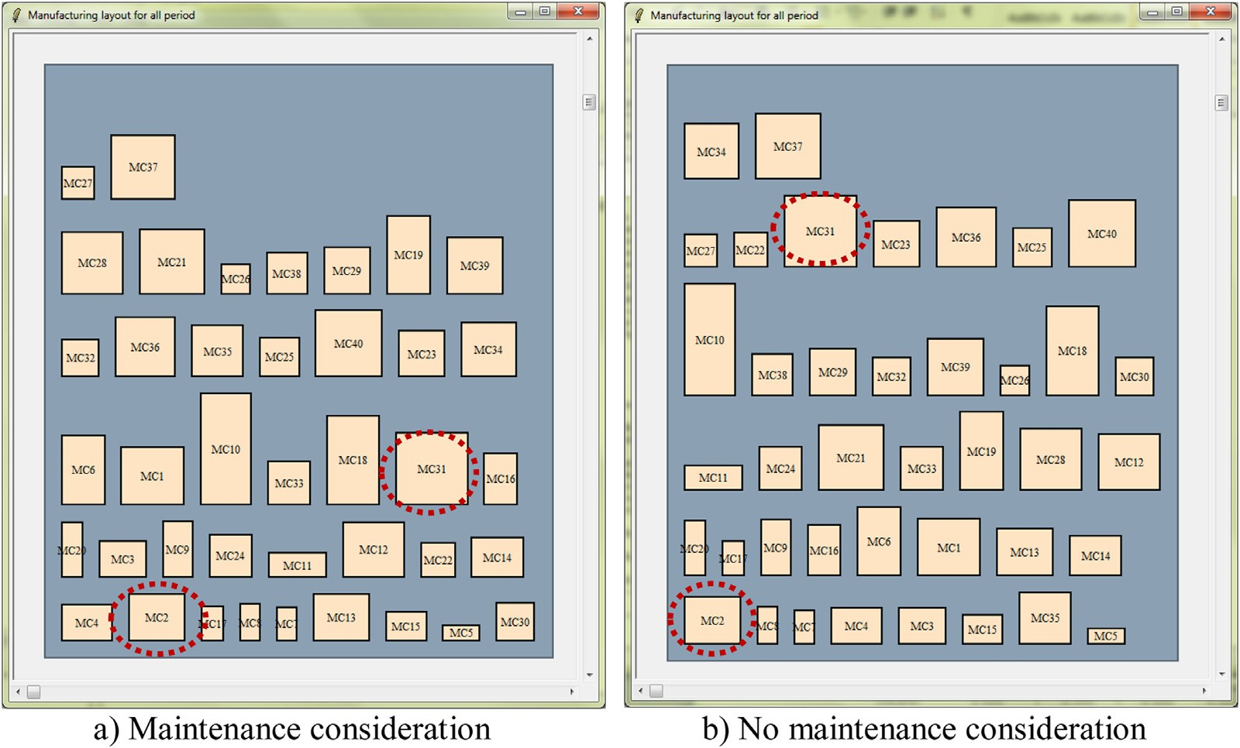

**Fig. 9.** Graphical layout for robust design for 40M20N dataset in 10%CM for scenario II.

**Table 8**

*P* values of ANOVA for scenario I, II, and III.

|  |  |  |  |  |  |
| --- | --- | --- | --- | --- | --- |
| Dataset | scenario I | scenario II | scenario III |  |  |
|  | PPM/QPM | %CM | PPM/QPM %CM | PPM/QPM ∗ %CM |
| 10M5N | 0.000 | 0.000 | 0.000 0.000 | 0.000 |  |
| 10M10N | 0.016 | 0.000 | 0.000 0.000 | 0.339 |  |
| 20M10N | 0.000 | 0.000 | 0.000 0.000 | 0.000 |  |
| 20M20N | 0.000 | 0.000 | 0.000 0.000 | 0.000 |  |
| 20M40N | 0.000 | 0.000 | 0.000 0.000 | 0.000 |  |
| 30M15N | 0.000 | 0.000 | 0.000 0.000 | 0.000 |  |
| 30M30N | 0.000 | 0.000 | 0.000 0.818 | 0.000 |  |
| 40M20N | 0.808 | 0.000 | 0.717 0.000 | 0.000 |  |
| 40M40N | 0.176 | 0.000 | 0.000 0.001 | 0.000 |  |
| 50M25N | 0.000 | 0.000 | 0.000 0.079 | 0.000 |  |
| 50M40M | 0.000 | 0.000 | 0.225 0.909 | 0.803 |  |

The results suggest that the number of machines with each type of PM had an effect on the flow distance. For scenario II, %CM significantly affected the material flow distance. An increase in the number of CM machines caused more changes in machine se- quences, so *MFD* increased. However, the machine sequences de- pended upon the alternative machines defined. For scenario III, the PPM/QPM ratios, %CM, and their interaction were significant fac- tors with a 95% confidence interval for almost all datasets. The influence of the number of machines receiving maintenance ma- chines on material flow distance confirms that maintenance sce- nario should be recognised in the layout design.

# Discussions and conclusions

This paper has presented the development of an approach that integrates maintenance planning with the design of non-identical machine layouts subject to dynamic demand, which addresses a gap in the literature. The GA aims to minimise the total material flow distance. The computational experiments were carried out us- ing eleven datasets with different demand distributions. The analy- sis considered three maintenance scenarios with PPM/QPM (ratios of 20/80, 50/50 and 80/20). Three levels of corrective maintenance were considered 10%, 20% and 30%. A combination of PMM/QPM

with ratios of (20/80 and 80/20) and two values of %CM (10% and 30%) were studied. The material flow distances can decrease or in- crease when some machines were maintained during each period. This was caused by changes in the routings due to the use of al- ternative machines.

Designing robust machine layouts considering machine mainte- nance leads to reduced material flow distances up to 30.91%, 9.8%, and 20.7% for PM, CM, and PM and CM scenarios, respectively. The distances obtained from designing the layout without and with maintenance consideration had statistically significant differences in the means. The PPM/QPM ratios, %CM, and a combination of PPM/QPM and %CM had significantly resulted in the material flow distance in almost all datasets.

It can be beneficial for companies to consider both demand and machine uncertainty when designing layouts, providing that the future demand and availability of machines are properly forecasted and planned. Further research could consider the option of allow- ing machines to be rotated by the algorithm.

# Declaration of competing interest

The authors declare that they have no conflict of interests on the work reported in this paper

# CRediT authorship contribution statement

**Srisatja Vitayasak:** Methodology, Writing - original draft, Fund- ing acquisition. **Pupong Pongcharoen:** Methodology, Conceptual- ization, Visualization, Investigation, Supervision, Project adminis- tration, Writing - review & editing, Funding acquisition. **Christian Hicks:** Writing - review & editing.

# Acknowledgements

This work was part of the research project supported by the [Thailand Research Fund](https://doi.org/10.13039/501100004396) under grant numbers MRG6080031 and MRG6280168.

# References

Abedzadeh, M., Mazinani, M., Moradinasab, N., & Roghanian, E. (2013). Parallel vari- able neighborhood search for solving fuzzy multi-objective dynamic facility lay- out problem. *International Journal of Advanced Manufacturing Technology, 65*(1– 4), 197–211. doi:[10.1007/s00170-012-4160-x](https://doi.org/10.1007/s00170-012-4160-x).

Altuntas, S., & Selim, H. (2012). Facility layout using weighted association rule-based data mining algorithms: Evaluation with simulation. *Expert Systems with Appli-* *cations, 39*(1), 3–13. doi:[10.1016/j.eswa.2011.06.045](https://doi.org/10.1016/j.eswa.2011.06.045).

Asl, A. D., & Wong, K. Y. (2017). Solving unequal-area static and dynamic facility lay- out problems using modified particle swarm optimization. *Journal of Intelligent* *Manufacturing, 28*(6), 1317–1336. doi:[10.1007/s10845-015-1053-5](https://doi.org/10.1007/s10845-015-1053-5).

Asl, A. D., Wong, K. Y., & Tiwari, M. K. (2016). Unequal-area stochastic facility lay- out problems: Solutions using improved covariance matrix adaptation evolution strategy, particle swarm optimisation, and genetic algorithm. *International Jour- nal of Production Research, 54*(3), 799–823. doi:[10.1080/00207543.2015.1070217](https://doi.org/10.1080/00207543.2015.1070217).

Ayodeji, S. P., Adeyeri, M. K., & Ogunsua, A. (2017). Development of dynamic layout model for poundo yam flour processing plant. *Cogent Engineering, 4*(1), 1336872. doi:[10.1080/23311916.2017.1336872](https://doi.org/10.1080/23311916.2017.1336872).

Azadeh, A., Moghaddam, M., Nazari, T., & Sheikhalishahi, M. (2016). Optimization of facility layout design with ambiguity by an eﬃcient fuzzy multivariate ap- proach. *The International Journal of Advanced Manufacturing Technology, 84*(1–4), 565–579. doi:[10.1007/s00170-015-7714-x](https://doi.org/10.1007/s00170-015-7714-x).

Azadeh, A., Motevali Haghighi, S., & Asadzadeh, S. M. (2014). A novel algorithm for layout optimization of injection process with random demands and se- quence dependent setup times. *Journal of Manufacturing Systems, 33*(2), 287–

302. doi:[10.1016/j.jmsy.2013.12.008](https://doi.org/10.1016/j.jmsy.2013.12.008).

[Azadivar, F., & Wang, J. (2000). Facility layout optimization using simulation and genetic algorithms. *International Journal of Production Research, 38*(17 SPEC), 4369–4383.](http://refhub.elsevier.com/S2590-1885(19)30015-0/sbref0008)

Azevedo, M. M., Crispim, J. A., & Pinho de Sousa, J. (2017). A dynamic multi- objective approach for the reconfigurable multi-facility layout problem. *Journal of Manufacturing Systems, 42*, 140–152. doi:[10.1016/j.jmsy.2016.12.008](https://doi.org/10.1016/j.jmsy.2016.12.008).

[Azimi, P., Saberi, E. J. E. C., & Studies, E. C.Research. (2013). An eﬃcient hybrid algo- rithm for dynamic facility layout problem using simulation technique and PSO. *Economic Computation and Economic Cybernetics Studies and Research, 47*(4).](http://refhub.elsevier.com/S2590-1885(19)30015-0/sbref0010)

[Azimi, P., & Soofi, P. (2017). An ANN-based optimization model for facility layout problem using simulation technique. *Scientia Iranica, 24*(1), 364–377.](http://refhub.elsevier.com/S2590-1885(19)30015-0/sbref0011)

[Balakrishnan, J. (1992). Solutions for the constrainted dynamic facility layout prob- lem. *European Journal of Operational Research, 57*, 280–286.](http://refhub.elsevier.com/S2590-1885(19)30015-0/sbref0012)

[Balakrishnan, J., & Cheng, C. H. (1998). Dynamic layout algorithms: A state-of-the-art survey. *Omega-International Journal of Management Science,* *26*(4), 507–521.](http://refhub.elsevier.com/S2590-1885(19)30015-0/sbref0013)

Balakrishnan, J., & Cheng, C.-. H. (2009). The dynamic plant layout problem: Incor- porating rolling horizons and forecast uncertainty. *Omega-International Journal of Management Science, 37*(1), 165–177. doi:[10.1016/j.omega.2006.11.005](https://doi.org/10.1016/j.omega.2006.11.005).

Baykasoglu, A., Dereli, T., & Sabuncu, I. (2006). An ant colony algorithm for solv- ing budget constrained and unconstrained dynamic facility layout problems. [*Omega-International Journal of Management Science, 34*(4), 385–396. doi:10.1016/ j.omega.2004.12.001.](https://doi.org/10.1016/j.omega.2004.12.001)

Bozorgi, N., Abedzadeh, M., & Zeinali, M. (2015). Tabu search heuristic for eﬃciency of dynamic facility layout problem. *International Journal of Advanced Manufac- turing Technology, 77*(1–4), 689–703. doi:[10.1007/s00170-014-6460-9](https://doi.org/10.1007/s00170-014-6460-9).

[Buzacott, J. A., & Mandelbaum, M. (1985). *Paper presented at the IE Fall Conference*](http://refhub.elsevier.com/S2590-1885(19)30015-0/sbref0017)

[Chicargo.](http://refhub.elsevier.com/S2590-1885(19)30015-0/sbref0017)

Byrne, M. D., & Chutima, P. (1997). Real-time operational control of an FMS with full routing flexibility. *International Journal of Production Economics, 51*(1–2), 109–

113. doi:[10.1016/s0925-5273(97)00074-1](https://doi.org/10.1016/s0925-5273(97)00074-1).

Chae, J., & Regan, A. C. (2016). Layout design problems with heterogeneous area [constraints. *Computers & Industrial Engineering, 102*, 198–207. doi:10.1016/j.cie. 2016.10.016.](https://doi.org/10.1016/j.cie.2016.10.016)

Chan, W. K., & Malmborg, C. J. (2010). A Monte Carlo simulation based heuristic pro- cedure for solving dynamic line layout problems for facilities using conventional material handling devices. *International Journal of Production Research, 48*(10), 2937–2956. doi:[10.1080/00207540902810536](https://doi.org/10.1080/00207540902810536).

Chang, A. Y. (2007). On the measurement of routing flexibility: A multiple at- tribute approach. *International Journal of Production Economics, 109*(1–2), 122–

136. doi:[10.1016/j.ijpe.2006.11.011](https://doi.org/10.1016/j.ijpe.2006.11.011).

Chang, C. C., Wu, T. H., & Wu, C. W. (2013). An eﬃcient approach to deter- mine cell formation, cell layout and intracellular machine sequence in cellu- lar manufacturing systems. *Computers & Industrial Engineering, 66*(2), 438–450. doi:[10.1016/j.cie.2013.07.009](https://doi.org/10.1016/j.cie.2013.07.009).

Chen, G. Y. H., & Lo, J. C. (2014). Dynamic facility layout with multi- [objectives. *Asia-Pacific Journal of Operational Research, 31*(4), 1450027. doi:10. 1142/S0217595914500274.](https://doi.org/10.1142/S0217595914500274)

Chen, G. Y. (2013). A new data structure of solution representation in hybrid ant colony optimization for large dynamic facility layout problems. *International Journal of Production Economics, 142*(2), 362–371 doi:[10.1016/j.ijpe.2012.12.012](http://dx.doi.org/10.1016/j.ijpe.2012.12.012).

Cheng Ying, Y., Ab-Samat, H., & Kamaruddin, S. (2016). Practical production lay- out design for multi-product and small-lot-size production: A case study. *Jurnal* *Teknologi, 78*(7), 161–175. doi:[10.11113/jt.v78.2893](https://doi.org/10.11113/jt.v78.2893).

[Dapa, K., Loreungthup, P., Vitayasak, S., & Pongcharoen, P. (2013). Bat algorithm, ge- netic algorithm and shuffied frog leaping algorithm for designing machine lay- out. *Lecture Notes in Computer Science, 8271*, 59–68.](http://refhub.elsevier.com/S2590-1885(19)30015-0/sbref0026)

Dong, M., Wu, C., & Hou, F. (2009). Shortest path based simulated annealing algo- rithm for dynamic facility layout problem under dynamic business environment.

[*Expert Systems with Applications, 36*(8), 11221–11232. doi:10.1016/j.eswa.2009.02. 091.](https://doi.org/10.1016/j.eswa.2009.02.091)

Drira, A., Pierreval, H., & Hajri-Gabouj, S. (2007). Facility layout problems: A survey.

*Annual Reviews in Control, 31*(2), 255–267. doi:[10.1016/j.arcontrol.2007.04.001](https://doi.org/10.1016/j.arcontrol.2007.04.001).

[Drira, A., Pierreval, H., & Hajri-Gabouj, S. (2013). Design of a robust layout with information uncertainty increasing over time: A fuzzy evolutionary approach. *Engineering Applications of Artificial Intelligence, 26*(3), 1052–1060.](http://refhub.elsevier.com/S2590-1885(19)30015-0/sbref0029)

[Dunker, T., Radons, G., & Westkamper, E. (2005). Combining evolutionary computa- tion and dynamic programming for solving a dynamic facility layout problem - Discrete optimization. *European Journal of Operational Research, 165*(1), 55–69.](http://refhub.elsevier.com/S2590-1885(19)30015-0/sbref0030)

Emami, S., S., & Nookabadi, A. (2013). Managing a new multi-objective model for the dynamic facility layout problem. *International Journal of Advanced Manufacturing Technology, 68*(9–12), 2215–2228. doi:[10.1007/s00170-013-4820-5](https://doi.org/10.1007/s00170-013-4820-5).

Fazlelahi, F. Z., Pournader, M., Gharakhani, M., & Sadjadi, S. J. (2016). A robust ap- proach to design a single facility layout plan in dynamic manufacturing envi- ronments using a permutation-based genetic algorithm. In *Proceedings of the in- stitution of mechanical engineers, Part B: journal of engineering manufacture: 230* (pp. 2264–2274). doi:[10.1177/0954405415615728](https://doi.org/10.1177/0954405415615728).

Fitouhi, M. C., & Nourelfath, M. (2012). Integrating noncyclical preventive mainte- nance scheduling and production planning for a single machine. *International Journal of Production Economics, 136*(2), 344–351. doi:[10.1016/j.ijpe.2011.12.021](https://doi.org/10.1016/j.ijpe.2011.12.021).

[Garg, A., & Deshmukh, S. G. (2006). Maintenance management: Literature re- view and directions. *Journal of Quality in Maintenance Engineering, 12*(3), 205–238.](http://refhub.elsevier.com/S2590-1885(19)30015-0/sbref0034)

Ghosh, T., Doloi, B., & Dan, P. K. (2016). Applying soft-computing techniques in solv- ing dynamic multi-objective layout problems in cellular manufacturing system. *International Journal of Advanced Manufacturing Technology, 86*(1–4), 237–257. doi:[10.1007/s00170-015-8070-6](https://doi.org/10.1007/s00170-015-8070-6).

[Goldberg, D. E. (1989). *Genetic algorithms in Search, optimisation and machine learn- ing*. Reading, MA: Addison-Wesley.](http://refhub.elsevier.com/S2590-1885(19)30015-0/sbref0036)

Guan, X., Dai, X., Qiu, B., & Li, J. (2012). A revised electromagnetism-like mecha- nism for layout design of reconfigurable manufacturing system. *Computers and Industrial Engineering, 63*(1), 98–108. doi:[10.1016/j.cie.2012.01.016](https://doi.org/10.1016/j.cie.2012.01.016).

Hanafy, M., & ElMaraghy, H. (2015). Developing assembly line layout for delayed product differentiation using phylogenetic networks. *International Journal of Pro- duction Research, 53*(9), 2633–2651. doi:[10.1080/00207543.2014.974839](https://doi.org/10.1080/00207543.2014.974839).

[Hicks, C. (2006). A genetic algorithm tool for optimising cellular or functional lay- outs in the capital goods industry. *International Journal of Production Economics, 104*(2), 598–614.](http://refhub.elsevier.com/S2590-1885(19)30015-0/sbref0039)

Holland, J. H. (1962). Outline for a logical theory of adaptive systems. *Journal of the ACM (JACM), 9*(3), 297–314. doi:[10.1145/321127.321128](https://doi.org/10.1145/321127.321128).

Hosseini, S. S., & Seifbarghy, M. (2016). A novel meta-heuristic algorithm for multi- objective dynamic facility layout problem. *RAIRO - Operations Research, 50*(4–5), 869–890. doi:[10.1051/ro/2016057](https://doi.org/10.1051/ro/2016057).

Hosseini, S., Khaled, A. A., & Vadlamani, S. (2014). Hybrid imperialist competitive algorithm, variable neighborhood search, and simulated annealing for dynamic facility layout problem. *Neural Computing and Applications, 25*(7–8), 1871–1885. doi:[10.1007/s00521-014-1678- x](https://doi.org/10.1007/s00521-014-1678-x).

Hosseini-Nasab, H., & Emami, L. (2013). A hybrid particle swarm optimisation for dynamic facility layout problem. *International Journal of Production Research, 51*(14), 4325–4335. doi:[10.1080/00207543.2013.774486](https://doi.org/10.1080/00207543.2013.774486).

Hosseini-Nasab, H., Fereidouni, S., Fatemi Ghomi, S. M. T., & Fakhrzad, M. B. (2018). Classification of facility layout problems: A review study. *International Jour-* [*nal of Advanced Manufacturing Technology, 94*(1–4), 957–977. doi:10.1007/ s00170-017- 0895- 8.](https://doi.org/10.1007/s00170-017-0895-8)

[Islier, A. A. (1998). A genetic algorithm approach for multiple criteria facility layout design. *International Journal of Production Research, 36*(6), 1549–1569.](http://refhub.elsevier.com/S2590-1885(19)30015-0/sbref0045)

Jithavech, I., & Krishnan, K. K. (2010). A simulation-based approach for risk as- sessment of facility layout designs under stochastic product demands. *Inter-* [*national Journal of Advanced Manufacturing Technology, 49*(1–4), 27–40. doi:10. 1007/s00170-009-2380-5.](https://doi.org/10.1007/s00170-009-2380-5)

Kaveh, M., Dalfard, V. M., & Amiri, S. (2014). A new intelligent algorithm for dy- namic facility layout problem in state of fuzzy constraints. *Neural Computing and Applications, 24*(5), 1179–1190. doi:[10.1007/s00521-013-1339- 5](https://doi.org/10.1007/s00521-013-1339-5).

Khaksar-Haghani, F., Kia, R., Mahdavi, I., & Kazemi, M. (2013). A genetic algorithm for solving a multi-floor layout design model of a cellular manufacturing sys- tem with alternative process routings and flexible configuration. *International* [*Journal of Advanced Manufacturing Technology, 66*(5–8), 845–865. doi:10.1007/ s00170-012-4370-2.](https://doi.org/10.1007/s00170-012-4370-2)

Kheirkhah, A. S., & Bidgoli, M. M. (2016). Dynamic facility layout prob- lem under competitive environment: A new formulation and some meta- [heuristic solution methods. *Production Engineering, 10*(6), 615–632. doi:10.1007/ s11740-016-0703- 6.](https://doi.org/10.1007/s11740-016-0703-6)

Kheirkhah, A., Navidi, H., & Messi Bidgoli, M. (2015). Dynamic facility layout Prob- lem: A new bilevel formulation and some metaheuristic solution methods. *IEEE* [*Transactions on Engineering Management, 62*(3), 396–410. doi:10.1109/TEM.2015. 2437195.](https://doi.org/10.1109/TEM.2015.2437195)

Kia, R., Baboli, A., Javadian, N., Tavakkoli-Moghaddam, R., Kazemi, M., & Khor- rami, J. (2012). Solving a group layout design model of a dynamic cellular manufacturing system with alternative process routings, lot splitting and flexi- ble reconfiguration by simulated annealing. *Computers and Operations Research, 39*(11), 2642–2658. doi:[10.1016/j.cor.2012.01.012](https://doi.org/10.1016/j.cor.2012.01.012).

[Kia,](http://refhub.elsevier.com/S2590-1885(19)30015-0/sbref0052) [R., Javadian, N., Paydar, M. M., & Saidi-Mehrabad, M. (2013). A simulated an- nealing for intra-cell layout design of dynamic cellular manufacturing systems with route selection, purchasing machines and cell reconfiguration. *Asia-Pacific Journal of Operational Research, 30*(4), 1350004.](http://refhub.elsevier.com/S2590-1885(19)30015-0/sbref0052)

Kia, R., Khaksar-Haghani, F., Javadian, N., & Tavakkoli-Moghaddam, R. (2014). Solving a multi-floor layout design model of a dynamic cellular manufacturing system by an eﬃcient genetic algorithm. *Journal of Manufacturing Systems, 33*(1), 218–

232. doi:[10.1016/j.jmsy.2013.12.005](https://doi.org/10.1016/j.jmsy.2013.12.005).

Kia, R., Shirazi, H., Javadian, N., & Tavakkoli-Moghaddam, R. (2015). Designing group layout of unequal-area facilities in a dynamic cellular manufacturing system with variability in number and shape of cells. *International Journal of Produc- tion Research, 53*(11), 3390–3418. doi:[10.1080/00207543.2014.986295](https://doi.org/10.1080/00207543.2014.986295).

Kouvelis, P., Kurawarwala, A. A., & Gutiérrez, G. J. (1992). Algorithms for robust single and multiple period layout planning for manufacturing systems. *Euro-* [*pean Journal of Operational Research, 63*(2), 287–303. doi:10.1016/0377-2217(92)](https://doi.org/10.1016/0377-2217(92)90032-5)

[90032-5.](https://doi.org/10.1016/0377-2217(92)90032-5)

[Kovács, G., & Kot, S. (2017). Facility layout redesign for eﬃciency improvement and cost reduction. *Journal of Applied Mathematics and Computational Mechan- ics, 16*(1), 63–74.](http://refhub.elsevier.com/S2590-1885(19)30015-0/sbref0056)

Krishnan, K. K., Jithavech, I., & Liao, H. T. (2009). Mitigation of risk in facility layout design for single and multi-period problems. *International Journal of Production Research, 47*(21), 5911–5940. doi:[10.1080/00207540802175337](https://doi.org/10.1080/00207540802175337).

Kulturel-Konak, S. (2007). Approaches to uncertainties in facility layout problems: Perspectives at the beginning of the 21(st) century. *Journal of Intelligent Manu- facturing, 18*(2), 273–284. doi:[10.1007/s10845-007-0020- 10](https://doi.org/10.1007/s10845-007-0020-10).

Kulturel-Konak, S., & Konak, A. (2015). A large-scale hybrid simulated annealing al- gorithm for cyclic facility layout problems. *Engineering Optimization, 47*(7), 963– 978. doi:[10.1080/0305215X.2014.933825](https://doi.org/10.1080/0305215X.2014.933825).

Kumar, R., & Singh, S. P. (2017). A similarity score-based two-phase heuristic ap- proach to solve the dynamic cellular facility layout for manufacturing sys- [tems. *Engineering Optimization, 49*(11), 1848–1867. doi:10.1080/0305215X.2016.](https://doi.org/10.1080/0305215X.2016.1274205)

[1274205.](https://doi.org/10.1080/0305215X.2016.1274205)

[Kusiak, A., & Heragu, S. S. (1987). The facility layout problem. *European Journal of Operational Research, 29*(3), 229–251.](http://refhub.elsevier.com/S2590-1885(19)30015-0/sbref0061)

Lenin, N., Siva Kumar, M., Islam, M. N., & Ravindran, D. (2013). Multi-objective op- timization in single-row layout design using a genetic algorithm. *International* [*Journal of Advanced Manufacturing Technology, 67*(5–8), 1777–1790. doi:10.1007/ s00170-012-4608-z.](https://doi.org/10.1007/s00170-012-4608-z)

Li, J., Tan, X., & Li, J. (2018). Research on dynamic facility layout problem of manu- facturing unit considering human factors. *Mathematical Problems in Engineering, 2018*, 1–13. doi:[10.1155/2018/6040561](https://doi.org/10.1155/2018/6040561).

Liu, J., Wang, D., He, K., & Xue, Y. (2017). Combining Wang–Landau sampling algo- rithm and heuristics for solving the unequal-area dynamic facility layout prob- [lem. *European Journal of Operational Research, 262*(3), 1052–1063. doi:10.1016/j. ejor.2017.04.002.](https://doi.org/10.1016/j.ejor.2017.04.002)

Manoochehri, M., & Mohammadjafari, M.J.H. (2017). Developed a mathematical model for solving the two-objective dynamic facility layout problem with bud- get constraints and optimal allocation of buffer size. 7(4), 1640–1654.

Mazinani, M., Abedzadeh, M., & Mohebali, N. (2013). Dynamic facility layout prob- lem based on flexible bay structure and solving by genetic algorithm. *Interna-* [*tional Journal of Advanced Manufacturing Technology, 65*(5–8), 929–943. doi:10. 1007/s00170-012-4229-6.](https://doi.org/10.1007/s00170-012-4229-6)

McKendall, A. R., & Hakobyan, A. (2010). Heuristics for the dynamic facility layout problem with unequal-area departments. *European Journal of Operational Re-* *search, 201*(1), 171–182. doi:[10.1016/j.ejor.2009.02.028](https://doi.org/10.1016/j.ejor.2009.02.028).

McKendall, A. R., Shang, J., & Kuppusamy, S. (2006). Simulated annealing heuristics for the dynamic facility layout problem. *Computers & Operations Research, 33*(8), 2431–2444. doi:[10.1016/j.cor.2005.02.021](https://doi.org/10.1016/j.cor.2005.02.021).

Meller, R. D., & Gau, K.-. Y. (1996). The facility layout problem: Recent and emerging [trends and perspectives. *Journal of Manufacturing Systems, 15*(5), 351–366 doi:10. 1016/0278-6125(96)84198- 7.](http://dx.doi.org/10.1016/0278-6125(96)84198-7)

Mohammadi, M., & Forghani, K. (2014). A novel approach for considering layout problem in cellular manufacturing systems with alternative processing routings and subcontracting approach. *Applied Mathematical Modelling, 38*(14), 3624– 3640. doi:[10.1016/j.apm.2013.11.058](https://doi.org/10.1016/j.apm.2013.11.058).

[Moslemipour, G., & Lee, T. S. (2012). Intelligent design of a dynamic machine layout in uncertain environment of flexible manufacturing systems. *Journal of Intelli- gent Manufacturing, 23*(5), 1849–1860.](http://refhub.elsevier.com/S2590-1885(19)30015-0/sbref0070)

Moslemipour, G., Lee, T. S., & Loong, Y. T. (2017). Performance analysis of intelligent robust facility layout design. *Chinese Journal of Mechanical Engineering (English Edition), 30*(2), 407–418. doi:[10.1007/s10033-017-0073- 9](https://doi.org/10.1007/s10033-017-0073-9).

[Murata, T., & Ishibuchi, H. (1994). Performance evaluation of genetic algorithms for flow shop scheduling problems. *Paper presented at the proceedings of the first IEEE international conference on evolutionary computation, 27-29th June*.](http://refhub.elsevier.com/S2590-1885(19)30015-0/sbref0072)

Nageshwaraniyer, S. S., Khilwani, N., Tiwari, M. K., Shankar, R., & Ben- Arieh, D. (2013). Solving the design of distributed layout problem using fore- cast windows: A hybrid algorithm approach. *Robotics and Computer-Integrated* *Manufacturing, 29*(1), 128–138. doi:[10.1016/j.rcim.2012.06.007](https://doi.org/10.1016/j.rcim.2012.06.007).

Neghabi, H., Eshghi, K., & Salmani, M. H. (2014). A new model for robust facility layout problem. *Information Sciences, 278*, 498–509 doi:[10.1016/j.ins.2014.03.067](http://dx.doi.org/10.1016/j.ins.2014.03.067). Nematian, J. (2014). A robust single row facility layout problem with fuzzy random variables. *International Journal of Advanced Manufacturing Technology, 72*(1–4),

255–267. doi:[10.1007/s00170-013-5564-y](https://doi.org/10.1007/s00170-013-5564-y).

[Nodem, F. I. D., Kenne, J. P., & Gharbi, A. (2011). Simultaneous control of production, repair/replacement and preventive maintenance of deteriorating manufacturing systems. *International Journal of Production Economics, 134*(1), 271–282.](http://refhub.elsevier.com/S2590-1885(19)30015-0/sbref0076)

Nouiri, M., Bekrar, A., Jemai, A., Trentesaux, D., Ammari, A. C., & Niar, S. (2017). Two stage particle swarm optimization to solve the flexible job shop predic- tive scheduling problem considering possible machine breakdowns. *Computers & Industrial Engineering, 112*, 595–606 doi:[10.1016/j.cie.2017.03.006](http://dx.doi.org/10.1016/j.cie.2017.03.006).

[Ousterhout, J. K.](http://refhub.elsevier.com/S2590-1885(19)30015-0/sbref0078) [(2010). *Tcl and tk tookit* (2nd ed). Addison Wesley](http://refhub.elsevier.com/S2590-1885(19)30015-0/sbref0078).

Pillai, V. M., Hunagunda, I. B., & Krishnan, K. K. (2011). Design of robust layout for dynamic plant layout problems. *Computers & Industrial Engineering, 61*(3), 813– 823. doi:[10.1016/j.cie.2011.05.014](https://doi.org/10.1016/j.cie.2011.05.014).

[Pongcharoen, P., Chainate, W., & Samranpun, C. (2007). Exploration of genetic pa- rameters and operators through travelling salesman problem. *ScienceAsia, 33*(2), 215–222.](http://refhub.elsevier.com/S2590-1885(19)30015-0/sbref0080)

Pourvaziri, H., & Naderi, B. (2014). A hybrid multi-population genetic algorithm for the dynamic facility layout problem. *Applied Soft Computing Journal, 24*, 457–

469. doi:[10.1016/j.asoc.2014.06.051](https://doi.org/10.1016/j.asoc.2014.06.051).

Pourvaziri, H., & Pierreval, H. (2017). Dynamic facility layout problem based on open queuing network theory. *European Journal of Operational Research, 259*(2), 538– 553 doi:[10.1016/j.ejor.2016.11.011](http://dx.doi.org/10.1016/j.ejor.2016.11.011).

Rabbani, M., Farrokhi-Asl, H., Rafiei, H., & Khaleghi, R. (2017). Using metaheuris- tic algorithms to solve a dynamic cell formation problem with considera- tion of intra-cell layout design. *Intelligent Decision Technologies, 11*(1), 109–126. doi:[10.3233/IDT-160281](https://doi.org/10.3233/IDT-160281).

Rezazadeh, H., Ghazanfari, M., Saidi-Mehrabad, M., & Sadjadi, S. J. (2009). An ex- tended discrete particle swarm optimization algorithm for the dynamic facility [layout problem. *Journal of Zhejiang University-Science A, 10*(4), 521. doi:10.1631/ jzus.A0820284.](https://doi.org/10.1631/jzus.A0820284)

[Rosenblatt, M. J. (1986). Dynamics of plant layout. *Management Science, 32*(1), 76–86.](http://refhub.elsevier.com/S2590-1885(19)30015-0/sbref0085)

Safari, E., & Sadjadi, S. J. (2011). A hybrid method for flowshops scheduling with condition-based maintenance constraint and machines breakdown. *Expert Sys- tems with Applications, 38*(3), 2020–2029. doi:[10.1016/j.eswa.2010.07.138](https://doi.org/10.1016/j.eswa.2010.07.138).

Sahin, R., & Turkbey, O. (2009). A new hybrid tabu-simulated annealing heuristic for the dynamic facility layout problem. *International Journal of Production Research, 47*(24), 6857. doi:[10.1080/00207540802376323](https://doi.org/10.1080/00207540802376323).

Salmani, M. H., Eshghi, K., & Neghabi, H. (2015). A bi-objective MIP model for facil- ity layout problem in uncertain environment. *International Journal of Advanced Manufacturing Technology, 81*, 1563–1575. doi:[10.1007/s00170-015-7290-0](https://doi.org/10.1007/s00170-015-7290-0).

Samarghandi, H., Taabayan, P., & Behroozi, M. (2013). Metaheuristics for fuzzy dy- namic facility layout problem with unequal area constraints and closeness rat- ings. *International Journal of Advanced Manufacturing Technology, 67*(9–12), 2701– 2715. doi:[10.1007/s00170-012-4685-z](https://doi.org/10.1007/s00170-012-4685-z).

Sbihi, M., & Varnier, C. (2008). Single-machine scheduling with periodic and flexible periodic maintenance to minimize maximum tardiness. *Computers & Industrial Engineering, 55*(4), 830–840. doi:[10.1016/j.cie.2008.03.005](https://doi.org/10.1016/j.cie.2008.03.005).

Schemeleva, K., Delorme, X., Dolgui, A., & Grimaud, F. (2012). Multi-product se- quencing and lot-sizing under uncertainties: A memetic algorithm. *Engineer-* [*ing Applications of Artificial Intelligence, 25*(8), 1598–1610 doi:10.1016/j.engappai. 2012.06.012.](http://dx.doi.org/10.1016/j.engappai.2012.06.012)

Sethi, A., & Sethi, S. (1990). Flexibility in manufacturing: A survey. *International Jour- nal of Flexible Manufacturing Systems, 2*(4), 289–328. doi:[10.1007/BF00186471](https://doi.org/10.1007/BF00186471).

Shafigh, F., Defersha, F. M., & Moussa, S. E. (2017). A linear programming embed- ded simulated annealing in the design of distributed layout with production planning and systems reconfiguration. *International Journal of Advanced Manu- facturing Technology, 88*(1–4), 1119–1140. doi:[10.1007/s00170-016-8813-z](https://doi.org/10.1007/s00170-016-8813-z).

[Singh,](http://refhub.elsevier.com/S2590-1885(19)30015-0/sbref0094) [S. P., & Sharma, R. R. K. (2006). A review of different approaches to facility layout problems. *International Journal of Advanced Manufacturing Technology, 30*, 425–433.](http://refhub.elsevier.com/S2590-1885(19)30015-0/sbref0094)

Sooncharoen, S., Vitayasak, S., & Pongcharoen, P. (2015). Application of biogeography-based optimisation for machine layout design problem. *In- ternational Journal of Mechanical Engineering and Robotics Research, 4*(3), 251–254 doi:[10.18178/ijmerr.4.3.251-254](http://dx.doi.org/10.18178/ijmerr.4.3.251-254).

Tavakkoli-Moghaddam, R., Javadian, N., Javadi, B., & Safaei, N. (2007). Design of a facility layout problem in cellular manufacturing systems with stochastic de- [mands. *Applied Mathematics and Computation, 184*(2), 721–728 doi:10.1016/j. amc.2006.05.172.](http://dx.doi.org/10.1016/j.amc.2006.05.172)

Tayal, A., Gunasekaran, A., Singh, S. P., Dubey, R., & Papadopoulos, T. (2017). For- mulating and solving sustainable stochastic dynamic facility layout problem: A key to sustainable operations. *Annals of Operations Research, 253*(1), 621–655 doi:[10.1007/s10479-016-2351- 9](http://dx.doi.org/10.1007/s10479-016-2351-9).

Tayal, A., & Singh, S. P. (2017). Designing flexible stochastic dynamic Layout: An in- tegrated firefly and chaotic simulated annealing-based approach. *Global Journal of Flexible Systems Management, 18*(2), 89–98 doi:[10.1007/s40171-016-0140-6](http://dx.doi.org/10.1007/s40171-016-0140-6).

[Tompkins, J. A., White, J. A., Bozer, Y. A., & Tanchoco, J. M. A. (2010). *Facilities plan- ning* (4th ed). John Wiley & Sons.](http://refhub.elsevier.com/S2590-1885(19)30015-0/sbref0099)

Turanog˘lu, B., & Akkaya, G. (2018). A new hybrid heuristic algorithm based on bac- terial foraging optimization for the dynamic facility layout problem. *Expert Sys- tems with Applications, 98*, 93–104 doi:[10.1016/j.eswa.2018.01.011](http://dx.doi.org/10.1016/j.eswa.2018.01.011).

Ulutas, B. H., & Islier, A. A. (2009). A clonal selection algorithm for dynamic facility [layout problems. *Journal of Manufacturing Systems, 28*(4), 123–131 doi:10.1016/j. jmsy.2010.06.002.](http://dx.doi.org/10.1016/j.jmsy.2010.06.002)

Ulutas, B., & Islier, A. A. (2015). Dynamic facility layout problem in footwear indus- try. *Journal of Manufacturing Systems, 36*, 55–61 doi:[10.1016/j.jmsy.2015.03.004](http://dx.doi.org/10.1016/j.jmsy.2015.03.004).

[Vitayasak, S. (2011). *Multiple-row rotatable machine layout using genetic algo- rithm*. Phitsanulok, Thailand: Naresuan University Technical research report (in Thai).](http://refhub.elsevier.com/S2590-1885(19)30015-0/sbref0103)

[Vitayasak, S., & Pongcharoen, P. (2011). Interaction of crossover and mutation oper- ations for designing non-rotatable machine layout. *Paper presented at the pro- ceedings of the operations research network conference*.](http://refhub.elsevier.com/S2590-1885(19)30015-0/sbref0104)

Vitayasak, S., & Pongcharoen, P. (2015). Genetic algorithm based robust layout de- sign by considering various demand variations. *Lecture* N*otes* in Computer Sci- ence*, 9140*, 257–265 doi:[10.1007/978- 3- 319-20466- 6_28](http://dx.doi.org/10.1007/978-3-319-20466-6_28).

Vitayasak, S., & Pongcharoen, P. (2016). Application of genetic algorithm for quan- tifying the affect of breakdown maintenance on machine lyaout. In C. Sombat- theera, F. Stolzenburg, F. Lin, & A. Nayak (Eds.), *Multi-disciplinary trends in arti-* *ficial intelligence*. Springer MIWAI 2016. Lecture Notes in Computer Science, vol 10053 doi:[10.1007/978- 3- 319-49397- 8_18](http://dx.doi.org/10.1007/978-3-319-49397-8_18).

Vitayasak, S., & Pongcharoen, P. (2018). Performance improvement of teaching- learning-based optimisation for robust machine layout design. *Expert Systems with Applications, 98*, 129–152 doi:[10.1016/j.eswa.2018.01.005](http://dx.doi.org/10.1016/j.eswa.2018.01.005).

Vitayasak, S., Pongcharoen, P., & Hicks, C. (2017). A tool for solving stochastic dy- namic facility layout problems with stochastic demand using either a genetic al- gorithm or modified backtracking search algorithm. *International Journal of Pro-* *duction Economics, 190*, 146–157 doi:[10.1016/j.ijpe.2016.03.019](http://dx.doi.org/10.1016/j.ijpe.2016.03.019).

[Waeyenbergh, G., & Pintelon, L. (2009). CIBOCOF: A framework for industrial main- tenance concept development. *International Journal of Production Economics,* *121*(2), 633–640.](http://refhub.elsevier.com/S2590-1885(19)30015-0/sbref0109)

Wang, G., Shin, Y. W., & Moon, D. H. (2016). Comparison of three flow line layouts with unreliable machines and profit maximization. *Flexible Services and Manu- facturing Journal, 28*(4), 669–693 doi:[10.1007/s10696-015-9233-3](http://dx.doi.org/10.1007/s10696-015-9233-3).

[Wang, H. (2002). A survey of maintenance policies of deteriorating systems. *Euro- pean Journal of Operational Research, 139*, 469–489.](http://refhub.elsevier.com/S2590-1885(19)30015-0/sbref0111)

Wang, P. S., Yang, T., & Chang, M. C. (2017). Effective layout designs for the Shojinka control problem for a TFT-LCD module assembly line. *Journal of Manufacturing Systems, 44*, 255–269 doi:[10.1016/j.jmsy.2017.07.004](http://dx.doi.org/10.1016/j.jmsy.2017.07.004).

Xiao, Y., Xie, Y., Kulturel-Konak, S., & Konak, A. (2017). A problem evolution al- gorithm with linear programming for the dynamic facility layout problem— A general layout formulation. *Computers and Operations Research, 88*, 187–207 doi:[10.1016/j.cor.2017.06.025](http://dx.doi.org/10.1016/j.cor.2017.06.025).

Xiong, J., Xing, L., & Chen, Y. (2013). Robust scheduling for multi-objective flexible job-shop problems with random machine breakdowns. *International Journal of Production Economics, 141*(1), 112–126 doi:[10.1016/j.ijpe.2012.04.015](http://dx.doi.org/10.1016/j.ijpe.2012.04.015).

[Yang, T., & Brett, A. P. (1998). Flexible machine layout design for dynamic and uncer- tain production environments. *European Journal of Operational Research, 108*(1), 49–64.](http://refhub.elsevier.com/S2590-1885(19)30015-0/sbref0115)

Yin, X. F., & Khoo, L. P. (2011). An exact schema theorem for adaptive genetic algo- rithm and its application to machine cell formation. *Expert Systems with Appli- cations, 38*(7), 8538–8552 doi:[10.1016/j.eswa.2011.01.055](http://dx.doi.org/10.1016/j.eswa.2011.01.055).

Zhao, Y., & Wallace, S. W. (2014). Integrated facility layout design and flow assign- ment problem under uncertainty. *Informs Journal on Computing, 26*(4), 798–808. doi:[10.1287/ijoc.2014.0599](https://doi.org/10.1287/ijoc.2014.0599).

Zhao, Y., & Wallace, S. W. (2016). Appraising redundancy in facility layout. *Interna-* [*tional Journal of Production Research, 54*(3), 665–679 doi:10.1080/00207543.2015. 1030041.](http://dx.doi.org/10.1080/00207543.2015.1030041)