[Egyptian Informatics Journal 19 (2018) 1–9](http://dx.doi.org/10.1016/j.eij.2017.04.001)

Contents lists available at [ScienceDirect](http://www.sciencedirect.com/science/journal/11108665)

Egyptian Informatics Journal

journal homepage: [www.sciencedirect.com](http://www.sciencedirect.com/)

Full length article

Selective epidemic broadcast algorithm to suppress broadcast storm in vehicular ad hoc networks



M. Chitra ⇑, S. Siva Sathya

*Department of Computer Science, School of Engineering & Technology, Pondicherry University, Puducherry 605014, India*

# a r t i c l e i n f o

*Article history:*

Received 13 October 2016

Revised 8 December 2016

Accepted 21 April 2017

Available online 18 May 2017

*Keywords:*

VANET

Broadcast storm ratio Redundant rebroadcast ratio Epidemic broadcast Dissemination delay

# a b s t r a c t

Broadcasting in Vehicular Ad Hoc Networks is the best way to spread emergency messages all over the network. With the dynamic nature of vehicular ad hoc networks, simple broadcast or flooding faces the problem called as Broadcast Storm Problem (BSP). The issue of the BSP will degrade the performance of a message broadcasting process like increased overhead, collision and dissemination delay. The paper is motivated to solve the problems in the existing Broadcast Strom Suppression Algorithms (BSSAs) like p-Persistence, TLO, VSPB, G-SAB and SIR. This paper proposes to suppress the Broadcast Storm Problem and to improve the Emergency Safety message dissemination rate through a new BSSA based on Selective Epidemic Broadcast Algorithm (SEB). The simulation results clearly show that the SEB outperforms the existing algorithms in terms of ESM Delivery Ratio, Message Overhead, Collision Ratio, Broadcast Storm Ratio and Redundant Rebroadcast Ratio with decreased Dissemination Delay.

© 2018 Production and hosting by Elsevier B.V. on behalf of Faculty of Computers and Information, Cairo

University. This is an open access article under the CC BY-NC-ND license ([http://creativecommons.org/](http://creativecommons.org/licenses/by-nc-nd/4.0/)

[licenses/by-nc-nd/4.0/](http://creativecommons.org/licenses/by-nc-nd/4.0/)).

1. Introduction

The new kind of intelligent wireless technology adopted among vehicles is known as Vehicular Ad Hoc Networks. The vehicles in this network share their resources either through Vehicle-to- Vehicle (V2V) or Vehicle-to-Infrastructure (V2I) communication. Through this communication the vehicles can transmit and receive the safety and non-safety information that are needed to avoid road accidents or to intimate the drivers about the dangerous sit- uation in the emerging area. In modern Intelligent Transportation System vehicles can automatically detect the emergent situation through On Board Unit (OBU) which is installed inside the vehicle and Road Side Unit (RSU) placed at the roadside [1]. Due to highly moving speed of the vehicles the communication links between the vehicles change frequently and when the vehicles are moving in the high speed the message lost ratio is also increased and com-

* Corresponding author.

*E-mail addresses:* [chitra.jrf@gmail.com](mailto:chitra.jrf@gmail.com) (M. Chitra), [ssivasathya@gmail.com](mailto:%20%20ssivasathya@gmail.com) (S. Siva Sathya).

Peer review under responsibility of Faculty of Computers and Information, Cairo University.

**Production and hosting by Elsevier**

munication link is disconnected which can be improved by increasing the transmission power of the source vehicle [2]. The emergency message dissemination can be affected by the vehicles moving at high speed, this problem is discussed in several papers and hence a new method need to be proposed to solve this issue [3].

The excitement about vehicular network is mostly due to their wide range of applications and open challenges that arise in our daily life while driving in bidirectional and multidirectional high- ways and other urban areas. Basically, in safety message broadcast- ing several important technical challenges need to be faced like high message delivery ratio, high mobility and high speed of the vehicles, or real-time requirements. Hence, the researchers are motivated to increase their interest in this area to provide a better communication model for the society to improve the public safety while driving [4].

The VANET safety applications are of two types based on the requirements, namely aperiodic and periodic [5]. Aperiodic mes- sages are sent to the vehicles which are in the emergency mode like a road accident, road construction, etc. Periodic messages are used to update the neighbor information or other information related to non-safety applications. These messages are synchro- nized by the IEEE 802.11p WAVE and ETSI standard by using an intermediate layer called message sub layer and facility layer [6,7]. There are two types of messages in facility layer called as Cooperative Awareness Message (CAM) and Decentralized

<http://dx.doi.org/10.1016/j.eij.2017.04.001>

1110-8665/© 2018 Production and hosting by Elsevier B.V. on behalf of Faculty of Computers and Information, Cairo University. This is an open access article under the CC BY-NC-ND license (<http://creativecommons.org/licenses/by-nc-nd/4.0/>).

Environmental Notification Message (DENM) [8]. CAM is used for single hop communication where as DENM is used for multi hop communication.

In Vehicular Safety Application, the DENM messages have the highest priority within the short period of time, 100 ms and CAM messages have the lowest priority within the time interval of 100–1000 ms. In this approach, there is no guarantee for retrans- mission of the message after transmitting the DENM message by the RHS. Due to this factor the facility layer faces the problem called as Broadcast Storm Problem. The efficient channel utiliza- tion is also an important factor in VANET. To facilitate the use of DSRC Control Channel (CCH) and Service Channel (SCH), the use of multiple channels for efficient data dissemination was discussed in [9].

The effect of Broadcast Storm Problem is discussed in several papers. But not all the proposed solutions provide better results to solve this problem. The Broadcast Storm Problem causes increased message overhead, broadcast collision, dissemination delay, etc. For emergency safety purpose the message should be passed without any interrupt within the short period of time. Emergency safety message dissemination is a time critical event, so it is important to investigate the time parameter while dissem- inating the emergency message.

Since most of the proposed algorithms were analyzed for single directional message dissemination schemes, this paper is moti- vated to propose a new Broadcast Storm Suppression Algorithm (BSSA) in bi/multidirectional highway network scenario. The main objective of this paper is to propose a new BSSA that dynamically adapts the vehicle’s position through the adaptive localization technique to broadcast the Emergency Safety Message based on the methodology named as a Selective Epidemic Broadcast (SEB) Algorithm. The SEB algorithm reduces the Broadcast Storm Prob- lem with selecting the vehicles which have sent the passive acknowledgment only. The passive acknowledgment (PACK) [10–](#_bookmark31) [12] indicates the vehicle which wants to communicate with the source vehicle that initiated the connection.

The rest of the paper is organized as follows: Section 2 of this paper gives a detail about the Broadcast Storm Suppression Algo- rithms (BSSAs) used in the existing research work. The proposed ‘‘Selective Epidemic Broadcast Algorithm” is explained in Section 3. The simulation results and analysis of the algorithms are shown in Section 4. Finally, Section 5 concludes the paper with further enhancements.

1. Related work

In the literature review several Broadcast Storm Suppression Algorithms (BSSAs) are proposed based on the different require- ments and scenarios. In vehicular networks broadcasting forms the basic method to disseminate the Emergency Safety Message. Basically Simple broadcasting, Probabilistic Broadcasting, Timer

Based Broadcasting, Neighbor Knowledge based Broadcasting and Distance based broadcasting are the techniques referred in the lit- erature. The details about these techniques are discussed in [13] and which also shows the shortcomings of these techniques based on some of the QoS metrics used for the qualitative analysis of the proposed SEB algorithm.

Table 1 shows the comparison of different Broadcast Storm Sup- pression Algorithms based on the metrics considered in this paper. Hence, this paper considers each technique for the qualitative anal- ysis to show the importance of the proposed Broadcast Storm Sup- pression Algorithm ‘‘SEB”.

DOT is one of the delay based BSSA used to control the high vehicle density by dividing the vehicles into different slots [14]. This algorithm uses large size beacon message and the vehicle density in each slot is not mentioned clearly. DRIVE [15] uses the sweet spot to disseminate the message, but still suffers from increased message overhead and dissemination delay when no vehicles exist in the sweet spot. ADM [16] dynamically adapts the broadcasting based on the priority level of the message sent. This algorithm reduces the latency and does not improve the redundancy rate.

p-Persistence is the probabilistic technique, it suffers from BSP when the vehicles have equal probability ‘p’ to rebroadcast the message, because in this algorithm the vehicle which has the high- est probability has a chance to rebroadcast the Emergency Safety Message. When the vehicles are in the same distance, all vehicles will have the same rebroadcast probability. In this situation increased BSP is a challenging issue [17,18].

The Last One (TLO) [19] is the famous distance based algorithm referred in most of the papers in the literature. This algorithm uses the distance to choose the next rebroadcasting vehicle. The vehicle which is in the most distant rebroadcast the message. But there is no guarantee for message reliability in TLO and is suitable only for highways and vehicle positioning is also not mentioned clearly [20,21].

Virtual Slotted p-Persistence Broadcasting (VSPB) [22] is the Timer based broadcasting technique which forms the virtual slot based on the position information and moving direction of the neighboring vehicles. VSPB is better than the slotted p- persistence to avoid empty slots due to low density and also vehi- cle collisions at high density scenarios. So VSPB controls the slot size by assigning a fixed number of vehicles per slot. The vehicles in the farthest slot are assigned the shortest waiting time to rebroadcast. But when the vehicle density increases the collision ratio, broadcast overhead and dissemination delay also increase simultaneously.

Grid based Speed Adaptive Broadcast (G-SAB) [23] is a latest probabilistic broadcasting technique based on the speed parame- ter. The vehicle density is identified by using the vehicles moving speed. In low density networks the vehicles moving speed are high, but in the high density networks the vehicles moving speed are low. Similar to VSPB, this algorithm also suffered from the simulta-

Table 1

Comparison of broadcast storm suppression algorithms.

|  |  |  |  |  |  |  |
| --- | --- | --- | --- | --- | --- | --- |
| Broadcast storm suppression algorithms (BSSAs) | Suppression technique used | Reliability (PDR) | Scalability (Broadcast Overhead) | Robustness (Packet Loss Rate) | Dissemination delay | Broadcast storm ratio |
| p-Persistence | Probabilistic | High | High | High | High | High |
| Slotted 1-persistence | Delay | High | Moderate | High | Low | Moderate |
| Slotted p-persistence | Probabilistic | Dependent | Dependent | High | Moderate | High |
| DOT | Delay | High | High | High | Low | High |
| DRIVE | Delay | High | High | High | Moderate | High |
| ADM | Probabilistic | High | High | High | Moderate | High |
| TLO | Distance | High | Moderate | Moderate | High | Moderate |
| VSPB | Delay | High | Dependent | Dependent | Moderate | High |
| G-SAB | Delay | High | Dependent | Dependent | Moderate | High |

neous transmission of the message by the nearest vehicles in the same slot. It assigns a different number of time slots based on the traffic condition of each vehicle. Hence, the vehicles in the high density slot have the chance to simultaneously transmit the mes- sage. G-SAB also assigns different waiting time while considering different lane. This algorithm is suitable for single directional mes- sage dissemination only and not for bidirectional and other com- plex network scenarios.

1. Proposed selective epidemic broadcast algorithm (SEB)

This section describes the proposed Selective Epidemic Broad- cast Algorithm. Broadcasting is the simplest form to send an Emer- gency Safety Message within the vehicular ad hoc network. The proposed SEB algorithm follows our Epidemic Spreading Model named as Susceptible Infected and Removed (SIR) algorithm that was discussed in [24] to spread the Emergency Safety Message (ESM) in a directed manner. Compared to SIR algorithm this paper is motivated to further suppress the broadcast storm by spreading the message only to selective vehicles which later rebroadcast the messages, resulting in lesser messages being sent. The vehicles are selected based on the Passive Acknowledgment (P_ACK) from the neighbors, which are reply messages from the neighbor list named as Emergency Broadcast Neighbors (EBN) located within the trans- mission range of the source vehicle. In SIR algorithm the Emer- gency Safety Message is sent to all the vehicles considering the bidirectional and multidirectional dissemination. The SIR algorithm reduces the scalability issues in simple scenarios and improves message reliability compared to the existing algorithms, but still suffers from transmission overhead in complex scenarios. Hence, in SEB scalability is further improved compared to SIR and the availability of the receivers are also checked to improve the link reliability to find the exact forwarding vehicle to rebroadcast the message to the next transmission range. Hence, BSP and Redundant Rebroadcast Ratio are minimized by selective forward- ing in a dynamic topology through P_ACK.

When a vehicle receives or identifies any emergency event, it finds the neighbors list through the beacon message. The neighbors who reply for the connection are named as Emergency Broadcast Neighbors (EBN) and the message is spread only to the EBN to min- imize the number of rebroadcast thus reducing the Broadcast Storm Problem.

In SIR, the source vehicle finds the Farthest Vehicle (FV) in its range and waits for an ACK from FV for reliable message commu-

nication. Fig. 1 shows the bidirectional traffic scenario based on the SIR algorithm where the vehicle ‘V5’ is farthest within the transmission range of ‘V1’ and ‘V10’ is farthest vehicle within the transmission range of ‘V5’. The farthest vehicles are used as a rebroadcast vehicle to rebroadcast the Emergency Safety Message (ESM). But after finding the FV, the position may change in varying time and speed. So the neighbors’ availability at the specific point of time is not assured in SIR algorithm.

Fig. 2 shows the multi directional message dissemination sce- nario in SEB algorithm. The red vehicle denotes the source vehicle that is ready to transmit the Emergency Safety Message, the yellow shaded vehicles are the vehicles which do not communicate with the source vehicle due to channel congestion, blocked by some shadowing objects or less signal strength; and the green vehicles which send the P-ACK to source vehicle indicates the availability of the EBN. So the messages are spread only to the selected EBNs to further suppress the broadcast storm and also to improve the neighbors availability when the source vehicle initiates a message broadcast.

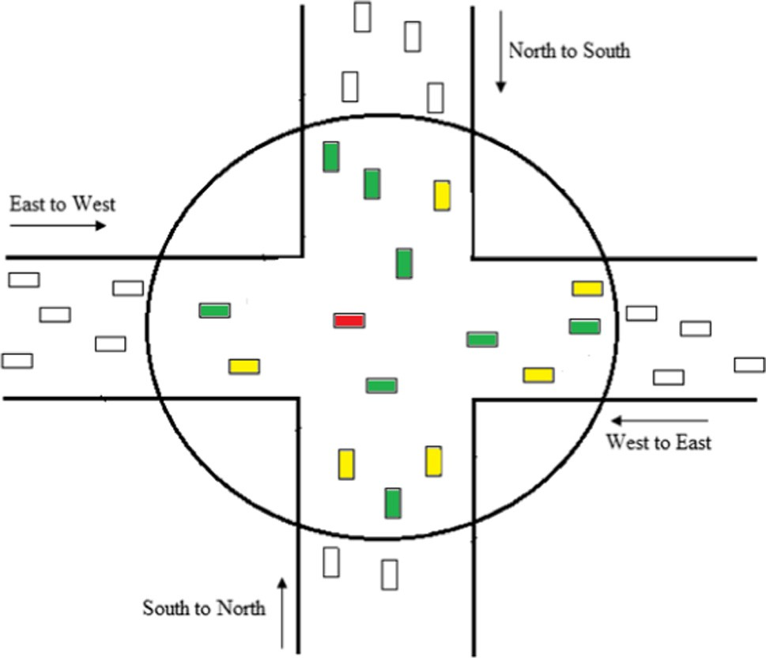

Fig. 2. Multidirectional lane scenario in SEB algorithm.

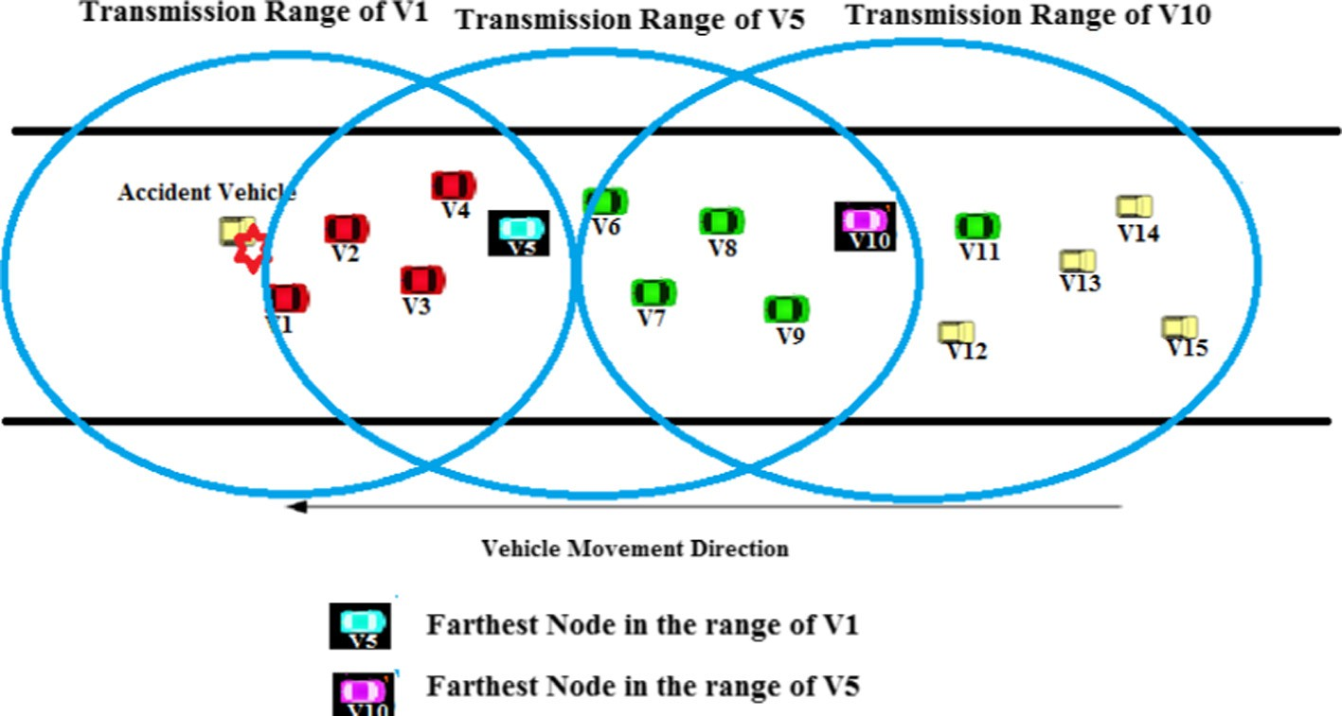

Fig. 1. SIR broadcasting scenario.

Table 2

Selective epidemic broadcast algorithm.

Selective Epidemic Broadcast (SEB) Algorithm

Initialize all the vehicles {V1, V2, .. ., Vn} e V // denotes susceptible state of the vehicles //

Let Vb be the Emergency Vehicle // Vb is the infected vehicle //

*// Condition for position information at the time interval of 1s //*

Initiate BCST from Vb to all V within (TR(Vb)) // Vb sends its position information to the next neighbors in range and expects a same kind of acknowledgement //

If (Vb receives ACK(Vi)) then

{

Compute {d1, d2, .. ., dn} for all V // for all vehicle’s ‘V’ in the range // Distance d(Vi, Vb) = sqrt[((x2 — x1)^2) — ((y2 — y1)^2)] * v(i) // Euclidean distance calculation formula //

*// Condition for in range vehicles //*

If d(Vi, Vb) ≤ TR(Vb) then {

Next_Vehicle ← Vi // Vi is the next vehicle for Vb//

*// Condition for Passive Acknowledgement within 0 ms to 10 ms //*

For all Vi e V, Request for Neighbors Availability // Request for the availability of the neighbors within TR(Vb) // if (Neighbors Availability = TRUE) then //

Check if Vb received P_ACK(i) then

EBN[] ← Vi // Store Emergency Broadcast Neighbors details //

For all Vi e EBN[]

BEGIN

Prepare EM(Vb, Vi, d) // Prepare Emergency Message to broadcast //

*// Condition for Emergency Message Broadcast //*

If {Vi ∈ Max{d(Vi, Vb)} && BT(Vb) > 10 ms && P_ACK(i) == TRUE} // broadcast time is greater than10 ms and if vehicle ‘i’ sends a

passive acknowledgement, where V i e V e TR(Vb) //

BCST EM(Vb, Vi, V) // Broadcast Emergency Message If {(All Vi e V) received an ESM} {

END

}}}}}

where, v(i) = [(sqrt((Xi + Xi+1)^2) + (Yi + Yi+1)^2))]/(Ti — Ti+1) // velocity of the vehicles at different time // Xi+1 and Yi+1 represent the new position of the vehicle after Ti+1 time

Xi+1 = Xi+vTcosb // angle of deviation at X-axis//

and Yi+1 = Yi+vTsinb // angle of deviation at Y-axis//

* 1. *Problem description*

SEB algorithm follows the Epidemic Spreading Model similar to disease spreading in the human body discussed in [24]. Initially, all the vehicles are in a susceptible state, i.e. the vehicles are ready to

receive the message. Let {v1, v2, v3.. .vn} e V be the set of vehicles

eligible for broadcasting the Emergency Safety Message. The objec- tive of this algorithm is to minimize the number of vehicles that rebroadcast the message, thus reducing the Broadcast Storm Prob-

when the source vehicle starts to broadcast the message. After receiving P_ACK, the source vehicle broadcasts the message to all vehicles in the EBN of broadcast vehicle (Vb). Among the EBN, it finds the farthest vehicle (FV) to forward the message to the next transmission range. The proposed SEB algorithm reduces the BSP in complex scenarios, by checking the neighbors availability before broadcasting. Hence, SEB algorithm is applicable for multiple sce- narios by finding the neighbors availability, to improve the mes- sage dissemination and to reduce BSP.

lem. In SEB algorithm, the vehicle selects its neighbors based on

the following three conditions:

1. The vehicle must have sent a Passive Acknowledgement (Vp)
2. The vehicle must be farthest in the range of the source vehi- cle (FVdis)
3. If Vp = true & FVdis > Vdis(n)

where FVdis ≤ Vb (source vehicles range) and FVdis denotes the distance of the farthest vehicle from the source vehicle. FVdis is

considered to forward the message to the next range. The vehicle which satisfies these criteria is named as ‘‘Infected Vehicles”. The remaining vehicles are named as ‘‘Exposed Vehicles”. Finally the vehicles that have not participated or partially participated in broadcasting are termed as ‘‘Removed Vehicles”. For the successive transmission of the Emergency Safety Message priority is given for the vehicles that are in ‘‘Infected State” observed from the previous transmission. Here the number of Infected Vehicles decreases than the number of vehicles in the range at time ‘t’.

Table 2 shows the pseudocode of Selective Epidemic Broadcast algorithm based on P_ACK. Before sending the Emergency Safety Message, the broadcast vehicle (Vb) waits for a Passive Acknowl- edgement (P_ACK) to improve the availability of the receivers

Notations

Vb – broadcast vehicle

v(i) – velocity of the vehicle

EBN [] – emergency broadcast neighbor list TR – transmission range of source vehicle BT – broadcast time

BCST – broadcast

P_ACK – passive acknowledgement

Tcosb – angle of deviation in X axis at time ‘t’ Tsinb – angle of deviation in Y axis at time ‘t’

1. Simulation and experimental results

This section describes the performance evaluation of the pro- posed Selective Epidemic Broadcast Algorithm. The results of the proposed SEB algorithm are analyzed through simulations using NS-2 Simulator version 2.34. SEB algorithm is compared with well known existing algorithms such as p-Persistence, TLO, VSPB, G-SAB and SIR. The results are obtained under different vehicle density and different vehicle moving speed.

* 1. *Simulation setup*

For evaluation purpose multi directional traffic scenario is con- sidered. The length of the road is assumed to be 1Km long in all the directions. The transmission range of each vehicle considered is 275 m and beacon message sending rate is 1 packet per second. The total message size is 128 bytes, including Emergency Safety Message, P_ACK Message and Beacon Message. The reason is that the smaller message size reaches the destination quickly. Two Ray Ground Propagation model is used in the wireless physical layer, and the Vehicle-to-Vehicle (V2V) propagation type is used as the communication model between the vehicles. The Emergency Message interval is set to 10 ms to 180 ms. For physical and MAC layer implementation, the proposed algorithm follows 802.11p based on the European Telecommunications Standards Institute (ETSI) standard, which is standardized in the year 2009 and largely based on 802.11p. It supports ad hoc communication without infrastructure support.

The results are analyzed for varying vehicle density ranging from 20, 40, 60, 80 and 100 vehicles per kilometer and varying vehicle moving speed ranging from 60 km/h to 120 km/h is consid- ered. The simulation time is 200 s. Table 3 shows the simulation parameters used for analysis purpose.

* 1. *Simulation parameters*

This section describes the performance metrics used for evalu- ation purpose. As mentioned in [13] the following metrics are con- sidered in the proposed algorithm to improve Reliability, Scalability and Dissemination Delay of the proposed SEB algorithm.

* *ESM Delivery Ratio:* The ratio of the number of delivered data packets to the destination of the total number of packets sent.

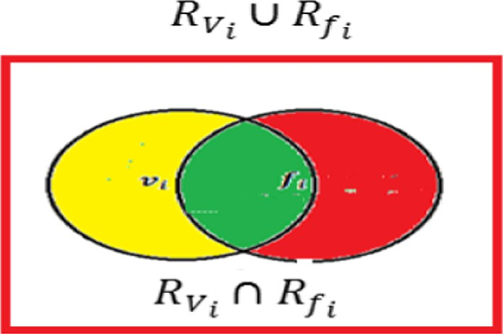

Fig. 3. Representation of broadcast storm.

* + 1. *Proposed metrics*

Two more metrics namely Broadcast Storm Ratio (BSR) and Redundant Rebroadcast Ratio (RRR) are also introduced in this paper to analyze the performance of the proposed SEB algorithm compared to other well known existing algorithms.

* + - * *Broadcast Storm Ratio (BSR):* It is defined as the ratio of the number of messages sent by the vehicles present in the trans-

mission range of both source vehicle and farthest vehicle from the source to the total number of messages sent by the vehicles present in the transmission range of source vehicle or the far- thest vehicle.

Fig. 3 shows the Broadcast Storm Representation where the yel- low shaded area is the source vehicle’s transmission range and the red shaded area is the farthest vehicle transmission range. The area covered by both the vehicles in the intersection causes a Broadcast Storm Problem. Broadcast Storm Ratio (BSR) is given in Eq. (1):

*RV* ∩ *Rf*

This illustrates the level of delivered data to the destination. When the delivery ratio is high the algorithm achieves high *reli-*

BSR = *i i*

*RVi* ∪ *Rfi*

(1)

*ability* of the emergency message dissemination.

* + - * *Dissemination Delay:* The average time taken by a data packet to arrive at the destination. Only the data packets that are suc-

cessfully delivered to destinations are counted. The minimized delay will improve the overall system performance.

* + - * *Broadcast Collision Ratio (BCR):* It is defined as the ratio of the

number of broadcast ESMs lost by collision to the total number

of broadcast ESMs. The minimized collision ratio solves the

*Broadcast Storm Problem*.

* + - * *Broadcast Overhead (BO):* It is defined as the ratio of the num- ber of broadcast ESMs transmitted (originated or forwarded) to

the number of broadcast ESMs received. The reduced broadcast overhead overcomes the *scalability* issue.

Table 3

Simulation parameters.

Parameters Value

Road length 1 KM

Physical propagation model Wireless

Propagation type Two ray ground

Vehicle traffic density 20, 40, 60, 80, 100/km

Vehicle size 2–6 m

Vehicle moving speed 60–120 km/h

Vehicle mobility model Manhattan mobility model

Broadcast packet size 128 bytes/20 Messages

ssBeacon message interval 1 s

Emergency safety message interval 10–240 ms

Antenna type Omni directional antenna

Communication type Vehicle to vehicle (V2V)

Traffic direction Bidirectional/multidirectional

Simulation time 200 s

where *RVi* and *Rf i* are the range of source vehicle and farthest vehicle respectively.

* + - * *Redundant Rebroadcast Ratio (RRR):* It is defined as the num- ber of rebroadcasting vehicles to the total number of vehicles

within the transmission range of a source vehicle. Redundant Rebroadcast Ratio (RRR*)* is given in Eq. (2):

RRR = No. of Rebroadcasting Vehicles (2)

Total No. of Vehicles within the Transmission Range

* 1. *Simulation results and analysis*

This section shows the results obtained from the simulation based on the performance metrics considered in this paper. The algorithms are analyzed for two different traffic scenarios like dif- ferent vehicle density and vehicle moving speed. When the vehicle density increases, the BSP also increases and when the vehicles are moving at high speed, there is no assurance for reliable message communication.

Figs. 4–9 show the results of p-Persistence, TLO, VSPB, G-SAB, SIR and SEB algorithms for varying vehicle density. When the vehi- cle density increases, the vehicles are in close distance. The algo- rithms are analyzed for three different traffic flows such as free flow in 20 vehicles/km, medium density in 40–60 vehicles/km and high density in 80–100/km vehicles density.

Fig. 4 shows the ESM Delivery Ratio of all the algorithms for varying vehicle density. In all the algorithms the delivery ratio is near to 100%. Compared to free flow traffic, in congested traffic the delivery ratio decreases because in congested traffic the mes-

100

95

**ESM Delivery Ratio(%)**

90

85

80

75

70

20 40 60 80 100

**Vehicle Density /KM**

 p-PERSISTENCE  TLO

 VSPB  G-SAB  SIR



 Proposed SEB

45000

40000

**Broadcast Overhead (messages)**

35000

30000

25000

20000

15000

10000

5000

0



20 40 60 80 100

**Vehicle Density (Km/h)**

Fig. 7. Broadcast overhead vs vehicle density.

p-PERSISTENCE TLO

VSPB G-SAB SIR

Proposed SEB

Fig. 4. ESM delivery ratio vs vehicle density.

240

220

200

**Dissemination Delay (ms)**

180

160

140

120

100

80

60

40

20

20 40 60 80 100

**Vehicle Density (Km/h)**

 p-PERSISTENCE  TLO

 VSPB  G-SAB  SIR



 Proposed SEB

90

80



**Broadcast Strom Ratio (%)**

70

60

50

40

30

20

10

0

20 40 60 80 100

**Vehicle Density (Km/h)**

 p-PERSISTENCE  TLO

 VSPB  G-SAB  SIR

 Proposed SEB

Fig. 5. Dissemination delay vs vehicle density. Fig. 8. Broadcast storm ratio vs vehicle density.

60



50

40

**Collision Ratio (%)**

30

20

10

0

20 40 60 80 100

**Vehicle Density (Km/h)**

 p-PERSISTENCE  TLO

 VSPB  G-SAB  SIR

 Proposed SEB

50

45



**Redundant Rebroadcast Ratio (%)**

40

35

30

25

20

15

10

5

0

20 40 60 80 100

**Vehicle Density (Km/h)**

 p-PERSISTENCE TLO

 VSPB

 G-SAB  SIR

 Proposed SEB

Fig. 6. Broadcast collision ratio vs vehicle density.

Fig. 9. Redundant rebroadcast ratio vs vehicle density.

sage gets flooded. As the vehicle density increases, due to the increase in broadcast, message overhead increases which interrupt ESM dissemination. SEB selects fewer vehicles among varying den- sity, and hence the number of interrupts decreases.

Fig. 5 shows the Dissemination Delay of all the algorithms for varying vehicle density. In SEB the dissemination delay is mini- mized compared to other algorithms. This is because in the SEB shorter waiting time is assigned to the source vehicle to broadcast the message. As the vehicle density increases, the number of broadcast increases and communication delay and communication error increases resulting in rebroadcast. Rebroadcast or recursive broadcast increases the transmission time of a message resulting in delay.

Fig. 6 shows the Collision Ratio of all the algorithms for varying vehicle density. In SEB the message loss is minimized compared to other algorithms. The message loss is minimized by checking the availability of the neighbor. When the vehicle density increases, the number of broadcast by each vehicle also increases. The increased vehicle density, interrupts the nearest possible vehicle request out of which a few may be active resulting in an increased collision ratio. The number of communicating vehicles is decided by SEB and hence the number of broadcasts decreases.

Fig. 7 shows the Broadcast Overhead of all the algorithms for varying vehicle density. In SEB broadcast overhead decreases com- pared to other algorithms. The message overhead is minimized by receiving P_ACK from the neighbors. Broadcast overhead increases

100

95

**ESM Delivery Ratio (%)**

90

85

80

75

70

60 70 80 90 100 110 120

**Vehicle Speed (Km/h)**

 p-PERSISTENCE TLO

 VSPB  G-SAB  SIR



 Proposed SEB

80

70



**Broadcast Storm Ratio (%)**

60

50

40

30

20

10

0

60 70 80 90 100 110 120

**Vehicle Speed (Km/h)**

 p-PERSISTENCE  TLO

 VSPB  G-SAB  SIR

 Proposed SEB

Fig. 10. ESM delivery ratio vs vehicle moving speed.

Fig. 14. Broadcast storm ratio vs vehicle moving speed.

110

100

**Dissemination Delay (ms)**

90

80

70

60

50

40

60 70 80 90 100 110 120

**Vehicle Speed (Km/h)**

 p-PERSISTENCE  TLO

 VSPB  G-SAB  SIR



 Proposed SEB

12

10



**Redundant Rebroadcast Ratio (%)**

8

6

4

2

0

60 70 80 90 100 110 120

 p-PERSISTENCE TLO

 VSPB  G-SAB  SIR

 Proposed SEB

Fig. 11. Dissemination delay vs vehicle moving speed.

40



35

30  p-PERSISTENCE

**collision Ratio (%)**

25  TLO

20  VSPB

15  G-SAB

 SIR

10  Proposed SEB

5

60 70 80 90 100 110 120

**Vehicle Speed (Km/h)**

Fig. 12. Broadcast collision ratio vs vehicle moving speed.

**Vehicle Speed (Km/h)**

Fig. 15. Redundant ratio vs vehicle moving speed.

as the number of communication failure increases. Communication failure increases as the vehicle density increases. In SEB despite of the vehicle density, as the vehicles are selective for each broadcast or rebroadcast, the number of required messages decreases.

Fig. 8 shows the Broadcast Storm Ratio of all the algorithms for varying vehicle density. In SEB, BSP decreases compared to other algorithms. As the vehicle density increases, broadcast storm increases due to number of active communication. In SEB, the number of active communication is determined by the source vehi- cle for which a broadcast reply alone serves the purpose of mes- sage dissemination.

Fig. 9 shows that the Redundant Rebroadcast Ratio, RRR decreases compared to other algorithms. When the vehicle density decreases, message dissemination for which a rebroadcast is needed increases. The number of rebroadcast is also vehicle depen- dent as all of the vehicles attempt to initialize communication thus

18000

**Broadcast Overhead (messaages)**

16000

14000

12000

10000

8000

6000

4000

2000

60 70 80 90 100 110 120

**Vehicle Speed (Km/h)**

 p-PERSISTENCE  TLO

 VSPB  G-SAB  SIR



 Proposed SEB

increasing redundancy. In SEB, as the vehicles are selected based on distance and P-ACK only few number of vehicles out of the entire vehicles forward the broadcast.

Figs. 10–15 show the results of p-Persistence, TLO, VSPB, G-SAB, SIR and SEB algorithms for varying vehicle moving speed.

Fig. 10 shows the ESM Delivery Ratio of all the algorithms for varying vehicle moving speed, the ESM delivery ratio changes due to the vehicles different moving speed. When the vehicles are moving in a high speed, they will not relay the message for a particular period of time.

Fig. 11 shows the Dissemination Delay of all the algorithms for varying vehicle Moving Speed. Due to the speed change of vehicles the time taken to reach the destination is also changing. As the vehicles are moving in a high speed there is a need for rebroadcast-

Fig. 13. Broadcast overhead vs vehicle moving speed.

ing of the emergency message hence delay is increased.

45



**Passive Acknowledged Vehicles (PAV)**

40

35

30

25

20

15

10

5

0

10 20 40 60 80 100

**Vehicle Density /Km**

Fig. 16. Passive acknowledged vehicles.

Fig. 12 shows the Broadcast Collision Ratio of all the algorithms for varying vehicle moving speed. In SEB the message loss is min- imized compared to other algorithms.

Fig. 13 shows the Broadcast Overhead of all the algorithms for varying vehicle moving speed. In SEB, the broadcast overhead decreases compared to other algorithms. This is due to the selec- tive emergency broadcast neighbors chosen from the neighbor list. Fig. 14 shows the Broadcast Storm Ratio of all the algorithms for varying vehicle moving speed. As the vehicle speed increases, there is no assurance for message communication. This will increase the

BSP.

Fig. 15 shows the Redundant Rebroadcast Ratio of all the algo- rithms for varying vehicle moving speed. Similar to BSP, more number of vehicles participates to improve message reliability, hence RRR is increased.

* 1. *Impact of passive acknowledgment in SEB*

Finally the SEB algorithm analyzes the results of Passive Acknowledgment with varying vehicle density. Passive Acknowl- edged Vehicle (PAV) is defined as the number of vehicles returning a passive Acknowledgment among the total number of vehicles in the network.

Fig. 16 shows the ratio of the vehicles returning a passive acknowledgment to the total number of vehicles (vehicle den- sity/km) in the network. Only the vehicles returning a passive acknowledgement are considered for rebroadcasting. Thus the number of vehicles considered itself becomes less in the case of SEB. Thereby, in SEB, rebroadcasting is greatly reduced, thus min- imizing the Broadcast Storm.

1. Conclusion

The Selective Epidemic Broadcast (SEB) has been developed for Broadcast Storm Suppression in Vehicular Ad Hoc Networks. The vehicular safety application requires broadcasting of the message to the vehicles in VANET satisfying Reliability, Scalability, Minimal Dissemination Delay, etc. Broadcast Storm Problem (BSP) is a seri- ous issue in Emergency Safety Message dissemination. Hence, it is necessary to investigate the issues that cause BSP and produce a solution. In such cases Broadcast Storm Suppression Algorithms play a vital role. This paper proposes a method to suppress the Broadcast Storm Problem thereby improving the overall perfor- mance of the network. The proposed SEB algorithm performs bet- ter in all cases and is suitable for scenarios like Bi/Multi directional highway scenarios compared to existing algorithms. From the results it is clearly seen that broadcast storm is minimized in P_ACK SEB when compared to the other algorithms. The SEB algo- rithm has been implemented and analyzed only for connected

vehicular networks using V2V communications and not for discon- nected networks. In disconnected networks, the receipt of passive acknowledgment may become a problem in the functioning of SEB. Hence, in future, this algorithm needs to be altered slightly for dis- connected networks with the help of RSUs because when the vehi- cles are not present in the transmission range of source vehicle, the RSUs can help for communication.

Acknowledgments

This work was financially supported by the University Grants Commission (UGC) – India under Senior Research Fellowship (SRF) for the UGC-JRF qualified candidate for the year Sep-2011– Sep-2016, India.

References

1. [Garrido M, Martinez P, Cano FJ, Calafate JC, Manzoni CT, Fogue P. Automatic](http://refhub.elsevier.com/S1110-8665(17)30139-1/h0005) [accident detection: assistance through communication technologies and](http://refhub.elsevier.com/S1110-8665(17)30139-1/h0005) [vehicles. IEEE Veh. Technol. Mag. 2012;7(3):90–100](http://refhub.elsevier.com/S1110-8665(17)30139-1/h0005).
2. [Diyar Khairi MS, Berqia Amine. Survey on QoS and security in vehicular ad hoc](http://refhub.elsevier.com/S1110-8665(17)30139-1/h0010) [networks. Int J Adv Res Comput Sci Softw Eng 2015;5(2):42–52](http://refhub.elsevier.com/S1110-8665(17)30139-1/h0010).
3. [Sharma Virender, Manzoor Aaliya. A survey of routing and mobility models for](http://refhub.elsevier.com/S1110-8665(17)30139-1/h0015) [wireless ad hoc network. SSRG Int J Comput Sci Eng (SSRG-IJCSE) 2015](http://refhub.elsevier.com/S1110-8665(17)30139-1/h0015) [(April):46–50](http://refhub.elsevier.com/S1110-8665(17)30139-1/h0015).
4. [Fogue JA, Garrido M, Martinez P, Cano FJ, Calafate JC, Sanguesa CT. A survey and](http://refhub.elsevier.com/S1110-8665(17)30139-1/h0020) [comparative study of broadcast warning message dissemination schemes for](http://refhub.elsevier.com/S1110-8665(17)30139-1/h0020) [VANETs. Mobile Inform Syst 2016](http://refhub.elsevier.com/S1110-8665(17)30139-1/h0020).
5. [Vegni Anna Maria, Loscri Valeria. A survey on vehicular social networks. IEEE](http://refhub.elsevier.com/S1110-8665(17)30139-1/h0025) [Commun Surv Tutorials 2015;17(4):2397–419](http://refhub.elsevier.com/S1110-8665(17)30139-1/h0025).
6. [Rehan G, Hasbullah M, Rehan H, Chughtai W, Aldabbagh O. A driver safety](http://refhub.elsevier.com/S1110-8665(17)30139-1/h0030) [information broadcast protocol for VANET. Appl Math 2016;10(2):451–68](http://refhub.elsevier.com/S1110-8665(17)30139-1/h0030).
7. Association IS et al. Wireless LAN medium access control (MAC) and physical layer (PHY) specifications; 2010.
8. [Pereñíguez J, Moragón F, Skarmeta AAF. Experimental evaluation of CAM and](http://refhub.elsevier.com/S1110-8665(17)30139-1/h0040) [DENM messaging services in vehicular communications. Transport Res Part C:](http://refhub.elsevier.com/S1110-8665(17)30139-1/h0040) [Emerg Technol, Santa 2014;46:98–120](http://refhub.elsevier.com/S1110-8665(17)30139-1/h0040).
9. [Dressler F, Cao F, Sommer J, Klingler C. MCB – a multi- channel beaconing](http://refhub.elsevier.com/S1110-8665(17)30139-1/h0045) [protocol. Ad Hoc Networks, Elsevier 2016(January):258–69](http://refhub.elsevier.com/S1110-8665(17)30139-1/h0045).
10. [Barradi Mohssin, Hafid Abdelhakim S, Aljahdali Sultan. Highway multihop](http://refhub.elsevier.com/S1110-8665(17)30139-1/h0050) [broadcast protocols for vehicular networks. International conference on](http://refhub.elsevier.com/S1110-8665(17)30139-1/h0050) [communications (ICC). IEEE 2012(June):5296–300](http://refhub.elsevier.com/S1110-8665(17)30139-1/h0050).
11. [Shaobin, Yao NianMin, Wang Nianbin, Yao Wenbin, Gu Cai Guochang.](http://refhub.elsevier.com/S1110-8665(17)30139-1/h0055) [Multipath passive data acknowledgement on-demand multicast protocol.](http://refhub.elsevier.com/S1110-8665(17)30139-1/h0055) [Comput Commun, Elsevier 2006;29:2074–83](http://refhub.elsevier.com/S1110-8665(17)30139-1/h0055).
12. Abbas Sohail, Merabti Madjid, Llewellyn-Jones David. A survey of reputation based schemes for MANET. The 11th annual conference on the convergence of telecommunications, networking; June 2010.
13. [Chitra M, Siva Sathya S. Issues and challenges in broadcast storm suppression](http://refhub.elsevier.com/S1110-8665(17)30139-1/h0065) [algorithms of vehicular ad hoc networks. Inform Eng, Int J (IEIJ) 2015;3](http://refhub.elsevier.com/S1110-8665(17)30139-1/h0065) [(2):11–27](http://refhub.elsevier.com/S1110-8665(17)30139-1/h0065).
14. Schwartz Ramon S et al. Exploiting beacons for scalable broadcast data dissemination in VANETs. Proceedings of the ninth ACM international workshop on vehicular inter-networking, systems, and applications. ACM; 2012.
15. [Boukerche LAs, Maia A, Pazzi G, Loureiro RW, Villas AA. DRIVE: an efficient and](http://refhub.elsevier.com/S1110-8665(17)30139-1/h0075) [robust data dissemination protocol for highway and urban vehicular ad hoc](http://refhub.elsevier.com/S1110-8665(17)30139-1/h0075) [networks. Comput Netw, Elsevier 2014:381–94](http://refhub.elsevier.com/S1110-8665(17)30139-1/h0075).
16. [Abdou Wahabou, Darties Benoît, Mbarek Nader. Priority levels based multi-](http://refhub.elsevier.com/S1110-8665(17)30139-1/h0080) [hop broadcasting method for vehicular ad hoc networks. Annals of](http://refhub.elsevier.com/S1110-8665(17)30139-1/h0080) [telecommunications-annales des télécommunications 2015:359–68](http://refhub.elsevier.com/S1110-8665(17)30139-1/h0080).
17. [Shinde Rajat Chandrashekhar, Agrawal Sejal, Raghuvanshi Aditya Om AS.](http://refhub.elsevier.com/S1110-8665(17)30139-1/h0085) [Information table based decision approach for broadcast storm suppression in](http://refhub.elsevier.com/S1110-8665(17)30139-1/h0085) [vehicular ad-hoc networks. Int J Eng Res Technol (IJERT) 2016;5(4):515–20](http://refhub.elsevier.com/S1110-8665(17)30139-1/h0085).
18. [Wisitpongphan O, Bai N, Mudalige F, Sadekar P, Tonguz V. Broadcasting in](http://refhub.elsevier.com/S1110-8665(17)30139-1/h0090) [VANET. Mobile networking for vehicular environments IEEE 2007:7–12](http://refhub.elsevier.com/S1110-8665(17)30139-1/h0090).
19. Suriyapaibonwattana Kanitsom, Pomavalai Chotipat. An effective safety alert broadcast algorithm for VANET. Communications and information technologies, ISCIT. International Symposium on. IEEE; 2008.
20. [Garrido M, Martinez P, Cano FJ, Calafate JC, Manzoni CT, Fogue P. Evaluating](http://refhub.elsevier.com/S1110-8665(17)30139-1/h0100) [the impact of a novel message dissemination scheme for vehicular networks](http://refhub.elsevier.com/S1110-8665(17)30139-1/h0100) [using real maps. Transport Res Part C: Emerg Technol 2012:61–80](http://refhub.elsevier.com/S1110-8665(17)30139-1/h0100).
21. [Muthamizh B, Siva Sathya S, Chitra M. Spanning tree based broadcasting for](http://refhub.elsevier.com/S1110-8665(17)30139-1/h0105) [VANET. Int J P2P Netw Trends Technol (IJPTT) 2014;7(April):21–5](http://refhub.elsevier.com/S1110-8665(17)30139-1/h0105).
22. [Nam Jae-Choong, Cho You-Ze, Choi Jae-In. Robust broadcast scheme regardless](http://refhub.elsevier.com/S1110-8665(17)30139-1/h0110) [of vehicle distribution in vehicular ad hoc networks. Springer; 2014](http://refhub.elsevier.com/S1110-8665(17)30139-1/h0110).
23. [Chaqfeh Moumena, Lakas Abderrahmane. A novel approach for scalable multi-](http://refhub.elsevier.com/S1110-8665(17)30139-1/h0115) [hop data dissemination in vehicular ad hoc networks. Elsvier AdHocNetworks](http://refhub.elsevier.com/S1110-8665(17)30139-1/h0115) [2015:1–12](http://refhub.elsevier.com/S1110-8665(17)30139-1/h0115).
24. [Chitra M, Siva Sathya S. Epidemic based broadcasting for vehicular Ad Hoc](http://refhub.elsevier.com/S1110-8665(17)30139-1/h0120) [networks. Adv Nat Appl Sci 2015;9(6):80–5. February](http://refhub.elsevier.com/S1110-8665(17)30139-1/h0120).

Mrs. M. Chitra is currently pursuing Full Time Ph.D. in the Department of Computer Science, School of Engineering & Technology, Pondichery University. Her current research area is Vehicular Ad Hoc Networks.

Dr. S. Siva Sathya is an Associate Professor in the Department of Computer Science, Pondicherry University. Her areas of interests include evolutionary algorithms, bioinformatics, intrusion detection, etc. She has to her credit a number of research papers in international journals and conferences.