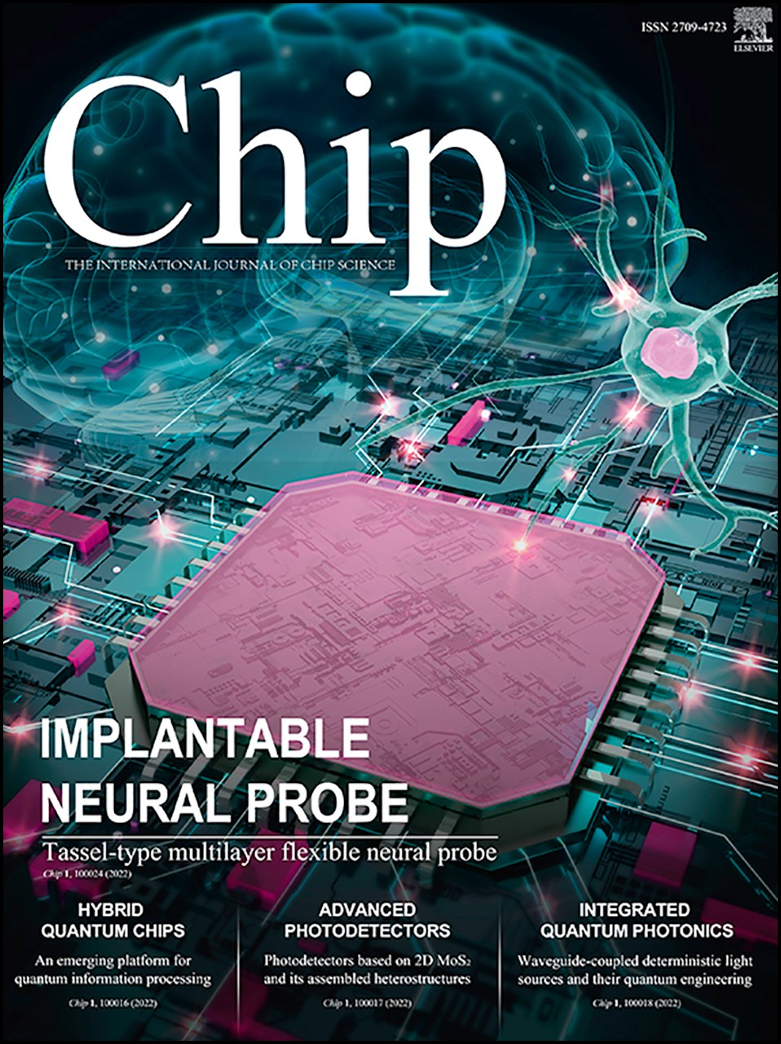Journal Pre-proof

Sensing with extended gate negative capacitance ferroelectric field-effect transistors Honglei Xue, Yue Peng, Qiushi Jing, Jiuren Zhou, Genquan Han, Wangyang Fu

PII: S2709-4723(23)00037-0

DOI: <https://doi.org/10.1016/j.chip.2023.100074> Reference: CHIP 100074

To appear in: *Chip*

Received Date: 23 August 2023

Revised Date: 22 October 2023

Accepted Date: 13 November 2023

Please cite this article as: Xue H, Peng Y, Jing Q, Zhou J, Han G, Fu W, Sensing with extended gate negative capacitance ferroelectric field-effect transistors, *Chip*, [https://doi.org/10.1016/](https://doi.org/10.1016/j.chip.2023.100074) [j.chip.2023.100074](https://doi.org/10.1016/j.chip.2023.100074).

This is a PDF file of an article that has undergone enhancements after acceptance, such as the addition of a cover page and metadata, and formatting for readability, but it is not yet the definitive version of record. This version will undergo additional copyediting, typesetting and review before it is published

in its final form, but we are providing this version to give early visibility of the article. Please note that, during the production process, errors may be discovered which could affect the content, and all legal disclaimers that apply to the journal pertain.

© 2023 The Author(s). Published by Elsevier B.V. on behalf of Shanghai Jiao Tong University.

1. **Sensing with extended gate negative capacitance ferroelectric field-effect**
2. **transistors**
3. Honglei Xue1#, Yue Peng2#, Qiushi Jing1, Jiuren Zhou2, Genquan Han2*, Wangyang Fu1*
4. 1Key Laboratory of Advanced Materials (MOE), School of Materials Science and Engineering, Tsinghua University, Beijing
5. 100084, People’s Republic of China
6. 2School of Microelectronics, Xidian Univeristy, Xi’an 710071, People’s Republic of China

7

1. *E-mail address: [gqhan@xidian.edu.cn;](mailto:gqhan@xidian.edu.cn) [fwy2018@mail.tsinghua.edu.cn](mailto:fwy2018@mail.tsinghua.edu.cn)

## ABSTRACT

1. With major signal analysis elements situated away from the measuring environment, extended gate (EG) ion-sensitive
2. field effect transistors (ISFETs) offer prospects for whole chip circuit design and system integration of chemical sensors. This
3. work presents the formulation of a highly sensitive and power-efficient ISFET based on a metal-ferroelectric-insulator gate
4. stack with negative capacitance (NC)-induced super-steep subthreshold swing and ferroelectric memory function. Along with
5. a remotely connected extended gate electrode, the architecture facilitates diverse sensing functions for future establishment of
6. smart biochemical sensor platforms.
7. **Keywords:** Extended gate, Ion-sensitive field-effect transistors, Negative capacitance, Sub-60 mV/dec subthreshold
8. swing, Ferroelectric memory effect

18

19

20

# INTRODUCTION

1. The integration of sensing, memory and computing (IoSMC), is of vital importance to meet the challenges in Internet-of-
2. Things (IoT) and Artificial Intelligent (AI)1-3. Extended gate (EG) ion-sensitive field-effect transistors (ISFETs) lay a solid
3. foundation for pursuing the development of such highly desired smart biochemical sensor platforms4. That is, by isolating the
4. transistors from the test environment, EG ISFETs offer whole chip circuit design and system integration for improved sensitivity,
5. long-term stability and reliability5, 6. Specific detection can be customized by functionalization of the EG. Thanks to the
6. separation of the sensing environment from the chips, EG ISFETs not only can help mitigate drift, degradation and aging,
7. suppress noise and ensure stable and reliable sensing response, but also facilitate sensor cleaning and recycling, thus reducing
8. costs and minimizing environment impact7.
9. Negative capacitance ferroelectric field-effect transistors (NC FeFETs), are promised to overcome the limitations of
10. traditional metal-oxide-semiconductor FET (MOSFET), specifically the Boltzmann-defined lowest subthreshold swing, i.e. 60
11. mV/decade at room temperature8-11. In addition, external electric field triggered polarization switching in ferroelectric materials
12. can contribute to distinct non-volatile states (“ON” and “OFF” states)12-14, thus opening up new possibilities on IoSMC by
13. utilizing the gating effect of the ferroelectric polarization field on the charge transport of the semiconducting channel.
14. Nevertheless, traditional ferroelectric materials suffer from the critical dimension problem, which limits their valuable
15. ferroelectricity at the nanometer scale and represents an obstacle for improving the transistor performance as well as the
16. computing and sensing capabilities14-17. Therefore, NC FeFETs based on two-dimensional (2D) ferroelectric ultrathin films
17. scaled down to several nanometers is highly promising18. Particularly, hafnium zirconium oxide (HfZrO*x*, HZO) achieved via
18. complementary MOS (CMOS) compatible atomic layer deposition (ALD) technology19-21, possesses relatively high-κ and large
19. bandgap and is an innovative candidate for the development of modern FeFETs22-26 and advanced sensors 27-29.
20. In this work, we propose a highly sensitive and power-efficient ISFET based on a metal-ferroelectric-insulator (MFI) gate
21. stack. Here, we employed a 6 nm HZO as the ferroelectric layer, along with a 2-nm-thick AlO*x* buffer layer, to construct an
22. MFI gate stack on p-type silicon or highly n doped germanium. This design allows to harvest the NC effect and the ferroelectric
23. memory effect with reduced operation voltage for sensing applications30. We successfully characterized the NC effect,
24. achieving valuable sub-60 mV/decade SS (the lowest point SS = 40 mV/dec) and the desired ferroelectric loop, in the fabricated
25. MFI-semiconductor (MFIS) FeFETs. Further ionic sensing measurements are applied on this NC FeFET with EG. Schematic
26. illustration of the sensing platform and the polarization states originated from different gating effect are shown in Fig.1a and
27. 1b, respectively. In principle, the ferroelectric polarization state in the HZO layer changes according to the polarity of the
28. applied gate voltage. Furthermore, different sensing environment with charged molecules around the reference electrode can
29. modulate the applied voltage on the HZO according to the charge detection principle of ISFETs. Therefore, the ferroelectric
30. polarization will be modulated by the environment. Fig. 1c illustrates a typical transfer curve of NC FeFET with a clockwise
31. ferroelectric memory window. The device’s ‘OFF’ state exhibits dominant downward polarization. In the presence of charged
32. molecules including pH, ions, DNAs and proteins, the ‘OFF’ state device can be switched ‘ON’ under the same gate voltage as
33. represented by the dashed red line interception, due to a potential positive shift of the Vth. Such upward polarization state is
34. nonvolatile and can be maintained unless it is intentionally erased or programed by applying an external gate voltage that
35. surpasses the positive coercive reset voltage. Therefore, the presence of charged molecules can be detected and recorded even
36. if the sensing environment comes back to its original conditions, signifying the potential of FeFETs for smart sensing. At the
37. end of our study, we find that when the potassium ion concentrations changes from 1 mM to 1 M, it reveals high sensitivity of
38. 62 (±2) mV/decade, which is superior to that of 48 mV/dec of its MOSFET counterparts31, 32. Along with configurable
39. ferroelectric memory windows, we envision potential development of NC FeFETs towards future IoSMC applications.

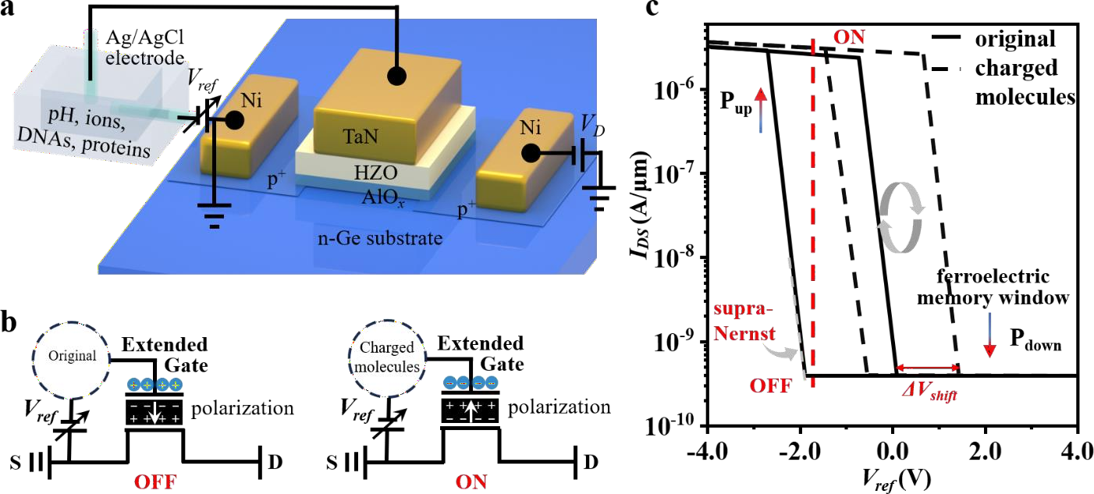

61

1. **Fig. 1 | Sensing platform and schematic of smart sensing modulation. a,** Illustration of the smart sensing
2. measurement on EG NC FeFETs. **b,** Schematic diagrams of the ferroelectric gating effect on EG NC FeFETs. Charges
3. with opposite sign to the gate are accumulated on the interface between the gating electrode and the ferroelectric layer.
4. Different gating states lead to different polarization states. **c,** Schematic image of the ideal smart sensing state originated
5. from different sensing environment. The black solid line indicates the original device state and the black dashed line
6. gives the transfer curve of devices in pH/ions, in which original device gives an “OFF” state and in the presence of
7. charged molecules, the device presents an “ON” state at the same gating condition (the red line).

69

# MATERIALS AND METHODS

1. In Fig. 2a, we present the optical image and the cross-section schematic structure of the MFISFET arrays. A sub-10 nm
2. gate dielectric stack constituted of 2 nm AlO*x* and 6 nm HZO was adopted on either p-type Si or n-type Ge substrates using an
3. atomic layer deposition (ALD) tool. Prior to deposition, pure n-type Ge (or p-Si) surface was firstly cleaned with acetone,
4. methanol and deionized water in an ultrasonic bath for 15min respectively, passivated with 10 cycles Al2O3 and then treated
5. with O3 atmosphere for 20 minutes to form a 2 nm AlO*x* layer. Here, AlO*x* was built up as a gate buffer layer to provide
6. performance enhancement. Two major restrictions in FeFETs including gate leakage current and charge traps can be better
7. improved through the AlOx buffer layer12, 33-35. Extra 6 nm high-quality HZO layer with a Zr/Hf ratio of 1:1 was grown on the
8. AlO*x* layer by ALD. A TaN layer (100 nm) was deposited by sputtering as the gate electrode. Boron ions (B+) for and
9. phosphorous ions (P-) were implanted into the source/drain electrode areas for Ge and Si channel transistors, respectively. The
10. implantation energy was 20 KeV and the dose was 1015 cm2. Ni (20-30 nm) was deposited into the source/drain(S/D) regions
11. to form the metallic S/D contacts. Finally, the devices were accomplished by a 30 seconds post annealing at 450 ℃. Indeed, in
12. our prior studies, we have examined orthorhombic phase in HZO36. XRD curves that we have obtained suggests mixed phases
13. within HZO after undergoing annealing at 450 ℃ for 30 s. This includes the presence of a partial orthorhombic phase. To
14. confirm the MFIS gate dielectric core structure, cross-sectional transmission electron microscopy (TEM) was made on a
15. representative device (Fig.2b, comparable MFS structure in Fig. S1). According to the TEM profile image, all interfaces
16. between every two layers are flat and clear, validating the integrity of the MFIS gate dielectric core structure. While it is
17. admittedly challenging to identify the orthorhombic phase37 in FFT of the TEM image showcased in Fig. 2b. We are of the
18. opinion that the analysis via XRD, in conjunction with the electrical P-E measurements, is adequate to ascertain the ferroelectric
19. properties of HZO.

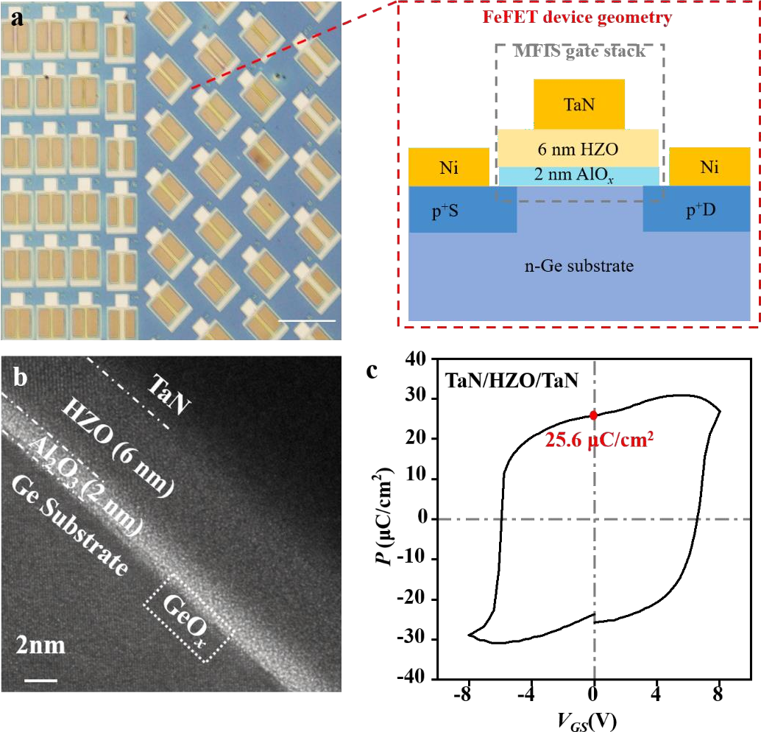

90

1. **Fig. 2 | The 6 nm HZO ferroelectric gate dielectric layer MFISFET device structure and ferroelectricity**
2. **characterization. a,** Optical image of 6 nm HZO ferroelectric FET arrays and schematic diagram of the HZO
3. ferroelectric FET gate stack cross-section. Scale bar, 200 µm. **b,** Transmission electron microscopy (TEM) image
4. showing the profile of TaN/HZO/Al2O3 gate stack of a representative device. Scale bar, 2 nm. **c,** Ferroelectric hysteresis
5. loop of 6 nm HZO ferroelectric film (TaN/HZO/TaN).

96

# RESULTS AND DISCUSSIONS

1. Ferroelectric properties embodied in, for example, the ferroelectric *P-V* hysteresis loop and the NC effect, are of key
2. importance in the electrical characterizations of NC FeFETs. In our study, we observed a robust ferroelectric polarization
3. response is from metal-ferroelectric HZO film-metal (MFM) *P-V* measurement. Fig. 2c depicts the *P-V* hysteresis loop with a
4. remnant polarization (*P*r) of 25.6 μC/cm2. Fig. S2 demonstrates an additional ferroelectric hysteresis loop of 10 nm HZO with
5. switching current.
6. Fig. 3a presents the output curves of a typical NC FeFET device with a 5 µm gate length (*L*G). Notably, the device exhibits
7. a negative differential resistance (NDR) effect in the whole subthreshold VDS region ranging from -0.4 V to -2 V (Fig. S3). One
8. step further, we measured the transfer characteristics and depicted the corresponding SS, as shown in Fig. 3b. Strikingly,
9. augmented by virtue of the NC effect from HZO ferroelectricity, the commendable FeFET achieves sub-60 mV/decade below

107

108

the thermionic limit. That is, Fig. 3b demonstrates 3 data points below the Boltzmann limit in the subthreshold region with the

lowest value of SS = 𝑑𝑉𝐺 = 40 mV/dec, where the potential sensing response will suppress that of conventional MOSFET

𝑑𝑙𝑔𝐼𝐷𝑆

1. devices. The suppressed gate leakage current due to MFIS structure was present in Fig. S4. We note here that the fluctuations
2. in SS (Fig. 3b) may be attributed to the switching of the multi-domains in the ferroelectric HZO thin film, as reported in our
3. previous publications36, 38, 39. Such fluctuations are reproducible to a large extend, as illustrated in Fig. S5a. Similar significant
4. SS fluctuations and none smooth transfer curves were also observed in NC FinFETs40. To promote further development of
5. highly sensitive biochemical sensors with low SS value and memory functions, in the follow we exam the synergetic
6. performance of the ferroelectric memory effect and charge trapping effect in the subthreshold region of NC FeFET devices.
7. Fig. 3c depicts the dual sweepings of gate voltage (*V*GS) with various ranges (±2 V to ±4 V), lead to either counter-
8. clockwise ferroelectric loop or clockwise hysteresis in an n-NC FeFET. Calculated SS values are shown in Fig. S6. Biased at a
9. sufficiently large *VGS* sweeping range of ±4 V, initial/remnant polarization can be flipped/switched and the device exhibits a
10. significant counter-clockwise ferroelectric loop (with a memory window of 1.3 V). We also observed clockwise hysteresis due
11. to charge trap states if biased at a small *V*GS sweeping range of ±2 V. Whereas at a moderate *VGS* sweeping range (±3 V), we
12. observed a counter-clockwise loop with a relatively small ferroelectric memory window. Such changes in the direction as well
13. as the width of the memory windows, can be ascribed to an underlying synergetic effect by taking into account both the
14. ferroelectric polarization effect and the interfacial charge-trapping effect41.

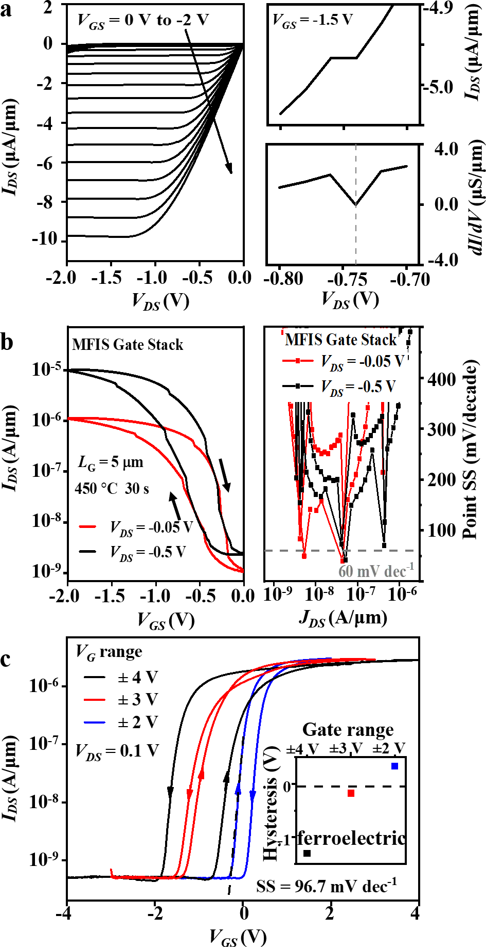123

1. **Fig. 3 | Electrical characterization of NC FeFETs. a,** Left: Output characteristic curves of the p-type HZO
2. FeFET. VGS is biased form 0 V to -2 V with a step of -0.1 V. Right up: Output characteristic curve with gate bias at
3. -1.5 V. Right down: The *dI/dV* spectra extracted from the upper curve, showing negative differential resistance. **b,**
4. Left: Forward and reverse transfer characteristic curves under VDS = -0.05 V and VDS = -0.5 V, respectively.
5. Inserted arrows show the hysteresis direction of the devices. Right: Calculated point SS according to the transfer
6. curve. **c,** Comparison of IDS as a function of top-gate voltage with different gate voltage range cycling from (±4 V,
7. ±2 V) in steps of 1 V.
8. To evaluate the sensing performance of the NC FeFETs, we performed further chemical sensing experiments in aqueous
9. solutions with various K+ concentrations as testbeds. Fig. S7a depicts the transfer characteristics of the FeFET and the calculated
10. SS spectra, respectively. It is important to note that the HZO ferroelectric thin film were polarized in Pdown state, as the gate
11. voltage (from -0.8 V to 0.8 V) were swept within the negative coercive voltage (<-2 V, Fig. 4b, see also the inset of Fig. 3c) of
12. the HZO ferroelectric thin film. Thanks to the ferroelectricity of the nanoscale ferroelectric HZO thin film, comparably lower
13. SS (Fig. S7b), as well as amplified voltage gating efficiency due to NC effect can be achieved advantageously42 for ion sensing
14. with enhanced responsivity and sensitivity. Noted that we operated the FeFET under the same gate step of 20 mV and constant
15. output source/drain voltage *VDS* (*VDS* = 0.1V for n-type FETs and *VDS* = -0.1V for p-type FETs), to exclude a possible impact of
16. gate voltage step and source/drain applied voltage on the electrical behaviors43-45. Ag/AgCl reference electrode was adopted as
17. the extended liquid gate to define the electrostatic potential in a homemade liquid chamber and then connected with the on-
18. chip gate electrode of NC FeFETs as illustrated in Fig. 1a and S8a. Fig. 4a depicts the drain current (*IDS*) plotted against the
19. reference voltage (*Vref*) in KCl solutions with increased concentrations from 1 mM to 1 M. The NC FeFET sensor yielded a
20. stable and evident response towards positive *V*th. We plotted the deduced threshold voltage shifts against the KCl concentrations
21. in the inset of Fig. 4a, which exhibited a positive threshold voltage shift of 62 (±2) mV/dec, corresponding to an overall 76
22. times change in current at *Vref* = -0.5 V when concentration varies from 1 mM to 1 M. The relative sensing response can be

146

deduced as 𝑆𝐶𝑜𝑛𝐼

= (𝐼𝐶𝑜𝑛𝐼−𝐼𝐶𝑜𝑛,𝑟𝑒𝑓). Repeating the measurements gave stable and reproducible results. In addition, Fig. S8b

𝐼𝐶𝑜𝑛,𝑟𝑒𝑓

1. illustrates that the calculated SS values here are consistent with those obtained in ambient air conditions. Our observed
2. potassium sensitivity of 62 mV/dec even slightly exceeds the theoretical value according to the thermodynamic Nernst limit
3. (60 mV/dec at room temperature). We ascribed the superior sensitivity beyond the Nernst limit to a capacitive effect, which can
4. be referred to the gate voltage amplification due to ferroelectric NC effect42. Remarkably, unless the baseline MOSFET has
5. ideal SS at 60 mV/decade limit, it is almost impossible to obtain sub-60 mV/decade SS. Nevertheless, better SS can be obtained
6. in NC FET over control device no matter whether the SS is steep or not, i.e., the NC effect might not always lead to the sub-
7. kT/q SS, but must contribute to the improved performance (SS) compared to the baseline device46, 47. When compare its
8. performance with its counterparts without ferroelectric NC effect (see Fig. S7b), we can clearly identify an improvement in the
9. SS values, suggesting the effectiveness of the NC effect from HZO*.*
10. Furthermore, smart sensing is expected based on the ferroelectric memory effect of the FeFETs. The polarization state of
11. ferroelectric layer could be modulated by the voltage on the extended gate, as illustrated in Fig.1b. In principle, downward and
12. upward polarization states of *Pdown* and *Pup* occur under respective gate biases separated by the ferroelectric window, resulting
13. in a low resistance state (LRS) and a high resistance state (HRS), corresponding to logic bits “1” and “0” as indicated by the
14. arrows in Fig. 4b, respectively. Fig. 4b gives the transfer curves of an n-NC FeFET with a relatively large counter-clockwise
15. ferroelectric window (1.3 V), tested in ambient air as the background (black line) and against 1 mM K+ solution (blue line) as
16. the analyte. Here, we conceived that chemical sensing information could be stored by employing ion-modulated polarization
17. states. The appreciable threshold voltage shift upon introducing 1 mM K+ (270 mV) in Fig. 4b, suggests the possibility of
18. switching the FeFET sensor from its HRS (Pup state) to LRS (Pdown state) if assuming an initially bias EG voltage of -0.7 V (see
19. the red line in Fig. 4b). This polarization state persists even when the sensor returns to its ambient background condition because
20. of the LRS along the reverse transfer curve. A coercive voltage -1.9 V for upward polarization state (erasing operation) is
21. needed to reprogram information, which is far away from the assumed Vref = -0.7 V. We also note here that the abovementioned
22. non-volatile sensing can be achieved, without compromising any prospects of the CMOS compatibility and computing
23. 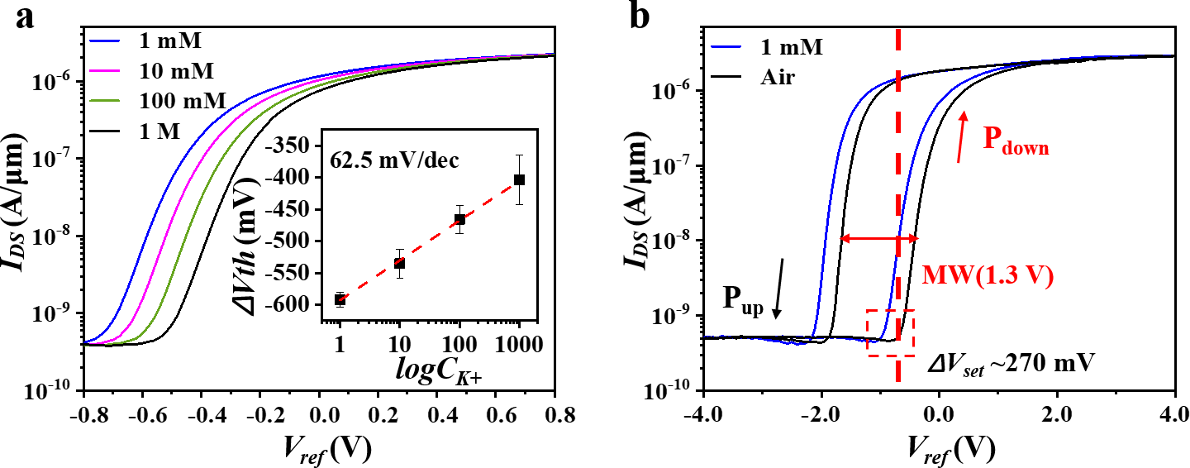capability of the NC FeFET.

170

1. **Fig. 4 | Sensitive, smart ion sensing response of HZO FeFETs. a,** Transfer curves of n-type ferroelectric sensors in
2. different concentrations KCl solutions from 1 mM to 1 M, shown by logarithmic scale. Inset: potassium response of the
3. FeFET. **b,** Transfer characteristics (at 0.1 V *VDS* and ±4 V gate range) under air and 1 mM solutions with relatively large
4. memory windows of around 1.3 V. Inserted arrows indicate ferroelectric loop direction with the polarization state.

175

176

## CONCLUSIONS

1. In summary, our study presents the demonstration of an HZO NC FeFET and its promising applications for sensing
2. purposes in the form of EG ISFETs. The potassium ion-sensitive FeFETs exhibit a slightly supra-Nernst sensitivity of 62 (±2)
3. mV/dec towards potassium ions, indicating their potential for highly sensitive ion detection. Furthermore, the incorporation of
4. a configurable non-volatile ferroelectric memory effect adds valuable memory retention and switching capabilities to the
5. FeFETs, enhancing their versatility in sensing applications. This opens up exciting possibilities for the future development of
6. diverse HZO NC FeFET biochemical sensor platforms in IoSMC applications.

184

## REFERENCE

1. 1. Chandrakasan, A. P., & Brodersen, R. W. Minimizing power consumption in digital CMOS circuits.

187 PROCEEDINGS OF THE IEEE 83, 498-523 (1995). <https://doi.org/10.1109/5.371964>

1. 2. Wang, S., Chen, X., Zhao, C., Kong, Y., Lin, B., Wu, Y., Bi, Z., Xuan, Z., Li, T., Li, Y., Zhang, W., Ma, E., Wang,
2. Z., & Ma, W. An organic electrochemical transistor for multi-modal sensing, memory and processing. Nat.
3. Electron. 6, 281-291 (2023). <https://doi.org/10.1038/s41928-023-00950-y>
4. 3. Yu, J., Wang, Y., Qin, S., Gao, G., Xu, C., Lin Wang, Z., & Sun, Q. Bioinspired interactive neuromorphic
5. devices. Mater. Today 60, 158-182 (2022). https://doi.org/https://doi.org/10.1016/j.mattod.2022.09.012
6. 4. Lauks, I., Chan, P., & Babic, D. The extended gate chemically sensitive field effect transistor as multi-species
7. microprobe. Sensors and Actuators 4, 291-298 (1983). https://doi.org/https://doi.org/10.1016/0250-
8. 6874(83)85035-5
9. 5. Wei, W., Zeng, Z., Liao, W., Chim, W. K., & Zhu, C. Extended Gate Ion-Sensitive Field-Effect Transistors
10. Using Al2O3/Hexagonal Boron Nitride Nanolayers for pH Sensing. ACS Applied Nano Materials 3, 403-408
11. (2020). <https://doi.org/10.1021/acsanm.9b02037>
12. 6. Das, A., Ko, D. H., Chen, C.-H., Chang, L.-B., Lai, C.-S., Chu, F.-C., Chow, L., & Lin, R.-M. Highly sensitive
13. palladium oxide thin film extended gate FETs as pH sensor. Sensors and Actuators B: Chemical 205, 199-
14. 205 (2014). https://doi.org/https://doi.org/10.1016/j.snb.2014.08.057
15. 7. Pullano, S. A., Tasneem, N. T., Mahbub, I., Shamsir, S., Greco, M., Islam, S. K., & Fiorillo, A. S. Deep
16. Submicron EGFET Based on Transistor Association Technique for Chemical Sensing. Sensors 19, 1063 (2019).
17. <https://doi.org/10.3390/s19051063>
18. 8. Catalan, G., Jimenez, D., & Gruverman, A. Negative capacitance detected. Nat. Mater. 14, 137-139 (2015).
19. <https://doi.org/10.1038/nmat4195>
20. 9. Salahuddin, S., & Dattat, S. Use of negative capacitance to provide voltage amplification for low power
21. nanoscale devices. Nano Lett. 8, 405-410 (2008). <https://doi.org/10.1021/nl071804g>
22. 10. Park, N., Kang, H., Park, J., Lee, Y., Yun, Y., Lee, J.-H., Lee, S.-G., Lee, Y. H., & Suh, D. Ferroelectric Single-
23. Crystal Gated Graphene/Hexagonal-BN/Ferroelectric Field-Effect Transistor. ACS Nano 9, 10729-10736
24. (2015). <https://doi.org/10.1021/acsnano.5b04339>
25. 11. Wang, X., Yu, P., Lei, Z., Zhu, C., Cao, X., Liu, F., You, L., Zeng, Q., Deng, Y., Zhu, C., Zhou, J., Fu, Q., Wang,
26. J., Huang, Y., & Liu, Z. Van der Waals negative capacitance transistors. Nat. Commun. 10, 3037 (2019).
27. <https://doi.org/10.1038/s41467-019-10738-4>
28. 12. Si, M., Saha, A. K., Gao, S., Qiu, G., Qin, J., Duan, Y., Jian, J., Niu, C., Wang, H., Wu, W., Gupta, S. K., & Ye,
29. P. D. A ferroelectric semiconductor field-effect transistor. Nat. Electron. 2, 580-586 (2019).
30. <https://doi.org/10.1038/s41928-019-0338-7>
31. 13. Miller, S. L., & McWhorter, P. J. Physics Of The Ferroeletric Nonvolatile Memory Field-effect Transistor.

219 JOURNAL OF APPLIED PHYSICS 72, 5999-6010 (1992). <https://doi.org/10.1063/1.351910>

1. 14. Mikolajick, T., Slesazeck, S., Park, M. H., & Schroeder, U. Ferroelectric hafnium oxide for ferroelectric
2. random-access memories and ferroelectric field-effect transistors. MRS Bulletin 43, 340-346 (2018).
3. <https://doi.org/10.1557/mrs.2018.92>
4. 15. Cheema, S. S., Shanker, N., Hsu, S.-L., Rho, Y., Hsu, C.-H., Stoica, V. A., Zhang, Z., Freeland, J. W., Shafer,
5. P., Grigoropoulos, C. P., Ciston, J., & Salahuddin, S. Emergent ferroelectricity in subnanometer binary oxide
6. films on silicon. Science 376, 648-+ (2022). <https://doi.org/10.1126/science.abm8642>
7. 16. Trieloff, M., Jessberger, E. K., Herrwerth, I., Hopp, J., Fieni, C., Ghelis, M., Bourot-Denise, M., & Pellas, P.
8. Structure and thermal history of the H-chondrite parent asteroid revealed by thermochronometry. Nature
9. 422, 502-506 (2003). <https://doi.org/10.1038/nature01499>
10. 17. Ambriz-Vargas, F., Kolhatkar, G., Broyer, M., Hadj-Youssef, A., Nouar, R., Sarkissian, A., Thomas, R.,
11. Gomez-Yáñez, C., Gauthier, M. A., & Ruediger, A. A Complementary Metal Oxide Semiconductor Process-
12. Compatible Ferroelectric Tunnel Junction. ACS Appl. Mater. Interfaces 9, 13262-13268 (2017).
13. <https://doi.org/10.1021/acsami.6b16173>
14. 18. Khan, A. I., Keshavarzi, A., & Datta, S. The future of ferroelectric field-effect transistor technology. Nat.

234 Electron. 3, 588-597 (2020). <https://doi.org/10.1038/s41928-020-00492-7>

1. 19. Böscke, T. S., Müller, J., Bräuhaus, D., Schröder, U., & Böttger, U. Ferroelectricity in hafnium oxide thin
2. films. Applied Physics Letters 99, 102903 (2011). <https://doi.org/10.1063/1.3634052>
3. 20. Zarubin, S., Suvorova, E., Spiridonov, M., Negrov, D., Chernikova, A., Markeev, A., & Zenkevich, A. Fully
4. ALD-grown TiN/Hf0.5Zr0.5O2/TiN stacks: Ferroelectric and structural properties. Applied Physics Letters
5. 109, 192903 (2016). <https://doi.org/10.1063/1.4966219>
6. 21. Das, D., & Khan, A. I. Ferroelectricity in CMOS-Compatible Hafnium Oxides: Reviving the ferroelectric
7. field-effect transistor technology. IEEE Nanotechnology Magazine 15, 20-32 (2021).
8. <https://doi.org/10.1109/MNANO.2021.3098218>
9. 22. Wang, J., Wang, D., Li, Q., Zhang, A., Gao, D., Guo, M., Feng, J., Fan, Z., Chen, D., Qin, M., Zeng, M., Gao,
10. X., Zhou, G., Lu, X., & Liu, J. M. Excellent Ferroelectric Properties of Hf0.5Zr0.5O2 Thin Films Induced by
11. Al2O3 Dielectric Layer. IEEE Electron Device Lett. 40, 1937-1940 (2019).
12. <https://doi.org/10.1109/LED.2019.2950916>
13. 23. Guo, R., Zhou, Y., Wu, L., Wang, Z., Lim, Z., Yan, X., Lin, W., Wang, H., Yoong, H. Y., Chen, S., Ariando,
14. Venkatesan, T., Wang, J., Chow, G. M., Gruverman, A., Miao, X., Zhu, Y., & Chen, J. Control of Synaptic
15. Plasticity Learning of Ferroelectric Tunnel Memristor by Nanoscale Interface Engineering. ACS Appl. Mater.
16. Interfaces 10, 12862-12869 (2018). <https://doi.org/10.1021/acsami.8b01469>
17. 24. Xi, F., Han, Y., Liu, M., Bae, J. H., Tiedemann, A., Grützmacher, D., & Zhao, Q.-T. Artificial Synapses Based
18. on Ferroelectric Schottky Barrier Field-Effect Transistors for Neuromorphic Applications. ACS Appl. Mater.
19. Interfaces 13, 32005-32012 (2021). <https://doi.org/10.1021/acsami.1c07505>
20. 25. Mueller, J., Boescke, T. S., Braeuhaus, D., Schroeder, U., Boettger, U., Sundqvist, J., Kuecher, P., Mikolajick,
21. T., & Frey, L. Ferroelectric Zr0.5Hf0.5O2 thin films for nonvolatile memory applications. APPLIED PHYSICS
22. LETTERS 99, 112901 (2011). <https://doi.org/10.1063/1.3636417>
23. 26. Tsai, S.-H., Fang, Z., Wang, X., Chand, U., Chen, C.-K., Hooda, S., Sivan, M., Pan, J., Zamburg, E., & Thean,
24. A. V.-Y. Stress-Memorized HZO for High-Performance Ferroelectric Field-Effect Memtransistor. ACS
25. Applied Electronic Materials 4, 1642-1650 (2022). <https://doi.org/10.1021/acsaelm.1c01321>
26. 27. Bellando, F., Dabhi, C. K., Saeidi, A., Gastaldi, C., Chauhan, Y. S., & Ionescu, A. M. Subthermionic negative
27. capacitance ion sensitive field-effect transistor. APPLIED PHYSICS LETTERS 116, 173503 (2020).
28. <https://doi.org/10.1063/5.0005411>

|  |  |  |
| --- | --- | --- |
| 263 | 28. | Xu, J., Jiang, S.-Y., Zhang, M., Zhu, H., Chen, L., Sun, Q.-Q., & Zhang, D. W. Ferroelectric HfZrOx-based |
| 264 |  | MoS2 negative capacitance transistor with ITO capping layers for steep-slope device application. APPLIED |
| 265 |  | PHYSICS LETTERS 112, 103104 (2018). <https://doi.org/10.1063/1.5019418> |
| 266 | 29. | Tu, L., Cao, R., Wang, X., Chen, Y., Wu, S., Wang, F., Wang, Z., Shen, H., Lin, T., Zhou, P., Meng, X., Hu, W., |
| 267 |  | Liu, Q., Wang, J., Liu, M., & Chu, J. Ultrasensitive negative capacitance phototransistors. Nat. Commun. 11, |
| 268 |  | 101 (2020). <https://doi.org/10.1038/s41467-019-13769-z> |
| 269 | 30. | Chen, K. T., Chen, H. Y., Liao, C. Y., Siang, G. Y., Lo, C., Liao, M. H., Li, K. S., Chang, S. T., & Lee, M. H. |
| 270  271  272 |  | Non-Volatile Ferroelectric FETs Using 5-nm Hf0.5Zr0.5O2 With High Data Retention and Read Endurance for 1T Memory Applications. IEEE Electron Device Lett. 40, 399-402 (2019).  <https://doi.org/10.1109/LED.2019.2896231> |
| 273 | 31. | Bhat, K. S., Ahmad, R., Mahmoudi, T., & Hahn, Y.-B. High performance chemical sensor with field-effect |
| 274 |  | transistors array for selective detection of multiple ions. CHEMICAL ENGINEERING JOURNAL 417, |
| 275 |  | 128064 (2021). <https://doi.org/10.1016/j.cej.2020.128064> |
| 276 | 32. | Zhang, J., Rupakula, M., Bellando, F., Cordero, E. G., Longo, J., Wildhaber, F., Herment, G., Guerin, H., & |
| 277 |  | Ionescu, A. M. Sweat Biomarker Sensor Incorporating Picowatt, Three-Dimensional Extended Metal Gate |
| 278 |  | Ion Sensitive Field Effect Transistors. ACS Sens. 4, 2039-2047 (2019). |
| 279 |  | <https://doi.org/10.1021/acssensors.9b00597> |
| 280 | 33. | Aizawa, K., Park, B.-E., Kawashima, Y., Takahashi, K., & Ishiwara, H. Impact of HfO2 buffer layers on data |
| 281 |  | retention characteristics of ferroelectric-gate field-effect transistors. Applied Physics Letters 85, 3199-3201 |
| 282 |  | (2004). <https://doi.org/10.1063/1.1806274> |
| 283 | 34. | Takahashi, K., Aizawa, K., Park, B.-E., & Ishiwara, H. Thirty-Day-Long Data Retention in Ferroelectric-Gate |
| 284 |  | Field-Effect Transistors with HfO2 Buffer Layers. Japanese Journal of Applied Physics 44, 6218-6220 (2005). |
| 285 |  | <https://doi.org/10.1143/jjap.44.6218> |
| 286 | 35. | Ni, K., Sharma, P., Zhang, J., Jerry, M., Smith, J. A., Tapily, K., Clark, R., Mahapatra, S., & Datta, S. Critical |
| 287 |  | Role of Interlayer in Hf0.5Zr0.5O2 Ferroelectric FET Nonvolatile Memory Performance. IEEE Transactions on |
| 288 |  | Electron Devices 65, 2461-2469 (2018). <https://doi.org/10.1109/TED.2018.2829122> |
| 289 | 36. | Zhou, J., Peng, Y., Han, G., Li, Q., Liu, Y., Zhang, J., Liao, M., Sun, Q. Q., Zhang, D. W., Zhou, Y., & Hao, Y. |
| 290 |  | Hysteresis Reduction in Negative Capacitance Ge PFETs Enabled by Modulating Ferroelectric Properties |
| 291 |  | in HfZrOx. IEEE Journal of the Electron Devices Society, 6, 41-48 (2018). |
| 292 |  | <https://doi.org/10.1109/JEDS.2017.2764678> |
| 293 | 37. | Wang, Y., Tao, L., Guzman, R., Luo, Q., Zhou, W., Yang, Y., Wei, Y., Liu, Y., Jiang, P., Chen, Y., Lv, S., Ding, |
| 294 |  | Y., Wei, W., Gong, T., Wang, Y., Liu, Q., Du, S., & Liu, M.. A stable rhombohedral phase in ferroelectric |
| 295 |  | Hf(Zr)1+xO2 capacitor with ultralow coercive field. Science, 381(6657), 558-563(2023). |
| 296 |  | <https://doi.org/10.1126/science.adf6137> |
| 297 | 38. | Zhou, J., Wu, J., Han, G., Kanyang, R., Peng, Y., Li, J., Wang, H., Liu, Y., Zhang, J., Sun, Q. Q., Zhang, D. |
| 298 |  | W., & Hao, Y. Frequency dependence of performance in Ge negative capacitance PFETs achieving sub-30 |
| 299 |  | mV/decade swing and 110 mV hysteresis at MHz. 2017 IEEE International Electron Devices Meeting |
| 300 |  | (IEDM), 15.5.1-15.5.4 (2017). <https://doi.org/10.1109/IEDM.2017.8268397> |
| 301 | 39. | Wang, C., Wu, J., Yu, H., Han, G., Miao, X., & Wang, X. Effects of Temperature on the Performance of |
| 302 |  | Hf₀.₅Zr₀.₅O₂-Based Negative Capacitance FETs. IEEE Electron Device Letters, 41(11), 1625-1628 (2020). |
| 303 |  | <https://doi.org/10.1109/LED.2020.3022384> |
| 304 | 40. | Krivokapic, Z., Rana, U., Galatage, R., Razavieh, A., Aziz, A., Liu, J., Shi, J., Kim, H. J., Sporer, R., Serrao, |

1. C.,Busquet, A., Polakowski, P., Müller, J., Kleemeier, W., Jacob, A., Brown, D., Knorr, A., Carter, R., & Banna,
2. S. 14nm Ferroelectric FinFET technology with steep subthreshold slope for ultra low power applications.
3. 2017 IEEE International Electron Devices Meeting (IEDM), 15.11.11-15.11.14 (2017).

|  |  |  |
| --- | --- | --- |
| 308 |  | <https://doi.org/10.1109/IEDM.2017.8268393> |
| 309 | 41. | Gao, J., Lian, X., Chen, Z., Shi, S., Li, E., Wang, Y., Jin, T., Chen, H., Liu, L., Chen, J., Zhu, Y., & Chen, W. |
| 310 |  | Multifunctional MoTe2 Fe-FET Enabled by Ferroelectric Polarization-Assisted Charge Trapping. Advanced |
| 311 |  | Functional Materials 32, 2110415 (2022). https://doi.org/https://doi.org/10.1002/adfm.202110415 |
| 312 | 42. | Íñiguez, J., Zubko, P., Luk’yanchuk, I., & Cano, A. Ferroelectric negative capacitance. Nature Reviews |
| 313 |  | Materials 4, 243-256 (2019). <https://doi.org/10.1038/s41578-019-0089-0> |
| 314 | 43. | Li, Y., Liang, R., Wang, J., Jiang, C., Xiong, B., Liu, H., Wang, Z., Wang, X., Pang, Y., Tian, H., Yang, Y., & |
| 315 |  | Ren, T. L. Negative Capacitance Oxide Thin-Film Transistor With Sub-60 mV/Decade Subthreshold Swing. |
| 316 |  | IEEE Electron Device Lett. 40, 826-829 (2019). <https://doi.org/10.1109/LED.2019.2907988> |
| 317 | 44. | Kwon, D., Chatterjee, K., Tan, A. J., Yadav, A. K., Zhou, H., Sachid, A. B., Reis, R. D., Hu, C., & Salahuddin, |
| 318 |  | S. Improved Subthreshold Swing and Short Channel Effect in FDSOI n-Channel Negative Capacitance Field |
| 319 |  | Effect Transistors. IEEE Electron Device Lett. 39, 300-303 (2018). <https://doi.org/10.1109/LED.2017.2787063> |
| 320 | 45. | Wang, Y., Bai, X., Chu, J., Wang, H., Rao, G., Pan, X., Du, X., Hu, K., Wang, X., Gong, C., Yin, C., Yang, C., |
| 321 |  | Yan, C., Wu, C., Shuai, Y., Wang, X., Liao, M., & Xiong, J. Record-Low Subthreshold-Swing Negative- |
| 322 |  | Capacitance 2D Field-Effect Transistors. Adv. Mater. 32, 2005353 (2020). |
| 323 |  | <https://doi.org/10.1002/adma.202005353> |
| 324 | 46. | Duarte, J. P., Khandelwal, S., Khan, A. I., Sachid, A., Lin, Y. K., Chang, H. L., Salahuddin, S., & Hu, C. |
| 325 |  | Compact models of negative-capacitance FinFETs: Lumped and distributed charge models. 2016 IEEE |
| 326 |  | International Electron Devices Meeting (IEDM)30.35.31-30.35.34 (2016). |
| 327 |  | [https://doi.org/10.1109/JEDS.2016.2632709.](https://doi.org/10.1109/JEDS.2016.2632709) |
| 328 | 47. | Li, J., Zhou, J., Han, G., Liu, Y., Peng, Y., Zhang, J., Sun, Q. Q., Zhang, D. W., & Hao, Y. Correlation of Gate |
| 329 |  | Capacitance with Drive Current and Transconductance in Negative Capacitance Ge PFETs. IEEE Electron |
| 330 |  | Device Lett. 38, 1500-1503 (2017). <https://doi.org/10.1109/LED.2017.2746088> |

## MISCELLANEA

1. **Data Availability Statement:** The data that supports the findings of this study are available within the article [and its
2. supplementary material].
3. **Acknowledgments:** Financial support from the National Natural Science Foundation of China No. 52073160 and the National
4. Key Research and Development Program of China No. 2020YFF01014706 is gratefully acknowledged.
5. **Conflicts of Interest:** The authors declare no conflict of interest.

337

338

1. **Conflicts of Interest:** The authors declare no conflict of interest.