HOSTE D BY

Available online at [www.sciencedirect.com](http://www.sciencedirect.com/science/journal/2314808X)

**ScienceDirect**

journal homepage: [http://ees.elsevier.com/ejbas/default.asp](http://http//ees.elsevier.com/ejbas/default.asp)

egyptian journal of basic and applied sciences 3 (2016) 322–328



**Full Length Article**

**Simulations of an all-optical flip-flop with a reset pulse frequency exceeding operating frequency**



***Hossam Zoweil*** ***\****

*Advanced Technology and New Materials Research Institute, City of Scientific Research and Technology Applications, New Borg EL-Arab City, P.O. Box 21934, Alexandria, Egypt*

A R T I C L E I N F O A B S T R A C T

*Article history:*

Received 17 March 2016 Received in revised form 24 April 2016

Accepted 24 April 2016

Available online 10 May 2016

*Keywords:*

All-optical flip-flop DFB laser

Optical nonlinearity Urbach tail

An all-optical flip-flop based on a nonlinear multi-section DFB semiconductor laser struc- ture is proposed. Holding beam is not required for device’s operation. A section of the DFB structure is detuned to prevent lasing in the “OFF” state, and it is accompanied with a nega- tive nonlinear coefficient that is due to partial absorption of photons at Urbach tail. At a high light intensity in the structure the nonlinear coefficient reduces the detuning, and the device is in lasing state; “ON” state. The device is reset by an optical pulse at a shorter wave- length through cross gain modulation. The reset pulse is absorbed in a middle section in the device before reaching the detuned nonlinear section. The switching times between the states are in nanoseconds time scale.

© 2016 Mansoura University. Production and hosting by Elsevier B.V. This is an open access article under the CC BY-NC-ND license (<http://creativecommons.org/licenses/by->

nc-nd/4.0/).

# Introduction

All optical Internet requires all optical devices to process optical data directly (without conversion to electrical signal) in the optical domain. Particularly, all-optical flip-flops have roles as all optical memory elements, and these memory elements could be used in all optical data routing [1]. The all-optical flip-flop could be used for other applications such as optical shift reg- ister, optical random access memory and other applications [2]. Several schemes/devices are suggested for all-optical flip- flop devices. In [3], a device that is based on two coupled laser diode is presented. A device that is constructed from ring laser is presented in [4]. A device with two states of a clockwise and an anti-clockwise laser mode is introduced in [5]. Devices that are based on a semiconductor distributed feedback (DFB) laser, and on vertical cavity semiconductor optical amplifier (VCSOA)

are shown in [6] and [7] respectively. All these devices require a holding beam or show output power in both states of the flip flop. Devices that have bistable optical output and do not require a holding beam are discussed in [8,9]. These devices have a satu- rable absorber in the laser cavity which has large optical loss at low light intensity in the laser cavity, and optical loss is reduced at high optical power intensity in the cavity.

In [10], a chirped DFB laser structure that behaves as an all- optical flip-flop is simulated. The flip-flop has a bi-stable output optical power behavior. The operation of the device does not require a holding beam. The chirped grating is accompanied by a linearly increasing negative nonlinear coefficient that is due to partial absorption of photons at the Urbach tail (The absorbed photons produce electron-hole pairs density that reduce the refractive index close to the band-gap energy). In the “OFF” state the chirp prevents constructive feedback from the grating and lasing does not occur. At high light intensity,

* Tel.: (002) 01223631091.

*E-mail address:* [zoweil@gmail.com](mailto:zoweil@gmail.com) <http://dx.doi.org/10.1016/j.ejbas.2016.04.001>

2314-808X/© 2016 Mansoura University. Production and hosting by Elsevier B.V. This is an open access article under the CC BY-NC-ND license ([http://creativecommons.org/licenses/by-nc-nd/4.0/).](http://creativecommons.org/licenses/by-nc-nd/4.0/))

egyptian journal of basic and applied sciences 3 (2016) 322–328

**323**

the chirp is reduced due to negative nonlinearity, and the laser mode builds up. The device is switched “OFF” by cross gain modulation. An optical pulse of a wavelength longer than the operating wavelength reduces the gain of the active layer, and in the same time does not produce much change in the re- fractive index (lower absorption coefficient at a longer wavelength).

In this work, a new design for an all-optical flip-flop is simu- lated. Instead of the chirped grating accompanied with a linear increasing negative nonlinear coefficient, a part of the wave- guiding grating of the suggested device is detuned from the rest of the grating. The detuned part has a slightly higher re- fractive index than the rest of the grating and has a negative nonlinear coefficient. The negative nonlinear coefficient is due to partial absorption of photons at the Urbach tail. The struc- ture investigated in this work is easier to fabricate than the structure mentioned in [10] because only one nonlinear section is needed to achieve optical bistability in the laser device. The switch OFF (“Reset”) mechanism is done by cross gain modu- lation (XGM), and a “Reset” pulse at a wavelength shorter than the wavelength of the “Set” pulse is used. The “Reset” pulse has a higher frequency (shorter wavelength) than the “Set” pulse and the operating frequency, which produces more design flex- ibility. This is in contrast to the device in [10], where the the “Reset” pulse has to be at a lower frequency than the operat- ing frequency. In the next section the device schematic is presented and the flip-flop design is discussed.

# Device schematic and description

The suggested device consists of a nonlinear DFB laser struc- ture. The refractive index distribution along the wave- guiding layer of the device is shown in Fig. 1. The grating

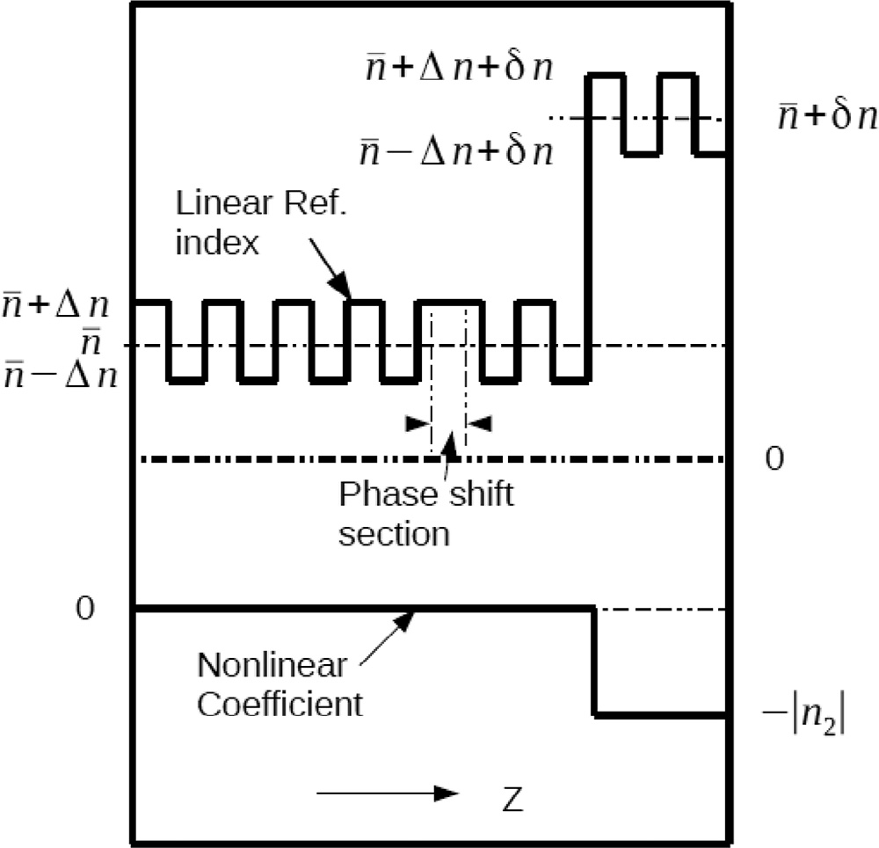

### Fig. 1 – Linear refractive index and nonlinear coefficient distribution.

period is adjusted as 2*nd*  *G*, where *n* is the average refrac- tive index along the grating, *d* is the grating period, *λG* is the wavelength at the center of the reflection band of the grating. The device has a phase shift section in the middle of the grating. The optical gain is provided by electrical current injected into the active layer along the wave-guiding layer. The negative nonlinear coefficient is due to direct absorption of photons at the Urbach tail at a photon energy slightly less than the semiconductor band-gap energy in the nonlinear

section. The loss coefficient at the Urbach tail is expressed as: ** **   **0  *exp**h*  *hg* *E*0  [11,12], *hg*  *Eg* is the band gap energy, *h* is the Plank’s constant (The energies are ex-

pressed in electron volt). The absorbed photons produce electron-hole pairs that reduce the refractive index at a photon energy slightly less than the semiconductor band-gap. At low optical power intensity in the structure, the detuned part of the wave-guiding layer reduces the available optical feed- back to the laser mode, and the laser mode does not build up. To set the flip-flop “ON”, an optical pulse of wavelength

*λ* = *λ*1 is injected, at *z* = 0, where *λ*1 = *λG*. The semiconductor

band gap energy *Eg* in the nonlinear section is adjusted such that the photons energies at *λ* = *λ*1 is slightly less than *Eg*. Fig. 2 shows the gain spectrum of the device [13], the “Set”

and “Reset” pulses frequencies (wavelengths), and the optical loss at Urbach tail. The injected “Set” pulse induces electron- hole pair densities in the nonlinear section and reduces its refractive index and its detuning; hence it provides extra

optical feedback to photons of wavelength around *λ* = *λ*1, the optical mode builds up and provides optical power (photons)

that produce electron-hole pairs in the nonlinear section and maintain the reduction in the detuning in that section.

To reset the flip-flop, an optical pulse at *λ* = *λ*2 is injected

at *z* = 0. In this work we choose *λ*2 < *λ*1, which means that the reset pulse will be absorbed in the nonlinear section and may

prevent the flip-flop from switching “OFF” properly. At *L*2  *z*  3*L*4 along the wave-guiding layer, the band-gap of the wave-guiding layer is altered to provide large absorption

to photons of wavelength *λ* = *λ*2 (Fig. 3). In Section “1”, the band gap energy is higher than “Set/Reset” pulse photons ener-

gies. In section “2”, the “Reset” pulse will be absorbed because the band gap energy is lower than the “Reset” pulse photon energy. The “Reset” pulse energy is totally absorbed in section “2” before it reaches section “3”. Section “3” is the detuned

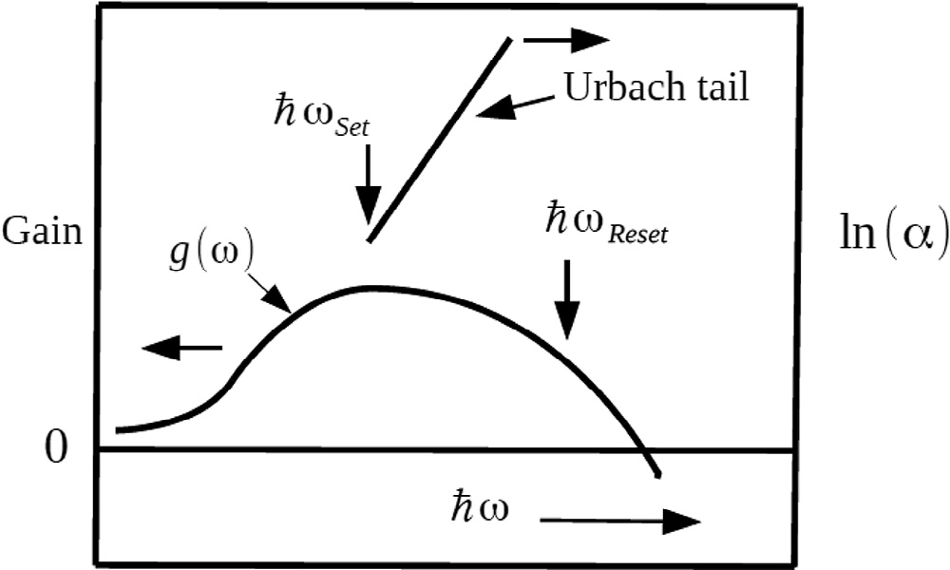

### Fig. 2 – Gain spectrum, Urbach tail loss and “Set/Reset” pulses frequencies (wavelengths).

**324** egyptian journal of basic and applied sciences 3 (2016) 322–328

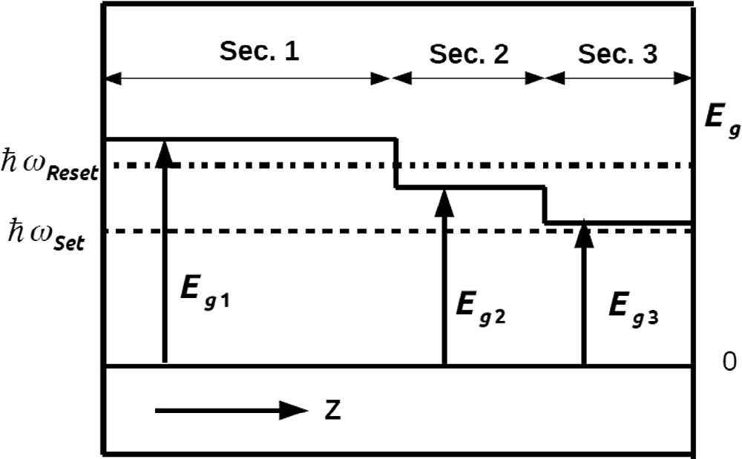the structure [14]. The optical modes are coupled with rate equations. The total optical field is expressed as: *E**z*, *t*  *E* *z*, *t*exp*iz*  *it*  *E* *z*, *t*exp*iz*  *it*  *c*.*c*.. The optical laser mode is modeled at *ω* = *ω*1. **  2*n G* .

The “Reset” pulse angular frequency *ω*2 is far detuned from reflection band of the grating. The “Reset” pulse optical field in

the structure has only a propagating component in the +*ve z* direction and is expressed as *EReset*  *E**z*, *t**R*  exp*iz*  *it*  *c*.*c*., and *ω* = *ω*2. It is assumed that the reset pulse is amplified in the first section (0 < *z* < *L*/2), and it is attenuated in the second section ( *L*2  *z*  3*L*4 ). Due to large attenuation constant in the

second section (compared to optical gain provided by the active layer), only loss coefficient is applied to the “Reset” pulse in the second section. In section “2”, it is assumed the propagating reset

*z*

### Fig. 3 – Energy gap of the semiconductor wave-guiding layer along the device; section “3” is the nonlinear wave- guiding section.

pulse optical power is multiplied by exp *L*2 ** **2 *dz*. It is assumed that the “Reset” pulse is completely consumed in the

second section, and no “Reset” signal propagates in the third section. The equations that model the all-optical flip-flop are as follows:

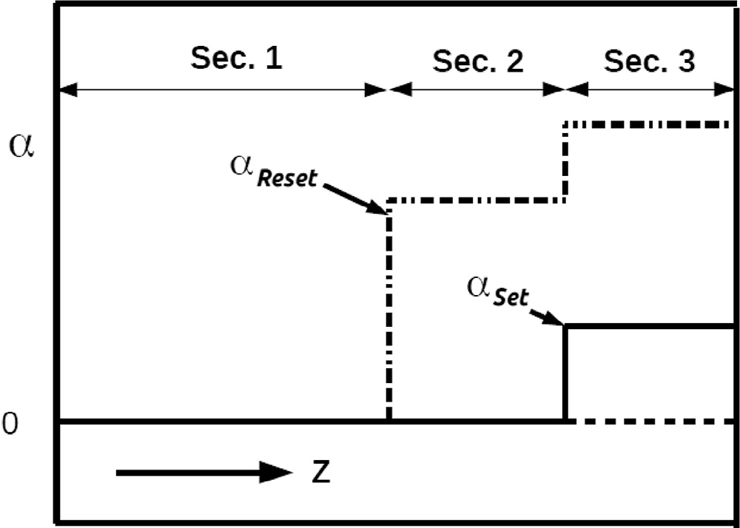*E*  *n* *E*   *i*1  *g* 1  *i*   *cav*  *E*

*z c* *t*  2 2 

 *i*2 exp*i* *z*  *i*2*z**E*

*E*  *n* *E*   *i*1  *g* 1  *i*   *cav*  *E*

(1)

*z c* *t*  2 2 

− *i*2 exp*i* *z*  *i*2*z**E*

*ER*  *n* *ER*   *i*1  *g* 1  *i*   *cav*  *ER*

(2)

(3)

*z c* *t*  2 2 

1  2** *n* *z*   *dn Nc* 1  *i*  *i * *z*, **1,2 

(4)

### Fig. 4 – Energy gap of the semiconductor wave-guiding

*G*  *dN*

 2

### layer along the device.

2  4 *n* (5)

**

grating section, its band gap energy is slightly higher than the “Set” pulse photon energy and the output laser mode photon

*G*

*Nc* *z*, *t*    *Nc*  *BN*2  *CN*3  ** *z*, **1  *I*1  ** *z*, **2  *I*2

1

(6)

energy. The absorption loss *Set* at the “Set” pulse frequency (*ω* = *ω*1 or *λ* = *λ*1), and the absorption loss *Reset* at the “Reset”

*t c*

*c c h*

*h*2

pulse frequency (*ω* = *ω*2 or *λ* = *λ*2) are plotted in Fig. 4.

*Ng* *z*, *t*  *Icurrent*   *Ng*  *BN*2  *CN*3  *v* *g* ** *S*  *g* ** *S* 

(7)

In this work it was assumed *λ*1 = 1500 nm and *λ*2 = 1450 nm (Window of low absorption loss in optical fiber). The reset pulse

*t qV g*

*g g g*

1 1 2 2

reduces the optical gain of the laser mode by XGM, and it is

*g**˜* *N*  *N* 

absorbed in section “2”. Whence the optical laser mode gain

*g* **1,2  

1,2

*g tr*

(8)

is reduced the light intensity at *λ* = *λ*1 is reduced and electron- hole density in section “3” decays toward zero, the optical

feedback in the cavity is reduced and the device is switched OFF. In the next sections, a mathematical model of the device is presented an solved numerically. “Set/Reset” dynamics are simulated in time domain and results are discussed.

# Mathematical model and simulations parameters

To simulate the switching dynamics in the structure coupled mode equations are used to model optical fields inside

1  ε *S*1  *S*2 

Equations 1 and 2 present the two counter propagating modes in the device. Equation 3 describes the “Reset” pulse

propagation in the structure. Γ1 presents the detuning along the structure due to optical gain change and refractive index

change, and it presents the optical loss in the cavity. Γ2 is the coupling between forward mode and backward mode. In the simulations *c*  3  108 m/s. *n*  3 is the average refractive index along the structure. Δ*n* = 0.001, and *δn* = 0.006, for 3*L*/4 < *z* < *L* and 0 otherwise. The optical nonlinearity in the nonlinear

section (Section “3”) is due to direct absorption of photons at *ω* = *ω*1. A part of photons is absorbed and electron-hole pairs are generated. The electron-hole pairs generated reduce

egyptian journal of basic and applied sciences 3 (2016) 322–328

**325**

|  |  |  |
| --- | --- | --- |
| **Table 1 – Simulation parameters.** | | |
| Symbols | Description | Value |
| *L* | Length | 187.5 μm |
| *Icurrent* | Current injected in the active layer | 0.095523 Ampere |
| *n* | Average ref. index | 3 |
| *vg* | Group velocity | 108 m/s |
| *cav* | Intrinsic cavity loss | 25 *cm*1 |
| *γ* | Line-width enhancement | −0.5 |
| *ε* | Gain saturation | 1.5  1023 m3 |
| Θ | Overlap factor | 0.35 |
| *V* | Cavity volume | 0.36  1016 m3 |
| *car* | Non-radiative recombination | 1 ns |
|  | in nonlinear sections |  |
| *τg* | Non-radiative recombination | 3 ns |
|  | in the active layer |  |
| *B* | Radiative recombination | 1023 m3 /s |
| *C* | Auger recombination | 3  1040 m6 /s |
| *g* *˜*1  | Differential gain at *ω*1 | 4  1020 m2 |
| *Ntr* | Transparency carrier density | 1023 m3 |

the refractive index at photon energies just below the energy gap of the semiconductor. At photon energy below the band gap energy the loss follows Urbach tail expression [12],

** **   **0  *exp**h*  *hg* *E*0  , *hg*  *Eg* , *E*0 is around 0.01 eV. In

this simulation ** **1   480 *cm*1 for 3*L*/4 < *z* < *L* and 0 other- wise. ** **2   9600 cm1, for *L*2  *z*  3*L*4 and 0 otherwise. The

change in the refractive index due to the change in the electron- hole density is  *dndN*  *Nc* , and −|*dn*/*dN*| = −10−26 m3 [15,16]. *ξ* = 0.03 is the ratio between the change in the refractive index to the change in the optical loss due to the generated elec-

tron hole density [16]. *I*1 and *I*2 are the optical power density on the “Set” pulse (optical laser mode at *ω*1) and the “Reset” pulse (at *ω*2) respectively. *S*1 and *S*2 are the photons densities in the laser cavity at *ω*1 and *ω*2 respectively. *ϕ* = 0 for 0 < *z* < /

*L*/2, and *ϕ* = *π* otherwise. It was assumed *g* *˜*2   0.5  *g* *˜*1 .

Other simulation parameters are shown in Table 1.

The structure is divided into 80 sections. In each section, the forward and backward fields are calculated using Rung- Kutta methods. The electron hole densities in the wave- guiding layer and the active layer are calculated with the same methods. In each step, random fields are added to the back- ward and forward mode to model the spontaneous emissions. To reduce the simulation time, the simulations are per- formed on a general purpose graphics processing unit (GPGPU). In each time step, the calculation load is distributed among 80 parallel threads; a thread per each section along the length of the structure (one can assign more threads per section). The integration step along the z axis is *L*/80, and the time step is *nLc*80. The work is performed on a PC machine 32 GB, pro- cessor: Intel Core i3-4130 CPU @ 3.40 GHz × 4, GPGPU: Geforce GTX 670. The simulation code is written using CUDA C [17]. The simulation’s time on PC is reduced 20 times by using GPGPU computing. In the following sections results and numerical simulations of the device are shown.

# Numerical simulations and results

In the following simulation the output optical field is normal- ized to *P*0  0.05  103 watt . *Ng* is normalized to *Nth*. *Nc* is normalized to *N*0  1023 *m*3.

## *Optical bi-stability loop*

To determine the required injected current to obtain two stable optical level output (at the same injected current) a numeri- cal experiment is performed. The injected current is increased linearly from zero to 0.122 Ampere in 75 ns, then the injected current is reduced again to 0 linearly in 75 ns. At part of the current versus optical output relation is plotted in Fig. 5. In the following simulations, the injected current *I* = 95.523 mA is assumed. It insures bistable operation of the device.

## *“OFF” state and “ON” state*

The output optical power in the “OFF” state at *z* = *L* is simu- lated in time domain for 75 ns, Fig. 6(a). The “ON” state is

triggered by an input pulse injected at *z* = 0, of power *P* = *P*0 and time width *t* = 187.5 picosecond ( 9.375  103 picojule). The device is triggered at *t* = 7.5 ns from the start of the simula- tion time, the output optical power at *z* = *L* is shown in Fig. 6(b). The injected pulse at *ω* = *ω*1 is amplified along the structure

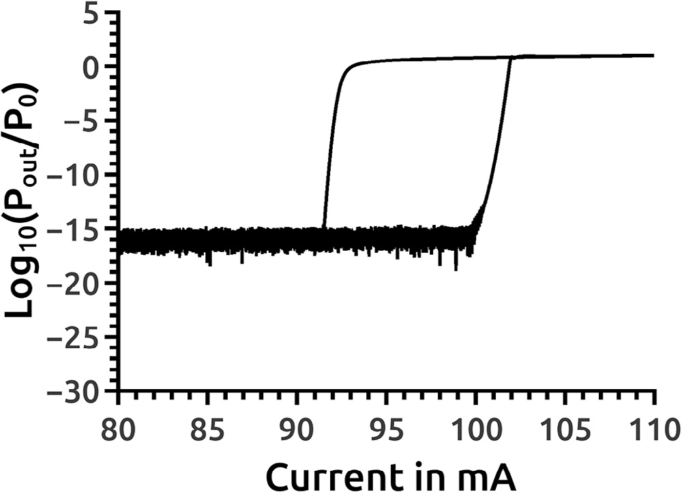

### Fig. 5 – Optical bi-stability loop, injected current versus

***Log*10** ***Pout P*0**  **.**

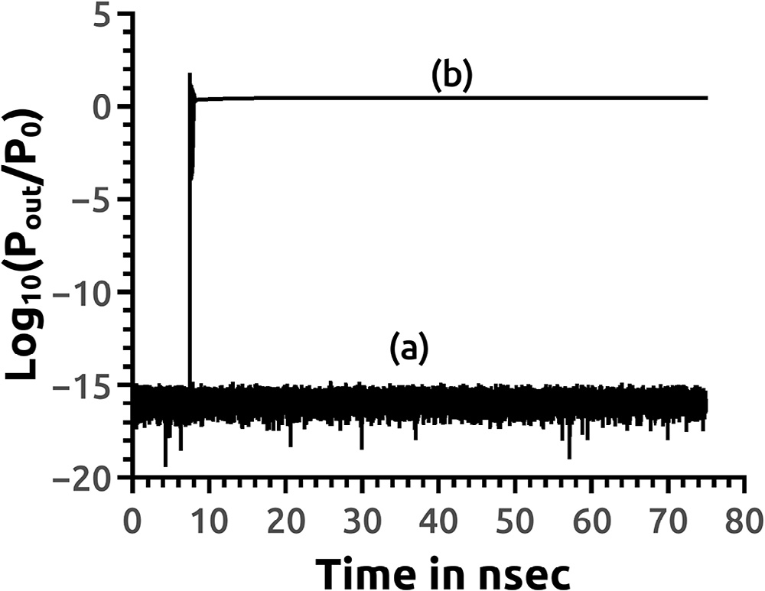

### Fig. 6 – Output optical power in; (a) “OFF” and (b) “ON” states simulations in time domain.

**326** egyptian journal of basic and applied sciences 3 (2016) 322–328

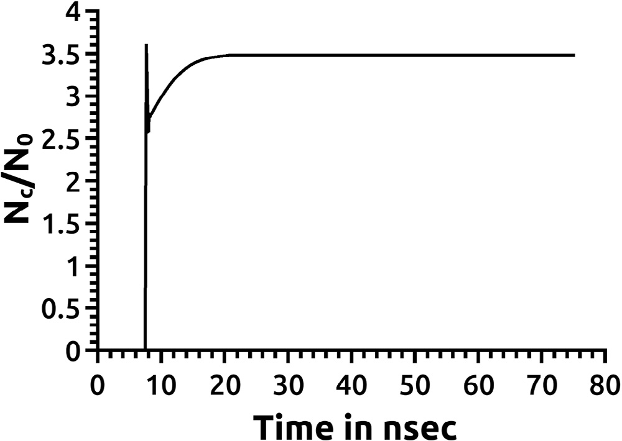

**Fig. 7 – *Nc*/*N*0 evolution at *z* = 7*L*/8.**

### Fig. 9 – Relative change in the refractive index in (a) “OFF”

and a part of photons is absorbed at the Urbach tail in the third section (the nonlinear section). The absorbed photons gener- ate electron-hole pairs that reduce the refractive index of that section. As the detuning of this section decreases, the grating in this section starts to reflect back more photons back to the device and decreases the number of photons leaving the device

at *ω* = *ω*1. The optical feedback along the structure increases

and the laser mode at *ω* = *ω*1 builds up. As the optical power of the laser mode builds up, it maintains the number of photons

in section 3 that are required to generate the electron hole density needed to set the detuning of this section to a low value.

The electron hole density *Nc* normalized to *N*0 in the non- linear section (Section 3) at (*z* = 7*L*/8), is shown in Fig. 7. The electron hole density in the active layer *Ng* normalized to *Nth*

is plotted in Fig. 8 at *z* = 7*L*/8.

*n*  *dndN*  *Nc* *n* is plotted in Fig. 9. It shows the rela-

tive changes in the refractive index in the nonlinear section after 75 ns in the “OFF” and in the “ON” states at *z* = 7*L*/8.

## *“ON/OFF” transitions dynamics*

### and (b) “ON” states after 75 ns*.*

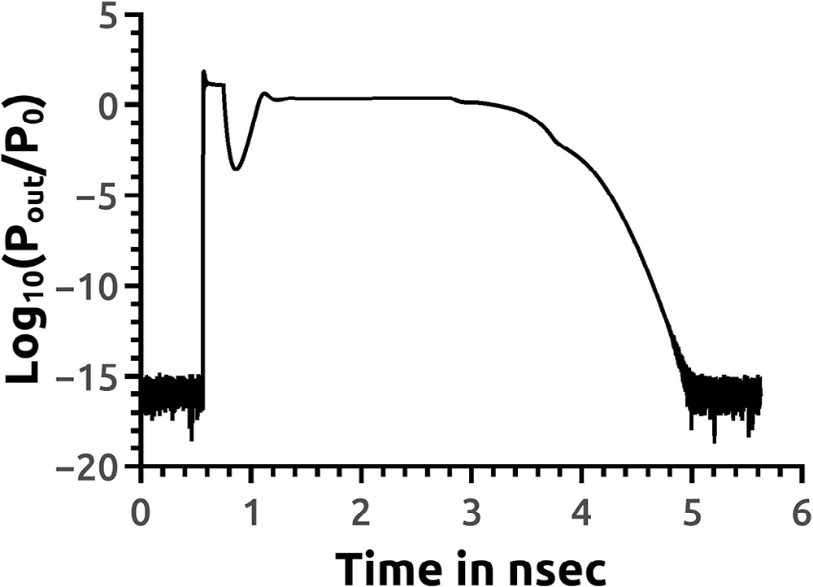

**Fig. 10 – Output optical power during “ON/OFF” (“Set/Reset”) operations.**

“ON/OFF” transitions are simulated in time domain. A “Set”

pulse followed by a “Reset” pulse are injected to the structure at *z* = 0, and the optical fields are simulated for 5.625 ns. A “Set”

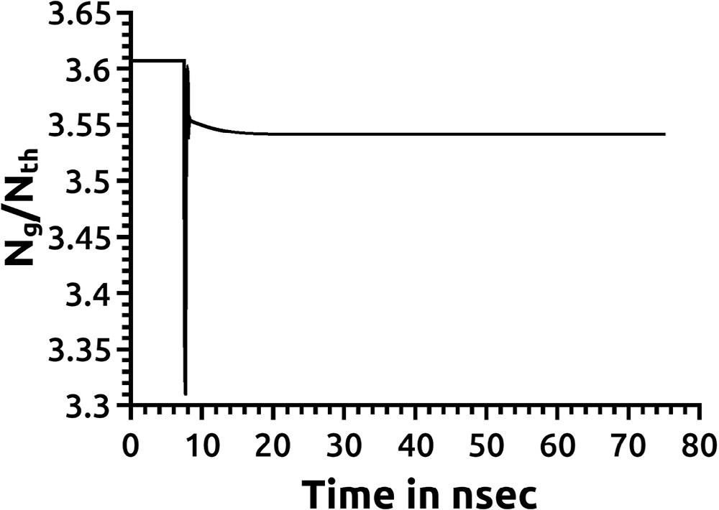pulse of power *P* = *P*0 and width 0.1875 ns (9.375  103 picojule), at *ω* = *ω*1 and *t* = 0.5625 ns switches the flip-flop “ON”. Another pulse at *t* = 2.8125 ns, of power *P* = *P*0, pulse width 0.9375 ns (*ω* = *ω*2, 46.875  103 picojule) switches the Flip-Flop “OFF”. The output field at *z* = *L* is shown in Fig. 10. The evolution of *Nc*/ *N*0, and *Ng Ntr* with time at *z* = 7*L*/8 are shown in Figs. 11 and 12 respectively.

The “Reset” pulse at *ω* = *ω*2 is amplified in the first half of the device. In section “2”, the pulse is absorbed almost

completely due to large attenuation coefficient. The amplifi- cation of pulse in that section is neglected compared to the large attenuation by the semiconductor of band gap *Eg*  *h*2 . The “Reset” pulse reduces the gain of the optical laser mode

at *ω* = *ω*1 by XGM. When the optical gain of the laser mode is reduced, the photons absorbed in section “3” are reduced, and

also the electron hole pairs generated in the wave-guiding layer in that section are reduced, the refractive index increases and

**Fig. 8 – *Ng Nth* evolution at *z* = 7*L*/8.**

the detuning is restored to its value in the “OFF” state. The

egyptian journal of basic and applied sciences 3 (2016) 322–328

**327**

### Fig. 11 – *Nc*/*N*0 evolution during “Set/Reset” operation at

***z* = 7*L*/8.**

### Fig. 13 – Refractive index distributions during “Set/Reset”

**operations at different time frames.**

“Reset” pulse at *ω* = *ω*2 is totally absorbed in section “2”, it does not reach section “3”, and does not affect the electron hole den-

sities in section “3”. As the “Reset” pulse is absorbed in section “2”, it generates electron hole pairs that changed the detuning for the laser mode along that section. The refractive index dis- tributions during “Set/Reset” operation in both sections “2” and “3” at successive time frames are shown in Fig. 13.

## *Multiple “Set/Reset” operations*

Multiple “Set/Reset” operations are simulated in the time domain for 45 ns. The input pulses at *z* = 0 are shown in Fig. 14. Each “Set” pulses is followed by a “Reset” pulse after 9 ns. “Reset” pulse is followed by a “Set” pulse after 6 ns. The input “Set” pulse of

*P* = *P*0 has pulse width 0.1875 ns (9.375  103 picojoule at *ω* = *ω*1). The “Reset” pulse of *P* = *P*0 has pulse width 0.9375 ns ( 46.875  103 picojoule at *ω* = *ω*2) switches the Flip-Flop “OFF”. The output optical power at *z* = *L* is shown in Fig. 15. The time evolution of *Nc*/*N*0 *z* = 7*L*/8 during multiple “Set/Reset” opera- tions is shown in Fig. 16. *Ng Ntr* time evolution is plotted in Fig. 17.

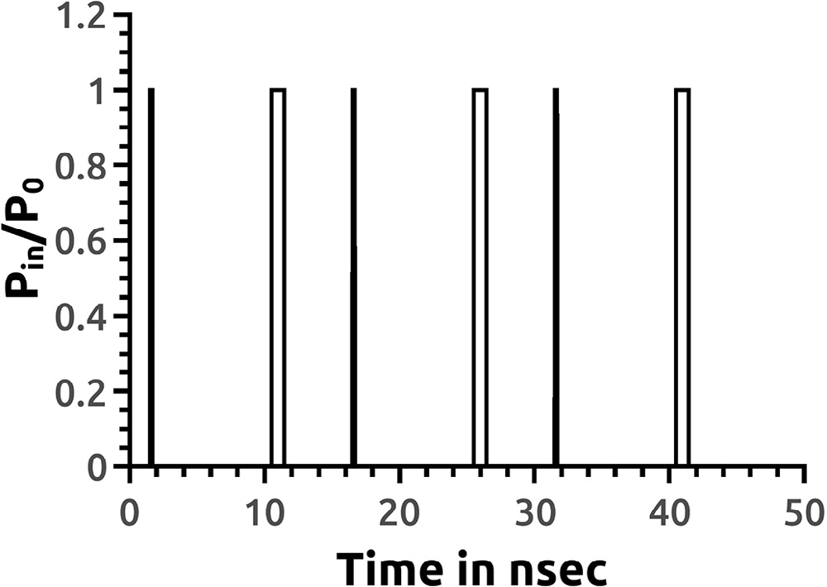

### Fig. 14 – Input signal.

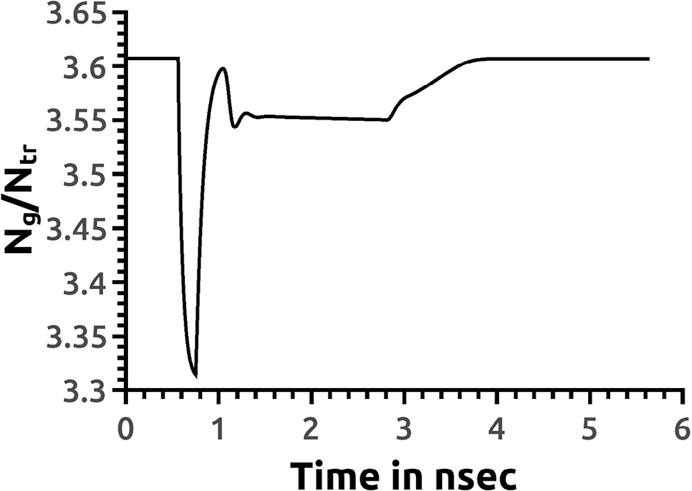

**Fig. 12 – *Ng Ntr* evolution during “Set/Reset” operation at**

***z* = 7*L*/8.**

### Fig. 15 – Output optical field at *z* = *L.*

**328** egyptian journal of basic and applied sciences 3 (2016) 322–328

### Fig. 16 – *Nc*/*N*0 evolution with time at *z* = 7*L*/8.

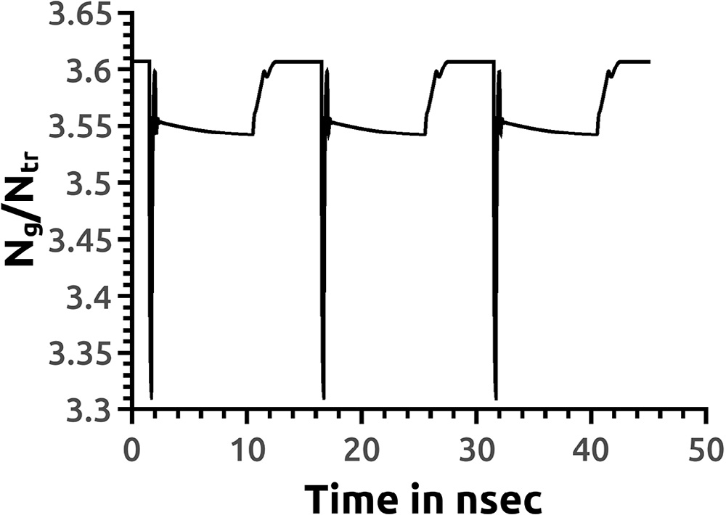

**Fig. 17 – *Ng Nth* evolution with time at *z* = 7*L*/8.**

# Discussion

The device operation requires altering the band gap of the semi- conductor material in the wave-guiding layer. This could be done as the device is fabricated from *InGaAsP* alloy on *InP* sub- strate. By changing the percentage of the *InGaAsP* alloy ingredient, the band gap could be changed [18]. The extinc-

tion ratio is *Log*10 *PON POFF*  *≃* 15, and no holding beam is

required for bi-stable operation. During “Set” operation the output optical field takes 0.5 ns to stabilize; however *Nc* takes about 10 ns to reach its steady state value ( *Nc * *N*0  3.5) (Fig. 7); however, an input pulse with higher energy can lead *Nc* to reach steady state in a shorter time. During “Set/Reset” operation (Fig. 10), a “Reset” pulse of width 0.9375 ns is injected to the device; however, the output optical output power takes about 2 ns to reach the optical level of the “OFF” state. The “Reset” dynamics in time domain are shown during *Nc* transition state (before *Nc* reaches transition state) in case of single “ON/OFF” (or “Set/Reset”) operation (Figs. 10–12) and at the end of *Nc* tran- sition state (9 ns after “Set” pulse) during multiple “Set/Reset” operation (Figs. 15–17).

# Conclusion

In this work, an all-optical flip-flop based on a non-linear semi- conductor DFB laser structure is introduced.The “Reset” mecha- nism uses an optical pulse of a shorter wavelength than the “Set” pulse wavelength. The device could be built using *InGaAsP* alloy. Simulations show that a “Set” pulse of 0.1875 ns pulse width switched the device “ON” and optical mode stabilizes in

0.5 ns. A “Reset” pulse of 0.9375 ns pulse width switches the de- vice “OFF” in 2 ns. The switching dynamics are in nanoseconds time scale and it is suitable for all optical data packets routing.

R E F E R E N C E S

1. [Dorren HJS, Hill MT Liu, Y, Calabretta N, Srivatsa A,](http://refhub.elsevier.com/S2314-808X(16)30013-6/sr0010) [Huijskens FM, et al. Optical packet switching and buffering](http://refhub.elsevier.com/S2314-808X(16)30013-6/sr0010) [by using all-optical signal processing methods. J Lightwave](http://refhub.elsevier.com/S2314-808X(16)30013-6/sr0010) [Technol 2003;21(1):2–12.](http://refhub.elsevier.com/S2314-808X(16)30013-6/sr0010)
2. [Li P, Wang Y, Zhang J. All-optical fast random number](http://refhub.elsevier.com/S2314-808X(16)30013-6/sr0015) [generator. Opt Express 2010;18(18):20360–9.](http://refhub.elsevier.com/S2314-808X(16)30013-6/sr0015)
3. [Martin T, de Waardt H, Khoe GD, Dorren HJS. All-optical](http://refhub.elsevier.com/S2314-808X(16)30013-6/sr0020)

[flip-flop based on coupled laser diodes. IEEE J Quant Electron](http://refhub.elsevier.com/S2314-808X(16)30013-6/sr0020) [2001;37(3):405–13.](http://refhub.elsevier.com/S2314-808X(16)30013-6/sr0020)

1. [Hill MY, Dorren HJ, De Vries T, Leijtens XJ, Den Besten JH,](http://refhub.elsevier.com/S2314-808X(16)30013-6/sr0025) [Smalbrugge B, et al. A fast low-power optical memory based](http://refhub.elsevier.com/S2314-808X(16)30013-6/sr0025) [on coupled micro-ring lasers. Nature 2004;432:206–8.](http://refhub.elsevier.com/S2314-808X(16)30013-6/sr0025)
2. [Liu L, Kumar R, Huybrechts K, Spuesens T, Roelkens G Geluk](http://refhub.elsevier.com/S2314-808X(16)30013-6/sr0030) [EJ, et al. An ultra-small, low-power, all-optical flip-flop](http://refhub.elsevier.com/S2314-808X(16)30013-6/sr0030) [memory on a silicon chip. Nature Photon 2010;4:182–7.](http://refhub.elsevier.com/S2314-808X(16)30013-6/sr0030)
3. [Huybrechts K, Morthier G, Baet R. Fast all-optical flip-flop](http://refhub.elsevier.com/S2314-808X(16)30013-6/sr0035) [based on a single distributed feedback laser diode. Opt](http://refhub.elsevier.com/S2314-808X(16)30013-6/sr0035) [Express 2008;16:11405–10.](http://refhub.elsevier.com/S2314-808X(16)30013-6/sr0035)
4. [Kaplan AM, Agrawal GP, Maywar DN. All-optical flip-flop](http://refhub.elsevier.com/S2314-808X(16)30013-6/sr0040) [operation of VCSOA. Electron Lett 2009;45(2):127–8.](http://refhub.elsevier.com/S2314-808X(16)30013-6/sr0040)
5. [Kawaguchi H. Bistable laser diodes and their applications:](http://refhub.elsevier.com/S2314-808X(16)30013-6/sr0045) [state of the art. IEEE J Sel Top Quantum Electron](http://refhub.elsevier.com/S2314-808X(16)30013-6/sr0045) [1997;3(5):1254–70.](http://refhub.elsevier.com/S2314-808X(16)30013-6/sr0045)
6. [Odagawa T. Bistable semiconductor laser diode device, US](http://refhub.elsevier.com/S2314-808X(16)30013-6/sr0050) [Patent, 5007061, 9 April, 1991.](http://refhub.elsevier.com/S2314-808X(16)30013-6/sr0050)
7. [Zoweil H. Numerical simulation of a novel all-optical](http://refhub.elsevier.com/S2314-808X(16)30013-6/sr0055)

[flip-flop based on a chirped nonlinear distributed feedback](http://refhub.elsevier.com/S2314-808X(16)30013-6/sr0055) [semiconductor laser structure using GPGPU computing.](http://refhub.elsevier.com/S2314-808X(16)30013-6/sr0055)

[J Mod Opt 2015;62(9):738–44.](http://refhub.elsevier.com/S2314-808X(16)30013-6/sr0055)

1. [Pankove JI. Absorption edge of impure gallium arsenide.](http://refhub.elsevier.com/S2314-808X(16)30013-6/sr0060) [Phys Rev 1965;140(6A):A2059–65.](http://refhub.elsevier.com/S2314-808X(16)30013-6/sr0060)
2. [Dow JD, Redfield D. Toward a unified theory of Urbach’s rule](http://refhub.elsevier.com/S2314-808X(16)30013-6/sr0065) [and exponential absorption edges. Phys Rev B 1972;5:594–](http://refhub.elsevier.com/S2314-808X(16)30013-6/sr0065) [610.](http://refhub.elsevier.com/S2314-808X(16)30013-6/sr0065)
3. [Agrawal GP, Dutta NK. Semiconductor lasers. New York:](http://refhub.elsevier.com/S2314-808X(16)30013-6/sr0070) [Kluwer Academic Publisher; 2003.](http://refhub.elsevier.com/S2314-808X(16)30013-6/sr0070)
4. [Carrol J, Whiteaway J, Plumb D. Distributed feedback](http://refhub.elsevier.com/S2314-808X(16)30013-6/sr0075) [semiconductor laser. London: IEE; 1998.](http://refhub.elsevier.com/S2314-808X(16)30013-6/sr0075)
5. [Bennett BR, Soref RA, Del Alamo JA. Carrier-induced change](http://refhub.elsevier.com/S2314-808X(16)30013-6/sr0080) [in refractive index of InP, GaAs, and InGaAsP. IEEE J Quant](http://refhub.elsevier.com/S2314-808X(16)30013-6/sr0080) [Electron 1990;26(1):113–22.](http://refhub.elsevier.com/S2314-808X(16)30013-6/sr0080)
6. [Haug H editor. Optical nonlinearities and instabilities in](http://refhub.elsevier.com/S2314-808X(16)30013-6/sr0085) [semiconductors. New York: Academic Press; 1988.](http://refhub.elsevier.com/S2314-808X(16)30013-6/sr0085)
7. [Programming Guide (PDF) – v7.5 – Last updated September 1,](http://refhub.elsevier.com/S2314-808X(16)30013-6/sr9000) 2015. Copyright © 2007–2015 NVIDIA Corporation <[https://](https://docs.nvidia.com/cuda/pdf/CUDA_C_Programming_Guide.pdf) [docs.nvidia.com/cuda/pdf/CUDA_C_Programming](https://docs.nvidia.com/cuda/pdf/CUDA_C_Programming_Guide.pdf)

[_Guide.pdf](https://docs.nvidia.com/cuda/pdf/CUDA_C_Programming_Guide.pdf)>.

1. [Adachi S. Physical properties of III-V semiconductor](http://refhub.elsevier.com/S2314-808X(16)30013-6/sr0095) [compounds: InP, InAs, GaAs, GaP, InGaAs, and InGaAsP.](http://refhub.elsevier.com/S2314-808X(16)30013-6/sr0095) [New York: Wiley; 1992.](http://refhub.elsevier.com/S2314-808X(16)30013-6/sr0095)