

[Egyptian Informatics Journal (2010) 11, 39](http://dx.doi.org/10.1016/j.eij.2010.06.006)–[48](http://dx.doi.org/10.1016/j.eij.2010.06.006)

Cairo University

Egyptian Informatics Journal

[www.elsevier.com/locate/eij](http://www.sciencedirect.com/science/journal/11108665) [www.sciencedirect.com](http://www.sciencedirect.com/science/journal/11108665)

ORIGINAL ARTICLE

Smart e-Learning: A greater perspective; from the fourth to the fifth generation e-learning

Shehab A. Gamalel-Din

*King Abdulaziz University, Faculty of Computing and Information Technology, Jeddah, KSA, Kingdom of Saudi Arabia Al-Azhar University, Systems and Computers Engineering Department, Cairo, Egypt*

Received March 2009; accepted 25 May 2010

Available online 22 July 2010

Abstract Distance learning has gone through four generations over more than a century. Those four generations, though have elevated the level of interaction between the student and his distant instructor and classmates, are still lacking an essential component for effective teaching, namely customizing the delivery of a course in terms of the material and the style of teaching according to the student profile. In traditional classrooms, the human teacher utilizes his experience and intel- ligence to adapt the teaching method and style to meet the average student in the classroom.

This research has focused on improving the effectiveness and quality of web-based e-learning through adapting the course authoring and delivery to match each individual student skills and preferences. In this article, we shed lights on the vision and status of the eight-year Smart e-Learn- ing environment project: The main objective of this project is to employ AI techniques to advance e- learning forward towards the fifth generation e-learning as we envision it. The idea is to embed instructional design theories as well as learning and cognition theories into e-learning environments to provide a more intelligent and, hence, more effective one-to-one e-learning environments. This article only gives a high level overview; however, the more interested reader will be referred to arti- cles describing the work in more technical details.

KEYWORDS

Student model; Cognitive model; Learning style; Domain ontology; Adaptive e-learning; Learning objects; Intelligent e-learning environments

© 2010 Faculty of Computers and Information, Cairo University. Production and hosting by

Elsevier B.V. All rights reserved.

E-mail address: [drshehabg@yahoo.com](mailto:drshehabg@yahoo.com)

1110-8665 © 2010 Faculty of Computers and Information, Cairo University. Production and hosting by Elsevier B.V. All rights reserved.

Peer review under responsibility of Faculty of Computers and Infor- mation, Cairo University.

doi:[10.1016/j.eij.2010.06.006](http://dx.doi.org/10.1016/j.eij.2010.06.006)

Production and hosting by Elsevier

1. Introduction: The Smart e-Learning’s global vision – a paradigm shift in education

Educated and skilled human resources and workers are real as- sets and keys of success and power for both nations and organi- zations. However, several challenges exist. Using the internet and WWW to support teaching and to deliver education and training is one way to overcome some of these challenge. This multimedia rich environment added new dimensions in design- ing course contents. It also created several models of education,

40 S.A. Gamalel-Din

such as self-paced, interactive, collaborative, and virtual classes. Web-based content delivery made course materials, announce- ments, electronic libraries, and other information accessible through carefully designed web pages. Interactive learning envi- ronments both asynchronously and synchronously are now available. However, the question of effective quality education still remains. Having such fascinating capabilities, however a question still remains; how can learning systems properly utilize such capabilities for a more effective learning process? In other words, what is the best teaching method to use for a specific stu- dent or group of students knowing that every one has his/her own learning objectives, motivations, knowledge, and skills, which are essential in tailoring a course material? On the Inter- net, now a day, most learning concepts could be found available in a multi-different ways of representation; the question is how to pick the most appropriate one for a specific course experience, especially that they are mostly heterogeneous and expressed in a non-unified format.

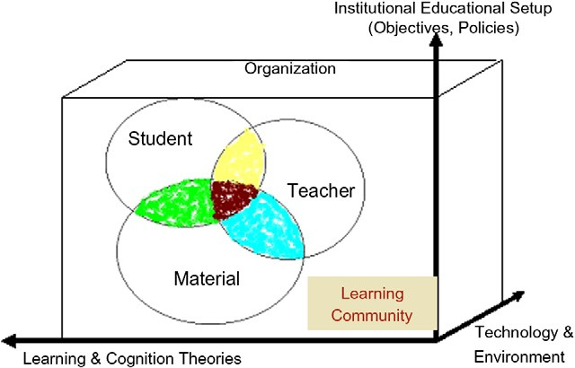

The philosophy of the Smart e-Learning’s vision is after empowering the student’s learning ability as well as empower- ing the teacher for smarter course preparation and delivery. It introduces a new model for e-learning to achieve such objec- tives. Accordingly, this proposed model guides students to use their intelligence and knowledge, rather than using knowl- edge and intelligence to guide learning through a rigid problem solving process. The idea is to help the student to:

* Learn to learn,
* Set cognitive goals,
* Facilitate problem comprehension, and
* Develop skills for self-monitoring and organizing knowledge.

In addition, the proposed model also intelligently guides the teacher through the process of course design. It helps him to:

* Properly set course objectives according to education theories.
* Properly understand the student(s) model: Imagine their cognitive models, skills, and traits,
* Intelligently determine the concepts to be covered and the best methods to present those concepts to the students according to their cognitive models, and
* Search for the best available assets and learning objects that achieve such criteria.

Figure 1 The envisioned Smart e-Learning’s model.

The model of the Smart e-Learning, as shown in Fig. 1, focuses on the major triad of the learning process – namely, the student, the teacher, and the material. This triad is a part of a learning community through which members should be properly coordinated for gaining maximum outcomes with minimum efforts through effective collaborative team work- ing. This could be achieved through a collaborating e-learning environment [1] that is governed by the coordination protocols and rules of the educational organization in charge. Notewor- thy, this learning organization works under three delimiters:

* The objectives and policies of the institutional educational setups at large,
* The currently available technology and its acceptance by the learning community, and.
* The current status of education, learning, and cognition theories and the pedagogical educational methods.

The learning environment should provide necessary tools to coordinate the relationships between the different elements of the educational triad, namely, the student, the teacher, and the material, yet should still be governed by the umbrella of this whole infrastructure.

Fortunately, in the era of the Internet, open sources of information intensively exist; and hence, material and learning material became available; also sharing and reusing them is gracefully allowed. Accordingly, instructors can use such learning material in preparing their courses. Sharing and reus- ing of teaching materials reduces the cost of designing new courses, saves the time of rewriting, and avoids duplicating efforts.

However, one of the most formidable tasks for educators is shaping their presentations of core knowledge to meet the indi- vidual needs of learners with varied and diverse cognitive and psychological traits [2]. In order to achieve such a goal, two is- sues must be considered. First, a detailed model of the individ- ual student which is called Student Model (SM) must be maintained and, second, learning materials must be composed of small granular multimedia objects referred to as Learning Objects (LOs).

Student models should be used for tailoring the teaching strategy and dynamically adapting it according to the student’s abilities and previous knowledge [3]. Student Models are often based on various different dimensions. The focus of our research group is on some of those dimensions, namely, the cognitive model: learning style, thinking style, etc. A learning style is de- fined, among many definitions, as ‘‘the unique collection of indi- vidual skills and preferences that affect how a student perceives, gathers, and process learning materials’’ [4]. In Section 2, we give a more detailed description on learning style models and their impact on the effectiveness of the learning process.

Furthermore, each multimedia LO must be designed to suit a specific individual student according to his/her specified stu- dent model. However, those Learning objects may be drawn from Learning Objects Repositories (LOR) that are specified using standard metadata formats, such as SCORM [5] and IEEE LOM [6]. Learning objects selection is based on proper identification of the appropriate values of metadata attributes specifying the required material. In this research we suggest adapting the LO metadata standards by adding extra attri- butes necessary for supporting the concepts of student model, especially the dimension of the learning styles.

Smart e-Learning: A greater perspective; from the fourth to the fifth generation e-learning 41

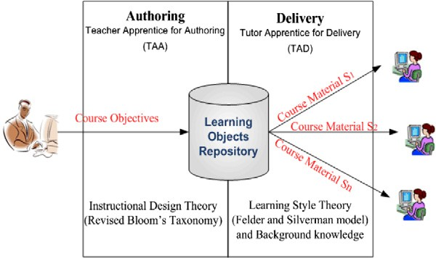

Figure 2 Adapted LOR is central to the whole e-learning lifecycle.



**[1]**

**Authoring**

**Cognition- Augmented LOR & Ontology**

**[2]**

**Delivery**

This research envisions adapted LOs that accommodate the concept of learning styles as a central component to all pro- cesses throughout the lifecycle of e-learning, as depicted by Fig. 2. Course authors should design their courses with their students’ styles in mind, course delivery should match the stu- dent style, and student assessment should also be adapted to match each specific student’s learning style, while student port- folio helps identifying the student model. In addition, many education support tools could also be designed around the concepts of learning styles to reveal better results [7]. Examples of such tools that our research project is researching are Smart eNoteBook [8] and Smart OfficeHours Assistant [technical report to appear].

An Overview on the Smart e-Learning Environment research project is presented in Section 2, while more details on the several research subprojects implementing the ideas and philosophy behind the model supported by Smart e-Learning are presented in Section 3. Section 4 outlines the experimental strategy and approach followed so far for verify- ing and assessing this work. Finally, a conclusion on the results uncovered by this research is presented in Section 5 with a highlight on some future research directions as seen by now.

1. Smart e-Learning environment –– the research project

Fig. 3 depicts the main stream of the Smart e-Learning Envi- ronment (SELE), namely, course authoring and adaptive delivery. This main stream is composed of two main processes; one for authoring assistance –– the Teacher Apprentice for

Figure 3 The general model of the main stream of SELE.

Authoring (TAA) –– and one for delivery assistance –– Tutor Apprentice for Delivery (TAD). Two theories are utilized: first, the revised Bloom’s instructional design theory [9] to adjust course objectives and accordingly organize course materials, and second, the Felder and Silverman learning style theory

[10] for adapting course delivery according to each individual student model. On one hand, during course preparation, the LOs selection process goes through a series of objectives rewriting steps each of which handles the specified objectives from a different angle. On the other hand, the LO delivery pro- cess goes through two main steps – namely, selection and sequencing strategy – according to each individual student’s model: both background and learning style.

* 1. *Central knowledge-base generation*

Fig. 4 presents the two main processes of: (1) generating the SELE’s knowledgebase––namely, the domain ontology and the LO Repository––out of the instructor submitted hyperme- dia learning material; (2) Identifying the main elements of the student model––namely, the learning style and the background knowledge––for each individual student.

The first process assumes that the instructor, through a gi- ven GUI, provides an Annotated Table of Contents (ATOC) as shown in Fig. 5a, which is then automatically converted into an equivalent XML as shown in Fig. 5b. This XML presenta- tion is the basis for building the specially designed Hypermedia domain Ontology, as shown in Fig. 6, which not only imple- ments several relationships but also incorporates all the six lev- els of the revised Bloom’s taxonomy. The Book Ontology is a Concept-Relationship model inter-relating the different ldomain concepts. Some of the concept relationships, such as aggregate and precede relationships, can be deduced directly from the TOC structure and section numbers, while others, such as prerequisite, analogy and super concept relationships, are assumed to be provided by the instructor and specified by the TOC annotations as in Fig. 5a.

On the other hand, creating the LO Repository is the sec- ond essential step in preparing the Smart Central knowledge- base. Again, this step requires the aid of the instructor and which is received through SELE’s GUI. Fig. 7 shows the type of information required from the instructor (Fig. 7a) to pro- vide for SELE to generate the XML specification of the corre- sponding LOs (Fig. 7b).

* 1. *Accommodating the revised bloom’s taxonomy in the selection of LOs*

The Authoring Engine of SELE, which is activated during course preparation by the authors, receives a high level tea- cher’s objective and then applies the revised Bloom’s taxon- omy employing the specially designed ontology that specifies the pre-requisite relationships among the concepts in terms of Bloom’s taxonomy levels (as shown in Fig. 7). Several cat- egories of rewriting rules are applied in sequence:

* + - Category#1: Rewriting rules based on the domain ontology of concepts and relations (HAS_PARTS and SUGGESTED_ ORDER).
    - Category#2: Rewriting rules based on the domain ontology and course prerequisite requirements.

42 S.A. Gamalel-Din

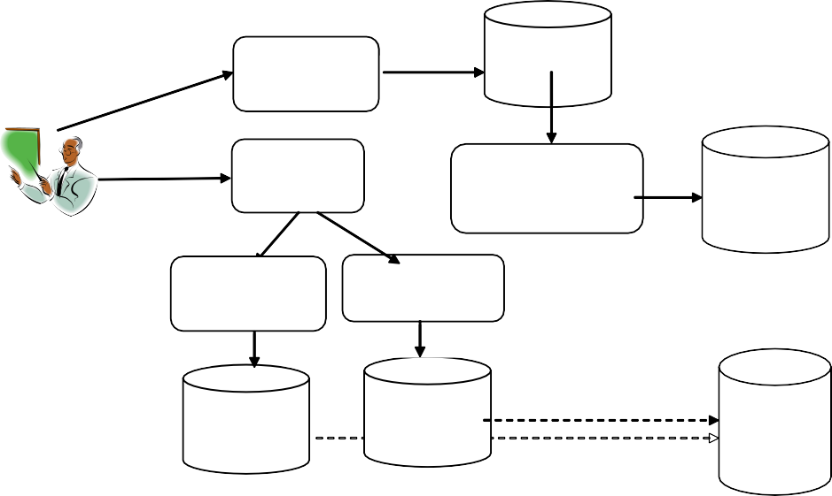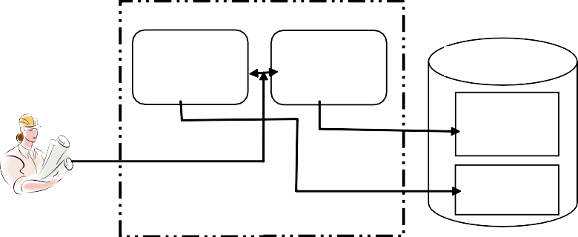

**Book Ontology**

**Book Ontology Builder**

**Book Ontology**

**LO Extractor**

**Incremental General Ontology Builder**

**Domain knowledge Ontology**

**Instructor**

**LO Metadata Builder**

**LO Relationship Builder**

**LO Metadata**

**LO Relations**

**Central Knowledge-Base Generator**

**LO Metadata attributes**

**LO**

**Relationship Model**

**LO**

**Repository**

**Learning Style Identifier**

**Background Knowledge Identifier**

**Student Model**

**Background Knowledge**

**Learning Styles**

**Student**

**Student Model Identifier**

Figure 4 The knowledge base building processes.

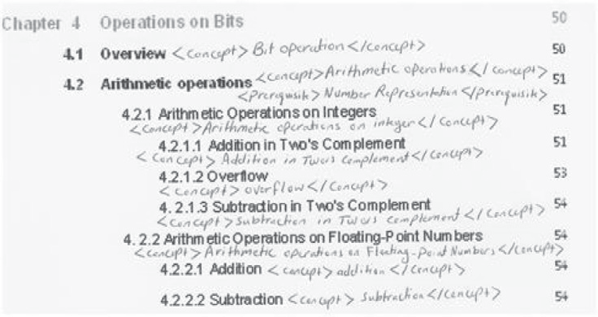

**<OperationsonBits>**

**<overview>**

**<Consept>Bit OPeration </Consept>**

**</overview>**

**<ArithmeticOperation>**

**<Consept>Arithmetic Operation </Consept>**

**<Prerequisite> Number Representation </Prerequisite>**

**<ArithmeticOperationonintegers>**

**<Consept>ArithmeticOperationonintegares</Consept>**

**<AdditioninTwosComplement>**

**<Consept>Addition in Twos Complement</Consept>**

**</AdditioninTwosComplement>**

**<overflow>**

**<Consept>overflow</Consept>**

**</overflow>**

**<SubtractioninTwosComplement>**

**<Consept>SubtractioninTwosComplement</Consept>**

**</SubtractioninTwosComplement>**

**</ArithmeticOperationonintegares>**

**<ArithmeticOperationonFloatingpointNumbers>**

**(a) Annotated Table of Contents (b) Corresponding XML**

Figure 5 Annotated TOC (ATOC) with concepts and relations and its corresponding XML. (A) Annotated table of contents. (B) Corresponding XML.

* + - * Category#3: Rewriting rules specifying both instructional and assessment strategy based on Bloom’s taxonomy.

In order for the authoring engine to pool up with the appropriate objects satisfying the rewritten objectives and serv- ing the Revised Bloom’s Taxonomy (RBT) requirements, our research suggested adding some extra attributes to the LO’s

specification standard. The selection process depends mainly on the values of those specific attributes satisfying the rewrit- ten objectives. The instructional theory gives attention to both exposition and assessment. Accordingly, a *classifying attribute* groups the learning objects into two categories – namely, expo- sitional and assessment objects. Another attribute is suggested to specify an LO according to the RBT level it supports, i.e.,

Smart e-Learning: A greater perspective; from the fourth to the fifth generation e-learning 43

Figure 6 Central ontology – A.

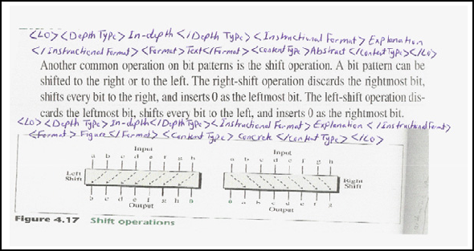

**Shift Operations**

63

**LO1 <LO> <DepthType>In-depth</DepthType>** 64

**<InstructionalFormat> Undefined </ InstructionalFormat> <Format> Text**

**</Format> <ContentType> Abstract**

**</ContentType>**

**LO2 <LO> <DepthType>In-depth</DepthType>** 64

**<InstructionalFormat> Undefined </ InstructionalFormat> <Format> Figure**

**</Format> <ContentType> Concrete**

**</ContentType>**

4.3.4.3 Flipping Specific Bits

62

**Summary**

65

**(a) Annotated Book Page (ABP) Determining LOs and their Attributes (b) Internal Worked TOC (IWTOC)**

Figure 7 Original materials and internal worked TOC. (A) Annotated Book Page (ABP) Determining Los and their attributes. (B) Internal Worked TOC (IWTOC).

one of the six levels. Teaching strategy is a third attribute that we suggested; the values of which might be, for example, expository or inquisitor presentations. A fourth attribute used by SIA is the instructional role, whose suggested values satis- fying effective strategies supporting the first three levels of RBT are shown in Table 1.

* 1. *Accommodating Felder and Silverman Model (FSLSM) in the selection of LOs*

To support the teaching techniques as suggested by FSLSM few extra attributes are added to the LO metadata. In this re- search, we focused only on three of the FSLSM’s dimensions, namely, Global/Sequential, Sensing/Intuitive and Visual/Ver- bal. Table 2 summarizes the guidelines that are suggested by Smart e-Learning when designing LOs to support each learn- ing style. Table 2 also outlines guidelines used in directing the selection strategy during the delivery phase.

1. Smart e-Learning environment and products––current research status

For more than eight years of the Smart e-Learning project, several research sub-projects focusing on designing e-learning tools and environments that embed educational theories and concepts with a central objective of utilizing Learning Objects Repositories (LOR) for sharability purposes. Fig. 8 depicts the research efforts and demonstrates how those projects are centered around two important knowledge based compo- nents, namely LOR (or actually the LO metadata) and do- main ontology, which are both adapted to embed the new models of the student model and the learning theories, espe- cially learning styles a background knowledge. Of course such knowledge bases are not simple databases; they rather have intra-relationships that complicate the model. A briefing on the function of each of those tools and environments will be described shortly.

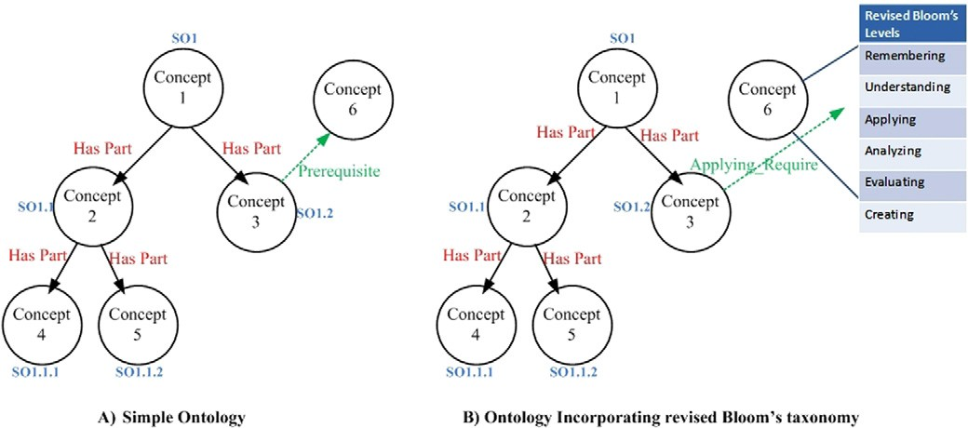

Table 1 The suggested LO attributes to support RBT.

Remembering level

Understanding level Applying level

Introduction, overview, definition, fact, remark, remembering example

Explanation, description, illustration, comparison, summary, conclusion, understanding example Theory, rule, procedure, algorithm, exercises, case study, real world problem, applying example

Table 2 Accommodating FSLSM dimenstions to guide the selection and presentation strategy.

Learning style dimension LO type and selection strategy

Visual Pictures, graphs, diagrams, flowcharts, schematics, concepts maps, animation, video, schematics and highlighted text Verbal Text and audio

Sensing Concrete concept such as facts, experimentation and example followed by explanation Present more examples than for ‘‘intuitive’’

Present examples before explanations

Intuitive Abstract concept such as theory, principle, explanation, and mathematical formulas Present explanation and then examples

Sequential Small chunks of information, with ‘forward’ and ‘backward’ navigation ability Global Table of contents, summary, and overview of information

Random jumps through hyperlinks for more information

**LOR**

**Domain Ontology**

**Central Cognition- augmented Knowledgebase**

**Smart Office Hours Assistant**

**Adaptive Delivery Environment**

**Smart Assessor & Grader**

**Smart Instructors Assistant**

**Smart Authoring Environment**

**Smart**

**e-NoteBook**

**Smart Coach**

Figure 8 The knowledge base is central to e-learning tools and environments.

Obviously, the efficiency of such central knowledge bases will not only impact the efficiency but also the workability of such tools and environments that are currently researched or will be investigated in the future. By efficiency, it is meant the efficiency of their operation, the richness, correctness, and completeness of their content, and more importantly the easiness and efficiency of the process of creating them. Sec- tion 4 reviews the initiated activities to verify Smart e-Learn- ing’s hypotheses.

* 1. *Products of the Smart e-Learning environment project- current research status*

Several components have been worked out under different research projects to support the global vision of the Smart e-Learning paradigm. Components are viewed as supportive to the relationships among the different elements of the educa- tional triad. Those components are briefly described below.

1. Learning Environment Architectures: This research has worked out the design of collaborating learning environments through four research projects – namely, Smart Authoring, LetUS Assist, Smart Instructor Apprentice, and IVCR:
   1. Smart Authoring Environment [11]: This research designed a platform independent framework to support mate- rial interoperability, software reusability, and system scalabil- ity. This research aims to support teachers in properly

authoring their courses and in selecting the appropriate course material and presentation techniques required to meet specific course objectives for a specific student or group of students knowing the exact student model of knowledge and skill set and taking into consideration that more understanding of the student model might be gained during the course conduc- tion, and hence dynamic adaptation to the course strategy and material is highly expected.

* 1. The Teamwork Coordinator (LetUs Assist) [1]: This research introduced architecture, LetUs Assist, to aid the members of a learning community in maintaining a consistent common behavior. Such a behavior is modeled in adaptive knowledge-based preference profiles and hence, the objective of this architecture is to direct members’ behaviors accordingly and to adapt and maintain such a profile consistently with all members.
  2. Smart Instructor Apprentice [12]: This research investi- gated the criteria affecting the selection of LOs from standard repositories to support both students and teachers for effective learning process based on specified course objectives. In essence, the LOs selection process goes through a series of objectives rewriting steps each of which handles the specified objectives from a different angle. The first category of rules re- writes the course objectives for projecting Bloom’s taxonomy on both the instructional and assessment approaches and, hence specifying the most appropriate criteria for LOs selec- tion and teaching strategy. Second, the student’s subject

knowledge and his/her achieved level, which are then com- pared against both the domain knowledge ontology and the course prerequisite requirements. This step rewrites the objec- tives by adding/removing knowledge objectives to satisfy miss- ing/already-achieved knowledge. In the third rewriting step, the student’s learning style is employed to consider the best way for delivering the target objectives.

1. Relationship among Student, Teacher, and Material: Another category supports the relationship between the three elements of the triad: the student, the teacher, and the course material through proper design of the material according to the student model and then managing the course delivery during asynchronous sessions. In this category are the Smart Tutor (ST) and the Smart e-NoteBook.
2. The Smart Tutor (ST) [2]: It is a web-based intelligent tutoring system. It is a prototype design for experimenting with the hypothesis that there are some important characteris- tics that are essential in designing an effective ITS, such as: adaptive teaching strategies, student models that are based on background knowledge and skills, and teaching approaches suiting specific skill sets. Another hypothesis is that the cogni- tive model of instructors, like all other experts in their fields, leads them to retrieve their previous teaching experiences, select one or more that are more close to the current situation, and adapt them for reuse. These adapted course plans are added to their repository of experience. These are cases in the goldmine of experience repository of the instructor.
3. Smart e-NoteBook [8]: It is an adaptive multimedia hyperlinked learning material management environment that supports students (or any users, such as researchers, teachers, writers, etc) during their different modes of use (study, review, or research to answer a question). Smart e-Notebook takes the instructor provided multimedia material that is not necessarily prepared for a specific person (let us call it e-Notebook), and generates many personalized editions of MySmart e-Note- Books one for each individual student that better suits his per- sonal student model. The student model attributes that the Smart e-Notebook considers are the learning style (according to Felder-Silverman model) and the domain knowledge. To fulfill its task, Smart e-NoteBook assumes that the input e-Notebook multimedia course material submitted by the instructor to be presented in the form of Learning Objects (LOs).
4. The Relationship Between the Student and Teacher: We worked out two components under this category: The Smart Coach (ST) and The Smart Grader (SG).
5. The Smart Coach (SC) [13]: It is an intelligent computer- ized coaching system that monitors students’ actions during problem solving sessions and advises them when needed. This research introduced the concept of Intelligent Coaching Sys- tems (ICS) that are supposed to integrate to the Smart Tutor (ST) for more empowerment. Smart Coach is a prototype that is to support students studying Lisp programming. Therefore, this research identified the characteristics of an intelligent coaching system as opposed to other active support systems, such as intelligent assistants and active intelligent help systems. It also introduced a novel approach for action plan recogni- tion, which is more suitable for the special characteristics of coaching systems.
6. The Smart Grader (SG) [14]: It is a computerized empowered intelligent grader that provides students with com- prehensive explanations on their mistakes and what would a

correct answer be. Intelligent computerized Graders would analyze students’ steps in problem solving sessions and advise them when needed. This research introduced the new concept of Intelligent Grading Systems (IGS), designed a generic framework, and implemented Smart Grader (SG) – a proto- type. SG is supposed to integrate to the Smart Tutor (ST) to provide more effective learning through grading student tests and correcting mistakes and providing advices on better ways of problem solving. This system is more appropriate in teach- ing mathematics and programming (the two experimental domains under this research).

1. The Relationship Between the Student/Teacher and Material:
2. Smart Office-hours Assistant [15]: It is an Intelligent Question Answering System (IQA) tool which simulates the same role of the instructor in answering as much questions as possible. Answers are adapted to suit each individual student according to his/her specific student model: learning style, background domain knowledge, IQ, thinking style, and motivation. To fulfill its task, Smart Office-hours Assistant assumes that the answers are already available in the form of Learning Objects (LOs).
3. The Student Model:
4. The Three Dimensional Student Model (3DSM) [3]: In this research, we introduced the concept and architecture of a proactive student modeling system (3DSM). Since people’s interests and abilities change over time. Therefore, proactive student models are expected to be more effective as they should be able not only to answer questions about the current status of knowledge and competences of a student, as reactive models do, but also to predict his future status of interests and abilities. Being proactive means that the system should under- stand and predict the user interests and abilities and, hence, suggest a suitable roadmap for his career improvement and recommend courses to take at specific sequence.

Our model is composed of three components: knowledge, personal (soft) and technical (hard) skills, and emotional state. Knowledge and skills are arranged in multi-layered networks to represent their interdependencies; and together with spe- cially designed inference rules the proactive effect is achieved. Fuzzy probability density functions are associated with each modeled variable in order to manage uncertainty. New tempo- ral operators and inference rules are specially designed to mod- el emotions.

1. Verification and assessment – current research status

It should be noted that the evaluation of the concepts sup- ported by this research and how they relate to suggested hypotheses has taken a considerable attention during the whole period of the project. Let us shed some lights on the ver- ification procedure that have been followed:

1. The learning style measuring scale (Filder & Silverman’s questionnaire) is first localized, verified, and tested to assure that it copes with the local culture (67).
2. A selected group of students from various disciplines have been chosen as subjects for the experiment. The question- naire was then distributed and applied to them. Analysis of the results revealed the validity of the tool to evaluate the learning styles of students.
   1. *Assessment of the model in terms of the viability to instructors*

Having a valid tool of learning style evaluation, an experiment to evaluate this research’s results and hypotheses was designed. First we wanted to assess the possibility and ability of none educationally-specialized academic teachers in constructing LOs with identifying the required attributes. Second, we wanted to test the effect of the idea on the students. The exper- iments were done as follows:

1. To assess the first hypothesis, two volunteered instructors were chosen; one specialized in computer science and the other in educational psychology. Each one was asked to select one of his favourite topics that he already teaches in order to prepare a lecture on; he was also asked to choose his favourite book on the topic. The first instructor has chosen a topic in binary number systems (Chapter 3 from Forouzan [16]), while the second has chosen a lecture on the left and right parts of the brain and their effect on the learning styles (the material was of his own).
2. An half-hour session was then given to them to explain the idea and to demonstrate the LO editor designed by this project.
3. In order to make slides out of the chosen chapter, each instructor is asked to divide the book material into small chunks each to compose a very simple slide. Then he was asked to describe this chunk in terms of the attributes as given by the LO editor.
4. One day was given to them before holding the second ses- sion to answer their questions.
5. A third session was held by the end of the week to review the results and to make appropriate corrections.
6. Using the detailed tables of contents and the identified LO attributes, a simple ontology was constructed only for those concepts covered by the experimental learning material.

The results in general were promising. The experiment demon- strated that it is possible, with minor training that education- ally-unspecialized academics can do the task and that creating LORs and ontology can be done incrementally follow- ing our approach and with simple tools without need for highly-skilled academics.

* 1. *Assessment of the model in terms of the effect on the learning process after delivery*

First of all, we want to make it clear that we are only employ- ing educational methods and psychological theories that be- long to specialized scientists. Our work does not involve by any means in proving or verifying any of those theories and methods, but rather only utilizing them. If any of them showed

to be incorrect or inaccurate, then it is the sole responsibility of its owner. This section discusses the evaluation of the model and its results.

One of the methods followed in evaluating the model was to conduct two experiments in each of which three groups of uniformly distributed students were formed according to Graf’s study. The students were distributed to the three groups randomly such that their GPAs are uniformly distrib- uted across the groups to become probabilistically equivalent. When the students registered to the system, she was asked to fill in a student model assessment questionnaire. Students belonging to the first group (referred to as matched group) were presented with a course that matched their learning styles. The second group (referred to as mismatched group) got a course that mismatched their learning styles. The third group (referred to as control group) was provided with a course where all available learning objects were presented in a default sequence independent of the students’ learning styles. After studying the material through the system, stu- dents were given a post-test for assessing their learning out- comes and performance.

To assess the efficiency of the learning process, the first experiment put no time limit on the students to finish studying the material; once the student finishes studying he/she was pre- sented with an assessment quiz. While the second experiment was designed to assess the effectiveness of the learning process by limiting the study time to a maximum of 1:15 hr for the stu- dent to finish studying the material after which they were pre- sented with the evaluation quiz to assess their depth of understanding. In both experiments the system measured the elapsed time per each student.

In the first experiment, the sample was of 30 volunteered students of the third year of the Information Technology Department at King AbdulAziz University who did not study any ‘‘Artificial Intelligence’’ Courses. The online lecture was composed of two subjects – depth and breadth first search strategies explaining theoretical and practical parts as well as examples.

Table 3 summarizes the results of the first experiment, which presents the mean (M) and the standard deviation (SD) of each group for both the post-test marks and the time spent in studying the material (open time was given for each individual student to finish the given material).

Analyzing the obtained results, a conclusion can be drawn as follows

* Because an open time was given for each student for per- fectly studying the presented material, the average of the post-test scores for the three groups was close, but the aver- age time spent was highly different. This neutralizes the effectiveness factor of the evaluation and focuses more on the efficiency.

|  |  |  |  |  |  |  |  |  |
| --- | --- | --- | --- | --- | --- | --- | --- | --- |
| Table 3 Statistical analysis for the results of the first experiment group.  Matched group Mismatched group Control group | | | | | | | | |
|  | M | SD |  | M | SD |  | M | SD |
| Time spent to study the course (in minutes) | 18 | 5.37 |  | 30 | 6.24 |  | 27 | 11 |
| Score of the post-test (10 marks) | 8.8 | 1.62 |  | 7.30 | 3.68 |  | 8.75 | 3 |
|  |  |  |  |  |  |  |  |  |

|  |  |  |  |
| --- | --- | --- | --- |
| Table 4 Statistical analysis for the results of the second experiment. | | | |
| Statistical function | Match group | Control group | Mismatch group |
| Average of exam grades (28 Marks) | 19.75 | 15 | 14.4 |
|  |  |  |  |

* Students of the matched group spent the least average time in the course, which confirms the hypothesis that using adapted learning material that matches the individual learn- ing style would make learning more efficient. In addition, the low standard deviation for the matched group as com- pared to the other two groups would be analyzed in favor of the presented material rather than the individual skills.
* However, analyzing the standard deviation of the post-test marks revealed that the dispersion for the matched group was the least indicating that adapting the material made weaker students achieve similarly to those stronger ones. On the other hand, the higher standard deviation of the post-test marks for the other two groups reveals a signifi- cant difference between the sample students indicating that those few high-score students (having strong individual skills) had unfairly affected the value of the mean, which still argues for the improved effectiveness of the learning process due to adapting the learning material regardless of the individual skills.

In the second experiment, a lecture was prepared for a course on data structures, in particular, the Linear List, the Stack and the Queue. The experiment took place within female students section of the Information Technology department at King AbdulAziz University. Twenty-three volunteered students par- ticipated in the experiment. Students were asked to study the material within the lecture time (1:15 h) after which each one of them went through an exam of the form of both multiple choice questions and open-ended questions in order to evalu- ate their level of understanding, and hence assessing the effec- tiveness of the study process according to the said model.

The aim of the analysis was to compare the performance of the three groups. The average of the grades obtained by the students of each group was used as a means for comparing the level of understanding of the three groups as shown in Table 4.

It is noticeable that the average of the match group is better than the average of the control group which in turn is better than the mismatch group. This actually supports the hypothe- sis of the improvement of the effectiveness of the learning pro- cess by adapting the learning material to match the learning style of each individual student.

In summary, the two experiments proved that away from the individual skills, adapting the learning material to match each individual student’s model would overcome the deficient student’s skills in favor of improving both the effectiveness and efficiency of the learning process for each individual student.

1. Conclusion and future work

This article reviewed the current status of the research project that was initiated six years ago by the author as an individual effort with support of students and which was later supported

by the e-learning chair at King AbdulAziz University (KAU) for the last four years. The main theme of this research is focusing on employing AI techniques to promote e-learning from fourth to fifth generation. The research developed many Smart tools and environments centered on the student model and supporting one-to-one adaptive e-learning. It employed theories from cognition, education, and learning. Proactive student model is also developed to model student’s traits, emo- tions, cognition, and background knowledge. A by product of the developed work is a methodology of incremental building of domain ontology and LORs out of instructor’s submitted learning material. Another contribution is the enrichment of both the LO metadata structure and the ontology relationships to accommodate learning style theories and the revised Bloom’s taxonomy.

There are still many research directions to investigate under the same lines presented in this article. Integrating all tools developed so far is one major concern as adaptation to accom- modate the central knowledgebase is expected for all tools, which in turn will expectedly lead to update in the knowledge- base model itself. Another concern would investigate methods for supporting students with special needs: super intelligent, re- tarded, etc. A third direction is investigating how to develop those knowledge-bases (ontologies and LORs) automatically from instructor’s submitted multimedia learning material.

References

1. S. Gamalel-Din, ‘‘LetUS Assist: An Architecture for Coordinat- ing Community-Based Collaborative Personal Assistant Intelli- gent Agents’’, In the Proceedings of the 10th International Conference on Artificial Intelligence Applications, Cairo, 6–9 Feb 2002.
2. S. Gamalel-Din, ‘‘The Smart Tutor: Student-Centered Case-Based Adaptive Intelligent e-Tutoring’’, In the Proceedings of the 1st International Conference on Informatics and Systems, Cairo, 17– 20 June 2002.
3. S. Gamalel-Din, ‘‘Have we forgotten Emotions? Temporal Pro- active Student Modeling’’, AUEJ, Vol 5, No. 4, Sept. 2002.
4. H. Hong and D. Kinshuk, Adaptation to student learning styles in web based educational systems. In: Cantoni L, McLoughlin C, editors. Proceedings of ED-MEDIA 2004 - World Conference on Educational Multimedia, Hypermedia & Telecommunications June 21–26. Switzerland: Lugano; 2004.
5. M. McClelland, ‘‘Metadata Standards for Educational Resources’’, Volume 36, Issue 11, Nov. 2003.
6. Learning Technology Standards Committee. IEEE Standard for Learning Object Metadata. IEEE Standard 1484.12.1, Institute of Electrical and Electronics Engineers, New York, 2002, Retrieved October 29, 2007 from <<http://ltsc.ieee.org/wg12>>.
7. S. Gamalel-Din and F. Al-Saad, ‘‘Learning styles, Learning Objects, and Adaptive e-Learning’’, Al-Azhar Engineering 10th International Conference, Cairo, December 24–26 2008.
8. S. Gamalel-Din and F. Al-Saad, ‘‘Smart E-NoteBook: an Adap- tive Hypermedia Learning Material Management Environment’’, The 7th European Conference on e-Learning, Cyprus, November 6–7 2008.
9. Anderson L and Krathwohl D. A Taxonomy for Learning Teaching, Assessing: A revision of Bloom’s taxonomy of educa- tional objectives. Addison Wesley Longman Inc: New York; 2001.
10. Felder RM. Reaching the Second Tier Learning and Teaching Styles in College Science Education. College Science Teaching 1993;23(5):286–90.
11. Gamalel-Din S, Al-Boraey F, Al-Sayed M, Noeaman A. Building an E-Learning Content Management Framework. Management Research Journal Sadat Academy of Management Science 2009.
12. S. Gamalel-Din and R. Al-Otaibi, ‘‘Smart Assistant for Adaptive Course Preparation and Delivery in E-Learning Environments’’, The 7th European Conference on e-Learning, Cyprus, 6–7 November 2008.
13. S. Gamalel-Din, ‘‘Intelligent Active Coaching – An Executable Plan Approach’’, AUEJ, Vol 5, No. 4, Sept. 2002.
14. S. Gamalel-Din and F. Al-Boraey, ‘‘The Smart Grader: An Intelligent Grading System for e-Learning Environments’’, Tech- nical Report Grant #180/426, Scientific Research Institute, KAU, 2006.
15. S. Gamalel-Din and A. Al-Ayed, ‘‘The Smart Office Hours Assistant: An Intelligent Student-Centered FAQ System’’, KAU, 2009 (to appear).
16. Forouzan BA. Foundations of Computer Science. From Data Manipulation to Theory of Computation. Brooks/Cole: Thomson Learning Inc.; 2003.