HOSTE D BY

Available online at [www.sciencedirect.com](http://www.sciencedirect.com/science/journal/2314808X)

ScienceDirect

journal homepage: <http://ees.elsevier.com/ejbas/default.asp>

[e gypti an j o ur nal o f b a sic and a p p l i ed sci e n c e s 2 ( 201 5 ) 190](http://dx.doi.org/10.1016/j.ejbas.2015.02.002) e[199](http://dx.doi.org/10.1016/j.ejbas.2015.02.002)



Full Length Article

Solution of fractional third-order dispersive partial differential equations



*A.S.V. Ravi Kanth* *a**,*\**, K. Aruna* *b*

a *Department of Mathematics, National Institute of Technology, Kurekshetra 136 119, Haryana, India*

b *Fluid Dynamics Division, School of Advanced Sciences, VIT University, Vellore 632014, Tamilnadu, India*

## a r t i c l e i n f o

*Article history:*

Received 11 June 2014 Received in revised form 22 November 2014

Accepted 8 February 2015

Available online 26 February 2015

*Keywords:*

Third-order dispersive equations Fractional differential transform method

Modified fractional differential transform method

## a b s t r a c t

In this paper, we proposed fractional differential transform method(FDTM) and modified fractional differential transform method(MFDTM) for the solution of fractional third-order dispersive partial differential equations in one- and higher-dimensional spaces. The plotted graphs illustrate the behavior of the solution for different values of fractional ordera. The efficiency and accurateness of the proposed methods are examined by means of four numerical experiments.

Copyright 2015, Mansoura University. Production and hosting by Elsevier B.V. This is an open access article under the CC BY-NC-ND license ([http://creativecommons.org/licenses/](http://creativecommons.org/licenses/by-nc-nd/4.„0/)

[by-nc-nd/4.0/](http://creativecommons.org/licenses/by-nc-nd/4.„0/)).

# 1. Introduction

In recent past, the glorious developments have been envis- aged in the field of fractional calculus and fractional differ- ential equations. Differential equations involving fractional order derivatives are used to model a variety of systems, of which the important applications lie in field of viscoelasticity, electrode-electrolyte polarization, heat conduction, electro- magnetic waves, diffusion equation and so on [1,2]. Due to its tremendous scope and applications in several disciplines, a considerable attention has been given to exact and numerical solutions of fractional differential equations. A great deal of

researchers has shown the advantageous use of the fractional calculus in the modeling and control of many dynamical systems [3](#_bookmark19)e[10]. Other than modeling aspects of these differ- ential equations, the solution techniques and their reliability are rather more important aspects. It is also equally important to handle critical points which cause sudden divergence convergence and bifurcation of the solutions of the model. In order to achieve the goal of highly accurate and reliable so- lutions, several methods have been proposed to solve the fractional order differential equations. Some of the recent analytical/numerical methods are Adomian decomposition method (ADM) [11](#_bookmark20)e[16], finite difference method [17], Varia- tional iteration method (VIM) [18,19], Operational matrix

* *Corresponding author*.

E-mail addresses: [asvravikanth@yahoo.com](mailto:asvravikanth@yahoo.com) (A.S.V. Ravi Kanth), [aruna27k@gmail.com](mailto:aruna27k@gmail.com) (K. Aruna).

Peer review under responsibility of Mansoura University. <http://dx.doi.org/10.1016/j.ejbas.2015.02.002>

2314-808X/Copyright 2015, Mansoura University. Production and hosting by Elsevier B.V. This is an open access article under the CC BY- NC-ND license ([http://creativecommons.org/licenses/by-nc-nd/4.0/](http://creativecommons.org/licenses/by-nc-nd/4.„0/)).

[e g ypti an j o ur nal o f b a sic and a pp l i e d sci en c e s 2 ( 201 5 ) 190](http://dx.doi.org/10.1016/j.ejbas.2015.02.002) e[199](http://dx.doi.org/10.1016/j.ejbas.2015.02.002) 191

method [20], Homotopy analysis method [21,22], generalized differential transform method [23,24], finite element method [25], fractional differential transform method [26,27] and ref- erences therein.

The main aim of this work is to apply FDTM and MFDTM to

Definition 3. The fractional derivative of *f*(*x*) in the Caputo [2] sense is defined as

*D*a*f* (*x*)= *Jm*—a*Dmf* (*x*)

*

1 Z*x*

solve third-order dispersive partial differential equations [28](#_bookmark28)e[32]. The DTM obtains an analytical solution in the form of

= G(*m* — a)

0

(*x* — *t*)*m*—a—1*fm*(*t*)*dt* for *m* — 1 < a < *m*,

a polynomial. It is different from the traditional high order Taylor's series method, which requires symbolic competition of the necessary derivatives of the data functions. The Taylor series method is computationally taken long time for large orders. With this method, it is possible to obtain highly ac-

curate results or exact solutions for differential equations. The use of DTM in electric circuit analysis was pioneered by Zhou [33]. Since then, DTM was successfully applied for large vari- ety of problems such as partial differential equations [34,35],

solitary wave solutions for the KdV and mKdV equations [36],

*m*2*N*, *x* > 0, *f* 2*Cn* .

—1

The unknown function *f* = *f*(*x*,*t*) is assumed to be a casual function of fractional derivatives (i.e., vanishing for a<0) taken

in Caputo sense as follows.

Definition 4. For *m* as the smallest integer that exceeds a, the Caputo time-fractional derivative operator of order a>0 is defined as

va*f* (*x*, *t*)

*D*a *f* (*x*, *t*)=

\**t*

linear and nonlinear Schrodinger equations [37], linear and nonlinear Klein-Gordon equations [38], nonlinear oscillators

with fractional nonlinearities [39], fractional linear and

v*t*a

8> 1

<

G(*m* — a)

0

=

*t*

(*t* — t)*m*—a—1

Z

v*mf* (*x*, t)

, *m* — 1 < a < *m*

vt*m*

.

nonlinear Schrodinger equation [41], nonlinear fractional

Klein-Gordon Equation [42] and references therein. Recently, in [40] presented a novel technique to obtain the differential transform of nonlinearities by the Adomian polynomials. The proposed FDTM and MFDTM do not require linearization, discretization or perturbation unlike the method discussed in

the literature. The main drawback of the ADM is to calculate

>>:

v*mf* (*x*, *t*)

v*tm* , a = *m*2*N*

Adomian polynomials for a nonlinear operator where the procedure is very complex. The difficulty in VIM has an inherent inaccuracy in identifying the Lagrange multiplier, correctional functional and stationary conditions for the fractional order. The disadvantage of the Homotopy pertur- bation method is to solve functional equation in each itera- tion, which is sometimes complicated and unattainable. Therefore, the proposed FDTM and MFDTM are much easier

# 3. Two-dimensional fractional differential

transform method

Consider a function of two variables *u*(*x*,*t*) and suppose that it can be represented as a product of two single variable func-

tions i.e., *u*(*x*,*t*)=*f*(*x*)*g*(*t*). Based on the properties of two-

dimensional fractional differential transform, the function

*u*(*x*,*t*) can be represented as

when compared with ADM, VIM and HPM. The outline of this ∞ ∞

X X

paper is as follows. In section 2 the basic definitions of frac- tional calculus are discussed. The basic definitions of two- dimensional FDTM and MFDTM are presented in section three and four. Four clear cut test problems of fractional third- order dispersive partial differential equations are given to elucidate the proposed methods in section 5. At the end, we

*u*(*x*, *t*) = *U*a,1(*k*, *h*)(*x* — *x*0)*k*(*t* — *t*0)*h*a (1)

*k*=0 *h*=0

where 0<a, *U*a,1(*k*,*h*) is called the spectrum of *u*(*x*,*t*). The

generalized two-dimensional fractional differential transform of the function *u*(*x*,*t*) is given by

write the conclusions of the work in section 6.

*U*a,1

1

=

*D*

G(*k* + 1)G(a*h* + 1)

1

\**x*0

*k* *D*a *hu*(*x*, *t*)

(2)

where (*D*a )*h* = *D*a *D*a ...*Dh*

\**t*0

|ﬄﬄﬄﬄﬄﬄﬄﬄﬄﬄ{zﬄﬄﬄﬄﬄﬄﬄﬄﬄﬄ}

*x*0 ,*t*0

. In real applications the function

# 2. Basic definitions of fractional calculus

\**t*0

\**t*0

\**t*0

\**t*0

[2,10]

*h*

*u*(*x*,*t*) is represented by a finite series of Eq. (1) can be written as

For convenience of the reader, we present a review of the basic *l n*

X X

definitions and properties of the fractional calculus theory.

*u*(*x*, *t*)= *U*a,1(*k*, *h*)*xkt*a*h* + *R*ln(*x*, *t*) (3)

*k*=0 *h*=0

*k*=*l*+1

Definition 1. A real function *f*(*x*), *x*>0 in the space*c*m, m2*R* if

and (1) implies that *R*ln(*x*, *t*)= P∞

∞

*h*=*n*+1

P

*U*a,1(*k*, *h*)*xkt*a*h* is

there exists a real number *p*>m, such that *f*(*x*)=*xpf*1(*x*),

where *f*1(*x*)2*C*[0,∞) and it is said to be in the space if *fm*2*C*m,

*m*2*N*.

Definition 2. The left-sided Riemann-Liouville fractional in-

tegral operator of order a≥0, of a function *f*2*C* , m≥—1 is

Z

by convergence of the series solution. In case of a = 1, the negligibly small. Usually, the values of l and n are decided generalized two-dimensional fractional differential trans-

form method (1) reduces to classical two-dimensional dif- ferential transform [34](#_bookmark31)e[38]. The fundamental mathematical operations performed by two-dimensional

*x*

defined as *I*a*f* (*x*)= 1

G(a)

m

(*x* — *t*)a—1*f* (*t*)*dt*, a > 0, *x* > 0 and *J*0*f*(*x*)=

fractional differential transform method are listed in

*f*(*x*). 0

Table 1.

192 [e gypti an j o ur nal o f b a sic and a p p l i ed sci e n c e s 2 ( 201 5 ) 190](http://dx.doi.org/10.1016/j.ejbas.2015.02.002) e[199](http://dx.doi.org/10.1016/j.ejbas.2015.02.002)

|  |
| --- |
| Table 1 e The operations for the two-dimensional fractional differential transform method. |
| Original function Transformed function |
| *w*(*x*,*t*) = *u*(*x*,*t*)±*v*(*x*,*t*) *W*a,1(*k*,*h*) = *U*a,1(*k*,*h*)±*V*a,1(*k*,*h*)  *w*(*x*,*t*) = m*u*(*x*,*t*) *W*a,1(*k*,*h*) = m*U*a,1(*k*,*h*)  *w*(*x*, *t*)= v*u*(*x*,*t*) *W*a,1(*k*,*h*) = (*k*+1)*U*a,1(*k*+1,*h*)  v*x*  *w*(*x*, *t*)= *D*a *u*(*x*, *t*), 0 < a ≤ 1 *W*a,1(*k*, *h*)= G(a(*h*+1)+1) *U*a,1(*k*, *h* + 1)  \**t*0 G(a*h*+1)  *w*(*x*,*t*) = (*x*—*x*0)*m*(*t*—*t*0)*n*a *W*a,1(*k*, *h*)= d(*k* — *m*, *h*a — *n*)= 1, *k* = *m*, *h* = *n*  0, *otherwise*  *w*(*x*,*t*) = *u*2(*x*,*t*) *W*a,1(*k*, *h*)= P*k* P*h U*a,1(*m*, *h* — *n*)*U*a,1(*k* — *m*, *n*)  *m*=0 *n*=0  *w*(*x*,*t*) = *u*3(*x*,*t*) *W*a,1(*k*, *h*)= P*k* P*k*—*r* P*h* P*h*—*s U*a,1(*r*, *h* — *s* — *p*)*U*a,1(*q*, *s*)*U*a,1(*k* — *r* — *q*, *p*)  *r*=0 *q*=0 *s*=0 *p*=0 |

# Modified fractional differential transform method

However, there are difficulties in FDTM while handling the non-linear functions in two-dimension. Let us consider the differential transform for

Example 1. We consider the linear fractional dispersive KdV equation

*u*a + 2*ux* + *uxxx* = 0, *t* > 0 (8)

*t*

Subject to the initial condition

*u*(*x*, 0) = sin *x* (9)

*k*

X

*u*3(*x*, *t*)=

X*k*—*r* X*h*

X*h*—*s*

*U*a,1(*r*, *h* — *s* — *p*)*U*a,1(*q*, *s*)*U*a,1(*k* — *r* — *q*, *p*)

*FDTM*: The transformed version of (8) is

*r*=0 *q*=0 *s*=0 *p*=0

(4)

G(a(*h* + 1)+ 1) *U*

G(a*h* + 1)

a,1

(*k*, *h* + 1)+ 2(*k* + 1)*U*

a,1

(*k* + 1, *h*)

(4) involves four summations. Thus it is necessary to have a lot

of computational work to calculate such differential trans- form *U*a,1(*k*,*h*) for the large number of (*k*, *h*). As we know that, FDTM is based on the Taylor series for all variables. To avoid these difficulties, MFDTM is considered the Taylor's series of

the function*u*(*x*,*t*) with respect to the specific variable. Assume

+ (*k* + 1)(*k* + 2)(*k* + 3)*U*a,1(*k* + 3, *h*)

= 0 (10)

The transformed version of (9) is

8> 0, *k* = 0, 2, 4, 8, …

that the specific variable‘*t*’ then, we have the Taylor's series

expansion of the function *u*(*x*,*t*) at*t* = *t*0 as follows.

*U*a,1(*k*, 0)= ><

1

*k*!, *k* = 1, 5, 9, …

(11)

∞

X 1 va*hu*(*x*, *t*)! a*h* >>: —1

*u*(*x*, *t*)=

*h*=0

G(a*h* + 1)

v*t*a*h*

(*t* — *t*0)

(5)

*k*! , *k* = 3, 7, 11, …

Substituting (11) in (10), yields the *U*a,1(*k*,*h*) values,

Definition 5. The modified fractional differential transform

*U*a,1(*x*,*h*) of *u*(*x*,*t*) with respect to the variable *t* at *t*0 is defined by

—1

*U* (0, 1)= , *U*

(1, 1)= 0, *U*

1

(2, 1)= ,

! a,1

va*hu*(*x*, *t*)

a*h*

*U*a,1(*x*, *h*)=

1

(6)

G(a + 1)

a,1

a,1

—1

2G(a + 1)

*t*=*t*0

G(a*h* + 1)

v*t*

*U*a,1(3, 1)= 0, *U*a,1(4, 1)=

Definition 6. The modified fractional differential inverse transform *U*a,1(*x*,*h*) of *u*(*x*,*t*) with respect to the variable *t* at *t*0 is

*U*a,1(0, 2) = 0, *U*

a,1

24Ga + 1

—1

, …

(1, 2) = , *U*

G(2a + 1)

a,1

(2, 2) = 0,

defined by

*u*(*x*, *t*)= X *U*a,1(*x*, *h*)(*t* — *t*0)a*h* (7)

∞

*U*a,1

1

(3, 2)= , *U*

6G(2a + 1)

a,1

(4, 2)= 0, …

*h*=0

Since the MFDTM results from the Taylor's series of the

function with respect to the specific variable it is expected that

Using *U*a,1(*k*,*h*) values in (1), we obtained the series solution

as

∞ ∞

X X

the corresponding algebraic equation from the given problem

is much simpler than the result obtained by the standard FDTM. The fundamental mathematical operations performed

by modified fractional differential transform method are lis-

*u*(*x*, *t*)= *U*a,1(*k*, *h*)*xkt*a*h*

*k*=0 *h*=0

*x* — 3! + 5! — …

*x*3 *x*5

=

—

*x*2 *x*4

*t*a

ted in Table 2.

1 — 2! + 4! — …

G(a + 1)

*x*3 *x*5 *t*2a

G(2a + 1)

*x*2 *x*4  *t*3a

—

*x* — 3! + 5! — …

# Applications

+ 1 — 2! + 4! — …

+ …

G(3a + 1)

(12)

In this section, four numerical examples are tested to authenticate the proposed FDTM and MFDTM.

When *l*,*n*≤5, then the FDTM solution (3) takes the following

form

[e g ypti an j o ur nal o f b a sic and a pp l i e d sci en c e s 2 ( 201 5 ) 190](http://dx.doi.org/10.1016/j.ejbas.2015.02.002) e[199](http://dx.doi.org/10.1016/j.ejbas.2015.02.002) 193

|  |
| --- |
| Table 2 e The operations for the modified fractional differential transform method. |
| Original function Transformed function |
| *w*(*x*,*t*) = *u*(*x*,*t*)±*v*(*x*,*t*) *W*a,1(*x*,*h*)=*U*a,1(*x*,*h*)±*V*a,1(*x*,*h*)  *w*(*x*,*t*) = m*u*(*x*,*t*) *W*a,1(*x*,*h*) = m*U*a,1(*x*,*h*)  *w*(*x*, *t*)= v*u*(*x*,*t*) *W*a,1 (*x*, *h*)= v*U*a,1 (*x*,*h*)  v*x* v*x*  *w*(*x*, *t*)= *D*a *u*(*x*, *t*), 0 < a ≤ 1 *W*a,1(*x*, *h*)= G(a(*h*+1)+1) *U*a,1(*x*, *h* + 1)  \**t*0 G(a*h*+1)  *w*(*x*,*t*) = (*x*—*x*0)*m*(*t*—*t*0)*n*a *W*a,1(*x*,*h*) = (*x*—*x*0)*m*d(*h*a—*n*)  *w*(*x*,*t*) = *u*2(*x*,*t*) *W*a,1(*x*, *h*)= P*h U*a,1(*x*, *m*)*U*a,1(*x*, *h* — *m*)  *m*=0  *w*(*x*,*t*) = *u*3(*x*,*t*) *W*a,1(*x*, *h*)= P*h* P*m U*a,1(*x*, *h* — *m*)*U*a,1(*x*, *l*)*U*a,1(*x*, *m* — *l*)  *m*=0 *l*=0 |

*x*3 *x*5

*u*(*x*, *t*)= *x* — 3! + 5!

*x*2 *x*4 *t*a

G(a(*h* + 1)+ 1) *U*

*k l h* 1

a,1( , ,

+

)

*x*3 *x*5 *t*2a *x*2 *x*4 *t*3a

—

1 — 2! + 4!

G(a + 1)

—

*x* — 3! + 5!

+

G(2a + 1)

1 — 2! + 4!

G(3a + 1)

+ (*k* + 1)(*k* + 2)(*k* + 3)*U*a,1(*k* + 3, *l*, *h*)

*x*3 *x*5 *t*4a *x*2 *x*4 *t*5a

+ (*l* + 1)(*l* + 2)(*l* + 3)*U*a,1(*k*, *l* + 3, *h*)

+ *x* — 3! + 5! G(4a + 1) — 1 — 2! + 4! G(5a + 1)

G(a*h* + 1)

(13)

= 0 (19)

The transformed version of (18) is

*MFDTM*: The transformed version of (8) with respect to‘*t*’ is

cos *k*p cos *l*p

sin *k*p sin *l*p

G(a(*h* + 1) + 1) *U* (*x*, *h* + 1)+ 2

G(a*h* + 1) a,1

v*U*a,1(*x*, *h*) +

v*x*

v3*U*a,1(*x*, *h*)

v*x*3 = 0 (14)

2

*U*a,1(*k*, *l*, 0)= *k*!

2 2

*l*! — *k*!

2

*l*! , *k*, *l* = 0, 1, 2, …

(20)

The transformed version of (9) is

*U*a,1(*x*, 0)= sin *x* (15)

Substituting Eq. (20) in Eq. (19), yields the *U*a,1(*k*,*l*,*h*) values

—2

*U*a,1(0, 0, 1)= 0, *U*a,1(1, 0, 1)= ( ,

The MFDTM recurrence Eq. (14) yields the *U*a,1(*x*,*h*) values

*U* (2, 0, 1)= 0, *U*

G 1 + a)

1

(3, 0, 1)= , …

*U*a,1(*x*, 1)=

—cos *x*

(

, *U*a,1(*x*, 1)=

—sin *x*

,

a,1

a,1

3G(1 + a)

*U*a,1

G a + 1)

cos *x*

(*x*, 3)= , …

G(3a + 1)

G(2a + 1)

*U*a,1(0, 1, 1)=

—2

, *U*a,1(1, 1, 1)= 0,

Substituting *U*a,1(*x*,*h*)’s into Eq. (7), we obtained solution in the following form

*U*a,1

G(1 + a)

1

(2, 1, 1)= , *U*

G(1 + a)

a,1

(3, 1, 1)= 0, …

*u*(*x*, *t*)= sin *x* — cos *x* a — sin *x* 2a + … (16)

*t t*

*U* (0, 2, 1)= 0, *U*

1

(1, 2, 1)= ,

G(a + 1) G(2a + 1)

a,1

*U* (2, 2, 1)= 0, *U*

a,1

G(1 + a)

—1

(3, 2, 1)= , …

When a/1, the approximate solution Eqs. (12) and (16)

takes the following form

a,1

a,1

6G(1 + a)

*u*(*x*, *t*)= sin *x* cos *t* — cos *x* sin *t* = sin(*x* — *t*)

*t*

Using *U*a,1(*k*,*l*,*h*) values in Eq. (1), we obtained the series

solution as

which is exactly same as the solution obtained in [32]. In Figs.

*x*2 *x*3*y y*2

*x*2*y*2

*xy*3

*x*3*y*3

1e2 we have shown the solution *u*(*x*,*t*) obtained by five term

FDTM, MFDTM and exact solution for the two different values

*u*(*x*, *y*, *t*)= 1 — 2 — *xy* —

6 — 2 + 4 + 6 — 36 + …

*x*3 2

2 *x*3*y*2

*y*3 *x*2*y*3

*t*a

of fractional ordera. It can be seen that the MFDTM results are

far better approximations than the FDTM results.

+ — 2*x* + 3 — 2*y* + *x y* + *xy* —

6 + 3 —

6 + …

+ …

G(1 + a)

(21)

Example 2. Next, consider the linear fractional dispersive

KdV equation in two-dimensional space

*MFDTM*: The transformed version of Eq. (17) is w. r. t ‘*t*’ is

*u*a + 2*uxxx* + *uyyy* = 0, *t* > 0 (17)

G(a(*h* + 1)+ 1) *U* (*x*, *y*, *h* + 1)+

G(a*h* + 1) a,1

v3*U*a,1(*x*, *y*, *h*)

v*x*3 +

v3*U*a,1(*x*, *y*, *h*)

v*y*3 = 0

(22)

Subject to the initial condition

*u*(*x*, *y*, 0)= cos(*x* + *y*) (18)

*FDTM*: The transformed version of (17) is

The transformed version of (18) is

*U*a,1(*x*, *y*, 0)= cos(*x* + *y*) (23)

The MFDTM recurrence Eq. (22) yields the *U*a,1(*x*,*y*,*h*) values

194 [e gypti an j o ur nal o f b a sic and a p p l i ed sci e n c e s 2 ( 201 5 ) 190](http://dx.doi.org/10.1016/j.ejbas.2015.02.002) e[199](http://dx.doi.org/10.1016/j.ejbas.2015.02.002)

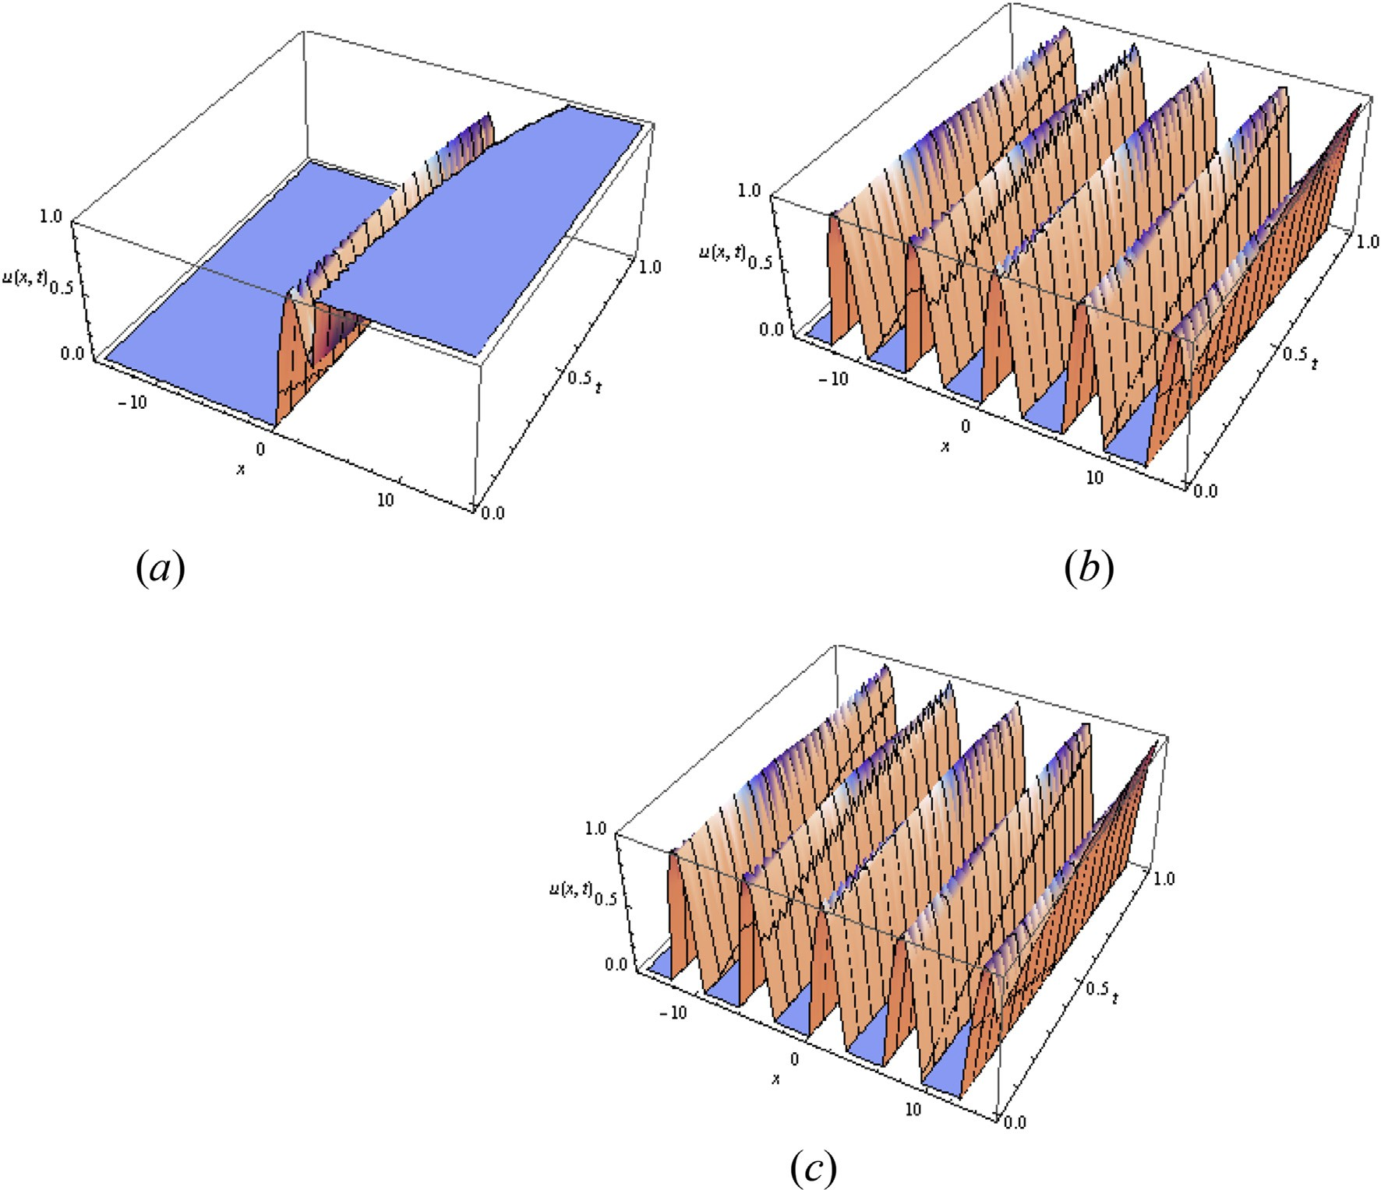

Fig. 1 e u(x,t) obtained by using five term (a) FDTM, (b) MFDTM and (c) Exact solution when a ¼ 0.95.

—2 sin(*x* + *y*)

*U* (*x*, *y*, 1)= , *U*

(*x*, *y*, 2

—4 cos(*x* + *y*)

a,1

*U*a,1

G(a + 1)

8 sin(*x* + *y*)

(*x*, *y*, 3)= , …

G(3a + 1)

a,1

)= ,

G(2a + 1)

*u*(0, *t*) = 0, *ux*(0, *t*) = p cos *t*, *uxx*(0, *t*) = 0 (27)

*FDTM*: The transformed version of (25) is

Using the inverse MFDTM, we obtained the solution in the

following form,

G(a(*h* + 1)+ 1) *U*

G(a*h* + 1)

a,1

(*k*, *h* + 1) + (*k* + 1)(*k* + 2)(*k* + 3)*U*

a,1

(*k* + 3, *h*)

*u*(*x*, *y*, *t*) = cos(*x* + *y*) —

2 sin(*x* + *y*)

*t*

G(a + 1)

— 4 cos(*x* + *y*) 2a

G(2a + 1)

a

*t*

+ … (24)

sin *k*p sin *h*p

cos *k*p cos *h*p

Whena/1, the approximate solution (21) and (24) takes

the following form

*u*(*x*, *t*)= sin(*x* + *y* + 2*t*)

= —(p)*k*

2 2

*k*! G(a*h* + 1)

— p3(p)*k*

2 2

*k*! G(a*h* + 1)

(28)

which is exactly same as the solution obtained in [32].

The transformed version of (26) is

Example 3. Consider the non-homogeneous fractional third- order dispersive partial differential equation

*u*a + *uxxx* = —sin p*x* sin *t* — p3 cos p*x* cos *t*, 0 < *x* < 1, *t* > 0 (25)

*t*

Subject to the initial condition

8

a,1( , )=

*U k* 0 >><

>

0, *k* = 0, 2, 4, 6, …

(p)*k*

*k*! , *k* = 1, 5, 9, …

(p)*k*

(29)

*u*(*x*, 0)= sin p*x* (26)

and time-dependent boundary conditions

: — *k*! , *k* = 3, 7, 11, …

*MFDTM*: The transformed version of (25) is w. r. t ‘*t*’ is

[e g ypti an j o ur nal o f b a sic and a pp l i e d sci en c e s 2 ( 201 5 ) 190](http://dx.doi.org/10.1016/j.ejbas.2015.02.002) e[199](http://dx.doi.org/10.1016/j.ejbas.2015.02.002) 195

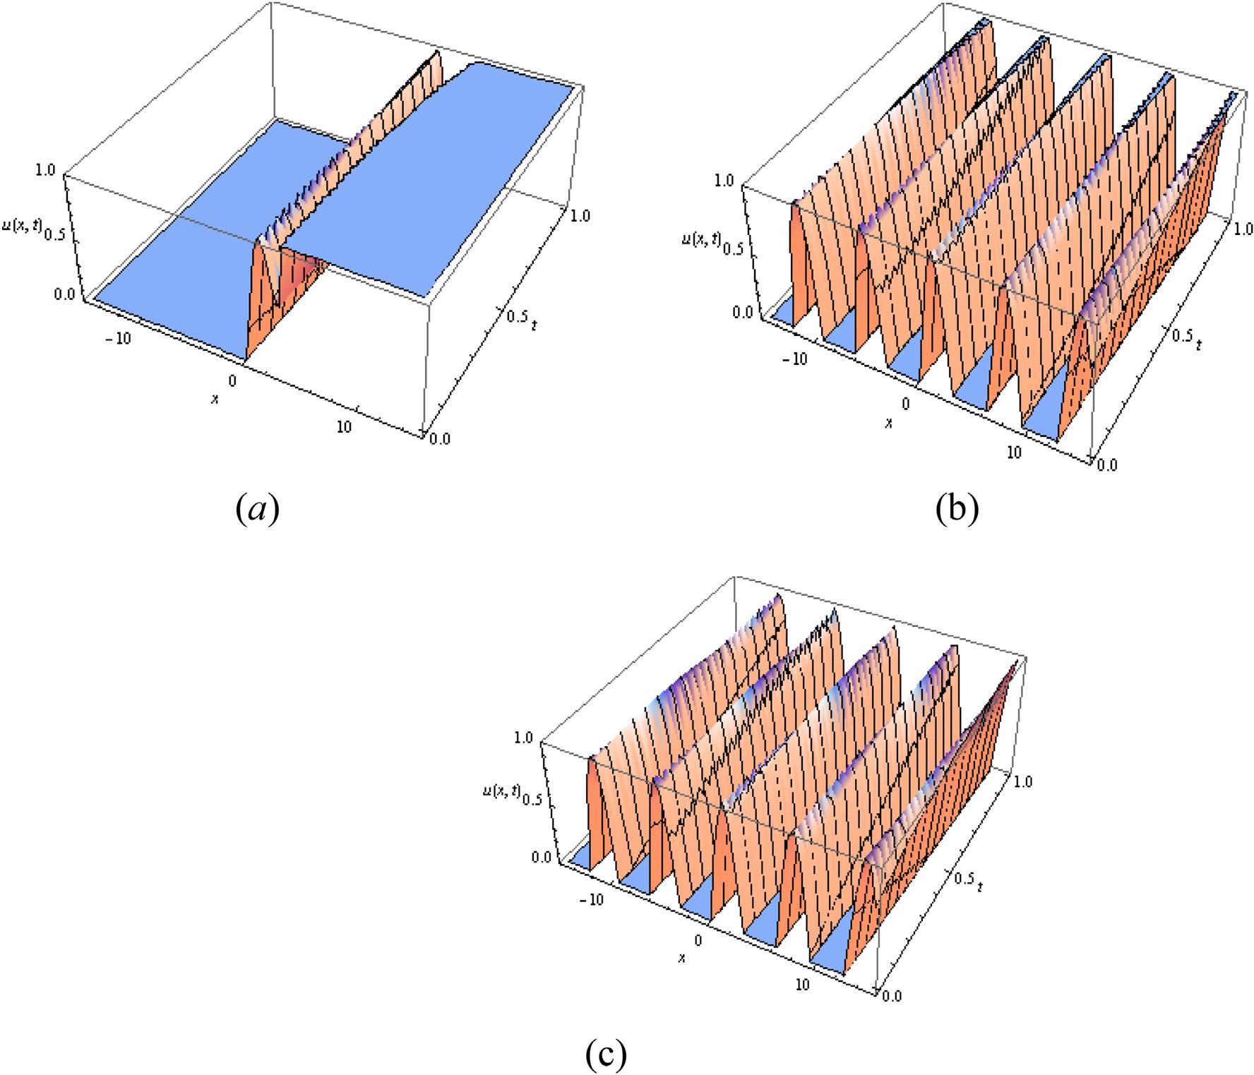

Fig. 2 e u(x,t) obtained by using five term (a) FDTM, (b) MFDTM and (c) Exact solution when a ¼ 1.5.

G(a(*h* + 1) + 1)

v3*U*a,1(*x*, *h*)

*u*(*x*, *t*)= sin p*x* cos *t* (34)

G(a*h* + 1) *U*a,1(*x*, *h* + 1)+

sin p*h*

2

v*x*3

cos p*h*

2

which is exactly same as the solution obtained in [32]. Five term solution of *u*(*x*,*t*) using FDTM, MFDTM corresponding to

= sin p*x*

G(a*h* + 1)

— p3 cos p*x*

G(a*h* + 1)

(30)

the values of a=0.5,1.95 and exact solution are plotted in Figs.

3e4 respectively.

The transformed version of (26) is

*U*a,1(*x*, 0)= sin p*x* (31)

Following the same procedure in Example 1 and 2, we ob-

tained the FDTM and MFDTM series solution

Example 4. Finally, consider the non-homogeneous fractional third-order dispersive partial differential equation in three dimensional space

*u*a + *u*

1 1

+ *u* +  *u*

= —3 cos(*x* + 2*y* + 3*z*)sin *t*

(p*x*)3

(p*x*)5 !

*t*2a

*t*4a

*t* *xxx*

8 *yyy* 27 *zzz*

*u*(*x*, *t*)=

p*x* —

3! +

5! — …

1 — + — …

G(2a + 1) G(4a + 1)

(32)

+ sin(*x* + 2*y* + 3*z*)cos *t*, *t* > 0 (35)

Subject to the initial condition

*t*2a *t*4a

*u*(*x*, *t*)= sin p*x*

1 — + — …

G(2a + 1) G(4a + 1)

(33)

*u*(*x*, *y*, *z*, 0) = 0 (36)

respectively. Whena/1, the approximate solution (32) and

(33) takes the following form

*FDTM*: The transformed version of (35) is

196 [e gypti an j o ur nal o f b a sic and a p p l i ed sci e n c e s 2 ( 201 5 ) 190](http://dx.doi.org/10.1016/j.ejbas.2015.02.002) e[199](http://dx.doi.org/10.1016/j.ejbas.2015.02.002)

G(a(*h* + 1)+ 1) *U*

(*k*, *l*, *m*, *h* + 1)+ (*k* + 1)(*k* + 2)(*k* + 3)*U*

(*k* + 3, *l*, *m*, *h*)

G(a*h* + 1)

1

a,1

a,1

1

+ (*l* + 1)(*l* + 2)(*l* + 3)*U*a,1(*k*, *l* + 3, *m*, *h*)+

8 27

(*m* + 1)(*m* + 2)(*m* + 3)*U*a,1(*k*, *l*, *m* + 3, *h*)

0 cos *k*p (3)*m* cos *m*p

2

sin *k*p (3)*m* sin *m*p 1 (2)*l* cos *l*p sin *h*p

= B@ — 3 *k*!

2 + 3 2

*m*! *k*!

*m*! CA

2 2

*l*! G(a*h* + 1)

2

0 sin *k*p (3)*m* cos *m*p

2

cos *k*p (3)*m* sin *m*p 1 (2)*l* sin *l*p sin *h*p

+B@3 *k*!

2 + 3 2

*m*! *k*!

*m*! CA

2 2

*l*! G(a*h* + 1)

2

(37)

0sin *k*p (3)*m* cos *m*p

2

cos *k*p (3)*m* sin *m*p 1 (2)*l* cos *l*p cos *h*p

+B@ *k*!

2 — 2

*m*! *k*!

*m*! CA

2 2

*l*! G(a*h* + 1)

2

0cos *k*p (3)*m* cos *m*p

2

sin *k*p (3)*m* sin *m*p 1 (2)*l* sin *l*p cos *h*p

—B@ *k*!

2 — 2

*m*! *k*!

*m*! CA

2 2

*l*! G(a*h* + 1)

2

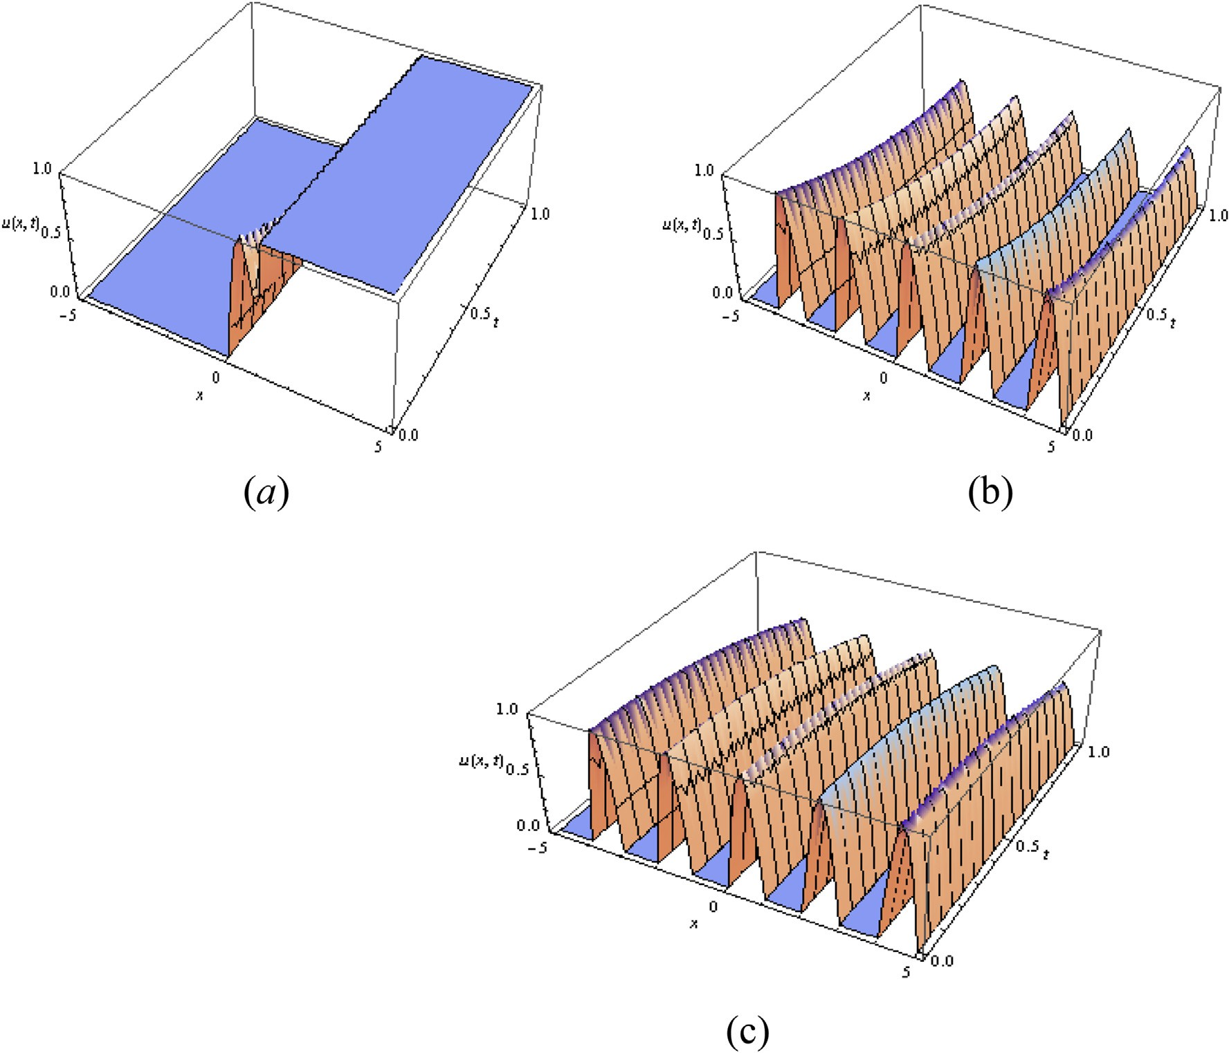

Fig. 3 e u(x,t) obtained by using five term (a) FDTM, (b) MFDTM and (c) Exact solution when a ¼ 0.5.

[e g ypti an j o ur nal o f b a sic and a pp l i e d sci en c e s 2 ( 201 5 ) 190](http://dx.doi.org/10.1016/j.ejbas.2015.02.002) e[199](http://dx.doi.org/10.1016/j.ejbas.2015.02.002) 197

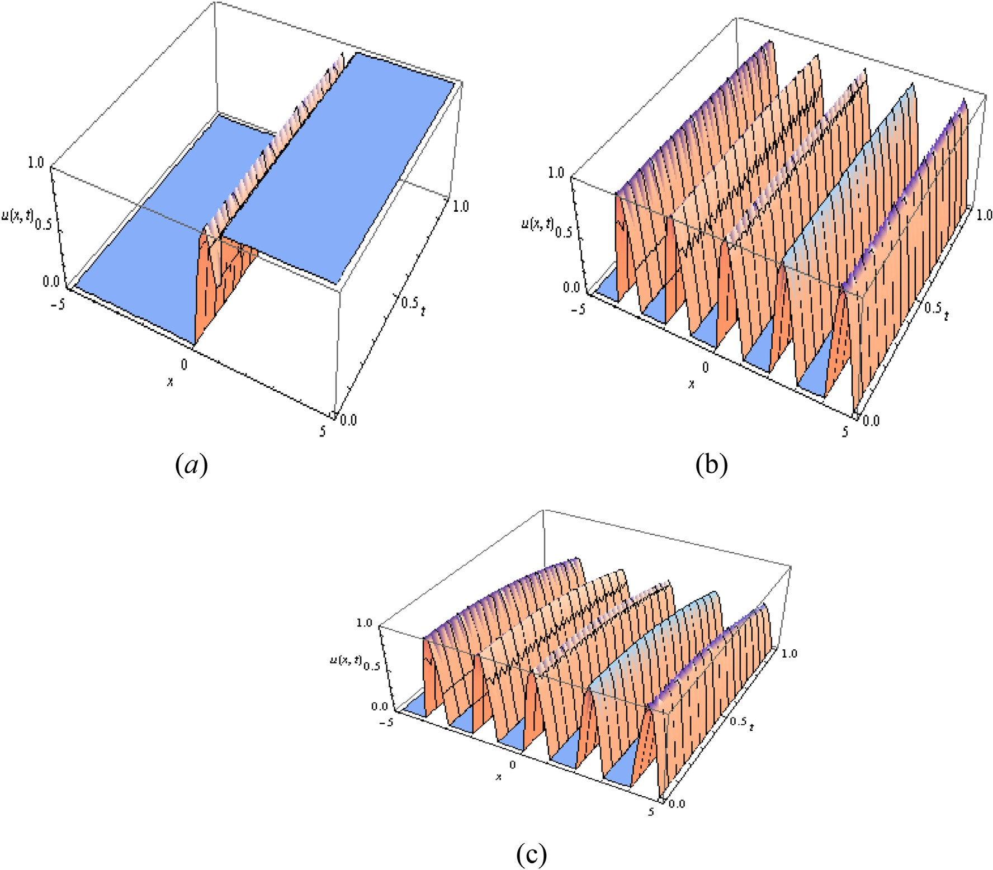

Fig. 4 e u(x,t) obtained by using five term (a) FDTM, (b) MFDTM and (c) Exact solution when a ¼ 1.95.

*x*3 4 3 9 3 2

The transformed version of (36) is

*u*(*x*, *t*)=

*x* + 2*y* + 3*z* — 6 — 3*y*

— 2*z*

— *x y* — 9*z y* — 2 *zx*

2 3 2

*U*a,1(*k*, *l*, *m*, 0)= 0, *k*, *l*, *m* = 0, 1, 2, … (38)

— 2*y*2*x* — 6*zy*22 + …

*t*a

G(a + 1)

— … (41)

*MFDTM*: The transformed version of (35) is w. r. t ‘*t*’ is

*t*a

*u*(*x*, *y*, *z*, *t*)= sin(*x* + 2*y* + 3*z*)

G(a + 1)

*t*3a

— G(3a + 1)

+ …

(42)

G(a(*h* + 1)+ 1) *U* (*x*, *y*, *z*, *h* + 1)+

G(a*h* + 1) a,1

v3*U*a,1(*x*, *y*, *z*, *h*)

v*x*3

respectively. Whena/1, the approximate solution (32) and

(33) takes the following form

1 v3*U*a,1(*x*, *y*, *z*, *h*) 1 v3*U*a,1(*x*, *y*, *z*, *h*)

+ 8 v*y*3 + 27

v*z*3

*u*(*x*, *y*, *z*, *t*)= sin(*x* + 2*y* + 3*z*)sin *t* (43)

sin p*h*

2

cos p*h*

2

which is exactly same as the solution obtained in [32].

= —3 cos(*x* + 2*y* + 3*z*) + sin(*x* + 2*y* + 3*z*)

G(a*h* + 1) G(a*h* + 1)

The transformed version of (36) is

(39)

# Conclusions

*U*a,1(*x*, *y*, *z*, 0) = 0 (40)

Following the same procedure in Example 1 and 2, we ob-

tained the FDTM and MFDTM series solution

In this paper, we implemented the two-dimensional FDTM and MFDTM for solving fractional third-order dispersive par- tial differential equation. DTM is an attractive tool for solving linear and nonlinear partial differential equations and it does

198 [e gypti an j o ur nal o f b a sic and a p p l i ed sci e n c e s 2 ( 201 5 ) 190](http://dx.doi.org/10.1016/j.ejbas.2015.02.002) e[199](http://dx.doi.org/10.1016/j.ejbas.2015.02.002)

not require linearization, discretization or perturbation. But it also faces some difficulties while constructing recursive equation for the function of three or more variables and it requires an expensive computational cost to solve the alge- braic recursive equation. The proposed MFDTM for the spe- cific variable can obtain the simple recursive equation. Thus it is concluded that MFDTM enhances the effectiveness of the computational work when compared with the FDTM. The proposed methods are simpler in its principles and effective in solving linear and nonlinear differential equations of frac- tional order and promising tool for solving wider class of nonlinear fractional models in mathematical physics with high accuracy.

# Acknowledgments

The authors would like to thank the referees for their com- ments and suggestions that have improved the paper.

## references

1. [Hilfer R. Applications of fractional calculus in physics.](http://refhub.elsevier.com/S2314-808X(15)00015-9/sref1) [Singapore: Word Scientific Company; 2000](http://refhub.elsevier.com/S2314-808X(15)00015-9/sref1).
2. [Caputo M. Linear models of dissipation whose Q is almost](http://refhub.elsevier.com/S2314-808X(15)00015-9/sref2) [frequency independent. Part II Geophys J RAstron Soc](http://refhub.elsevier.com/S2314-808X(15)00015-9/sref2) [1967;13:529](http://refhub.elsevier.com/S2314-808X(15)00015-9/sref2)e[39](http://refhub.elsevier.com/S2314-808X(15)00015-9/sref2).
3. [Kilbas Anatoly A, Srivastava HM, Trujillo Juan J. Theory and](http://refhub.elsevier.com/S2314-808X(15)00015-9/sref3) [applications of fractional differential equations. North-](http://refhub.elsevier.com/S2314-808X(15)00015-9/sref3) [Holland: Jan Van Mill; 2006](http://refhub.elsevier.com/S2314-808X(15)00015-9/sref3).
4. [Petras Ivo. Fractional-order nonlinear systems: modeling,](http://refhub.elsevier.com/S2314-808X(15)00015-9/sref4) [analysis and simulation. Beijing: Higher Education Press;](http://refhub.elsevier.com/S2314-808X(15)00015-9/sref4) [2011](http://refhub.elsevier.com/S2314-808X(15)00015-9/sref4).
5. [Laroche E, Knittel D. An improved linear fractional model for](http://refhub.elsevier.com/S2314-808X(15)00015-9/sref5) [robustness analysis of a winding system. Control Eng Pract](http://refhub.elsevier.com/S2314-808X(15)00015-9/sref5) [2005;13:659](http://refhub.elsevier.com/S2314-808X(15)00015-9/sref5)e[66](http://refhub.elsevier.com/S2314-808X(15)00015-9/sref5).
6. [Calderon A, Vinagre B, Feliu V. Fractional order control](http://refhub.elsevier.com/S2314-808X(15)00015-9/sref6) [strategies for power electronic buck converters. Signal](http://refhub.elsevier.com/S2314-808X(15)00015-9/sref6) [Process 2006;86:2803](http://refhub.elsevier.com/S2314-808X(15)00015-9/sref6)e[19](http://refhub.elsevier.com/S2314-808X(15)00015-9/sref6).
7. [Sabatier J, Aoun M, Oustaloup A, Grgoire G, Ragot F, Roy P.](http://refhub.elsevier.com/S2314-808X(15)00015-9/sref7) [Fractional system identification for lead acid battery state of](http://refhub.elsevier.com/S2314-808X(15)00015-9/sref7) [charge estimation. Signal Process 2006;86:2645](http://refhub.elsevier.com/S2314-808X(15)00015-9/sref7)e[57](http://refhub.elsevier.com/S2314-808X(15)00015-9/sref7).
8. [Vinagre B, Monje C, Calderon A, Suarej J. Fractional PID](http://refhub.elsevier.com/S2314-808X(15)00015-9/sref8) [controllers for industry application. A brief introduction. J](http://refhub.elsevier.com/S2314-808X(15)00015-9/sref8) [Vib Control 2007;13:1419](http://refhub.elsevier.com/S2314-808X(15)00015-9/sref8)e[30](http://refhub.elsevier.com/S2314-808X(15)00015-9/sref8).
9. [Monje C, Vinagre B, Feliu V, Chen Y. Tuning and autotuning](http://refhub.elsevier.com/S2314-808X(15)00015-9/sref9) [of fractional order controllers for industry applications.](http://refhub.elsevier.com/S2314-808X(15)00015-9/sref9) [Control Eng Pract 2008;16:798](http://refhub.elsevier.com/S2314-808X(15)00015-9/sref9)e[812](http://refhub.elsevier.com/S2314-808X(15)00015-9/sref9).
10. [Podlubny I. Fractional differential equations. San Diego:](http://refhub.elsevier.com/S2314-808X(15)00015-9/sref10) [Academic Press; 1999](http://refhub.elsevier.com/S2314-808X(15)00015-9/sref10).
11. [Ray SS, Bera RK. Analytical solution of Bagley](http://refhub.elsevier.com/S2314-808X(15)00015-9/sref11)e[Torvik](http://refhub.elsevier.com/S2314-808X(15)00015-9/sref11) [equation by Adomian decomposition method. Appl Math](http://refhub.elsevier.com/S2314-808X(15)00015-9/sref11) [Comput 2005;168(1):398](http://refhub.elsevier.com/S2314-808X(15)00015-9/sref11)e[410](http://refhub.elsevier.com/S2314-808X(15)00015-9/sref11).
12. [Momani S, Odibat Z. Numerical approach to differential](http://refhub.elsevier.com/S2314-808X(15)00015-9/sref12) [equations of fractional orders. J Comput Appl Math](http://refhub.elsevier.com/S2314-808X(15)00015-9/sref12) [2007;207(1):96](http://refhub.elsevier.com/S2314-808X(15)00015-9/sref12)e[110](http://refhub.elsevier.com/S2314-808X(15)00015-9/sref12).
13. [Duan Jun-sheng, Jianye An, Mingyu Xu. Solution of system of](http://refhub.elsevier.com/S2314-808X(15)00015-9/sref13) [fractional differential equations by Adomian decomposition](http://refhub.elsevier.com/S2314-808X(15)00015-9/sref13) [method. Appl Mathematics-A J Chin Univ 2007;22(1):7](http://refhub.elsevier.com/S2314-808X(15)00015-9/sref13)e[12](http://refhub.elsevier.com/S2314-808X(15)00015-9/sref13).
14. [Odibat Z, Momani S. Numerical methods for nonlinear](http://refhub.elsevier.com/S2314-808X(15)00015-9/sref14) [partial differential equations of fractional order. Appl Math](http://refhub.elsevier.com/S2314-808X(15)00015-9/sref14) [Model 2008;32:28](http://refhub.elsevier.com/S2314-808X(15)00015-9/sref14)e[9](http://refhub.elsevier.com/S2314-808X(15)00015-9/sref14).
15. [Li Changpin, Wang Yihong. Numerical algorithm based on](http://refhub.elsevier.com/S2314-808X(15)00015-9/sref15) [Adomian decomposition for fractional differential equations.](http://refhub.elsevier.com/S2314-808X(15)00015-9/sref15) [Comput Math Appl 2009;57(10):1672](http://refhub.elsevier.com/S2314-808X(15)00015-9/sref15)e[81](http://refhub.elsevier.com/S2314-808X(15)00015-9/sref15).
16. [Duan Jun-sheng, Chaolu Temuer, Rach Randolph, Lu Lei. The](http://refhub.elsevier.com/S2314-808X(15)00015-9/sref16) [Adomian decomposition method with convergence](http://refhub.elsevier.com/S2314-808X(15)00015-9/sref16) [acceleration techniques for nonlinear fractional differential](http://refhub.elsevier.com/S2314-808X(15)00015-9/sref16) [equations. Comput Math Appl 2013;66(5):728](http://refhub.elsevier.com/S2314-808X(15)00015-9/sref16)e[36](http://refhub.elsevier.com/S2314-808X(15)00015-9/sref16).
17. [Meerschaert M, Tadjeran C. Finite difference approximations](http://refhub.elsevier.com/S2314-808X(15)00015-9/sref17) [for two sided space fractional partial differential equations.](http://refhub.elsevier.com/S2314-808X(15)00015-9/sref17) [Appl Numer Math 2006;56:80](http://refhub.elsevier.com/S2314-808X(15)00015-9/sref17)e[90](http://refhub.elsevier.com/S2314-808X(15)00015-9/sref17).
18. [Mustafa Inc. The approximate and exact solutions of the](http://refhub.elsevier.com/S2314-808X(15)00015-9/sref18) [space- and time- fractional Burger's equations with initial](http://refhub.elsevier.com/S2314-808X(15)00015-9/sref18) [conditions by variational iteration method. J Math Anal Appl](http://refhub.elsevier.com/S2314-808X(15)00015-9/sref18) [2008;345(1):476](http://refhub.elsevier.com/S2314-808X(15)00015-9/sref18)e[84](http://refhub.elsevier.com/S2314-808X(15)00015-9/sref18).
19. [Das S. Analytical solution of a fractional diffusion equation](http://refhub.elsevier.com/S2314-808X(15)00015-9/sref19) [by variational iteration method. Comput Math Appl](http://refhub.elsevier.com/S2314-808X(15)00015-9/sref19) [2009;57:483](http://refhub.elsevier.com/S2314-808X(15)00015-9/sref19)e[7](http://refhub.elsevier.com/S2314-808X(15)00015-9/sref19).
20. [Saadatmandi A, Dehghan M. A new operational matrix for](http://refhub.elsevier.com/S2314-808X(15)00015-9/sref20) [solving fractional order differential equations. Comput Math](http://refhub.elsevier.com/S2314-808X(15)00015-9/sref20) [Appl 2010;59:1326](http://refhub.elsevier.com/S2314-808X(15)00015-9/sref20)e[36](http://refhub.elsevier.com/S2314-808X(15)00015-9/sref20).
21. [Pandey RK, Singh OP, Baranwal VK. An analytic algorithm for](http://refhub.elsevier.com/S2314-808X(15)00015-9/sref21) [the space](http://refhub.elsevier.com/S2314-808X(15)00015-9/sref21)e[time fractional advection](http://refhub.elsevier.com/S2314-808X(15)00015-9/sref21)e[dispersion equation.](http://refhub.elsevier.com/S2314-808X(15)00015-9/sref21) [Comput Phys Commun 2011;182:1134](http://refhub.elsevier.com/S2314-808X(15)00015-9/sref21)e[44](http://refhub.elsevier.com/S2314-808X(15)00015-9/sref21).
22. [Khan Najeeb Alam, Khan Nasir-uddin, Ara Asmat,](http://refhub.elsevier.com/S2314-808X(15)00015-9/sref22)

[Jamil Muhammad. Approximate analytical solutions of](http://refhub.elsevier.com/S2314-808X(15)00015-9/sref22) [fractional reaction-diffusion equations. J King Saud Univ](http://refhub.elsevier.com/S2314-808X(15)00015-9/sref22) e [Sci 2012;24(2):111](http://refhub.elsevier.com/S2314-808X(15)00015-9/sref22)e[8](http://refhub.elsevier.com/S2314-808X(15)00015-9/sref22).

1. [Odibat Z, Momani S, Erturk VS. Generalized differential](http://refhub.elsevier.com/S2314-808X(15)00015-9/sref23) [transform method: application to differential equations of](http://refhub.elsevier.com/S2314-808X(15)00015-9/sref23) [fractional order. Appl Math Comput 2008;197:467](http://refhub.elsevier.com/S2314-808X(15)00015-9/sref23)e[77](http://refhub.elsevier.com/S2314-808X(15)00015-9/sref23).
2. [Liu J, Hou G. Numerical solutions of the space- and](http://refhub.elsevier.com/S2314-808X(15)00015-9/sref24) [timefractional coupled Burgers equation by generalized](http://refhub.elsevier.com/S2314-808X(15)00015-9/sref24) [differential transform method. Appl Math Comput](http://refhub.elsevier.com/S2314-808X(15)00015-9/sref24) [2011;217(16):7001](http://refhub.elsevier.com/S2314-808X(15)00015-9/sref24)e[8](http://refhub.elsevier.com/S2314-808X(15)00015-9/sref24).
3. [Jiang Y, Ma J. Higher order finite element methods for time](http://refhub.elsevier.com/S2314-808X(15)00015-9/sref25) [fractional partial differential equations. J Comput Appl Math](http://refhub.elsevier.com/S2314-808X(15)00015-9/sref25) [2011;235(11):3285](http://refhub.elsevier.com/S2314-808X(15)00015-9/sref25)e[90](http://refhub.elsevier.com/S2314-808X(15)00015-9/sref25).
4. [Arikoglu A, Ozkol I. Solution of a fractional differential](http://refhub.elsevier.com/S2314-808X(15)00015-9/sref26) [equations by using differential transform method. Chaos](http://refhub.elsevier.com/S2314-808X(15)00015-9/sref26) [Solit Fractals 2007;34:1473](http://refhub.elsevier.com/S2314-808X(15)00015-9/sref26)e[81](http://refhub.elsevier.com/S2314-808X(15)00015-9/sref26).
5. [Erturk VS, Momani S. Solving systems of fractional](http://refhub.elsevier.com/S2314-808X(15)00015-9/sref27) [differential equations using differential transform method. J](http://refhub.elsevier.com/S2314-808X(15)00015-9/sref27) [Comput Appl Math 2008;215:142](http://refhub.elsevier.com/S2314-808X(15)00015-9/sref27)e[51](http://refhub.elsevier.com/S2314-808X(15)00015-9/sref27).
6. [Djidjeli K, Twizell EH. Global extrapolations of numerical](http://refhub.elsevier.com/S2314-808X(15)00015-9/sref28) [methods for solving a third-order dispersive partial](http://refhub.elsevier.com/S2314-808X(15)00015-9/sref28) [differential equations. Int J Comput Math 1991;41:81](http://refhub.elsevier.com/S2314-808X(15)00015-9/sref28)e[9](http://refhub.elsevier.com/S2314-808X(15)00015-9/sref28).
7. [Twizell EH. Computational methods for partial differential](http://refhub.elsevier.com/S2314-808X(15)00015-9/sref29) [equations. Ellis Horwood, New York: Chichester and John](http://refhub.elsevier.com/S2314-808X(15)00015-9/sref29) [Wiley and Sons; 1984](http://refhub.elsevier.com/S2314-808X(15)00015-9/sref29).
8. [Lewson JD, Morris JLI. The extrapolation of first-order](http://refhub.elsevier.com/S2314-808X(15)00015-9/sref30) [methods for parabolic partial differential equations I. SIAM J](http://refhub.elsevier.com/S2314-808X(15)00015-9/sref30) [Numer Anal 1978;15:1212](http://refhub.elsevier.com/S2314-808X(15)00015-9/sref30)e[24](http://refhub.elsevier.com/S2314-808X(15)00015-9/sref30).
9. [Mengzhao Q. Difference scheme for the dispersive equation.](http://refhub.elsevier.com/S2314-808X(15)00015-9/sref31) [Computing 1983;31:261](http://refhub.elsevier.com/S2314-808X(15)00015-9/sref31)e[7](http://refhub.elsevier.com/S2314-808X(15)00015-9/sref31).
10. [Wazwaz AM. An analytic study on the third-order dispersive](http://refhub.elsevier.com/S2314-808X(15)00015-9/sref32) [partial differential equation. Appl Math Comput](http://refhub.elsevier.com/S2314-808X(15)00015-9/sref32) [2003;142:511](http://refhub.elsevier.com/S2314-808X(15)00015-9/sref32)e[20](http://refhub.elsevier.com/S2314-808X(15)00015-9/sref32).
11. [Zhou JK. Differential transformation and its applications for](http://refhub.elsevier.com/S2314-808X(15)00015-9/sref33) [electrical circuits. Wuhan: Huazhong University Press; 1986](http://refhub.elsevier.com/S2314-808X(15)00015-9/sref33).
12. [Chen CK, Ho SH. Solving partial differential equations by](http://refhub.elsevier.com/S2314-808X(15)00015-9/sref34) [two-dimensional differential transform method. Appl Math](http://refhub.elsevier.com/S2314-808X(15)00015-9/sref34) [Comput 1999;106:171](http://refhub.elsevier.com/S2314-808X(15)00015-9/sref34)e[9](http://refhub.elsevier.com/S2314-808X(15)00015-9/sref34).
13. [Jang MJ, Chen CL, Liu YC. Two-dimensional differential](http://refhub.elsevier.com/S2314-808X(15)00015-9/sref35) [transform for partial differential equations. Appl Math](http://refhub.elsevier.com/S2314-808X(15)00015-9/sref35) [Comput 2001;121:261](http://refhub.elsevier.com/S2314-808X(15)00015-9/sref35)e[70](http://refhub.elsevier.com/S2314-808X(15)00015-9/sref35).
14. [Figen Kangalgil O, Ayaz F. Solitary wave solutions for the](http://refhub.elsevier.com/S2314-808X(15)00015-9/sref36) [KdV and mKdV equations by differential transform method.](http://refhub.elsevier.com/S2314-808X(15)00015-9/sref36) [Chaos Solit Fractals 2009;41(1):464](http://refhub.elsevier.com/S2314-808X(15)00015-9/sref36)e[72](http://refhub.elsevier.com/S2314-808X(15)00015-9/sref36).

[e g ypti an j o ur nal o f b a sic and a pp l i e d sci en c e s 2 ( 201 5 ) 190](http://dx.doi.org/10.1016/j.ejbas.2015.02.002) e[199](http://dx.doi.org/10.1016/j.ejbas.2015.02.002) 199

1. [Ravi Kanth ASV, Aruna K. Two-dimensional differential](http://refhub.elsevier.com/S2314-808X(15)00015-9/sref37) [transform method for solving linear and non-linear](http://refhub.elsevier.com/S2314-808X(15)00015-9/sref37) [Schrodinger equations. Chaos Solit Fractals 2009;41:2277](http://refhub.elsevier.com/S2314-808X(15)00015-9/sref37)e[81](http://refhub.elsevier.com/S2314-808X(15)00015-9/sref37).
2. [Ravi Kanth ASV, Aruna K. Differential transform method for](http://refhub.elsevier.com/S2314-808X(15)00015-9/sref38) [solving the linear and nonlinear Klein](http://refhub.elsevier.com/S2314-808X(15)00015-9/sref38)e[Gordon equation.](http://refhub.elsevier.com/S2314-808X(15)00015-9/sref38) [Comput Phys Commun 2009;180:708](http://refhub.elsevier.com/S2314-808X(15)00015-9/sref38)e[11](http://refhub.elsevier.com/S2314-808X(15)00015-9/sref38).
3. [Ebaid AE. A reliable after treatment for improving the](http://refhub.elsevier.com/S2314-808X(15)00015-9/sref39) [differential transformation method and its application to](http://refhub.elsevier.com/S2314-808X(15)00015-9/sref39) [nonlinear oscillators with fractional nonlinearities. Commun](http://refhub.elsevier.com/S2314-808X(15)00015-9/sref39) [Nonlinear Sci Numer Simul 2011;16:528](http://refhub.elsevier.com/S2314-808X(15)00015-9/sref39)e[36](http://refhub.elsevier.com/S2314-808X(15)00015-9/sref39).
4. [Fatoorehchi H, Abolghasemi H. Improving the differential](http://refhub.elsevier.com/S2314-808X(15)00015-9/sref40) [transform method: a novel technique to obtain the](http://refhub.elsevier.com/S2314-808X(15)00015-9/sref40)

[differential transforms of nonlinearities by the Adomian](http://refhub.elsevier.com/S2314-808X(15)00015-9/sref40) [polynomials. Appl Math Model 2013;37:6008](http://refhub.elsevier.com/S2314-808X(15)00015-9/sref40)e[17](http://refhub.elsevier.com/S2314-808X(15)00015-9/sref40).

1. [Aruna K, Ravi Kanth ASV. Approximate solutions of non-](http://refhub.elsevier.com/S2314-808X(15)00015-9/sref41) [linear fractional Schrodinger equation via differential](http://refhub.elsevier.com/S2314-808X(15)00015-9/sref41) [transform method and modified differential transform](http://refhub.elsevier.com/S2314-808X(15)00015-9/sref41) [method. Natl Acad Sci Lett 2013;36(2):201](http://refhub.elsevier.com/S2314-808X(15)00015-9/sref41)e[13](http://refhub.elsevier.com/S2314-808X(15)00015-9/sref41).
2. [Aruna K, Ravi Kanth ASV. Two-dimensional differential](http://refhub.elsevier.com/S2314-808X(15)00015-9/sref42) [transform method and modified differential transform](http://refhub.elsevier.com/S2314-808X(15)00015-9/sref42) [method for solving nonlinear fractional Klein-Gordon](http://refhub.elsevier.com/S2314-808X(15)00015-9/sref42) [equation. Natl Acad Sci Lett 2014;37(2):163](http://refhub.elsevier.com/S2314-808X(15)00015-9/sref42)e[71](http://refhub.elsevier.com/S2314-808X(15)00015-9/sref42).