[e gypti an j o ur nal o f b a sic and a pp l i ed sci e n c e s 1 ( 2014) 38](http://dx.doi.org/10.1016/j.ejbas.2014.02.001) e[48](http://dx.doi.org/10.1016/j.ejbas.2014.02.001)

 

Available online at [www.sciencedirect.com](http://www.sciencedirect.com/science/journal/2314808X)

ScienceDirect

journal homepage: <http://ees.elsevier.com/ejbas/default.asp>

Full Length Article

Spatial distribution and lifetime cancer risk due to gamma radioactivity in Yelagiri Hills, Tamilnadu, India



*A. Chandrasekaran* *a**, R. Ravisankar* *b**,**\***, G. Senthilkumar* *c**,*

*K. Thillaivelavan* *d**, B. Dhinakaran* *e**, P. Vijayagopal* *f**, S.N. Bramha* *f**,*

*B. Venkatraman* *f*

a *Global Institute of Engineering & Technology, Vellore 632509, Tamilnadu, India*

b *Post Graduate and Research Department of Physics, Government Arts College, Thiruvanamalai 606603,*

*Tamilnadu, India*

c *Department of Physics, University College of Engineering Arni, Arni 632317, Tamilnadu, India*

d *Department of Physics, Periayar Arts College, Cuddalore 607 001, Tamilnadu, India*

e *Department of Physics, Government Arts College, Chidambaram 608102, Tamilnadu, India*

f *Radiation Safety Section, Indira Gandhi Centre for Atomic Research, Kalpakkam 603102, Tamilnadu, India*

## a r t i c l e i n f o

*Article history:*

Received 23 October 2013 Received in revised form 27 December 2013

Accepted 6 February 2014

Available online 26 February 2014

*Keywords:*

Soil

Gamma ray spectrometry Excess lifetime cancer risk Statistical analysis

Spatial distribution

## a b s t r a c t

The spatial distribution of natural radioactivity due to uranium, thorium and potassium was investigated in soils from the undisturbed areas in Yelagiri Hills, Tamilnadu, India by Isodose map. The radiological hazards due to natural radionuclides content such as representative level index (RLI), activity utilization index (AUI), excess lifetime cancer risk (ELCR) and internal radiation hazards (*H*in) of the soil samples in this area were calculated. The calculated radiological hazard parameters are compared with different countries of

the world. The calculated range of ELCR is 0.326 × 10—3 to 1.067 × 10—3 with an average of 0.700 × 10—3 for soils. This average value of ELCR is more twice than the world average (0.290 × 10—3). A correlation analysis was made between measured dose rate and individual radionuclides, in order to delineate the contribution of the respective nuclides toward the

dose rate. The U/Th concentration ratio in surface soil samples ranged from 0.05 to 1.72 with an average of 0.43 which is more higher (80%) than the world average of 0.26. The application of cluster analysis (CA) and principal component analysis (PCA), coupled with Pearson correlation coefficient analysis, were utilized to analyze the data, identify and clarify between the radiological parameters to know the existing relations. The CA and PCA results showed that the former method yielded three distinctive groups of the soil variables

* *Corresponding author*. Tel.: +91 9443520534/+91 9840807356; fax: +91 4175 236553. E-mail address: [ravisankarphysics@gmail.com](mailto:ravisankarphysics@gmail.com) (R. Ravisankar).

Peer review under responsibility of Mansoura University

**Production and hosting by Elsevier**

<http://dx.doi.org/10.1016/j.ejbas.2014.02.001>

2314-808X/Copyright ª 2013, Mansoura University. Production and hosting by Elsevier B.V. All rights reserved.

[e g ypti an j o ur nal o f b a sic and a pp l i e d sci en c e s 1 ( 2014) 38](http://dx.doi.org/10.1016/j.ejbas.2014.02.001) e[48](http://dx.doi.org/10.1016/j.ejbas.2014.02.001) 39

whereas the latter one yielded the number of variables into two factors with 94.47% vari- ance explanation.

Copyright ª 2013, Mansoura University. Production and hosting by Elsevier B.V. All rights

reserved.

# Introduction

The radioactivity level from the natural radionuclides is termed as background radiation which will depend on the amount of the radioactive materials in the environment. The background radiation can be high if the environment is polluted either from man-made or natural activities. Mate- rials from the deposit may be brought to the surface soil through processes such as weathering of rocks and soil for- mation. They can also leach into the groundwater system, contaminate it, and lead to pollution far away from the source.

Natural radioactivity arises mainly from the primordial radionuclides, such as 40K and the radionuclides from 238U

condition. The ability of hydrogenous migration falls in the order U > Ra > Th. Uranium is able to remain in soluble state for a long time and gets migrated by flow of streams or river to a long distance. Horizontal transfer of uranium and thorium is dominated by interchange of sorption and desorption [5]. Un- fortunately rapid increasing of population and usage of fertil- izers for agriculture day by day contaminate the soils. Due to

one of the main tourism places in Tamilnadu, point and nonpoint pollution sources are dominated in study area. Hence it is necessary to determine the concentration levels of the 238U and 232Th as well as 40K in the soil from Yelagiri hills, Tamil- nadu, India and to analyze the spatial distribution of natural radionuclides by Isodose map with statistical approach.

and 232Th series and their decay products, which are present

at trace levels in all ground formations [1]. Monitoring the release of gamma radiation from natural radionuclides is important to protect the humans from lung cancer. The main sources of gamma radiations are due to two major radionu- clide chains: uraniumeradium and thorium. A geological and geographical condition of the study area determine the radioactivity and the associated external exposure due to gamma radiation at different levels in the soils of each region in the world [2](#_bookmark24)e[4].

The data will offer useful and necessary information in the monitoring of environmental contamination which will pro- vide appropriate and better protection guidelines to the public.

The distribution of radionuclide concentration reflects migration of uranium and thorium under surface soil

# Previous work

In an earlier work, activity concentration of natural radionu- clide that in different locations of Yelagiri Hills is reported by Ravisankar et al. [4]. They indicated that average activity concentration of 232Th in that study was 1.19 times higher than world median value while the activity of 238U and 40K was found to be lower and also major gamma radiation exposure to humans in Yelagiri Hills due to enrichment of 232Th content in soils [4]. The present work is a continuation of the previous research work in Yelagiri Hills, Tamilnadu to study the spatial distribution of natural radionuclide and the application of Multivariate statistical method to analyze the data, identify and clarify between the radiological parameters to know the existing relations.

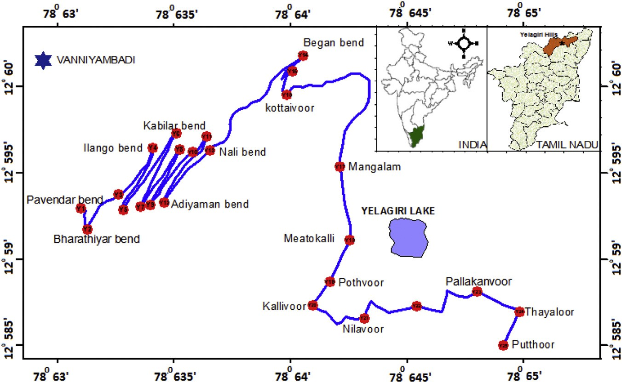

Fig. 1 e Soil samples collected at different sampling points of Yelagiri Hills, Tamilnadu, India.

40 [e gypti an j o ur nal o f b a sic and a pp l i ed sci e n c e s 1 ( 2014) 38](http://dx.doi.org/10.1016/j.ejbas.2014.02.001) e[48](http://dx.doi.org/10.1016/j.ejbas.2014.02.001)

|  |  |  |  |  |  |  |  |  |
| --- | --- | --- | --- | --- | --- | --- | --- | --- |
| Table 1 e Activity concentration, representative level index (RLI), activity utilization index (AUI), annual gonadal dose equivalent (AGDE), excess lifetime cancer risk (ELCR), internal radiation hazards (Hin) of soils of Yelagiri Hills, Tamilnadu, India. | | | | | | | | |
| Sample location Id | Locations | Activity concentration  238U 232Th | (Bq kg—1)  40K | RLI  (Bq kg—1) | AUI | AGDE  (mSv y—1) | ELCR × 10—3 | Internal radiation hazards (*H*in) |
| YS1 | Pavendar bend | BDL 24.47 6.11 | 2207.3 50.53 | 1.57 | 0.480 | 795.38 | 0.876 | 0.553 |
| YS2 | Bharathiyar bend | BDL 21.1 5.59 | 656.51 33.29 | 0.60 | 0.310 | 294.34 | 0.326 | 0.218 |
| YS3 | Thiruvalluvar bend | BDL 13.54 5.23 | 851.13 34.90 | 0.65 | 0.235 | 323.85 | 0.357 | 0.229 |
| YS4 | Ilango bend | 18.93 8.25 83.77 8.03 | 1137 44.30 | 1.63 | 1.282 | 765.67 | 0.863 | 0.662 |
| YS5 | Kambar bend | 25.55 7.20 36.24 6.31 | 913.95 39.04 | 1.06 | 0.750 | 517.41 | 0.588 | 0.468 |
| YS6 | Kabilar bend | 6.24 6.63 28.45 6.12 | 1391.6 42.96 | 1.16 | 0.517 | 575.17 | 0.639 | 0.433 |
| YS7 | Oviyar bend | 23.35 7.12 38.95 6.34 | 872.86 38.28 | 1.05 | 0.759 | 509.04 | 0.578 | 0.458 |
| YS8 | Paari bend | 18.45 9.04 89.48 8.82 | 1025.2 46.59 | 1.62 | 1.337 | 752.95 | 0.850 | 0.658 |
| YS9 | Kaari bend | 33.39 9.49 114.75 9.21 | 936.11 45.95 | 1.91 | 1.773 | 876.77 | 0.998 | 0.818 |
| YS10 | Oori bend | BDL 22.81 5.25 | 1143.8 36.54 | 0.91 | 0.371 | 454.50 | 0.502 | 0.326 |
| YS11 | Aayai bend | 21.2 8.59 100.42 8.47 | 1128.8 44.92 | 1.81 | 1.503 | 839.71 | 0.948 | 0.737 |
| YS12 | Adiyaman bend | 15.76 7.96 71.31 7.69 | 1250.2 44.83 | 1.56 | 1.111 | 739.34 | 0.831 | 0.620 |
| YS13 | Nali bend | BDL 28.05 6.41 | 1455.5 45.19 | 1.15 | 0.460 | 574.28 | 0.634 | 0.411 |
| YS14 | Began bend | BDL 26.06 5.88 | 2165.5 48.52 | 1.56 | 0.495 | 788.90 | 0.869 | 0.551 |
| YS15 | Arthanavoor | BDL 41.45 6.72 | 1137.8 41.88 | 1.10 | 0.596 | 530.53 | 0.588 | 0.397 |
| YS16 | Kottaivoor | 10.1 6.45 43.34 6.10 | 2105.4 46.83 | 1.76 | 0.792 | 873.47 | 0.970 | 0.660 |
| YS17 | Mangalam | 13.13 6.48 29.52 5.85 | 1219.1 39.97 | 1.11 | 0.580 | 546.76 | 0.612 | 0.438 |
| YS18 | Meatokalli | 23.76 8.95 13.78 17.21 | 1263 72.55 | 1.04 | 0.491 | 527.60 | 0.594 | 0.444 |
| YS19 | Pothvoor | 23.79 8.38 61.69 16.44 | 700.93 58.66 | 1.18 | 1.023 | 551.47 | 0.628 | 0.513 |
| YS20 | Kallivoor | 34.93 9.16 46.79 16.71 | 2052.8 76.73 | 1.91 | 1.059 | 948.10 | 1.067 | 0.796 |
| YS21 | Nilavoor | 39.89 5.64 57.6 8.64 | 630.41 32.08 | 1.19 | 1.117 | 561.98 | 0.648 | 0.569 |
| YS22 | Meatokanivoor | 39.55 5.55 50.24 8.31 | 625.09 31.46 | 1.11 | 1.024 | 528.49 | 0.610 | 0.538 |
| YS23 | Pallakanvoor | 49.72 7.00 35.95 9.85 | 261.11 33.06 | 0.81 | 0.915 | 385.89 | 0.457 | 0.462 |
| YS24 | Thayaloor | 20.45 4.95 44.47 9.26 | 983.08 39.25 | 1.16 | 0.808 | 557.76 | 0.630 | 0.487 |
| YS25 | Putthoor | 53.23 7.07 89.89 10.89 | 557.88 36.27 | 1.55 | 1.624 | 715.40 | 0.829 | 0.751 |
| Average |  | 19.16 48.56 | 1146.88 | 1.29 | 0.857 | 621.39 | 0.700 | 0.528 |

# Geology of study area

Yelagiri is a hill station/village in Vellore district of Tamilnadu,

through thick reserve forests. Mangalam, a small village, is at the base of this hill. There are other trekking options that include smaller peaks like Javadi Hills, Palamathi Hills etc.

India, situated off the VaniyambadieTirupattur road. Located at

an altitude of 1410 m above Mean Sea Level and spread across 30 km2, the Yelagiri village (also spelled Elagiri at times) is sur- rounded by orchards, rose-gardens, and green valleys. Yelagiri comprises of 14 hamlets and a number of temples spread over a couple of hills. The highest point in Yelagiri is the Swamimalai Hill, standing at 4338 ft: Swamimalai is a popular destination for trekkers. The hill provides a good number of trekking trails

# Materials and methods

### *Sampling methodology*

The soil profiles were sampled using an automatic core driller. Cores extruded and sectioned at 10 cm diameter and 25 cm depth were used to take soil samples [6]. The soil samples

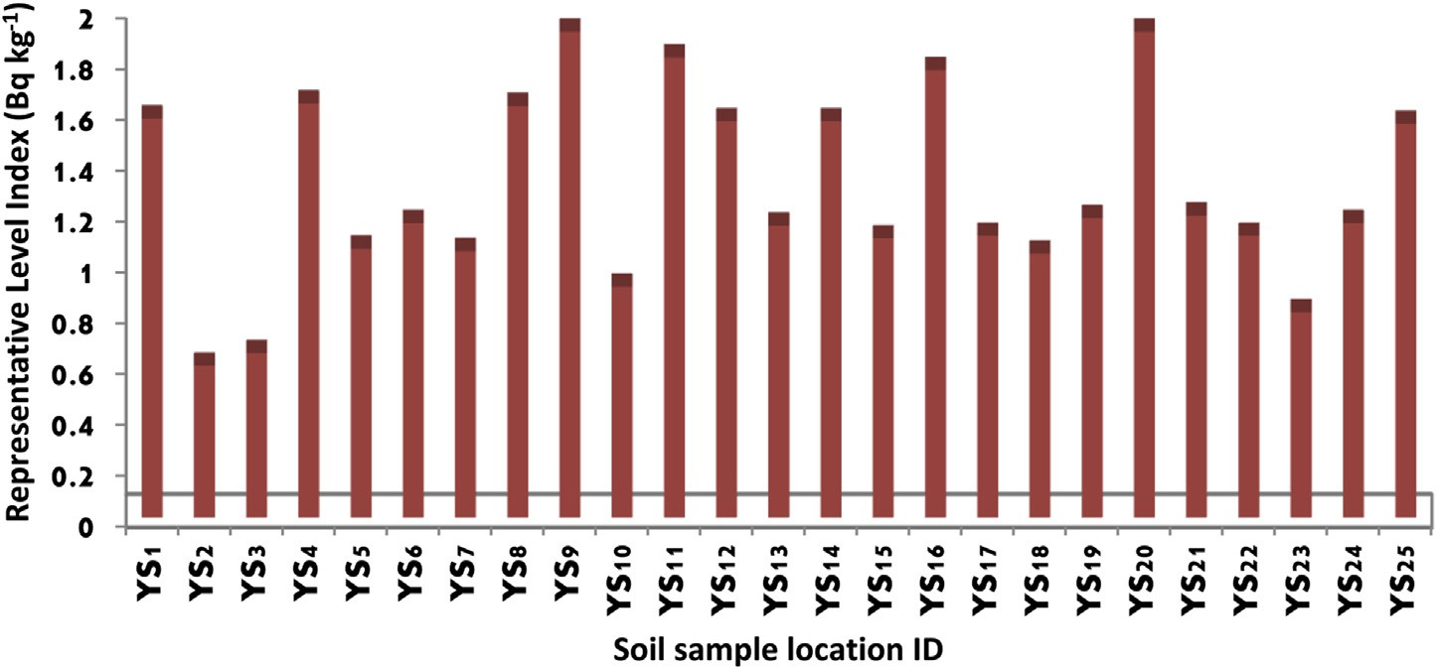

Fig. 2 e Soil sample location Id versus representative level index (Bq kgL1).

[e g ypti an j o ur nal o f b a sic and a pp l i e d sci en c e s 1 ( 2014) 38](http://dx.doi.org/10.1016/j.ejbas.2014.02.001) e[48](http://dx.doi.org/10.1016/j.ejbas.2014.02.001) 41

### *Radioactivity measurements*

|  |  |  |  |
| --- | --- | --- | --- |
| Table 2 e Comparison of mean value of ELCR, RLI and Hin  of present study with different countries of the world. | | | |
| Country | Radiological parameters  RLI ELCR × 10—3 *H*in | | References |
| China (Zhejiang) | 1.4 e | e | [8] |
| Syria | 0.5 e | e | [7] |
| Bangladesh | 1.6 e | 0.71 | [10] |
| (Southern part) |  | |  |
| Nigeria | e e | 0.18e0.37 | [30] |
| Malaysia | e e | 1.13e4.491 | [31] |
| Turkey (Kirklareli) | e 0.5 | e | [18] |
| World | 1.0 0.29 | 1.0 | [7] |
| Present study | 1.29 0.70 | 0.52 | e |

were determined using a 3 × 3 NaI (Tl) gamma ray system. The concentrations of natural radioactivity in soil samples The detector was shielded by 15 cm thick lead on all sides

'' ''

including the top to reduce background due to cosmic ray component by almost 98%. The inner sides of the lead shielding are lined by 2 mm thick cadmium and 1 mm thick copper to cut off lead X-rays and cadmium X-rays respec- tively. This graded lining shield further reduces the back- ground especially in the low energy region. Standard sources of the primordial radionuclides obtained from IAEA in the same geometry and having the same density, as that of the prepared soil samples, were used to determine the efficiency of the detector for various energies in the prescribed geom-

3

''

''

were collected from 25 sites with the only constraint that no

etry. The soil samples were placed on the top of 3

× NaI

sampling site should be taken to a field boundary, a road, a tree, a building or other obstruction. The sample collected at different locations of Yelagiri Hills, Tamilnadu is shown in

Fig. 1. For each soil sample collected, an area of 1 m × 1 m was

marked and carefully cleared of debris to a few centimeters

depth. The collected samples were then placed in labeled polythene bags and transferred to the laboratory for prepa- ration and analysis. These samples were mixed together thoroughly, in order to obtain a representative sample of that area.

### *Sample preparation*

In the laboratory, the soil samples were sieved by a 2 mm mesh to remove larger objects and then ground using mortar and pestle to fine powder in order to have the same matrix as the reference sample. After that, the samples were dried in an

oven at a temperature around 105◦C for two hours until con-

stant weights were attained and then placed in desiccators to

avoid moisture absorption. The homogenized sample was packed in a standard 250 ml airtight PVC plastic container and sealed using silicon and plastic tapes air tight. The samples were left for a minimum of 28 days for radioactive secular equilibrium between 222Rn-radon gas and its decay products (214Pb, 214Bi, and 226Ra), from the 238U decay series to be ac- quired [7].

(Tl) crystal and using the gamma ray spectrometer and

multichannel analyzer, count spectra were obtained for each of the soil sample. Each radionuclide can be detected in either direct or indirect way. The radioisotope 40K emits gamma ray with an energy of 1.461 MeV. Hence the deter- mination of 40K is considered as direct. The determination of 238U depends on the detection of the 214Bi radionuclide which is a member of the 238U decay series emitting an energy of 1.764 MeV. Therefore, the detection of 238U is indirect. The determination 232Th concentration is indirect as referred to the 208Tl radionuclide with an energy of 2.615 MeV, origi-

Th and K is measured in Bq kg—1 and reported by Ravisankar nating from the 232Th decay series. The concentration of U, et al. [4].

The minimum detectable activity (MDA) of each of the three primordial radionuclides was determined from the background radiation spectrum obtained for the same

mated as 2.15 Bq kg—1 for 232Th, 2.22 Bq kg—1 for 238U and counting time as was done for the soil samples and is esti-

8.83 Bq kg—1 for 40K. The sealed containers were left for at least

4 weeks (>7 half life’s of 222Rn) before counting by gamma ray

spectrometry in order to ensure that the daughter products of 226Ra up to 210Pb and 228Th up to 208Pb achieve equilibrium with their respective parent radionuclides. All the soil sam- ples were subjected to gamma ray spectral analysis with a counting time of 20,000 s.

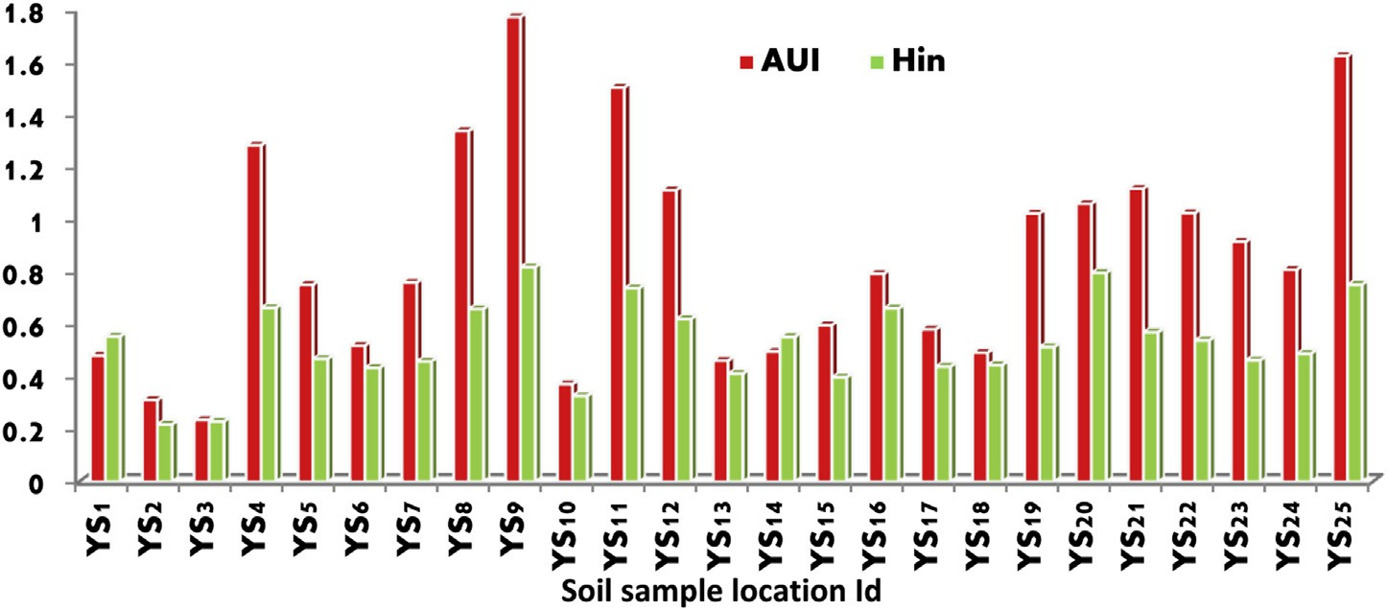

Fig. 3 e Soil sample location Id versus activity utilization index (AUI) & internal hazard indices (Hin).

42 [e gypti an j o ur nal o f b a sic and a pp l i ed sci e n c e s 1 ( 2014) 38](http://dx.doi.org/10.1016/j.ejbas.2014.02.001) e[48](http://dx.doi.org/10.1016/j.ejbas.2014.02.001)

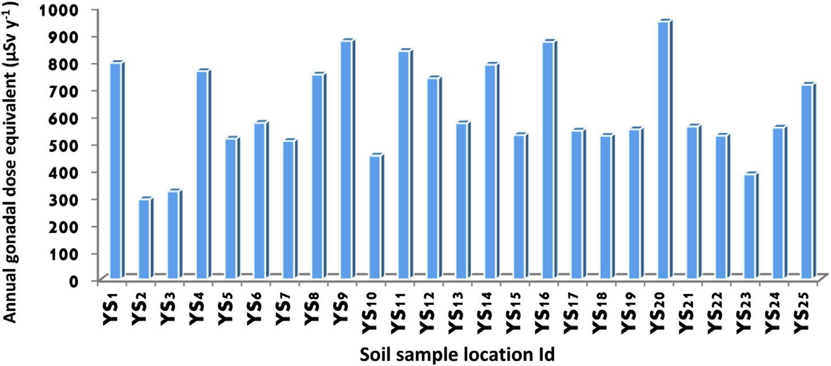

Fig. 4 e Soil sample location Id versus annual gonadal dose equivalent (mSv yL1).

### *Multivariate statistical analysis*

Multivariate statistical analysis (Pearson’s correlation anal- ysis, Cluster analysis and Factor analysis) has been carried out to find out the interrelation among the parameters obtained from natural radionuclides. In this work main statistical software ‘Statistical program for the Social Science (SPSS/PC)’ was used for statistical analysis.

### *Spatial distribution of radioactivity*

The Spatial distribution of radioactivity from soils due to naturally occurring radionuclides (238U, 232Th and 40K) is studied in Yelagiri Hills, Tamilnadu using isodose map which is made by SURFER (software version 8).

# Results and discussions

### *238U, 232Th and 40K activities*

The results for the activity concentrations of natural radio- nuclides 238U, 232Th and 40K in soil samples of different loca- tions of Yelagiri Hills, Tamilnadu are reported in Table 1. The

activity concentrations of 238U, 232Th and 40K range from ≤2.17 to 53.23 Bq kg—1, 13.54e114.75 Bq kg—1 and 261.11e2207.3 Bq kg—1, respectively. Except for 4 locations the obtained results for 238U have lower values of activity con-

(35 Bq kg—1 for 238U) of this radionuclide in the soil [5]. Simi- centrations, when compared with worldwide average value larly except 9 locations, the obtained results for 232Th have

worldwide average value (30 Bq kg—1 for 232Th, respectively) of higher values of activity concentrations, when compared with this radionuclide in the soil [5]. Except for one location, the

median values (400 Bq kg—1). The lowest value, of obtained results for 40K have higher value than the worldwide

261.11 Bq kg—1 of 40K, was found in the soil sample from the

2207.3 (Bq kg—1) in the soil sample from the Pavender bend of Pallakanvoor village of Yelagiri Hills and the high value of Yelagiri. The average activity concentration of 232Th and 40K in

the present study is 1.38 and 2.86 times higher than world median value while the activity of 238U is found to be lower.

### *Representative level index (RLI)*

The level of gamma radioactivity associated with different concentrations of some specific radionuclides is known as the representative level index [8](#_bookmark29)e[12] which is given as [12]

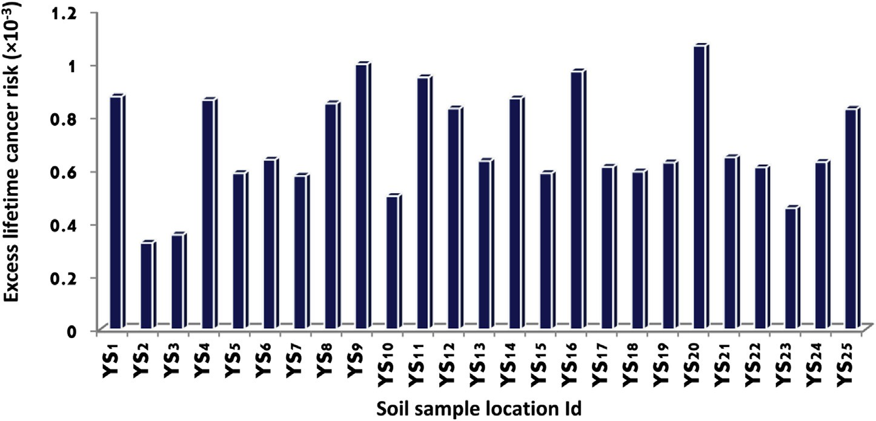

Fig. 5 e Soil sample location Id versus excess lifetime cancer risk (310L3).

[e g ypti an j o ur nal o f b a sic and a pp l i e d sci en c e s 1 ( 2014) 38](http://dx.doi.org/10.1016/j.ejbas.2014.02.001) e[48](http://dx.doi.org/10.1016/j.ejbas.2014.02.001) 43

RLI = 1 *A* + 1 *A* + 1 *A*

(1)

AGDE mSv y—1 = 3.09*A*U + 4.18*A*Th + 0.314*A*K (3)

|  |  |  |  |  |  |  |  |  |
| --- | --- | --- | --- | --- | --- | --- | --- | --- |
| Table 3 e Pearson correlation matrix among the radiological variables. Bold values in the table represent the positive correlation between the radiological variables. | | | | | | | | |
| Variables | 238-U | 232-Th | 40-K | RLI | AUI | AGDE | ELCR | *H*in |
| 238-U | 1 |  |  |  |  |  |  |  |
| 232-Th | 0.495 | 1 |  |  |  |  |  |  |
| 40-K | —0.514 | —0.239 | 1 |  |  |  |  |  |
| RLI | 0.202 | 0.681 | 0.522 | 1 |  |  |  |  |
| AUI | 0.704 | 0.961 | —0.274 | 0.676 | 1 |  |  |  |
| AGDE | 0.139 | 0.586 | 0.618 | 0.992 | 0.587 | 1 |  |  |
| ELCR | 0.194 | 0.619 | 0.575 | 0.996 | 0.629 | 0.998 | 1 |  |
| *H*in | 0.542 | 0.795 | 0.232 | 0.931 | 0.860 | 0.897 | 0.921 | 1 |

150 U 100 Th 1500 K

232Th, 238U and 40K in Bq kg—1, respectively. The calculated RLI where *A*Th, *A*U and *A*K are the average activity concentration of values for the samples under investigation are given in Table

1. The representative level index varies from 0.60 to 1.91 with an average of 1.29. It is clear that the Yelagiri soil samples slightly exceed the upper limit for RLI which is unity [12] and it indicates that the soil samples are upgraded in the study area. Fig. 2 shows the sample location Id and representative level index (RLI). The comparison of RLI with different countries of the world is given in Table 2.

### *Activity utilization index (AUI)*

In order to facilitate the calculation of dose rates in air from different combinations of the three radionuclides in soils and by applying the appropriate conversion factors, an activity utilization index (AUI) is constructed that is given by the following expression [13]

The AGDE values are presented in Table 1. As can be seen, the average value does not, exceed the permissible recommended limits, indicating that the hazardous effects of these radia- tions are negligible. The obtained value of AGDE for the studied samples ranges from 294.34 to 948.10 with an average

of 621.39 mSv y—1. In literature, the world average value for AGDE was found to be 300 mSv y—1 for soils [17]. However, obtained average value is more than twice the world average

value for soil. Fig. 4 shows the sample location Id and annual gonadal dose equivalent (AGDE).

### *Excess lifetime cancer risk (ELCR)*

Excess lifetime cancer risk (ELCR) is calculated using the following equation and presented in Table 1 [13]

ELCR = AEDE × DL × RF (4)

AUI =

*C*U

50 Bq/kg

*f*U +

*C*Th

50 Bq/kg

*f*Th +

*C*K

500 Bq/kg

*f*K (2)

alent, duration of life (70 years) and risk factor (0.05 Sv—1), where AEDE, DL and RF are the Annual Effective Dose Equiv- respectively. Annual effective dose equivalent of each location

mass (Bq kg—1) of 232Th, 238U, and 40K in the building materials where *C*Th, *C*U and *C*K are actual values of the activities per unit considered; *f*Th (0.604), *f*U (0.462) and *f*K (0.041) are the frac-

tional contributions to the total dose rate in air due to gamma radiation from the actual concentrations of these radionu- clides. In the NEA [9] Report, typical activities per unit mass of

232Th, 238U, and 40K in soils *C*Th, *C*U and *C*K are referred to be 50,

50 and 500 Bq kg—1, respectively. The activity utilization of the soil samples is calculated using equation (2). The calculated

values vary from 0.235 (Thiruvalluvar bend) to 1.773 (Kaari bend) with an average of 0.857. This value shows that AUI < 2, which corresponds to an annual effective dose < 0.3 mSv/y [14]. This indicates that Yelagiri soil samples can be used as one of the safe building material. Fig. 3 shows the sample location Id and activity utilization index (AUI).

### *Annual gonadal dose equivalent (AGDE)*

In the same context, the activity bone marrow and the bone surface cells are considered as the organs of interest by UNSCEAR [15]. Therefore, the annual gonadal dose equivalent (AGDE) due to the specific activities of 238U, 232Th and 40K was calculated using the following formula [16]

were reported in earlier work [4]. For stochastic effects, ICRP

of ELCR is 0.326 × 10—3 to 1.067 × 10—3 with an average of 60 uses values of 0.05 for the public [18]. The calculated range 0.700 × 10—3 for soils. This average value of ELCR is more twice

than the world average (0.290 × 10—3) [6]. Fig. 5 shows the

sample location Id and Excess lifetime cancer risk (ELCR).

|  |  |  |  |
| --- | --- | --- | --- |
| Table 4 e Rotated factor loading of the calculated radiological variables in soils of Yelagiri Hills, Tamilnadu, India. | | | |
| Variables | 1 | Component | 2 |
| 238-U | 0.024 |  | 0.868 |
| 232-Th | 0.509 |  | 0.773 |
| 40-K | 0.701 |  | —0.698 |
| RLI | 0.974 |  | 0.223 |
| AUI | 0.493 |  | 0.863 |
| AGDE | 0.993 |  | 0.117 |
| ELCR | 0.984 |  | 0.273 |
| *H*in | 0.837 |  | 0.534 |
| % of Variance explained | 57.47 |  | 37.00 |

44 [e gypti an j o ur nal o f b a sic and a pp l i ed sci e n c e s 1 ( 2014) 38](http://dx.doi.org/10.1016/j.ejbas.2014.02.001) e[48](http://dx.doi.org/10.1016/j.ejbas.2014.02.001)

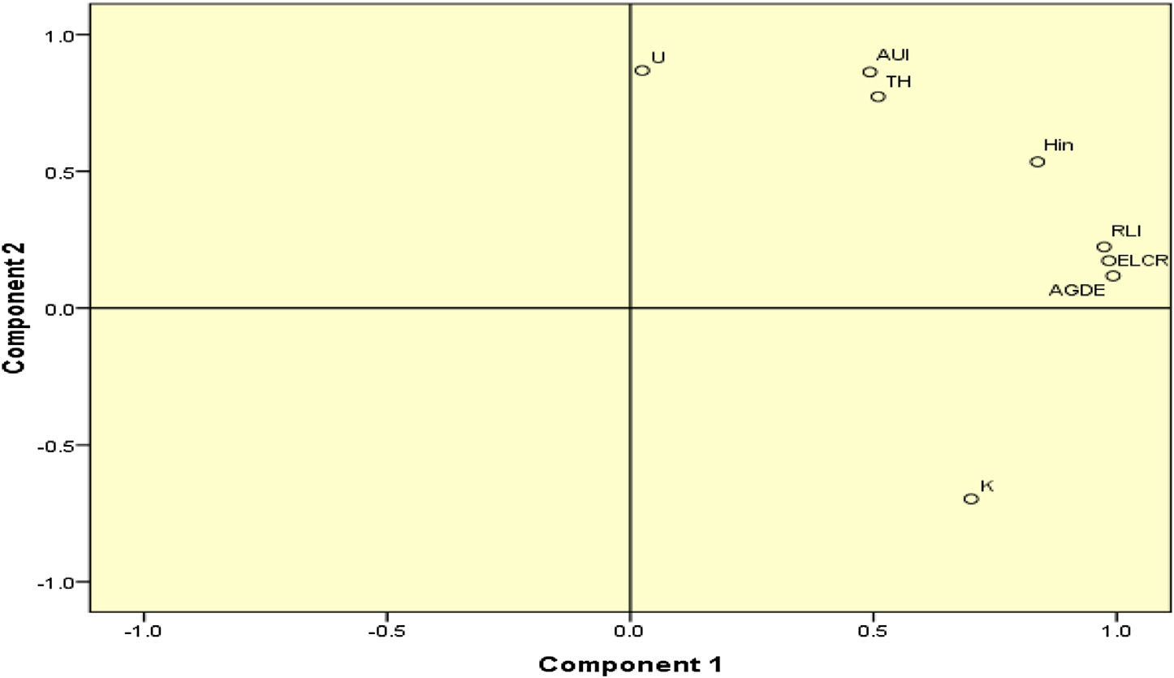

Fig. 6 e Graphical representation of component 1 (57.47%) and component 2 (37%).

### *Internal radiation hazard indices (*H*in)*

In addition to the external exposure, radon and its short-lived products are also dangerous to the respiratory organs. The internal hazard index (*H*in) is used to control the internal exposure to 222Rn and its radioactive progeny [19]. The inter- nal exposure to radon and its daughter products is quantified by the internal hazard index (*H*in), which was calculated using the following formula [19].

# Statistical analyses of the data

The univariate statistics was applied to obtain data and com- plete discussion is given in earlier work [4]. The simplicity of the univariate statistical analysis is obvious and likewise the fallacy of reductionism could be apparent [20]. In order to avoid this problem, multivariate analysis such as Pearson’s corre- lation and cluster analysis are used to explain the correlation amongst a large number of variables in terms of a small

*H* = *A*U + *A*Th + *A*K

in 185 Bq/kg 259 Bq/kg 4810 Bq/kg

(5)

number of underlying factors without losing much informa- tion [21,22]. The intention underlying the use of multivariate

The calculated internal radiation hazard indices (*H*in) of soil samples are given in Table 1.This *H*in values varies from

0.218 to 0.818 with average of 0.528. The recommended value of internal radiation hazard indices is less than 1. Therefore, these areas may not pose radiological risks to the in- habitants owing to harmful effects of ionizing radiation from the natural radionuclides in soil. Fig. 3 shows the sample location Id and internal radiation hazard indices (*H*in). The comparison of *H*in with different countries of the world is given in Table 2.

analysis is to achieve great efficiency of data compression from the original data, and to gain some information useful in the interpretation of the environmental geochemical origin. This method can also help to simplify and organize large data sets to provide meaningful insight [23] and can help to indicate natural associations between samples and/or variables [24] thus highlighting the information not available at first glance. This multivariate treatment of environmental data is widely and successfully used to interpret relationships among variables so that the environmental system could be managed

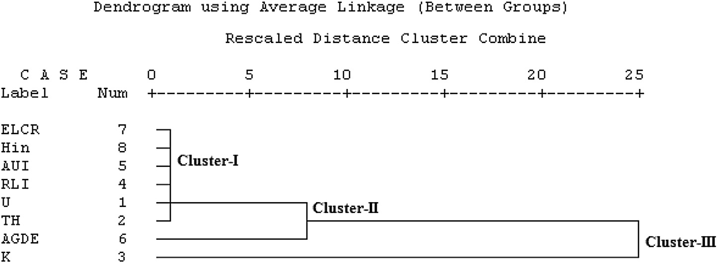

Fig. 7 e Dendrogram shows cluster of radionuclides and their radiological parameters.

[e g ypti an j o ur nal o f b a sic and a pp l i e d sci en c e s 1 ( 2014) 38](http://dx.doi.org/10.1016/j.ejbas.2014.02.001) e[48](http://dx.doi.org/10.1016/j.ejbas.2014.02.001) 45

strength of association between pairs of variables through calculation of the linear Pearson correlation coefficient. Re- sults for Pearson correlation coefficients between all the studied radioactive variables for Yelagiri soil samples are shown in Table 3.

|  |  |  |  |
| --- | --- | --- | --- |
| Table 5 e U/Th ratio and Th/U ratio of all locations of Yelagiri Hills, Tamilnadu, India. | | | |
| Sample location Id | Locations | U/Th | Th/U |
| YS1 | Pavendar bend | 0.092 | 10.876 |
| YS2 | Bharathiyar bend | 0.107 | 9.378 |
| YS3 | Thiruvalluvar bend | 0.166 | 6.018 |
| YS4 | Ilango bend | 0.226 | 4.425 |
| YS5 | Kambar bend | 0.705 | 1.418 |
| YS6 | Kabilar bend | 0.219 | 4.559 |
| YS7 | Oviyar bend | 0.599 | 1.668 |
| YS8 | Paari bend | 0.206 | 4.850 |
| YS9 | Kaari bend | 0.291 | 3.437 |
| YS10 | Oori bend | 0.099 | 10.138 |
| YS11 | Aayai bend | 0.211 | 4.737 |
| YS12 | Adiyaman bend | 0.221 | 4.525 |
| YS13 | Nali bend | 0.080 | 12.467 |
| YS14 | Began bend | 0.086 | 11.582 |
| YS15 | Arthanavoor | 0.054 | 18.422 |
| YS16 | Kottaivoor | 0.233 | 4.291 |
| YS17 | Mangalam | 0.445 | 2.248 |
| YS18 | Meatokalli | 1.724 | 0.580 |
| YS19 | Pothvoor | 0.386 | 2.593 |
| YS20 | Kallivoor | 0.747 | 1.340 |
| YS21 | Nilavoor | 0.693 | 1.444 |
| YS22 | Meatokanivoor | 0.787 | 1.270 |
| YS23 | Pallakanvoor | 1.383 | 0.723 |
| YS24 | Thayaloor | 0.460 | 2.175 |
| YS25 | Putthoor | 0.592 | 1.689 |
| Average |  | 0.432 | 5.074 |

The high good positive correlation coefficient was observed between 232Th and 238U because uranium and thorium decay series occur together in nature [26]. But very weak negative correlation coefficient was observed between 40K and 238U, 232Th since 40K origins are in different decay series. And also Representative level index (RLI), Annual gonadal dose equiv- alent (AGDE), Excess lifetime cancer (ELCR) and internal haz- ard indices (*H*in) have high good positive correlation coefficients with 238U, 232Th and 40K which indicates that the radiological parameters exist due to high concentration of radionuclides.

### *6.2. Factor analysis*

[25]. In this work, radioactive measurements acquired by the spectrometric gamma technique were subjected to qualitative and quantitative statistical analyses in order to draw a valid conclusion regarding the nature and significance of the dis- tribution of radioactive elements in soil samples of Yelagiri hills of Tamilnadu, India. The main statistical software in use was SPSS 16.0. The activity concentrations of natural radio- nuclides 238U, 232Th, 40K and obtained radiological data are taken for analysis.

### *Pearson’s correlation coefficients analysis of* radioactive variables

Correlation analysis has been carried out, as a bivariation statistics in order to determine the mutual relationships and



Factor analysis was carried out on the data set (8 variables as in the above analyses) to assess the relationship as per the procedure given in [13]. The rotated factor 1 and factor 2 values are reported in Table 4. Factor analysis yielded two factors with eigen value < 1, explaining 94.47% of the total variance. From rotate space of component-1 and component- 2 the first factor accounted for 57.47% of the total variance and mainly characterized by high positive loading of concentra- tions of 232Th, 40K. Factor-2 accounted for 37% of the total variance, which mainly consists of positive loading of 238U.

From the overall factor analysis, it is seen that 232Th, 40K in- crease the radioactivity in the soils. Fig. 6 gives a Graphical representation of factor component 1 and component 2.

### *6.3. Cluster analysis*

Cluster Analysis (CA) is a multivariate technique, whose pri- mary purpose is to classify the objects of the system into categories or clusters based on their similarities, and the objective is to find an optimal grouping for which the obser- vations or objects within each cluster are similar, but the clusters are dissimilar from each other. The dendrogram visually displays the order in which parameters or variables combine to form clusters with similar properties. The most similar objects are first grouped, and these initial groups are



     



Fig. 8 e Scatter plot of the 238U versus measured dose rate.

46 [e gypti an j o ur nal o f b a sic and a pp l i ed sci e n c e s 1 ( 2014) 38](http://dx.doi.org/10.1016/j.ejbas.2014.02.001) e[48](http://dx.doi.org/10.1016/j.ejbas.2014.02.001)





Fig. 9 e Scatter plot of the 232Th versus measured dose rate.

emerged according to their similarities. Similarity is a mea- sure of distance between clusters relative to the largest dis- tance between any two individual variables. 100% similarity means the clusters were zero distance apart in their sample measurements, while the similarity of 0% means the cluster areas are disparate as the least similar region.

In this work cluster analysis is performed using average linkage method, to calculate the Euclidean distance between the variables. The derived dendrogram is shown in Fig. 7. In this dendrogram, all 8 parameters are grouped into three statistically significant clusters. Cluster-I consists of all measured radiological parameters except AGDE and uranium and thorium; cluster-II consists of only Annual Gonadal Dose Equivalent (AGDE) which is linked with uranium. Finally cluster-III consists of K with high Euclidean distance. All the clusters are formed on the basis of existing similarities. From cluster-I and Cluster-II the total level of the radioactivity mainly depends on 232Th and 40K concentrations. But Annual gonadal dose equivalent in Yelagiri Hills is due to the content of uranium.

# Spatial distribution of gamma radiation levels

### *238U and 232Th activity ratios*

The calculated U/Th and Th/U ratio values of each locations are given in Table 5 The majority of locations fall on straight

line with a slope 5.074 corresponding to Th/U ratio which is higher than the reported global Th/U ratio of 3.5 [27]. This greater value indicates that uranium is in equilibrium with its daughter [28]. Compared to the reported intercept of 0.3 mg/kg obtained by nationwide survey carried by an intercept of

6.5 mg/kg in present study indicates higher thorium content in the soil [29].

### *Correlation studies between the activity* concentration and the measured dose rate

In order to find the existence of these radioactive nuclides together at a particular place, correlation studies were per- formed between combination of radionuclides like 238U and 232Th and 238U and 40K. A very poor correlation observed be- tween individual activity concentration of radionuclides which indicate individual results for any one of the radionu- clide is not a good predictor of the concentration of the other [29]. Therefore an attempt was made to delineate the contri- bution of individual radionuclides toward the measured gamma dose rate in the study area irrespective of the cosmic radiation. Correlation studies were performed between the measured dose rates with the respective radionuclide activity concentration. A nearly good correlation existed between 232Th (0.665) and 40K (0.537) with the measured absorbed dose rate as shown in Figs. 9 and 10. Since the study area has thorium and potassium enriched soils and major portion of dose is contributed to 232Th and 40K series, a poor correlation existed between 238U (0.184) with the measured dose rate as



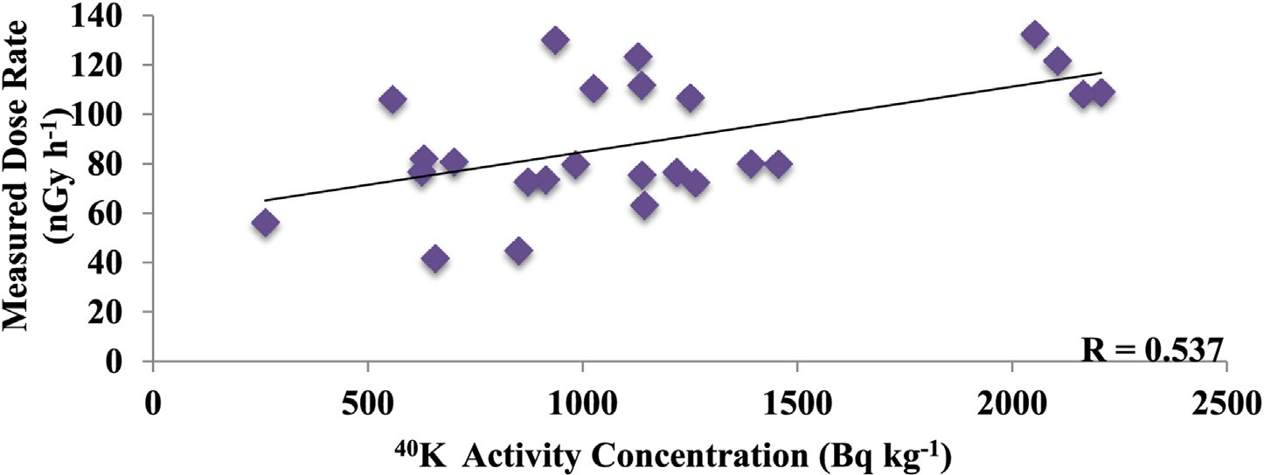

Fig. 10 e Scatter plot of the 40K versus measured dose rate.

[e g ypti an j o ur nal o f b a sic and a pp l i e d sci en c e s 1 ( 2014) 38](http://dx.doi.org/10.1016/j.ejbas.2014.02.001) e[48](http://dx.doi.org/10.1016/j.ejbas.2014.02.001) 47

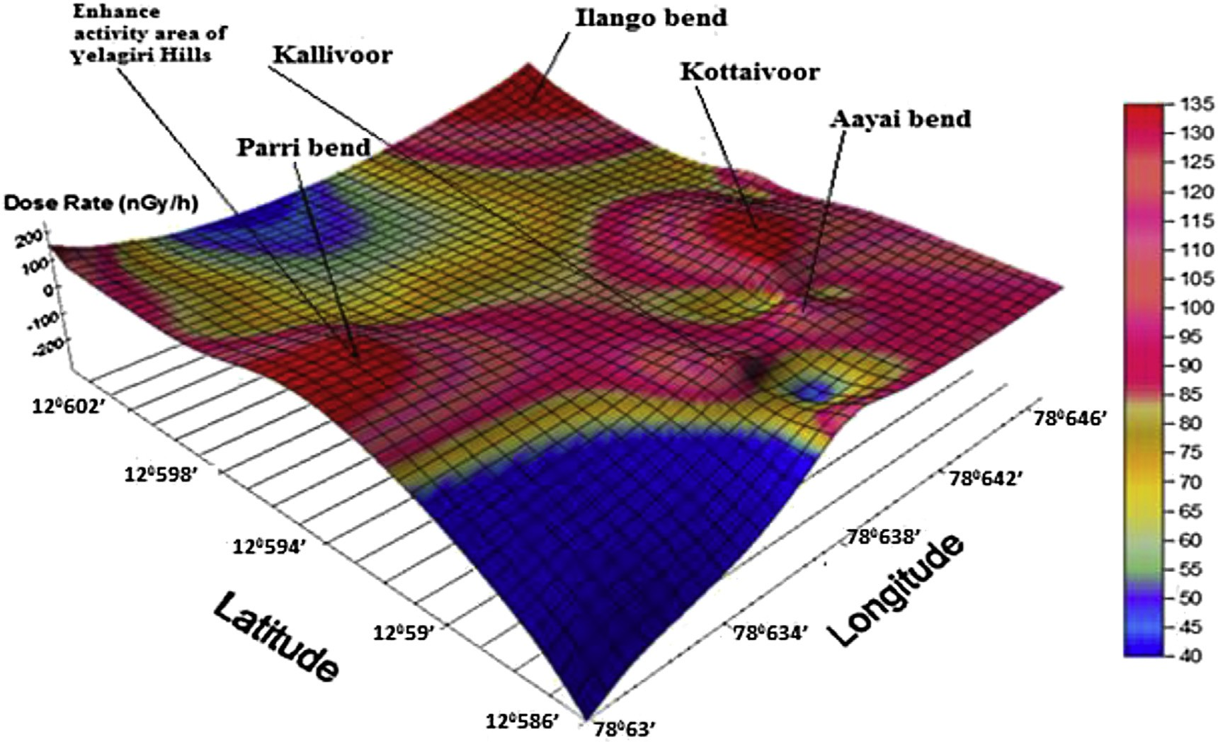

Fig. 11 e The 3D plots of isodose map Yelagiri Hills showing the sampling locations.

shown in Fig. 8. Hence gamma dose is negligible due to 238U series. The present 238U, 232Th and 40K activities in the surface soils are due to both natural and anthropogenic activities in the study area.

### *Gamma isodose map*

The terrestrial gamma dose rates at each sampling locations are plotted using SURFER (software version 8). Fig. 11 shows the 3D plot of the gamma dose map of different locations of the study area with absorbed dose rate. The Enhanced activity areas are indicated with higher peaks with red color regions in the plotted map.

# Conclusion

1. The concentration of 232Th and 40K in the soil samples of Yelagiri hills is more that 238U which is less than the world average.
2. The obtained Th/U concentration ratio of 5.074 is higher compared to global ratio of 3.5 and the average U/Th concentration ratio of 0.43 which is higher than the world average of 0.26
3. The spatial distribution of radioactivity due to natural terrestrial radionuclides of 238U, 232Th, and 40K were studied by isodose map for surface soil samples and enhanced activity areas are indicated with higher peak regions in plotted map.
4. The average value (0.700 × 10—3) of ELCR is more twice than the world average value average (0.290 × 10—3).
5. The values of internal hazard index determined in the

soil samples is less than the recommended limit.

1. Methods of multivariate data analysis have proved to be a suitable tool for the interpretation of soil samples.

# Acknowledgment

One of the authors (Dr. R. Ravisankar) is highly indebted to Mrs. S. Suganya, Assistant Professor of Physics, Government Arts College, Thiruvanamalai, Tamilnadu, India for her critical reading, constant support and encouragements in each and every stage of the manuscript preparation.

## references

1. [Tzortzis M, Svoukis E, Tsetos H. A comprehensive study of](http://refhub.elsevier.com/S2314-808X(14)00007-4/sref1) [natural gamma radioactivity levels and associated dose rates](http://refhub.elsevier.com/S2314-808X(14)00007-4/sref1) [from surface soils in Cyprus. Radiat Prot Dosim](http://refhub.elsevier.com/S2314-808X(14)00007-4/sref1) [2004;109(3):217](http://refhub.elsevier.com/S2314-808X(14)00007-4/sref1)e[24](http://refhub.elsevier.com/S2314-808X(14)00007-4/sref1).
2. [Abbady A, Ahmed NK, El-Arabi AM, Michel R, El-Kamel AH,](http://refhub.elsevier.com/S2314-808X(14)00007-4/sref2) [Abbady AGE. Estimation of radiation hazard indices from](http://refhub.elsevier.com/S2314-808X(14)00007-4/sref2) [natural radioactivity of some rocks. Nucl Sci Tech](http://refhub.elsevier.com/S2314-808X(14)00007-4/sref2) [2006;17(2):118](http://refhub.elsevier.com/S2314-808X(14)00007-4/sref2)e[22](http://refhub.elsevier.com/S2314-808X(14)00007-4/sref2).
3. [El-Arabi AM, Ahmed NK, El-Kamel AH. Gamma spectroscopic](http://refhub.elsevier.com/S2314-808X(14)00007-4/sref3) [analysis of powdered granite samples in some Eastern](http://refhub.elsevier.com/S2314-808X(14)00007-4/sref3) [desert’s areas. In: Proceedings of the fifth radiation](http://refhub.elsevier.com/S2314-808X(14)00007-4/sref3) [conference, 5](http://refhub.elsevier.com/S2314-808X(14)00007-4/sref3)e[9 November 2000, Cairo, Egypt; 2000](http://refhub.elsevier.com/S2314-808X(14)00007-4/sref3).
4. [Ravisankar R, Chandrasekaran A, Vijayagopal P,](http://refhub.elsevier.com/S2314-808X(14)00007-4/sref4) [Venkatraman B, Senthilkumar G, Eswaran P, et al. Natural](http://refhub.elsevier.com/S2314-808X(14)00007-4/sref4) [radioactivity in soil samples of Yelagiri Hills, Tamil Nadu,](http://refhub.elsevier.com/S2314-808X(14)00007-4/sref4) [India and the associated radiation hazards. Radiat Phys](http://refhub.elsevier.com/S2314-808X(14)00007-4/sref4) [Chem 2012;81:1789](http://refhub.elsevier.com/S2314-808X(14)00007-4/sref4)e[95](http://refhub.elsevier.com/S2314-808X(14)00007-4/sref4).

48 [e gypti an j o ur nal o f b a sic and a pp l i ed sci e n c e s 1 ( 2014) 38](http://dx.doi.org/10.1016/j.ejbas.2014.02.001) e[48](http://dx.doi.org/10.1016/j.ejbas.2014.02.001)

1. [Sartandel SJ, Jha SK, Bara SV, Tripathi RM, Puranik VD.](http://refhub.elsevier.com/S2314-808X(14)00007-4/sref5) [Spatial distribution of uranium and thorium in the surface](http://refhub.elsevier.com/S2314-808X(14)00007-4/sref5) [soil around proposed uranium mining site at Lambapur and](http://refhub.elsevier.com/S2314-808X(14)00007-4/sref5) [its vertical profile in the Nagarjuna Sagar Dam. J Environ](http://refhub.elsevier.com/S2314-808X(14)00007-4/sref5) [Radioact 2009;100:831](http://refhub.elsevier.com/S2314-808X(14)00007-4/sref5)e[4](http://refhub.elsevier.com/S2314-808X(14)00007-4/sref5).
2. [Ravisankar R, Rajalakshmi A, Eswaran P, Gajendrian V,](http://refhub.elsevier.com/S2314-808X(14)00007-4/sref6) [Meenakshisundram V. Radioactivity levels in soils of salt](http://refhub.elsevier.com/S2314-808X(14)00007-4/sref6) [field area Kelambakkam, Tamil Nadu, India. Nucl Sci Tech](http://refhub.elsevier.com/S2314-808X(14)00007-4/sref6) [2007;18:372](http://refhub.elsevier.com/S2314-808X(14)00007-4/sref6)e[5](http://refhub.elsevier.com/S2314-808X(14)00007-4/sref6).
3. [UNSCEAR](http://refhub.elsevier.com/S2314-808X(14)00007-4/sref7) e [United National Scientific Committee on the](http://refhub.elsevier.com/S2314-808X(14)00007-4/sref7) [Effects of Atomic Radiation. Sources and risks of ionizing](http://refhub.elsevier.com/S2314-808X(14)00007-4/sref7) [radiation [Report to the general assembly with annexes].](http://refhub.elsevier.com/S2314-808X(14)00007-4/sref7) [New York: United Nations; 2000](http://refhub.elsevier.com/S2314-808X(14)00007-4/sref7).
4. [Ziqiang P, Yang Y, Mingqiang G. Natural radiation and](http://refhub.elsevier.com/S2314-808X(14)00007-4/sref8) [radioactivity in China. Radiat Prot Dosim 1988;24(1/4):29](http://refhub.elsevier.com/S2314-808X(14)00007-4/sref8)e[38](http://refhub.elsevier.com/S2314-808X(14)00007-4/sref8).
5. [NEA-OECD. Exposure to radiation from natural radioactivity](http://refhub.elsevier.com/S2314-808X(14)00007-4/sref9) [in building materials [Report by NEA group of Experts of the](http://refhub.elsevier.com/S2314-808X(14)00007-4/sref9) [nuclear energy agency]. Paris, France: OECD; 1979](http://refhub.elsevier.com/S2314-808X(14)00007-4/sref9).
6. [Chowdhury MI, Kamal M, Alam MN, Saleha Yeasmin,](http://refhub.elsevier.com/S2314-808X(14)00007-4/sref10) [Mostafa MN. Distribution of naturally occurring](http://refhub.elsevier.com/S2314-808X(14)00007-4/sref10) [radionuclides in soils of the southern districts of Bangladesh.](http://refhub.elsevier.com/S2314-808X(14)00007-4/sref10) [Radiat Prot Dosim 2005;335:1](http://refhub.elsevier.com/S2314-808X(14)00007-4/sref10)e[5](http://refhub.elsevier.com/S2314-808X(14)00007-4/sref10).
7. [Abbady AGE. Estimation of radiation hazard indices from](http://refhub.elsevier.com/S2314-808X(14)00007-4/sref11) [sedimentary rocks in Upper Egypt. Appl Radiat Isot](http://refhub.elsevier.com/S2314-808X(14)00007-4/sref11) [2004;60:111](http://refhub.elsevier.com/S2314-808X(14)00007-4/sref11)e[4](http://refhub.elsevier.com/S2314-808X(14)00007-4/sref11).
8. [Alam MN, Miah MMH, Chowdhury MI, Kamal M, Ghose S,](http://refhub.elsevier.com/S2314-808X(14)00007-4/sref12) [Islam MN, et al. Radiation dose estimation from the](http://refhub.elsevier.com/S2314-808X(14)00007-4/sref12) [radioactivity analysis of lime and cement used in](http://refhub.elsevier.com/S2314-808X(14)00007-4/sref12) [Bangladesh. J Environ Radioact 1999;42:77](http://refhub.elsevier.com/S2314-808X(14)00007-4/sref12)e[85](http://refhub.elsevier.com/S2314-808X(14)00007-4/sref12).
9. [Ramasamy V, Suresh G, Meenakshisundaram V,](http://refhub.elsevier.com/S2314-808X(14)00007-4/sref13) [Ponnusam. V. Horizontal and vertical characterization of](http://refhub.elsevier.com/S2314-808X(14)00007-4/sref13) [radionuclides and minerals in river sediments. Appl Radiat](http://refhub.elsevier.com/S2314-808X(14)00007-4/sref13) [Isot 2011;69:184](http://refhub.elsevier.com/S2314-808X(14)00007-4/sref13)e[95](http://refhub.elsevier.com/S2314-808X(14)00007-4/sref13).
10. [El-Gamal A, Nasr S, El-Taher A. Study of the spatial](http://refhub.elsevier.com/S2314-808X(14)00007-4/sref14) [distribution of natural radioactivity in Upper Egypt Nile River](http://refhub.elsevier.com/S2314-808X(14)00007-4/sref14) [sediments. Radiat Meas 2007;42:457](http://refhub.elsevier.com/S2314-808X(14)00007-4/sref14)e[65](http://refhub.elsevier.com/S2314-808X(14)00007-4/sref14).
11. [UNSCEAR](http://refhub.elsevier.com/S2314-808X(14)00007-4/sref15) e [United Nations Scientific Committee on the](http://refhub.elsevier.com/S2314-808X(14)00007-4/sref15) [Effects of Atomic Radiation. Sources, effects and risks of](http://refhub.elsevier.com/S2314-808X(14)00007-4/sref15) [ionizing radiation. New York: United Nations; 1988](http://refhub.elsevier.com/S2314-808X(14)00007-4/sref15).
12. [Mamont-Ciesla K, Gwiazdowski B, Biernacka M, Zak A.](http://refhub.elsevier.com/S2314-808X(14)00007-4/sref16) [Radioactivity of building materials in Poland. In: Vohra G,](http://refhub.elsevier.com/S2314-808X(14)00007-4/sref16) [Pillai KC, Sadavisan S, editors. Natural radiation](http://refhub.elsevier.com/S2314-808X(14)00007-4/sref16) [environment. New York: Halsted Press; 1982. p. 551](http://refhub.elsevier.com/S2314-808X(14)00007-4/sref16).
13. [Xinwei L, Lingqing W, Xiaodan J. Radiometric analysis of](http://refhub.elsevier.com/S2314-808X(14)00007-4/sref17) [Chinese commercial granites. J Radioanal Nucl Chem](http://refhub.elsevier.com/S2314-808X(14)00007-4/sref17) [2006;267(3):669](http://refhub.elsevier.com/S2314-808X(14)00007-4/sref17)e[73](http://refhub.elsevier.com/S2314-808X(14)00007-4/sref17).
14. [Taskin H, Karavus M, Ay P, Topuzoglu A, Hidiroglu S,](http://refhub.elsevier.com/S2314-808X(14)00007-4/sref18) [Karahan G. Radionuclide concentrations in soil and lifetime](http://refhub.elsevier.com/S2314-808X(14)00007-4/sref18) [cancer risk due to the gamma radioactivity in Kirklareli,](http://refhub.elsevier.com/S2314-808X(14)00007-4/sref18) [Turkey. J Environ Radioact 2009;100:49](http://refhub.elsevier.com/S2314-808X(14)00007-4/sref18)e[53](http://refhub.elsevier.com/S2314-808X(14)00007-4/sref18).
15. [Al-Trabulsy HA, Khater AEM, Habbani FI. Radioactivity levels](http://refhub.elsevier.com/S2314-808X(14)00007-4/sref19) [and radiological hazard indices at the Saudi coastline of the](http://refhub.elsevier.com/S2314-808X(14)00007-4/sref19) [Gulf of Aqaba. Radiat Phys Chem 2011;80:343](http://refhub.elsevier.com/S2314-808X(14)00007-4/sref19)e[8](http://refhub.elsevier.com/S2314-808X(14)00007-4/sref19).
16. [Ashley RP, Lloyd JW. An example of the use of factor analysis](http://refhub.elsevier.com/S2314-808X(14)00007-4/sref20) [and cluster analysis in groundwater chemistry](http://refhub.elsevier.com/S2314-808X(14)00007-4/sref20) [interpretation. J Hydrol 1978;39:335](http://refhub.elsevier.com/S2314-808X(14)00007-4/sref20)e[64](http://refhub.elsevier.com/S2314-808X(14)00007-4/sref20).
17. [Jackson JE. A user’s guide to principal components. New](http://refhub.elsevier.com/S2314-808X(14)00007-4/sref21) [York: Wiley; 1991](http://refhub.elsevier.com/S2314-808X(14)00007-4/sref21).
18. [Meglen RR. Examining large databases: a chemometric](http://refhub.elsevier.com/S2314-808X(14)00007-4/sref22) [approach using principal component analysis. Mar Chem](http://refhub.elsevier.com/S2314-808X(14)00007-4/sref22) [1992;39:217](http://refhub.elsevier.com/S2314-808X(14)00007-4/sref22)e[37](http://refhub.elsevier.com/S2314-808X(14)00007-4/sref22).
19. [Laaksoharju M, Skarman C, Skarman E. Multivariate mixing](http://refhub.elsevier.com/S2314-808X(14)00007-4/sref23) [and mass balance (M3) calculations, a new tool for decoding](http://refhub.elsevier.com/S2314-808X(14)00007-4/sref23) [hydrogeochemical information. Appl Geochem](http://refhub.elsevier.com/S2314-808X(14)00007-4/sref23) [1999;14:861](http://refhub.elsevier.com/S2314-808X(14)00007-4/sref23)e[71](http://refhub.elsevier.com/S2314-808X(14)00007-4/sref23).
20. [Wenning RJ, Erickson GA. Interpretation and analysis of](http://refhub.elsevier.com/S2314-808X(14)00007-4/sref24) [complex environmental data using chemometric methods.](http://refhub.elsevier.com/S2314-808X(14)00007-4/sref24) [Trends Anal Chem 1994;13:446](http://refhub.elsevier.com/S2314-808X(14)00007-4/sref24)e[57](http://refhub.elsevier.com/S2314-808X(14)00007-4/sref24).
21. [Liu WX, Li XD, Shen ZG, Wang DC, Wai OWH, Li YS.](http://refhub.elsevier.com/S2314-808X(14)00007-4/sref25)

[Multivariate statistical study of heavy metal enrichment in](http://refhub.elsevier.com/S2314-808X(14)00007-4/sref25) [sediments of the Pearl River Estuary. Environ Pollut](http://refhub.elsevier.com/S2314-808X(14)00007-4/sref25) [2003;121:377](http://refhub.elsevier.com/S2314-808X(14)00007-4/sref25)e[88](http://refhub.elsevier.com/S2314-808X(14)00007-4/sref25).

1. [Tanaskovi Irena, Golobocanin Dusan, Milijevic Nada.](http://refhub.elsevier.com/S2314-808X(14)00007-4/sref26) [Multivariate statistical analysis of hydrochemical and](http://refhub.elsevier.com/S2314-808X(14)00007-4/sref26) [radiological data of Serbian spa waters. J Geochem Explor](http://refhub.elsevier.com/S2314-808X(14)00007-4/sref26) [2012;112:226](http://refhub.elsevier.com/S2314-808X(14)00007-4/sref26)e[34](http://refhub.elsevier.com/S2314-808X(14)00007-4/sref26).
2. [Adams JAS. In: Israel H, Krebs A, editors. Nuclear radiation in](http://refhub.elsevier.com/S2314-808X(14)00007-4/sref27) [geophysics. Berlin: Springer-Verlag; 1962](http://refhub.elsevier.com/S2314-808X(14)00007-4/sref27).
3. [Mishra UC, Sadasivan S. Natural radioactivity levels in Indian](http://refhub.elsevier.com/S2314-808X(14)00007-4/sref28) [soils. J Sci Ind Res 1971;30(2):59](http://refhub.elsevier.com/S2314-808X(14)00007-4/sref28)e[62](http://refhub.elsevier.com/S2314-808X(14)00007-4/sref28).
4. [Mandakini M, Narayani K, Sengupta D. Spatial distribution of](http://refhub.elsevier.com/S2314-808X(14)00007-4/sref29) [gamma radiation levels in surface soils from Jaduguda](http://refhub.elsevier.com/S2314-808X(14)00007-4/sref29) [uranium mineralization zone, Jharkhand, India, using](http://refhub.elsevier.com/S2314-808X(14)00007-4/sref29) [gamma ray spectrometry and determination of outdoor dose](http://refhub.elsevier.com/S2314-808X(14)00007-4/sref29) [to the population. J Med Phys 2010;35(4):235](http://refhub.elsevier.com/S2314-808X(14)00007-4/sref29)e[41](http://refhub.elsevier.com/S2314-808X(14)00007-4/sref29).
5. [Agbalagba E, Onoja R. Evaluation of natural radioactivity in](http://refhub.elsevier.com/S2314-808X(14)00007-4/sref30) [soil, sediment and water samples of Niger Delta (Biseni)](http://refhub.elsevier.com/S2314-808X(14)00007-4/sref30) [flood plain lakes, Nigeria. J Environ Radioact](http://refhub.elsevier.com/S2314-808X(14)00007-4/sref30) [2011;102:667](http://refhub.elsevier.com/S2314-808X(14)00007-4/sref30)e[71](http://refhub.elsevier.com/S2314-808X(14)00007-4/sref30).
6. [Almayahi CBA, Tajuddin AA, Jaafar MS. Radiation hazard](http://refhub.elsevier.com/S2314-808X(14)00007-4/sref31) [indices of soil and water samples in Northern Malaysian](http://refhub.elsevier.com/S2314-808X(14)00007-4/sref31) [Peninsula. Appl Radiat Isot 2012;70:2652](http://refhub.elsevier.com/S2314-808X(14)00007-4/sref31)e[60](http://refhub.elsevier.com/S2314-808X(14)00007-4/sref31).