Full Length Article

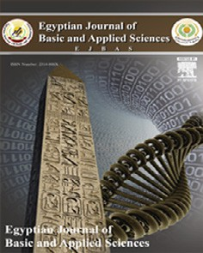

Contents lists available at [ScienceDirect](http://www.sciencedirect.com/science/journal/2314808X)

Egyptian Journal of Basic and Applied Sciences

journal homepage: [www.elsevier.com/locate/ejbas](http://www.elsevier.com/locate/ejbas)

Spatio-temporal evaluation of the surface water quality in the middle Nile Delta using Palmer’s algal pollution index



Zenhom Salem a,⇑, Mohamed Ghobara b, Abdel Aziz El Nahrawy a

a *Department of Geology, Faculty of Science, Tanta University, Egypt*

b *Department of Botany, Faculty of Science, Tanta University, Egypt*

# a r t i c l e i n f o

*Article history:*

Received 23 November 2016

Received in revised form 18 May 2017 Accepted 19 May 2017

Available online 30 May 2017

*Keywords:*

Middle Nile Delta Water pollution Palmer index Irrigation canals Drians

# a b s t r a c t

This work aims to evaluate the spatio-temporal change in the surface water pollution in the middle Nile Delta using algal pollution index (Palmer Index). Water was sampled during winter and summer seasons from 18 stations distributed along the water pathways from south to north for two main irrigation canals (Qudaba and Mit-yazed canals) and two drains (El-Gharbia main drain and Janag drain). An algal analysis was carried out based on the species and genera that mentioned in Palmer Index (PI). High Palmer Index scores were noticed in most of the stations especially during summer, which might be related to various pollution supplies. Limited number of stations showed low palmer index scores indicating relatively clean water. In winter, the two irrigation canals showed similar spatial distribution patterns where PI val- ues increased reaching its maximum at the middle of water pathways and then decreased. In summer, PI had no definite trend in Qudaba canal and decreasing trend in Mit-yazed canals along the water pathway to the northern direction. PI of El-Gharbia main drain showed increasing and decreasing trends in winter and summer, respectively. Janag drain had opposite patterns compared to that of El-Gharbia main.

One of the major differences between irrigation canals and drainage water was the algal community structure where the drainage water was characterized by the abundance of Euglenophyta and *Chlamydomonas* spp. and rare occurrences of Bacillariophyta except the last station of El-Gharbia main drain, which was of estuary nature.

© 2017 Mansoura University. Production and hosting by Elsevier B.V. This is an open access article under

the CC BY-NC-ND license (<http://creativecommons.org/licenses/by-nc-nd/4.0/>).

1. Introduction

River Nile is the main water resource for Egypt. It supports the country with water needs for food, urban, industrial and environ- mental uses [1]. The main body of the River bifurcates near Cairo into Damietta and Rosetta branches. A network of Irrigation canals and drains covers all Delta regions (Fig. 1A). The irrigation canals network helps to deliver the water to most of the cultivated lands and urban areas, while the drains help to discharge the waste water.

River Nile provides Egypt with about 55.5 Billion cubic meters of fresh water every year [2]; however there is an increased short- age of water. So, suitable management of water resources should be considered, including the control of water loss and the amount of pollutants that deteriorate the water quality in the river and the irrigation canal network due to the irresponsible discharging of variety of wastes in the water pathways.

* Corresponding author.

*E-mail addresses:* [zenhomsalem@yahoo.com](mailto:zenhomsalem@yahoo.com) (Z. Salem), [mohamedghobara@](mailto:mohamedghobara@rocketmail.com) [rocketmail.com](mailto:mohamedghobara@rocketmail.com) (M. Ghobara), [azizmbne@gmail.com](mailto:azizmbne@gmail.com) (A.A. El Nahrawy).

Organic pollution in the river Nile considers an essential active field of research [3,4]. It became a significant environmental prob- lem. Almost all freshwater bodies are widely affected by the human population explosion and urbanization. Water pathways are polluted by organic material such as sewage, food waste and farm effluent [5,6]. So, detecting the organic pollution and trying to manage this environmental crisis are considered important tasks to do.

Algae are considered an important component of any aquatic ecosystem and are responsible for the primary productivity of those systems [7]. Due to their relatively short life spans, their community composition alters quickly in a response to the changes of the water physico-chemical parameters [8]. That is why algal communities are used as indicators of aquatic pollution [9].

The first attempt to identify and prepare a list of the most tol- erant algal species and genera to pollution had been done by pal- mer [10]. Palmer index is considered a rapid, reliable and relatively inexpensive way to record water pollution probability across number of sites [11]. It is used beside other indices for inor- ganic pollution and eutrophication level [9]. Palmer index has been used before in Egypt by El-Kassas and Gharib [12]. In the present

<http://dx.doi.org/10.1016/j.ejbas.2017.05.003>

2314-808X/© 2017 Mansoura University. Production and hosting by Elsevier B.V.

This is an open access article under the CC BY-NC-ND license (<http://creativecommons.org/licenses/by-nc-nd/4.0/>).

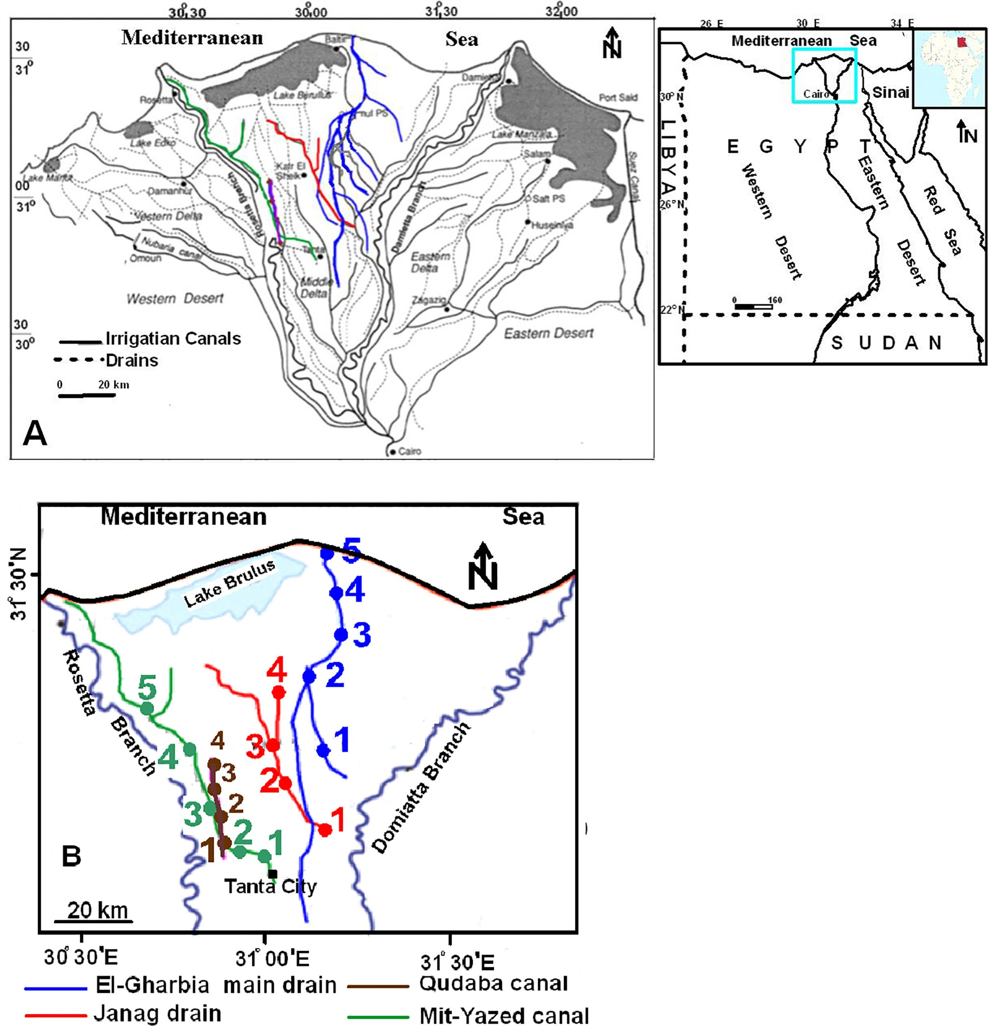

Fig. 1. Maps of the Nile Delta show the distribution of irrigation canals and drains (A) and sampling stations (B).

study Palmer index (PI) was used to obtain information about the water pollution probability along the path of two main irrigation canals and two main drains in the Middle part of the Nile delta.

1. Material and methods

Water was sampled from 18 sites (Fig. 1B) twice from every location in 2015, once in winter and the other in summer. Sam- pling sites were distributed along the path ways from south to north of two main irrigation canals (Mit-Yazed, 4 sites and Qudaba canal, 5 sites) and two main drains (El-Gharbia main drain, 5 sites and Janag drain, 4 sites). Mit-yazed canal is recharged from Shubin

rivulet at 30°520 N and 31°080 E. Qudaba canal receives water from

Rosetta branch near El-Qanater El-khiria at 30°110 N and 31°070 E

and goes parallel to the Rosetta branch until discharging in it at Rosetta city. El-Gharbia main drain starts in the middle part of the Nile Delta and collecting the agricultural, domestic and indus- trial waste water by number of smaller drains along its path and discharges in the Mediterranean Sea near Burullus Lake. Janag drain is a relatively short drain located in the middle Nile Delta region to the west and starts at Kafr El-Ziat City (Industrial city) and runs to the northern direction (Fig. 1B). Fig. 2 includes some photos showing the water bodies in some of the sampling stations.

* 1. *Sampling and microalgae analysis*

Samples were collected in clean opaque one liter-sized plastic bottles. About 7–10 ml of Lugol’s solution (iodine in potassium

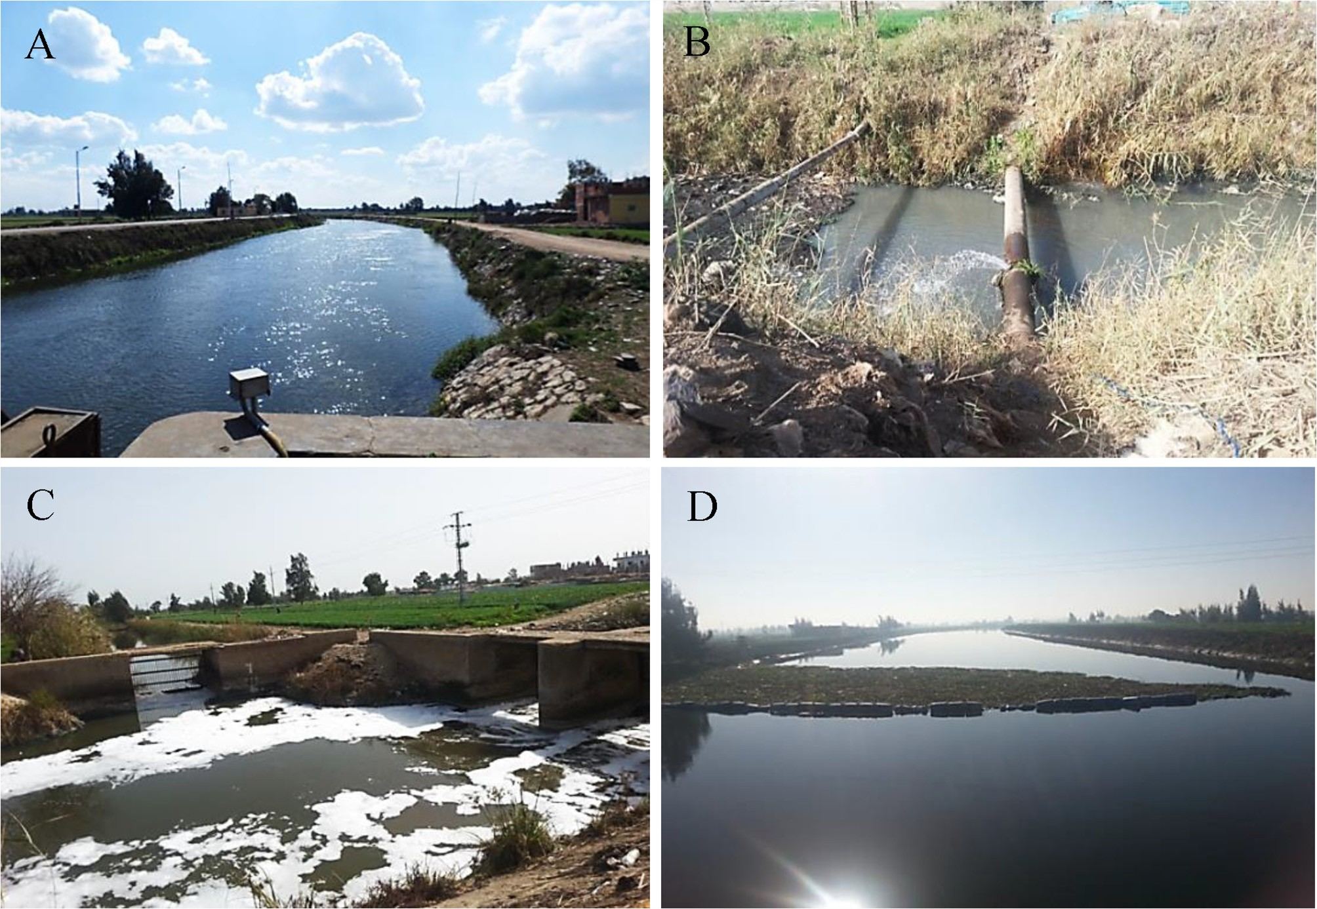

Fig. 2. Photographs of some sampling stations, (A) is The second station of Mit-yazed canal; (B) is the first station of Janag drain; (C) is the last station of Janag drain; (D) is the third station of El-Gharbia main drain.

iodide) was added to each sample at field for sample preservation. Preparation of samples for counting and identification of phyto- plankton was started immediately after returning to the labora- tory. The algal cells were let to sediment in a cylinder for 2 days. Most of the supernatant was carefully siphoned using a siphon droplet system (0.1 mm in diameter) with a tight piece of phyto- plankton net (with meshes <10 mm) at its end. The sediment algal cells were then swirled to make a homogenous suspension. The final concentrated sample was about 100 ml. This technique is based on Utermöhl technique [13]. Sedgwick-rafter cell was used for cell counting. One milliliter of algal suspension liquid was transferred to the chamber for counting and the chamber was cov- ered by its cover slip to be devoid from any air bubbles. Phyto- plankton genera and species were identified according the following references [14–18].

* 1. *Palmer index calculation*

The species and genera which proposed by palmer [10] as pol- lution indicators were investigated in the studied samples. Only seventeen genera and seventeen species (Table 1) were appeared in the studied stations out of twenty genera and twenty species included in palmer index [10]. The taxa are considered significant if its concentration was at least (<50) cells per liter. The final pal- mer index value is the summation of the scores of all the present taxa in the station. Palmer index numerical values were calculated for both species and genera then compared with the reference val- ues that proposed by palmer as following: 0–10 indicate no evi- dence of organic pollution, 10–15 indicate moderate pollution,

15–20 indicate probable high organic pollution and 20 or more indicate high organic pollution.

1. Results and discussion

Large numbers of genera and species were found in the studied irrigation canals and drains. Our most interest was the genera and species that were mentioned in Table 1. The occurrence and distri- bution of palmer algal genera and species, at the four water bodies during both winter and summer, was illustrated in Tables 2 and 3, respectively. Algal taxa, which were indicated probable high pollu- tion and not included in the palmer index scoring, were also men- tioned. Plate 1 shows some of the high organic pollution tolerant taxa. The living genera that were found in the drainage water con- firmed high organic pollution levels in most of the sampling sta- tions including *Chlamydomonas* spp., *Euglena* spp., *Phacus* spp. and *Lepocinclis* spp. especially in the summer season. Eugleno- phyceae generally is characterizing the eutrophication [10].

* 1. *Qudaba canal*

Winter data (Fig. 3A) showed no evidence of pollution at the first and last stations as both genera and species have palmer index scores below 10. The evidence for high pollution was increased along the water pathway from south (sample 2) to north (sample 4). Station 4 high Palmer index value could be related to the pres- ence of high organic pollution tolerant algal taxa; *Cyclotella meneghiniana*, *Melosiera varians*, *Nitzschia palea*, *Nitzschia acicularis*, *Synedra ulna*, *Oscillatoria limosa* and *Chlorella vulgaris*. The presence

Table 1

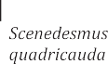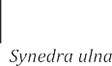

Genera and species that are included in the palmer index and detected in the studied water bodies.

|  |  |  |  |  |
| --- | --- | --- | --- | --- |
| Taxa number | Genera index | Index value | Species index | Index value |
| 1 | *Ankistrodesmus* | 2 | *Ankistrodesmus falcatus* | 3 |
| 2 | *Chlamydomonas* | 4 | *Chlorella vulgaris* | 2 |
| 3 | *Chlorella* | 3 | *Cyclotella meneghiniana* | 2 |
| 4 | *Closterium* | 1 | *Euglena gracilis* | 1 |
| 5 | *Cyclotella* | 1 | *Euglena viridis* | 6 |
| 6 | *Euglena* | 5 | *Gomphonema parvulum* | 1 |
| 7 | *Gomphonema* | 1 | *Melosiera varians* | 2 |
| 8 | *Lepocinclis* | 1 | *Navicula cryptocephala* | 1 |
| 9 | *Melosira* | 1 | *Nitzschia acicularis* | 1 |
| 10 | *Navicula* | 3 | *Nitzschia palea* | 5 |
| 11 | *Nitzschia* | 3 | *Oscillatoria limosa* | 4 |
| 12 | *Oscillatoria* | 5 | *Oscillatoria princeps* | 1 |
| 13 | *Pandorina* | 1 | *Oscillatoria putrida* | 1 |
| 14 | *Phacus* | 2 | *Oscillatoria tenuis* | 4 |
| 15 | *Phormidium* | 1 | *Pandorina morum* | 3 |
| 16 | *Scenedesmus* | 4 | *Scenedesmus quadricauda* | 4 |
| 17 | *Synedra* | 2 | *Synedra ulna* | 3 |
|  | Total | 40 | Total | 44 |

Table 2

Palmer genera occurrence and distribution at different stations in the studied water bodies. Summer and winter data are presented by white and gray colors, respectively.

|  |  |  |  |  |  |  |  |  |  |  |  |  |  |  |  |  |  |  |  |  |  |  |  |  |  |  |  |  |  |  |  |  |  |  |  |  |
| --- | --- | --- | --- | --- | --- | --- | --- | --- | --- | --- | --- | --- | --- | --- | --- | --- | --- | --- | --- | --- | --- | --- | --- | --- | --- | --- | --- | --- | --- | --- | --- | --- | --- | --- | --- | --- |
|  |  | | | | | | | | | |  | | | | | | | | | | | | | | | | | |  | | | | | | | |
|  | | | | | | | | | | | | | | | | | | | | | | | | | | | | | | | | | | | | |
|  |  | |  | |  | |  | |  | |  | |  | |  | |  | |  | |  | |  | |  | |  | |  | |  | |  | |  | |
|  |  |  |  |  |  |  |  |  |  |  |  |  |  |  |  |  |  |  |  |  |  |  |  |  |  |  |  |  |  |  |  |  |  |  |  |  |
|  |  |  |  |  |  |  |  |  |  |  |  |  |  |  |  |  |  |  |  |  |  |  |  |  |  |  |  |  |  |  |  |  |  |  |  |  |
|  |  |  |  |  |  |  |  |  |  |  |  |  |  |  |  |  |  |  |  |  |  |  |  |  |  |  |  |  |  |  |  |  |  |  |  |  |
|  |  |  |  |  |  |  |  |  |  |  |  |  |  |  |  |  |  |  |  |  |  |  |  |  |  |  |  |  |  |  |  |  |  |  |  |  |
|  |  |  |  |  |  |  |  |  |  |  |  |  |  |  |  |  |  |  |  |  |  |  |  |  |  |  |  |  |  |  |  |  |  |  |  |  |
|  |  |  |  |  |  |  |  |  |  |  |  |  |  |  |  |  |  |  |  |  |  |  |  |  |  |  |  |  |  |  |  |  |  |  |  |  |
|  |  |  |  |  |  |  |  |  |  |  |  |  |  |  |  |  |  |  |  |  |  |  |  |  |  |  |  |  |  |  |  |  |  |  |  |  |
|  |  |  |  |  |  |  |  |  |  |  |  |  |  |  |  |  |  |  |  |  |  |  |  |  |  |  |  |  |  |  |  |  |  |  |  |  |
|  |  |  |  |  |  |  |  |  |  |  |  |  |  |  |  |  |  |  |  |  |  |  |  |  |  |  |  |  |  |  |  |  |  |  |  |  |
|  |  |  |  |  |  |  |  |  |  |  |  |  |  |  |  |  |  |  |  |  |  |  |  |  |  |  |  |  |  |  |  |  |  |  |  |  |
|  |  |  |  |  |  |  |  |  |  |  |  |  |  |  |  |  |  |  |  |  |  |  |  |  |  |  |  |  |  |  |  |  |  |  |  |  |
|  |  |  |  |  |  |  |  |  |  |  |  |  |  |  |  |  |  |  |  |  |  |  |  |  |  |  |  |  |  |  |  |  |  |  |  |  |
|  |  |  |  |  |  |  |  |  |  |  |  |  |  |  |  |  |  |  |  |  |  |  |  |  |  |  |  |  |  |  |  |  |  |  |  |  |
|  |  |  |  |  |  |  |  |  |  |  |  |  |  |  |  |  |  |  |  |  |  |  |  |  |  |  |  |  |  |  |  |  |  |  |  |  |
|  |  |  |  |  |  |  |  |  |  |  |  |  |  |  |  |  |  |  |  |  |  |  |  |  |  |  |  |  |  |  |  |  |  |  |  |  |
|  |  |  |  |  |  |  |  |  |  |  |  |  |  |  |  |  |  |  |  |  |  |  |  |  |  |  |  |  |  |  |  |  |  |  |  |  |
|  |  |  |  |  |  |  |  |  |  |  |  |  |  |  |  |  |  |  |  |  |  |  |  |  |  |  |  |  |  |  |  |  |  |  |  |  |

Table 3

Palmer Species occurrence and distribution at different stations in the studied water bodies. Summer and winter data are presented by white and gray colors, respectively.

|  |  |  |  |  |  |  |  |  |  |  |  |  |  |  |  |  |  |  |  |  |  |  |  |  |  |  |  |  |  |  |  |  |  |  |  |  |
| --- | --- | --- | --- | --- | --- | --- | --- | --- | --- | --- | --- | --- | --- | --- | --- | --- | --- | --- | --- | --- | --- | --- | --- | --- | --- | --- | --- | --- | --- | --- | --- | --- | --- | --- | --- | --- |
|  |  | | | | | | | | | |  | | | | | | | | | | | | | | | | | |  | | | | | | | |
|  | | | | | | | | | | | | | | | | | | | | | | | | | | | | | | | | | | | |
|  |  | |  | |  | |  | |  | |  | |  | |  | |  | |  | |  | |  | |  | |  | |  | |  | |  | |  | |
|  |  |  |  |  |  |  |  |  |  |  |  |  |  |  |  |  |  |  |  |  |  |  |  |  |  |  |  |  |  |  |  |  |  |  |  |  |
|  |  |  |  |  |  |  |  |  |  |  |  |  |  |  |  |  |  |  |  |  |  |  |  |  |  |  |  |  |  |  |  |  |  |  |  |  |
|  |  |  |  |  |  |  |  |  |  |  |  |  |  |  |  |  |  |  |  |  |  |  |  |  |  |  |  |  |  |  |  |  |  |  |  |  |
|  |  |  |  |  |  |  |  |  |  |  |  |  |  |  |  |  |  |  |  |  |  |  |  |  |  |  |  |  |  |  |  |  |  |  |  |  |
|  |  |  |  |  |  |  |  |  |  |  |  |  |  |  |  |  |  |  |  |  |  |  |  |  |  |  |  |  |  |  |  |  |  |  |  |  |
|  |  |  |  |  |  |  |  |  |  |  |  |  |  |  |  |  |  |  |  |  |  |  |  |  |  |  |  |  |  |  |  |  |  |  |  |  |
|  |  |  |  |  |  |  |  |  |  |  |  |  |  |  |  |  |  |  |  |  |  |  |  |  |  |  |  |  |  |  |  |  |  |  |  |  |
|  |  |  |  |  |  |  |  |  |  |  |  |  |  |  |  |  |  |  |  |  |  |  |  |  |  |  |  |  |  |  |  |  |  |  |  |  |
|  |  |  |  |  |  |  |  |  |  |  |  |  |  |  |  |  |  |  |  |  |  |  |  |  |  |  |  |  |  |  |  |  |  |  |  |  |
|  |  |  |  |  |  |  |  |  |  |  |  |  |  |  |  |  |  |  |  |  |  |  |  |  |  |  |  |  |  |  |  |  |  |  |  |  |
|  |  |  |  |  |  |  |  |  |  |  |  |  |  |  |  |  |  |  |  |  |  |  |  |  |  |  |  |  |  |  |  |  |  |  |  |  |
|  |  |  |  |  |  |  |  |  |  |  |  |  |  |  |  |  |  |  |  |  |  |  |  |  |  |  |  |  |  |  |  |  |  |  |  |  |
|  |  |  |  |  |  |  |  |  |  |  |  |  |  |  |  |  |  |  |  |  |  |  |  |  |  |  |  |  |  |  |  |  |  |  |  |  |
|  |  |  |  |  |  |  |  |  |  |  |  |  |  |  |  |  |  |  |  |  |  |  |  |  |  |  |  |  |  |  |  |  |  |  |  |  |
|  |  |  |  |  |  |  |  |  |  |  |  |  |  |  |  |  |  |  |  |  |  |  |  |  |  |  |  |  |  |  |  |  |  |  |  |  |
|  |  |  |  |  |  |  |  |  |  |  |  |  |  |  |  |  |  |  |  |  |  |  |  |  |  |  |  |  |  |  |  |  |  |  |  |  |
|  |  |  |  |  |  |  |  |  |  |  |  |  |  |  |  |  |  |  |  |  |  |  |  |  |  |  |  |  |  |  |  |  |  |  |  |  |

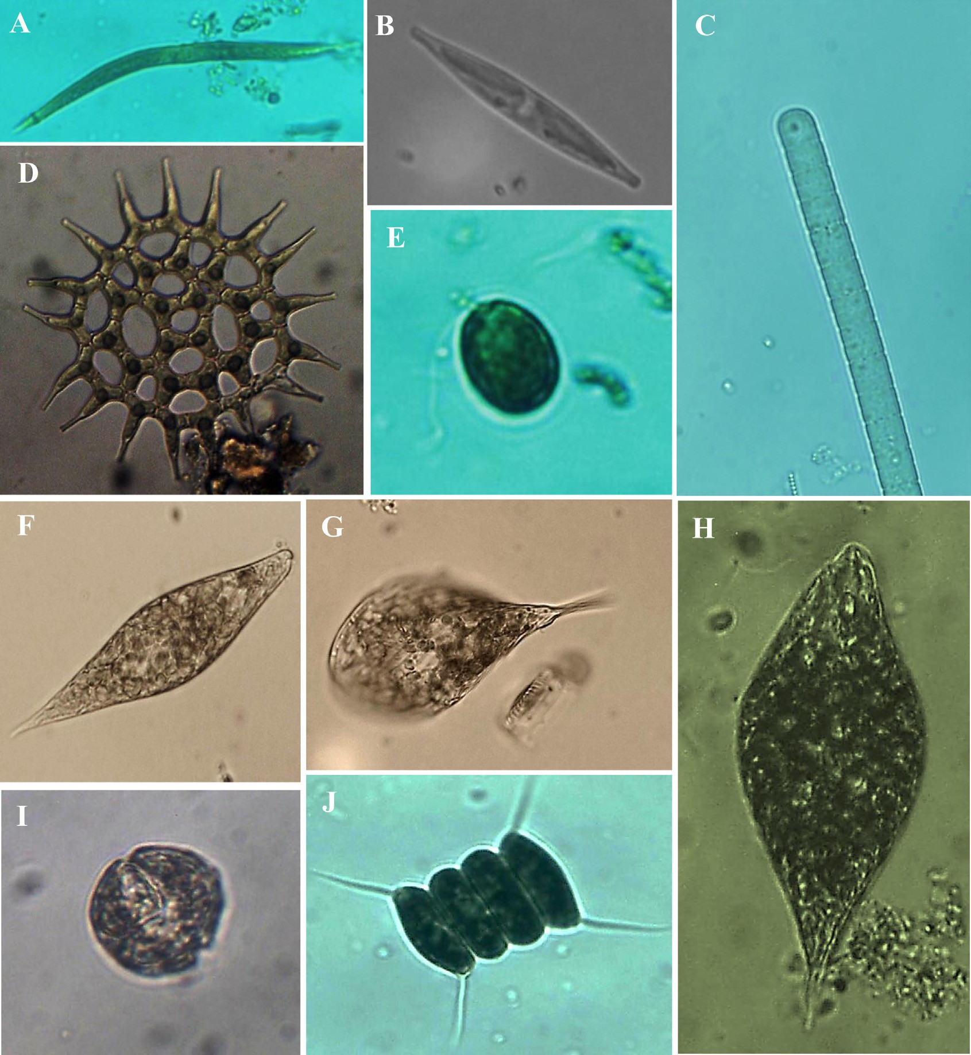

Plate 1. Some optical micrographs of high organic tolerant microalgae that present in the studied stations (Magnification power = 600X). (A) *Ankistrodesmus* falcatus; (B)

*Nitzschia palea*; (C) *Oscillatoria* sp.; (D) *Pediastrum simplex*; (E) *Chlamydomonas* sp.; (F, H) *Euglena* sp.; (G) *Phacus tortus*; (I) *Peridinium* sp.; (J) *Scenedesmus quadricauda*.

of *Cryptomonas ovata* and *Rhodomonas lacustris*, which belongs to Cryptophyta, indicated relatively clean water [19].

During summer, the water depth was higher than that of winter season in both irrigation canals and drains which might impact the organic pollution load. Summer data of Qudaba canal (Fig. 3B) showed an increase of Palmer index of the five stations from mod- erated to high values indicating higher pollution load in summer compared to winter. The stations from 1 to 4 had similar PI values indicating high organic pollution level in general. Station five showed a higher palmer value compared to winter but still lower than the other stations.

In contrast to winter season, in summer Cryptophyta that indi- cates relatively clean water disappeared [9] and Chlorophyta exhibited flourishing of Chlorophycean taxa with large numbers of *Pediastrum* spp. and *Scendesmus* spp. were detected. Chloro- phycean taxa give unwanted odour to the drinking waters and also indicate eutrophication [20,21]. Moreover, presence of Dino- phycean taxa especially *Peridinium* spp. suggests advanced trophic level [22].

* 1. *Mit-yazed canal*

Winter data (Fig. 4A) showed no evidence of algal related organic pollution at the first and the last stations while an increase in PI values was detected along the path way from sta- tion 1 to 3 similar to the results of Qudaba canal. A higher palmer index score was noticed in the second station reaching the max- imum score at station 3. This trend was confirmed by the pres- ence of high organic pollution tolerant algal species; *Melosiera varians*, *Nitzschia palea*, *Oscillatoria limosa*, *Scenedesmus quadri- cauda* and *Synedra ulna*.

In contrast to winter season, during summer (Fig. 4B) data show a general decreasing trend in PI values along the water pathway with noticeable increase in stations 1, 2 and 4 and decrease in sta- tion 3. Such major spatial and seasonal differences could be related to higher waste water discharge to the irrigation canals in summer. Large numbers of *Pediastrum* spp. and *Scendesmus* spp. are detected in all the stations which give unwanted odor to the drinking waters and also indicate eutrophication [20,21].

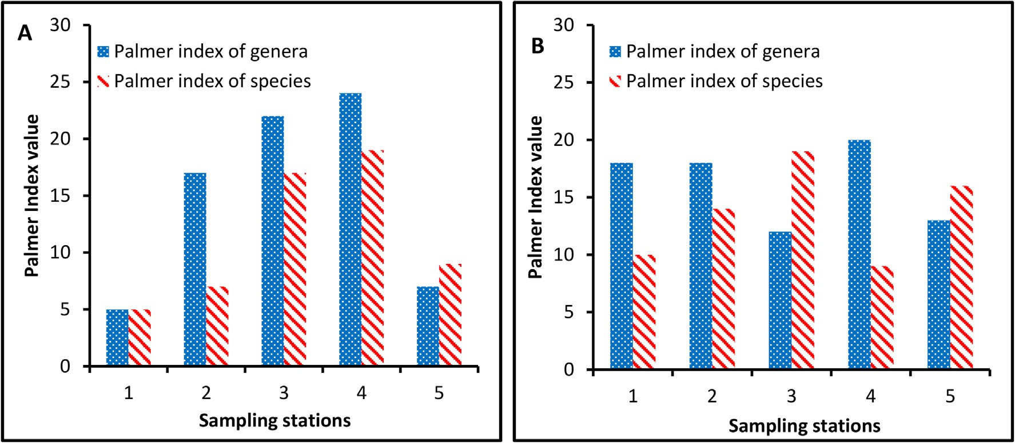

Fig. 3. Pollution index scores of algal genera (blue) and species (red) at the selected sampling stations of Qudaba irrigation canal. (A) is the Palmer index during winter and (B) is the Palmer index during summer.

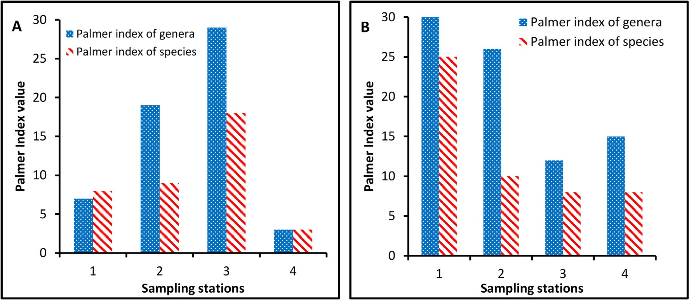

Fig. 4. Pollution index scores of algal genera (blue) and species (red) at the selected sampling stations of Mit-yazed irrigation canal. (A) is the Palmer index during winter and

(B) is the Palmer index during summer.

Moreover, the presence of Dinophycean taxa especially *Peri- dinium* spp. and Euglenophyceae in the summer at all stations indi- cated advanced trophic level there, which could be related to leakage from Semtay drain where its water is transferred under the canal using pipe lines at the second station.

* 1. *El-Gharbia main drain*

In winter (Fig. 5A), Palmer index scores are low (station 2), moderate (stations 1), probable high (station 3, 4) and high load (station 5). Therefore the last there stations have high organic pol- lution load. This drain is wide, long and receives water from many other small drains along its path (Fig. 1A and B) therefore; no def- inite trend of Palmer index was noticed in winter data.

Summer data (Fig. 5B) showed a general decreasing trend of Palmer index from south to north (from station 1 to 5). The first four stations 1, 2, 3 and 4 showed high organic pollution evidence with the maximum value at station 1. This high pollution load was confirmed by the presence of organic pollution tolerant algal spe- cies; *Ankistrodesmus falcatus*, *Cyclotella meneghiniana*, *Navicula*

*cryptocephala*, *Nitzschia acicularis*, *Oscillatoria princeps*, *Oscillatoria putrida* and *Oscillatoria tenuis*. Palmer index value of station 5 is lower than the other stations and located in the probable high organic pollution range. Compared to winter data, summer water of this drain showed higher pollution load.

* 1. *Janag drain*

Genera Palmer index values during winter showed the highest value with probable high organic pollution at the first station and no evidence for organic pollution at station 2, 3 and 4 (Fig. 6A). During summer season this drain receives more water compared to winter, therefore, Palmer index values of summer are higher than that of winter (Fig. 6A and B). Fig. 6B shows an increasing trend from station 1 (low value) to station 3 (high value) and then decreased a little in station 4. In general, organic pollution was confirmed by the presence of high organic pollution tolerant algal taxa; *Cyclotella meneghiniana*, *Oscillatoria princeps*, *Oscillatoria tenuis* and *Scenedesmus quadricauda*.

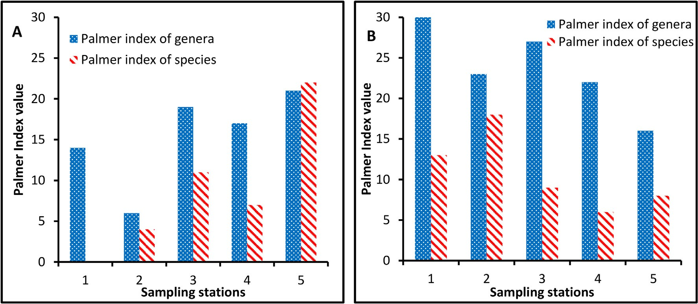

Fig. 5. Pollution index scores of algal genera (blue) and species (red) at the selected sampling stations of El-Gharbia main drain. (A) is the Palmer index during winter and (B) is the Palmer index during summer.

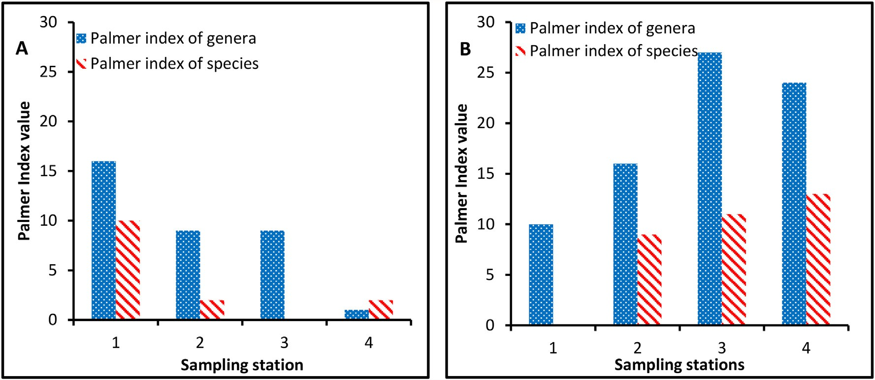

Fig. 6. Pollution index scores of algal genera (blue) and species (red) at the selected sampling stations of Janag drain. (A) is the Palmer index during winter and (B) is the Palmer index during summer.

1. Conclusions

Palmer index was a significant tool to show the pollution prob- ability in the surface water of the Nile Delta either irrigation canals or drains. The Palmer index of genera was more helpful than that of the species in case of drainage water. Pollution load in form of Pal- mer index changes spatially along the water pathways or tempo- rally from winter to the summer for the same sampling station. In general, the surface water of the Nile Delta suffers from organic pollution in most of the sampled stations. In winter where the water depth is shallow and either canals or drains received a little water, the organic pollution was lower than that of the summer and generally, increased along the water pathways from south to north. In summer where the water depth was higher than winter, organic pollution load was noticed at all the stations. Mit-yazed maximum organic pollution was higher than that of Qudaba canal, due to the higher urbanization along Mit-yazed canal pathway compared to Qudaba canal. El-Gharbia main drain as a big drain had higher palmer index scores than Janag drain. As the canal water is used for drinking and drain water is used sometimes for fish and cultivation farms, therefore, caution and treatment should be done to avoid the hazardous effects of the detected pollution.

Conflicts of interest

The authors declare no conflict of interest.

Acknowledgments

The authors are grateful to Tanta University – Egypt for the financial support offered by the project number ‘‘TU-01-12-03” during the course of this paper. The comments of the editor and the two anonymous reviewers helped to improve the quality of this manuscript.

References

1. [Gohar AA, Ward FA. Gains from expanded irrigation water trading in Egypt: an](http://refhub.elsevier.com/S2314-808X(16)30163-4/h0005) [integrated basin approach. Ecol Econ 2010;69:2535–48](http://refhub.elsevier.com/S2314-808X(16)30163-4/h0005).
2. [Paisley RK, Henshaw TW. Transboundary governance of the Nile River Basin:](http://refhub.elsevier.com/S2314-808X(16)30163-4/h0010) [past, present and future. Environ Dev 2013;7:59–71](http://refhub.elsevier.com/S2314-808X(16)30163-4/h0010).
3. [El-Sayed M, Ouf EA. Studies on River Nile aquatic environment II. Organic](http://refhub.elsevier.com/S2314-808X(16)30163-4/h0015) [pollutants. Am Eurasian J Agric Environ Sci 2009;5:159–70](http://refhub.elsevier.com/S2314-808X(16)30163-4/h0015).
4. [Megahed AM, Dahshan H, Abd-El-Kader MA, Abd-Elall AM, Elbana MH,](http://refhub.elsevier.com/S2314-808X(16)30163-4/h0020) [Nabawy E, et al. Polychlorinated biphenyls water pollution along the River](http://refhub.elsevier.com/S2314-808X(16)30163-4/h0020) [Nile, Egypt. Sci World J 2015;7](http://refhub.elsevier.com/S2314-808X(16)30163-4/h0020).
5. [Carpenter SR, Caraco NF, Correll DL, Howarth RW, Sharpley AN, Smith VH.](http://refhub.elsevier.com/S2314-808X(16)30163-4/h0025) [Nonpoint pollution of surface waters with phosphorus and nitrogen. Ecol Appl](http://refhub.elsevier.com/S2314-808X(16)30163-4/h0025) [1998;8:559–68](http://refhub.elsevier.com/S2314-808X(16)30163-4/h0025).
6. [Smith VH, Tilman GD, Nekola JC. Eutrophication: impacts of excess nutrient](http://refhub.elsevier.com/S2314-808X(16)30163-4/h0030) [inputs on freshwater, marine, and terrestrial ecosystems. Environ Pollut](http://refhub.elsevier.com/S2314-808X(16)30163-4/h0030) [1999;100:179–96](http://refhub.elsevier.com/S2314-808X(16)30163-4/h0030).
7. [Bellinger E, Sigee D. Introduction to freshwater algae. In: Bellinger E, Sigee D,](http://refhub.elsevier.com/S2314-808X(16)30163-4/h0035) [editors. Freshwater algae: identification and use as](http://refhub.elsevier.com/S2314-808X(16)30163-4/h0035) [bioindicators. Chichester: John Wiley & Sons, Ltd Inc.; 2010. p. 1–40](http://refhub.elsevier.com/S2314-808X(16)30163-4/h0035).
8. [Saha SB, Bhattacharya SB, Choudhury A. Diversity of phytoplankton of sewage](http://refhub.elsevier.com/S2314-808X(16)30163-4/h0040) [pollution brackish water tidal ecosystems. J Environ Biol 2000;21:9–14](http://refhub.elsevier.com/S2314-808X(16)30163-4/h0040).
9. [Bellinger E, Sigee D. Algae as bioindicators. In: Bellinger E, Sigee D, editors.](http://refhub.elsevier.com/S2314-808X(16)30163-4/h0045) [Freshwater algae: identification and use as bioindicators. Chichester: John](http://refhub.elsevier.com/S2314-808X(16)30163-4/h0045) [Wiley & Sons, Ltd Inc; 2010. p. 99–136](http://refhub.elsevier.com/S2314-808X(16)30163-4/h0045).
10. [Palmer CM. A composite rating of algae tolerating organic pollution. J Phycol](http://refhub.elsevier.com/S2314-808X(16)30163-4/h0050) [1969;5:78–82](http://refhub.elsevier.com/S2314-808X(16)30163-4/h0050).
11. [Noel SD, Rajan MR. Evaluation of organic pollution by Palmer’s algal genus](http://refhub.elsevier.com/S2314-808X(16)30163-4/h0055) [index and physico-chemical analysis of Vaigai River at Madurai, India. Nat](http://refhub.elsevier.com/S2314-808X(16)30163-4/h0055) [Resour Conserv 2015;3:7–10](http://refhub.elsevier.com/S2314-808X(16)30163-4/h0055).
12. [El-Kassas HY, Gharib SM. Phytoplankton abundance and structure as indicator](http://refhub.elsevier.com/S2314-808X(16)30163-4/h0060) [of water quality in the drainage system of the Burullus Lagoon, southern](http://refhub.elsevier.com/S2314-808X(16)30163-4/h0060) [Mediterranean coast, Egypt. Environ Monit Assess 2016;188(530):1–14](http://refhub.elsevier.com/S2314-808X(16)30163-4/h0060).
13. [Edler L, Elbrächter M. The Utermöhl method for quantitative phytoplankton](http://refhub.elsevier.com/S2314-808X(16)30163-4/h0065) [analysis. In: Karlson B, Cusack C, Bresnan E, editors. Microscopic and molecular](http://refhub.elsevier.com/S2314-808X(16)30163-4/h0065)

[methods for quantitative phytoplankton analysis. Paris: The United Nations](http://refhub.elsevier.com/S2314-808X(16)30163-4/h0065) [Educational, Scientific and Cultural Organization Inc.; 2010. p. 114](http://refhub.elsevier.com/S2314-808X(16)30163-4/h0065).

1. [Prescott GW. Algae of the western Great Lakes area. Dubuque, USA: Brown;](http://refhub.elsevier.com/S2314-808X(16)30163-4/h0070) [1962](http://refhub.elsevier.com/S2314-808X(16)30163-4/h0070).
2. [Prescott GW. How to know the fresh water algae. 3rd ed. Dubuque,](http://refhub.elsevier.com/S2314-808X(16)30163-4/h0075) [USA: Brown; 1978](http://refhub.elsevier.com/S2314-808X(16)30163-4/h0075).
3. Diatoms of the United States; Diatom identification guide & ecological resource, Available online: <https://westerndiatoms.colorado.edu/>.
4. [John DM, Whitton BA, Brook AJ. The freshwater algal flora of the British Isles:](http://refhub.elsevier.com/S2314-808X(16)30163-4/h0085) [an identification guide to freshwater and terrestrial](http://refhub.elsevier.com/S2314-808X(16)30163-4/h0085) [algae. Cambridge: Cambridge University Press; 2002](http://refhub.elsevier.com/S2314-808X(16)30163-4/h0085).
5. [Desikachary VT. Cyanophyta. New Delhi: Indian Council of Agricultural](http://refhub.elsevier.com/S2314-808X(16)30163-4/h0090) [Research; 1959](http://refhub.elsevier.com/S2314-808X(16)30163-4/h0090).
6. [Bellinger E, Sigee D. A key to the more frequently occurring freshwater algae.](http://refhub.elsevier.com/S2314-808X(16)30163-4/h0095) [In: Bellinger E, Sigee D, editors. Freshwater algae: identification and use as](http://refhub.elsevier.com/S2314-808X(16)30163-4/h0095) [bioindicators. Chichester: John Wiley & Sons, Ltd Inc.; 2010. p. 137–244](http://refhub.elsevier.com/S2314-808X(16)30163-4/h0095).
7. [Palmer CM. Algae in water supplies of the United States. In: Jackson DF, editor.](http://refhub.elsevier.com/S2314-808X(16)30163-4/h0100) [Algae and man. Washington DC: US Department of Health, Education, and](http://refhub.elsevier.com/S2314-808X(16)30163-4/h0100) [Welfare Inc.; 1964. p. 239–61](http://refhub.elsevier.com/S2314-808X(16)30163-4/h0100).
8. [Hutchinson GE, Edmondson YH. A treatise on limnology: geography, physics](http://refhub.elsevier.com/S2314-808X(16)30163-4/h0105) [and chemistry. New York: John Willey and Sons; 1957](http://refhub.elsevier.com/S2314-808X(16)30163-4/h0105).
9. [Kanue PS, Munshi S. Trophic status of Manasbal Lake on the basis of water](http://refhub.elsevier.com/S2314-808X(16)30163-4/h0110) [chemistry and periphyton. Acad Arena 2014;6:55–8](http://refhub.elsevier.com/S2314-808X(16)30163-4/h0110).