[Engineering Science and Technology, an International Journal 45 (2023) 101475](https://doi.org/10.1016/j.jestch.2023.101475)

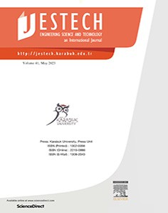

Contents lists available at [ScienceDirect](http://www.sciencedirect.com/science/journal/22150986)

Engineering Science and Technology, an International Journal

journal homepage: [www.elsevier.com/locate/jestch](http://www.elsevier.com/locate/jestch)

[](http://crossmark.crossref.org/dialog/?doi=10.1016/j.jestch.2023.101475&domain=pdf)Study on thermal performance and simulation method of oil medium steel-BMC mechanical joints

Jiaxing Shen a,b,⇑, Zihao Pan b, Yu Chen b, Ping Xu b, Yinghua Yu b

a *Research Institute of Technology and Equipment for the Exploitation and Utilization of Mineral Resources, Liaoning Technical University, Fuxin 123000, China*

b *School of Mechanical Engineering, Liaoning Technical University, Fuxin 123000, China*

a r t i c l e i n f o

*Article history:*

Received 24 March 2023

Revised 1 June 2023

Accepted 29 June 2023

Available online 11 July 2023

*Keywords:*

Oil-medium

Steel-BMC mechanical joints Actual contact proportion Thermal performance

a b s t r a c t

In order to study the thermal performance and simulation analysis method of oil medium steel-BMC mechanical joints. Discrete analytical methods of the actual solid contact proportion and actual lubricat- ing oil contact proportion of the oil medium steel-BMC mechanical joints were established respectively. A theoretical model of the thermal behaviour parameters and equivalent thickness of the oil medium steel- BMC mechanical joints was developed and the influence of preload and roughness on its thermal beha- viour parameters was investigated. A virtual material-simulation analysis method for oil medium steel- BMC mechanical joints considering contact weights has been developed. The temperature variation of oil medium steel-BMC mechanical joint specimens was investigated using virtual material-simulation anal- ysis methods and experimental methods. It was found that the maximum relative error between the two methods is —2.1%, verifying the validity of the analytical method for the actual contact proportion of oil medium steel-BMC mechanical joints and the theoretical model for the thermal behaviour parameters of oil medium steel-BMC mechanical joints. Finally, the thermal performance and thermal mechanical cou- pling performance of the BMC bed foundation were investigated through simulation analysis, proving that the oil medium steel-BMC mechanical joints have a significant impact on the overall performance of the machine tool.

© 2023 Karabuk University. Publishing services by Elsevier B.V. This is an open access article under the CC

BY-NC-ND license (<http://creativecommons.org/licenses/by-nc-nd/4.0/>).

1. Introduction

Mineral composite (MC) materials have the characteristics of high damping, high thermal stability, high ratio of stiffness to mass, etc. Using mineral composites as the basic components of a machine tool is one of the effective ways to improve its machin- ing accuracy and performance [1–6]. The mineral composite mate- rial studied in this paper is a new type of mineral composite material, which is mainly composed of basalt aggregate, basalt fiber, fly ash, epoxy resin, etc., abbreviated as BMC. The BMC has a high damping ratio, specific heat capacity, stiffness to mass ratio and strength to mass ratio. In addition, it has the advantages of simple manufacturing process, short curing period and rich raw materials, etc [7]. Therefore, the use of BMC materials to manufac- ture machine tools can significantly improve the static, dynamic and thermal properties of machine tools. BMC material can be machined into the basic components of machine tools, such as

* Corresponding author at: Research Institute of Technology and Equipment for the Exploitation and Utilization of Mineral Resources, Liaoning Technical Univer- sity, Fuxin 123000, China.

*E-mail addresses:* [329833309@qq.com](mailto:329833309@qq.com), [shenjiaxing@lntu.edu.cn](mailto:shenjiaxing@lntu.edu.cn) (J. Shen).

machine beds and columns. The steel parts of the machine and the BMC base parts combine to form a steel BMC mechanical joint. Because the machined surface is rough and its surface has many micro-convex peaks, the actual contact area of the mechanical joints is a fraction of the nominal contact area. There are numerous tiny pores within the mechanical joints [8–10]. The guideway of the machine tool is usually lubricated with rich oil when it is work- ing. The excess lubricant oil fills the gap in the mechanical joint and constitutes the oil medium steel-BMC mechanical joints. The thermal and dynamic properties of oil medium steel-BMC mechan- ical joints differ markedly from those of conventional steel and BMC materials. Therefore, the oil medium steel-BMC mechanical joint has a fundamental influence on the thermal performance, dynamic performance and thermomechanical coupling properties of the machine tool [11].

Currently, researches on mechanical joints are mostly focused on the performance of metal mechanical joints for conventional machine tools. For example, Shoukry [12] studied the contact stiff- ness of mechanical joints and developed a corresponding mathe- matical model. He also found that mechanical joints have a constant tangential-normal contact stiffness ratio. Archenti [13] studied the proportion of the mechanical joints errors to the total

<https://doi.org/10.1016/j.jestch.2023.101475>

2215-0986/© 2023 Karabuk University. Publishing services by Elsevier B.V.

This is an open access article under the CC BY-NC-ND license (<http://creativecommons.org/licenses/by-nc-nd/4.0/>).

error of the machine. He found that the accuracy of the machine tools is largely affected by the mechanical joints. Zhao [14] deduced the elastic modulus and shear modulus of the mechanical joints based on the fractal contact theory. Chen [10] investigated the effect of friction on the contact stiffness of mechanical joints and developed a model for the contact stiffness considering the effect of friction. It can be seen that very little research has been carried out on the performance of oil medium steel-BMC mechan- ical joints.

This paper investigates the thermal characteristics of oil med- ium steel-BMC mechanical joints. A new discrete analytical method for the actual contact proportion of oil medium steel- BMC mechanical joints considering contact weight was developed. The variation pattern of the actual contact proportion with preload and roughness is analysed. A model of the thermal parameters of the oil medium steel-BMC mechanical joints was developed. The virtual material-simulation analysis method of oil medium steel- BMC mechanical joints was established theoretically, and the accu- racy of the theoretical model and simulation analysis method was verified through experiments and simulations. Taking certain type of BMC bed foundation as an example, the influence of oil medium steel-BMC mechanical joints on thermal performance and thermal mechanical coupling characteristics of BMC bed foundation was studied. The important influence of thermal properties and ther- mal mechanical coupling characteristics of oil medium steel-BMC mechanical joints is proved.

1. Analysis of actual contact proportion
   1. *Actual solid contact proportion*

Fig. 1 shows that the contact position of the mechanical joints is the tiny convex peak contact, and the contact gap is filled with lubricating oil. The oil medium steel-BMC mechanical joints con- sist of the steel-lubricating oil-BMC mechanical joints and the steel BMC mechanical joints. As shown in the figure, the deformation at the highest position of the tiny convex body is the largest under the pressure load, and the other deformation gradually decreases. As shown in the enlarged view, the larger the deformation, the dar- ker the color.

The actual contact area of the mechanical joints is the founda- tion for analysing the mechanical joints performance [15–16]. To calculate the actual contact area of the mechanical joints, the max- imum contact area of the tiny convex peak of the mechanical joints must be determined. However, it is difficult to find the maximum contact area of the tiny convex peak, which makes the accurate cal- culation very complex and difficult [17–18]. This paper will study the new calculation method.

For convenience of analysis, it is assumed that the contact imprint image of the mechanical joint is shown in Fig. 2(a). The white area in the figure is the non-contact area, and the gray and black areas are the contact areas. The larger the contact deforma- tion of the tiny convex peak in the contact area, the denser the con- tact degree, and the darker the contact color, even the blacker. On

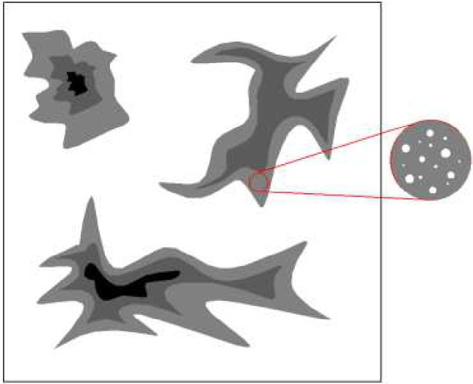

1. Contact imprint image

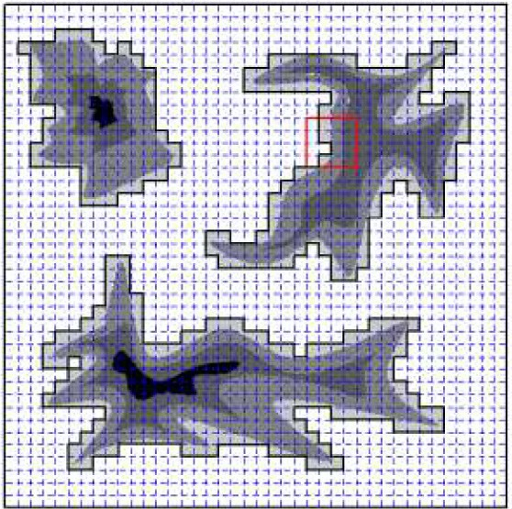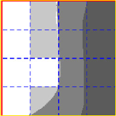

boundary line

*L*

*b*

*i*

*L*

Supplementary unit

|  |  |  |
| --- | --- | --- |
| 255  255 | 230 173 91  230 173 91 | |
| 255 255 | | 173 91 |
| 255 | 173 173 91 | |

1. Discrete division of contact imprints

Fig. 2. Discrete contact area division considering contact weights.

the contrary, the lighter the color, the less sufficient the contact, and even there will be non-contact holes in the contact area.

The contact imprinting image in Fig. 2 (b), whose side length is *L*, is divided into *n* equal parts, and the image has *n*2 discrete ele- ments of square with side length D*L = L/n*. Discrete elements are defined as contact elements or non-contact elements depending on whether they contain a contact area or not. According to the position of contact elements, they are divided into inner contact elements and boundary contact elements. The area enclosed by the yellow lines in the Fig. 2 (b) contains the inner contact element *i* (the surrounding elements are all contact elements) and the boundary contact element *b* (the surrounding elements have non-contact elements). After counting the amount of internal con- tact elements and boundary contact elements and multiplying by the element area, the contact area of the mechanical joints can be roughly calculated. The actual contact area of the boundary con- tact element is less than or equal to the area of the discrete ele- ment, as shown in the fourth row and second column of the yellow enlargement in Fig. 2(b). The boundary line divides the ele- ment into contact and non-contact parts. According to the above rough calculation, the contact area obtained is the area of the gray

area in the enlarged figure of Fig. 2 (b), which leads to excessive

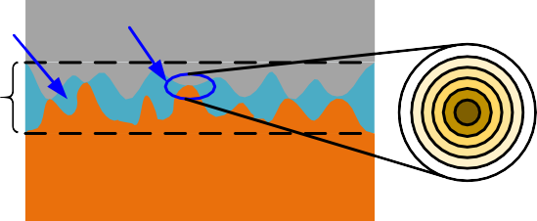Oil I

Joint Surface

Steel

BFPC

I calculation area.

The contact imprint image after grayscale processing is stored in MATLAB as grayscale value matrix, set as Hn×n. As shown in the gray value matrix in Fig. 2 (b), the gray value 255 represents the white area (non-contacted area), the gray value 0 represents the black area (contacted area, and the maximum contact density), and the other values are gray (contacted area, but the contact den- sity is relatively small). To facilitate the analysis, the gray value

matrix is inversely processed. The value 255 is subtracted from the gray value matrix to obtain Cn×n

## *C*

### *Arc* =

*n*

*n*

*n*

*n*

*s*=1

X

X*t*=1

*In*×*n*

+ *b*

max(*Cn*×*n*)

X*s*=1

X*t*=1

*Bn*×*n*

!

max(*Cn*×*n*)

# × D*L*2

# (4)

*n*×*n* = 255 — *Hn*×*n* (1)

The gray value of elements in the non-contact region of matrix Cn×n is zero. The gray value of the matrix Cn×n contact region is non-zero, and the larger the gray value, the larger the contact deformation.

The inverse-treated contact imprint matrix Cn×n is decomposed into internal contact element matrix and boundary contact ele- ment matrix.

where, *b* is the contact proportion coefficient of boundary contact element.

As shown in Fig. 3, there are two intersections between the boundary line of the boundary contact element and the edge of the element. Connect the two intersections with a straight line to get a split line. The area enclosed by the split line and the discrete

element boundary is *S*(*x*; h). *x* and h are uniformly distributed vari-

ables, so the area *S*(*x*; h) is

## *C I B*

2 8>

1 (D*L* — *x*)2 tan h; 0 < h 6 arctan D*L* ;

*n*×*n*=

*n*×*n*+

*n*×*n* ( )

2

>

D*L*—*x*

> D*L*2 — *x*D*L* — D*L*2 ; arctan D*L*

< h 6 arctan D*L*

; *x* < D*L* ;

2 tan h

>

D*L*—*x*

D*L*—2*x* 2

< *x*D*L* + D*L*2 ; arctan D*L* < h 6 *p* — arctan D*L* ; *x* < D*L* ;

where, I*n*×*n* is the internal contact element matrix, and B*n*×*n* is the

*S*(*x*; h) =

2 tan h

D*L*—2*x*

*x*

2

(5)

boundary contact element matrix. After inversely processing, the

> D*L*2 — *x*D*L* — D*L*2 ; arctan D*L* < h 6 *p* — arctan D*L* ; *x* P D*L* ;

2 tan h

>

D*L*—*x*

2*x*—D*L* 2

gray value matrix of the region surrounded by yellow lines in

> *x*D*L* + D*L*2 ; *p* — arctan D*L* < h 6 *p* — arctan D*L* ; *x* P D*L* ;

>: 2 tan h

26 37

Fig. 2 (b) is decomposed into the inner contact element matrix

— 1 *x*2 tan h; *p* — arctan D*L* < h < *p*

2

2*x*—D*L x* 2

*x*

0 0 82 164

0 0 82 164

The average contact area of boundary contact element is

64 0 0 0 164 75 and boundary contact element matrix

0

— 1 Z *p* Z D*L*

0 0 82 164

2 0 25 0 0 3

0 25 0 0

*S* = *p*D*L*

*S*(*x*; h)*dxd*h (6)

0

0 0 82 0 .

64 75

0 82 0 0

There are numerous tiny pores in the contact element. To improve the accuracy of the calculation of the actual contact area, the affect of the contact weight of the contact elements should be taken into account. Divide the internal contact element matrix I*n*×*n* and boundary contact element matrix B*n*×*n* by the largest element in matrix Cn×n, and then sum the numerical values of all elements. The solid contact area of the mechanical joints considering the con- tact weight is obtained by discrete calculation method as

*b* is the ratio of *S* to D*L* . According to literature [19–20], it can be deduced that the *b* is

—*S*

—

2

*b* = D*L*2 ≈ 0.150387 (7)

Because the split line is a straight line, and the boundary line is usually a curve, replace the triangle area with a quarter of the cir- cular area as shown in Fig. 4, and the proportional relationship between them is

*S*' = *pS*D/2 (8)

*Arc* = D*L*2 ×

X*n* X

*In*×*n*

# + X X

*Bn*×*n* !

# (3)

According to Eqs. (4), (7) and (8), the solid discrete contact area

is

*s*=1

*t*=1 max(*Cn*×*n* )

*n*

*n*

*n*

*s*=1

*t*=1 max(*Cn*×*n*) !

*Arc* = X X

2

*n*

*n*

*n*

*n*

*In*×*n*

+ *pb* X X

*Bn*×*n*

× D*L* (9)

The area of the discrete element is larger than the actual contact

area of the boundary contact element, so Eq. (3) is improved

*s*=1

*t*=1 max(*Cn*×*n* )

2 *s*=1

*t*=1 max(*Cn*×*n*)

The solid discrete contact proportion is

*L* Split



***S*(*x*, )**

line

Border

*x*



*Rrc* = *Arc*

*L*2

X*n* X

*n*

=

*In*×*n*

max(*Cn*×*n*) + 2

*pb* X X

*Bn*×*n* !

*2.3. Analysis of actual contact proportion of solid and lubricating oil*

The BMC specimens are manufactured by casting. The size of

max(*Cn*×*n*)

specimens is 150 150 20 mm cubes. The specimen and mould are shown in Fig. 5. The BMC specimens are milled, and the rough-

× ×

# D*L* 2

*n*

*n*

*L*

*s*=1

*t*=1

×

# (10)

*s*=1

*t*=1

ness of machined specimens is Ra3.2 lm, Ra6.3 lm, Ra12.5 lm, respectively. The contact surface of the BMC specimens were

The analysis shows that the equal parts *n* tends to infinity, the discrete element area tends to zero, and discrete contact propor- tion tends to the actual contact proportion.

* 1. *Actual lubricating oil contact proportion*

Lubricating oil is a liquid, and it has uniform contact with steel and BMC surfaces, so the actual contact area doesn’t need to con- sider the influence of contact weight of lubricating oil. Due to the viscosity of lubricating oil, it is difficult for lubricating oil to pene- trate into the micropores in the solid contact area of the steel-BMC mechanical joints. Therefore, when calculating the actual contact area of lubricating oil, its size is calculated by subtracting the

evenly coated with red ink. The preload of 0.2 MPa 1 MPa was applied to the steel-BMC mechanical joints using a hydraulic press to obtain the contact imprint images. The grayscale processed con- tact imprint images are shown in Fig. 6.

According to the process in Fig. 7, the actual solid contact pro- portion (with contact weight) and the actual lubricating oil contact proportion were calculated using MATLAB.

~

The roughness of steel specimens is Ra3.2 lm. The roughness of

BMC specimens is Ra6.3 lm. Table 1 shows the discrete solid con- tact area under different conditions. Fig. 8 is the change curve of solid discrete contact proportion. The contact proportion function is obtained by MATLAB fitting, and its parameters are shown in Table 2.

actual solid contact area without considering the contact weight from the nominal contact area of the steel-BMC mechanical joints.

The solid contact area without considering the contact weight is

*RrcP* = *p*1*n* + *p*2

# (14)

*A*' = Count(*In n pb* Count(*Bn n*) × D*L*2 (11)

*n* + *q*

*rc* × )+ 2 ×

where, *p*1, *p*2 and *q* are fitting parameters, and *P* is preload of mechanical joints.

*n*?+∞, the actual solid contact proportion is

where Count(*In*×*n*) and Count(*Bn*×*n*) are the number of non-zero ele- *R*

# lim *R*

# lim

*p*1*n* + *p*2 *p* 15

ments of the internal contact element matrix I*n*×*n* and the boundary

*cP* = *n*→+∞ *rcP* = *n*→+∞ *n* + *q* = 1 ( )

contact element matrix B*n*×*n*, respectively. The actual lubricating oil contact area is

*Arl* = *L*2 — *A*'*rc* (12)

The actual lubricating oil contact proportion is

*L*2 — *A*'*rc*

The roughness of steel specimens is Ra3.2 lm. The roughness of BMC specimens is Ra6.3 lm. The preloads of the steel BMC mechanical joints are 0.2 MPa 1 MPa, respectively. The actual

solid contact proportion of steel BMC mechanical joints with con-

~

tact weight are 2.03%, 2.877%, 3.628%, 4.468% and 4.859%, respec- tively. The actual solid contact proportion of steel BMC

*Rrl* = *L*2

×

*pb*

= 1 — Count(*In*×*n*)+ 2 Count(*Bn*×*n*)

D*L* 2

*L*

(13)

BMC

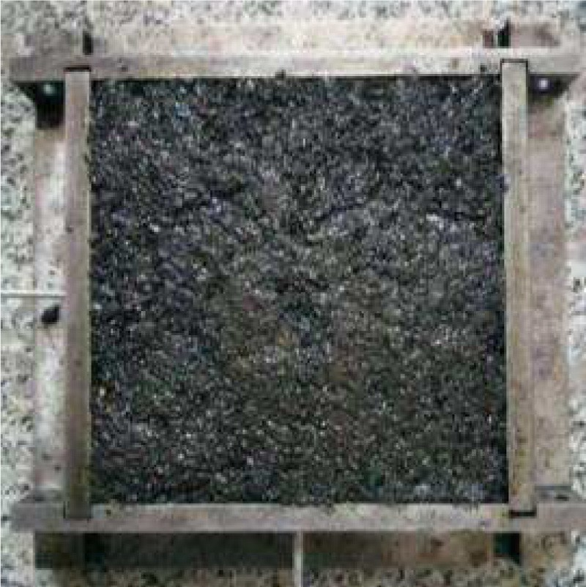

specimen

Mould

mechanical joints without contact weight is 3.56%, 4.497%,





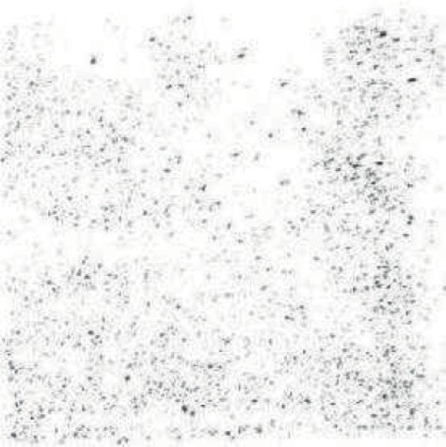Fig. 5. BMC specimen and mould. Fig. 6. Contact imprint image (grayscale processed).

**N** Decide whether **Y**

Discretization the picture

Enter the number of

equa l parts, *n*

*cst* is an internal

contact unit

Process the grayscale picture

Reverse-processe the graysca le picture

Extract the discretized data matrix, **C***n×n*

Import the contact imprint picture of the joint surface

*cst* is a boundary contact unit

unit *cst* of **C***n×n* is a

boundary contact

Decomposition Decomposition

contact matrix, **B***n×n*

Obtain the boundary

|  |  |
| --- | --- |
| Obtain the internal | |
| contact matrix, **I***n×n* | |
|  |  |

Calcula tion of solid contact are a ratio considering contact weight, *Rrc*

Calcula te the conta ct area ratio of oil, *Rrl*

End

Fig. 7. Calculation Process.

Table 1

Discrete calculation results of solid contact proportion.

|  |  |  |  |  |  |  |  |
| --- | --- | --- | --- | --- | --- | --- | --- |
| Preload/MPa | Equal fractions/*n* | With weight | Without weight | Preload/MPa | Equal fractions /*n* | With weight | Without weight |
| 0.2 | 90 | 0.5134 | 0.5976 | 0.8 | 90 | 0.6625 | 0.8813 |
|  | 120 | 0.4182 | 0.5180 |  | 120 | 0.5395 | 0.7718 |
|  | 180 | 0.2662 | 0.3902 |  | 180 | 0.3722 | 0.5837 |
|  | 240 | 0.2036 | 0.2939 |  | 240 | 0.2725 | 0.4534 |
|  | 360 | 0.1482 | 0.2117 |  | 360 | 0.2109 | 0.3294 |
|  | 720 | 0.0904 | 0.1484 |  | 720 | 0.1354 | 0.2308 |
| 0.4 | 90 | 0.5612 | 0.7507 | 1.0 | 90 | 0.6995 | 0.9201 |
|  | 120 | 0.4613 | 0.6589 |  | 120 | 0.5767 | 0.8162 |
|  | 180 | 0.2966 | 0.5015 |  | 180 | 0.4071 | 0.6191 |
|  | 240 | 0.2264 | 0.3845 |  | 240 | 0.3052 | 0.4853 |
|  | 360 | 0.1673 | 0.2762 |  | 360 | 0.2306 | 0.3513 |
|  | 720 | 0.1061 | 0.1938 |  | 720 | 0.1505 | 0.2492 |
| 0.6 | 90 | 0.6211 | 0.8121 | 0.6 | 240 | 0.2518 | 0.4155 |
|  | 120 | 0.5012 | 0.7055 |  | 360 | 0.1892 | 0.3012 |
|  | 180 | 0.3295 | 0.5382 |  | 720 | 0.1168 | 0.2081 |

5.248%, 6.254% and 6.677%, respectively. Fig. 9 shows the curve of actual solid contact proportion and preload of BMC mechanical joints.

The actual solid contact proportion and the actual lubricating oil contact proportion of the steel BMC mechanical joints under dif- ferent roughness and preload are obtained by the same calculation method. The results are shown in Table 3.

Fig. 10 shows the coupling effect of preload and roughness on the actual contact proportion of the mechanical joints. The figure shows that the actual solid contact proportion of the mechanical joints increases with the increase of preload, and reduces with increasing roughness. It can be seen from the figure that the influ-

ence of preload is greater than that of roughness. The actual con- tact proportion of lubricating oil is negatively related to the preload and positively related to the roughness value. The influ- ence of preload is greater than roughness.

1. Theoretical model of thermal properties of mechanical joints
   1. *Equivalent thermal conductivity*

As shown in Fig. 11, the heat conduction forms of the oil med- ium steel-BMC mechanical joints mainly include steel BMC heat conduction and steel-oil-BMC heat conduction. According to Four-

mula, the equivalent thermal conductivity of the oil medium steel-BMC mechanical joints is

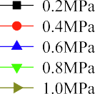

*kc* = *Arc*  2*kskB* + *Arl ko* = *Rrc*  2*kskB* + *Rrlko* (17)

*A ks* + *kB A ks* + *kB*

where, *A* is the nominal contact area of oil medium steel-BMC mechanical joints, *L*2; *ks*, *kB*, *ko* are thermal conductivity of steel, BMC and oil, respectively.

* 1. *Equivalent density*

In Fig. 11, the equivalent thickness of steel specimen and BMC specimen is *hs* and *hB*, respectively. The sum of the lubricating oil mass *mo*, the steel mass *ms*, and the BMC mass *mB* is divided by the equivalent volume *V* of the mechanical joints to obtain the equivalent density.

*qc* = *ms*+*mB*+*mo* = *qsArchs*+*qBArchB*+*qoArl*(*hs*+*hB*)

*V A*(*hs*+*hB*)

*qs Rrchs* +*qBRrc hB* +*qo Rrl* (*hs* +*hB* ) (*hs*+*hB*)

=

# (18)

where, *qs*, *qB*, *qo* are the density of steel, BMC and lubricating oil.

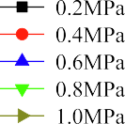

* 1. *Equivalent specific heat capacity*

Because the thickness of the mechanical joints is very small, assume that the temperature changes of all components of the mechanical joints are equal to D*T*. The heat absorbed by the steel component of the oil medium steel-BMC mechanical joints is *Qs*, the heat absorbed by the BMC component is *QB*, and the heat absorbed by the lubricating oil is *Qo*. The equivalent specific heat capacity *cc* of the oil medium steel-BMC mechanical joints is

*cc* = *Qs*+*QB*+*Qo* = *csms*D*T*+*cBmB*D*T*+*como*D*T*

*mc* D*T*

*mc* D*T*

*csqs Rrc hs* +*cBqBRrchB* +*coqo Rrl* (*hs* +*hB* )

=

*qc* (*hs*+*hB*)

# (19)





Fig. 8. Curve of discrete contact proportion.

ier heat conduction law, the relationship between heat flow and temperature difference and heat transfer area is as follows

*/* = —*kS dT*/*dx* (16)

where: */* is heat flow; *k* is thermal conductivity; d*T* is temperature difference; d*x* is thickness of specimen; *S* is area of heat transfer.

The total heat flow of the oil medium steel-BMC mechanical joints is kept conservation [21]. According to energy balance for-

where, *cs*, *cB*, *co* are the specific heat capacities of steel, BMC and lubricating oil.

* 1. *Equivalent thickness*

The equivalent thickness of steel and BMC is closely related to their surface roughness and tiny structure. The roughness of pro- cessed steel is Ra3.2 lm, and its equivalent thickness *hs* is about

0.5 mm [22,23]. According to literature [22,23], it can be seen that surface roughness has a critical impact on equivalent thickness, and the relationship between them is proportional. The surface roughness of processed BMC specimens is about 1, 2, and 3 times that of steel specimens, so *hB* of BMC is nearly 1, 2, and 3 times that of *hs* respectively. The equivalent thickness of BMC is approxi- mately 0.5 mm, 1 mm and 1.5 mm. The equivalent thickness of the mechanical joints is *hc* = *hs* + *hB*.

Table 2

Fitting coefficient.

|  |  |  |  |  |  |  |  |  |
| --- | --- | --- | --- | --- | --- | --- | --- | --- |
| Preload/MPa | With weight |  |  |  | Without weight |  | | |
|  | *p*1/×10-2 | *p*2 | *q* |  | *p*1/×10-2 | *p*2 | *q* |  |
| 0.2 | 2.030 | 46.64 | 2.995 |  | 3.56 | 79.05 | 45.47 |  |
| 0.4 | 2.877 | 50.92 | 3.837 |  | 4.497 | 106.7 | 55.12 |  |
| 0.6 | 3.628 | 54.88 | 2.56 |  | 5.248 | 112.9 | 52.93 |  |
| 0.8 | 4.468 | 61.31 | 7.488 |  | 6.254 | 121.5 | 52.06 |  |
| 1 | 4.859 | 70.25 | 15.55 |  | 6.677 | 132.8 | 58.16 |  |

Fig. 9. Relationship between actual contact proportion and preload.

Table 3

Actual contact proportion of mechanical joints.

|  |  |  |  |
| --- | --- | --- | --- |
| Preload/MPa | Roughness Ra/lm | Solid | Lubricating oil |
| 0.2 | 3.2 | 2.827% | 95.756% |
| 0.2 | 6.3 | 2.030% | 96.44% |
| 0.2 | 12.5 | 1.519% | 97.02% |
| 0.4 | 3.2 | 3.837% | 94.772% |
| 0.4 | 6.3 | 2.877% | 95.503% |
| 0.4 | 12.5 | 2.401% | 96.162% |
| 0.6 | 3.2 | 4.758% | 93.618% |
| 0.6 | 6.3 | 3.628% | 94.752% |
| 0.6 | 12.5 | 3.330% | 95.317% |
| 0.8 | 3.2 | 5.653% | 92.679% |
| 0.8 | 6.3 | 4.468% | 93.746% |
| 0.8 | 12.5 | 4.008% | 94.501% |
| 1.0 | 3.2 | 6.185% | 92.141% |
| 1.0 | 6.3 | 4.859% | 93.323% |
| 1.0 | 12.5 | 4.319% | 94.118% |

* 1. *Variation law of equivalent thermal performance of mechanical joints*

Table 4 shows the thermal performance parameters of steel, BMC and lubricating oil. According to Eqs. (17) (19), the equiva- lent thermal performance parameters of the oil medium steel- BMC mechanical joints with different roughness and preload are calculated, as shown in Table 5.

~

Fig. 12 shows the equivalent thermal performance curve of the oil medium steel-BMC mechanical joints. According to Fig. 12(a) (b), the equivalent thermal conductivity and equivalent density of the mechanical joints show rapid increase with increasing preload, but the increase rate gradually decreases. Equivalent thermal con- ductivity and equivalent density are inversely related to roughness. According to Fig. 12(c), the equivalent specific heat capacity decreases nonlinearly with the increase of preload. However, the specific heat capacity is the opposite.

~

Analyze the cause of thermal performance changes of oil med- ium steel-BMC mechanical joints. The actual solid contact propor- tion of the mechanical joints grows as the roughness falls or as the preload grows. The thermal properties of mechanical joints tend to be the properties of solid material (BMC and steel) with the increase of the actual solid contact proportion. The thermal con- ductivity and density of solid materials (steel and BMC) is much greater than that of lubricants oil, so the relevant performance

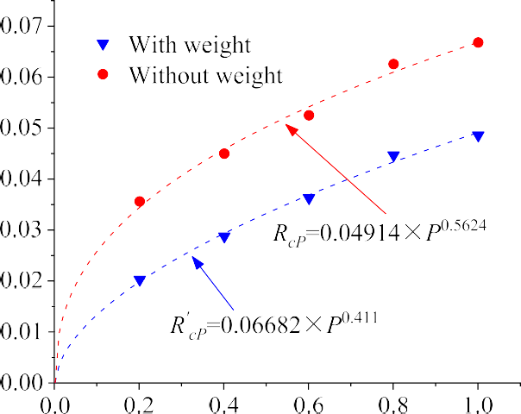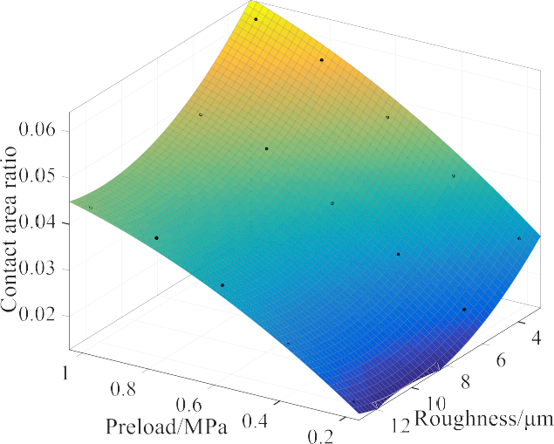

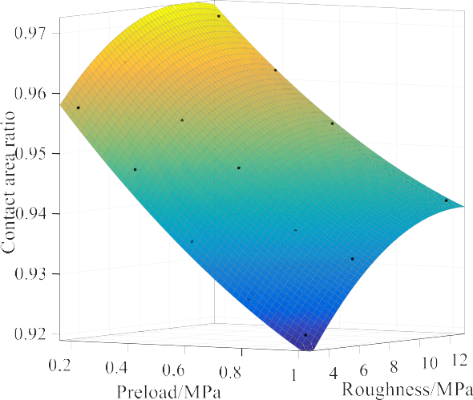

Fig. 10. Coupling effect of preload and roughness.

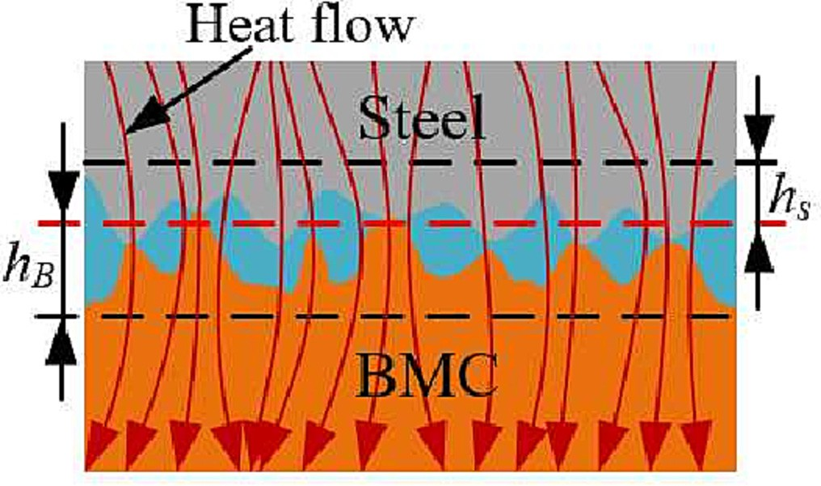

Fig. 11. Heat conduction forms of mechanical joints.

parameters of mechanical joints increase with the proportion of solids in contact. However, the equivalent specific heat capacity of the oil medium steel-BMC mechanical joints is the reverse.

Table 4

Material parameters.

Thermal conductivity/ W·(m·K)-1

Specific heat capacity/ kJ·(kg·K)-1

Density/kg·m—3

Steel 45 0.46 7850

BMC 1.5134 1.07 2850

Oil 0.1324 1.87 873

Table 5

Performance parameters of mechanical joints.

|  |  |  |  |  |
| --- | --- | --- | --- | --- |
| Preload/MPa | Roughness/lm | Equivalent thermal conductivity/W·(m·K)-1 | Equivalent density/kg·m—3 | Equivalent specific heat capacity/kJ·(kg·K)-1 |
| 0.2 | 3.2 | 0.20956 | 987.19438 | 1.67887 |
| 0.2 | 6.3 | 0.18713 | 933.60953 | 1.75673 |
| 0.2 | 12.5 | 0.17294 | 909.26360 | 1.79521 |
| 0.4 | 3.2 | 0.23784 | 1032.63906 | 1.62200 |
| 0.4 | 6.3 | 0.21069 | 963.68569 | 1.71447 |
| 0.4 | 12.5 | 0.19763 | 937.93526 | 1.75539 |
| 0.6 | 3.2 | 0.26328 | 1071.83814 | 1.57372 |
| 0.6 | 6.3 | 0.23169 | 991.04963 | 1.67929 |
| 0.6 | 12.5 | 0.22371 | 968.64741 | 1.71609 |
| 0.8 | 3.2 | 0.28824 | 1111.52317 | 1.53056 |
| 0.8 | 6.3 | 0.25496 | 1020.20725 | 1.64185 |
| 0.8 | 12.5 | 0.24249 | 989.32173 | 1.68862 |
| 1.0 | 3.2 | 0.30311 | 1135.28843 | 1.50639 |
| 1.0 | 6.3 | 0.26585 | 1034.17462 | 1.62524 |
| 1.0 | 12.5 | 0.25109 | 998.72914 | 1.67639 |

1. Virtual material simulation method of mechanical joints

where, *Ks*\* *B*

is the dimensionless contact stiffness. *g*(*D*) is the

2—*D*

*D*

parameter, *g*(*D*) = (2 — *D*)2 · *D* 2 · (*D* — 1)—1. *D* is the fractal dimen-

In order to accurately simulate and analyse the thermal and thermomechanical coupling properties of oil medium steel-BMC

—

mechanical joints. The application of virtual material simulation

sion of the BMC rough surface. *E* is the equivalent elastic modulus,

*E*—1 = 1 — *v*2 *E*—1 + 1 — *v*2 *E*—1. *m*1, *m*2, *E*1 and *E*2 are Poisson’s ratio

1

1

2

2

*c*

—

method to the analysis of oil medium steel-BMC mechanical joints

was investigated. The oil medium steel-BMC mechanical joint was

and elastic modulus of steel and BMC respectively. *ac*\* is the dimen- sionless critical contact area, *a*\* = *G*\*2·[*H*/(2*E*)]—*D*2 1 . *H* is the hardness

simulated with a layer of uniform virtual material [9,24], as shown in Fig. 13. Virtual materials’ thermal performance parameters are described in Section 3. In addition, the theoretical models of equiv- alent elastic modulus, equivalent expansion coefficient and Pois- son’s ratio of virtual materials need to be derived.

of BMC. *G\** is the dimensionless characteristic scale parameter of BMC rough surface, *G*\* *G*/,*An*. *G* is the characteristic scale param-

eter of BMC rough surface.

= ﬃﬃﬃﬃﬃ

It is assumed that there is no leakage of lubricating oil on the mechanical joints. According to the bulk elastic modulus of lubri- cating oil, its elastic modulus is deduced as

* 1. *Virtual materials’ equivalent elastic modulus*

*E*  D*po*

D*F*/*Arl*

### *hcKo*

The elastic modulus is the proportion of normal stress *r* to nor- mal strain *e*. The normal stress is the proportion of the normal load *Fn* to the area *A* of force action. The normal strain *e* is the proportion of the compression deformation D*dc* to the equivalent thickness *hc*

of the mechanical joints. The compression deformation D*dc* of the mechanical joints is negatively related to the equivalent stiffness *Kn*.

*o* = *Vo* D*Vo* = (*Arlhc*) × *Arl* D*d* = *Arl* (23)

where, *E*o is the elastic modulus of lubricating oil, 1.5GPa. *Vo* is the volume of lubricating oil in the mechanical joints. D*po* is the change pressure on the lubricating oil. D*Vo* is the change volume of lubri- cating oil after pressure. D*F* is the normal support force provided by the lubricating oil. D*d* is the change of oil film thickness after the mechanical joints is compressed.

*r F* /*A F h F h*

1 *K h*

The contact stiffness provided by the lubricating oil is

*Ec* =

*n*  *n c*  *n c*

= = = ×

*n c*

=

# (20)

*K A E* /*h* 24

*e* D*dc*/*hc*

*A*D*dc*

### *A Fn*/*Kn A*

*o* = *rl o c* ( )

The equivalent stiffness *Kn* of the oil medium steel-BMC mechanical joints is provided by the solid contact stiffness and the lubricating oil contact stiffness, and they are in parallel. *Kn* is

*Kn* = *Ks*—*B* + *Ko* (21)

where, *Ks*—*B* is the contact stiffness provided by solid materials, and

*Ko* is the contact stiffness provided by lubricating oil.

The solid contact stiffness of mechanical joints can be obtained from the fractal contact theory.

In fact, the lubricating oil in the mechanical joints is not com- pletely sealed, taking into account the influence of lubricant leak- age, Eq. (24) is modified as

*Ko* = *cArlEo*/*hc* (25)

where, *c* is the leakage coefficient, dependent on the roughness and geometry of the mechanical joints, 0.421[25].

According to Eqs. (20) (22) and Eq. (25), the total normal stiff- ness of oil medium steel-BMC mechanical joints is

~

*Ec c g*(*D*) · *R*2 ·

—2

= ,ﬃﬃﬃﬃﬃ**ﬃ** · *rc*

· *Rrc*

— *ac*\* —2

+ *cRrlEo* (26)

# ,ﬃﬃﬃ *

*Ks*—*B* = *E*

*A* × *Ks*—*B*

2*Eh*

*D* " 2 — *D* 1—2*D* 1 *D*

1 *D* #

2*E*,*A*

ﬃﬃﬃ

# = ,ﬃ*p*ﬃﬃﬃ

*D*

· *g*(*D*) · *R*2 ·

*rc*

*c*

" 2 — *D* 1—2*D*

*D*

1—2*D*

· *rc*

*R*

— *a*\*1—2*D* #

*Ap D*

# (22)

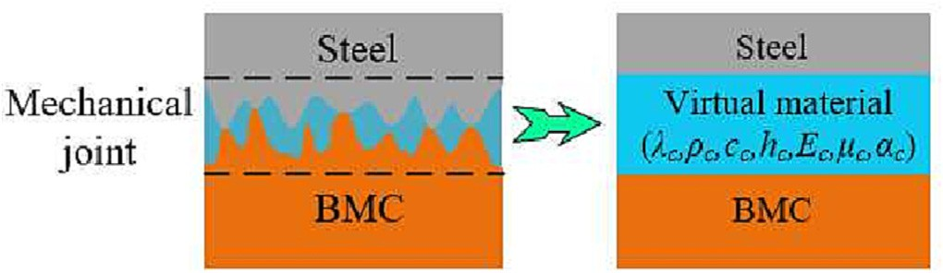

Fig. 13. Virtual material model of mechanical joints.



* 1. *Virtual materials’ equivalent expansion coefficient*

The oil medium steel-BMC mechanical joints are composed of lubricating oil, steel and BMC. The equivalent expansion coefficient of oil medium steel-BMC mechanical joints is equal to the algebraic sum of the product of the volume fraction of each component and its expansion coefficient [26].

*ac* = *Archs as* + *ArchB aB* + *cArlhc ao*

*Ahc*

*Ahc*

*Ahc*

*Rrchs Rrc hB*

= *a* + *a*

*s*

*B*

*rl*

*o*

*hc*

*hc*

+ *cR a*

# (27)

Where, *as* is the expansion coefficient of steel, *aB* is the expan- sion coefficient of BMC, and *ao* is the expansion coefficient of lubri- cating oil.

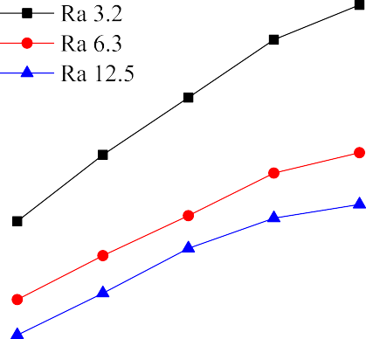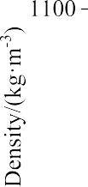

* 1. *Virtual materials’ equivalent Poisson’s ratio*

The Poisson’s ratio is the ratio of tangential deformation to the normal deformation. As the contact of the mechanical joints is incomplete, the transverse deformation of the tiny convex peak by the force will fill the gap of tiny convex peaks. On the whole, there is essentially no deformation in the tangential direction of

the mechanical joints. The equivalent Poisson’s ratio *lc* is zero.

* 1. *Theoretical verification of thermal performance of mechanical joints*
     1. *Simulation study*

To test the accuracy of the above study, the temperature varia- tion of the oil medium steel-BMC mechanical joints which heated with 39.84 W for 600 s was studied by simulation and experiment respectively.

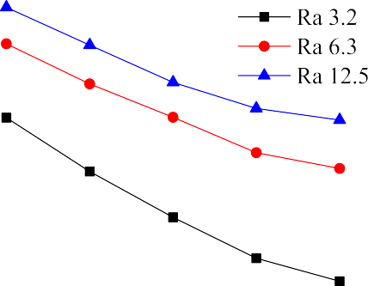

The BMC specimen is a cuboid with a size of

150 150 20 mm, its roughness is Ra6.3 lm, and its fractal parameters are *D* = 1.17 and *G* = 2.8. The hardness of BMC material is 45 MPa, its elastic modulus is 35GPa, its Poisson’s ratio is 0.26, and its expansion coefficient is 2.48 × 10-6/K. The steel specimen

× ×

is a cuboid with a size of 150 × 150 × 10 mm. The roughness of steel specimen is Ra3.2 lm. Its elastic modulus is 200GPa, its Pois- son’s ratio is 0.27, and its expansion coefficient is 1.17 × 10-5/K.

Table 6

Equivalent parameters of the virtual material.

Thermal conductivity/ W·(m·K)-1

Specific heat capacity/ kJ·(kg·K)—1

Density/ kg·m—3

Thickness/ mm

0.255 1.6419 1020.2173 1.5

Elastic modulus/MPa Expansion coefficient/K Poisson’s —

ratio

Fig. 12. Thermal performance parameters of mechanical joints.

828.51 2.53 × 10-4 0 —

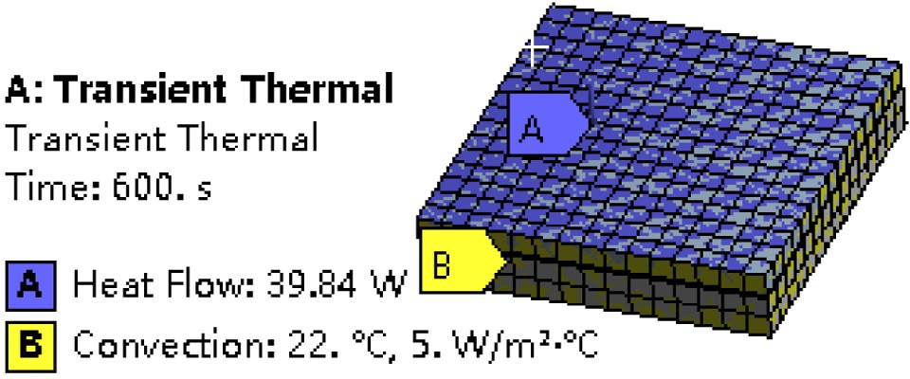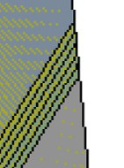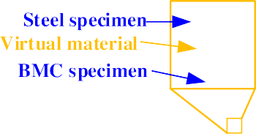

Fig. 14. Simulation analysis model.

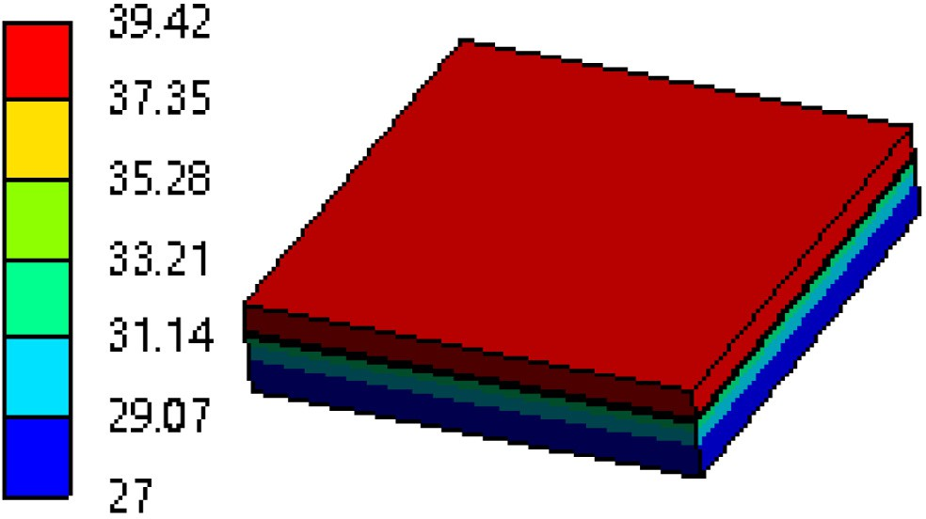

**Steel specimen**

**BMC specimen**

Fig. 15. Temperature analysis results.

The bulk modulus of elasticity of lubricating oil is 1.5GPa, and its expansion coefficient is 6.4 10-4/K.

×

The preload of the oil medium steel-BMC mechanical joints was

0.8 MPa. The solid contact proportion is 0.04468, and the actual lubricating oil contact proportion is 0.93746. The equivalent parameters of the virtual material are shown in Table 6.

Creo software was used to draw the 3D model of virtual mate- rial specimen. In the software, a 1.5 mm thin layer was cut on the mechanical joints as a virtual material layer which uses boolean operations. The 3D model was imported into Workbench software

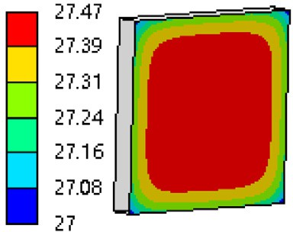

and assigned material properties according to Table 6. The upper surface of the steel specimen was subjected to a thermal power of 39.84 W. Because of the air heat dissipation, the heat dissipation

power of 5 W/(m2 ℃) is received around the mechanical joint spec-

·

imen. Fig. 14 shows the setup of the simulation analysis model. Fig. 15 shows the overall temperature of the mechanical joint specimen.

The result of the analysis shows that the highest temperature of the model was 39.42℃, located on the upper surface of the steel specimen, and the lowest temperature of the model was 27℃,

located on the bottom surface of the BMC specimen. The highest temperature change of BMC specimen within 600 s is shown in the curve in Fig. 16. Because there was air cooling around the spec- imen, the highest temperature at the center of the bottom surface

of BMC was 27.47 ℃.

* + 1. *Experimental verification*

As shown in Fig. 17 (The figure is the middle section of the experimental facility), a resistance heating film was placed at the bottom of the oil medium steel-BMC specimen. In order to prevent the heat loss of the heating film, adiabatic asbestos was used to insulate the bottom of the heating film. To prevent heat transfer to the pressure plate, a adiabatic asbestos was used between the BMC specimen and the pressure plate. A thermocouple tempera- ture sensor was used to check the temperature at the center of the contact surface between the BMC specimen and the adiabatic asbestos. The voltage through the heating film was 20.55 V. The resistance of the heating film was 10.6 X and the power of the heating film was calculated to be 39.84 W based on the applied voltage. The experimental heating power was the same as that of the simulation. The temperature change of BMC specimen was detected within 600 s, and the BMC temperature was recorded every 30 s.

Fig. 18 is the experimental device. Fig. 19 is the temperature curve of the BMC specimen. The ambient temperature during both

simulation and experiment is 22℃. The simulation results and

experimental results almost coincided within 300 s, and then the temperature of the simulation results rose rapidly, but the change trend of experimental results and simulation results was consis- tent. The highest temperature of the contact surface between the

BMC specimen and the adiabatic asbestos measured at 600 s was 26.9℃, and the relative error with the simulation was only 2.1%. The experimental temperature was slightly lower than

—

the simulation temperature because the asbestos can’t be com- pletely insulated, and part of the heat loss caused the experimental temperature to be slightly lower. However, the experimental results can still prove the accuracy of the thermal performance simulation analysis method and a theoretical model of the oil med- ium steel-BMC mechanical joints.

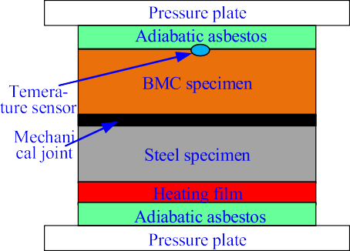

Fig. 16. Highest temperature on the bottom of BMC specimen. Fig. 17. Basic principle of experiment.

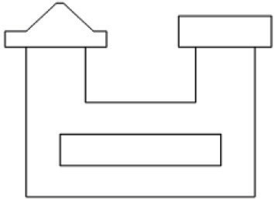

Fig. 21. Dimensions of the BMC bed foundation.

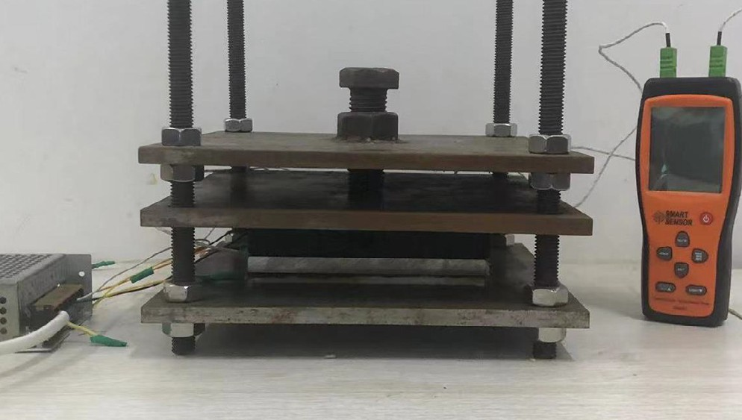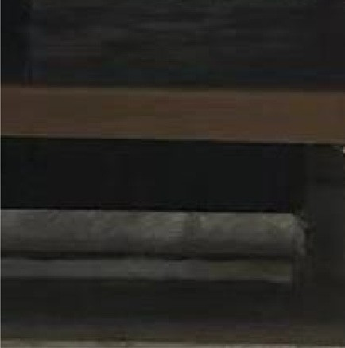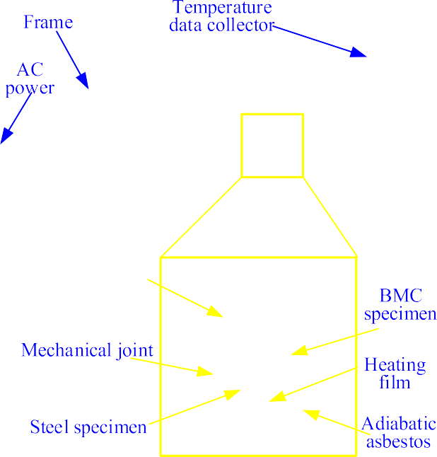

The temperature distribution of the oil medium steel-BMC mechanical joint specimens was examined by the infrared ther- mography. The results are shown in Fig. 19. According to the infra- red image, the temperature at the junction of steel and BMC specimen dropped sharply, and the infrared temperature distribu- tion was consistent with the simulation temperature distribution.

1. Example analysis

Fig. 18. Experimental detection device.

Fig. 19. Result comparison.

Fig. 20 shows the BMC bed foundation, the BMC bed foundation consists of the BMC bed and steel guide rails. The dimensions of the BMC bed foundation are shown in Fig. 21. The steel guide rail con- tacts the BMC bed to form an oil medium steel-BMC mechanical joints. According to the cutting force and self weight of the machine tool, the friction coefficient of the guide rail, and the max- imum feed speed, the maximum heating power of the machine tool guide rail is calculated to be about 400 W. The performance param- eters of oil medium steel-BMC mechanical joints are the same as those in Section 4.4.1. The thermal performance and thermal mechanical coupling performance of the BMC bed base foundation with and without the mechanical joints in 0 1200 s were studied by simulation.

When considering the influence of oil-mediated steel-BMC mechanical joints, a 1.5 mm thick virtual material layer was cut at the contact position of the mechanical joints. The material parameters for each part of the BMC bed foundation and the virtual material layer were defined during simulation analysis. The mesh size is 10 mm, and automatic division is used for mesh division. The model contains 103,149 nodes and 20,825 elements. A thermal

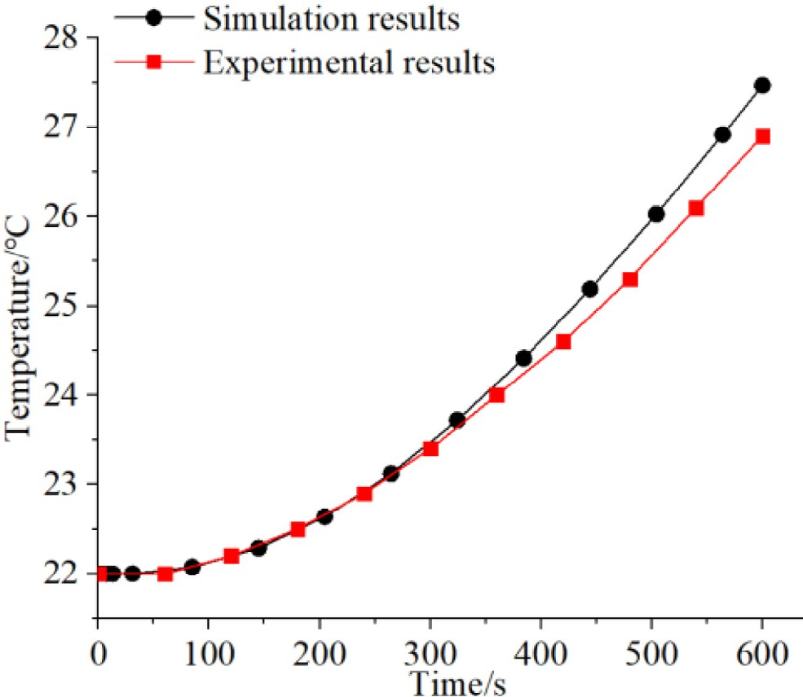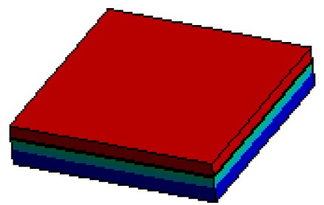

Mecha- nical joint

BMC

specimen

Steel specimen

~

power load of 400 W is applied to the surface of the rails. The BMC bed is subjected to 5 W/(m2 ℃) of heat dissipation power. The fixed constraint was applied on the bottom of the BMC bed. The same

·

method was used to define the material parameters, the con- straints and boundary conditions respectively for the model ignor- ing the oil-mediated steel-BMC mechanical joints, and the constraints and boundary conditions are the same as when consid- ering the oil-mediated steel-BMC mechanical joints. Fig. 22 shows the temperature results of the BMC bed foundation at 1200 s. The

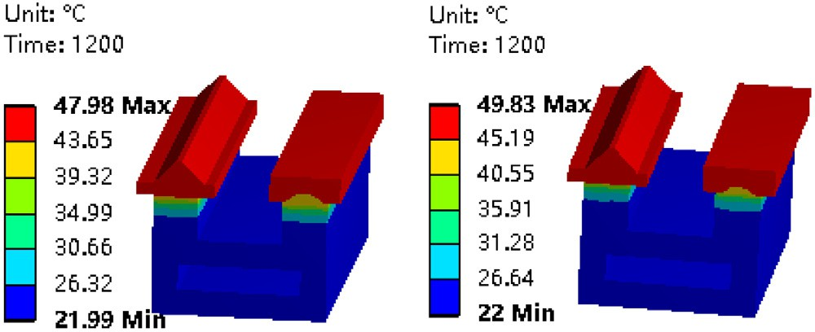highest temperature of the model without considering the mechanical joints was 47.98℃. The highest temperature of the

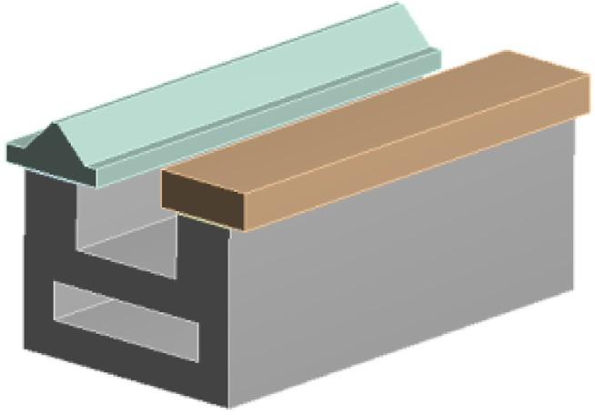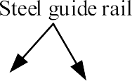

Fig. 20. BMC bed foundation. Fig. 22. Temperature results at 1200 s.

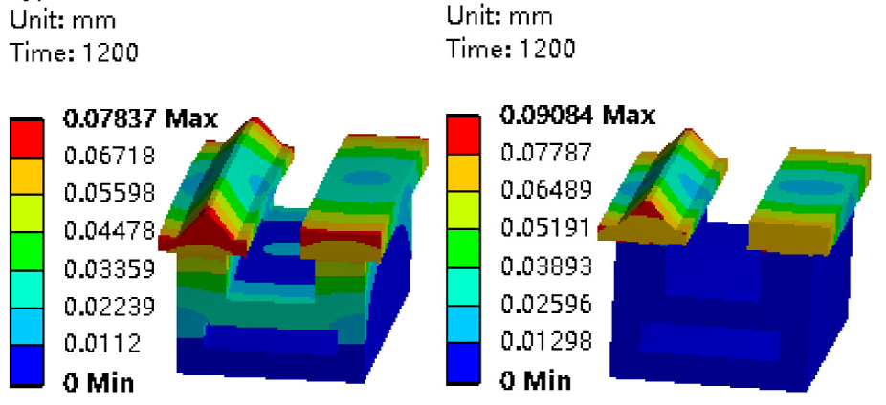



Fig. 23. Thermal deformation at 1200 s.

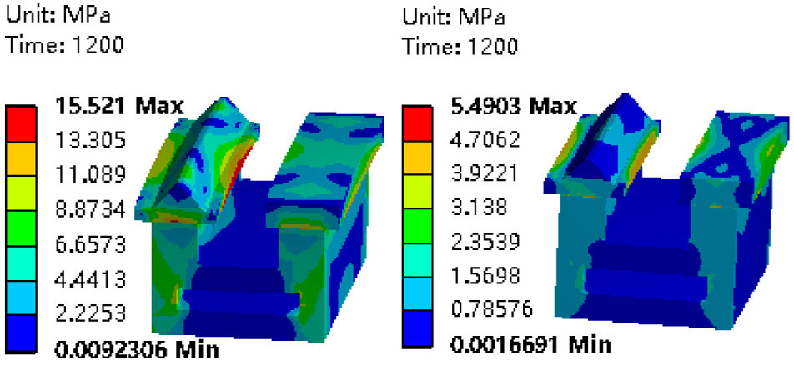

Fig. 24. Thermal stress at 1200 s.

model considering the mechanical joints was 49.83 ℃. The relative change rate of the highest temperature is + 3.9%.

Fig. 23 shows the maximum thermal deformation of the BMC bed foundation affected by thermal mechanical coupling. Without considering the mechanical joints, maximum thermal deformation of the BMC bed foundation is 0.07837 mm. The maximum thermal deformation of the BMC bed foundation considering the mechani- cal joints is 0.09084 mm. The relative change rate of the maximum thermal deformation is + 15.9%. Fig. 24 shows the maximum ther- mal stress of the BMC bed foundation affected by thermal mechan- ical coupling. The maximum thermal stress of the BMC bed foundation without considering the mechanical joints is

15.521 MPa. The maximum thermal stress of the BMC bed founda- tion considering the mechanical joints is 5.4903 MPa. The relative change rate of the maximum thermal stress is —64.6%.

1. Conclusion

A discrete analytical method for the actual contact proportion of the oil medium steel-BMC mechanical joints considering the con- tact weight was established. The effects of the preload and rough- ness of the mechanical joints on the equivalent thermal performance of the oil medium steel-BMC mechanical joints was analyzed. A virtual material-simulation analysis method for oil medium steel-BMC mechanical joints considering contact weights has been developed. The accuracy of the study was verified through simulation and experiment. The conclusions are as following:

1. The actual solid contact proportion of the mechanical joints increases as the roughness decreases or the preload increases, and the effect of preload is greater than that of roughness. The actual lubricating oil contact proportion is negatively related to the pre- load, and positively related to the roughness, and the pressure load has a greater impact.
2. The equivalent density and the equivalent thermal conduc- tivity of the oil medium steel-BMC mechanical joints have similar

changing laws. They increase nonlinearly with the increase of the preload of the mechanical joints. They increase as the surface qual- ity of the mechanical joints increases. The equivalent specific heat capacity of the mechanical joints decreases nonlinearly with the increase of preload. However, its performance decreases with increasing surface quality.

1. The temperature rise of the oil medium steel-BMC mechan- ical joints specimen was studied by virtual material simulation analysis method and the experimental method respectively. The relative error of highest temperature of the two methods is only

2.1%, which prove the accuracy of this study.

—

1. The thermal performance and thermal mechanical coupling performance of BMC bed foundation were studied with and with- out considering the influence of oil medium steel-BMC mechanical joints. The results showed that the highest temperature relative error is +3.9%, the maximum thermal deformation relative error is +15.9%, and the maximum thermal stress relative error is 64.6% with the same load and boundary conditions. It is proved that the oil medium steel-BMC mechanical joints have a key influ- ence on the thermal performance and thermal mechanical cou-

—

pling performance of the machine tool.

Declaration of Competing Interest

The authors declare that they have no known competing finan- cial interests or personal relationships that could have appeared to influence the work reported in this paper.

Acknowledgments

The present work is supported by National Natural Science Foundation of China (52005238), Doctor Initiation Fund of Science and Technology Department of Liaoning Province (2020-BS-256).

References

1. [H.-C. Möhring, C. Brecher, E. Abele, J. Fleischer, F. Bleicher, Materials in](http://refhub.elsevier.com/S2215-0986(23)00153-2/h0005) [machine tool structures, CIRP Ann. 64 (2) (2015) 725–748](http://refhub.elsevier.com/S2215-0986(23)00153-2/h0005).
2. [D.I. Kim, S.C. Jung, J.E. Lee, S.H. Chang, Parametric study on design of](http://refhub.elsevier.com/S2215-0986(23)00153-2/h0010) [composite–foam–resin concrete sandwich structures for precision machine](http://refhub.elsevier.com/S2215-0986(23)00153-2/h0010) [tool structures, Compos. Struct. 75 (1-4) (2006) 408–414](http://refhub.elsevier.com/S2215-0986(23)00153-2/h0010).
3. [D. Kono, S. Mizuno, T. Muraki, M. Nakaminami, A machine tool motorized](http://refhub.elsevier.com/S2215-0986(23)00153-2/h0015) [spindle with hybrid structure of steel and carbon fiber composite, CIRP Ann. 68](http://refhub.elsevier.com/S2215-0986(23)00153-2/h0015)

[(1) (2019) 389–392](http://refhub.elsevier.com/S2215-0986(23)00153-2/h0015).

1. P. Dunaj, T. Okulik, B. Powałka, et al. Experimental investigations of steel welded machine tool bodies filled with composite material, International Scientific-Technical Conference MANUFACTURING, Springer, Cham. 61-69 2019.
2. [E.F. Kushnir, M.R. Patel, T.M. Sheehan, Material considerations in optimization](http://refhub.elsevier.com/S2215-0986(23)00153-2/h0025) [of machine tool structure, ASME International Mechanical Engineering](http://refhub.elsevier.com/S2215-0986(23)00153-2/h0025) [Congress and Exposition, Am. Soc. Mech. Eng. 35746 (2001) 133–145](http://refhub.elsevier.com/S2215-0986(23)00153-2/h0025).
3. [J. Yin, J. Zhang, W. Wang, X. Ren, Effect of glass fiber surface treatment on the](http://refhub.elsevier.com/S2215-0986(23)00153-2/h0030) [mechanical strength of glass fiber reinforced resin mineral composite for](http://refhub.elsevier.com/S2215-0986(23)00153-2/h0030) [machine tool bed, Polym. Compos. 38 (8) (2017) 1559–1570](http://refhub.elsevier.com/S2215-0986(23)00153-2/h0030).
4. [J. Shen, P. Xu, Y. Yu, Dynamic Characteristics Analysis and Finite Element](http://refhub.elsevier.com/S2215-0986(23)00153-2/h0035) [Simulation of Steel–BFPC Machine Tool Mechanical joints, J. Manuf. Sci. Eng.](http://refhub.elsevier.com/S2215-0986(23)00153-2/h0035) [142 (1) (2020) 011006](http://refhub.elsevier.com/S2215-0986(23)00153-2/h0035).
5. [Y. Chang, J. Ding, Z. He, et al., Effect of joint interfacial contact stiffness on](http://refhub.elsevier.com/S2215-0986(23)00153-2/h0040) [structural dynamics of ultra-precision machine tool, Internat. J. Machine Tools](http://refhub.elsevier.com/S2215-0986(23)00153-2/h0040) [Manuf. 158 (2020)](http://refhub.elsevier.com/S2215-0986(23)00153-2/h0040).
6. [H. Tian, B. Li, H. Liu, et al., A new method of virtual material hypothesis-based](http://refhub.elsevier.com/S2215-0986(23)00153-2/h0045) [dynamic modeling on fixed mechanical joints in machine tools, Int. J. Mach.](http://refhub.elsevier.com/S2215-0986(23)00153-2/h0045) [Tool Manu. 51 (3) (2011) 239–249](http://refhub.elsevier.com/S2215-0986(23)00153-2/h0045).
7. [Q. Chen, F. Xu, P. Liu, et al., Research on fractal model of normal contact](http://refhub.elsevier.com/S2215-0986(23)00153-2/h0050) [stiffness between two spheroidal mechanical joints considering friction factor,](http://refhub.elsevier.com/S2215-0986(23)00153-2/h0050) [Tribology Internat. 97 (2016) 253–326](http://refhub.elsevier.com/S2215-0986(23)00153-2/h0050).
8. [J. Liu, C. Ma, S. Wang, S. Wang, B.o. Yang, H.u. Shi, Thermal-structure](http://refhub.elsevier.com/S2215-0986(23)00153-2/h0055) [interaction characteristics of a high-speed spindle-bearing system, Int. J. Mach.](http://refhub.elsevier.com/S2215-0986(23)00153-2/h0055) [Tool Manu. 137 (2019) 42–57](http://refhub.elsevier.com/S2215-0986(23)00153-2/h0055).
9. [S.N. Shoukry, R.H. Thornley, Theoretical expressions for the normal and](http://refhub.elsevier.com/S2215-0986(23)00153-2/h0060) [tangential stiffness of machine tool joints, in: Proceedings of the Twenty-](http://refhub.elsevier.com/S2215-0986(23)00153-2/h0060) [second International Machine Tool Design and Research Conference,](http://refhub.elsevier.com/S2215-0986(23)00153-2/h0060) [Palgrave,](http://refhub.elsevier.com/S2215-0986(23)00153-2/h0060) [London, 1982, pp. 131–138](http://refhub.elsevier.com/S2215-0986(23)00153-2/h0060).
10. [A. Archenti, M. Nicolescu, A top-down equivalent stiffness approach for](http://refhub.elsevier.com/S2215-0986(23)00153-2/h0065) [prediction of deviation sources in machine tool joints, CIRP Ann. 66 (1) (2017)](http://refhub.elsevier.com/S2215-0986(23)00153-2/h0065) [487–490](http://refhub.elsevier.com/S2215-0986(23)00153-2/h0065).
11. [Y. Zhao, C. Yang, L. Cai, W. Shi, Z. Liu, Surface contact stress-based nonlinear](http://refhub.elsevier.com/S2215-0986(23)00153-2/h0070) [virtual material method for dynamic analysis of bolted joint of machine tool,](http://refhub.elsevier.com/S2215-0986(23)00153-2/h0070) [Precis. Eng. 43 (2016) 230–240](http://refhub.elsevier.com/S2215-0986(23)00153-2/h0070).
12. [R. Wang, L. Zhu, C. Zhu, Research on fractal model of normal contact stiffness](http://refhub.elsevier.com/S2215-0986(23)00153-2/h0075) [for mechanical joint considering asperity interaction, Int. J. Mech. Sci. 134](http://refhub.elsevier.com/S2215-0986(23)00153-2/h0075) [(2017) 357–369](http://refhub.elsevier.com/S2215-0986(23)00153-2/h0075).
13. [X. Zhang, N. Wang, G. Lan, et al., Tangential damping and its dissipation factor](http://refhub.elsevier.com/S2215-0986(23)00153-2/h0080) [models of mechanical joints based on fractal theory with simulations, J. Tribol.](http://refhub.elsevier.com/S2215-0986(23)00153-2/h0080) [136 (1) (2014) 011704](http://refhub.elsevier.com/S2215-0986(23)00153-2/h0080).
14. [S.Y. Jiang, Y.J. Zheng, H. Zhu, A contact stiffness model of machined plane joint](http://refhub.elsevier.com/S2215-0986(23)00153-2/h0085) [based on fractal theory, J. Tribol.-Trans. ASME 132 (1) (2010) 1–7](http://refhub.elsevier.com/S2215-0986(23)00153-2/h0085).
15. [K. Konowalski, Experimental research and modeling of normal contact](http://refhub.elsevier.com/S2215-0986(23)00153-2/h0090) [stiffness and contact damping of machined mechanical joints, Adv. Manuf.](http://refhub.elsevier.com/S2215-0986(23)00153-2/h0090) [Sci. Technol. 33 (3) (2009) 53–68](http://refhub.elsevier.com/S2215-0986(23)00153-2/h0090).
16. [V.A. Yastrebov, G. Anciaux, J.F. Molinari, On the accurate computation of the](http://refhub.elsevier.com/S2215-0986(23)00153-2/h0095) [true contact-area in mechanical contact of random rough surfaces, Tribol. Int.](http://refhub.elsevier.com/S2215-0986(23)00153-2/h0095) [114 (2017) 161–171](http://refhub.elsevier.com/S2215-0986(23)00153-2/h0095).
17. [J.X. Shen, Z.H. Pan, P. Xu, et al., Theoretical modelling and simulation analysis](http://refhub.elsevier.com/S2215-0986(23)00153-2/h0100) [of the thermal performance of a steel-basalt fiber polymer concrete machine](http://refhub.elsevier.com/S2215-0986(23)00153-2/h0100) [tool mechanical joints, J. Mech. Sci. Technol. 36 (7) (2022) 3753–3765](http://refhub.elsevier.com/S2215-0986(23)00153-2/h0100).
18. [W.L. Gu, Y.S. Yang, The influence of temperature on contact resistance of](http://refhub.elsevier.com/S2215-0986(23)00153-2/h0105) [metallic surfaces temperature, Trans. Nanjing Univ. Aeronaut. Astronaut. 26](http://refhub.elsevier.com/S2215-0986(23)00153-2/h0105) [(1994) 342–350](http://refhub.elsevier.com/S2215-0986(23)00153-2/h0105).
19. [H.L. Tian, F.R. Liu, Z.F. Fang, et al., Immovable mechanical joint’s model using](http://refhub.elsevier.com/S2215-0986(23)00153-2/h0110) [isotropic virtual material, J. Vib. Eng. 137 (2019) 42–57](http://refhub.elsevier.com/S2215-0986(23)00153-2/h0110).
20. [X.P. Li, H. Guo, J.N. Liu, et al., Fractal model and simulation of normal contact](http://refhub.elsevier.com/S2215-0986(23)00153-2/h0115) [stiffness considering the friction between mechanical joints, J. Vib. Measure.](http://refhub.elsevier.com/S2215-0986(23)00153-2/h0115) [Diag. 33 (2) (2013) 211–1123](http://refhub.elsevier.com/S2215-0986(23)00153-2/h0115).
21. [J.D. Suh, G.L. Do, Thermal characteristics of composite sandwich structures for](http://refhub.elsevier.com/S2215-0986(23)00153-2/h0120) [machine tool moving body applications, Compos. Struct. 66 (1–4) (2004) 429–](http://refhub.elsevier.com/S2215-0986(23)00153-2/h0120)

[438](http://refhub.elsevier.com/S2215-0986(23)00153-2/h0120).

1. [Cameron, Basic lubrication theory, Ellis Horwood Press, London, 1981](http://refhub.elsevier.com/S2215-0986(23)00153-2/h0125).
2. [T.K. Dey, M. Tripathi, Thermal properties of silicon powder filled high-density](http://refhub.elsevier.com/S2215-0986(23)00153-2/h0130) [polyethylene composites, Thermochim. Acta 502 (1–2) (2010) 35–42](http://refhub.elsevier.com/S2215-0986(23)00153-2/h0130).