HOSTE D BY

Available online at [www.sciencedirect.com](http://www.sciencedirect.com/science/journal/2314808X)

**ScienceDirect**

journal homepage: [http://ees.elsevier.com/ejbas/default.asp](http://http//ees.elsevier.com/ejbas/default.asp)

egyptian journal of basic and applied sciences 3 (2016) 118–124



**Full Length Article**

**Synthesis and antitumor activity of some new pyrazolo[3,4-d]pyrimidine and**



**pyrazolo[3,4-b]pyridine derivatives**

***E. Abdel-latif*** ***a******,******\*******, S. Abdel-fattah*** ***a******, H.E. Gaffer*** ***b******, H.A. Etman*** ***a***

a *Department of Chemistry, Faculty of Science, Mansoura University, ET-35516 Mansoura, Egypt*

b *Textile Research Division, National Research Centre, 12622 Dokki, Giza, Egypt*

A R T I C L E I N F O A B S T R A C T

*Article history:*

Received 8 October 2015 Received in revised form 19 November 2015

Accepted 28 November 2015

Available online 12 January 2016

*Keywords:*

5-Aminopyrazole Phenyl isothiocyanate Formic acid

Thiourea

Pyrazolo[3,4-d]pyrimidines Antitumor activity Epidermoid carcinoma

A new series of pyrazolo[3,4-d]pyrimidine-3-carbonitrile and pyrazolo[3,4-b]pyridine-3- carbonitrile derivatives was synthesized by the reaction of 5-amino-1-tosyl-1*H*-pyrazole- 3,4-dicarbonitrile as a key starting material with various electrophilic and nucleophilic reagents. All the newly synthesized compounds were structurally confirmed by various modern ana- lytical methods (IR, 1H NMR and MS). All the title compounds have been evaluated for their potential cytotoxicity against human laryngeal epidermoid carcinoma cells **(Hep2)**. Among the screened compounds, **3** and **4** exhibited the highest significant effect.

© 2015 Mansoura University. Production and hosting by Elsevier B.V. This is an open access article under the CC BY-NC-ND license (<http://creativecommons.org/licenses/by->

nc-nd/4.0/).

# Introduction

Pyrazole derivatives are characterized by their biological and pharmacological activities as potential inhibitors of HIV-1 [1], pesticides [2], fungicides [3], antihypertensive agents [4] and anticancer activity [5]. They are also important and useful pre- cursors for the synthesis of other fused heterocyclic systems, among these pyrazolo[3,4-d]pyrimidine derivatives [6], which have a considerable chemical and pharmacological importance as purine analogues [7–9]. In the literature, it was found that

the replacement of 1*H* of pyrazole of pyrazolo[3,4-d]pyrimidine ring system by some other bioactive moieties drastically alters its pharmacological properties [10]. Also, the pyrazolo[3,4- *b*]pyridine derivatives represent important building blocks in both natural and synthetic bioactive compounds [11]. They show anxiolytic activity along with xanthine oxidase inhibitors, cho- lesterol formation inhibitor, and anti-Alzheimer [12]. Moreover, fused heterocyclic containing pyrazolopyridine systems have been described to be associated with several biological and me- dicinal activities [13–16]. In the present work, some new 1-tosyl- pyrazolo[3,4-d]pyrimidine and 1-tosyl-pyrazolo[3,4-b]pyridine

* *Corresponding author.* Tel.: +2-01002529365.

*E-mail address:* [ehabattia00@gmx.net](mailto:ehabattia00@gmx.net) (E. Abdel-latif). <http://dx.doi.org/10.1016/j.ejbas.2015.11.001>

2314-808X/© 2015 Mansoura University. Production and hosting by Elsevier B.V. This is an open access article under the CC BY-NC-ND license ([http://creativecommons.org/licenses/by-nc-nd/4.0/).](http://creativecommons.org/licenses/by-nc-nd/4.0/))

egyptian journal of basic and applied sciences 3 (2016) 118–124

**119**

derivatives incorporating the tosyl moiety were synthesized to evaluate their potential cytotoxicity against epidermoid car- cinoma of the larynx (**Hep2**).

# Experimental

## *Materials and methods*

All melting points (uncorrected) were determined on an elec- trothermal Gallenkamp melting point apparatus. The IR spectra were recorded in KBr disks on a Thermo Scientific Nicolet iS 50 FT-IR spectrometer (not all frequencies are reported). The NMR spectra were acquired using a Bruker WP 300 spectrom- eter at 300 MHz using *TMS* as an internal standard and DMSO- *d6* as solvent. The mass spectra were performed using a LC-MS (Shimadzu-Mass spectrometer) at 70 eV. Elemental analy- ses were carried out at the Microanalytical Unit, Cairo University, Giza, Egypt; the results were in satisfactory agreement with the calculated values.

* + 1. *5-amino-1-tosyl-1H-pyrazole-3,4-dicarbonitrile (2)*

To a cold solution of p-toluenesulfonyl hydrazide (0.05 mol, 9.3 g) in 50 ml ethanol, tetracyanoethylene (0.05 mol, 6.4 g) was added. The reaction mixture was stirred for 1 hour and then heated under reflux on a steam bath for 30 minutes. The mixture was then cooled and the white precipitate was collected and washed with ethanol.

Yield 80%; mp (°C); 213–215 (Lit. m.p. = 214–216 °C) [17]; IR

( *V* cm1 ): 3313, 3246 (NH2), 2238 (C—N), 1639 (C—N); 1H NMR

(DMSO-*d* ): *δ*/ppm = 2.30 (s, 3H, CH ), 7.10 (d, 2H, Ar-H, J = 7.95 Hz),

12 hrs. The reaction mixture was allowed to cool at room tem- perature and then poured into ice cold water. The precipitate that formed was filtered off, dried and then recrystallized from EtOH to afford **4** as yellowish brown crystals.

Yield 65%; mp (°C); 155–157; IR ( *V* cm1 ): 3374 (NH), 3180

(NH), 2222 (C—N), 1632 (C—N); 1H NMR (DMSO-*d6*): *δ*/ppm = 2.35 (s, 3H, CH3), 6.90–7.35 (m, 7H, Ar-H), 7.65 (d, 2H, Ar-H, J = 1.85 Hz),

10.25 (s, 1H, NH), 12.45 (s, 1H, NH); MS (EI): m/z (%) = 422 (mo-

lecular ion, 6), 372 (17), 345 (20), 329 (31), 311 (41), 297 (44), 282

(35), 268 (46), 253 (base peak, 100), 236 (65), 210 (19), 182 (18),

155 (11), 133 (26), 107 (33), 93 (60), 77 (65), 65 (20). Analysis for

C19H14N6O2S2 (422.48): Calcd.%: C, 54.01; H, 3.34; N, 19.89; Found%:

C, 54.18; H, 3.41; N, 19.78.

* + 1. *4-Amino-6-thioxo-1-tosyl-6,7-dihydro-1H-*

*pyrazolo[3,4-d]pyrimidine-3-carbonitrile (5)*

A mixture of compound **2** (2 mmol, 0.57 g) and thiourea (2 mmol, 0.16 g) was heated together in oil bath at 180–185 °C for 2 hrs. After cooling, the resulting solid was dissolved in dilute sodium hydroxide and then acidified with dil. HCl to give the crude product **5**. The solid product that formed was filtered off, dried and then recrystallized from EtOH to furnish **5** as dark yellow crystals.

Yield 65%; mp (°C); > 300; IR ( *V* cm1 ): 3337, 3193 (NH and NH2), 2221 (C—N), 1640 (C—N); 1H NMR (DMSO-*d6*): *δ*/ppm = 2.35 (s, 3H, CH3), 6.40 (s, 2H, NH2), 7.25 (d, 2H, Ar-H, J = 8.05 Hz), 7.65

(d, 2H, Ar-H, J = 1.80 Hz), 11.25 (s, 1H, NH); MS (EI): m/z (%) = 346

(molecular ion, 9.1), 246 (40.2), 172 (21.0), 133 (19.9), 107 (32.6),

91 (base peak, 100), 77 (32.0), 65 (41.7). Analysis for C13H10N6O2S2

(346.39): Calcd.%: C, 45.08; H, 2.91; N, 24.26; Found%: C, 45.29;

H, 2.80; N, 24.38.

*6* 3

7.50 (d, 2H, Ar-H, J = 1.80 Hz), 7.85 (s, 2H, NH2); MS (EI): m/z

(%) = 287 (molecular ion, 19), 272 (14), 242 (7), 215 (33), 195 (8),

173 (15), 155 59), 139 (6), 114 (37), 91 (base peak, 100), 77 (23),

65 (40). Analysis for C12H9N5O2S (287.30): Calcd.%: C, 50.17; H,

3.16; N, 24.38; Found%: C, 50.28; H, 3.11; N, 24.45.

* + 1. *4,5,6,7-tetrahydro-4,6-dithioxo-1-tosyl-1H-*

*pyrazolo[3,4-d]pyrimidine-3-carbonitrile (3)*

To a stirred suspension of compound **2** (2 mmol, 0.57 g) in pyri- dine (20 ml), carbon disulfide (4 mmol, 0.3 ml) was added dropwise. The reaction mixture was then heated on water bath for 12 hrs. The reaction mixture was cooled at room tempera- ture, then poured into ice cold water, and neutralized with hydrochloric acid. The precipitated product was filtered off, washed and recrystallized from EtOH-DMF mixture (1:1) to afford the corresponding product **3** as dark green crystals.

Yield 61%, mp (°C); > 300; IR ( *V* cm1 ): 3437 (NH), 2221 (C—N),

* + 1. *4,5-Diamino-6-thioxo-1-tosyl-4,5,6,7-tetrahydro-1H-*

*pyrazolo[3,4-d]pyrimidine-3-carbonitrile (6)*

A mixture of compound **2** (2 mmol, 0.57 g) and thiosemicarbazide (2 mmol, 0.19 g) was fused in oil bath at 180– 185 °C for 3 hrs under dry conditions. The fused mixture was heated in ethanol (15 ml) and the precipitate that formed on cooling was collected by filtration, dried and recrystallized from EtOH:DMF mixture (1:1) to furnish compound **6** as brown crystals.

Yield 55%; mp (°C); > 300; IR ( *V* cm1 ): 3417, 3332, 3195 (NH and NH2), 2218 (C—N), 1632 (C—N); 1H NMR (DMSO-*d6*):

*δ*/ppm = 2.35 (s, 3H, CH3), 5.20 (s, 1H, CH), 6.15 (s, 2H, NH2), 7.25

(d, 2H, Ar-H, J = 8.10 Hz), 7.70 (d, 2H, Ar-H, J = 1.80 Hz), 8.35 (s, 2H, NH2), 11.10 (s, 1H, NH); MS (EI): m/z (%) = 363 (molecular ion,

20.0), 304 (29.2), 266 (45.4), 246 (68.4), 190 (64.8), 172 (28.7), 133

(17.0), 107 (34.6), 91 (100.0), 77 (35.6), 65 (44.8). Analysis for

C H N O S (363.42): Calcd.%: C, 42.97; H, 3.61; N, 26.98; Found%:

13 13 7 2 2

1638 (C—N); 1H NMR (DMSO-*d6*): *δ*/ppm = 2.25 (s, 3H, CH3), 7.10 (d, 2H, Ar-H, J = 7.95 Hz), 7.50 (d, 2H, Ar-H, J = 1.80 Hz), 11.22 (s,

1H, NH), 13.69 (s, 1H, NH); MS (EI): m/z (%) = 363 (molecular ion,

20.1), 200 (21.2), 172 (17.7), 133 (48.1), 91 (188.7), 80 (base peak,

100), 64 (63.7). Analysis for C13H9N5O2S3 (363.44): Calcd.%: C, 42.96;

H, 2.50; N, 19.27; Found%: C, 42.82; H, 2.56; N, 19.35.

* + 1. *4-Imino-5-phenyl-6-thioxo-1-tosyl-4,5,6,7-tetrahydro-*

*1H-pyrazolo[3,4-d]pyrimidine-3-carbonitrile (4)*

A mixture of compound **2** (2 mmol, 0.57 g) and phenyl isothiocyanate (2 mmol, 0.24 ml) in 15 ml DMF was refluxed for

C, 43.14; H, 3.72; N, 26.86.

* + 1. *4-Oxo-1-tosyl-4,5-dihydro-1H-pyrazolo[3,4-d]*

*pyrimidine-3-carbonitrile (7)*

A suspension of compound **2** (2 mmol, 0.57 g) in excess of formic acid (10 ml) was refluxed on sand bath for 6 hrs. After cooling, the mixture was diluted by cooled water (10 ml) and the pre- cipitate that formed was filtered off, dried and purified by recrystallization from EtOH to give **7** as yellowish brown powder. Yield 55%; mp (°C); 266–268; IR ( *V* cm1 ): 3253 (NH), 2240 (C—N), 1668 (C—O); 1H NMR (DMSO-*d6*): *δ*/ppm = 2.40 (s, 3H, CH3),

**120** egyptian journal of basic and applied sciences 3 (2016) 118–124

7.23 (d, 2H, Ar-H, J = 7.90 Hz), 7.64 (d, 2H, Ar-H, J = 1.80 Hz), 8.20

(s, 1H, pyrimidine CH—N), 9.45 (s, 1H, NH); MS (EI): m/z (%) = 315

(molecular ion, 6.8), 203 (55.7), 179 (base peak, 100), 161 (13.3),

136 (28.0), 79 (33.5), 52 (31.0). Analysis for C13H9N5O3S (315.31):

Calcd.%: C, 49.52; H, 2.88; N, 22.21; Found%: C, 49.71; H, 2.93;

N, 22.27.

* + 1. *4-Amino-1-tosyl-1H-pyrazolo[3,4-d]pyrimidine-3-*

*carbonitrile (8)*

A mixture of pyrazole **2** (2 mmol, 0.57 g) and formamide (10 ml) in DMF (10 ml) was heated under reflux for 12 hrs. The reac- tion mixture was allowed to cool at room temperature and poured onto 200 ml ice-cooled water. The yellow precipitate that formed was filtered off, dried and recrystallized from EtOH to give **8** as a yellow powder.

Yield 83%; mp (°C); 133–135; IR ( *V* cm1 ): 3323, 3166 (NH2), 2235 (C—N), 1636 (C—N); 1H NMR (DMSO-*d6*): *δ*/ppm = 2.35 (s,

3H, CH3), 7.30 (d, 2H, Ar-H, J = 8.05 Hz), 7.55 (s, 2H, NH2), 7.75 (d,

2H, Ar-H, J = 1.75 Hz), 8.25 (s, 1H, pyrimidine CH—N). Analysis for C13H10N6O2S (314.32): Calcd.%: C, 49.67; H, 3.21; N, 26.74;

Found%: C, 49.48; H, 3.13; N, 26.82.

* + 1. *Ethyl N-3,4-dicyano-1-tosyl-1H-pyrazol-5-yl*

*formimidate (9)*

To a mixture of triethyl orthoformate (5 mmol, 0.75 ml) and acetic anhydride (20 ml), the pyrazole **2** (5 mmol, 1.44 g) was added. The reaction mixture was refluxed for 5 hrs and the solvent was removed under reduced pressure. The separated solid was recrystallized from ethanol to afford **9** as a yellow powder.

Yield 66.5%; mp (°C); 145–147°; IR ( *V* cm1 ): 2233 (C—N), 1638

(C—N); 1H NMR (DMSO-*d6*): *δ*/ppm = 1.20 (t, 3H, CH3,J = 7.15 Hz),

2.35 (s, 3H, CH3), 4.40 (q, 2H, OCH2, J = 7.15 Hz), 7.30 (d, 2H, Ar-

H, J = 8.10 Hz), 7.55 (s, 1H, N—CH), 7.80 (d, 2H, Ar-H, J = 1.75 Hz). Analysis for C15H13N5O3S (343.36): Calcd.%: C, 52.47; H, 3.82; N, 20.40; Found%: C, 52.63; H, 3.88; N, 20.53.

* + 1. *5-Amino-4-imino-1-tosyl-4,5-dihydro-1H-*

*pyrazolo[3,4-d]pyrimidine-3-carbonitrile (10)*

To a solution of compound **9** (2 mmol, 0.68 g) in absolute ethanol (50 ml), hydrazine hydrate (4 mmol, 0.2 ml) was added. The re- action mixture was refluxed for 4 hrs, concentrated and cooled. The solid product that separated out was filtered off and re- crystallized from EtOH to yield **10** as a yellow powder.

Yield 81%; mp (°C); 186–188; IR ( *V* cm1 ): 3342, 3216 (NH and

NH ), 2236 (C—N), 1635 (C—N); 1H NMR (DMSO-*d* ): *δ*/ppm = 2.35

HCl. The solid product that obtained by filtration was purified by recrystallization from EtOH to obtain **12** as brown crystals. Yield 65%; mp (°C); 305–308; IR ( *V* cm1 ): 3293, 3201, 3140 (NH2 and OH), 2240 (C—N), 1702 (C—O), 1648 (C—N); 1H NMR

(DMSO-*d6*): *δ*/ppm = 2.35 (s, 3H, CH3), 2.50 (s, 3H, CH3), 6.02 (s,

2H, NH2), 7.35 (d, 2H, Ar-H, J = 8.05 Hz), 7.75 (d, 2H, Ar-H,

J = 1.80 Hz), 11.55 (s, 1H, OH); MS (EI): m/z (%) = 371 (molecu-

lar ion, 43), 199 (base peak, 100), 170 (19), 158 (11), 77 (5), 67 (20). Analysis for C16H13N5O4S (371.37): Calcd.%: C, 51.75; H, 3.53; N,

18.86; Found%: C, 51.62; H, 3.61; N, 18.94.

*2.1.11. 4,6-diamino-1-tosyl-1H-pyrazolo[3,4-b]pyridine-3,5-*

*dicarbonitrile (13)*

A mixture of compound **2** (4 mmol, 1.36 g) and malononitrile (4 mmol, 0.27 g) in 15 ml DMF containing few drops of piperi- dine was refluxed for 12 hrs. The reaction mixture was allowed to cool to room temperature, diluted with cold water and then neutralized by few drops of dilute HCl. The resulting solid was filtered off, washed several times with cold water, dried and then recrystallized from EtOH:DMF mixture (1:1) to afford **13** as brown crystals.

Yield 67%; mp (°C); > 300; IR ( *V* cm1 ): 3410, 3335, 3245 (NH2), 2216 (C—N), 1651 (C—N); 1H NMR (DMSO-*d6*): *δ*/ppm = 2.40 (s,

3H, CH3), 6.45 (s, 2H, NH2), 7.42 (d, 2H, Ar-H, J = 8.05 Hz), 7.61 (d,

2H, Ar-H, J = 1.80 Hz), 8.47 (s, 2H, NH2); MS (EI): m/z (%) = 353

(molecular ion, 8.2), 199 (57.3), 143 (58.5), 115 (33.2), 80 (49.5),

55 (base peak, 100). Analysis for C15H11N7O2S (353.36): Calcd.%:

C, 50.99; H, 3.14; N, 27.75; Found%: C, 50.78; H, 3.22; N, 27.65.

## *In vitro antitumor activity*

* + 1. *Cell line*

Epidermoid carcinoma (larynx) Hep2 was obtained from ATCC via a holding company for biological products and vaccines (VACSERA), Cairo, Egypt. 5-Fluorouracil was used as a stan- dard anticancer drug for comparison.

* + 1. *Chemical reagents*

The reagents were RPMI-1640 medium, MTT, DMSO and 5-fluorouracil (Sigma Co., St. Louis, USA), and fetal bovine serum (GIBCO, UK).

* + 1. *MTT assay* *[18]*

The cell line mentioned above was utilized to determine the inhibitory effects of compounds on cell growth utilizing the MTT test. This colorimetric test is based on the transforma-

2 *6* tion of the yellow 3-(4,5-dimethylthiazol-2-yl)-2,5-diphenyl

(s, 3H, CH3), 7.30 (d, 2H, Ar-H, J = 7.95 Hz), 7.45 (s, 2H, NH2), 7.80

(d, 2H, Ar-H, J = 1.80 Hz), 8.15 (s, 1H, pyrimidine CH), 11.35 (s, 1H, NH). Analysis for C13H11N7O2S (329.34): Calcd.%: C, 47.41; H,

3.37; N, 29.77; Found%: C, 47.58; H, 3.29; N, 29.86.

* + 1. *5-Acetyl-4-amino-6-hydroxy-1-tosyl-1H-*

*pyrazolo[3,4-b]pyridine-3-carbonitrile (12)*

A mixture of compound **2** (4 mmol, 1.36 g), potassium carbon- ate (6 mmol, 0.83 g) and ethyl acetoacetate (4 mmol, 0.52 ml) in 15 ml DMF was heated under reflux for 12 hrs. The reac- tion mixture was allowed to cool at room temperature, poured into ice-cooled water and then neutralized by drops of dilute

tetrazolium bromide (MTT) to a purple formazan derivative by mitochondrial succinate dehydrogenase in practical cells. Hep2 was refined in RPMI-1640 medium with 10% fetal bovine serum. The anti-toxins included were 100 units/ml penicillin and

100 μg/ml streptomycin at 37 °C in a 5% CO2 incubator. The cell line was seeded in a 96-well plate at a density of 1 × 104 cells/

well [19] at 37 °C for 48 hours under 5% CO2. After incubation the cells were treated with distinctive concentration of com- pounds and incubated for 24 hours. After 24 hours of medication

treatment, 20 μl of MTT solution at 5 mg/ml was added and

incubated for 4 hours. Dimethyl sulfoxide (DMSO) in volume of 100 μl is added into each well to dissolve the purple formazan

egyptian journal of basic and applied sciences 3 (2016) 118–124

**121**

formed. The colorimetric test is measured and recorded at the absorbance of 570 nm utilizing a plate reader (EXL 800, USA). The relative cell viability in percentage was ascertained as: (A570 of treated samples/A570 of untreated sample) × 100.

functions, 2222 cm−1 for the nitrile function (C—N), and 1632 cm−1 for the (C—N) function. The 1*H* NMR spectra of **4** re- vealed the presence of singlet signal at 2.35 ppm for methyl

protons (CH3), and two singlet signals at 10.25 and 12.45 ppm of two NH protons, in addition to the aromatic protons as mul-

tiplet (7H) and doublet (2H) in the range 6.90–7.65 ppm. The mass

# Results and discussion

## *Chemistry*

The key starting material 5-amino-1-tosyl-1*H*-pyrazole-3,4- dicarbonitrile **(2)** was synthesized in 80% yield by refluxing *p*-toluenesulfonyl hydrazide **(1)** with tetracyanoethylene in ab- solute ethanol [17]. The ease synthesis and expected biological activity of the starting compound prompted us to prepare some 3-cyano-1-tosyl-pyrazolo[3,4-d]pyrimidine and 3-cyano-1-tosyl- pyrazolo[3,4-b]pyridine derivatives starting from available and inexpensive compounds such as carbon disulfide, thiourea, formic acid and ethyl acetoacetate. Thus, heating of the pyrazole compound **2** with carbon disulfide in pyridine for 12 hours fur- nished the corresponding 4,6-dithioxo-1-tosyl-1*H*-pyrazolo[3,4- *d*]pyrimidine derivative **3** in good yield (Scheme 1). The chemical structure of **3** was secured by its correct elemental analysis and spectral data. Its IR spectrum showed absorption bands at 3437 and 2221 cm−1 for the imino (NH) and nitrile (C—N) func- tions. The 1*H* NMR spectrum revealed singlet signal at 2.25 ppm

for methyl protons (CH3), two doublet signals at 7.10 and

7.50 ppm for para-disubstituted benzene ring, and two singlet signals at NH at 11.22 and 13.69 ppm for two imine protons (NH). The reaction of pyrazole compound **2** with phenyl isothiocyanate proceeded by heating under reflux in di- methyl formamide to afford the corresponding 4-imino-5- phenyl-6-thioxo-1-tosyl-1*H*-pyrazolo[3,4-*d*]-pyrimidine derivative

1. The chemical structure of **4** was established on the basis of elemental and spectroscopic analyses. The IR spectrum showed two absorption bands at 3374 and 3180 cm−1 for two (NH)

spectrum showed the molecular ion peak at m/z = 422 corre- sponding to the molecular weight of its chemical formula

C19H14N6O2S2.

Fusion of pyrazole **2** with thiourea furnished one product on TLC, which identified as 4-amino-6-thioxo-1-tosyl-6,7- dihydro-1*H*-pyrazolo[3,4-*d*]-pyrimidine-3-carbonitrile **(5)** on the basis of its elemental analysis and spectral data. The IR spec- trum showed absorption bands at 3337 and 3193 cm−1 for the

amino function (NH2) and 2221 cm−1 for the nitrile function (C—N). The 1*H* NMR spectrum exhibited singlet signal at

2.35 ppm referring to three protons of methyl group (CH3), singlet signal at 6.40 ppm for two protons of amino group (NH2), two doublet signals at 7.25 and 7.65 ppm for para-disubstituted benzene ring, and a further singlet signal appear downfield at

11.25 ppm corresponding to (NH) proton.

In the same way with compound **5**, 4,5-diamino-6-thioxo- 1-tosyl-1*H*-pyrazolo[3,4-*d*]pyrimidine derivative **6** was prepared by fusion of the starting compound **2** and thiosemicarbazide. The IR spectrum showed absorptions bands at 3417, 3332, and

3195 cm−1 referring to (NH) and (NH2) groups, 2218 cm−1 for the nitrile function (C—N), and absorption band at 1632 cm−1 for the (C—N) function. The 1*H* NMR spectrum revealed singlet

signal at 2.35 ppm for methyl protons (CH3), singlet signal at

5.20 ppm for (CH) proton, two singlet signals of two amino (NH2) groups at 6.15 and 8.35 ppm, two doublet signals at 7.25 and

7.70 ppm for the aromatic protons, and singlet signal at

11.10 ppm corresponding to imino (NH) group.

When compound **2** reacted with formic acid at reflux tem- perature afforded 4-oxo-1-tosyl-4,5-dihydro-1*H*-pyrazolo[3,4- *d*]pyrimidine-3-carbonitrile **7** (Scheme 2). The structure of **7** was

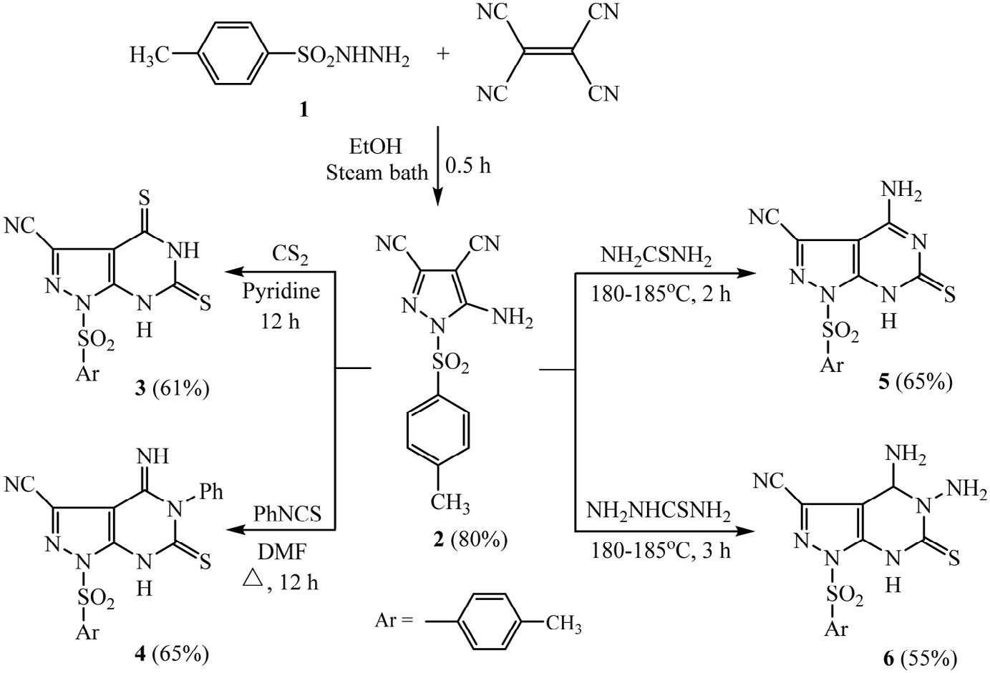

### Scheme 1 – Synthesis of 6-thioxo-1-tosyl-pyrazolo[3,4-d]pyrimidine-3-carbonitriles 3-6.

**122** egyptian journal of basic and applied sciences 3 (2016) 118–124

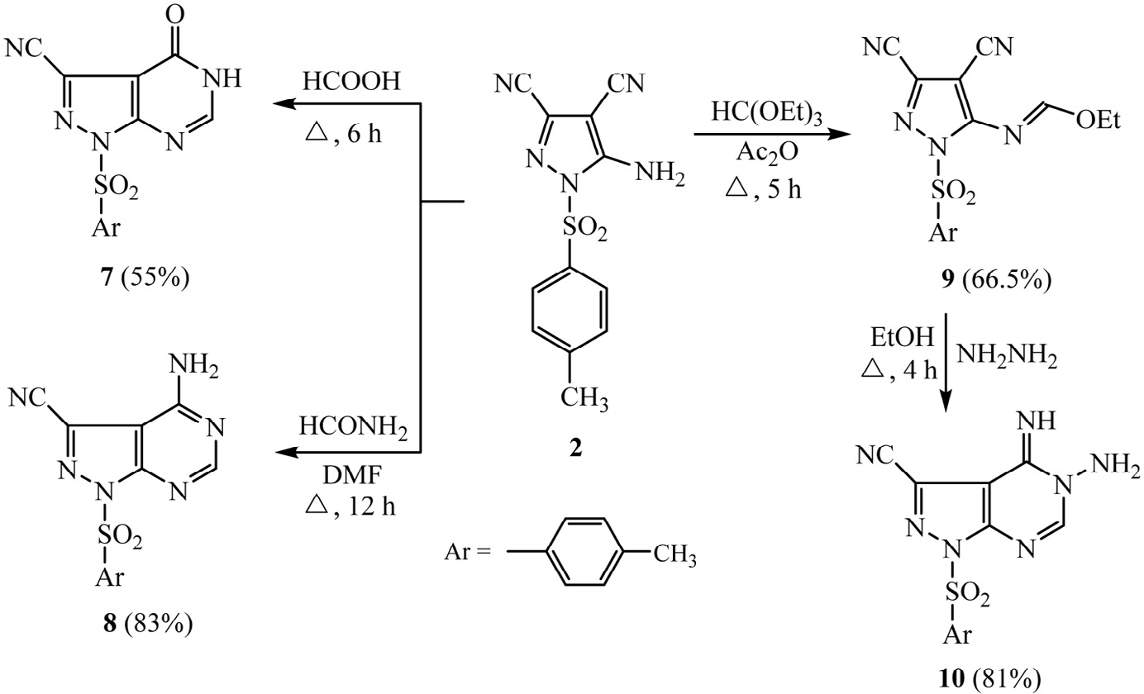

### Scheme 2 – Synthesis of 1-tosyl-pyrazolo[3,4-d]pyrimidine-3-carbonitriles 7, 8 and 10.

confirmed by elemental analysis and spectral data. IR spec- trum showed absorption band at 3253 cm−1 referring to imino group (NH), band of nitrile group (C—N) was detected at 2240 cm−1, and a sharp peak appeared at 1668 cm−1 for the amidic carbonyl group (C—O). The 1*H* NMR spectrum of **7** re- vealed singlet signal at 2.40 ppm corresponding to protons of

methyl group (CH3), two doublet signals at 7.23 and 7.64 ppm for the para-disubstituted benzene ring, singlet signal at

8.20 ppm referring to proton of (CH—N) function, and singlet signal at 9.45 ppm for imino (NH) group proton.

Heating of pyrazole compound **2** with formamide in dimethyl formamide (DMF) as a solvent afforded the corre- sponding 4-amino-1-tosyl-1*H*-pyrazolo[3,4-*d*]pyrimidine-3- carbonitrile **(8)**. The structure of **8** was established on the basis of elemental analysis and spectral data. The IR spectrum

showed absorption bands at 3323 and 3166 cm−1 referring to

the amino (NH2) group, 2235 cm−1 for the nitrile group (C—N) and 1636 cm−1 for the (C—N) function. The 1*H* NMR spectrum of **8** revealed singlet signal at 2.35 ppm for three protons of

methyl group (CH3), and two doublet signals at 7.30 and

7.55 ppm for the aromatic protons, in addition to singlet signal at 8.25 ppm characteristic to the pyrimidine proton (CH—N). Heating of compound **2** with triethyl orthoformate in acetic anhydride afforded ethyl N-(3,4-dicyano-1-tosyl-1H-pyrazol- 5-yl)formimidate **9**, which underwent heterocyclization with hydrazine hydrate in absolute ethanol, afforded 5-amino-4- imino-1-tosyl-4,5-dihydro-1*H*-pyrazolo[3,4-*d*]pyrimidine-3- carbonitrile **10** in good yield. The IR spectrum showed

absorption bands at 3342 and 3216 cm−1 for the (NH and NH2) groups, 2236 cm−1 due to the presence of nitrile (C—N) func- tion and 1635 cm−1 for the (C—N) group. The 1*H* NMR of **10** showed singlet signal at 2.35 ppm for three protons of methyl

group (CH3), two doublet signals of the aromatic protons at 7.30 and 7.80 ppm, and singlet signal at 8.15 ppm due to pyrimi- dine C-2 proton, and it also revealed two singlet signals of NH2 and C—NH protons at 7.45 and 11.35 ppm respectively.

Heating of compound **2** with ethyl acetoacetate in di- methyl formamide in the presence of an equimolar amount of potassium carbonate gave one spot on TLC using ethyl acetate:petroleum ether mixture (2:3) as eluent, the obtained product was identified as 5-Acetyl-4-amino-6-hydroxy-1-tosyl- 1*H*-pyrazolo-[3,4-*b*]pyridine-3-carbonitrile **(12)** on the basis of elemental and spectral analyses (Scheme 3). The formation of **12** was proposed to be continued through heterocyclization of the expected intermediate 5-acetyl-4-amino-6-hydroxy-1- tosyl-1*H*-pyrazolo[3,4-*b*]pyridine-3-carbonitrile **(11)**. The IR spectrum showed absorption bands at 3293, 3201 and 3140 cm−1

for (OH and NH2) groups, 2240 cm−1 corresponding to nitrile func- tion (C—N), 1702 cm−1 due to C—O group and 1648 cm−1 referring to (C—N) function. The *1H* NMR revealed two singlet signals at

2.35 and 2.50 ppm for six protons of two methyl groups (2CH3), singlet signal at 6.02 ppm referring to the (NH2) protons, two doublet signals at 7.35 and 7.75 ppm for para-disubstituted benzene ring protons, and singlet signal at 11.55 ppm corre-

sponding to (OH) proton. The mass spectrum showed the molecular ion peak at *m/z* = 371 corresponding to the molecu- lar weight of the molecular formula C16H13N5O4S.

Heating of compound **2** with malononitrile in refluxing DMF containing piperidine produces a sole product that iden- tified as 4,6-diamino-1-tosyl-1*H*-pyrazolo[3,4-*b*]pyridine-3,5- dicarbonitrile **13**, in 67% isolated yield. Presumably, ionized malononitrile attacks the cyano group in compound **2** before the amino group of the latter attacks one of the malononitrile cyano groups resulting in ring formation. The IR spectrum

showed absorption peaks at 3410, 3335 and 3245 cm−1 due to

the presence of amino groups (NH2), 2216 cm−1 due to the nitrile function (C—N) and 1651 cm−1 corresponding to (C—N) func- tion. The *1H* NMR spectrum exhibited singlet signal at 2.40 ppm

corresponding to the methyl protons (CH3), two singlet signals at 6.42 and 8.47 ppm for the two amino groups (NH2), while the doublet signals at 7.42 and 7.61 ppm were assigned for the aro- matic protons.

egyptian journal of basic and applied sciences 3 (2016) 118–124

**123**

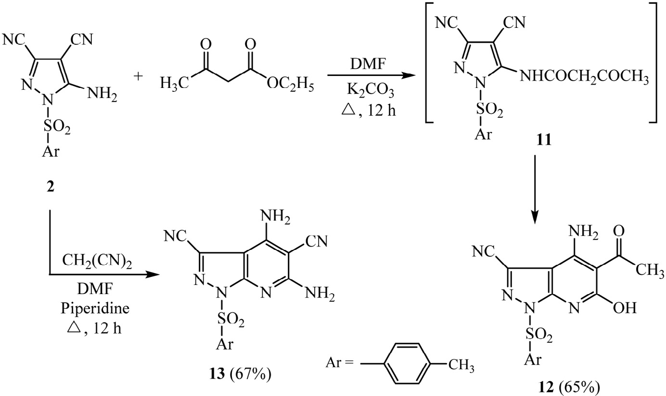

**Scheme 3 – Synthesis of 4-amino-1-tosyl-pyrazolo[3,4-b]pyridine-3-carbonitriles 12 and 13.**

## *3.2. In vitro antitumor activity*

The antitumor activity of the synthesized compounds were evaluated against human laryngeal epidermoid carcinoma cell line **(Hep2)** using the MTT assay method. The results ac-

quired in Table 1 demonstrated that compounds **3** (IC50 36.9 μM)

and **4** (IC50 21.3 μM) have the highly significant effect com- pared to the standard anticancer drug 5-fluorouracil (IC50 41.5 μM). This may be because of the presence of such NH- C—S moiety in addition to the *N*-tosyl-pyrazolo-pyrimidine

moiety in the two compounds. The other compounds showed low impact against epidermoid carcinoma (**Hep2**).

# Acknowledgment

The authors would like to thank Mr. Ahmed Abas, the re- searcher at Drugs Department, Faculty of Pharmacy, Mansoura University, Egypt, for kindly providing his technical assis- tance during the antitumor activity testing.

|  |  |
| --- | --- |
| **Table 1 – Cytotoxic activity of the synthesized compounds against epidermoid carcinoma cell line (Hep2).** | |
| Compounds | In vitro cytotoxicity IC50 (μM) Hep2 |
| **5-FU** | 41.5 ± 3.1 |
| **2** | 196.8 ± 13.4 |
| **3** | 36.9 ± 2.6 |
| **4** | 21.3 ± 1.6 |
| **5** | 55.5 ± 5.2 |
| **5-FU** = 5-fluorouracil. Data are reported as means ± SD. | |

R E F E R E N C E S

1. [Kamal El-Dean AM, Elkhawaga AM, Radwan S, Ahmed MM.](http://refhub.elsevier.com/S2314-808X(15)00081-0/sr0010) [Synthesis of some pyridothienopyrazolopyrimidopyrimidine](http://refhub.elsevier.com/S2314-808X(15)00081-0/sr0010) [and mercaptomethylpyrazolopyrimidine derivatives.](http://refhub.elsevier.com/S2314-808X(15)00081-0/sr0010) [Phosphorous Sulfur Silicon 2009;184:2034–48.](http://refhub.elsevier.com/S2314-808X(15)00081-0/sr0010)
2. [Min G, Eric C, Lihu Y. A general method for the preparation](http://refhub.elsevier.com/S2314-808X(15)00081-0/sr0015) [of 3-acyl-4-cyano-5-amino-pyrazoles. Tetrahedron Lett](http://refhub.elsevier.com/S2314-808X(15)00081-0/sr0015) [2006;47:5797–9.](http://refhub.elsevier.com/S2314-808X(15)00081-0/sr0015)
3. [Hassan AE, Abdella MM, Ahmed AI. Studies on the synthesis](http://refhub.elsevier.com/S2314-808X(15)00081-0/sr0020) [and cyclization reactions of 2-(5-Amino-3-arylpyrazol-1-yl)-](http://refhub.elsevier.com/S2314-808X(15)00081-0/sr0020) [3-methylquinoxalines. J Chem Res (S) 1997;322–3.](http://refhub.elsevier.com/S2314-808X(15)00081-0/sr0020)
4. [Aly AA. Synthesis of polyfunctionally substituted](http://refhub.elsevier.com/S2314-808X(15)00081-0/sr0025) [pyrazolonaphthyridine, pentaazanaphthalene, and](http://refhub.elsevier.com/S2314-808X(15)00081-0/sr0025) [heptaazaphenanthrene derivatives. Phosphorous Sulfur](http://refhub.elsevier.com/S2314-808X(15)00081-0/sr0025) [Silicon 2006;181:2395–409.](http://refhub.elsevier.com/S2314-808X(15)00081-0/sr0025)
5. [Aymn ER, Mohamed IH, Randa EAM, Nahed F, Farouk MEAM.](http://refhub.elsevier.com/S2314-808X(15)00081-0/sr0030) [Synthesis and anti-HSV-1 evaluation of some pyrazoles and](http://refhub.elsevier.com/S2314-808X(15)00081-0/sr0030) [fused pyrazolopyrimidines. Eur J Med Chem 2009;44:3285–92.](http://refhub.elsevier.com/S2314-808X(15)00081-0/sr0030)
6. [Elkhawaga AM, Kamal El-Dean AM, Radwan M, Ahmed MM.](http://refhub.elsevier.com/S2314-808X(15)00081-0/sr0035) [Synthesis of some imidazopyrazolopyrimidines,](http://refhub.elsevier.com/S2314-808X(15)00081-0/sr0035) [pyrazolopyrimidopyrimidines and](http://refhub.elsevier.com/S2314-808X(15)00081-0/sr0035) [pyrazolopyrimidothiazines. Bull Korean Chem Soc](http://refhub.elsevier.com/S2314-808X(15)00081-0/sr0035) [2009;30:561–6.](http://refhub.elsevier.com/S2314-808X(15)00081-0/sr0035)
7. [Schenone S, Bruno O, Radi M, Botta M. 4-amino-substituted](http://refhub.elsevier.com/S2314-808X(15)00081-0/sr0040) [pyrazolo[3,4-d]pyrimidines: synthesis and biological](http://refhub.elsevier.com/S2314-808X(15)00081-0/sr0040) [properties. Mini-Rev Org Chem 2009;6:220–33.](http://refhub.elsevier.com/S2314-808X(15)00081-0/sr0040)
8. [Eljazi IA, Samer AA. Heterocyclic *o*-aminonitriles:](http://refhub.elsevier.com/S2314-808X(15)00081-0/sr0045) [preparation of pyrazolo[3,4-*d*]-pyrimidines with modification](http://refhub.elsevier.com/S2314-808X(15)00081-0/sr0045) [of the substituents at the 1-position. Molecules 2001;6:621–](http://refhub.elsevier.com/S2314-808X(15)00081-0/sr0045) [38.](http://refhub.elsevier.com/S2314-808X(15)00081-0/sr0045)
9. [Abdellatif MS, Ana MFO, Ligia MR. Heterocyclic synthesis](http://refhub.elsevier.com/S2314-808X(15)00081-0/sr0050) [with nitriles: synthesis of pyrazolopyrimidine and](http://refhub.elsevier.com/S2314-808X(15)00081-0/sr0050) [pyrazolopyridine derivatives. Synth Commun 2009;39:1186–](http://refhub.elsevier.com/S2314-808X(15)00081-0/sr0050) [95.](http://refhub.elsevier.com/S2314-808X(15)00081-0/sr0050)
10. [Holla BS, Shivananda MK, Akberali PM, Shenoy MS.](http://refhub.elsevier.com/S2314-808X(15)00081-0/sr0055) [Synthesis and antibacterial activities of some fluorine](http://refhub.elsevier.com/S2314-808X(15)00081-0/sr0055) [containing arylfurylpropenones, pyrazolines and](http://refhub.elsevier.com/S2314-808X(15)00081-0/sr0055)

[*N-*acetylpyrazoline. Indian J Chem 2000;39B:440–7.](http://refhub.elsevier.com/S2314-808X(15)00081-0/sr0055)

1. [Mourad C, Elena S, Abdelouahid S, Marco-Contelles J. Studies](http://refhub.elsevier.com/S2314-808X(15)00081-0/sr0060) [on the acetylation of 3,6-diamino-1H-pyrazolo[3,4-](http://refhub.elsevier.com/S2314-808X(15)00081-0/sr0060)

**124** egyptian journal of basic and applied sciences 3 (2016) 118–124

b]pyridine-5-carbonitrile derivatives. J Heterocyclic Chem [2010;47:861–72.](http://refhub.elsevier.com/S2314-808X(15)00081-0/sr0060)

1. [Zhmurenko LA, Molodavkin GM, Voronina TA, Lezina VP.](http://refhub.elsevier.com/S2314-808X(15)00081-0/sr0065) [Synthesis and antidepressant and anxiolytic activity of](http://refhub.elsevier.com/S2314-808X(15)00081-0/sr0065) [derivatives of pyrazolo[4,3-c ]pyridine and](http://refhub.elsevier.com/S2314-808X(15)00081-0/sr0065)

[4-phenylhydrazinonicotinic acids. Pharm Chem J 2012;46:15–](http://refhub.elsevier.com/S2314-808X(15)00081-0/sr0065) [19.](http://refhub.elsevier.com/S2314-808X(15)00081-0/sr0065)

1. [Mohamed AE, Hala FR, Doha MB, Ibrahim YE. Microwave-](http://refhub.elsevier.com/S2314-808X(15)00081-0/sr0070) [assisted synthesis of some new pyrazolopyridines and their](http://refhub.elsevier.com/S2314-808X(15)00081-0/sr0070) [antioxidant, antitumor and antimicrobial activities. Eur J](http://refhub.elsevier.com/S2314-808X(15)00081-0/sr0070) [Med Chem 2013;66:415–22.](http://refhub.elsevier.com/S2314-808X(15)00081-0/sr0070)
2. [Farag MAA. Synthesis and antimicrobial evaluation of some](http://refhub.elsevier.com/S2314-808X(15)00081-0/sr0075) [novel Bis-α,β-unsaturated ketones, nicotinonitrile, 1,2-](http://refhub.elsevier.com/S2314-808X(15)00081-0/sr0075) [dihydropyridine-3-carbonitrile, fused thieno[2,3-*b*]pyridine](http://refhub.elsevier.com/S2314-808X(15)00081-0/sr0075)

[and pyrazolo[3,4-*b*]pyridine derivatives. Int J Mol Sci](http://refhub.elsevier.com/S2314-808X(15)00081-0/sr0075) [2013;14:2967–79.](http://refhub.elsevier.com/S2314-808X(15)00081-0/sr0075)

1. [Steve W, Kateri AA, Alex JB, Bainian F, Susan LG, Stefan G,](http://refhub.elsevier.com/S2314-808X(15)00081-0/sr0080) [et al. Pyrazolopyridine inhibitors of B-RafV600E. Part 2:](http://refhub.elsevier.com/S2314-808X(15)00081-0/sr0080)

[structure–activity relationships. Bioorg Med Chem Lett](http://refhub.elsevier.com/S2314-808X(15)00081-0/sr0080) [2011;21:5533–7.](http://refhub.elsevier.com/S2314-808X(15)00081-0/sr0080)

1. [Jun Q, Wei Z, Xianhai H, Pawan D, Anandan P, Robert A, et al.](http://refhub.elsevier.com/S2314-808X(15)00081-0/sr0085) [Discovery of a potent pyrazolopyridine series of γ-secretase](http://refhub.elsevier.com/S2314-808X(15)00081-0/sr0085) [modulators. ACS Med Chem Lett 2011;2:471–6.](http://refhub.elsevier.com/S2314-808X(15)00081-0/sr0085)
2. [Dickinson CL, Williams JK, McKusick BC.](http://refhub.elsevier.com/S2314-808X(15)00081-0/sr0090) [Aminocyanopyrazoles. J Org Chem 1964;29:1915–19.](http://refhub.elsevier.com/S2314-808X(15)00081-0/sr0090)
3. [(a) Tim M. Rapid colorimetric assay for cellular growth and](http://refhub.elsevier.com/S2314-808X(15)00081-0/sr0095) [survival: application to proliferation and cytotoxicity assays.](http://refhub.elsevier.com/S2314-808X(15)00081-0/sr0095) [J Immunol Methods 1983;65:55–63;](http://refhub.elsevier.com/S2314-808X(15)00081-0/sr0095) [(b) Francois D, Rita L.](http://refhub.elsevier.com/S2314-808X(15)00081-0/sr0100) [Rapid colorimetric assay for cell growth and survival:](http://refhub.elsevier.com/S2314-808X(15)00081-0/sr0100) [modifications to the tetrazolium dye procedure giving](http://refhub.elsevier.com/S2314-808X(15)00081-0/sr0100) [improved sensitivity and reliability. J Immunol Methods](http://refhub.elsevier.com/S2314-808X(15)00081-0/sr0100) [1986;89:271–7.](http://refhub.elsevier.com/S2314-808X(15)00081-0/sr0100)
4. [Helena JM, Nader NH, Micheal AB, David HG, Mary JS, Kerri](http://refhub.elsevier.com/S2314-808X(15)00081-0/sr0105) [AS, et al. Combined effects of angiostatin and ionizing](http://refhub.elsevier.com/S2314-808X(15)00081-0/sr0105) [radiation in antitumour therapy. Nature 1998;394:287–](http://refhub.elsevier.com/S2314-808X(15)00081-0/sr0105)

[91.](http://refhub.elsevier.com/S2314-808X(15)00081-0/sr0105)