HOSTE D BY

Available online at [www.sciencedirect.com](http://www.sciencedirect.com/science/journal/2314808X)

**ScienceDirect**

journal homepage: [http://ees.elsevier.com/ejbas/default.asp](http://http//ees.elsevier.com/ejbas/default.asp)

egyptian journal of basic and applied sciences 3 (2016) 106–11 7



**Full Length Article**

**Synthesis and characterization of Hg(II) and Cd(II) complexes derived from the novel acenaphthaquinone-4-phenyl thiosemicarbazone and its CPE application**



***Ibrahim M. Kenawy*** ***a******, Mohamed M. Hassanien*** ***b******,***

***Mohamed H. Abdel-Rhman*** ***a******,******\*******, Rania R. Zaki*** ***a******, Hala S. Rashed*** ***a***

a *Chemistry Department, Faculty of Science, Mansoura University, Mansoura, Egypt*

b *Chemistry Department, Industrial Education College, Beni-Suef University, Beni-Suef, Egypt*

A R T I C L E I N F O A B S T R A C T

*Article history:*

Received 30 August 2015

Received in revised form 25 October 2015

Accepted 27 October 2015

Available online 16 November 2015

*Keywords:* Acenaphthaquinone Thiosemicarbazone

Separation and preconcentration CPE

The new acenaphthaquinone-4-phenyl thiosemicarbazone (APTH) was synthesized. The re- action of Hg(II) and Cd(II) chloride with APTH yields bimetallic complexes, which are characterized by elemental, IR, UV-Vis., 1H-NMR and Mass spectroscopy. The APTH em- ployed as a chelating agent for CPE procedure of trace amounts of mercury and cadmium from aqueous medium. The Hg(II) and Cd(II) is preconcentrated using 0.1% w/v Triton X-114 and 2 × 10−5 M APTH at pH 7. The calibration curve is linear in the ranges 0.25–3 and 0.25–

7.5 ng/ml for Cd(II) and Hg(II), respectively. The proposed method was applied successfully

in the determination of Hg(II) and Cd(II) in different water samples.

© 2015 Mansoura University. Production and hosting by Elsevier B.V. This is an open access article under the CC BY-NC-ND license (<http://creativecommons.org/licenses/by->

nc-nd/4.0/).

# Introduction

Thiosemicarbazones is an important class of NS donors due to their variable donor properties, structural diversity and bio- logical applications [1]. They got biological importance from the fact that they have good antiparasital [2], antibacterial [3], an- titumor [4,5], antimalarial [6], antineoplastic [7] and antivira1

[8] activities. Chelation of some thiosemicarbazones to some

metal ions increase their antitumor activity [9,10]. Since, the chemical nature of thiosemicarbazone derivatives and their metal complexes have been widely investigated [11–15]. Thiosemicarbazones have been used for extraction and determination of some metal ions in biological and pharma- cological samples [16,17].

Acenaphthaquinone used as an intermediate for the manu- facturing of dyes, pharmaceuticals, pesticides, and synthesis of versatile fluorescent chemosensors when reacts with

* *Corresponding author.* Tel.: +201006192777.

*E-mail address:* [mhassan2371@yahoo.com](mailto:mhassan2371@yahoo.com) (M.H. Abdel-Rhman). <http://dx.doi.org/10.1016/j.ejbas.2015.10.001>

2314-808X/© 2015 Mansoura University. Production and hosting by Elsevier B.V. This is an open access article under the CC BY-NC-ND license ([http://creativecommons.org/licenses/by-nc-nd/4.0/).](http://creativecommons.org/licenses/by-nc-nd/4.0/))

egyptian journal of basic and applied sciences 3 (2016) 106–11 7

**107**

|  |  |  |  |  |  |  |
| --- | --- | --- | --- | --- | --- | --- |
| **Table 1 – Analytical and physical data of APTH and its complexes.** | | | | | | |
| Compound | m.p. (°C) | Color | Elemental analyses; found (Calcd.)  C H M | | | Λm  a |
| APTH | 190 | Brown | 68.13 (68.86) | 3.79 (3.95) | – | – |
| [Cd2(APTH)Cl4] | 175 | Red break | 33.35 (32.69) | 2.13 (1.88) | 32.89 (32.21) | 5.47 |
| [Hg2(APTH)2Cl4(EtOH)2] | 215 | Reddish brown | 39.11 (38.87) | 2.51 (2.95) | 31.18 (30.91) | 18.50 |
| a Ohm−1.cm2.mol−1. | | | | | | |

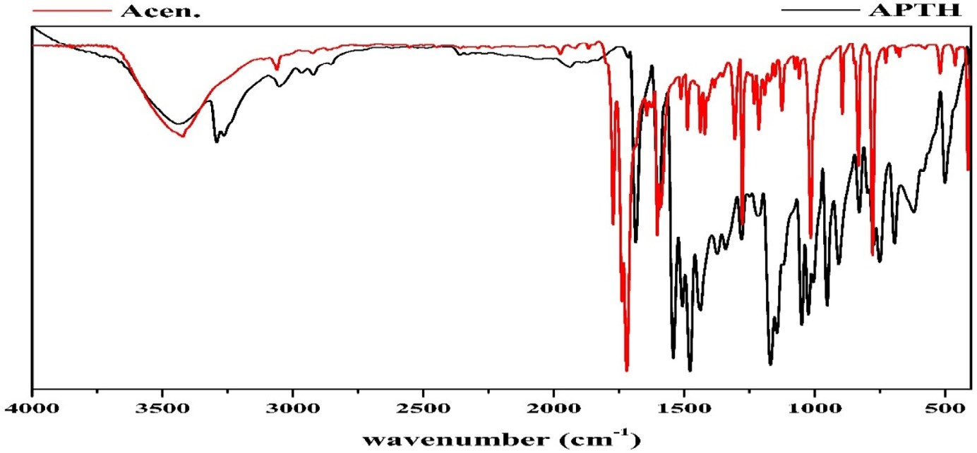

#### Fig. 1 – IR spectrum of APTH in comparison to acenaphthoquinone.

8-aminoquinoline [18]. Acenaphthaquinone thiosemicarbazone reacted with Fe(III), Ni(II), Cu(II) and Zn(II) chlorides or acetates leads to formation of complexes that have been char- acterized by spectroscopic studies. Also, the free ligand showed high activity of cell proliferation inhibition and induced dif- ferentiation on Friend erythroleukemia cells (FLC) [19].

Determination of trace metals in a complex matrix has been usually complicated. In such matrixes, separation and preconcentration steps should precede determination to minimize or even eliminate matrix effects and contami- nants, lower the detection limit and enhance the detectability. Cloud point extraction (CPE), as an effective separation and preconcentration technique, was first studied by Watanabe and co-workers in the early 1980’s [20–23]. The CPE have distinct merits of low cost, simplicity, speed, and lower toxicity to the environment than extractions using organic solvents, which have high capacity to concentrate wide variety of analytes, high recoveries, and high concentration factors. In the CPE technique, the surfactants used are mostly of nonionic type, such as Triton X-114, X-100, or PONPE. Triton X-114 is the most applied surfactant due to its low cloud-point temperature (30 °C), high density, commercial availability and lower toxic- ity [24].

Heavy metals like Cd(II) and Hg(II) are toxic [25,26] where the excess of Cd(II) leads to renal toxicity while Hg(II) leads to damage of the central nervous system and causes neuropsy- chiatric disorders [27]. Due to their low concentration in the environmental and biological samples, a preconcentration- separation technique is generally necessary prior to determination. For this purpose, various analytical proce- dures have been used such as adsorption on graphene oxide nanosheets [26], activated carbon [28,29], co-precipitation [30,31],

*Streptococcus pyogenes* immobilized on Dowex Optipore SD-2 [32], column extraction [33,34], ion selective electrode [35,36], liquid– liquid extraction LLE [37], biosorbent *Staphylococcus aureus* [38], biomass *Drepanocladus revolvens* and *Xanthoparmelia conspersa* [39,40] and cloud-point extraction CPE [41,42].

In the present study, the new acenaphthaquinone-4- phenylthiosemicarbazone (APTH) and its complexes with Hg(II) and Cd(II) was synthesized and characterized. In addi- tion, it is employed in CPE procedure for separation, preconcentration and determination of Cd(II) and Hg(II) in water samples.

|  |  |  |  |
| --- | --- | --- | --- |
| **Table 2 – Infrared spectral date of APTH and its metal complexes in KBr.** | | | |
| Assignment | APTH | [Cd2(APTH)Cl4] | [Hg2(APTH)2 Cl4(EtOH)2] |
| ν(N4H) | 3292 | 3290 | 3351 |
| ν(N2H) | 3263 | 3236 | 3293 |
| ν(C = O)free | 1690a | – | 1702 |
| ν(C = O)H-bonded | 1680a | 1675a | 1683 |
| ν(C = N1) | 1660a | 1655a | 1620 |
| ν(C = C) | 1600 | 1600 | 1600 |
| Thioamide I | 1540 | 1535 | 1577 |
| Thioamide II | 1430 | 1442 | 1456 |
| Thioamide III | 1168 | 1172 | 1174 |
| ν(C = S) | 828 | 802 | 827 |
| ν(N—N) | 1143 | 1145 | 1139 |
| ν(C—O) | 1049 | 1025 | 1031 |
| ρ(NH) | 750 | 732 | 730,750 |
| a Band obtained from deconvolution analysis. | | | |

**108** egyptian journal of basic and applied sciences 3 (2016) 106–11 7

|  |  |  |  |  |
| --- | --- | --- | --- | --- |
| **Table 3 – Deconvolution analysis parameters of the APTH IR spectrum in the range 1710–1620 cm−1**  **(R2 = 0.9986).** | | | | |
| Peak type / No. | Center | Amplitude | FWHM | % Area |
| Gauss Amp 1 | 1660 | 4.94 | 39.41 | 32.81 |
| Gauss Amp 2 | 1680 | 12.69 | 19.47 | 42.17 |
| Gauss Amp 3 | 1690 | 9.97 | 14.71 | 25.02 |

# Experimental

## *Apparatus*

The IR spectra were recorded as KBr discs using Thermo- Nicolet IS10 FTIR Spectrometer (Thermo Fisher Scientific Inc, Waltham, MA, USA). The electronic spectra were measured on a Unicam UV-Vis Spectrometer UV2 (Akribis Scientific Ltd., Cheshire, WA16 0JG, United Kingdom). The 1H-NMR spectra of

#### Structure 1 – Structure of APTH.

APTH and its Cd(II) complex, in DMSO-d6, were recorded on Jeol

Delta2 Spectrometer (500 MHz) (JEOL USA Inc., Peabody, MA 01960, USA). The mass spectrum of APTH was measured by Thermo DSQ II Spectrometer (Thermo Fisher Scientific Inc., Waltham, MA, USA). The FAAS measurements were carried out using A Perkin Elmer Analyst 800 atomic absorption spectrom- eter (Perkin Elmer Inc., Waltham, MA 02451, USA) with a longitudinal Zeeman background correction furnished with a

transversely heated graphite atomizer (THGA), which was used for the determination of Cd(II) at wavelength 228.8 nm, slit width

0.7 nm and lamp current 12 mA. Sample solutions were in- jected into the atomizer by using AS-800 auto-sampler. The sample injection volume was 20 μl. The system is equipped with winLab 32 software. The Hg(II) was determined by cold vapor technique (CVAAS) using 1% m/v NaBH4 in 0.05% m/v NaOH

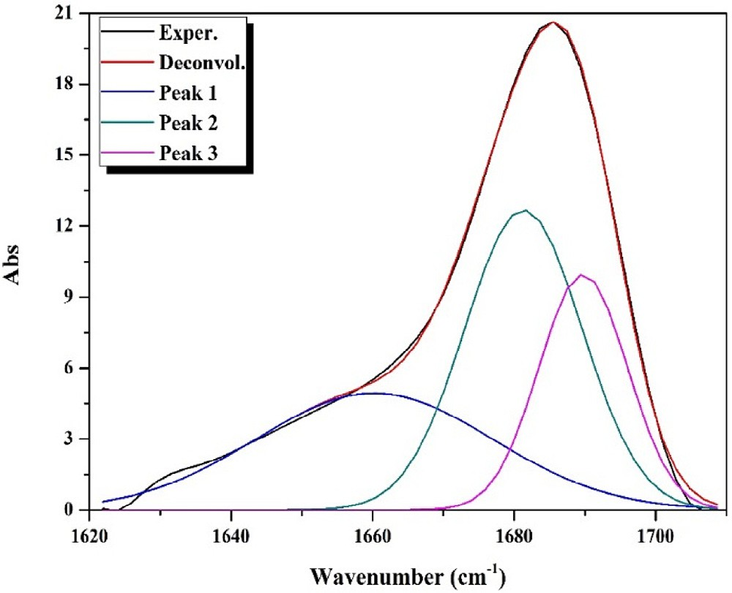

#### Fig. 2 – IR deconvolution analysis of APTH in the range 1710–1620 cm−1.

at carrier gas flow rate of 1000 ml/min and slit width 0.7 nm. The pH of the solution was adjusted using Hanna instru- ment model 8519 digital pH meter (HANNA Instruments, Rhode Island, Woonsocket, RI 02895, USA). The temperature of the cell compartment was kept constant by circulating water from a thermostatic water bath at the desired temperature, which was used for the CPE experiments (Memmert GmbH Co. KG, D-91126 Schwabach, Germany). A centrifuge was used to accelerate the phase separation process employing Centrifuge Hematocrit Mikro set (Alkeslabindo, Kota Depok, Indonesia).

## *Reagents and solutions*

All chemicals purchased from Aldrich (Sigma-Aldrich Chemie GmbH, Munich, Germany) were of analytical grade quality and used without purification. Distilled water was used in all ex-

periments. The stock solution of 10−4 M CdCl2 and HgCl2 was prepared by dissolving 0.0660 and 0.0027 g, respectively, in

100 ml distilled water in a measuring flask. The non-ionic sur- factant, Triton X-114, was used without further purification. The stock solution 1% w/v was prepared by dissolving 1 g of Triton X-114 in 100 ml distilled water. Hexamine buffer solutions 0.5 M,

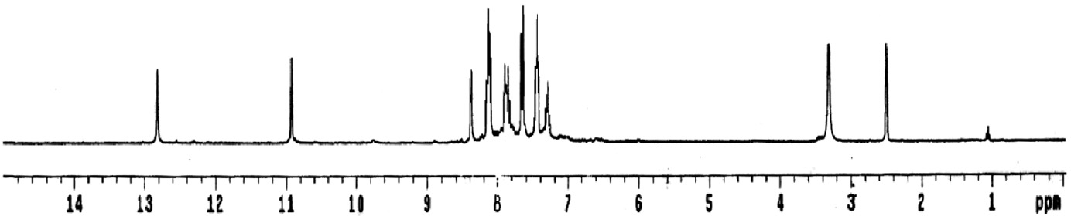

#### Fig. 3 – 1H-NMR spectrum of APTH.

egyptian journal of basic and applied sciences 3 (2016) 106–11 7

**109**



#### Scheme 1 – Fragmentation pattern of APTH.

pH 4-8, were prepared by dissolving 17.5240 g in 250 ml dis- tilled water in a measuring flask. A 0.1 M NaOH and/or HNO3 solution used to adjust the pH to the desired value. For pH 9 and 10, ammonium chloride/ammonium hydroxide buffer so- lution was used. A stock solution of the ligand (APTH) 10−3 M was prepared by dissolving 0.0331 g in 100 ml acetone.

## *Preparation of the ligand and solid complexes*

The acenaphthaquinone-4-phenylthiosemicarbazone (APTH) was prepared by heating under reflux a mix- ture of acenaphthaquinone (0.01 mol, 1.82 g) and 4-phenylthiosemicarbazide (0.01 mol, 1.67 g) in ethanol in the

presence of 5 ml glacial acetic acid for 1 h. On cooling, a fine brown powder was formed, filtered off, and washed success- fully with EtOH and then diethyl ether, and recrystallized from EtOH (m.p. 190 °C; yield 91%).

The metal complexes prepared by reacting the APTH (0.001 mol, 0.331 g) with the equivalent amount of CdCl2.2.5H2O and HgCl2 salts were dissolved in EtOH under reflux for 2 h after. A red break and reddish brown precipitate were formed in case of Cd(II) and Hg(II), respectively, filtered off while hot, washed successfully with hot ethanol and then diethyl ether, and dried and preserved in a vacuum desiccator over anhydrous calcium chloride (for Cd(II); m.p. 275 °C, yield 96%; for Hg(II), m.p. 215 °C, yield 93%).

**110** egyptian journal of basic and applied sciences 3 (2016) 106–11 7

## *CPE procedure*

For the CPE, an aliquot of 10 ml of a solution containing Cd(II) or Hg(II), Triton X-114 (0.1% w/v), 2 × 10−5 M APTH and 2 ml of buffer solution (pH = 7), were kept for 10 min in a thermo- static bath at 45 °C. Subsequently, separation of the phases was achieved by centrifugation for 10 min at 4000 rpm. The phases were cooled down in an ice bath in order to increase the vis- cosity of the surfactant rich phase. The bulk aqueous phase was easily decanted simply by inverting the tube. The surfactant-rich phase was made up to 0.5 ml by adding abso- lute methanol. The absorbance was measured at 478 and 446 nm for Cd(II) and Hg(II), respectively.

## *Sample preparation*

First, the water samples from different origin were filtered through filter paper to separate the coarse particles and suspended matter, and second, through a Millipore cellulose

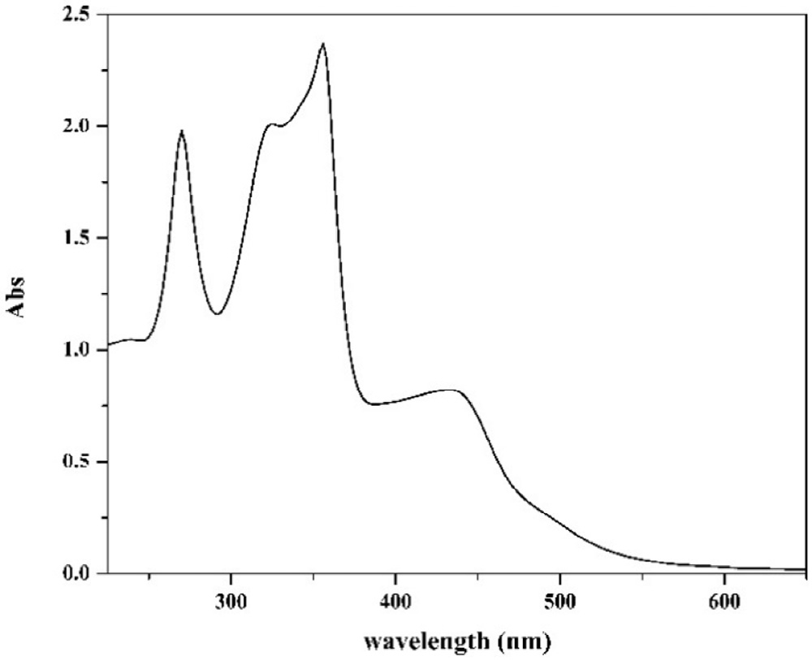

#### Fig. 4 – Electronic spectrum of APTH.

nitrate membrane (pore size 0.45 μm), then acidified to pH 2

with HNO3 and stored in a refrigerator in a dark polyethylene bottle.

The mass spectrum of APTH showed a molecular ion peak at (m/z = 331; 31.23%), which coincides with its molecular weight (331.39). The suggested fragmentation pattern, shown in

Scheme 1, indicated that there were two routes by which frag-

# Result and discussion

The reaction of the ligand with the chloride salt of Cd(II) and Hg(II) led to formation of bimetallic complexes which its el- emental analyses indicate that have the formula [Cd (APTH)Cl ]

mentation may occur, showing base peak at m/z = 180 corresponding to the formula C12H8N2 (180.21).

Finally, the electronic spectrum of the ligand in DMSO showed four bands at 37,040, 30,675, 28,090 and 23,255 cm−1 with

a shoulder at 19,840 cm−1. The first two bands were attributed

2 4

to π→π* transitions of the aromatic rings, C = O, C = N1 and

(red break) and [Hg2(APTH)2Cl4(EtOH)2] (reddish brown) respec- tively (Table 1).

## *Characterization of APTH*

The comparison of the APTH infrared spectrum with that of the acenaphthylene-1,2-dione, as shown in Fig. 1, indicated that four new bands were observed at 3292, 3263, 1143 and 750 cm−1, and attributed to ν(N4H), ν(N2H), ν(N—N) and ρ(NH) [43] vibra- tions, respectively. Another four bands were observed at 1540, 1430, 1168 and 828 cm−1 and assigned to Thioamide I, II, III and ν(C = S) [44], respectively (Table 2). The broad band observed in 1710–1620 cm−1 region consisted of three overlapped bands according the deconvolution analysis data (Table 3). The first one at 1690 cm−1 was attributed to the ν(C = O) while the second at 1680 cm−1 was due to the ν(C = O) involved in hydrogen bond. The third one at 1660 cm−1 was assigned to ν(C = N1) vibra- tion (Fig. 2). The existence of a shoulder at 3238 cm−1 in addition to a weak band at 1937 cm−1 suggest the involvement of the C = O and N2H in intramolecular hydrogen bond [45] (Table 2). The 1H-NMR spectrum of the ligand in DMSO-d6 shows two singlet signals at 12.82 and 10.93 ppm attributed to protons of N4H and N2H [19], respectively. Addition of D2O to the solu- tion of the ligand leads to disappearance of these two signals, confirming its assignment. Also, the spectrum displayed three triplet signals at 7.45, 7.87 and 8.12 ppm assigned to the protons at positions (*f*), (*b*) and (*e*) [44], respectively. Moreover, the spec- trum shows three doublet signals at 7.32, 7.65 and 8.37 ppm attributed the protons at (*d*), (*a*) and (*c*) positions [44], respec-

tively (Fig. 3) (Structure 1).

C = S [43] while the other three bands were attributed to n→π* transitions of carbonyl, azomethine and C = S groups [45,46], respectively (Fig. 4).

## *Characterization of metal complexes*

The spectrum of [Cd2(APTH)Cl4] complex, in KBr disc, dis- played band at 3236 cm−1 with a shoulder at 3292 cm−1 in

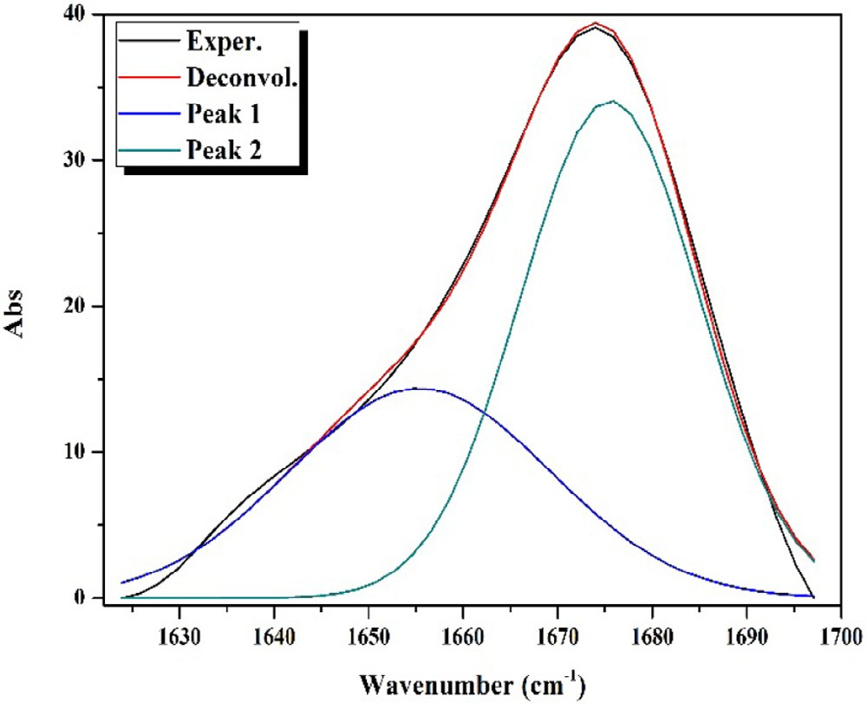

#### Fig. 5 – IR deconvolution analysis of [Cd2(APTH)Cl4] in the range 1700–1620 cm−1.

egyptian journal of basic and applied sciences 3 (2016) 106–11 7

**111**

|  |  |  |  |  |
| --- | --- | --- | --- | --- |
| **Table 4 – Deconvolution analysis parameters of the [Cd2(APTH)Cl4] IR spectrum in the range 1700–1620 cm−1 (R2 = 0.9966).** | | | | |
| Peak type / No. | Center | Amplitude | FWHM | % Area |
| Gauss Amp 1 | 1655 | 14.37 | 32.42 | 38.08 |
| Gauss Amp 2 | 1675 | 34.08 | 22.23 | 61.92 |

addition to two bands at 1145 and 732 attributed to ν(N2H), ν(N4H) [46], ν(N—N), and ρ(NH) [43] vibrations, respectively. More- over, four bands were observed at 1535, 1442, 1172 and 802 cm−1 assigned Thioamide I, II, III and ν(C = S) [44], respectively. The deconvolution analysis of the broad band centered at 1673 cm−1, shown in Fig. 5, indicated that it consisted of two overlapped bands at 1675 and 1655 cm−1 attributed to ν(C = O) [47] and ν(C = N1) [48] vibrations, respectively (Table 4). The compari- son of the spectral data with that belonging to the ligand clears that ν(N2H), ν(C = O), ν(C = N1) and ν(C = S) are shifted to lower wavenumbers suggesting its involvement in coordination to the metal ion [49] (Table 2). Therefore, it could be concluded that the ligand is coordinated to the metal ion in neutral tetradentate manner and exists in keto-form (Structure 2).

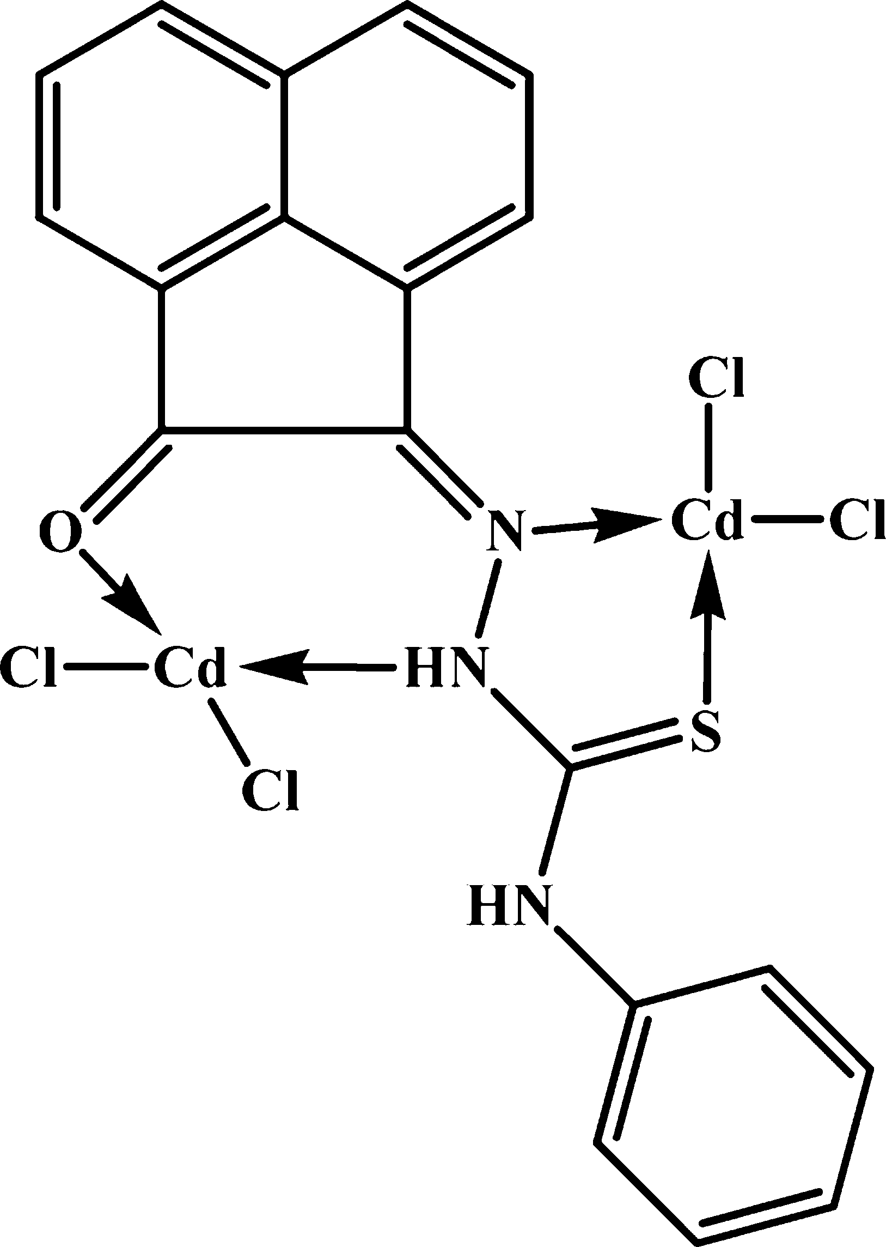

#### Structure 2 – Structure of Cd(II) complex.

#### Structure 3 – Structure of Hg(II) complex.

On the other hand, the [Hg2(APTH)2Cl4(EtOH)2] spectrum showed a broad band centered at 3450 cm−1 attributed to the ν(OH) of the ethanol molecules. The appearance of the ν(N4H) band at 3290 cm−1 indicates that it did not participate in co- ordination to the metal ion [46] (Fig. 6). A band at 3351 cm−1 and shoulder at 3264 cm−1 were attributed to ν(N2H) [49] in- volved in coordination to the metal ion and the free one, respectively. Moreover, two bands at 1706 and 1683 cm−1 were observed and attributed to ν(C = O) coordinated to metal ion

[47] and ν(C = O) free, respectively. The ν(C = N1) vibration band

observed at 1620 [49] cm−1 indicating its participation in co- ordination to metal ion. All these spectral data clears out that the ligand exists in keto-form [46]. Thus, the appearance of two bands due to ν(N2H) and ν(C = O) vibrations corresponding to the free and coordinated groups was taken as evidence for that one ligand molecule coordinated to the metal ion as neutral tetradentate while the other is neutral bidentate (Structure 3) (Table 2).

Moreover, the 1H-NMR spectrum of Cd(II) complex in DMSO- d6, in comparison to that of the ligand, shows the aromatic protons at more or less the same positions in addition to singlet signals at 12.83 and 10.84 ppm attributed to the N2H and N4H protons, respectively. The appearance of the N4H at the same

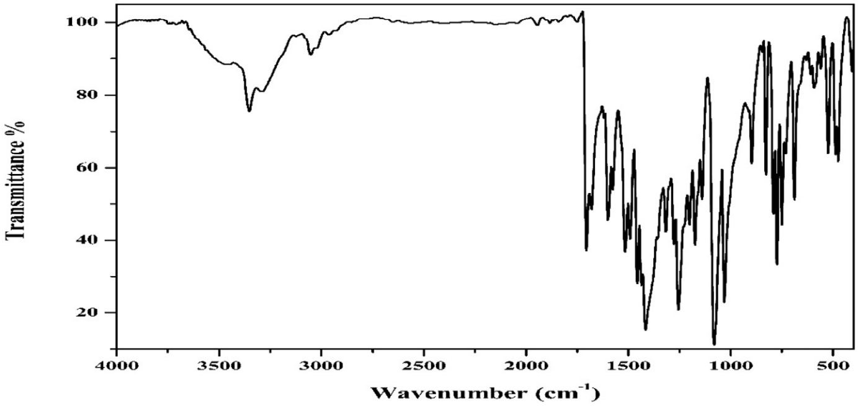

#### Fig. 6 – IR spectrum of [Hg2(APTH)2Cl4(EtOH)2].

**112** egyptian journal of basic and applied sciences 3 (2016) 106–11 7

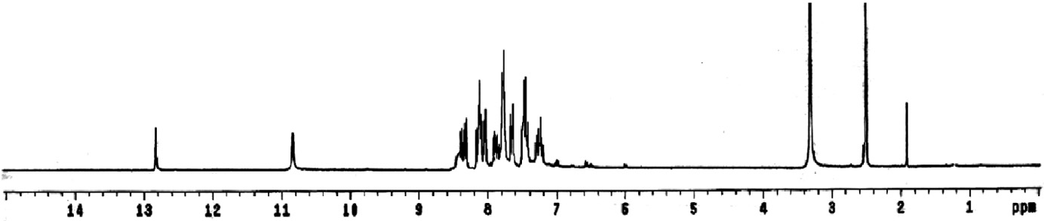

#### Fig. 7 – 1H-NMR spectrum [Cd2(APTH)Cl4] complex.

position and the shift of N2H to upfield (~0.1 ppm) confirm the involvement of N2H in coordination to the metal ion (Fig. 7).

The electronic spectrum of Cd(II) complex in DMSO showed three bands at 36,230, 32,050 and 27,930 cm−1 attributed π→π* of the aromatic rings, π→π* of C = O and n→π* of C = O [43,45,46], respectively. Also, a band at 20,000 cm−1 was ob- served with two shoulders at 23,255 and 21,460 cm−1 and

assigned to ligand to metal charge transfer [50] and n→π* of azomethine groups, respectively. The shift in band position of the carbonyl transition confirms the involvement of carbonyl group in coordination to the metal ion. Finally, the spectrum of Hg(II) complex displayed three bands at 33,780, 27,780 and 19,840 cm−1 with three shoulders at 31,850 and 23,925 cm−1 due to intra-ligand transitions. Moreover, a new band at 21,000 cm−1 was observed and attributed to LMCT transition. The data confirm the existence of the ligand in keto form.

## *Cloud point extraction*

### *Effect of pH on CPE*

The extraction of metal ions using cloud point technique in- volves formation of a complex with the reagent used that has sufficient hydrophobic nature to be extracted into a small volume of surfactant-rich phase and so obtaining the desired preconcentration. The pH plays a unique role in metal- chelate formation and subsequent extraction [51]. Fig. 8 shows the influence of pH on the absorbance of the Cd(II) and Hg(II) complexes at 478 and 446 nm, respectively. As seen, both metals

can be extracted efficiently at pH 7 after which the complex- ation and/or extraction of the metal ion decreased. The Hg(II) shows higher stability than Cd(II), which has a sharp de- crease. Hence, pH 7 was chosen as the working pH.

### *Effect of APTH concentration*

The effect of concentration of APTH on analytical response is shown in Fig. 9. As seen, the absorbance increases, reaching maximum at 2 × 10−5 M, which is considered as complete che- lation and extraction of both metals Cd(II) and Hg(II). From the data, the optimum concentration used for further studies is 2 × 10−5 M.

### *Effect of Triton X-114 concentration*

The plot of the recovery percentage versus the concentration of Triton X-114 is shown in Fig. 10. At a concentration of 0.1% (w/v), optimum recovery of the analytes is obtained. At lower concentrations, the extraction of chelated metal ions is low probably because of the inadequacy of the surfactant mi- celles to entrap the hydrophobic complex formed quantitatively. Increasingly, after this optimal concentration, the recovery is observed to decrease, which may be attributed to the in- crease in the final volume of the surfactant that causes the preconcentration factor (phase volume ratio) to decrease [52].

### *Effect of the equilibration temperature and* centrifugation time

Optimal incubation time and equilibration temperature are nec- essary to complete reactions and to achieve easy phase

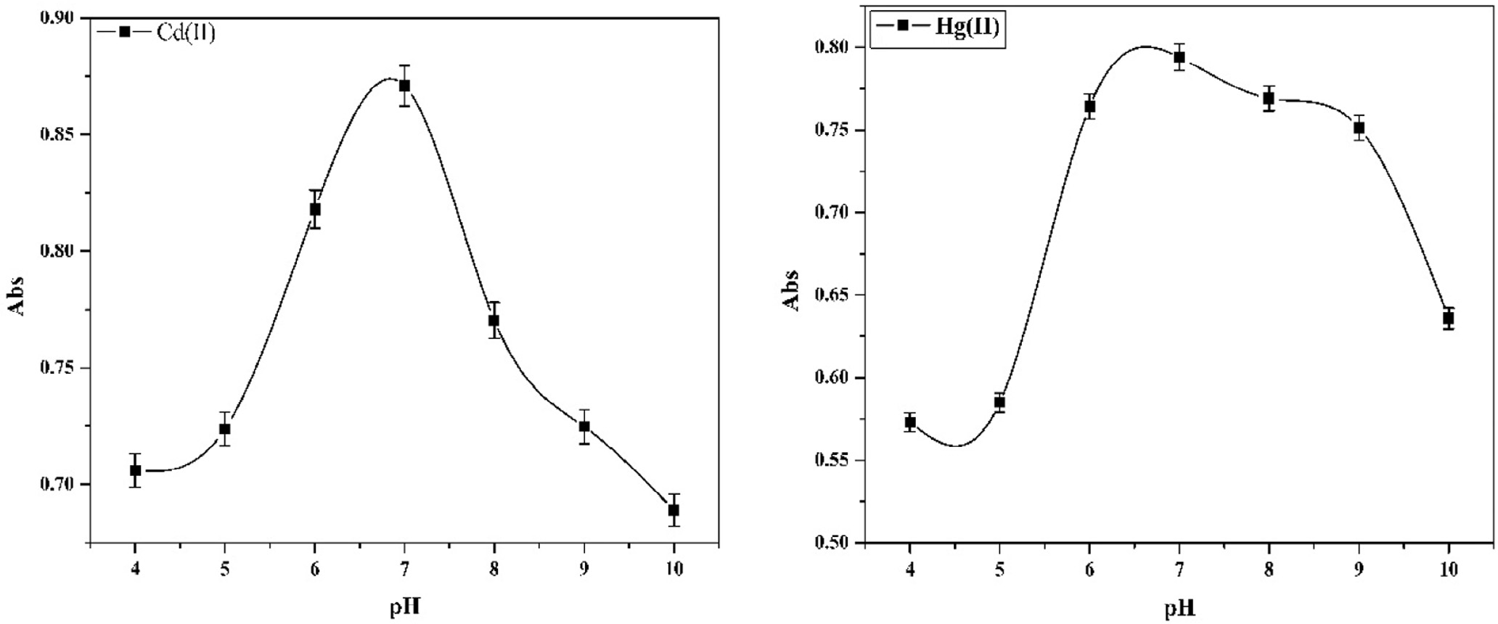

#### Fig. 8 – Effect of pH on the extraction recovery of Cd(II) and Hg(II) using APTH (10−5 M) and Triton X-114 (0.1 % w/v).

egyptian journal of basic and applied sciences 3 (2016) 106–11 7

**113**

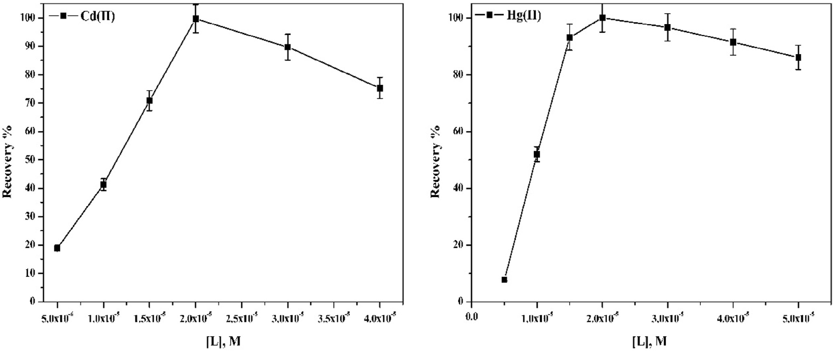

#### Fig. 9 – Effect of APTH concentration on the extraction recovery of Cd(II) and Hg(II) using Triton X-114 (0.1 % w/v) at pH 7.

separation and preconcentration as efficient as possible. The greatest analyte preconcentration factors are expected under conditions where the CPE is conducted using temperatures that are well above the cloud point temperature of the surfactant. It was found that a temperature of 45 °C is adequate for the analytes (Fig. 11).

It was desirable to employ the shortest equilibration time and the lowest possible equilibration temperature, which com- promise the completion of reaction and efficient separation of phases. The dependence of absorbance upon equilibration and centrifugation times was studied within the range 5–25 min. The optimal time for equilibration and centrifugation is 10 min (Fig. 12).

### *Figures of merit*

Under the optimum conditions, the increase of the metal con- centration was studied in the range 0.25–10 ng/ml for Cd(II) and 0.25–25 ng/ml for Hg(II). The data indicated that the linear ranges are 0.25–3 and 0.25–7.5 ng/ml for Cd(II) and Hg(II), respec- tively; LOD = 1.0 and 2.0 ng/ml for Cd(II) and Hg(II), respectively; LOQ = 3.38 and 6.65 ng/ml for Cd(II) and Hg(II), respectively; %

R.S.D. in the range 1.20–1.62 and phase volume ratio = 50 (Figs. 13 and 14). The detection limits (LODs) and limits of quantifica- tion (LQDs) calculation were based on the 3σ and 10σ criterion, respectively, where σ is the standard deviation of 5 determi- nations of the method carried out during the same analytical run. The blank was a 1% v/v ultrapure HNO3 solution.

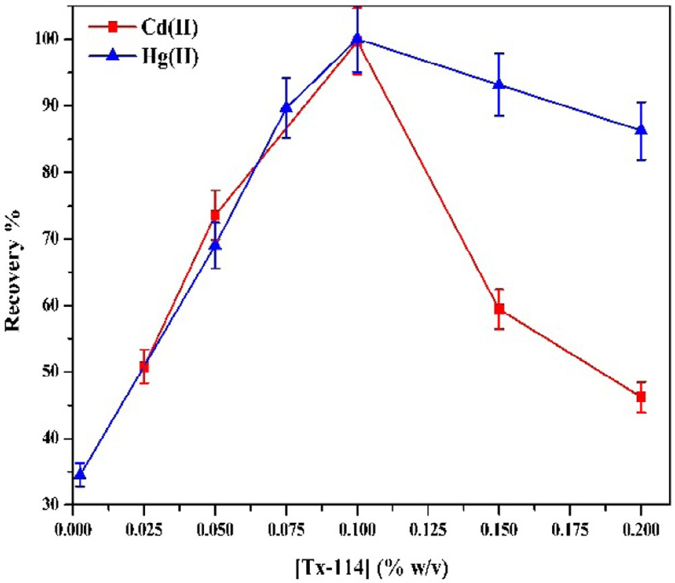 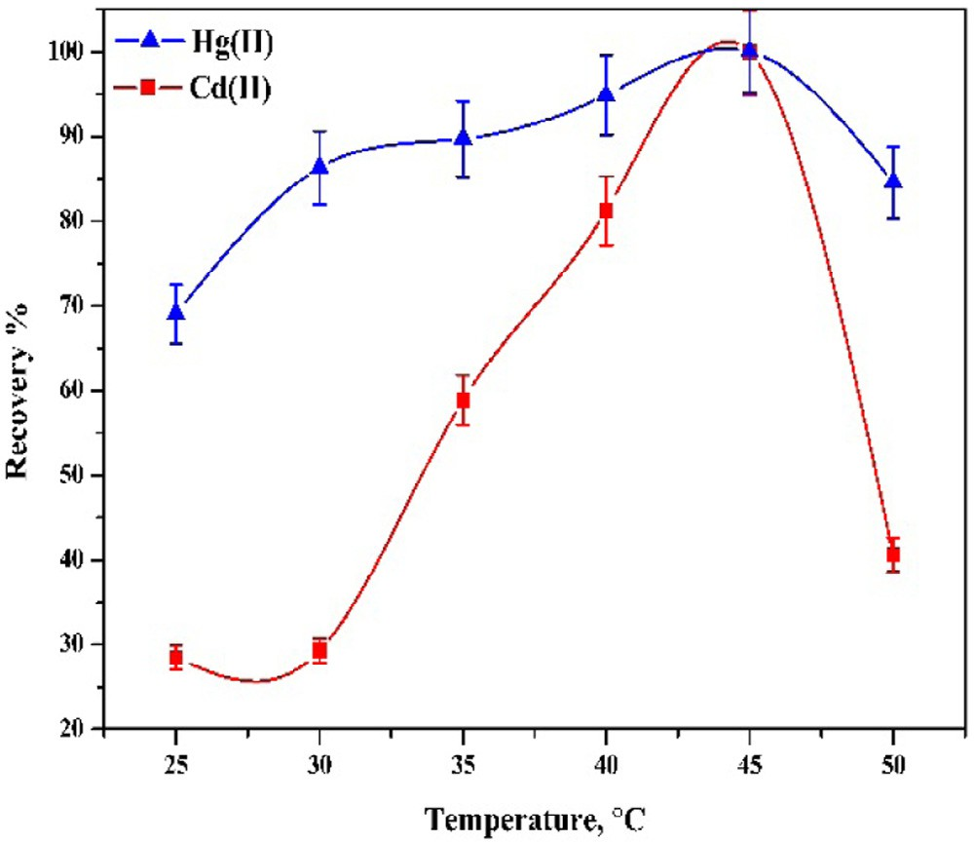

#### Fig. 10 – Effect of Triton X-114 concentration on the extraction recovery % of the Cd(II) and Hg(II) using APTH (2 × 10−5 M) at pH 7.

**Fig. 11 – Effect of temperature on the extraction recovery % of the Cd(II) and Hg(II) using APTH (2 × 10−5 M) and Triton X-114 (0.1 %w/v) at pH 7.**

**114** egyptian journal of basic and applied sciences 3 (2016) 106–11 7

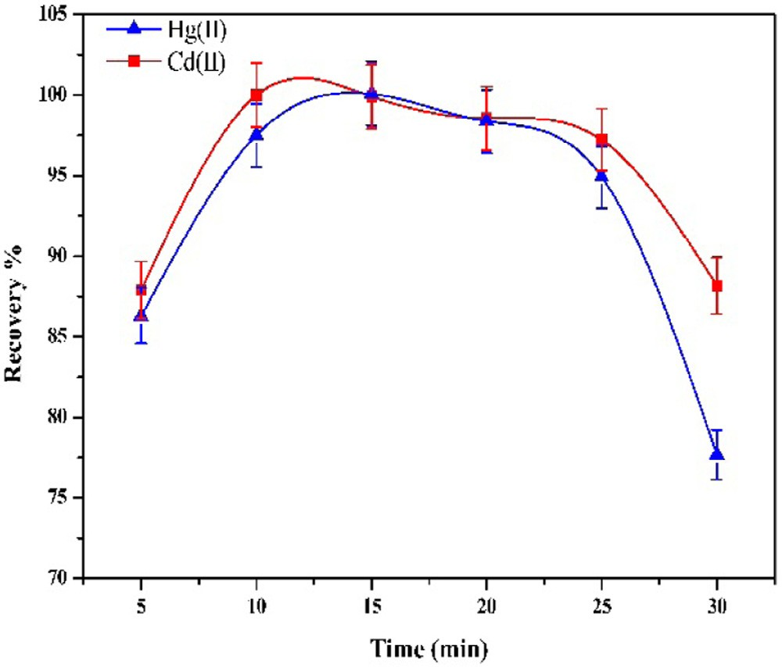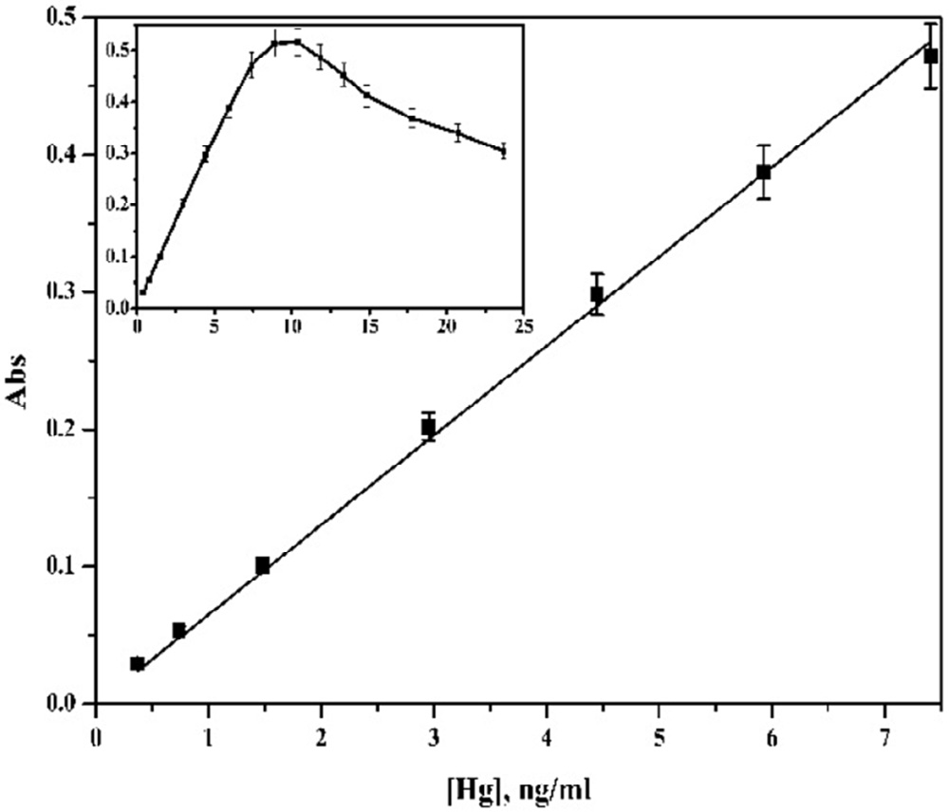

**Fig. 12 – Effect of incubation time on the extraction recovery % of the Cd(II) and Hg(II) using APTH (2 × 10−5 M)**

**Fig. 14 – Calibration curve of the Hg(II) using APTH (2 × 10−5 M) and Triton X-114 (0.1 % w/v) at pH 7.**

**and Triton X-114 (0.1 %w/v) at pH 7.**

Repeatability (precision) was calculated as the relative stan- dard deviation of five measurements of a sample with concentration values in the central region of the analytical range carried out during the same analytical run.

### *Effect of interfering ions*

Two types of interference affect the preconcentration and/or the detection [53]. The effect of interfering ions at different con- centrations on the absorbance of a solution containing 0.25 ppm of both Cd(II) and Hg(II) was studied. An ion was considered to interfere when its presence produced a variation in the ab- sorbance of the sample of more than 5%. This increment of absorbance was evaluated for Cd(II) and Hg(II) at 478 and

446 nm, respectively, to establish the different effects of the interfering ions on the analytes. Among the tested interfer- ing ions, Na+, K+, Cl− and NO − did not interfere at concentrations higher than that of the analytes by even more than 1000 fold while ions like Mg2+, Ca2+, I−, PO 3− and SCN− in addition to thio- urea did not interfere at medium concentrations in the range 500–100 fold. On the other hand, Fe2+, Fe3+,Al3+, SO 2−, F−, acetate and citrate show strong inference in concentration range 1–50 fold (Table 5).

### *Analysis of real water samples*

3

4

4

The proposed CPE procedure was applied in determination of Cd(II) and Hg(II) from real water samples. The water samples were collected from tap water in Mansoura City, River Nile at

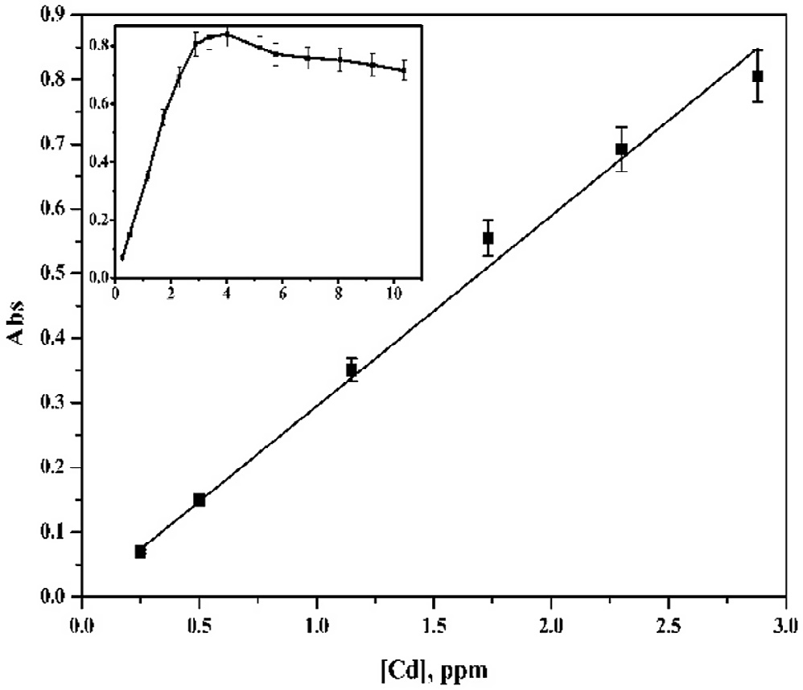

#### Fig. 13 – Calibration curve of the Cd(II) using APTH (2 × 10−5 M) and Triton X-114 (0.1 %w/v) at pH 7.

|  |  |  |  |  |
| --- | --- | --- | --- | --- |
| **Table 5 – Tolerance limits for interference ions.** | | | | |
| Interfering ion | Cd(II)  Tolerance Recovery limit % | | Hg(II)  Tolerance Recovery limit % | |
| K+ | 1000 | 105.23 | 1000 | 99.46 |
| Na+ | 1000 | 101.87 | 1000 | 98.34 |
| Mg2+ | 1000 | 98.58 | 1000 | 100.34 |
| Ca2+ | 1000 | 99.92 | 1000 | 99.88 |
| Fe2+ | 1 | 98.63 | 1 | 99.69 |
| Fe3+ | 1 | 100.01 | 1 | 102.42 |
| Al3+ | 10 | 109.23 | 2 | 99.94 |
| F− | 25 | 98.95 | 10 | 97.07 |
| Cl− | 1000 | 98.23 | 1000 | 97.34 |
| I− | 300 | 97.28 | 100 | 98.47 |
|  |  | |  | |
| NO3 | 1000 | 102.77 | 1000 | 99.93 |
|  |  | |  | |
| SO4 | 100 | 103.22 | 100 | 99.69 |
|  |  | |  | |
| PO4 | 80 | 99.67 | 30 | 98.22 |
| SCN− | 150 | 99.50 | 50 | 97.64 |
| Thiourea | 200 | 96.50 | 100 | 97.79 |
| Oxalate | 20 | 98.18 | 1 | 98.55 |
| Citrate | 5 | 99.71 | 2 | 102.45 |

egyptian journal of basic and applied sciences 3 (2016) 106–11 7

**115**

|  |  |  |  |  |
| --- | --- | --- | --- | --- |
| **Table 6 – Determination of the Hg(II) and Cd(II) in 50 ml water samples using the presented CPE procedure in comparison with those obtained by FAAS.** | | | | |
| Water sample (location) | Cd(II) (ng/ml)  Spectrophotometrically | FAAS | Hg(II) (ng/ml)  Spectrophotometrically | CVAAS |
| Tape (Mansoura) | 0.15 | 0.145 | 0.12 | 0.11 |
| River Nile (Mansoura) | 0.03 | 0.03 | 0.05 | 0.04 |
| El-Manzala lake (El-Manzala) | 0.17 | 0.18 | 0.70 | 0.65 |
| Mediterranean Sea (Gamasa) | 0.22 | 0.21 | 0.34 | 0.35 |
| Underground (Belqas territory) | 0.13 | 0.14 | 0.17 | 0.16 |

|  |  |  |  |  |  |  |
| --- | --- | --- | --- | --- | --- | --- |
| **Table 7 – CPE applications for metal ions analysis of the current work in comparison with previous studies.** | | | | | | |
| Ion | Reagent | Surfactant | Detection system | DL (mg/l) | Matrix | References |
| Hg(II) | 5-Br-PADAP | PONPE7.5 | ETAAS | 0.01 | Human hair; urine and water | [54] |
|  | APDC | TritonX-114 | ICP-Ms | 0.005 | River, bottled, reservoir and tap water | [55] |
|  | Dithiazone | TritonX-100 | Spectrophotometry | 0.014 | Natural water | [56] |
|  | PAN | TritonX-114 | Spectrophotometry | 1.65 | River, lake and tap water | [57] |
|  | APTH | TritonX-114 | Spectrophotometry | 2.0 | River, lake, underground and tap water | Current work |
| Cd(II) | 5-Br-PADAP | PONPE7.5 | ETAAS | 0.008 | Urine, water | [58] |
|  | APDC | TritonX-114 | ICP-Ms | 0.002 | River, bottled, reservoir and tap water | [55] |
|  | Dithiazone | TritonX-114 | ICP-OES | 0.093 | Petroleum produced water | [57] |
|  | PAN | TritonX-114 | ICP-OES | 4.0 | Dolomite and bone ash | [58] |
|  | APTH | TritonX-114 | Spectrophotometry | 1.0 | River, lake, underground and tap water | Current work |

Mansoura City, El-Manzala Lake, Mediterranean Sea at Gamasa,

R E F E R E N C E S

and underground water at Belqas territory. Hence, the deter- minations were carried out in spiked water samples with 1 ml

of 20 ng/ml to 50 ml, assuming that the original content of this ions was negligible compared to the concentration spiked. The Hg(II) and Cd(II) content were determined spectrometrically and compared with those determined by HG-FAAS and FAAS, re- spectively. Table 6 shows the results of applying the proposed method on different water samples to determine the Cd(II) and Hg(II) contents. Finally, a comparison of the current work with previous studies is shown in Table 7. In case of Hg(II), the pro- posed procedure showed detection limit higher than the spectrophotometric determination using PAN as chelating agent (difference is 0.35 mg/l) [57]. In case of Cd(II), the detection limit of the proposed procedure is very close to ICP-OES determi- nation using Dithiazone as chelating agent [57].

# Conclusion

In this study the new acenaphthaquinone-4-phenyl thiosemicarbazone (APTH) and its bimetallic Hg(II) and Cd(II) complexes were synthesized and characterized. The chela- tion mode of the ligand to the metal ions is tetradentate as N,N,S,O donor. Applying the APTH as a chelating agent in CPE procedure for extraction of Hg(II) and Cd(II) from aqueous medium was achieved at pH 7 using 0.1% w/v Triton X-114 and 2 × 10−5 M APTH. Linear calibration curve is obtained in the ranges 0.25–3 and 0.25–7.5 ng/ml for Cd(II) and Hg(II), respec- tively. The method was applied successfully for determination of Hg(II) and Cd(II) in different water samples.

1. [Gingras B, Somorjai R, Bayley C. The preparation of some](http://refhub.elsevier.com/S2314-808X(15)00078-0/sr0010) [thiosemicarbazones and their copper complexes. Can J](http://refhub.elsevier.com/S2314-808X(15)00078-0/sr0010) [Chem 1961;39(5):973–85.](http://refhub.elsevier.com/S2314-808X(15)00078-0/sr0010)
2. [Du X, Guo C, Hansell E, Doyle PS, Caffrey CR, Holler TP, et al.](http://refhub.elsevier.com/S2314-808X(15)00078-0/sr0015) [Synthesis and structure-activity relationship study of potent](http://refhub.elsevier.com/S2314-808X(15)00078-0/sr0015) [trypanocidal thio semicarbazone inhibitors of the](http://refhub.elsevier.com/S2314-808X(15)00078-0/sr0015) [trypanosomal cysteine protease cruzain. J Med Chem](http://refhub.elsevier.com/S2314-808X(15)00078-0/sr0015) [2002;45(13):2695–707.](http://refhub.elsevier.com/S2314-808X(15)00078-0/sr0015)
3. [Kovala-Demertzi D, Demertzis MA, Filiou E, Pantazaki AA,](http://refhub.elsevier.com/S2314-808X(15)00078-0/sr0020) [Yadav PN, Miller JR, et al. Platinum (II) and palladium (II)](http://refhub.elsevier.com/S2314-808X(15)00078-0/sr0020) [complexes with 2-acetyl pyridine 4N-ethyl](http://refhub.elsevier.com/S2314-808X(15)00078-0/sr0020) [thiosemicarbazone able to overcome the cis-platin](http://refhub.elsevier.com/S2314-808X(15)00078-0/sr0020) [resistance. Structure, antibacterial activity and DNA strand](http://refhub.elsevier.com/S2314-808X(15)00078-0/sr0020) [breakage. Biometals 2003;16(3):411–18.](http://refhub.elsevier.com/S2314-808X(15)00078-0/sr0020)
4. [Kovala-Demertzi D, Domopoulou A, Demertzis MA,](http://refhub.elsevier.com/S2314-808X(15)00078-0/sr0025) [Papageorgiou A, West DX. Palladium (II) complexes of](http://refhub.elsevier.com/S2314-808X(15)00078-0/sr0025) [2-acetylpyridine N (4)-propyl, N (4)-dipropyl-and](http://refhub.elsevier.com/S2314-808X(15)00078-0/sr0025)

[3-hexamethyleneiminylthiosemicarbazones with potentially](http://refhub.elsevier.com/S2314-808X(15)00078-0/sr0025) [interesting biological activity. Synthesis, spectral properties,](http://refhub.elsevier.com/S2314-808X(15)00078-0/sr0025) [antifungal and in vitro antitumor activity. Polyhedron](http://refhub.elsevier.com/S2314-808X(15)00078-0/sr0025) [1997;16(20):3625–33.](http://refhub.elsevier.com/S2314-808X(15)00078-0/sr0025)

1. [Klayman D, Scovill J, Mason C, Bartosevich J, Bruce J, Lin AJ.](http://refhub.elsevier.com/S2314-808X(15)00078-0/sr0030) [2-Acetylpyridine thiosemicarbazones. 6.2-Acetylpyridine](http://refhub.elsevier.com/S2314-808X(15)00078-0/sr0030) [and 2-butyrylpyridine thiosemicarbazones as antileukemic](http://refhub.elsevier.com/S2314-808X(15)00078-0/sr0030) [agents. Arzneimittelforschung 1982;33(7):909–12.](http://refhub.elsevier.com/S2314-808X(15)00078-0/sr0030)
2. [Klayman DL, Scovill JP, Bartosevich JF, Mason CJ.](http://refhub.elsevier.com/S2314-808X(15)00078-0/sr0035) [2-Acetylpyridine thiosemicarbazones. 2. N4, N4-](http://refhub.elsevier.com/S2314-808X(15)00078-0/sr0035)

[Disubstituted derivatives as potential antimalarial agents.](http://refhub.elsevier.com/S2314-808X(15)00078-0/sr0035) [J Med Chem 1979;22(11):1367–73.](http://refhub.elsevier.com/S2314-808X(15)00078-0/sr0035)

1. [Klayman DL, Scovill JP, Bartosevich JF, Bruce J.](http://refhub.elsevier.com/S2314-808X(15)00078-0/sr0040)

[2-Acetylpyridine thiosemicarbazones. 5. 1-[1-(2-Pyridyl)](http://refhub.elsevier.com/S2314-808X(15)00078-0/sr0040) [ethyl]-3-thiosemicarbazides as potential antimalarial](http://refhub.elsevier.com/S2314-808X(15)00078-0/sr0040) [agents. J Med Chem 1983;26(1):35–9.](http://refhub.elsevier.com/S2314-808X(15)00078-0/sr0040)

**116** egyptian journal of basic and applied sciences 3 (2016) 106–11 7

1. [Shipman C, Smith SH, Drach JC, Klayman DL.](http://refhub.elsevier.com/S2314-808X(15)00078-0/sr0045) [Thiosemicarbazones of 2-acetylpyridine, 2-acetylquinoline,](http://refhub.elsevier.com/S2314-808X(15)00078-0/sr0045) [1-acetylisoquinoline, and related compounds as inhibitors](http://refhub.elsevier.com/S2314-808X(15)00078-0/sr0045) [of herpes simplex virus in vitro and in a cutaneous herpes](http://refhub.elsevier.com/S2314-808X(15)00078-0/sr0045) [guinea pig model. Antiviral Res 1986;6(4):197–222.](http://refhub.elsevier.com/S2314-808X(15)00078-0/sr0045)
2. [Turk SR, Shipman C, Drach JC. Selective inhibition of herpes](http://refhub.elsevier.com/S2314-808X(15)00078-0/sr0050) [simplex virus ribonucleoside diphosphate reductase by](http://refhub.elsevier.com/S2314-808X(15)00078-0/sr0050) [derivatives of 2-acetylpyridine thiosemicarbazone. Biochem](http://refhub.elsevier.com/S2314-808X(15)00078-0/sr0050) [Pharmacol 1986;35(9):1539–45.](http://refhub.elsevier.com/S2314-808X(15)00078-0/sr0050)
3. [French FA, Blanz EJ. The carcinostatic activity of α-(N)](http://refhub.elsevier.com/S2314-808X(15)00078-0/sr0055) [heterocyclic carboxaldehyde thiosemicarbazones I.](http://refhub.elsevier.com/S2314-808X(15)00078-0/sr0055) [Isoquinoline-1-carboxaldehyde thiosemicarbazone. Cancer](http://refhub.elsevier.com/S2314-808X(15)00078-0/sr0055) [Res 1965;25(9 Pt 1):1454–8.](http://refhub.elsevier.com/S2314-808X(15)00078-0/sr0055)
4. [Campbell MJ. Transition metal complexes of](http://refhub.elsevier.com/S2314-808X(15)00078-0/sr0060) [thiosemicarbazide and thiosemicarbazones. Coord Chem](http://refhub.elsevier.com/S2314-808X(15)00078-0/sr0060) [Rev 1975;15(2):279–319.](http://refhub.elsevier.com/S2314-808X(15)00078-0/sr0060)
5. [Padhye S, Kauffman GB. Transition metal complexes of](http://refhub.elsevier.com/S2314-808X(15)00078-0/sr0065) [semicarbazones and thiosemicarbazones. Coord Chem Rev](http://refhub.elsevier.com/S2314-808X(15)00078-0/sr0065) [1985;63:127–60.](http://refhub.elsevier.com/S2314-808X(15)00078-0/sr0065)
6. [West DX, Liberta AE, Padhye SB, Chikate RC, Sonawane PB,](http://refhub.elsevier.com/S2314-808X(15)00078-0/sr0070) [Kumbhar AS, et al. Thiosemicarbazone complexes of copper](http://refhub.elsevier.com/S2314-808X(15)00078-0/sr0070) [(II): structural and biological studies. Coord Chem Rev](http://refhub.elsevier.com/S2314-808X(15)00078-0/sr0070) [1993;123(1):49–71.](http://refhub.elsevier.com/S2314-808X(15)00078-0/sr0070)
7. [Farrell N. Biomedical uses and applications of inorganic](http://refhub.elsevier.com/S2314-808X(15)00078-0/sr0075) [chemistry. An overview. Coord Chem Rev 2002;232(1):1–4.](http://refhub.elsevier.com/S2314-808X(15)00078-0/sr0075)
8. [Lobana TS, Sharma R, Bawa G, Khanna S. Bonding and](http://refhub.elsevier.com/S2314-808X(15)00078-0/sr0080) [structure trends of thiosemicarbazone derivatives of metals](http://refhub.elsevier.com/S2314-808X(15)00078-0/sr0080) [– an overview. Coord Chem Rev 2009;253(7–8):977–1055.](http://refhub.elsevier.com/S2314-808X(15)00078-0/sr0080)
9. [Ahmed SA. Alumina physically loaded by thiosemicarbazide](http://refhub.elsevier.com/S2314-808X(15)00078-0/sr0085) [for selective preconcentration of mercury (II) ion from](http://refhub.elsevier.com/S2314-808X(15)00078-0/sr0085) [natural water samples. J Hazard Mater 2008;156(1):521–9.](http://refhub.elsevier.com/S2314-808X(15)00078-0/sr0085)
10. [Mahmoud ME, Yakout AA, Ahmed SB, Osman MM.](http://refhub.elsevier.com/S2314-808X(15)00078-0/sr0090) [Speciation, selective extraction and preconcentration of](http://refhub.elsevier.com/S2314-808X(15)00078-0/sr0090) [chromium ions via alumina-functionalized-isatin-](http://refhub.elsevier.com/S2314-808X(15)00078-0/sr0090) [thiosemicarbazone. J Hazard Mater 2008;158(2):541–8.](http://refhub.elsevier.com/S2314-808X(15)00078-0/sr0090)
11. [Lodeiro C, Capelo JL, Mejuto JC, Oliveira E, Santos HM, Pedras](http://refhub.elsevier.com/S2314-808X(15)00078-0/sr0095) [B, et al. Light and colour as analytical detection tools: a](http://refhub.elsevier.com/S2314-808X(15)00078-0/sr0095) [journey into the periodic table using polyamines to bio-](http://refhub.elsevier.com/S2314-808X(15)00078-0/sr0095) [inspired systems as chemosensors. Chem Soc Rev](http://refhub.elsevier.com/S2314-808X(15)00078-0/sr0095) [2010;39(8):2948–76.](http://refhub.elsevier.com/S2314-808X(15)00078-0/sr0095)
12. [Rodriguez-Argüelles MC, Ferrari MB, Fava GG, Pelizzi C, Pelosi](http://refhub.elsevier.com/S2314-808X(15)00078-0/sr0100) [G, Albertini R, et al. Acenaphthenequinone](http://refhub.elsevier.com/S2314-808X(15)00078-0/sr0100) [thiosemicarbazone and its transition metal complexes:](http://refhub.elsevier.com/S2314-808X(15)00078-0/sr0100) [synthesis, structure, and biological activity. J Inorg Biochem](http://refhub.elsevier.com/S2314-808X(15)00078-0/sr0100) [1997;66(1):7–17.](http://refhub.elsevier.com/S2314-808X(15)00078-0/sr0100)
13. [Watanabe H, Tanaka H. A non-ionic surfactant as a new](http://refhub.elsevier.com/S2314-808X(15)00078-0/sr0105) [solvent for liquid – liquid extraction of zinc (II) with 1-(2-](http://refhub.elsevier.com/S2314-808X(15)00078-0/sr0105) [pyridylazo)-2-naphthol. Talanta 1978;25(10):585–9.](http://refhub.elsevier.com/S2314-808X(15)00078-0/sr0105)
14. [Welleman J, Hulsbergen F, Verbiest J, Reedijk J. Influence of](http://refhub.elsevier.com/S2314-808X(15)00078-0/sr0110) [alkyl chain length in N-alkyl imidazoles upon the complex](http://refhub.elsevier.com/S2314-808X(15)00078-0/sr0110) [formation with transition-metal salts. J Inorg Nucl Chem](http://refhub.elsevier.com/S2314-808X(15)00078-0/sr0110) [1978;40(1):143–7.](http://refhub.elsevier.com/S2314-808X(15)00078-0/sr0110)
15. [Saitoh T, Kimura Y, Kamjdate T, Watanabe H, Haraguchi K.](http://refhub.elsevier.com/S2314-808X(15)00078-0/sr0115) [Distribution equilibria of metal chelates with thiazolylazo](http://refhub.elsevier.com/S2314-808X(15)00078-0/sr0115) [dyes between two phases formed from an aqueous micellar](http://refhub.elsevier.com/S2314-808X(15)00078-0/sr0115) [solution of a nonionic surfactant. Analytical Sciences](http://refhub.elsevier.com/S2314-808X(15)00078-0/sr0115) [1989;5(5):577–81.](http://refhub.elsevier.com/S2314-808X(15)00078-0/sr0115)
16. [Watanabe H, Saitoh T, Kamidate T, Haraguchi K. Distribution](http://refhub.elsevier.com/S2314-808X(15)00078-0/sr0120) [of metal chelates between aqueous and surfactant phases](http://refhub.elsevier.com/S2314-808X(15)00078-0/sr0120) [separated from a micellar solution of a nonionic surfactant.](http://refhub.elsevier.com/S2314-808X(15)00078-0/sr0120) [Microchim Acta 1992;106(1–2):83–90.](http://refhub.elsevier.com/S2314-808X(15)00078-0/sr0120)
17. [Pytlakowska K, Kozik V, Dabioch M. Complex-forming](http://refhub.elsevier.com/S2314-808X(15)00078-0/sr0125) [organic ligands in cloud-point extraction of metal ions: a](http://refhub.elsevier.com/S2314-808X(15)00078-0/sr0125) [review. Talanta 2013;110:202–28.](http://refhub.elsevier.com/S2314-808X(15)00078-0/sr0125)
18. [Duruibe J, Ogwuegbu M, Egwurugwu J. Heavy metal pollution](http://refhub.elsevier.com/S2314-808X(15)00078-0/sr0130) [and human biotoxic effects. Int J Phys Sci 2007;2(5):112–18.](http://refhub.elsevier.com/S2314-808X(15)00078-0/sr0130)
19. [Zhao G, Li J, Ren X, Chen C, Wang X. Few-layered graphene](http://refhub.elsevier.com/S2314-808X(15)00078-0/sr0135) [oxide nanosheets as superior sorbents for heavy metal ion](http://refhub.elsevier.com/S2314-808X(15)00078-0/sr0135)

[pollution management. Environ Sci Technol](http://refhub.elsevier.com/S2314-808X(15)00078-0/sr0135) [2011;45(24):10454–62.](http://refhub.elsevier.com/S2314-808X(15)00078-0/sr0135)

1. [Roat-Malone RM. Bioinorganic chemistry: a short course.](http://refhub.elsevier.com/S2314-808X(15)00078-0/sr0140) [Hoboken, New Jersey: John Wiley & Sons; 2007.](http://refhub.elsevier.com/S2314-808X(15)00078-0/sr0140)
2. [Jankowski K, Yao J, Kasiura K, Jackowska A, Sieradzka A.](http://refhub.elsevier.com/S2314-808X(15)00078-0/sr0145) [Multielement determination of heavy metals in water](http://refhub.elsevier.com/S2314-808X(15)00078-0/sr0145) [samples by continuous powder introduction microwave-](http://refhub.elsevier.com/S2314-808X(15)00078-0/sr0145) [induced plasma atomic emission spectrometry after](http://refhub.elsevier.com/S2314-808X(15)00078-0/sr0145) [preconcentration on activated carbon. Spectrochim Acta](http://refhub.elsevier.com/S2314-808X(15)00078-0/sr0145) [Part B At Spectrosc 2005;60(3):369–75.](http://refhub.elsevier.com/S2314-808X(15)00078-0/sr0145)
3. [Cerutti S, Moyano S, Marrero J, Smichowski P, Martinez L.](http://refhub.elsevier.com/S2314-808X(15)00078-0/sr0150) [On-line preconcentration of nickel on activated carbon prior](http://refhub.elsevier.com/S2314-808X(15)00078-0/sr0150) [to its determination by vapor generation associated to](http://refhub.elsevier.com/S2314-808X(15)00078-0/sr0150) [inductively coupled plasma optical emission spectrometry.](http://refhub.elsevier.com/S2314-808X(15)00078-0/sr0150) [J Anal At Spectrom 2005;20(6):559–61.](http://refhub.elsevier.com/S2314-808X(15)00078-0/sr0150)
4. [Umashankar V, Radhamani R, Ramadoss K, Murty D.](http://refhub.elsevier.com/S2314-808X(15)00078-0/sr0155) [Simultaneous separation and preconcentration of trace](http://refhub.elsevier.com/S2314-808X(15)00078-0/sr0155) [elements in water samples by coprecipitation on](http://refhub.elsevier.com/S2314-808X(15)00078-0/sr0155) [manganese dioxide using D-glucose as reductant for](http://refhub.elsevier.com/S2314-808X(15)00078-0/sr0155) [KMnO(4). Talanta 2002;57(6):1029–38.](http://refhub.elsevier.com/S2314-808X(15)00078-0/sr0155)
5. [Doner G, Ege A. Determination of copper, cadmium and lead](http://refhub.elsevier.com/S2314-808X(15)00078-0/sr0160) [in seawater and mineral water by flame atomic absorption](http://refhub.elsevier.com/S2314-808X(15)00078-0/sr0160) [spectrometry after coprecipitation with aluminum](http://refhub.elsevier.com/S2314-808X(15)00078-0/sr0160) [hydroxide. Anal Chim Acta 2005;547(1):14–17.](http://refhub.elsevier.com/S2314-808X(15)00078-0/sr0160)
6. [Tuzen M, Uluozlu OD, Karaman I, Soylak M. Mercury (II) and](http://refhub.elsevier.com/S2314-808X(15)00078-0/sr0165) [methyl mercury speciation on *Streptococcus pyogenes* loaded](http://refhub.elsevier.com/S2314-808X(15)00078-0/sr0165) [Dowex Optipore SD-2. J Hazard Mater 2009;169(1):345–50.](http://refhub.elsevier.com/S2314-808X(15)00078-0/sr0165)
7. [Tewari P, Singh AK. Preconcentration of lead with Amberlite](http://refhub.elsevier.com/S2314-808X(15)00078-0/sr0170) [XAD-2 and Amberlite XAD-7 based chelating resins for its](http://refhub.elsevier.com/S2314-808X(15)00078-0/sr0170) [determination by flame atomic absorption spectrometry.](http://refhub.elsevier.com/S2314-808X(15)00078-0/sr0170) [Talanta 2002;56(4):735–44.](http://refhub.elsevier.com/S2314-808X(15)00078-0/sr0170)
8. [Jain VK, Mandalia HC, Gupte HS, Vyas DJ. Azocalix [4] pyrrole](http://refhub.elsevier.com/S2314-808X(15)00078-0/sr0175) [Amberlite XAD-2: New polymeric chelating resins for the](http://refhub.elsevier.com/S2314-808X(15)00078-0/sr0175) [extraction, preconcentration and sequential separation of](http://refhub.elsevier.com/S2314-808X(15)00078-0/sr0175) [Cu (II), Zn (II) and Cd (II) in natural water samples. Talanta](http://refhub.elsevier.com/S2314-808X(15)00078-0/sr0175) [2009;79(5):1331–40.](http://refhub.elsevier.com/S2314-808X(15)00078-0/sr0175)
9. [Gholivand MB, Mohammadi M. Khodadadian M, Rofouei MK.](http://refhub.elsevier.com/S2314-808X(15)00078-0/sr0180) [Novel platinum (II) selective membrane electrode based on](http://refhub.elsevier.com/S2314-808X(15)00078-0/sr0180) [1, 3-bis (2-cyanobenzene) triazene. Talanta 2009;78(3):922–8.](http://refhub.elsevier.com/S2314-808X(15)00078-0/sr0180)
10. [Li X-G, Ma X-L, Huang M-R. Lead (II) ion-selective electrode](http://refhub.elsevier.com/S2314-808X(15)00078-0/sr0185) [based on polyaminoanthraquinone particles with intrinsic](http://refhub.elsevier.com/S2314-808X(15)00078-0/sr0185) [conductivity. Talanta 2009;78(2):498–505.](http://refhub.elsevier.com/S2314-808X(15)00078-0/sr0185)
11. [Camino M, Bagur M, Sanchez-Vinas M, Gazquez D, Romero](http://refhub.elsevier.com/S2314-808X(15)00078-0/sr0190)

[R. Multivariate optimization of solvent extraction of Cd (II),](http://refhub.elsevier.com/S2314-808X(15)00078-0/sr0190) [Co (II), Cr (VI), Cu (II), Ni (II), Pb (II) and Zn (II) as](http://refhub.elsevier.com/S2314-808X(15)00078-0/sr0190)

[dibenzyldithiocarbamates and detection by AAS. J Anal At](http://refhub.elsevier.com/S2314-808X(15)00078-0/sr0190) [Spectrom 2001;16(6):638–42.](http://refhub.elsevier.com/S2314-808X(15)00078-0/sr0190)

1. [Tuzen M, Karaman I, Citak D, Soylak M. Mercury (II) and](http://refhub.elsevier.com/S2314-808X(15)00078-0/sr0195) [methyl mercury determinations in water and fish samples](http://refhub.elsevier.com/S2314-808X(15)00078-0/sr0195) [by using solid phase extraction and cold vapour atomic](http://refhub.elsevier.com/S2314-808X(15)00078-0/sr0195) [absorption spectrometry combination. Food Chem Toxicol](http://refhub.elsevier.com/S2314-808X(15)00078-0/sr0195) [2009;47(7):1648–52.](http://refhub.elsevier.com/S2314-808X(15)00078-0/sr0195)
2. [Sari A, Tuzen M. Removal of mercury (II) from aqueous](http://refhub.elsevier.com/S2314-808X(15)00078-0/sr0200) [solution using moss (*Drepanocladus revolvens*) biomass:](http://refhub.elsevier.com/S2314-808X(15)00078-0/sr0200) [equilibrium, thermodynamic and kinetic studies. J Hazard](http://refhub.elsevier.com/S2314-808X(15)00078-0/sr0200) [Mater 2009;171(1):500–7.](http://refhub.elsevier.com/S2314-808X(15)00078-0/sr0200)
3. [Tuzen M, Sari A, Mendil D, Soylak M. Biosorptive removal of](http://refhub.elsevier.com/S2314-808X(15)00078-0/sr0205) [mercury (II) from aqueous solution using lichen](http://refhub.elsevier.com/S2314-808X(15)00078-0/sr0205) [(*Xanthoparmelia conspersa*) biomass: kinetic and equilibrium](http://refhub.elsevier.com/S2314-808X(15)00078-0/sr0205) [studies. J Hazard Mater 2009;169(1):263–70.](http://refhub.elsevier.com/S2314-808X(15)00078-0/sr0205)
4. [Zhao L, Zhong S, Fang K, Qian Z, Chen J. Determination of](http://refhub.elsevier.com/S2314-808X(15)00078-0/sr0210) [cadmium (II), cobalt (II), nickel (II), lead (II), zinc (II), and](http://refhub.elsevier.com/S2314-808X(15)00078-0/sr0210) [copper (II) in water samples using dual-cloud point](http://refhub.elsevier.com/S2314-808X(15)00078-0/sr0210) [extraction and inductively coupled plasma emission](http://refhub.elsevier.com/S2314-808X(15)00078-0/sr0210) [spectrometry. J Hazard Mater 2012;239:206–12.](http://refhub.elsevier.com/S2314-808X(15)00078-0/sr0210)
5. [Xu H, Zhang W, Zhang X, Wang J, Wang J. Simultaneous](http://refhub.elsevier.com/S2314-808X(15)00078-0/sr0215) [preconcentration of cobalt, nickel and copper in water](http://refhub.elsevier.com/S2314-808X(15)00078-0/sr0215) [samples by cloud point extraction method and their](http://refhub.elsevier.com/S2314-808X(15)00078-0/sr0215)

egyptian journal of basic and applied sciences 3 (2016) 106–11 7

**117**

determination by flame atomic absorption spectrometry. [Proc Environ Sci 2013;18:258–63.](http://refhub.elsevier.com/S2314-808X(15)00078-0/sr0215)

1. [Hassanien M, Gabr I, Abdel-Rhman M, El-Asmy A. Synthesis](http://refhub.elsevier.com/S2314-808X(15)00078-0/sr0220) [and structural investigation of mono-and polynuclear](http://refhub.elsevier.com/S2314-808X(15)00078-0/sr0220) [copper complexes of 4-ethyl-1-(pyridin-2-yl)](http://refhub.elsevier.com/S2314-808X(15)00078-0/sr0220) [thiosemicarbazide. Spectrochim Acta A Mol Biomol](http://refhub.elsevier.com/S2314-808X(15)00078-0/sr0220) [Spectrosc 2008;71(1):73–9.](http://refhub.elsevier.com/S2314-808X(15)00078-0/sr0220)
2. [Silverstein R, Webster F. Spectrometric identification of](http://refhub.elsevier.com/S2314-808X(15)00078-0/sr0225) [organic compounds. Hoboken, New Jersey: John Wiley &](http://refhub.elsevier.com/S2314-808X(15)00078-0/sr0225) [Sons; 2006.](http://refhub.elsevier.com/S2314-808X(15)00078-0/sr0225)
3. [Abdel-Rhman MH, Hassanian MM, El-Asmy AA. Spectral and](http://refhub.elsevier.com/S2314-808X(15)00078-0/sr0230) [structural density functional theory on 4-ethyl and 4-(p-](http://refhub.elsevier.com/S2314-808X(15)00078-0/sr0230) [tolyl)-1-(pyridin-2-yl)thiosemicarbazides and their Pd(II)](http://refhub.elsevier.com/S2314-808X(15)00078-0/sr0230) [complexes. J Mol Struct 2012;1019:110–19.](http://refhub.elsevier.com/S2314-808X(15)00078-0/sr0230)
4. [El-Asmy AA, Hassanian MM, Abdel-Rhman MH. Synthesis,](http://refhub.elsevier.com/S2314-808X(15)00078-0/sr0235) [characterization and antibacterial activity of Pd (II), Pt (II)](http://refhub.elsevier.com/S2314-808X(15)00078-0/sr0235) [and Ag (I) complexes of 4-ethyl and 4-(p-tolyl)-1-(pyridin-2-](http://refhub.elsevier.com/S2314-808X(15)00078-0/sr0235) [yl) thiosemicarbazides. J Sulfur Chem 2010;31(2):141–51.](http://refhub.elsevier.com/S2314-808X(15)00078-0/sr0235)
5. [Orif MI, Abdel-Rhman MH. Synthesis, spectral and structural](http://refhub.elsevier.com/S2314-808X(15)00078-0/sr0240) [studies on some new isonicotinic thiosemicarbazide](http://refhub.elsevier.com/S2314-808X(15)00078-0/sr0240) [complexes and its biological activity. Polyhedron](http://refhub.elsevier.com/S2314-808X(15)00078-0/sr0240) [2015;98:162–79.](http://refhub.elsevier.com/S2314-808X(15)00078-0/sr0240)
6. [El-Asmy AA, Rakha TH, Abdel-Rhman MH, Hassanien MM,](http://refhub.elsevier.com/S2314-808X(15)00078-0/sr0245) [Al-Mola AS. Synthesis, spectral, thermal and biological](http://refhub.elsevier.com/S2314-808X(15)00078-0/sr0245) [studies on N(2,4-dinitro-phenyl)-2-mercaptoacetohydrazide](http://refhub.elsevier.com/S2314-808X(15)00078-0/sr0245) [and its metal complexes. Spectrochim Acta A Mol Biomol](http://refhub.elsevier.com/S2314-808X(15)00078-0/sr0245) [Spectrosc 2015;136:1718–27.](http://refhub.elsevier.com/S2314-808X(15)00078-0/sr0245)
7. [Nakamoto K. Infrared and Raman spectra of inorganic and](http://refhub.elsevier.com/S2314-808X(15)00078-0/sr0250) [coordination compounds. New York: Wiley Online Library;](http://refhub.elsevier.com/S2314-808X(15)00078-0/sr0250) [1978.](http://refhub.elsevier.com/S2314-808X(15)00078-0/sr0250)
8. [Lever ABP. Inorganic electronic spectroscopy. Amsterdam,](http://refhub.elsevier.com/S2314-808X(15)00078-0/sr0255) [Netherlands; 1968.](http://refhub.elsevier.com/S2314-808X(15)00078-0/sr0255)
9. [Paleologos EK, Giokas DL, Karayannis MI. Micelle-mediated](http://refhub.elsevier.com/S2314-808X(15)00078-0/sr0260) [separation and cloud-point extraction. TrAC Trends Analyt](http://refhub.elsevier.com/S2314-808X(15)00078-0/sr0260) [Chem 2005;24(5):426–36.](http://refhub.elsevier.com/S2314-808X(15)00078-0/sr0260)
10. [Laespada MEF, Pavón JLP, Cordero BM. Micelle-mediated](http://refhub.elsevier.com/S2314-808X(15)00078-0/sr0265) [methodology for the preconcentration of uranium prior to](http://refhub.elsevier.com/S2314-808X(15)00078-0/sr0265) [its determination by flow injection. Analyst 1993;118(2):209–](http://refhub.elsevier.com/S2314-808X(15)00078-0/sr0265) [12.](http://refhub.elsevier.com/S2314-808X(15)00078-0/sr0265)
11. [Aranda PR, Gil RA, Moyano S, De Vito IE, Martinez LD. Cloud](http://refhub.elsevier.com/S2314-808X(15)00078-0/sr0270) [point extraction of mercury with PONPE 7.5 prior to its](http://refhub.elsevier.com/S2314-808X(15)00078-0/sr0270) [determination in biological samples by ETAAS. Talanta](http://refhub.elsevier.com/S2314-808X(15)00078-0/sr0270) [2008;75(1):307–11.](http://refhub.elsevier.com/S2314-808X(15)00078-0/sr0270)
12. [Liao P-H, Jiang S-J, Sahayam A. Cloud point extraction](http://refhub.elsevier.com/S2314-808X(15)00078-0/sr0275) [combined with flow injection vapor generation](http://refhub.elsevier.com/S2314-808X(15)00078-0/sr0275) [inductively coupled plasma mass spectrometry for](http://refhub.elsevier.com/S2314-808X(15)00078-0/sr0275) [preconcentration and determination of ultra trace Cd, Sb](http://refhub.elsevier.com/S2314-808X(15)00078-0/sr0275) [and Hg in water samples. J Anal At Spectrom](http://refhub.elsevier.com/S2314-808X(15)00078-0/sr0275) [2012;27(9):1518–24.](http://refhub.elsevier.com/S2314-808X(15)00078-0/sr0275)
13. [Garrido M, Di Nezio M, Lista A, Palomeque M, Fernández](http://refhub.elsevier.com/S2314-808X(15)00078-0/sr0280) [Band B. Cloud-point extraction/preconcentration on-line](http://refhub.elsevier.com/S2314-808X(15)00078-0/sr0280) [flow injection method for mercury determination. Anal](http://refhub.elsevier.com/S2314-808X(15)00078-0/sr0280) [Chim Acta 2004;502(2):173–7.](http://refhub.elsevier.com/S2314-808X(15)00078-0/sr0280)
14. [Ulusoy HI˙, Gürkan R, Ulusoy S. Cloud point extraction and](http://refhub.elsevier.com/S2314-808X(15)00078-0/sr0285)

[spectrophotometric determination of mercury species at](http://refhub.elsevier.com/S2314-808X(15)00078-0/sr0285) [trace levels in environmental samples. Talanta 2012;88:516–](http://refhub.elsevier.com/S2314-808X(15)00078-0/sr0285) [23.](http://refhub.elsevier.com/S2314-808X(15)00078-0/sr0285)

1. [Bezerra MA, Mitihiro do Nascimento Maêda S, Oliveira EP,](http://refhub.elsevier.com/S2314-808X(15)00078-0/sr0290) [de Fátima Batista de Carvalho M, Santelli RE. Internal](http://refhub.elsevier.com/S2314-808X(15)00078-0/sr0290) [standardization for the determination of cadmium,](http://refhub.elsevier.com/S2314-808X(15)00078-0/sr0290) [cobalt, chromium and manganese in saline produced](http://refhub.elsevier.com/S2314-808X(15)00078-0/sr0290) [water from petroleum industry by inductively coupled](http://refhub.elsevier.com/S2314-808X(15)00078-0/sr0290) [plasma optical emission spectrometry after cloud point](http://refhub.elsevier.com/S2314-808X(15)00078-0/sr0290) [extraction. Spectrochim Acta Part B At Spectrosc](http://refhub.elsevier.com/S2314-808X(15)00078-0/sr0290) [2007;62(9):985–91.](http://refhub.elsevier.com/S2314-808X(15)00078-0/sr0290)
2. [Borkowska-Burnecka J, Szymczycha-Madeja A, Z˙ yrnicki W.](http://refhub.elsevier.com/S2314-808X(15)00078-0/sr0295)

[Determination of toxic and other trace elements in calcium-](http://refhub.elsevier.com/S2314-808X(15)00078-0/sr0295) [rich materials using cloud point extraction and inductively](http://refhub.elsevier.com/S2314-808X(15)00078-0/sr0295) [coupled plasma emission spectrometry. J Hazard Mater](http://refhub.elsevier.com/S2314-808X(15)00078-0/sr0295) [2010;182(1):477–83.](http://refhub.elsevier.com/S2314-808X(15)00078-0/sr0295)