

Electronic Notes in Theoretical Computer Science

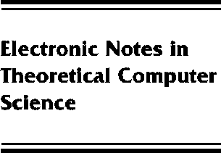[www.elsevier.com/locate/entcs](http://www.elsevier.com/locate/entcs)

The domain of differentiable functions

Abbas Edalat

**Abstract**

We construct a domain for differentiable real valued functions of a real variable. The classical C1 functions, equipped with its C1 norm, is embedded into the set of maximal elements of this domain, which is a countably based bounded complete continuous domain. The construction can be generalized to Ck functions and to real valued functions of several variables.

1571-0661 *⃝*c Elsevier Ltd Open access under [CC BY-NC-ND license.](http://creativecommons.org/licenses/by-nc-nd/3.0/)

10.1016/S1571-0661(05)80040-4