[Egyptian Informatics Journal 21 (2020) 139–144](https://doi.org/10.1016/j.eij.2019.12.003)

Contents lists available at [ScienceDirect](http://www.sciencedirect.com/science/journal/11108665)

Egyptian Informatics Journal

journal homepage: [www.sciencedirect.com](http://www.sciencedirect.com/)

[](http://crossmark.crossref.org/dialog/?doi=10.1016/j.eij.2019.12.003&domain=pdf)The impacts of social media on University students in Iraq

Abbas Fadhil Aljuboori a,⇑, Abdulnaser M. Fashakh b, Oguz Bayat b

a *University of Information Technology and Communications, Baghdad, Iraq*

b *Altinbas University, Department of IT, Institute of Science, Istanbul, Turkey*

# a r t i c l e i n f o

*Article history:*

Received 15 August 2019

Revised 24 November 2019

Accepted 22 December 2019

Available online 8 January 2020

*Keywords:*

Social media University students Education

Business Political

# a b s t r a c t

The rapid increase in the era of the technological revolution and the Internet, especially the social media, have created a new reality in the daily life of the societies in general and of the university students in particular, so this new reality without any doubt imposes on us the general effects of this increasing use of social media has affected all areas and societies The effects are positive and negative. These social means have become a vast space for exchanging ideas, making new friends, proposals, sources of infor- mation, business and e-shopping. In this study, we have decided to shed light on the academic, political and economic effects of the study by comparing them to the general effects of social media by looking at the demographic variables of Iraqi university students. Three universities (Kerbela University in the Middle Euphrates, UOITC University in the capital Baghdad and Tikrit University in western Iraq) where we considered spatial, cultural and social differences. Data collected through a survey consisting of four categories, General Influences, Academic Influences, Political Influences and Influences Business (dis- tributed over 40 questions) We tried to cover most of the students’ common uses of social media and their impact on them. The questionnaire was distributed through 100 questionnaires to each university. The total number of participants was (201) distributed on (77) participants from Karbala University, (50) participants from Tikrit University and (74) participants from the University of Information and Communication Technology (UOITC).

© 2020 Production and hosting by Elsevier B.V. on behalf of Faculty of Computers and Artificial Intelli-

gence, Cairo University. This is an open access article under the CC BY-NC-ND license ([http://creative-](http://creativecommons.org/licenses/by-nc-nd/4.0/)

[commons.org/licenses/by-nc-nd/4.0/](http://creativecommons.org/licenses/by-nc-nd/4.0/)).

1. Introduction

In the last few years, evolutions have been trying an increasing interest in using the internet and communication technologies tool (ICT). Wide groups of applications and technologies were generated to support communication to others anytime and everywhere. Pre- sently, the internet has become be a necessity for the world commu- nity. All people can reach all the information without any limitation, on time and place. Also, in the learning procedure, communication can be one of the determinant factors to gain success in the learning process. The use of ICT also can be given good impacts for learning process as well as to provide learning efficiency in order to help

* Corresponding author.

*E-mail addresses:* [abbas.aljuboori@uoitc.edu.iq](mailto:abbas.aljuboori@uoitc.edu.iq) (A.F. Aljuboori), [andulnaser.](mailto:andulnaser.fashakh@altinbas.edu.tr) [fashakh@altinbas.edu.tr](mailto:andulnaser.fashakh@altinbas.edu.tr) (A.M. Fashakh), [oguz.bayat@altinbas.edu.tr](mailto:oguz.bayat@altinbas.edu.tr) (O. Bayat).

Peer review under responsibility of Faculty of Computers and Information, Cairo University.

**Production and hosting by Elsevier**

students cooperate with other about the topic of the lessons because each one from them has different unique learning style [1]. Likewise, with respect to huge scale mobile social networking, users may have a place with various networks or groups, and covering clients may assume unique jobs in complex systems. From that point, the basic issue is the manner by which to survey or clarify client reliability. Under such a situation, trust induction assumes a significant job in the confided in the social linkage between (portable) users. To sur- mise the fluffy trust connection between clients in the enormous scale informal communication of covering networks, Chen et al. [2]. With the blast and thrive of social networks, common trust has gotten one of the essentials of all administrations in informal organizations. Since the foundation of the trust relationship is a con- fused and dynamic procedure that incorporates cooperation history, administration substance, reliable proposal, trust the board (TM), feeling and brain science, and so forth. TM framework should like- wise be a mind-boggling arrangement of including multi-factors. In this way, how to fabricate a finished trust assessment model gets one of the most significant works for social networks [3]. Moreover, an enormous number of social network sites, instruments, and administrations cause it workable for individuals to be associated

<https://doi.org/10.1016/j.eij.2019.12.003>

1110-8665/© 2020 Production and hosting by Elsevier B.V. on behalf of Faculty of Computers and Artificial Intelligence, Cairo University. This is an open access article under the CC BY-NC-ND license (<http://creativecommons.org/licenses/by-nc-nd/4.0/>).

with the (portable) Internet by means of an assortment of client ter- minals, whenever and anyplace. Accordingly, getting to data on- request to share and trade information assets become rather helpful, successful and far-reaching [4]. Notwithstanding orderly check messages on various social networks, perusing discourse or gather- ings, also, consistently check papers, presently people moreover, checking profiles of them on social sites by subordinate others’ changes, by posting their summery [5]. Research has shown that many folks hook up with SNS. From types of eLearning system that is increasing now is a social education. According Horton [6]. Mostly of people uses SNS for a range of more reasons ‘‘convenience, per- mitting fast updating, explore and share persistently big informa- tion, considering daily life, creating up and keeping up unaffected social contacts and connections, continuing easygoing learning rewords with collaboration and correspondence and empowering transport of guidelines are the principle ones‘‘. These thought pro- cesses illuminate why SNS are acknowledged rapidly regardless of the way that they at first had ascended with the inspiration driving sharing photos, person’s information accounts, profiles, and related substance [7]. The unmistakable greater part of informal organiza- tion destinations is being utilized by the present youthful age partic- ularly from a substantial segment of college understudies. Therefore, SNS is expected to assume a dynamic job in youthful ages step by step [8]. The association between the juvenile and their interest in SNS has entranced numerous sorts of research that focused on adolescent’s activities in association with secretly con- cern relating in their utilization of interpersonal organization [9]. Since individuals meeting about and sharing needs energetically in interpersonal organizations, especially tendency to frame new gatherings and social occasions or looking into them derive. In those circumstances, individuals move as of beings un-involved cus- tomers to totally working people by conferring their assets and viewpoints to others whom they accomplish reasonably finally [10]. Thusly, this pleasant activity urges people to shape their iden- tity despite their individual characters. It has turned out to be important to discover why everyone is pulled in towards interper- sonal organization so effectively. What an individual search for when an individual uses an interpersonal organization? Research has been done by various individuals in regard to individuals’ use of informal organization [11]. An outstanding essayist to be specific Ellison cites that informal community is being used by various indi- viduals for killing timing, investigating persons and their ways of life have decent social networking and as an observation. Leading group of classes or colleges. Other than that, in conditions of work office, interpersonal organization assumes an imperative job. Becoming acquainted with about new extraordinary individuals, discovering their interests, or issues of governmental issues [12]. Web-based life catches the eye of the understudies and afterwards redirects it towards non-instructive and improper activities including futile vis- iting and outrageous web surfing. In light of the above proclamation, we can say that web-based life may seriously influence the exami- nation propensities, scholastic life and learning encounters of the understudy (Kappuswamy and Shankar, 2010) [13]. Web-based life is an approach to impart online that can be utilized to associate, share data and team up with others. Web-based life can be like sites and applications [14]. The harmed instructive execution and web habit are connected through the usage of asynchronous correspon- dence program through the web locale and the fora. Jocabsen et al. [15]. illuminated that informal organization is tending towards the business-related point of view, developing new associations, or leading to shared interests, for example, authoritative issues or music. Lockyer et al. [16] additionally exhibited that customers can bestow their very own information to the help profile page of them, interface with distinction usages, split sight and tag and

sound substance that they have created a relationship with others to an arrangement of accessible substance, begin or join subgroups of successive concern gatherings. Concede [17]. Social networks are an approach to impart online that can be utilized to connecting, share data and group up to other. Internet-based life can be like sites and applications [18].

1. Related works

In that review investigated the achievability of utilizing Face- book to enlist guardians of center school understudies to a self- guided family program to counteract immature medication use [19]. This exploration plans to look at how investing energy in Facebook influence understudies’ scholarly execution [20]. In this paper learned about usage of internet systems administration and its effect on study. A poll overview was prosecuted to inspire ate information [21]. In this investigation, web content mining methods are utilized to decide famous internet shopping firms’ Facebook designs. For this reason, 200 prevalent Turkish organiza- tions’ web URLs are utilized. Web content mining through normal language preparing methods is analyzed. Likeness examination and bunching are finished. Subsequently, the bunches of the Face- book sites and their connections and similitudes of the organiza- tions are gotten [22]. In this paper we concentrated on Facebook statuses, which we can see as suppositions of clients or their response on the worry we need to break down. We create device status puller that naturally gathers arbitrary Facebook statuses. At that point we make classifier that performs arrangements on that corpus gathered from Facebook [23]. The target of this paper is to think about on the most popular long-range interpersonal communication website Facebook and other online web-based social networking systems (OSMNs) considering the idea of rela- tionship or fellowship. This paper talked about the philosophy which can be utilized to direct the investigation of the informal community Facebook (FB) and furthermore characterize the struc- ture of the Web Mining stage. Finally, different mechanical difficul- ties were investigated which were lying under the assignment of removing data from FB and examine in detail the about creeping operator usefulness [24]. The present investigation is led on the informal organization of Facebook, where content promoting, another type of advertising, is used and as opposed to presenting the merchandise, the substance of various products is introduced [25]. This examination goes for dissecting printed information from Facebook and endeavors to discover fascinating learning from such information and speak to it in various structures [26]. This examination is done as such as to highlight the potential outcomes of online life in the educational setting by aggregate learning and improve the understudies ’academic execution. The results exhibit that aggregate adjusting decidedly and out and out with instinctive with partners, astute with instructors and duty which influence the understudies’ academic execution [27].

In our work in this paper, and in line with the growing num- bers and high demand for the use of social media and the mul- tiple uses of these means where social media platforms today become shorten the time and ease of information exchange and promotional platforms we have seen the selection of four categories of analysis and evaluation (general category, academic category, political category, and business category) And in vari- ous social media we wanted to cover the most common uses of students in social media through a questionnaire containing multiple questions to which the research belongs to the univer- sity students and from different regions and universities in three cities and four categories age, both gender and more than aca- demic level.

1. Methodology

The quantitative research design was selected as a major method of study. In a quantitative method, the researcher collects, analyzes and interprets Quantitative search is used to analyze data. The survey technique was developed through a structured questionnaire to collected data. In the viewpoint of Kumekpor

[28] ‘‘social study might be said to be a target, quantitative way to deal with the investigation of the social procedures inside a well-characterized zone at a given time through at least one foun- dations by methods for a meeting plan, a poll, and the information in this way gotten related factually”. Different data obtained from college students through the four effects sections (In General, political, academic and business) on them. The questionnaire will be a survey paper in the three Iraqi universities (University Kerbela, Tikrit university and UOITC university Baghdad) from students where the data collected and analyzed, and we faced challenges like in data collection stage because it was manually processed and from three different universities in different cities and some answer were not completed. Also, Demographic vari- ables included age, gender, education level, After the completion of the collection of the survey papers were filled it in the pages of Excel tables and were encoded and converted into numerical values and were called through the program Jupyter Notebook and were analyzed by the language of Python using many of libraries Python language such as Numpy, Pandas, Matplotlib, SciPy, Seaborn and Scikit-learn. where the language of Python is language modern to get our results. The study included (201) students from three universities in Iraq (Kerbala University, Tikrit University and University of Information Technology and Commu- nication). The aim of the study was to measure the impacts of social communication on these students through general, aca- demic, political and commercial influences. We can see summary Statistics descriptive analysis used percentage to measure answers of respondents in (Table 1) below:

1. Results and disscusion
   1. *General results analysis*

Here in this category, we include the general questions that we will review in the (Table 2) below:

We also review the results. Here, in the answer to the first ques- tion, we find that a clear majority believes that there are positive impacts on the utilize of social media. In the second question, many see themselves as vulnerable to privacy violations and black- mail while using social media. In the third question, we see a high percentage of those who sometimes see the possibility of social media negatively affecting their health and, to a lesser extent, In the fourth question, the answer was clear to a majority of those

them to addiction. However, the answer to the fifth question gave us a significant majority who see the importance of social media as an important factor in awareness Society and in the sixth question, there is also an absolute majority do not use fake pages on social media. In the seventh question shows us the most widely used website by Facebook is very distinctive. In the eighth question, there are varying percentages of them who believe that the per- sonal data is reserved, confidential and reliable on their accounts in the social media. The ninth question is that we have the impres- sion that the majority of them easily use these means with the sim- ple access to information. In question 10, Its negative media impact is negative on the real social community between family, relatives and friends. In this question, we conclude with the eleventh ques- tion that the nature of the use of these means of social communi- cation is to browse in a majority and preference. We will see all these answers in detail illustrated in (Table 3 and Fig. 1) below:

* 1. *Academic results analysis*

Here in this category, we include the Academic questions that we will review in the (Table 4) below:

Here we try to review the results of the impacts of social media in the use of the academic aspect, where we indicate here in answer to the first question that the majority used the means of social media for academic purposes sometimes, and also shows us in the second question as well as the vast majority of those who follow the accounts of their universities on social media and in question Third, most see social media as an important source in their academic studies. In the fourth question, there are also varying ratios between those who see social media as an alterna- tive source of scientific sources and what they see only sometimes. In question 5 there is also a majority that sometimes sees social media as a reliable source of academic information. In the sixth question, the majority shows that social communication is a means of reducing time, effort and money in obtaining academic informa- tion. In the seventh question, there is also unequal use of the means of social communication between teaching, teaching and learning together. In the eighth question, Facebook maintains the top of the most generally utilized web-based social networking, with reference to the great use of YouTube. We will see all these answers in detail illustrated in (Table 5 and Fig. 2) below:

* 1. *Political results analysis*

Here in this category, we include the Political questions that we will review in the (Table 6) below:

Table 2

General Questions.

with a common belief that their use of the social media exposed

No Description of questions

Q1 What do you think about Social Media effects?

Table 1

Respondents of students.

Total sample size, n = 201

Age 18–22 = 78.60%(n = 158)

23–25 = 10.94%(n = 22)

26–30 = 5.97%(n = 12)

31+ = 4.47%(n = 9)

Gender Female = 53.23%(n = 107)

Male = 46.76%(n = 94)

EDUCATION Undergraduate = 87.07%(n = 175)

Postgraduate = 12.93%(n = 26) University Kerbela UNV = 38.30%(n = 77)

UOITC UNV = 36.81%(n = 74) Tikrit UNV = 24.87%(n = 50)

Q2 Do you think that social media violates your privacy and makes you vulnerable to extortion?

Q3 Do you think social media effect to your health negatively? Q4 Do you think social media leads to addiction?

Q5 Do you think social media is an important factor in educating the community?

Q6 How many fake pages do you have on social media? Q7 What is your most used for social media?

Q8 Do you think your personal data is confidential, secret and reliable on social media?

Q9 Do you think the use of social media is easy and simple to access information?

Q10 Do you think the use of virtual social media negatively affects real social communication such as family, friends and relatives?

Q11 What is the nature of your use of social media?

Table 3

Total General Answers.

Q1 Positive 45.771144%

|  |  |  |
| --- | --- | --- |
|  | Negative | 27.860697% |
| No Effect | 24.378109% |
| Q2 | Sometimes | 47.263682% |
|  | No | 36.318408% |
|  | Yes | 14.925373% |
| Q3 | Sometimes | 41.293532% |
|  | No | 40.796020% |
|  | Yes | 16.915423% |
| Q4 | Yes | 55.721393% |
|  | Sometimes | 31.840796% |
|  | No | 11.442786% |
| Q5 | Yes | 61.691542% |
|  | Sometimes | 31.840796% |
|  | No | 6.467662% |
| Q6 | None | 87.064677% |
|  | One | 6.965174% |
|  | Two | 2.487562% |

Table 4

Academic Questions.

No Description of questions

Q1 I use social media for Academic?

Q2 Do you follow your university website on social media?

Q3 Do you think social media is an important source in your academic field?

Q4 Do you think social media are a substitute for scientifically recognized sources?

Q5 Do you think social media are a reliable source of access to academic information?

Q6 Do you think social media reducing the time, effort and money to access academic information?

Q7 Are you using social media for learning or education? Q8 What is your most used social media for academic?

Table 5

Total Academic Answers.

|  |  |  |  |  |  |
| --- | --- | --- | --- | --- | --- |
|  | More | 1.990050% |  | | |
| Three | 1.492537% | Q1 | Sometimes | 58.208955% |
| Q7 | Facebook | 55.721393% |  | Always | 22.885572% |
|  | YouTube | 32.338308% |  | Never | 17.412935% |
|  | Twitter | 5.472637% | Q2 | Yes | 74.626866% |
|  | Blog | 1.492537% |  | Sometimes | 11.940299% |
|  | LinkedIn | 0.497512% |  | No | 10.945274% |
| Q8 | Yes | 37.810945% | Q3 | Sometimes | 63.681592% |
|  | Sometimes | 30.348259% |  | Yes | 25.870647% |
|  | No | 29.850746% |  | No | 9.452736% |
| Q9 | Yes | 67.661692% | Q4 | Sometimes | 39.800995% |
|  | Sometimes | 21.890547% |  | Yes | 39.303483% |
|  | No | 7.462687% |  | No | 18.407960% |
| Q10 | Yes | 56.716418% | Q5 | Sometimes | 55.721393% |
|  | Sometimes | 30.348259% |  | Yes | 24.378109% |
|  | No | 11.442786% |  | No | 16.417910% |
| Q11 | Browse | 37.810945% | Q6 | Yes | 50.746269% |
|  | Both of them | 30.348259% |  | Sometimes | 33.333333% |
|  | Chat | 22.388060% |  | No | 12.935323% |
|  | Call | 3.482587% | Q7 | Both | 49.253731% |
|  |  |  |  | Learning | 43.283582% |
|  |  |  |  | Education | 5.472637% |
|  |  |  | Q8 | Facebook | 45.771144% |
|  |  |  |  | YouTube | 39.800995% |
|  |  |  |  | Twitter | 5.970149% |
|  |  |  |  | Blog | 1.990050% |

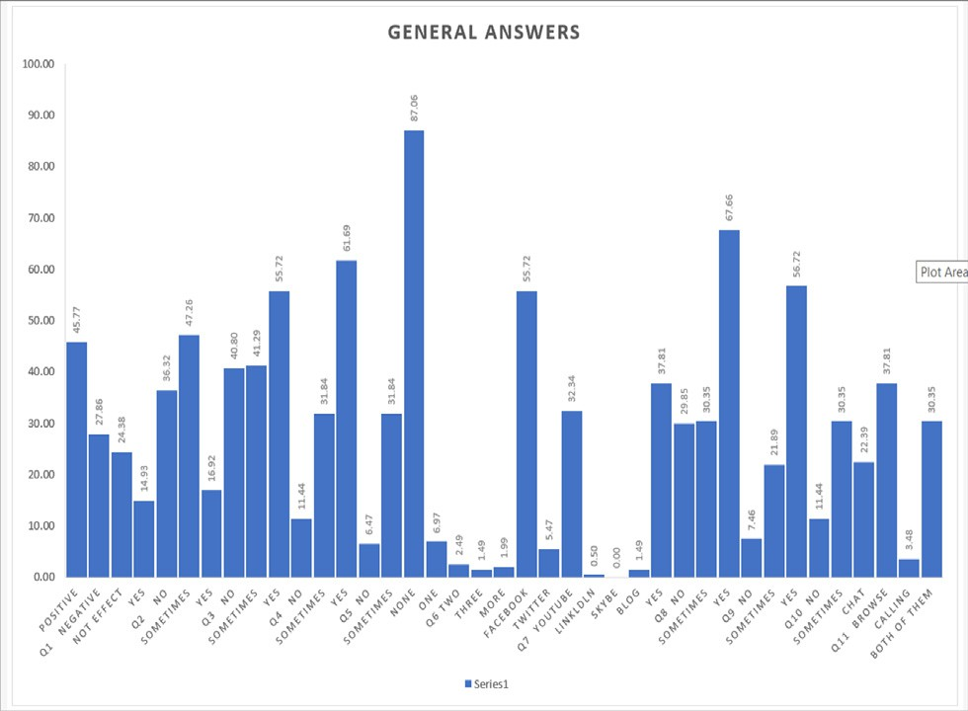Fig. 1. (General Answers).

As for the political aspect, in the first question, we show that the majority does not use social media. In the second question, there is no participation in the political groups or even follow the political forums. In the third question, we find that there is no time spent through social media compared to Daily use. In the fourth question, however, there is a widespread belief that social media is influen- tial in changing the political process. In the fifth question, there is a simple majority that social media see as a dangerous factor in some cases. In question sixth, Facebook keeps progress on the rest of social media Use of political matters as well. We will see all these answers in detail illustrated in (Table 7 and Fig. 3) below:

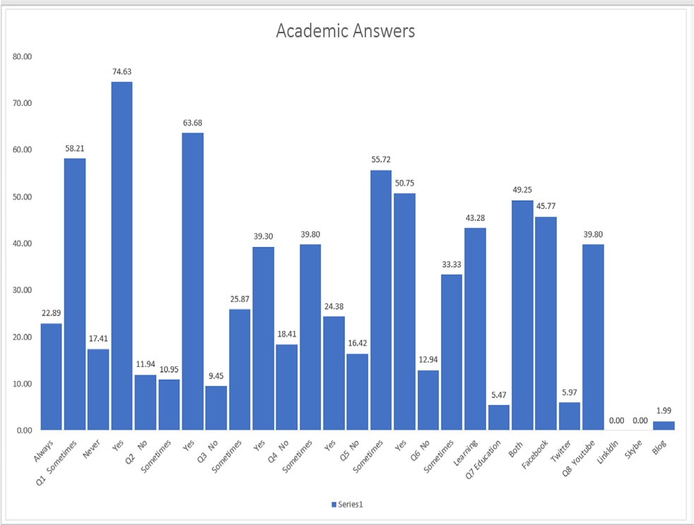Fig. 2. (Academic Answers).

* 1. *Business results analysis*

Here in this category, we include the Business questions that we will review in the (Table 8) below:

Table 6

Political Questions.

No Description of questions

Q1 I use social media for politics?

Q2 How many politics groups did you involve?

Q3 How many hours you spend to Follow-up of political events?

Q4 Do you think social media affect and change the political events? Q5 Do you think social media is a dangerous factor?

Q6 What is your most used social media for political?

Table 7

Total Political Answers.

|  |  |  |
| --- | --- | --- |
| Q1 | Never | 64.676617% |
|  | Sometimes | 27.860697% |
|  | Always | 5.970149% |
| Q2 | Never | 51.741294% |
|  | Less than 5 | 28.358209% |
|  | More than 5 | 18.905473% |
| Q3 | Never | 48.258706% |
|  | Less than 5 | 40.298507% |
|  | More than 5 | 10.447761% |
| Q4 | Yes | 48.756219% |
|  | Sometimes | 39.303483% |
|  | No | 10.447761% |
| Q5 | Sometimes | 44.278607% |
|  | Yes | 32.835821% |
|  | No | 20.895522% |
| Q6 | Facebook | 68.159204% |
|  | YouTube | 15.422886% |
|  | Twitter | 7.462687% |
|  | Blog | 2.487562% |
|  | LinkedIn | 0.497512% |

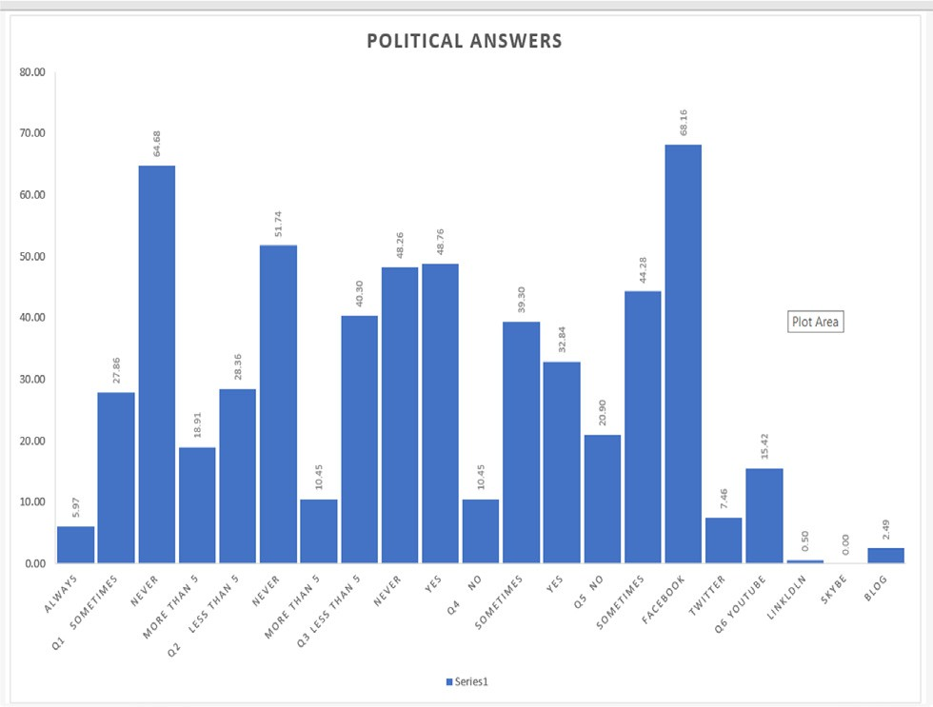

Fig. 3. (Political Answers).

We conclude by reviewing aspects of Business impacts using social media. Therefore, we note in the first question here that the use of social media for this purpose varies between use some- times and non-use. In the second question, there is no interest and follow-up to the Business groups. In the third question, we find that there is not much time spent on Business use through social media. In the fourth question, the majority see their use being for sale and purchase together. In the fifth question, About normal shopping methods and compensation through e-shopping on social media. In the sixth question, we find that there is also great dissatisfaction with the clear majority of commercial Ad. In the seventh question, it is sometimes thought that the promotion of products through these means is effective, or in the eighth question, we also have confidence in the process of shopping and

Table 8

Business Questions.

No Description of questions

Q1 I use social media for Business?

Q2 How many Business groups did you involve?

Q3 How many hours you spend to Follow-up of Business events? Q4 Do you use social media for Business?

Q5 Do you think you can do away with shopping and just shopping through social media?

Q6 Are you uncomfortable with Commercial ads while using social media?

Q7 Do you think the promotion of your product as a social media provider is effective?

Q8 Do you have confidence in shopping through social media? Q9 What is your most used social media for Business?

Table 9

Total Business Answers.

|  |  |  |
| --- | --- | --- |
|  | Answers | score |
| Q1 | Sometimes | 50.248756% |
|  | Always | 41.293532% |
|  | Never | 6.965174% |
| Q2 | Never | 49.751244% |
|  | Less than 5 | 35.820896% |
|  | More than 5 | 13.432836% |
| Q3 | Never | 48.756219% |
|  | Less than 5 | 44.776119% |
|  | More than 5 | 5.472637% |
| Q4 | Both | 49.751244% |
|  | Sell | 35.820896% |
|  | Buy | 13.432836% |
| Q5 | Sometimes | 41.293532% |
|  | No | 40.796020% |
|  | Yes | 15.920398% |
| Q6 | Yes | 59.203980% |
|  | Sometimes | 28.358209% |
|  | No | 10.945274% |
| Q7 | Some effective | 57.213930% |
|  | Very effective | 22.885572% |
|  | No Effect | 17.412935% |
| Q8 | Some confidence | 65.671642% |
|  | No confidence | 16.417910% |
|  | Full confidence | 15.920398% |
| Q9 | Facebook | 70.149254% |
|  | YouTube | 12.935323% |
|  | Twitter | 5.970149% |
|  | Blog | 1.492537% |
|  | LinkedIn | 0.995025% |
|  | Skype | 0.497512% |

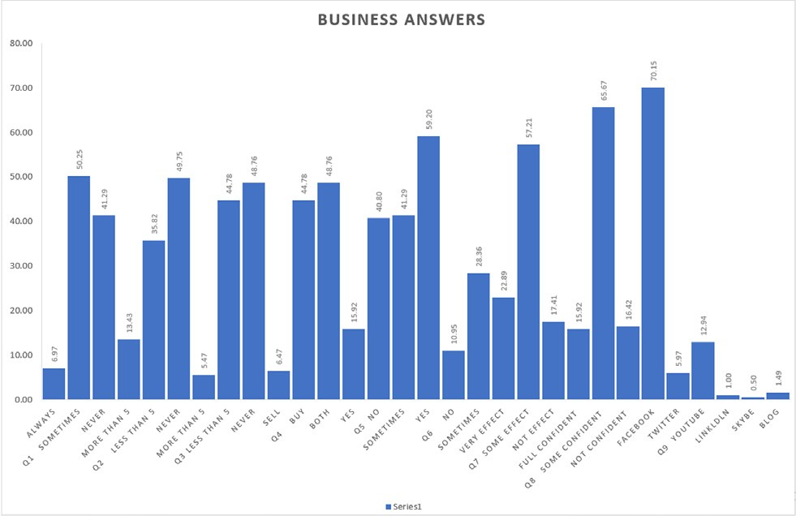

Fig. 4. (Business Answers).

electronic payment through Social media. In the ninth and last question, Facebook also maintains its status as the most widely used site among social networking sites.

We will see all these answers in detail illustrated in (Table 9 and Fig. 4) below:

1. Conclusions

In our study, we found that there is a generally positive impres- sion among students about social media. There is also a great inter- est and increasing use of these social media for academic use. Many of them do not want to use it for business purposes and do not see the possibility of adopting e-shopping as an alternative to regular shopping. In the political aspects, with their conviction of the extent of the influence of social media in the possibility of changing political events and maybe a dangerous factor in this area, but they also have no desire to participate and follow up the use of social media, For this reason, we should focus on the aca- demic aspect and the range to which students respond to the uti- lization of social media in their scope and academic studies. This is very encouraging by focusing on making these platforms a reliable educational platform, for example, Academic and activate this aspect and focus on it through the recommendations of stakehold- ers in the academic field we must not overlook negative aspects such as impact it is necessary to note the negative effects on health, especially addiction and the use of social media. It is noteworthy that Facebook is the most common and the most popular and most common among all these means social communication, which was presented in the questionnaire with a clear and noticeable advancement of YouTube in the academic field only, which enhances the possibility of using it for academic purposes reliably by academic institutions. In future, we can expand this study through by taking other societies and countries and achieve a com- parative study among them. We also can do a survey for other stakeholders sides like faculty staff members and employers to improve the performance of our future studies.

References

1. [Buhalis DLR. Progress in information technology and tourism management: 20](http://refhub.elsevier.com/S1110-8665(19)30207-5/h0005) [years on and 10 years after the Internet—The state of eTourism research.](http://refhub.elsevier.com/S1110-8665(19)30207-5/h0005) [Tourism Manage. 2008;29(4):609–23](http://refhub.elsevier.com/S1110-8665(19)30207-5/h0005).
2. [Zhang Z, Gupta BB. Social media security and trustworthiness: overview and](http://refhub.elsevier.com/S1110-8665(19)30207-5/h0010) [new direction. Future Gener Comput Syst 2018;86:914–25](http://refhub.elsevier.com/S1110-8665(19)30207-5/h0010).
3. [Wang G, Park J, Sandhu R, Wang J, Gui X. Dynamic trust evaluation model](http://refhub.elsevier.com/S1110-8665(19)30207-5/h0015) [based on bidding and multi-attributes for social networks. Int J High Perform](http://refhub.elsevier.com/S1110-8665(19)30207-5/h0015) [Comput Networking 2019;13(4):436–54](http://refhub.elsevier.com/S1110-8665(19)30207-5/h0015).
4. [Zhang Z, Sun R, Zhao C, Wang J, Chang CK, Gupta BB. CyVOD: a novel trinity](http://refhub.elsevier.com/S1110-8665(19)30207-5/h0020) [multimedia social network scheme. Multimedia Tools Appl 2017;76](http://refhub.elsevier.com/S1110-8665(19)30207-5/h0020) [(18):18513–29](http://refhub.elsevier.com/S1110-8665(19)30207-5/h0020).
5. [Van Dijck J. The culture of connectivity: A critical history of social](http://refhub.elsevier.com/S1110-8665(19)30207-5/h0025) [media. Oxford University Press; 2013](http://refhub.elsevier.com/S1110-8665(19)30207-5/h0025).
6. [Greenhowa C, Gibbinsb T, Menzerc MM. Re-thinking scientific literacy out-of-](http://refhub.elsevier.com/S1110-8665(19)30207-5/h0030) [school: arguing science issues in a niche Facebook application. Comput Hum](http://refhub.elsevier.com/S1110-8665(19)30207-5/h0030) [Behav 2015;53:593–604](http://refhub.elsevier.com/S1110-8665(19)30207-5/h0030).
7. [Ahmed MS, Dar M, Masood F. Impact of social media on academic: a](http://refhub.elsevier.com/S1110-8665(19)30207-5/h0035) [quantitative study. *IEEE* 2018:1–5](http://refhub.elsevier.com/S1110-8665(19)30207-5/h0035).
8. Diana G. Oblinger James L. Oblinger, ‘‘Educating the net generation,” Boulder, Colo.: EDUCAUSE, c2005. 1 v.(various pagings): illustrations., 2005.
9. [Isbister J. Exploring adolescents use of social networking sites and their](http://refhub.elsevier.com/S1110-8665(19)30207-5/h0045) [perceptions of this can influence their peer relationships. Institute of](http://refhub.elsevier.com/S1110-8665(19)30207-5/h0045) [Education: University of London; 2013](http://refhub.elsevier.com/S1110-8665(19)30207-5/h0045).
10. [Collins R. Interaction ritual chains, 62. Princeton University Press; 2014](http://refhub.elsevier.com/S1110-8665(19)30207-5/h0050).
11. [Lasch C. The culture of narcissism: american life in an age of diminishing](http://refhub.elsevier.com/S1110-8665(19)30207-5/h0055) [expectations. WW Norton & Company 2018](http://refhub.elsevier.com/S1110-8665(19)30207-5/h0055).
12. [Wilcock AA. An occupational perspective of health. Slack Incorporated 2006](http://refhub.elsevier.com/S1110-8665(19)30207-5/h0060).
13. [Kuppuswamy S, Narayan P. The Impact of Social Networking Websites on the](http://refhub.elsevier.com/S1110-8665(19)30207-5/h0065) [Education of Youth. Int J Virtual Communities Soc Networking (IJVCSN) 2010;2](http://refhub.elsevier.com/S1110-8665(19)30207-5/h0065) [(1):67–79](http://refhub.elsevier.com/S1110-8665(19)30207-5/h0065).
14. [Kaplan AMHM. Users of the world, unite! The challenges and opportunities of](http://refhub.elsevier.com/S1110-8665(19)30207-5/h0070) [Social Media. Bus Horiz 2010;53(1):59–68](http://refhub.elsevier.com/S1110-8665(19)30207-5/h0070).
15. [Jacobsen WC, Forste R. The wired generation: study and social outcomes of](http://refhub.elsevier.com/S1110-8665(19)30207-5/h0075) [electronic media utilization among university students. Cyber Psychol Behav](http://refhub.elsevier.com/S1110-8665(19)30207-5/h0075) [Soc Networking 2011;18(5). pp.6, 275-285](http://refhub.elsevier.com/S1110-8665(19)30207-5/h0075).
16. [Lockyer L, Patterson J. Integrating social networking technologies in education:](http://refhub.elsevier.com/S1110-8665(19)30207-5/h0080) [a case study of a formal learning environment. Adv Learning Technologies,](http://refhub.elsevier.com/S1110-8665(19)30207-5/h0080) [ICALT IEEE Int Conf 2008](http://refhub.elsevier.com/S1110-8665(19)30207-5/h0080).
17. N. Grant, ‘‘On the Usage of Social Networking Software Technologies in Distance Learning Education,” Proceedings of Society for Information Technology and Teacher Education International Conference, 2008.
18. N. E. Council, ‘‘What is Social Media,” 2017.
19. Marina Epstein, Kevin P. Haggerty, Megan A. Moreno. May 2018, Volume 19,

Issue 4, pp 559–569 | Cite as

1. Mathur, Garima, Nathani, Navita, Sharma, Ashwini, Modi, Divya Arora, Garima, 10/08/2017,10.1109/ICRIIS.2017.8002518,IEEE
2. Ahmed, Muhammed, et al ‘‘Impact of social media on academic: A quantitative study.”2018 International Conference on Computing, Mathematics and Engineering Technologies (iCoMET). IEEE, 2018.
3. [Kahya-Özyirmudokuz Esra. Analyzing unstructured Facebook social network](http://refhub.elsevier.com/S1110-8665(19)30207-5/h0110) [data through we text mining: a study of online shopping firms in Turkey.](http://refhub.elsevier.com/S1110-8665(19)30207-5/h0110) [Information Development 2016;32(1):70–80](http://refhub.elsevier.com/S1110-8665(19)30207-5/h0110).
4. Shrivastava, Mr Akash, and Bhasker Pant. ‘‘Opinion extraction and classification of real time Facebook status. ”Global Journal of Computer Science and Technology (2012).
5. Madan, Marnta, and Meenu Chopra. ‘‘Using mining predict relationships on the social media network: Facebook (FB).”IJARI) International Journal of Advance Research in Artificial Intelligence 4 92015.
6. [Forouzandeh Saman, Soltanpanah Heirsh, Sheikhahmadi Amir. Content](http://refhub.elsevier.com/S1110-8665(19)30207-5/h0125) [marketing through data mining of Facebook social network. Webology](http://refhub.elsevier.com/S1110-8665(19)30207-5/h0125) [2014;11(1):1](http://refhub.elsevier.com/S1110-8665(19)30207-5/h0125).
7. [Salloum Said A, Al-Emran Mostafa, Shaalan Khaled. Mining social media text:](http://refhub.elsevier.com/S1110-8665(19)30207-5/h0130) [extracting knowledge from facebook. Int J Comput Digital Syst 2017;6](http://refhub.elsevier.com/S1110-8665(19)30207-5/h0130) [(02):73–81](http://refhub.elsevier.com/S1110-8665(19)30207-5/h0130).
8. [Al-Rahmi W, Othman M. The impact of social media use on academic](http://refhub.elsevier.com/S1110-8665(19)30207-5/h0135) [performance among university students: a pilot study. J Inf Syst Res](http://refhub.elsevier.com/S1110-8665(19)30207-5/h0135) [Innovation 2013;4(12):1–10](http://refhub.elsevier.com/S1110-8665(19)30207-5/h0135).
9. [Kumekpor TKB. Research methods and techniques of social. Res. Accra: Sonlife](http://refhub.elsevier.com/S1110-8665(19)30207-5/h0140) [2002:117–8](http://refhub.elsevier.com/S1110-8665(19)30207-5/h0140).