

Electronic Notes in Theoretical Computer Science

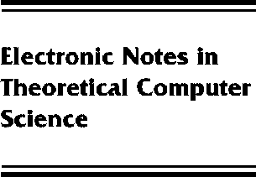[www.elsevier.com/locate/entcs](http://www.elsevier.com/locate/entcs)

The other topology

Ralph Kopperman

**Abstract**

Understanding and in some cases, solution of problems involving topology in computer science, involve two interrelated topologies. A classical such case is that of the Scott and lower topologies on a continuous poset. A more recent example is the solution of the maximal point space problem (the maximal point spaces of Scott domains are the complete separable metrizable spaces). The role of these topologies will be discussed with reference to the two situations above and others.

1571-0661 *⃝*c Elsevier Ltd Open access under [CC BY-NC-ND license.](http://creativecommons.org/licenses/by-nc-nd/3.0/)

10.1016/S1571-0661(05)80049-0