[Egyptian Journal of Basic and Applied Sciences 5 (2018) 63–68](https://doi.org/10.1016/j.ejbas.2018.01.001)

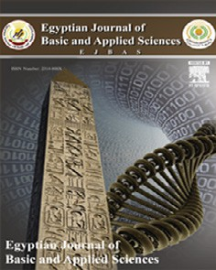

Contents lists available at [ScienceDirect](http://www.sciencedirect.com/science/journal/2314808X)

Egyptian Journal of Basic and Applied Sciences

journal homepage: [www.elsevier.com/locate/ejbas](http://www.elsevier.com/locate/ejbas)

Full Length Article

[](http://crossmark.crossref.org/dialog/?doi=10.1016/j.ejbas.2018.01.001&domain=pdf)Thioredoxin-1 and MMP-9 as biomarkers in breast cancer metastasis in Egyptian female patients

Al Shaima G. Abd El Salam a,⇑, Mohamed A. Ebrahim b, Laila A. Eissa a, Mamdouh M. El-Shishtawy a,⇑

a *Department of Biochemistry, Faculty of Pharmacy, Mansoura University, Mansoura 35516, Egypt*

b *Oncology Center, Faculty of Medicine, Mansoura University, Mansoura 3516, Egypt*

# a r t i c l e i n f o

a b s t r a c t

© 2018 Mansoura University. Production and hosting by Elsevier B.V. This is an open access article under the CC BY-NC-ND license (<http://creativecommons.org/licenses/by-nc-nd/4.0/>).

*Article history:*

Received 23 September 2017

Received in revised form 27 December 2017 Accepted 1 January 2018

Available online 12 January 2018

1. Introduction

Breast cancer is the most prevalent diagnosed malignancy among women worldwide [1]. It is also the major cause of malig- nancy-related death among women [2]. In Egypt, breast cancer is the most common type of cancers among females as it accounts for approximately 32% of reported malignancies [3]. In addition, tumor metastasis is a major clinical challenge. Nearly one-third of breast cancer women worldwide die from metastasis, especially brain metastasis [4,5].

Oxidative stress is a characteristic hallmark of initiation and pro- gression of many cancers, including breast cancer [6]. To maintain cancer cell function, many antioxidants are up-regulated to balance reactive oxygen species (ROS) levels [7]. One of the most important antioxidants is thioredoxin-1 (Trx-1), which is highly expressed in many tumors. A recent study showed increased level of serum Trx-1 in breast cancer patients in comparison with other cancers and normal persons [8]. Cellular redox homeostasis mediated by Trx-1 is required for activation of ribonucleotide reductase [9] and peroxiredoxins [10], induction of vascular endothelial growth factor (VEGF) and matrix metalloproteinase-9 (MMP-9) [11,12].

In addition, ROS initiate lipid peroxidation of polyunsaturated fatty acids in cell membrane producing malondialdehyde (MDA). MDA used as biomarker of oxidative stress and play an important role in breast cancer initiation, progression and metastasis [13].

MMP-9, also known as gelatinase B, is a 92-kDa endopeptidase that is strongly associated with aggressiveness and metastatic spread in breast cancer [14]. During tumor angiogenesis, MMP-9 degrades type IV collagen, the main component of vascular base- ment membrane surrounding tumor cells which is an essential

* Corresponding authors.

*E-mail addresses:* [alshaimagamal@mans.edu.eg](mailto:alshaimagamal@mans.edu.eg) (A.S.G.A. El Salam), [mshisht@](mailto:mshisht@mans.edu.eg) [mans.edu.eg](mailto:mshisht@mans.edu.eg) (M.M. El-Shishtawy).

process in initiation of metastasis. Furthermore, stroma-derived MMP-9 can facilitate the liberation of extracellular matrix (ECM)- sequestered VEGF that leads to metastasis [15].

The overexpression of Trx-1 that stimulates MMP-9 expression and down regulates its inhibitor, tissue inhibitor of metallopro- teinase-1 (TIMP-1), increasing MMP-9 activity [12]. Therefore, we conducted this study to investigate the possible role of serum Trx-1, MMP-9 and MDA in the detection of metastasis in female breast cancer patients and their correlation with clinicopathologic parameters.

1. Subjects and methods
   1. *Subjects*

The current study was performed on 90 female subjects:

* + - Non-metastatic breast cancer (NMBC) patients included 37 newly diagnosed aged 31–67 years, with a mean ± SD of

51.70 ± 11.04 years.

* + - Metastatic breast cancer (MBC) patients included 38 patients aged 31–78 years, with a mean ± SD of 51.78 ± 11.24 years.
    - Healthy control group included 15 apparently healthy women aged 26–59 years, with a mean ± SD of 44.66 ± 10.36 years.

Patients were diagnosed between March and November 2015 in the Oncology Center, Mansoura University; Mansoura, Egypt.

Patients were classified according to the American Joint Committee on Cancer (AJCC) TNM system [16] to stage 0 (3 patients), stage I (9 patients), stage II (12 patients), stage III (13 patients) and stage IV (38 patients). The patients and controls do not have renal, liver disorders or any other type of malignancies. Recorded clinical and pathological features for each patient were obtained from Oncology Center including age, grade, stage, serum

<https://doi.org/10.1016/j.ejbas.2018.01.001>

2314-808X/© 2018 Mansoura University. Production and hosting by Elsevier B.V.

This is an open access article under the CC BY-NC-ND license (<http://creativecommons.org/licenses/by-nc-nd/4.0/>).

carcinoembryonic antigen (CEA) and serum cancer antigen 15-3 (CA 15-3).

The study was approved by the local institutional ethical com- mittee of Faculty of Pharmacy, Mansoura University, Mansoura, Egypt; and patients’ consents were obtained according to the reg- ulations of the Egyptian Ministry of Health. Metastasis was diag- nosed by clinical examination including symptomatology; together with radiology including a plan X-ray, ultrasonography, computed tomography and bone scan.

* 1. *Collection of blood samples*

Patients and control subjects were fasted overnight. Blood sam- ples were collected and left for 30 min at room temperature to clot, centrifuged at 3000 rpm for 10 min. The serum was separated and stored at —80 °C.

* 1. *Biochemical parameters determination*

Serum Trx-1 level and MMP-9 level were measured by commer- cially available enzyme-linked immunosorbent assay (ELISA) kits using human thioredoxin ELISA kit, (Boster bio, Pleasanton, CA, USA) and human MMP-9 platinum ELISA kit, (eBioscience, San Diego, CA, USA). Serum malondialdehyde (MDA) was determined using thiobarbituric acid (TBA) method [17] by using a commer- cially available colorimetric kit (Biodiagnostic, Giza, Egypt).

* 1. *Statistical analysis*

The SPSS version 21 was used for data analysis. One-sample Kolmogorov-Smirnov test was used to test the normality of data. Qualitative data were defined using number and percent. The rela- tion between categorical variables was prepared using Chi-square test. Continuous variables were described as Median for non-para- metric data. For comparison of median of more than two groups (non-parametric data) Kruskal Wallis test was used. Correlation between continuous non parametric data was done using Spear- man correlation. Receiver Operating Characteristic (ROC) curve was done to define sensitivity and specificity at different cutoff points. Statistical significance was considered at P < .05.

1. Results
   1. *Patient’s characteristics*

Clinical characteristics of breast cancer patients were shown in Table 1. T1 tumor size was reported in 13 NMBC patients (35.1%). T2 was reported in 11 NMBC patients (29.7%) and 1 MBC patient (2.6%). T3 was reported in 13 NMBC patients (35.1%) and 19 MBC patients (50%) and T4 was reported in 18 MBC patients (47.4%). Lymph node positive was reported in 26 NMBC patients (70.2%) and 38 MBC patients (100%). Grade 1 was reported in 10 NMBC patients (27%). Grade 2 was reported in 21 NMBC patients (56.8%) and 20 MBC patients (52.6%) and grade 3 was reported in

6 NMBC patients (16.2%) and 18 MBC patients (47.4%).

* 1. *Measured biochemical parameters*

The serum levels of studied parameters were summarized in Table 2. In MBC patients, the serum level of Trx-1 was signifi- cantly increased compared with NMBC patients and healthy con- trols (*p <* .001), (*p <* .001), respectively (Fig. 1). The level of serum MMP-9 of MBC patients was significantly higher than those of NMBC patients and healthy controls (*p <*.001), (*p <* .001), respec- tively (Fig. 2). Serum MDA level was significantly increased compared with NMBC patients and healthy controls (*p <* .001), (*p <* .001), respectively (Fig. 3). Both of CEA and CA15-3 for MBC patients were significantly higher than those of NMBC patients and healthy controls (*p <* .001), (*p <* .001), respectively. In addition, NMBC patients showed a significant increase in serum levels of Trx-1, MMP-9, MDA, CEA and CA15-3 compared to control subjects (*p* < .001, for all parameters).

* 1. *Relations between measured parameters*

The relation between serum Trx-1 level and MMP-9 level with clinicopathological parameters in all patients was analyzed and represented in Table 3. Serum Trx-1 level and MMP-9 level in patients of stage IV breast cancer were significantly increased than those of stage I, II or III (P < .001). Trx-1 level and MMP-9 level were significantly increased with tumor mass more than

Table 1

Clinical characteristics of metastatic and non-metastatic breast cancer patients.

Items Non metastatic breast cancer patients (*n* = 37)

Metastatic breast cancer patients (*n* = 38)

Test of sig. *p*-value

|  |  |  |  |  |  |  |
| --- | --- | --- | --- | --- | --- | --- |
|  | No | % |  | No | % |  |
| Staginga Stage I | 12 | 32.4 |  | 0 | 0 | *X2* = 75 p < .001 |
| Stage II | 12 | 32.4 |  | 0 | 0 |  |
| Stage III | 13 | 35.2 |  | 0 | 0 |  |
| Stage IV | 0 | 0 |  | 38 | 100 |  |
| Grading G1 | 10 | 27.0 |  | 0 | 0 | *X2* = 16.014 p < .001 |
| G2 | 21 | 56.8 |  | 20 | 52.6 |  |
| G3 | 6 | 16.2 |  | 18 | 47.4 |  |
| Tumor size |  |  |  |  |  |  |
| T1 | 13 | 35.1 | 0 | | 0 | *X2* = 40.45 p < .001 |
| T2 | 11 | 29.7 | 1 | | 2.6 |  |
| T3 | 13 | 35.1 | 19 | | 50.0 |  |
| T4 | 0 | 0 | 18 | | 47.4 |  |
| Lymph node Stage |  |  |  |  |  |  |
| N0 | 11 | 29.7% | 0 | | 0 | *X2* = 57.002 p < .001 |
| N1 | 14 | 37.8% | 0 | | 0 |  |
| N2 | 8 | 21.6% | 1 | | 2.6 |  |
| N3 | 4 | 10.8% | 37 | | 97.4 |  |

a American Joint Committee on Cancer (AJCC), v2; Chi square test, *n*; number of patients.

Table 2

Comparison of studied parameters in MBC vs. NMBC patients and control group [Median (Min-Max)].

|  |  |  |  |
| --- | --- | --- | --- |
| Biomarkers | Control (*n* = 15) | NMBC patients (*n* = 37) | MBC patients (*n* = 38) |
| Trx-1 (ng/ml) | 22.82 (14.03–43.51) | 107.39 (23.03–296.38)* | 313.26 (229.22–426.80)*,# |
| MMP-9 (ng/ml) | 93.84 (3.26–184.42) | 438.04 (238.77–510.51)* | 691.66 (465.22–764.13)*,# |
| MDA (nmol/ml) | 2.79 (1.22–7.84) | 5.77 (2.01–19.13)* | 10.29 (5.51–27.99)*,# |
| CEA (ng/ml) | 0.50 (0.30–1.10) | 1.70 (0.90–3.40)* | 5.78 (0.30–70)*,# |
| CA-15-3 (U/ml) | 5.10 (4.10–6.80) | 20.00 (7.00–86.00)* | 84.05 (18.00–443.00)*,# |

NMBC; non metastatic breast cancer, MBC; metastatic breast cancer, *n*; number of subjects; Trx-1, thioredoxin-1; MMP-9, matrix metalloproteinase-9; MDA, malondi- aldehyde; CA15-3, cancer antigen 15-3; CEA, Carcinoembryonic antigen.

* *p* < .001 compared with control group.

# *p* < .001 compared with NMBC patients.



Fig. 1. The median and range of thioredoxin-1 level (Trx-1) (ng/ml) in metastatic breast cancer (MBC), non-metastatic breast cancer (NMBC) and control groups.

Fig. 3. The median and range of malondialdehyde level (MDA) (nmol/ml) in metastatic breast cancer (MBC), non-metastatic breast cancer (NMBC) and control groups.



Fig. 2. The median and range of matrix metalloproteinase-9 level (MMP-9) (ng/ml) in metastatic breast cancer (MBC), non-metastatic breast cancer (NMBC) and control groups.

5 cm (P < .001). Serum levels of both Trx-1 and MMP-9 were sig- nificantly higher in patients with lymph node metastasis than those without lymph node metastasis (P < .05). Serum Trx-1 level and MMP-9 level were significantly higher in grades 2 and 3 than grade 1 (P < .05). However, the serum levels of both Trx-1 and MMP-9 show no statistically significant difference between the different age groups in the breast cancer patients.

MDA level is significantly increased in patients with stage IV breast cancer than stages I, II and III (P < .001). MDA is significantly increased only with tumor mass more than 5 cm (P < .001). Furthermore MDA level in patients with lymph node metastasis was highly significant than those with no lymph node metastasis (P < .05). However, serum level of MDA shows no statistically sig- nificant difference between the different age groups in the breast cancer patients.

Spearman’s q analysis revealed a highly significant positive correlation between Trx-1 and MMP-9 serum levels (r = 0.718,

P < .001; Fig. 4). Furthermore, there was a highly significant positive correlation between serum level of Trx-1 and serum level of CEA and CA15-3 (r = 0.581, P < .001 and r = 0.570, P < .001,

respectively; Fig. 5). Also, the analysis shows a significant positive correlation between serum level of MMP-9 and serum levels of CEA and CA15-3 (r = 0.538, P < .001 and r = 0.637, P < .001, respectively; Fig. 6).

* 1. *Determination of diagnostic values of Trx-1 and MMP-9*

ROC analysis was adopted to detect the diagnostic values of serum Trx-1 and MMP-9 as biomarkers in metastatic breast cancer disease. Analysis of results suggested that; serum Trx-1 and MMP-9 could predict breast cancer metastasis at cutoff points;

231.1 ng/ml and 492.4 ng/ml, respectively. Trx-1 diagnostic specificity and sensitivity were found to be 94.6% and 97.4%, respectively, and MMP-9 diagnostic specificity and sensitivity were found to be 97.3% and 97.4% respectively. Moreover, the area under curve (AUC) was 0.986 for Trx-1 and 0.993 for MMP-9 (Fig. 7).

1. Discussion

Breast cancer metastasis is the leader cause for breast cancer- related deaths [4]. In spite of advances in treatment, 20–30% of patients with early breast cancer ultimately develop relapse with distant metastasis [18]. CA 15-3 and CEA are broadly used markers for the early diagnosis of MBC in the clinical situations. The united measurement of both serum markers permits early diagnosis of metastases in up to 60–80% of breast cancer patients [19]. Recent study shows that elevated CA 15-3 and CEA levels were identified in 163 (57.4%) and 97 (34.2%), respectively, of the 284 patients

Table 3

Relation between serum thioredoxin-1 (Trx-1), matrix metalloproteinase 9 (MMP-9) and malondialdehyde (MDA) serum levels with clinicopathological parameters in breast cancer patients.

|  |  |  |  |  |  |
| --- | --- | --- | --- | --- | --- |
| Parameters |  | n | Trx-1 (ng/ml) Median (Range) | MMP-9 (ng/ml) Median (Range) | MDA (nmol/ml) Median (Range) |
| Age (years) | ≤50 | 35 | 229.22 (23.03–426.80) | 8.16 (2.01–14.49) | 483.33 (350.10–755.07) |
|  | >50 | 40 | 263.51 (45.56–393.43) | 8.00 (3.21–27.99) | 505.98 (238.77–764.13) |
| Tumor staging | Stage I | 12 | 95.81 (23.03–216.73) | 5.39 (2.80–8.16) | 424.46 (350.10–483.33) |
|  | Stage II | 12 | 105.04 (83.23–186.02) | 5.74 (2.80–11.40) | 428.99 (383.70–474.28) |
|  | Stage III | 13 | 134.01 (50.27–296.38) | 6.21 (2.01–19.13) | 447.10 (238.77–501.45) |
|  | Stage IV | 38 | 313.27a (229.22–426.80) | 10.29a (5.51–27.99) | 691.67a (465.22–764.13) |
| Tumor size (cm) | <2 | 13 | 98.59 (23.03–216.73) | 5.04 (2.80–8.16) | 410.87 (350.10–483.33) |
|  | <5 ≥ 2 | 12 | 109.54 (83.23–271.40) | 5.89 (2.80–13.62) | 433.51 (383.70–655.43) |
|  | ≥5 | 50 | 294.84b (50.27–426.80) | 9.49b (2.01–27.99) | 646.38b (238.77–764.13) |
| Tumor Grading | G1 | 10 | 105.85 (60.09–216.73) | 5.41 (3.21–8.16) | 424.46 (350.10–474.28) |
|  | G2 | 41 | 229.22c (23.03–391.58) | 8.05c (2.01–14.49) | 483.33c (238.77–764.13) |
|  | G3 | 24 | 293.51c (90.40–426.80) | 10.00c,d (4.52–27.99) | 614.67c,d (410.87–736.96) |
| Lymph node metastasis | Negative | 11 | 100.00 (23.03–216.73) | 4.90 (2.80–8.16) | 438.04 (350.10–483.33) |
|  | Positive | 64 | 265.56e (45.56–426.80) | 9.05e (2.01–27.99) | 582.97e (238.77–764.13) |

*n:* number of patients; G: grade.

asignificant difference as compared with the stages I, II and III at p < .05. bsignificant difference as compared with the tumor size < 2 and < 5≥2 at p < .05. csignificant difference as compared with G1 at p < .05.

dsignificant difference as compared with G2 at p < .05.

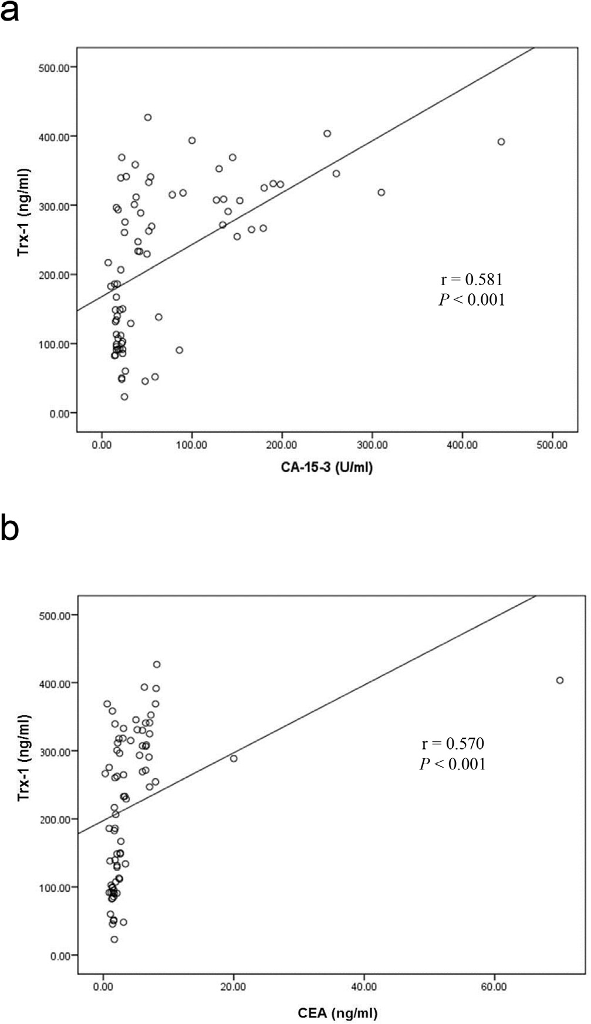esignificant difference as compared with lymph node negative at p < .05.

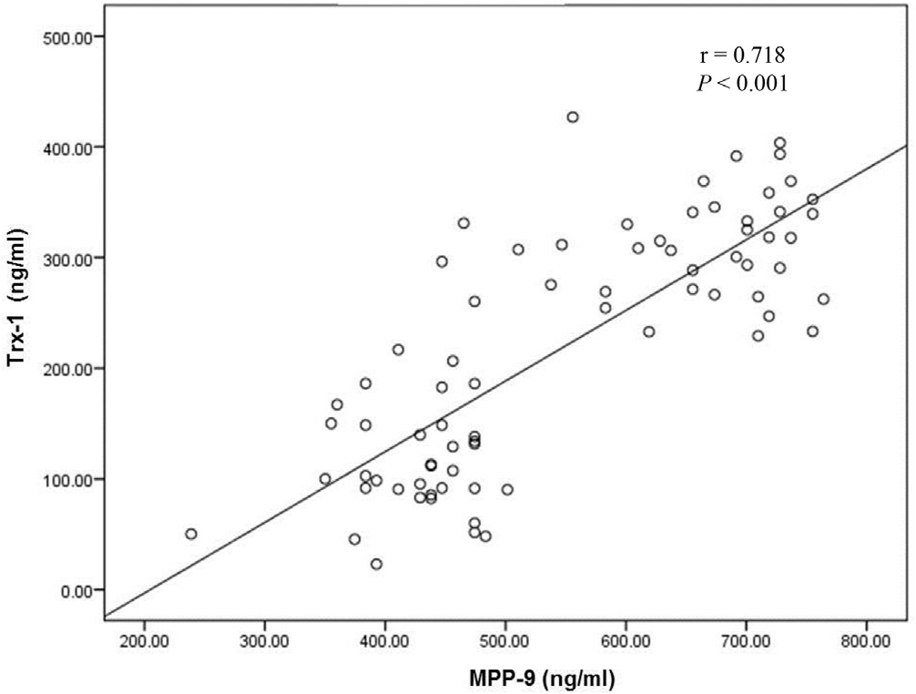

Fig. 4. Positive correlation between serum thioredoxin-1 (Trx-1) level and matrix metalloproteinase-9 (MMP-9) level in all breast cancer patients.

with distant metastasis [20]. Thus, we studied the role of both Trx- 1 and MMP-9 in diagnosis of breast cancer and their correlation with clinicopathological parameters of MBC and NMBC Egyptian patients, as well as, their sensitivity and specificity in the disease prognosis.

Breast cancer metastasis is the process by which tumor cells migrate and establish from their primary site to secondary tumors [21]. This process requires degradation of the ECM in both primary and secondary tumor tissues via MMP-9 [22]. Trx-1 stimulates MMP-9 expression and promotes MMP-9 dependent invasion in breast cancer cells [12]. Thioredoxin system is highly expressed in breast tumors [23,24] and Trx-1 has been previously suggested as a suitable and diagnostic biomarker for breast cancer [8,13]. Our results extend these previous studies to show that Trx-1 level is significantly increased in breast cancer patients as compared to control. Moreover, Trx-1 correlates with distant metastasis and poor prognosis [11]. Tumor metastasis and aggressiveness could be explained by the ability of Trx-1 to push the balance towards MMP-9 function. MMP-9 involvement in malignant behavior depends upon change in equilibrium with its tissue specific inhibi- tor, TIMP-1 [12]. This suggests that Trx-1 could be a therapeutic

Fig. 5. Positive correlation between serum thioredoxin-1 (Trx-1) and cancer antigen 15-3 (CA15-3) levels (a) and serum Trx-1 and carcinoembryonic antigen (CEA) levels (b) in all breast cancer patients.

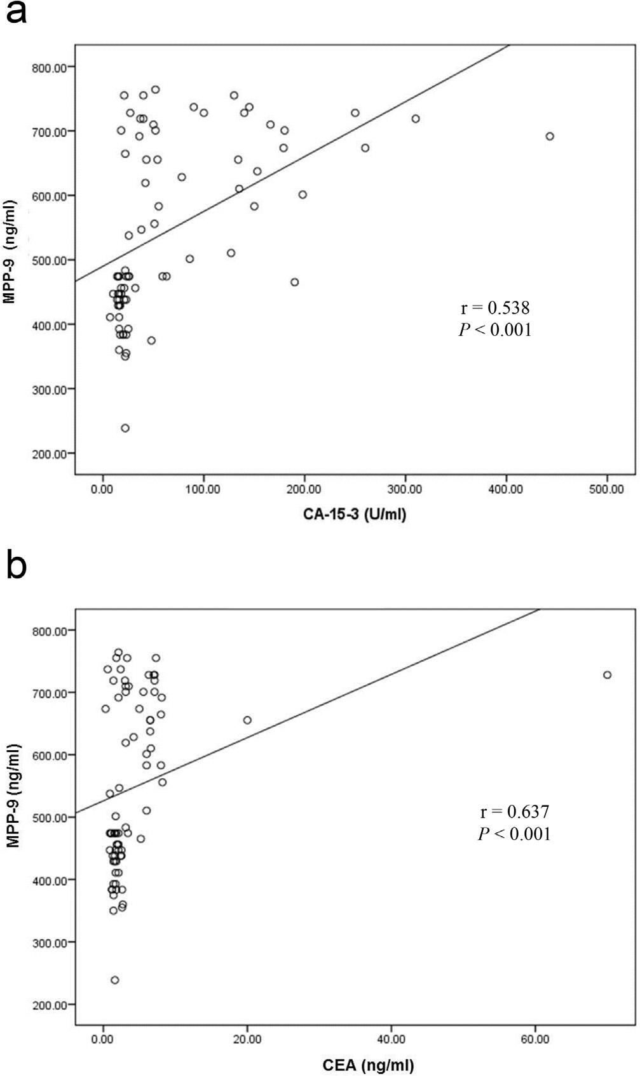

Fig. 6. Positive correlation between serum matrix metalloproteinase-9 (MMP-9) level and cancer antigen 15-3 (CA15-3) level (a) and serum MMP-9 level and carcinoembryonic antigen (CEA) level (b) in breast cancer patients.

target to reduce the tumor cell invasion and hence metastasis of breast cancer [11]. To our knowledge, this is the first time to report the relationship between serum Trx-1 and breast cancer metastasis and progression. Serum Trx-1 level is significantly increased in metastatic breast cancer patients. It is correlated with tumor stage, tumor grading and lymph node metastasis. However, serum Trx-1 level is not related to tumor size. Since Trx-1values in MBC patients are significantly higher than those in NMBC patients, so serum Trx-1 may be used as a predictive biomarker for metastasis.

MMP-9 has an important role in breast cancer invasion and metastasis. Our study shows that serum MMP-9 level was signifi- cantly elevated in breast cancer patients as compared to control. This result agreed with that of Patel et al. [25] and La Rocca et al. [26]. In addition, MMP-9 appears to have a greater biological activity in car- cinogenesis. Recent studies show that a down- regulation of MMP-9 prevents cancer cell growth, invasion and angiogenesis [27,28]. Moreover, we constitute that serum MMP-9 was significantly increased in MBC patients; subsequently MMP-9 was correlated with breast cancer stage as defined by AJCC-TNM system. Therefore, MMP-9 may play a vital role in breast cancer metastasis which agreed with the results of Patel et al. [25] and Rashad et al. [29].

We found that serum MMP-9 level predicts lymph node metas- tasis, which agreed with Zhang et al. [30] and Heo et al. [31]. In addition, serum MMP-9 level is significantly higher in grade 2 and 3 than grade 1. Zhang et al. [30] stated that MMP-9 parallel with tumor size, on the other hand Daniele et al. [32] and Rashad et al. [29] studies show no correlation among serum MMP-9 and tumor size which agreed with our results. MMP-9 is associated with poor general condition (progressive disease stage and metas- tasis), so, we recommend that MMP-9 may be a possible therapeu- tic target in breast cancer. This was in agreement with Li et al. [28], Park et al. [33] and Sinha et al. [34] who conclude that suppression of MMP-9, served as a possible target in treatment of breast cancer metastasis.

Malondialdehyde (MDA) is the end-product of lipid peroxida- tion (LPO) produced from the free radical degradation of polyun- saturated fatty acids. MDA promote breast cancer via interaction with amino groups of nucleic acid bases in DNA forming malondi- aldehyde-DNA adducts [35].

Previous studies show that a serum MDA level was significantly elevated in breast cancer patients compared to healthy subjects [13,36–39]. These results are in consistence with our study and confirm increase lipid peroxidation in breast cancer patients.

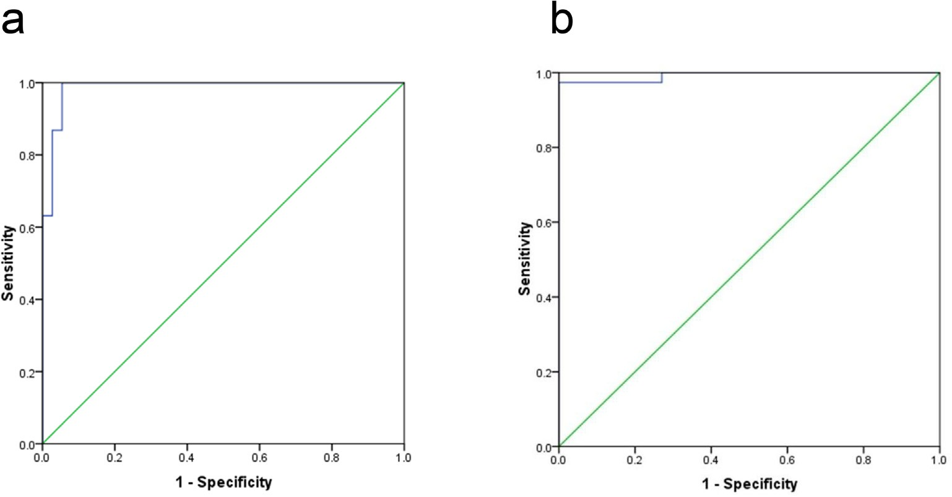

Fig. 7. Receiver operating characteristic curve (ROC) for serum thioredoxin-1 (Trx-1) level (a) and for serum matrix metalloproteinase-9 (MMP-9) level (b) for detection of breast cancer metastases.

Moreover, Pande et al. shows that VEGF and MDA levels are increased in breast cancer patients and were positively correlated. VEGF is a significant stimulator of tumor angiogenesis and metas- tasis and up-regulated by oxidative stress conditions [40]. In our study the serum MDA level was significantly elevated in meta- static breast cancer patients and correlated with clinical stage. This result agreed with Sadati Zarrini et al. [36] Baskic et al.

[41] and Gonenc et al. [42]. In addition, MDA level was correlated with tumor grading and lymph node metastasis but not related to tumor size.

Conclusion

* Serum Trx-1 level and MMP-9 level are significantly increased in metastatic breast cancer patients. Trx-1and MMP-9 elevation correlate with progression of the disease state.
* Trx-1 and MMP-9 are promising candidates as guide for relapse of breast cancer with distant metastases, as they linked with advanced disease stage.
* Trx-1 and MMP-9 are possible therapeutic targets for preven- tion of breast cancer metastasis.
* MDA as biomarker of oxidative stress is implicated in the pro- gress of metastasis in breast cancer patients.
* These results should be confirmed in further prospective studies employing a large number of subjects for the use of Trx-1 and MMP-9 in early diagnosis and follow-up of metastatic breast cancer.

References

1. [Ferlay J, Soerjomataram I, Dikshit R, Eser S, Mathers C, Rebelo M, et al. Cancer](http://refhub.elsevier.com/S2314-808X(17)30436-0/h0005) [incidence and mortality worldwide: sources, methods and major patterns in](http://refhub.elsevier.com/S2314-808X(17)30436-0/h0005) [GLOBOCAN 2012. Int J Cancer 2015;136(5):E359–86](http://refhub.elsevier.com/S2314-808X(17)30436-0/h0005).
2. [Servick K. Breast cancer. Breast cancer: a world of differences. Science (New](http://refhub.elsevier.com/S2314-808X(17)30436-0/h0010) [York, NY) 2014;343(6178):1452–3](http://refhub.elsevier.com/S2314-808X(17)30436-0/h0010).
3. [Ibrahim AS, Khaled HM, Mikhail NN, Baraka H, Kamel H. Cancer incidence in](http://refhub.elsevier.com/S2314-808X(17)30436-0/h0015) [Egypt: results of the national population-based cancer registry program. J](http://refhub.elsevier.com/S2314-808X(17)30436-0/h0015) [Cancer Epidemiol 2014;2014:437971](http://refhub.elsevier.com/S2314-808X(17)30436-0/h0015).
4. [Kimbung S, Loman N, Hedenfalk I. Clinical and molecular complexity of breast](http://refhub.elsevier.com/S2314-808X(17)30436-0/h0020) [cancer metastases. Semin Cancer Biol 2015;35:85–95](http://refhub.elsevier.com/S2314-808X(17)30436-0/h0020).
5. [Siegel RL, Miller KD, Jemal A. Cancer statistics, 2015. CA Cancer J Clin 2015;65](http://refhub.elsevier.com/S2314-808X(17)30436-0/h0025) [(1):5–29](http://refhub.elsevier.com/S2314-808X(17)30436-0/h0025).
6. [Nourazarian AR, Kangari P, Salmaninejad A. Roles of oxidative stress in the](http://refhub.elsevier.com/S2314-808X(17)30436-0/h0030) [development and progression of breast cancer. Asian Pac J Cancer Preven:](http://refhub.elsevier.com/S2314-808X(17)30436-0/h0030) [APJCP 2014;15(12):4745–51](http://refhub.elsevier.com/S2314-808X(17)30436-0/h0030).
7. [Harris IS, Treloar AE, Inoue S, Sasaki M, Gorrini C, Lee KC, et al. Glutathione and](http://refhub.elsevier.com/S2314-808X(17)30436-0/h0035) [thioredoxin antioxidant pathways synergize to drive cancer initiation and](http://refhub.elsevier.com/S2314-808X(17)30436-0/h0035) [progression. Cancer Cell 2015;27(2):211–22](http://refhub.elsevier.com/S2314-808X(17)30436-0/h0035).
8. [Park BJ, Cha MK, Kim IH. Thioredoxin 1 as a serum marker for breast cancer](http://refhub.elsevier.com/S2314-808X(17)30436-0/h0040) [and its use in combination with CEA or CA15-3 for improving the sensitivity of](http://refhub.elsevier.com/S2314-808X(17)30436-0/h0040) [breast cancer diagnoses. BMC Res Notes 2014;7:7](http://refhub.elsevier.com/S2314-808X(17)30436-0/h0040).
9. [Holmgren A. Thioredoxin. Annu Rev Biochem 1985;54:237–71](http://refhub.elsevier.com/S2314-808X(17)30436-0/h0045).
10. [Rhee SG, Chae HZ, Kim K. Peroxiredoxins: a historical overview and](http://refhub.elsevier.com/S2314-808X(17)30436-0/h0050) [speculative preview of novel mechanisms and emerging concepts in cell](http://refhub.elsevier.com/S2314-808X(17)30436-0/h0050) [signaling. Free Radical Biol Med 2005;38(12):1543–52](http://refhub.elsevier.com/S2314-808X(17)30436-0/h0050).
11. [Bhatia M, McGrath KL, Di Trapani G, Charoentong P, Shah F, King MM, et al. The](http://refhub.elsevier.com/S2314-808X(17)30436-0/h0055) [thioredoxin system in breast cancer cell invasion and migration. Redox Biol](http://refhub.elsevier.com/S2314-808X(17)30436-0/h0055) [2016;8:68–78](http://refhub.elsevier.com/S2314-808X(17)30436-0/h0055).
12. [Farina AR, Cappabianca L, DeSantis G, Di Ianni N, Ruggeri P, Ragone M, et al.](http://refhub.elsevier.com/S2314-808X(17)30436-0/h0060) [Thioredoxin stimulates MMP-9 expression, de-regulates the MMP-9/TIMP-1](http://refhub.elsevier.com/S2314-808X(17)30436-0/h0060) [equilibrium and promotes MMP-9 dependent invasion in human MDA-MB-](http://refhub.elsevier.com/S2314-808X(17)30436-0/h0060) [231 breast cancer cells. FEBS Lett 2011;585(20):3328–36](http://refhub.elsevier.com/S2314-808X(17)30436-0/h0060).
13. [Kilic N, Yavuz Taslipinar M, Guney Y, Tekin E, Onuk E. An investigation into the](http://refhub.elsevier.com/S2314-808X(17)30436-0/h0065) [serum thioredoxin, superoxide dismutase, malondialdehyde, and advanced](http://refhub.elsevier.com/S2314-808X(17)30436-0/h0065) [oxidation protein products in patients with breast cancer. Ann Surg Oncol](http://refhub.elsevier.com/S2314-808X(17)30436-0/h0065) [2014;21(13):4139–43](http://refhub.elsevier.com/S2314-808X(17)30436-0/h0065).
14. [Mehner C, Hockla A, Miller E, Ran S, Radisky DC, Radisky ES. Tumor cell-](http://refhub.elsevier.com/S2314-808X(17)30436-0/h0070) [produced matrix metalloproteinase 9 (MMP-9) drives malignant progression](http://refhub.elsevier.com/S2314-808X(17)30436-0/h0070) [and metastasis of basal-like triple negative breast cancer. Oncotarget 2014;5](http://refhub.elsevier.com/S2314-808X(17)30436-0/h0070) [(9):2736–49](http://refhub.elsevier.com/S2314-808X(17)30436-0/h0070).
15. [Sand JM, Larsen L, Hogaboam C, Martinez F, Han M, Rossel Larsen M, et al.](http://refhub.elsevier.com/S2314-808X(17)30436-0/h0075) [MMP mediated degradation of type IV collagen alpha 1 and alpha 3 chains](http://refhub.elsevier.com/S2314-808X(17)30436-0/h0075) [reflects basement membrane remodeling in experimental and clinical](http://refhub.elsevier.com/S2314-808X(17)30436-0/h0075) [fibrosis–validation of two novel biomarker assays. PLoS One 2013;8(12):](http://refhub.elsevier.com/S2314-808X(17)30436-0/h0075) [e84934](http://refhub.elsevier.com/S2314-808X(17)30436-0/h0075).
16. [Edge SB, Compton CC. The American joint committee on cancer: the 7th](http://refhub.elsevier.com/S2314-808X(17)30436-0/h0080) [edition of the AJCC cancer staging manual and the future of TNM. Ann Surg](http://refhub.elsevier.com/S2314-808X(17)30436-0/h0080) [Oncol 2010;17(6):1471–4](http://refhub.elsevier.com/S2314-808X(17)30436-0/h0080).
17. [Yoshioka T, Kawada K, Shimada T, Mori M. Lipid peroxidation in maternal and](http://refhub.elsevier.com/S2314-808X(17)30436-0/h0085) [cord blood and protective mechanism against activated-oxygen toxicity in the](http://refhub.elsevier.com/S2314-808X(17)30436-0/h0085) [blood. Am J Obstet Gynecol 1979;135(3):372–6](http://refhub.elsevier.com/S2314-808X(17)30436-0/h0085).
18. Effects of chemotherapy and hormonal therapy for early breast cancer on recurrence and 15-year survival: an overview of the randomised trials. Lancet (London, England). 2005;365 (9472):1687–717.
19. [Molina R, Barak V, van Dalen A, Duffy MJ, Einarsson R, Gion M, et al. Tumor](http://refhub.elsevier.com/S2314-808X(17)30436-0/h0095) [markers in breast cancer- European group on tumor markers recommen-](http://refhub.elsevier.com/S2314-808X(17)30436-0/h0095) [dations. Tumour Biology: J Int Soc Oncodev Biol Med 2005;26(6):281–93](http://refhub.elsevier.com/S2314-808X(17)30436-0/h0095).
20. [Geng B, Liang MM, Ye XB, Zhao WY. Association of CA 15–3 and CEA with](http://refhub.elsevier.com/S2314-808X(17)30436-0/h0100) [clinicopathological parameters in patients with metastatic breast cancer. Mol](http://refhub.elsevier.com/S2314-808X(17)30436-0/h0100) [Clin Oncol 2015;3(1):232–6](http://refhub.elsevier.com/S2314-808X(17)30436-0/h0100).
21. [Fidler IJ. Critical factors in the biology of human cancer metastasis: twenty-](http://refhub.elsevier.com/S2314-808X(17)30436-0/h0105) [eighth G.H.A. Clowes memorial award lecture. Cancer Res 1990;50](http://refhub.elsevier.com/S2314-808X(17)30436-0/h0105) [(19):6130–8](http://refhub.elsevier.com/S2314-808X(17)30436-0/h0105).
22. [Yamaguchi H, Wyckoff J, Condeelis J. Cell migration in tumors. Curr Opin Cell](http://refhub.elsevier.com/S2314-808X(17)30436-0/h0110) [Biol 2005;17(5):559–64](http://refhub.elsevier.com/S2314-808X(17)30436-0/h0110).
23. [Lincoln DT, Ali Emadi EM, Tonissen KF, Clarke FM. The thioredoxin-thioredoxin](http://refhub.elsevier.com/S2314-808X(17)30436-0/h0115) [reductase system: over-expression in human cancer. Anticancer Res 2003;23](http://refhub.elsevier.com/S2314-808X(17)30436-0/h0115) [(3b):2425–33](http://refhub.elsevier.com/S2314-808X(17)30436-0/h0115).
24. [Cha MK, Suh KH, Kim IH. Overexpression of peroxiredoxin I and thioredoxin1](http://refhub.elsevier.com/S2314-808X(17)30436-0/h0120) [in human breast carcinoma. J Exp Clin Cancer Res: CR 2009;28:93](http://refhub.elsevier.com/S2314-808X(17)30436-0/h0120).
25. [Patel S, Sumitra G, Koner BC, Saxena A. Role of serum matrix](http://refhub.elsevier.com/S2314-808X(17)30436-0/h0125) [metalloproteinase-2 and -9 to predict breast cancer progression. Clin](http://refhub.elsevier.com/S2314-808X(17)30436-0/h0125) [Biochem 2011;44(10–11):869–72](http://refhub.elsevier.com/S2314-808X(17)30436-0/h0125).
26. [La Rocca G, Pucci-Minafra I, Marrazzo A, Taormina P, Minafra S. Zymographic](http://refhub.elsevier.com/S2314-808X(17)30436-0/h0130) [detection and clinical correlations of MMP-2 and MMP-9 in breast cancer sera.](http://refhub.elsevier.com/S2314-808X(17)30436-0/h0130) [Br J Cancer 2004;90(7):1414–21](http://refhub.elsevier.com/S2314-808X(17)30436-0/h0130).
27. [Gao J, Liu X, Yang F, Liu T, Yan Q, Yang X. By inhibiting Ras/Raf/ERK and MMP-](http://refhub.elsevier.com/S2314-808X(17)30436-0/h0135) [9, knockdown of EpCAM inhibits breast cancer cell growth and metastasis.](http://refhub.elsevier.com/S2314-808X(17)30436-0/h0135) [Oncotarget 2015;6(29):27187–98](http://refhub.elsevier.com/S2314-808X(17)30436-0/h0135).
28. [Li J, Zhang J, Wang Y, Liang X, Wusiman Z, Yin Y, et al. Synergistic inhibition of](http://refhub.elsevier.com/S2314-808X(17)30436-0/h0140) [migration and invasion of breast cancer cells by dual docetaxel/quercetin-](http://refhub.elsevier.com/S2314-808X(17)30436-0/h0140) [loaded nanoparticles via Akt/MMP-9 pathway. Int J Pharm 2017;523](http://refhub.elsevier.com/S2314-808X(17)30436-0/h0140) [(1):300–9](http://refhub.elsevier.com/S2314-808X(17)30436-0/h0140).
29. [Rashad YA, Elkhodary TR, El-Gayar AM, Eissa LA. Evaluation of serum levels of](http://refhub.elsevier.com/S2314-808X(17)30436-0/h0145) [HER2, MMP-9, nitric oxide, and total antioxidant capacity in Egyptian breast](http://refhub.elsevier.com/S2314-808X(17)30436-0/h0145) [cancer patients: correlation with clinico-pathological parameters. Sci Pharm](http://refhub.elsevier.com/S2314-808X(17)30436-0/h0145) [2014;82(1):129–45](http://refhub.elsevier.com/S2314-808X(17)30436-0/h0145).
30. [Zhang J, Yin L, Wu J, Zhang Y, Xu T, Ma R, et al. Detection of serum VEGF and](http://refhub.elsevier.com/S2314-808X(17)30436-0/h0150) [MMP-9 levels by Luminex multiplexed assays in patients with breast](http://refhub.elsevier.com/S2314-808X(17)30436-0/h0150) [infiltrative ductal carcinoma. Exp Ther Med 2014;8(1):175–80](http://refhub.elsevier.com/S2314-808X(17)30436-0/h0150).
31. [Heo DS, Choi H, Yeom MY, Song BJ, Oh SJ. Serum levels of matrix](http://refhub.elsevier.com/S2314-808X(17)30436-0/h0155) [metalloproteinase-9 predict lymph node metastasis in breast cancer](http://refhub.elsevier.com/S2314-808X(17)30436-0/h0155) [patients. Oncol Rep 2014;31(4):1567–72](http://refhub.elsevier.com/S2314-808X(17)30436-0/h0155).
32. [Daniele A, Zito AF, Giannelli G, Divella R, Asselti M, Mazzocca A, et al.](http://refhub.elsevier.com/S2314-808X(17)30436-0/h0160) [Expression of metalloproteinases MMP-2 and MMP-9 in sentinel lymph node](http://refhub.elsevier.com/S2314-808X(17)30436-0/h0160) [and serum of patients with metastatic and non-metastatic breast cancer.](http://refhub.elsevier.com/S2314-808X(17)30436-0/h0160) [Anticancer Res 2010;30(9):3521–7](http://refhub.elsevier.com/S2314-808X(17)30436-0/h0160).
33. [Park JH, Cho YY, Yoon SW, Park B. Suppression of MMP-9 and FAK expression](http://refhub.elsevier.com/S2314-808X(17)30436-0/h0165) [by pomolic acid via blocking of NF-kappaB/ERK/mTOR signaling pathways in](http://refhub.elsevier.com/S2314-808X(17)30436-0/h0165) [growth factor-stimulated human breast cancer cells. Int J Oncol 2016;49](http://refhub.elsevier.com/S2314-808X(17)30436-0/h0165) [(3):1230–40](http://refhub.elsevier.com/S2314-808X(17)30436-0/h0165).
34. [Sinha S, Khan S, Shukla S, Lakra AD, Kumar S, Das G, et al. Cucurbitacin B](http://refhub.elsevier.com/S2314-808X(17)30436-0/h0170) [inhibits breast cancer metastasis and angiogenesis through VEGF-mediated](http://refhub.elsevier.com/S2314-808X(17)30436-0/h0170) [suppression of FAK/MMP-9 signaling axis. Int J Biochem Cell Biol](http://refhub.elsevier.com/S2314-808X(17)30436-0/h0170) [2016;77:41–56. Pt A](http://refhub.elsevier.com/S2314-808X(17)30436-0/h0170).
35. Wang M, Dhingra K, Hittelman WN, Liehr JG, de Andrade M, Li D. Lipid peroxidation-induced putative malondialdehyde-DNA adducts in human breast tissues. Cancer epidemiology, biomarkers & prevention: a publication of the American Association for Cancer Research, cosponsored by the American Society of Preventive Oncology. 1996;5(9):705–10
36. [Sadati Zarrini A, Moslemi D, Parsian H, Vessal M, Mosapour A, Shirkhani](http://refhub.elsevier.com/S2314-808X(17)30436-0/h0180) [Kelagari Z. The status of antioxidants, malondialdehyde and some trace](http://refhub.elsevier.com/S2314-808X(17)30436-0/h0180) [elements in serum of patients with breast cancer. Caspian J Internal Med](http://refhub.elsevier.com/S2314-808X(17)30436-0/h0180) [2016;7(1):31–6](http://refhub.elsevier.com/S2314-808X(17)30436-0/h0180).
37. [Rajneesh CP, Manimaran A, Sasikala KR, Adaikappan P. Lipid peroxidation and](http://refhub.elsevier.com/S2314-808X(17)30436-0/h0185) [antioxidant status in patients with breast cancer. Singapore Med J 2008;49](http://refhub.elsevier.com/S2314-808X(17)30436-0/h0185) [(8):640–3](http://refhub.elsevier.com/S2314-808X(17)30436-0/h0185).
38. [Yeh CC, Hou MF, Tsai SM, Lin SK, Hsiao JK, Huang JC, et al. Superoxide anion](http://refhub.elsevier.com/S2314-808X(17)30436-0/h0190) [radical, lipid peroxides and antioxidant status in the blood of patients with](http://refhub.elsevier.com/S2314-808X(17)30436-0/h0190) [breast cancer. Clin Chim Acta; Int J Clin Chem 2005;361(1–2):104–11](http://refhub.elsevier.com/S2314-808X(17)30436-0/h0190).
39. [Gonenc A, Ozkan Y, Torun M, Simsek B. Plasma malondialdehyde (MDA) levels](http://refhub.elsevier.com/S2314-808X(17)30436-0/h0195) [in breast and lung cancer patients. J Clin Pharm Ther 2001;26(2):141–4](http://refhub.elsevier.com/S2314-808X(17)30436-0/h0195).
40. [Pande D, Negi R, Khanna S, Khanna R, Khanna HD. Vascular endothelial growth](http://refhub.elsevier.com/S2314-808X(17)30436-0/h0200) [factor levels in relation to oxidative damage and antioxidant status in patients](http://refhub.elsevier.com/S2314-808X(17)30436-0/h0200) [with breast cancer. J Breast Cancer 2011;14(3):181–4](http://refhub.elsevier.com/S2314-808X(17)30436-0/h0200).
41. [Baskic D, Popovic S, Bankovic D, Arsovic A, Vukovic V, Zelen I, et al. Evaluation](http://refhub.elsevier.com/S2314-808X(17)30436-0/h0205) [of inflammatory biomarkers as helping diagnostic tool in patients with breast](http://refhub.elsevier.com/S2314-808X(17)30436-0/h0205) [cancer. Cancer Biomarkers: Sec A Dis Markers 2014;14(6):401–8](http://refhub.elsevier.com/S2314-808X(17)30436-0/h0205).
42. [Gonenc A, Tokgoz D, Aslan S, Torun M. Oxidative stress in relation to lipid](http://refhub.elsevier.com/S2314-808X(17)30436-0/h0210) [profiles in different stages of breast cancer. Indian J Biochem Biophys 2005;42](http://refhub.elsevier.com/S2314-808X(17)30436-0/h0210) [(3):190–4](http://refhub.elsevier.com/S2314-808X(17)30436-0/h0210).