

[Egyptian Informatics Journal (2012) 13, 111–121](http://dx.doi.org/10.1016/j.eij.2012.05.002)

Cairo University

Egyptian Informatics Journal

[www.elsevier.com/locate/eij](http://www.elsevier.com/locate/eij) [www.sciencedirect.com](http://www.sciencedirect.com/science/journal/11108665)

ORIGINAL ARTICLE

Threshold based AntNet algorithm for dynamic traﬃc routing of road networks

Ayman M. Ghazy, Fatma EL-Licy, Hesham A. Hefny *

*Department of Computer and Information Sciences, Institute of Statistical Studies and Research, Cairo University, Giza, Egypt*

Received 2 November 2011; revised 6 May 2012; accepted 13 May 2012

Available online 12 June 2012

KEYWORDS

Swarm intelligence; Dynamic traffic routing; AntNet;

Forward ant; Backward ant; Check ant

Abstract Dynamic routing algorithms play an important role in road traffic routing to avoid con- gestion and to direct vehicles to better routes. AntNet routing algorithms have been applied, exten- sively and successfully, in data communication network. However, its application for dynamic routing on road networks is still considerably limited. This paper presents a modified version of the AntNet routing algorithm, called ‘‘Threshold based AntNet’’, that has the ability to efficiently utilize a priori information of dynamic traffic routing, especially, for road networks. The modifica- tion exploits the practical and pre-known information for most road traffic networks, namely, the good travel times between sources and destinations. The values of those good travel times are manipulated as threshold values. This approach has proven to conserve tracking of good routes. According to the dynamic nature of the problem, the presented approach guards the agility of redis- covering a good route. Attaining the thresholds (good reported travel times), of a given source to destination route, permits for a better utilization of the computational resources, that, leads to bet- ter accommodation for the network changes. The presented algorithm introduces a new type of ants called ‘‘check ants’’. It assists in preserving good routes and, better yet, exposes and discards the

* Corresponding author. Address: Department of Computer and Information Sciences. Institute of Statistical studies and Research Cairo University, 5 Tharwat St. ORMAN GIZA, P.O. 12613, Egypt. Tel.: +20 2 3351499/2 3351223; fax: +20 2 7482533.

E-mail addresses: [aymghazy@yahoo.com](mailto:aymghazy@yahoo.com) (A.M. Ghazy), [Why2fatma](mailto:Why2fatma%20@yahoo.com) [@yahoo.com](mailto:Why2fatma%20@yahoo.com) (F. EL-Licy), [hehefny@ieee.org](mailto:hehefny@ieee.org) (H.A. Hefny).

1110-8665 © 2012 Faculty of Computers and Information, Cairo University. Production and hosting by Elsevier B.V. All rights

reserved.

Peer review under responsibility of Faculty of Computers and Information, Cairo University. <http://dx.doi.org/10.1016/j.eij.2012.05.002>

Production and hosting by Elsevier

112 A.M. Ghazy et al.

degraded ones. The threshold AntNet algorithm presents a new strategy for updating the routing information, supported by the backward ants.

© 2012 Faculty of Computers and Information, Cairo University. Production and hosting by Elsevier B.V. All rights reserved.

1. Introduction

Finding best routes based on dynamic data have been studied extensively in literature. Old approaches used traditional techniques such as Dijkstra algorithm, which, have high compu- tational complexity. In the last decade, population-based search- ing methodologies, such as genetic algorithms (GAs) and artificial immune systems (AISs), are proposed as efficient parallel search- ing algorithms that can successfully be adopted for finding short paths over dynamic networks [1–3]. Swarm Intelligence (*SI*) based techniques have been also investigated as a solution for finding good routes in a dynamically changing network. Ant rout- ing algorithms is one of the most promising *SI* techniques for find- ing near optimal solutions at low computational cost.

AntNet is a distributed agent based routing algorithm in- spired by the behavior of natural ants [4]. It has been shown that under varying traffic loads, AntNet algorithm is amenable to the associated changes. It shows better performance than that of shortest path routing algorithms [5]. Several enhance- ments have been made to the AntNet algorithm. Baran and Sosa [6], proposed to initialize the routing table at each node in the network. The proposed initialization reflects previous knowledge about network topology rather than the assumed uniform distribution probabilities (as in standard AntNet algorithms) [6]. Kassabalidis et al. [7], have shown that good routing solutions can be achieved by the combined use of net- work clustering autonomous system and ant colony algorithm. A new type of helping ants has been introduced in [8] to in- crease cooperation among neighboring nodes, thereby reducing AntNet algorithm’s convergence time. Tekiner et al. [9], pro- duced a version of the AntNet algorithm that improved the throughput and the average delay. In addition, their algorithm utilized the ant/packet ratio to limit the number of used ants [9]. Radwan et al. [10], proposed an adapted AntNet protocol with blocking–expanding ring search and local retransmission tech- nique for routing of MANET (Mobile ad hoc network).

Most of the research efforts and applications of Ant rout- ing algorithms are directed towards finding best routes over data communication networks. However, its application for dynamic routing on road networks is still considerably lim- ited. Dynamic routing algorithms play an important role in road traffic routing to avoid congestion and to direct cars to better routes. An Ant Based Control (ABC) algorithm has been applied in [11], for routing of road traffic through a city. In [12] a city based parking routing system (CBPRS) that used Ant based routing has been proposed. In [13] a modification to the Ant Based Control (ABC) and AntNet has been presented for routing vehicle drivers using histori- cally-based traffic information. In [14], a version of the Ant- Net algorithm has been applied to improve traveling time over a road traffic network with the ability to divert traffic from congested routes.

In this paper, a new modified version of the AntNet algo- rithm is proposed for dynamic routing of road traffic net- works. A pre-known information about good travel times

among different nodes is exploited to increase the performance of the algorithm by reducing much of the computations. This enforces the agility in exploring more routes in a given net- work, therefore, guaranties fast coverage of the changes in the road states. The proposed algorithm, not only accelerates the discovery of good routes, but it, also, conserves it. A soft- ware agent (called check ants) were employed to monitor the conserved good routes, in such a way to discover and reject the derogated ones.

The main benefits of the proposed modifications are:

Reducing computation time, which guaranties agility of exploring new routes.

●

Conserving the discovered good routes, shrinks the size of searching problem, (for a pre-determined time) and acceler- ating the explorations of more routes. This would permits rapid cycles of covering the changes in the dynamic road network.

●

Discovering the derogated good route enforces fast recov- ery to obtain better routs.

●

The adopted performance measures for evaluating the pro- posed modified algorithm with the traditional AntNet are:

The average travel time per simulation period for each node The average travel time at each simulation minute for all nods.

●

●

For the purpose of this paper, the standard Antnet algo- rithm is introduced in Section 2. While, the proposed modi- fied version of the algorithm is presented in Section 3. Section 4 presents the simulation experiment. Section 5 con- cludes the paper.

1. Description of AntNet algorithm

The AntNet routing algorithm [4], utilizes two types of soft- ware agents, namely, forward and backward ants. A forward ant is responsible for gathering information about the state of the network while moving from a source node to a destina- tion node. A backward ant, however, is responsible for manip- ulating these information to update the routing tables of each node while moving backward from destination node to source node.

* 1. *Data structures*

Ants communicate through the information they concurrently read and write in the data structures stored at each network node. The data structures for a given node *k* over a network of *N* nodes are the two tables *Tk* and *Mk*, representing routing table and local traffic table respectively [4], as shown in Fig. 1. Each row in *Tk* corresponds to one destination in the network, whereas, each column corresponds to one of the neighbors of node *k.* For each destination *d* and each neighboring node *n*,

Threshold based AntNet algorithm for dynamic traffic routing of road networks 113

**Network nodes**

|  |  |  |
| --- | --- | --- |
|  |  |  |
|  |  |  |
|  |  |  |
|  |  |  |

|  |  |  |  |
| --- | --- | --- | --- |
| **1** | **2** |  | **N** |
|  |  |  |  |

Fig. 1 A network node *k* with its routing table (*Tk*) and local traffic table (*Mk*).



**z**

**x**

**Neighbor nodes**

**Routing Table**

**Network**

**Node (k)**

**Network nodes**

**y**

**=**

**Local Traffic Statistics**

the probability *pnd* of choosing *n* as the next node when the destination is *d*, is stored in *Tk* such that:

at a node *k* coming from node *j* the identifier of the vis- ited node *k* and the travel time needed to reach *k* com-

X *Pnd*

= 1, *n* ∈ *Nk*

(1)

ing from *j* are pushed into a memory stack *Ssd*.

1. At each visited node *k*, the next node is selected from

where *d* ∈ [1, *N*] and *Nk* = {neighbors (*k*)}.

The local traffic table *Mk* stores statistical information about road network corresponding to node *k*. The *J*th column of the table holds statistical information about the travel times consumed by all the forward ants that had been launched from node *k* to reach destination node *j*. It is represented in the form

*Mk*(*ld*, *r*2, *Wd*), where:

*d*

*ld* is the mean travel times calculated as:

*ld* ← *ld* + *g*(*tkd* — *ld*) (2)

*r*2 is the variance of the travel times calculated as:

*d*

*r*2 ← *r*2 + *g*((*tkd* — *l* )2 — *r*2) (3)

*d d d d*

where *tkd* is the trip time observed by the current forward ant (launches from node *k* to destination *d*). *g* (0, 1], weighs the number of recent samples that will affect *ld* and *r*2. *Wd* The moving observation window of size *Wmax* which is used to save the trip time of the last *Wmax* ants that launched from node *k* to node *d*. *Wd* is used to find the best trip time *tbestd*. *g* is related to *Wmax* as follows:

∈

*d*

*Wmax* = 5*c*/*g*, *wherec* < 1 (4)

*2.2. The AntNet algorithm*

The AntNet algorithm can be described as follows [4]:

1. At regular intervals, a random destination *d* is chosen, and a forward ant *Fsd* is launched.
2. While *Fsd* is traveling towards the destination *d*, it keeps a memory about its path. When an ant arrives

the neighbors that have not been visited according to the probability *Pnd*. If all the neighboring nodes have been visited previously, then the next node is chosen among all the neighbors.

1. If a cycle is detected, i.e. if the ant is forced to return to an already visited node, the cycle’s nodes are popped from the ant’s stack and all memory about the cycle is destroyed.
2. When the destination node *d* is reached, a backward ant *Bds* is generated and the forward ant dies after transferring its memory contained in the stack *Ssd* to the backward ant.
3. The backward ant takes the opposite direction of the same path as the corresponding forward ant. At each node *k*, the backward ant pops up the stack *Ssd* to know the next node.
4. When arriving at a node *k* coming from a neighbor node *h*, the backward ant updates both of routing table *Tk* and local traffic table *Mk* for all the entries corre- sponding to the destination node *d*. Updates also are performed on the entries corresponding to every node

*k*' ∈ *Ssd*, *k*' „ *d*, on the sup path followed by *Fsd* when the elapsed trip time is less than *l* + *I(l, r),* where

*I*(*l*, *r*) is an estimate of a confidence interval for *l*.

1. The mean *ld* and variance *r*2 of the model *Mk* are updated using the formulas (2) and (3).

*d*

The routing table *Tk* is updated as follows:

The probability *Phd*' is increased by the reinforcement value

*r* as:

*Phd*' ← *Phd*' + *r*(1 — *Phd*' ) (5)

114 A.M. Ghazy et al.

While the other neighbors *Pnd*' are decreased by the nega- tive reinforcement as:

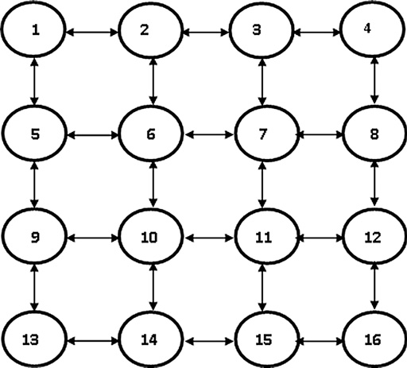

Table 1 The routing table (*Tk*) utilized to implement the modified AntNet.

*Pnd*' ← *Pnd*' — *rPnd*' , *n*–*h*, *n* ∈ *Nk* (6)

where *h* is the next node to *k* in the chosen path by the forward

*PX*1

*PY*1

*PZ*1

*T_Good*1 *G*1

ant, *d*' the destination or sub path destination and *Nk* is the set

.*PX*2

.

.*PY*2

.

.*PZ*2

.

.*T_Good*2

.

.*G*2

.

of neighbors of node *k*.

Every path that is generated by a forward ant receives a po- sitive reinforcement, *r* ∈ (0, 1]

*r* = *c*1(*tbestd* /*tkd*)+ *c*2{(*tsup* — *tbestd*)/((*tsup* — *tbestd*)+ (*tkd*

— *tbestd*))} (7)

where *tkd* is the observed forward ant’s trip time from node *k* to the destination *d. tbestd* is the best trip time experienced by the forward ants traveling towards the destination *d* over the observation window *Wd*.

The coefficients *C*1 and *C*2 weight the importance of each term in Eq. (7). *C*2 is a correction coefficient, a typical upper limit for *C*2 is observed by Caro and Dorigo [4], not to exceed 0*.*35.

The value of *tsup* is calculated as:

*Tsup* = *ld* + *rd*/(,((1 — *c*)|*wmax*|) (8)

where *c* is the selected confidence level. It is observed that best results are obtained for *c* [0.75, 0.8].

∈

The value of *r* calculated in (7) is finally transformed by means of a squash function *s*(*x*) defined as:

*s*(*x*)= 1/(1 + *exp*(*a*/*x*)), *x* ∈ (0, 1], *a* ∈ *R*+ (9)

*r* ← *s*(*r*)/*s*(1) (10)

The squash function *s*(*x*), dilutes the values of, *r*, while updating the routing tables.

1. The proposed threshold-based AntNet

The main strategy of the standard AntNet algorithm [4], is to search for better routes via launching ants that fetch for routes among the network nodes. Yet, even after discovering good routes, the algorithm does not account on it, but rather, seeks for ever better routes. This is, not only rational, but it is also, necessary, for a high speed data communication networks, where best routes among different hosts may change in a few milliseconds. Road-traffic conditions, however, change with a much slower rate. However dynamic, it sustain its flow or con- gestion conditions for a considerable period of time. This property influenced the idea behind the proposed threshold- based AntNet algorithm. The idea is constituted in the rules:

A discovered good route at time *t*, is assumed to be good until proven otherwise.

●

A threshold values for travelling times between the nodes of a given road network, could be estimated or obtained, see Sec- tion 3.3. Those threshold values are the seeds for the typical good travel time among the network node. Thus, the rules:

At time *t* + D*t*, a discovered good route at time *t*, is assumed to be good if its travel times were bounded by a given threshold values.

●

Due to the dynamic changes of the state of the road traffic network, a periodical checking is necessary to examine the integrity of the assumption about the route.

*PXN PYN PZN T_GoodN GN*

Fig. 2 The topology of a road network with 16 nodes.

At time *t* + D*t*, a check is on action for each discovered good route at time *t*. A failed check derogates the route.

●

The value of D*t*, ranges from several minutes to several hours, depending on the network geographical location (af- fected by weather and road type), the time of day (peek traffic time, regular or night), the calendar time (vacation, national, religious and social events), managerial and road maintenance factors.

Utilizing this set of rules in the AntNet algorithm reduces much of the computations involved in route discovery, leading to better utilization of the computation power. Therefore, per- mits for discovering and monitoring more routes in the net- work, counterbalancing better with dynamic road states. This was the policy that inspired the enhancement in the *Threshold-Based* AntNet algorithm.

* 1. *Threshold enhancement theory*

Given a network of *n* nodes*, p*1, *p*2, ..., *pn*, a good route *Rsd* between a source node *sp*1 and destination node *spd* is defined to be the route *{sp*1, *sp*2,..., *spd*}, such that the travel time between each consecutive nodes, *spi* and *spi+*1*,* (*i =* 1,..., *d* — 1), in the route, is bounded by the corresponding threshold

Table 2 Number of launched ants and the average travel time.

Algorithm

AntNet

Modified AntNet

Percentage of improvement (%)

Average ± standard deviation.

Average

no. of ants

1667 ± 69

1865 ± 163

11.88

Average

travel time

34.50 ± 1.82

33.42 ± 1.87

3.13

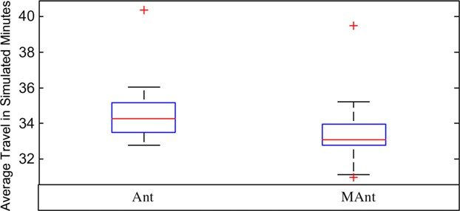

Threshold based AntNet algorithm for dynamic traffic routing of road networks

115

values. The enhancement rules are integrated into the original

AntNet as follows:

When a good route *Rsd* is discovered, the algorithm performs the following:

1. Assigns a maximum probability values for the nodes *spi* (*i= 1,* ..., *d*) in the routing table, rather than comput- ing the ordinary update Eq. (5).
2. Stops searching for another good route from *spi* to *spd.*
3. Checks the integrity of the assumed good route after a

pre-specified period of time (D*t*)

To apply this enhancement a new type of ants, called ‘‘ *check ants*’’ is introduced. Check ants are software agents that are responsible of periodically checking the travel time of the discovered good route against the corresponding threshold.

* 1. *The proposed data structure*

The proposed data structures for implementing the threshold AntNet algorithm is an extension to that of the standard AntNet, shown in Fig. 1. Two tables *Tk* and *Mk*, are reserved for each node *k*, in the given network of *N* nodes. What is more, the routing table, *Tk* is enlarged by adding two col- umns, as shown in Table 1. The first column, (*T_Goodi*), con- tains the exploited good travel time between the source node *k* and every destination node, *i*, in the road network. Thus, *T_Goodi*, *i* = 1 *N*, are the threshold values for the travel times. The second column, (*G*), acts as a flag to mark those destinations for which a good routes were discovered. The value of *Gi*, indirectly, discriminates the type of ant to be launched as follows:

·· ·

* + - *(Gi = ‘yes’)* → launch a check ant
    - *(Gi = ‘no’)* → launch a forward followed by backward ant
  1. *Setting of threshold travel times*

In road networks, good travel times among different nodes can be obtained by various ways such as:

1. Consulting traffic road experts.
2. Using the information about the available maximum speed for each link on the road network by which a route of shortest travel time can be computed between every source and destination.
3. Running the classical AntNet routing system, without any pre-assumption about good travelling times between any source and any destination. In other words, good travel time is considered to be a zero value. After run- ning the routing system for a pre-determined period of time, best routes found by the launched ants are saved together with their good travel times in the various rout- ing tables at every considered node.1 This process can, also, be applied for several intervals of time during the day. Also, it can be used to provide real accurate data during critical and peak traffic day/seasons times.

1 *This method is used in our testing experiment simulation in Section 4*.

Fig. 3 Boxplot comparison between average ants’travel time for both of AntNet and modified AntNet for travelling times.

Exploitation of the pre-known good travel times as thresh- old values combined by the strategy of periodical check of the discovered routes achieves the following benefits:

* Reducing computation cost.
* Conserving the discovered good route.
* Accelerating convergence of a good route discovery.
* Accelerating recovery from a derogated route.
  1. *Threshold AntNet algorithm*

The pseudo code for the threshold AntNet algorithm for dy- namic road traffic network is illustrated bellow.2 The lines of codes appear in bold font represent the new modifications compared with the standard AntNet algorithm.

It is worth to mention that the standard AntNet as a dis- tributed agent based algorithm can be implemented on a par- allel processing system. In such a case, each processing unit can be responsible for finding routes from one or more pre-speci- fied nodes to all other nodes in the network. It is true, of course, that the computational complexity can be greatly re- duced, in this case, from the order of O(n2) down to order

O(n). However, the argument here is that the newly proposed algorithm is still better than standard AntNet even in case of a parallel processing environment. This is due to its ability to converge fast to good route solutions and to conserve on the good discovered ones. More discussions about our modified AntNet algorithms are given in [15].

1. Experiment

A simulation program was designed and implemented (in vi- sual basic) to test the newly Threshold-based AntNet algo- rithm and to compare its performance with the standard AntNet. The network under study has 16 nodes with the lattice topology shown in Fig. 2. The objective of the algorithm is to get best routes *R*1*j*, *j* = 2 16 between the source node 1, and the network nodes, during a certain period of time.

·· ·

2 *The modified AntNet algorithm reverts to the standard AntNet by setting the values in the column T_Good in all routing tables T*k *to zero and setting all the values of the G column to ‘‘No’’. Such a setting does not permit the launching of check ant*.

116 A.M. Ghazy et al.

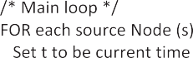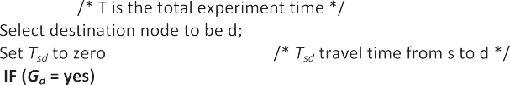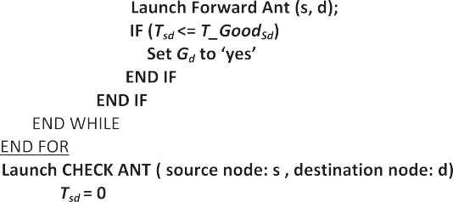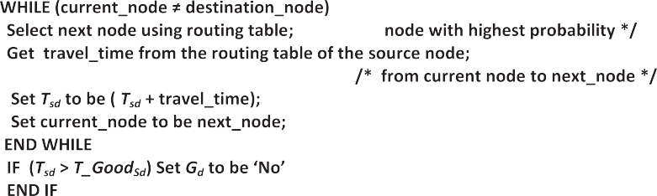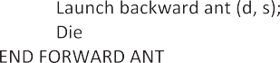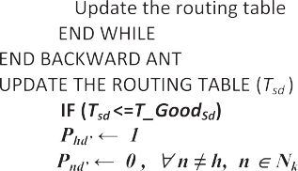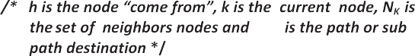

* 1. *Simulation data*

The simulation data is generated by initializing a *From-To*

time table. This time table contains information about the

travel times (in minutes) between each node in the network and its neighbors. The experiment is simulated for 20 min with 5 min intervals. The travel time between each neighbor- ing nodes (i.e. for each of the 48 links shown in Fig. 2 are,

Threshold based AntNet algorithm for dynamic traffic routing of road networks 117

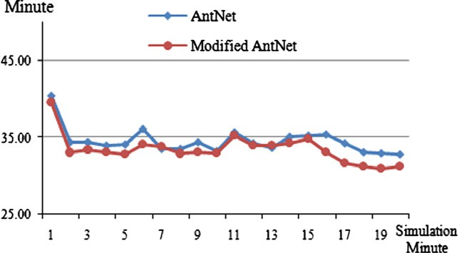

Fig. 4 The average ant’s travel time at each minute.

|  |  |  |
| --- | --- | --- |
| Table 3 Average travel time at each minute.  Minute AntNet Threshold based AntNet | | |
| 1 | 40.37 ± 5.55 | 38.99 ± 6.08 |
| 2 | 34.39 ± 3.97 | 32.44 ± 5.07 |
| 3 | 34.34 ± 4.68 | 31.97 ± 5.98 |
| 4 | 33.92 ± 3.92 | 32.02 ± 5.65 |
| 5 | 34.13 ± 4.08 | 31.8 ± 5.7 |
| 6 | 36.02 ± 4.60 | 33.86 ± 4.99 |
| 7 | 33.56 ± 4.63 | 32.87 ± 5.72 |
| 8 | 33.46 ± 4.28 | 32 ± 5.53 |
| 9 | 34.31 ± 4.49 | 32.22 ± 6.14 |
| 10 | 33.15 ± 5.10 | 32.32 ± 6.14 |
| 11 | 35.67 ± 4.16 | 35.31 ± 4.85 |
| 12 | 34.27 ± 3.72 | 33.76 ± 5.2 |
| 13 | 33.57 ± 4.05 | 33.28 ± 5.46 |
| 14 | 35.11 ± 4.09 | 33.64 ± 5.74 |
| 15 | 35.24 ± 4.36 | 33.38 ± 5.69 |
| 16 | 35.39 ± 3.83 | 32.35 ± 3.66 |
| 17 | 34.24 ± 3.50 | 31.11 ± 4.16 |
| 18 | 33.03 ± 2.98 | 30.29 ± 4.04 |
| 19 | 32.95 ± 3.44 | 30.1 ± 4.54 |
| 20 | 32.78 ± 3.43 | 29.93 ± 4.19 |
| Average ± standard deviation. | | |

randomly, generated in the range 3 to 15 min. Those ran- domly generated values are invariant during the assumed 5 min interval. However, at the end of each time interval, differ- ent set of travel times are generated, randomly, and reassigned to the corresponding entry in the *From-To* time table. There- fore, a total of 240 values for travel times are randomly gener- ated to simulate four sudden changes in values of the travel times over the total time of the experiment.

—

The entries of node *k* routing table *Tk* (shown in Table 1), are initialized to be the values of the minimum travel time from that node to every destination node. For each row in *Tk*, the smallest of those minimums is assigned to the *T_Good* entry. The last column of *Tk* is preset to ‘‘*No*’’. It is worth to recall, as mentioned in Section 3.3, that the minimum travel times val- ues were obtained from a previous experiment employing the standard AntNet algorithm.

* 1. *The simulation process*

Simulation experiments were carried out for the standard and the Threshold-based AntNet algorithms to evaluate and com-

pare their performance. Forward or check ants are, continu- ously, launched from the source node 1 to some arbitrary node in the network. For each launched ant the algorithm computes the travel time to a certain destination node. Soon after, another ant is launched from the source node 1 to an- other arbitrary node (which may be a previously visited node). The elapsed time between the launched ants is computed (in simulation seconds). During a 60 running simulation seconds, the average of ant’s travel times (from node 1) to each destina- tion node, and that of ant’s travel times to all network nodes are computed. After 20 simulation minutes, the total number of launched ants and the total averages of travel times to each destination node are computed.

This experiment was repeated with 40 different set of ran- dom data, which, were applied, each, for exercising both algo- rithms. The experiments were executed on the same platform with 2.2 GHz Intel core2duo processor and 2 GB RAM memory.

* 1. *Experimental results*

Analysis of the experiments results indicates the following observations:

1. The modified AntNet algorithm allows 11.88% increase in the number of launched ants with 3.13% decrease in their average travel time as shown in Table 2. Fig. 3 illustrates the Boxplot comparison between the whole average ants’travel time for each algorithm.
2. At each simulation minute, the average travelling time to all network nodes for the modified AntNet is less than it in the case of the standard AntNet as shown in Fig. 4 and Table 3. Detailed statistical comparisons using Box- plots are illustrated in Fig. 5, for the first 10 min, and Fig. 6, for the last 10 min.
3. Over all the simulation period, the average travelling time to each network’s node for the modified AntNet is less than it in the case of the standard AntNet as shown in Table 4 and Fig. 7. Figs. 8 and 9 illustrate the Boxplot statistical comparison of the travelling time to each node.
   1. *Statistical analysis*

Related *t*-test is utilized to ensure the significance of the achieved enhancement of AntNet algorithm. A one-tailed *t*- test in the positive direction was designed and applied to relate the standard AntNet to the modified algorithm. A one-tailed *t*- test in the positive direction is used. In our experiment, the degree of freedom (df) equals 39, then the tabulated *t*-value at a critical level (*a*) of 0.05 is found to be *t*crit = + 1.68. Therefore, when the computed *t*-value is greater than or equals to 1.68, the Null hypothesis can be rejected, which means a real significant enhancement of the proposed algorithm over the standard AntNet algorithm.

The declared *t*-test was applied for the data shown in Tables 2–4. Its results indicate that the Threshold-based AntNet algo- rithm provides:

1. A significant enhancement of the average travel time during the simulation period, over that of the standard

118 A.M. Ghazy et al.

Fig. 5 Boxplot comparison between AntNet and modified AntNet for travelling times for minutes 1 up to 10.

Fig. 6 Boxplot comparison between AntNet and modified AntNet for travelling times for minutes 11 up to 20.

AntNet. It is found that the computed *t*-value is 12.62 which is pretty higher than +1.68 and surely indicates a significant performance enhancement.

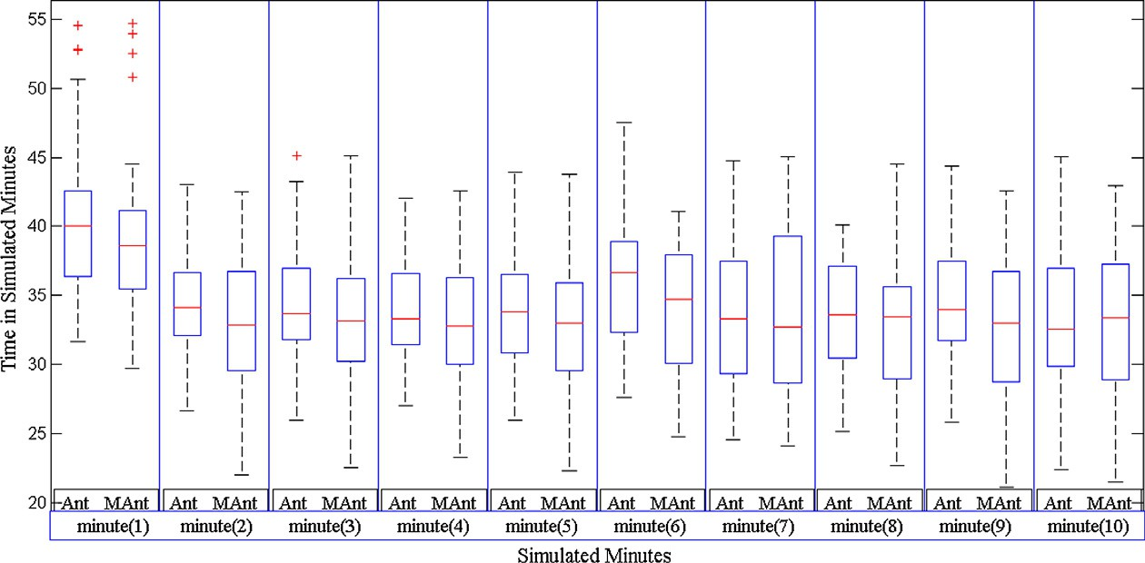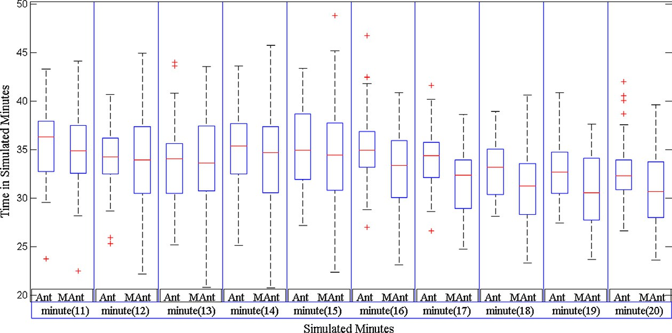

1. Significant enhancement during 60%, of simulation time, of the average travel time at each minute, as illus- trated in Table 5. It shows a significant decreases in aver- age travel times for 12 min, shown in red color, of the 20 simulation minutes.
2. Significant performance enhancement for 80% of the network nodes, as shown in Table 6. It shows a signifi- cant decrease in average travel times achieved for 12 nodes, shown in red color, out of the 15 visited nodes.
3. Conclusion

In this paper, a Threshold-based version of the AntNet algo- rithm is presented as a promising approach to be applied for dynamic traffic routing of road networks. The algorithm ex- ploits the practical pre-known information about good travel times among various points over road network.

Exploitation of the pre-known good travel times as threshold values combined by the strategy of periodical check of the discovered routes accelerates, not only, convergence of a good route discovery, but also, recovery from a derogated route.

Threshold based AntNet algorithm for dynamic traffic routing of road networks 119

|  |  |  |
| --- | --- | --- |
| Table 4 Average travel time for each node. | | |
| Node | AntNet | Threshold based AntNet |
| 2 | 12.39 ± 2.46 | 11.76 ± 2.64 |
| 3 | 28.56 ± 3.67 | 25.36 ± 4.03 |
| 4 | 42.97 ± 5.07 | 39.88 ± 4.24 |
| 5 | 12 ± 2.44 | 11.81 ± 2.59 |
| 6 | 19.6 ± 2.48 | 19.05 ± 2.24 |
| 7 | 32.31 ± 3.78 | 30.12 ± 2.96 |
| 8 | 44.72 ± 3.66 | 42.31 ± 3.74 |
| 9 | 23.82 ± 3.66 | 22.73 ± 3.72 |
| 10 | 29.21 ± 2.57 | 27.77 ± 2.59 |
| 11 | 41.53 ± 2.57 | 38.94 ± 2.59 |
| 12 | 50.33 ± 3.09 | 48.9 ± 3.78 |
| 13 | 37.84 ± 4.03 | 35.43 ± 4.33 |
| 14 | 40.47 ± 3.36 | 37.61 ± 3.84 |
| 15 | 46.18 ± 3.09 | 44.78 ± 3.26 |
| 16 | 55.85 ± 3.03 | 53.55 ± 3.00 |
| Average ± standard deviation. | | |

Fig. 7 The average travel time from node 1 to all other nodes during the simulation period.

In theory, the performance of the threshold algorithm for a given network of n nodes was computed to be at worse case O(n2). Yet, the processing time for a discovered route de- creases significantly to become a constant that depends, only, on the number of nodes in the given route (as it is monitored, only, by the check ant). This performance last until the route became derogated. This behavior of the algorithm permits for a rapid coverage of the network changes (more forward ants will traverse and discover good routes for the remaining destinations), therefore, counterbalancing better with dynamic road states.

The standard AntNet algorithm is amenable to the asso- ciated changes in traffic load. Dhillon and Mieghem [5], showed that it has better performance than that of the shortest path routing algorithms. In that context, the influ- ence of the modification were measured by comparing the modified algorithm performance with that of the standard Antnet. It was tested through a designed simulation experi- ment. Experiment results indicated 11.88%, increase in the number of launched ants and a 3.13% decrease in the aver- age travel time, as shown in Table 2. These results were val- idated, even, further by applying a one-tailed *t*-test. In general it proved the significance of the enhancement pro- vided by the Threshold-based AntNet algorithm. In particu- lar, it validated the significant performance of ant’s travel time during 60% of the simulation time, as shown in Table 5. Also, the *t*-test confirmed the significance of enhancement performance for 80% of the network nodes, as shown in Table 6.

Experimental results ensure that the efficiency of the Threshold-based AntNet is significant with respect to the stan- dard AntNet algorithm. The improvement in the performance was highlighted in the time efficiency that reduces computa- tional time. Whereas, reduction in the average travel time, al- lows significant increase in the number of launched ants which accelerates the search for new good routes. The presented

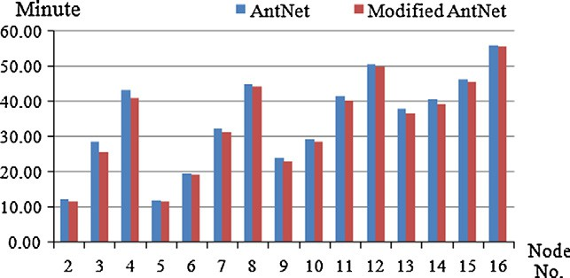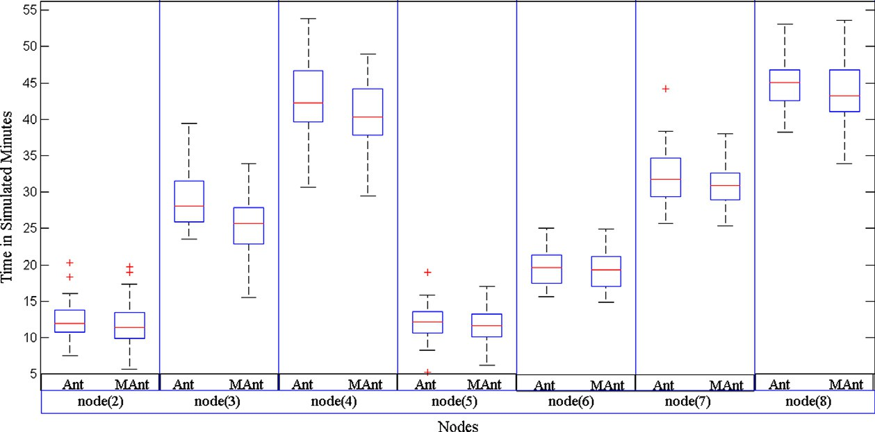

Fig. 8 Boxplot comparison between AntNet and modified AntNet For travelling times for nodes 2–8.

120 A.M. Ghazy et al.

Fig. 9 Boxplot comparison between AntNet and modified AntNet for travelling times for nodes 9–16.

Table 5

Minutes 1

2

3

4

5

Related *t*-test at each minute.

*t*-Value

2.3

3.5

2.04

1.89

2.86

Minutes

6

7

8

9

10

*t*-Value

3.83

—0.29

Minutes

11

12

13

14

15

*t*-Value

0.94

0.80

1.56

2.16

0.48

—0.85

1.60

0.73

Minutes

16

17

18

19

20

*t*-Value

3.34

5.30

3.82

4.77

3.04

|  |  |  |  |  |  |  |  |  |  |  |  |  |  |  |  |
| --- | --- | --- | --- | --- | --- | --- | --- | --- | --- | --- | --- | --- | --- | --- | --- |
| Table 6 Related *t*-test for each node. | | | | | | | | | | | | | | | |
| Node | 2 | 3 | 4 | 5 | 6 | 7 | 8 | 9 | 10 | 11 | 12 | 13 | 14 | 15 | 16 |
| Computed *t*-value | 2.39 | 8.68 | 3.71 | 1.58 | 1.63 | 2.42 | 1.62 | 2.66 | 2.75 | 3.36 | 1.74 | 3.63 | 3.81 | 2.73 | 1.77 |
|  |  |  |  |  |  |  |  |  |  |  |  |  |  |  |  |

modifications, allowed the algorithm to preserve the discov- ered good routes and to, rapidly, converge toward good routes. The inspired agent, ‘ *check ant*’, assist in preserving good routes and, better yet, exposes and discards the degraded good route.

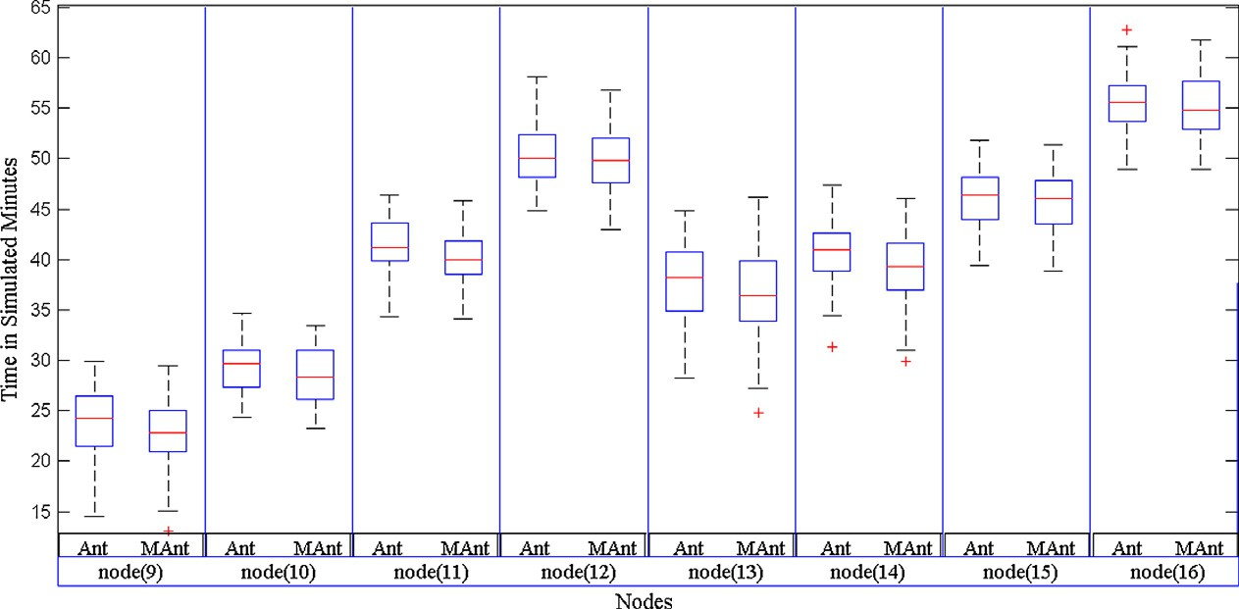

References

1. Kanoh H, Kozuka H. Evaluation of GA-based dynamic route guidance for car navigation using cellular automata. In: IEEE intelligent vehicle symposium, 17–21 June 2002, vol. 1. p. 178–

83.

1. Yang L, Lin J, Wang D, Jia L. Dynamic route guidance based on artificial immune system. J Control Theory Appl 2007;5(4): 385–90.
2. Hamed AY. A Genetic algorithm for finding the *k* shortest paths in a network. Egyptian Inform J 2010;11:75–9.
3. Di Caro G, Dorigo M. AntNet: distributed stigmergetic control for communications networks. J Articial Intell Res (JAIR) 1998;9:317–65.
4. Dhillon SS, Van Mieghem P. Performance analysis of the AntNet algorithm. Comput Networks 2007;51:2104–25.
5. Baran B, Sosa R. AntNet routing algorithm for data networks based on mobile agents. Inteligencia Artificial, Revista Ibero- americana de Inteligencia Artificial 2001;12:75–84.
6. Kassabalidis I, El-Sharkawi MA, Marks RJ, Arabshahi P, Gray

AA. Adaptive-SDR: adaptive swarm-based distributed routing. In: Proceedings of the international joint conference on neural networks, Honolulu (HI), vol. 1; 2002, p. 351–4.

1. Soltani A, Akbarzadeh-T M-R, Naghibzadeh M. Helping ants for adaptive network routing. J Franklin Inst 2006;343:389–403.
2. Tekiner F, Ghassemlooy FZ, Al-khayatt S. The AntNet Routing Algorithm-Improved Version. In: Proceedings of the international symposium on communication systems networks and digital signal processing (CSNDSP), Newcastle (UK), July 2004. p. 22–6.

Threshold based AntNet algorithm for dynamic traffic routing of road networks 121

1. Radwan A, Mahmoud T, Houssein E. AntNet-RSLR: a proposed ant routing protocol for MANETs. In: Proceedings of the first Saudi international electronics, communications and electronics conference (SIECPC’11), April 23–26, 2011. p. 1–6.
2. Kroon R, Rothkrantz LJM. Dynamic vehicle routing using an ABC-algorithm. In: Transportation and telecommunication in the 3rd millennium, Prague, 2003. pp. 26–7.
3. Boehle´J, Rothkrantz L, van Wezel M. CBPRS: a city based parking and routing system. Technical report ERS-2008-029-LIS, Erasmus Research Institute of Management, ERIM, University Rotterdam; 2008.
4. Suson A. Dynamic routing using ant-based control. Master thesis, Faculty of Electrical Engineering, Mathematics and Computer Science, Delft University of Technology; 2010.
5. Tatomir B, Rothkrantz LJM. Dynamic traffic routing using Ant based control. In: IEEE international conference on systems, man and cybernetics (SMC 2004) on impacts of emerging cybernetics and human-machine systems, October, 2004. p. 3970–3975.
6. Ghazy A. Enhancement of dynamic routing using ant based control algorithm. Master thesis, Institute of Statistical Studies and Research, Cairo University; 2011.