[Egyptian Informatics Journal 20 (2019) 131–141](https://doi.org/10.1016/j.eij.2019.01.002)

Contents lists available at [ScienceDirect](http://www.sciencedirect.com/science/journal/11108665)

Egyptian Informatics Journal

journal homepage: [www.sciencedirect.com](http://www.sciencedirect.com/)

Full length article

[](http://crossmark.crossref.org/dialog/?doi=10.1016/j.eij.2019.01.002&domain=pdf)Total opportunity cost matrix – Minimal total: A new approach to determine initial basic feasible solution of a transportation problem

Bilqis Amaliah a,⇑, Chastine Fatichah a, Erma Suryani b

a *Department of Informatics, Faculty of Information and Communication Technology, Institut Teknologi Sepuluh Nopember, Surabaya 60111, Indonesia*

b *Department of Information Systems, Faculty of Information and Communication Technology, Institut Teknologi Sepuluh Nopember, Surabaya 60111, Indonesia*

a r t i c l e i n f o

*Article history:*

Received 27 July 2018

Revised 4 December 2018

Accepted 14 January 2019

Available online 26 January 2019

*Keywords:*

Transportation problem Initial basic feasible solution Optimal solution

Total opportunity cost matrix

a b s t r a c t

Transportation Problem (TP) deals with cost planning for delivering the product from the source to the destination and Initial Basic Feasible Solution (IBFS) is presented to find the way out in obtaining an opti- mal solution. IBFS is an important element to reach an optimal result. The previous methods related to it did not always provide the satisfied result all the time. Therefore a new method called Total Opportunity Cost Matrix – Minimal Total (TOCM-MT) to determine IBFS as a basic solution to solve TP was proposed. The objective is to achieve a total cost with similar or closer values to the optimal solution. TOCM for the initial matrix and a better mechanism are highly considered to obtain IBFS. Thirty-one numerical exam- ples, in which twenty-five were selected from some journals and six were generated randomly, were used to evaluate the performance of it. The proposed method has been compared to Vogel’s Approximation Method (VAM), Juman and Hoque Method (JHM), and Total Differences Method 1 (TDM1). TOCM-MT was proven to have twenty-four numerical examples with similar values and seven numerical examples with closer values to the optimal solution. The experiment results indicated that TOCM-MT obtained bet- ter minimal cost than that of VAM, JHM, and TDM1.

© 2019 Production and hosting by Elsevier B.V. on behalf of Faculty of Computers and Information, Cairo

University. This is an open access article under the CC BY-NC-ND license ([http://creativecommons.org/](http://creativecommons.org/licenses/by-nc-nd/4.0/)

[licenses/by-nc-nd/4.0/](http://creativecommons.org/licenses/by-nc-nd/4.0/)).

1. Introduction

The Transportation Problem (TP) deals with transporting some products from the source to the destination with the minimal total cost subject to satisfy the demand and the supply constraints [1]. The objective of TP is to achieve minimal total cost as an optimal solution. It was first developed by Hitchcock [2] and one of the lin- ear programming problems [1,3]. It can be applied to the real- world problems such as personal assignment [4], task allocation [5], problems of flow shop scheduling [6,7], and vehicle routing [8,9].

There are two steps in obtaining the optimal solution of TP. The first step is finding an Initial Basic Feasible Solution (IBFS) and the

* Corresponding author.

*E-mail addresses:* [bamaliah@gmail.com](mailto:bamaliah@gmail.com) (B. Amaliah), [chastine@if.its.ac.id](mailto:chastine@if.its.ac.id) (C. Fatichah), [erma.suryani@gmail.com](mailto:erma.suryani@gmail.com) (E. Suryani).

Peer review under responsibility of Faculty of Computers and Information, Cairo University.

**Production and hosting by Elsevier**

second one is finding an optimal solution from IBFS [10]. It is nec- essary to start with IBFS to solve transportation problem [1,3,4,10]. Finding IBFS is important and significant because it is a basic solu- tion in obtaining optimal solution [3]. The result of IBFS can be similar or closer to the values of the optimal solution. The better result of IBFS can decrease the number of iterations in obtaining an optimal solution [1]. This research focuses on finding IBFS to obtain the minimal total cost of the transportation problem.

Many studies related to IBFS have been done by several researchers and the three well-known ones are Northwest Corner Method (NCM), Least Cost Method (LCM), and Vogel’s Approxima- tion Method (VAM) [11]. Some methods to find IBFS based on LCM have been developed by some researchers such as Juman and Hoque [1], Babu [12], Juman and Hoque [13], Babu [14], Dhurai [15], Kousalya and Malarvizhi [16], Ahmed et al. [17,18], Desh- mukh [19]. Juman and Hoque [1] proposed Juman Hoque Method (JHM) to obtain IBFS. It was different from the other ones because it started with an infeasible solution and leads to an efficient IBFS. The experiment showed that JHM led to the minimal total cost of 16 out of 18 transportation problem. Ahmed et al. [17] presented Incessant Allocation Method (IAM) to get the IBFS for transporta- tion problem. It can be applied in a balanced and unbalanced transportation problem. They [18] developed the Allocation

<https://doi.org/10.1016/j.eij.2019.01.002>

1110-8665/© 2019 Production and hosting by Elsevier B.V. on behalf of Faculty of Computers and Information, Cairo University. This is an open access article under the CC BY-NC-ND license (<http://creativecommons.org/licenses/by-nc-nd/4.0/>).

Table Method (ATM) which began from the least odd cost to obtain IBFS. It was similar to the one presented by Deshmukh [19].

VAM is the best well-known initial basic feasible solution in general [3]. It has been studied for a long time and modified by some researchers such as Hosseini [3], Soomro et al. [20,21], Rashid [22], Hakim [23]. Goyal [24], Das et al. [25,26], Azad and Hossain

[27], Alkubaisi [28], Seethalakshmy and Srinivasan [29]. Hosseini

[3] proposed Total Differences Method 1 (TDM1) to obtain IBFS for TP. VAM calculates penalties for all rows and columns, while TDM1 calculates penalty only for rows. Another difference is how to calculate the penalty. TDM1 penalty is more complete than that of VAM. It is because VAM penalty is the difference between two least costs and TDM1 penalty is the total differences between the least and other costs. Azad and Hossain [27] considered the aver- age row and column penalties. Alkubaisi [28] used the median cost to find the penalty value. Seethalakshmy and Srinivasan [29] offered an alternative method to calculate the penalty value. The row penalty is the difference between the two highest costs and the column penalty is the difference between the max and the min cost. Soomro et al. [21] developed Modified Vogel’s Approxi- mation Method (MVAM) to find a basic feasible solution for the transportation problem.

Total Opportunity Cost Matrix (TOCM) was introduced by Kirca and Satir [30]. It transforms the original matrix of TP into an initial matrix by adding the row and the column opportunity cost matrix. The row/column opportunity cost matrix subtracts every element in it by the least cost. Khan et al. [31] proposed TOCM-SUM to obtain a feasible solution of the transportation problem. Dubey and Shrivastara [32] used TOCM to improve VAM. Islam et al. [33] presented Total Opportunity Cost Table (TOCT) to find the basic feasible solution (BFS) of the trans- portation problem. Khan et al. [34] specified the distribution indi- cator for each cell of the TOCM. Mathirajan and Meenakshi [35] combined TOCM and VAM to get the minimal total cost of the transportation problem.

Some literatures concerning with the TP and the various tech- niques have been developed. Maity and Roy [36] developed a mathematical model to solve a multi–objective nonlinear trans- portation problem with multi-choice demand. Their research [37] discussed the various mathematical models of multi-objective transportation problem (MOTP) such as goal programming (GP), weighted goal programming (WGP), and revised multi-choice goal programming (RMOGP). After that they developed a new approach of RMOGP and utility function of MOTP. Roy and Maity [38] considered a new way to minimize the cost and the time of transportation problem through a single objective function in the multi-choice environment with interval value. Their research

[39] proposed the utility function to select goals of multi- objective transportation problem which has two stages and multi-choice grey number. Ali and Mustapha [40] compared five methods of transportation problem to find the best one. Roy et al. [41] introduced a conic scalarization approach to obtain a

VAM, JHM and TDM1 were examined to find IBFS and they could not provide the optimal solution all the time. Then TDM1 was chosen because of the following reasons: the highest penalty (HP) is arbitrarily chosen and the maximum units are directly allo- cated to the least cost cell. Hence the optimal solution was not always obtained. Some studies used TOCM matrix as the initial matrix and produce a better IBFS. Therefore this research inte- grates TOCM and modified TDM1 called Total Opportunity Cost Matrix – Minimal Total (TOCM-MT) to determine IBFS of TP. The benefits of TOCM-MT over TDM1 can be expressed as follows:

1. TOCM-MT uses TOCM as the initial matrix due to the greater chance of being selected as the least cost while TDM1 uses the original one without any chances
2. TOCM-MT has the rules to select HP while TDM1 chooses HP arbi- trarily when there are several HP with the same values. So that, TOCM-MT has a higher chance to obtain the optimal solution.
3. TOCM-MT has a mechanism to allocate the maximum units to the least cost cell when the least cost is equal to zero while TDM1 directly allocates maximum units to the least cost cell. So that, has a greater chance to obtain the minimal cost.

The remainder of this paper is organized as follows: Sections 2 and 3 present the mathematical formulation of the transportation problem and Total opportunity cost matrix. The existing methods are summarized in Section 4. Section 5 is the description of TOCM-MT and Section 6 is the illustration of the numerical samples. The experimental results showing the performance of the proposed method is discussed in Section 7. The conclusions of the experiment and future research are demonstrated in Section 8.

1. Mathematical formulation of transportation problem

Transportation problem (TP) can be represented by the network diagram in Fig. 1 [10,18] and by the formulation table in Table 1 [17]. The objective of the network diagram and formulation table is to determine the value of variable *Xi,j* that will minimize the total cost of the transportation problem as shown in Eq. (1).

The following notation is used for the mathematical formula- tion [31].

* 1. Total number of supply
  2. Total number of demand

*Si* Supply *i*

*Dj* Demand *j*

*Ci,j* Transportation cost from the supply *i* to demand *j Xi,j* Allocation made from the supply *i* and demand *j*

Using the notation, the objective TP can be formulated as follow:

solution of the multi-objective transportation problem. Maity *m n*

XX

et al. [42] studied the multi-objective transportation problem with fuzzy multi-choice goals of an objective function.

Because of the intractability of carrying out calculations, some

Min *Z* = *CijXij* (1)

*i*=1 *j*=1

Subject to P*n Xij* = *Si* for *i* = 1; 2; ... *m*

*j*=1

P *Xij* = *Dj* for *j* = 1; 2; .. . ; *n*

researchers implemented the methods using C++ program lan- guage, Java and Matlab. Imam et al. [43] and Sen et al. [44] used C++ program language to make the object-oriented model to solve

*m i*=1

Where *Xij* P 0 for all *i*; *j*

(2)

the transportation problem. Juman and Hoque [1] implemented JHM in C++ program language. Lawal and Eberendu [45] imple-

A transportation problem is balanced if the total supply is equal to the total demand as shown in Eq. (3).

mented the Northwest, Least cost, VAM, Modified Distribution *m m*

and the stepping stone in Java and Net Beans. Khan et al. [46]

Implemented twelve methods in Matlab.

X*Si* = X*Dj* (3)

*i*=1

*j*=1

|  |  |  |  |  |  |
| --- | --- | --- | --- | --- | --- |
| Table 3  TOCM Matrix. |  | | | | |
|  | D1 | D2 | D3 | D4 | Supply |
| S1 | 9 | 42 | 50 | 0 | 7 |
| S2 | 91 | 22 | 10 | 80 | 9 |
| S3 | 53 | 0 | 92 | 22 | 18 |
| Demand | 5 | 8 | 7 | 14 |  |

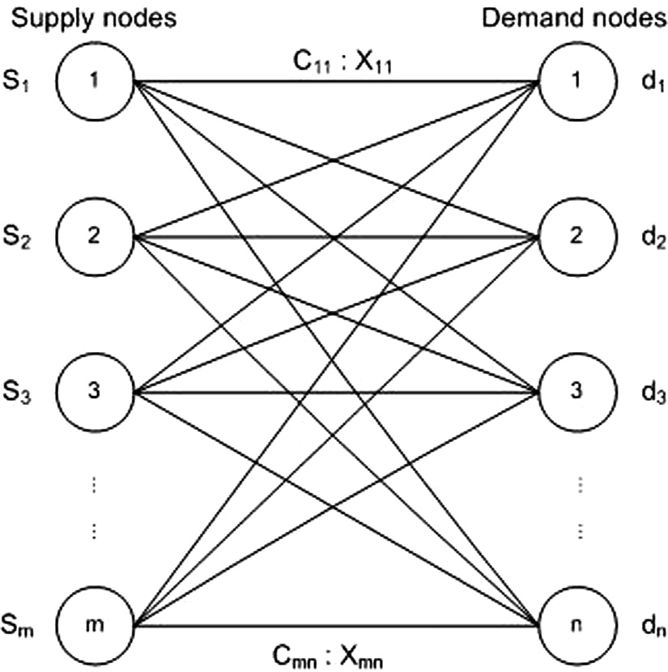Fig. 1. Network diagram of the transportation problem.

Table 1

Formulation table of the transportation problem.

Demand 1 Demand 2 Demand n

Supply 1 C11 C12 .. . C1*n* S1

X11 X12 X1*n*

Supply 2 C21 C22 .. . C2*n* S2

X21 X22 X2*n*

. . .. . .

. . .

. . .

Supply *m* C*m*1 C*m*2 .. . C*mn* S*m*

X*m*1 X*m*2 X*mn* D1 D2 D*n*

1. Total opportunity cost matrix

Total Opportunity Cost Matrix (TOCM) is introduced by Kirca and Satir [30]. It is transforming the matrix transportation problem from the original matrix into an initial matrix by adding the row and column opportunities. Table 2 is the matrix of the original transportation problem. The row opportunity subtracts every ele- ment in the row by the least cost in it. The column opportunity subtracts every element in the column by the least cost in it. TOCM is the sum of row and column opportunities as shown in Table 3.

1. The existing methods to find IBFS

Initial Basic Feasible Solution (IBFS) is an initial solution of transportation problem (TP) and is known as the starting solution of TP. In some cases, IBFS gets the optimal solution. Three existing methods will be discussed to find IBFS in this section.

The first method is Vogel’s Approximation Method (VAM) which is better than Northwest method and the least cost method [1]. The steps of VAM can be described as follows: Step 1 Construct

Table 2

Original transportation problem matrix.

the transportation problem matrix. If the total supply is not equal to the total demand, then the dummy row or column is added. Step 2 Find the penalty for each row and column. The penalty is the dif- ference between the two least costs. Step 3 Select the highest pen- alty. Step 4 Select the least cost. Step 5 Allocate the maximum possible units to it. Step 6 Adjust the supply and demand then cross out the satisfied row or column. Step 7 Recalculate the pen- alty without considering the cross out rows and columns. Step 8 Repeat steps 3–7 until all rows and columns are satisfied. Step 9 Finally, calculate the total cost transportation problem. Total cost transportation problem is the multiplication of the cost and units allocated.

The second method is the Juman and Hoque Method (JHM). JHM doesn’t need balance transportation problem and penalty [1]. The steps of JHM can be described as follows: Step 1 Construct the ini- tial transportation problem matrix. Step 2 For each column, iden- tify the least cost cell, and then assign the demand there. Step 3 Check each of the row whether the row sum is less than or equal to the supply quantity. If so, go to step 9. Step 4 If there are a few unmet rows, determine the difference between the second least and the least unit costs, identify the smallest of them, and go to Step 5. If only one unmet row, go to step7. Step 5 For each unmet row, check the cell without the second least unit cost in another unmet row. Check the previous row when such a row is found and go to step 7. Step 6 Select any two unmet rows. For each of them, find differences between the second least and the least unit costs. Step 7 Considering the identified unmet row in step 5 (or step 4or step 6) transfer the maximum amount of the excess supply from the least cost cell to the next least cost cell, and con- tinue this transferring until no excess supply exists. Step 8 Cross off the row that has been satisfied, and go to step 3. Step 9 Stop, the current solution is the IBFS.

The third method is Total Difference Method 1 (TDM1). TDM1 calculates the penalty only for rows [3]. The steps of TDM1 can be described as follows: Step 1 Construct the transportation prob- lem matrix. If the total supply is not equal to the total demand, then the dummy row or column is added. Step 2 Find the penalty for each row. The penalty is the total difference between the least and other costs. Step 3 Select the highest penalty. Step 4 Select the least cost. Step 5 Allocate the maximum possible units to it. Step 6 Adjust the supply and demand then cross out the satisfied row or column. Step 7 Recalculate the penalty without considering the cross out rows and columns. Step 8 Repeat steps 3–7 until all rows and columns are satisfied. Step 9 Finally, calculate the total cost transportation problem. Total cost transportation problem is the multiplication of the cost and units allocated.

1. Total opportunity cost matrix – Minimal total

Total Opportunity Cost Matrix – Minimal Total (TOCM-MT) is the combination of TOCM and modified TDM1. The steps of TOCM-MT can be described as follows:

|  |  |  |  |  |  |  |
| --- | --- | --- | --- | --- | --- | --- |
|  | D1 | D2 | D3 | D4 | Supply |  |
| S1 | 19 | 30 | 50 | 10 | 7 | Step 1: Construct an original Transportation Problem (TP) |
| S2 | 70 | 30 | 40 | 60 | 9 | matrix m × n with cost C*ij*, supplies S*i*; *i* = 1..*m* and demands |
| S3 | 40 | 8 | 70 | 20 | 18 | D*j*; *j* = 1..*n*. If the total supply is not equal to the total demand, |
| Demand | 5 | 8 | 7 | 14 |  | then the dummy row or column is added. |

Step 2: Construct a row opportunity matrix from the original TP by finding the least cost of each row then subtract each cost in the row with the least cost.

Step 3: Construct a column opportunity matrix from original TP by finding the least cost of each column then subtract each cost in the column with the least cost.

Step 4: Construct the TOCM in which the entries are the sum of the row and column opportunity matrix.

Step 5: Find the penalty *Pi* for each row. The penalty *Pi* is the total difference between the least cost *LCi* and other costs in the row, as shown in Eqs. (4) and (5).

*LCi* = *min*(*Cij*), *j* = 1..*n* (4)

*n*

X

*Pi* = (*Cij* — *LCi*) (5)

*j*=1

Step 6: Select the Highest Penalty (HP) as shown in Eq. (6). In case of a tie (i.e. equal HP), use the following tie-breakers in the given order: (i) Select HP with the smallest *Cij*. (ii) In case of a tie in (i), select penalty with the greatest total cost *TCi* as shown in Eq. (7). (iii) In case of a tie in (ii), select penalty with

the max allocation of *Xi,j*.

Table 4

Comparison of TOCM-MT and TDM1.

|  |  |  |  |  |
| --- | --- | --- | --- | --- |
| Step | Step Description | TOCM-MT | TDM1 |  |
| 1 | Construct original TP | Yes | Yes |  |
| 2 | Construct a row opportunity matrix | Yes |  | No |
| 3 | Construct a column opportunity matrix | Yes |  | No |
| 4 | Construct the TOCM | Yes |  | No |
| 5 | Find the penalty Pi for each row | Yes | Yes |  |
| 6 | Rules to select the Highest Penalty | Yes |  | No |
| 7 | Select the least cost | Yes | Yes |  |
| 8 | Check the value of LC | Yes |  | No |
| 9 | Allocate the maximum possible units Xij | Yes | Yes |  |
| 10 | Adjust the supply and demand | Yes | Yes |  |
| 11 | Recalculate the penalty | Yes | Yes |  |
| 12 | Repeat step 6–11 | Yes | Yes |  |
| 13 | Calculate TCTP | Yes | Yes |  |

Step 12: Repeat steps 6–11 until all the rows and columns are satisfied.

Step 13: Finally, calculate the Total Cost Transportation Prob- lem (TCTP) by combining TOCM-MT with the penalty and the original transportation problem as shown in equation (11).

*m n*

XX

*HP* = *max*(*Pi*), *i* = 1..*m* (6)

*n*

X

*TCi* = *Cij* (7)

*j*=1

Step 7: Select the least cost (LC) from the highest penalty. In case of a tie (i.e. equal LC), select LC with the max allocation of *Xi,j.*

Step 8: Check the value of LC. If LC is not equal to zero, then go to step 9, else if LC equal to zero then select the HP from the first HP (HP1) or second HP (HP2). Select the HP by comparing each cost cell in HP1 and each cost cell in HP2. *C*1*j* is the cost at HP1 and *C*2*j* is the cost at HP2. The value of *GV*1*j* is 1 if the cost in HP1 is greater than the cost in HP2 and 0 if the cost in HP1 is smaller than the cost in HP2. The value of *GV*2*j* is 1 if the cost in HP1 is smaller than the cost in HP2 and 0 if the cost in HP1 is greater than the cost in HP2. *TotalGV*1*j* is the sum of *GV*1*j* as shown in Eq. (8) and *TotalGV*2*j* is the sum of *GV*2*j* as shown in Eq. (9). HP is HP1 if *TotalGV*1*j* is greater than *TotalGV*2*j* and HP is HP2 if *TotalGV*1*j* is smaller than *TotalGV*2*j* as shown in Eq. (10).

*n*

X

*TCTP* = *CijXij* (11)

*i*=1 *j*=1

There are three differences between TOCM-MT and TDM1. The first one is TOCM-MT uses TOCM matrix while TDM1 uses the orig- inal matrix. The second one is TOCM-MT has the rules to select the HP while TDM1 does not. The third one is TOCM-MT checks the value of the least cost before allocating the maximum units X*ij* while TDM1 directly allocated the maximum units X*ij* to the least cost. The comparison of TOCM-MT and TDM1 is shown in Table 4.

1. Computational experiment

This research used thirty-one numerical examples to illustrate the proposed method TOCM-MT. Twenty-five numerical examples were selected from journals and six numerical examples were gen- erated randomly. The following sample from Deshmukh [19] is used to illustrate the proposed method. For Examples, a company has 3 supply plants which produce 7, 9 and 18 cars. The company

supplies to four buyers whose demands are 5, 8, 7, 14 cars respec- tively. The transportation cost per piece of cars is given in Table 5.

# *TotalGV* 1*j*

where

= *GV* 1*j*

*j*=1

(8)

The goal is to find out the schedule of shifting cars from plants to buyers with the minimum total cost.

Step 1: Construct an original Transportation Problem (TP) as

*GV* 2*j* =

1 *if C*1*j* < *C*2*j*, *j* = 1, 2, ..*n*

0 *if C*1*j* P *C*2*j*, *j* = 1, 2, ..*n*

*n*

X

shown in Table 5.

Step 2: Construct a row opportunity matrix from the original TP; find the least cost of each row then subtract each cost in the row with the least cost, e.g. the least cost of row 1 is 10, then

*TotalGV* 2*j* = *GV* 2*j* (9)

*j*=1

where

subtract each cost in the cell with 10.

Step 3: Construct a column opportunity matrix from the origi- nal TP; find the least cost of each column then subtract each

*HP* = *HP*1 *if TotalGV* 1*j* P *TotalGV* 2*j*

# *HP*2 *if TotalGV* 1*j* < *TotalGV* 2*j*

Step 9: Allocate the maximum possible units *Xij*

(10)

to the least cost

Table 5

An original transportation problem.

cell of HP.

|  |  |  |  |  |  |
| --- | --- | --- | --- | --- | --- |
|  | D1 | D2 | D3 | D4 | Supply |
| S1 | 19 | 30 | 50 | 10 | 7 |
| S2 | 70 | 30 | 40 | 60 | 9 |
| S3 | 40 | 8 | 70 | 20 | 18 |
| Demand | 5 | 8 | 7 | 14 |  |

Step 10: Adjust the supply and demand then cross out the sat- isfied row or column.

Step 11: Recalculate the penalty without considering the cross out rows and columns.

Table 6

TOCM Matrix of original TP.

|  |  |  |  |  |  |
| --- | --- | --- | --- | --- | --- |
|  | D1 | D2 | D3 | D4 | Supply |
| S1 | 9 | 42 | 50 | 0 | 7 |
| S2 | 91 | 22 | 10 | 80 | 9 |
| S3 | 53 | 0 | 92 | 22 | 18 |
| Demand | 5 | 8 | 7 | 14 |  |

Table 7

Penalty 1 for each row and allocation 7 unit to the cell (2,3).





cost in the column with the least cost, e.g. the least cost of col- umn 1 is 19, then subtract each cost in the cell with 19.

Step 4: Construct the TOCM in which the entries are the sum of the row and column opportunity matrix as shown in Table 6. Step 5: Find the penalty for each row. The penalty is the total difference between the least cost and other costs in the row. Penalty 1 of row 1 is 101, row 2 is 163, and row 3 is 167 as shown in Table 7.

Step 6: Select the Highest Penalty (HP). The HP of Penalty 1 is 167 at row 3.

Step 7: Select the least cost (LC) from the highest penalty. The LC is 0.

Step 8: Check the value of LC. Because LC is equal to zero then select the HP from the first HP (HP1) or second HP (HP2). The first HP is 167 and second HP is 163.

Select the HP by comparing each cost cell in HP1 and each cost cell in HP2.

C11, C12, C13, and C14 are cost at HP1 where C11 is 53, C12 is 0, C13 is 92, and C13 is 22. C21, C22, C23, and C24 are cost at HP2 where C21 is 91, C22 is 22, C23 is 10, and C24 is 80.

The value of GV11 is 0 because 53 is smaller than 91. The value of GV12 is 0 because 0 is smaller than 22. The value of GV13 is 1 because 92 is greater than 10. The value of GV14 is 0 because 22 is smaller than 80. The value of GV21 is 1 because 53 is smaller than

91. The value of GV22 is 1 because 0 is smaller than 22. The value of GV23 is 0 because 92 is greater than 10. The value of GV24 is 1 because 22 is smaller than 80. *TotalGV*1*j* is the sum of GV11, GV12, GV13, and GV14, and then the *TotalGV*1*j* is 1. *TotalGV*2*j* is the sum

of GV21, GV22, GV23, and GV24, and then the *TotalGV*2*j* is 3. Because

*TotalGV*2*j* is greater than *TotalGV*1*j*, then HP is HP2.

Step 9: Allocate the maximum possible units *Xij* to the least cost cell of HP as shown in Table 7. Allocate 7 units (box) to the cell (3), (4). Adjust the supply and demand, supply S2 become 2 from 9 (it is remaining 2 cars in the Supply 2) and demand D3 become 0 from 7 (it means that the demand 3 has been satisfied)

Step 10: Adjust the supply and demand then cross out the sat- isfied row or column. Cross out the satisfied demand D3.

Step 11: Recalculate the penalty 2 without considering the cross out rows and columns as shown in Table 8. The penalty 2 of row 1 is 51, row 2 is 127, and row 3 is 75.

Step 12: Go to step 6 and repeat steps 6 – 11 until the rows and columns are satisfied. The final table is shown in Table 8.

Step 13: Finally, calculate the Total Cost Transportation Prob- lem (TCTP) by combining TOCM-MT with the penalty and orig- inal transportation problem as shown in Table 9.

Hence the allocation units given from Table 9 are as follows: X11 = 5, X14 = 2, X22 = 2, X23 is 7, X32 = 6, X34 = 12, along with asso-

ciated total cost 743, which is the optimal solution for this numer- ical example. Note that the total cost of this numerical example found by VAM and TDM1 is 779, which is not the optimal solution. Based on the above description, TDM1 did not get the optimal solution which is different from TOCM-MT. The allocation units given from Table 10 are as follows: X11 = 5, X14 = 2, X23 = 7,

X24 = 2, X32 = 8, X34 = 10, along with associated total cost 779.

1. Experimental result

This section provides the comparisons among the existing methods of VAM, JHM, TDM1, and the proposed one TOCM-MT. The comparison results are shown in Tables 11, 12, and in Figs. 2–

5. The 25 numerical examples used in this experiment are taken from 20 different journals and also 6 numerical examples ran- domly generated. The detail data of 6 randomly generated samples are given in Appendix A. TOCM-MT, TDM1, and JHM have been coded in C++ programming language and run successfully for the solution of 31 numerical examples. TORA software was applied in VAM and optimal solution.

The experimental results of VAM, JHM, TDM1, and TOCM-MT for 25 numerical examples from the journal are shown in Table 11 and for 6 randomly generated numerical examples are shown in Table 12. Tables 11 and 12 show the improvement percentage of TOCM-MT over VAM, JHM and TDM1, in which the positive num- ber means that TOCM-MT provides better results compared to VAM, JHM and TDM1, zero value indicates that the total cost of TOCM-MT is the same as VAM, JHM and TDM1, and the negative number means that VAM, JHM and TDM1 yields better results

Table 8

TOCM-MT with a penalty based on Deshmukh numerical example.



Table 9

Combining TOCM-MT with the penalty and original transportation problem based on Deshmukh numerical example.



compared to TOCM-MT. The improvement percentage [1] is calcu- lated using Eq. (12).

*Ip* = *IBFS* — *Tm x*100 (12)

# *IBFS*

Notation

*Ip* Improvement

*IBFS* initial basis feasible solution

*Tm* TOCM-MT

Table 10

The final result of TDM1 based on Deshmukh numerical example.



Table 11

The experimental results of VAM, JHM, TDM1, and TOCM-MT for 25 numerical examples from the journal.

Problem chosen Initial Basic Feasible Solution (IBFS) Optimal (Op) Improvement of TOCM-MT

over VAM, JHM, and TDM1 (%) -(Ip)

Deviation percentage from optimal (%) (Dv)

|  |  |  |  |  |  |  |  |  |  |  |  |  |  |  |
| --- | --- | --- | --- | --- | --- | --- | --- | --- | --- | --- | --- | --- | --- | --- |
|  | VAM | JHM | TDM1 | TOCM-MT (Tm) |  | VAM | JHM | TDM1 |  | VAM | JHM | TDM1 | TOCM-MT |  |
| Srinivasan [47] | 955 | 880 | 880 | 880* | 880 | 7.85 | 0 | 0 |  | 8.52 | 0 | 0 | 0 |  |
| Sen et al. [44] | 2,164,000 | 2,146,750 | 2,158,500 | 2,158,500 | 2,146,750 | 0.25 | —0.55 | 0 |  | 0.8 | 0 | 0.55 | 0.55 |  |
| Goyal [24] | 1,745 | 1,650 | 1,650 | 1,650* | 1,650 | 5.44 | 0 | 0 |  | 5.76 | 0 | 0 | 0 |  |
| Deshmukh [19] | 779 | 743 | 779 | 743* | 743 | 4.62 | 0 | 4.62 |  | 4.85 | 0 | 4.85 | 0 |  |
| Ramadan [48] | 5,600 | 5,600 | 5,600 | 5,600* | 5,600 | 0 | 0 | 0 |  | 0 | 0 | 0 | 0 |  |
| Kulkarni [49] | 880 | 840 | 980 | 980 | 840 | —11.36 | —16.67 | 0 |  | 4.76 | 0 | 16.67 | 16.67 |  |
| Schrenk [50] | 59 | 59 | 59 | 61 | 59 | —3.39 | —3.39 | —3.39 |  | 0 | 0 | 0 | 3.39 |  |
| Samuel [51] | 28 | 28 | 28 | 28* | 28 | 0 | 0 | 0 |  | 0 | 0 | 0 | 0 |  |
| Imam et al. [43] | 475 | 460 | 475 | 435* | 435 | 8.42 | 5.43 | 8.42 |  | 9.2 | 5.75 | 9.2 | 0 |  |
| Adlakha [52] | 390 | 390 | 400 | 390* | 390 | 0 | 0 | 2.5 |  | 0 | 0 | 2.56 | 0 |  |
| Juman [1] | 3,663 | 3,458 | 3,572 | 3,513 | 3,458 | 4.1 | —1.59 | 1.65 |  | 5.93 | 0 | 3.3 | 1.59 |  |
| Juman [1] | 109 | 109 | 117 | 109* | 109 | 0 | 0 | 6.84 |  | 0 | 0 | 7.34 | 0 |  |
| Ahmed [18] | 470 | 420 | 435 | 435 | 410 | 7.45 | —3.57 | 0 |  | 14.63 | 2.44 | 6.1 | 6.1 |  |
| Ahmed [18] | 2,850 | 2,850 | 2,850 | 2,850* | 2,850 | 0 | 0 | 0 |  | 0 | 0 | 0 | 0 |  |
| Ahmed [17] | 187 | 183 | 186 | 187 | 183 | 0 | —2.19 | —0.54 |  | 2.19 | 0 | 1.64 | 2.19 |  |
| Uddin and Khan [10] | 859 | 799 | 859 | 799* | 799 | 6.98 | 0 | 6.98 |  | 7.51 | 0 | 7.51 | 0 |  |
| Uddin and Khan [10] | 273 | 273 | 273 | 273* | 273 | 0 | 0 | 0 |  | 0 | 0 | 0 | 0 |  |
| Das et al. [25] | 1,220 | 1,170 | 1,160 | 1,160* | 1,160 | 4.92 | 0.85 | 0 |  | 5.17 | 0.86 | 0 | 0 |  |
| Khan et al. [31] | 204 | 218 | 200 | 200* | 200 | 1.96 | 8.26 | 0 |  | 2 | 9 | 0 | 0 |  |
| Azad and Hossain [27] | 248 | 240 | 248 | 240* | 240 | 3.23 | 0 | 3.23 |  | 3.33 | 0 | 3.33 | 0 |  |
| Morade [53] | 820 | 820 | 820 | 820* | 820 | 0 | 0 | 0 |  | 0 | 0 | 0 | 0 |  |
| Jude [54] | 190 | 190 | 190 | 190* | 190 | 0 | 0 | 0 |  | 0 | 0 | 0 | 0 |  |
| Jude [54] | 92 | 83 | 83 | 83* | 83 | 9.78 | 0 | 0 |  | 10.84 | 0 | 0 | 0 |  |
| Hosseini [3] | 3,520 | 3,460 | 3,570 | 3,460* | 3,460 | 1.7 | 0 | 3.08 |  | 1.73 | 0 | 3.18 | 0 |  |
| Hosseini [3] | 650 | 610 | 650 | 610* | 610 | 6.15 | 0 | 6.15 |  | 6.56 | 0 | 6.56 | 0 |  |
| * Optimal solution. |  |  |  |  |  |  |  |  |  |  |  |  |  |  |

Table 12

The experimental results of VAM, JHM, TDM1, and TOCM-MT 6 numerical examples randomly generated samples.

Sample No. Initial Basic Feasible Solution (IBFS) Optimal (Op) Improvement of TOCM-MT

over VAM, JHM, and TDM1 (%) -(Ip)

Deviation percentage from optimal (%) (Dv)

|  |  |  |  |  |  |  |  |  |  |  |  |  |  |  |
| --- | --- | --- | --- | --- | --- | --- | --- | --- | --- | --- | --- | --- | --- | --- |
|  | VAM | JHM | TDM1 | TOCM-MT (Tm) |  | VAM | JHM | TDM1 |  | VAM | JHM | TDM1 | TOCM-MT |  |
| 1 | 109 | 109 | 117 | 109* | 109 | 0 | 0 | 6.84 |  | 0 | 0 | 7.34 | 0 |  |
| 2 | 990 | 960 | 990 | 910* | 910 | 8.08 | 5.21 | 8.08 |  | 8.79 | 5.49 | 8.79 | 0 |  |
| 3 | 1,680 | 1,690 | 1,670 | 1,670* | 1,670 | 0.6 | 1.18 | 0 |  | 0.6 | 1.2 | 0 | 0 |  |
| 4 | 2,400 | 2,340 | 2,400 | 2,400 | 2,280 | 0 | —2.56 | 0 |  | 5.26 | 2.63 | 5.26 | 5.26 |  |
| 5 | 2,980 | 2,500 | 2,980 | 2,460* | 2,460 | 17.45 | 1.6 | 17.45 |  | 21.14 | 1.63 | 21.14 | 0 |  |
| 6 | 327 | 327 | 291 | 291* | 291 | 11.01 | 11.01 | 0 |  | 12.37 | 12.37 | 0 | 0 |  |

* Optimal solution.

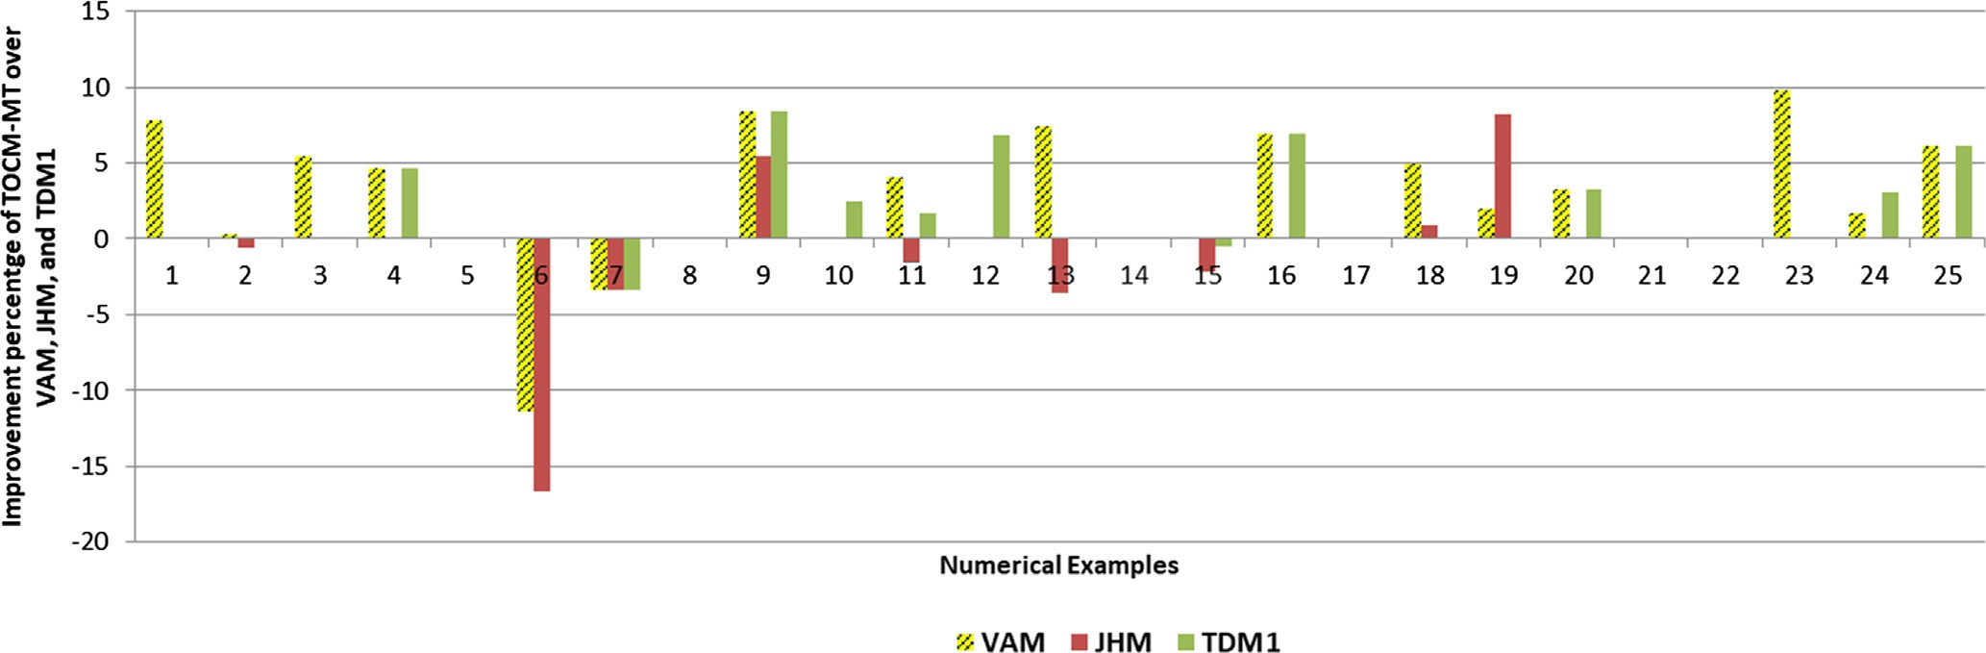

Fig. 2. The improvement percentage of TOCM-MT over VAM, JHM, and TDM1 for 25 numerical examples problem from the journal.

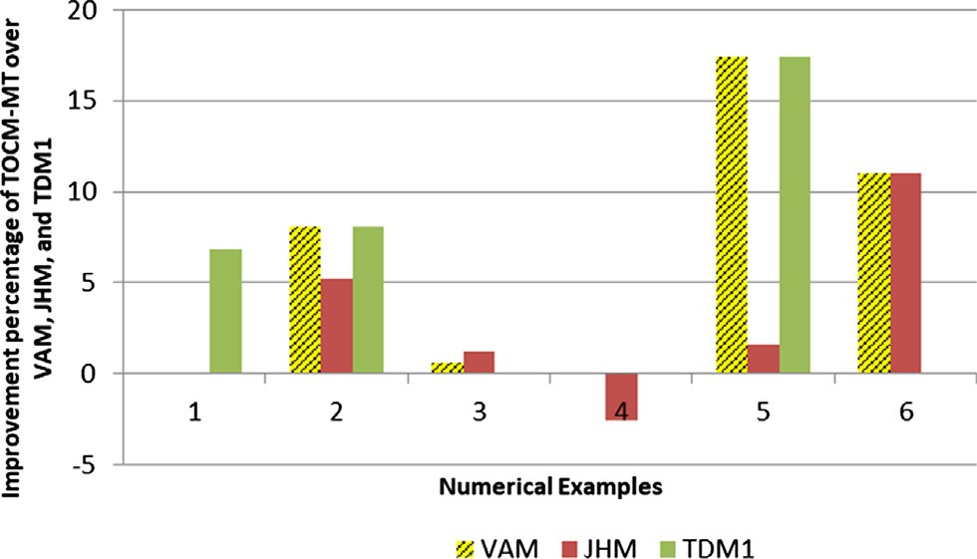the zero value indicates that the total cost is the optimal solution and the positive number means that the total cost is larger than the optimal solution. The deviation percentage [1] is determined using Eq. (13).

*Dv* = *IBFS* — *Op x*100 (13)

*Op*

Notation:

*Dv* Deviation

*IBFS* Initial basic feasible solution

*Op* Optimal

Fig. 3. The improvement percentage of TOCM-MT over VAM, JHM, and TDM1 for 6 numerical examples randomly generated samples.

Tables 11 and 12 show the TOCM-MT provides 18 better results compared to VAM and both have the same result in 11 numerical examples. In the remaining 2 numerical examples, VAM produces better result compared to TOCM-MT. The TOCM-MT obtains 7 bet- ter results compared to JHM and both have the same results in 17 numerical examples which the rest 7 numerical examples shown that JHM produces better result compared to TOCM-MT. The TOCM-MT also provides 12 better results compared to TDM1 and obtains the same results in 17 numerical examples for both meth- ods. TDM1 produces better result compared to TOCM-MT in the rest 2 numerical examples.

Tables 11 and 12 also show the deviation percentage of VAM, JHM, TDM1, and TOCM-MT from the optimal solution, in which

Base on the deviation percentage, Tables 11 And 12 show that the TOCM-MT leads to the optimal solution 24 out of 31 numerical examples, whereas each VAM, JHM, and TDM1 leads to optimal solution 10, 22 and 14 out of 31 numerical examples, respectively. TOCM-MT leads to optimal solution 24 out of 31 numerical exam- ples and obtains 77.42% accuracy. Otherwise, VAM leads to optimal solution 10 out of 31 numerical examples and obtains 32.26% accu- racy. JHM leads to optimal solution 22 out of 31 numerical exam- ples and obtains 70.96% accuracy. At last, TDM1 leads to the optimal solution 14 out of 31 numerical examples and obtains 45.16% accuracy.

The positive value of improvement percentage that shown in Figs. 2 and 3 indicated that TOCM-MT provides better result com- pare with VAM, JHM, and TDM1 in most cases. The zero value of

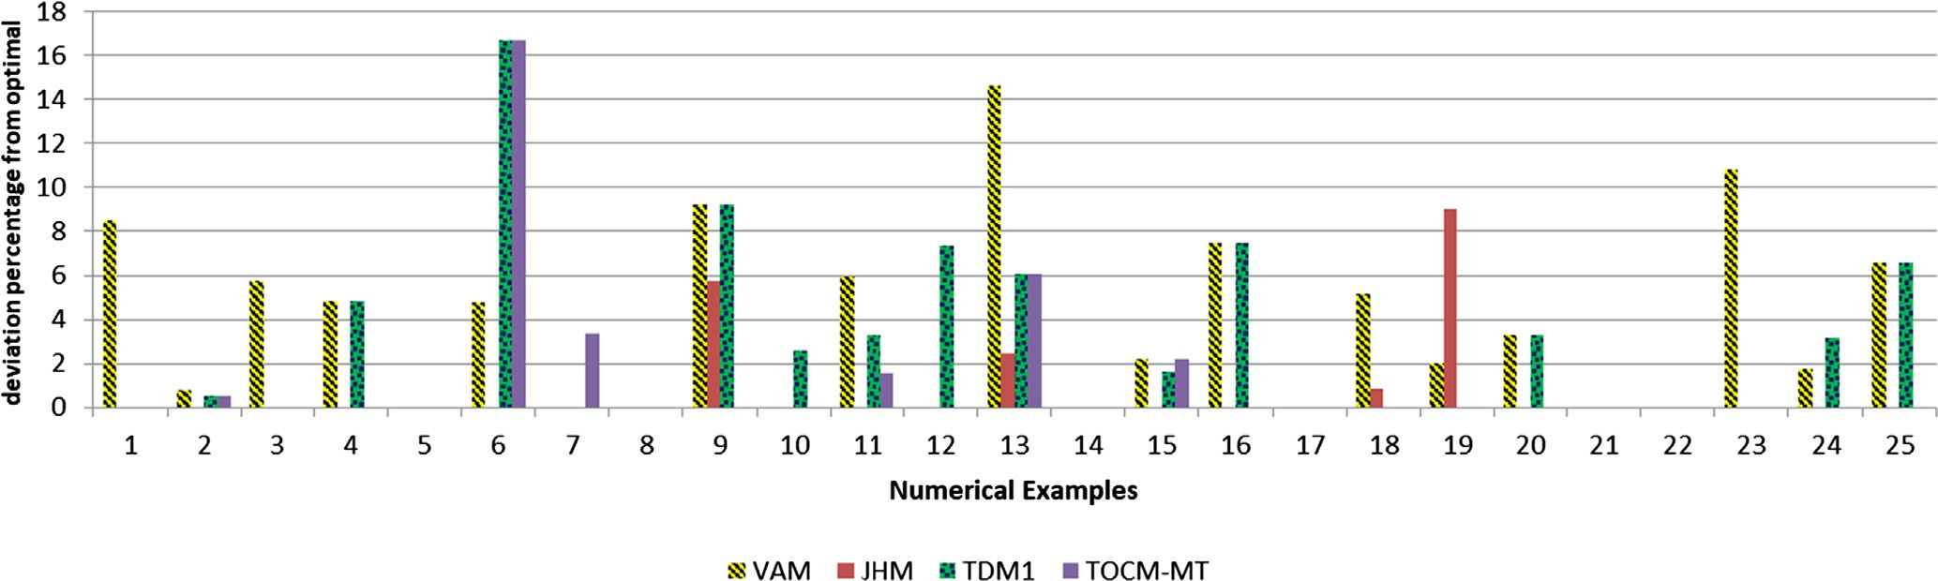

Fig. 4. The deviation percentage of VAM, JHM, TDM1 and TOCM-MT for 25 numerical examples from the journal.

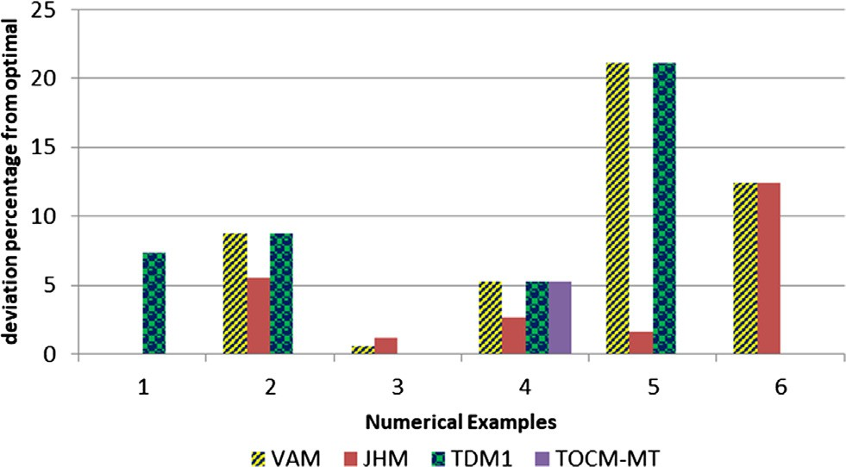

Fig. 5. The deviation percentage of VAM, JHM, TDM1 and TOCM-MT for 6 numerical examples randomly generated samples.

deviation percentage that shown in Figs. 4 and 5 indicated that TOCM-MT achieves the optimal solution in most cases.

The numerical examples for the benefits of TOCM-MT over TDM1 can be expressed as follows:

1. TOCM-MT uses TOCM as the initial matrix, while TDM1 uses the original matrix. The following sample from Hosseini [3] is used to illustrate the benefit of using TOCM as the initial matrix, and no ties exist.

Table 13 shows the final result of TOCM-MT with the penalty. Table 14 shows the combining TOCM-MT with the penalty and original transportation problem. The final result of TDM1 which uses the original matrix is shown in Table 15.

The allocation units given from Table 14 are as follows: X11 = 60, X12 = 40, X13 = 20, X23 = 30, X24 = 40, X34 = 15, along

with associated total cost 3.460, which is the optimal solution for this numerical example.It

could be seen that TOCM-MT is better than TDM1 in getting the optimal solution. The allocation units given from Table 15 are as follows: X11 = 40, X14 = 40, X14 = 40, X24 = 70, X31 = 20, X33 = 30,

along with associated total cost 3.570.

1. TOCM-MT has rules to select HP while TDM1 chooses HP arbi- trarily when there are several HP with the same values. The fol- lowing sample from Juman [1] is used to illustrate the benefit of using TOCM-MT when there are several same values of HP. Table 16 shows the final result of TOCM-MT with the penalty. Table 17 shows the combining TOCM-MT with the penalty and original transportation problem. The final result of TDM1 which choose the HP arbitrarily when there are several same values of HP is shown in Table 18.

The allocation units given from Table 17 are as follows: X13 = 1, X16 = 1, X26 = 5, X31 = 1, X32 = 2, X33 = 3, X41 = 1, X44 = 4, X45 = 4,

along with associated total cost 109, which is the optimal solu- tion for this numerical example.It

Table 14

Combining TOCM-MT with the penalty and original transportation problem based on Hosseini numerical example.



could be seen that TOCM-MT is better than TDM1 in getting the optimal solution. The allocation units given from Table 18 are as follows: X13 = 2, X26 = 5, X32 = 2, X35 = 4, X41 = 2, X33 = 3, X43 = 2,

X44 = 4, X46 = 1, along with associated total cost 117.

1. TOCM-MT has a mechanism to allocate the maximum units to the least cost cell when the least cost equals to zero while TDM1 directly allocates maximum units to the least cost cell. The following sample from Deshmukh [19] is used to illustrate the benefit of using TOCM-MT when the least cost equal to zero. Table 8 shows the final result of TOCM-MT with the penalty. Table 9 shows the combining TOCM-MT with the penalty and original transportation problem. The final result of TDM1 when the least cost equal to zero is shown in Table 10. Hence the allo- cation units given from Table 9 are as follows: X11 = 5, X14 = 2, X22 = 2, X23 = 7, X32 = 6, X34 = 12, along with associated total cost 743, which is the optimal solution for this numerical exam- ple.It

could be seen that TOCM-MT is better than TDM1 in getting the optimal solution. The allocation units given from Table 9 are as follows X11 = 5, X14 = 2, X23 = 7, X24 = 2, X32 = 8, X34 = 10, along

with associated total cost 779.

1. Conclusion

Initial basic feasible solution (IBFS) is one of the main steps to achieve an optimal solution for TP. This research developed a new method called TOCM-MT to determine IBFS of TP. TOCM-MT is coded using C++ programming language. TOCM-MT can achieve a total cost which similar or closer values to the optimal solution. TOCM-MT shows better performance than VAM, JHM, and TDM1 because TOCM-MT considers a total opportunity cost matrix for the initial matrix, provides a better mechanism if there are sev- eral HP with the same values and if the least cost of highest penalty is equal to zero. To evaluate the proposed method, thirty-one numerical examples were used in which twenty-five were selected

from journals and six were generated randomly.

The comparative study indicated that TOCM-MT obtained eigh- teen better results than that of VAM, seven better results than that

Table 13

TOCM-MT with a penalty based on Hosseini numerical example.



Table 15

The final result of TDM1 based on Hosseini numerical example.



Table 16

TOCM-MT with a penalty based on Juman numerical example.



Table 17

Combining TOCM-MT with the penalty and original transportation problem based on Juman numerical example.



Table 18

The final result of TDM1 based on Juman numerical example.



of JHM, and twelve better results than that of TDM1. TOCM-MT was found to have 24 optimal solutions out of 31 numerical exam- ples, thus this method gets 77.42% accuracy. Otherwise, VAM, JHM, and TDM1 obtain an accuracy level of 32.26%, 70.96%, and 45.16% respectively.

The future research might be carried out in developing the pro- posed IBFS method for real application in case of incomplete infor- mation about the parameters of the TP.

Appendix A

Six problem that are randomly generated.

Problem 1 Problem 4

[Cij]4x6 = [9 12 9 6 9 10; 7 3 7 7 5 5; [Cij]4x4 = [21 5 9 11; 12 3

6 5 9 11 3 11; 6 8 11 2 2 10] 8 6; 9 8 10 5; 6 6 7 3]

[Si]4x1 = [2, 5, 6, 9] [Si]4x1 = [120, 100, 80,

60]

[Dj]1x6 = [2, 2, 4, 4, 4, 6] [Dj]1x4 = [120, 120, 80,

40]

Problem 2 Problem 5

[Cij]3x4 = [20 2 20 11; 24 7 9 20; 8 [Cij]3x4 = [10 2 20 22; 12

14 16 18] 7 9 40; 4 14 16 32]

[Si]3x1 = [30, 50, 20] [Si]3x1 = [60, 100, 40]

1. [Dhurai K, Karpagam A. To obtain initial basic feasible solution physical](http://refhub.elsevier.com/S1110-8665(18)30147-6/h0075) [distribution problems. Glob J Pure Appl Math 2017;13(9):4671–6](http://refhub.elsevier.com/S1110-8665(18)30147-6/h0075).
2. [Kousalya P, Malarvizhi P. A new technique for finding initial basic feasible](http://refhub.elsevier.com/S1110-8665(18)30147-6/h0080) [solution to transportation problem. Int J Eng Manage Res 2016;6(3):26–32](http://refhub.elsevier.com/S1110-8665(18)30147-6/h0080).
3. [Ahmed MM, Khan AR, Ahmed F, Uddin S. Incessant allocation method for](http://refhub.elsevier.com/S1110-8665(18)30147-6/h0085) [solving transportation problems. Am J Oper Res 2016;6(May):236–44](http://refhub.elsevier.com/S1110-8665(18)30147-6/h0085).
4. [Ahmed MM, Khan AR, Uddin S, Ahmed F. A new approach to solve](http://refhub.elsevier.com/S1110-8665(18)30147-6/h0090) [transportation problems. Open J Optim 2016;5(March):22–30](http://refhub.elsevier.com/S1110-8665(18)30147-6/h0090).
5. [Deshmukh NM. An Innovative Method for Solving Transportation. Int J Phys](http://refhub.elsevier.com/S1110-8665(18)30147-6/h0095) [Math Sci 2012;2(3):86–91](http://refhub.elsevier.com/S1110-8665(18)30147-6/h0095).
6. [Soomro AS, Tularam GA, Bhayo Ghulam Murtaa. A comparative study of initial](http://refhub.elsevier.com/S1110-8665(18)30147-6/h0100) [basic feasible solution methods for transportation problems. Math Theory](http://refhub.elsevier.com/S1110-8665(18)30147-6/h0100) [Model 2014;4(1):11–8](http://refhub.elsevier.com/S1110-8665(18)30147-6/h0100).
7. [Soomro AS et al. Modified Vogel’s approximation method for solving](http://refhub.elsevier.com/S1110-8665(18)30147-6/h0105) [transportation problem. Math Theory Model 2015;5(4):32–43](http://refhub.elsevier.com/S1110-8665(18)30147-6/h0105).
8. [Rashid A. Development of a simple theorem in solving transportation](http://refhub.elsevier.com/S1110-8665(18)30147-6/h0110) [problems. J Phys Sci 2015;21:23–8](http://refhub.elsevier.com/S1110-8665(18)30147-6/h0110).
9. [Hakim MA. An alternative method to find initial basic feasible solution of a](http://refhub.elsevier.com/S1110-8665(18)30147-6/h0115) [transportation problem. Ann Pure Appl Math 2012;1(2):203–9](http://refhub.elsevier.com/S1110-8665(18)30147-6/h0115).
10. [Goyal SK. Improving VAM for unbalanced transportation problems. J Oper Res](http://refhub.elsevier.com/S1110-8665(18)30147-6/h0120) [Soc 1984;35(12):1113–4](http://refhub.elsevier.com/S1110-8665(18)30147-6/h0120).
11. [Das UK, Babu A, Khan AR, Helal A, Uddin S. Logical development of Vogel’s](http://refhub.elsevier.com/S1110-8665(18)30147-6/h0125) [approximation method (LD-VAM): an approach to find basic feasible solution](http://refhub.elsevier.com/S1110-8665(18)30147-6/h0125) [of transportation problem. Int J Sci Technol Res 2014;3(2):42–8](http://refhub.elsevier.com/S1110-8665(18)30147-6/h0125).
12. [Das UK, Babu A, Khan AR, Uddin S. Advanced Vogel’s approximation method](http://refhub.elsevier.com/S1110-8665(18)30147-6/h0130) [(AVAM): a new approach to determine penalty cost for better feasible solution](http://refhub.elsevier.com/S1110-8665(18)30147-6/h0130) [of transportation problem. Int. J. Eng. Res. Technol. 2014;3(1):182–7](http://refhub.elsevier.com/S1110-8665(18)30147-6/h0130).
13. [Azad SMAK, Hossain MB. A new method for solving transportation problems](http://refhub.elsevier.com/S1110-8665(18)30147-6/h0135) [considering average penalty. IOSR J Math 2017;13(01):40–3](http://refhub.elsevier.com/S1110-8665(18)30147-6/h0135).
14. [Alkubaisi M. Modified VOGEL method to find initial basic feasible solution](http://refhub.elsevier.com/S1110-8665(18)30147-6/h0140) [(IBFS) introducing a new methodology to find best IBFS. Bus Manage Res](http://refhub.elsevier.com/S1110-8665(18)30147-6/h0140) [2015;4(2):22–36](http://refhub.elsevier.com/S1110-8665(18)30147-6/h0140).
15. [Seethalakshmy A, Srinivasan N. An improved algorithm to obtain initial basic](http://refhub.elsevier.com/S1110-8665(18)30147-6/h0145)

[Dj]1x4

= [10, 30, 30, 30] [Dj]1x4

= [20, 60, 60, 60]

[feasible solution for the transportation problem. Int J Sci Res 2015;6](http://refhub.elsevier.com/S1110-8665(18)30147-6/h0145) [(4):1225–9](http://refhub.elsevier.com/S1110-8665(18)30147-6/h0145).

Problem 3 Problem 6

1. [Kirca O, Satir A. A Heuristic for Obtaining an Initial Solution for the](http://refhub.elsevier.com/S1110-8665(18)30147-6/h0150) [Transportation Problem. J Oper Res Soc 1990;41(9):865–71](http://refhub.elsevier.com/S1110-8665(18)30147-6/h0150).

[Cij]4x4 = [7 5 27 22; 4 3 24 12; 6 16

60 20; 2 6 21 6]

[Cij]3x3 = [7 8 7; 18 8 12;

8 12 12]

1. [Khan AR, Vilcu A, Sultana N, Ahmed SS. Determination of initial basic feasible](http://refhub.elsevier.com/S1110-8665(18)30147-6/h0155) [solution of a transportation problem: a tocm-sum approach. Bul INSTITUTULUI](http://refhub.elsevier.com/S1110-8665(18)30147-6/h0155) [Politeh DIN IASI 2015;61(1):39–49](http://refhub.elsevier.com/S1110-8665(18)30147-6/h0155).

[Si]4x1 = [60, 50, 40, 30] [Si]3x1 = [13, 14, 8]

[Dj]1x4 = [60, 60, 40, 20] [Dj]1x3 = [14, 8, 13]

References

1. [Juman ZAMS, Hoque MA. An efficient heuristic to obtain a better initial feasible](http://refhub.elsevier.com/S1110-8665(18)30147-6/h0005) [solution to the transportation problem. Appl Soft Comput J 2015;34:813–26](http://refhub.elsevier.com/S1110-8665(18)30147-6/h0005).
2. [Hitchcock FL. The distribution of a product from several sources to numerous](http://refhub.elsevier.com/S1110-8665(18)30147-6/h0010) [localities. J Math Phys 1941;20:224–30](http://refhub.elsevier.com/S1110-8665(18)30147-6/h0010).
3. [Hosseini E. Three new methods to find initial basic feasible solution of](http://refhub.elsevier.com/S1110-8665(18)30147-6/h0015) [transportation problems. Appl Math Sci 2017;11(37):1803–14](http://refhub.elsevier.com/S1110-8665(18)30147-6/h0015).
4. [Jude O, Ben Ifeanyichukwu O, Ihuoma IA, Akpos EP. A new and efficient](http://refhub.elsevier.com/S1110-8665(18)30147-6/h0020) [proposed approach to find initial basic feasible solution of a transportation](http://refhub.elsevier.com/S1110-8665(18)30147-6/h0020) [problem. Am J Appl Math Stat 2017;5(2):54–61](http://refhub.elsevier.com/S1110-8665(18)30147-6/h0020).
5. [Pendharkar PC. An ant colony optimization heuristic for constrained task](http://refhub.elsevier.com/S1110-8665(18)30147-6/h0025) [allocation problem. J Comput Sci 2015;7:37–47](http://refhub.elsevier.com/S1110-8665(18)30147-6/h0025).
6. [Komaki GM, Kayvanfar V. Grey Wolf Optimizer algorithm for the two-stage](http://refhub.elsevier.com/S1110-8665(18)30147-6/h0030) [assembly flow shop scheduling problem with release time. J Comput Sci](http://refhub.elsevier.com/S1110-8665(18)30147-6/h0030) [2015;8:109–20](http://refhub.elsevier.com/S1110-8665(18)30147-6/h0030).
7. [Behnamian J. A parallel competitive colonial algorithm for JIT flowshop](http://refhub.elsevier.com/S1110-8665(18)30147-6/h0035) [scheduling. J Comput Sci 2014;5(5):777–83](http://refhub.elsevier.com/S1110-8665(18)30147-6/h0035).
8. [Mohammed MA, Abd Ghani MK, Hamed RI, Mostafa SA, Ahmad MS, Ibrahim](http://refhub.elsevier.com/S1110-8665(18)30147-6/h0040) [DA. Solving vehicle routing problem by using improved genetic algorithm for](http://refhub.elsevier.com/S1110-8665(18)30147-6/h0040) [optimal solution. J Comput Sci 2017;21:255–62](http://refhub.elsevier.com/S1110-8665(18)30147-6/h0040).
9. [Goel R, Maini R. A hybrid of ant colony and firefly algorithms (HAFA) for](http://refhub.elsevier.com/S1110-8665(18)30147-6/h0045) [solving vehicle routing problems. J Comput Sci 2018;25:28–37](http://refhub.elsevier.com/S1110-8665(18)30147-6/h0045).
10. [Uddin S, Khan AR. Improved least cost method to obtain a better IBFS to the](http://refhub.elsevier.com/S1110-8665(18)30147-6/h0050) [transportation problem. J Appl Math Bioinform 2016;6(2):1–20](http://refhub.elsevier.com/S1110-8665(18)30147-6/h0050).
11. [Taha HA. Operations Research: An Introduction. 8th ed. Pearson Prentice Hall;](http://refhub.elsevier.com/S1110-8665(18)30147-6/h0055) [2007](http://refhub.elsevier.com/S1110-8665(18)30147-6/h0055).
12. [Babu A, Helal A, Hasan MS, Das UK. Lowest allocation method (LAM): a new](http://refhub.elsevier.com/S1110-8665(18)30147-6/h0060) [approach to obtain feasible solution of transportation model. Int J Sci Eng Res](http://refhub.elsevier.com/S1110-8665(18)30147-6/h0060) [2013;4(11):1344–8](http://refhub.elsevier.com/S1110-8665(18)30147-6/h0060).
13. [Juman ZAMS, Hoque MA. A heuristic solution technique to attain the minimal](http://refhub.elsevier.com/S1110-8665(18)30147-6/h0065) [total cost bounds of transporting a homogeneous product with varying](http://refhub.elsevier.com/S1110-8665(18)30147-6/h0065) [demands and supplies. Eur J Oper Res 2014;239(1):146–56](http://refhub.elsevier.com/S1110-8665(18)30147-6/h0065).
14. [Babu A, Helal A, Sazzad Hasan M, Kanti Das U. Implied cost method (ICM): an](http://refhub.elsevier.com/S1110-8665(18)30147-6/h0070) [alternative approach to find the feasible solution of transportation problem.](http://refhub.elsevier.com/S1110-8665(18)30147-6/h0070) [Glob J Sci Front Res Math Decis Sci 2014;14(1):5–13](http://refhub.elsevier.com/S1110-8665(18)30147-6/h0070).
15. [Dubey SSGC, Shrivastava R. Optimization and analysis of some variants](http://refhub.elsevier.com/S1110-8665(18)30147-6/h0160) [through Vogel ’ s approximation method (VAM). IOSR J Eng 2012;2(9):20–30](http://refhub.elsevier.com/S1110-8665(18)30147-6/h0160).
16. [Islam A, Khan AR, Uddin MS, Malek MA. Determination of basic feasible](http://refhub.elsevier.com/S1110-8665(18)30147-6/h0165) [solution of transportation problem: a new approach. Jahangirnagar Univ J Sci](http://refhub.elsevier.com/S1110-8665(18)30147-6/h0165) [2012;35(1):101–8](http://refhub.elsevier.com/S1110-8665(18)30147-6/h0165).
17. [Khan AR, Vilcu A, Uddin S, Ungureanu F. A competent algorithm to find the](http://refhub.elsevier.com/S1110-8665(18)30147-6/h0170) [initial basic feasible solution of cost minimization transportation problem. Bul](http://refhub.elsevier.com/S1110-8665(18)30147-6/h0170) [INSTITUTULUI Politeh DIN IASI 2015;61(2):71–83](http://refhub.elsevier.com/S1110-8665(18)30147-6/h0170).
18. [Mathirajan M, Meenakshi B. Experimental analysis of some variants of Vogel’S](http://refhub.elsevier.com/S1110-8665(18)30147-6/h0175) [approximation method. Asia-Pacific J Oper Res 2004;21(04):447–62](http://refhub.elsevier.com/S1110-8665(18)30147-6/h0175).
19. [Maity G, Roy SK. Solving a multi-objective transportation problem with](http://refhub.elsevier.com/S1110-8665(18)30147-6/h0180) [nonlinear cost and multi-choice demand. Int J Manage Sci Eng Manage](http://refhub.elsevier.com/S1110-8665(18)30147-6/h0180) [2015;11(1):62–70](http://refhub.elsevier.com/S1110-8665(18)30147-6/h0180).
20. [Maity G, Roy SK. Solving multi-objective transportation problem with interval](http://refhub.elsevier.com/S1110-8665(18)30147-6/h0185) [goal using utility function approach. Int J Oper Res 2016;27(4):513–29](http://refhub.elsevier.com/S1110-8665(18)30147-6/h0185).
21. [Roy SK, Maity G. Minimizing cost and time through single objective function in](http://refhub.elsevier.com/S1110-8665(18)30147-6/h0190) [multi-choice interval valued transportation problem. J Intell Fuzzy Syst](http://refhub.elsevier.com/S1110-8665(18)30147-6/h0190) [2017;32(3):1697–709](http://refhub.elsevier.com/S1110-8665(18)30147-6/h0190).
22. [Kumar S, Gurupada R, Weber G. Multi-objective two-stage grey transportation](http://refhub.elsevier.com/S1110-8665(18)30147-6/h0195) [problem using utility function with goals. Cent Eur J Oper Res 2017;25](http://refhub.elsevier.com/S1110-8665(18)30147-6/h0195) [(2):417–39](http://refhub.elsevier.com/S1110-8665(18)30147-6/h0195).
23. [Ali UA, Mustapha AM. Comparison of transportation algorithms using data](http://refhub.elsevier.com/S1110-8665(18)30147-6/h0200) [from Katsina state transport authority, Katsina State, Nigeria. Niger J Basic](http://refhub.elsevier.com/S1110-8665(18)30147-6/h0200) [Appl Sci 2013;21(3):207–14](http://refhub.elsevier.com/S1110-8665(18)30147-6/h0200).
24. [Roy SK, Maity G, Weber GW, Gok SZA. Conic scalarization approach to solve](http://refhub.elsevier.com/S1110-8665(18)30147-6/h0205) [multi-choice multi-objective transportation problem with interval goal. Ann](http://refhub.elsevier.com/S1110-8665(18)30147-6/h0205) [Oper Res 2017;253(1):599–620](http://refhub.elsevier.com/S1110-8665(18)30147-6/h0205).
25. [Maity G, Roy SK, Verdegay JL. Multi-objective transportation problem with](http://refhub.elsevier.com/S1110-8665(18)30147-6/h0210) [cost reliability under uncertain environment. Int J Comput Intell Syst 2016;9](http://refhub.elsevier.com/S1110-8665(18)30147-6/h0210) [(5):839–49](http://refhub.elsevier.com/S1110-8665(18)30147-6/h0210).
26. [Imam T, Elsharawy G, Gomah M, Samy I. Solving transportation problem using](http://refhub.elsevier.com/S1110-8665(18)30147-6/h0215) [object-oriented model. Int J Comput Sci Netw Secur 2009;9(2):353–61](http://refhub.elsevier.com/S1110-8665(18)30147-6/h0215).
27. [Sen N, Som T, Sinha B. A study of Transportation Problem for an Essential Item](http://refhub.elsevier.com/S1110-8665(18)30147-6/h0220) [of Southern Part of North Eastern Region of India as an OR Model and Use of](http://refhub.elsevier.com/S1110-8665(18)30147-6/h0220) [Object Oriented Programming. Int J Comput Sci Netw Secur 2010;10(4):78–86](http://refhub.elsevier.com/S1110-8665(18)30147-6/h0220).
28. [Lawal JI, Eberendu AC. Automating the computation of optimal solutions to](http://refhub.elsevier.com/S1110-8665(18)30147-6/h0225) [transportation problems. Int J Comput Sci Eng 2016;8(10):383–93](http://refhub.elsevier.com/S1110-8665(18)30147-6/h0225).
29. [Khan AR, Vilcu A, Istrate C. THE performance evaluation of various techniques](http://refhub.elsevier.com/S1110-8665(18)30147-6/h0230) [for transportation problem. Bul INSTITUTULUI Politeh DIN IA](http://refhub.elsevier.com/S1110-8665(18)30147-6/h0230)S [I 2016;62](http://refhub.elsevier.com/S1110-8665(18)30147-6/h0230) [(66):19–30](http://refhub.elsevier.com/S1110-8665(18)30147-6/h0230).
30. [Srinivasan V, Thompson GL. Cost operator algorithms for the transportation](http://refhub.elsevier.com/S1110-8665(18)30147-6/h0235) [problem. Math Program 1977;12(1):372–91](http://refhub.elsevier.com/S1110-8665(18)30147-6/h0235).
31. [Ramadan SZ, Ramadan IZ. Hybrid two-stage algorithm for solving](http://refhub.elsevier.com/S1110-8665(18)30147-6/h0240) [transportation problem. Mod Appl Sci 2012;6(4):12–22](http://refhub.elsevier.com/S1110-8665(18)30147-6/h0240).
32. [Kulkarni SS. On solution to modified unbalanced transportation problem. Bull](http://refhub.elsevier.com/S1110-8665(18)30147-6/h0245) [Marathwada Math Soc 2010;11(2):20–6](http://refhub.elsevier.com/S1110-8665(18)30147-6/h0245).
33. [Schrenk S, Finke G, Cung VD. Two classical transportation problems revisited:](http://refhub.elsevier.com/S1110-8665(18)30147-6/h0250) [pure constant fixed charges and the paradox. Math Comput Model 2011;54(9–](http://refhub.elsevier.com/S1110-8665(18)30147-6/h0250) [10):2306–15](http://refhub.elsevier.com/S1110-8665(18)30147-6/h0250).
34. [Samuel AE. Improved zero point method (IZPM) for the transportation](http://refhub.elsevier.com/S1110-8665(18)30147-6/h0255) [problems. Appl Math Sci 2012;6(109):5421–6](http://refhub.elsevier.com/S1110-8665(18)30147-6/h0255).
35. [Adlakha V, Kowalski K. Alternate solutions analysis for transportation](http://refhub.elsevier.com/S1110-8665(18)30147-6/h0260) [problems. J Bus Econ Res Feb. 2011;7(11):41–50](http://refhub.elsevier.com/S1110-8665(18)30147-6/h0260).
36. [Morade NM. New Method to find initial basic feasible solution of](http://refhub.elsevier.com/S1110-8665(18)30147-6/h0265) [Transportation Problem using MSDM. Int J Comput Sci Eng 2017;5(12):223–6](http://refhub.elsevier.com/S1110-8665(18)30147-6/h0265).
37. [Jude O. Comparison of existing methods of solving linear transportation](http://refhub.elsevier.com/S1110-8665(18)30147-6/h0270) [problems with a new approach. Int J Innov Sci Math 2016;4(5):158–63](http://refhub.elsevier.com/S1110-8665(18)30147-6/h0270).