Available online at [www.sciencedirect.com](http://www.sciencedirect.com/)



[Electronic Notes in Theoretical Computer Science 275 (2011) 5–21](http://dx.doi.org/10.1016/j.entcs.2011.09.002)

[www.elsevier.com/locate/entcs](http://www.elsevier.com/locate/entcs)

Towards the Evaluation of Environment and Business Trade-offs in Supply Chains

# Gabriel Alves Jr.1 , Paulo Maciel2 , Ricardo Lima3

*Center of Informatics*

*Federal University of Pernambuco (UFPE) Recife-PE, Brazil*

# F´abio Magnani4

*Department of Mechanical Engineering Federal University of Pernambuco (UFPE) Recife-PE, Brazil*

# Adilson Arcoverde Jr.5

*S˜ao Mateus Frigor´ıfico Recife-PE, Brazil*

Abstract

Supply chains (SCs) are one of the most environment impacting systems. Analysis of such systems should thus take into account not only performance but also environment indicators. The amount of energy consumed for producing goods and the total emissions of greenhouse gases (GHG) of an activity are examples of such indicators. This paper presents a framework for assessing performance as well as Global Warming Potential (GWP) and exergy indicators in SCs. In order, exergy accounting helps on finding reliable GWP indicators for different energy sources adopted in the supply chain. This framework supports the evaluation of supply chains’ business and environment indicators trade-offs using a unified model. A real case study is conducted to demonstrate the application of the proposed modeling technique.

*Keywords:* Key Environmental Indicators, Life Cycle Assessment, Manufacturing Systems, Modeling, Performance Evaluation, Stochastic Models, Supply Chains

1 Email: [gaaj@cin.ufpe.br](mailto:gaaj@cin.ufpe.br)

2 Email: [prmm@cin.ufpe.br](mailto:prmm@cin.ufpe.br)

3 Email: [rmfl@cin.ufpe.br](mailto:rmfl@cin.ufpe.br)

4 Email: [magnani@ufpe.br](mailto:magnani@ufpe.br)

5 Email: [aoaj@saomateusfrigorifico.com](mailto:%20aoaj@saomateusfrigorifico.com)

1571-0661 © 2011 Elsevier B.V. Open access under [CC BY-NC-ND license](http://creativecommons.org/licenses/by-nc-nd/3.0/).

[doi:10.1016/j.entcs.2011.09.002](http://dx.doi.org/10.1016/j.entcs.2011.09.002)

# Introduction

While economic and service level indicators were adequate to assess the performance of supply chains and manufacturing systems in the past, nowadays, environmental indicators are gradually becoming more relevant. Many prominent companies and academic research groups around the world are making efforts to provide environ- mentally responsible products and services. These topics are subjects of intensive study not only due to the respective impact of the production and transport sys- tems in our planet but also particularly related to the image these companies aim to project to the society.

The Life Cycle Assessment (LCA) is a well known method for evaluating the environment impacts owing to the product existence [14]. Currently, there are some commercial tools used for LCA (e.g. SimaPRO). Within these tools, metrics like the Global Warming Potential (GWP) [14] are estimated based on a conversion database of resource consumption. Nevertheless, these tools are not well suited to conduct a performance evaluation of the activities involved in the product life cycle (e.g. machines utilization, reliability analysis), since it is not adressed by LCA.

The concept of *exergy* is linked to the Second Law of Thermodynamics (SLT) [5, 16, 27]. It assess the amount of energy that can be converted into useful work. Exergy analysis has been employed to measure and compare the use of different energy sources in systems and processes [13, 27]. Some efforts have been made towards combining exergy and LCA in order to create a single sustainability metric [13, 23]. The main difficulty to use an exergy based method is to capture the entire exergy flow for each resource used in the production of a good or service.

Modeling is quite often used to make quantitative and qualitative evaluation of systems [10, 13, 17, 18, 28]. Stochastic models have been widely used for evaluating supply chains and manufacturing systems [26]. These models are well suited for modeling systems where there is at least one variable that is assumed to follow a probability distribution. The strict mathematical modeling is often applied in such cases [8, 22]. Although, queue networks, Markov chains, and Petri nets might also be adopted for stochastic modeling of these systems [10, 24, 26].

Stochastic Petri nets (SPN) [2, 7, 20] is a type of Petri net that deals with prob- abilistic distributed times. The use of SPNs to model systems might also require a deep knowledge of this technique. Model based performance evaluations might also require some tasks like the verification and validation of the models against the modeled system.

To tackle this problem, this work proposes the use of a library of SPN compo- nents to model supply chains and manufacturing systems. These components model specific entities or processes of the real system, focusing on the product/information flows. This approach allows using SPNs as the modeling technique even without further knowledge on it. Moreover, the component-based approach tackles the re- quirement of verifying the model’s correctness. Although, a validation of the model might still be required. It happens, because the components guarantee that the structure of the systems will be correctly represented in the Petri net notation.

But, it does not guarantee that the model’s parameters (e.g. mean time between failures and tasks delays) were assigned correctly in the model.

The graphical representation of SPNs permits to represent and estimate the impact of issues like buffers limits, failures, orders arrival rate and replenishment policies over operational, environmental, and cost metrics with relatively low costs. How this work addresses these topics will be discussed in following sections. Re- garding sustainability, this work focuses on two environment indicators: exergy and Global Warming Potential (GWP). This work adopts a specific type of SPNs for modeling and evaluating models: the Stochastic Reward Nets (SRNs). We adopt the SRNs as modeling technique, in spite of other types of SPNs, since they allow the use of most of the SPNs features (e.g.: marking-dependent firing rates and arcs) and also embed rewards definitions within the SPNs [6,7,21]. This work contributes thus with a single model for assessing business and environmental indicators. Fur- thermore, the use of SRNs allows assessing supply chains’ sustainability indicators in probabilistic means. To the best of our knowledge, using stochastic Petri nets in such context is a novel approach.

# Assessing Indicators with SRN

This section presents the proposed approach to assess environment impacting and business indicators using SRN models. In order to achieve this assessment, reward functions should be associated to transitions and places of a SRN. These functions are calculated for each state of the SRN model returning a result that represents the performance indicator.

Definition 2.1 presents a formal description for SRNs based on [7]. This definition groups the weight of immediate transitions and the rate of timed transitions into a single matrix, in spite of the original definition, where such elements are described in different matrices.

Definition 2.1 [*Stochastic reward nets*] A SRN is a 10-tuple *N* = (*P, T, I, O, H,* Π*, G, M*0*, W,* R), where:

* + *P* is the ordered set of places;
  + *T* is the ordered set of transitions, *P* ∩ *T* = ∅;
  + *I* ∈ (N|*P* | → N)|*P* |×|*T* | is the matrix of marking-dependent multiplicities of input arcs. If place *pj* is an input place of transition *tk*, then *ijk* ≥ 1 else *ijk* = 0;
  + *O* ∈ (N|*P* | → N)|*P* |×|*T* | is the matrix of marking-dependent multiplicities of output arcs. If place *pj* is an output place of transition *tk*, then *ojk* ≥ 1 else *ojk* = 0;
  + *H* ∈ (N|*P* | → N)|*P* |×|*T* | is the matrix of marking-dependent multiplicities of inhi- bition arcs. If place *pj* is an inhibition place of transition *tk*, then *hjk* ≥ 1 else *hjk* = 0;
  + Π ∈ N|*T* | is the vector of transitions’ priorities function. If transition *tk* is an immediate transition, then *πk* ≥ 1 else *πk* = 0;
  + *G* ∈ (N|*P* | → {*true, false*})|*T* | → {*true, false*} is the vector of marking-

dependent transitions’ guards. If *tk* is enabled within N|*P* |, then *gk* = *true* else

*gk* = *false*;

* *M*0 ∈ N|*P* | is the vector of places’ initial markings, where *μ*0 ≥ 0*,* ∀*pj* ∈ *P* ;

*j*

* *W* ∈ (N|*P* | → R+)|*T* | is the vector of marking-dependent immediate transitions’ weights and timed transitions’ rates. For immediate transitions the *k* −*th* element of *W* is denoted by *wk*, representing its weight. Regarding timed transitions, *λk* is the *k* − *th* element of *W* and depicts its rate, which in turn must be greater than zero;
* R is a finite ordered set of rewards of *N* . Each element ∇*i* ∈R is a triplet (*ρ, r, ψ*) representing the *i-th* reward of the SRN, where: *ρ* is a reward rate, *r* is a reward impulse and *ψ* is a reward based on the results of other rewards.

Since SRNs support marking-dependent timed transitions’ rates, these transi- tions can be defined as single-, k-, or infinite-server, in the same sense as queueing networks. Let *N* be a SRN, where *pj* ∈ *P* is the only input place of a transition *tk* ∈ *T* , with rate 0*.*5. The depicted server semantics are respectively represented by *λk* = 0*.*5, *λk* = 0*.*5×*min*(*mj, L*) and *λk* = 0*.*5×*mj*, where *mj* is the marking of place *pj* ina given state and *L* is the upper limit of the k-server semantics. Furthermore, the *phase approximation* technique [10] can be applied to represent poly-exponential distribution functions such as Erlang, hypo-exponential, and hyper-exponential dis- tributions.

SRNs associate rewards with transition firing and place marking at the net level. The underlying SPN’s Markov chain is then transformed into a Markov reward model (MRM). An MRM associates rewards with each state of the Markov chain [29]. In MRMs, *reward rates* relate to the rate that the reward is accumulated while the system is in a state *si*. *reward impulses* determine the amount of a reward that is instantaneously accumulated when the system goes from a state *si* to a state *sj*. Such MRM rewards are respectively represented by *ρ* and *r* components of each SRN’s reward ∇*i* ∈ R.

Regarding R, a reward rate function *ρi* of an SRN depends on its markings, and is defined as *ρ* : N|*P* | → R, where *P* is the set of places of the SRN. Thus,

∀*μ* ∈ *RS*, *ρi*(*μ*) depicts the rate in which reward *i* is accumulated while the system is in marking *μ*, where *RS* is the reachability set [19].The reward impulse function

*ri,t* refers to the amount of reward *i* accumulated when a transition *t* fires. Let *P* and *T* be the respective sets of places and transitions of a SRN, the reward impulse is a function *ri,t* : N|*P* | → R. Thus, ∀*μ* ∈ *RS*, *ri,t*(*μ*) depicts the amount of reward *i* that is accumulated in marking *μ* when transition *t* fires. The reward functions can also be defined depending on the results other rewards. Let *i* represent the amount of *CO*2 expelled in the system. It is possible to define a reward *ψj* that measures the probability for the amount of *CO*2 being over the average amount, or the maximum amount of *CO*2 expelled per unit of time. A detailed description of how these rewards are computed can be found in [7].

Before evaluation of a system, it is important to collect data to calculate the en- vironmental indicators. After identifying the system’s components (e.g.: machines,

entities, processes) that are going to be represented in the model, the modeler should gather information about:

* Energy - The amount of resources consumed for energetic means. It is important to define the energy source (e.g. electricity, biomass, gasoline, diesel);
* Raw Materials - The amount of resources used to produce a good or realize an activity. Raw materials should be categorized by type (e.g. water, wood, hazardous, non-hazardous) and its origin (e.g. first use, reuse, recycled);
* Waste - The amount of waste generated by system’s activities. This information should be structured by the type of the waste (e.g. wood, card, plastic) and by its destination (e.g. recycling, landfill, composting).

It is important to stress that a resource might be used as energy source, raw material or be a waste of an activity. For instance, wood might be a raw material in the production of a good, and some amount of this wood might be wasted. It can also be burned, providing energy for an activity.

The proposed classification aims at providing means to separately measure GWP and exergy outputs of each activity/process, without being over-detailed avoiding a complex and inefficient evaluation process. Furthermore, a different value of GWP or exergy efficiency can be assigned to the same substance depending on its classification. For instance, a block of wood has a different GWP value when used as raw material of a good, disposed for recycling, or disposed in landfill. We chose this categorization based on the conversion factors usually adopted in LCA [4, 9, 12], in order to provide detailed description of the GWP of consumed/disposed resources.

Let *N* be a SRN that models the evaluated system, I is its set with the classified energy, raw material, and waste items. For each element in the set of classified items

(I) it should be defined a reward ∇*i* ∈R related to its consumption or disposal. For convenience, the set with these basic rewards is denoted RI, where RI ⊆ R.

An important remark considering the rewards definition is that they do not distinguish between places of the SRN. Instead, reward rates are based on the state of the SRN. But, sometimes it is wanted to have an insight of a specific process or a set of processes of the modeled system. In such cases, the rewards should be defined for each place and transition of the SRN.

If such strategy is used, the total reward of a classified item should be derived from the sum of the rewards for each (or some) place and transition of the SRN. Let *N* , *P* × ⊆ *P* and *T* × ⊆ *T* be a SRN and its respective sets of places and transitions of *N* , for which it is intended to obtain the expected time-averaged reward of ∇*i* ∈ (R− RI). ∇*i* is measured as depicted in Equation 1.

*j*=|R′|

∇*i* =

Σ

*j*=0

∇*j* (1)

where RI× ⊆ RI is the set of rewards related to ∇*i* that were defined for *p* ∈ *P* ×

and *t* ∈ *T* ×.

Assuming that the evaluated system produces physical goods (not virtual ones,

as occurs with most informatics services) a mass balance analysis might be directly derived from the sum of all raw materials inputs and output goods (Equation 2).

*Qtygood*

∇*i* = Σ*j*=|R′| ∇

*j*=0

*j*

(2)

where R× ⊆R is the set rewards that represents the input of raw materials (in kg/time) used in the production of the good and *Qtygood* is the amount of goods produced per unit of time (in kg/time). *Qtygood* could be obtained from the through- put of a SRN transition that represents the production of goods.

There are another three important rewards that should be defined in terms of each classified item. These rewards are: cost, global warming potential, and exergetic input/output. For each reward ∇*i* ∈ RI, a cost reward ∇*j* ∈ (R− RI) must be defined. The financial reward should assign a financial profit (positive signal) or cost (negative signal) related to the classified item. This reward is defined as

∇*j* = *K* + *β* × ∇*i* (3)

where *K* is a constant and *β* is the unitary profit/cost for the classified item. The total value is simply depicted by the sum of the financial rewards.

For each reward ∇*i* ∈ RI, a global warming potential reward ∇*j* ∈ (R− RI) can also be defined as

∇*j* = *g* × ∇*i* (4)

where *g* is the GWP for each unit of the classified item. The total GWP is thus simply depicted by the sum of the GWP rewards.

For each reward ∇*i* ∈ RI, that refers to energy consumption, an exergy input, output, and lost reward ∇*j,* ∇*k,* ∇*l* ∈ (R− RI) can be respectively defined as

∇*j* = *xch* × ∇*i* (5)

∇*k* = *ηII* × ∇*j* (6)

∇*l* = ∇*k* − ∇*j* (7)

where *ηII* and *xch* are the weighted-average exergetic efficiency and chemical exergy of the used energy. The total exergy is thus simply depicted by the sum of the exergy rewards.

For each type of energy source consumed, the estimated exergetic efficiency of fuel *f* regarding activity/location *act* represented by the SRN’s transition/place should be informed (*ηII,act,f* ). This efficiency factor in conjunction with the already known fuel’s chemical exergy (*xch,f* ) allows calculating the exergy output in the activity *Xout,act*. Based on the exergy output (Equation 8), it is possible to compare the adoption of different types of energy sources. This comparison is carried out by considering that the exergy output of each activity must be the same regardless of the energy source. The amount (in *kg*) of the energy source of the new energy source could be calculated using Equation 9. It is important to stress that changing

the energy source would probably vary the exergetic efficiency *ηII* in the activity.

*Xout,acti,f*1 = *ηII,acti,f*1 × *xch,f*1 × *Qtyacti,f*1 (8)

*X* = *Xout,acti*

∴ *Qty*

= *Xout,acti*

(9)

*in,acti,f*2

# Basic Models

*ηII,acti,f*2

*acti,f*2

*xch,f*2

× *ηII,acti,f*2

This section presents some SRN models that were conceived to represent facilities and processes of a supply chain and manufacturing systems. The manufacturing systems models were based on [10]. These models were conceived with the aim of developing a library of reusable components that could be used to model systems in a bottom-up approach. Furthermore, the composition of these modules result in a final model that has some properties like boundedness, allowing either a steady state or transient evaluation [1].

Figure 1 presents the proposed components. Some of these components are different when being used to model a pull, push or reverse supply chain [3,11,25]. In a *push* or *reverse* flow, the consumer component is not explicitly modeled. Instead, it is represented by transition *ta* of the flow model, which models the arrival of goods in the destination. The set of models used to represent entities of a push SCs are similar to that ones used in the context of reverse ones.

In the components presented in Figure 1, places named *pxDual* are the dual places of places named *px*. These places were included in order to guarantee that the final model is *structurally bounded* [20], allowing a stationary analysis of it. Each producer model (Figure 1(a)) is a SRN defined as *PRDi* = (*P P RDi* , *T P RDi* , *IP RDi* , *OP RDi* , *HP RDi* , Π*P RDi* , *GP RDi* , *MP RDi* , *W P RDi* , R*P RDi* ), *i* = 1*,* 2*,... , j*. Place

0

*pstP RDi* represents producer’s finished goods inventory. The initial marking of place

*pstDualP RDi* depicts the producer’s maximal storage capacity of finished goods. The place *ppP RDi* depicts the producing orders. In the context of reverse supply chains, this model represents the consumer of the supply chain. This consumer becomes the “producer” of the reverse flow product.

Each consumer model (Figure 1(c)) is a SRN defined as *ZNi* = (*P ZNi* , *T ZNi* ,

*IZNi* , *OZNi* , *HZNi* , Π*ZNi* , *GZNi* , *MZNi* , *W ZNi* , R*ZNi* ), *i* = 1*,* 2*,... , j*. The place

0

*poCSMi* represents a recent order of the consumer. Place *paCSMi* represents the orders that have not yet been delivered to the consumer. If the marking of *paDualCSMi* reaches zero in any reachable state, the consumer’s demand should be inhibited, what is not desired. Therefore, its initial marking (*MCSMi* ) must be high enough to avoid this situation with a high probability.

The occurrence of transition *tdCSMi* depicts the request of *n* items to a producer. When the amount requested from the producer equals the predetermined amount of *c* tons or items, the products are shipped. This amount *c* is often a quantity close to the complete load of the vehicle class allocated to the consumer. It is possible to set the rate of transition *tdCSMi* with the time necessary to request the amount

*c*. This approach reduces the state space size without loss of expressiveness. The reader should bear in mind that arc weights *k* must equal *c* in the flow model.

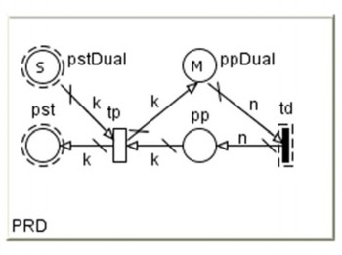 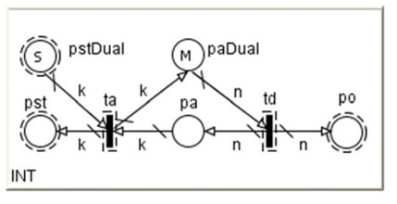 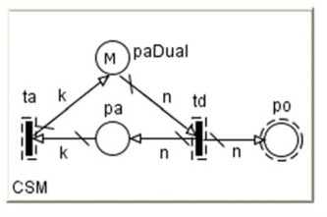

12

*G. Alves Jr. et al. / Electronic Notes in Theoretical Computer Science 275 (2011) 5–21*

(a) Producer (pull). (b) Intermediary (pull). (c) Consumer (pull).

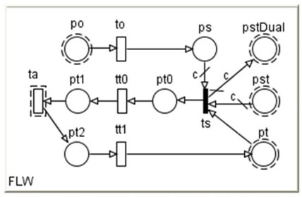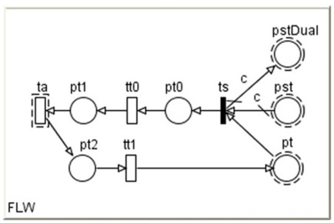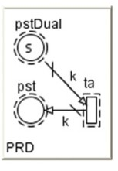

(d) Information/Goods Flow (pull). (e) Information/Goods Flow (push and reverse). (f) Producer (push and reverse).

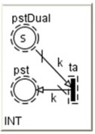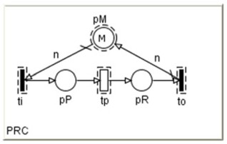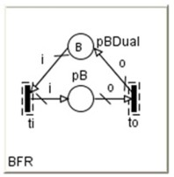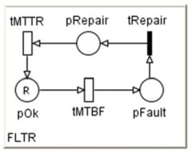

(g) Intermediary (push and reverse). (h) Manufacturing Process. (i) Manufacturing Buffer. (j) Faults.

Fig. 1. SRN models for entities and flows of a GSC.

Intermediaries have characteristics of consumers and factories. They act like consumers to the facilities that supply their demands, and like a factories to enti- ties that requests their products. Explanations given for consumer and producer models are thus valid for intermediary models as well. Each intermediary model (Figure 1(b) and Figure 1(g)) is a SRN defined as *INTi* = (*P INTi* , *T INTi* , *IINTi* , *OINTi* , *HINTi* , Π*INTi* , *GINTi* , *MINTi* , *W INTi* , R*INTi* ), *i* = 1*,* 2*,... , j*. This model

0

represents any intermediary of the logistics network, such as warehouses and whole-

salers. Therefore, it is possible to have an intermediary model connected to another one, representing the supplying relationship between a distributor and a wholesaler, for example.

Within the intermediaries models, the occurrence of transition *taINTi* represents arrival of *k* items for replenishing the inventory. Furthermore, the value of *k* must be equal to the shipped load per travel to the intermediary (*c*), represented in the flow component.

The flow model represents information flow from a customer to a supplier and goods flow from a supplier to a customer. Each flow model (Figure 1(d) and Fig- ure 1(e)) is a SRN defined as *FLWi* = (*P F LWi* , *T F LWi* , *IF LWi* , *OF LWi* , *HF LWi* , Π*F LWi* , *GF LWi* , *MF LWi* , *W F LWi* , R*F LWi* ), *i* = 1*,* 2*,... , j*. Places *pstF LWi* and *pstDualF LWi* have the same meaning as the equally named ones in the producer models. When composing models, these places will be merged with these corre- sponding ones. Place *poF LWi* has the same meaning as in the customer model and will also be merged with its corresponding place. Place *psF LWi* depicts orders that

0

have not been shipped to the consumer yet, due to a lack of vehicles or inventory (backorders).

Place *ptF LWi* depicts the transportation vehicle used to serve the consumer. This place could be merged with the homonymous places of other flow models, in order to represent shared resources. Firing transition *tsF LWi* models shipping of products to a consumer. When it fires, *c* tokens are consumed from place *pstF LWi* , meaning the removal of *c* items from the producer’s store. The arc weight *c* cannot be higher than the maximal load capacity of the kind of vehicle used to send products to the consumer. Immediate transition *tsF LWi* allows representing a *priority* and *weight* between consumers orders fulfillment.

Occurrence of transitions *toF LWi* , *tt*0*F LWi* , *taF LWi* and *tt*1*F LWi* models order reception from a customer, traveling from producer to consumer, and delivering of goods to consumer and traveling back to producer, respectively. In a real situation, it is possible to place more than one order at the producer, or to have more than one vehicle traveling from/to a consumer at the same time. Therefore, the depicted transitions have *inﬁnite-server semantics* (ISS).

Each manufacturer’s process model (Figure 1(h)) is a SRN defined as *PRCi* = (*PP RCi* , *T P RCi* , *IP RCi* , *OP RCi* , *HP RCi* , Π*P RCi* , *GP RCi* , *MP RCi* , *W P RCi* , R*P RCi* ),

0

*i* = 1*,* 2*,... , j*. Place *pMP RDi* represents a resource that is required to accomplish

a task represented by transition *tpP RDi* . This place can be merged other places *pMP RDk* in order to represent a shared resource. Transition *tpP RDi* must have a infinite-server semantics.

Process components might be connected to buffers or directly connected with other processes models. Depending on the level of abstraction adopted, this com- ponent might represent a single process, a machine operation, or even a whole production line of the manufacturer.

Each buffer model (Figure 1(i)) is a SRN defined as *BFRi* = (*P BF Ri* , *T BF Ri* , *IBF Ri* , *OBF Ri* , *HBF Ri* , Π*BF Ri* , *GBF Ri* , *MBF Ri* , *W BF Ri* , R*BF Ri* ), *i* = 1*,* 2*,... , j*.

0

The initial marking of place *pPBDualP RDi* represents the buffer’s limit, while mark-

ings in*pP BP RDi* denotes the used space of the buffer.

In the context of supply chains, faults occur quite often. Delivering failures, products, vehicles or machines breaks are examples of such faults that might tem- porarily halt an activity or impact its usual rate. Furthermore, depending on the fault/repair rate, the overal system’s performance might also be affected. The fail- ure model (Figure 1(j)) is a SRN defined as *FLT Ri* = (*P F LT Ri* , *T F LT Ri* , *IF LT Ri* , *OFLT Ri* , *HFLT Ri* , Π*F LT Ri* , *GFLT Ri* , *MFLT Ri* , *W FLT Ri* , R*FLT Ri* ), *i* = 1*,* 2*,... , j*.

0

Transitions *tMT BFF LT Ri* and *tMTT RF LT Ri* respectively depict the mean time

between failures and the mean time to repair. The initial marking of *pOkF LT Ri* denotes the maximum amount of resources that might be used in an activity that is susceptible to faults.

If *R >* 1, thus the rates of the timed transitions might depend on the marking of its input places (infinite server semantics). For instance the fault rate 2*.*5 ×

*pOkF LT Ri* denotes each of the resources available fails with a rate of 2*.*5. The

repair rate might also depend on the marking of *pRepairF LT Ri* . Furthermore, this rate might represent the usage of a limited maintenance team. For instance, the rate 0*.*5 × *min*( *pRepairF LT Ri,* 3) associated with *tMTT RF LT Ri* denotes that once a resource fails, it is repaired with a rate of 0*.*5, but there is a limited amount of 3 resources in the maintenance team.

If the rate of *tMTT RF LT Ri* denotes the repair rate limit, the guard of *tRepairF LT Ri* allows representing the limited allocation of the maintenance team. It is useful when the model contains two or more *FLTR* components. For instance, if there are two components *FLT R*1 and *FLTR*2, and the maintenance team is limited to 3 resources, the guard of *tRepairF LT R*1 and *tRepairF LT R*2 should be

*pRepairF LT R*1 + *pRepairF LT R*2 *<* 3. Furthermore, it might also be adopted differ- ent repairing priorities for each failure, by changing the priority of these transitions. This model might also represent the failures in one or more activities. The rate associated with *tMT BFF LT Ri* represents the failure rate when a set of activities are being executed, or the absolute time between failures. In the first case, it is necessary to assign to transition *tMT BFF LT Ri* a guard [*tk >,* ∀*tk* ∈ *T* ×, where *T* × is

the set of transitions that represents activities susceptive to the modeled fault.

The guards and rates of such transitions must also depend on the failure model. If a transition *tk* ∈ *T* × must have at least *n* resources working to be fired, it must have a guard like *pOkF LT Ri* ≥ *n*, where *n* is an integer. If *n* = *R* it means that if a single resource is in the fail state, the activity represented by *tk* halts. Alternatively, the *FLTR* can be reduced by removing transition *tRepairF LT Ri* and place *pRepairF LT Ri* . It can be adopted when it is not necessary to represent the

limited allocation of the maintenance team.

# Case Study

This section presents a case study conducted in a Brazilian meat processing industry. This study considers a production line composed of different machines and sub- processes. These elements were grouped in stages of the production line. It was thus mapped three main stages which will be called *Stage 1*, *Stage 2* and *Stage 3*. This case study focuses on the following environment impacting aspects: energy consumption and waste generation. Beyond environment issues, we also model the failures at each stage. We address this issue to assess the impact of fails in the system performance. This impact might provide information for decisions on the

maintenance of the production line’s machines.

Table 1 details the values for the resources used in the production line. We cat- egorized wastes as depicted in Section 2. The alias column refers to an abbreviation used in metrics and graphics presented along this section. Column *I/O* shows that if the resource is used as input (consumption) or output (disposal) in the production stage. The electricity is used for powering machines, whilst the natural gas is used for cooking goods.

Table 1

Production line parameters per stage.

|  |  |  |  |  |
| --- | --- | --- | --- | --- |
| Material | Alias | I/O | Stage 1 Stage 2 | Stage 3 |
| Electricity (*kW h*/ton) | el | I | 63.68 102.94 | 22.96 |
| Natural Gas(*m*3/ton) | gas | I | - 26.76 | - |
| Workers (*qty.*/ton) | hr | I | - - | 6.52 |
| Paper and Card (*kg*/ton) | card | O | 3.742 - | - |
| Organic (*kg*/ton) | org | O | - 6.287 | - |
| Wood (*kg*/ton) | wood | O | 0.152 - | - |
| Dense Plastic (*kg*/ton) | dense plst | O | 0.917 - | - |
| Film Plastic (*kg*/ton) | film plst | O | - 6.688 | - |
| Ferrous Metal (*kg*/ton) | ferrous | O | 0.344 - | - |
| Non-Ferr. Metal (*kg*/ton) | nferrous | O | 0.036 - | - |

The system works as a pipeline, having each component sequentially connected to the next one. We collected the data history for each evaluated stage and removed the outliers. Such outliers were detected through the *Interquartile range* (IQR) analysis. Since data history presented a small number of outliers, it is possible to assure that such data are reliable.

Figure 2 shows the SRN model for the production line. As observed in such a

model, the failures were also represented. It is thus possible to compare the effects of failures over performance and environmental metrics. Since for this kind of problem the failure rates tend to affect not only the availability but also the system performance, they could not be modeled in separate, for instance using reliability block diagrams.

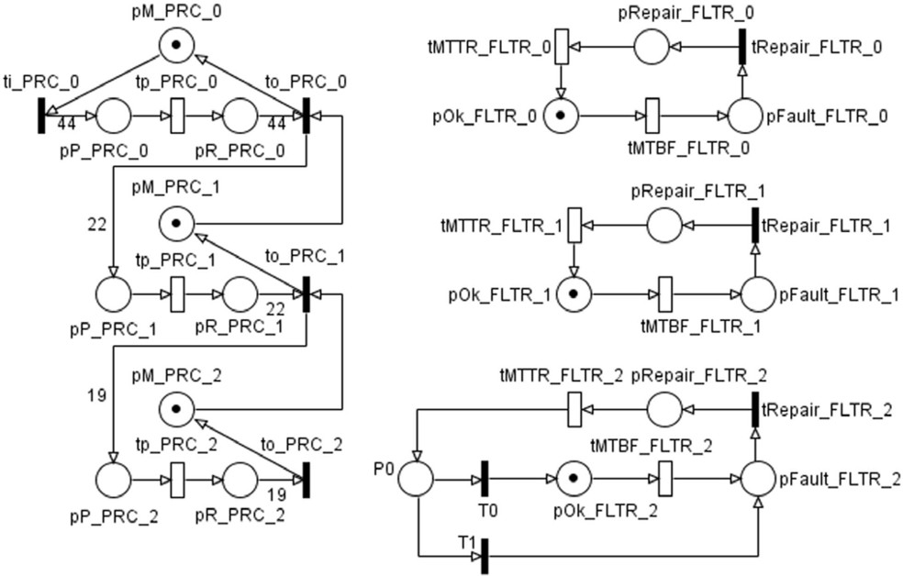

Fig. 2. Stochastic Petri Net for the production line.

Table 2 provides a summary of the exergetic values adopted for following calcu- lations [16]. Such efficiences are used in the exergy/GWP comparison. The natural gas and fuel oil efficiences considered for powering machines represent the efficiency for converting the energy source into electricity, that in turn could be directly used by machines.

Table 2

Exergy efficiency per source and use.

Source Use Efficiency (*ηII* ) *xch,f* (kJ/kg)

|  |  |  |  |
| --- | --- | --- | --- |
| Electricity | Power | 0.92 | 3600 |
| Electricity | Cooking | 0.115 | 3600 |
| Natural Gas | Power | 0.2931 | 51702 |
| Natural Gas | Cooking | 0.233 | 51702 |
| Fuel Oil | Power | 0.3207 | 47101 |
| Fuel Oil | Cooking | 0.233 | 47101 |

Table 3 presents the reward functions adopting the SPNP tool syntax [15]. We

used the SPNP tool to compute these rewards in the steady-state. Table 4 depicts the results of three experiments that were carried out. The first experiment, removes the failures from the model. The second one, includes failures but considers that there are no limitations for the maintenance team. The third experiment, consider that there is only one resource available in the maintenance team.

Table 3

Reward functions expressions.

|  |  |  |
| --- | --- | --- |
| Metric | Stage | Expression |
| rate1 (un./hour) | 1 | return rate(”tp PRC 0”)/44.0; |
| rate2 (un./hour) | 2 | return rate(”tp PRC 1”)/22.0; |
| rate3 (un./hour) | 3 | return rate(”tp PRC 2”)/19.0; |
| Utilization1 (un./hour) | 1 | return enabled(”tp PRC 0”)?mark(”pP PRC 0”)/44.0:0.0; |
| Utilization2 (un./hour) | 2 | return enabled(”tp PRC 1”)?mark(”pP PRC 1”)/22.0:0.0; |
| Utilization3 (un./hour) | 3 | return enabled(”tp PRC 2”)?mark(”pP PRC 2”)19.0:0.0; |
| el1 (kWh/hour) | 1 | return (63.6812*rate1()); |
| el2 (kWh/hour) | 2 | return (102.9402*rate2()); |
| el3 (kWh/hour) | 3 | return (22.9600*rate3()); |
| gas2 (*m*3/hour) | 2 | return (26.7559*rate2()); |
| hr3 (un./hour) | 3 | return (6.52*rate3()); |
| card1 (kg/hour) | 1 | return (3.7423*rate1()); |
| org3 (kg/hour) | 3 | return (6.2870*rate3()); |
| wood1 (kg/hour) | 1 | return (0.1516*rate1()); |
| dense plst1 (kg/hour) | 1 | return (0.9167*rate1()); |
| film plst3 (kg/hour) | 3 | return (6.6881*rate3()); |
| ferrous1 (kg/hour) | 1 | return (0.3441*rate1()); |
| nferrous1 (kg/hour) | 1 | return (0.0355*rate1()); |
| X in el1 (MJ/hour) | 1 | return (3.6*el1()); |
| X in el2 (MJ/hour) | 2 | return (3.6*el2()); |
| X in el3 (MJ/hour) | 3 | return (3.6*el3()); |
| X in gas2 (MJ/hour) | 2 | return (51.702*0.714*gas2()); |
| X out power (MJ/hour) | system | return 0.92*(X in el1()+X in el2()+X in el3()); |
| X out cooking (MJ/hour) | system | return (0.233*X in gas2()); |
| repairing1 (un./hour) | 1 | return mark(”pRepair FLTR 0”); |
| repairing2 (un./hour) | 2 | return mark(”pRepair FLTR 1”); |
| repairing3 (un./hour) | 3 | return mark(”pRepair FLTR 2”); |
| waiting repair1 (un./hour) | 1 | return mark(”pFault FLTR 0”); |
| waiting repair2 (un./hour) | 2 | return mark(”pFault FLTR 1”); |
| waiting repair3 (un./hour) | 3 | return mark(”pFault FLTR 2”); |

The results presented in Table 4 shows that the inclusion of failures reduces in almost 8% the production rate (from 4.13629 to 3.81551). This rate means that in 3.81551 units of time, a tonne of goods is produced. The lower utilization of the second stage sugests that it represents a bottleneck in the system. So, investments in this stage should be prioritized. The experiment that considers the limitation in the maintenance team presents results that are quite similar to those provided by the scenario without this limitation. Thus, considering the current failures and maintenance rates, a single maintenance team could meet the needs of this produc- tion line. But if such failures increase, new experiments could be conducted in order to check if this assumption remains true.

Table 4

Reward functions results.

|  |  |  |  |  |
| --- | --- | --- | --- | --- |
| Metric | Stage | Scenario 1 | Scenario 2 | Scenario 3 |
| rate1 (un./hour) | 1 | 4.13629 | 3.81797 | 3.82243 |
| rate2 (un./hour) | 2 | 4.13629 | 3.81739 | 3.82111 |
| rate3 (un./hour) | 3 | 4.13629 | 3.81551 | 3.81879 |
| Utilization1 (un./hour) | 1 | 0.48134 | 0.44428 | 0.44479 |
| Utilization2 (un./hour) | 2 | 0.41707 | 0.38491 | 0.38526 |
| Utilization3 (un./hour) | 3 | 0.43849 | 0.40446 | 0.40494 |
| el1 (kWh/hour) | 1 | 263.40376 | 243.13300 | 243.41676 |
| el2 (kWh/hour) | 2 | 425.79028 | 392.96251 | 393.34586 |
| el3 (kWh/hour) | 3 | 94.96916 | 87.60421 | 87.67934 |
| gas2 (*m*3/hour) | 2 | 110.67010 | 102.13761 | 102.23724 |
| hr3 (un./hour) | 3 | 26.96860 | 24.87715 | 24.89849 |
| card1 (kg/hour) | 1 | 15.47923 | 14.28799 | 14.30467 |
| org3 (kg/hour) | 3 | 26.00484 | 23.98814 | 24.00871 |
| wood1 (kg/hour) | 1 | 0.62706 | 0.57880 | 0.57948 |
| dense plst1 (kg/hour) | 1 | 3.79173 | 3.49993 | 3.50402 |
| film plst3 (kg/hour) | 3 | 27.66391 | 25.51854 | 25.54043 |
| ferrous1 (kg/hour) | 1 | 1.42330 | 1.31376 | 1.31530 |
| nferrous1 (kg/hour) | 1 | 0.14684 | 0.13554 | 0.13570 |
| X in el1 (MJ/hour) | 1 | 948.25354 | 875.27880 | 876.30034 |
| X in el2 (MJ/hour) | 2 | 1532.84500 | 1414.66503 | 1416.04509 |
| X in el3 (MJ/hour) | 3 | 341.88899 | 315.37515 | 315.64561 |
| X in gas2 (MJ/hour) | 2 | 4085.41194 | 3770.43302 | 3774.11120 |
| X out power (MJ/hour) | system | 2597.14854 | 2396.89347 | 2399.35176 |
| X out cooking (MJ/hour) | system | 951.90098 | 878.51089 | 879.36791 |
| repairing1 (un./hour) | 1 | - | 0.00580 | 0.00573 |
| repairing2 (un./hour) | 2 | - | 0.03292 | 0.03437 |
| repairing3 (un./hour) | 3 | - | 0.04039 | 0.03794 |
| waiting repair1 (un./hour) | 1 | - | 0.00000 | 0.00006 |
| waiting repair2 (un./hour) | 2 | - | 0.00000 | 0.00007 |
| waiting repair3 (un./hour) | 3 | - | 0.00000 | 0.00013 |

The following analysis are based on the second experiment that represents the actual situation of the production line. Assuming the current operation of the industry, it is possible to infer that this production line assigns a GWP of 147 *kg CO*2*e/ton* of goods. We performed this estimation considering the conver- sion factors provided by DEFRA [9]. Figure 3 presents the GWP participation separated for the energy sources and disposed resources. The energy sources are responsible for more than 95% of the overall GWP. It is important spot that the electricity conversion factor might vary from country to country. This case study adopted the UK factors provided by DEFRA. Taking into consideration the elec- tricity participation in the total GWP, if the Brazilian’s conversion factor (which is lower than in UK), the GWP resultant from the production line should considerably decrease.

We calculated the amount of exergy input necessary to generate the same exergy output (see Table 4) with a single energy source. Based on that exergy input, we calculate the GWP and compared it to the actual operation of the production line. Figure 4 presents that comparison result. The graphs labeled as “ideal efficiency”

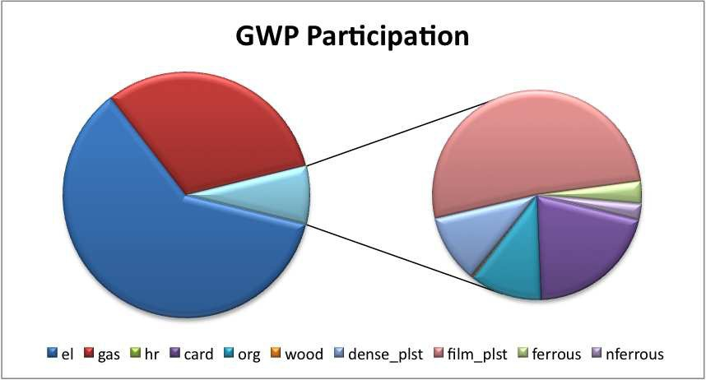

Fig. 3. Participation of resources in the total GWP.

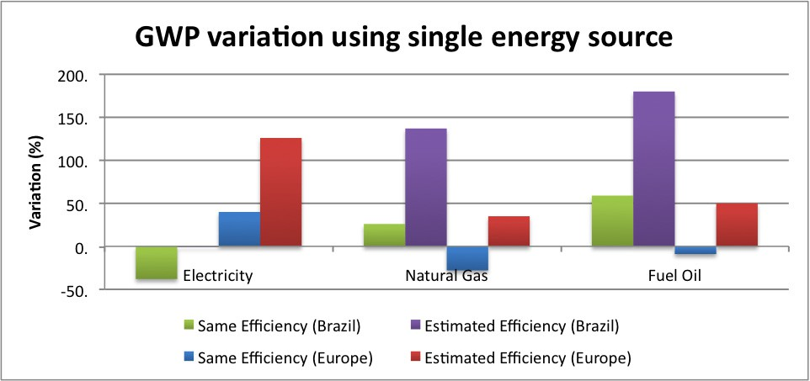

Fig. 4. Impact of energy source over GWP.

assume a hypothetical situation where the current efficiency *ηII,a,f* is preserved. The “real efficiency” graphs, depict the variation in a real scenario where the exergetic efficiency changes according to the energy source.

It is possible to observe that considering an hypothetical situation where the exergy efficiency is preserved, the use of natural gas as the single energy source decreases the GWP in european countries, whilst in Brazil, this value increases. It occurs due to the fact that in Brazil, the GWP factor of the energy is very low when compared to other countries, due to the extensive use of hydroelectric energy.

Regarding the real efficiences, despite of the fact that the exergetic efficiency of the electricity for cooking processes is lower than that one of the natural gas, the GWP variation remains almost constant when the electricity is used as the only energy source in Brazil. Furthermore, although the fuel oils have a high chemical exergy, their high GWP concentration make them be the worst alternative from the

environment issue. Analysis of costs might justify their usage in some points of the production line in detriment to environment impacts.

# Concluding Remarks

This paper presented the evaluation of GWP and exergetic indicators in manufac- turing systems and supply chains using stochastic models. It presents a comparison of exergetic values for different energy sources and the corresponding GWP resul- tant from the use of such sources. It was observed the importance of considering not only the energy source, but also the localities, that means, the effects of the system location (e.g. country, city, etc) over evaluated metrics. Especially for the electricity, the GWP factor might vary substantially according to the country that is using such issue. Since resources are detailed, its costs could be directly assessed. In conjunction with the analysis of costs, this kind of comparison might support the cost/environment trade-off analysis.

The proposed approach uses a single model to measure environmental and per- formance indicators. Using stochastic Petri nets to measure such indicators allows the calculation of measurements like the probability of having an indicator over a limit amount. Furthermore, this modeling technique allowed the definition of high-level components that could not be defined using other techniques like Markov chains. The library of components could thus be used to model a whole system using a bottom-up approach.

# References

1. G. Alves, P. Maciel, R. Lima, and A. Zimmermann. Automatic Modeling for Performance Evaluation of Inventory and Outbound Distribution. *Systems, Man and Cybernetics, Part A: Systems and Humans, IEEE Transactions on*, 40(5):1025–1044, 2010.
2. G. Balbo. Introduction to Stochastic Petri Nets. *LNCS 2090*, pages 84–155, 2001.
3. R. H. Ballou. *Business Logistics/Supply Chain Management*. Pearson Education, Inc., 5 edition, 2004.
4. M. E. Bo¨sch, S. Hellweg, M. A. J. Huijbregts, and R. Frischknecht. Applying Cumulative Exergy Demand (CExD) Indicators to the ecoinvent Database. *The International Journal of Life Cycle* *Assessment*, 12(3):181–190, 2007.
5. Y. A. C¸ engel and M. A. Boles. *Thermodynamics: An Engineering Approach*. McGraw-Hill, 5 edition, 2005.
6. G. Ciardo, A. Blakemore, P. Chimento, J. Muppala, and K. Trivedi. Automated generation and analysis of markov reward models using stochastic reward nets. *IMA Volumes in Mathematics and its Applications*, 48:145–145, 1993.
7. G. Ciardo and K. Trivedi. A decomposition approach for stochastic reward net models. *Performance Evaluation*, 18:37–59, 1993.
8. M.A. Cohen and H.L. Lee. Strategic analysis of integrated production-distribution systems: models and methods. *Operations Research*, 36(2):216–228, 1988.
9. DEFRA - Department for Environment, Food and Rural Affairs. 2009 Guidelines to Defra / DECC’s GHG Conversion Factors for Company Reporting, 2009.
10. A. A. Desrochers and R. Y. Al-Jaar. *Applications of Petri Nets in Manufacturing Systems: Modeling, Control, and Performance Analysis*. Institute of Electrical & Electronics Enginee, 1994.
11. M. Fleischmann, J. M. Bloemhof-Ruwaard, R. Dekker, E. van der Laan, J. A. E. E. van Nunen, and L. N. van Wassenhove. Quantitative models for reverse logistics: A review. *European Journal of Operational* *Research*, 103:1–17, 1997.
12. M. Goedkoop, R. Spriensma, et al. *The Eco-indicator 99*. PR´e Consultants, 2000.
13. M. Gong and G. Wall. On exergy and sustainable development–part 2: Indicators and methods. *Exergy, An International Journal*, 1(4):217–233, 2001.
14. R. Heijungs, J. Guin´ee, G. Huppes, R. Lankreijer, H. Udo de Haes, A. Wegener Sleeswijk, A. Ansems,

P. Eggels, R. Duin, and H. Goede. *Environmental life cycle assessment of products*. Centre of Environmental Science. University of Leiden, 1992.

1. C. Hirel, B. Tuffin, and K. Trivedi. SPNP: Stochastic Petri Nets. Version 6.0. In *Computer Performance Evaluation. Modelling Techniques and Tools*, volume 1786, pages 354–pp. Springer Verlag, 2000.
2. T. J. Kotas. *The Exergy Method of Thermal Plant Analysis*. Butterworths, 1985.
3. A. Law, W. Kelton, and W. Kelton. *Simulation modeling and analysis*. McGraw-Hill New York, 1991.
4. P. Maciel, T. Barros, and C. Pimentel. Modeling Two-Dimensional Runlength-Limited Sequences for Data Storage Storage Using Petri Nets. *International Journal of Computational and Numerical Analysis and Applications*, 17:17–35, 2007.
5. M. A. Marsan. Stochastic Petri nets: an elementary introduction. *Advances in Petri nets 1989*, pages 1–29, 1990.
6. M. A. Marsan, G. Balbo, G. Conte, S. Donatelli, and G. Franceschinis. *Modelling with Generalized Stochastic Petri Nets*. John Wiley & Sons, 1995.
7. J. Muppala, G. Ciardo, and K. Trivedi. Stochastic reward nets for reliability prediction.

*Communications in reliability, maintainability and serviceability*, 1(2):9–20, 1994.

1. E.H. Sabri and B.M. Beamon. A multi-objective approach to simultaneous strategic and operational planning in supply chain design. *Omega*, 28(5):581–598, 2000.
2. E. Sciubba. Extended exergy accounting applied to energy recovery from waste: The concept of total recycling. *Energy*, 28(13):1315–1334, 2003.
3. M. Silva and P. Maciel. Modelling and analysis of inventory policy: an approach based on petri nets. In *International IEEE Conference on Systems, Man and Cybernetics*, Hawaii, 2005.
4. D. Simchi-Levi, P. Kaminsky, and E. Simchi-Levi. *Designing and managing the supply chain: concepts, strategies and case studies*. McGraw-Hill, 2000.
5. S. K. Srivastava. Green Supply-Chain Management: A State-of-the-Art Literature Review.

*International Journal of Management Reviews*, 9(1):53 – 80, 2007.

1. J. Szargut. *Exergy Method: Technical and Ecological Applications*. WIT Press, 2005.
2. E. Tavares, P. Maciel, P. Dallegrave, B. Silva, T. Falc˜ao, B. Nogueira, G. Callou, and P. Cunha. Model- driven software synthesis for hard real-time applications with energy constraints. *Design Automation for Embedded Systems*, 15:20–42, 2011.
3. H. Tijms. *A first course in stochastic models*. John Wiley & Sons Inc, 2003.