*Open access under* [*CC BY-NC-ND license.*](http://creativecommons.org/licenses/by-nc-nd/3.0/)

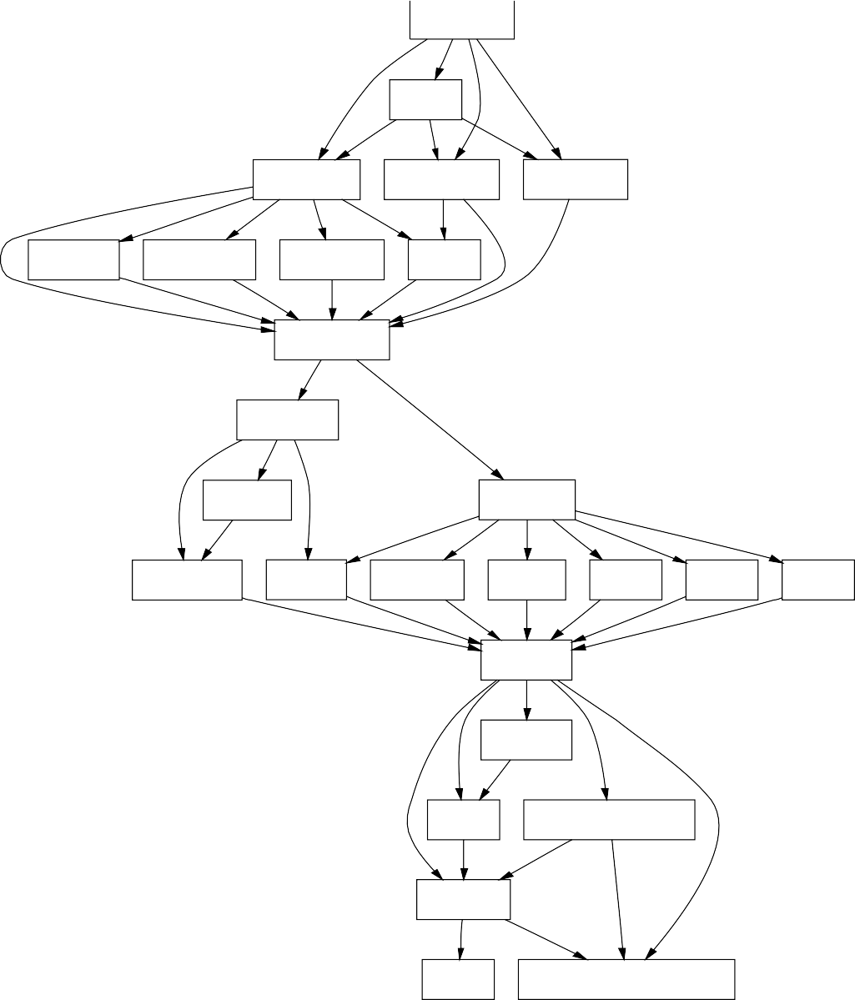

Framework

ZigZag

Refactoring Construction Destruction

YACCify DeYACCify Alternation

Move

Combinators

Conditions

Coverage

Primitives

Equivalence Yielders Substitute Replace

Reset

Add

Sub

Auxiliary

Matching

Focus IdentifierGeneration

Properties

Bool

Extended-SDF2-Grammar

Full grammar

Parser

generator

Code

Parser

AST

Coverage accumulator

Coverage

Grammar Minimiser

Minimised grammar

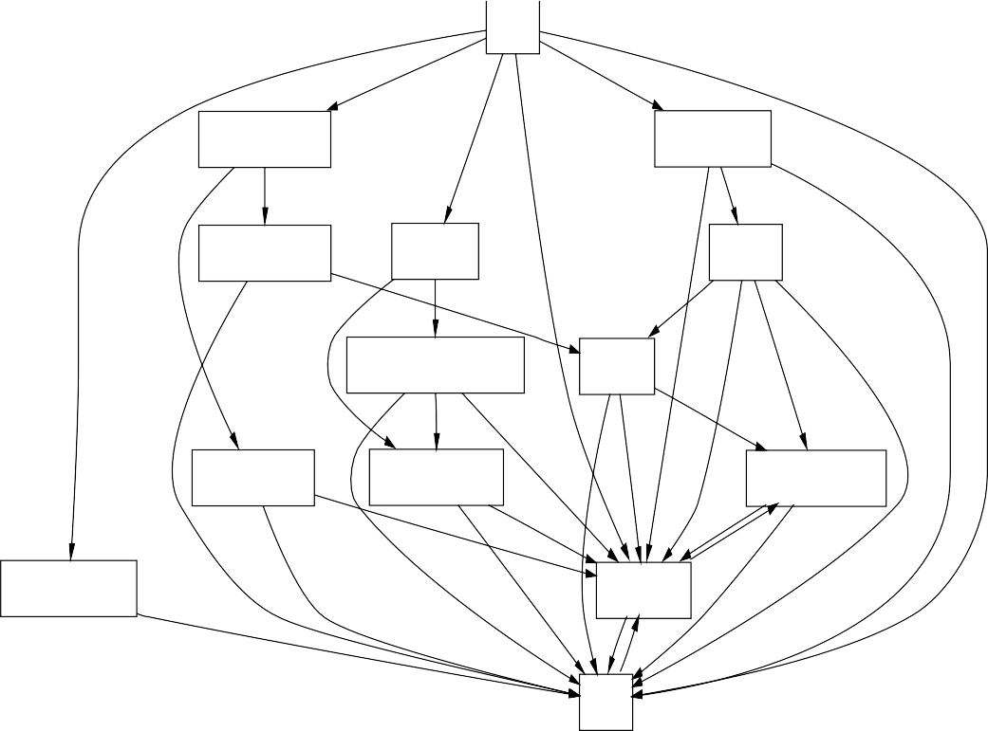

Cobol

EnvironmentDivision

ProcedureDivision

ConfigurationSection

DataDivision

Statements

FileAndSortDescriptionEntry

Conditions

InputOutputSection

DataDescriptionEntry

ArithmeticExpressions

IdentificationDivision

DataReference

Names

|  |  |  |
| --- | --- | --- |
|  |  |  |
|  |  |  |
|  |  |  |
|  |  |  |
|  |  |  |
|  |  |  |