HOSTE D BY

Available online at [www.sciencedirect.com](http://www.sciencedirect.com/science/journal/2314808X)

**ScienceDirect**

journal homepage: [http://ees.elsevier.com/ejbas/default.asp](http://http//ees.elsevier.com/ejbas/default.asp)

egyptian journal of basic and applied sciences 3 (2016) 134–140



**Full Length Article**

**Traveling wave solutions of generalized Zakharov–Kuznetsov–Benjamin–Bona–Mahony and simplified modified form of Camassa–Holm equation exp(–*φ*(*η*)) – Expansion method**



***Ayyaz Ali, Muhammad Asad Iqbal, Syed Tauseef Mohyud-Din*** ***\****

*Department of Mathematics, Faculty of Sciences, HITEC University Taxila, Pakistan*

A R T I C L E I N F O A B S T R A C T

*Article history:*

Received 20 May 2015

Received in revised form 7 January 2016

Accepted 7 January 2016

Available online 16 March 2016

*Keywords:*

Exp(–*φ*(*η*))-expansion method Nonlinear evolution equation Generalized Zakharov–Kuznetsov– Benjamin–Bona–Mahony equation Simplified Modified form of Camassa–Holm equation Traveling wave solutions

In this article, we established abundant traveling wave solutions for nonlinear evolution equa- tions. The exp(–*φ*(*η*))-expansion method is used to construct traveling wave solutions for the generalized Zakharov–Kuznetsov–Benjamin–Bona–Mahony equation and Simplified Modi- fied form of Camassa–Holm equation. The traveling wave solutions are expressed in terms of the hyperbolic functions, the trigonometric functions and the rational functions. The pro- posed solutions are found to be important for the explanation of some practical physical problems in mathematical physics and engineering.

© 2016 Mansoura University. Production and hosting by Elsevier B.V. This is an open access article under the CC BY-NC-ND license (<http://creativecommons.org/licenses/by->

nc-nd/4.0/).

# Introduction

It is well known that seeking exact solutions [1–53] for non- linear evolution equations (NLEES) plays an important role in mathematical physics. For instance, nonlinear evolution equa- tions (NEEs) are widely used as models to describe complex physical phenomena in various fields of sciences, especially

in fluid mechanics, solid-state physics, plasma physics, plasma waves and biology. One of the basic physical problems for those models is to obtain their travelling wave solutions. In particu- lar, various methods have been utilized to explore different kinds of solutions of physical models described by nonlinear partial differential equations (NPDEs). In the past few decades or so, many effective methods have been presented, which contain the inverse scattering transform method, the Backlund

* *Corresponding author.* Tel.: +92 3235577701.

*E-mail address:* [syedtauseefs@hotmail.com](mailto:syedtauseefs@hotmail.com) (S.T. Mohyud-Din).

<http://dx.doi.org/10.1016/j.ejbas.2016.01.001>

2314-808X/© 2016 Mansoura University. Production and hosting by Elsevier B.V. This is an open access article under the CC BY-NC-ND license ([http://creativecommons.org/licenses/by-nc-nd/4.0/).](http://creativecommons.org/licenses/by-nc-nd/4.0/))

egyptian journal of basic and applied sciences 3 (2016) 134–140

**135**

transformation [1], bilinear transformation, the tanh-sech method [2], the extended tanh method, the pseudo-spectral method [3,8–10,14,15], trial function and the sine-cosine method [4,5], Hirota method [6], tanh-coth method [2,7,11,13], the ex- ponential function method [16–24], the (*G´*/*G*)-expansion method [25–29], the homogeneous balance method [30,31], F-expansion method [33–35] and the Jacobi elliptic function expansion method [36–38] and so on. In a subsequent work, Ma et al. [39]

where *u*  *u**x*, *t* is an unknown function, *P* is a polynomial in *u**x*, *t* and its various partial derivatives, in which the highest order derivatives and nonlinear terms are involved. In order to solve Eq. (2) by using the exp(–*φ*(*η*))-expansion method we have to follow the following steps.

**Step 1.** Combining the real variables *x* and *t* by a com- pound variable *η* we assume

developed the complexiton solutions for Toda lattice equa- tion through the Casoratian formulation and hence obtained

*u**x*, *t*  *u* **,

**  *x*  *Vt*

(3)

a set of coupled conditions which guaranteed Casorati deter- minants to be the solution of Toda Lattice which consequently produced complexiton solutions. Moreover, Ma and You [40] used variation of parameters for solving the involved non-

where *V* is the speed of the traveling wave. Using the travel- ing wave variable (3), Eq. (2) is reduced to the following ODE for *u*  *u* **

homogeneous partial differential equations and obtained

solution formulas helpful in constructing the existing solu- tions coupled with a number of other new solutions including

*Q* *u*, *u*, *u*, *u*, *u*, …  0,

(4)

rational solutions, solitons, positions, negatons, breathers, com- plexions and interaction solutions of the KdV equations. It is needed to be highlighted that the basic spirit of the exp- function method which is the conversion of nonlinear partial differential equations into integrable ordinary differential equa-

where Q is a function of *u* ** and its derivatives, prime denotes

derivative with respect to *η*.

**Step 2.** Suppose the solution of (4) can be expressed by a polynomial in exp(–*φ*(*η*)) as follows

tions was explicitly presented and minutely analyzed in 1996 by Ma and Fuchssteiner [41]. In fact, the exp-function method

*u* **  *an* exp** ***n*  *an*1 exp** ***n*1  ⋯,

(5)

is restricted to produce rational solutions in the form of trans- formed variables and such solutions can be obtained easily by making use of other techniques including Wronskian and Casoratian [41–43]. Recently, Ma, Wu and He [44] presented a much more general idea to yield exact solutions to nonlinear wave equations by searching for the so-called Frobenius trans- formations. Some recently developed methods, such as, the

modified simple equation [45–49], the enhanced Exp(–*φ*(*(*))- expansion method [50,51], the Enhanced (G′/G)-Expansion method [52,53], etc. which provide useful exact solutions to

where *an*, *an*1, ⋯ and V are constants to determined later such that *an* ≠ 0 and ** ** satisfies Eq. (1).

**Step 3.** By using the homogenous principal, we can evalu- ate the value of positive integer *n* between the highest order linear terms and nonlinear terms of the highest order in Eq.

(4). Our solutions now depend on the parameters involved in Eq. (1).

Case 1. *h*2 − 4*μ* > 0 and *μ* ≠ 0,

NLEEs have been discussed.

 1 



  

The objective of this article is to apply the exp(–*φ*(*η*))-

** **  ln    **2  4** tanh

**  *c*1   ** ,

(6)

expansion method to construct the exact solutions for nonlinear evolution equations in mathematical physics via generalized

**2  4**

2** 

 2   

Zakharov–Kuznetsov–Benjamin–Bona–Mahony equation and Simplified Modified form of Camassa–Holm equation. The subject matter of this method is that the traveling wave so- lutions of a nonlinear evolution equation can be expressed by

where *c*1 is a constant of integration.

Case 2. *h*2 − 4*μ* < 0 and *μ* ≠ 0,

a polynomial in exp(–*φ*(*η*)), where *φ*(*η*) satisfies the ordinary dif-





** **  ln  1  **  **2  4** tan

**2  4** **  *c*  

ferential equation (ODE):

**  **  exp** **  ** exp** **  **

Where *η* = *x* − *Vt*.

(1)

2**   2

Case 3. *μ* = 0 and *h* ≠ 0,

** **   ln * * ** 

 

exp** **  *c*1   1

1   

(7)

(8)

 

# Description of exp(–*φ*(*η*))-expansion

**method**

Now we explain the exp(–*φ*(*η*))-expansion method for finding traveling wave solutions of nonlinear evolution equations. Let us consider the general nonlinear partial differential equa-

Case 4. **2  4**  0, **  0, and *μ* ≠ 0,

** **  ln 2 ** **  *c*1   2

 2 

** **  *c*1 





(9)

tion of the form.

*P**u*, *ut*, *ux*, *utt*, *uxx*, *uxxx*,…,

(2)

Case 5. *h* = 0, and *μ* = 0,

** **  ln **  *c*1 

(10)

**136** egyptian journal of basic and applied sciences 3 (2016) 134–140

**Step 4.** Substitute Eq. (5) into Eq. (4) and using Eq. (1), the

*C*  0, **  1  2

*ab**V*  1

*a* 2*bV*  *V*  1  2*b*

*a* 2*bV*  *V*  1  2*b* ,

left hand side is converted into a polynomial in exp** **. Equating each coefficient of this polynomial to zero, we obtain a set of algebraic equations for *an*, ⋯ *V*, **, ** .

**Step 5.** Eventually, solving the algebraic system of equa-





 a1 



*ab**V*  1

*a*



2 *ab**V*  1

, a0  *a* ,



tions obtained in Step 4 by the use of Maple or Mathematica, we obtain the values of the constants *an*, ⋯, *V*, ** and *μ*. Sub- stituting *an*, ⋯, *V* and the general solution of Eq. (1) into solution

where *h* and *μ* are arbitrary constants. Now substituting the values into Eq. (14), we obtain

of Eq. (5), we obtain some valuable traveling wave solutions of Eq. (2).

*u*  2**  1 

2*e*****, (16)

# Solution procedure

## *Generalized Zakharov–Kuznetsov–Benjamin–Bona–* Mahony equation

Let us consider the generalized Zakharov–Kuznetsov–Benjamin–

where **  *x*  *y*  *Vt*. Now substituting Eq. (6) to Eq. (10) into Eq.

(16) respectively, we get the following five traveling wave so- lutions of generalized Zakharov–Kuznetsov–Benjamin–Bona– Mahony equation.

Case 1. When *h*2 − 4*μ* > 0 and *μ* ≠ 0, we obtain the hyperbolic function traveling wave solution.

 2 2**

Bona–Mahony equation.

*u*1 ** 

2**  1  

−

**2  4** tanh

,

**2  4** **  *c*   **

ut  ux  au3   buxt  uyy   0, (11)

  2

1  

x x

where *η* = *x* + *y* − V*t* and where *c*1 is an arbitrary constant.

where *a* and *b* are some nonzero parameters. We utilize the

traveling wave variable

*u**x*, *t*  *u* **, **  *x*  *y*  *Vt*, we can

Case 2. When *h*2 − 4*μ* < 0 and *μ* ≠ 0, we obtain trigonometric so-

convert Eq. (11) into an ordinary differential equation.

*Vu*  *u*  3au2*u*  *bu*3*V*  *bu*  0, (12)

lution.

u   2  1  2 2 ,

2    

2  4

 2  4 tanh   c1   

where the prime denotes the derivative with respect to *η*. Now integrating Eq. (12) we have,

*Vu*  *u*  *bVu*  *au*3  *bu*  *C*  0, (13)

Balancing the *u*’’ and *u*2 by using homogenous principal, we have

  2  

where *η* = *x* + *y* − V*t* and where *c*1 is an arbitrary constant.

Case 3. When *μ* = 0 and *h* ≠ 0, we obtain exponential solu- tion.

3*M*  *M*  2,

*u*3 ** 

2  1  2** ,

exp**  *c*1 **  1

*M*  1.

Then the trial solution of Eq. (12) can be expressed as follows,

where *η* = *x* + *y* − V*t* and where *c*1 is an arbitrary constant.

Case 4. When **2  4**  0, **  0 and *μ* ≠ 0, we obtain rational function solution.

*u* **  **1 exp** **  **0,

(14)

*u*4 ** 

2  1  ,

where *α*1 ≠ 0 and *α*0 is a constant to determined, while *h*, *μ* are arbitrary constants.



2 **  *c*1 **2

2 **  *c*1 **  2

Substituting *u*, *u*, *u*, *u*2 into Eq. (13) and then equating the coefficients of *exp*** ** to zero, we get

*a*0  *ba*1**  *C*  *bVa*1** *aa*3  *Va*0  0,

0

where *η* = *x* + *y* − V*t* and where *c*1 is an arbitrary constant.

Case 5. When *h* = 0, and *μ* = 0, we obtain rational function so- lution.

*a*1  *bVa*1**2  2*ba*1**  2*bVa*1**  3*aa a*2  *ba*1**2 *Va*  0,



2

1 0 1

1

3*aa a*2  3*ba *  3*bVa *  0,

(15)

*u*5 ** 

2  1  **  *c*  ,

0 1 1 1

*aa*3  2*ba*  2*bVa*  0

1 1 1

Solving the set of algebraic equations, we obtain the fol- lowing solution.

where *η* = *x* + *y* − V*t* and where *c*1 is an arbitrary constant.

### Graphical representation of the solutions:

egyptian journal of basic and applied sciences 3 (2016) 134–140

**137**

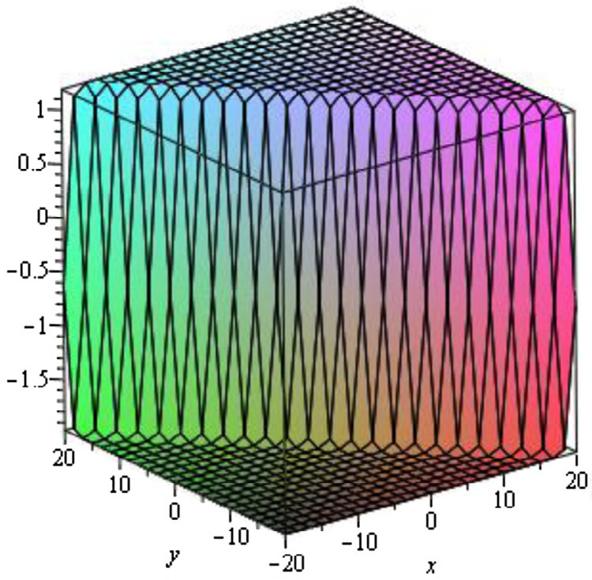 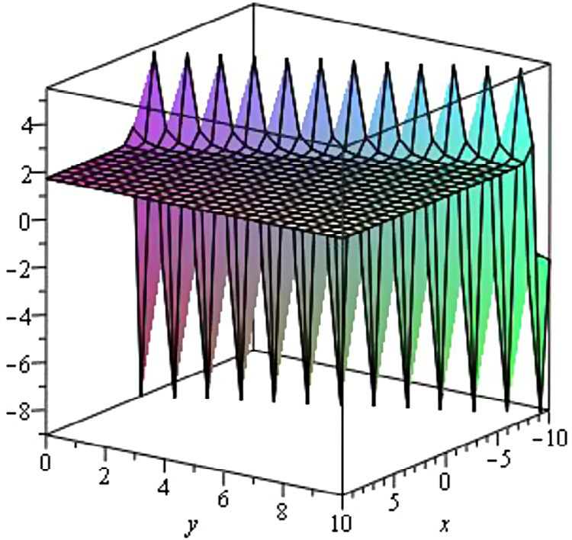

### Fig. 1 – Kink wave solution *u*1 ** when

***a*2**  **1, *a*0**  **2, *y***  **0,** **  **3,** **  **2, *c*1**  **1 .**

### Fig. 3 – Singular Kink wave solution *u*3 ** when

***a*2**  **1, *a*0**  **2, *y***  **0,** **  **1, *c*1**  **1 .**

The graphical illustrations of the solutions are given below in the figures with the aid of Maple (Figs. 1–5).

## *Simplified Modified form of Camassa–Holm equation*

Let us consider Simplified Modified form of Camassa–Holm equation.

*ut*  2*ux*  *uxxt*  *u*2*ux*  0, (17)

where *β* and *δ* are some nonzero parameters.

We utilize the traveling wave variable *u**x*, *t*  *u* **, *η* = *x* − *Vt*, we can convert Eq. (17) into an ordinary differential equa-

tion.

*Vu*  2*u*  *Vu*  *u*2*u*  0, (18) where the prime denotes the derivative with respect to *η*.

Now integrating Eq. (18) we have,

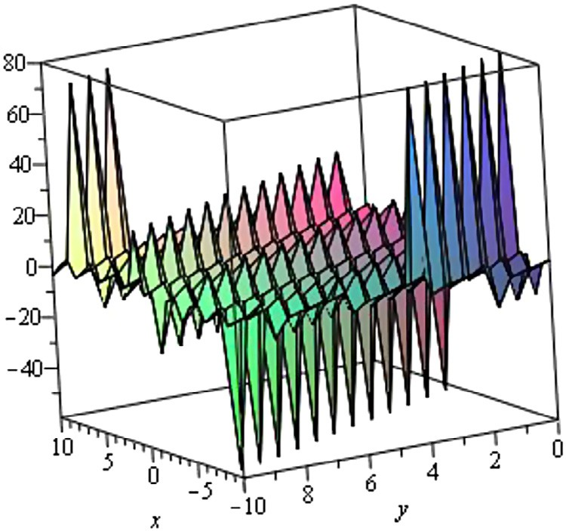

### Fig. 2 – Singular Kink wave solution *u*2 ** when

***a*2**  **10, *a*0**  **8, *y***  **0,** **  **7,** **  **5, *c*1**  **10 .**

*Vu*  2*u*  *u**V*  1 *u*3  *C*  0, (19)

3

Balancing the *u*’ and *u*2 by using homogenous principal, we have

3*M*  *M*  2,

*M*  1.

Then the trial solution of Eq. (18) can be expressed as follows,

*u* **  **1 exp** **  **0, (20)

where *α*1 ≠ 0, *α*0 is a constant to determined, while *h*, *μ* are ar- bitrary constants.

Substituting *u*, *u*, *u*, *u*2 into Eq. (19) and then equating the coefficients of *exp*** ** to zero, we get

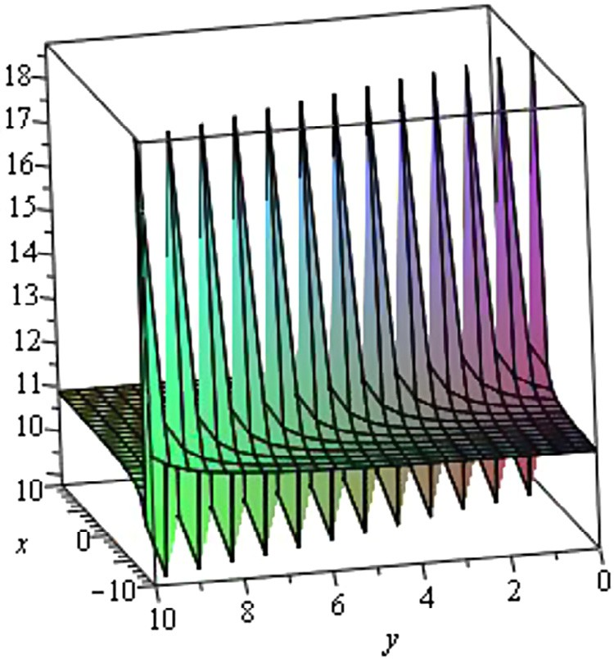

### Fig. 4 – Singular Kink wave solution *u*4 ** when

***a*2**  **3, *a*0**  **2, *y***  **0,** **  **5,** **  **4, *c*1**  **2 .**

**138** egyptian journal of basic and applied sciences 3 (2016) 134–140

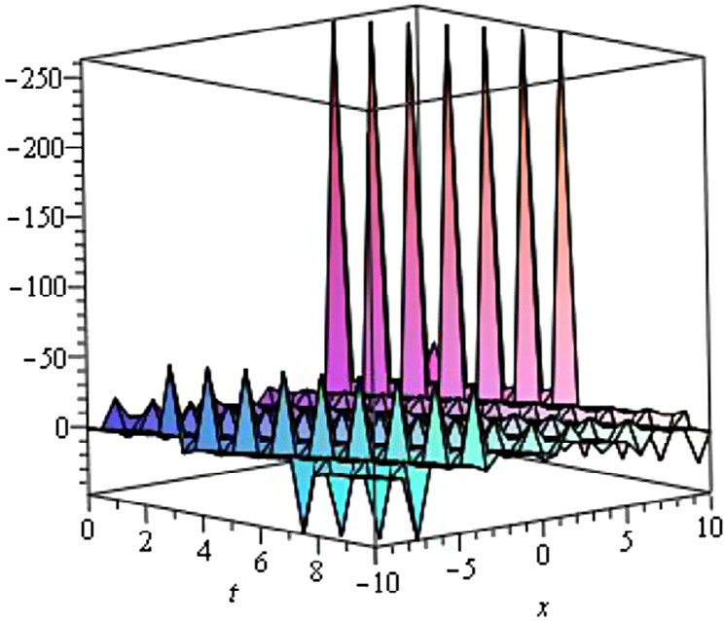

### Fig. 5 – Singular Kink wave solution *u*5 ** when

***a*2**  **0.5, *a*0**  **0.2, *y***  **0,** **  **0.1, *c*1**  **0.1 .**

### Fig. 6 – Kink wave solution *u*1 ** when

***C***  **1, *a*0**  **0.1, *y***  **0,** **  **0.2,** **  **0.5, *c*1**  **0.3 .**

where *η* = *x* − V*t* and where *c*1 is an arbitrary constant.

1 *a*3  2*a *  *C*  *Va *  *Va*

 0,

Case 3. When *μ* = 0 and *h* ≠ 0, we obtain exponential solu- tion.

3 0 0 1 0

2*Va*1**  *a*2*a*  2*a *  *C*  *Va *2  *Va*

 0,

6**

0 1 1 1 1

*a a*2  3*Va *  0,

0 1

1

(21)

*u*3 **  *a*0

− *exp***  *c* **  1,

1 *a*3  2*Va*  0

1

3 1 1

where *η* =

*x* − V*t*

and where *c*1

is an arbitrary constant.

Solving the set of algebraic equations, we obtain the fol- lowing solution.

Case 4. When **2  4**  0, **  0, and *μ* ≠ 0, we obtain rational function solution.

** 

6*V*

  6*V*



1 *a*0

, ** 

1 3*V*  6**  *a*2

,

0

a1  

, C  0,



6 **  *c*1 **2

2 **  *c*1 **  2

 3 *V* 6 *V * *u*4 **  *a*0  ,

where *h* and *μ* are arbitrary constants.

Now substituting the values into Eq. (20), we obtain,

*u*  



*a*0  6 –*Ve*****

**

(22)

where *η* = *x* − V*t* and where *c*1 is an arbitrary constant.

Case 5. when *h* = 0, and *μ* = 0, we obtain rational function so- lution.

Where *η* = *x* − *Vt*.

Now substituting Eq. (6) to Eq. (10) into Eq. (22) respec- tively, we get the following five traveling wave solutions of the Simplified Modified form of Camassa–Holm equation.

Case 1. When *h*2 − 4*μ* > 0 and *μ* ≠ 0, we obtain the hyperbolic function traveling wave solution.

 2 6**

*u*5 **  *a*0   6 ,

where *η* = *x* − V*t* and where *c*1 is an arbitrary constant.



**  *c*1 

### Graphical representation of the solutions:

The graphical illustrations of the solutions are given below in the figures with the aid of Maple (Figs. 6–10).

**Conclusions:** The exp** **-expansion method is very im-

*u*1 **  *a*0  

 

**2  4** tanh

  ,

**  *c*1   **

**2  4**

portant in finding the exact solutions of nonlinear evolution equations. In this article, we have successfully formulated the

  2  



where *η* = *x* − V*t* and where *c*1 is an arbitrary constant.

Case 2. When *h*2 − 4*μ* < 0 and *μ* ≠ 0, we obtain trigonometric so- lution.

*u*2 **  *a*0  2 6** ,

  **2  4** tan **2  4** **  *c*   **

exact and traveling wave solutions to the generalized Zakharov– Kuznetsov–Benjamin–Bona–Mahony equation and Simplified Modified form of Camassa–Holm equation. The wave solu- tions are obtained through the hyperbolic, trigonometric, exponential and rational functions. The calculation proce- dure is simple, direct and constructive. This study shows that the method is quite efficient and much effective for finding exact solutions of nonlinear evolution equations (NLEEs). Also, we observe that the method is straightforward and can be

  2

1  

applied to many other nonlinear evolution equations.

egyptian journal of basic and applied sciences 3 (2016) 134–140

**139**

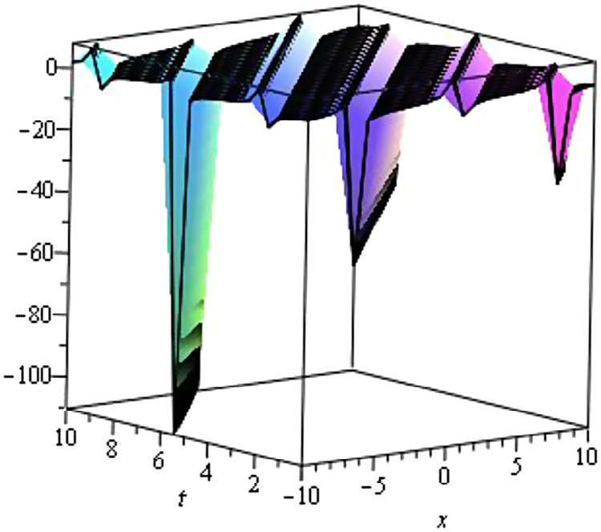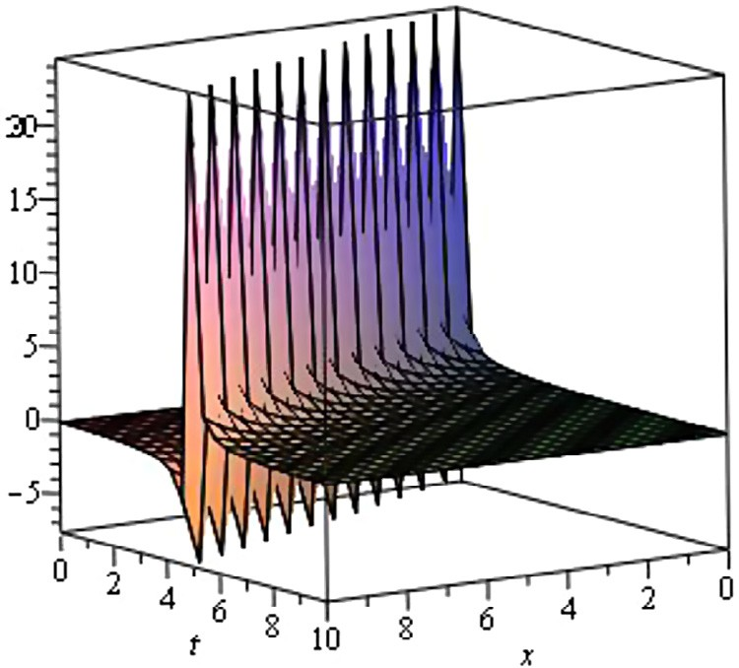

### Fig. 7 – Periodic solution *u*2 ** when

***a*0**  **1, *C***  **1, *y***  **0,** **  **0.1,** **  **0.2, *c*1**  **0.1 .**

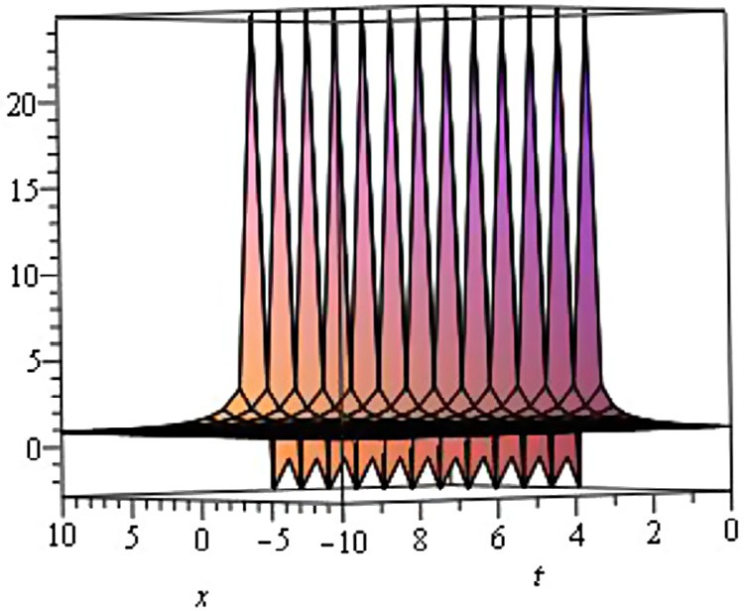

### Fig. 8 – Singular Kink wave solution *u*3 ** when

**  **0.1, *C***  **1, *y***  **0,** **  **0.3, *a*0**  **0.1, *c*1**  **0.1 .**

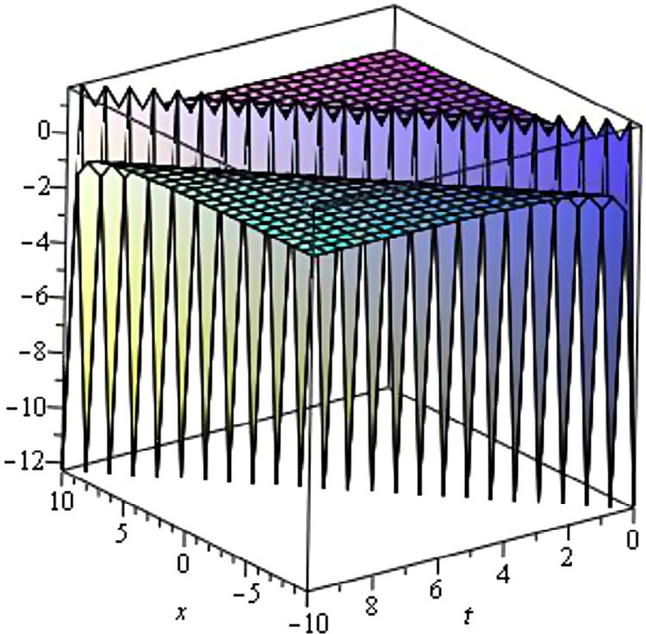

### Fig. 9 – Singular Kink wave solution *u*4 ** when

***a*0**  **0.1, *C***  **1, *y***  **0,** **  **0.1,** **  **1, *c*1**  **0.1 .**

### Fig. 10 – Singular Kink wave solution *u*5 ** when

***C***  **1, *y***  **0,** **  **0.1, *a*0**  **0.1, *c*1**  **0.1 .**

R E F E R E N C E S

1. [Ablowitz MJ, Clarkson PA. Solitons, nonlinear evolution](http://refhub.elsevier.com/S2314-808X(16)00003-8/sr0010) [equations and inverse scattering. New York: Cambridge](http://refhub.elsevier.com/S2314-808X(16)00003-8/sr0010) [University Press; 1991.](http://refhub.elsevier.com/S2314-808X(16)00003-8/sr0010)
2. [Wazwaz AM. The tanh-method for traveling wave solutions](http://refhub.elsevier.com/S2314-808X(16)00003-8/sr0015) [of nonlinear equations. Appl Math Comput 2004;154:713–23.](http://refhub.elsevier.com/S2314-808X(16)00003-8/sr0015)
3. [Rosenau P, Hyman JM. Compactons: solitons with finite](http://refhub.elsevier.com/S2314-808X(16)00003-8/sr0020) [wavelengths. Phys Rev Lett 1993;70:564–7.](http://refhub.elsevier.com/S2314-808X(16)00003-8/sr0020)
4. [Wazwaz AM. An analytic study of compactons structures in](http://refhub.elsevier.com/S2314-808X(16)00003-8/sr0025) [a class of nonlinear dispersive equations. Math Comput](http://refhub.elsevier.com/S2314-808X(16)00003-8/sr0025) [Simul 2003;63:35–44.](http://refhub.elsevier.com/S2314-808X(16)00003-8/sr0025)
5. [Wazwaz AM. A sine–cosine method for handling nonlinear](http://refhub.elsevier.com/S2314-808X(16)00003-8/sr0030) [wave equations. Math Comput Model 2004;40:499–508.](http://refhub.elsevier.com/S2314-808X(16)00003-8/sr0030)
6. [Hirota R. Exact solutions of the Korteweg-de-Vries equation](http://refhub.elsevier.com/S2314-808X(16)00003-8/sr0035) [for multiple collisions of solitons. Phys Lett A 1971;27:1192–](http://refhub.elsevier.com/S2314-808X(16)00003-8/sr0035) [4.](http://refhub.elsevier.com/S2314-808X(16)00003-8/sr0035)
7. [Malfliet W, Hereman W. The tanh method: exact solutions](http://refhub.elsevier.com/S2314-808X(16)00003-8/sr0040) [of nonlinear evolution and wave equations. Phys Scr](http://refhub.elsevier.com/S2314-808X(16)00003-8/sr0040) [1996;54:563–8.](http://refhub.elsevier.com/S2314-808X(16)00003-8/sr0040)
8. [Abdou MA. The extended tanh method and its applications](http://refhub.elsevier.com/S2314-808X(16)00003-8/sr0045) [for solving nonlinear physical models. Appl Math Comput](http://refhub.elsevier.com/S2314-808X(16)00003-8/sr0045) [2007;190:988–96.](http://refhub.elsevier.com/S2314-808X(16)00003-8/sr0045)
9. [El-Wakil SA, Abdou MA. New exact traveling wave solutions](http://refhub.elsevier.com/S2314-808X(16)00003-8/sr0050) [using modified extended tanh-function method. Chaos Solit](http://refhub.elsevier.com/S2314-808X(16)00003-8/sr0050) [Fract 2007;31:840–52.](http://refhub.elsevier.com/S2314-808X(16)00003-8/sr0050)
10. [Fan EG. Extended tanh-function method and its applications](http://refhub.elsevier.com/S2314-808X(16)00003-8/sr0055) [to nonlinear equations. Phys Lett A 2000;277:212–18.](http://refhub.elsevier.com/S2314-808X(16)00003-8/sr0055)
11. [Wazwaz AM. The tanh-method for traveling wave solutions](http://refhub.elsevier.com/S2314-808X(16)00003-8/sr0060) [of nonlinear wave equations. Appl Math Comput](http://refhub.elsevier.com/S2314-808X(16)00003-8/sr0060) [2007;187:1131–42.](http://refhub.elsevier.com/S2314-808X(16)00003-8/sr0060)
12. [Zayed EME, Abdel Rahman HM. The extended tanh-method](http://refhub.elsevier.com/S2314-808X(16)00003-8/sr0065) [for finding traveling wave solutions of nonlinear PDEs.](http://refhub.elsevier.com/S2314-808X(16)00003-8/sr0065) [Nonlin Sci Lett A 2010;1(2):193–200.](http://refhub.elsevier.com/S2314-808X(16)00003-8/sr0065)
13. [Zayed EME, Abdel Rahman HM. The tanh-function method](http://refhub.elsevier.com/S2314-808X(16)00003-8/sr0070) [using a generalized wave transformation for nonlinear](http://refhub.elsevier.com/S2314-808X(16)00003-8/sr0070) [equations. Int J Nonlin Sci Numer Simul 2010;11:595–601.](http://refhub.elsevier.com/S2314-808X(16)00003-8/sr0070)
14. [Wazwaz AM. The extended tanh-method for new compact](http://refhub.elsevier.com/S2314-808X(16)00003-8/sr0075) [and non-compact solutions for the KP–BBM and the ZK–BBM](http://refhub.elsevier.com/S2314-808X(16)00003-8/sr0075) [equations. Chaos Solit Fract 2008;38:1505–16.](http://refhub.elsevier.com/S2314-808X(16)00003-8/sr0075)
15. [Yaghobi Moghaddam M, Asgari A, Yazdani H. Exact travelling](http://refhub.elsevier.com/S2314-808X(16)00003-8/sr0080) [wave solutions for the generalized nonlinear Schrödinger](http://refhub.elsevier.com/S2314-808X(16)00003-8/sr0080) [(GNLS) equation with a source by extended tanh-coth, sine-](http://refhub.elsevier.com/S2314-808X(16)00003-8/sr0080) [cosine and exp-function methods. Appl Math Comput](http://refhub.elsevier.com/S2314-808X(16)00003-8/sr0080) [2009;210:422–35.](http://refhub.elsevier.com/S2314-808X(16)00003-8/sr0080)

**140** egyptian journal of basic and applied sciences 3 (2016) 134–140

1. [Mohyud-Din ST. Solution of nonlinear differential equations](http://refhub.elsevier.com/S2314-808X(16)00003-8/sr0085) [by exp-function method. World Appl Sci J 2009;7:116–47.](http://refhub.elsevier.com/S2314-808X(16)00003-8/sr0085)
2. [Wu HX, He JH. Exp-function method and its application to](http://refhub.elsevier.com/S2314-808X(16)00003-8/sr0090) [nonlinear equations. Chaos Solit Fract 2006;30:700–8.](http://refhub.elsevier.com/S2314-808X(16)00003-8/sr0090)
3. [Wu XH, He JH. Solitary solutions, periodic solutions and](http://refhub.elsevier.com/S2314-808X(16)00003-8/sr0095) [compacton like solutions using the exp-function method.](http://refhub.elsevier.com/S2314-808X(16)00003-8/sr0095) [Comput Math Appl 2007;54:966–86.](http://refhub.elsevier.com/S2314-808X(16)00003-8/sr0095)
4. [Abdou MA, Soliman AA, Basyony ST. New application of](http://refhub.elsevier.com/S2314-808X(16)00003-8/sr0100) [exp-function method for improved Boussinesq equation.](http://refhub.elsevier.com/S2314-808X(16)00003-8/sr0100) [Phys Lett A 2007;369:469–75.](http://refhub.elsevier.com/S2314-808X(16)00003-8/sr0100)
5. [Bekir A, Boz A. Exact solutions for nonlinear evolution](http://refhub.elsevier.com/S2314-808X(16)00003-8/sr0105) [equation using exp-function method. Phys Lett A](http://refhub.elsevier.com/S2314-808X(16)00003-8/sr0105) [2008;372:1619–25.](http://refhub.elsevier.com/S2314-808X(16)00003-8/sr0105)
6. [Wu XH, He JH. Exp-function method and its application to](http://refhub.elsevier.com/S2314-808X(16)00003-8/sr0110) [nonlinear equations. Chaos Solit Fract 2008;38:903–10.](http://refhub.elsevier.com/S2314-808X(16)00003-8/sr0110)
7. [Noor MA, Mohyud-Din ST, Waheed A. Exp-function method](http://refhub.elsevier.com/S2314-808X(16)00003-8/sr0115) [for solving Kuramoto–Sivashinsky and Boussinesq](http://refhub.elsevier.com/S2314-808X(16)00003-8/sr0115) [equations. J Appl Math Comput 2008;29:1–13. doi:10.1007/](http://refhub.elsevier.com/S2314-808X(16)00003-8/sr0115) [s12190-008-0083-y.](http://refhub.elsevier.com/S2314-808X(16)00003-8/sr0115)
8. [Naher H, Abdullah FA, Akbar MA. New travelling wave](http://refhub.elsevier.com/S2314-808X(16)00003-8/sr0120) [solutions of the higher dimensional nonlinear partial](http://refhub.elsevier.com/S2314-808X(16)00003-8/sr0120) [differential equation by the exp-function method. J Appl](http://refhub.elsevier.com/S2314-808X(16)00003-8/sr0120) [Math 2012;14.](http://refhub.elsevier.com/S2314-808X(16)00003-8/sr0120)
9. [Zhu SD. Exp-function method for the discrete m KdV lattice.](http://refhub.elsevier.com/S2314-808X(16)00003-8/sr0125) [Int J Nonlin Sci Numer Simul 2007;8:465–9.](http://refhub.elsevier.com/S2314-808X(16)00003-8/sr0125)
10. [Wang M, Li X, Zhang J. The (*G´*/*G*)-expansion method and](http://refhub.elsevier.com/S2314-808X(16)00003-8/sr0130) [travelling wave solutions of nonlinear evolution equations](http://refhub.elsevier.com/S2314-808X(16)00003-8/sr0130) [in mathematical physics. Phys Lett A 2008;372:417–23.](http://refhub.elsevier.com/S2314-808X(16)00003-8/sr0130)
11. [Ebadi G, Biswas A. The (*G´*/*G*)-expansion method and](http://refhub.elsevier.com/S2314-808X(16)00003-8/sr0135) [topological soliton solution of the K(m,n) equation.](http://refhub.elsevier.com/S2314-808X(16)00003-8/sr0135) [Commun Nonlinear Sci Numer Simulat 2011;16:2377–82.](http://refhub.elsevier.com/S2314-808X(16)00003-8/sr0135)
12. [Zayed EME, Gepreel KA. The (*G´*/*G*)-expansion method for](http://refhub.elsevier.com/S2314-808X(16)00003-8/sr0140) [finding traveling wave solutions of nonlinear partial](http://refhub.elsevier.com/S2314-808X(16)00003-8/sr0140) [differential equations in mathematical physics. J Math Phys](http://refhub.elsevier.com/S2314-808X(16)00003-8/sr0140) [2009;50:13502–12.](http://refhub.elsevier.com/S2314-808X(16)00003-8/sr0140)
13. [Zayed EME, EL-Malky MAS. The extended (*G´*/*G*)-expansion](http://refhub.elsevier.com/S2314-808X(16)00003-8/sr0145) [method and its applications for solving the (3+1)-](http://refhub.elsevier.com/S2314-808X(16)00003-8/sr0145) [dimensional nonlinear evolution equations in mathematical](http://refhub.elsevier.com/S2314-808X(16)00003-8/sr0145)

[physcis. Glob J Sci Front Res 2011;11.](http://refhub.elsevier.com/S2314-808X(16)00003-8/sr0145)

1. [Ekici M, Duran D, Sonmezoglu A. Constructing of exact](http://refhub.elsevier.com/S2314-808X(16)00003-8/sr0150) [solutions to the (2+1)-dimensional breaking soliton](http://refhub.elsevier.com/S2314-808X(16)00003-8/sr0150) [equations by the multiple (*G´*/*G*)-expansion method. J Adv](http://refhub.elsevier.com/S2314-808X(16)00003-8/sr0150)

[Math Stud 2014;7:27–44.](http://refhub.elsevier.com/S2314-808X(16)00003-8/sr0150)

1. [Fan E, Zhang H. A note on the homogeneous balance](http://refhub.elsevier.com/S2314-808X(16)00003-8/sr0155) [method. Phys Lett A 1998;246:403–6.](http://refhub.elsevier.com/S2314-808X(16)00003-8/sr0155)
2. [Wang M. Solitary wave solutions for variant Boussinesq](http://refhub.elsevier.com/S2314-808X(16)00003-8/sr0160) [equations. Phys Lett A 1995;199:169–72.](http://refhub.elsevier.com/S2314-808X(16)00003-8/sr0160)
3. [Chen HT, Zhang HQ. New double periodic and multiple](http://refhub.elsevier.com/S2314-808X(16)00003-8/sr0165) [soliton solutions of the generalized (2 + 1)-dimensional](http://refhub.elsevier.com/S2314-808X(16)00003-8/sr0165) [Boussinesq equation. Chaos Solit Fract 2004;20:765–9.](http://refhub.elsevier.com/S2314-808X(16)00003-8/sr0165)
4. [Ebaid A, Aly EH. Exact solutions for the transformed reduced](http://refhub.elsevier.com/S2314-808X(16)00003-8/sr0170) [Ostrovsky equation via the F-expansion method in terms of](http://refhub.elsevier.com/S2314-808X(16)00003-8/sr0170) [Weierstrass-elliptic and Jacobian-elliptic functions. Wave](http://refhub.elsevier.com/S2314-808X(16)00003-8/sr0170) [Motion 2012;49:296–308.](http://refhub.elsevier.com/S2314-808X(16)00003-8/sr0170)
5. [Filiz A, Ekici M, Sonmezoglu A. F-expansion method and](http://refhub.elsevier.com/S2314-808X(16)00003-8/sr0175) [new exact solutions of the SchrÄodinger-KdV equation. Sci](http://refhub.elsevier.com/S2314-808X(16)00003-8/sr0175) [World J 2014;2014:Article ID 534063.](http://refhub.elsevier.com/S2314-808X(16)00003-8/sr0175)
6. [Abdou MA. The extended F-expansion method and its](http://refhub.elsevier.com/S2314-808X(16)00003-8/sr0180) [applications for a class of nonlinear evolution equations.](http://refhub.elsevier.com/S2314-808X(16)00003-8/sr0180) [Chaos Solit Fract 2007;31:95–104.](http://refhub.elsevier.com/S2314-808X(16)00003-8/sr0180)
7. [Dai CQ, Zhang JF. Jacobian elliptic function method for](http://refhub.elsevier.com/S2314-808X(16)00003-8/sr0185) [nonlinear differential–difference equations. Chaos Solit](http://refhub.elsevier.com/S2314-808X(16)00003-8/sr0185) [Fract 2006;27:1042–7.](http://refhub.elsevier.com/S2314-808X(16)00003-8/sr0185)
8. [Liu D. Jacobi elliptic function solutions for two variant](http://refhub.elsevier.com/S2314-808X(16)00003-8/sr0190) [Boussinesq equations. Chaos Solit Fract 2005;](http://refhub.elsevier.com/S2314-808X(16)00003-8/sr0190) [24:1373–85.](http://refhub.elsevier.com/S2314-808X(16)00003-8/sr0190)
9. [Chen Y, Wang Q. Extended Jacobi elliptic function rational](http://refhub.elsevier.com/S2314-808X(16)00003-8/sr0195) [expansion method and abundant families of Jacobi elliptic](http://refhub.elsevier.com/S2314-808X(16)00003-8/sr0195)

[functions solutions to (1+1)-dimensional dispersive long](http://refhub.elsevier.com/S2314-808X(16)00003-8/sr0195)

[wave equation. Chaos Solit Fract 2005;24:745–57.](http://refhub.elsevier.com/S2314-808X(16)00003-8/sr0195)

1. [Ma WX, Maruno K. Complexiton solutions of the Toda lattice](http://refhub.elsevier.com/S2314-808X(16)00003-8/sr0200) [equation. Phys A 2004;343:219–37.](http://refhub.elsevier.com/S2314-808X(16)00003-8/sr0200)
2. [Ma WX, Zhou DT. Explicit exact solution of a generalized](http://refhub.elsevier.com/S2314-808X(16)00003-8/sr0205) [KdV equation. Acta Math Sci 1997;17:168–74.](http://refhub.elsevier.com/S2314-808X(16)00003-8/sr0205)
3. [Ma WX, You Y. Solving the Korteweg-de Vries equation by its](http://refhub.elsevier.com/S2314-808X(16)00003-8/sr0210) [bilinear form: wronskian solutions. Trans Am Math Soc](http://refhub.elsevier.com/S2314-808X(16)00003-8/sr0210) [2004;357:1753–78.](http://refhub.elsevier.com/S2314-808X(16)00003-8/sr0210)
4. [Ma WX, You Y. Rational solutions of the Toda lattice](http://refhub.elsevier.com/S2314-808X(16)00003-8/sr0215) [equation in Casoratian form. Chaos Solitons Fractals](http://refhub.elsevier.com/S2314-808X(16)00003-8/sr0215) [2004;22:395–406.](http://refhub.elsevier.com/S2314-808X(16)00003-8/sr0215)
5. [Ma WX, Fuchssteiner B. Explicit and exact solutions of](http://refhub.elsevier.com/S2314-808X(16)00003-8/sr0220) [Kolmogorov–PetrovskII–Piskunov equation. Int J Nonlin](http://refhub.elsevier.com/S2314-808X(16)00003-8/sr0220) [Mech 1996;31(3):329–38.](http://refhub.elsevier.com/S2314-808X(16)00003-8/sr0220)
6. [Ma WX, Wu HY, He JS. Partial differential equations](http://refhub.elsevier.com/S2314-808X(16)00003-8/sr0225) [possessing Frobenius integrable decompositions. Phys Lett A](http://refhub.elsevier.com/S2314-808X(16)00003-8/sr0225) [2007;364:29–32.](http://refhub.elsevier.com/S2314-808X(16)00003-8/sr0225)
7. [Khan K, Akbar MA. Exact and solitary wave solutions for the](http://refhub.elsevier.com/S2314-808X(16)00003-8/sr0230) [Tzitzeica–Dodd–Bullough and the modified KdV–Zakharov–](http://refhub.elsevier.com/S2314-808X(16)00003-8/sr0230) [Kuznetsov equations using the modified simple equation](http://refhub.elsevier.com/S2314-808X(16)00003-8/sr0230) [method. Ain Shams Eng J 2013;4(4):903–9.](http://refhub.elsevier.com/S2314-808X(16)00003-8/sr0230)
8. [Khan K, Akbar MA. Traveling wave solutions of the (2+ 1)-](http://refhub.elsevier.com/S2314-808X(16)00003-8/sr0235)

[dimensional Zoomeron equation and the Burgers equations](http://refhub.elsevier.com/S2314-808X(16)00003-8/sr0235)

[via the MSE method and the exp-function method. Ain](http://refhub.elsevier.com/S2314-808X(16)00003-8/sr0235) [Shams Eng J 2014;5(1):247–56.](http://refhub.elsevier.com/S2314-808X(16)00003-8/sr0235)

1. [Khan K, Akbar MA, Alam MN. Traveling wave solutions of](http://refhub.elsevier.com/S2314-808X(16)00003-8/sr0240) [the nonlinear Drinfel’d–Sokolov–Wilson equation and](http://refhub.elsevier.com/S2314-808X(16)00003-8/sr0240) [modified Benjamin–Bona–Mahony equations. J Egyp Math](http://refhub.elsevier.com/S2314-808X(16)00003-8/sr0240) [Soc 2013;21(3):233–40.](http://refhub.elsevier.com/S2314-808X(16)00003-8/sr0240)
2. [Khan K, Akbar MA. Exact solutions of the (2+ 1)-dimensional](http://refhub.elsevier.com/S2314-808X(16)00003-8/sr0245) [cubic Klein–Gordon equation and the (3+ 1)-dimensional](http://refhub.elsevier.com/S2314-808X(16)00003-8/sr0245)

[Zakharov–Kuznetsov equation using the modified simple](http://refhub.elsevier.com/S2314-808X(16)00003-8/sr0245) [equation method. J Assoc Arab Uni Basic Appl Sci](http://refhub.elsevier.com/S2314-808X(16)00003-8/sr0245) [2014;15:74–81.](http://refhub.elsevier.com/S2314-808X(16)00003-8/sr0245)

1. [Ahmed MT, Khan K, Akbar MA. Study of nonlinear evolution](http://refhub.elsevier.com/S2314-808X(16)00003-8/sr0250) [equations to construct traveling wave solutions via modified](http://refhub.elsevier.com/S2314-808X(16)00003-8/sr0250) [simple equation method. Phy Rev Res Int 2013;3(4):490–503.](http://refhub.elsevier.com/S2314-808X(16)00003-8/sr0250)
2. [Khan K, Akbar MA. Application of Exp(–*φ*(*η*))-expansion](http://refhub.elsevier.com/S2314-808X(16)00003-8/sr0255) [method to find the exact solutions of Modified Benjamin–](http://refhub.elsevier.com/S2314-808X(16)00003-8/sr0255) [Bona-Mahony equation. World Appl Sci J 2013;24(10):](http://refhub.elsevier.com/S2314-808X(16)00003-8/sr0255) [1373–7.](http://refhub.elsevier.com/S2314-808X(16)00003-8/sr0255)
3. [Akhtet S, Roshid H, Alam MN, Rahman N, Khan K, Akbar](http://refhub.elsevier.com/S2314-808X(16)00003-8/sr0260) [MA. Application of exp(–*φ*(*η*))-expansion method to find the](http://refhub.elsevier.com/S2314-808X(16)00003-8/sr0260) [exact solutions of nonlinear evolution equations. IOSR-JM](http://refhub.elsevier.com/S2314-808X(16)00003-8/sr0260) [2014;9(6):106–13.](http://refhub.elsevier.com/S2314-808X(16)00003-8/sr0260)
4. [Khan K, Akbar MA. Exact traveling wave solutions of](http://refhub.elsevier.com/S2314-808X(16)00003-8/sr0265) [nonlinear evolution equation via enhanced (G′/G)-expansion](http://refhub.elsevier.com/S2314-808X(16)00003-8/sr0265) [method. Br J Math Comp Sci 2014;4(10):1318–34.](http://refhub.elsevier.com/S2314-808X(16)00003-8/sr0265)
5. [Khan K, Akbar MA. Traveling wave solutions of nonlinear](http://refhub.elsevier.com/S2314-808X(16)00003-8/sr0270) [evolution equations via the enhanced (G′/G)-expansion](http://refhub.elsevier.com/S2314-808X(16)00003-8/sr0270) [method. J Egyp Math Soc 2014;22(2):220–6.](http://refhub.elsevier.com/S2314-808X(16)00003-8/sr0270)