

Electronic Notes in Theoretical Computer Science

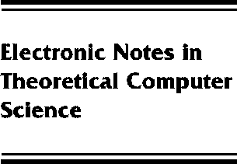[www.elsevier.com/locate/entcs](http://www.elsevier.com/locate/entcs)

Typed Logical Variables in Haskell

Claessen Koen and Peter Ljunglo¨f

**Abstract**

We describe how to embed a simple typed functional logic programming language in Haskell. The embedding is a natural extension of the Prolog embedding by Seres and Spivey [16]. To get full static typing we need to use the Haskell extensions of quantified types and the ST-monad.

1571-0661 *⃝*c Elsevier B.V. Open access under [CC BY NC ND license.](http://creativecommons.org/licenses/by-nc-nd/3.0/)

10.1016/S1571-0661(05)80544-4