[Egyptian Journal of Basic and Applied Sciences 4 (2017) 236–248](http://dx.doi.org/10.1016/j.ejbas.2017.06.006)

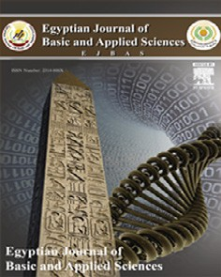

Contents lists available at [ScienceDirect](http://www.sciencedirect.com/science/journal/2314808X)

Egyptian Journal of Basic and Applied Sciences

journal homepage: [www.elsevier.com/locate/ejbas](http://www.elsevier.com/locate/ejbas)

Full Length Article

Uptake of Cu2+ and Zn2+ from simulated wastewater using muskmelon peel biochar: Isotherm and kinetic studies



Tabrez Alam Khan a,⇑, Amer Arif Mukhlif a, Equbal Ahmad Khan b

a *Department of Chemistry, Jamia Millia Islamia, Jamia Nagar, New Delhi 110 025, India*

b *Department of Chemistry, Al-Falah University, Dhauj, Faridabad 121 004, India*

a r t i c l e i n f o

*Article history:*

Received 23 November 2016

Received in revised form 16 June 2017 Accepted 16 June 2017

Available online 28 June 2017

*Keywords:*

Copper(II) and zinc(II) Muskmelon peel biochar Langmuir

Pseudo-second order Exothermic

a b s t r a c t

The muskmelon peel, an abundant common food waste material, has been gainfully utilized for the pro- duction of biochar. The biosorptive characteristics of muskmelon peel biochar towards copper(II) and zinc(II) from water are investigated. The biochar is characterized by infrared spectroscopy (FT-IR), scan- ning electron microscopy (SEM) and energy dispersive X-ray (EDX) studies. The various process param- eters for the removal of copper(II) and zinc(II) using biochar are optimized. The maximum biosorption of Cu(II) and Zn(II) is attained at pH 7. Maximum Langmuir adsorption capacity (*qm*) are 78.74 for copper(II) and 72.99 mg/g for zinc(II) at 303 K. Langmuir isotherm is found to best fit the equilibrium data indicat- ing homogeneous adsorption of metal ions onto the biochar surface. The pseudo-second order kinetic model describes the data best indicating adsorption of one molecule of metal ions onto two surface sites. Thermodynamic parameters suggest the adsorption process to be spontaneous and exothermic. Both liquid-film and intra-particle diffusions controll the overall kinetics of the adsorption process. Biochar proved to be an inexpensive and efficient adsorbent for the removal of titled metals from liquid phase.

© 2017 Mansoura University. Production and hosting by Elsevier B.V. This is an open access article under

the CC BY-NC-ND license (<http://creativecommons.org/licenses/by-nc-nd/4.0/>).

Introduction

The growing industrialization has resulted in an increased influx of industrial effluents containing heavy metals into the aqueous streams. Electroplating and metal surface treatment pro- cesses produce large quantity of wastewater containing heavy metals, which include copper(II) and zinc(II). The presence of cop- per(II) and zinc(II) in aquatic environment, even at low concentra- tions, is potentially harmful to human health. Copper(II), beyond the maximum concentration limit (0.25 mg/L) can cause liver dam- age, Wilson disease, insomnia, and depression, while a person exposed to zinc(II) (exposure limit, 0.80 mg/L) is likely to suffer from neurological disorders, lethargy, and thirst. Considering the toxicity and harmful effects of these metals, it is essential to pre- treat metals bearing wastewater before discharging into aquatic system.

Several techniques available for heavy metals removal from wastewater such as reverse osmosis [1], electrocoagulation [2], ultrafiltration [3], dialysis/electrodialysis [4], and solvent extrac- tion [5] are either costly or less effective due to their own limita- tions. However, the treatment of aqueous effluents using

* Corresponding author.

*E-mail address:* [takhan501@yahoo.com](mailto:takhan501@yahoo.com) (T.A. Khan).

adsorption of metals onto low cost adsorbents [6–12] is regarded as an efficient and economical alternative. Biosorption using many agricultural biomass has attracted recent attention because of var- ious functional groups available on the surface of biosorbents for the removal of heavy metals/dyes even at very low concentration from aqueous system [13,14].

In recent past, biochar derived from many agricultural wastes has been used as an effective, efficient, and low cost adsorbent for the removal of heavy metals and organic contaminants from water and soil [15] because of its highly porous structure, large surface area, high functional groups and mineral components [16]. Biochars are mainly applied for enhancing soil fertility and crops productivity, reducing emission of green house gases, waste management and energy production [17,18]. Biochars are usually prepared by the pyrolysis of carbon rich agro-solid waste materi- als. Various agro-wastes have been used as the precursor for the preparation of biochars and utilized for the removal of heavy met- als from water, which include corn straw [19], rice straw [20] straws of peanut, soybean and canola [21] sugar beet tailing [22,23], oak wood and oak bark [24], rice husks, olive pomace, orange waste and compost [25].

The surface properties, yield and adsorption capacity of biochar mainly depend upon the type of precursor (lignocellulosic content) and pyrolytic conditions [26,27]. Slow pyrolysis of biomass at low temperature (400–500 °C) with slow heating rate (0.1–1 °C/s) at

<http://dx.doi.org/10.1016/j.ejbas.2017.06.006>

2314-808X/© 2017 Mansoura University. Production and hosting by Elsevier B.V.

This is an open access article under the CC BY-NC-ND license (<http://creativecommons.org/licenses/by-nc-nd/4.0/>).

large resident time 5–30 min favors high yield of biochar. In inter- mediate pyrolysis with pyrolytic temperature (500–650 °C), heat- ing rate (0.1–10 °C/min) and resident time 300–1000 s, 15–25% biochar is obtained. Similarly, the pyrolysis at higher temperature (850–1250 °C), heating rate (10–200 °C/s) and small residence time (1–10 s) generally yields 15–25% of biochar. It has been reported

[28] that slow pyrolysis generally results in biochars with surface area of 1.8–56 m2/g), while during fast pyrolysis the biochars usu- ally possess surface area between 7 and 50 m2/g [29].

Muskmelon (*Cucumis melo* L.) fruit belonging to *Cucurbitaceae* family, commonly known as kharbuja in India, is abundantly avail- able during summers. The edible portion of the ripe fruit is con- sumed while the peel is discarded as a biowaste. The major constituent of muskmelon peel is cellulose, protein and polysac- charides (pectic acid) with –OH and –COOH functional groups, which may bind with metal ions. Recently, the muskmelon peel chemically modified with calcium hydroxide has been studied for the removal of Pb(II) from aqueous solution [30] with adsorption capacity of 167.8 mg/g. However, muskmelon peel has not been utilized as a precursor for production of its biochar.

In this study, various operating conditions in batch process such

sive X-ray analyzer (EDX). FTIR spectra (4000–400 cm—1) of the biochar were run on a Perkin-Elmer spectrometer (model BX spec-

trum, United States).

*Batch equilibrium studies*

Batch adsorption experiments were carried out in a series of 50 mL erlenmeyer flasks. Each flask was filled with 25 mL metal solution of desired concentration (50 mg/L) and adjusted to the desired pH. A known amount (0.02 g) of biochar was added to each flask and kept in isothermal shaker (303 K) at 200 rpm until equi- librium was reached. The supernatant of reaction mixture was sep- arated by centrifugation. The equilibrium concentration of metal ion was determined by AAS (Perkin Elmer, AAnalyst 200). The equi- librium adsorption capacity (*q*e, mg/g) and% removal was deter- mined by Eqs. (1) and (2):

*q* = *C* — *Ce* × *V* (1)

*m*

*e*

*C* — *Ce*

as biochar dose, contact time, initial Cu(II) and Zn(II) concentration, initial solution pH and temperature are optimized. The biosorption

# %Removal =

*C* × 100

(2)

efficiency of muskmelon (*Cucumis melo* L.) peel biochar for copper and zinc from water has been assessed. The isotherm, kinetics and thermodynamics of the biosorption process has been evaluated from the experimental data. The surface properties of adsorbent are examined by FTIR and SEM analysis to evaluate the surface functionality and morphology of the biosorbent.

Experimental

*Materials*

shop (Jamia Nagar, New Delhi, India). CuSO4·5H2O, ZnSO4·7H2O, Muskmelon peel was collected from the fruit juice and shake NaOH and HCl was obtained from Merck, India.

*Preparation of muskmelon peel biochar*

The musk melon peel was washed with distilled water to remove adhering dust particles/impurities, and dried in oven at 333 K. The dried biomass was grinded in a mechanical grinder to a particle size of 1–3 mm. For the preparation of biochar, muskme- lon peel (200 g) was pyrolysed at 873 K in a Muffle furnace (Matrix Scientific, India) with heating rate of 278 K/min under inert atmo- sphere (N2 gas) for 1 h, and cooled to room temperature. The black solid char was crushed with mortar and pestle, washed with dis- tilled water, sieved to less than 75 mm particle size, and stored in

an airtight reagent bottle.

*Preparation of adsorbate solution*

[CuSO4·5H2O] and zinc sulphate heptahydrate [ZnSO4·7H2O] were The stock solution (250 mg/L) of copper sulphate pentahydrate prepared by dissolving 0.982 g and 1.099 g of the respective salt

in double distilled water (1 L). The required solutions were pre- pared by diluting the stock solution with double distilled water.

*Characterization*

The surface morphology and elemental composition of biochar was evaluated by using a Carl Zeiss (Sigma 5.05, Germany) scan- ning electron microscopy conjugated with BRUKER energy disper-

where *C* and *C*e is the initial and equilibrium concentration of metal ions solution (mg/L), *V* is the volume of metal solution (L), and *m* is the mass of adsorbent (g).

All experiments were carried out in triplicate and average val- ues are reported.

Results and discussion

*Characterization of adsorbent FTIR studies*

The FTIR spectral studies were performed to elucidate the active

metal ions. A strong band observed at 3405 cm—1 in the IR spec- surface functional groups, which may provide binding sites for the trum of the muskmeolon peel may be assigned to O–H stretching

and carboxylic acids. The bands at 2930 and 2850 cm—1 are vibration of inter and intramolecular hydrogen bonded phenols 1660 and 1410 cm—1 are ascribed to C@O antisymmetric and sym- ascribed to aliphatic C–H of carboxylic acid. The strong bands at bending vibration of lignin. A weak peak at 1540 cm—1 is due to metric stretching vibration in carboxylate group and C–H in plane The peaks at 1250 and 1040 cm—1 may be due to C–OH vibrations C@C stretching vibration of conjugated aromatic ring of lignin. 800–400 cm—1 corresponds to C@C–H vibration of benzene ring of carboxylic acids and alcohol groups of cellulose. The shoulder at decreased intensity, appears at 3400 cm—1, which may be due to (Fig. 1a). However, in the biochar, the O–H stretching band, of a cleaving of phenolic groups and dehydration of peel structure.

The band observed at 2930 cm—1 in the muskmelon peel shifts to 2920 cm—1, whereas the new weak peaks at 1733 and 1573 cm—1 may be attributed to the formation of carbonate and/or

1170 cm—1 is observed due to the rupture of cellulosic/hemicellu- carbonate-carboxyl group during pyrolysis. The broad shoulder at losic groups (Fig. 1b). In the spectra of Cu(II)- and Zn(II)-loaded

biochar the O–H stretching band at 3400 cm—1 is shifted to 3440 and 3436 cm—1, while the peak at 1170 cm—1 disappears. Similarly, the peak at 1573 cm—1 is observed at 1600 and 1585 cm—1 after the (1390) and 1038 (1050) cm—1 suggest an appreciable interaction of adsorption of Cu(II) and Zn(II), respectively. The new peaks at 1400 the surface functional groups with Zn(Cu) metal ions (Fig. 1

(c) and (d).

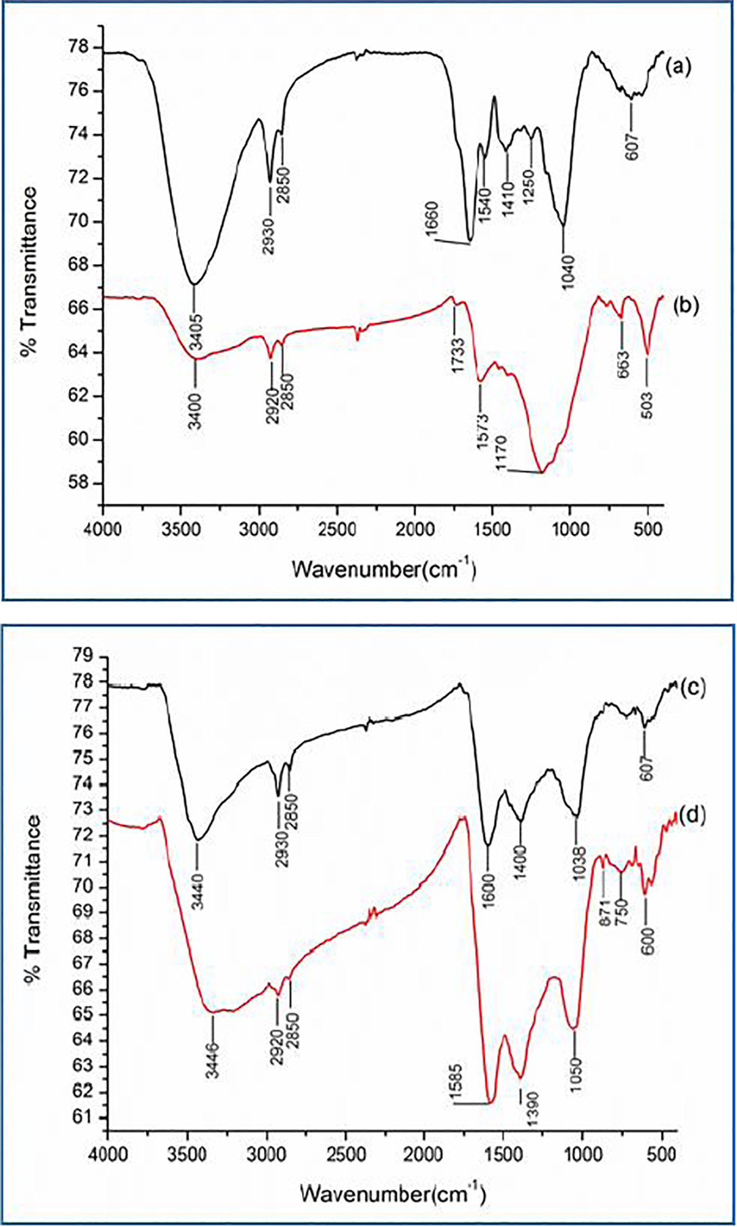

Fig. 1. FTIR spectra of raw muskmelon peel (a), biochar (b), Cu loaded biochar (c), and Zn loaded biochar (d).

*SEM and EDX studies*

The SEM images (mag. 20,00 KX and 50,00 KX) of raw musk- melon peel exhibit homogeneous and smooth surface with por- ous structures (Fig. 2a and b). The images of biochar, however, display heterogeneous surface with enlarged porous structures (Fig. 2c and d). The SEM micrographs of metal loaded biochar, however, show that the surface is covered with copper and zinc molecules (Fig. 2e to 2h). The EDS spectra of biochar and metal loaded biochar is shown in Fig. 3. The main constituents of musk-

melon biochar (wt%) are: C (59.28) and O (31.46) with traces of Mg (1.83), P (1.92), K (1.68), and Ca (3.84) (Fig. 3a). After biochar formation, the element wt% are: C (56.43) and O (41.77), Mg (0.40), K (0.79), and Ca (3.84). The P element disappears probably due to heat treatment resulting in the formation of surface voids. In the EDX analyses, after copper and zinc adsorption, new peaks of Cu (1.63 wt%) and Zn (9.50) appear, which indicates the adsorption of these metals on the surface of the biochar (Table 1).

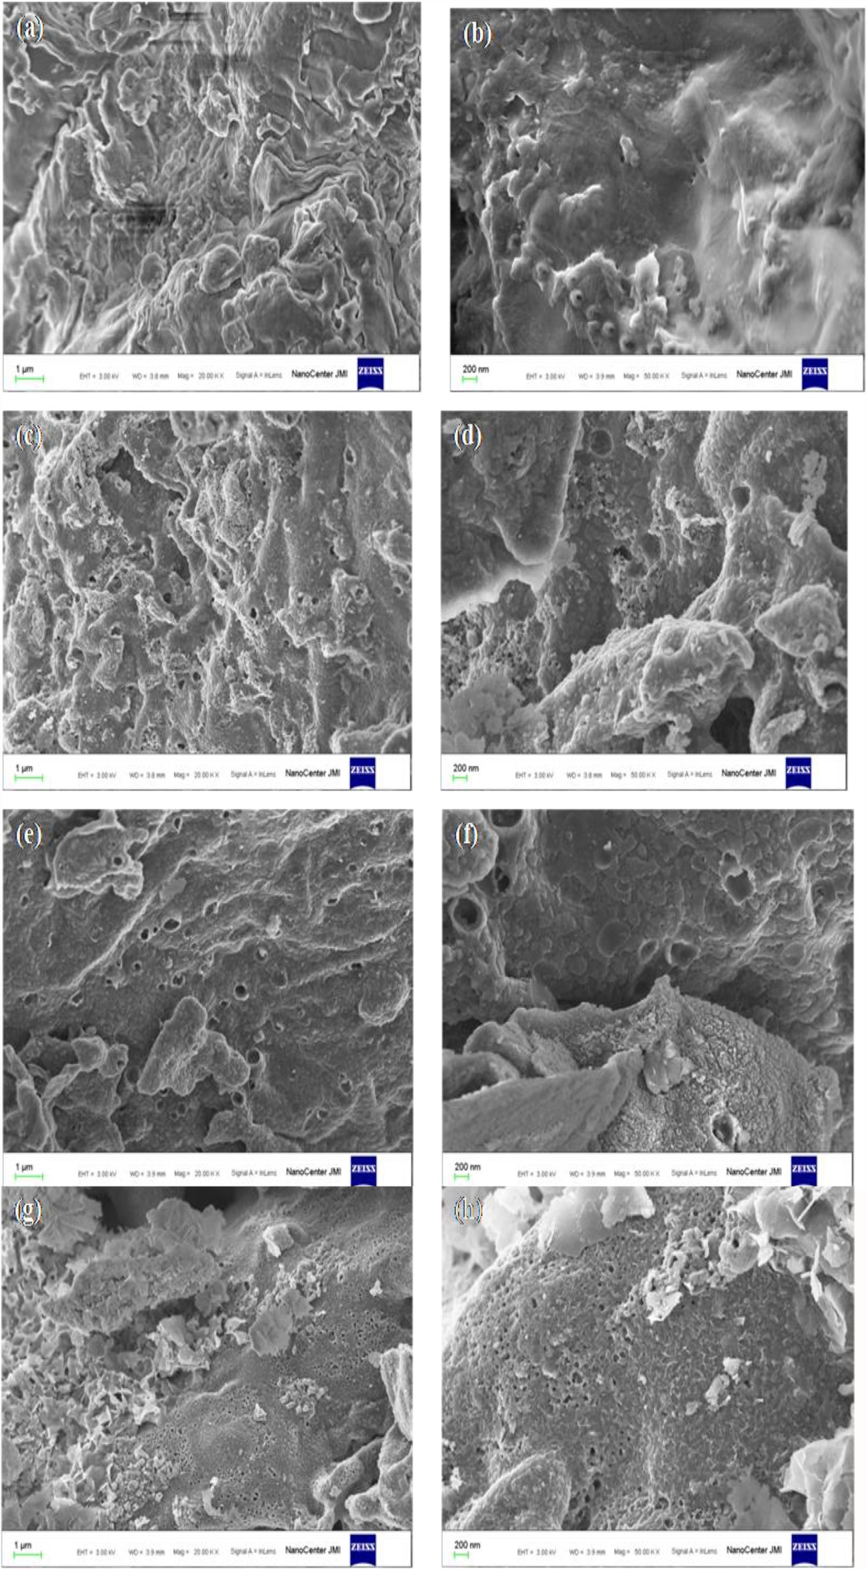

Fig. 2. SEM images at different magnifications of raw muskmelon peel (a,b), biochar (c,d), Cu loaded biochar (e,f), and Zn-loaded biochar (g,h).

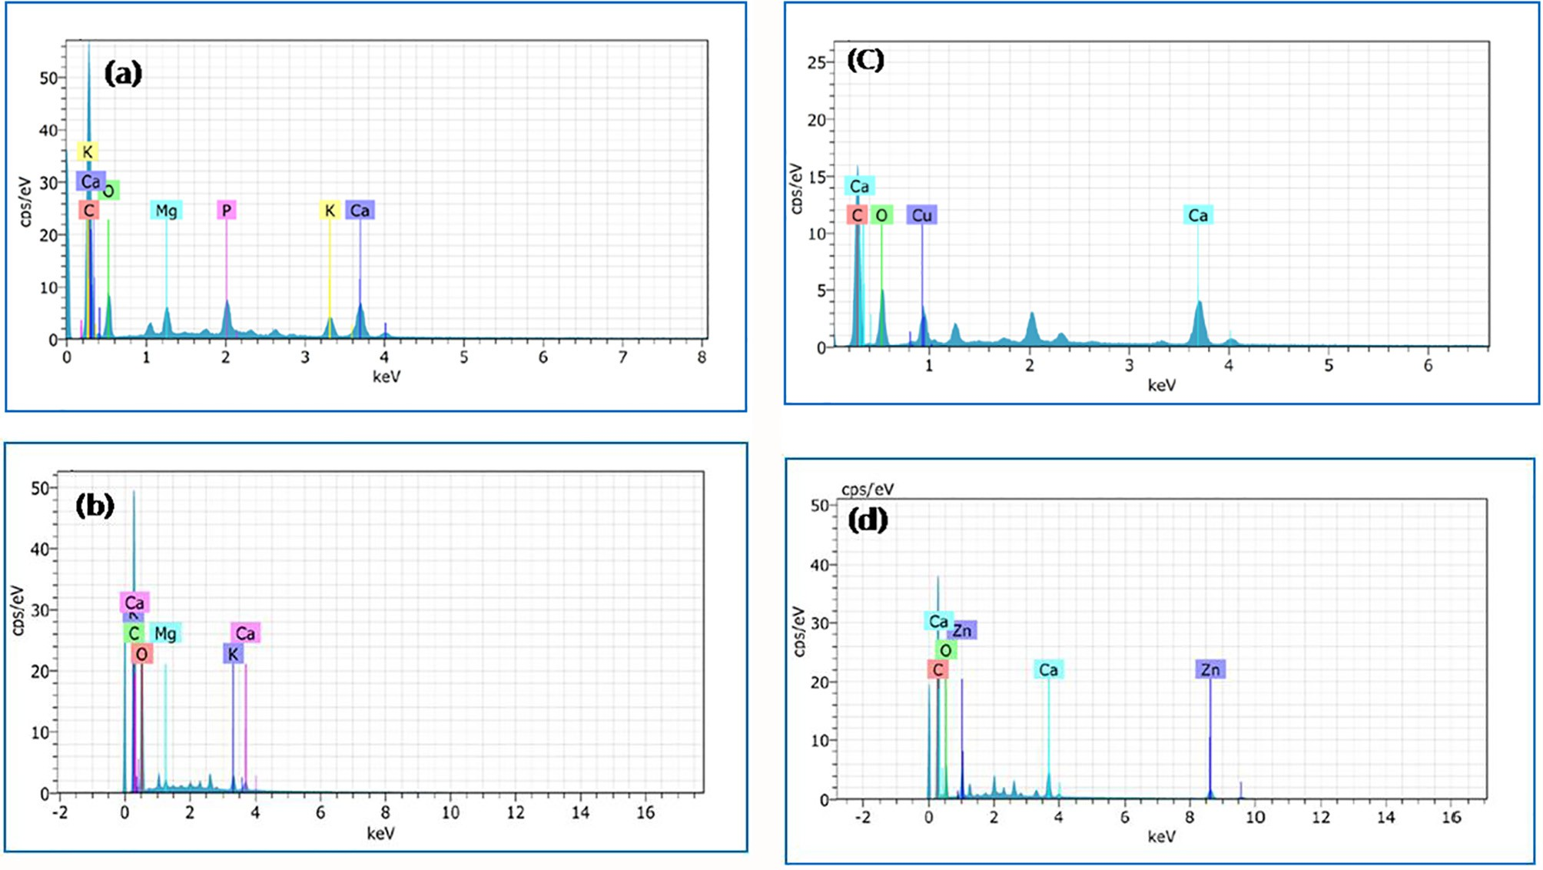

Fig. 3. EDS spectra of raw muskmelon peel (a), biochar (b), Cu-loaded (c), and Zn-loaded (d) biochar.

Table 1

Thermodynamic parameters.

Adsorbate D*H*° (kJ/mol) D*S*° (J/mol/K) —D*G*° (kJ/mol)

|  |  |  |  |  |  |  |
| --- | --- | --- | --- | --- | --- | --- |
|  | | | 303 K | 313 K | 323 K |  |
| Cu(II) | —32.712 | —87.19 | 6.293 | 5.421 | 4.549 |  |
| Zn(II) | —18.039 | —43.88 | 4.743 | 4.304 | 3.865 |  |

*Equilibrium adsorption studies Effect of contact time*

The optimum contact time for the removal of Cu(II) and Zn(II) by biochar was determined by varying the contact time between

10 and 140 min at initial metal concentration (50 mg/L), dose (0.8 g/L), pH (7) and 303 K. It was observed (Fig. 4) that the percent removal of Cu(II) increases from 44.4 to 90.2 and Zn(II) from 35.4 to 83.5 with increasing contact time, attaining equilibrium at 120 min (90.2 for Cu(II) and 83.5 for Zn(II) (Fig. 4). The initial rapid uptake of metal ions may be ascribed to the presence of large num- ber of vacant sites available for metal ions, and afterwards the remaining free metal ions are difficult to be occupied, because of repulsive forces between the free and adsorbed metal ions.

*Effect of initial metal concentrations*

Batch experiment is to study the effect of initial metal concen- tration on the percentage removal of copper(II) and zinc(II) by bio- char was carried out at fixed contact time (120 min), dose (0.8 g/L),

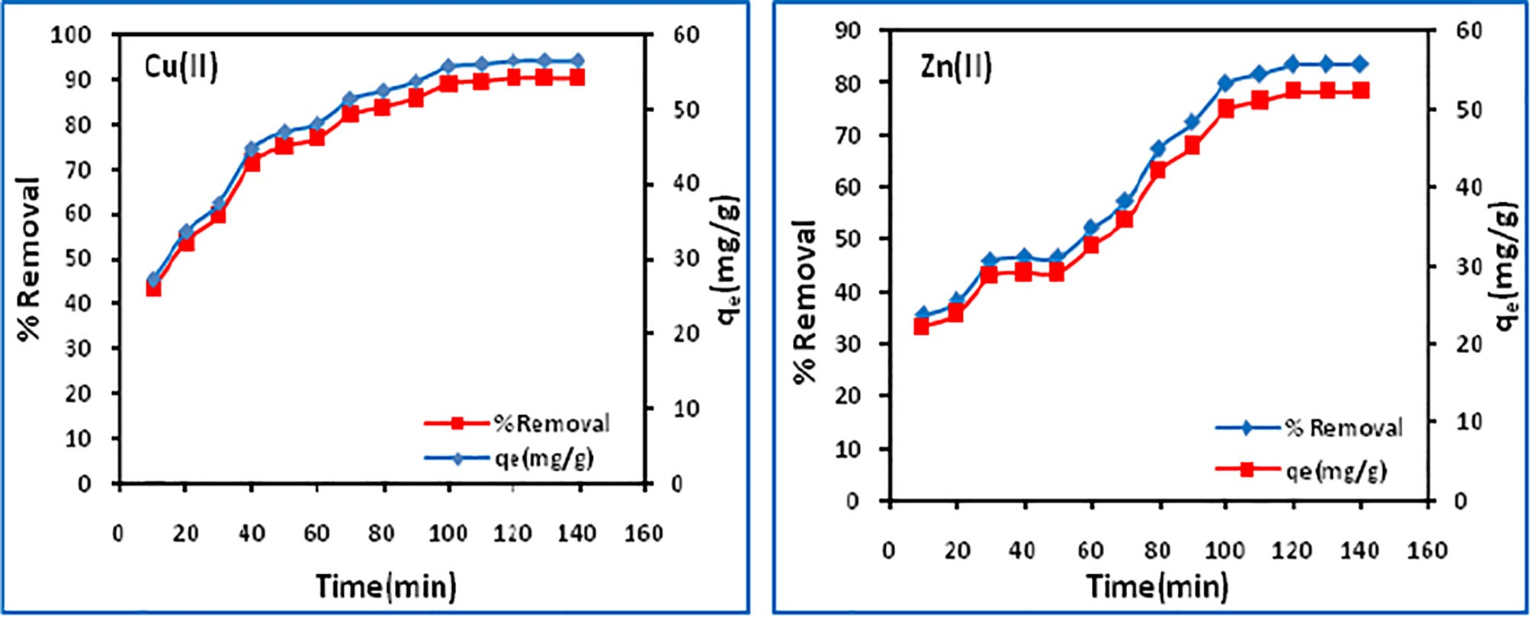

Fig. 4. Effect of contact time on Cu(II) and Zn(II) uptake.

temperature (303 K) and pH (7) but varying the initial concentra- tion from 30 to 60 mg/L. It is found that the adsorption is depen- dent on initial metal concentrations with percentage uptake of copper(II) and zinc(II) decreasing from 99 to 89.5 and 96.6 to 83.5, respectively, with increasing initial metal concentrations (Fig. 5). However, the adsorption capacity increases from 37.1 to

70.8 mg/g for copper(II) and 36.2 to 71.4 mg/g for zinc(II). The opti- mum adsorption takes place at 60 mg/L.

*Effect of pH*

The effect of pH on the removal of Cu(II) and Zn(II) was evalu- ated at varying pH (2–9) keeping other parameters constant. The amount of uptake (%) increases from 42.0 to 93.3 and 39.5 to

86.0 for copper and zinc, respectively between pH 2 and 9, due to decrease in competition between H3O+ and metal cations (Fig. 7). At pH above pHzpc (6.5), surface attains a negative charge while at pH below pHzpc the surface acquires a positive charge. With increase in the initial solution pH, copper(II) and zinc(II) exist in a variety of species such as Cu2(OH)2+, Cu (OH)2+, CuOH+, Cu (-

2

3

4

2

3

3

*Effect of biochar dose*

OH)+, Cu(OH)2 and Zn2+, Zn(OH)+, Zn(OH)2 and Zn(OH)—. Below

In this study, the biochar dose was varied from 0.2 to 1.2 g/L at optimized contact time (120 min) and initial metal concentration (50 mg/L). The variation in percentage removal of copper(II) and zinc(II) together with biochar adsorption capacity is depicted in (Fig. 6), which indicates that the percent adsorption of copper(II) and zinc(II) increases from 41.3 to 89. 2 and 52 to 85.2 with increasing dose (Fig. 6), with maximum percentage removal occur- ring at 0.8 g/L. This might be attributed to the greater availability of the active sites for adsorption or increase in the surface area at higher amount of the adsorbent dose.

pH 7, copper(II) and zinc(II) exist predominantly as divalent cations and pH > 7, metal cations may precipitate due to formation of hydroxyl species. The maximum adsorption occurs at pH 7.

*Effect of temperature and thermodynamic studies*

The effect of temperature on the removal of copper(II) and zinc

(II) by biochar was studied at 303, 308 and 313 K, and is shown in Fig. 8. The removal of metals (%) decreases with increase in tem- perature, indicating the adsorption process to be exothermic. The increase in temperature increases the solubility and decreases

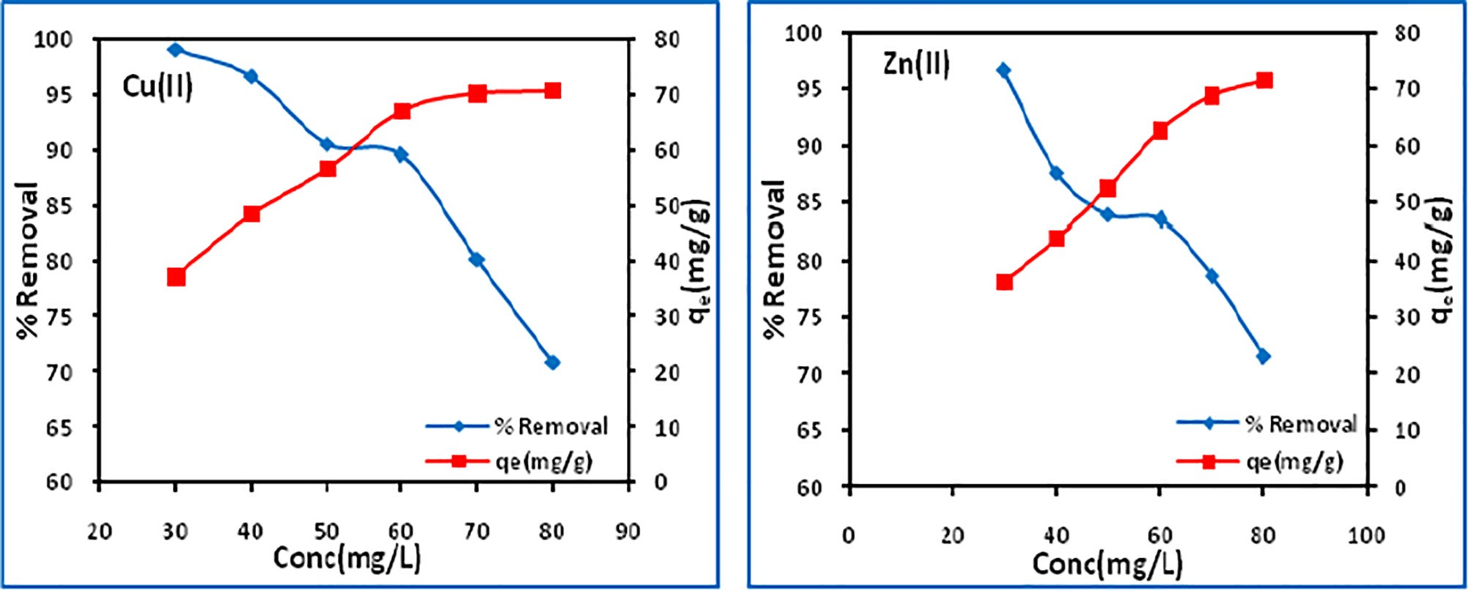

Fig. 5. Effect of initial metal concentration on Cu(II) and Zn(II) uptake.

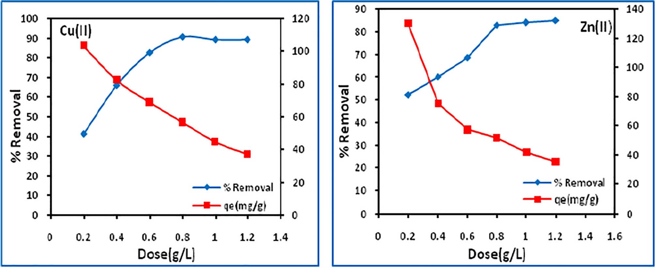

Fig. 6. Effect of biochar dose.

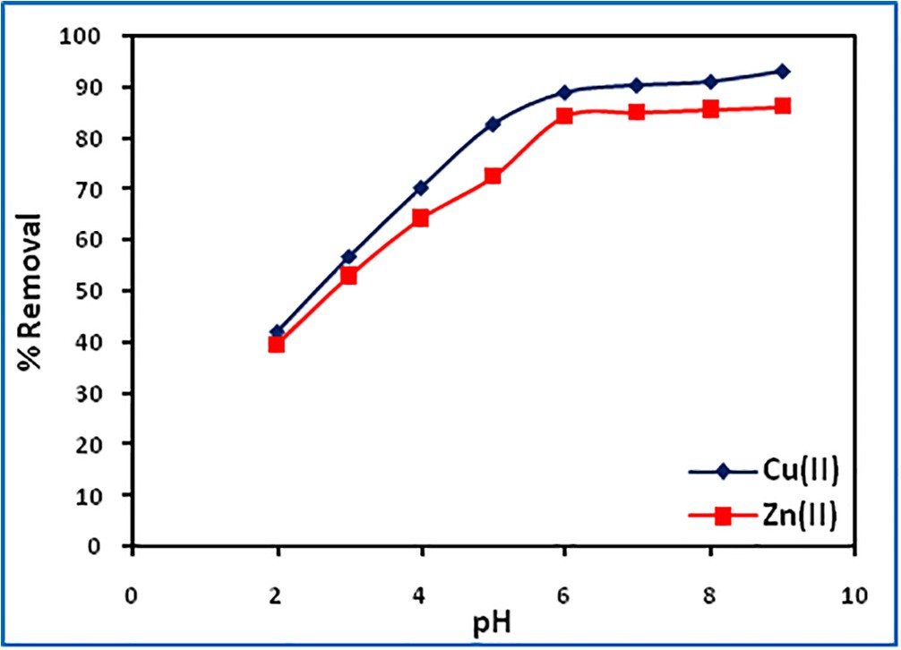 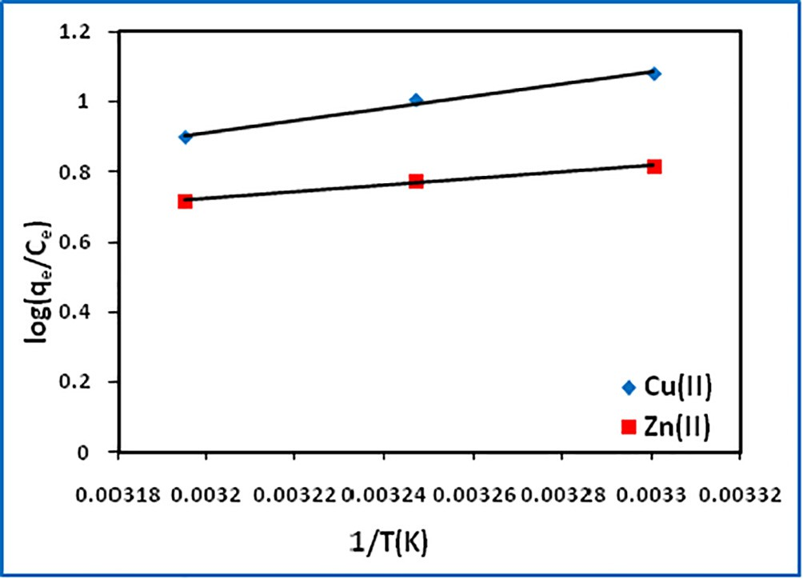

Fig. 7. Effect of initial solution pH. Fig. 9. vant Hoff’s plot.

the chemical potential of the adsorbate, a controlling factor in the adsorption process, thereby resulting in a decrease in adsorption. To understand the kinetics of adsorption, the energy and entropy considerations are important. Negative D*G*° indicates the

spontaneity of the adsorption process. D*H*° is used to identify the

exothermic or endothermic nature of adsorption. A positive value of D*S*° indicates increased randomness of adsorbate molecules on the solid surface than in the solution.

The change in enthalpy (D*H*°) and entropy (D*S*°) were deter- mined from the slope and intercept, respectively of the vant Hoff’s plot of log(*qe*/*Ce*) vs 1/*T* (Fig. 9)*.* The free energy change (D*G*°) was calculated using the Gibb’s equation (Eqs. (3) and (4)).

decrease in spontaneity (D*G*° becoming less negative) adsorption process with increase in temperature indicates more feasible adsorption at lower temperature.

*Equilibrium studies*

Equilibrium studies explain the ratio of the amount of adsorbate adsorbed and that remaining in solution at a constant temperature when equilibrium has been achieved. Langmuir [32], Freundlich

[33] and Dubinin-Radushkevich [34] isotherm models were applied to the experimental data to determine the best fit model.

*Langmuir isotherm model*

# log

*qe*

## *Ce*

D*S*

# = 2.303*R*

◦

◦

D*H*

— 2.303*RT*

◦

(3)

If the experimental data fits the Langmuir model it indicates an energetically homogeneous adsorption sites and a uniform cover- age of adsorbate molecules onto adsorbent surface without any

D*G* = D*H*

◦

◦

— *T*D*S*

(4)

interaction between adsorbed molecules. The linear form of the

Langmuir isotherm model is expressed as follows:

The negative D*H*° values indicate the exothermic nature of the

adsorption of copper(II) and zinc(II) onto biochar. The D*H*° values, 32.712 for Cu(II) and 18.039 kJ/mol for Zn(II), are found to be lower

*Ce* 1 *Ce*

*q* = *bq* + 

*m*

*q*

*e*

*m*

(5)

than 40 kJ/mol, supporting physisorption [31] (Table 1). The nega- tive D*S*° values suggest the probability of favorable adsorption. The

where *b* is the Langmuir constant related to the energy of adsorp- tion, and *q*m is the maximum adsorption capacity (mg/g).

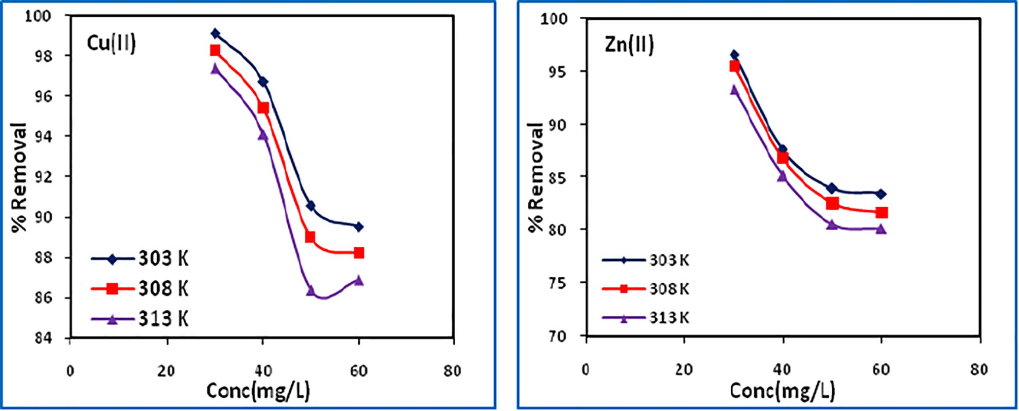

Fig. 8. Effect of temperature.

The monolayer adsorption capacity (*qm*) and Langmuir constant

(*b*) representing affinity of adsorbate to adsorbent were calculated

log *qe*

1

= log *kf* + *nf* log *Ce* (7)

from the slope and intercept of the *Ce/qe* vs *Ce* plot (Fig. 10), and are given in Table 2.

The dimensionless separation factor (*RL*) [35], can be used to predict the type of adsorption (favorable, linear, unfavourable or irreversible).

where *k*f and *n*f are the Freundlich isotherm constants related to adsorption capacity and adsorption intensity, respectively. The Fre- undlich parameters, *kf* and *nf* were obtained from the slope and the intercept of the log *qe* vs log *Ce* plots (Fig. 11). The values of *kf* and *nf* along with *R*2 are shown in Table 2. The lower *R*2 values indicate

*RL* 1

(1 + *bCo*)

=

(6)

that the adsorption does not follow Freundlich model. The values of *nf* < 1 suggest more favorable physical adsorption.

If *R*L > 1, the adsorption is unfavorable; if 0 < *R*L < 1, the adsorp- tion is favorable; and if *R*L = 0, the adsorption is irreversible. The affinity of adsorption of metal ions is in the 0.054–0.075 range for Cu(II) and 0.013–0.015 for Zn(II), which suggests that the adsorption process is highly favorable.

Correlation coefficients (*R*2) of all the studied isotherm models are compared to find out the best fit model (Table 2), which indi- cate that the adsorption data best follows the Langmuir isotherm model. A comparison of *qm* values for copper (79.36 mg/g) and zinc (72.99 mg/g) with other reported adsorbents (Table 3) suggests that muskmelon peel biochar is superior to many of these adsor- bents. Higher values of *b* for copper(II) compared to zinc(II) revealed that the biochar has higher affinity towards copper(II).

*Freundlich isotherm*

This model is based on heterogeneous distribution of adsorp- tion sites on the surface of an adsorbent. The linear form of the Fre- undlich equation is as follows:

*Dubinin–Radushkevich (D–R) isotherm*

The D–R isotherm model assumes multilayer adsorption, which generally involves weak van der Waals forces, indicative of physi- cal adsorption process. The model equation is given as follows:

ln *qe* = ln *qD* — b∈2 (8)

where *q*D is the maximum adsorption capacity (mg/g), b is the activ-

ity coefficient related to mean adsorption energy (mol2/kJ2) and e is the Polanyi potential.

The values of *q*D and b were calculated from the slope and inter- cept of ln*q*e vs e2 plot (Fig. 12), while that of e was calculated using Eq. (9).

# ∈= *RT* ln 1 + 1 (9)

*Ce*

where *R* is the gas constant in kJ/(mol/K) and *T* is the temperature

(K). The mean free energy of adsorption (*E*) was estimated using Eq. (10).

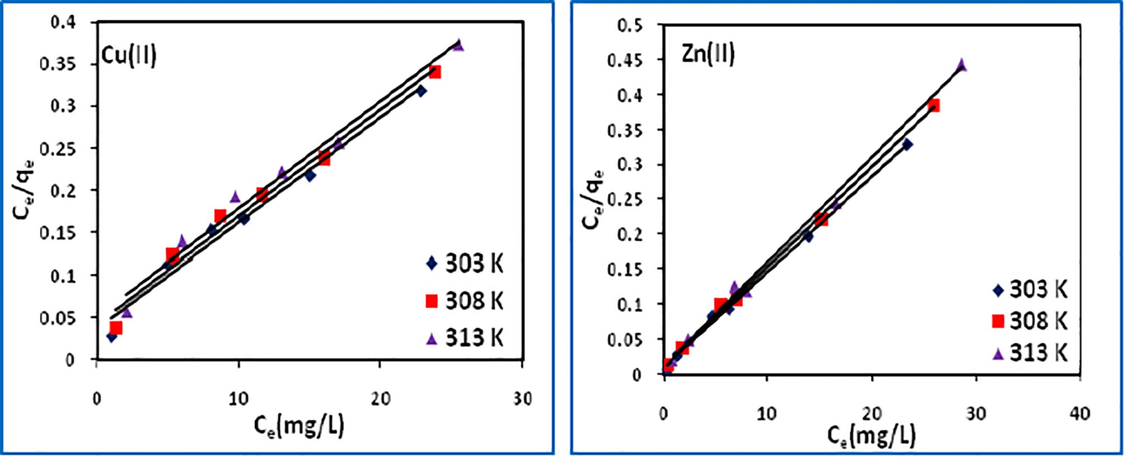

Fig. 10. Langmuir adsorption isotherm plots.

Table 2

Various isotherm parameters.

|  |  |  |  |  |  |  |  |  |  |  |
| --- | --- | --- | --- | --- | --- | --- | --- | --- | --- | --- |
|  | Isotherm Parameter |  | Cu(II) |  |  |  | Zn(II) |  | | |
|  |  | 303 K | 308 K | 313 K |  | 303 K | 308 K | 313 K |  |
| Langmuir | *qm* (mg/g) | 79.36 | 78.74 | 78.74 |  | 72.99 | 69.93 | 66.66 |  |
|  |  | *b* (L/mg) | 0.349 | 0.304 | 0.246 |  | 1.505 | 1.375 | 1.293 |  |
|  |  | *RL* | 0.0542 | 0.0616 | 0.0751 |  | 0.0131 | 0.0143 | 0.0152 |  |

*R*2 0.980 0.981 0.982 0.998 0.998 0.996

|  |  |  |  |  |  |  |  |
| --- | --- | --- | --- | --- | --- | --- | --- |
| Freundlich | *Kf* (L/g) | 34.03 | 31.49 | 27.54 | 40.04 | 46.37 | 46.33 |
|  | 1*/nf* | 0.235 | 0.252 | 0.285 | 0.171 | 0.167 | 0.152 |

*R*2 0.919 0.942 0.957 0.884 0.928 0.960

|  |  |  |  |  |  |  |  |
| --- | --- | --- | --- | --- | --- | --- | --- |
| D-R | *qD* (mg/g) | 59.73 | 60.53 | 61.33 | 60.82 | 62.29 | 63.34 |
|  | *E* (kJ/mol) | 1.000 | 1.000 | 1.118 | 2.236 | 2.500 | 3.535 |
| *R*2 0.897 | | | 0.900 | 0.902 | 0.804 | 0.796 | 0.763 |

Table 3

Adsorption capacity (*q*m) of reported adsorbents for Cu(II) and Zn(II) uptake.

|  |  |  |  |  |  |  |  |  |  |  |
| --- | --- | --- | --- | --- | --- | --- | --- | --- | --- | --- |
|  | Cu(II) |  |  |  |  | Zn(II) |  | | | |
| Adsorbent | pH | qm (mg/g) | Ref |  | Adsorbent | pH | qm (mg/g) | Ref |  |
|  | Wheat shells | 5.0 | 8.26 | [36] |  | Rice husk ash | 6.0 | 5.88 | [47] |  |
|  | Arca shell | 3–6 | 17.64 | [37] |  | Bagasse fly ash | 6.0 | 7.03 | [48] |  |
|  | Cashew nut shells | 5.0 | 20.0 | [38] |  | Zeolite 4A | 6.5 | 42.82 | [49] |  |
|  | *Betula sp* saw dust | 5.5 | 4.90 | [39] |  | Zeolite 13X | 6.5 | 38.31 | [49] |  |
|  | Barly straw | 7.0 | 4.64 | [40] |  | Bentonite | 6.5 | 35.17 | [49] |  |
|  | Citric acid modified barly straw | 7.0 | 31.71 | [41] |  | Jute unmodified | 5.87 | 3.55 | [50] |  |
|  | Garden grass | 6.0 | 58.34 | [41] |  | Jute dye loaded | 5.87 | 5.95 | [50] |  |
|  | Hardwood biochar | 5.0 | 6.79 | [19] |  | Jute oxidized | 5.87 | 8.02 | [50] |  |
|  | Corn straw biochar | 5.0 | 12.52 | [19] |  | Vermiculite | 5.6 | 71.89 | [51] |  |
|  | Citric acid modified Spent coffee grains | 5.0 | 60.37 | [42] |  | Bentonite | 6.0 | 30.7 | [52] |  |
|  | HNO—modified CNTs | 5.0 | 28.49 | [43] |  | Na-enriched bentonite | 6.0 | 57.43 | [52] |  |
|  | CNTs/calcium alginate composites | 5.0 | 84.88 | [44] |  | Sulphured orange peel | 5.0 | 80 | [53] |  |
|  | Muskmelon peel biochar | 7.0 | 79.36 | This study |  | Muskmelon peel biochar | 7.0 | 72.99 | This study |  |
|  | Sulfonated multiwalled carbon nanotubes (sMWCNTs) 5.0 | | 43.16 | [45] |  | KCl modified orange peel | 5–5.5 | 45.29 | [53] |  |
|  | Single walled carbon nanotubes (SWCNTs) | 5.0 | 24.29 | [46] |  | Nano-porous activated neem bark | – | 11.9 | [54] |  |

3

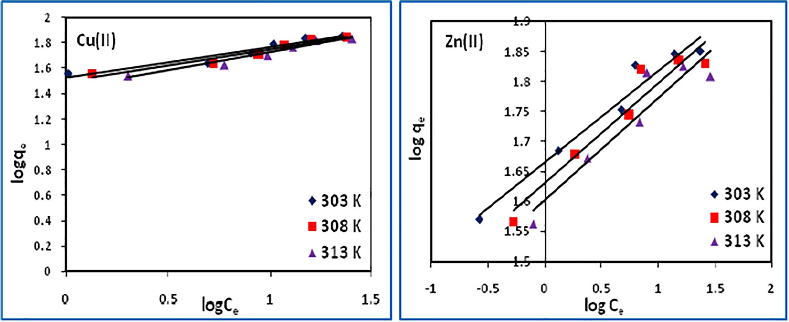

Fig. 11. Freundlich adsorption isotherm plots.

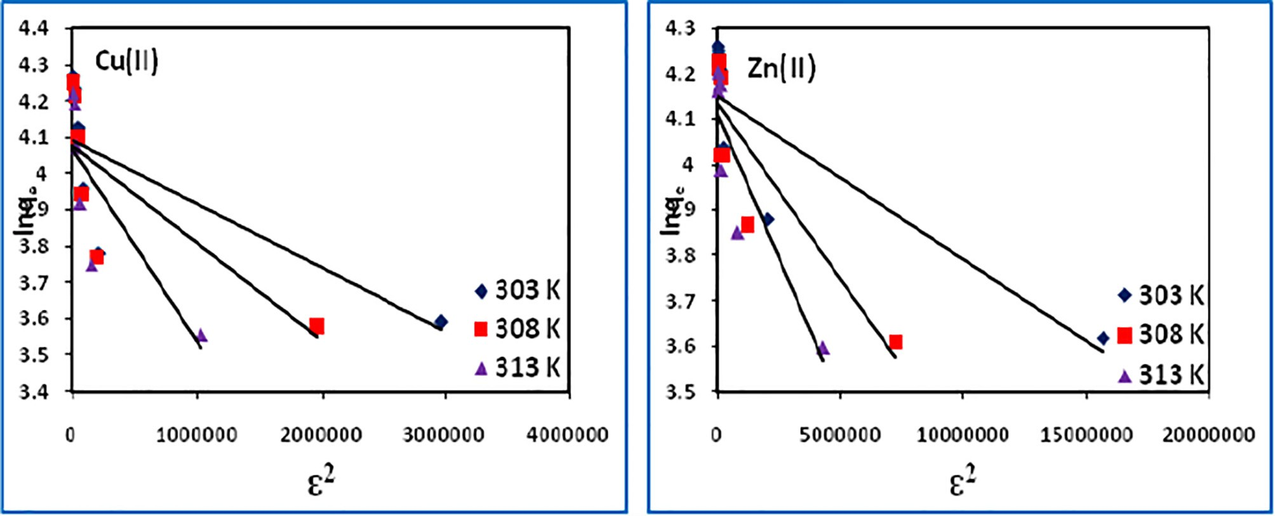

Fig. 12. D-R adsorption isotherm plots.

1

= p2ﬃﬃﬃbﬃﬃﬃ

*E*

(10)

where *q*t (mg/g), is the amounts of metal ions adsorbed at time *t*, *k*1

and *k*2 is the pseudo-first-order (1/min) and pseudo-second-order rate constant (g/mg/min).

The values of *E* (1.0–1.12 for Cu(II) and 2.23–3.53 kJ/mol for Zn

(II)) are found in the range 0–8 kJ/mol, indicating the adsorption process to be physical in nature. The values of *R*2 (0.897–0.902 for Cu(II) and 0.763–0.804 for Zn(II), however, suggest a poor fit of the model.

*Kinetic studies*

*Pseudo-first order and pseudo-second order*

The dynamics of the adsorption was investigated using Lager- gren’s pseudo-first order [55] and pseudo-second order equations [56]. The pseudo-first order model and pseudo-second order model can be expressed as:

sponding plots of log(*qe* — *qt*) vs *t*, (Fig. 13) and *t*/*q* vs *t* (Fig. 14), The *k*1 and *k*2 were calculated from the intercept of the corre- and are tabulated in Table 4 along with correlation coefficients, *qe*(*-*

*calc*) and *qe*(*exp*) values. The higher *R*2 values and close agreement between *qe*(*calc*) and *qe*(*exp*) values for the pseudo-second order rate equation suggest the suitability of the model indicating adsorption of one dye molecule onto two surface sites.

*Liquid–film and intra–particle diffusions*

The adsorption rate constant for liquid–film diffusion, *Kfd* (1/ min) and the intra–particle diffusion rate constant, *ki* (mg/g/ min1/2) were calculated from the slope of the corresponding plots

of ln(1 — F) vs *t* [57] and *qt* vs *t*0.5 [58] as:

log(*q* — *q* )= log *q* — *k*1.*t*

# (11)

*qt*

*e t e*

# 2.303

— ln 1 —

*e*

*q*

= *kfd* · *t* (13)

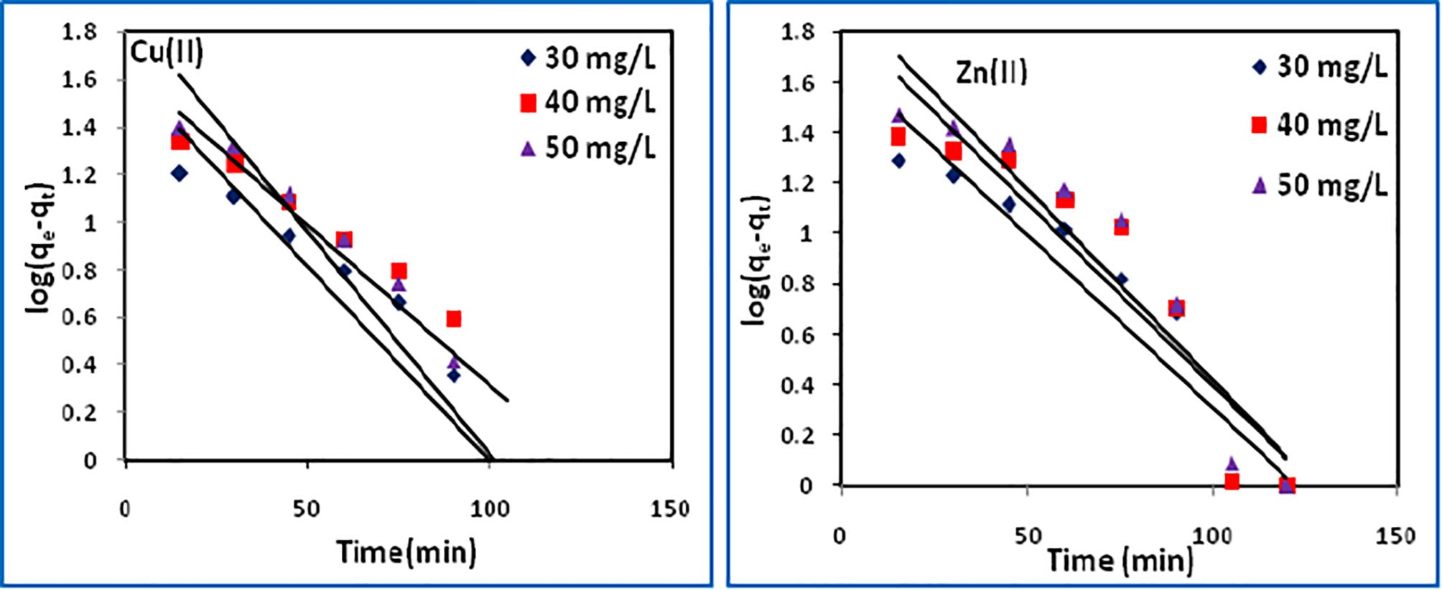*q* = (*k*2*q*2) + *q t* 1 *t*

*e*

*t e*

# (12)

*qt* = *ki* · *t*0.5 + *Ci*

# (14)

Fig. 13. Pseudo-first order kinetic plots.

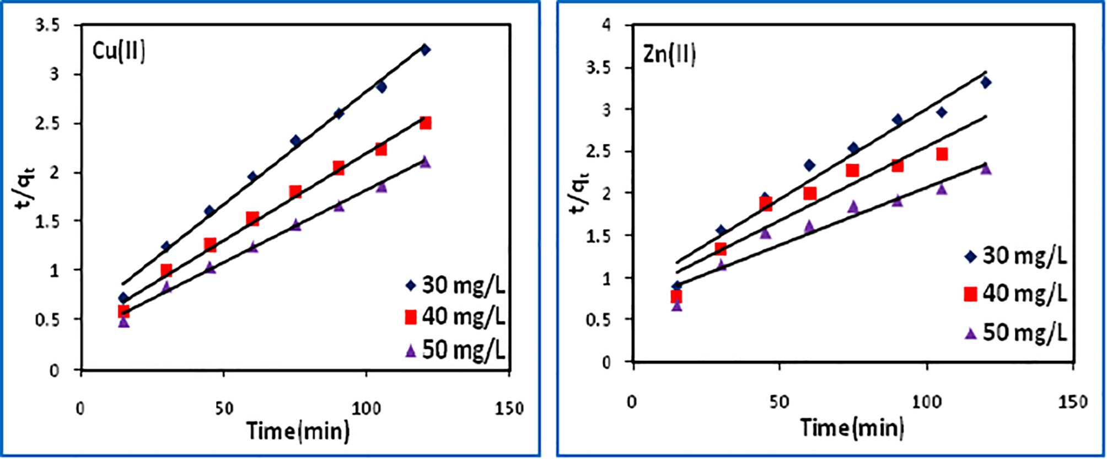

Fig. 14. Pseudo-second order kinetic plots.

Table 4

Pseudo-first order and pseudo-second order model parameters.

|  |  |  |  |  |  |  |  |  |  |
| --- | --- | --- | --- | --- | --- | --- | --- | --- | --- |
| Adsorbate | Conc (*mg/L*) | Pseudo-first order | | | *qe*(*exp*) (*mg/g*) | Pseudo-second order | | | |
|  | | *k*1 × 10—2 (1*/*min) *qe*(*cal*) (*mg*/*g*) *R*2 | | |  | *k*2 × 10—3 (*g*/*mg*/min) | *qe*(*cal*) (*mg*/*g*) *R*2 | |  |
| Cu(II) | 40 | 3.754 | 43.06 | 0.839 | 48.36 | 1.060 | 43.10 | 0.992 | |
|  | 50 | 3.086 | 45.77 | 0.899 | 56.60 | 0.750 | 56.49 | 0.992 | |
|  | 60 | 4.306 | 79.14 | 0.861 | 67.13 | 0.660 | 67.11 | 0.994 | |
| Zn(II) | 40 | 3.155 | 47.97 | 0.860 | 43.82 | 0.529 | 46.73 | 0.993 | |
|  | 50 | 3.316 | 68.12 | 0.866 | 52.45 | 0.393 | 56.50 | 0.899 | |
|  | 60 | 3.477 | 85.23 | 0.893 | 62.08 | 0.263 | 72.99 | 0.930 | |

where *kfd* (1/min) is the film-diffusion rate constant, and *F* is the fractional attainment of equilibrium (*F = qt*/*qe)* at time *t, ki* (mg/ g min0.5) is intra-particle diffusion rate constant, *Ci* is a constant (mg/g) which gives an idea about the thickness of the boundary layer on the adsorbent surface.

The liquid-film diffusion plots are linear (Fig. 15), but do not pass through the origin so it may not be the only controlling factor in determining the kinetics of the process. The intra-particle diffu-

sion plots (Fig. 16) have the three steps of adsorption, i) an initial curved portion attributed to the bulk diffusion ii), a linear portion to the intra-particle diffusion, and iii) a plateau due to the equilib- rium. The magnitudes of *kfd, ki* and the corresponding regression coefficients are listed in Table 5. The *ki* values indicate substantial diffusion of copper(II) and zinc(II). It may be inferred that both the liquid-film and intra-particle diffusion are be controlling the adsorption kinetics.

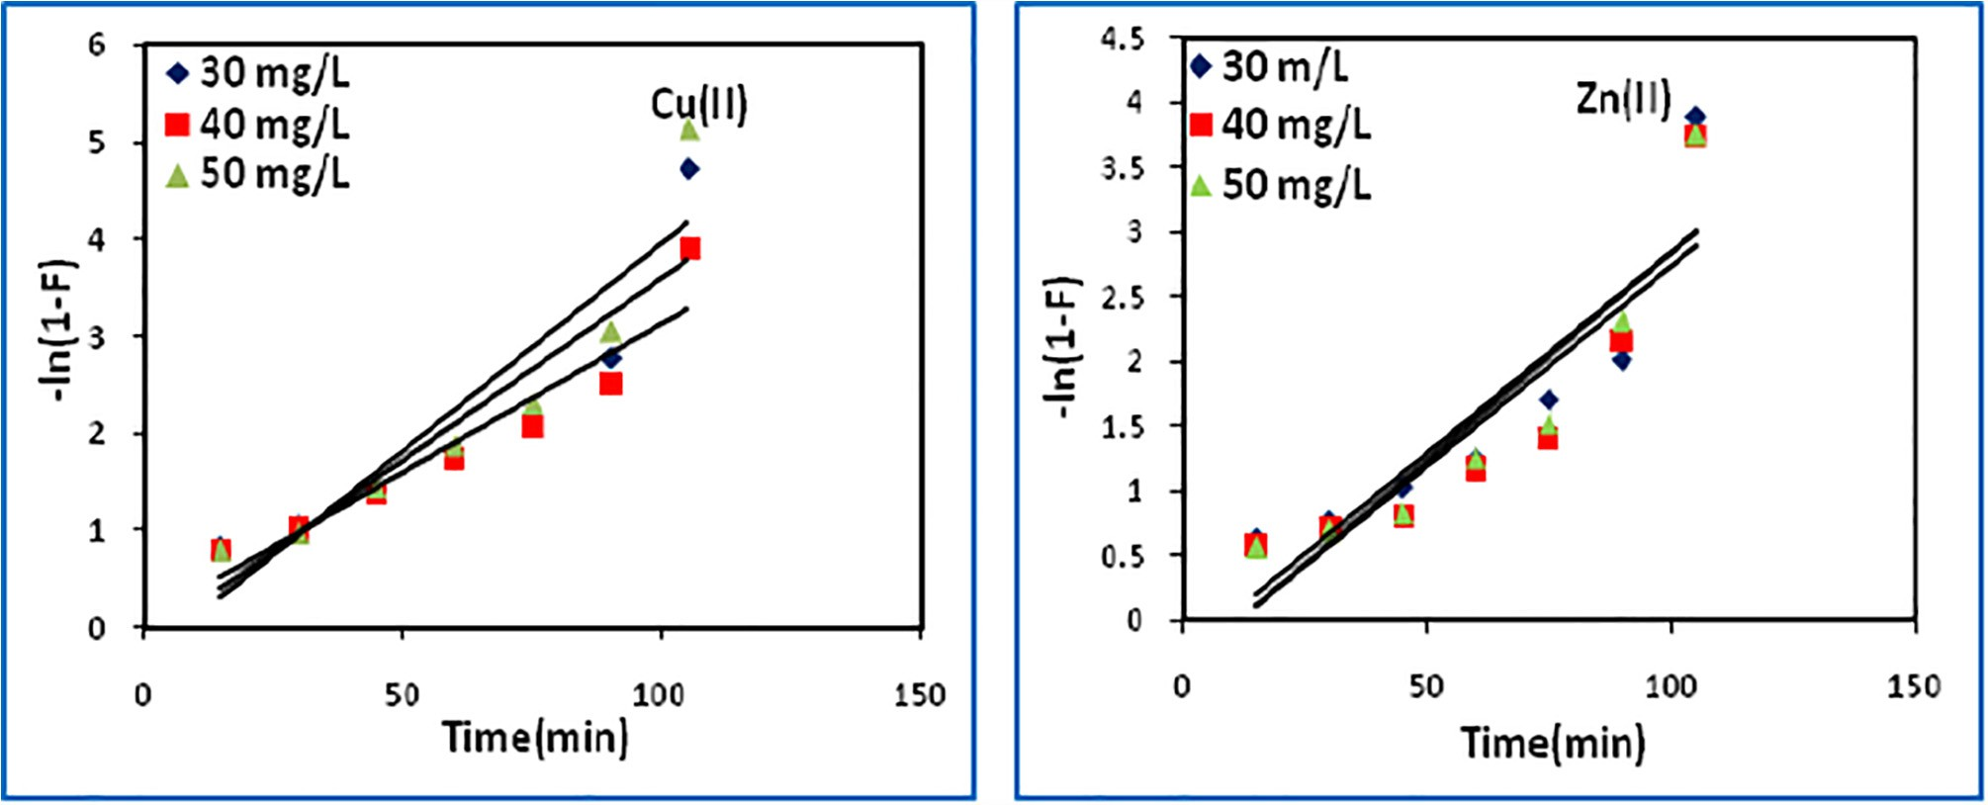

Fig. 15. Liquid-film diffusion plots.

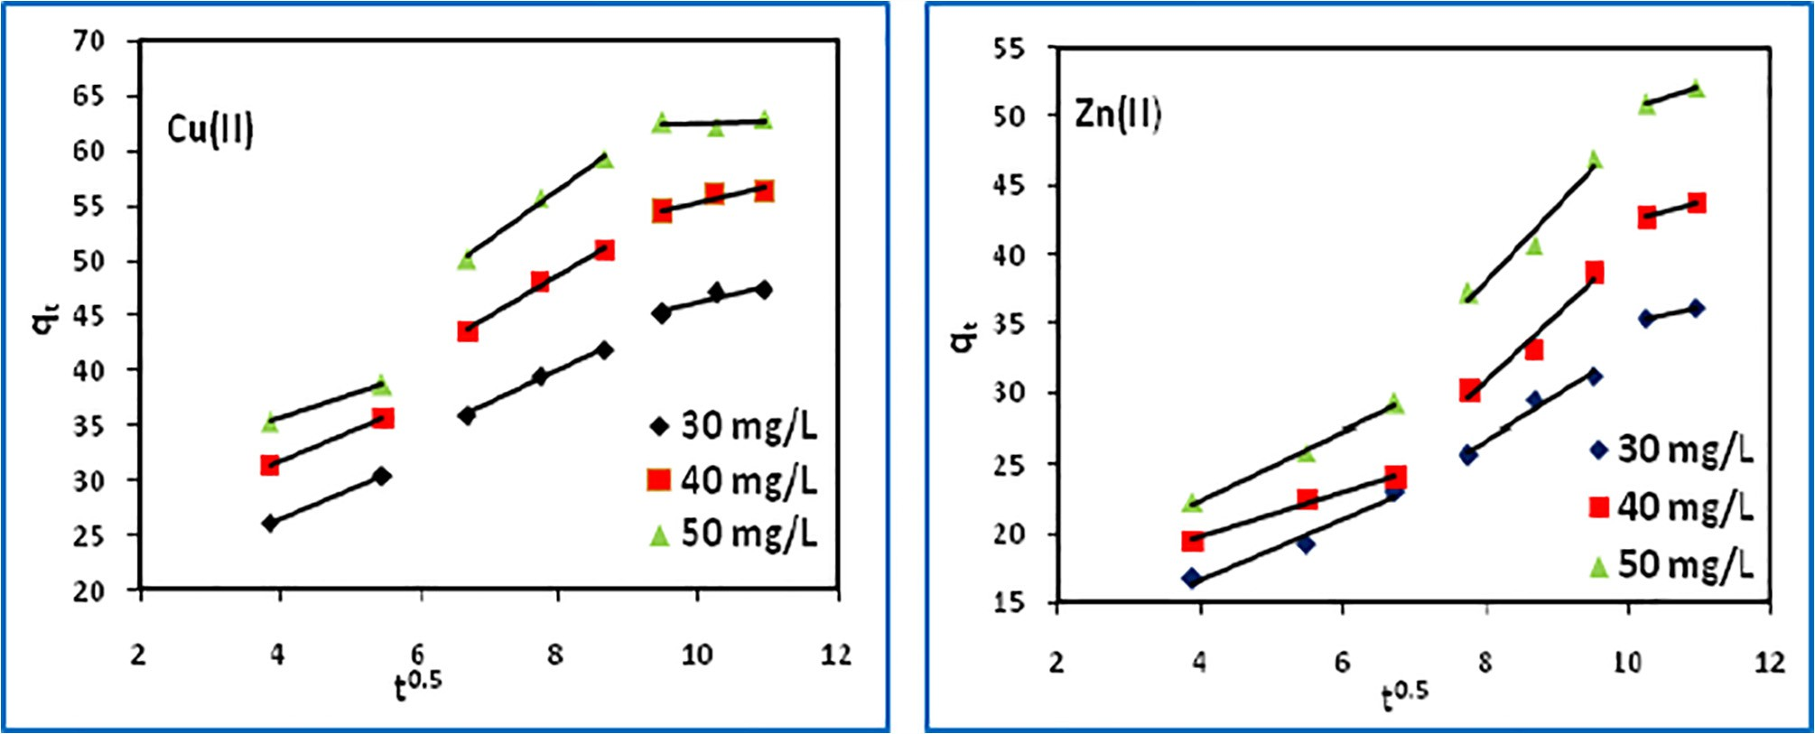

Fig. 16. Intra-particle diffusion plots.

Table 5

Liquid-film and intra-particle diffusion model parameters.

Liquid–film diffusion

|  |  |  |  |  |  |  |  |
| --- | --- | --- | --- | --- | --- | --- | --- |
| Adsorbate | Conc (mg/L) | *kD R*2 | |  | *ki R*2 | |  |
| Cu(II) | 40 | 0.0430 | 0.861 | 3.853 | | 0.976 | |
|  | 50 | 0.0375 | 0.838 | 3.215 | | 0.992 | |
|  | 60 | 0.0309 | 0.899 | 2.386 | | 0.992 | |
| Zn(II) | 40 | 0.0309 | 0.798 | 4.656 | | 0.971 | |
|  | 50 | 0.0308 | 0.799 | 3.767 | | 0.956 | |
|  | 60 | 0.0321 | 0.840 | 2.934 | | 0.983 | |

Conclusions

Intra–particle diffusion

1. [Yang K, Yang J, Jiang Y, Wu W, Lin D. Correlations and adsorption mechanisms](http://refhub.elsevier.com/S2314-808X(16)30161-0/h0235) [of aromatic compounds on a high heat temperature treated bamboo biochar.](http://refhub.elsevier.com/S2314-808X(16)30161-0/h0235) [Environ Poll 2016;210:57–64](http://refhub.elsevier.com/S2314-808X(16)30161-0/h0235).
2. [Lehmann J. A handful of carbon. Nature 2007;447(7141):143–4](http://refhub.elsevier.com/S2314-808X(16)30161-0/h0240).
3. [Chen X, Chen G, Chen L, Chen Y, Lehmann J, McBride MB, Hay AG. Adsorption](http://refhub.elsevier.com/S2314-808X(16)30161-0/h0245) [of copper and zinc by biochars produced from pyrolysis of hardwood and corn](http://refhub.elsevier.com/S2314-808X(16)30161-0/h0245) [straw in aqueous solution. Bioresour Technol 2011;102(19):8877–84](http://refhub.elsevier.com/S2314-808X(16)30161-0/h0245).
4. [Han X, Liang CF, Li TQ, Wang K, Huang HG, Yang XE. Simultaneous removal of](http://refhub.elsevier.com/S2314-808X(16)30161-0/h0250) [cadmium and sulfamethoxazole from aqueous solution by rice straw biochar. J](http://refhub.elsevier.com/S2314-808X(16)30161-0/h0250) [Zhejiang Univ Sci B 2013;14(7):640–9](http://refhub.elsevier.com/S2314-808X(16)30161-0/h0250).
5. [Tong XJ, Li JY, Yuan JH, Xu RK. Adsorption of Cu(II) by biochars generated from](http://refhub.elsevier.com/S2314-808X(16)30161-0/h0255) [three crop straws. Chem Eng J 2011;172(2):828–34](http://refhub.elsevier.com/S2314-808X(16)30161-0/h0255).
6. [Dong X, Ma LQ, Li Y. Characteristics and mechanisms of hexavalent chromium](http://refhub.elsevier.com/S2314-808X(16)30161-0/h0260) [removal by biochar from sugar beet tailing. J Hazard Mater 2011;190](http://refhub.elsevier.com/S2314-808X(16)30161-0/h0260) [(1):909–15](http://refhub.elsevier.com/S2314-808X(16)30161-0/h0260).
7. [Yao Y, Gao B, Inyang M, Zimmerman AR, Cao X, Pullammanappallil P, Yang L.](http://refhub.elsevier.com/S2314-808X(16)30161-0/h0265) [Removal of phosphate from aqueous solution by biochar derived from](http://refhub.elsevier.com/S2314-808X(16)30161-0/h0265) [anaerobically digested sugar beet tailings. J Hazard Mater 2011;190(1):501–7](http://refhub.elsevier.com/S2314-808X(16)30161-0/h0265).
8. [Mohan D, Kumar H, Sarswat A, Alexandre-Franco M, Pittman CU. Cadmium](http://refhub.elsevier.com/S2314-808X(16)30161-0/h0270) [and lead remediation using magnetic oak wood and oak bark fast pyrolysis](http://refhub.elsevier.com/S2314-808X(16)30161-0/h0270)

The process parameters for removal of copper and zinc using

biochar are optimized. Maximum Langmuir adsorption capacity (*qm*) are 78.74 for copper(II) and 72.99 mg/g for zinc(II) at 303 K. The values of *RL* between zero and unity supported favorable adsorption. Langmuir isotherm is found to best fit the equilibrium data indicating homogeneous adsorption onto the biochar surface. The pseudo-second order kinetic model describes the data best indicating adsorption of one molecule of metal ions onto two sur- face sites. Thermodynamic parameters suggest the adsorption pro- cess to be spontaneous and exothermic. Both liquid-film and intra- particle diffusions controll the overall kinetics of the adsorption process. Biochar proved to be an inexpensive and efficient adsor- bent for the removal of titled metals from aqueous solution.

References

1. [Kurniawan TA, Chan GY, Lo WH, Babel S. Physico–chemical treatment](http://refhub.elsevier.com/S2314-808X(16)30161-0/h0005) [techniques for wastewater laden with heavy metals. Chem Eng J 2006;118](http://refhub.elsevier.com/S2314-808X(16)30161-0/h0005) [(1):83–98](http://refhub.elsevier.com/S2314-808X(16)30161-0/h0005).
2. [Ali I, Khan TA, Asim M. Removal of arsenate from groundwater by](http://refhub.elsevier.com/S2314-808X(16)30161-0/h0010) [electrocoagulation method. Environ Sci Poll Res 2012;19(5):1668–76](http://refhub.elsevier.com/S2314-808X(16)30161-0/h0010).
3. [Ghosh G, Bhattacharya PK. Hexavalent chromium ion removal through](http://refhub.elsevier.com/S2314-808X(16)30161-0/h0015) [micellar enhanced ultrafiltration. Chem Eng J 2006;119(1):45–53](http://refhub.elsevier.com/S2314-808X(16)30161-0/h0015).
4. [Khattab IA, Shaffei MF, Shaaban NA, Hussein HS, El-Rehim SA. Electrochemical](http://refhub.elsevier.com/S2314-808X(16)30161-0/h0020) [removal of copper ions from dilute solutions using packed bed electrode. Part](http://refhub.elsevier.com/S2314-808X(16)30161-0/h0020)

[II. Egypt J Petrol 2013;22(1):205–10](http://refhub.elsevier.com/S2314-808X(16)30161-0/h0020).

1. [Cˇerná M. Use of solvent extraction for the removal of heavy metals from liquid](http://refhub.elsevier.com/S2314-808X(16)30161-0/h0130) [wastes. Environ Monit Assess 1995;34(2):151–62](http://refhub.elsevier.com/S2314-808X(16)30161-0/h0130).
2. [Khan TA, Nazir M, Khan EA. Magnetically modified multiwalled carbon](http://refhub.elsevier.com/S2314-808X(16)30161-0/h0135) [nanotubes for the adsorption of bismarck brown R and Cd(II) from aqueous](http://refhub.elsevier.com/S2314-808X(16)30161-0/h0135) [solution: batch and column studies. Desalination Water Treat](http://refhub.elsevier.com/S2314-808X(16)30161-0/h0135) [2015;11:19374–90](http://refhub.elsevier.com/S2314-808X(16)30161-0/h0135).
3. [Khan TA, Nazir M, Khan EA, Riaz U. Multiwalled carbon nanotube–](http://refhub.elsevier.com/S2314-808X(16)30161-0/h0140) [polyurethane (MWCNT/PU) composite adsorbent for safranin T and Pb(II)](http://refhub.elsevier.com/S2314-808X(16)30161-0/h0140) [removal from aqueous solution: batch and fixed-bed studies. J Mol Liq](http://refhub.elsevier.com/S2314-808X(16)30161-0/h0140) [2015;212:467–79](http://refhub.elsevier.com/S2314-808X(16)30161-0/h0140).
4. [Khan TA, Singh VV. Removal of cadmium(II), lead(II), and chromium(VI) ions](http://refhub.elsevier.com/S2314-808X(16)30161-0/h0145) [from aqueous solution using clay. Toxicol Environ Chem 2010;92(8):1435–46](http://refhub.elsevier.com/S2314-808X(16)30161-0/h0145).
5. [Saleh TA, Gupta VK. Column with CNT/magnesium oxide composite for lead(II)](http://refhub.elsevier.com/S2314-808X(16)30161-0/h0150) [removal from water. Environ Sci Poll Res 2012;19(4):1224–8](http://refhub.elsevier.com/S2314-808X(16)30161-0/h0150).
6. [Gupta VK, Agarwal S, Saleh TA. Synthesis and characterization of alumina-](http://refhub.elsevier.com/S2314-808X(16)30161-0/h0155) [coated carbon nanotubes and their application for lead removal. J Hazard](http://refhub.elsevier.com/S2314-808X(16)30161-0/h0155) [Mater 2011;185(1):17–23](http://refhub.elsevier.com/S2314-808X(16)30161-0/h0155).
7. [Gupta VK, Nayak A. Cadmium removal and recovery from aqueous solutions](http://refhub.elsevier.com/S2314-808X(16)30161-0/h0160) [by novel adsorbents prepared from orange peel and Fe2O3](http://refhub.elsevier.com/S2314-808X(16)30161-0/h0160) [nanoparticles. Chem](http://refhub.elsevier.com/S2314-808X(16)30161-0/h0160) [Eng J 2012;180:81–90](http://refhub.elsevier.com/S2314-808X(16)30161-0/h0160).
8. [Khan TA, Mukhlif AA, Khan EA, Sharma DK. Isotherm and kinetics modeling of](http://refhub.elsevier.com/S2314-808X(16)30161-0/h0165) [Pb(II) and Cd(II) adsorptive uptake from aqueous solution by chemically](http://refhub.elsevier.com/S2314-808X(16)30161-0/h0165) [modified green algal biomass. Model Earth Syst Environ 2016;2:117](http://refhub.elsevier.com/S2314-808X(16)30161-0/h0165).
9. [Gupta VK, Srivastava SK, Mohan D, Sharma S. Design parameters for fixed bed](http://refhub.elsevier.com/S2314-808X(16)30161-0/h0190) [reactors of activated carbon developed from fertilizer waste for the removal of](http://refhub.elsevier.com/S2314-808X(16)30161-0/h0190) [some heavy metal ions. Waste Manag 1998;17(8):517–22](http://refhub.elsevier.com/S2314-808X(16)30161-0/h0190).
10. [Mohammadi N, Khani H, Gupta VK, Amereh E, Agarwal S. Adsorption process](http://refhub.elsevier.com/S2314-808X(16)30161-0/h0215) [of methyl orange dye onto mesoporous carbon material–kinetic and](http://refhub.elsevier.com/S2314-808X(16)30161-0/h0215) [thermodynamic studies. J Colloid Interface Sci 2011;362(2):457–62](http://refhub.elsevier.com/S2314-808X(16)30161-0/h0215).
11. [Wang G, Li A, Li M. Sorption of nickel ions from aqueous solutions using](http://refhub.elsevier.com/S2314-808X(16)30161-0/h0225) [activated carbon derived from walnut shell waste. Desalinat Water Treatment](http://refhub.elsevier.com/S2314-808X(16)30161-0/h0225) [2010;16(1–3):282–9](http://refhub.elsevier.com/S2314-808X(16)30161-0/h0225).
12. [Lonappan L, Rouissi T, Das RK, Brar SK, Ramirez AA, Verma M, Surampalli RY,](http://refhub.elsevier.com/S2314-808X(16)30161-0/h0230) [Valero JR. Adsorption of methylene blue on biochar microparticles derived](http://refhub.elsevier.com/S2314-808X(16)30161-0/h0230) [from different waste materials. Waste Manag 2016;49:537–44](http://refhub.elsevier.com/S2314-808X(16)30161-0/h0230).

[bio-chars. Chem Eng J 2014;236:513–28](http://refhub.elsevier.com/S2314-808X(16)30161-0/h0270).

1. [Pellera FM, Giannis A, Kalderis D, Anastasiadou K, Stegmann R, Wang JY,](http://refhub.elsevier.com/S2314-808X(16)30161-0/h0275) [Gidarakos E. Adsorption of Cu(II) ions from aqueous solutions on biochars](http://refhub.elsevier.com/S2314-808X(16)30161-0/h0275) [prepared from agricultural by-products. J Environ Manag 2012;96(1):35–42](http://refhub.elsevier.com/S2314-808X(16)30161-0/h0275).
2. [Yao Y, Gao B, Zhang M, Inyang M, Zimmerman AR. Effect of biochar](http://refhub.elsevier.com/S2314-808X(16)30161-0/h0280) [amendment on sorption and leaching of nitrate, ammonium, and phosphate](http://refhub.elsevier.com/S2314-808X(16)30161-0/h0280) [in a sandy soil. Chemosphere 2012;89(11):1467–71](http://refhub.elsevier.com/S2314-808X(16)30161-0/h0280).
3. [Zhao L, Cao X, Mašek O, Zimmerman A. Heterogeneity of biochar properties as](http://refhub.elsevier.com/S2314-808X(16)30161-0/h0285) [a function of feedstock sources and production temperatures. J Hazard Mater](http://refhub.elsevier.com/S2314-808X(16)30161-0/h0285) [2013;256:1–9](http://refhub.elsevier.com/S2314-808X(16)30161-0/h0285).
4. [Kloss S, Zehetner F, Dellantonio A, Hamid R, Ottner F, Liedtke V, Schwanninger](http://refhub.elsevier.com/S2314-808X(16)30161-0/h0290) [M, Gerzabek MH, Soja G. Characterization of slow pyrolysis biochars: effects of](http://refhub.elsevier.com/S2314-808X(16)30161-0/h0290) [feedstocks and pyrolysis temperature on biochar properties. J Environ Quality](http://refhub.elsevier.com/S2314-808X(16)30161-0/h0290) [2012;41(4):990–1000](http://refhub.elsevier.com/S2314-808X(16)30161-0/h0290).
5. [Brewer CE, Schmidt-Rohr K, Satrio JA, Brown RC. Characterization of biochar](http://refhub.elsevier.com/S2314-808X(16)30161-0/h0295) [from fast pyrolysis and gasification systems. Environ Prog Sustain Energy](http://refhub.elsevier.com/S2314-808X(16)30161-0/h0295) [2009;28(3):386–96](http://refhub.elsevier.com/S2314-808X(16)30161-0/h0295).
6. [Huang K, Zhu H. Removal of Pb2+](http://refhub.elsevier.com/S2314-808X(16)30161-0/h0300) [from aqueous solution by adsorption on](http://refhub.elsevier.com/S2314-808X(16)30161-0/h0300) [chemically modified muskmelon peel. Environ Sci Pollut Res 2013;20](http://refhub.elsevier.com/S2314-808X(16)30161-0/h0300) [(7):4424–34](http://refhub.elsevier.com/S2314-808X(16)30161-0/h0300).
7. [Bhatnagar A, Kumar E, Minocha AK, Jeon BH, Song H, Seo YC. Removal of](http://refhub.elsevier.com/S2314-808X(16)30161-0/h0305) [anionic dyes from water using *Citrus limonum* (lemon) peel: equilibrium](http://refhub.elsevier.com/S2314-808X(16)30161-0/h0305) [studies and kinetic modeling. Separ Sci Technol 2009;44(2):316–34](http://refhub.elsevier.com/S2314-808X(16)30161-0/h0305).
8. [Langmuir I. The adsorption of gases on plane surfaces of glass, mica and](http://refhub.elsevier.com/S2314-808X(16)30161-0/h0310) [platinum. J Am Chem Soc 1918;40(9):1361–403](http://refhub.elsevier.com/S2314-808X(16)30161-0/h0310).
9. [Freundlich HMF. Over the adsorption in solution. J Phys Chem](http://refhub.elsevier.com/S2314-808X(16)30161-0/h0315) [1906;57:385–471](http://refhub.elsevier.com/S2314-808X(16)30161-0/h0315).
10. [Dubinin MM, Radushkevich LV. Equation of the characteristic curve of](http://refhub.elsevier.com/S2314-808X(16)30161-0/h0320) [activated charcoal. Chem Zentr 1947;1(1):875](http://refhub.elsevier.com/S2314-808X(16)30161-0/h0320).
11. [Hall KR, Eagleton LC, Acrivos A, Vermeulen T. Pore-and solid-diffusion kinetics](http://refhub.elsevier.com/S2314-808X(16)30161-0/h0325) [in fixed-bed adsorption under constant-pattern conditions. Ind Eng Chem](http://refhub.elsevier.com/S2314-808X(16)30161-0/h0325) [Fundam 1966;5(2):212–23](http://refhub.elsevier.com/S2314-808X(16)30161-0/h0325).
12. [Basci N, Kocadagistan E, Kocadagistan B. Biosorption of copper(II) from](http://refhub.elsevier.com/S2314-808X(16)30161-0/h0330) [aqueous solutions by wheat shell. Desalination 2004;164(2):135–40](http://refhub.elsevier.com/S2314-808X(16)30161-0/h0330).
13. [Dahiya S, Tripathi RM, Hegde AG. Biosorption of heavy metals and](http://refhub.elsevier.com/S2314-808X(16)30161-0/h0335) [radionuclide from aqueous solutions by pre-treated arca shell biomass. J](http://refhub.elsevier.com/S2314-808X(16)30161-0/h0335) [Hazard Mater 2008;150(2):376–86](http://refhub.elsevier.com/S2314-808X(16)30161-0/h0335).
14. [SenthilKumar P, Ramalingam S, Sathyaselvabala V, Kirupha SD, Sivanesan S.](http://refhub.elsevier.com/S2314-808X(16)30161-0/h0340) [Removal of copper(II) ions from aqueous solution by adsorption using cashew](http://refhub.elsevier.com/S2314-808X(16)30161-0/h0340) [nut shell. Desalination 2011;266(1):63–71](http://refhub.elsevier.com/S2314-808X(16)30161-0/h0340).
15. [Grimm A, Zanzi R, Björnbom E, Cukierman AL. Comparison of different types of](http://refhub.elsevier.com/S2314-808X(16)30161-0/h0345) [biomasses for copper biosorption. Bioresour Technol 2008;99(7):2559–65](http://refhub.elsevier.com/S2314-808X(16)30161-0/h0345).
16. [Pehlivan E, Altun T, Parlayici](http://refhub.elsevier.com/S2314-808X(16)30161-0/h0350) S [. Modified barley straw as a potential biosorbent](http://refhub.elsevier.com/S2314-808X(16)30161-0/h0350) [for removal of copper ions from aqueous solution. Food chem 2012;135](http://refhub.elsevier.com/S2314-808X(16)30161-0/h0350) [(4):2229–34](http://refhub.elsevier.com/S2314-808X(16)30161-0/h0350).
17. [Hossain MA, Ngo HH, Guo WS, Setiadi T. Adsorption and desorption of copper](http://refhub.elsevier.com/S2314-808X(16)30161-0/h0355)

[(II) ions onto garden grass. Bioresour Technol 2012;121:386–95](http://refhub.elsevier.com/S2314-808X(16)30161-0/h0355).

1. [Cerino-Córdova FJ, Díaz-Flores PE, García-Reyes RB, Soto-Regalado E, Gómez-](http://refhub.elsevier.com/S2314-808X(16)30161-0/h0360) [González R, Garza-González MT, Bustamante-Alcántara E. Biosorption of Cu(II)](http://refhub.elsevier.com/S2314-808X(16)30161-0/h0360) [and Pb(II) from aqueous solutions by chemically modified spent coffee grains.](http://refhub.elsevier.com/S2314-808X(16)30161-0/h0360) [Int J Environ Sci Technol 2013;10(3):611–22](http://refhub.elsevier.com/S2314-808X(16)30161-0/h0360).
2. [Li YH, Ding J, Luan Z, Di Z, Zhu Y, Xu C, Wu D, Wei B. Competitive adsorption of](http://refhub.elsevier.com/S2314-808X(16)30161-0/h0365) [Pb2+, Cu2+](http://refhub.elsevier.com/S2314-808X(16)30161-0/h0365) [and Cd2+](http://refhub.elsevier.com/S2314-808X(16)30161-0/h0365) [ions from aqueous solutions by multiwalled carbon](http://refhub.elsevier.com/S2314-808X(16)30161-0/h0365) [nanotubes. Carbon 2003;41(14):2787–92](http://refhub.elsevier.com/S2314-808X(16)30161-0/h0365).
3. [Li Y, Liu F, Xia B, Du Q, Zhang P, Wang D, Wang Z, Xia Y. Removal of copper](http://refhub.elsevier.com/S2314-808X(16)30161-0/h0370) [from aqueous solution by carbon nanotube/calcium alginate composites. J](http://refhub.elsevier.com/S2314-808X(16)30161-0/h0370) [Hazard Mater 2010;177(1):876–80](http://refhub.elsevier.com/S2314-808X(16)30161-0/h0370).
4. [Ge Y, Li Z, Xiao D, Xiong P, Ye N. Sulfonated multi-walled carbon nanotubes for](http://refhub.elsevier.com/S2314-808X(16)30161-0/h0375) [the removal of copper(II) from aqueous solutions. J Ind Eng Chem 2014;20](http://refhub.elsevier.com/S2314-808X(16)30161-0/h0375) [(4):1765–71](http://refhub.elsevier.com/S2314-808X(16)30161-0/h0375).
5. [Moradi O. The removal of ions by functionalized carbon nanotube:](http://refhub.elsevier.com/S2314-808X(16)30161-0/h0380) [equilibrium, isotherms and thermodynamic studies. Chem Biochem Eng](http://refhub.elsevier.com/S2314-808X(16)30161-0/h0380) [Quart 2011;25(2):229–40](http://refhub.elsevier.com/S2314-808X(16)30161-0/h0380).
6. [C. Srivastava V, Mall ID, Mishra IM. Modelling individual and competitive](http://refhub.elsevier.com/S2314-808X(16)30161-0/h0385) [adsorption of cadmium(II) and zinc(II) metal ions from aqueous solution onto](http://refhub.elsevier.com/S2314-808X(16)30161-0/h0385) [bagasse fly ash. Sep Sci Technol 2006;41(12):2685–710](http://refhub.elsevier.com/S2314-808X(16)30161-0/h0385).
7. [Srivastava VC, Mall ID, Mishra IM. Removal of cadmium(II) and zinc(II) metal](http://refhub.elsevier.com/S2314-808X(16)30161-0/h0390) [ions from binary aqueous solution by rice husk ash. Colloid Surfaces A:](http://refhub.elsevier.com/S2314-808X(16)30161-0/h0390) [Physicochem Eng Asp 2008;312(2):172–84](http://refhub.elsevier.com/S2314-808X(16)30161-0/h0390).
8. [Rao GP, Satyaveni S, Ramesh A, Seshaiah K, Murthy KS, Choudary NV. Sorption](http://refhub.elsevier.com/S2314-808X(16)30161-0/h0395) [of cadmium and zinc from aqueous solutions by zeolite 4A, zeolite 13X and](http://refhub.elsevier.com/S2314-808X(16)30161-0/h0395) [bentonite. J Environ Manag 2006;81(3):265–72](http://refhub.elsevier.com/S2314-808X(16)30161-0/h0395).
9. [Shukla SR, Pai RS. Adsorption of Cu(II), Ni(II) and Zn(II) on modified jute fibres.](http://refhub.elsevier.com/S2314-808X(16)30161-0/h0400) [Bioresour Technol 2005;96(13):1430–8](http://refhub.elsevier.com/S2314-808X(16)30161-0/h0400).
10. [da Fonseca MG, de Oliveira MM, Arakaki LN. Removal of cadmium, zinc,](http://refhub.elsevier.com/S2314-808X(16)30161-0/h0405) [manganese and chromium cations from aqueous solution by a clay mineral. J](http://refhub.elsevier.com/S2314-808X(16)30161-0/h0405) [Hazard Mater 2006;137(1):288–92](http://refhub.elsevier.com/S2314-808X(16)30161-0/h0405).
11. [Kaya A, Ören AH. Adsorption of zinc from aqueous solutions to bentonite. J](http://refhub.elsevier.com/S2314-808X(16)30161-0/h0410) [Hazard Mater 2005;125(1):183–9](http://refhub.elsevier.com/S2314-808X(16)30161-0/h0410).
12. Guo XY, Liang S, Tian QH. Removal of heavy metal ions from aqueous solutions by adsorption using modified orange peel as adsorbent. In: Advanced Materials Research 2011 (Vol. 236, pp. 237–240). Trans Tech Publications.
13. [Maheshwari U, Mathesan B, Gupta S. Efficient adsorbent for simultaneous](http://refhub.elsevier.com/S2314-808X(16)30161-0/h0420) [removal of Cu(II), Zn(II) and Cr(VI): kinetic, thermodynamics and mass transfer](http://refhub.elsevier.com/S2314-808X(16)30161-0/h0420) [mechanism. Proc Safety Environ Protect 2015;98:198–210](http://refhub.elsevier.com/S2314-808X(16)30161-0/h0420).
14. [Lagergren S. About the theory of so-called adsorption of soluble substances.](http://refhub.elsevier.com/S2314-808X(16)30161-0/h0425) [Kung Svenska Vetenskapsakademiens Handl 1898;24(4):1–39](http://refhub.elsevier.com/S2314-808X(16)30161-0/h0425).
15. [Ho YS, McKay G. Pseudo-second order model for sorption processes. Process](http://refhub.elsevier.com/S2314-808X(16)30161-0/h0430) [Biochem 1999;34:451–65](http://refhub.elsevier.com/S2314-808X(16)30161-0/h0430).
16. [Boyd GE, Adamson AW, Meyers LS. The exchange adsorption of ions from](http://refhub.elsevier.com/S2314-808X(16)30161-0/h0435) [aqueous solutions by organic zeolites II. J Am Chem Soc 1947;69:2836–48](http://refhub.elsevier.com/S2314-808X(16)30161-0/h0435).
17. [Weber WJ, Morris JC. Kinetics of adsorption on carbon from solution. J Sanit](http://refhub.elsevier.com/S2314-808X(16)30161-0/h0440) [Eng Div Am Soc Civ Eng 1963;89:31–60](http://refhub.elsevier.com/S2314-808X(16)30161-0/h0440).