[Computers](https://doi.org/10.1016/j.cexr.2023.100019) & [Education: X Reality 2 (2023) 100019](https://doi.org/10.1016/j.cexr.2023.100019)

 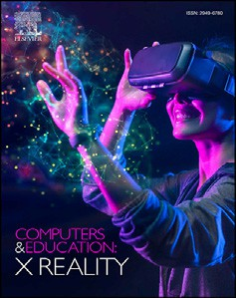

Contents lists available at [ScienceDirect](http://www.sciencedirect.com/science/journal/29496780)

Computers & Education: X Reality

journal homepage: [www.journals.elsevier.com/computers-and-education-x-reality](http://www.journals.elsevier.com/computers-and-education-x-reality)

[](http://crossmark.crossref.org/dialog/?doi=10.1016/j.cexr.2023.100019&domain=pdf)Virtual reality and embodied learning for improving letter-sound knowledge and attentional control in preschool children: A study protocol

Anne Husted Henriksen a,*, Marta Katarzyna Topor a, Rasmus Ahmt Hansen a, Linn Damsgaard b,

Anne-Mette Veber Nielsen c, Andreas Wulff-Abramsson a, Jacob Wienecke a

a *Movement and Neuroscience, Department of Nutrition Exercise and Sports, University of Copenhagen, Copenhagen, Denmark*

b *Department of Midwifery, Physiotherapy, Occupational Therapy and Psychomotor Therapy, Faculty of Health, University College Copenhagen, Copenhagen, Denmark*

c *The National Centre for Reading, University College Copenhagen, Copenhagen, Denmark*

A R T I C L E I N F O

*Keywords:*

VR

Education Literacy

Embodied learning Movement

A B S T R A C T

Previous studies have shown that many children struggle with the acquisition of literacy skills and that these problems can be observed since the earliest stages of literacy learning. Embodied learning has been highlighted as a way to enhance the acquisition of early literacy skills. In addition, the use of technologies has been suggested as way of improving attentional control and motivation, which ultimately can improve learning outcomes. However, the combination of Virtual Reality (VR) and embodied learning in preschool children is yet to be explored wherefore the idea to the VR PLAYMORE study emerged. The project is designed as a three-armed randomized controlled trial with 6-7-year-old children in the Copenhagen area of Denmark. Children will be allocated to either a: 1) VR group, 2) mirror group or 3) control group throughout a 2-week intervention period. The VR group and mirror group will perform activities designed with accordance to the embodied learning theory. However, the VR group will perform the activities while wearing VR headsets whereas the mirror group will perform the ac- tivities in front of a whole-body mirror without VR headsets. The control group will continue regular teaching activities without the research group interruption. This study protocol follows the SPIRIT guidelines. Outcome measurements will include testing of literacy skills and attentional control. The study will add new knowledge to the research field of embodied learning and the use of VR technology in a school setting with focus on reading- and spelling-related skills and attentional control since this combination is yet to be explored.

1. Introduction

Children's acquisition and development of reading skills are impor- tant in modern society. Previous studies have shown that children and adolescents who have reading difficulties and poor spelling skills will be more likely to have poorer academic achievement (Savolainen et al., 2008), which will reflect lower occupational status in adulthood (Smart et al., 2017). This emphasizes the need of action towards reading in early childhood. The present study attempts to build on the current knowledge regarding educational approaches that can facilitate the acquisition of early literacy skills. For this purpose, we will focus on two central early literacy skills, phoneme awareness and letter-sound knowledge. Phoneme awareness and letter-sound knowledge are crucial skills ac- quired during early literacy learning (Ehri et al., 2001; Hulme et al., 2012), known to be strong predictors of later reading and spelling abil- ities (Caravolas et al., 2012; Furnes & Samuelsson, 2009; Hammill, 2004;

Hulme et al., 2012). Children should acquire and retain the connections between the phonemes of spoken words and the graphemes of written words (letter-sound knowledge) when learning to read because this will help them decode unknown words (Byrne & Fielding-Barnsley, 1989). As Danish contains irregular orthography including standard and condi- tional pronunciations of letters, this may be challenging for prereaders (Elbro, 2013; Juul & Sigurdsson, 2005), which supports the importance of acquisition of phoneme awareness and letter-sound knowledge early on. Building on the wealth of knowledge from the field of embodied learning, the current study aims to facilitate the acquisition of both skills in pre-readers through the use of movements.

* 1. *An overview of embodied learning*

Studies consistently show an increase in cognitive performance and academic achievement in relation to physical activity (Donnelly et al.,

* Corresponding author.

*E-mail address:* [ahh@nexs.ku.dk](mailto:ahh@nexs.ku.dk) (A.H. Henriksen).

<https://doi.org/10.1016/j.cexr.2023.100019>

Received 28 September 2022; Received in revised form 3 April 2023; Accepted 3 April 2023

2949-6780/© 2023 The Authors. Published by Elsevier Ltd. This is an open access article under the CC BY license (<http://creativecommons.org/licenses/by/4.0/>).

2016). These studies are primarily based on neurobiological and mo- lecular events that are positively affected by physical activity because of neuroplastic changes in the central nervous system (Gomez-Pinilla & Hillman, 2013). In the recent years, an emerging research field called embodied learning attempted to harness the beneficial effects of move- ment on cognition, with promising results in general learning outcomes. Embodied learning combines movements with academic content in an educational context (Skulmowski & Rey, 2018). This is a more qualita- tive approach that originates from embodied cognition and integrates the body's interactions with the world in cognitive processing (Shapiro & Stolz, 2019). Skulmowski and Rey (2018) divided embodied learning into different dimensions covering: task integration (incidental vs. inte- grated) and bodily engagement (low vs. high). For task integration, movements can be either integrated meaningfully with relation to the task, or they can remain incidental where movements are unrelated to the task. Bodily engagement refers to how much bodily activity is involved in the learning task, which can be either low or high. Watching animations or remaining seated while doing gestures will be referred to as low bodily engagement whereas performing bodily movements and locomotion will be referred to as high bodily engagement.

The integration of meaningful movements is thought to be particu-

larly effective in enhancing memory recall because the motor system is engaged which will facilitate encoding (Mavilidi et al., 2015) instead of just hearing or observing the content (Engelkamp & Zimmer, 1989). This is also a way of dividing the cognitive load of a learning task onto specific subsystems (visual and auditory) of working memory and thereby pre- venting overload (Baddeley, 2003, 2010). The limited capacity of working memory for holding information temporarily and manipulating the content in cognitive tasks is different from person to person (Adams et al., 2018; Eriksson et al., 2015). Children with high working memory performance may show better literacy skills because it is easier for them to learn new letter sounds and shapes and to understand the connection between them because their working memory capacity is bigger (Preβler et al., 2014). On the other hand, children with low working memory may experience a higher load on working memory resulting in difficulties acquiring early reading skills. Using embodied learning when acquiring letter-sound knowledge could be a way of harnessing attentional re- sources by which both visual, auditory, and motor-sensory features relevant to the learnt letter objects can be efficiently processed (Quak et al., 2015). This has been shown to be beneficial in diminishing the cognitive load of working memory because irrelevant information is filtered out which ultimately may be beneficial for children with low working memory performance (Quak et al., 2015).

According to Skulmowski and Rey (2018) low vs. high bodily

engagement has a minor influence on enhanced performance compared to the integration of meaningful movements. However, Mavilidi et al. (2015) interestingly found that using whole-body movements integrated in the academic content resulted in higher scores in a foreign language vocabulary task when compared to the use of hand movements. This is in agreement with Beck et al. (2016) who found that the integration of whole-body movements in the academic content improved children's mathematical performance. Data from the PLAYMORE project (Dam- sgaard et al., 2022) also showed that the use of whole-body movements had the biggest long-lasting effect on letter-sound knowledge. However, in the same study they found that the group performing hand movements gained a bigger effect when tested for recalling of conditional letter-sounds (Damsgaard et al., 2022). This is in accordance with another study by Damsgaard and colleagues (2020) where 7-year-old children using hand-movements for distinguishing the letters b and d, performed better than children performing whole-body movements. Taken together, this strongly indicates that the use of meaningful movements integrated in the learning content has a greater influence on learning outcomes than the motor-modality used.

Considering the benefits of using integrated meaningful movements in learning contexts discussed above, the current study will implement an intervention with movements that are integrated and meaningful. In

addition, standing whole-body movement will be used, which as described above, have already been shown to be effective for learning in early school years. We believe that we can further enhance the planned intervention by focusing on improving children's on-task attention.

* 1. *Attention and embodied learning*

Attention is an important aspect of children's learning outcomes which should be considered when designing new interventions for reading acquisition. According to Kerns et al. (1999), attention can be separated into different components covering the sustainment of atten- tion over time, being able to attend selectively to different stimuli, an ability to exchange or switch attention between two things, and finally, being able to divide the attention so that more than one ongoing process can be maintained. In a community-based study of seven-year-old boys, it was established that inattentive behaviour is, amongst others, associated with poorly developed reading skills (Warner-Rogers et al., 2000). This behaviour will continue to be manifested in later grades and thereby negatively affect general academic performance (Alexander et al., 1993).

We know that embodied learning may already have a beneficial effect on attention. Cormick and Schnobrich (1971) conducted a study with perceptual-motor training involving both gross and fine motor skills ac- tivities. They saw an increase in reading achievement in the children receiving motor training. In the study, they hypothesized that it was due to improved control over attentional processes and decreased impulsivity and distractibility as their program did not provide any specific reading instruction (Cormick & Schnobrich, 1971). It seems that attentional control (choosing what is task-relevant and leaving out distractors) is a particularly important component as it has both been related to reading abilities during childhood and early attentional abilities that can predict later reading skills (Franceschini et al., 2012). We believe that by focusing the design of embodied learning interventions on the improvement of attentional control, the interventions could become even more effective and potentially more beneficial for children who may experience challenges with sustaining attention naturally.

* 1. *The use of technologies in educational contexts*

Attentional control in educational interventions could be further facilitated via the use of technologies. One of which is Virtual Reality (VR; Riva et al., 2020). VR is a technology utilizing stereoscopic pro- jections, head and hand tracking to facilitate sensory immersion. In that way, VR could be considered as an “embodied technology” (Romer- o-Ayuso et al., 2021). Several studies have looked into VR-use in children with attention deficit hyperactivity disorder (ADHD) with focus on distractibility and attention enhancement. However, in these particular studies, VR has been used as a tool to validate the assessment of attention in a virtual classroom environment (Coleman et al., 2019; Parsons et al., 2007; Rizzo et al., 2009) and not as an “embodied technology” in a learning setting. To our knowledge, only one study has combined VR with embodied learning. Fuhrman et al. (2021) saw that motor interac- tion with objects in VR promoted better memory of object names in a foreign language in adults. Though these findings add to the research field of embodied learning, it is still not clear whether motor interactions in VR have a bigger effect on the learning outcome compared to using motor interactions in “the real world” and whether VR can enhance attentional control.

Despite of the unknowns, VR technology has gained popularity in

educational settings. Particularly in domains of science, technology, en- gineering, and mathematics (STEM) education and higher education (Luo et al., 2021; Mikropoulos & Natsis, 2011). The affordances of VR have the potential to enable experimental and inquiry-based learning, leading to advantages such as an enriched learning experience, deeper engagement and enhanced transfer of knowledge (Dalgarno & Lee, 2010; Shin, 2017). The promising results in these subjects are encouraging regarding the use of VR in schools but there remain gaps that further

research should address. One is the lack of investigation into the use of VR technology in other subject areas, particularly literacy. Reading and spelling are foundational skills that are essential for academic success. For example, Savolainen et al. (2008), Smart et al. (2017), and Willcutt et al. (2007) have all reported that children with spelling and reading difficulties tend to experience lower grades and struggle in school in comparison to their peers. Additionally, research conducted by Daniel et al. (2006) and McGee et al. (2002) has demonstrated a higher risk of disengagement from education and increased likelihood of dropping out of school, wherefore a bigger focus should be paid to the area of literacy. Another gap concerns the age and population of VR-users. Most studies on VR technology in education have been conducted with older learners in higher education settings (Hew & Cheung, 2010; Luo et al., 2021) or in children with ADHD (Romero-Ayuso et al., 2021). Research should explore the potential benefits of VR technology in younger, typically developing populations. Particularly in elementary schools in order to determine whether this method should be implemented.

* 1. *Aim*

Our overall research aim is to contribute to developing the Danish school system with movement and motivational tools (e.g., VR) foremost since reading abilities of Danish school children are in decline (Mejding et al., 2016). This is critical because impaired reading skills potentially may change the children's future career opportunities (Smart et al., 2017). Consequently, the current study primarily aims to investigate if VR can be used as an embodied learning tool to improve letter-sound knowledge and whether this transfers onto higher reading- and spelling scores. Furthermore, we want to explore whether the use of VR and embodied learning has a greater learning effect on children with low working memory performance and finally if the potential learning effect could be explained by greater acute attentional benefit when using VR. We have designed a longitudinal two-week intervention with a phonic approach that will be delivered three times a week for 30 min to inves- tigate the effect of embodied learning, with/and without VR as part of the learning activates, on literacy skills. The outcomes of the interventions will be compared to a control group performing conventional teaching activities without the research group interruption.

To reach the aims the following three questions will be answered:

1. Will VR combined with whole-body movements result in higher letter-sound knowledge and thus higher word reading and spelling scores in post intervention tests compared to using only whole-body movements and regular teaching activities?

Letter-sound knowledge and letter knowledge are good predictors of later reading and spelling abilities (Hammil, 2004) and therefore essential for children's literacy acquisition. Furthermore, motivation (Finkelstein et al., 2013; Riva et al., 2020) and learning (Baek-Hwan, 2002) has been positively enhanced in neurodivergent populations by using VR. We will investigate if embodied learning, with and without combination of VR, affects children's knowledge of letter-sound con- nections trained in the intervention (divided into standard and condi- tional sounds) and whether this will affect children's ability to read and spell words in standardized tests. We will test the hypothesis that VR and whole-body movements combined will result in an improved letter-sound knowledge that will transfer positively onto higher word reading and spelling scores in the post-tests compared to the group using whole-body movements but not wearing VR-glasses and the control group that performs no movements and does not wear VR-glasses.

1. Is there a difference in letter-sound knowledge, spelling and reading gains as an interaction between the working memory subgrouping and intervention?

Individual differences in working memory capacity have

consequences for children's academic performance and ability to acquire new skills (Swanson & Alloway, 2012). Children with low working memory may experience a higher load on working memory resulting in difficulties acquiring early reading skills. The challenges regarding low working memory could be improved if attentional control is improved with embodied learning and VR because the attentional resources are efficiently harnessed. We will explore whether there is a difference in letter-sound knowledge, spelling and reading gains as an interaction between low- and high working memory performance (based on the N-back test) and intervention.

1. Will the attentional benefit in the selective attention task be greater when performed in VR than when performed on a computer?

Attentional control could be facilitated via the use of technologies, including VR (Riva et al., 2020). To investigate whether VR can facilitate attentional control, a selective attention task has been revised from the paper by Matusz et al. (2019). In order to show evidence of enhanced attentional control with multisensory processing in VR, we would expect that using VR could lead to an attentional benefit when presented with multisensory distractors, since visual distractors from “the real world” are left out. We will test the hypothesis that performing the selective attention task in VR will result in faster median reaction times (RTs) on correct trials, including both “attentional benefits” (i.e., faster RTs on congruent vs. neutral trials) and reduced “attentional costs” (i.e., slower RTs on incongruent vs. neutral trials), than when performed on a computer.

1. Methods

The hypothesis of the study has been preregistered at OSF the 5th of September 2022 ([https://osf.io/ew7ma/?view_only](https://osf.io/ew7ma/?view_only=62ddd046d17f49c1b9984bb0b0a28500)¼[62ddd046d17f4](https://osf.io/ew7ma/?view_only=62ddd046d17f49c1b9984bb0b0a28500) [9c1b9984bb0b0a28500](https://osf.io/ew7ma/?view_only=62ddd046d17f49c1b9984bb0b0a28500)) before start of data collection. This study pro-

tocol follows the SPIRIT guidelines (Chan et al., 2013).

* 1. *Study design*

The VR PLAYMORE study is designed as a three-armed randomized controlled trial including two intervention groups and one control group (see Fig. 1 for study design and flow of participants).

Both intervention activities are completed as whole-body movements. However, one group does the activities while seeing their virtual selves in VR while wearing VR-glasses (VR group) and one group does the activ- ities while seeing themselves in a mirror (mirror group). The control group continues normal teaching with their own teacher. The interven- tion is conducted over a two-week period in three primary schools in Copenhagen. Participants are randomly allocated (1:1:1, stratified by class) to one of the three groups; (1) VR group, (2) mirror group, (3) control group. The stratified sampling method is used to strata the different classes of each school to ensure that in each group there is a similar number of children from each class. In that way the intervention groups are not overrepresented by one of the classes. This prevents bias in the outcome of the study which could relate to the teaching style or the progress that children achieve in different classes. Two researchers from the research team are responsible for enrolment and allocation of par- ticipants. Collection of outcome measurements prior and post the inter- vention period will enable the assessment of short-term intervention effects.

* 1. *Participants and recruitment*

The intervention includes children aged six to seven years old who have just started Grade 1 (approximately one month after starting). In Grade 1, the children will normally know all the letters of the alphabet, some are able to read short words, but fewer are able to spell words with short and simple structures (Juul, 2019).

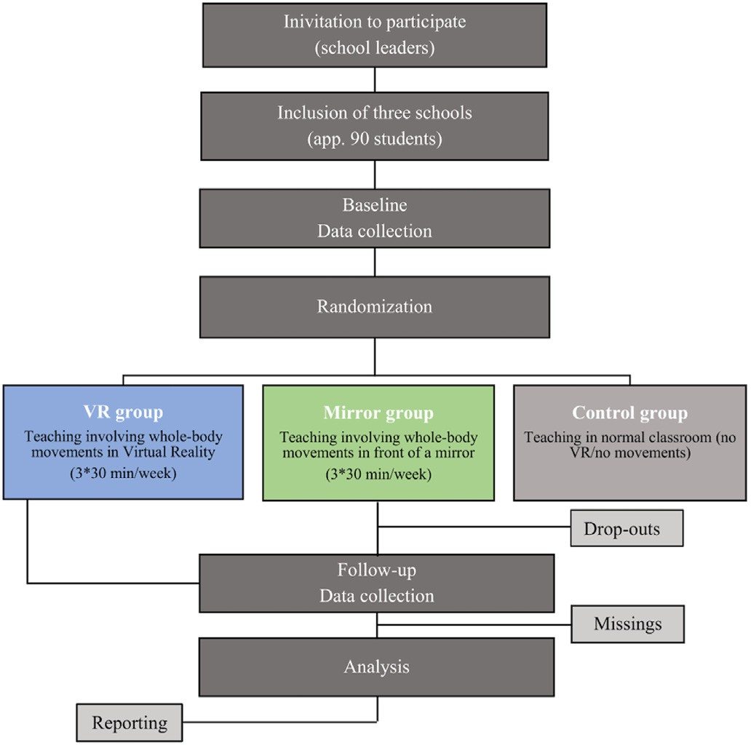

Fig. 1. | Study design and flow of participants.

Communication with the school leaders of the three primary schools are initiated by phone and e-mail and afterwards invitations are sent to an initial meeting to discuss the plan of the intervention (non-committal). Provided that the school leader including teachers agree to participate, further planning is conducted in collaboration with the teachers to ensure optimal time schedule of the school day. All children of Grade 1 classes are invited to participate (including non-Danish speaking pupils).

Children who have cognitive or physical disabilities that prevent them from participation in the activities are excluded from the study and will not participate in the activities. Furthermore, children who do not understand Danish or English will be excluded from the study. Only children with written informed consent from parent(s) or legal guard- ian(s) can participate in the study. Children without consent or who do not want to participate in the activities attend teaching in their normal classroom and will not be part of the study. We plan to recruit approxi- mately 90 pupils with 30 children in each group (VR group, mirror group and control group). It is feasible that we reach between 80 and 100 children as we know that the interest in participation is high and exclusion criteria of this study are not strict.

* 1. *Justification of sample size*

Power calculation is based on previous unpublished work from our lab with the same methodology as in the present paper but applied

outside VR (Cohens d effect size ¼ 1.3 on spelling). That, and other

similar work focusing on spelling and reading interventions outside VR consistently show medium to large effect sizes (Bara & Bonneton-Bott´e, 2017; Gejl et al., 2021; Damsgaard et al., 2022). In the current study, we are planning to conduct a MANOVA interaction model including working memory (low and high performers) and three intervention outcome factors in the form of delta scores -letter-knowledge, spelling and reading. If we discover differences between the groups in the baseline

measurements, we plan to use the pre-test results as co-variants and run a MANCOVA if all assumptions are met. The aim of this is to remove the impact of potential pre-group differences*.* Considering the complexity of the statistical models, we are likely to obtain smaller effect sizes. Using G*Power (Faul et al., 2019), we conducted a sample size calculation with expected medium effect size suitable for a MANOVA interaction effect, *η2*

*p*

¼ 0.06. All settings used in the calculation included: effect size *f* ¼ 0.25

(transformed from *η2* using G*Power's inbuilt function); *α* ¼ 0.05; power at 0.8; number of groups at 6 counting additional subgroups divided by working memory; number of measurements at 3 indicating three outcome variables. All remaining settings were kept at default values. The power calculation suggested 78 participants in total (26 children in each of the three main groups; VR group, mirror group and control group). Therefore, the final minimal target sample size is 30 children per group accounting for ~15% attrition rate.

* 1. *Structure and learning content of the activities*

*p*

The two-week intervention contains six sessions of approximately 30 min duration (three sessions per week). Trained instructors perform the activities at the school in both intervention groups. There is no difference in the learning content of the intervention activities. Children in the intervention groups perform whole-body movements that are linked to letter sounds and letterforms (body phonemes). In the VR group, they make movements while wearing VR-glasses and in the mirror group while looking at themselves in a mirror. The control group is not wearing VR-glasses nor performing whole-body movements but continues regular teaching activities, with teaching materials (*Den f*ø*rste læsning,* Petersen & Borstrøm, 1999; *Fandango Mini,* Jacobsen & Veber Nielsen, 2011)*.* Activities in the control group are therefore not under research group interruption. Intervention activities are developed based on the PLAYMORE-study (Damsgaard et al., 2022; Gejl et al., 2021) with focus on letter-sounds (phonic approach) covering standard and conditional pronunciations of the letters. These activities are developed based on the Danish teaching material, *Fandango Mini,* that are research-founded and used widely by preschool teachers in Denmark (Jacobsen & Veber Niel- sen, 2011). Fig. 2 provides a condition overview made with inspiration from Damsgaard et al. (2022).

The activities are divided into different sessions, with focus on different letters. In session 1 an introduction to the coming weeks is provided while the children are standing/sitting in a circle with the instructor. In session 2 the children learn letter-sounds for the letters ‘a’ and ‘c’, in session 3 for the letters ‘d’ and ‘e’, in session 4 for the letters ‘o’ and ‘r’ and in session 5 for the letters ‘u’ and ‘v’. In session 6 all letters and letter-sounds from session 2–5 are repeated and practiced (Table 1). In Table 1 an overview is provided where standard pronunciations are seen to the left and conditional pronunciations to the right. A detailed description of session structure/intervention activities are presented in Table 2 with session 2 as an example. The structure of the sessions does not vary between VR group and mirror group and always follows the same format, consisting of introduction, introduction to two letters per sessions and an activity focusing on letter-sounds.

* 1. *Content and organization of intervention and control activities*
     1. *Intervention conditions*

The activities and motor modality used in both intervention groups do not vary. In both groups, the theory of embodied learning is used, where whole-body movements are linked to letter sounds and letter- forms. These movements are developed by a group from our lab at Uni- versity of Copenhagen, Movement and Neuroscience (Gejl et al., 2021). The mentioned study was carried out by Damsgaard et al. (2022), where the movement-sound couplings followed the reading directions (from left to right) and the movements used were associated with objects or ani- mals (e.g., the movement coupled to the sound “R” was associated with a cat-like animal scratching). Also, staccato-like letter sounds were per- formed fast and powerful, and long letter sounds were made as slow and fluent movements (Damsgaard et al., 2022; Gejl et al., 2021). In this study we focus only on letters containing *both* standard and conditional sounds.

The VR environment is developed in collaboration with Institute of Psychology at University of Copenhagen and Section of Movement and Neuroscience at University of Copenhagen and programmed in Unity for

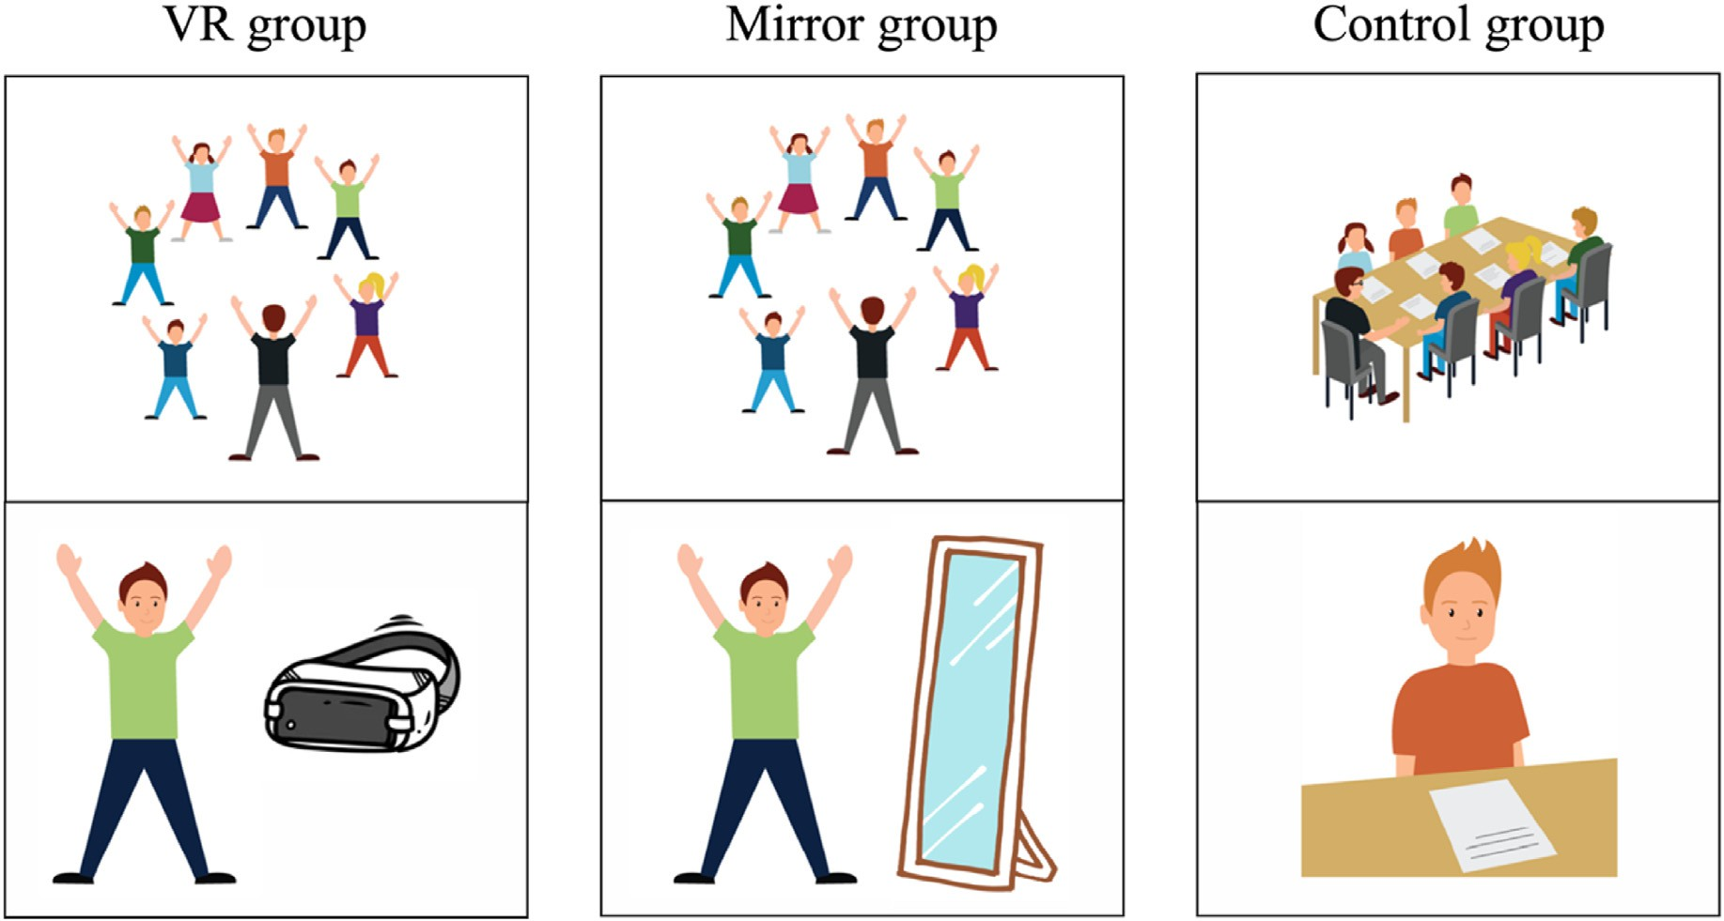

Fig. 2. | Condition overview. Overview of intervention groups (VR and mirror group) and control group. VR group and mirror group perform movements using their whole body to form the shapes of the phonemes (body phonemes) either while wearing VR glasses or when performing the movements in front of a mirror. The control group continues regular teaching activities without the research group interruption.

Table 1

Letters and letter sounds trained during each session of the intervention period. Standard pronunciations to the left and conditional pronunciations to the right.

|  |  |  |  |  |  |  |  |  |  |  |  |  |  |  |  |  |  |  |  |
| --- | --- | --- | --- | --- | --- | --- | --- | --- | --- | --- | --- | --- | --- | --- | --- | --- | --- | --- | --- |
| Session | 1 | 2 |  |  |  | 3 |  |  |  |  | 4 |  |  |  | 5 |  |  |  | 6 |
| Letters | Intro | a |  | c |  | d |  | e |  |  | o |  | r |  | u |  | v |  | All |
| Letter sounds | Intro | [a] | [ɑ] | [s] | [k] | [d] | [ð] | [e] | [ϵ] | [ə] | [o] | [ʌ] | [ʁ] | [ɐ] | [u] | [ɔ] | [v] | [w] | All |

the Oculus Quest 2 VR headset. The content is displayed as a square room with a mirror in front of an avatar (Fig. 3). The avatar is either a boy or a girl depending on the choice of the participating child. The children control the hands of the avatar which through inverse kinematics ap- proximates the rest of the avatar's movements. These are all projected to the children through the virtual mirror. The VR group performs activity II (Table 2) while wearing VR-glasses whereas the mirror group performs activity II (Table 2) while standing in front of a physical whole-body mirror. Each child has their own mirror and is thereby able to see their own movements. The intervention is designed with the consideration of limitations associated with VR use. This includes considerations on programming, which should be both affordable and easy. Setting up a VR environment with only one avatar in an empty room is a relatively simple programming task. Furthermore, the intervention is designed with the focus of maximizing the benefits of embodied learning. Using a mirror in the empty VR environment could be a way to enhance the child's sense of agency through the observation and control of one's own movements (Haggard, 2017). Finally, to investigate the potential added benefit of using VR with embodied learning, the intervention needs to be as similar as possible in the real and virtual setting by which a physical whole-body mirror is included in the mirror group to replicate the VR group.

* + 1. *Control condition*

The control condition continues regular teaching activities without the research group interruption. We have therefore no influence on the learning content in this group throughout the intervention.

* 1. *Blinding*

It is not possible to blind the participants nor the instructors throughout the intervention; however, pre- and post-testing are carried

out by blinded assessors.

* 1. *Measures*

The primary outcome of the study is to see if there is an intervention effect on literacy skills. The direct intervention effect is measured indi- vidually on letter-sound knowledge (see ‘Naming of letter sounds including the use of movements). The reliability of this is high since similar randomized controlled trials have used this test as a direct mea- sure on letter-sound knowledge (Damsgaard et al., 2022; Damsgaard et al., 2022; under review). The international consistency of the test evaluated by the Kuder-Richardson formula 20 has previously been analysed to 0.73 (95% CI 0.72–0.75) (Malling et al., 2021). Potential transfer effect of this to word reading and spelling performance is tested via widely used tests in the Danish school system (‘Staveprøve 1’ and ‘Ordlæseprøve 1’) which secures high validity of the outcome measure- ments. All mentioned tests are administered before and after a two-week intervention period.

The secondary outcomes of the study are to investigate whether the use of VR and embodied learning has a greater learning effect on children with low working memory performance. To subdivide children in high and low performers we use a 1-back visual working memory task (‘N- back’) at baseline. This is frequently used in cognitive neuroscience research contexts (Pelegrina et al., 2015). Statistical interaction effects between working memory subgrouping and intervention on delta im- provements scores are collected for letter-sounds, reading and spelling measures. Furthermore, we want to investigate whether there is a dif- ference in attentional benefit when performing the selective attention task in VR or on a computer. To do this a ‘Selective attention task’ has been revised from Matusz et al. (2019).

All testing is administered by trained staff. At baseline (T0) N-back,

Table 2

Description of intervention activities.

PROTOCOL ONE SESSION (EXAMPLE: SESSION 2)

Letters in focus: A, C SESSION 2

Activity VR group Mirror group

‘Naming of letter sounds (including use of movements)’ and ‘Selective attention task’ are delivered on an individual basis. ‘Spelling test 1’ and ‘Word reading test 1’ are delivered in groups at T0. Afterwards all participating children are randomized to either VR group, mirror group or control group. The control group continues regular teaching without interruption from the research group. At post-testing (T1) children per- forms ‘Naming of letter sounds (including use of movements)’ individ-

Introduction (2 min) While the children are

standing in a circle, the instructor talks with the children about VR and introduces them to the following weeks. Names of children must be remembered.

While the children are standing in a circle, the instructor talks with the children about the mirrors and introduces them to the following weeks.

Names of children must be remembered.

ually whereas ‘Spelling test 1’ and ‘Word reading test 1’ again are performed on a group level (Fig. 4) for intervention and test overview). Group and individual testing are on different days. Both testing and intervention activities are delivered during school hours to ensure participation of the children.

* + 1. *Group tests*

Today's letters and letter sounds (3 min) Letter: A, C

Activity I (5 min) Title: “Sound duel” Letter: A, C

Activity II (10 min) Title: “Sound duel” in VR and mirror Letter: A, C

In the circle the instructor introduces a and c (simple and conditioned sounds) and the belonging body phonemes for both letters.

The movements are practiced collectively, going in the reading direction round the circle (without VR glasses). After all movements and sounds for a and c are practiced, sound duel is practiced collectively in the circle. Words including one of the two a- and c-pronun- ciations (simple or conditional) are read aloud. Children have to identify the correct sound and related body pho-neme by themselves (without VR glasses).If wrong, corrections are made collectively.

The children are placed in a square and the instructor makes a quick introduction on how to wear the VR glasses. Afterwards sound duel is performed with the VR glasses on with the children standing in their own square.Corrections are made individually.

In the circle the instructor introduces a and c (simple and condi-tioned sounds) and the belonging body phonemes for both letters. The move-ments are practiced collectively, going in the reading direction round the circle. After all movements and sounds for a and c are practiced, sound duel is practiced collectively in the circle. Words including one of the two a- and c-pronunciations (simple or condi-tional) are read aloud. Children have to identify the correct sound and related body phoneme by them- selves. If wrong, corrections are made collectively.

The children are placed in

front of a mirror and the instructor goes trough what to do in front of the mirror. Afterwards sound duel is performed with the children standing in front of their own mirror.

Corrections are made individually.

Group testing is conducted by subdividing the class into 12–14 chil- dren and the test duration is approximately 15 min to deliver both tests. During the test, children are placed with enough space between them so that copying is avoided. Materials includes purchase of the below- mentioned pen and paper tests from Hogrefe Psykologisk Forlag A/S.

* + - 1. *Stavepr*ø*ve 1 [*‘*Spelling test 1*’*].* Spelling test 1 is used broadly in the Danish school system and the manufacture's description of procedure is followed closely (Juul, 2019). The test evaluates spelling performance in Grade 1. In the test, the children are presented with 17 words that are also shown as pictures. The instructor reads the words aloud and the children have to spell them. The words increase from two to seven letters throughout the test. The children are instructed to look at the assessor when they have written the word. When all children are ready, the instructor reads the next word. Percentage of correctly spelled words comprise the test score.
      2. *Ordlæsepr*ø*ve 1 [*‘*Word reading test 1*’*].* Word reading task 1 is also widely used in the Danish school system and is carried out in accordance with the manufacture's description (Juul & Møller, 2010). The test evaluates word reading accuracy and efficiency. In the test, children are presented with 78 items (and two practice items) and in each of them the participants must select one of four pictures that is in accordance with a printed word. The length of the words increases (two to four letters), and the participants have to solve as many items as possible in 4 min. The children have to change pencil colour every minute (instructed by the assessor) to monitor their progression. Number

De-briefing (2 min) Children are summoned to a

quick de-briefing going through the activities of the day to ensure the children's well-being.

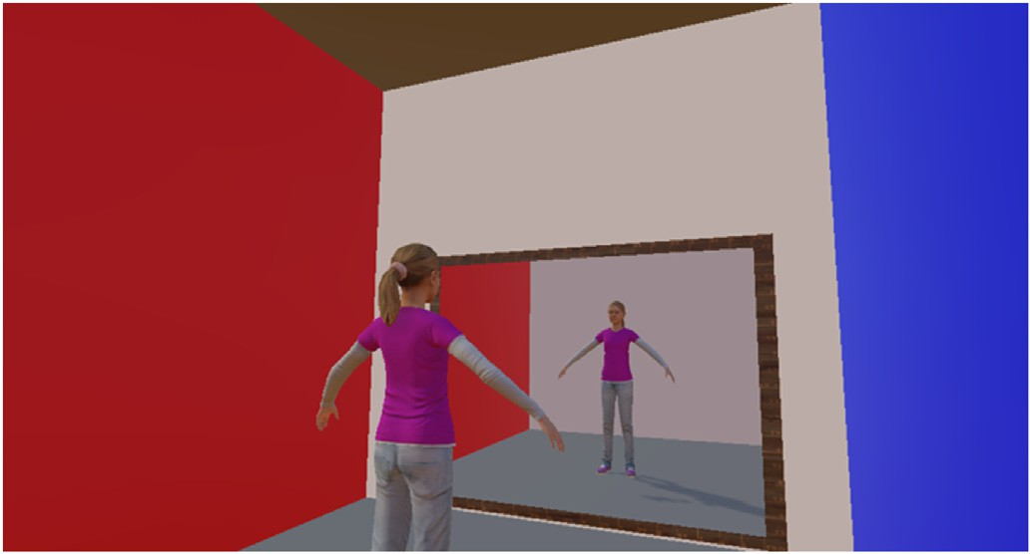Protocol for one session (example: session 2).

Fig. 3. | VR environment.

Children are summoned to a quick de-briefing going through the activities of the day to ensure the children's well- being.

of correct answers (efficiency) comprise the test score.

* + 1. *Individual tests*

Individual testing is conducted with only one assessor in a quiet room for the duration of approximately 30 min per child. At the start of indi- vidual testing, the assessor collects background information including sex, dominant hand, and bilingualism. Materials to perform the below- mentioned tests includes computers and VR-headsets.

* + - 1. *Naming of letter sounds including the use of movements.* During the intervention, the children are taught the coupling between letter sounds and movements for letters containing both standard and condi- tional letter-sounds. In the PLAYMORE study protocol by Gejl et al. (2021), a test to evaluate beneficial effects of using movements in com- bination with letter sounds was constructed and later applied in the study by Damsgaard et al. (2022). Following on from these studies, we are using the same test in the current project to assess children's letter-sound knowledge, including eight standard letter-sounds and nine conditional letter-sounds. With the child standing in front of an assessor, the instructor reads a, c, d, e, o, r, u and v aloud, one at a time. The child is asked to pronounce the letter-sounds of the read letter and told that they are allowed to use movements at the same time, if remembered. The child's answer for every sound is registered as correct/incorrect/missing and whether movement/no movement is used. Numbers of correct

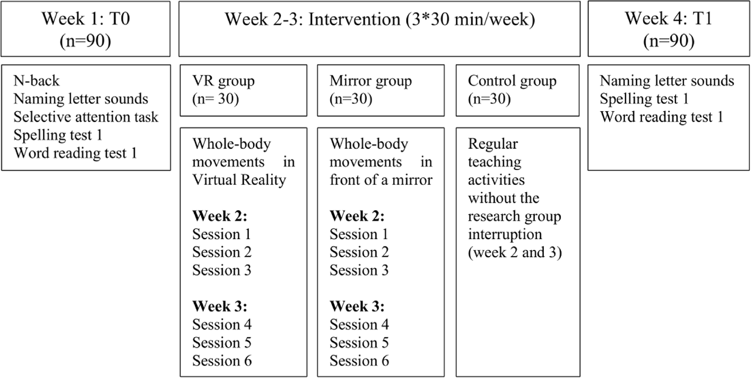

Fig. 4. | Intervention and test overview. At T0 a N-back test, naming of letter sounds-test (including use of movements) and a selective attention task are performed individually. Spelling test 1 and word reading test 1 are performed as group tests. All participating children are randomized into either one of two intervention groups (VR group or mirror group) or a control group. The control group attends normal teaching in their usual classroom. At T1 children perform naming of letter sounds-test (including use of movements) individually and spelling test 1 and word reading test 1 as group tests.

letter-sounds pronounced in total, as standard letter-sounds, and as conditional letter-sounds constitutes the result. The test is used to eval- uate the direct training effect of the intervention.

* + - 1. *N-back.* A 1-back visual working memory task is completed to subdivide the children into low- and high performers since individual differences in working memory capacity have consequences for chil- dren's academic performance and ability to acquire new skills (Swanson & Alloway, 2012). The 1-back task presents a set of symbols (car, cloud, globe, note, headphones, airplane, plate, key, eye and bicycle) on a computer screen, one at a time. The children have to compare each current symbol with the symbol that was presented immediately before. If the two symbols are identical, the children are instructed to press “yes” (a green key). If the symbols are different, the children have to press “no” (a red key). The children are instructed to do this as fast and as accurate as possible. They complete 20 practice trials (30% “yes” trials) that are followed by two test blocks consisting of 20 trials each (30% “yes” trials). Symbols are presented for 500 ms followed by a 3000 ms blank screen. The response window and the inter-stimuli interval together are 3500 ms. The outcome measure is accuracy on congruent trials (8 correct re- sponses on congruent trials are needed to be in high performers based on normative data provided by Pelegrina et al. (2015).
      2. *Selective attention task.* The aim of the task is to evaluate attentional control in and outside of VR. Therefore, the task is done on a computer and in VR in two separate sessions. On the computer, the participant is sitting on a chair approximately 50 cm from the screen with a reachable external keyboard in front. In the VR condition, the partici- pant is sitting at the same desk wearing VR-glasses with the same reachable keyboard in front. The task is a visual search task adjusted and revised from the paper by Matusz et al. (2019). It has two possible targets and two types of corresponding responses (Fig. 5).

The task has a child-friendly narrative where the children are told that they will help Santa to sort letters needed to put names on Christmas presents. The child is presented with a set of four letters in a two by two layout. They are instructed to search for one of two possible targets (“b”, “p”) and press one of two buttons on a keyboard upon detection (left alt key and right alt key, respectively). The target is presented as one of the

four letters on the visual search field. The remaining three letters are visual distractors (“y”, “i”, “h”). The visual distractors are the same in each trial, but their positions are randomized. In addition, a multisensory perceptual distractor is presented on some trials as either 1) a highly confusable distractor (“b” or “p”, depending on which one is the target) or 2) a neutral distractor (“g”). The distractors are presented in one of three different sensory modalities (visual, auditory or visual-auditory). When the perceptual distractor is visual, it is positioned on top of the visual search field. When the perceptual distractor is auditory, a letter sound is played through headphones. Children wear the same head- phones when completing the task on a laptop and in VR. Sound intensity is kept at 50 dB. The task consists of six blocks (estimated time: 20 min), covering two training blocks (9 trials within each) and four test blocks (36 trials within each; Fig. 6).

Each trial begins with 1000-ms-long central fixation point, immedi-

ately followed by a 200-ms-long visual search display, followed by a

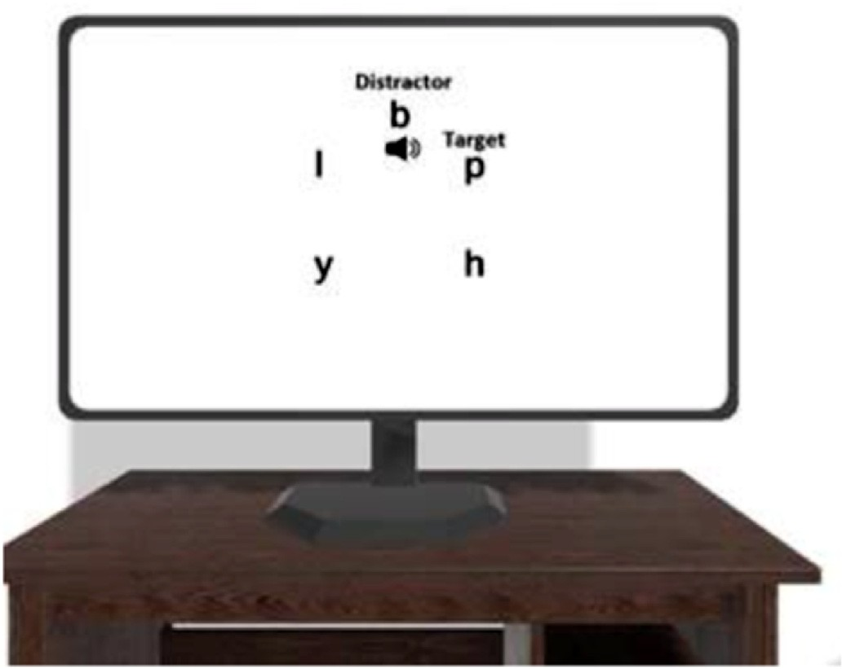

Fig. 5. | An example of a search display where the target stimulus “p” is pre- sented at high load, with a target-incompatible, audiovisual distractor (“b”).

5000 ms blank white response screen and lastly 500 ms feedback screen with happy faces for correct, sad faces for incorrect responses and “faster” in the case of no response. Furthermore, 12 trials are with visual perceptual distractors, 12 trials with auditory perceptual distractors and 12 trials with visual-auditory perceptual distractors. The following trial

types are repeated twice for each distractor modality (visual, auditory, auditory + visual):

1. Target ¼ “b”, Perceptual distractor ¼ “b” (congruent),
2. Target ¼ “b”, Perceptual distractor ¼ “p” (incongruent),
3. Target ¼ “b”, Perceptual distractor ¼ “g” (neutral),
4. Target ¼ “p”, Perceptual distractor ¼ “p” (congruent),
5. Target ¼ “p”, Perceptual distractor ¼ “b” (incongruent),
6. Target ¼ “p”, Perceptual distractor ¼ “g” (neutral).

The result of the selective attention task is evaluated on median re- action times (RTs) on correct trials. This is calculated as two separate variables including “attentional benefits” (i.e., faster RTs on congruent vs. neutral trials) and “attentional costs” (i.e., slower RTs on incongruent vs. neutral trials).

* + 1. *Compliance to the intervention*

After every session the instructors note attendance of each child. Attendance covers both presence (yes/no) and active participation as to whether the child is taking part in the intervention or sitting out (yes/

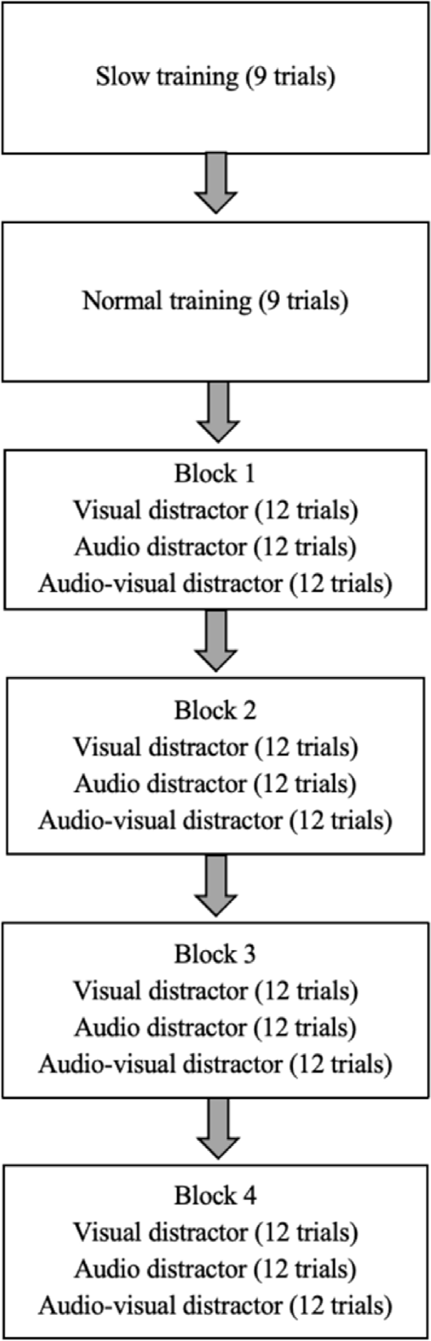

Fig. 6. | Flow of the selective attention task.

no).

* 1. *Plan for data analysis*

For each group we provide descriptive statistics, summarized across all classes. Chi-square tests are used for the categorical measures (bilin- gual, dominant hand, and sex). The first hypothesis is addressed by analysing between-group-differences before and after the intervention using multivariate analysis of variance (MANOVA) for the three main variables (‘Naming of letter-sounds’, ‘Word reading test 1’ and ‘Spelling test 1’) as delta scores (subtracted before from after). The second hy- pothesis is tested with a two-way ANOVA as a statistical interaction effect between the working memory subgrouping and intervention on delta improvement scores collected for letter-sounds, reading and spelling measures. The third hypothesis is evaluated with a one-way ANOVA conducted twice - first time with attentional benefit, second time with attentional costs between the three groups. Children with test results of more than 2SD from the mean in two or more tests are considered outliers and are excluded from all analyses. Otherwise, we do not plan to exclude any outliers unless we notice extreme scores in the cases of children who did not engage in the study procedures properly. Multiple comparisons correction is applied accordingly to all planned tests and any post-hoc comparisons.

* 1. *Ethics and data security*

All parents of children in Grade 1 (from the recruited schools) receive written and oral information before their child is included in the study. The children can only participate if written informed consent from par- ent(s)/legal guardian(s) is handed in before baseline measurements. Parent(s)/legal guardian(s) and children can always redraw written consent and stop participation without providing a reason. Data is ano- nymized by giving each child an identification number (ID number), and sensitive personal information is stored alongside data. Execution of the VR PLAYMORE study follows rules from the Danish Data Protection Agency and General Data Protection Regulation (GDPR) throughout all phases.

1. Discussion

This study will provide additional insights in the research field of embodied learning in combination with the use of technologies. Both intervention groups (VR- and mirror group) will perform whole-body movements and thereby experience high bodily engagement and high task integration (Skulmowski & Rey, 2018). Damsgaard et al. (2022) found that recalling of letter-sounds (both standard and conditional) were significantly higher when performing whole-body movements, which reinforces the idea that movement integrated in the learning content may be more beneficial than conventional methods. This is also called the enactment effect (Engelkamp & Zimmer, 1989), which is that performing an action during learning will promote memory consolida- tion of the information as opposed to getting verbal information only. In this study, we will focus only on letters containing *both* standard and conditional sounds to promote letter-sound knowledge, as this is an essential part of learning to read (Hammil, 2004).

We are hoping to clarify whether VR combined with whole-body movements can contribute to a learning effect in addition to embodied learning. The rationale behind this is that VR will reduce distractions from the environment by potentially lowering the level of perceptual load (Murphy et al., 2016). When entering the VR environment visual stimuli from the outside world will be lost. It is our belief that children will increase their focus on what is task-relevant and not be distracted from what is task-irrelevant (e.g., visual inputs from the outside world). The intention of using VR during the intervention is to stimulate letter processing and phonological attention, which will possibly transfer into larger learning effects (higher reading and spelling scores in VR group)

due to higher focus on the task.

Long-term or sustained attention is however not expected to increase during a 2-week intervention and therefore not relevant to perform the Selective Attention Task at post-testing. In addition, there is a risk of bias regarding practice effects in the VR group. In order to show evidence of enhanced attentional control with multisensory processing in VR, we would expect that using VR would lead to attentional benefit at least when presented with multisensory distractors but also perhaps in the case of visual or auditory only distractors. This means that using VR would result inon-task attentional benefit when compared to a non-VR setup. Thereby we will gain insights regarding the use of VR to improve attentional control that has also been shown to be an important aspect in reading abilities (Cormick & Schnobrich, 1971; Franceschini et al., 2012). If we were to show enhanced attentional control and a transfer effect on learning outcome in the VR group, further exploration of VR-use for children with neurodiverse profiles e.g. ADHD, children with sub-clinical attention deficits or dyslexic children would be a new potential route of investigation.

A strength of the VR PLAYMORE study is the blinding of assessors at

both pre- and post-testing, which will limit the risk of bias. Due to the nature of the intervention, it will not be possible to blind the participants (besides during pre-testing). However, since the participating children are approximate 6–7 years old, this is not expected to induce any biases. Another consideration of the study is that activities in both intervention groups (VR- and mirror group) will be administered by trained in- structors from our research group Movement and Neuroscience at Uni- versity of Copenhagen to secure indifferences in performance of the intervention activities. This is however not the case for the control group that will continue normal teaching with their usual teacher, which may induce bias. Nonetheless, the control group is important to establish a cause-and-effect relationship so that we can confirm or rule out that the study results are due to the intervention activities. Furthermore, having usual teachers to facilitate the control group, children without written consent will be able to continue their normal classroom teaching while the intervention groups are being taken out during the school day.

* 1. *VR in education*

Using VR in education is highly relevant since both researchers and teachers are urging for effective simulation-based learning, which is being driven by recent advancements in and the expanding availability of immersive technologies (Barrie et al., 2019; Chen et al., 2022). According to Johnson-Glenberg (2018) there are two attributes associated with VR that can positively affect education. These are referred to as profound affordances, where the first accounts for the feeling of presence. The second profound affordance relates to embodiment and the opportunity to manipulate objects in three dimensions which ultimately will give the learner personal control over the learning environment (Johnson-Glen- berg, 2018). The sense of agency is especially relevant in the context of education as it refers to the experience of controlling own movements and by that the course of external events. Using VR may extend the sense of agency because the environment can be controlled by one's own movements (Haggard, 2017). This could, potentially, be a way to in- crease attention and engagement and we are interested in whether this transfers positively onto learning outcomes. We will with our research design be able to test if it is embodied learning in itself that potentially increases learning outcomes or if VR has the potential to further grab the learner's attention and thereby enhance the learning outcome. We are therefore taking an important step in line with the technological devel- opment where the strengthening of technology in teaching at all levels of education is essential (Børne- og Undervisningsministeriet, 2018). Importantly, technological innovation for the use of VR in education should not only focus on engagement and entertainment design with potential interfering consequences, but also on how learners can acquire knowledge faster and show better retention of the content (Johnson-- Glenberg, 2018). Accordingly, our VR setup is very simple and accessible

because we want to gain knowledge on how to use VR as a learning tool and not as an entertainment tool in the primary schools of Denmark. Future research could, however, advantageously focus on game-based learning as this seems to be particularly promising (Chen et al., 2020). For example, gamification has been shown to improve learning atten- dance, motivation, and engagement, all of which were crucial for the development of reading skills (Gooch et al., 2016; Hong & Masood, 2014). In this regard, future research on the gamification of reading in- terventions offers exciting opportunities (Jamshidifarsani et al., 2019).

The methodological approach presented in this report is unique. It brings about both advantages and challenges in comparison to other teaching methods such as traditional classroom-based learning or online learning. Traditional classroom-based learning provides direct interac- tion between teachers and students but may be limited in terms of teaching methods and hands-on experiences (Deslauriers et al., 2019). Online learning provides flexibility but can be limited in terms of social interaction and hands-on experiences (Means et al., 2009). Embodied learning with VR can provide a full sensory experience but may be expensive and require significant technical expertise (Merchant et al., 2014). Despite of this, embodied learning with VR may provide a unique opportunity to combine the advantages of traditional classroom-based learning to create immersive and engaging learning experiences (Bai- lenson et al., 2008).

* 1. *Limitations and future directions*

Although abovementioned points show promising evidence for the use of VR technology in educational settings, there are also potential challenges that should be considered when implementing this technology in conjunction with embodied learning. To our knowledge, no studies have investigated the combination of VR and embodied learning with 6–7-year-old children in an ecologically valid school setting and with a focus on literacy. This means that there are limited sources of informa- tion we can use to foresee and avoid difficulties with the implementation of the planned intervention in a school setting. One consideration is that children are very easily influenced (Bailey & Bailenson, 2017; Segovia & Bailenson, 2009; Southgate et al., 2017), which means that they should not be exposed to any VR experiences that they would not be exposed to in the real world (e.g., scary experiences like shooting games) as they may not be able to distinguish between the virtual and the real world. Children must be thoroughly prepared for the VR experience, which in- cludes briefing before and after VR activities. For instance, in the case of our intervention, we plan to ensure that children know the avatar in the mirror is not real before they enter the virtual environment. Following each VR-session, children will also be debriefed to make sure they can separate the virtual world from the real world. Another important aspect and a potential limitation, is the requirement for space. It is crucial to ensure safety for the duration of the activities and thus all tables, chairs, sharp edges, etc. should be removed. Since VR-headsets are quite heavy, this is also a limitation when used with children. It will both be a chal- lenge to make the headset fit properly around the head but also to adjust the headset to match their eye distance (Aubrey et al., 2018). Otherwise, it will make the experience blurry and increase the risk of cyber sickness (Rebenitsch & Owen, 2016).

There are also potential barriers to the implementation of the pro-

posed educational intervention with the use of VR. One concerns the inequities in access. The proposed protocol requires children to have regular access to repeated VR sessions over a period of at least two weeks. This means that schools would need sufficient supplies of the VR headsets for all children and expect high wear and tear. While the cost of VR technology has decreased in recent years, it may still be prohibitive for some schools and students (Merchant et al., 2014). Additionally, students who do not have access to VR technology outside of school may be at a disadvantage compared to their peers who do. Another potential barrier is the need for effective teacher training and support. Teachers may need training and ongoing support to effectively incorporate VR technology

into their lessons and to facilitate embodied learning experiences (Mer- chant et al., 2014). Without appropriate training and support, teachers may not be able to effectively utilize VR technology in the classroom or may inadvertently reinforce incorrect behaviors or misunderstandings. This is specifically important when considering embodied learning VR interventions, as incorrect instructions or child's misunderstanding of the instructions, could hinder the embodiment effect. Overall, while there are potential issues to consider for the protocol's implementation in school settings, the use of VR technology in conjunction with embodied learning holds promise for enhancing learning outcomes and engaging students in novel and immersive educational experiences. Further, the proposed protocol offers a real advantage it its ecologically valid approach. We will integrate the use of VR within the natural setting of the classroom and curriculum-aligned student learning. Continued research and development in this area has the potential to transform the way we approach education and improve outcomes for learners of all ages and backgrounds.

1. Conclusion

The VR PLAYMORE study will provide information on the acute effect of VR-use on attentional control in children aged 6–7 years old. Furthermore, we will gain insights into combined use of VR and embodied learning (whole-body movements) and whether this combi- nation provides an immediate effect on letter-sound knowledge at if it transfers onto reading and spelling performance. We will however not be able to say if the intervention has potential long-lasting effects. If we are to show positive effects on learning outcome, further studies should clarify if VR-use in combination with embodied learning potentially could have an even bigger impact in children with attention deficits. This could contribute to further development of tools for implementation in difficult learning settings.

Authors’ contributions

AHH, MKT, RAH, LD, GBLP, GM, AMVN and JW conceptualized the study. AHH prepared the initial version of the study protocol and the included figures and tables. AW-A implemented the Selective Attention test and co-developed the VR mirror setup. All authors have critically reviewed and accepted the final version of the manuscript.

Ethics approval

The study was approved by the local Ethical Committee at University of Copenhagen (protocol: 504–0032/18–5000) and carried out in accordance with the Helsinki Declaration II.

Consent to participate

Written consent was obtained from the parents.

Funding

This project was supported by a grant from Independent Research Fund Denmark (#8018-00132B).

Declaration of competing interest

None.

Acknowledgements

We would like to thank the Independent Research Fund Denmark for funding the research project and Ruben Schachtenhaufen at humanistic faculty of Copenhagen University for letter sounds implemented into the selective attention test. Also, we would like to thank Guido Makransky

and Gustav Bøg Lassen Petersen from Department of Psychology, Uni- versity of Copenhagen, for initiating the collaboration and contributing with important knowledge of VR in learning settings. Finally, we thank the Independent Research Fund Denmark for funding the research project.

References

Adams, E. J., Nguyen, A. T., & Cowan, N. (2018). Theories of working memory: Differences in definition, degree of modularity, role of attention, and purpose. *Language, Speech, and Hearing Services in Schools, 49*(3), 340–355. [https://doi.org/](https://doi.org/10.1044/2018_LSHSS-17-0114) [10.1044/2018_LSHSS-17-0114](https://doi.org/10.1044/2018_LSHSS-17-0114)

Alexander, K. L., Entwisle, D. R., & Dauber, S. L. (1993). First-Grade classroom behavior: Its short- and long-term consequences for school performance. *Child Development,* *64*(3), 801–814. <https://doi.org/10.1111/j.1467-8624.1993.tb02944.x>

Aubrey, J. S., Robb, M. B., Bailey, J., & Bailenson, J. (2018). *Virtual reality 101: What you need to know about kids and VR*. San Francisco, CA: Common Sense. Retrieved from [htt](https://www.commonsensemedia.org/research/virtual-reality-101-what-you-need-to-know-about-kids-and-vr) [ps://www.commonsensemedia.org/research/virtual-reality-101-what-you-need-to-](https://www.commonsensemedia.org/research/virtual-reality-101-what-you-need-to-know-about-kids-and-vr) [know-about-kids-and-vr](https://www.commonsensemedia.org/research/virtual-reality-101-what-you-need-to-know-about-kids-and-vr).

Baddeley, A. (2003). Working memory: Looking back and looking forward. *Nature* *Reviews Neuroscience, 4*, 829–839. <https://doi.org/10.1038/nrn1201>

Baddeley, A. (2010). Working memory. *Current Biology, 20*(4), R136–R140. [https://](https://doi.org/10.1016/j.cub.2009.12.014) [doi.org/10.1016/j.cub.2009.12.014](https://doi.org/10.1016/j.cub.2009.12.014)

Bailenson, J. N., Yee, N., Blascovich, J., Beall, A. C., Lundblad, N., & Jin, M. (2008). The use of immersive virtual reality in the learning sciences: Digital transformations of teachers, students, and social context. *The Journal of the Learning Sciences, 17*(1). <https://doi.org/10.1080/10508400701793141>

Bailey, J. O., & Bailenson, J. N. (2017). Considering virtual reality in children's lives.

*Journal of Children and Media, 11*(1), 107–113. [https://doi.org/10.1080/](https://doi.org/10.1080/17482798.2016.1268779) [17482798.2016.1268779](https://doi.org/10.1080/17482798.2016.1268779)

Bara, F., & Bonneton-Bott´e, N. (2017). Learning letters with the whole body: Visuomotor

versus visual teaching in kindergarten. *Perceptual and Motor Skills, 125*(1), 190–207. <https://doi.org/10.1177/0031512517742284>

Barrie, M., Socha, J. J., Mansour, L., & Patterson, E. S. (2019). Mixed reality in medical education: A narrative literature review. *Proceedings of the International Symposium on Human Factors and Ergonomics in Health Care, 8*(1). [https://doi.org/10.1177/](https://doi.org/10.1177/2327857919081006) [2327857919081006](https://doi.org/10.1177/2327857919081006)

Beck, M. M., Lind, R. R., Geertsen, S. S., Ritz, C., Lundbye-Jensen, J., & Wienecke, J. (2016). Motor-enriched learning activities can improve mathematical performance in preadolescent children. *Frontiers in Human Neuroscience, 10*. [https://doi.org/](https://doi.org/10.3389/fnhum.2016.00645) [10.3389/fnhum.2016.00645](https://doi.org/10.3389/fnhum.2016.00645)

Børne- og Undervisningsministeriet. (2018). *Handlingsplan for teknologi i undervisningen.*

*Styrelsen for IT og Læring*. Retrieved from [https://www.stil.dk/aktuelt/uvm/2018/feb/180202-undervisningsministeren-](https://www.stil.dk/aktuelt/uvm/2018/feb/180202-undervisningsministeren-vil-rykke-teknologiforstaaelsen-helt-ind-i-klassevaerelset#%3A~%3Atext%3DHandlingsplan%20for%20teknologi%20i%20undervisning%20(pdf)

[vil-rykke-teknologiforstaaelsen-helt-ind-i-klassevaerelset#:~:text](https://www.stil.dk/aktuelt/uvm/2018/feb/180202-undervisningsministeren-vil-rykke-teknologiforstaaelsen-helt-ind-i-klassevaerelset#%3A~%3Atext%3DHandlingsplan%20for%20teknologi%20i%20undervisning%20(pdf)¼[Handlingsplan%](https://www.stil.dk/aktuelt/uvm/2018/feb/180202-undervisningsministeren-vil-rykke-teknologiforstaaelsen-helt-ind-i-klassevaerelset#%3A~%3Atext%3DHandlingsplan%20for%20teknologi%20i%20undervisning%20(pdf)

[20for%20teknologi%20i%20undervisning%20(pdf](https://www.stil.dk/aktuelt/uvm/2018/feb/180202-undervisningsministeren-vil-rykke-teknologiforstaaelsen-helt-ind-i-klassevaerelset#%3A~%3Atext%3DHandlingsplan%20for%20teknologi%20i%20undervisning%20(pdf).

Byrne, B., & Fielding-Barnsley, R. (1989). Phonemic awareness and letter knowledge in the child's acquisition of the alphabetic principle. *Journal of Educational Psychology,* *81*(3), 313–321. <https://doi.org/10.1037/0022-0663.81.3.313>

Caravolas, M., Lervåg, A., Mousikou, P., Efrim, C., Litavský, M., Onochie-Quintanilla, E., & Hulme, C. (2012). Common patterns of prediction of literacy development in diferent alphabetic orthographies. *Psychological Science, 23*(6), 678–686. [https://doi.org/](https://doi.org/10.1177/0956797611434536) [10.1177/0956797611434536](https://doi.org/10.1177/0956797611434536)

Chan, A.-W., Tetzlaff, J. M., Altman, D. G., Laupacis, A., Gøtzsche, P. C., Krleˇza-Jeri´c, K.,

et al. (2013). SPIRIT 2013 statement: Defining standard protocol items for clinical trials. *Annals of Internal Medicine, 158*(3), 200–207. [https://doi.org/10.7326/0003-](https://doi.org/10.7326/0003-4819-%20158-3-201302050-00583) [4819- 158-3-201302050-00583](https://doi.org/10.7326/0003-4819-%20158-3-201302050-00583)

Chen, X., Xie, H., & Li, Q. (2022). Vision, status, and topics of X reality in education.

*Computers and Education: X Reality, 1*. <https://doi.org/10.1016/j.cexr.2022.100001> Chen, X., Zou, D., Cheng, G., & Xie, H. (2020). Detecting latent topics and trends in

educational technologies over four decades using structural topic modeling: A retrospective of all volumes of computers & education. *Computers and Education, 151*. <https://doi.org/10.1016/j.compedu.2020.103855>

Coleman, B., Marion, S., Rizzo, A., Turnbull, J., & Nolty, A. (2019). Virtual reality assessment of classroom – related attention: An ecologically relevant approach to evaluating the effectiveness of working memory training. *Frontiers in Psychology, 10*. <https://doi.org/10.3389/fpsyg.2019.01851>

Cormick, C. C. M., & Schnobrich, J. N. (1971). Perceptual-motor training and improvement in concentration in a montessori preschool. *Perceptual and Motor Skills,* *32*(1), 71–77. <https://doi.org/10.2466/pms.1971.32.1.71>

Dalgarno, B., & Lee, M. J. W. (2010). What are the learning affordances of 3-D virtual environments? *British Journal of Educational Technology, 41*(1). [https://doi.org/](https://doi.org/10.1111/j.1467-8535.2009.01038.x) [10.1111/j.1467-8535.2009.01038.x](https://doi.org/10.1111/j.1467-8535.2009.01038.x)

Damsgaard, L., Nielsen, A.-M. V., Gejl, A. K., Malling, A. S. B., Jensen, S. K., & Wienecke, J. (2022). Effects of 8 Weeks with embodied learning on 5–6-year-old Danish children's pre-reading skills and word reading skills: The PLAYMORE project, DK. *Educational Psychology Review, 34*(3), 1709–1737. [https://doi.org/10.1007/](https://doi.org/10.1007/s10648-022-09671-8) [s10648-022-09671-8](https://doi.org/10.1007/s10648-022-09671-8)

Daniel, S. S., Walsh, A. K., Goldston, D. B., Arnold, E. M., Reboussin, B. A., & Wood, F. B. (2006). Suicidality, school dropout, and reading problems among adolescents.

*Journal of Learning Disabilities, 39*(6). [https://doi.org/10.1177/](https://doi.org/10.1177/00222194060390060301) [00222194060390060301](https://doi.org/10.1177/00222194060390060301)

Deslauriers, L., McCarty, L. S., Miller, K., Callaghan, K., & Kestin, G. (2019). Measuring actual learning versus feeling of learning in response to being actively engaged in the

classroom. *Proceedings of the National Academy of Sciences of the United States of America, 116*(39). <https://doi.org/10.1073/pnas.1821936116>

Donnelly, J. E., Hillman, C. H., Castelli, D., Etnier, J. L., Lee, S., Tomporowski, P., Lambourne, K., & Szabo-Reed, A. N. (2016). Physical activity, fitness, cognitive function, and academic achievement in children. *Medicine* & *Science in Sports* & *Exercise, 48*(6), 1197–1222. <https://doi.org/10.1249/MSS.0000000000000901>

Ehri, L. C., Nunes, S. R., Willows, D. M., Schuster, B. V., Yaghoub-Zadeh, Z., & Shanahan, T. (2001). Phonemic awareness instruction helps children learn to read: Evidence from the national reading panel's meta-analysis. *Reading Research Quarterly,* *36*(3), 250–287. <https://doi.org/10.1598/RRQ.36.3.2>

[Elbro, C. (2013). Literacy acquisition in Danish: A deep orthography in cross-linguistic](http://refhub.elsevier.com/S2949-6780(23)00013-2/sref25) [light. In *Handbook of orthography and literacy* (pp. 31](http://refhub.elsevier.com/S2949-6780(23)00013-2/sref25)–[45)](http://refhub.elsevier.com/S2949-6780(23)00013-2/sref25).

Engelkamp, J., & Zimmer, H. D. (1989). Memory for action events: A new field of research. *Psychological Research, 51*(4), 153–157. [https://doi.org/10.1007/](https://doi.org/10.1007/BF00309142) [BF00309142](https://doi.org/10.1007/BF00309142)

Eriksson, J., Vogel, E. K., Lansner, A., Bergstro€m, F., & Nyberg, L. (2015). Neurocognitive

architecture of working memory. *Neuron, 88*(1), 33–46. [https://doi.org/10.1016/](https://doi.org/10.1016/j.neuron.2015.09.020) [j.neuron.2015.09.020](https://doi.org/10.1016/j.neuron.2015.09.020)

Faul, F., Buchner, A., Erdfelder, E., & Lang, A.-G. (2019). *G*Power*. Retrieved from <https://download.cnet.com/G-Power/3000-2054_4-10647044.html>.

Franceschini, S., Gori, S., Ruffino, M., Pedrolli, K., & Facoetti, A. (2012). A causal link between visual spatial attention and reading acquisition. *Current Biology, 22*(9), 814–819. <https://doi.org/10.1016/j.cub.2012.03.013>

Fuhrman, O., Eckerling, A., Friedmann, N., Tarrasch, R., & Raz, G. (2021). The moving learner: Object manipulation in virtual reality improves vocabulary learning. *Journal of Computer Assisted Learning, 37*(3), 672–683. <https://doi.org/10.1111/jcal.12515>

Furnes, B., & Samuelsson, S. (2009). Preschool cognitive and language skills predicting kindergarten and grade 1 reading and spelling: A cross-linguistic comparison. *Journal of Research in Reading, 32*(3), 275–292. [https://doi.org/10.1111/j.1467-](https://doi.org/10.1111/j.1467-9817.2009.01393.x) [9817.2009.01393.x](https://doi.org/10.1111/j.1467-9817.2009.01393.x)

Gejl, A. K., Malling, A. S. B., Damsgaard, L., Veber-Nielsen, A.-M., & Wienecke, J. (2021). Motor-enriched learning for improving pre-reading and word recognition skills in preschool children aged 5–6 years – study protocol for the PLAYMORE randomized controlled trial. *BMC Pediatrics, 21*(1), 2. [https://doi.org/10.1186/s12887-020-](https://doi.org/10.1186/s12887-020-02430-0) [02430-0](https://doi.org/10.1186/s12887-020-02430-0)

Gomez-Pinilla, F., & Hillman, C. (2013). The influence of exercise on cognitive abilities. In

*Comprehensive physiology* (pp. 403–428). <https://doi.org/10.1002/cphy.c110063> Gooch, D., Vasalou, A., Benton, L., & Khaled, R. (2016). Using gamification to motivate

students with dyslexia. In *Conference on human factors in computing systems -* *proceedings*. <https://doi.org/10.1145/2858036.2858231>, 2016-January.

Haggard, P. (2017). Sense of agency in the human brain. *Nature Reviews Neuroscience,* *18*(4), 196–207. <https://doi.org/10.1038/nrn.2017.14>

Hammill, D. D. (2004). What we know about correlates of reading. *Exceptional Children,* *70*(4), 453–469. <https://doi.org/10.1177/001440290407000405>

Hew, K. F., & Cheung, W. S. (2010). Use of three-dimensional (3-D) immersive virtual worlds in K-12 and higher education settings: A review of the research. *British Journal of Educational Technology, 41*(1). [https://doi.org/10.1111/j.1467-](https://doi.org/10.1111/j.1467-8535.2008.00900.x) [8535.2008.00900.x](https://doi.org/10.1111/j.1467-8535.2008.00900.x)

[Hong, G. Y., & Masood, M. (2014). Effects of gami](http://refhub.elsevier.com/S2949-6780(23)00013-2/sref38)fi[cation on lower secondary school](http://refhub.elsevier.com/S2949-6780(23)00013-2/sref38) [students' motivation and engagement. *International Journal of Social, Education,*](http://refhub.elsevier.com/S2949-6780(23)00013-2/sref38)[*Economics and Management Engineering, 8*(12), 3483](http://refhub.elsevier.com/S2949-6780(23)00013-2/sref38)–[3490](http://refhub.elsevier.com/S2949-6780(23)00013-2/sref38).

Hulme, C., Bowyer-Crane, C., Carroll, J. M., Duff, F. J., & Snowling, M. J. (2012). The causal role of phoneme awareness and letter-sound knowledge in learning to read. *Psychological Science, 23*(6), 572–577. <https://doi.org/10.1177/0956797611435921>

[Jacobsen, K. K., & Veber Nielsen, A.-M. (2011). *Fandango Mini*](http://refhub.elsevier.com/S2949-6780(23)00013-2/sref40)– [*bogstavlydbog*. Gyldendal](http://refhub.elsevier.com/S2949-6780(23)00013-2/sref40) [Publishers](http://refhub.elsevier.com/S2949-6780(23)00013-2/sref40).

Jamshidifarsani, H., Garbaya, S., Lim, T., Blazevic, P., & Ritchie, J. M. (2019). Technology-based reading intervention programs for elementary grades: An analytical review. *Computers and Education, 128*, 427–451. [https://doi.org/10.1016/](https://doi.org/10.1016/j.compedu.2018.10.003) [j.compedu.2018.10.003](https://doi.org/10.1016/j.compedu.2018.10.003)

Johnson-Glenberg, M. C. (2018). Immersive VR and education: Embodied design principles that include gesture and hand controls. *Frontiers in Robotics and AI, 5*. <https://doi.org/10.3389/frobt.2018.00081>

[Juul, H. (2019). *Vejledning til stavepr*ø*ve 1*](http://refhub.elsevier.com/S2949-6780(23)00013-2/sref43)–[*3*. Hogrefe Psykologisk Forlag](http://refhub.elsevier.com/S2949-6780(23)00013-2/sref43).

[Juul, H., & Møller, L. (2010). *Vejledninag til ordlæsepr*ø*ve 1*](http://refhub.elsevier.com/S2949-6780(23)00013-2/sref44)–[*2*. Hogrefe Psykologisk Forlag](http://refhub.elsevier.com/S2949-6780(23)00013-2/sref44).

Juul, H., & Sigurdsson, B. (2005). Orthography as a handicap? A direct comparison of spelling acquisition in Danish and Icelandic. *Scandinavian Journal of Psychology, 46*(3), 263–272. <https://doi.org/10.1111/j.1467-9450.2005.00456.x>

Kerns, K. A., Eso, K., & Thomson, J. (1999). Investigation of a direct intervention for improving attention in young children with ADHD. *Developmental Neuropsychology,* *16*(2), 273–295. <https://doi.org/10.1207/S15326942DN1602_9>

Luo, H., Li, G., Feng, Q., Yang, Y., & Zuo, M. (2021). Virtual reality in K-12 and higher education: A systematic review of the literature from 2000 to 2019. *Journal of* *Computer Assisted Learning, 37*(3). <https://doi.org/10.1111/jcal.12538>

Malling, A. S. B., Juul, H., Gejl, A. K., Damsgaard, L., Wienecke, J., & Nielsen, A. M. V. (2021). Word reading, letter knowledge, and memory skills in Danish children (6- year-olds). *Scandinavian Journal of Educational Research*, (6)[https://doi.org/10.1080/](https://doi.org/10.1080/00313831.2021.1983646) [00313831.2021.1983646](https://doi.org/10.1080/00313831.2021.1983646)

Matusz, P. J., Merkley, R., Faure, M., & Scerif, G. (2019). Expert attention: Attentional allocation depends on the differential development of multisensory number representations. *Cognition, 186*, 171–177. [https://doi.org/10.1016/](https://doi.org/10.1016/j.cognition.2019.01.013) [j.cognition.2019.01.013](https://doi.org/10.1016/j.cognition.2019.01.013)

Mavilidi, M.-F., Okely, A. D., Chandler, P., Cliff, D. P., & Paas, F. (2015). Effects of integrated physical exercises and gestures on preschool children's foreign language vocabulary learning. *Educational Psychology Review, 27*(3), 413–426. [https://doi.org/](https://doi.org/10.1007/s10648-015-9337-z) [10.1007/s10648-015-9337-z](https://doi.org/10.1007/s10648-015-9337-z)

McGee, R., Prior, M., Williams, S., Smart, D., & Sanson, A. (2002). The long-term signifcance of teacher-rated hyperactivity and reading ability in childhood: Findings from two longitudinal studies. *The Journal of Child Psychology and Psychiatry and* *Allied Disciplines, 43*(8), 1004–1017. <https://doi.org/10.1111/1469-7610.00228>

[Means, B., Toyama, Y., Murphy, R., Bakia, M., & Jones, K. (2009). *Evaluation of evidence-*](http://refhub.elsevier.com/S2949-6780(23)00013-2/sref52)[*based practices in online learning. Structure*](http://refhub.elsevier.com/S2949-6780(23)00013-2/sref52).

[Mejding, J., Neubert, K., & Larsen, R. (2016). *Pirls 2016: En international unders*ø*gelse om*](http://refhub.elsevier.com/S2949-6780(23)00013-2/sref53)[*læsekompetence i 3. og 4. klasse*. Aarhus Universitetsforlag](http://refhub.elsevier.com/S2949-6780(23)00013-2/sref53).

Merchant, Z., Goetz, E. T., Cifuentes, L., Keeney-Kennicutt, W., & Davis, T. J. (2014).

Effectiveness of virtual reality-based instruction on students' learning outcomes in K- 12 and higher education: A meta-analysis. *Computers and Education, 70*. [https://](https://doi.org/10.1016/j.compedu.2013.07.033) [doi.org/10.1016/j.compedu.2013.07.033](https://doi.org/10.1016/j.compedu.2013.07.033)

Mikropoulos, T. A., & Natsis, A. (2011). Educational virtual environments: A ten-year review of empirical research (1999-2009). *Computers and Education, 56*(3). [https://](https://doi.org/10.1016/j.compedu.2010.10.020) [doi.org/10.1016/j.compedu.2010.10.020](https://doi.org/10.1016/j.compedu.2010.10.020)

Murphy, G., Groeger, J. A., & Greene, C. M. (2016). Twenty years of load theory—where are we now, and where should we go next? *Psychonomic Bulletin* & *Review, 23*(5), 1316–1340. <https://doi.org/10.3758/s13423-015-0982-5>

Parsons, T. D., Bowerly, T., Buckwalter, J. G., & Rizzo, A. A. (2007). A controlled clinical comparison of attention performance in children with ADHD in a virtual reality classroom compared to standard neuropsychological methods. *Child Neuropsychology, 13*(4), 363–381. <https://doi.org/10.1080/13825580600943473>

Pelegrina, S., Lechuga, M. T., García-Madruga, J. A., Elosúa, M. R., Macizo, P., Carreiras, M., Fuentes, L. J., & Bajo, M. T. (2015). Normative data on the n-back task for children and young adolescents. *Frontiers in Psychology, 6*. [https://doi.org/](https://doi.org/10.3389/fpsyg.2015.01544) [10.3389/fpsyg.2015.01544](https://doi.org/10.3389/fpsyg.2015.01544)

[Petersen, D. K., & Borstrøm, I. (1999). *Den f*ø*rste læsning: Arbejdsbogen* (1 udg.). Alinea](http://refhub.elsevier.com/S2949-6780(23)00013-2/sref59). Preßler, A.-L., Ko€nen, T., Hasselhorn, M., & Krajewski, K. (2014). Cognitive preconditions of early reading and spelling: A latent-variable approach with longitudinal data.

*Reading and Writing, 27*(2), 383–406. <https://doi.org/10.1007/s11145-013-9449-0> Quak, M., London, R. E., & Talsma, D. (2015). A multisensory perspective of working

memory. *Frontiers in Human Neuroscience, 9*. [https://doi.org/10.3389/](https://doi.org/10.3389/fnhum.2015.00197) [fnhum.2015.00197](https://doi.org/10.3389/fnhum.2015.00197)

Rebenitsch, L., & Owen, C. (2016). Review on cybersickness in applications and visual displays. *Virtual Reality, 20*(2), 101–125. [https://doi.org/10.1007/s10055-016-0285-](https://doi.org/10.1007/s10055-016-0285-9)

[9](https://doi.org/10.1007/s10055-016-0285-9)

Rizzo, A. A., Bowerly, T., Buckwalter, J. G., Klimchuk, D., Mitura, R., & Parsons, T. D. (2009). A virtual reality scenario for all seasons: *The virtual classroom*. *CNS Spectrums,* *11*(1), 35–44. <https://doi.org/10.1017/S1092852900024196>

Romero-Ayuso, D., Toledano-Gonz´alez, A., Rodríguez-Martínez, M.del C., Arroyo-

Castillo, P., Trivin~o-Ju´arez, J. M., Gonz´alez, P., Ariza-Vega, P., del Pino Gonz´alez, A., & Segura-Fragoso, A. (2021). Effectiveness of virtual reality-based interventions for children and adolescents with ADHD: A systematic review and meta-analysis.

*Children, 8*(2), 70. <https://doi.org/10.3390/children8020070>

Savolainen, H., Ahonen, T., Aro, M., Tolvanen, A., & Holopainen, L. (2008). Reading comprehension, word reading and spelling as predictors of school achievement and choice of secondary education. *Learning and Instruction, 18*(2), 201–210. [https://](https://doi.org/10.1016/j.learninstruc.2007.09.017) [doi.org/10.1016/j.learninstruc.2007.09.017](https://doi.org/10.1016/j.learninstruc.2007.09.017)

Segovia, K. Y., & Bailenson, J. N. (2009). Virtually true: Children's acquisition of false memories in virtual reality. *Media Psychology, 12*(4), 371–393. [https://doi.org/](https://doi.org/10.1080/15213260903287267) [10.1080/15213260903287267](https://doi.org/10.1080/15213260903287267)

Shapiro, L., & Stolz, S. A. (2019). Embodied cognition and its significance for education.

*Theory and Research in Education, 17*(1), 19–39. [https://doi.org/10.1177/](https://doi.org/10.1177/1477878518822149) [1477878518822149](https://doi.org/10.1177/1477878518822149)

Shin, D. H. (2017). The role of affordance in the experience of virtual reality learning: Technological and affective affordances in virtual reality. *Telematics and Informatics, 34*(Issue 8). <https://doi.org/10.1016/j.tele.2017.05.013>

Skulmowski, A., & Rey, G. D. (2018). Embodied learning: Introducing a taxonomy based on bodily engagement and task integration. *Cognitive Research: Principles and Implications, 3*(1), 6. <https://doi.org/10.1186/s41235-018-0092-9>

Smart, D., Youssef, G. J., Sanson, A., Prior, M., Toumbourou, J. W., & Olsson, C. A. (2017).

Consequences of childhood reading difficulties and behaviour problems for educational achievement and employment in early adulthood. *British Journal of Educational Psychology, 87*(2), 288–308. <https://doi.org/10.1111/bjep.12150>

Southgate, E., Smith, S. P., & Scevak, J. (2017). Asking ethical questions in research using immersive virtual and augmented reality technologies with children and youth. *IEEE* *Virtual Reality (VR)*, 12–18. <https://doi.org/10.1109/VR.2017.7892226>

Swanson, H. L., & Alloway, T. P. (2012). Working memory, learning, and academic achievement. Theories, constructs, and critical issues. In *APA educational psychology handbook, 1* pp. 327–366). American Psychological Association. [https://doi.org/](https://doi.org/10.1037/13273-012) [10.1037/13273-012](https://doi.org/10.1037/13273-012).

Warner-Rogers, J., Taylor, A., Taylor, E., & Sandberg, S. (2000). Inattentive behavior in childhood. *Journal of Learning Disabilities, 33*(6), 520–536. [https://doi.org/10.1177/](https://doi.org/10.1177/002221940003300602) [002221940003300602](https://doi.org/10.1177/002221940003300602)

Willcutt, E. G., Betjemann, R. S., Pennington, B. F., Olson, R. K., DeFries, J. C., & Wadsworth, S. J. (2007). Longitudinal study of reading disability and attention- deficit/hyperactivity disorder: Implications for education. *Mind, Brain, and Education,*

*1*(4). <https://doi.org/10.1111/j.1751-228x.2007.00019.x>