[Egyptian Journal of Basic and Applied Sciences 5 (2018) 69–74](https://doi.org/10.1016/j.ejbas.2017.12.002)

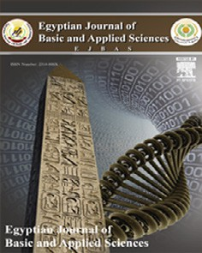

Contents lists available at [ScienceDirect](http://www.sciencedirect.com/science/journal/2314808X)

Egyptian Journal of Basic and Applied Sciences

journal homepage: [www.elsevier.com/locate/ejbas](http://www.elsevier.com/locate/ejbas)

Full Length Article

[](http://crossmark.crossref.org/dialog/?doi=10.1016/j.ejbas.2017.12.002&domain=pdf)Visfatin gene expression and oxidative stress in pregnancy induced hypertension

Hanan M.A. El-Taweel a,⇑, Nevein A. Salah a, Amal K. Selem b, A.A. El-Refaeey c, A.F. Abdel-Aziz a

a *Biochemistry Division, Department of Chemistry, Faculty of Science, Mansoura University, Mansoura, Egypt*

b *Department of Medical Biochemistry, Faculty of Medicine, Mansoura University, Mansoura, Egypt*

c *Department of Obstetrics and Gynecology, Faculty of Medicine, Mansoura University, Mansoura, Egypt*

## a r t i c l e i n f o

*Article history:*

Received 16 October 2017

Received in revised form 17 December 2017 Accepted 18 December 2017

Available online 27 December 2017

*Keywords:* Visfatin Preeclampsia Hypertension Oxidative stress

## a b s t r a c t

Preeclampsia, a hypertensive disorder of pregnancy, was related to hypertension, diabetes, oxidative stress, obesity, in addition to polycystic ovarian diseases. Visfatin, potentially a new adipokine has emerged having high contribution in pathogenesis of preeclampsia. Oxidative stress was increased lipid peroxidation and caused vascular endothelial damage. This study was conducted with the aim of evalu- ating the level of visfatin gene expression in placenta and measuring some oxidative stress parameters. Eighty Egyptian patients of newly diagnosed pregnant hypertensive disorder were selected for the study which was recruited from Mansoura University Hospital, Department of Obstetrics and Gynecology and also normotensive pregnant women were collected. The pregnant women groups were classified into four groups: gestational hypertension (n = 20), mild preeclampsia (n = 16), severe preeclampsia (n = 25), chronic hypertension with superimposed preeclampsia (n = 19) and compared with normoten- sive pregnant women (n = 10) as control group. Visfatin gene expression level was decreased in placenta of pregnant hypertensive disorder women groups with mean 1.28 ± 0.42, 1.01 ± 0.24, 0.40 ± 0.14 and

0.32 ± 0.11 respectively when compared to normotensive pregnant women with mean 1.56 ± 0.69. Additionally, catalase activity, total antioxidant capacity and reduced glutathione levels were decreased in hypertensive pregnant women groups compared with normotensive ones. On the other hand malon- dialdhyde level was increased in preeclampsia groups when compared with normalized pregnant women. Decreased visfatin level has an important pathophysiology of preeclampsia and suggests the complication in pregnancy. Also the imbalance between oxidant and antioxidant has an important cau- sative factor in the pathogenesis of preeclampsia.

© 2017 Mansoura University. Production and hosting by Elsevier B.V. This is an open access article under

the CC BY-NC-ND license (<http://creativecommons.org/licenses/by-nc-nd/4.0/>).

Introduction

A condition in pregnancy characterized by high blood pressure contributes greatly to maternal morbidity and mortality and the fetus as well around the world [1]. The mere solution for preeclampsia and pregnancy induced hypertension is delivery of the fetus and placenta [2]. Blood pressure’s interruptions that hap- pen in pregnancy have harmful influence on organ systems of both the pregnant woman and the fetus [3]. Complications in pregnant women suffer from preeclampsia are seizure activity, placental abruption, stroke, hemolysis, hemolysis elevated liver enzymes and low platelets (HELLP) syndrome, liver hemorrhage, pulmonary edema, acute renal failure, and disseminated intravascular coagulation [4].

* Corresponding author.

*E-mail address:* [taweel_h@mans.edu.eg](mailto:taweel_h@mans.edu.eg) (H.M.A. El-Taweel).

The exact reasons of preeclampsia are not well known so risk of it may be elevated by some factors such as the first pregnancy [5]. Also women with a history of preeclampsia [4] and multiple gesta- tions elevate the risk [2]. Furthermore, some disease present before pregnancy such as obesity, diabetes mellitus, insulin resistance, chronic hypertension, gestational diabetes, lupus, vascular or con- nective tissue disorders and also chronic kidney disease may be increase the risk of preeclampsia [6]. High blood pressure during pregnancy is divided into four groups as recommended by the National High Blood Pressure Education Program Working Group on High Blood Pressure in Pregnancy. The first group is chronic hypertension, the second group is gestational hypertension, the third group is mild and severe preeclampsia and the fourth group is preeclampsia superimposed on chronic hypertension [7]. Gesta- tional hypertension and preeclampsia generally can be diagnosed by measurements of high blood pressure and proteinuria [8]. Also some symptoms may be associated with increasing in blood

<https://doi.org/10.1016/j.ejbas.2017.12.002>

2314-808X/© 2017 Mansoura University. Production and hosting by Elsevier B.V.

This is an open access article under the CC BY-NC-ND license (<http://creativecommons.org/licenses/by-nc-nd/4.0/>).

pressure such as vision interruption, continuous acute headaches, unexpected expand in face, hands and feet, vomiting, epigastric pain, lowering in platelets and increasing in liver enzymes and serum creatinine [9].

Adipokines play an important role in some process including inflammation, organization of food intake, and arrangement of body weight homeostasis, proliferation, insulin sensitivity, immu- nity and vascular homeostasis [10]. In obesity and type 2 diabetes mellitus have an alteration in adipokine production. Also, there is imbalance in adipokine production at the onset of insulin resis- tance, adipose tissue inflammation, chronic systemic inflamma- tion, cardiovascular disease and endothelial dysfunction [11]. Fukuhara et al. [12] are the first one that characterize visfatin as an adipokine and show that insulin mimetic properties in mice with binding to and promoting the insulin receptor. Visfatin was found identical to pre-B cell colony enhancing factor (PBEF). It is a highly conserved 52 kDa cytokine-like protein. It increases the maturation of B cell precursors in relation to interleukin-7 and stem cell factor [11] and also suppresses the apoptosis of neu- trophils [13]. Rongvaux et al. [14] reported that visfatin displays intrinsic enzymatic activity as a nicotinamide phosphoribosyl transferase (Nampt). However, the physiological connection of NAMPT stay argumentative [15], Revollo et al. [16] showed that the critical role of NAMPT in the monitoring of glucose metabolism through the NAD biosynthetic activity.

Pathogenesis of preeclampsia is influenced by oxidative stress. It could lead to tissue damage by the end [17]. An adaptive mech- anism promoting the antioxidant defense system in pregnant women to oppose the effect of oxygen active species through enzy- matic antioxidants like superoxide dismutase, glutathione peroxi- dase, catalase and also non-enzymatic antioxidants like reduced glutathione can hinder the occurrence of oxidative stress in preeclampsia [18]. Elevation of lipid peroxidation products causes impaired antioxidant enzyme defense mechanism and this imbal- ance may result in preeclampsia pathogenesis [19].

The purpose of this study was to evaluate the visfatin gene expression level in placental hypertensive and normotensive preg- nant women groups as well as some antioxidants were determined in all groups.

Subjects and methods

*Patients*

The study was conducted from May 2014 until December 2016; patients chosen from the Obstetrics and Gynecology Department, Mansoura University. The study group was comprised 80 Egyptian pregnant women with hypertensive disorder and was divided into four groups. Group I (gestational hypertensive): twenty of preg- nant women were gestational hypertensive with the age range 27 to 41 years with the mean age 34.40 ± 4.27 years which defined as blood pressure ≥ 140/90 mmHg after gestational age 20 weeks without proteinuria. Group II (mild preeclampsia): Sixteen of preg- nant women were mild preeclampsia with the age range 33 to 46 years with the mean age 39.63 ± 4.40 years which defined as BP ≥ 140/90 mmHg after gestational age 20 weeks with significant pro- teinuria (+ protein in urine on dipstick). Group III (severe preeclampsia): Twenty-five of pregnant women were severe preeclampsia with the age range 21 to 40 years with the mean age 30.28 ± 6.39 years. Severe preeclampsia was determined with blood pressure ≥ 160/110 mmHg with excessive proteinuria (≥ +

+++ protein in urine on dipstick). Group IV (chronic hypertension with superimposed preeclampsia): Nineteen of pregnant women were chronic hypertension with superimposed preeclampsia with the age range 28 to 45 years with the mean age 36.84 ± 5.40 years.

The preeclampsia with hypertension present before pregnancy was defined as certified BP ≥ 140/90 prior to pregnancy with new onset proteinuria (+ protein in urine on dipstick). Group V (Normotensive group): The normotensive pregnant women comprised 10 with the age range 21 to 42 years with the mean age 31.20 ± 7.79 years. Normal participants were at the same maternal and gestational age. Also, their pre-pregnancy parity and maternal body mass index were equal.

An informed written approval was provided by all study partic- ipants. Additionally, the Ethical Board of Mansoura University approved conducting the study. Also, the study was delimited to patients who did not provide a written approval, those who smoke, those with gestational diabetes, infectious disease, and premature rupture of membrane or suffer from other medical diseases. More- over, participants with abnormal glucose tolerance who partici- pated in the gestation test administration at weeks 24–28 or suffer from other medical diseases were also eliminated.

*Tissue preparation*

Placental biopsy samples were obtained during Caesarean sec- tions from both normotensive patients and those with hyperten- sive pregnant women. Only some placental samples taken from a woman by a caesarean operation were included in the study to prevent any probable effects of labor on visfatin gene expressions. An anatomization of a central area of chronic tissue and extraction of maternal deciduas and amnionic membranes were taken for analysis. Large tissue samples cut to ≤ 0.5 cm in any single dimen- sion then placed the fresh tissue in in epindorff containing 500 ml of

RNA later tissue collection (RNA later Inc., Austin, Texas, U.S.). Tis-

sue samples in RNA later solution were stored at 4 °C for 2 week without compromising RNA quality.

*Blood collection*

Morning fasting blood samples were collected from the study participants to be estimated after applying all aseptic precautions. One ml blood was collected in EDTA tubes for estimation of reduced glutathione level and the rest blood was collected into clean and dry test tubes then allowed to clot, serum was separated by centrifugation at 3000 rpm for 10 min and then stored in deep

frozen at —20 °C until used. Serum was used for estimation of cata-

lase activity, total antioxidant capacity level and malondialdhyde level.

*RNA isolation and quantitative PCR*

Total RNA was collected from placental tissue samples utilizing vivantis kit (Vivantis Technologies Sdn. Bhd., Malaysia), based on the manufacturer’s instructions. The extracted RNA was transcript

into cDNA by using seni FASTTM cDNA synthesis kit (Bioline USA Inc., USA), based on the manufacturer’s instructions. The house- keeping gene (GAPDH) was used to normalize mRNA concentra- tions. Quantitative PCR was performed for comparing expression levels of visfatin transcripts. The relative expression levels of vis- fatin in the tissue samples and reference sample were assessed by quantitative PCR using real-time RT–PCR analyses (Piko Real 96 type 5100, thermo scientific). RT–PCRs were performed using

a seni FASTTM SYBR NO-ROX kit (Bioline USA Inc., USA) in a final volume of 20 ml. An initial PCR activation step was 2 min at 95

°C followed by 40 cycles of 5 s at 95 °C, and 20 s at 60 °C and 10

s at 72 °C. The sequence of primers, used in real-time PCR, was designed according to Vivantis Technologies Sdn. Bhd., Malaysia to span introns to prevent detection of genomic DNA as shown in

Table 1

The sequence of primers used in real-time PCR.

Oligo name Len Sequence

GAPDH-F 20 50 -CTC TGC TCC TCC TGT TCG AC-30 GAPDH-R 20 50 -GCG CCC AAT ACG ACC AAA TC-30 NAMPT-F 24 50 -GAC GCC AGC AGGGAA TTT TGT TAC-30 NAMPT-R 24 50 -AGC TTT TTG TCA CCT TGC CAT TCT-30

(Table 1). It was used to reverse-transcribe and expand the RNA template for 40 cycles so finally Ct was estimated.

*Assessment of the biochemical parameters*

Serum catalase activity was determined by the method of Fos- sati et al. [20] and Aebi [21] by using a commercially available kit (Biodiagnostic, Dokki, Giza, Egypt). 0.5 ml of reagent 1

(chromogen- buffer) was added to 50 ml of serum sample then 100 ml of reagent 2 (H2O2). 0.2 ml of reagent 3 (catalase – inhibitor) and 0.5 ml of reagent 4 (peroxidase enzyme) were added. The pink color appears measured at 510 nm. Serum total antioxidant capac- ity level was determined by the method of Karacevic et al. [22] by using a commercially available kit (Biodiagnostic, Dokki, Giza, Egypt). 0.5 ml of reagent 1 (H2O2) was added 20 ml of sample serum then 0.5 ml of working reagent (chromogen- enzyme- buffer) was added. The absorbance was recorded at 505 nm.

Blood reduced glutathione content was determined by the method of Beutler et al. [23] by using a commercially available kit (Biodiagnostic, Dokki, Giza, Egypt). 0.5 ml of reagent 1 (trichlor- oacetic acid) was added to 0.1 ml of blood sample, centrifuged. 1.0 ml of reagent 2 (buffer) was added to 0.5 ml of the supernatant then add 0.1 ml of reagent 3 (5,50 -dithiobis(2-nitrobenzoic acid)). The color was measured at 405 nm. Thiobarbituric acid (TBA) test is widely used assay for the measurement of lipid peroxidation (malondialdehyde) according the method of Draper and Hadly, [24]. 0.5 ml serum was mixed with 2.5 ml of TCA to precipitate proteins. After centrifugation 1.0 ml of TBA was added to 2.0 ml of the supernatant and a pink chromogen was measured at 532 nm.

*Statistical analysis*

Statistical Package for the Social Sciences Version 16.0 (SPSS) was used in the study analysis. Exploration of data revealed pre- served normality. We used mean and standard deviation for description of the central tendency and dispersion. Analysis of dif- ferences between two groups as regards quantitative parameters was done using independent *t*-test with the probability of <.05 considering significant. Correlation between two quantitative parameters was assessed using Pearson correlation with (r) repre- senting the correlation coefficient and its significance was starred if <.05.

Results

There was no statistically significant difference (*P* = .196) in age between hypertensive pregnant women patients with mean age

34.74 ± 6.27 years and normalized group with mean age 31.20 ±

7.79 years.

*The level of placental visfatin gene expression in hypertensive pregnant women groups compared to normotensive group*

There was no statistically significant decreased in placental visfatin gene expression level with mean 1.28 ± 0.42 in gestational hypertensive pregnant women when compared with normotensive group with the mean 1.56 ± 0.69 (Table 2). Also there was statisti- cally significant decrease of placental visfatin gene expression level with mean 1.01 ± 0.24 in mild preeclampsia pregnant women as compared with normotensive pregnant women group with mean

1.56 ± 0.69 (Table 2). Severe preeclampsia and chronic with super- imposed preeclampsia pregnant women have highly statistically significant decrease of placental visfatin gene expression level with mean 0.40 ± 0.14 and 0.32 ± 0.11 respectively as compared with normotensive pregnant women group with mean 1.56 ± 0.69 (Table 2).

*Oxidative stress parameters in hypertensive pregnant women groups compared to normotensive pregnant women group*

Serum catalase activity, serum total antioxidant capacity and blood reduced glutathione levels were decreased in gestational hypertension pregnant women, mild preeclampsia pregnant women group, severe preeclampsia and chronic with superim- posed pregnant women group when compared to normotensive group (Table 3). In contrast, serum malondialdhyde level was ele- vated in gestational hypertension pregnant women, mild preeclampsia pregnant women group and severe preeclampsia and also chronic with superimposed pregnant women group when compared to normotensive group (Table 3).

It is clearly that there was a significant negative correlation between serum CAT and serum MDA (p = .044) as in Fig. 1 in mild preeclampsia pregnant women group. Also there was a significant positive correlation between serum CAT and serum TAC (p = .010) as in Fig. 2 in severe preeclampsia pregnant women group. There was no correlation between visfatin gene and oxidative stress mea- sured parameter except a significant negative correlation between tissue visfatin gene and serum TAC (p = .009) as shown in Fig. 3 in chronic hypertension with superimposed preeclampsia pregnant women group.

Discussion

The etiology of preeclampsia is unknown but adipokines have an important role in pathogenesis of preeclampsia [25]. Moreover,

Table 2

The placental visfatin gene expression in hypertensive pregnant women groups compared to normotensive pregnant women group.

Groups

Normalized group Hypertensive Groups (n = 80)

|  |  |  |  |  |  |  |
| --- | --- | --- | --- | --- | --- | --- |
| Parameter |  | Gestational | Mild preeclampsia | Severe preeclampsia | Chronic with superimposed |  |
| Placental visfatin gene |  |  |  |  |  |  |
| expression Mean ± SD |  |  |  |  |  |  |
| n | 1.56 ± 0.69 | 1.28 ± 0.42 | 1.01 ± 0.24 | 0.40 ± 0.14 | 0.32 ± 0.11 |  |
| *P* | 10 | 20 | 16 | 25 | 19 |  |
|  |  | 0.254 | 0.034* | <0.001** | <0.001** |  |

*P*-Value compared with control group. *Significant p < .05. **Highly significant p < .001.

Table 3

The oxidative stress measured parameters in hypertensive compared to normotensive pregnant women groups.

Groups

Normalized Hypertensive (n = Groups 80)

group (n = 10)

Parameter Gestational (n = 20) Mild preeclampsia (n = 16)

Severe preeclampsia (n = 25)

Chronic with superimposed (n = 19)

Serum CAT (U/L) Mean ± SD

P

Serum TAC (mM/L) Mean ± SD

P

Blood GSH (mg/dl) Mean ± SD

P

Serum MDA (nmol/ml) Mean ± SD

P

853.74 ± 85.16 805.76 ± 84.790.156 687.33 ± 211.030.027* 588.33 ± 175.55 < 0.001** 518.56 ± 185.40 < 0.001**

0.96 ± 0.13 0.88 ± 0.140.152 0.76 ± 0.150.002* 0.60 ± 0.18 < 0.001** 0.49 ± 0.16 < 0.001**

2.14 ± 0.81 1.78 ± 0.540.157 1.45 ± 0.310.026* 0.79 ± 0.24 < 0.001** 0.72 ± 0.17 < 0.001**

4.32 ± 1.34 4.96 ± 1.280.218 6.47 ± 1.590.002* 7.96 ± 1.91 < 0.001** 8.88 ± 1.19 < 0.001**

*P*-Value compared with control group. *Significant p < .05. **Highly significant p < .001.

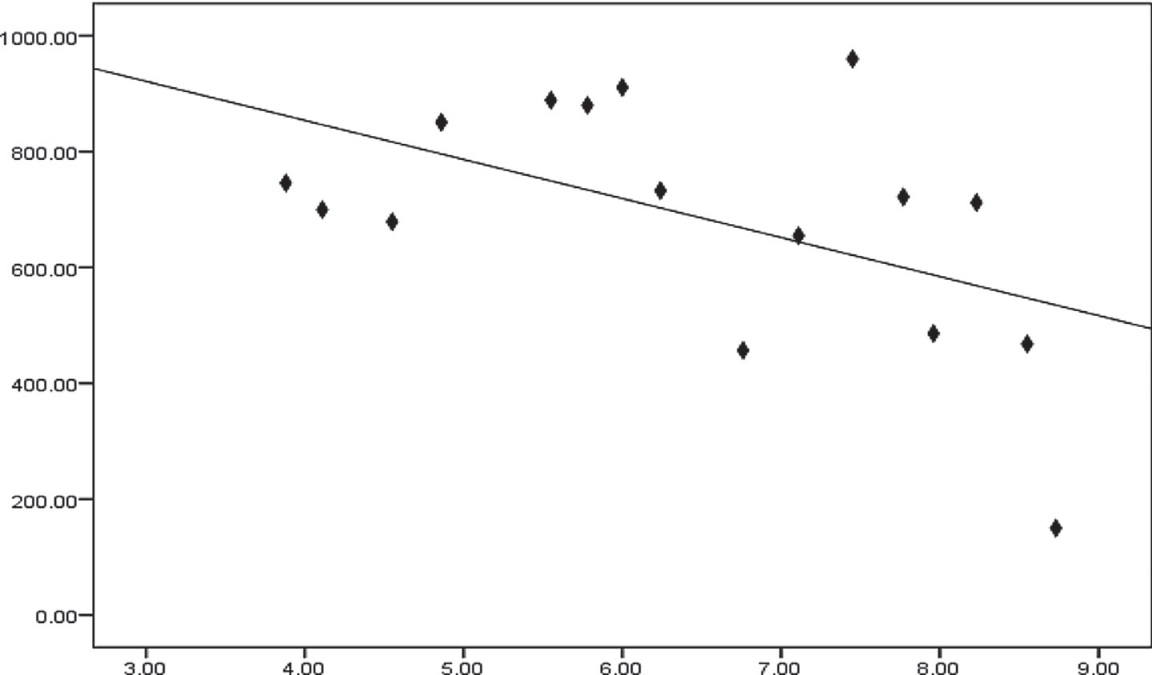

Y= 166.6667*X+-500 r = - 0.509

r square = 0.259 P = 0.044 (<0.05)

**MDA (nmol/ml)**

Fig. 1. Linear Pearson correlation between each serum CAT and serum MDA among mild preeclampsia pregnant women group (n = 16).

adipokines regulation problems may be present in the pathophys- iology of insulin resistance [26], obesity [27], dyslipidemia and the metabolic syndrome [28]. These findings were consistent with adi- pokine have been comprised in metabolic adaptations to health pregnancy [29], as well as in preeclampsia [30]. The expression of visfatin is not only in adipose tissue but also in placenta, fetal membranes, neutrophils [31], myometrium [32], bone marrow, liver, kidney, heart, muscle, lung [11] and macrophages [33]. In this study placental visfatin gene expression level was decreased in all hypertensive pregnant women groups when compared with nor- motensive pregnant women group.

**CAT (U/L)**

Preeclampsia is related with elevated cardiovascular disease risk later in life [7]. Preeclampsia and cardiovascular risk factors have the same work in inflammation, insulin resistance, and obe- sity. Since visfatin levels are increased in all above metabolic syn- drome, authors were purposed that Nampt may contribute to preeclampsia. Ferreira et al. [34] showed that serum visfatin levels in preeclampsia pregnant women were increased in comparison to pregnant controls. In contrast, other authors were proposed that expression of visfatin was decreased due to act as a proangiogenic

factor so may be related to the pathogenesis of preeclampsia. Thus, Hu et al. [35] showed that plasma Nampt levels were decreased in mild preeclampsia and excessive decreased in severe preeclamp- sia. In the same idea, Kim et al. [36] reported that the expression of visfatin was decreased in placental biopsies in comparison to the Nampt levels in placentas from normal pregnant.

The first state in preeclampsia is decreased placental perfusion and begins set of statements that change vascular function and hypertension. Consequently, impaired placental perfusion induced endothelial dysfunction [37]. Visfatin induction in preeclampsia was not affected by placental perfusion damaging mechanism [34]. Ognjanovic et al. [38] have elucidated that Nampt secretion from amniotic epithelium cells in the human placenta was increased due to pro-inflammatory stimuli such as lipopolysaccha- ride and interleukin-1[38]. Also visfatin has a protective role in preventing apoptosis induced by infection in the placenta [39]. Thus, it is still an open question [40].

Oxidative stress is the abnormal levels of reactive oxygen spe- cies and the natural antioxidants present in the body [41]. Eleva- tion of oxidative stress markers lead to endothelial cell

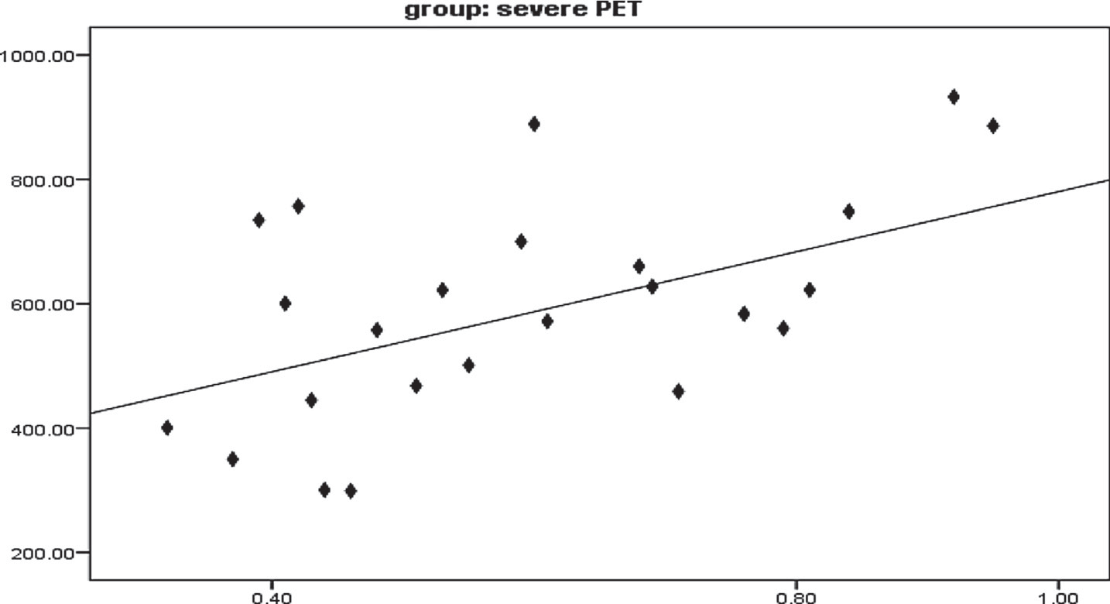

Y= 1142.8571*X+-142.8571 r = 0.503

r square = 0.253 P = 0.010 (<0.05)

**TAC (mM/L)**

Fig. 2. Linear Pearson correlation between each serum CAT and serum TAC among severe preeclampsia pregnant women group (n = 25).

**visfatin gene**

**CAT (U/L)**

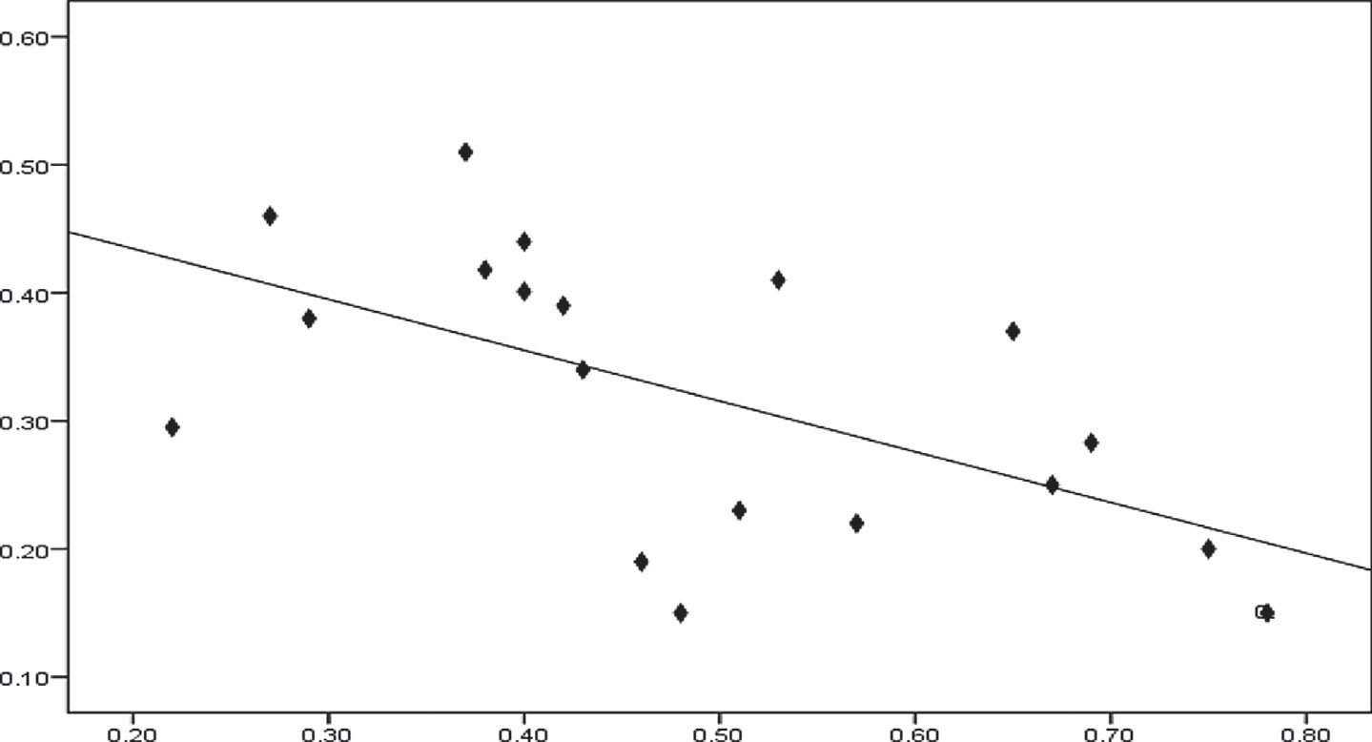

Y= 0.8333*X+-0.0667 r = -0.581

r square = 0.337 P = 0.009 (<0.05)

# TAC (mM/L)

Fig. 3. Linear Pearson correlation between each serum TAC and tissue visfatin gene among chronic hypertension with superimposed preeclampsia pregnant women group (n = 19).

dysfunction and so elevated the blood pressure in preeclamptic patients [42]. In the present study, there was decreased in catalase activity, total antioxidant capacity and reduced glutathione levels in hypertensive pregnant women groups when compared with normotensive ones. A significantly reduced of antioxidant in preeclampsia may be due to increased attack of free radicals and thus resulted in low production of them [43]. In contrast to this study, few others reported showed an increased in antioxidants [44].

Lipid peroxidation has the main originator factor for oxidative stress and the etiopathogeneiss of preeclampsia [45]. In this result, there was increased in malondialdhyde level in hypertensive preg- nant women groups when compared with normotensive pregnant women group. Products of lipid peroxidation are the candidate fac- tors that mediate disturbance of the maternal vascular endothe- lium and may inhibit prostacyclin synthesis and also stimulate smooth muscle contraction that lead to widespread vasospasm, a prominent feature of preeclampsia [1].

In conclusion, pregnancy induced hypertension women showed decreased in visfatin gene expression level when com-

pared to normal pregnant women. Our observation revealed that an imbalance between lipid peroxidation and antioxidants in preeclampsia lead to free radical mediated endothelial dysfunction so we strongly recommend that all pregnant women have to be supplemented with antioxidants to avoid overwhelming effect of oxidative stress.

References

1. [Ghulmiyyah L, Sibai B. Maternal mortality from preeclampsia / eclampsia.](http://refhub.elsevier.com/S2314-808X(17)30479-7/h0005) [Semin Perinatol 2012;36(1):56–9](http://refhub.elsevier.com/S2314-808X(17)30479-7/h0005).
2. Dattel BJ, Chescheir N, Lockwood C. Your pregnancy & birth. 4th ed. Washington, D.C.: The American College of Obstetricians and Gynecologists; 2005.
3. [Borgelt LM, O’Connell MB, Smith JA, Calis KA. Women’s health across the](http://refhub.elsevier.com/S2314-808X(17)30479-7/h0015) [lifespan. Maryland: American Society of Health-System Pharmacists; 2010](http://refhub.elsevier.com/S2314-808X(17)30479-7/h0015).
4. [Vest AR, Cho LS. Hypertension in pregnancy. Cardiol Clin 2012;30:407–23](http://refhub.elsevier.com/S2314-808X(17)30479-7/h0020).
5. Barss V, Repke J. Preeclampsia (beyond the basics). South Holland: Up-todate; 2012.
6. [McCoy S, Baldwin K. Pharmacotherapeutic options for the treatment of](http://refhub.elsevier.com/S2314-808X(17)30479-7/h0030) [preeclampsia. Am J Health Syst Pharm 2009;66:337–44](http://refhub.elsevier.com/S2314-808X(17)30479-7/h0030).
7. [Steegers EA, von Dadelszen P, Duvekot JJ, Pijnenborg R. Pre-eclampsia Lancet](http://refhub.elsevier.com/S2314-808X(17)30479-7/h0035) [2010;376:631–44](http://refhub.elsevier.com/S2314-808X(17)30479-7/h0035).
8. [ACOG Committee on Practice Bulletins-Obstetrics. ACOG practice bulletin.](http://refhub.elsevier.com/S2314-808X(17)30479-7/h0040) [Diagnosis and management of preeclampsia and eclampsia. Number 33,](http://refhub.elsevier.com/S2314-808X(17)30479-7/h0040) [January 2002. Obstet Gynecol. 2002;99:159–67](http://refhub.elsevier.com/S2314-808X(17)30479-7/h0040).
9. DiPiro J, Talbert RL, Yee G, Matzke G, Wells B, Posey LM. Pharmacotherapy A Pathophysiologic Approach. 8th ed. McGraw Hill; 2011.
10. [Fukuhara A, Matsuda M, Nishizawa M, Segawa K, Tanaka M, Kishimoto K.](http://refhub.elsevier.com/S2314-808X(17)30479-7/h0050) [Retraction. Science 2007;318(5850):565](http://refhub.elsevier.com/S2314-808X(17)30479-7/h0050).
11. [Samal B1, Sun Y, Stearns G, Xie C, Suggs S, McNiece I. Cloning and](http://refhub.elsevier.com/S2314-808X(17)30479-7/h0055) [characterization of the cDNA encoding a novel human pre-B-cell colony-](http://refhub.elsevier.com/S2314-808X(17)30479-7/h0055) [enhancing factor. Mol Cell Biol 1994;14(2):1431–7](http://refhub.elsevier.com/S2314-808X(17)30479-7/h0055).
12. [Fukuhara A1, Matsuda M, Nishizawa M, Segawa K, Tanaka M, Kishimoto K.](http://refhub.elsevier.com/S2314-808X(17)30479-7/h0060) [Visfatin: a protein secreted by visceral fat that Mimics the effects of insulin.](http://refhub.elsevier.com/S2314-808X(17)30479-7/h0060) [Science 2005;307(5708):426–30](http://refhub.elsevier.com/S2314-808X(17)30479-7/h0060).
13. [Jia SH, Li Y, Parodo J, Kapus A, Fan L, Rotstein OD, et al. Pre-B cell colony-](http://refhub.elsevier.com/S2314-808X(17)30479-7/h0065) [enhancing factor inhibits neutrophil apoptosis in experimental inflammation](http://refhub.elsevier.com/S2314-808X(17)30479-7/h0065) [and clinical sepsis. J Clin Invest 2004;113:1318–27](http://refhub.elsevier.com/S2314-808X(17)30479-7/h0065).
14. [Rongvaux A, Shea RJ, Mulks MH, Gigot D, Urbain J, Leo O, et al. Pre-B-cell](http://refhub.elsevier.com/S2314-808X(17)30479-7/h0070) [colony enhancing factor, whose expression is up-regulated in activated](http://refhub.elsevier.com/S2314-808X(17)30479-7/h0070) [lymphocytes, is a nicotinamide phosphoribosyl-transferase, a cytosolic](http://refhub.elsevier.com/S2314-808X(17)30479-7/h0070) [enzyme involved in NAD biosynthesis. Eur J Immunol 2002;32(11):3225–34](http://refhub.elsevier.com/S2314-808X(17)30479-7/h0070).
15. [de Luis D, Sagrado MG, Aller R, Conde R, Izaola O, et al. Circulating visfatin in](http://refhub.elsevier.com/S2314-808X(17)30479-7/h0075) [obese non-diabetic patients in relation to cardiovascular risk factors, insulin](http://refhub.elsevier.com/S2314-808X(17)30479-7/h0075) [resistance, and adipocytokines: a contradictory piece of the puzzle. Nutrition](http://refhub.elsevier.com/S2314-808X(17)30479-7/h0075) [2008;26:11–2](http://refhub.elsevier.com/S2314-808X(17)30479-7/h0075).
16. [Revollo JR, Körner A, Mills KF, Satoh A, Wang T, Garten A, et al. Nampt/PBEF/](http://refhub.elsevier.com/S2314-808X(17)30479-7/h0080) [Visfatin regulates insulin secretion in beta cells as a systemic NAD](http://refhub.elsevier.com/S2314-808X(17)30479-7/h0080) [biosynthetic enzyme. Cell Metab 2007;6(5):363–75](http://refhub.elsevier.com/S2314-808X(17)30479-7/h0080).
17. [Phalak P, Kulkarni J, Tilak M, Thorat AP. Role of lipid peroxidation and](http://refhub.elsevier.com/S2314-808X(17)30479-7/h0085) [antioxidant status in pathogenesis of preeclampsia. Indian J Basic Appl Med](http://refhub.elsevier.com/S2314-808X(17)30479-7/h0085) [Res 2013;2(6):536–9](http://refhub.elsevier.com/S2314-808X(17)30479-7/h0085).
18. [Patil SB, Kodliwadmath MV, Kodlwadmath SM, Patil MB. Lipid peroxidation](http://refhub.elsevier.com/S2314-808X(17)30479-7/h0090) [and non-enzymatic antioxidants status in preeclampsia and postpartum](http://refhub.elsevier.com/S2314-808X(17)30479-7/h0090) [preeclmaptic women. Natl J Basic Med Sci 2012;3(1):39–43](http://refhub.elsevier.com/S2314-808X(17)30479-7/h0090).
19. [Sharmila KT, Raja RD, Venkata RE, Aparna RR, Naidu JN. Correlation between](http://refhub.elsevier.com/S2314-808X(17)30479-7/h0095) [lipid peroxidation product – malondialdehyde (MDA) and reduced glutathione](http://refhub.elsevier.com/S2314-808X(17)30479-7/h0095) [(GSH) in preeclampsia. Int J Appl Biol Pharmaceut Technol 2015;6(2):196–9](http://refhub.elsevier.com/S2314-808X(17)30479-7/h0095).
20. [Fossati P, Prencipe L, Bert G. Use of 3,5- dichloro-2-hydroxybenzene sllforic](http://refhub.elsevier.com/S2314-808X(17)30479-7/h0100) [acid /4-amino phenazone chromogenic system in direct enzymic assay of uric](http://refhub.elsevier.com/S2314-808X(17)30479-7/h0100) [acid in serum and urine. Clin. Chem. 1980;26:227–31](http://refhub.elsevier.com/S2314-808X(17)30479-7/h0100).
21. [Aebi H. Catalase in vitro. Method Enzymol 1984;105:121–6](http://refhub.elsevier.com/S2314-808X(17)30479-7/h0105).
22. [Koracevic D, Koracevic G, Djordjevic V, Andrejevic S, Cosic V. Method for the](http://refhub.elsevier.com/S2314-808X(17)30479-7/h0110) [measurement of antioxidant activity in human fluids. J Clin Pathol](http://refhub.elsevier.com/S2314-808X(17)30479-7/h0110) [2001;54:356–61](http://refhub.elsevier.com/S2314-808X(17)30479-7/h0110).
23. [Beutler E, Duron O, Kelly MB. Improved method for the determination of blood](http://refhub.elsevier.com/S2314-808X(17)30479-7/h0115) [glutathione. J Lab Clin Med 1963;61:882–8](http://refhub.elsevier.com/S2314-808X(17)30479-7/h0115).
24. [Draper W, Hadley M. Indirect determination of oxygen free radical. Method](http://refhub.elsevier.com/S2314-808X(17)30479-7/h0120) [Enzymol 1990;186:421–31](http://refhub.elsevier.com/S2314-808X(17)30479-7/h0120).
25. [Watanabe K, Naruse K, Tanaka K, Metoki H, Suzuki Y. Outline of definition and](http://refhub.elsevier.com/S2314-808X(17)30479-7/h0125) [classification of ‘‘pregnancy induced hypertension (PIH)”.](http://refhub.elsevier.com/S2314-808X(17)30479-7/h0125) [Hyperten Res Preg](http://refhub.elsevier.com/S2314-808X(17)30479-7/h0125) [2013;1(1):3–4](http://refhub.elsevier.com/S2314-808X(17)30479-7/h0125).
26. [Catalano PM, Hoegh M, Minium J, Huston-Presley L, Bernard S, Kalhan S, et al.](http://refhub.elsevier.com/S2314-808X(17)30479-7/h0130) [Adiponectin in human pregnancy: implications for regulation of glucose and](http://refhub.elsevier.com/S2314-808X(17)30479-7/h0130) [lipid metabolism. Diabetologia 2006;49:1677–85](http://refhub.elsevier.com/S2314-808X(17)30479-7/h0130).
27. [Frayn KN. Obesity and metabolic disease: is adipose tissue the culprit? Proc](http://refhub.elsevier.com/S2314-808X(17)30479-7/h0135) [Nutr Soc 2005;64:7–13](http://refhub.elsevier.com/S2314-808X(17)30479-7/h0135).
28. [Matsuzawa Y, Funahashi T, Kihara S, Shimomura L. Adiponectin and metabolic](http://refhub.elsevier.com/S2314-808X(17)30479-7/h0140) [syndrome. Arterioscler Thromb Vasc Biol 2004;24:29–33](http://refhub.elsevier.com/S2314-808X(17)30479-7/h0140).
29. [Mazaki-Tovi S, Romero R, Kusanovic JP, Erez O, Vaisbuch E, Gotsch F, et al.](http://refhub.elsevier.com/S2314-808X(17)30479-7/h0145) [Adiponectin multimers in maternal plasma. J Matern Fetal Neonatal Med](http://refhub.elsevier.com/S2314-808X(17)30479-7/h0145) [2008;21(11):796–815](http://refhub.elsevier.com/S2314-808X(17)30479-7/h0145).
30. [Mazaki-Tovi S, Romero R, Vaisbuch E, Kusanovic JP, Erez O, Gotsch F, et al.](http://refhub.elsevier.com/S2314-808X(17)30479-7/h0150) [Maternal serum adiponectin multimers in preeclampsia. J Perinat Med](http://refhub.elsevier.com/S2314-808X(17)30479-7/h0150) [2009;37(4):349–63](http://refhub.elsevier.com/S2314-808X(17)30479-7/h0150).
31. [Kendal-Wright CE, Hubbard D, Bryant-Greenwood GD. Chronic stretching of](http://refhub.elsevier.com/S2314-808X(17)30479-7/h0155) [amniotic epithelial cells increases pre B cell colony-enhancing factor (PBEF/](http://refhub.elsevier.com/S2314-808X(17)30479-7/h0155) [visfatin) expression and protects them from apoptosis. Placenta](http://refhub.elsevier.com/S2314-808X(17)30479-7/h0155) [2008;29:255–65](http://refhub.elsevier.com/S2314-808X(17)30479-7/h0155).
32. [Esplin MS, Fausett MB, Peltier MR, Hamblin S, Silver RM, Branch DW, et al. The](http://refhub.elsevier.com/S2314-808X(17)30479-7/h0160) [use of cDNA microarray to identify differentially expressed labor associated](http://refhub.elsevier.com/S2314-808X(17)30479-7/h0160) [genes within the human myometrium during labor. Am J Obstet Gynecol](http://refhub.elsevier.com/S2314-808X(17)30479-7/h0160) [2005;193(2):404–13](http://refhub.elsevier.com/S2314-808X(17)30479-7/h0160).
33. [Dahl TB, Yndestad A, Skjelland M,](http://refhub.elsevier.com/S2314-808X(17)30479-7/h0165) Øie [E, Dahl A, Michelsen A, et al. Increased](http://refhub.elsevier.com/S2314-808X(17)30479-7/h0165) [expression of visfatin in macrophages of human unstable carotid and coronary](http://refhub.elsevier.com/S2314-808X(17)30479-7/h0165) [atherosclerosis: possible role in inflammation and plaque destabilization.](http://refhub.elsevier.com/S2314-808X(17)30479-7/h0165) [Circulation 2007;115(8):972–80](http://refhub.elsevier.com/S2314-808X(17)30479-7/h0165).
34. [Ferreira AF, Rezende JC, de Cassia COR, Akolekar R, Nicolaides KH. Maternal](http://refhub.elsevier.com/S2314-808X(17)30479-7/h0170) [serum visfatin at 11–13 weeks’ gestation in preeclampsia. J Hum Hypertens](http://refhub.elsevier.com/S2314-808X(17)30479-7/h0170) [2013;27(4):261–4](http://refhub.elsevier.com/S2314-808X(17)30479-7/h0170).
35. [Hu W, Wang Z, Wang H, Huang H, Dong M. Serum visfatin levels in late](http://refhub.elsevier.com/S2314-808X(17)30479-7/h0175) [pregnancy and preeclampsia. Acta Obstet Gynecol Scand 2008;87(4):413–8](http://refhub.elsevier.com/S2314-808X(17)30479-7/h0175).
36. [Kim SC, Park MJ, Joo BS, Joo JK, Suh DS, Lee KS. Decreased expressions of](http://refhub.elsevier.com/S2314-808X(17)30479-7/h0180) [vascular endothelial growth factor and visfatin in the placental bed of](http://refhub.elsevier.com/S2314-808X(17)30479-7/h0180) [pregnancies complicated by preeclampsia. J Obst Gynaecol Res 2012;38](http://refhub.elsevier.com/S2314-808X(17)30479-7/h0180) [(4):665–73](http://refhub.elsevier.com/S2314-808X(17)30479-7/h0180).
37. [Roberts JM, Cooper DW. Pathogenesis and genetics of preeclampsia. Lancet](http://refhub.elsevier.com/S2314-808X(17)30479-7/h0185) [2001;357(9249):53–6](http://refhub.elsevier.com/S2314-808X(17)30479-7/h0185).
38. [Ognjanovic S, Ku TL, Bryant-Greenwood GD. Pre-B cell colony-enhancing](http://refhub.elsevier.com/S2314-808X(17)30479-7/h0190) [factor is a secreted cytokine-like protein from the human amniotic epithelium.](http://refhub.elsevier.com/S2314-808X(17)30479-7/h0190) [Am J Obstet Gynecol 2005;193(1):273–82](http://refhub.elsevier.com/S2314-808X(17)30479-7/h0190).
39. [Ognjanovic S, Bryant-Greenwood GD. Pre-B-cell colony-enhancing factor, a](http://refhub.elsevier.com/S2314-808X(17)30479-7/h0195) [novel cytokine of human fetal membranes. Am J Obstet Gynecol 2002;187](http://refhub.elsevier.com/S2314-808X(17)30479-7/h0195) [(4):1051–8](http://refhub.elsevier.com/S2314-808X(17)30479-7/h0195).
40. [Filippatos TD, Randeva HS, Derdemezis CS, Elisaf MS, Mikhailidis DP. Visfatin/](http://refhub.elsevier.com/S2314-808X(17)30479-7/h0200) [PBEF and atherosclerosis-related diseases. Curr Vasc Pharmacol 2010;8](http://refhub.elsevier.com/S2314-808X(17)30479-7/h0200) [(1):12–28](http://refhub.elsevier.com/S2314-808X(17)30479-7/h0200).
41. [Buonocore G, Perrone S, Tataranno ML. Oxygen toxicity: chemistry and biology](http://refhub.elsevier.com/S2314-808X(17)30479-7/h0205) [of reactive oxygen species. Semin Fetal Neonatal Med 2010;15:186–90](http://refhub.elsevier.com/S2314-808X(17)30479-7/h0205).
42. [Sharma JB, Mittal S. Oxidative stress and preeclampsia. Obstet Gynacol Today](http://refhub.elsevier.com/S2314-808X(17)30479-7/h0210) [2004(9):551–4](http://refhub.elsevier.com/S2314-808X(17)30479-7/h0210).
43. Sarkar P, Jayaram S. Estimation of primary enzymatic antioxidants in pregnancy induced hypertension. Webmed Central: 2013; [<http://www.](http://www/) webmedcentral.com/ article_view/3980> cited on 31.01.13.
44. [Sheena PS. Comparative study of oxidative stress in pregnancy induced](http://refhub.elsevier.com/S2314-808X(17)30479-7/h0220) [hypertension preeclampsia and eclampsia. Int J Biomed Adv Res 2012;3](http://refhub.elsevier.com/S2314-808X(17)30479-7/h0220) [(11):810–4](http://refhub.elsevier.com/S2314-808X(17)30479-7/h0220).
45. [Sharmila KT, Raja DR, Venkata RE, Aparna RR, Naidu JN. Correlation between](http://refhub.elsevier.com/S2314-808X(17)30479-7/h0225) [lipid peroxidation product – malondialdehyde (MDA) and reduced glutathione](http://refhub.elsevier.com/S2314-808X(17)30479-7/h0225) [(GSH) in preeclampsia. Int J Appl Biol Pharmaceut Technol 2015;6(2):196–9](http://refhub.elsevier.com/S2314-808X(17)30479-7/h0225).