[Egyptian Informatics Journal 23 (2022) 21–31](https://doi.org/10.1016/j.eij.2021.05.002)

Contents lists available at [ScienceDirect](http://www.sciencedirect.com/science/journal/11108665)

Egyptian Informatics Journal

journal homepage: [www.sciencedirect.com](http://www.sciencedirect.com/)

[](http://crossmark.crossref.org/dialog/?doi=10.1016/j.eij.2021.05.002&domain=pdf)Wireless battery recharging through UAV in wireless sensor networks

Mohit Angurala a,⇑, Manju Bala b, Sukhvinder Singh Bamber c

a *Department of Computer Science & Engineering, Chitkara University Institute of Engineering and Technology, Chitkara University, Punjab, India*

b *Khalsa College of Engineering and Technology, Amritsar, Punjab, India*

c *Panjab University Swami Sarvanand Giri Regional, Centre Hoshiarpur, Punjab, India*

a r t i c l e i n f o

*Article history:*

Received 20 December 2020

Revised 27 March 2021

Accepted 8 May 2021

Available online 20 May 2021

*Keywords:*

Data gathering Recharging topology WSNs

a b s t r a c t

In this contemporary era, recent developments have seen proliferation of methods on improving energy utilization for wireless sensor networks. Although the proposed methods can mitigate the problem of rapid battery depletion to some extent, the lifespan of sensor nodes is still a biggest constraint. Many studies conducted so far have shown continuous network functions with the help of external harvesting techniques. However, these provide low output because of the limitation on the energy capturing devices. Therefore, energy limitation strongly restricts the usage of wireless sensor nodes. This paper aims to pro- vide high recharging rates and better energy efficiency by proposing a three-step mechanism, which is an extension of our existing proposed work J-ERLB (Joint Energy Replenishment and Load Balancing). In a three-step mechanism, topology selection followed by recharging and load balancing are combined together to prolong the lifetime of sensor nodes. Topology selection is performed by implementing J- ERLB on various topologies like ring, star, and cluster. Further, taking advantage of Unmanned Aerial vehi- cle (UAV) we focus on data collection and high-rate recharging. We have implemented System on Chip (SoC) integrated chip on UAV to achieve goal of perpetual network operations. Finally, the effectiveness of proposed mechanism is tested by comparing its numerical outcomes with existing J-ERLB and J- MERDG (Joint Mobile Energy Replenishment and Data Gathering) techniques. The overall throughput for 3SM is doubled in comparison with the existing techniques, whereas the average remaining energy shows 6 times better savings for the proposed solution in comparison to the existing J-ERLB and J- MERDG when varying data rates is applied.

© 2022 THE AUTHORS. Published by Elsevier B.V. on behalf of Faculty of Computers and Information,

Cairo University. This is an open access article under the CC BY-NC-ND license ([http://creativecommons.](http://creativecommons.org/licenses/by-nc-nd/4.0/)

[org/licenses/by-nc-nd/4.0/](http://creativecommons.org/licenses/by-nc-nd/4.0/)).

1. Introduction

Topology selection in wireless sensor networks (WSNs) is the paramount reason that limits the performance of sensor nodes. Due to the wireless nature of sensors, they are mostly battery pow- ered devices and hence can operate for a limited time period [2]. Moreover, when the sensors deplete their energy, the data from sensor nodes become unavailable and therefore the network becomes fragmented. In such situations, the battery of dead

* Corresponding author.

*E-mail address:* [mohit.angurala@chitkara.edu.in](mailto:mohit.angurala@chitkara.edu.in) (M. Angurala).

Peer review under responsibility of Faculty of Computers and Information, Cairo University.

**Production and hosting by Elsevier**

sensors needs to be replaced with the new ones in order to maintain the connectivity within a network. Extensive research attempts have been carried out since the past few years to extend lifetime of sensor nodes for WSNs. Typical approaches employed to improve lifespan can be categorized into two parts. The first part known as ‘‘Existing methods” [14] are used for minimizing energy utilization in WSNs involves the implementation of energy effi- cient wireless solutions, less complex software architecture, and low-power hardware design. The applications of WSNs are now been widely used in medical fields, habitat monitoring, environ- ment monitoring and many more. Different applications have dif- ferent requirements, for example, the data to be sensed in the medical field requires large sized image, while the data captured for environmental monitoring is usually smaller in size. The proto- col used for data transmission varies as per the size of data to be captured by the sensor nodes.

Another solution makes use of energy harvesting methods to reduce energy limitations of sensor nodes by recharging. The energy harvesting approach is different from existing approach in

<https://doi.org/10.1016/j.eij.2021.05.002>

1110-8665/© 2022 THE AUTHORS. Published by Elsevier B.V. on behalf of Faculty of Computers and Information, Cairo University. This is an open access article under the CC BY-NC-ND license (<http://creativecommons.org/licenses/by-nc-nd/4.0/>).

a way that energy harvesting methods allows sensors to acquire energy when required, which completely overcomes the issue of battery dependent system. Harvesting energy from environment is considered to be promising solution to provide continuous con- nectivity within the sensor nodes in a network. However, appropri- ate way of organizing the sensor nodes is must because the UAV responsible for recharging the sensor nodes is already aware of the visits (APs), so recharging the sensor nodes would be an easy task. This would bring up highest recharging and efficiency rates in WSNs. Therefore, in this paper, we have focused upon analyzing the effect of various topologies in WRSNs using J-ERLB and then implement appropriate topology based on the numerical outcomes with J-ERLB to formulate 3SM. Finally, results of 3SM, J-ERLB [14] and J-MERDG [8] are compared based on Throughput and Average Remaining Energy. The routing mechanism for J-ERLB and pro- posed 3SM technique makes use of modified Adhoc on Demand Distance Vector routing (M—AODV) protocol. J-ERLB is our existing proposed solution to increase network lifetime that makes use of random deployment of sensor nodes, while 3SM follows topology-based deployment of sensor nodes. The experiment takes place in two phases. In the first phase, we tested J-ERLB on various topologies to opt most appropriate type of topology for WRSNs. Then, in the second phase of experiment, we formulate 3SM by combining appropriate topology type and J-ERLB. Finally, the pro- posed 3SM is compared with the existing J-ERLB and J-MERDG.

Overall, the research work is formulated as under:

1. Testing J-ERLB on topologies like: star, ring and cluster with a motive to find the most appropriate topology type based on delay, throughput and average remaining energy.
2. Merging the appropriate topology with J-ERLB to formulate Three-Step Method (3SM).
3. Comparing 3SM with the existing J-ERLB and J-MERDG using throughput and average remaining energy.

The rest of the paper is organized as follows. Section 2 demon- strates the literature survey. Section 3 figures out the testing of dif- ferent topologies with a motive to find optimum topology for energy efficient solution and section 4 discusses the existing tech- niques J-ERLB and J-MERDG. Section 5 proposes 3SM Technique. Section 6 compares the result of proposed work and existing tech- niques. Finally, section 7 concludes the work.

1. Related work

This section briefly reviews the literature survey for various energy efficient techniques or models. The section divides the liter- ature study into four parts: Data Gathering Techniques, Energy Replenishment, Protocol Selection and Topology Selection.

* 1. *Data gathering techniques*

D. Takaishi et al. [1] proposed an innovative data gathering and mobile sink routing techniques and derived an optimal number of clusters with a motive of minimizing the energy consumption in WSNs. S. Guo et al. [2] proposed a dual mechanism of wireless energy replenishment and data gathering using Anchor Point (AP) selection. For this, the authors considered different energy consumption loopholes and time-based energy recharging in WSNs. C. Zhu et al. [3] introduced tree-cluster-based data- gathering algorithm (TCBDGA) with a mobile sink for improving the lifespan of WSNs. F. Zhou et al. [4] introduced an accurate solu- tion to find best data gathering tree with highest network lifetime. The solution is based upon the Mixed-Integer linear Programming (MIP). K. Lan et al. [5] presented Compressibility-Based Clustering

Algorithm (CBCA) for Hierarchical Compressive Data Gathering (HCDG) which considers less data transmission than random clus- tering method. S. Rani et al. [6] proposed an energy efficient Big Data algorithm (BDEG) for data collection in real time in WSNs.

O. J. Pandey et al. [7] utilized latest development in social networks known as small world characteristics in order to introduce new technique of joint data gathering and localization in WSNs.

* 1. *Energy Replenishment*

M. Zhao et al. [8] introduced dual mechanism of recharging and data collection for offering high replenishing rates using a SenCar (a multi utility mobile node used for recharging and data collec- tion) which is employed via short-range communication. Q. Wang et al. [9] reviewed dynamic optimization path replenishing issue of Wireless Sensor Network (WSN) for obtaining reasonable charging route for sensor nodes. R. La Rosa et al. [10] proposed a novel approach called Radio Frequency (RF) based energy harvester for recharging battery kept away from RF transmitter at some dis- tances. The proposed method is tested under realistic conditions for simplifying the battery maintenance process in Internet of Things (IOT) sensor nodes. J. Xu et al. [11] presented an equaliza- tion strategy to balance the lifetime of sensor nodes for utilizing the energy of Mobile Wireless Charger (MWC) in optimum way.

M. Tian et al. [12] used mobile Wireless Charging Vehicle (WCV) for charging sensor nodes in clustered manner to achieve high rechargeable rate in WSNs. G. R. Sakthidharan et al. [13] intro- duced a Schedule Based Optimized Node Recharging Model (SONRM) that efficiently considers the dynamic changes of energy utilization. M. Angurala et al. [14] said that for circumventing the negative effects like: quick battery depletion and traffic congestion in WSNs, dual technique of energy recharging and load balancing is required.

* 1. *Protocol selection*

Ali. Ghaffari [15] proposed a new energy-efficient routing pro- tocol (EERP) for WSNs. They used A-star algorithm to improve the lifespan of network by forwarding data packets through opti- mal shortest path. A. Sarkar et al. [16] aimed to classify the routing issues. M. K. Khan et al. [17] proposed an energy efficient routing protocol for WSNs that consists of a routing algorithm for trans- mission of data, Cluster Head (CH) selection algorithm, and a scheme for cluster formation. Z. Abedin et al. [18] and M. Khalil et al. [19] studied several routing protocols for sensor networks and revealed the reason for the segregation of routing protocols on the basis of operational function. M. Shafiq et al. [20] performed Systematic Literature Review (SLR) that facilitates to find out, clas- sify, and evaluate the existing literature or related research question.

* 1. *Topology selection*

S. K. Iyer et al. [21] discussed results for one-dimensional net- works having random distribution of nodes in (0, z) uniformity.

C. Buratti et al. [22] reported an overview of WSNs along with its applications and features. T. M. Chiwewe et al. [23] presented dis- tributed topology control method that works on to improve energy efficiency. The method also reduces radio interference in WSNs. Every node within a network locally decides its transmission power; thereby forming a topology that preserves global connec- tivity. D. Sheela et al. [24] proposed a protection strategy to achieve a cost-effective solution. Under this protection strategy the topological limitations are included in a survivable network design. M. C. Mancilla et al. [25] reviewed works that are catego- rized into centralized and distributed techniques. Centralized and

distributed techniques consider conditions such as failures in the medium access, collisions in the wireless medium, traffic and many more. R. Tavakoli et al. [26] proposed Time-Slotted Channel Hop- ping (TSCH) and cross layer Low-Latency topology management to provide high timeslot utilization for the TSCH schedule with minimum latency. M. Vecchio et al. [27] proposed an integrated optimization framework by means of topology design to improve the convergence speed of a distributed consensus algorithm. X. Fu et al. [28] and X. Tu et al. [29] worked for improving the lifespan of sensor nodes and discussing various techniques and methods to mitigate energy issues in WSNs.

Although the discussed schemes in the literature survey can contribute in energy saving by utilizing mobile recharging and data collection techniques, none of them used energy efficient solutions to prolong lifespan of sensors using topology selection in WSNs. Below table 1 illustrates the pros and cons of the optimum existing techniques.

Based on the extensive literature survey, several issues are found which can be mitigated using the proposed solution. On the contrary, our research work not only considers an appropriate topology selection, but also implements the concept of recharging and load balancing with appropriate topology to extend network lifespan. Further, UAV moves around the pre-defined Anchor Points (APs) to recharge the node which falls within its transmission range. It computes the migration tour of UAV based on the joint consideration of recharging demand and data gathering performance.

1. Performance assessment of various topologies in WSNs

WSNs are subset of sensor nodes that consists of a sink node (base station) and several batteries operating wireless sensor nodes. The sink node in general has considerably high data storage and data processing abilities than the other nodes in WSN. WSNs consist of many components such as: Sensor Node, Gateway, Bridge, Aggregator and Sink Node. A wireless sensor network is a smart sensor that can gather the sensory information, provides processing and communication within other linked nodes in a net- work. Routers are responsible for forwarding of data packets amid two or more computer networks. Gateways on the other hand have the responsibility to perform protocol translation within distinct networks and can operate at any network layer. The one that con- nects two or more than two segments of network along the layer 2 is called bridge. Sink Node is responsible for reducing the overall size of the data. The role of Sink Node is to forward data from

the WSN to a server. Multiple sensors in WSNs are commonly amalgamated to form high-level topologies with a motive to deli- ver real world applications.

In this research work, topology implementation is tested for J- ERLB in WRSNs. It helps to ease the selection of Anchor Points (APs), also known as Pre-trajectory selection, used during recharg- ing process. These topologies vary in complexity from a single sen- sor node to an aggregator or fully meshed networks that covers large geographical area. The functioning of different wireless topologies is explained using Fig. 1. Ring topology is a type of topology that has several sensor nodes (SN) arranged in a circular fashion, as shown in Fig. 1 (a). However, the use of such topology depends on the application type. This topology is easy to install and reconfigure. A ring topology fails to deliver data if a single node within a network fails. In sensor network, dual ring mechanism does not work because of the wireless nature. Star topology con- sists of a central sensor node that acts as a hub in the network responsible for connecting all other sensor nodes, as shown in Fig. 1 (b). This topology is flexible as all the data flows through the central sensor node. However, failure of central sensor node may result in failure of the entire network. The star network topol- ogy is one of the most common sensor network topologies. Cluster topology is the collection of different types of clusters forming a single large cluster known as Autonomous System as shown in Fig. 1 (c). In this topology, the maximum traffic is locally processed and if required is transmitted from one CH to another CH, thereby minimizing the traffic on the network medium.

After going through the basic topologies in WSNs, the imple- mentation of these topologies is performed using J-ERLB in NS2 simulator.

* 1. *Technical specifications of sensor nodes and topology type*

Total of 7 static sensor nodes are deployed at various locations in 1000 * 1000 m grid area for Star, Ring and Cluster topology. The technical specifications followed by X and Y-axis positions are detailed in table 2 and table 3 respectively. Table 3 gives the posi- tion of X and Y Axis for each sensor node for carrying out the data transmission within network.

* 1. *Data transmission between sensor nodes*

The communication between the sensor nodes is performed with the help of MAODV routing protocol. As, AODV is considered to be the most energy efficient and widely used protocol, we mod-

Table 1

Pros and cons of existing techniques.

|  |  |  |  |  |
| --- | --- | --- | --- | --- |
| S.  No. | Name of Authors | Proposed Solution | Pros | Cons |
| 1  2 | F. Zhou et al. [4]  M. Zhao et al. [8] | Mixed-integer linear programming  Combination of Recharging and Load Balancing | Efficient data gathering mechanism  Perfect way to re-energize the | The authors ignored lifetime improvement of sensor nodes  No pre-defined trajectory selected for re- |
| 3 | T. M. Chiwewe et al. [23] | techniques used  New distributed topology control technique | sensor nodes  High energy efficiency and | charging  No defined protocol used |
| 4 | M. Angurala [14] | J-ERLB | data and low radio interference  High recharging and efficient | No fixed topology selected for recharging |
| 5 | A. Sarkar et al. [16] | Routing related issues are discussed | load balancing  Optimization of routing | No significant contributions towards energy |
| 6 | R. Tavakoli et al. [26] | Cross-layer low-latency topology management | algorithms  High time-slot utilization and | efficient methods  No recharging mechanism used for lifespan |
| 7 | M. Vecchio et al. [27] | and TSCH scheduling (LLTT) technique is proposed  Integrated optimization framework | reduced communication latency  Highest energy saving | extension  Only focused on large scale problems and |
|  |  |  |  | authors not focused upon throughput |
|  |  |  |  | parameter |

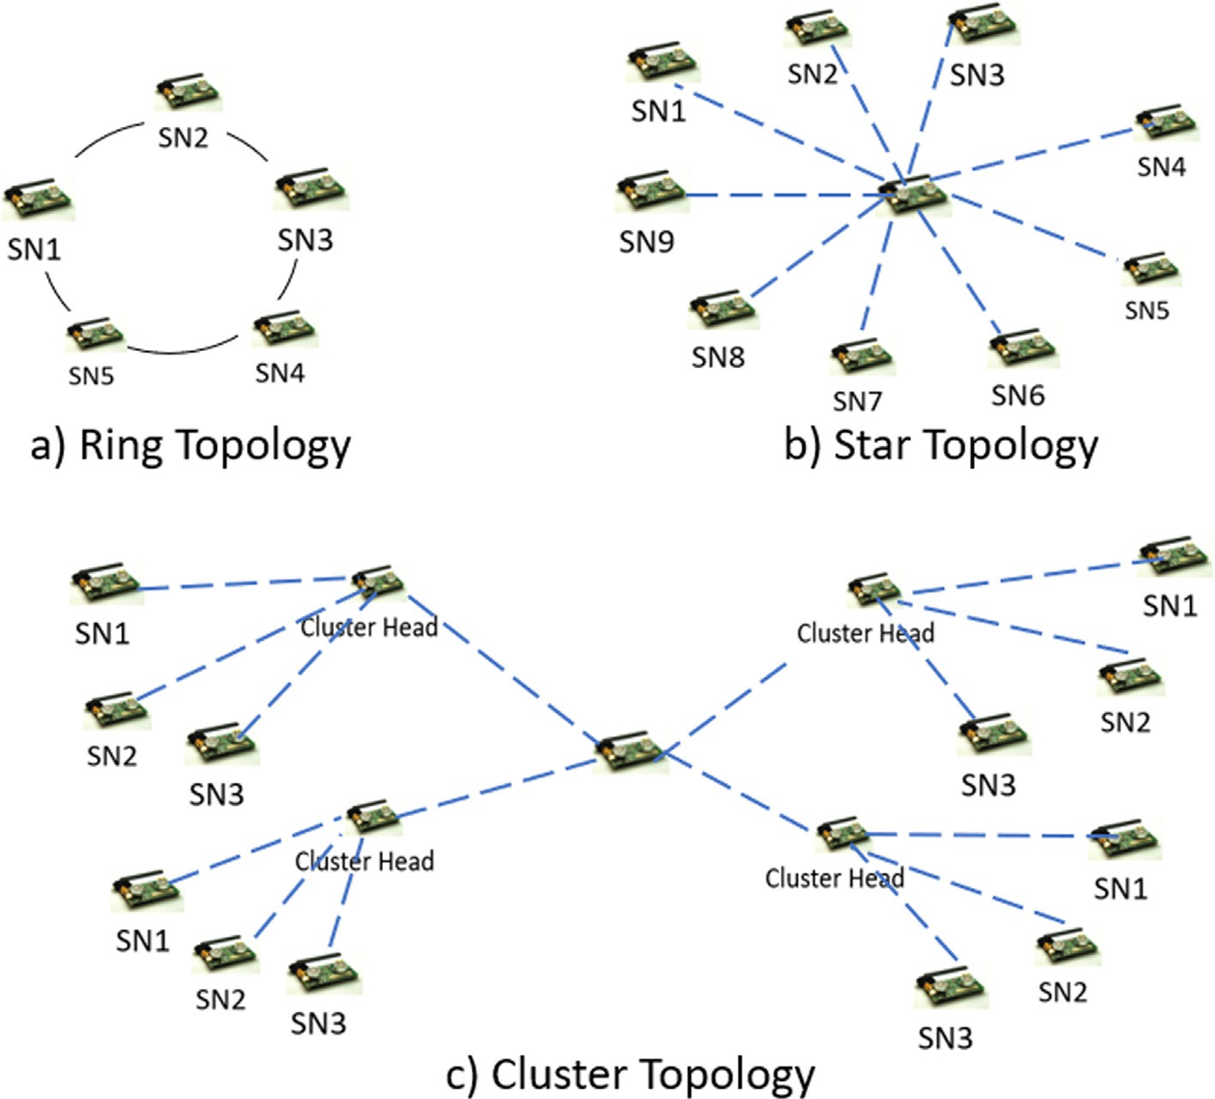

Fig. 1. Topologies in WSNs.

Table 2

Technical Specifications.

Table 3

Position of 7 different sensor nodes in various Topologies.

|  |  |  |  |  |  |  |
| --- | --- | --- | --- | --- | --- | --- |
| Name of Parameter | Selection |  | Topology Type | Sensor Node | X-Axis | Y-Axis |
| Area | 1000*1000 *m* |  |  | (Number) | (Degree) | (Degree) |
| Initial Energy of each sensor node | 20 (Joules) |  | Ring Topology | SN1 | 68 | 370 |
| Number of Nodes | 7 |  | Ring Topology | SN2 | 203 | 545 |
| Simulation Time | 400 Seconds |  | Ring Topology | SN3 | 419 | 568 |
| Packet Size | 1460 |  | Ring Topology | SN4 | 624 | 510 |
| Type of Antenna Used in SN | Omni-Directional |  | Ring Topology | SN5 | 493 | 311 |
| Propagation Type | Two-Ray Ground |  | Ring Topology | SN6 | 265 | 269 |
| Routing Protocol | AODV |  | Ring Topology | SN7 | 863 | 343 |
|  |  |  | Star Topology | SN1 | 399 | 308 |
|  |  |  | Star Topology | SN2 | 165 | 332 |
| Star Topology | | | | SN3 | 331 | 533 |
| ified its working to further improve the performance of WSNs. | | Star Topology | | SN4 | 588 | 455 |
| Moreover, MAODV protocol can overcome the issues of topological | | Star Topology | | SN5 | 614 | 187 |
| change constraint, overhead and bandwidth problems. MAODV is | | Star Topology | | SN6 | 340 | 80 |

On-Demand reactive routing protocol in which a route is created only when needed. In this case, whenever any sensor node wants

|  |  |  |  |
| --- | --- | --- | --- |
| Star Topology | SN7 | 863 | 343 |
| Cluster Topology | SN1 | 216 | 392 |
| Cluster Topology | SN2 | 139 | 441 |

|  |  |  |  |  |
| --- | --- | --- | --- | --- |
| to transmit the data, a Route Discovery process is initiated by | Cluster Topology | SN3 | 137 | 352 |
| broadcasting a Route Request (RREQ) message. Then, every inter- | Cluster Topology | SN4 | 412 | 396 |

mediate sensor node in the network retransmits the RREQ message until it reaches its destination point. Finally, the destination sensor

|  |  |  |  |
| --- | --- | --- | --- |
| Cluster Topology | SN5 | 551 | 447 |
| Cluster Topology | SN6 | 540 | 342 |
| Cluster Topology | SN7 | 863 | 343 |

node responds by transmitting the Route Reply (RREP) message.

Thus, in this way the communication between various sensor nodes take place without causing additional overheads within

the network.

* 1. *Results and discussions*

In this section, different topologies are assessed based on the statistical outcomes achieved. Various parameters such as: Aver- age Remaining Energy, Packet Delivery Ratio and Throughput are used to compare the efficiency of Star, Ring and Cluster topology.

* + 1. *Average remaining energy (AVG (RE))*

Wireless sensor node loses a particular amount of energy when- ever a packet is transmitted or received. As a consequence, the ini- tial energy of a node falls. Thus, the amount of energy left within a node after transmitting or receiving the routing packets is called the Average Remaining Energy. To calculate the current remaining energy of a WSN, available energy of current node has to be known. However, voltage and temperature plays vital role for estimating the remaining energy in battery-based sensor network. The

Average Remaining Energy is calculated using (1). Fig. 2. Show the comparison of average remaining energy (in Joules) in different

PDR = R(RP)

# R(TPS)

# (2)

topologies.

# AVG(RE) = R(Energy(Initial)) — R(Energy(Consumed)) (1)

AVG (RE) obtained for ring topology and star topology is best when data rate is 04 packets/sec, 08 Packets/sec, and 12 packets/ sec: that is average remaining energy for star topology is 3.26484 Joules, 4.00836 Joules and 4.73546 Joules respectively and for ring topology it is 4.56339, 3.06143 and 4.32466 Joules respectively. However, at similar data rates, the outcomes obtained for cluster topology are 3.30904 Joules, 3.68098 Joules and 4.29467 Joules respectively. Finally, at data rate of 16 packets/sec and 20 packet/ sec, average remaining energy for star topology and ring topology is again highest for star and ring topology in comparison to cluster topology. In conclusion, for average remaining energy, the star topology performs better at varying data rate, because, when cen- tral node becomes dead, the whole network becomes fragmented. This stops the communication process, owing to which the residual energy observed for the star topology remains high for most of the cases. Similar trend has been observed for ring topology, because ring topology in WSNs provides jamming free communication between the sensor nodes owing to which energy depletion rate is balanced, thereby resulting into higher residual energy. Cluster

Where, RP is the number of received packets and TPS is the Total Number of Packets Sent by the sender.

As shown in Fig. 3, when the data rate is varied from 04 packets/ sec to 20 Packets/sec, ring performs better than the star and cluster topologies. On increasing the data rate, number of packets deliv- ered to the destination also increases in case of ring topology, while in case of star and cluster topology, the number of packets delivered keeps on decreasing. The output in the form of PDR for star and cluster topology is same due to which the values shown in graph overlap each other. This is due to more congestion rate across the central node and the CHs when the data rate is increased in star and cluster topology respectively, while in ring topology the data transmission is balanced among all the nodes. This leads to higher PDR for ring topology.

*3.3.3. Throughput*

Throughput also known as Network throughput is the rate of packets successfully delivered over a transmission channel. Kbps is the measurement unit for throughput and is calculated using (3):

# Throughput =

topology on the other hand experiences least residual energy because of more energy being consumed by the CHs, thereby leav- ing least remaining energy in a network. Thus, for AVG (RE), both

# sum(numberofsuccessfulpackets)* (averagepacket size)) TotalTimesentindeliveringthatamountofdata

(3)

Star and Ring topology outperforms cluster topology. However, more residual energy in star topology is because of the failure of central node. Due to this, the communication between the sensor nodes becomes fragmented and energy gets saved. Although, the maximum energy is saved in star topology, but the energy saved in this way affect other parameters like throughput, PDR and many more in a negative way. Overall, Ring topology performs better in comparison to star and cluster topology as this provides jamming-less service without breaking the communication.

* + 1. *Packet Delivery ratio (PDR)*

The PDR is defined as the ratio of packets successfully received to the total number of packets sent by the sender. The PDR can be calculated using the mathematical formula (2):

As shown in Fig. 4, the trend for throughput is almost similar to PDR. Generally, this happens because both are directly propor- tional to each other, that is, if PDR increases, then throughput also increases and vice versa. Star topology and Cluster topology both performs almost similarly when the data rate is varied from 04 packet/second to 20 packet/sec. But, on increasing the data rate in Ring topology, that is, from 04 packets/second to 20 packets/sec- ond, the throughput value comes out to be 204 kbps, which is the highest achieved throughput among other topologies. This is because data transmission takes in linearly queued hop by hop manner that helps to ameliorate the throughput in Ring topology. Thus, the performance of Ring topology is found to be better than Star and Cluster topologies in achieving higher throughput values for given data rates.

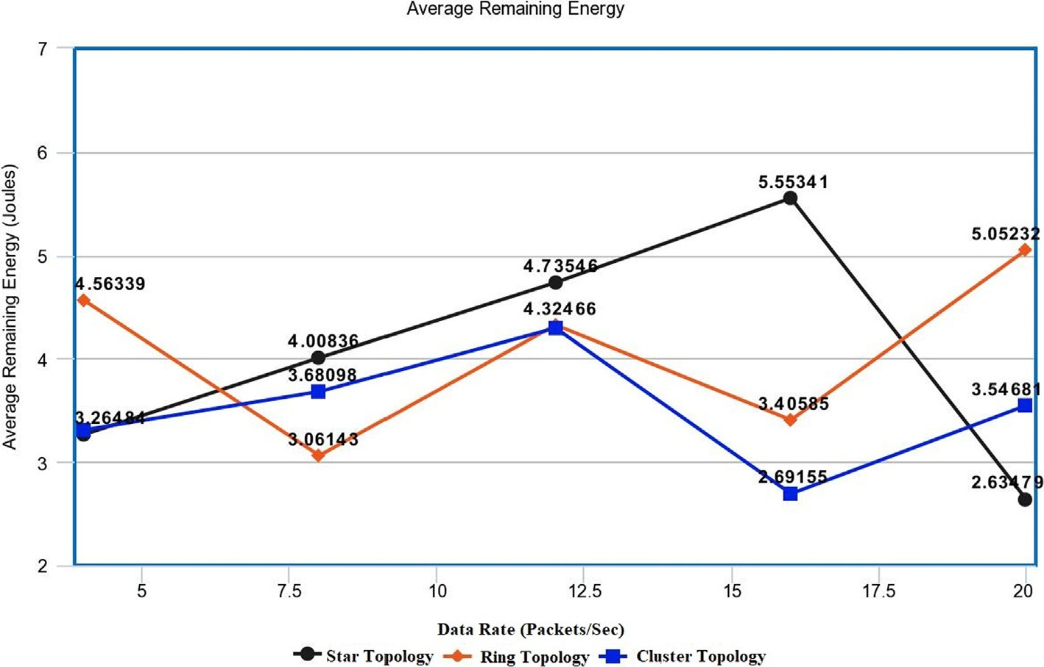

Fig. 2. Average Remaining Energy (AVG(RE)).

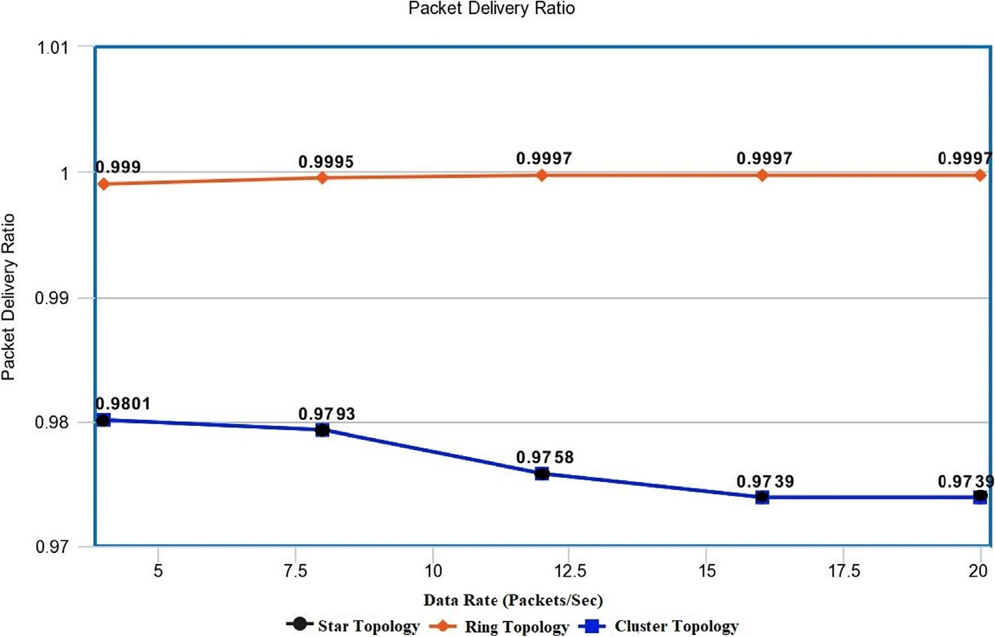

Fig. 3. Packet Delivery Ratio.

After extracting the statistical data for various topologies, ring topology seems to outperform star and cluster topology by provid- ing reliable and long-lasting communication. Thus, we merged ring topology in existing J-ERLB to ameliorate the performance of J- ERLB. In the next section, existing J-ERLB and J-MERDG techniques are discussed.

1. Existing J-ERLB technique

The existing J-ERLB approach used a three-phase algorithm to increase the lifespan of WSNs which is our previous proposed work [14]. In the first phase, recharging of sensor nodes having energy less than the threshold level is considered. Then, the SenCar ran- domly moves across the network to compute the residual energy of static sensor nodes in network. If the value of the calculated energy level of a node is below the threshold value, then the Sen- Car will recharge that specific node with half amount of value (10

Joules). But, if the energy level of the node within its range has more value than the pre-defined threshold, then the SenCar moves to the next AP node in the network. The second phase and third phase depict how a path is established between a sender and recei- ver in the routing protocol. It checks if the queue size at a node is less than 75%, then only it will be used for transferring the data, otherwise, a new path is chosen. Therefore, in this way the load balancing is performed in AODV. Although the existing J-ERLB used a joint concept of load balancing and recharging, it still lacks in performance due to random distribution of sensor nodes. Similarly, J-MERDG also implemented the concept of data gathering and recharging to improve the lifetime of sensor nodes. However, the authors did not implement any technique to overcome the concept of congestion. They tested both the technique on random and reg- ular topologies (Square topology). Therefore, a strong and robust architecture is required to overcome the issues of energy saving in WRSNs.

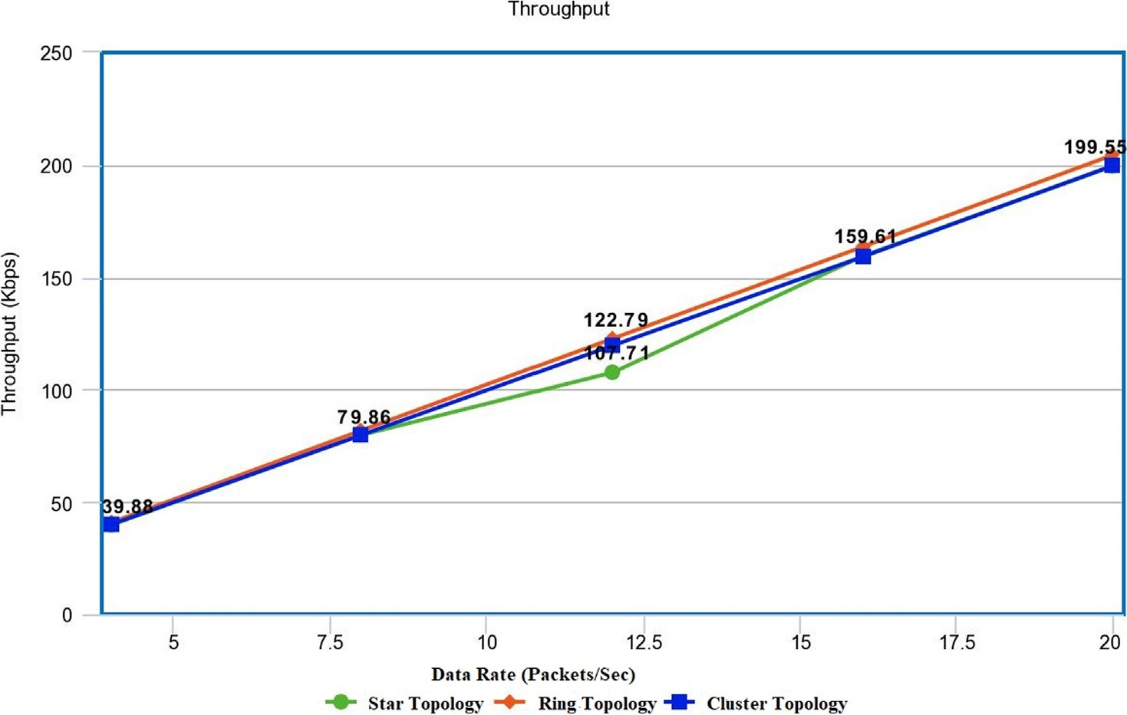

Fig. 4. Throughput.

Till date, none of the researcher implemented and tested the concept of regular topologies like bus, ring, star, cluster and hybrid topologies in WRSNs. This can greatly help in improving the overall performance of the WSNs by not only easing the selection of pre- defined trajectory but also help the mobile node to locate the posi- tion of the nodes accurately for recharging their batteries. After analysing J-ERLB and J-MERDG in detail, reduced throughput and less residual energy are noticed. Therefore, in order to overcome these drawbacks, 3SM is implemented for testing its effectiveness over J-ERLB and J-MERDG in WSNs.

1. Three-Step model (3SM)

The proposed solution makes use of ring topology to ease the selection of APs, where the UAV halts for recharging the nodes that falls under its clustered range. The UAV assists the sensor node car- rying heavy battery (500 Joules) to move along the pre-defined tra- jectory so that the mobile sensor node can gather the energy level of static sensors and recharge them if the threshold value of the battery falls below the threshold value. The threshold value for the sensor node is fixed as 3 Joules. The initial energy level of every sensor node is 20 Joules. The mobile UAV carrying a heavy battery of 500 Joules helps to recharge other nodes, thus ameliorating the lifespan of each sensor node in WRSNs. For efficiently recharging the static sensors, an efficient recharging technique is required to be embedded in mobile UAV. For 3SM, we selected Radio Fre- quency (RF) based wireless recharging mechanism.

* 1. *Wireless recharging techniques*

For recharging the sensor nodes, several energy harvesting techniques such as Magnetic Resonance, Radio Frequency (RF), Laser, and Inductive Coupling are proposed. After studying the advantage of each in literature survey section, RF based wireless recharging mechanism is selected for 3SM model because, it not only has the flexibility to fit into the smallest electronic device, it can perform long range charging for wireless sensor nodes. As RF can travel long distances, therefore, it can perform charging in a better and efficient way than the other approaches. This wireless charging is performed by UAV which visits every pre-defined AP to recharge the nodes with 10 Joules. The readers send RF signals via circularly polarized antennas and through the linearly polar- ized dipole antennas, Wireless Identification and Sensing Platform (WISP) tags receive the signal. The block diagram of RF based Recharging model is shown in Fig. 5.

Fig. 5 shows System on Chip (SoC) architecture which is fully Integrated Chip (IC) having high performance (350 MHz to 2.4 GHz) with 188dBm. The average output voltage of IC SoC is

2.4 Volt. In the above given charging model, received RF power at antenna is calculated using Friis transmission Eq. (4).

*Gtr Greg*NcNre *a*  2

1. Transmitted Power
2. Transmitting Gain
3. Receiving Antenna Gain
4. Distance between the transmitter and the receiver

The battery type used for the model is lithium ion because of its high energy density. Also, this type of battery is lighter than other rechargeable batteries. The technical specifications of the SoC and battery used during the research are detailed as follows:

* + 1. *Technical specifications of SoC*

The SoC has been considered as an innovative modular approach having robust architecture (See Fig. 5). It differentiates itself as a flex- ible platform for RF energy harvesting and wireless power transmis- sions that can be used to implement real scenarios with minimum efforts. Further, when SoC is integrated within a system, it provides powerful charging facility and easy maintenance in WSNs. However, the same is made possible with novel system architecture which integrates a DC/DC converter with a specific bandwidth to perform high power conversion efficiency (PCE).

Further, Amplitude-Shift-Keying/Frequency-Shift-Keying (ASK/ FSK) receiver when integrates gives an added value. ASK/FSK is an asynchronous programmable logic circuit and finite state machine that makes the system configurable thereby able to receive simultaneously data and power. Switch is used to turn off the battery when not in use and Digital Circuitry is used to mini- mize the channel bandwidth. These characteristics of SoC offer a high adaptability to the system to address different scenarios.

Also, with reference to Fig. 5, intelligent power management in SoC can provide a regulated voltage and measure the scavenged energy simultaneously. This intelligent power management is known as ultra-low power management and is the key circuitry to scavenge the energy with a nano-power circuit having current as low as 75nA. Further, for proper configuration of address and recharging device, SoC is installed with an ASK receiver which supports 433 MHz and 915 MHz. ASK receiver is designed with minimum data rate of 62 kbit/s to allow a channel bandwidth occupation of around 250 kHz.

Fig. 6 shows how a battery supplies a real time service to UAV so that it can transfer the power to other nodes which are within its transmission range. The transmitted power must be capable enough to transmit the power wirelessly within a specified time according to the target distance and the receiver sensitivity.

The power received by RF antenna is converted into DC by the converter and is stored in Cstorage, which is the external storage capacitor. Voltage (Vstor) defines that the stored energy is enough for the internal circuitry of the SoC to operate.

*Str* = *Lp*

4*p*(d + *b*)

(4)

In the above Eq. (4), Nc is the congestion within a network, *g* is rectifier efficiency, Gtr is transmitter antenna gain and *b* is the con- stant used for Friis’Free Space short distances, Lp is polarization loss, d is the distance between the Recharging node and the recei- ver, and Gre is receiver antenna gain. Eq. (4) can be simplified to:

*Str* = *r*

# (d + *b*)2

(5)

where, *r* = Gtr Gre *g*NcNre *a* 2 and experimental values for *r* is 4.32

Lp 4*p*

×10-4 and *b* is 0.2316.

However, the RF energy stored in the battery depends on the following factors:

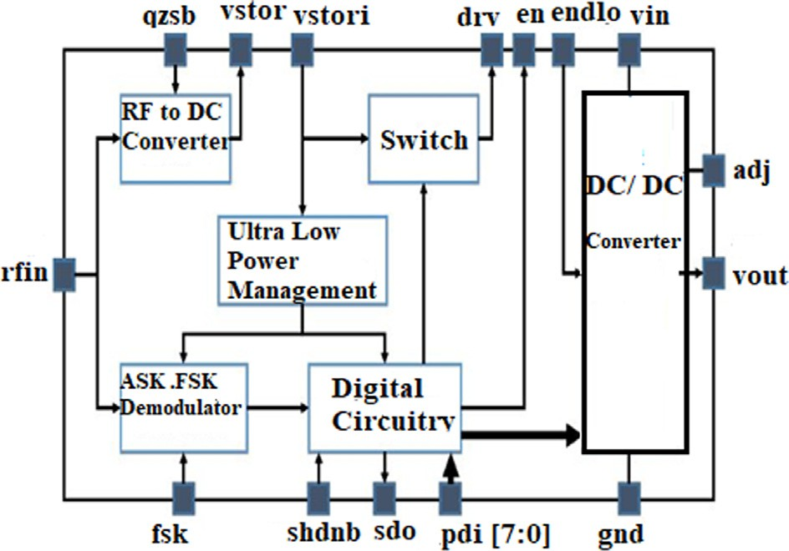Fig. 5. Block Diagram of SoC.

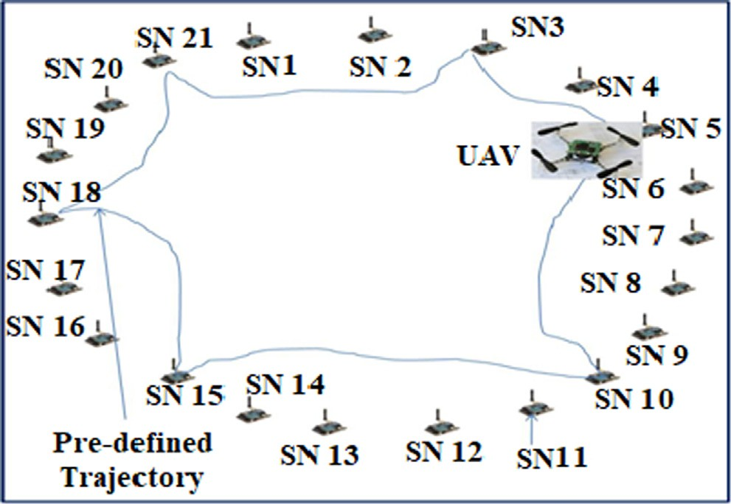Fig. 7 represents the architecture of 3SM and UAV following ring-based topology for sensor arrangement and recharging. It shows the implementation of RF Energy Transmitter and Receiver with Lithium-ion battery. Here, the blue line indicates the pre- defined trajectory formed for UAV.

Besides this, simulation has been performed using NS2 simula- tor to evaluate performance of 3SM and then implementation of 3SM is performed and the results are gathered. Table 4 shows the common technical specifications considered for the implemen- tation of existing and proposed techniques. Random distribution method is used for placing the static sensor nodes in J-ERLB, while for 3SM, Ring based topology is used for the deployment of sensor nodes. Omni-Directional antenna is used in J-ERLB and 3SM to pro- vide consistent coverage in all directions.

* 1. *Data gathering process*

Here, we assume that every sensor node contains a passive Radio Frequency Identification (RFID) device which wakes up the transceiver of sensor node after receiving a beep signal from

Table 4

Fig. 7. Architecture of 3SM.

UAV. One advantage of using RFID device is that it does not require any power supply. The energy from the RF signal of UAV can be used for this purpose. Also because of attenuation and fading, sometimes all the APs may not be tracked down by the UAV during its visit in the ring-shaped sensor field. Therefore, following heuris- tic algorithm helps to solve the problem with accuracy:

Algorithm: Data Gathering Mechanism

START

1. While (the data exchange is taking place)
2. r(i)=set of all APs; i20,1,2 n /* Set of pre-defined anchor

points in the formulated scenario */

1. SN(i)=set of all sensor nodes in a network, where i20,1,2 n
2. If d<threshold, h=R(i), where i20,1,2 n /* *calculate node’s*

*distance from UAV and put the node in set ‘h’ whose value is less than a threshold distance*\*/

1. Send beep signal (Using RFID) to the neighbouring nodes within its sensing range
2. Recharge nodes in ‘h’ via UAV in pre-defined trajectory
3. REPEAT step 1 to 5 /* *Keep on recharging the nodes until required data from environment is captured*\*/

STOP

Common Technical Specifications for proposed and existing techniques.

Name of Parameters Selected Values

Number of Nodes 50

Mobile Recharging Sensor Node Speed 0.5 m/sec

Size of Data Packet 512 kb/sec

Initial Energy of Drone Embedded SN’s Battery 500 Joules Initial Energy of Static Sensor Node 20 Joules

Average Energy 10 Joules

Default Queue Length for Load Balancing 50

Antenna Type Omni-Directional

Simulation Area 1000*1000 (meters)

* 1. *Proposed algorithm for 3SM technique*

The Proposed algorithm is divided into three phases: the first phase is implementation of Ring topology in WSNs, the second phase is the path establishment in MAODV, and last is the Recharg- ing phase. The entire algorithm is explained in the comment sec- tion of each module.

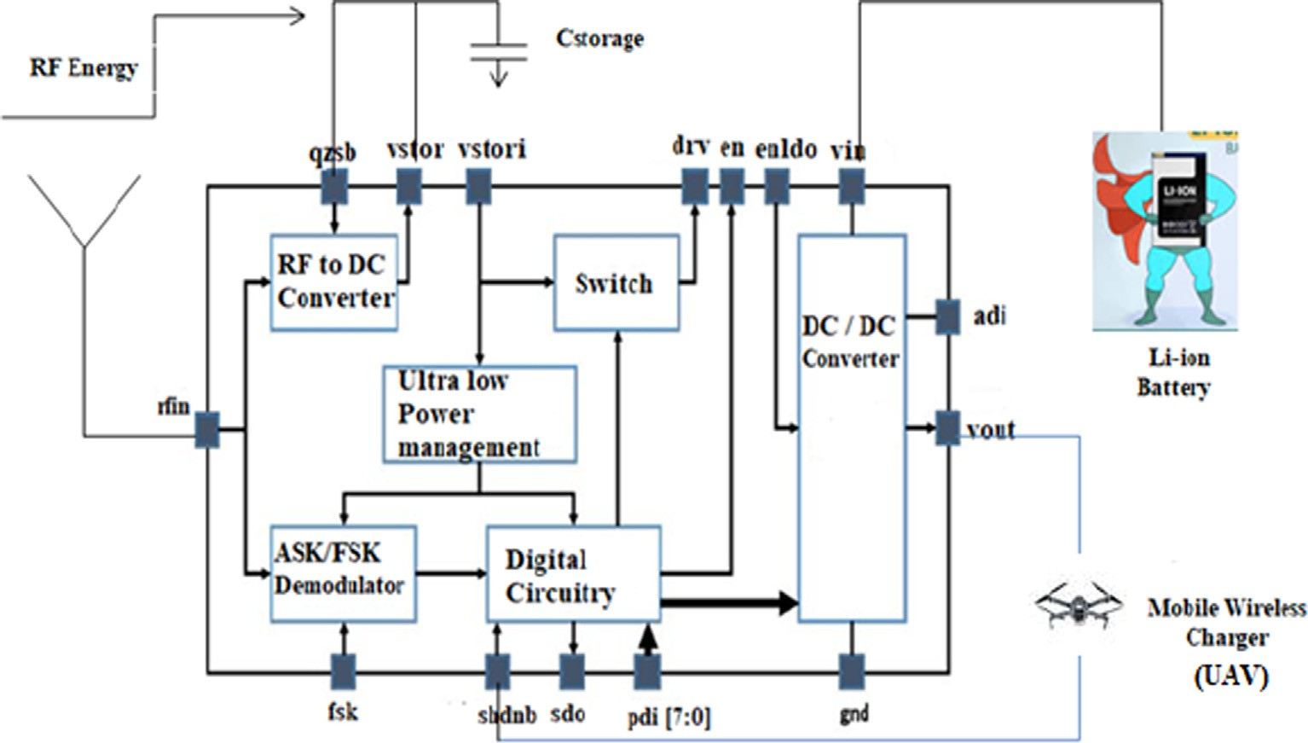

Fig. 6. Recharging Sensor Node equipped with SoC Module.

Phase 1 (Implementation of Ring Topology for sensor nodes)

Select_area of deployment () /\**Deployment area of sensor nodes is selected* */

{

Keep_node_distance = 60cm /\**60 cm area is fixed between the sensor nodes*\*/

{

For (N= 50) /\**For all 50 sensor nodes*\*/

{

Formulate_Ring_Topology /\**All sensor nodes are positioned in Ring Topology structure*\*/

}

Phase 2 (Path Selection)

Make_request (id_request); /* *The Path Route request is made*\*/ Recvd_request(packet) /\**A Request arrives at a node*\*/

{

If (index== destination _ packet || available _ path ()) /* *Condi- tion is matched here*\*/

{

reply _ send (length of queue); /* *Reply packet with queue length is sent*\*/

}

else

{

packet _ sent () /\**Packet of the node is forwarded with queue length* */

}

}

reply _ recvd (Packet) /\**Establishment of Forward path after receiving reply*\*/

{

path_add(); /\**Route is added with queue length in routing table* */

}

Phase 3 (Recharging Technique)

Rch_round () /* *Used to recharge the dying nodes with 10 Joule*\*/

{

For (0 to n) energy_node_check() /\**This function is used to check* *the status of battery level of every node*\*/

{

If (energy_node<threshold) /\**The condition checks level of energy and compares with the threshold value (3 Joules)*\*/

{

recharge_node(); /\**Transmit the energy to 10 Joule*\*/

}

}

}

1. Performance analysis of 3SM

The effectiveness of 3SM is measured using Throughput and Average Remaining Energy parameters and is compared with exist- ing J-ERLB and J-MERDG. The performance is analyzed by varying data rates (04, 08, 12, 16, and 20 packets/second).

* 1. *Throughput*

Throughput is defined as the number of data packets success- fully received at the receiver over a specified time period. Here, the data units successfully received by all the nodes are summed up. Fig. 8 shows the throughput comparison for existing and pro- posed techniques. In 3SM technique, UAV that carries the mobile node visits the first AP and recharges the nodes which fall under its administration. Then, it moves to the next AP as per the pre- defined trajectory. As UAV in 3SM follows pre-defined trajectory to recharge the dying sensor nodes, a greater number of nodes are expected to be covered during its recharging round at APs. Therefore, the throughput level is not at all affected, while in case of J-ERLB and J-MERDG, it covers lesser number of nodes within its transmission range due to random deployment. This decreases the throughput rate because the nodes that are not covered within the sensing range of UAV are not able to refuel their energy level. Moreover, load balancing performed using MAODV helps to miti- gate the problem of traffic congestion, thereby increasing the throughput rate of network for 3SM and J-ERLB. On the contrary, J-MERDG does not implement the load balancing, hence due to traffic congestion, extra energy gets consumed which further leads to more number of dead nodes. Thus, the average throughput rate for 3SM is quite high in comparison to the existing J-ERLB and J- MERDG.

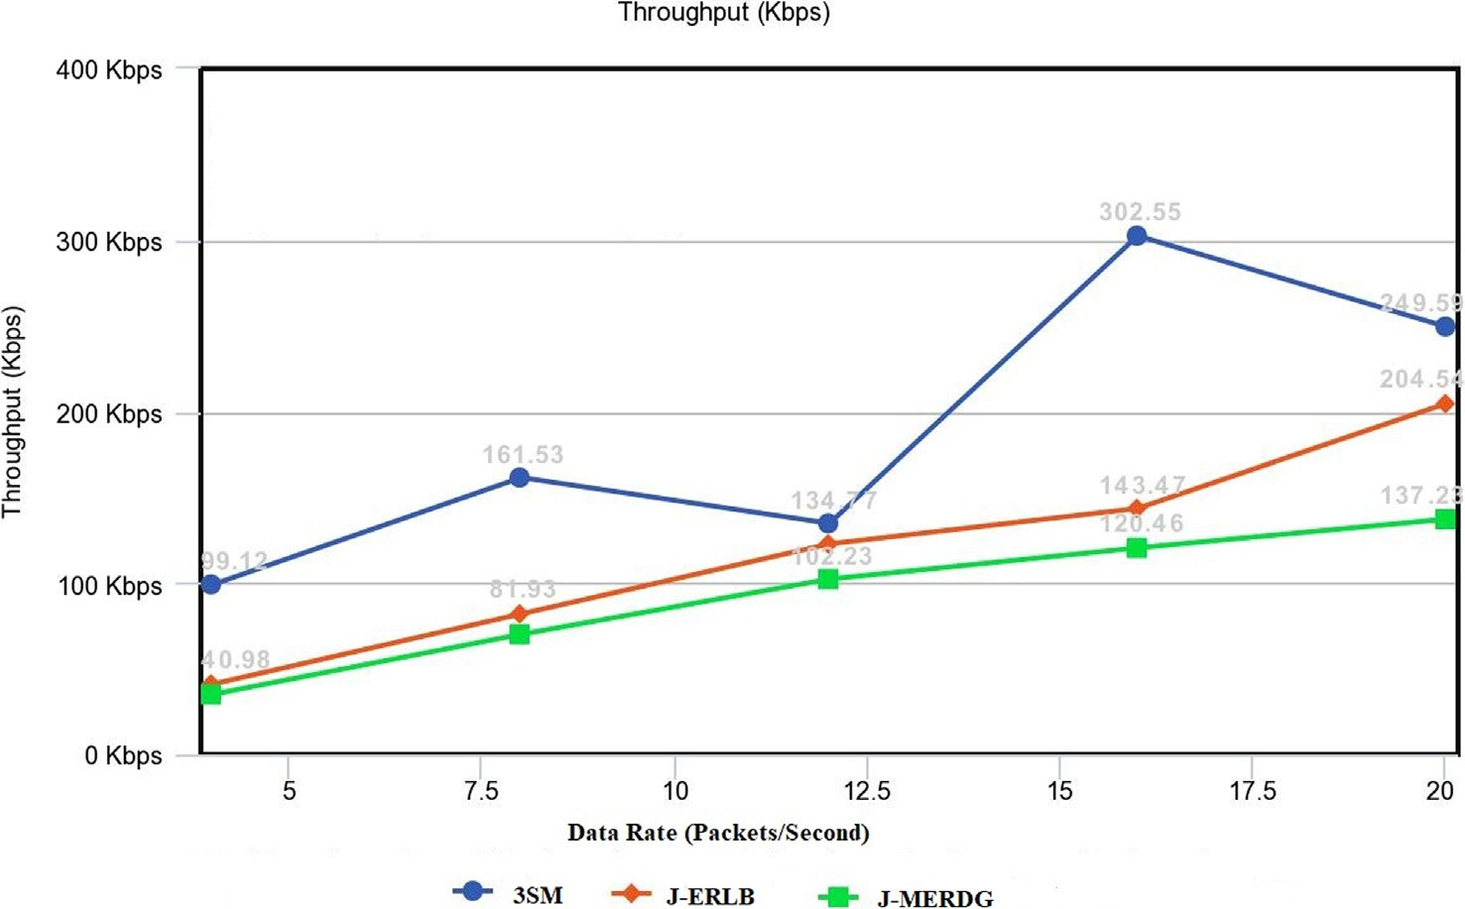

Fig. 8. Throughput Comparison for 3SM, J-ERLB and J-MERDG.

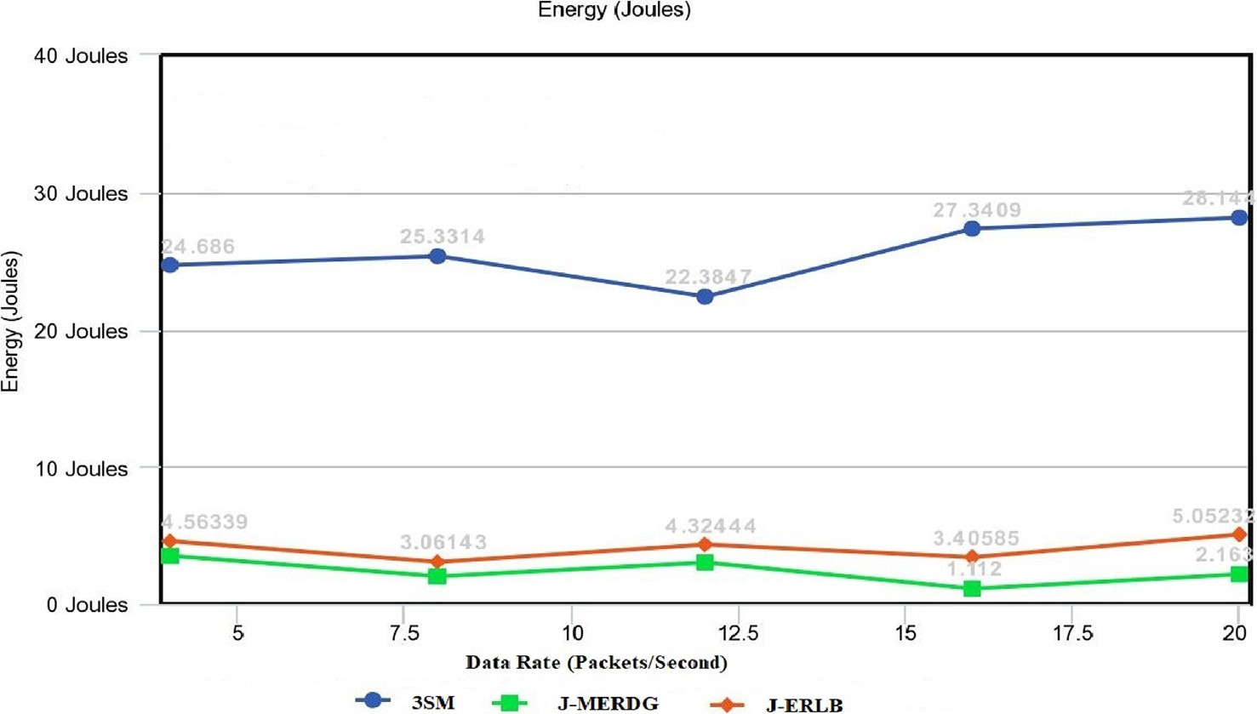

Fig. 9. Average Remaining Energy Comparison for 3SM, J-ERLB and J-MERDG.

* 1. *Average remaining energy (AVG (RE))*

Fig. 9 shows AVG (RE) for 3-SM, J-ERLB and J-MERDG tech- niques. The residual energy obtained in case of J-ERLB and J- MERDG is extremely low when the data rate is varied from 04 packet/second to 20 packets/second. This happens because the deployments of nodes are random, therefore, the probability to recharge every sensor node is a difficult task for mobile node (Sen- Car). Some nodes within a network may run out of battery because of not getting recharged within a specific time period. This stops the communication within the network leading to less average residual energy for the network. 3SM, on the other hand follows a pre-defined route to recharge the node. Hence, the average resid- ual energy is always very high for a network as it continues to recharge every node after a specific time interval. UAV moves around a ring in a circular fashion and charge the static sensor nodes placed at a fixed distance. The APs are chosen in such a way that it covers almost every node within a network. Thus, the achieved AVG (RE) for 3SM is more in comparison to existing techniques.

1. Conclusion

In this paper, we have studied various topologies and its imple- mentation in WRSNs by exploiting mobility using UAV. Specifi- cally, J-ERLB is implemented on various regular topologies like ring, star and cluster topology. Then, the optimum topology is cho- sen based on performance metrics packet delivery ratio, through- put and delay. Then the selected ring topology is merged with J- ERLB to formulate 3SM model, 3SM uses three step methods in which first step involves choosing an appropriate topology, second step involves the recharging process that can be implemented using UAV and last step is implementation of MAODV which involves the function of balancing the load among sensor nodes. UAV migrates along pre-defined APs, performs the function of wireless power transmissions and collects the sensed data from sensors in hop-by-hop routing. We also proposed a three-phase algorithm as a solution to limited lifespan of WRSNs. The proposed solution could be used in the real-time applications such as agri- culture automated watering system. Further, extensive numerical outcomes demonstrate that 3SM can effectively achieve high net-

work utility and maintain perpetual network operations by saving the amount of residual energy and high throughput values.

Future Work

The future work can be focused on implementing the proposed model on deep reinforcement scenarios where large size network could be considered to test the proposed model. Also, two or more number of UAVs could be used for better recharging the sensor nodes where the size of network is very large.

Funding Statement

The research and publication of this article was not funded, by any financially supporting bodies.

Declaration of Competing Interest

The authors declare that they have no known competing finan- cial interests or personal relationships that could have appeared to influence the work reported in this paper.

References

1. [Takaishi D, Nishiyama H, Kato N, Miura R. Towards energy efficient big data](http://refhub.elsevier.com/S1110-8665(21)00028-1/h0005) [gathering in densely distributed sensor networks. IEEE T Emerg Top Com](http://refhub.elsevier.com/S1110-8665(21)00028-1/h0005) [2012:1–10](http://refhub.elsevier.com/S1110-8665(21)00028-1/h0005).
2. [Guo S, Wang C, Yang Y. Joint mobile data gathering and energy provisioning in](http://refhub.elsevier.com/S1110-8665(21)00028-1/h0010) [wireless rechargeable sensor networks. IEEE Trans Mob Comput 2013:1–14](http://refhub.elsevier.com/S1110-8665(21)00028-1/h0010).
3. [Zhu C, Wu S, Han G, Shu L, Wu H. A tree-cluster-based data-gathering](http://refhub.elsevier.com/S1110-8665(21)00028-1/h0015) [algorithm for industrial WSNs with a mobile sink. IEEE Access 2015;3:381–96](http://refhub.elsevier.com/S1110-8665(21)00028-1/h0015).
4. [Zhou F, Chen Z, Guo S, Li J. Maximizing lifetime of data-gathering trees with](http://refhub.elsevier.com/S1110-8665(21)00028-1/h0020) [different aggregation modes in WSNs. IEEE Sens J 2016:1–10](http://refhub.elsevier.com/S1110-8665(21)00028-1/h0020).
5. Lan K, Wei M. ‘‘A Compressibility-Based Clustering Algorithm for Hierarchical Compressive Data Gathering”, IEEE Sensors Journal, Vol. 17, No. 8, 2017.
6. [Rani S, Ahmed SH, Talwar R, Malhotra J. Can sensors collect big data? an energy](http://refhub.elsevier.com/S1110-8665(21)00028-1/h0030) [efficient big data gathering algorithm for WSN. IEEE Trans Ind Inf 2017:1–8](http://refhub.elsevier.com/S1110-8665(21)00028-1/h0030).
7. [Pandey OJ, Mahajan A, Hegde RM. Joint Localization and Data Gathering over](http://refhub.elsevier.com/S1110-8665(21)00028-1/h0035) [Small World WSN with Optimal Data MULE Allocation. IEEE Trans Veh Technol](http://refhub.elsevier.com/S1110-8665(21)00028-1/h0035) [2018;67(7):6518–32](http://refhub.elsevier.com/S1110-8665(21)00028-1/h0035).
8. Zhao M, Li J, Yang Y. ‘‘A Framework of Joint Mobile Energy Replenishment and Data Gathering in Wireless Rechargeable Sensor Networks”, IEEE Transactions on Mobile Computing, Vol. 13, No. 12, 2014.
9. Wang Q, Kong F, Wang M, Wang H. ‘‘Optimized Charging Scheduling with Single Mobile Charger for Wireless Rechargeable Sensor Networks” Symmetry MDPI, Vol. 9, 2017.
10. [La Rosa R, Zoppi G, Finocchiaro A, Papotto G. An over-the-distance wireless](http://refhub.elsevier.com/S1110-8665(21)00028-1/h0050) [battery charger based on RF energy harvesting. IECON 2016–42nd Annual](http://refhub.elsevier.com/S1110-8665(21)00028-1/h0050) [Conference of the IEEE Industrial Electronics Society (IEEE), 2017](http://refhub.elsevier.com/S1110-8665(21)00028-1/h0050).
11. J. Xu, X. Yuan, Z. Wei, J. Han, L. Shi and Z. Lyu, ‘‘A Wireless Sensor Network Recharging Strategy by Balancing Lifespan of Sensor Nodes,” 2017 IEEE Wireless Communications and Networking Conference (WCNC), San Francisco, CA, pp. 1-6, doi: 10.1109/WCNC.2017.7925625, 2017.
12. [Tian M, Jiao W, Liu J, Ma S. A Charging Algorithm for the Wireless Rechargeable](http://refhub.elsevier.com/S1110-8665(21)00028-1/h0060) [Sensor Network with Imperfect Charging Channel and Finite Energy Storage.](http://refhub.elsevier.com/S1110-8665(21)00028-1/h0060) [Sensors MDPI 2019;19:1–19](http://refhub.elsevier.com/S1110-8665(21)00028-1/h0060).
13. [Sakthidharan G, Reddy P. Schedule-based optimized node recharging model](http://refhub.elsevier.com/S1110-8665(21)00028-1/h0065) [(SONRM) for increasing longevity of wireless rechargeable sensor network](http://refhub.elsevier.com/S1110-8665(21)00028-1/h0065) [(WRSN). Int J Intell Eng Syst 2019;12(3):319–29](http://refhub.elsevier.com/S1110-8665(21)00028-1/h0065).
14. Angurala M, Bala M, Bamber SS. Performance analysis of modified AODV routing protocol with lifetime extension of wireless sensor networks. IEEE Access 2020;8:10606–13. doi: [https://doi.org/10.1109/](https://doi.org/10.1109/Access.628763910.1109/ACCESS.2020.2965329) [Access.628763910.1109/ACCESS.2020.2965329](https://doi.org/10.1109/Access.628763910.1109/ACCESS.2020.2965329).
15. [Ghaffari A. An energy efficient routing protocol for wireless sensor networks](http://refhub.elsevier.com/S1110-8665(21)00028-1/h0075) [using a-star algorithm. J Appl Res Technol 2014;12(4):815–22](http://refhub.elsevier.com/S1110-8665(21)00028-1/h0075).
16. [Sarkar A, Murugan TS. Routing protocols for wireless sensor networks: What](http://refhub.elsevier.com/S1110-8665(21)00028-1/h0080) [the literature says?. Alexandria Eng J (Elsevier) 2016;55:3173–83](http://refhub.elsevier.com/S1110-8665(21)00028-1/h0080).
17. [Khan MK, Shiraz M, Ghafoor KZ, Khan S, Safaa Sadiq A, Ahmed G. EE-MRP:](http://refhub.elsevier.com/S1110-8665(21)00028-1/h0085) [energy efficient multistage routing protocol for wireless sensor networks.](http://refhub.elsevier.com/S1110-8665(21)00028-1/h0085) [Wireless Communications and Mobile Computing 2018;2018:1–13](http://refhub.elsevier.com/S1110-8665(21)00028-1/h0085).
18. Z. Abedin, S. Paul, S. Akhter, K. N. Siddiquee, M. S. Hussain and K. Andersson, ‘‘Selection of Energy Efficient Routing Protocol for Irrigation Enabled by Wireless Sensor Networks”, 2017 IEEE 42nd Conference on Local Computer Networks Workshops (LCN Workshops), Singapore, 2017, pp. 75-81, doi: 10.1109/LCN.Workshops.2017.67.
19. M. Khalil, A. Khalid, F. U. Khan and A. Shabbir, ‘‘A Review of Routing Protocol Selection for Wireless Sensor Networks in Smart Cities,” 2018 24th Asia-Pacific

Conference on Communications (APCC), Ningbo, China, 2018, pp. 610-615, doi: 10.1109/APCC.2018.8633456.

1. [Shafiq M, Ashraf H, Ullah A, Tahira S. Systematic Literature Review on Energy](http://refhub.elsevier.com/S1110-8665(21)00028-1/h0100) [Efficient Routing Schemes in WSN – A Survey. Mobile Networks and](http://refhub.elsevier.com/S1110-8665(21)00028-1/h0100) [Applications 2020;25(3):882–95](http://refhub.elsevier.com/S1110-8665(21)00028-1/h0100).
2. [Iyer SK, Manjunath D. Topological properties of random wireless networks.](http://refhub.elsevier.com/S1110-8665(21)00028-1/h0105) [Sadhana Academy Proceedings in Engineering Sciences 2006;31(2):117–39](http://refhub.elsevier.com/S1110-8665(21)00028-1/h0105).
3. [Buratti C, Conti A, Dardari D, Verdone R. An overview on wireless sensor](http://refhub.elsevier.com/S1110-8665(21)00028-1/h0110) [networks technology and evolution. Sensors 2009;9:6869–96](http://refhub.elsevier.com/S1110-8665(21)00028-1/h0110).
4. T. M. Chiwewe, and Gerhard P. Hancke, ‘‘A Distributed Topology Control Technique for Low Interference and Energy Efficiency in Wireless Sensor Networks”, IEEE Transactions on Industrial Informatics, Vol. 8, No. 1, 2012.
5. [Sheela D, Chellamuthu C. Protection in optical mesh networks - a cost effective](http://refhub.elsevier.com/S1110-8665(21)00028-1/h0120) [strategy based on topological constraints. Malays J Comput Sci 2012;25](http://refhub.elsevier.com/S1110-8665(21)00028-1/h0120) [(1):38–55](http://refhub.elsevier.com/S1110-8665(21)00028-1/h0120).
6. [Carlos-Mancilla M, López-Mellado E, Siller M. Wireless sensor networks](http://refhub.elsevier.com/S1110-8665(21)00028-1/h0125) [formation: approaches and techniques. J Sens 2016;2016:1–18](http://refhub.elsevier.com/S1110-8665(21)00028-1/h0125).
7. Tavakoli R, Nabi M, Basten T, Goossens K. Topology Management and TSCH Scheduling for Low-Latency Convergecast in In-Vehicle WSNs. IEEE Trans Ind Inf 2019;15(2):1082–93. doi: <https://doi.org/10.1109/TII.2018.2853986>.
8. Vecchio M, Amendola G, Ducange P. An integrated topology control framework to accelerate consensus in broadcast wireless sensor networks. IEEE Trans Wireless Commun 2018;17(11):7472–85. doi: [https://doi.org/10.1109/](https://doi.org/10.1109/TWC.2018.2867486) [TWC.2018.2867486](https://doi.org/10.1109/TWC.2018.2867486).
9. [Fu X, Fortino G, Li W, Pace P, Yang Y. WSNs-assisted opportunistic network for](http://refhub.elsevier.com/S1110-8665(21)00028-1/h0140) [low-latency message forwarding in sparse settings. Future Gener. Comput.](http://refhub.elsevier.com/S1110-8665(21)00028-1/h0140) [Syst. 2019;91:223–37](http://refhub.elsevier.com/S1110-8665(21)00028-1/h0140).
10. [Tu W, Xu X, Ye T, Cheng Z. A study on wireless charging for prolonging the](http://refhub.elsevier.com/S1110-8665(21)00028-1/h0145) [lifetime of wireless sensor networks. Sensors 2017;17(7):1560](http://refhub.elsevier.com/S1110-8665(21)00028-1/h0145).