Chapter 1

General Introduction

The visual system encounters an enormous amount of complex information that is processed to produce a smooth phenomenal experience of the world. The visual processes that produce this experience require memory processes that encode, retain and manipulate the visual information. For example, an active memory store is required to integrate the information between saccades Irwin and Andrews (1996), to orient where attention should be deployed Awh and Jonides (2001), and to retain information about objects during visual search and tracking # CHECK LUCK AND VOGEL reference # The system responsible for storing the visual information actively for perception has been termed visual working memory (VWM).

Despite its necessity, the capacity of visual working memory is surprisingly limited. In their seminal study, Luck and Vogel (1997) popularised the measurement of visual working memory capacity using a change-detection paradigm.

# Insert change-detection figure here

In this paradigm, an array of objects is presented for a brief duration before disappearing. After a short delay, the array may reappear identically or with one object changed. The proportion of changes that are detected can be used to estimate the number of items the participant held in visual working memory. Luck and Vogel (1997) varied the number of colour squares that appeared in the array and found that performance started to drop when the array contained more than 4 colour squares. However, the number of items held in visual working memory capacity (K), estimated by the proportion of changes detected stayed constant at approximately 3-4 items.

Luck and Vogel (1997) also manipulated the number of features that the visual stimuli contained. They manipulated the conjunctions of colour, orientation, and the presence or absence of a gap. They found that the 3-4 item capacity limit was consistent for these increasingly complex visual stimuli.

This led Luck and Vogel Luck and Vogel (1997) to suggest that the architecture of VWM is 3-4 'slots', where visual objects with their features integrated are stored in independent slots.

However, this was contested by the findings of Alvarez and Cavanagh (2004). In their study, participants completed the same change-detection task as in Luck and Vogel (1997) but with different stimulus sets, such as random polygons and chinese characters (see Figure 1). They indexed the complexity of these stimuli by measuring the amount of additional time taken to find the target in a visual search task with each added item to the array. This visual search rate, their measure of complexity, was strongly correlated with the VWM capacity, such that it was lower the more complex the item was.

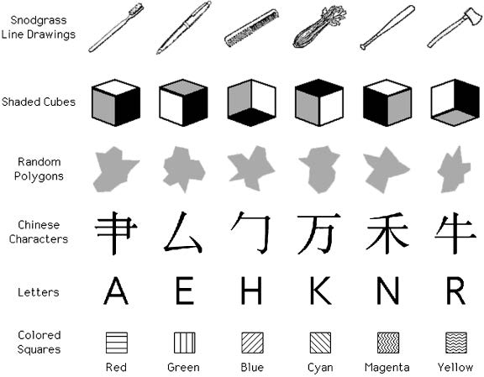

The stimuli sets used in Alvarez and Cavanagh (2004)

However, the effect of training participants to be familiar with stimuli on visual working memory performance is unclear. To train recognition to polygons, Chen, Eng and Jiang (2006) presented four polygons out of a training set of eight, before presenting two polygons, one the same and one from the unpresented set. Despite being able to recognise the trained polygon, this familiarity did not improve visual working memory performance for the trained polygons over novel polygons. However, Blalock (2015) found a positive effect of familiarity training on visual working memory performance. Blalock (2015) presented a target polygon before asking the participant to select the target out of an array of four polygons. This recognition training produced better change-detection performance for trained polygons over the novel polygons. Another notable discrepancy between these studies is the sample size. While Chen et al. (2006) used twelve participants in each of their experiments, Blalock (2015) used over seventy and 102 in each of theirs. This difference in the statistical power of experiments may explain the contrasting results of familiarity training.

# References

Alvarez, G. A., and P. Cavanagh. 2004. “The Capacity of Visual Short-Term Memory Is Set Both by Visual Information Load and by Number of Objects.” *Psychological Science* 15: 106–11. <http://visionlab.harvard.edu/Members/Patrick/PDF.files/2005%20pdfs/Alvarez%26Cavanagh(2004).pdf>.

Awh, Edward, and John Jonides. 2001. “Overlapping Mechanisms of Attention and Spatial Working Memory.” *Trends in Cognitive Sciences* 5 (3): 119–26. doi:[10.1016/S1364-6613(00)01593-X](https://doi.org/10.1016/S1364-6613(00)01593-X).

Irwin, David E., and Rachel V. Andrews. 1996. “Integration and Accumulation of Information Across Saccadic Eye Movements.” *Attention and Performance XVI: Information Integration in Perception and Communication* 16: 125–55. <https://books.google.com/books?hl=en&lr=&id=HUcGqC-O8i0C&oi=fnd&pg=PA125&ots=UWQsVUeSfh&sig=R6Df_G3AVOHh__q_XjHHILzVxvA>.

Luck, Steven J., and Edward K. Vogel. 1997. “The Capacity of Visual Working Memory for Features and Conjunctions.” *Nature* 390 (6657): 279–81. doi:[10.1038/36846](https://doi.org/10.1038/36846).