WFC Procedural generative phishing site Data Wrangling for band detection
Group 19
ZhongJun Qian 301541827
https://github.com/WilliamQ28/WFC-band-detection-CV/tree/main

This project aims to automate and improve the process of the heuristic-based band detection used previously as simply reading the HTML and detecting from there provides inconsistent results and the method of highlighting everything and detecting color changes would only work on simplistic sites thus limiting the data pool available to the generator. The type of problem is supervised object detection task. The model is optimized for desktop and laptop GPUs with CUDA cores.

Dataset was created by capturing full page screenshots of public technical/hardware adjacent websites using screenshot_from_links.py at a fixed viewport of 1440px. Each site was rendered heedlessly and saved as a PNG image. 200 sites were annotated manually in label studio, 80/20 split is done to the raw images such that training is 160 and evaluation is 40 images. The training dataset is then augmented 2 times, once with color tint augmentation (color_augment.py) once with grey scale augmentation (color_decolorize.py) providing 480 training images.

The 6 semantic bands are:
Banner: promotional or hero elements above the header;
Header: title/logo region, usually containing branding;
Nav: navigation bars or menus;
Main: core content section;
Supplement: any non-legal related links at the end of the page;
Footer: terminal content such as licensing or links.

Potential bias arises from the over-representation of “Main” and “Footer”, which occupy larger pixel areas than “Nav” or “Banner”, leading to higher confidence in those classes. Further improvements could include class-balanced sampling.
All source sites are publicly accessible and contain no personal or user-generated data. The complete dataset (0.86GB) is submitted as a SFU OneDrive link.

Training was performed on an RTX 3060 Laptop GPU (6GB VRAM) for 50 epochs in mixed-precision mode via (train_yolo_gpu.bat), mixed precision reduces GPU memory consumption and training time. This allows the model to process larger batches and sustain stable gradient updates, making it ideal for laptop-class GPU.

Two training runs of YOLOv8n were performed to evaluate how input resolution affects detection accuracy across six website-layouts (Banner, Footer, Header, Main, Nav, Supplement)

Run1 | Run2
50 Epochs | 50 Epochs
640px Image Size | 832px Image Size
Standard training parameter | Increase image resolution to capture finer details and improve boundary precision

Metric | Run1 | Run2 | Change
Precision | 0.668 | 0.604 | Slight change increase in false positives at high res
Recall | 0.618 | 0.674 | Better recovery of smaller bands
mean Average Precision @ 0.5 | 0.677 | 0.657 | Negligible loss of confidence precision
mean Average Precision @ 0.5-0.95 | 0.482 | 0.503 | Improved consistency

The high-resolution configuration reduced overall detection quality. While its predictions were slightly more confident, they were also fewer, leading to lower recall and mean Average Precision (mAP).
Per-Class Comparison
Class | Run1 mean Average Precision @ 0.5 | Run2 mean Average Precision @ 0.5
Banner | 0.245 | 0.179
Footer | 0.726 | 0.671
Header | 0.824 | 0.758
Main | 0.889 | 0.884
Nav | 0.542 | 0.657
Supplement | 0.834 | 0.790

Only Nav improved; the rest decreased, confirming that higher resolution favored narrow horizontal structures but weakened overall generalization.
Run1 Confusion Matrix
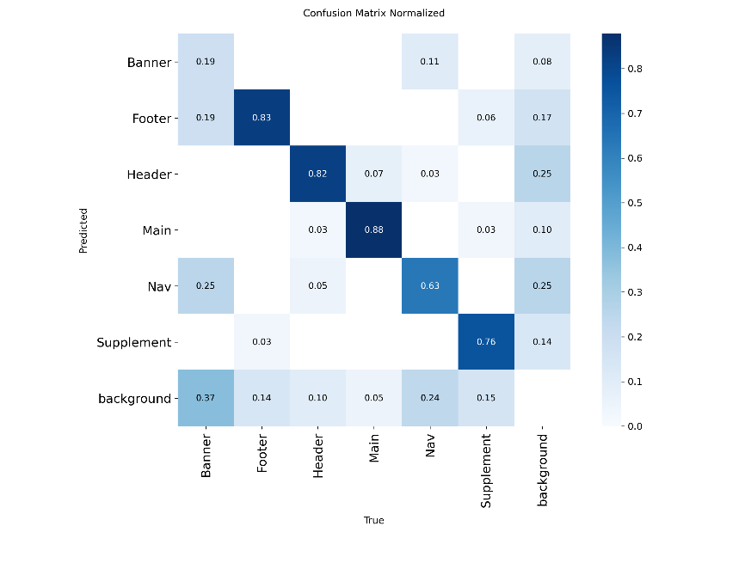
Run2 Confusion Matrix
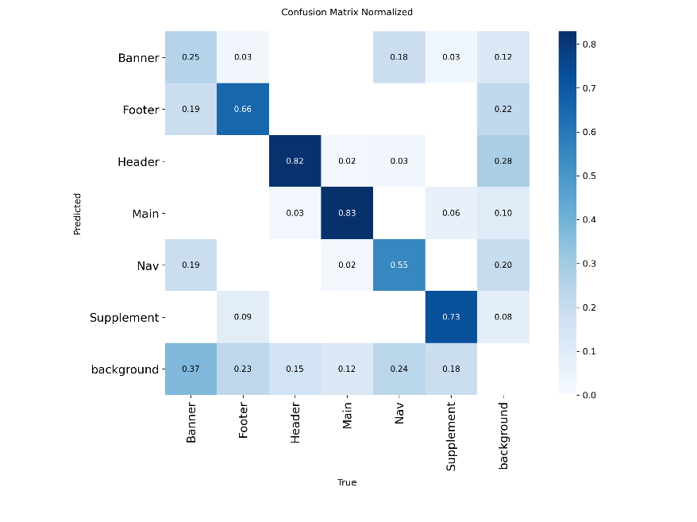
Both runs show strong diagonals for Header, Main, and Footer — well-separated classes. Run 3 reduces scatter in Nav and Supplement, showing improved segmentation of narrow horizontal and marginal bands.
However, Banner misclassifications remain frequent; it overlaps semantically and visually with Header regions. Background false positives persist around 15–20 %, largely due to design variance in captured websites.

Run1 Precision Recall Curve
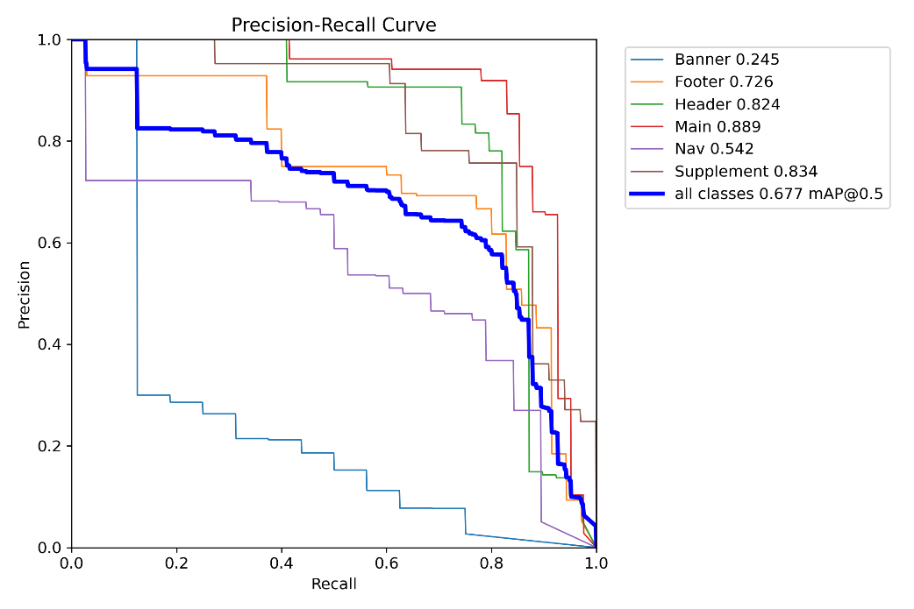
Run2 Precision Recall Curve
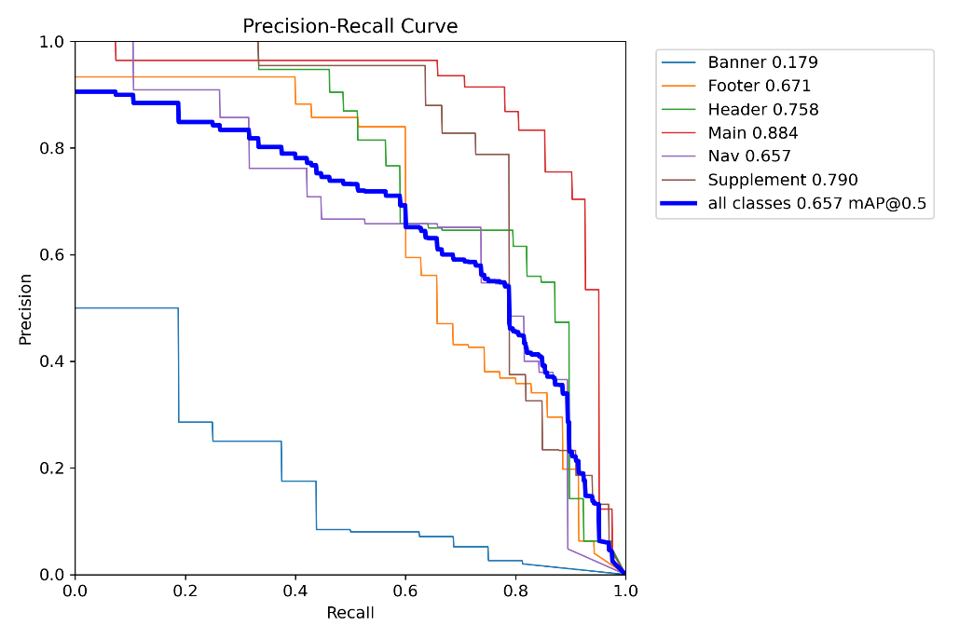
Compared to Run 1, Run 3’s curve is smoother and more balanced: Run 1 (640 px) shows a steep early precision drop near recall ≈ 0.1–0.2, revealing uneven confidence calibration. Run 3 (832 px) maintains a flatter, steadier curve, indicating better confidence distribution and improved handling of lower-confidence detections.
The right tail (recall > 0.7) declines more gradually, suggesting false positives increase linearly rather than abruptly. Although Run 3’s overall mAP @ 0.5 decreased slightly (0.657 vs 0.677), its curve area near mid-recall widened, confirming improved stability. This trade-off favors recall-sensitive detection — critical in layout extraction, where missing a region is worse than over-detecting one.

Success:
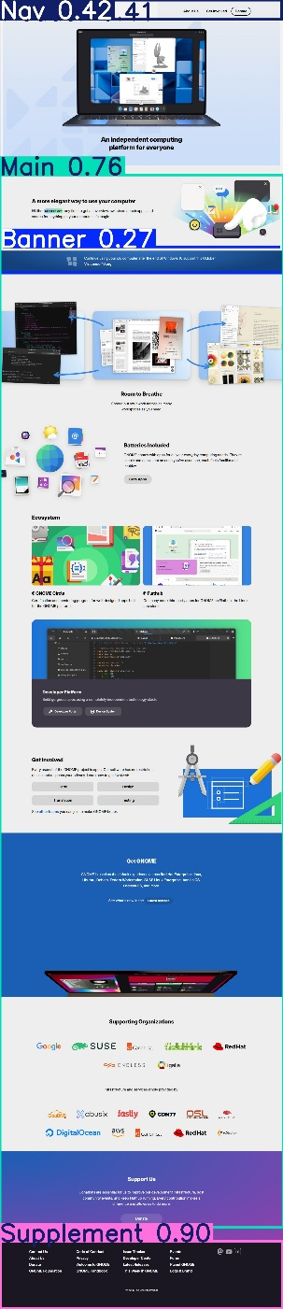

Failure:
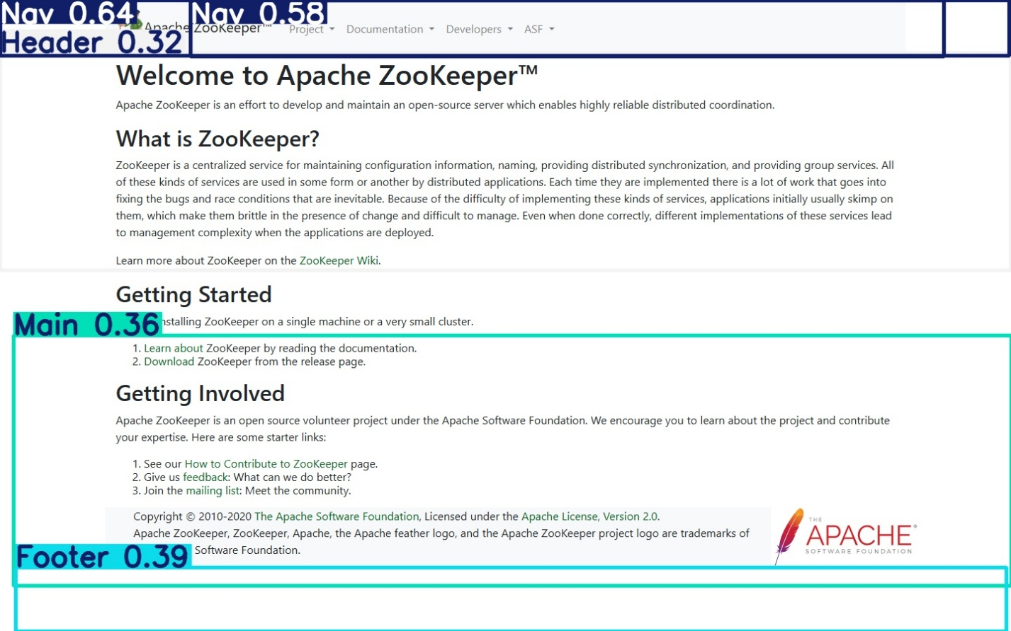
Modified parameter:
imgsz = 832 (previously 640)
This change increases the spatial resolution of input images by 1.69×, allowing the model to learn finer details in narrow interface bands (like navigation bars).
The trade-off is longer inference time and slightly higher false-positive rate, which explains the precision decline.
Other parameters (batch = 8, workers = 2, epochs = 50, color augmentation) were retained to isolate the effect of resolution.

Conclusions
Run 3 demonstrates more stable calibration and better localization, evidenced by smoother PR curves and higher mAP @ 0.5–0.95. Run 1 remains marginally superior in raw mAP @ 0.5 due to fewer false positives.
For real-world use (dynamic webpage segmentation), Run 3 is preferred, since smoother confidence behavior and improved Nav detection are more valuable than a small precision loss. Further improvement could come from targeted data augmentation — e.g., synthetic Banner/Header overlays or increased label diversity in small horizontal strips.

Reference:
Ultralytics. (2024). Ultralytics YOLOv8: Real-time object detection and image segmentation.
GitHub repository. https://github.com/ultralytics/ultralytics
Qian, Z. J. (2025). WFC UI Layout Dataset (v1.0): Labeled website band screenshots for YOLOv8 training. Self-compiled dataset, Simon Fraser University, School of Interactive Arts and Technology.
(Source data collected from ~200 publicly available technical and documentation websites between August and October 2025; includes six functional band classes: Banner, Header, Nav, Main, Supplement, and Footer.)

