Comparative Effectiveness of an Individualized Medication Assessment and Planning (iMAP) Intervention versus Standard Care in Older Adults
A Pragmatic Randomized Clinical Trial

William Zhang
BIS 681: Statistical Practice Capstone
April 29, 2026

Academic honesty attestation
"I have not given, received, or witnessed inappropriate exchange of information on this assignment, and I certify that this is my own original work."

Abstract
Background: Managing medications for older adults is a major public health topic. Insufficient care can lead to poor health outcomes and inflated healthcare costs. To address this problem, we evaluated whether a well-structured, 10-step pharmacist-guided Individualized Medication Assessment and Planning (iMAP) program could effectively reduce medication-related problems (MRPs) and decrease the need for acute health services.
Methods: This individually randomized, two-arm clinical trial enrolled 3,388 older adults (aged 65+) taking ≥3 medications. Participants were randomized 1:1 to iMAP (n=1,702) or Standard Care (n=1,686). Primary endpoints included total MRP count at 6 months, analyzed via a linear mixed-effects model with an AR(1) correlation structure, and time to first acute health service utilization over 12 months, analyzed via Cox Proportional Hazards (PH) regression.
Results: At 6 months, participants in the Standard Care group had 1.15 more MRPs than the iMAP group (95% CI: 0.92–1.38; p < 0.0001). While iMAP was associated with a reduction in the hazard of first acute health service utilization, the result was not statistically significant (HR = 0.929; 95% CI: 0.856–1.008; p = 0.0759). However, a secondary analysis using a Negative Binomial model revealed a significant reduction in the total count of acute health service utilizations (IRR = 0.916; p = 0.011).
Conclusions: The iMAP intervention significantly reduced the number of medication-related problems and total healthcare utilization counts. Although it did not significantly delay the time to the first acute event, it effectively mitigated the cumulative healthcare burden.

Lay Summary
Managing multiple medications is often a difficult situation for many seniors. In this study we tested a new program to tackle this issue, called iMAP (Individualized Medication Assessment and Planning), in which pharmacists join with a senior's care team to review their medications.
Our study followed 3,388 older adults for one year. We found that patients in the iMAP program had significantly fewer medication mistakes compared to those in the standard care group. These mistakes can include things like taking the wrong dose or missing necessary treatments.
While the program did not significantly delay the time for a patient to have their first hospital or emergency room visit, it did meaningfully reduce the total number of hospital visits patients had throughout the year. The result suggests that having a pharmacist actively involved in a senior’s care can make medication usage safer and thus reduce the overall burden on the healthcare system.

1. Introduction

Public Health Burden
Multiple medication use is common in older adults and is often necessary for maintaining health, but it can also create preventable harm when regimens are poorly coordinated or difficult to follow. In this report, medication-related problems (MRPs) include underuse, overuse, misuse, nonadherence, inappropriate prescribing, and adverse drug events [1-3]. Older adults with multiple chronic conditions are especially vulnerable because they may see several prescribers, take many daily medications, and have less reserve when a medication problem occurs [4].

iMAP Context
The individualized Medication Assessment and Planning (iMAP) program was developed to give clinical pharmacists a structured way to identify MRPs and recommend patient-specific medication changes [3]. Compared with narrower medication therapy management programs that focus on selected problems or are delivered outside routine primary care, iMAP was meant to look across the patient's medication regimen as a whole. This matters because an older adult's MRPs may come from interactions among prescriptions, monitoring gaps, adherence barriers, and care coordination problems rather than a single drug choice. The standardized 10-step pharmacist assessment was also embedded in the primary care team, making the intervention more intensive than a remote or one-time medication review [3,4]. A prior observational pilot study in 64 primary care patients suggested that iMAP could be implemented in routine care and might reduce MRPs, but the evidence was still limited by the small, non-randomized design [4]. The current trial took that work a step further by testing iMAP in a larger randomized setting and by evaluating outcomes that mattered clinically, not only the MRP count.

Research Question and Aims
The study asked whether iMAP was more effective than standard care for older adults receiving community-based primary care. The primary focus was on two outcomes: total MRPs at 6 months and time to first acute health service utilization within 12 months. We hypothesized that iMAP participants would have fewer 6-month MRPs and lower 12-month acute utilization than standard-care participants. For utilization, this could appear either as a longer time to the first hospitalization or emergency department visit or as fewer total acute events during follow-up.
- Aim 1: Estimate whether iMAP reduced total MRPs at 6 months compared with standard care.
- Aim 2: Estimate whether iMAP reduced the risk of first acute health service utilization within 12 months.
- Secondary analyses: Evaluate 12-month MRPs and the total number of acute utilization events during follow-up.

2. Methods

Trial Design and Participants
This was an individually randomized, pragmatic, two-arm clinical trial conducted in two community-based primary care practices. Eligible participants were English-speaking adults at least 65 years old who were taking at least three medications, including at least one prescription medication, had an expected survival of at least 12 months, and were receiving ongoing primary care. Participants were randomized 1:1 to iMAP or standard care and stratified by site and race.

Data Integrity and Cleaning
The final intention-to-treat analytic dataset included 3,388 participants after removing 12 duplicate rows caused by a merge problem. Before analysis, we standardized race and sex coding, caught and corrected six negative MRP values that were confirmed to be sign errors, and fixed utilization dates that created impossible zero or negative event times. These cleaning decisions were documented in the scripts and completed before the final treatment comparisons were run, so the corrections were not driven by which arm appeared to perform better.

Blinding
Participants and pharmacists could not be blinded because the intervention required pharmacist contact. Outcome assessors for MRPs and the statistical analysts were kept blinded to treatment assignment until the analysis dataset and primary models were finalized.

Statistical Software
All analyses were performed in R using packages for table construction, mixed models, survival analysis, and count models [5]. The reported estimates and model diagnostics were taken from the study data and R output.

3. Statistical Analysis Plan

General Approach
All primary analyses followed the intention-to-treat principle, so participants were analyzed according to their randomized assignment. Baseline balance was summarized descriptively by treatment arm. Two-sided tests were used, and 95% confidence intervals were reported for treatment effects.

Primary Outcomes
For MRPs, we used a linear mixed-effects model because repeated MRP measurements from the same participant were likely to be correlated. The patient-level random intercept allowed each participant to have their own underlying MRP level while estimating the treatment effect over time. The main model included treatment, time, a treatment-by-time interaction, site, and race. Because outcome missingness was related to observed clinical characteristics, we also checked covariate-adjusted MRP models that added age, total medications, and comorbid conditions. The treatment effect was reported as the adjusted mean difference in MRPs for standard care minus iMAP.
For time to first acute health service utilization, we fit a Cox proportional hazards model with treatment, site, and race. Deaths before utilization were censored in the primary analysis, and the proportional hazards assumption was assessed using Schoenfeld residuals.

Secondary and Sensitivity Analyses
Secondary analyses used the same mixed-model framework for 12-month MRPs. For total acute utilization counts over 12 months, we used a negative binomial regression model with follow-up time included as an offset; this choice was supported by overdispersion checks and a likelihood ratio comparison against a standard Poisson model. Because death could prevent a later utilization event, we also fit a Fine-Gray competing risks sensitivity model for time to first utilization.

Missing Data
The missing-data plan used available-case analysis only when missingness was small and not clearly related to baseline factors. If missingness was associated with observed baseline characteristics, the plan called for a covariate-adjusted sensitivity analysis; if missingness was larger or more consistent with a missing-at-random mechanism, multiple imputation was used as an additional sensitivity analysis. In this dataset, 6-month MRP missingness was 4.4% overall and balanced across treatment arms, but participants with missing 6-month MRP outcomes were older and had higher medication and comorbidity burden. For that reason, the 6-month MRP sensitivity analysis added age, total medications, and comorbid conditions to the mixed model. Because 12-month MRP missingness was higher, multiple imputation was also used as a sensitivity analysis for that outcome.

4. Results

Participant Flow and Baseline Characteristics
The final analytic sample included 1,702 participants assigned to iMAP and 1,686 assigned to standard care. Participant flow and outcome availability are shown in Figure 1. Baseline characteristics were very similar across treatment arms, including age, sex, race, site, medication burden, prior utilization, and comorbid conditions (Table 1). The age difference seen in the missingness review was therefore a complete-versus-incomplete outcome issue, not a treatment-arm imbalance.

Medication-Related Problems
Compared with standard care, participants in the iMAP group had fewer MRPs at both 6 and 12 months of follow-up. At 6 months, the adjusted mean number of MRPs in standard care was 1.15 higher than in iMAP (95% CI: 0.92 to 1.38; p < 0.0001). At 12 months, the adjusted difference increased to 1.71 MRPs (95% CI: 1.45 to 1.97; p < 0.0001). The residual Q-Q plots showed some tail deviation, especially at 12 months, but the planned sensitivity analyses were consistent with the primary estimates (Figure 2): 1.16 MRPs at 6 months after covariate adjustment and 1.75 MRPs at 12 months after multiple imputation.

Acute Health Service Utilization
For time to first acute utilization, the Cox model estimated a lower hazard in the iMAP group, but the result did not reach the conventional 0.05 significance threshold (HR = 0.929; 95% CI: 0.856 to 1.008; p = 0.0759). The global Schoenfeld residual test did not indicate a violation of the proportional hazards assumption (global p = 0.337). The Fine-Gray competing risks model gave a similar result (SHR = 0.930; p = 0.0821).
The total-count analysis was more supportive of an iMAP effect than the time-to-first-event analysis. Total acute utilization was lower in the iMAP arm, and the negative binomial model estimated an 8.4% lower utilization rate for iMAP compared with standard care (IRR = 0.916; 95% CI: 0.857 to 0.980; p = 0.011). Taken together, the utilization results suggest that the intervention may not clearly delay the first acute event, but it may reduce repeated acute care use over follow-up.

5. Discussion

Interpretation
Overall, there is strong evidence that the pharmacist-led iMAP intervention reduced MRPs in older adults receiving primary care. This was the clearest finding in the analysis: the treatment difference was statistically significant at both 6 and 12 months and remained similar in the sensitivity analyses. That pattern fits the purpose of iMAP, since the intervention was designed to review the overall medication regimen rather than correct only one isolated medication problem.
The utilization results need a more cautious interpretation. The Cox model did not show a statistically significant delay in first acute utilization, so the study does not provide strong evidence that iMAP prevents the first hospitalization or emergency department visit. However, the negative binomial model did show fewer total utilization events. Clinically, this distinction matters because two patients can have the same time to first event but very different numbers of later acute care visits. Reducing repeated events could still lower burden for patients and health systems even if the intervention does not completely prevent a first event.

Strengths and Limitations
Several strengths make the findings more credible. The sample was large, participants were analyzed according to their randomized assignments, and the data cleaning process corrected documented problems without changing the intention-to-treat framework. The analysis also had a complete plan for checking missingness, model assumptions, and sensitivity analyses, which was important given the different outcome types.
The main limitation is that outcome missingness was not completely random. Six-month missingness was below 5% and balanced by treatment arm, but missing cases were older and clinically more complex. Covariate-adjusted and multiple-imputation sensitivity analyses for the MRP outcomes were consistent with the primary estimates. The sample was also mostly White, which limits how confidently these results can be generalized to more racially diverse primary care populations. Finally, the MRP mixed models showed some residual tail deviation, especially for 12-month MRPs, so the exact model-based confidence intervals should be read with that diagnostic in mind.

Conclusion
Taken together, the findings support iMAP as a pharmacist-led strategy for reducing medication-related problems in older adults receiving primary care. The clearest evidence was for MRPs, where iMAP showed fewer problems at both 6 and 12 months and the sensitivity analyses did not materially change that conclusion. The utilization results were more mixed: iMAP did not significantly delay the first acute event, but it was associated with fewer total acute utilization events over follow-up. That pattern suggests the intervention may be more effective at reducing repeated acute care use than at preventing every first event. Future work should examine whether the reduction in MRPs helps explain later utilization changes, test the intervention in more racially diverse primary care populations, and identify which patients benefit most from pharmacist involvement.

6. References
1. Strand LM, Morley PC, Cipolle RJ, Ramsey R, Lamsam GD. Drug-related problems: their structure and function. Ann Pharmacother. 1990;24(11):1093-1097.
2. Shrank WH, Asch SM, Adams J, et al. The quality of pharmacologic care for adults in the United States. Med Care. 2006;44(10):936-945.
3. Crisp GD, Burkhart JI, Esserman DA, Weinberger M, Roth MT. Development and testing of a tool for assessing and resolving medication-related problems in older adults in an ambulatory care setting: the individualized medication assessment and planning (iMAP) tool. Am J Geriatr Pharmacother. 2011;9(6):451-460. doi:10.1016/j.amjopharm.2011.10.003.
4. Roth MT, Ivey JL, Esserman DA, Crisp G, Kurz J, Weinberger M. Individualized Medication Assessment and Planning: optimizing medication use in older adults in the primary care setting. Pharmacotherapy. 2013;33(8):787-797. doi:10.1002/phar.1274.
5. R Core Team. R: A language and environment for statistical computing. Vienna, Austria: R Foundation for Statistical Computing.
Note on the Use of Artificial Intelligence: AI tools were used to help with literature/background brainstorming, organization, analysis explanation, and wording edits. The statistical analyses, reported estimates, and final interpretations were checked by the author against the study data and analysis output.

Appendix A: Tables and Figures
Table 1. Baseline characteristics stratified by treatment group.
Variable | Level | Overall (N=3,388) | iMAP (N=1,702) | Standard Care (N=1,686)
Race, n (%) | non-White | 712 (21.0) | 359 (21.1) | 353 (20.9)
 | White | 2,676 (79.0) | 1,343 (78.9) | 1,333 (79.1)
Sex, n (%) | Female | 2,195 (64.8) | 1,094 (64.3) | 1,101 (65.3)
 | Male | 1,193 (35.2) | 608 (35.7) | 585 (34.7)
Site, n (%) | Site A | 2,202 (65.0) | 1,103 (64.8) | 1,099 (65.2)
 | Site B | 1,186 (35.0) | 599 (35.2) | 587 (34.8)
Age, mean (SD) | - | 78.55 (7.91) | 78.51 (7.95) | 78.59 (7.86)
Total medications, mean (SD) | - | 10.43 (3.14) | 10.48 (3.12) | 10.37 (3.16)
Prescribed medications, mean (SD) | - | 6.92 (2.47) | 6.98 (2.44) | 6.87 (2.50)
Prior health utilizations, mean (SD) | - | 1.64 (2.02) | 1.62 (2.00) | 1.67 (2.04)
Comorbid conditions, mean (SD) | - | 4.83 (1.30) | 4.86 (1.30) | 4.81 (1.30)
Note. Continuous variables are shown as mean (SD); categorical variables are shown as n (%).
Table 2. Summary of estimated treatment effects.
Outcome | Model | Effect estimate | 95% CI | p-value
MRPs at 6 months | Mixed model | SC - iMAP = 1.15 MRPs | 0.92 to 1.38 | <0.0001
MRPs at 12 months | Mixed model | SC - iMAP = 1.71 MRPs | 1.45 to 1.97 | <0.0001
Time to first utilization | Cox PH | HR = 0.929 | 0.856 to 1.008 | 0.0759
Competing risks sensitivity | Fine-Gray | SHR = 0.930 | 0.857 to 1.009 | 0.0821
Total utilization count | Negative binomial | IRR = 0.916 | 0.857 to 0.980 | 0.011
Note. SC = Standard Care; HR = hazard ratio; SHR = subdistribution hazard ratio; IRR = incidence rate ratio.
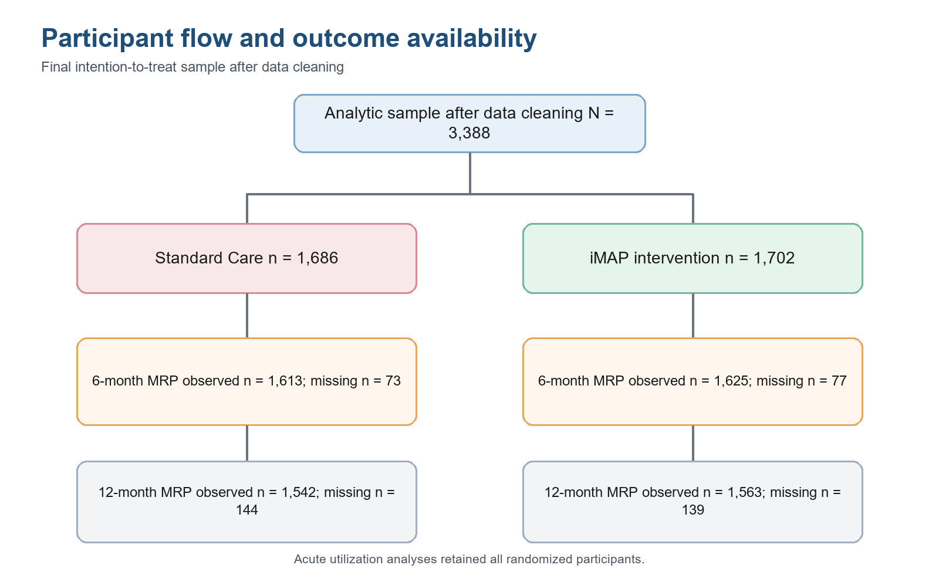
Figure 1. Participant flow and outcome availability in the intention-to-treat analytic sample.
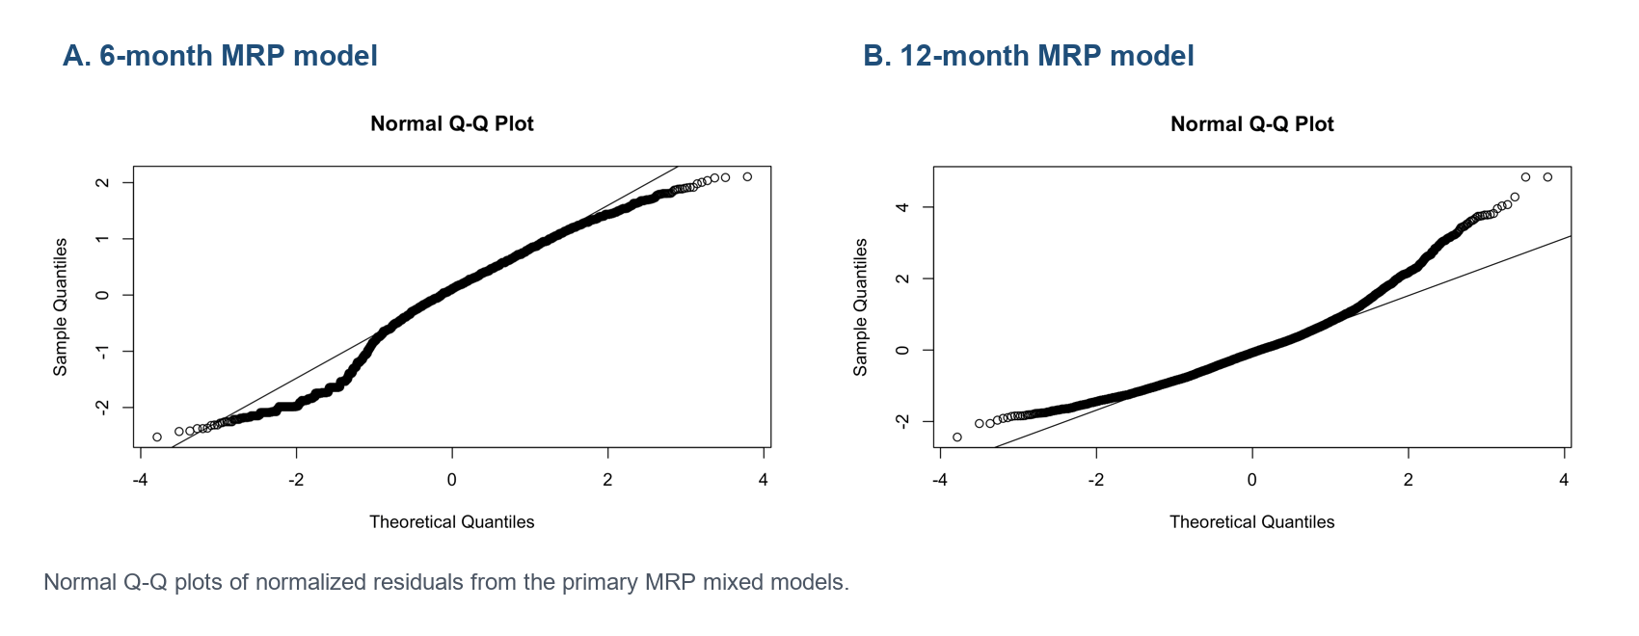
Figure 2. Normal Q-Q plots for residuals from the 6-month and 12-month MRP mixed models.

Appendix B: Annotated R Code
The code below includes the main analysis steps used for the results presented in this report. File paths were adjusted locally when scripts were run.

Data cleaning and validation
# Read raw trial data and standardize coding.
raw <- read_csv("iMAP_Data.csv", show_col_types = FALSE)
df <- raw %>%
mutate(
race = case_when(race %in% c("black", "Black") ~ "Black", TRUE ~ race),
race_strat = ifelse(race == "White", "White", "non-White"),
sex = case_when(sex %in% c("F", "Female") ~ "Female",
sex %in% c("M", "Male") ~ "Male", TRUE ~ sex)
)
# Mentor-confirmed data corrections before analysis.
df <- df %>% mutate(MRP_6 = ifelse(MRP_6 < 0, MRP_6 * -1, MRP_6))
# neg_time_ids were records identified during validation as having impossible event times.
df <- df %>% mutate(Utilization = if_else(ID %in% neg_time_ids,
Utilization + years(1), Utilization))
df <- df %>% filter(race != "Unknown")
# Validation checks used before saving the analysis dataset.
stopifnot(all(df$MRP_0 >= 0))
stopifnot(all(df$MRP_6 >= 0, na.rm = TRUE))
stopifnot(all(df$MRP_12 >= 0, na.rm = TRUE))
stopifnot(all(df$time_to_event >= 0))
stopifnot(nrow(df) == 3388)
write_csv(df, "iMAP_Data_Cleaned.csv")

Baseline table and missingness review
cat_vars <- c("Treatment", "race_strat", "sex", "site")
cont_vars <- c("Age", "Total_Meds", "Presc_Meds",
"Health_Utilization", "Conditions")
table1 <- CreateTableOne(vars = c(cat_vars, cont_vars),
strata = "Treatment",
data = df,
factorVars = cat_vars,
addOverall = TRUE)
df <- df %>% mutate(incomplete_outcome = ifelse(is.na(MRP_6), 1, 0))
table1_mcar <- CreateTableOne(vars = c(cat_vars, cont_vars),
strata = "incomplete_outcome",
data = df,
factorVars = cat_vars)

MRP mixed models
df_long <- df %>%
select(ID, Treatment, site, race_strat, Age, Conditions, Total_Meds,
MRP_0, MRP_6) %>%
pivot_longer(cols = c(MRP_0, MRP_6),
names_to = "time", values_to = "MRP") %>%
mutate(time = ifelse(time == "MRP_0", 0, 6),
ID = factor(ID),
Treatment = factor(Treatment, levels = c("Standard Care", "iMAP")))
mrp6_primary <- lme(
fixed = MRP ~ Treatment * time + site + race_strat,
random = ~1 | ID,
correlation = corAR1(form = ~ time | ID),
data = df_long,
na.action = na.exclude,
method = "REML"
)
emm <- emmeans(mrp6_primary, ~ Treatment | time)
summary(contrast(emm, method = "pairwise", by = "time"), infer = TRUE)
# Sensitivity model used because 6-month missingness related to baseline factors.
mrp6_sensitivity <- update(
mrp6_primary,
fixed = MRP ~ Treatment * time + site + race_strat +
Age + Conditions + Total_Meds
)
qqnorm(residuals(mrp6_primary, type = "normalized"))
qqline(residuals(mrp6_primary, type = "normalized"))
# 12-month secondary MRP model.
df_long_12 <- df %>%
select(ID, Treatment, site, race_strat, Age, Conditions, Total_Meds,
MRP_0, MRP_12) %>%
pivot_longer(cols = c(MRP_0, MRP_12),
names_to = "time", values_to = "MRP") %>%
mutate(time = ifelse(time == "MRP_0", 0, 12),
ID = factor(ID),
Treatment = factor(Treatment, levels = c("Standard Care", "iMAP")))
mrp12_model <- lme(
fixed = MRP ~ Treatment * time + site + race_strat +
Age + Conditions + Total_Meds,
random = ~1 | ID,
correlation = corAR1(form = ~ time | ID),
data = df_long_12,
na.action = na.exclude,
method = "REML"
)
emm12 <- emmeans(mrp12_model, ~ Treatment | time)
summary(contrast(emm12, method = "pairwise", by = "time"), infer = TRUE)
# Multiple-imputation sensitivity analysis for 12-month MRPs.
imp_data <- df %>%
select(ID, Treatment, site, race_strat, Age, Conditions, Total_Meds,
MRP_0, MRP_6, MRP_12) %>%
mutate(across(c(ID, Treatment, site, race_strat), factor))
ini <- mice(imp_data, maxit = 0)
meth <- ini$method
pred <- ini$predictorMatrix
meth["ID"] <- ""
meth[c("MRP_6", "MRP_12")] <- "pmm"
imp <- mice(imp_data, m = 20, method = meth, predictorMatrix = pred, seed = 123)
# Fit the same 12-month model in each imputed dataset and pool the contrast
# estimates using Rubin's rules.

Utilization models
surv_obj <- Surv(time = df$time_to_event, event = df$status)
cox_model <- coxph(surv_obj ~ Treatment + site + race_strat, data = df)
ph_test <- cox.zph(cox_model)
df <- df %>% mutate(event_cr = case_when(
status == 1 ~ 1L,
status == 0 & death == 1 ~ 2L,
TRUE ~ 0L
))
fg_data <- finegray(Surv(time_to_event, factor(event_cr)) ~ .,
data = df %>% select(time_to_event, event_cr, Treatment, site, race_strat),
etype = "1")
fg_model <- coxph(Surv(fgstart, fgstop, fgstatus) ~ Treatment + site + race_strat,
data = fg_data, weight = fgwt)
df <- df %>% mutate(follow_up_months = ifelse(death == 1, time_to_event / 30.44, 12))
nb_model <- glm.nb(status_total ~ Treatment + site + race_strat +
offset(log(follow_up_months)), data = df)

