Facial Paralysis Technical Report

1. Data Preprocessing

1.1 Input Data
Each session is a single iPhone video recorded with the LiveLinkFace application. The video is captured in portrait at 720 × 1280, at 60 frames per second. Recordings are short by design (ideally 45s, but the current videos are around 3-4 mins).

1.2 Landmark Extraction
Each frame is processed by Google MediaPipe FaceLandmarker in video mode, under a single-face assumption. The model returns three per-frame outputs. The first is a set of 478 three-dimensional facial landmarks, of which 468 lie on the face mesh and 10 trace the iris boundaries. The second is a vector of 52 ARKit-compatible blendshape coefficients in [0, 1], encoding higher-level expressions. The third is a 4 × 4 rigid transformation matrix that describes the six-degree-of-freedom head pose. Downstream modeling reads from these three streams.

1.3 Per-Take Outputs
For each video the pipeline writes the artifacts below, together with an annotated preview video and a top-level batch manifest.
Artifact | Shape | Description
Landmark coordinates | n_frames × 478 × 3 | Image-plane x, y in [0, 1] and a relative depth per landmark
Blendshape coefficients | n_frames × 52 | ARKit expression intensities in [0, 1]
Head pose matrices | n_frames × 4 × 4 | Per-frame 6-DOF rigid transform of the face
Annotated preview video | Original resolution and frame rate | All 478 landmarks overlaid for visual inspection
Batch manifest | One row per video | Resolution, frame rate, frame counts, face-detection rate, processing time

1.4 Training-Time Preprocessing
The outputs of Section 1.3 are general-purpose. Each downstream model defines its own training preprocessing on top of them. Every pose recording is summarized by a small set of representative frames, at minimum a neutral start frame and a peak-exertion frame. The peak frame is selected automatically from blendshape activity. These frames are then assembled into the input expected by the chosen architecture. Hard geometric pre-alignment of the face is avoided. Compensatory head tilt is itself a facial-palsy feature, and forced left-right symmetry destroys the very asymmetry the model is meant to measure. Implementation details are deferred to the training scripts.

1.5 Pretraining and External Datasets
Transfer learning is essential at the planned cohort size. We combine self-supervised face-video pretraining with FP-specific supervised pretraining, using the public resources below.
Source | Scale and type | How we use it
Marlin (CVPR 2023) | 700k+ YouTube face videos, MAE-pretrained | Frozen face-video encoder for facial dynamics
FaRL (CVPR 2022) | 20M face-text pairs, CLIP-style | Alternative per-frame face image encoder
MEEI Facial Palsy Standard Set | 60 patients, with SFGS, HB, and eFACE labels | Supervised warm-start before Mayo fine-tuning
YouTube Facial Palsy (YFP) | 31 videos, 21 patients | External validation benchmark
PalsyNet (HuggingFace) | YouTube FP frames | Auxiliary binary FP-versus-healthy pretraining

2. Model Selection

2.1 Architecture Comparison
The candidate model families are summarized below. At our cohort size, inductive bias and small-data behavior are the dominant criteria.
Architecture | Inductive bias | Strengths | Weaknesses
Closed-form geometric | Hand-designed symmetry formulas over landmark coordinates, with no learning | Interpretable and deterministic, and needs no training data | Performance ceiling is the formula itself. Reported r between 0.46 and 0.73 (Heinrich 2025 and 2026)
Classical ML on engineered features | Hand-crafted asymmetry or blendshape features fed to an SVM, a random forest, or gradient boosting | Data-efficient, with transparent feature importance | Feature engineering caps accuracy, and cannot exploit raw pixel or temporal structure
CNN | Translation-equivariant, with local receptive fields | Mature and data-efficient at small n. Used in the Harkel 2024 baseline | Not rotation-invariant, and cannot natively use the landmark graph
GNN | Permutation-equivariant on graph nodes, with message passing over mesh edges | Matches the MediaPipe face mesh graph. Shagdar 2024 reports about 95% accuracy | Ignores raw image texture, and usually needs a companion vision branch
Transformer (general) | Self-attention over an arbitrary token sequence, for example landmarks, blendshapes, or video clips. No spatial prior | Flexible, supports cross-modal fusion, and scales with data | Quadratic in sequence length, and data-hungry
Vision Transformer (ViT) | Specialization where tokens are fixed-size image patches with learned positional embeddings | State of the art on large image benchmarks | Typically requires >100k samples to outperform CNNs from scratch

The chosen architectures, the training plan, and the cohort-size feasibility analysis are deferred to the Zotero demonstration.

2.2 Reference Baselines
Four baselines from the recent facial paralysis literature are carried as reference points. Three are converted to House-Brackmann output by training a head on our data; the fourth is evaluated on its native binary task.
1. Oo et al. 2025 (MLP-Mixer + handcrafted features). Multimodal fusion model combining a pretrained MLP-Mixer image encoder with 29 handcrafted geometric features computed from MediaPipe landmarks. The original code repository was retracted; we reconstructed the inference pipeline from a Wayback Machine snapshot and the released checkpoint files. The frozen MLP-Mixer is used as a 768-dimensional face representation, on top of which an HB classifier head is trained.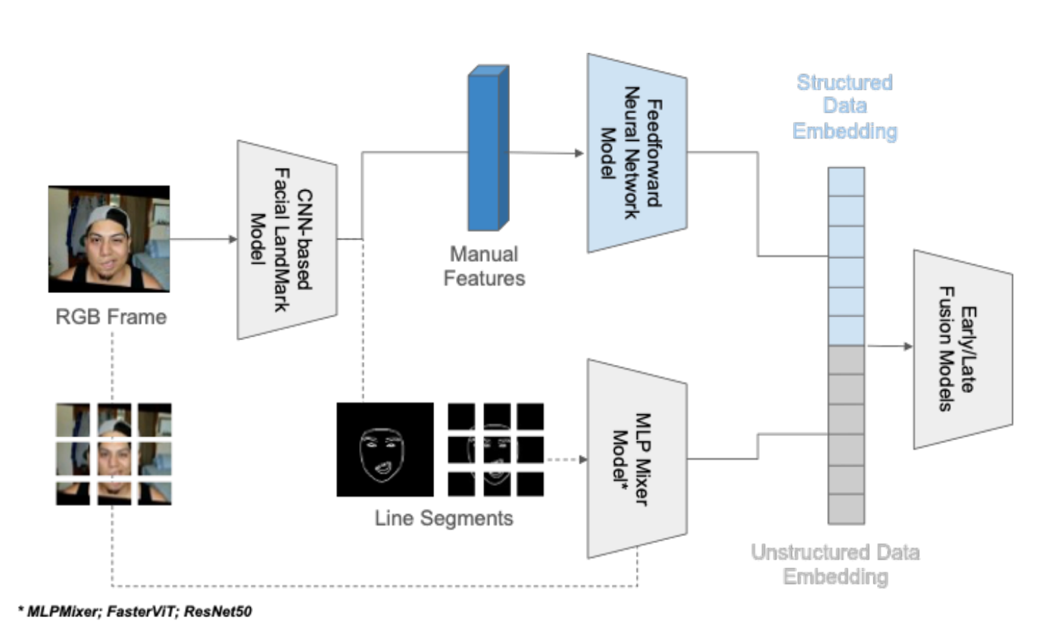
2. Gaber et al. 2022 (Animation Symmetry Index). Kinect-based facial paralysis assessment paper that defines an Animation Symmetry Index (ASI) over pairs of facial animation units in the eye, eyebrow, and mouth regions. The paper released no code; we reimplemented the eight ASI equations from scratch and mapped the original Kinect animation unit schema to our ARKit and MediaPipe blendshapes. An HB head is trained on the per-action ASI vector.
3. Baumann 2022 (House-Brackmann CNN ensemble). Master's thesis from OTH Regensburg. Five ResNet-18 sub-networks (symmetry, eye, mouth, forehead, and direct HB) consume nine standardized poses per patient through an early-fusion 27-channel conv1, and emit an HB grade either directly or via a finite-state automaton over the four module-level outputs. The only HB-native baseline in our shortlist. We fine-tune the released checkpoints on our cohort.
4. Shagdar et al. 2024 (graph neural network). Workshop paper that builds a face graph from 478 MediaPipe landmarks via Delaunay triangulation and applies a GCN backbone (GCNMid) for binary stroke versus non-stroke classification on the Toronto NeuroFace dataset. We use the released weights as-is and evaluate the model on its native binary task, comparing against a binary collapse of our HB labels.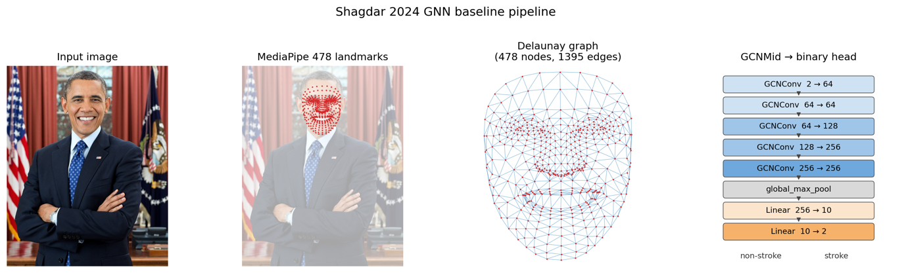

3. Evaluation

3.1 Scoring Standards
The clinical team has selected the House-Brackmann (HB) scale as the primary grading target for this project. HB is summarized below.
Scale | Output | Human IRR | Notes
House-Brackmann (HB) | Ordinal grade I to VI | Kappa 0.40 to 0.55 | Older clinical standard. Still widely used, but less reliable

3.2 House-Brackmann Action Protocol
The House-Brackmann scale is a holistic clinician assessment without a single canonically prescribed pose sequence. The data-capture session probes the three motor regions assessed by HB (forehead, eye, mouth) and exposes secondary movement (synkinesis), via the following standard poses. Each pose is held for approximately three seconds, with a brief rest between.
Rest. Neutral face, eyes open and mouth closed, held for approximately 5 seconds. Provides the resting symmetry baseline.
Brow elevation. Eyebrows raised maximally. Probes the frontalis muscle, served by the temporal branch of the facial nerve.
Light eye closure. Eyes closed gently, as if falling asleep. Probes orbicularis oculi and reveals lagophthalmos when present.
Forced eye closure. Eyes squeezed tightly shut. Tests maximum orbicularis oculi function and exposes synkinesis (involuntary mouth or cheek movement co-occurring with eye closure). This pose is particularly important for distinguishing HB Grade II and III, where synkinesis is the discriminating sign.
Open-mouth smile. Broad smile with teeth visible. Probes the zygomaticus complex (buccal branch). Commissure deviation is the dominant FP signal at the mouth.
Additional poses such as snarl (nose wrinkle / upper lip lift) and lip pucker may be captured for richer dynamics but are not strictly required for HB grading.

3.3 House-Brackmann Grading Criteria
The House-Brackmann scale assigns one of six grades based on the holistic appearance during the standard exam. Brief definitions per Brackmann & House (1985):
Grade I (Normal). Normal symmetric facial function in all areas. No synkinesis, contracture, or spasm.
Grade II (Mild dysfunction). Slight weakness noticeable only on close inspection. At rest, normal symmetry and tone. Forehead, moderate to good function. Eye, complete closure with minimum effort. Mouth, slight asymmetry with movement. May have very slight synkinesis.
Grade III (Moderate dysfunction). Obvious but not disfiguring difference between the two sides. At rest, normal symmetry and tone. Forehead, slight to moderate movement. Eye, complete closure with effort. Mouth, slightly weak with maximum effort. Noticeable but not severe synkinesis, contracture, or hemifacial spasm. (This is the boundary where synkinesis becomes a defining feature.)
Grade IV (Moderately severe dysfunction). Obvious weakness and/or disfiguring asymmetry. At rest, normal symmetry and tone. Forehead, no motion. Eye, incomplete closure. Mouth, asymmetric with maximum effort.
Grade V (Severe dysfunction). Only barely perceptible motion. At rest, asymmetry is now apparent. Forehead, no motion. Eye, incomplete closure. Mouth, slight movement.
Grade VI (Total paralysis). No movement. Loss of tone. No synkinesis, contracture, or hemifacial spasm.
The scale focuses on three motor regions (forehead, eye, mouth) and secondary movements (synkinesis, contracture, spasm). Inter-rater reliability is moderate (kappa 0.40 to 0.55), which sets an upper bound on the agreement any model can be expected to achieve against a single clinician.

