姓名 | 周海博
评分

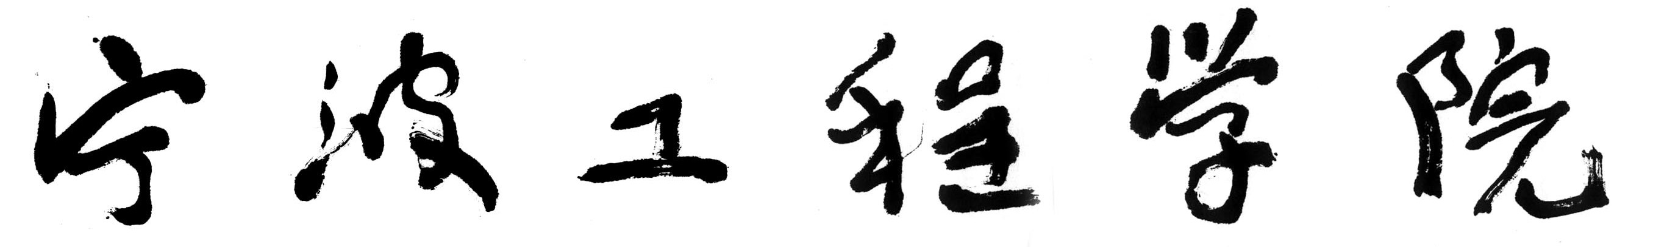

统计与数据科学学院课程报告


课程名称： C语言课程设计
题 目： 闯关游戏
班 级： 统计25-2
姓名学号： 周海博（25480030221）
指导教师： 陈明

2026年7月3日
一、设计目的
设计一个闯关游戏。玩家通过躲避敌人、拾取子弹、发射子弹、消灭敌人来实现通关。
游戏规则
玩家（红色方块）通过小写英文字母wasd进行上下左右的移动，移动至供应点（黄色方块）获取子弹，通过ijkl进行子弹的发射，子弹遇到敌人（蓝色方块）后消灭敌人。
游戏特性：
1.子弹打到供应点会穿过并摧毁供应点
2.敌人无法通过墙壁和供应点
二、总体设计
模仿推箱子游戏和小球反弹游戏的思路，将整个游戏分为面子和里子
面子：将整个游戏看成一个棋盘（通过drawbk()函数实现），将游戏的各个要素（空白，玩家，敌人，墙壁，子弹）看成棋子。用一个二维数组记录棋盘各个位置上的棋子，每隔一段时间或玩家每操作一次就把棋子的情况刷在棋盘上（通过drawtoken()实现）。
里子：主函数负责推进游戏，把握游戏节奏。通过setup1()和setup2()设置第一关和第二关的地图。每200ms检测一次按键，通过move()移动玩家位置，通过shoot()控制子弹移动并检测是否击中敌人，通过moveA(),moveB(),moveC()实现敌人的移动并检测是否触碰玩家。

三、详细设计
（1）drawbk()— 绘制棋盘背景
设置白色背景，黑色线条绘制11×11网格线（实际为10×10个格子）。
（2）drawtoken()— 绘制所有游戏元素
遍历state[1..10][1..10]，根据值填充不同颜色或绘制特殊形状：
0: 白色矩形（空地）
1: 黑色矩形（墙壁）
2: 黄色矩形（弹药箱）
3: 红色矩形（玩家）
4: 蓝色矩形（敌人）
5: 红色对角线交叉（玩家死亡）
6: 绿色矩形（弹药拾取瞬间）
7: 品红色圆（子弹）
8: 紫色矩形（敌人死亡）
（3）setup1()/ setup2()— 关卡初始化
重置全局变量，清空state，按预置坐标放置墙壁、弹药箱、敌人、玩家。
第一关：两个敌人，分别水平/垂直往返；第二关：三个敌人，使用BFS寻路。
（4）plx()/ ply()— 获取玩家坐标
遍历state查找值为3的格子，返回其行/列。
（5）move(char key)— 玩家移动
根据按键w/s/a/d计算目标格子。
若目标为空地：直接移动（原位置置0，新位置置3）。
若目标为弹药箱：先改为6（绿色闪烁），弹药数+1，延迟50ms后再改为3。
（6）moveA()/ moveB()/ moveC()— 敌人移动
第一关：moveA水平移动（Ai方向），moveB垂直移动（Bj方向）；撞墙或边界则反向；若踩到玩家则触发失败。
第二关：三个敌人均采用BFS寻路：
1.以敌人当前位置为起点，玩家位置为目标。
2.使用队列进行广度优先搜索，允许通行的格子为state==0（空地）或state==3（玩家）。
3.回溯得到从起点到目标的第一步，执行移动。
4.若第一步即为玩家位置，则判定失败。
（7）shoot(char key)— 射击
弹药数减1，根据方向（i上/k下/j左/l右）沿直线逐格扫描。
每步将子弹（7）画在当前位置，擦除前一格，延迟50ms制造动画效果。
遇墙壁或边界：停止并清除子弹。
遇敌人（4）：改为敌人死亡标记（8），标记对应敌人为false，延迟50ms后清除该格。
（8）main()— 主控循环
初始化图形窗口，调用drawbk()。
进入第一关循环（while(checkpoint==1)）：
每200ms调用moveA()、moveB()。
检测键盘输入，调用move()或shoot()。
若两敌皆死则checkpoint++进入第二关；若lose==true则退出。
过渡后调用setup2()重置地图。
进入第二关循环（while(checkpoint==2)）：
每200ms递增计数器k，当k%5==0时才移动敌人（降低难度）。
三敌皆死则胜利；失败同理。

四、程序代码
#include<conio.h>
#include<graphics.h>
#include<stdio.h>
const int len = 60, grid=10;
int bullet = 0;
int state[11][11] = { 0 };
int Ax, Ay, Bx, By,Cx, Cy, Ai,Aj,Bi,Bj,Ci,Cj;
int checkpoint = 0;
bool lose = false, A = true, B = true, C=true;
void drawbk() {
setbkcolor(WHITE);
cleardevice();
setlinecolor(BLACK);
for (int i = 1; i <= grid + 1; i++)
{
line(i * len, len, i * len, (grid + 1) * len);
line(len, i * len, (grid + 1) * len, i * len);
}
return;
}

void drawtoken() {
int i, j;
for (i = 1; i <= grid; i++) {
for (j = 1;j <= grid;j++)
{
if (state[i][j] == 0) {
setfillcolor(WHITE);
fillrectangle(i * len, j * len, (i + 1) * len, (j + 1) * len);
}
if(state[i][j] == 1) {
setfillcolor(BLACK);
fillrectangle(i * len, j * len, (i + 1) * len, (j + 1) * len);
}
if (state[i][j] == 2) {
setfillcolor(YELLOW);
fillrectangle(i * len, j * len, (i + 1) * len, (j + 1) * len);
}
if (state[i][j] == 3) {
setfillcolor(RED);
fillrectangle(i * len, j * len, (i + 1) * len, (j + 1) * len);
}
if (state[i][j] == 4) {
setfillcolor(BLUE);
fillrectangle(i * len, j * len, (i + 1) * len, (j + 1) * len);
}
if (state[i][j] == 5) {
setlinecolor(RED);
line(i * len, j * len, (i + 1) * len, (j + 1) * len);
line(i * len, (j + 1) * len, (i + 1) * len, j * len);
}
if (state[i][j] == 6) {
setfillcolor(GREEN);
fillrectangle(i * len, j * len, (i + 1) * len, (j + 1) * len);
}
if (state[i][j] == 7) {
setfillcolor(LIGHTMAGENTA);
fillcircle((i+0.5)* len,(j+0.5) * len, 0.3 * len);
}
if (state[i][j] == 8) {
setfillcolor(MAGENTA);
fillrectangle(i * len, j * len, (i + 1) * len, (j + 1) * len);
}
}

}
return;
}
void setup1() {
A = true, B = true;
state[1][1] = 3;

state[5][9] = 2;
state[8][4] = 2;
state[9][7] = 2;

state[4][7] = 4;
state[6][2] = 4;
Ax = 4;Ay = 7;Bx = 6;By = 2;
Ai = 1;Aj = 0;Bi = 0;Bj = 1;

state[1][4] = 1;
state[1][5] = 1;
state[1][6] = 1;
state[2][6] = 1;
state[3][2] = 1;
state[3][3] = 1;
state[3][4] = 1;
state[4][2] = 1;
state[5][4] = 1;
state[5][5] = 1;
state[5][6] = 1;
state[4][6] = 1;
state[4][8] = 1;
state[4][9] = 1;
state[5][8] = 1;
state[7][3] = 1;
state[8][3] = 1;
state[9][3] = 1;
state[9][4] = 1;
state[7][6] = 1;
state[8][6] = 1;
state[9][6] = 1;
state[9][8] = 1;
state[10][8] = 1;
state[7][8] = 1;
state[7][9] = 1;

drawtoken();
return;
}

int plx() {
for (int i = 1;i <= 10;i++) {
for (int j = 1; j <= 10; j++) {
if (state[i][j] == 3) return i;
}
}
}

int ply() {
for (int i = 1;i <= 10;i++) {
for (int j = 1; j <= 10; j++) {
if (state[i][j] == 3) return j;
}
}
}

void move(char key) {
int x = plx();
int y = ply();
if (key == 'w') {
if (state[x][y - 1] == 0 && y > 1) {
state[x][y] = 0;
state[x][y - 1] = 3;
}
if (state[x][y - 1] == 2) {
state[x][y] = 0;
state[x][y - 1] = 6;
bullet++;
drawtoken();
Sleep(50);
state[x][y - 1] = 3;
}

}
if (key == 's') {
if (state[x][y + 1] == 0 && y < 10) {
state[x][y] = 0;
state[x][y + 1] = 3;
}
if (state[x][y + 1] == 2) {
state[x][y] = 0;
state[x][y + 1] = 6;
bullet++;
drawtoken();
Sleep(50);
state[x][y + 1] = 3;
}
}
if (key == 'a') {
if (state[x - 1][y] == 0 && x > 1) {
state[x][y] = 0;
state[x - 1][y] = 3;
}
if (state[x - 1][y] == 2) {
state[x][y] = 0;
state[x - 1][y] = 6;
bullet++;
drawtoken();
Sleep(50);
state[x - 1][y] = 3;
}
}
if (key == 'd') {
if (state[x + 1][y] == 0 && x < 10) {
state[x][y] = 0;
state[x + 1][y] = 3;
}
if (state[x + 1][y] == 2) {
state[x][y] = 0;
state[x + 1][y] = 6;
bullet++;
drawtoken();
Sleep(50);
state[x + 1][y] = 3;
}
}
drawtoken();
return;
}

void moveA() {//Move the enemy A and check if it hits the player
if (checkpoint == 1 && A == true) {
if (state[Ax+Ai][Ay] == 0 && Ax + Ai > 0 && Ax+Ai <11) {
state[Ax][Ay] = 0;
state[Ax+Ai][Ay] = 4;
Ax = Ax + Ai;
drawtoken();
}
else if (state[Ax + Ai][Ay] == 3) {
state[Ax][Ay] = 0;
state[Ax + Ai][Ay] = 5;
Ax = Ax + Ai;
drawtoken();
lose = true;
}
else Ai = -Ai;
}
if (checkpoint == 2) {
int px = plx();
int py = ply();
int qx[105], qy[105];
int head = 0, tail = 0;
int prevX[11][11], prevY[11][11];
bool visited[11][11] = { false };
qx[tail] = Ax;
qy[tail] = Ay;
tail++;
visited[Ax][Ay] = true;
prevX[Ax][Ay] = -1;
prevY[Ax][Ay] = -1;
int dx[4] = { 0, 0, -1, 1 };
int dy[4] = { -1, 1, 0, 0 };
bool found = false;
int targetX = -1, targetY = -1;
while (head < tail) {
int cx = qx[head];
int cy = qy[head];
head++;
if (cx == px && cy == py) {
found = true;
targetX = cx;
targetY = cy;
break;
}
for (int d = 0; d < 4; d++) {
int nx = cx + dx[d];
int ny = cy + dy[d];
if (nx < 1 || nx > 10 || ny < 1 || ny > 10) continue;
if (visited[nx][ny]) continue;
if (state[nx][ny] == 1 || state[nx][ny] == 2 || state[nx][ny] == 4) continue;
visited[nx][ny] = true;
prevX[nx][ny] = cx;
prevY[nx][ny] = cy;
qx[tail] = nx;
qy[tail] = ny;
tail++;
}
}
if (!found) return;
int bx = targetX, by = targetY;
while (!(prevX[bx][by] == Ax && prevY[bx][by] == Ay)) {
int pbx = prevX[bx][by];
int pby = prevY[bx][by];
bx = pbx;
by = pby;
}
if (bx == px && by == py) {
state[Ax][Ay] = 0;
state[bx][by] = 5;
Ax = bx; Ay = by;
lose = true;
drawtoken();
return;
}
state[Ax][Ay] = 0;
state[bx][by] = 4;
Ax = bx; Ay = by;
drawtoken();
}
return;
}

void moveB() {
if (checkpoint == 1 && B==true) {
if (state[Bx][By + Bj] == 0 && By + Bj > 0 && By + Bj < 11) {
state[Bx][By] = 0;
state[Bx][By + Bj] = 4;
By = By + Bj;
drawtoken();
}
else if (state[Bx][By + Bj] == 3) {
state[Bx][By] = 0;
state[Bx][By + Bj] = 5;
By = By + Bj;
drawtoken();
lose = true;
}
else Bj = -Bj;
}
if (checkpoint == 2){

int px = plx();
int py = ply();
int qx[105], qy[105];
int head = 0, tail = 0;
int prevX[11][11], prevY[11][11];
bool visited[11][11] = { false };
qx[tail] = Bx;
qy[tail] = By;
tail++;
visited[Bx][By] = true;
prevX[Bx][By] = -1;
prevY[Bx][By] = -1;
int dx[4] = { 0, 0, -1, 1 };
int dy[4] = { -1, 1, 0, 0 };
bool found = false;
int targetX = -1, targetY = -1;
while (head < tail) {
int cx = qx[head];
int cy = qy[head];
head++;
if (cx == px && cy == py) {
found = true;
targetX = cx;
targetY = cy;
break;
}
for (int d = 0; d < 4; d++) {
int nx = cx + dx[d];
int ny = cy + dy[d];
if (nx < 1 || nx > 10 || ny < 1 || ny > 10) continue;
if (visited[nx][ny]) continue;
if (state[nx][ny] == 1 || state[nx][ny] == 2 || state[nx][ny] == 4) continue;
visited[nx][ny] = true;
prevX[nx][ny] = cx;
prevY[nx][ny] = cy;
qx[tail] = nx;
qy[tail] = ny;
tail++;
}
}
if (!found) return;
int bx = targetX, by = targetY;
while (!(prevX[bx][by] == Bx && prevY[bx][by] == By)) {
int pbx = prevX[bx][by];
int pby = prevY[bx][by];
bx = pbx;
by = pby;
}
if (bx == px && by == py) {
state[Bx][By] = 0;
state[bx][by] = 5;
Bx = bx; By = by;
lose = true;
drawtoken();
return;
}
state[Bx][By] = 0;
state[bx][by] = 4;
Bx = bx; By = by;
drawtoken();
}
return;
}

void moveC() {
if (checkpoint == 2 && C == true) {
int px = plx();
int py = ply();
int qx[105], qy[105];
int head = 0, tail = 0;
int prevX[11][11], prevY[11][11];
bool visited[11][11] = { false };
qx[tail] = Cx;
qy[tail] = Cy;
tail++;
visited[Cx][Cy] = true;
prevX[Cx][Cy] = -1;
prevY[Cx][Cy] = -1;
int dx[4] = { 0, 0, -1, 1 };
int dy[4] = { -1, 1, 0, 0 };
bool found = false;
int targetX = -1, targetY = -1;
while (head < tail) {
int cx = qx[head];
int cy = qy[head];
head++;
if (cx == px && cy == py) {
found = true;
targetX = cx;
targetY = cy;
break;
}
for (int d = 0; d < 4; d++) {
int nx = cx + dx[d];
int ny = cy + dy[d];
if (nx < 1 || nx > 10 || ny < 1 || ny > 10) continue;
if (visited[nx][ny]) continue;
if (state[nx][ny] == 1 || state[nx][ny] == 2 || state[nx][ny] == 4) continue;
visited[nx][ny] = true;
prevX[nx][ny] = cx;
prevY[nx][ny] = cy;
qx[tail] = nx;
qy[tail] = ny;
tail++;
}
}
if (!found) return;
int bx = targetX, by = targetY;
while (!(prevX[bx][by] == Cx && prevY[bx][by] == Cy)) {
int pbx = prevX[bx][by];
int pby = prevY[bx][by];
bx = pbx;
by = pby;
}
if (bx == px && by == py) {
state[Cx][Cy] = 0;
state[bx][by] = 5;
Cx = bx; Cy = by;
lose = true;
drawtoken();
return;
}
state[Cx][Cy] = 0;
state[bx][by] = 4;
Cx = bx; Cy = by;
drawtoken();
}
return;
}

void shoot(char key) {
bullet--;
int x = plx();
int y = ply();
if (key == 'i') {
for (int j = y - 1; j >= 0; ) {
if (state[x][j] == 1) {
if (state[x][j + 1] == 7) state[x][j + 1] = 0;
return;
}
if (j == 0) {
if (state[x][j + 1] == 7) state[x][j + 1] = 0;
return;
}
else if (state[x][j] == 0 || state[x][j] == 2) {
state[x][j] = 7;
if (state[x][j + 1] == 7) state[x][j + 1] = 0;
drawtoken();
j--;
}
else if (state[x][j] == 4) {
state[x][j] = 8;
if (state[x][j + 1] == 7) state[x][j + 1] = 0;
if (x == Ax && j == Ay) A = false;
else if (x == Bx && j == By) B = false;
else if (x == Cx && j == Cy) C = false;
drawtoken();
Sleep(50);
state[x][j] = 0;
drawtoken();
return;
}
Sleep(50);
}
}
else if (key == 'k') {
for (int j = y + 1; j <= 11; ) {
if (state[x][j] == 1) {
if (state[x][j - 1] == 7) state[x][j - 1] = 0;
return;
}
if (j == 11) {
if (state[x][j - 1] == 7) state[x][j - 1] = 0;
return;
}

else if (state[x][j] == 0 || state[x][j] == 2) {
state[x][j] = 7;
if (state[x][j - 1] == 7) state[x][j - 1] = 0;
drawtoken();
j++;
}
else if (state[x][j] == 4) {
state[x][j] = 8;
if (state[x][j - 1] == 7) state[x][j - 1] = 0;
if (x == Ax && j == Ay) A = false;
else if (x == Bx && j == By) B = false;
else if (x == Cx && j == Cy) C = false;
drawtoken();
Sleep(50);
state[x][j] = 0;
drawtoken();
return;
}
Sleep(50);
}
}
else if (key == 'j') {
for (int i = x - 1; i >= 0; ) {
if (state[i][y] == 1) {
if (state[i + 1][y] == 7) state[i + 1][y] = 0;
return;
}
if (i == 0) {
if (state[i + 1][y] == 7) state[i + 1][y] = 0;
return;
}
else if (state[i][y] == 0 || state[i][y] == 2) {
state[i][y] = 7;
if (state[i+1][y] == 7) state[i+1][y] = 0;
drawtoken();
i--;
}
else if (state[i][y] == 4) {
state[i][y] = 8;
if (state[i+1][y] == 7) state[i+1][y] = 0;
if (i == Ax && y == Ay) A = false;
else if (i == Bx && y == By) B = false;
else if (i == Cx && y == Cy) C = false;
drawtoken();
Sleep(50);
state[i][y] = 0;
drawtoken();
return;
}
Sleep(50);
}
}
else if (key == 'l') {
for (int i = x + 1; i <= 11; ) {
if (state[i][y] == 1) {
if (state[i - 1][y] == 7) state[i - 1][y] = 0;
return;
}
if (i == 11) {
if (state[i - 1][y] == 7) state[i - 1][y] = 0;
return;
}
else if (state[i][y] == 0 || state[i][y] == 2) {
state[i][y] = 7;
if (state[i - 1][y] == 7) state[i - 1][y] = 0;
drawtoken();
i++;
}
else if (state[i][y] == 4) {
state[i][y] = 8;
if (state[i - 1][y] == 7) state[i - 1][y] = 0;
if (i == Ax && y == Ay) A = false;
else if (i == Bx && y == By) B = false;
else if (i == Cx && y == Cy) C = false;
drawtoken();
Sleep(50);
state[i][y] = 0;
drawtoken();
return;
}
Sleep(50);
}
}
}

void setup2() {
bullet = 0;
lose = false;//Reset the game state for checkpoint 2

A = true, B = true, C=true;
for (int i = 0; i < 11; i++)
for (int j = 0; j < 11; j++)
state[i][j] = 0;

state[5][1] = 3;
state[7][1] = 2;
state[3][2] = 2;
state[1][10] = 2;
state[7][9] = 2;
state[2][5] = 4;
state[5][10] = 4;
state[8][7] = 4;
Ax = 2; Ay = 5; Bx = 5; By = 10;Cx = 8; Cy = 7;
Ai = 0; Aj = 0; Bi = 0; Bj = 0;Ci = 0; Cj = 0;
state[4][1] = 1;
state[4][2] = 1;
state[4][3] = 1;
state[3][3] = 1;
state[2][3] = 1;
state[3][5] = 1;
state[3][6] = 1;
state[4][5] = 1;
state[4][6] = 1;
state[2][9] = 1;
state[3][9] = 1;
state[4][9] = 1;
state[4][8] = 1;
state[6][1] = 1;
state[6][2] = 1;
state[7][2] = 1;
state[7][3] = 1;
state[8][3] = 1;
state[8][4] = 1;
state[6][6] = 1;
state[6][7] = 1;
state[6][8] = 1;
state[6][9] = 1;
state[7][6] = 1;
state[7][7] = 1;
state[7][8] = 1;
state[8][8] = 1;
state[9][8] = 1;
state[9][9] = 1;

drawtoken();
return;
}

int main()
{
initgraph(12*len,12*len);
drawbk();
setup1();
checkpoint++;
while (checkpoint == 1)
{
Sleep(200);
if (A == false && B == false) {
printf("You win!\n");
checkpoint++;
}
if(A==true) moveA();
if (B == true) moveB();
drawtoken();
if (_kbhit())
{
char ch = _getch();
if (ch == 'w'|| ch == 's'|| ch == 'a'|| ch == 'd') {
move(ch);
}
if ((ch == 'i' || ch == 'j' || ch == 'k' || ch == 'l') && bullet > 0) {
shoot(ch);
}
}
if (lose == true) {
printf("You lose!\n");
break;
}
}
if (checkpoint == 2) {
Sleep(800);
setup2();
}
int k = 0;//New enemy moving rule for checkpoint 2
while (checkpoint == 2)
{
Sleep(200);
k++;
if (A == false && B == false && C == false) {
printf("You win!\n");
checkpoint++;
}
if (k % 5 == 0) {
if (A == true) moveA();
if (B == true) moveB();
if (C == true) moveC();
}
drawtoken();
if (_kbhit())
{
char ch = _getch();
if (ch == 'w' || ch == 's' || ch == 'a' || ch == 'd') {
move(ch);
}
if ((ch == 'i' || ch == 'j' || ch == 'k' || ch == 'l') && bullet > 0) {
shoot(ch);
}
}
if (lose == true) {
printf("You lose!\n");
break;
}
}
_getch();
closegraph();
return 0;
}

五、实现效果
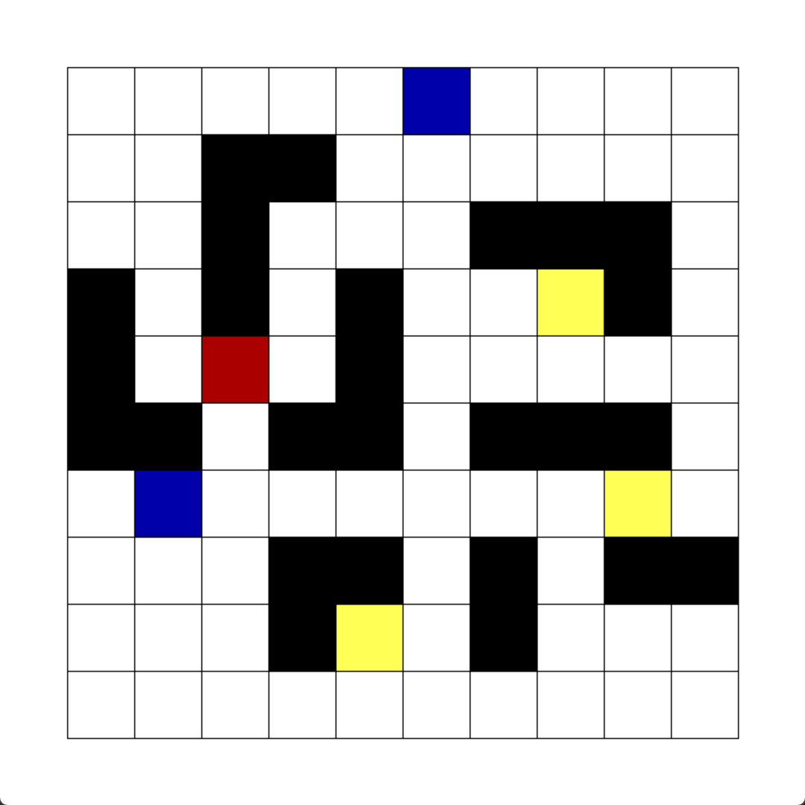
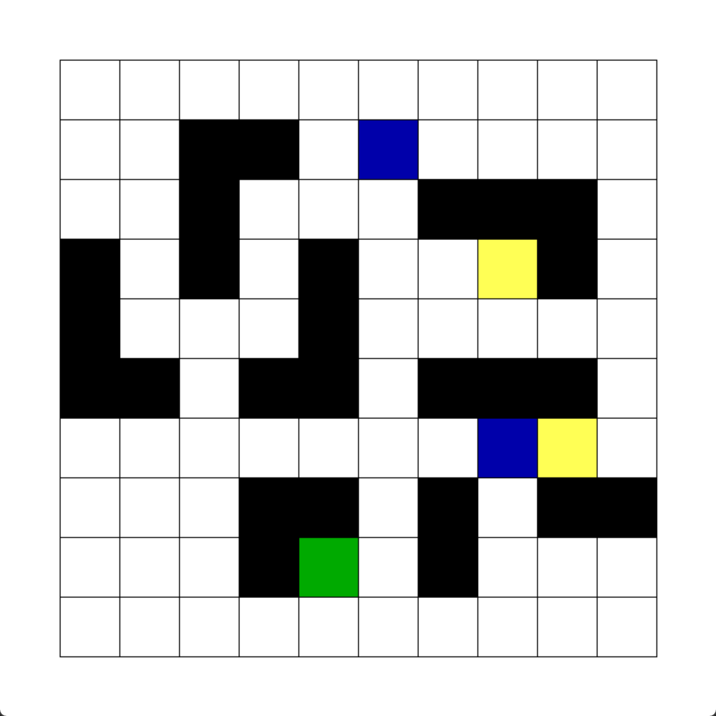
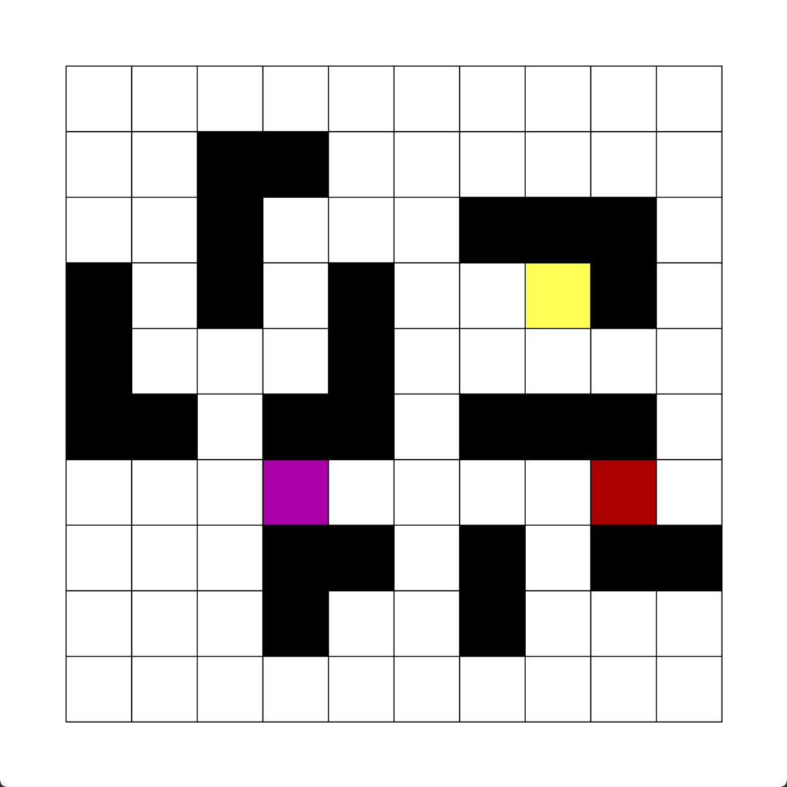
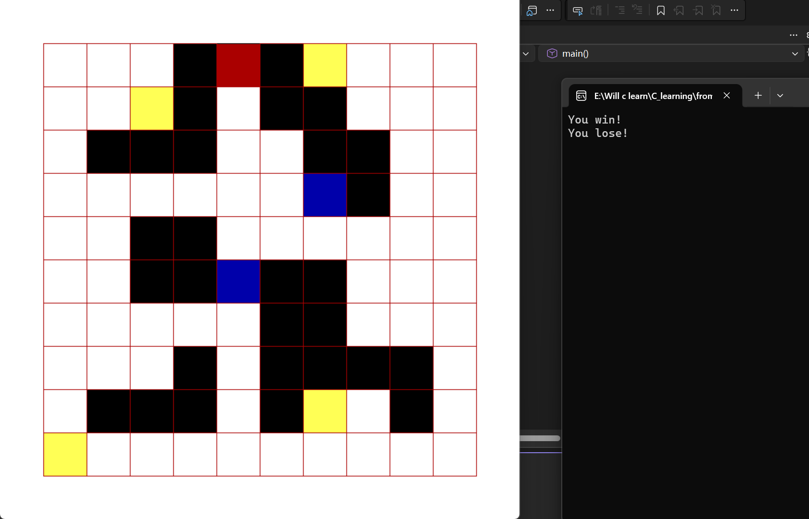
六、心得体会
深刻认识了函数的封装和调用思想
加强了对广度优先算法的理解

（另起一页）答辩记录：

成绩评定：
项目 | 程序设计 | 代码效果 | 格式规范 | 答辩情况 | 总 分
标准分 | 20 | 20 | 10 | 50 | 100
得 分

指导教师（签名）

2026年 7月3日

