Database Normal Forms
Here is a list of Normal Forms in SQL:
- 1NF (First Normal Form)
- 2NF (Second Normal Form)
- 3NF (Third Normal Form)
- BCNF (Boyce-Codd Normal Form)
- 4NF (Fourth Normal Form)
- 5NF (Fifth Normal Form)
- 6NF (Sixth Normal Form)
The Theory of Data Normalization in MySQL server is still being developed further. For example, there are discussions even on 6th Normal Form. However, in most practical applications, normalization achieves its best in 3rd Normal Form. The evolution of Normalization in SQL theories is illustrated below-
Database Normal Forms

Database Normalization With Examples
Database Normalization Example can be easily understood with the help of a case study. Assume, a video library maintains a database of movies rented out. Without any normalization in database, all information is stored in one table as shown below. Let's understand Normalization database with normalization example with solution:
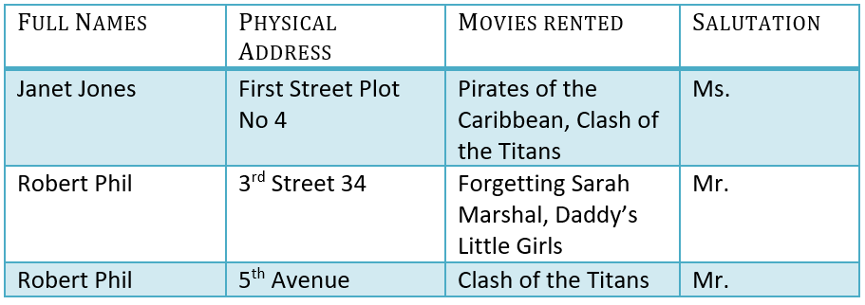
Here you see Movies Rented column has multiple values. Now let's move into 1st Normal Forms:

1NF (First Normal Form) Rules
- Each table cell should contain a single value.
- Each record needs to be unique.
The above table in 1NF-

1NF Example
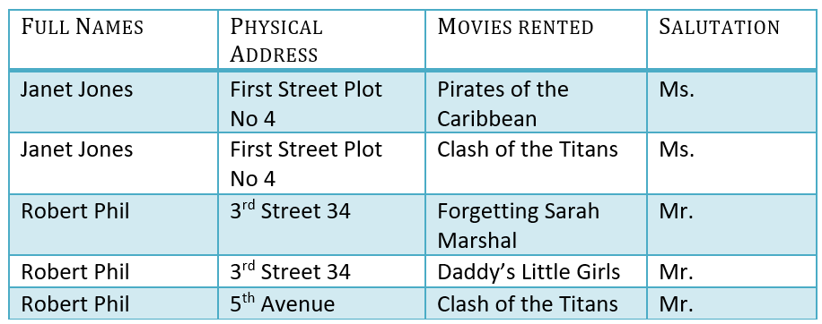
Example of 1NF in DBMS
Before we proceed let's understand a few things --

What is a KEY in SQL?
A KEY in SQL is a value used to identify records in a table uniquely. An SQL KEY is a single column or combination of multiple columns used to uniquely identify rows or tuples in the table. SQL Key is used to identify duplicate information, and it also helps establish a relationship between multiple tables in the database.
Note: Columns in a table that are NOT used to identify a record uniquely are called non-key columns.

What is a Primary Key?

Primary Key in DBMS
A primary is a single column value used to identify a database record uniquely.
It has following attributes
- A primary key cannot be NULL
- A primary key value must be unique
- The primary key values should rarely be changed
- The primary key must be given a value when a new record is inserted.

What is Composite Key?
A composite key is a primary key composed of multiple columns used to identify a record uniquely
In our database, we have two people with the same name Robert Phil, but they live in different places.
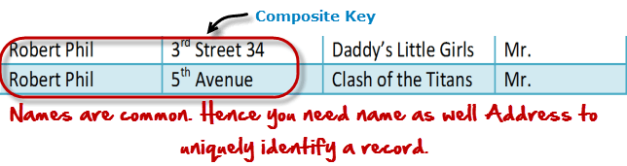
Composite key in Database
Hence, we require both Full Name and Address to identify a record uniquely. That is a composite key.
Let's move into second normal form 2NF

2NF (Second Normal Form) Rules
- Rule 1- Be in 1NF
- Rule 2- Single Column Primary Key that does not functionally dependant on any subset of candidate key relation
It is clear that we can't move forward to make our simple database in 2nd Normalization form unless we partition the table above.
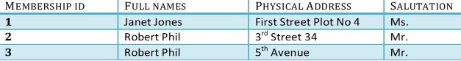
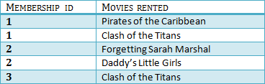
We have divided our 1NF table into two tables viz. Table 1 and Table2. Table 1 contains member information. Table 2 contains information on movies rented.
We have introduced a new column called Membership_id which is the primary key for table 1. Records can be uniquely identified in Table 1 using membership id

Database - Foreign Key
In Table 2, Membership_ID is the Foreign Key
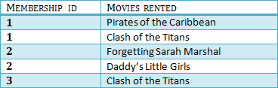

Foreign Key in DBMS
Foreign Key references the primary key of another Table! It helps connect your Tables
- A foreign key can have a different name from its primary key
- It ensures rows in one table have corresponding rows in another
- Unlike the Primary key, they do not have to be unique. Most often they aren't
- Foreign keys can be null even though primary keys can not
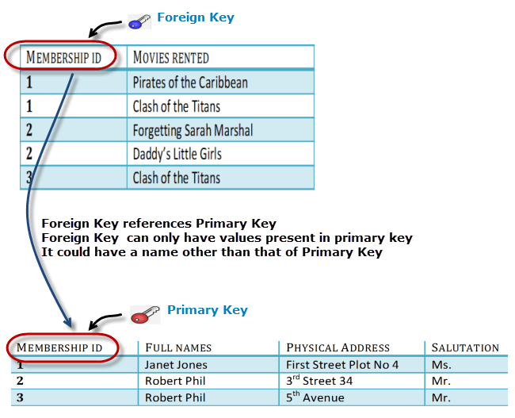

Why do you need a foreign key?
Suppose, a novice inserts a record in Table B such as
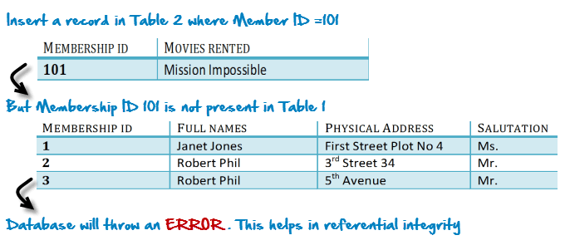
You will only be able to insert values into your foreign key that exist in the unique key in the parent table. This helps in referential integrity.
The above problem can be overcome by declaring membership id from Table2 as foreign key of membership id from Table1
Now, if somebody tries to insert a value in the membership id field that does not exist in the parent table, an error will be shown!

What are transitive functional dependencies?
A transitive functional dependency is when changing a non-key column, might cause any of the other non-key columns to change
Consider the table 1. Changing the non-key column Full Name may change Salutation.
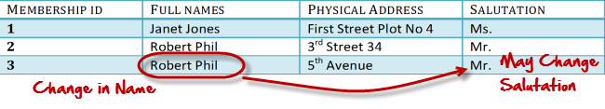
Let's move into 3NF

3NF (Third Normal Form) Rules
- Rule 1- Be in 2NF
- Rule 2- Has no transitive functional dependencies
To move our 2NF table into 3NF, we again need to again divide our table.

3NF Example
Below is a 3NF example in SQL database:
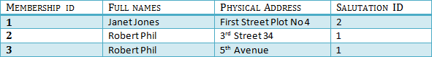
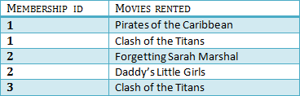
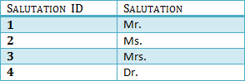
We have again divided our tables and created a new table which stores Salutations.
There are no transitive functional dependencies, and hence our table is in 3NF
In Table 3 Salutation ID is primary key, and in Table 1 Salutation ID is foreign to primary key in Table 3
Now our little example is at a level that cannot further be decomposed to attain higher normal form types of normalization in DBMS. In fact, it is already in higher normalization forms. Separate efforts for moving into next levels of normalizing data are normally needed in complex databases. However, we will be discussing next levels of normalisation in DBMS in brief in the following.

BCNF (Boyce-Codd Normal Form)
Even when a database is in 3rd Normal Form, still there would be anomalies resulted if it has more than one Candidate Key.
Sometimes is BCNF is also referred as 3.5 Normal Form.

4NF (Fourth Normal Form) Rules
If no database table instance contains two or more, independent and multivalued data describing the relevant entity, then it is in 4th Normal Form.

5NF (Fifth Normal Form) Rules
A table is in 5th Normal Form only if it is in 4NF and it cannot be decomposed into any number of smaller tables without loss of data.

6NF (Sixth Normal Form) Proposed
6th Normal Form is not standardized, yet however, it is being discussed by database experts for some time. Hopefully, we would have a clear & standardized definition for 6th Normal Form in the near future...
That's all to SQL Normalization!!!

Summary
- Database designing is critical to the successful implementation of a database management system that meets the data requirements of an enterprise system.
- Normalization in DBMS is a process which helps produce database systems that are cost-effective and have better security models.
- Functional dependencies are a very important component of the normalize data process
- Most database systems are normalized database up to the third normal forms in DBMS.
- A primary key uniquely identifies are record in a Table and cannot be null
- A foreign key helps connect table and references a primary key

