1. for loop

1. while loop

1. Use while loop to count 1-10:

1. Do while loop

1. Arrays: Push (Add an item to the end)

1. Arrays: Pop (Remove the last item)

1. Array: shift (Remove the first item)

1. Array: unshift (Add an item to the beginning of the array)

1. Array: splice (Add/Remove ) : add two items starting from position “1”.

1. Array: slice (): remove items at the beginning of the array

1. Array sort(): descending by default



1. Array reverse(): ascending order



1. Array concat: Merge arrays

1. Alert Popup Box:

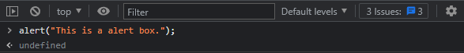

1. Confirm Box:



1. Prompt Box:

